Influence of Staphylococcus epidermidis on Collagen Crimp Patterns of Soft Tissue Allograft
Abstract
Background: Postoperative infections, commonly from Staphylococcus epidermidis, may result in anterior cruciate ligament (ACL) graft failure and necessitate revision surgery. In biomechanical studies, S. epidermidis has been shown to establish biofilms on tendons and reduce graft strength.
Purpose: The goal of this study is to determine the impact of bacterial bioburden on the collagen structure of tendon. We hypothesized that an increase in S. epidermidis biofilm will compromise tendon crimp, a pattern necessary for mechanical integrity, of soft tissue allografts.
Study design: Controlled laboratory study.
Methods: Cultures of S. epidermidis were inoculated on tibialis anterior cadaveric tendons. Conditions assessed included 5 x 10⁵ CFUs (colony-forming units) or concentrated spent media from culture (no living bacteria). Incubation times of 30 minutes, 3 hours, 6 hours, and 24 hours were utilized. Second-harmonic generation microscopy allowed for visualization of collagen autofluorescence. Crimp lengths were determined with ImageJ and compared based on incubation time. Incubation time positively correlated with increasing S. epidermidis bioburden. Results: Both fine and coarse crimp patterns lengthened with increasing incubation time. Significant coarse crimp changes were observed after only 30-minute incubations (p=<0.029), whereas significant fine crimp lengthening occurred after 6 hours (p=<0.0001). No changes in crimp length were identified following incubation media lacking living bacteria.
Conclusions: The results of this study demonstrate that exposure to S. epidermidis biofilms negatively impact collagen crimp structure. Structural alterations at the collagen fiber level occur within 30 minutes of exposure to media containing S. epidermidis.
Key terms: S. epidermis; tendon; allograft; bacterial bioburden; collagen fiber.
What is known about the subject: Previous research has explored the relationship between S. epidermidis biofilms and ACL graft strength by testing the mechanical integrity of tibialis posterior tendon grafts. Following incubation of S. epidermidis (10000 CFU/ml), the Young’s modulus of elasticity of the grafts significantly decreased resulting in increased compliance, and increasing bioburden was also associated with decreased tensile strength.
What this study adds to existing knowledge: The results of this study demonstrate that S. epidermidis biofilms negatively impact collagen crimp structure and suggest that a bacterial metabolite may aid in this process. In the presence of S. epidermidis, structural alterations at the collagen fiber level occur within 30 minutes of exposure and before gross changes can be appreciated, which highlights the need for antimicrobial precautions to prevent graft colonization and maximize graft mechanical strength.

Introduction
Anterior cruciate ligament (ACL) injury rates are increasing, and there are over 200,000 ACL reconstructions performed each year in the United States.^{16,14} Reconstruction is considered a safe and effective treatment for ACL rupture and utilizes autograft or allograft tissues.²¹ Autografts are obtained from the patient and often include part of the hamstring, quadriceps, or patellar tendons. Allografts, such as Achilles and tibialis tendons, are harvested from donors. The selected graft is fixated in surgically created tunnels in the patient’s femur and tibia to reconstitute the ACL.⁴

Type I collagen fibrils in native ligaments and tendon grafts provide mechanical integrity to the tissue. Collagen fibrils are organized to allow for maximum energy dissipation and can be considered rope-like.⁵ Individual collagen polypeptides are composed of a specific sequence, assembled into a triple helix, and subsequent triple helices are thermodynamically assembled in a hierarchal manner into fibrils.²⁹ Collagen fibrils associate to form collagen fibers, the basic unit of tendons and ligaments. Collagen fibers contain crimp, a pattern resembling waves that allows for stretch and flexibility. Specific crimp orientation and ability to straighten accommodate loading responses during physiological functioning.^{35,13} This complex organization allows for tendons to transmit and withstand rotational and longitudinal forces and to serve as grafts for ruptured ligaments.³¹

Although success rates are generally high, 10%-15% of patients undergoing ACL reconstruction require a revision due to graft failure.⁶ A reconstruction may be deemed a failure if there is objective laxity and patient perceived instability. Failure can result from surgical technique, trauma, infection, or a combination of these factors. The rate of symptomatic infection following ACL reconstruction is low and is estimated to cause 1% of failures.²² Incidence of infection are higher among younger patients and patients with revision cases.²⁰ Subclinical infection may also be clinically important and may compromise mechanical strength of the graft without overt symptoms.⁸ Infections are often attributed to members of the Staphylococcus genus. Particularly, Staphylococcus epidermidis has emerged as one of the most common organisms present in joint infections.²⁸ Additionally, S. epidermidis is capable of forming biofilms on tendon grafts, implants, and screws, decreasing antibiotic efficacy and making bacterial removal difficult.²⁴ Biofilms are often simply considered as biomaterial adhered to a surface. However, biofilms are much complex ranging from surface adhered and non-surface adhered aggregates with a non-linear biofilm life cycle that may fluctuate between aggregation, growth, and disaggregation.²⁷

The relationship between bacterial colonization and failed ACL reconstructions is not well understood. Bacterial DNA has been identified in failed ACL reconstructions, including from S. epidermidis.¹⁷ Interestingly, 80% of grafts that have not failed are colonized by Cutibacterium (previously Propionibacterium) acnes.¹¹ C. acnes is generally considered low virulence organisms, and one suspicion is that they might be asymptomatically present until catastrophic failure.¹ In one study, a cohort of patients with failed reconstructions presented with no clinical signs of infection; however, larger tunnel diameter was positively associated with higher amounts of bacterial DNA.¹² Taken together, these studies suggest that current clinical techniques may underestimate bacterial presence in failed ACL reconstructions and prompt further investigation to understand why certain bacterial strains are associated with failed ACL reconstructions.

Previous research has explored the relationship between S. epidermidis biofilms and ACL graft strength by testing the mechanical integrity of tibialis posterior tendon grafts. Following incubation of S. epidermidis (10000 CFU/ml), the Young’s modulus of elasticity of the grafts significantly decreased resulting in increased compliance, and increasing bioburden was also associated with decreased tensile strength.³⁰ However, the reason for decreased peak load failure has yet to be determined. The inverse relationship between crimp lengthening and increased elasticity may be explained by joint laxity or over-stretching that ultimately results in graft failure.

The purpose of this study was to analyze changes that may occur in ACL allograft crimp pattern following incubation with S. epidermidis. We hypothesized that increasing incubation time with S. epidermidis will lengthen crimp pattern, resulting in increased tendon elasticity and reduced strength.

Methods
Strains and biofilm growth
Staphylococcus epidermidis ATCC® 35984™, isolated from catheter sepsis, was cultured overnight in Brain Heart Infusion (BHI [Becton, Dickinson, and Company; Sparks, MD]) at 37°C. Human tibialis anterior tendons were prepared and inoculated. Growth conditions assessed included inoculum concentration of 500,000 CFU in 100% BHI media and durations of 30 minutes, 3 hours, 6 hours, and 24 hours as done in previous work.³⁰ We believe this inoculum might reasonably occur during harvesting and surgical placement of a graft. Incubation with 100% BHI for 24 hours served as a control. Surface adhered bacterial aggregates will be considered biofilms in this study according to work by Sauer et al.²⁷

Tibialis anterior graft preparation
Cadaveric human tibialis anterior tendon grafts were harvested under sterile conditions. Specimens were stored at -20°C and thawed at 4°C. Tendons were freed from remaining muscle fibers and cut into 2cm sections using an ethanol-flame sterilized razor blade. Tendon sections were submerged deionized water for approximately 10 hours to prevent drying until inoculation.

Inoculation protocol
Human tibialis anterior tendons were prepared, and each section was transferred to a well in a sterile 6-well plate (Falcon; Corning, NY). Specimens were submerged in 5 mL of 100,000 CFU/mL diluted in BHI from overnight culture and then statically incubated at 37°C for either 30 minutes, 3 hours, 6 hours, or 24 hours. A control of 5 mL of BHI media added to the tendon was run for 24 hours under the same conditions.

Spent Media Incubation
After preparation of human tibialis anterior tendons, each section was transferred to a sterile 6-well plate. Overnight culture of S. epidermidis in 25 mL of BHI were centrifuged at 4300 g for 5 minutes at room temperature to remove bacteria. The supernatant was collected and vacuum filtered through a 0.22 µm filter. Tendon sections were submerged in 5 mL of the spent media and then statically incubated at 37°C for either 30 minutes, 3 hours, 6 hours, or 24 hours. Similarly, an incubation with 5 mL of BHI media for 24 hours served as the control.

Assessing bioburden of S. epidermidis
Bioburden was both visualized and quantified in separate trials. Following inoculation with S. epidermidis or BHI control media, tendons were washed twice with DI water and stained with 100 uL of 7 uM hexidium iodide from the LIVE Baclight Bacterial Gram Stain kit (Invitrogen; Waltham, MA). Fluorescence was imaged on an EVOS FLoid Imaging System at 40x (Thermo Fischer Scientific; Waltham, MA). To remove planktonic cells following inoculation, experimental and control samples were washed gently twice in sterile Dulbecco's phosphate-buffered saline (DPBS) and transferred to a 15 mL conical containing 5 mL of DPBS. Tendons were then sonicated for 5 minutes to remove bacterial aggregates. Concentration of the bacterial suspension from biofilm was determined via plate counts on BHI agar grown overnight at 37°C.

Second-Harmonic Generation Imaging
After incubation with S. epidermidis or BHI control media, tendon sections were washed twice with DI water and stained with 100 uL of 7 uM hexidium iodide gram stain to again allow for visualization of bacteria (LIVE Baclight Bacterial Gram Stain, Invitrogen; Waltham, MA). To utilize second-harmonic generation (SHG) imaging, a multiphoton MaiTai DeepSee laser at 870 nm allowed for visualization of S. epidermidis and autofluorescence of collagen fibers (Olympus Multiphoton FV1000, Olympus Corporation; Tokyo, Japan). Images were taken with a 25x objective and LUTs were optimized. Tendon sections that were treated with spent media alone did not undergo staining with hexidium iodide and were immediately taken for SHG imaging of collagen following incubation.

Determining Surface Area and Crimp Length Changes
Before and after incubation, macroscopic images were taken of the tendon sections. Length and width measurements were determined using ImageJ. Percent increase of length, width, and surface area were calculated. One-way ANOVA analyses with multiple comparisons were used with an alpha of 0.05 deemed statistically significant. Crimp in the 10-30 $μ$m range was defined as ‘fine’ and was approximately half of the length of ‘coarse’ crimp defined to be 30-60 $μ$m, as similarly characterized by Zhao et al.³⁴ Crimp length was analyzed from SHG images via ImageJ by measuring the distance between crimp amplitudes. The mean and variances of fine and coarse crimp lengths for each biological replicate were calculated. Using GraphPad Prism, Two-way ANOVA analyses with multiple comparisons and Holm-Sidak corrections were utilized with an alpha of 0.05. T-tests assuming equal variances compared the crimp length means of replicates incubated in spent media or bacteria with an alpha of 0.05. Linear regression models were performed on Microsoft Excel using the trendline function.

Results
Establishment of Bioburden
To determine the amount of bacteria present on tibialis anterior tendons following inoculation, bioburden was quantified and visualized. Increased incubation time was positively associated with greater bioburden (Figure 1A). Additionally, tendons were stained with a Baclight hexidium iodide gram stain to visualize S. epidermidis aggregates in vivo. Hexidium iodide also stains mammalian cells; thus, host cells (10 um) must be discerned from bacteria cells (1um). The increased presence of S. epidermidis was observed with increasing incubation time (Figure 1B-F). Together, these results indicate that S. epidermidis is capable of adhering to tibialis anterior tendons.

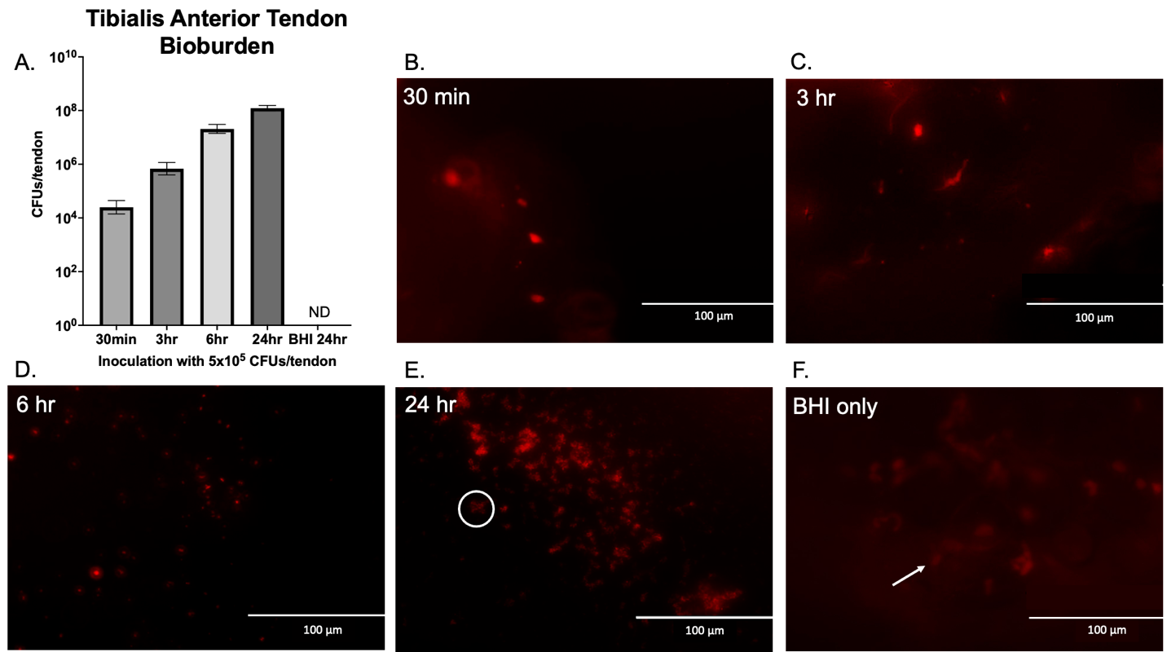
Figure 1. Tibialis anterior bioburden increases with greater incubation time. CFUs per tendon section were determined following incubation with an initial inoculum of 5 x 10⁵ CFUs (A). Hexidium iodide stained both host and S. epidermidis cells. S. epidermidis cells are ~1um in diameter and spherical in shape, and host cells are ~10um and more amorphous in shape. The two cell types can be differentiated on the basis of shape and size (B-F). Bacterial growth in sterile BHI media was undetected (UD). A cluster of S. epidermidis cells is identified in a circle (E) and a host cell is indicated with an arrow (F).

Determination of Macroscopic Expansion
Images of tendons were taken before and after inoculation to assess for macroscopic alterations. Projected surface area, length, and width of the tendons demonstrated an increasing trend in percent increase with longer incubation time (Figure 2A-C). Following 6 hours of incubation, projected surface area, length, and width percent increases compared to 24 hours in BHI media were statistically significant. Tendon sections incubated with BHI alone also increased in length and width compared to pre-inoculum measurements, suggesting that submersion in BHI does have an underlying effect on macroscopic expansion. However, the presence of S. epidermidis biofilm had a more robust effect on macroscopic changes than BHI alone and over shorter incubation times (Figure 2A-D).
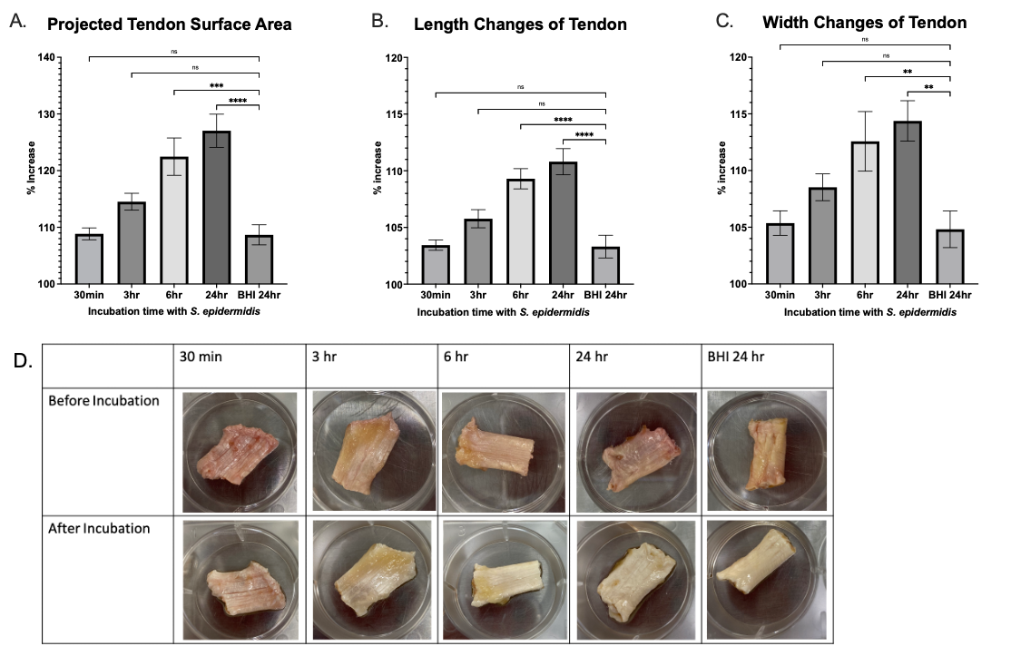

Figure 2. Macroscopic alterations of tendon structure following S. epidermidis incubation. Before and after incubation, tendon sections were imaged, and the percent increase was determined. Surface area, length, and width of each tendon trended upward, indicating a greater increase with increasing incubation time (A-C). A significant percent increase in surface area was achieved following 6 hours (p=0.0003) (A). Length and width changes also increased significantly following 6 hours (p<0.0001, p=0.0099) (B-C). Error bars represent standard error for BHI only controls, (n=10) and experimental replicates (n=9). One-way ANOVA analyses identified statistical significance between means. Representative images of tendon sections are shown before and after incubation (D).

Collagen structure and bacterial distribution on the tendon
To determine the impact of S. epidermidis on collagen and explain the observed macroscopic expansion, tendon sections were imaged using second-harmonic generation imaging to visualize auto-fluorescence of collagen and S. epidermidis stained with hexidium iodide following bacterial incubation (Figure 3). The collagen fibers appeared as distinct green wavy strands and the bacteria were seen as distinct red cocci of 1 µm diameter (Fig. 3C). The bacteria appeared to be attached to a layer overlying the collagen. As previously described, stain uptake, size and shape were used to differentiate bacterial cells from host cells. The “wavelength” of the strands appeared to be correlated to the incubation exposure time to S. epidermidis (Figs. 3 and 4).

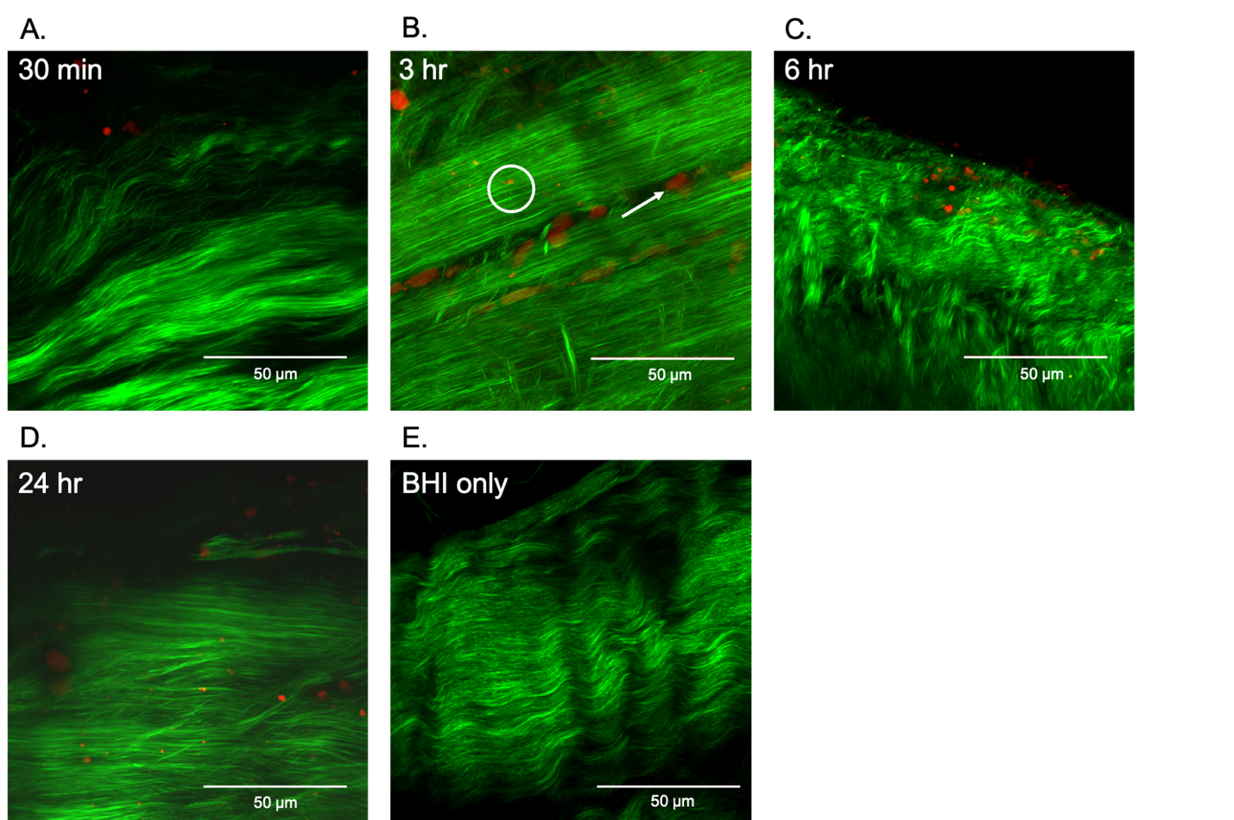

Figure 3. Collagen structure and bacterial distribution on the tendon. Representative Second-Harmonic Generation (SHG) maximum projection images of the tendon following incubation with S. epidermidis are shown. The collagen fibers appeared as distinct green strands and the bacteria were seen as red cocci of 1 µm diameter (Fig. 3C). The bacteria appeared to be attached to a layer overlying the surface of the collagen. A cluster of S. epidermidis cells is identified in a circle and a host cell is indicated with an arrow (B).

Effect of S. epidermidis on Tendon Crimp Patterns
After confirming the presence of S. epidermidis on the tendons, crimp patterns were determined to be fine or coarse, and the length was measured between amplitudes (Figure 4). Several images from different areas of each tendon section were taken to attempt to overcome the inherent variability between individual collagen fibers. As incubation time increased, both fine and coarse crimp patterns trended toward lengthening (Figure 5). The data was fitted to a linear regression model with crimp length = 0.5901$μ$m/hr x t + 11.551$μ$m, R²= 0.787 for fine crimp and crimp length = 1.9$μ$m/hr x t + 27.349$μ$m, R²=0.818 for coarse crimp. Fine crimp length was nearly half of the coarse crimp and defined to be between 10-30 $μ$m as compared to 30-60 $μ$m, respectively. A statistically significant increase in the fine crimp length was observed following 6 hours; however significant lengthening of the coarse crimp length occurred after only 30 minutes compared to BHI alone. These results identify that the coarse crimp patterns were compromised before fine crimp by the presence of S. epidermidis.
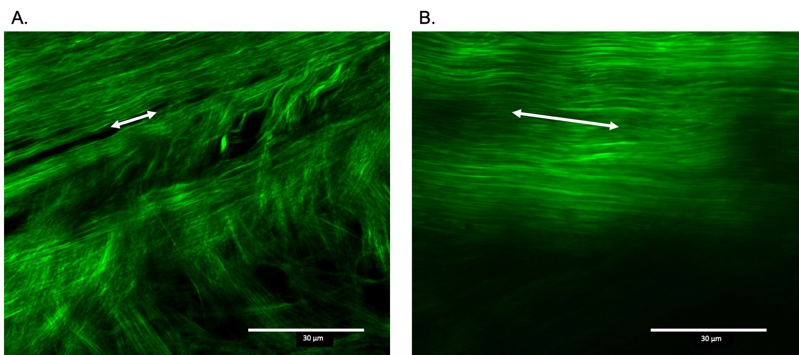
Figure 4. Tendon crimp length increases with exposure to S. epidermidis. Second-harmonic generation imaging allowed for the visualized of the autofluorescence of collagen. Collagen fiber crimp length was measured between peaks of wave patterns. Fine crimp (A) and coarse crimp (B) patterns were identified and differentiated. The arrows show how the wavelength of representative crimps were measured.

Figure 5. Crimp patterns lengthen during incubation with S. epidermidis. Following inoculation and incubation with S. epidermidis, fine and coarse crimp lengths were determined from SHG images. Two-way ANOVA analyses with the Holm-Sidak correction and multiple comparison tests were utilized to examine differences within and between experimental groups. Both fine and coarse crimp values demonstrated a trend of increasing length with incubation time. The fine crimp length was determined to be significantly greater in the presence of S. epidermidis than with sterile BHI alone after 6 hours (p<0.0001, n=4). Coarse crimp lengthened after only 30 minutes of incubation (p=0.029, n=3). Error bars represent 1 standard error.

Crimp Lengthening due to Bacterial Presence or a Secreted Metabolite
To determine whether S. epidermidis required physical attachment to tendon or if secreted metabolites might cause structural compromise, we also incubated tendons with spent media. Spent media, in the supernatant, was assumed to contain secreted metabolic byproducts that may be present in vivo. A trend of macroscopic expansion of the tendon with increasing incubation time with spent media alone was observed (Figure 6A). However, a significant difference compared to BHI alone was not achieved until 24 hours of exposure, and the rate of percent increase per time was not as significant compared to that which occurred when S. epidermidis cells were present (Figure 2A). Fine and coarse crimp lengthening did not follow the same trend as observed in the presence of S. epidermidis cells (Figure 5). All timepoints analyzed exhibited a significant increase in both fine and coarse crimp length compared to BHI alone (Figure 6B-C). To compare the effect on crimp lengths between spent media and S. epidermidis biofilm, the average length from each tendon following spent media incubation was subtracted from the average length after S. epidermidis incubation at each timepoint (Figure 6D). The crimp lengthening following S. epidermidis incubation was significantly longer than its spent media counterpart at 6 and 24 hours for both fine and coarse crimp. However, at 30 minute and 3-hour timepoints, the average crimp length following spent media incubation was longer than that following S. epidermidis incubation.

Figure 6. Tibialis anterior tendon alterations following incubation with cell-free S. epidermidis spent media compared to S. epidermidis biofilm. Using the Holm-Sidak correction and multiple comparisons two-way ANOVA tests, fine and coarse crimp were determined to significantly lengthen across all time points compared to BHI alone (A) but did not trend toward increasing length with increasing incubation time (B-C). The average fine and coarse crimp length values were determined from each time point following incubation with spent media and subtracted from the average crimp lengths following incubation with S. epidermidis (D). All error bars represent standard error.

Discussion
This study identifies that microscopic alterations occur before macroscopic changes can be appreciated in ACL soft tissue allografts in the presence of S. epidermidis. Specifically, inherent crimp patterns are compromised at a relatively low inoculation time with changes in coarse crimp occurring more quickly than fine crimp. Taken together, these results explain the previously described weakening of mechanical strength and graft integrity with increasing bacterial colonization.³⁰ We suggest a step-wise manner for allograft failure during infection that results in coarse crimp lengthening, fine crimp lengthening, and lastly, macroscopic length and width expansion. We additionally identified the possibility for a secreted metabolite to play a role in compromising crimp patterns; however, the physical presence of a bacterial biofilm has a much greater impact on crimp lengthening.

Infection from S. epidermidis and other strains present a challenge for successful ACL reconstruction. On average, it takes 4.7 days from the time of surgery to the onset of symptoms associated with infection.¹⁹ Current culture techniques report infection in less than 1% of ACL reconstructions following knee aspiration. However, 80% of failed grafts were identified to be inhabited by bacteria, despite having no infection upon clinical impression.¹⁷ Even in undetected, subclinical infections, bacterial presence is associated with increased graft failure rates highlighting the need for precautionary surgical measures. Additionally, bacteria capable of producing biofilms pose a greater threat for infection because they are not as easily picked up in joint fluid aspiration as planktonic counterparts.⁷

Although prophylactic antibiotics offer protection against surgical infection, antibiotics in general may hinder diagnosis. If antibiotics were recently taken before surgery or given hastily due to a presumed infection, the sensitivity to detect bacterial infection is significantly reduced via aspiration, and standard signs of infection are less likely to occur.¹⁸ Therefore, a complete medical and antibiotic history must be obtained if a post-reconstruction infection if suspected as classic diagnostic tools may not be as accurate, and a prompt diagnosis should be made prior to antibiotic therapy to reduce the threat to joint components. Understanding the mechanism by which bacterial colonization can impact the mechanical properties of a graft tissue and enhancing infection detection are critical.

Proper collagen crimp architecture is essential in tendons for their function of withstanding forces and strains. This study only focused on crimp patterns in tibialis anterior tendons. However, crimp morphology differs among types of tendons and ligaments due to differences in mechanical behavior.^{33,25} Additionally, tendon grafts undergo ligamentization following ACL reconstruction.⁹ Fibroblasts and crimp lengths may increase for years in the graft after surgery.²³ Adaptive responses or physiological crimp reorganization may be impacted if infection persists. Understanding how commonly used tendon grafts are impacted by bacterial infection would allow for better graft selection, especially in patients with previous joint infection or who are at risk for infection.¹⁵ Future work characterizing tendon graft mechanical strength and crimp integrity following inoculation with different types of bacteria will allow for better physician-patient decision-making due to individual risks and preferences.

The exact mechanism behind crimp lengthening in the presence of S. epidermidis biofilm during infection warrants future exploration. We propose that crimp lengthening observed following incubation with spent media may be due to the concentration of spent media components or enzymatic activity from a secreted metabolite. Overnight cultures had an OD₆₀₀ of 1.4 AU and were approximately 1,500x more concentrated with bacterial metabolites than the starting inoculum of 5x10⁵ CFUs utilized to establish biofilms on the tendons. A high spent media concentration was utilized to identify a possible effect from a metabolite more clearly than a low concentration. Spent media was assumed to contain all metabolic byproducts and secreted proteins that would be present in vivo. However, we chose to utilize a standard practice of overnight, liquid culture that promotes planktonic bacteria to obtain spent media. Further work should employ the use of spent media following the promotion of biofilms. Results from this study demonstrate that spent media possibly impacted collagen crimp as a trend in crimp lengthening was not associated with increase incubation time. We are not sure whether a possible secreted metabolite or BHI media components in our spent media are more concentrated, more enzymatically active, or capable of having an osmotic affect that would alter crimp lengthening. Increases in surface area expansion were observed in BHI controls which support the idea that submersion in liquid media inherently results in changes in size. The purpose of this experiment was to determine if the bacteria physically needed to be present to seen an effect on crimp. S. epidermidis biofilms resulted in greater crimp compromise with increasing bioburden compared to incubation with only spent media. Therefore, the effect of physical biofilms has a greater impact on crimp lengthening than a potential metabolite. Collagenases with catalytic zinc have been well-characterized in other bacteria genuses, such as Clostridium¹⁰ but, S. epidermidis is not known to secrete collagenases. The lack of full characterization of S. epidermidis metabolites cannot rule out the possibility that a protease may also affect native collagen structure.

Several limitations exist in this study. Crimp was assessed by two-dimensional parameters which fail to take into account crimp angle or other three-dimensional aspects of collagen organization. If any contamination occurred, residual hexidium iodide could stain all gram-positive bacteria on the sample, and the current experimental procedures did not allow for specific identification of S. epidermidis. Our investigation attempted to use an inoculum concentration that was biologically relevant and determined to be representative of a clinical infection as described by Sorenson et al.³⁰ It is possible that this study may over or underestimate the burden S. epidermidis biofilm on ACL allografts. Our work focused on tibialis anterior allograft, which is not a standard graft option for ACL reconstruction. Additionally, our in vitro system analyzed the influence of S. epidermidis attachment and growth on crimp patterns. The inflammatory joint environment is much more complex than our experimental conditions. Factors such as cytokine production, reactive oxygen species, and biological cell infiltration are also likely to influence graft integrity in combination with the possibility of subclinical infection.^{3,26,2} More work is needed to determine if these results are applicable to other ACL graft options and the in vivo joint environment.

Experiments performed in this study were designed to mimic clinical infection at an advanced rate and demonstrate alterations at the collagen level that can occur due to S. epidermidis biofilm. Crimp patterns, both fine and coarse, lengthened with increased exposure to S. epidermidis. Further research is warranted to identify why the physical presence of bacteria invokes such changes and which metabolites may be involved in the degradation of fiber architecture. Such findings would highlight why some bacterial strains are more detrimental than others and may offer a more targeted therapeutic approach to preventing ACL allograft infection.

The results of this study demonstrate that exposure to S. epidermidis biofilms negatively impact collagen crimp structure. Structural alterations at the collagen fiber level occur within 30 minutes of exposure to media containing S. epidermidis, which highlights the need for antimicrobial precautions to prevent graft colonization and maximize graft mechanical strength.

References
1. Achermann Y, Goldstein EJC, Coenye T, Shirtliff ME. Propionibacterium acnes: from Commensal to Opportunistic Biofilm-Associated Implant Pathogen. Clin Microbiol Rev. 2014;27(3):419-440.
2. Alivernini S, MacDonald L, Elmesmari A, et al. Distinct synovial tissue macrophage subsets regulate inflammation and remission in rheumatoid arthritis. Nat Med. 2020;26(8):1295-1306.
3. Barbosa GM, Cunha JE, Russo TL, et al. Thirty days after anterior cruciate ligament transection is sufficient to induce signs of knee osteoarthritis in rats: pain, functional impairment, and synovial inflammation. Inflamm Res Off J Eur Histamine Res Soc Al. 2020;69(3):279-288.
4. Behrend H, Stutz G, Kessler MA, Rukavina A, Giesinger K, Kuster MS. Tunnel placement in anterior cruciate ligament (ACL) reconstruction: quality control in a teaching hospital. Knee Surg Sports Traumatol Arthrosc Off J ESSKA. 2006;14(11):1159-1165.
5. Buehler MJ. Nature designs tough collagen: explaining the nanostructure of collagen fibrils. Proc Natl Acad Sci U S A. 2006;103(33):12285-12290.
6. Buller LT, Best MJ, Baraga MG, Kaplan LD. Trends in Anterior Cruciate Ligament Reconstruction in the United States. Orthop J Sports Med. 2014;3(1):2325967114563664.
7. Costerton JW, Montanaro L, Arciola CR. Bacterial communications in implant infections: a target for an intelligence war. Int J Artif Organs. 2007;30(9):757-763.
8. Descriptive Epidemiology of the Multicenter ACL Revision Study (MARS) Cohort. Am J Sports Med. 2010;38(10):1979-1986.
9. Dustmann M, Schmidt T, Gangey I, Unterhauser FN, Weiler A, Scheffler SU. The extracellular remodeling of free-soft-tissue autografts and allografts for reconstruction of the anterior cruciate ligament: a comparison study in a sheep model. Knee Surg Sports Traumatol Arthrosc Off J ESSKA. 2008;16(4):360-369.
10. Eckhard U, Schönauer E, Brandstetter H. Structural Basis for Activity Regulation and Substrate Preference of Clostridial Collagenases G, H, and T *. J Biol Chem. 2013;288(28):20184-20194.
11. Everhart JS, DiBartola AC, Dusane DH, et al. Bacterial Deoxyribonucleic Acid Is Often Present in Failed Revision Anterior Cruciate Ligament Reconstructions. Arthrosc J Arthrosc Relat Surg Off Publ Arthrosc Assoc N Am Int Arthrosc Assoc. 2018;34(11):3046-3052.
12. Flanigan DC, Everhart JS, DiBartola AC, et al. Bacterial DNA is associated with tunnel widening in failed ACL reconstructions. Knee Surg Sports Traumatol Arthrosc Off J ESSKA. 2019;27(11):3490-3497.
13. Franchi M, Quaranta M, Macciocca M, et al. Collagen fibre arrangement and functional crimping pattern of the medial collateral ligament in the rat knee. Knee Surg Sports Traumatol Arthrosc. 2010;18(12):1671-1678.
14. Gianotti SM, Marshall SW, Hume PA, Bunt L. Incidence of anterior cruciate ligament injury and other knee ligament injuries: a national population-based study. J Sci Med Sport. 2009;12(6):622-627.
15. Group M, Brophy RH, Wright RW, et al. Rate of infection following revision anterior cruciate ligament reconstruction and associated patient- and surgeon-dependent risk factors: Retrospective results from MOON and MARS data collected from 2002 to 2011. J Orthop Res. 2021;39(2):274-280.
16. Herzog MM, Marshall SW, Lund JL, Pate V, Mack CD, Spang JT. Trends in Incidence of ACL Reconstruction and Concomitant Procedures Among Commercially Insured Individuals in the United States, 2002-2014. Sports Health. 2018;10(6):523-531.
17. Hiller NL, Chauhan A, Palmer M, et al. Presence of bacteria in failed anterior cruciate ligament reconstructions. SpringerPlus. 2015;4(1):460.
18. Hindle P, Davidson E, Biant L. Septic arthritis of the knee: the use and effect of antibiotics prior to diagnostic aspiration. Ann R Coll Surg Engl. 2012;94(5):351-355.
19. Kim YM, Joo YB. Clinical Presentation of Staphylococcus epidermidis Septic Arthritis Following Anterior Cruciate Ligament Reconstruction. Knee Surg Relat Res. 2012;24(1):46-51.
20. Marom N, Kapadia M, Nguyen JT, et al. Factors Associated With an Intra-articular Infection After Anterior Cruciate Ligament Reconstruction: A Large Single-Institution Cohort Study. Am J Sports Med. 2022;50(5):1229-1236.
21. Marx RG. Latest Trends in ACL Reconstruction. Sports Med Arthrosc Rev. 2020;28(2):35.
22. Matava MJ, Evans TA, Wright RW, Shively RA. Septic arthritis of the knee following anterior cruciate ligament reconstruction: results of a survey of sports medicine fellowship directors. Arthrosc J Arthrosc Relat Surg Off Publ Arthrosc Assoc N Am Int Arthrosc Assoc. 1998;14(7):717-725.
23. Mayr HO, Stoehr A, Herberger KT, et al. Histomorphological Alterations of Human Anterior Cruciate Ligament Grafts During Mid-Term and Long-Term Remodeling. Orthop Surg. 2021;13(1):314-320.
24. Nowicka J, Bartoszewicz M, Gościniak G. [Effect of selected properties of Staphylococcus epidermidis to biofilm formation on orthopedic implants]. Med Dosw Mikrobiol. 2012;64(3):189-196.
25. Roukis TS, Hurless JS, Page JC. Functional significance of torsion of the tendon of tibialis posterior. J Am Podiatr Med Assoc. 1996;86(4):156-163.
26. Sanchez-Lopez E, Coras R, Torres A, Lane NE, Guma M. Synovial inflammation in osteoarthritis progression. Nat Rev Rheumatol. 2022;18(5):258-275.
27. Sauer K, Stoodley P, Goeres DM, et al. The biofilm life cycle– expanding the conceptual model of biofilm formation. Nat Rev Microbiol. 2022;20(10):608-620.
28. Schollin-Borg M, Michaëlsson K, Rahme H. Presentation, outcome, and cause of septic arthritis after anterior cruciate ligament reconstruction: a case control study. Arthrosc J Arthrosc Relat Surg Off Publ Arthrosc Assoc N Am Int Arthrosc Assoc. 2003;19(9):941-947.
29. Shoulders MD, Raines RT. Collagen structure and stability. Annu Rev Biochem. 2009;78:929-958.
30. Sorensen HH, Magnussen RA, DiBartola AC, et al. Influence of Staphylococcus epidermidis biofilm on the mechanical strength of soft tissue allograft. J Orthop Res. 2022;2022:1-7.
31. Tozer S, Duprez D. Tendon and ligament: development, repair and disease. Birth Defects Res Part C Embryo Today Rev. 2005;75(3):226-236.
32. Vandecandelaere I, Depuydt P, Nelis HJ, Coenye T. Protease production by Staphylococcus epidermidis and its effect on Staphylococcus aureus biofilms. Pathog Dis. 2014;70(3):321-331.
33. Yahia LH, Drouin G. Microscopical investigation of canine anterior cruciate ligament and patellar tendon: collagen fascicle morphology and architecture. J Orthop Res Off Publ Orthop Res Soc. 1989;7(2):243-251.
34. Zhao L, Thambyah A, Broom N. Crimp morphology in the ovine anterior cruciate ligament. J Anat. 2015;226(3):278-288.
35. Zuskov A, Freedman BR, Gordon JA, Sarver JJ, Buckley MR, Soslowsky LJ. Tendon biomechanics and crimp properties following fatigue loading are influenced by tendon type and age in mice. J Orthop Res Off Publ Orthop Res Soc. 2020;38(1):36-42.

