Persistence of immune response in heterologous COVID vaccination schedules in the Com-COV2 study – a single-blind, randomised trial incorporating mRNA, viral-vector and protein-adjuvant vaccines
Robert H Shaw^{1,2^}, MSci; Melanie Greenland¹, MSc; Arabella SV Stuart^{1,2}, MSc; Parvinder K Aley¹, PhD; Nick J Andrews³, PhD; J Claire Cameron⁴, FFPH; Sue Charlton⁵, PhD; Elizabeth A. Clutterbuck¹, PhD; Andrea M Collins⁶, PhD; Tom Darton, DPhil⁷; Tanya Dinesh¹, MSci; Christopher JA Duncan⁸, DPhil; Saul N Faust⁹, PhD; Daniela M Ferreira⁶, PhD; Adam Finn¹⁰,PhD; Anna L Goodman¹¹, DPhil; Christopher A Green¹², DPhil; Bassam Hallis⁵, PhD; Paul T Heath¹³, FRCPCH; Helen Hill⁶, PhD; Teresa Lambe^{1,14}, PhD; Vincenzo Libri¹⁶, MD; Patrick J Lillie¹⁷, PhD; Ella Morey¹; Yama F Mujadidi¹, MSc; Ruth Payne⁷, PhD; Emma L Plested¹; Samuel Provstgaard-Morys¹, BSc; Maheshi N Ramasamy^{1,2}, DPhil; Mary Ramsay³, FFPH; Robert C Read⁹, FRCP; Hannah Robinson¹, RN; Gavin R Screaton¹⁸, PhD; Nisha Singh¹, DPhil; David PJ Turner¹⁹, PhD; Paul J Turner, PhD²⁰; Rachel White¹, RN; Jonathan S Nguyen-Van-Tam²¹, DM; Xinxue Liu^{1*}, PhD; Matthew D Snape^{1,22*}, MD; and the Com-COV2 Study Group†.
- Oxford Vaccine Group, Department of Paediatrics, University of Oxford, Oxford, UK
- Oxford University Hospitals NHS Foundation Trust, Oxford, UK
- Immunisation and Vaccine Preventable Diseases Division, UK Health Security Agency, London, UK
- Public Health Scotland, Glasgow, Scotland, UK
- UK Health Security Agency, Porton Down, Salisbury, UK
- Liverpool School of Tropical Medicine, Liverpool, UK
- Department of Infection, Immunity and Cardiovascular Disease, University of Sheffield; Department of Infection and Tropical Medicine, Sheffield Teaching Hospitals NHS Foundation Trust
- The Newcastle upon Tyne Hospitals NHS Foundation Trust; Translational and Clinical Research Institute, Newcastle University
- NIHR Southampton Clinical Research Facility and Biomedical Research Centre, University Hospital Southampton NHS Foundation Trust, Southampton, UK; Faculty of Medicine and Institute for Life Sciences, University of Southampton, Southampton, UK
- Schools of Population Health Sciences and Cellular and Molecular Medicine, University of Bristol, Bristol, UK
- Department of Infection & NIHR BRC, Guy's and St Thomas' NHS Foundation Trust; MRC Clinical Trials Unit, University College London;
- NIHR/Wellcome Trust Clinical Research Facility, University Hospitals Birmingham NHS Foundation Trust, Birmingham, UK; Institute of Microbiology & Infection, University of Birmingham, UK
- The Vaccine Institute, St. George's University of London, London, UK
- Chinese Academy of Medical Science (CAMS) Oxford Institute (COI), University of Oxford, Oxford, UK
- NIHR UCLH Clinical Research Facility and NIHR UCLH Biomedical Research Centre, University College London Hospitals NHS Foundation Trust, London, UK
- Infection Research Group, Hull University Teaching Hospitals NHS Trust, Hull, UK
- Wellcome Centre for Human Genetics, Nuffield Department of Medicine, University of Oxford, Oxford, UK; Chinese Academy of Medical Science (CAMS) Oxford Institute (COI), University of Oxford, Oxford, UK
- University of Nottingham, Nottingham, UK; Nottingham University Hospitals NHS Trust, Nottingham, UK
- National Heart & Lung Institute, Imperial College London, London, UK
- Unit of Lifespan and Population Health, University of Nottingham School of Medicine, Nottingham, UK
- Oxford NIHR – Biomedical Research Centre, Oxford University Hospitals NHS Foundation Trust, Oxford, UK
^ Corresponding author – Robert H Shaw, Oxford Vaccine Group, Department of Paediatrics, University of Oxford, Oxford OX3 9DU, UK, robert.shaw@paediatrics.ox.ac.uk, Phone 01865 611400
* Contributed equally as senior author
†Com-COV2 Study Group authorship - appendix

Abstract

Background
Heterologous COVID vaccine priming schedules are immunogenic and effective. This report aims to understand the persistence of immune response to the viral vectored, mRNA and protein-based COVID-19 vaccine platforms used in homologous and heterologous priming combinations, which will inform the choice of vaccine platform in future vaccine development.

Methods
Com-COV2 was a single-blinded trial in which adults ≥50 years, previously immunised with single dose ‘ChAd’ (ChAdOx1 nCoV-19, AZD1222, Vaxzevria, Astrazeneca) or ‘BNT’ (BNT162b2, tozinameran, Comirnaty, Pfizer/BioNTech), were randomised 1:1:1 to receive a second dose 8-12 weeks later with either the homologous vaccine, or ‘Mod’ (mRNA-1273, Spikevax, Moderna) or ‘NVX’ (NVX-CoV2373, Nuvaxovid, Novavax). Immunological follow-up and the secondary objective of safety monitoring were performed over nine months. Analyses of antibody and cellular assays were performed on an intention-to-treat population without evidence of COVID-19 infection at baseline or for the trial duration.

Findings
In April/May 2021, 1072 participants were enrolled at a median of 9.4 weeks after receipt of a single dose of ChAd (N= 540, 45% female) or BNT (N=532, 39% female) as part of the national vaccination programme.
In ChAd-primed participants, ChAd/Mod had the highest anti-spike IgG from day 28 through to 6 months, although the heterologous vs homologous geometric mean ratio (GMR) dropped from 9.7 (95%CI: 8.2,11.5) at D28 to 6.2 (95%CI: 5.0, 7.7) at D196. The heterologous/homologous GMR for ChAd/NVX similarly dropped from 3.0 (95%CI:2.5-3.5) to 2.4 (95%CI:1.9-3.0).
In BNT-primed participants, decay was similar between heterologous and homologous schedules with BNT/Mod inducing the highest anti-spike IgG for the duration of follow-up. The aGMR for BNT/Mod compared with BNT/BNT increased from 1.36 (95%CI: 1.17, 1.58) at D28 to 1.52 (95%CI: 1.21, 1.90) at D196, whilst for BNT/NVX this aGMR was 0.55 (95%CI: 0.47, 0.64) at day 28 and 0.62 (95%CI: 0.49, 0.78) at day 196.
Heterologous ChAd-primed schedules produced and maintained the largest T-cell responses until D196. Immunisation with BNT/NVX generated a qualitatively different antibody response to BNT/BNT, with the total IgG significantly lower than BNT/BNT during all follow-up time points, but similar levels of neutralising antibodies.

Interpretation
Heterologous ChAd-primed schedules remain more immunogenic over time in comparison to ChAd/ChAd. BNT-primed schedules with a second dose of either mRNA vaccine also remain more immunogenic over time in comparison to BNT/NVX. The emerging data on mixed schedules using the novel vaccine platforms deployed in the COVID-19 pandemic, suggest that heterologous priming schedules might be considered as a viable option sooner in future pandemics. ISRCTN:27841311 EudraCT:2021-001275-16

Funding
UK Vaccine Task Force (VTF), Coalition for Epidemic Preparedness Innovations (CEPI) and National Institute for Health and Carte Research (NIHR). NVX was supplied for trial use by Novavax, Inc.

Introduction
Several COVID vaccines based on different technologies, have received both full and emergency authorisation licensure and have been used to save tens of millions of lives worldwide(1). While some technologies, such as adjuvanted protein have been well-studied and widely used in other vaccines, the complete immunological profiles of some of these newer vaccine technologies such as viral-vectored and mRNA lipid nanoparticle vaccines, have not yet been completely understood, nor how these may change in combined heterologous priming schedules (2). Many countries have pragmatically opted to administer additional doses of COVID-19 vaccine (2), in order to boost antibody levels, thereby hoping to prevent severe disease associated with SARS-CoV2 infection. Furthermore, data on long-term persistence of immune protection against severe disease afforded by primary immunisation schedules is lacking and still of critical importance.
Com-COV2 was a single-blinded randomised study investigating the safety, reactogenicity and immunogenicity of heterologous and homologous priming COVID-19 vaccine schedules, for which the primary outcome of immunogenicity at 28-days post-second dose has been previously reported (3). In summary, following a first dose of ChAd (ChAdOx1 nCoV-19, AZD1222, Vaxzevria, Astrazeneca) the greatest increase in antibody concentrations was seen after a second dose of ‘Mod’ (mRNA-1273, Spikevax, Moderna), with a second dose of ‘NVX’ (NVX-CoV2373, Nuvaxovid, Novavax) providing the next highest response, and a second dose of homologous ChAd the lowest. For participants primed with BNT (BNT162b2, tozinameran, Comirnaty, Pfizer/BioNTech) the ordinal order was Mod, BNT, NVX. Overall, BNT containing schedules had an antibody response approximately 4-10 times greater than homologous ChAd, depending on priming interval. T-cell responses for ChAd-primed participants were greatest for Mod and NVX with a lesser response for ChAd. The T-cell response of BNT-primed participants was ordered Mod, BNT, NVX. It remains the only trial to study COVID adjuvanted protein vaccines in heterologous priming schedules in adults with accompanying data in adolescents to follow from Com-COV3 (4).
The related Com-COV study has published its persistence data (5), which showed mRNA vaccine containing schedules all maintained higher antibody responses than the homologous ChAd schedule up to 6 months follow up. Antibody responses were generally further increased by prolonging priming interval from 4-weeks to 12-weeks. Decay of antibody response following priming schedules was slower for less immunogenic schedules. Only the homologous BNT/BNT schedule showed a significantly slower decay by prolonging the priming interval. T cell decay rates were similar amongst all schedules regardless of peak T-cell response or priming interval.
In this report, we aim to delineate the longevity of immunological responses of the six vaccine schedules in Com-COV2. Understanding the different rates of waning after primary immunisation will not only inform national immunisation programmes on the necessity for further boosting against COVID-19, but also how best to use these novel vaccine platforms against other pathogens.

Methods

Trial Design & Oversight, Participants, Laboratory Methods, Treatments, Endpoints, Safety
The single-blinded trial (ISRCTN: 27841311 EudraCT: 2021-001275-16) has been previously reported (3). In brief, participants who were aged 50 years or over, with no or well-controlled, mild-moderate comorbidities and no history of laboratory confirmed SARS-CoV-2 infection, who had received a single dose of either ChAd or BNT by routine immunisation 8 to 12 weeks earlier were separately randomised 1:1:1 into the general cohort to receive a single dose of either the same vaccine as their prime dose (BNT or ChAd homologous schedules), or Mod, or NVX (heterologous schedules). A separate immunology cohort had a smaller number of participants (25 per arm) randomised to it for more detailed exploratory immunological analyses, including mucosal immunity assessment not presented here. The trial was approved by the South-Central Berkshire Research Ethics Committee (21/SC/0119), the Medicines and Healthcare Products Regulatory Agency (MHRA) and the NHS Research Ethics Service (UK Human Research Authority). An independent data safety monitoring board (DSMB) reviewed safety data, and local trial-site physicians provided oversight of all adverse events in real-time. Full inclusion and exclusion criteria are in the protocol.
Participants had blood sampled at day 14 and 28 post-second dose (already reported) (3) then day 56, 112 and 196, with the last timepoint being brought forward from day 294 to accommodate the rapid roll out of the national third dose ‘booster’ campaign. The protocol was amended on 21st June 2021, around the time of the day 56 visit, to allow individual unblinding of participants to prevent disadvantaging them in accessing facilities or travel. Blood samples were tested for anti-spike IgG, anti-nucleocapsid IgG and anti-spike T-cell ELISpot assays as previously described (3,6–8), with T-Cell ELISpot assays performed on samples from five of nine selected sites (approximately 60% of all participants) based on logistical constraints. Neutralising assays were performed on a randomised subset of 300 samples due to limited laboratory capacity. They were assessed at 28 and 112 day timepoints for Victoria, B.1.351 (Beta), and B.1.617.1 (Delta), and the 112 day timepoint only for B.1.1.529 (Omicron) variants. Solicited, unsolicited and medically attended adverse events were collected for 7 days, 28 days and 3 months respectively following vaccination. Serious adverse events (SAEs) and adverse events of special interest (AESIs) were collected for the duration of the trial. Participants self-reported positive SARS-CoV-2 results from community testing via both PCR and lateral flow testing and were reviewed for safety on the ‘C19 Pathway’.

Statistical analysis
The sample size calculation has been described previously (3). All analyses were conducted on all cohorts combined on an intention-to-treat (ITT) basis, including participants with no evidence of COVID-19 infection, defined as self-reported COVID-19 infection or anti-nucleocapsid IgG ≥1.0, from baseline up until trial completion. Sensitivity analyses also excluded any participants who had more than a 2-fold increase in anti-spike IgG titre at any point beyond 28 days post-second dose.
The geometric means of anti-Spike IgG concentrations (GMC) and T cell frequencies (GMF) were calculated, as were the adjusted geometric mean ratios (aGMR) of these values between heterologous and homologous schedules. If these aGMRs got closer to one from day 28 to day 196, it means the decay rate of the more immunogenic schedule out of the homologous and heterologous schedules being compared was faster over time than for the less immunogenic schedule. We also calculated the fold-change of immunological endpoints in the intervals day 28 to 56, day 56 to 112 and day 112 to 196 (i.e. the ratios of GMCs between each of these time points) for each participant and then present the GMRs of these for each vaccine arm. A higher ratio indicates a slower decay over that time period. The heterologous/homologous aGMRs of these fold change GMRs (i.e. ratio of ratios) are also presented with 95% CIs using the homologous arms as the reference. A trend of the aGMR approaching one over these three time periods indicates the difference in rates of decay between the schedules is reducing. All aGMRs and 95% CIs were estimated using non-hierarchical mixed-effects linear regression models; one model per prime vaccine per timepoint. The log₁₀ transformed immunogenicity data (absolute titre or time-period ratio) was the dependant variable and the ‘sites’ and ‘cohort’ variables were included as non-hierarchical random effects in the model with age, baseline immunogenicity, vaccine schedule, interval between 1st and 2nd vaccine, the duration between 2nd vaccine and actual visit timepoint, sex, ethnicity, comorbidity and body-mass index (BMI) as fixed effects. Each aGMR was calculated as the antilogarithm of the adjusted difference between arms in the model. Subgroup analyses were conducted in a similar fashion, on timepoints subsequent to day 0 to explore the factors affecting differences between schedules. P values for the effect of covariates on immunogenicity, were not adjusted for multiple testing, but arbitrarily set at 0.05, as this was an exploratory analysis. Unadjusted data was plotted as boxplot timeseries to explore the change in absolute GMCs over time in addition to the forest plots demonstrating changes in relative aGMRs. All statistical analyses were carried out using R version 4.1.1 (2021-08-10), SAS v9.4 and Stata 17.

Results

Demographics
Between 19th April and 14th May, 2021, 1072 participants were enrolled and randomised across nine study sites in England: 921 to the general cohort and 151 to the immunology cohort. 634/1072 had T cell immunology conducted, including the 151 from the immunology cohort (Supplementary Figure 1). The baseline characteristics of this analysis population (Supplementary Table 1) were broadly similar to those previously reported (3). Recruitment was stratified by community prime vaccine, with 540 participants having received ChAd and 532 BNT.

Immunogenicity
The ordinal ranking of schedules by anti-spike IgG concentrations remained unchanged from day 28 to 196 (Figure 1). Specifically, in participants receiving a first dose of ChAd, anti-spike IgG GMC’s (Figure 2) at day 196 post second dose were 3191 ELU/mL (95% CI 2794, 3646) in those receiving Mod, 1052 ELU/mL (95% CI 856, 1293) in those receiving NVX and 494 ELU/mL (95% CI 397, 616) in those receiving a second dose of ChAd. The aGMR for ChAd/Mod compared with ChAd/ChAd fell from 9.7 at day 28 to 6.2 at day 196 (Figure 2), suggesting an approximately one-third reduction in the differences between the groups between the two timepoints. For ChAd/NVX this aGMR was 3.0 at day 28 and 2.4 at day 196, a reduction of approximately one-fifth.
In participants receiving a first dose of BNT, anti-spike IgG GMC’s at day 196 post second dose were 3588 ELU/mL (95% CI 3141, 4098) in those receiving Mod, 1334 ELU/mL (95% CI, 1034, 1721) in those receiving NVX and 2281 ELU/mL (95% CI 1965, 2647) in those receiving a second dose of BNT. The aGMR for BNT/Mod compared with BNT/BNT increased from 1.36 at day 28 to 1.52 at day 196. For BNT/NVX this aGMR was 0.55 at day 28 and 0.62 at day 196. Sensitivity analyses revealed similar results (Supplementary Figure 2).
The magnitude of anti-spike IgG waning reduced over time for all schedules (Figure 3). The rate of waning for ChAd/ChAd was initially slower than waning for ChAd/Mod or ChAd/NVX up until the day 112 timepoint, however this difference in waning speed reduced after day 112. Conversely waning was slower for BNT/NVX than for BNT/BNT up until day 56, but again, this difference in speed of waning between schedules reduced after day 56. There was no significant difference in rate of wane over time between BNT/BNT and BNT/Mod.
Live virus neutralisation assays revealed similar patterns to the binding antibody data (Figure 2) except for BNT/NVX. The anti-spike IgG response is lower in the BNT/NVX than in BNT/BNT with an aGMR ranging 0.55-0.66 across the follow-up period (Figure 2A), but a similar or even higher level of live virus neutralising antibodies was seen in the BNT/NVX arm compared with BNT/BNT at D28 and D112 (Figure 2C). Repeating the anti-spike IgG analysis only on samples which had neutralisation assays performed on them, supported this finding (Supplementary Figure 3), although censoring at the assay’s lower limit of detection affected less immunogenic schedules disproportionately (Supplementary Tables 2 & 3).
The ordinal ranking of schedules by T-cell ELISpot counts changed slightly from day 28 to 196 (Figure 1). Specifically, in participants receiving a first dose of ChAd, ELISpot count at day 196 post second dose were 69 SFC/10⁶ PBMC (95% CI 53, 91) in those receiving Mod, 61 SFC/10⁶ PBMC (95% CI 47, 80) in those receiving NVX and 30 SFC/10⁶ PBMC (95% CI 21, 43) in those receiving a second dose of ChAd. The aGMR for ChAd/Mod compared with ChAd/ChAd fell from 3.0 at day 28 to 2.3 at day 196 (Figure 2). For ChAd/NVX this aGMR was 4.2 at day 28 and 2.2 at day 196. Amongst homologous schedules, there was a suggestion that despite the relatively poor expansion in antigen-specific T-cells in the peripheral blood for ChAd/ChAd following second dose, there was better maintenance of ELISpot count than for BNT/BNT (Figure 1B).
In participants receiving a first dose of BNT, T-cell responses by ELISpot at day 196 post second dose were 34 SFC/10⁶ PBMC (95% CI 25, 47) in those receiving Mod, 17 SFC/10⁶ PBMC (95% CI 12, 22) in those receiving NVX and 18 SFC/10⁶ PBMC (95% CI 13, 26) in those receiving a second dose of BNT. The aGMR for BNT/Mod compared with BNT/BNT went from 1.5 at day 28 to 1.7 at day 196. For BNT/NVX this aGMR was 0.7 at day 28 and 0.8 at day 196.
The speed of waning reduced over time for all schedules, however, in contrast to the kinetics of antibody decline, T-cell ELISpot waning plateaued for all schedules by 4 months. When comparing relative rates of decline between heterologous and homologous schedules, a similar trend was seen for T-cell ELISpot counts as for anti-spike IgG concentration, but these effects were largely non-significant.
The mixed effects linear regression models, grouped by first vaccine dose, used to estimate the GMCs of the different schedules at individual timepoints, suggest that some covariates have a significant effect on humoral immunogenicity in addition to which schedule was received. These included anti-spike IgG level at the point of second-dose (‘Baseline’) and body mass index (BMI) for both ChAd- and BNT-primed schedules. BNT-primed schedules were also affected by age and interval between doses, whilst ChAd-primed schedules were affected by participant sex (Supplementary Tables 4A & 4B). For T-cell responses, baseline immunogenicity and arm schedule were significant covariates for both ChAd- and BNT-primed, whereas BMI, age and comorbidity were significant only for BNT-primed schedules (Supplementary Tables 4C & 4D). Decay rate, as measured by ratio of day 196 vs day 28 responses, for both anti-spike IgG and T-cell ELISpot in ChAd-primed schedules was affected by peak response at day 28 and by BMI, but not by the schedule received. Anti-spike IgG decay for BNT-primed schedules was additionally affected by interval and schedule received (Supplementary Tables 4E-H).
Exploratory subgroup analyses (Supplementary Figures 4-7) suggest that ChAd/Mod was humorally more immunogenic in participants aged 63 years or older than in those aged 50-62 years (Supplementary Figures 4A & 5A). Both ChAd/NVX and BNT/NVX demonstrated trends of lower response with higher BMIs (Supplementary Figures 4C & 5C). BNT/BNT and ChAd/Mod demonstrated a trend towards greater response with longer interval (Supplementary Figures 4F & 5F). Female participants had higher immune responses than male participants in all schedules apart from BNT/NVX. Female participants receiving ChAd/NVX appeared to have a slower rate of decay than male participants (Supplementary Figures 4G & 5G).
In the T-cell analysis, higher baseline was again consistently positively associated with a higher response (Supplementary Figure 6B). Subgroup analyses for T-cells suggested a lower response in older participants in comparison to younger participants in BNT/BNT and BNT/Mod (Supplementary Figures 6A & 7A). The effect of BMI was inconsistent: BNT/BNT T-cell response appeared correlated with BMI, whereas BNT/Mod showed the reverse trend (Supplementary Figures 6C & 7C). There were no clear trends for interval or sex (Supplementary Figures 6G & 7G).

Safety
Between enrolment and an updated data cut date of 3rd October 2022, there were 756 adverse events in 436 participants, proportionally split across arms (Supplementary Table 6). Updated descriptions of all non-serious AEs of grade 3 or above are presented in (Supplementary Table 7). There remained five AEs of special interest (excluding SARS-CoV-2/COVID-19 events), one deemed possibly related to study vaccination (Supplementary Table 8). 34 participants tested positive for SARS-CoV-2 with infections per arm displayed in Supplementary Table 9. A single participant was hospitalised but did not require invasive ventilation. There were 21 serious AEs across all arms (Supplementary Table 10), none of which were deemed related to immunisation.

Discussion
Here we report the first randomised data elucidating persistence of heterologous priming schedules deploying ChAd, BNT, Mod & NVX. Schedules with higher peak antibody had a more rapid initial wane. All schedules displayed non-linear decay of the logarithmically transformed data indicating that all schedules’ rates of decay slowed over time. However, as rates of decay slowed, humorally less immunogenic schedules (ChAd/ChAd and BNT/NVX) waned even more slowly. There was no indication that heterologous priming schedules per se have improved persistence on homologous schedules nor was there any indication whether each schedule was decaying to the same baseline (either zero or some above-zero set-point). T-cell decay differed from antibody decay with an apparent plateauing.
It should be noted that there were qualitative differences in the nature of the antibody response between schedules, most notably BNT/BNT and BNT/NVX, where the latter produced proportionally more neutralising antibodies, most obviously at day 112, although this result will be affected, in part by increased lower bound censoring. This lower bound censoring affects less immunogenic schedules more, as well as later timepoints, whose antibody titres will have waned, and finally affects more the VOC assays against which there was overall lower neutralising activity.
The implications of the statistically significant covariates in the models to the practical implementation of vaccine programs is not yet clear, however, by comparing the exploratory analyses’ box plots of raw data with the adjusted GMR forest plots, one may hypothesise that the negative correlation of BMI with NVX-boosted regimens may suggest that the vaccine responseis affected by the relative antigenic dose. The improved immunological response in female participants with homologous ChAd has been demonstrated previously (9), however, caution must be exercised when interpreting the relevance of this as no difference in vaccine efficacy has been noted to date. The positive correlation of immune response with interval with BNT-primed schedules has been similarly noted in the secondary analyses of the Com-COV trial (5), although the effect in ChAd-primed schedules was not reproduced here (10). The previously reported effect of increasing interval improving persistence in BNT/BNT is again suggested to be true by these data.
The exploratory analyses of covariates generate hypotheses that require further investigation – most notably that boosting with an adjuvanted protein appears to show more rapid waning in younger participants. Additionally, the reduced immunogenicity of these two schedules in those with higher BMI, might suggest that this is dose-related and that one might postulate that higher second doses of adjuvanted protein may give a better response. The fact that a higher baseline immunity level are correlated with a better response is unsurprising, but what is interesting is that this is at odds with a longer interval also giving a better response and further to this, that a longer interval might improve persistence, as already suggested for BNT/BNT in Com-COV. This may indicate either that there are groups of people who are ‘low-responders’ or ‘high-responders’ to vaccination for both first and second doses. Alternatively, it might also suggest that there may be an optimum interval at which to give the second dose. It should be noted that the magnitude of effect of baseline appears not to be linear, but becomes less for higher baseline participants, suggesting that there may be a ‘cap’ or ‘ceiling’ effect.
The differences in waning speeds between schedules may be due to fundamental differences in the way immunological memory is laid down between different combinations of vaccine platforms. An alternative explanation may be that there is a ‘floor’ or ‘plateau’ effect. Each vaccine schedule, may, in the long-term, decay to a baseline level – it is not evident whether this would be an undetectable level or a higher one; nor is it clear whether each vaccine schedule will have the same baseline. As the schedules appear to be decaying asymptotically towards a baseline, the schedules which are proportionally closer to their own baseline will wane even more slowly sooner, therefore this effect will disproportionately affect the less immunogenic schedules. As follow up of these participants was curtailed by the rolling out of the UK government ‘3rd dose’ booster programme, we are unable to investigate this more definitively, but further work on immunological persistence markers is under way. This plateau effect is supported by results from the related 3rd dose COV-Boost trial (11), where other less immunogenic schedules (including those who received a control Men ACWY vaccine as their 3rd dose) also had slower rates of decay in comparison to a 3rd dose of BNT, after homologous ChAd/ChAd or homologous BNT/BNT priming schedules. However, it should be noted that in the related COV-Boost study, which investigated the immunogenicity of third vaccine doses, BNT/BNT-primed participants, who received an adenoviral vectored vaccine as their third dose such as ChAd or Janssen (Ad26.COV2.S) were not initially as immunogenic as the BNT-boosted schedule, but the rate of decay of the adenoviral vector boosted schedules was sufficiently slower, that by 3 months, the total amount of antibody was greater in recipients of Ad26 than in recipients of 3rd dose BNT. This suggest that the incorporation of an adenoviral-vectored vaccine as part of three-dose vaccine regimen improves immune persistence.
In contrast, in this study, Com-COV2, the rank order of schedules was unaffected by decay up to six months post-second dose, although the differences between schedules did reduce over time.
Evidence that repeated doses of vaccines increase protection against symptomatic infection exists, reducing deaths for those who are co-morbid or physiologically frail, for whom a physiological stressor such as an upper respiratory viral tract infection may cause decompensation and hospitalisation. There is also evidence that there may be some mild loss of efficacy against severe COVID lower respiratory tract infection after two doses of vaccine over time. The extent of this wane is difficult to assess given the subsequent booster programs, but available (12,13) evidence suggests that this wane plateaus. This picture is further complicated by the changes of circulating variants with variable pathogenicity, as well as the effect of hybrid immunity. It is not yet clear what aspect of the vaccine-induced immune response mediates protection against severe SARS-CoV2 infection, even though high levels of binding and neutralising antibody do appear to be associated with protection against symptomatic infection. Evaluation of memory and immunological persistence markers remain key in determining which schedules might provide ongoing protection against both symptomatic infection and severe disease as immune responses wane.

Limitations
Analyses were conducted separately between schedules with different primes, as prime doses were not randomised and there were differences between baseline populations. such that co-morbidity was greater in BNT-primed participants. This was, by definition, a more at-risk population who were targeted for early vaccination with the BNT vaccine, which was licensed earlier than ChAd. The three BNT-primed schedules cannot therefore be directly compared to the three ChAd-primed schedules. Additionally, follow up beyond 6 months post-second dose is not possible due to the roll out of the government 3rd dose booster programme.
The mixed effects models used were conducted by prime dose and therefore it is not possible to ascribe whether any of the apparently statistically significant co-variates have more of an impact on one schedule or another. Individual models per schedule lack power to demonstrate statistical significance and further modelling work is required to ascertain how relevant these co-variates are to the immune response and what the underlying immunological mechanisms may be. Given the large number of exploratory analyses on covariates, no statistical tests were performed to confirm the trends described, and the trends mentioned need further confirmation and investigation. The ranges covered by some of the covariates, such as age and dosing interval were not comprehensive, looking only at 50-70 year olds and intervals of 56-84 days only respectively. Given that only 10% of participants were non-white and that this group is highly heterogenous in itself, it is unlikely that this subgroup analysis will be informative.

Conclusion
In conclusion, the differences in waning and the changes in these waning rates over time are likely due to a combination of a floor/plateau effect for less immunogenic schedules as well as, likely, an innate difference in how memory responses are laid down by mixing different vaccine platforms. Even so, up until 6 months follow-up there was no change in the ordering of schedules for peak antibody level, which were still higher than levels pre-second dose. It is not clear, yet, whether one combination of vaccine platforms may hold clinically significant advantages over any other combination. However, heterologous priming schedules might be considered, to ease logistical constraints, as a viable option sooner in future pandemics

Author Contributions
MDS and JSN-V-T conceived the trial and MDS is the chief investigator. MDS, AS, RHS, and XL contributed to the protocol and design of the study. AS, EP and RHS led the implementation of the study. XL and MG conducted the statistical analysis and have verified the underlying data. RHS, MG, XL and MDS drafted the report. All other authors contributed to the implementation and data collection. All authors reviewed and approved the final report.

Declaration of interests
At the time of this study MDS acted on behalf of the University of Oxford as an Investigator on studies funded or sponsored by vaccine manufacturers including AstraZeneca, GlaxoSmithKline, Pfizer, Novavax, Janssen, Medimmune, and MCM vaccines. He received no personal financial payment for this work. Subsequent to this study MDS is employed by Moderna Biotech UK and holds equity in this company. Moderna Biotech had no role in the study design, analysis of data or interpretation of results. JSN-V-T was seconded to the Department of Health and Social Care (DHSC), England from October 2017 to March 2022; since leaving DHSC he reports a lecture fee from AstraZeneca. AMC and DMF are investigators on studies funded by Pfizer and Unilever. They receive no personal financial payment for this work. AF is a member of the Joint Committee on Vaccination and Immunisation and chair of the WHO European Technical Advisory Group of Experts (ETAGE) on Immunisation. He is an investigator and/or provides consultative advice on clinical trials and studies of COVID-19 vaccines produced by AstraZeneca, Janssen, Valneva, Pfizer, and Sanofi, and of other vaccines from these and other manufacturers, including GlaxoSmithKline, VPI Pharmaceuticals, Takeda, and Bionet Asia. He receives no personal remuneration or benefits for any of this work. SNF acts on behalf of University Hospital Southampton NHS Foundation Trust as an investigator and/or providing consultative advice on clinical trials and studies of COVID-19 and other vaccines funded or sponsored by vaccine manufacturers, including Janssen, Pfizer, AstraZeneca, GlaxoSmithKline, Novavax, Seqirus, Sanofi, Medimmune, Merck, and Valneva vaccines and antimicrobials. He receives no personal financial payment for this work. PTH acts on behalf of St. George's University of London as an investigator on clinical trials of COVID-19 vaccines funded or sponsored by vaccine manufacturers, including Janssen, Pfizer, AstraZeneca, Novavax, and Valneva. He receives no personal financial payment for this work. CAG acts on behalf of University Hospitals Birmingham NHS Foundation Trust as an investigator on clinical trials and studies of COVID-19 and other vaccines funded or sponsored by vaccine manufacturers, including Janssen, Pfizer, AstraZeneca, Novavax, CureVac, Moderna, and Valneva. He receives no personal financial payment for this work. VL acts on behalf of University College London Hospitals NHS Foundation Trust as an investigator on clinical trials of COVID-19 vaccines funded or sponsored by vaccine manufacturers including Pfizer, AstraZeneca, and Valneva. He receives no personal financial payment for this work. TL is named as an inventor on a patent application covering the ChAd vaccine and is an occasional consultant to Vaccitech, unrelated to this work. ALG is named as an inventor on a patent covering use of a particular promoter construct that is often used in -vectored vaccines and is incorporated in the ChAdOx1 nCoV-19 vaccine. ALG may benefit from royalty income paid to the University of Oxford from sales of this vaccine by AstraZeneca and its sublicensees under the University’s revenue sharing policy. Oxford University has entered into a partnership with AstraZeneca for further development of ChAdOx1 nCoV-19. All other authors declare no competing interests. The views expressed in this manuscript are those of its authors and not necessarily those of DHSC, VTF or NIHR.

Data sharing
The study protocol is provided in the appendix. Individual participant data will be made available when the trial is complete, upon requests directed to the corresponding author; after approval of a proposal, data can be shared through a secure online platform.

Acknowledgments
The study is funded by the UK Government through the National Institute for Health Research (NIHR), the Vaccine Task Force (VTF) and the Coalition for Epidemic Preparedness Innovations (CEPI). This research was supported by the NIHR Oxford Biomedical Research Centre, NIHR Guy's and St Thomas' Biomedical Research Centre, NIHR King's Clinical Research Facility and NIHR Policy Research Programme (PR-R17-0916-22001), the Southampton NIHR Biomedical Research Centre and Southampton NIHR Clinical Research Facility and delivered through the NIHR-funded National Immunisation Schedule Evaluation Consortium (NISEC). The views expressed are those of the authors and not necessarily those of the NIHR or the Department of Health and Social Care (DHSC). NVX-CoV2373 vaccine was supplied for use in the trial by Novavax, Inc. MDS and SNF are NIHR senior investigators. The views expressed are those of the authors and not necessarily those of the NIHR or the Department of Health and Social Care. The investigators express their gratitude for the contribution of all trial participants, and for the invaluable advice of the data safety monitoring board. We additionally acknowledge the broader support from the various teams within the University of Oxford, including the Department of Paediatrics, Clinical Trials Research Governance, Research Contracts, and the Public Affairs Directorate.

References
1. Watson OJ, Barnsley G, Toor J, Hogan AB, Winskill P, Ghani AC. Global impact of the first year of COVID-19 vaccination: a mathematical modelling study. Lancet Infect Dis [Internet]. 2022 Sep 1 [cited 2022 Oct 3];22(9):1293–302. Available from: http://www.thelancet.com/article/S1473309922003206/fulltext
2. Our World in Data. Coronavirus (COVID-19) Vaccinations - Statistics and Research [Internet]. Our World in Data. 2021 [cited 2021 Jun 20]. Available from: https://ourworldindata.org/covid-vaccinations
3. Stuart AS, Shaw RH, Liu X, Greenland M, Aley PK, Andrews NJ, et al. Immunogenicity, safety, and reactogenicity of heterologous COVID-19 primary vaccination incorporating mRNA, viral-vector, and protein-adjuvant vaccines in the UK (Com-COV2): a single-blind, randomised, phase 2, non-inferiority trial. The Lancet [Internet]. 2021 Dec [cited 2021 Dec 13];0(0). Available from: http://www.thelancet.com/article/S0140673621027185/fulltext
4. University of Oxford. COM-CoV3 Study website [Internet]. 2021 [cited 2022 Oct 23]. Available from: https://comcovstudy.org.uk/about-com-cov3
5. Shaw RH, Liu X, Stuart AS v, Greenland M, Aley PK, Andrews NJ, et al. Effect of priming interval on reactogenicity, peak immunological response, and waning after homologous and heterologous COVID-19 vaccine schedules: exploratory analyses of Com-COV, a randomised control trial. Lancet Respir Med [Internet]. 2022 Jun [cited 2022 Jun 22]; Available from: /pmc/articles/PMC9179150/
6. Liu X, Shaw RH, Stuart AS v, Greenland M, Aley PK, Andrews NJ, et al. Safety and immunogenicity of heterologous versus homologous prime-boost schedules with an adenoviral vectored and mRNA COVID-19 vaccine (Com-COV): a single-blind, randomised, non-inferiority trial. The Lancet [Internet]. 2021 Aug [cited 2021 Aug 11];0(0). Available from: http://www.thelancet.com/article/S0140673621016949/fulltext
7. Peng Y, Mentzer AJ, Liu G, Yao X, Yin Z, Dong D, et al. Broad and strong memory CD4+ and CD8+ T cells induced by SARS-CoV-2 in UK convalescent individuals following COVID-19. Nat Immunol [Internet]. 2020 Nov 1 [cited 2021 Jan 23];21(11):1336–45. Available from: https://doi.org/10.1038/s41590-020-0782-6
8. Payne RP, Longet S, Austin JA, Skelly DT, Dejnirattisai W, Adele S, et al. Sustained T cell immunity, protection and boosting using extended dosing intervals of BNT162b2 mRNA vaccine. 2021;25.
9. Marchevsky NG, Li G, Aley P, Ann S, Clemens C, Barrett JR, et al. An exploratory analysis of the response to ChAdOx1 nCoV-19 (AZD1222) vaccine in males and females. EBioMedicine [Internet]. 2022 Jul 1 [cited 2022 Sep 4];81:104128. Available from: http://www.thelancet.com/article/S2352396422003097/fulltext
10. Ramasamy MN, Minassian AM, Ewer KJ, Flaxman AL, Folegatti PM, Owens DR, et al. Safety and immunogenicity of ChAdOx1 nCoV-19 vaccine administered in a prime-boost regimen in young and old adults (COV002): a single-blind, randomised, controlled, phase 2/3 trial. The Lancet [Internet]. 2020 Nov 19 [cited 2020 Dec 26];396(10267):1979–93. Available from: https://doi.org/10.1016/
11. Liu X, Munro APS, Feng S, Janani L, Aley PK, Babbage G, et al. Persistence of immunogenicity after seven COVID-19 vaccines given as third dose boosters following two doses of ChAdOx1 nCov-19 or BNT162b2 in the UK: Three month analyses of the COV-BOOST trial. J Infect [Internet]. 2022 Apr [cited 2022 Apr 28]; Available from: /pmc/articles/PMC8993491/
12. Ukhsa. COVID-19 vaccine surveillance report: week 48. 2022;
13. Stowe J, Andrews N, Kirsebom F, Ramsay M, Bernal JL. Effectiveness of COVID-19 vaccines against Omicron and Delta hospitalisation, a test negative case-control study. Nat Commun [Internet]. 2022 Dec 1 [cited 2022 Dec 13];13(1). Available from: /pmc/articles/PMC9523190/
14. Pollard AJ, Launay O, Lelievre JD, Lacabaratz C, Grande S, Goldstein N, et al. Safety and immunogenicity of a two-dose heterologous Ad26.ZEBOV and MVA-BN-Filo Ebola vaccine regimen in adults in Europe (EBOVAC2): a randomised, observer-blind, participant-blind, placebo-controlled, phase 2 trial. Lancet Infect Dis [Internet]. 2021 Apr 1 [cited 2022 Nov 14];21(4):493–506. Available from: http://www.thelancet.com/article/S147330992030476X/fulltext

Figure 1 –Kinetics of immune response over time with all schedules in the seronegative population A) Anti-spike IgG titre, B) T-cell ELISpot count; C) Live virus neutralisation assay for wild type, Beta, Delta and Omicron variants
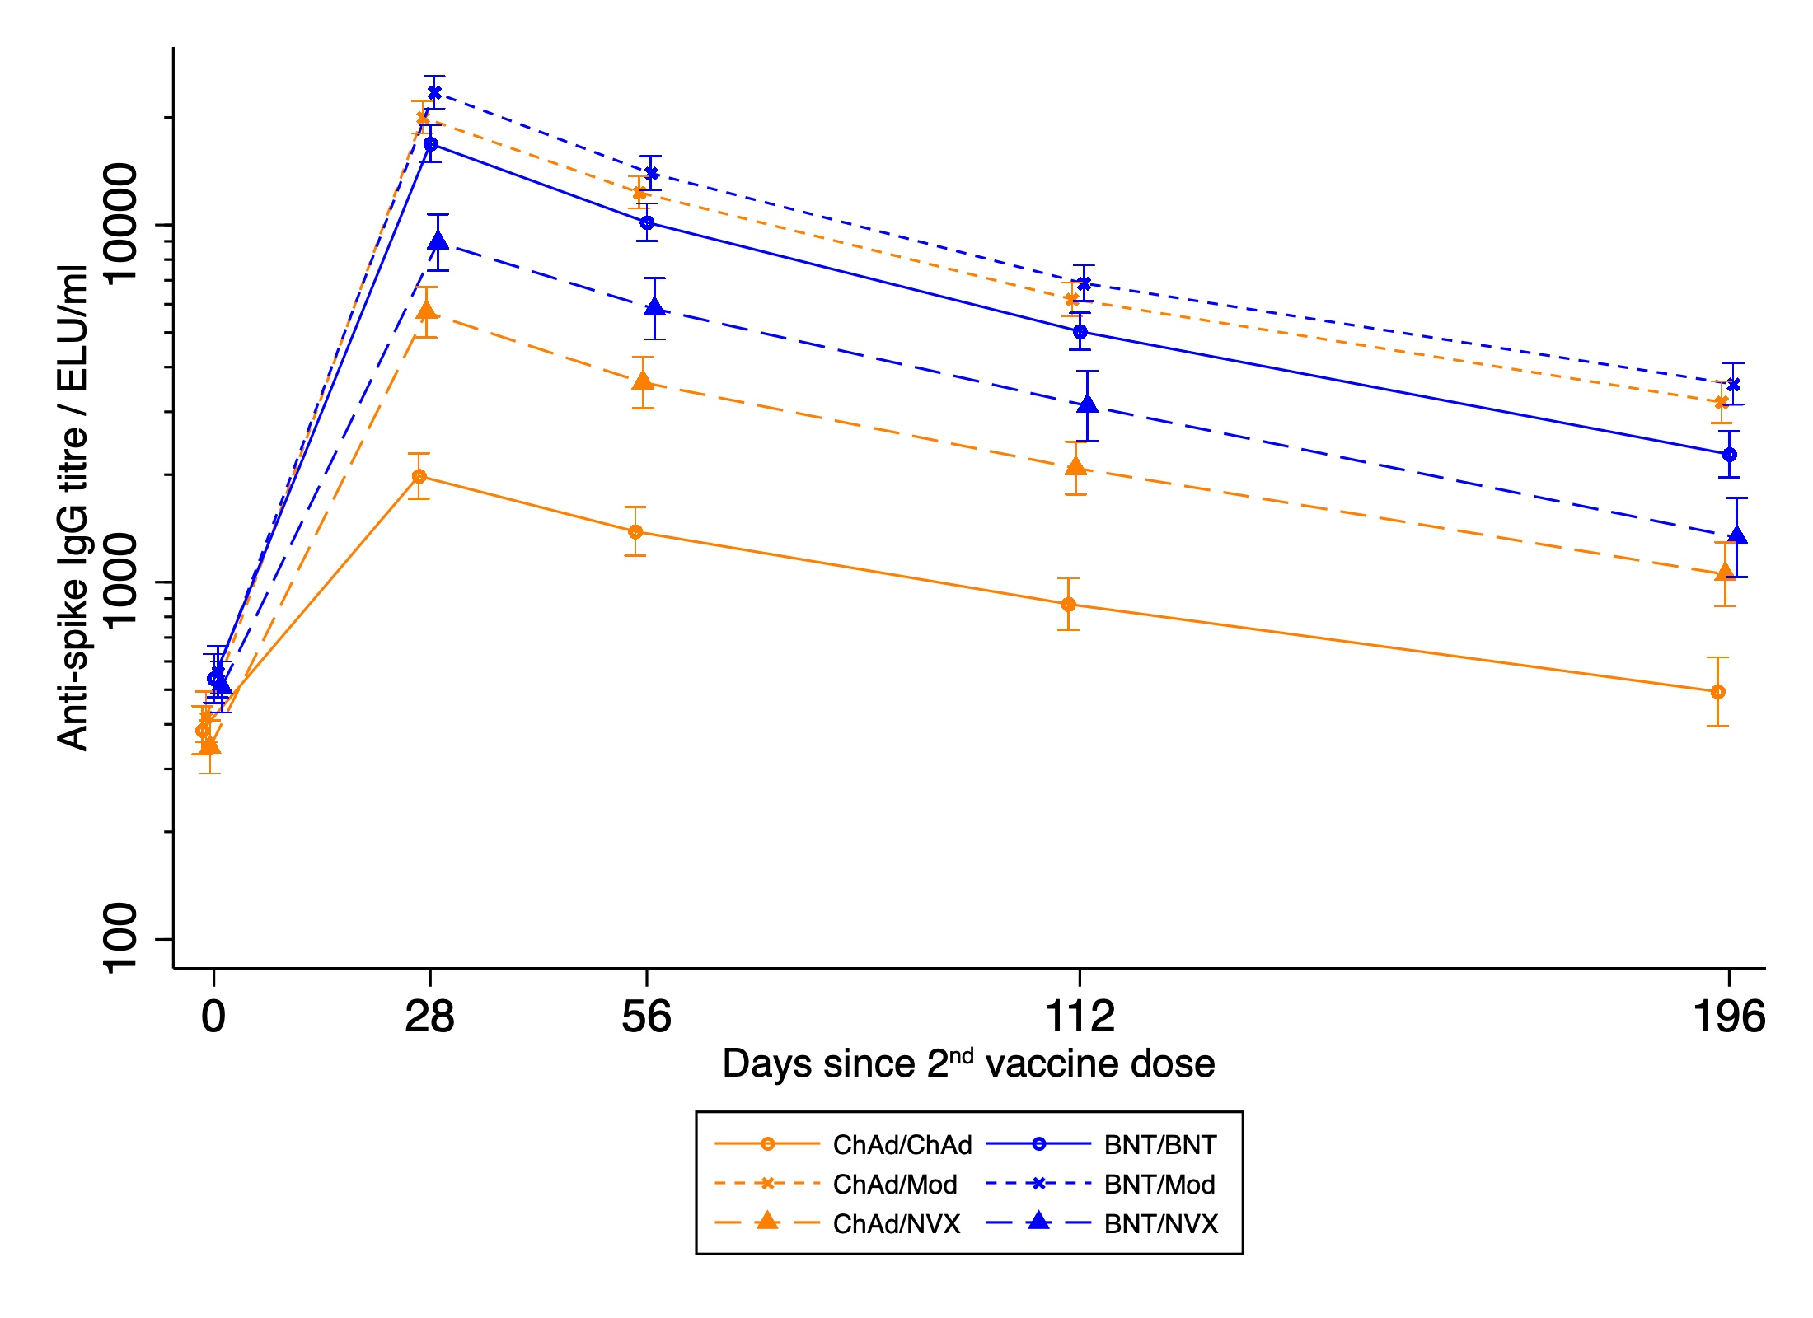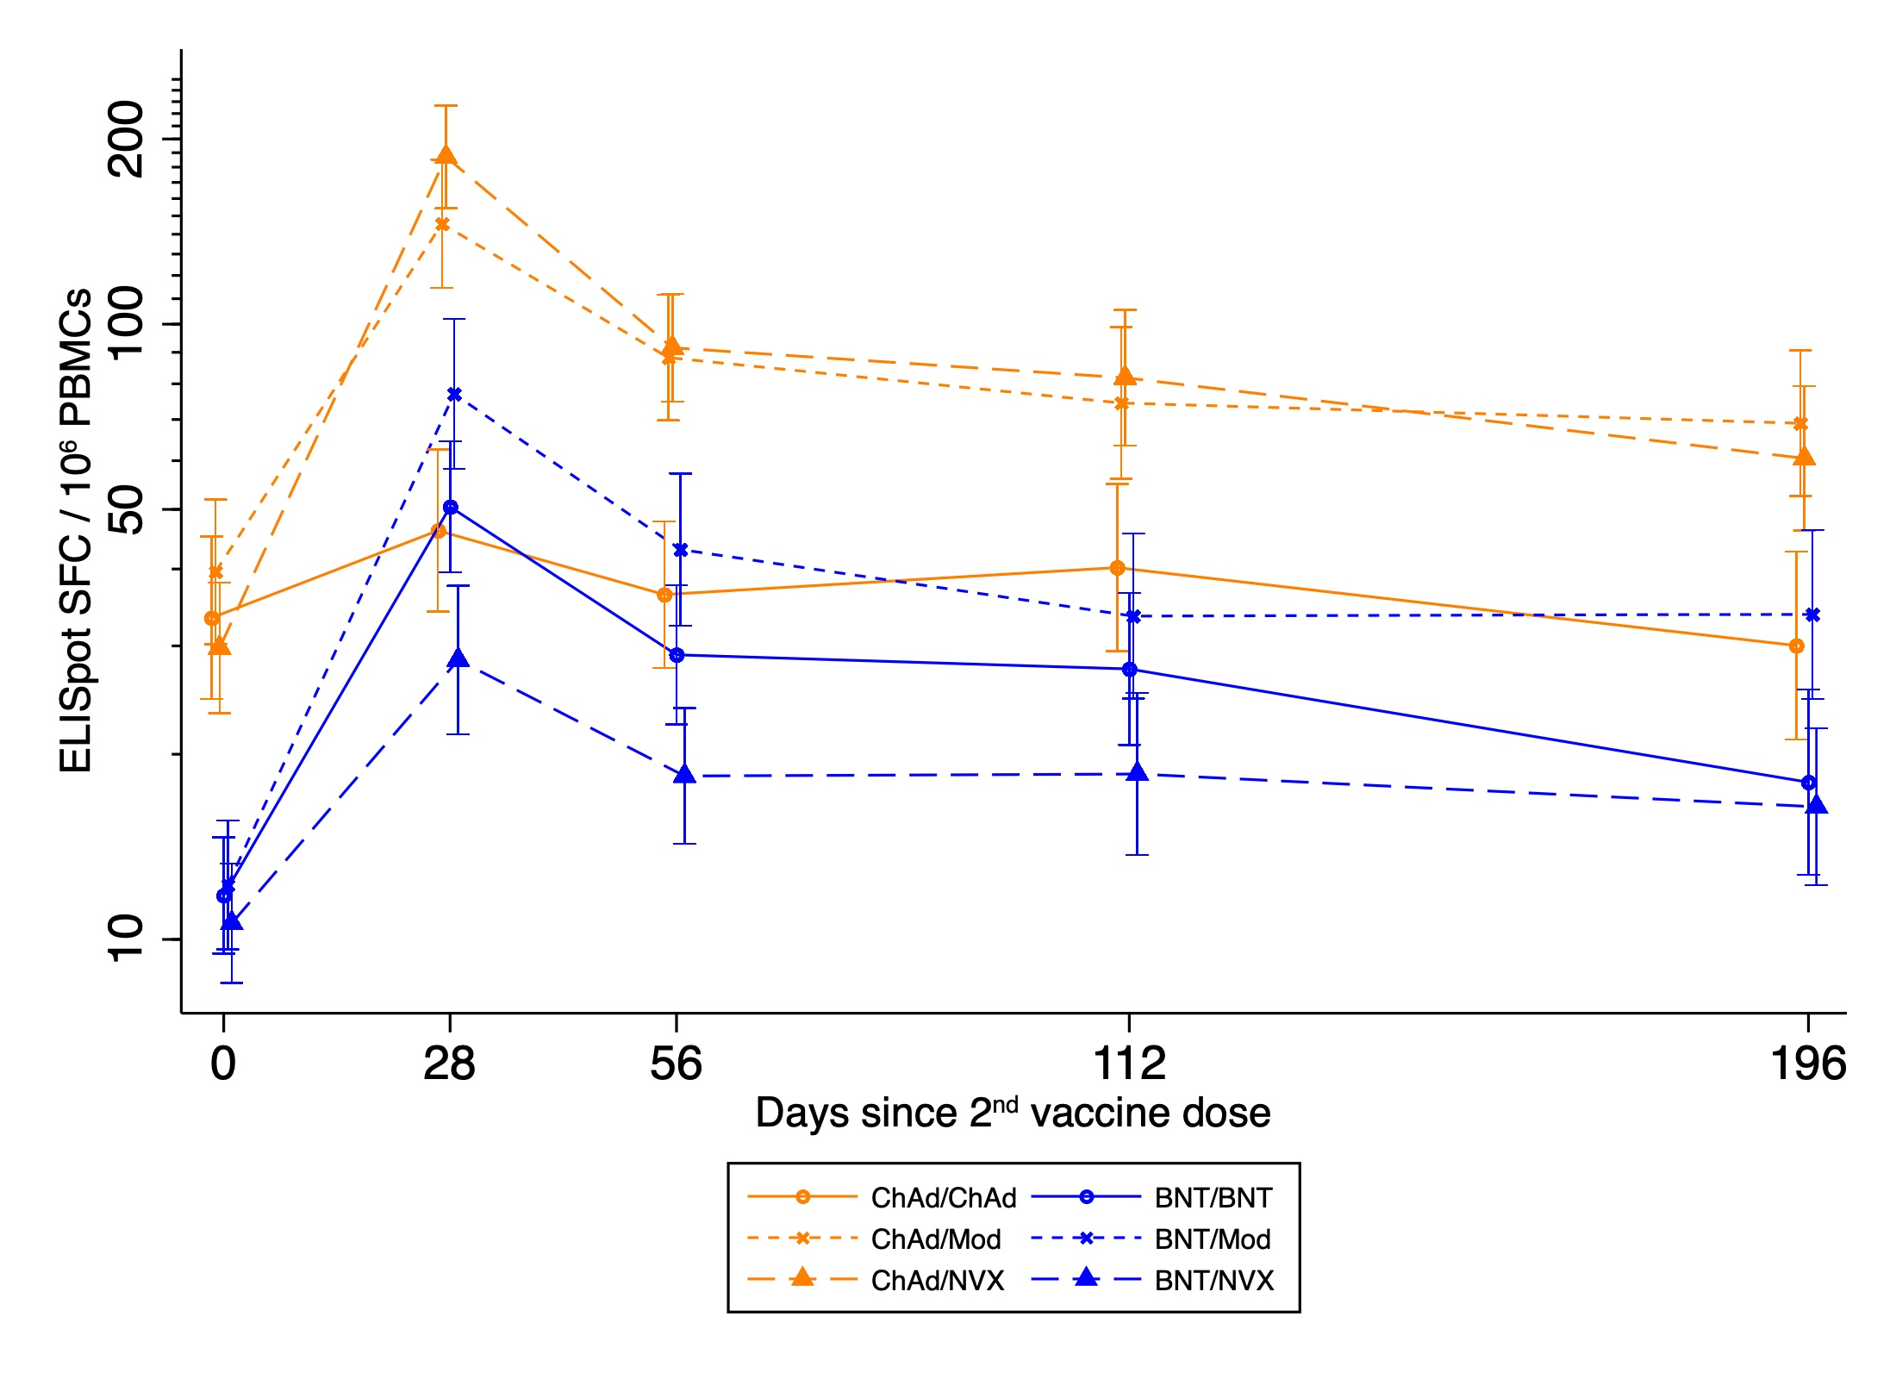
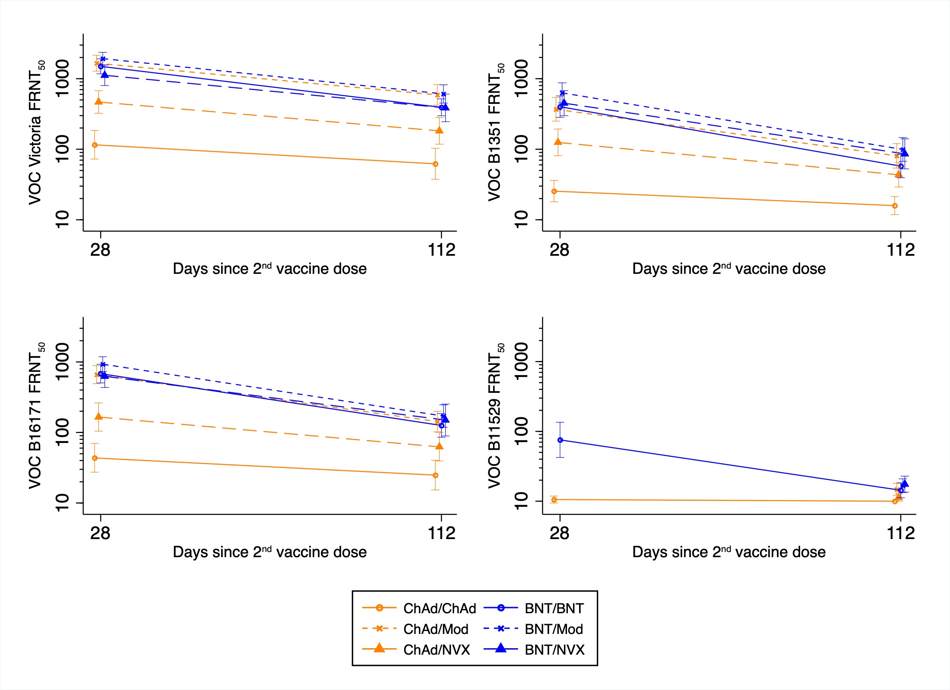
D0 refers to time of second dose; Data points are geometric mean concentrations, with whiskers showing the 95% confidence intervals. Day 28 Omicron VOC titres are only available for homologous schedules due to laboratory constraints
Figure 2 – Forest plots comparing heterologous and homologous immunological outcomes per timepoint for A) Anti-spike IG, B) T-cell ELISpot and C) Live virus neutralising assay for wild type, Beta, Delta and Omicron variants

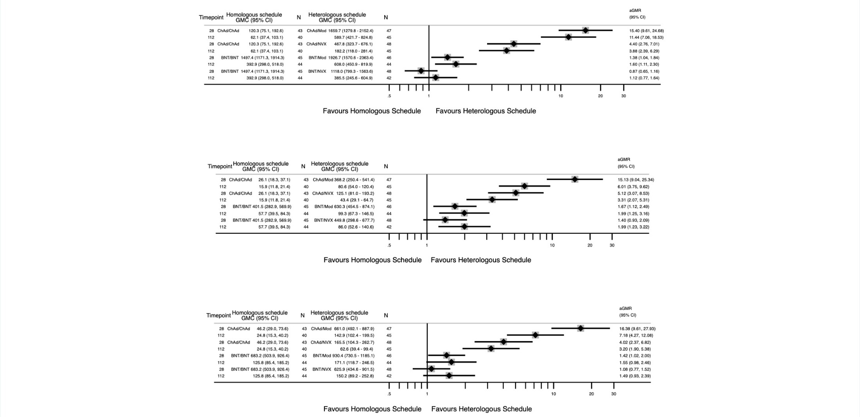

GMC (Geometric mean concentration) shown per schedule per timepoint with 95% CI (confidence intervals). aGMR (adjusted Geometric mean ratio) with 95% CI are displayed using separate mixed effects models for BNT-primed and ChAd-primed groups, adjusting for random effects (site) and fixed effects (schedule, cohort, D0 level, interval between first and second doses, exact number of days between second dose and blood test, BMI, Comorbidity [presence/absence of cardiovascular condition, respiratory condition of diabetes], Sex, Age, Ethnicity) comparing each schedule’s timepoint to the equivalent timepoint in the homologous schedule. Day 28 Omicron VOC titres are only available for homologous schedules due to laboratory constraints and so aGMRs are unavailable at this timepoint. The forestplot for Omicron VOC is not displayed as it suffers more greatly from lower limit censoring. Neutralising activity against Omicron was so low, that large proportions of the samples did not have an NT50 that was above the LLOQ. Values were imputed as half the LLOQ and so the aGMRs have been artefactually brought closer to one. This artefactual bringing closer to one affects lower titres more and therefore affects the D112 timepoint more. Tabulated results for all variants are also available in Supplementary Table 3.

Figure 3 – Forest plots comparing heterologous and homologous rates of decay of immunological outcomes per time period by aGMR of GMRs for A) Anti-spike IG, B) T-cell ELISpot and C) Live virus neutralising assay for wild type, Beta, Delta and Omicron variants

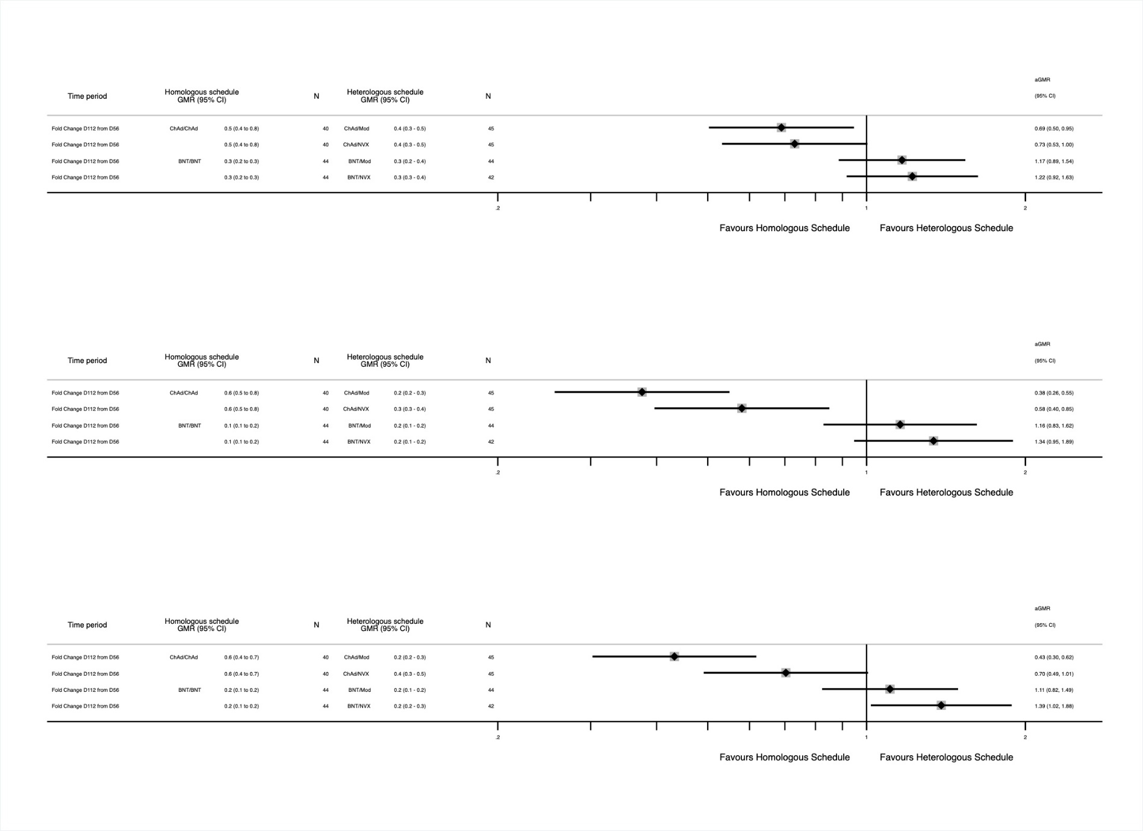

GMR (geometric mean ratios) with 95% CI are displayed for rows with fold changes, which compare each time period’s fold change for that schedule to the fold change for the same period of the relevant homologous schedule. aGMR (adjusted GMR) with 95% CI are displayed using separate mixed effects models for BNT-primed and ChAd-primed groups, adjusting for random effects (site) and fixed effects (schedule, cohort, D0 level, interval between first and second doses, exact number of days between second dose and blood test, BMI, Comorbidity [presence/absence of cardiovascular condition, respiratory condition of diabetes], Sex, Age, Ethnicity) comparing each schedule’s time period GMR to the equivalent time period GMR in the homologous schedule

