Supplementary Figure 6 - Boxplots of raw, unadjusted T-cell ELISpot counts by subgroup of covariates in mixed effects model A) Age, B) Sex, C) BMI, D) Comorbidity, E) Ethnicity, F) Interval, G) Baseline
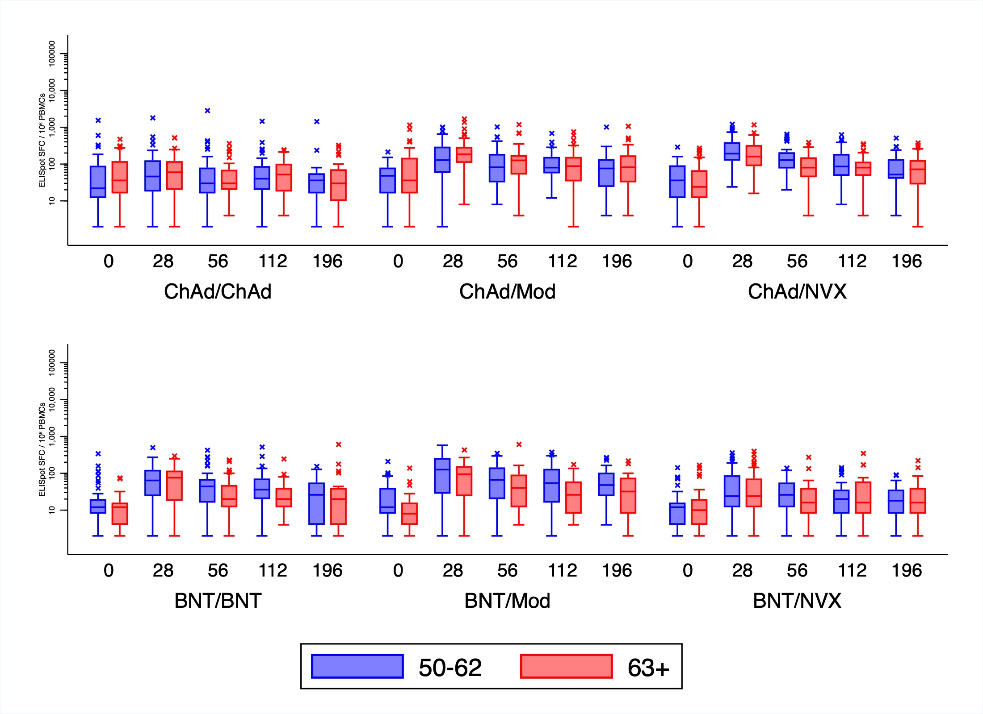
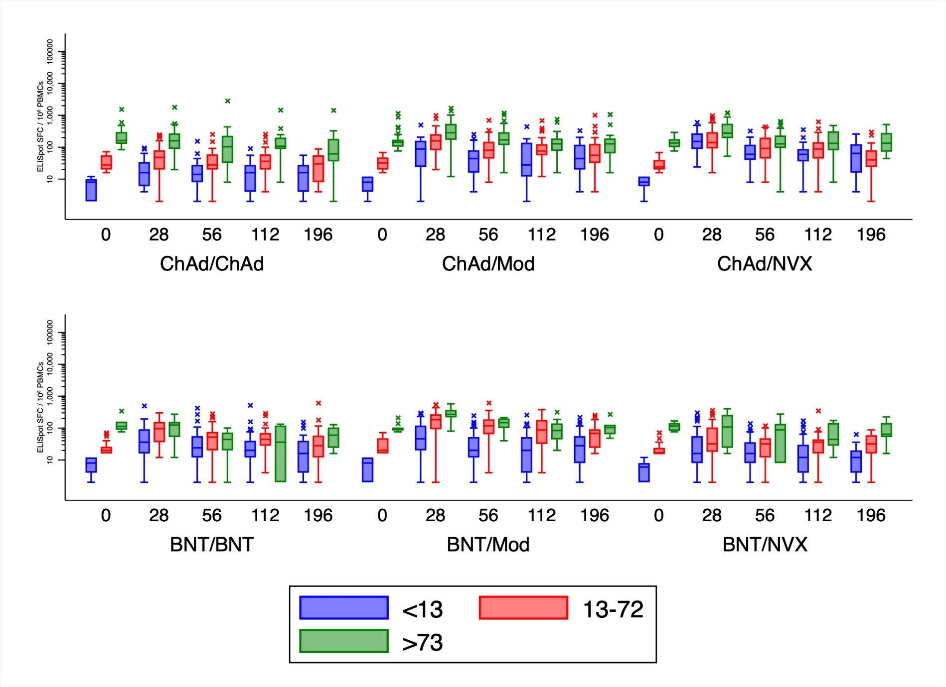
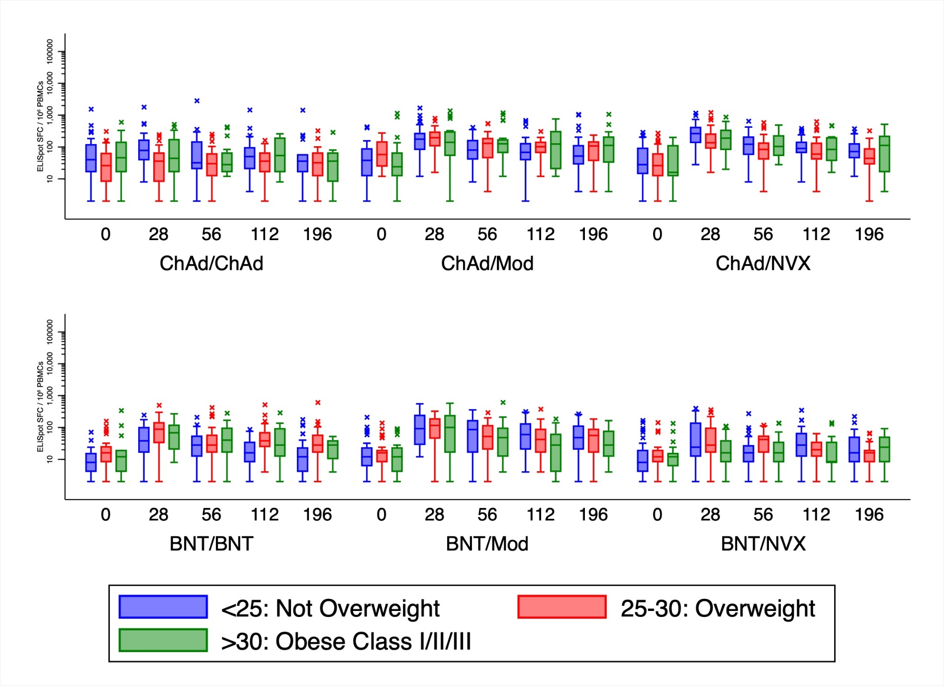
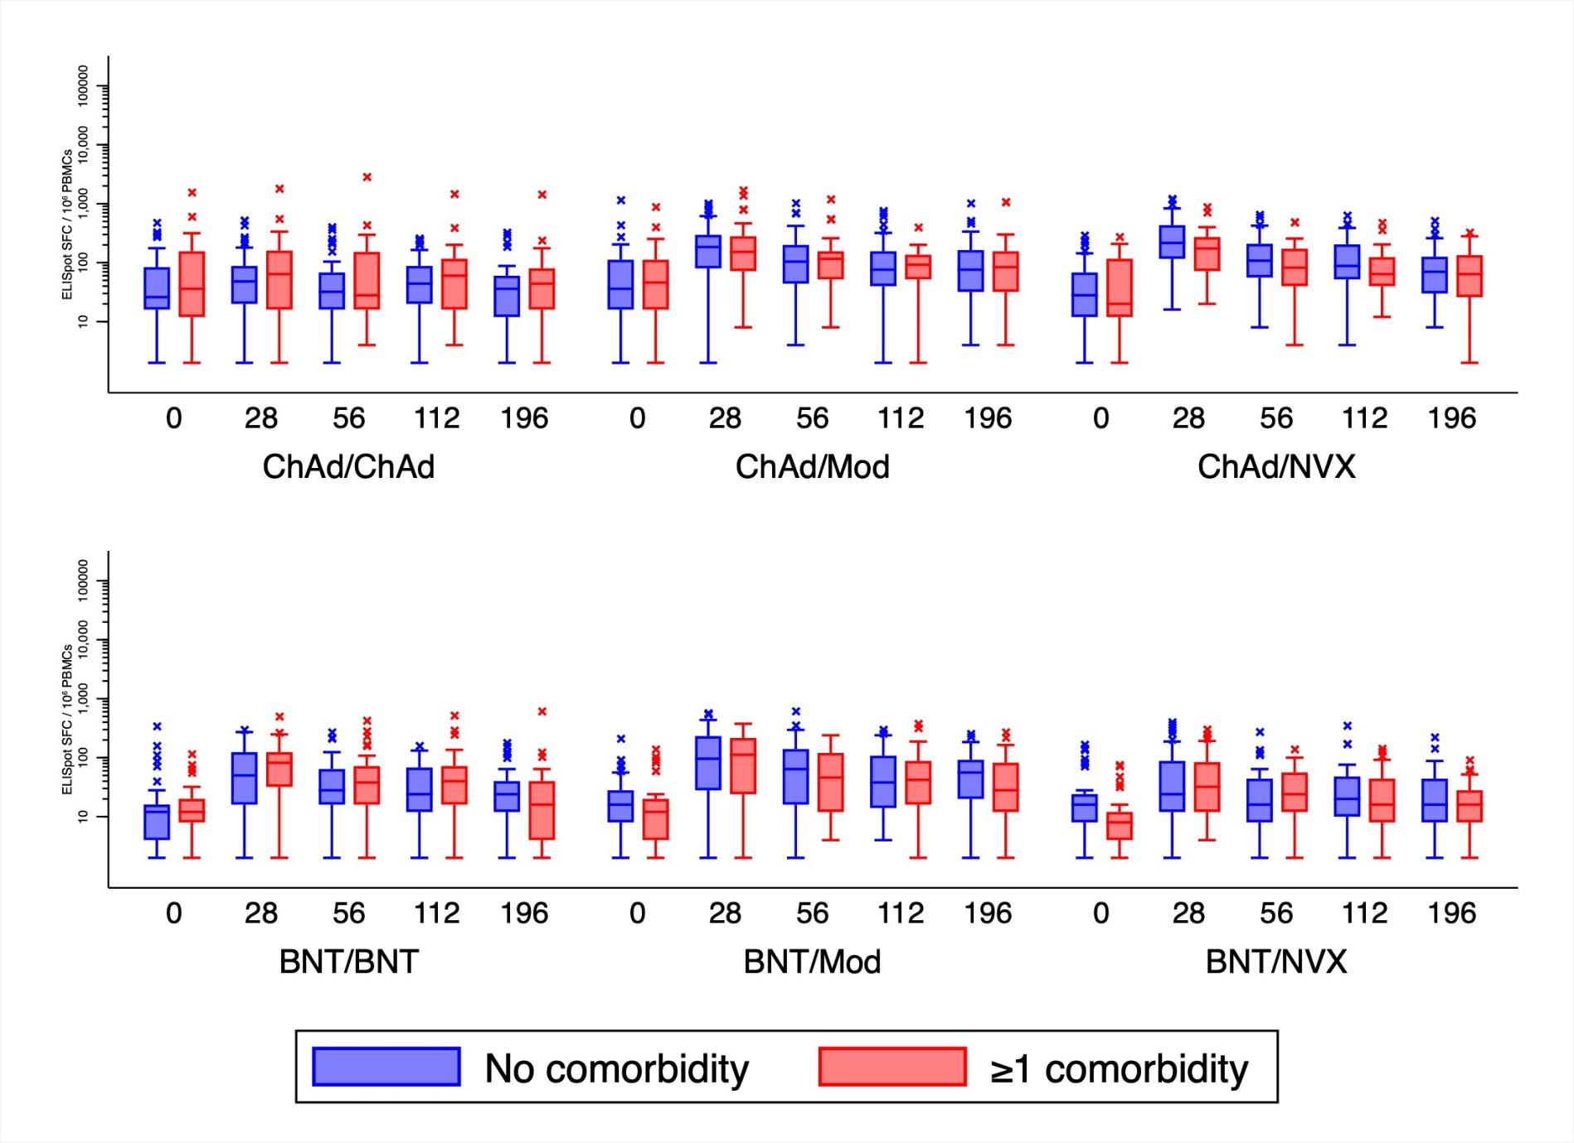
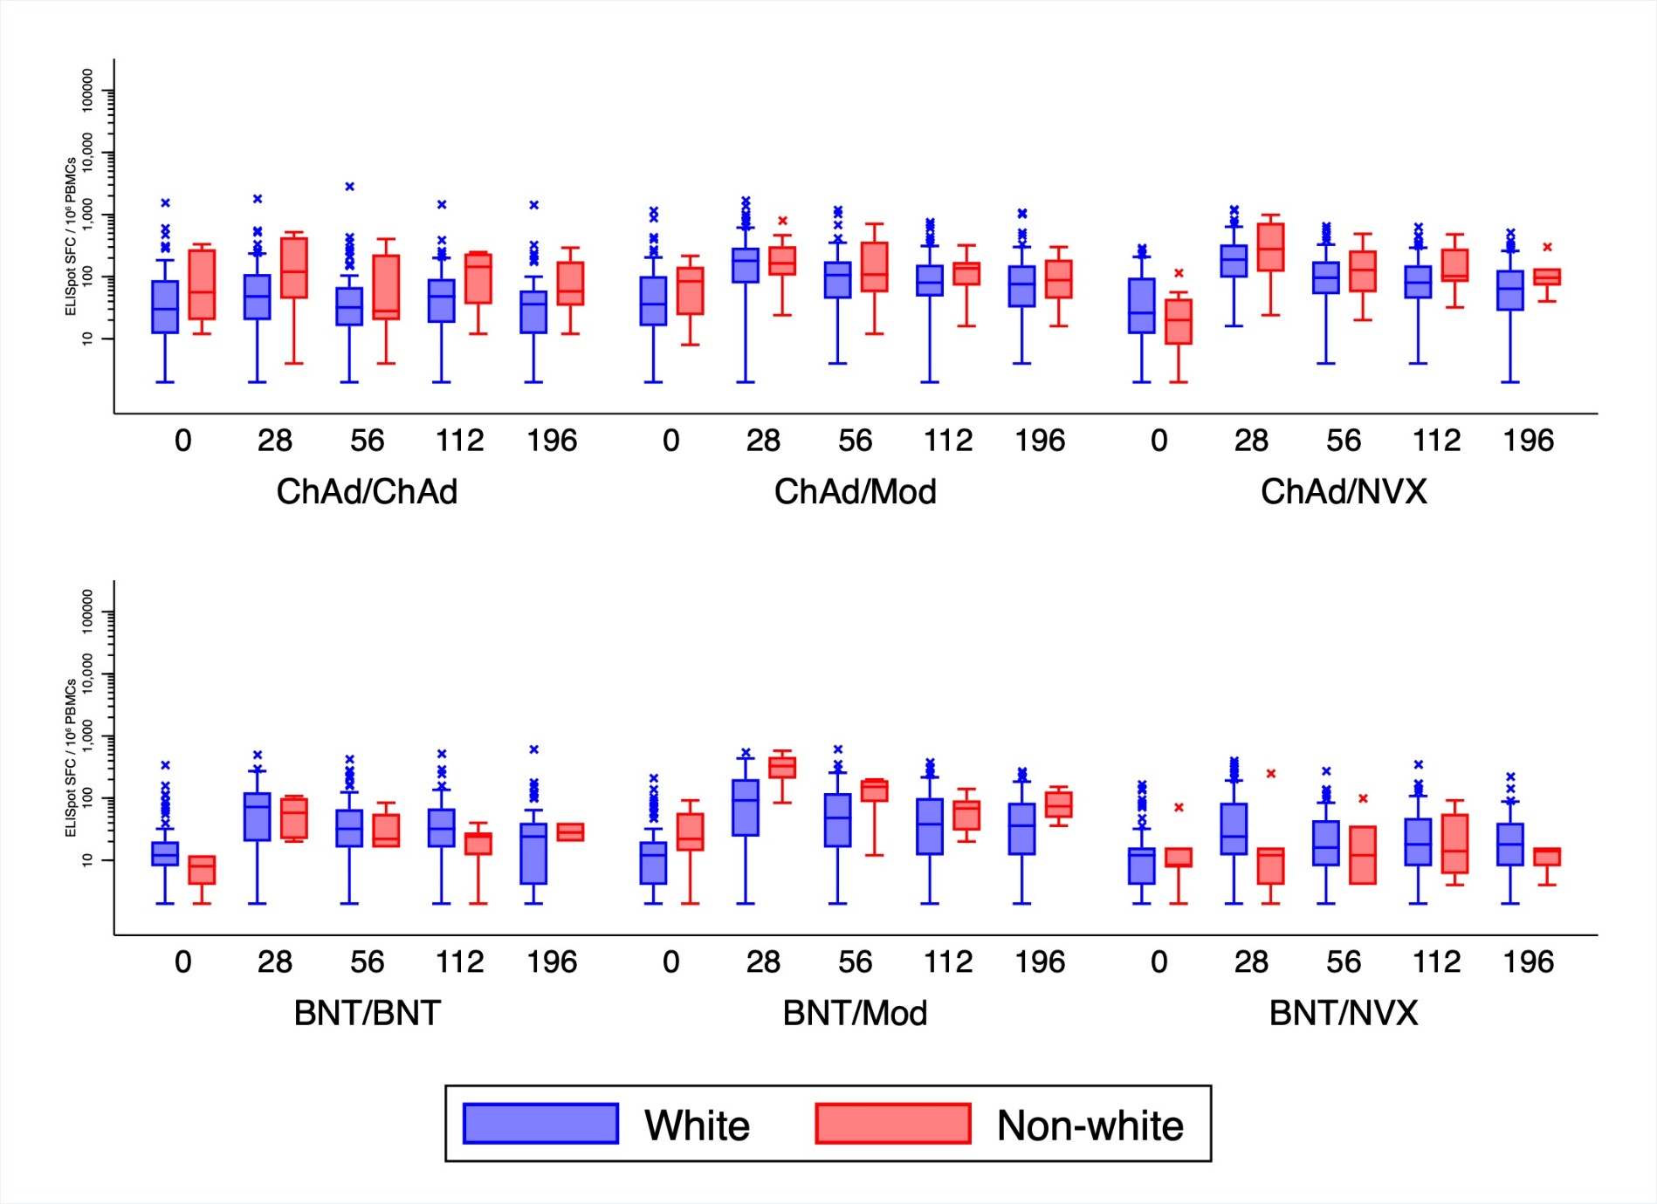
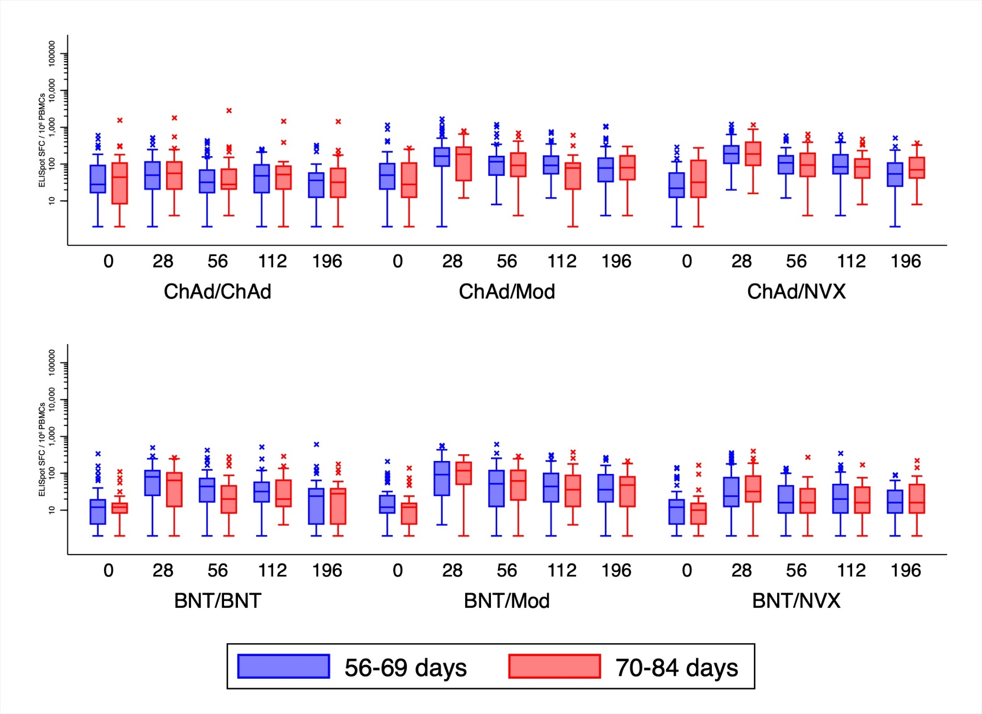
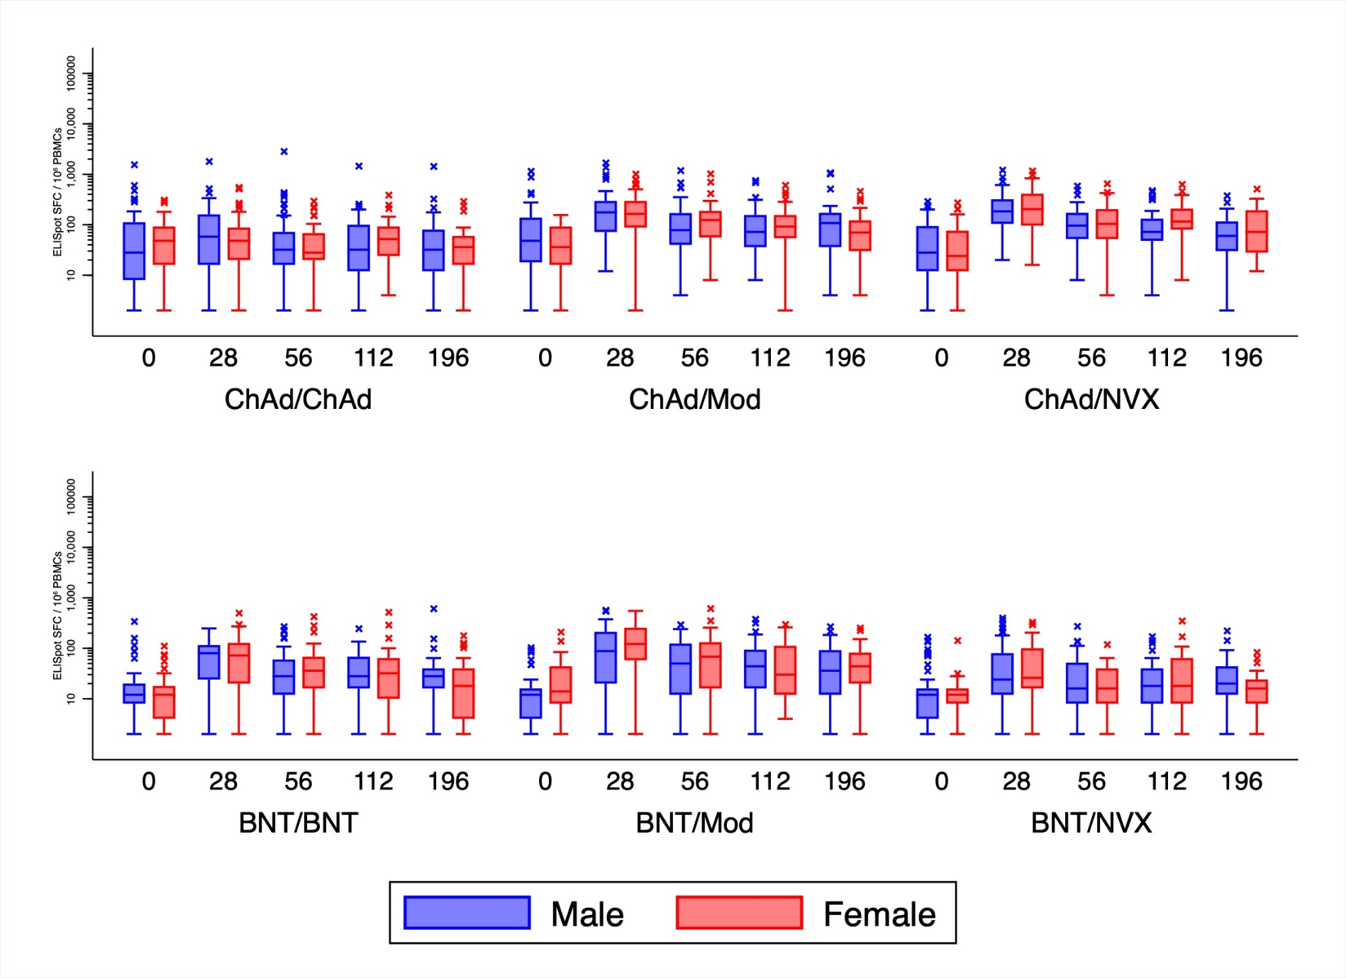
Supplementary Figure 7 - Forest plots comparing T-cell ELISpot counts over time between heterologous and homologous schedules by subgroup of covariates in mixed effects model A) Age, B) Sex, C) BMI, D) Comorbidity, E) Ethnicity, F) Interval, G) Baseline
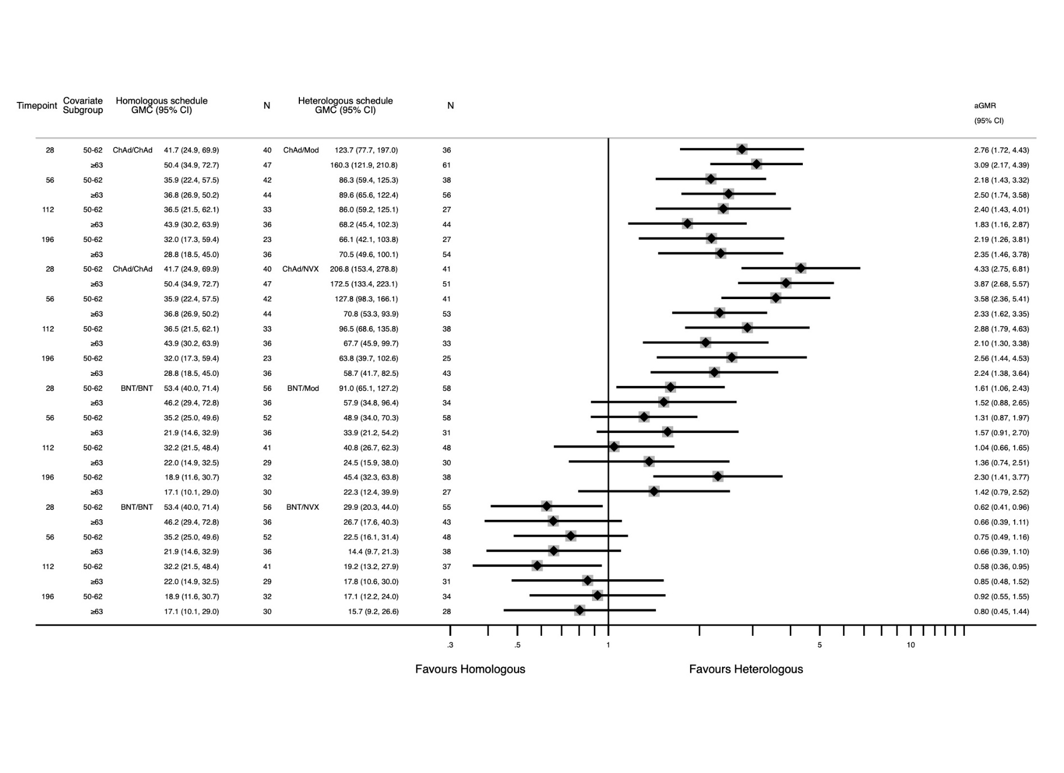
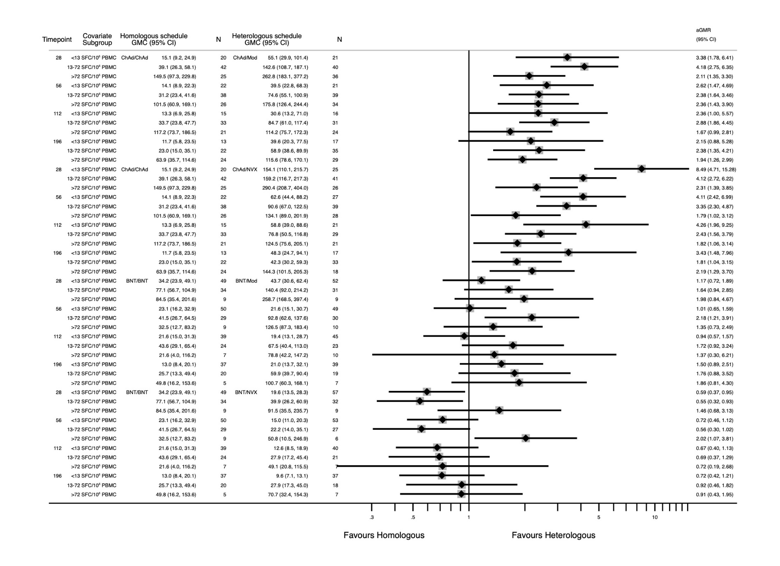
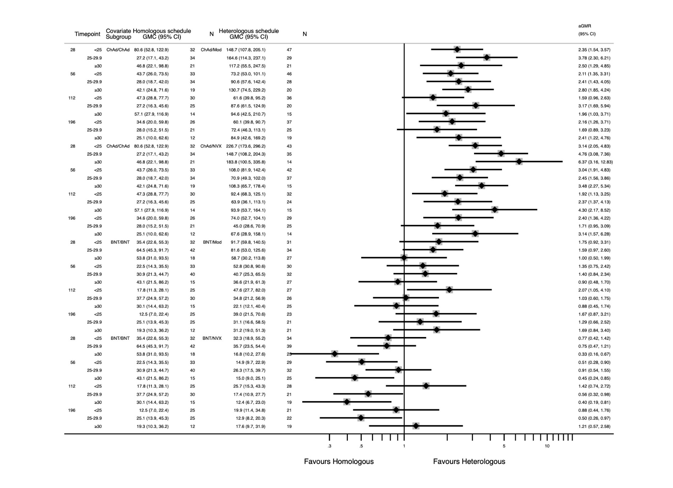
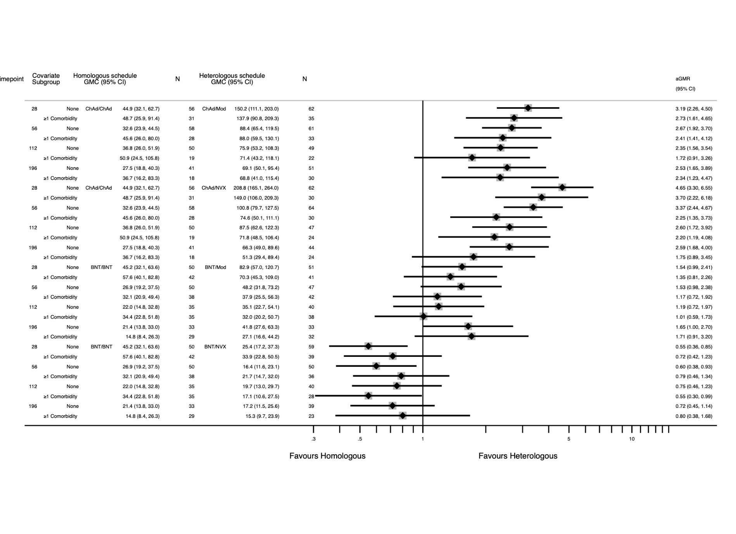
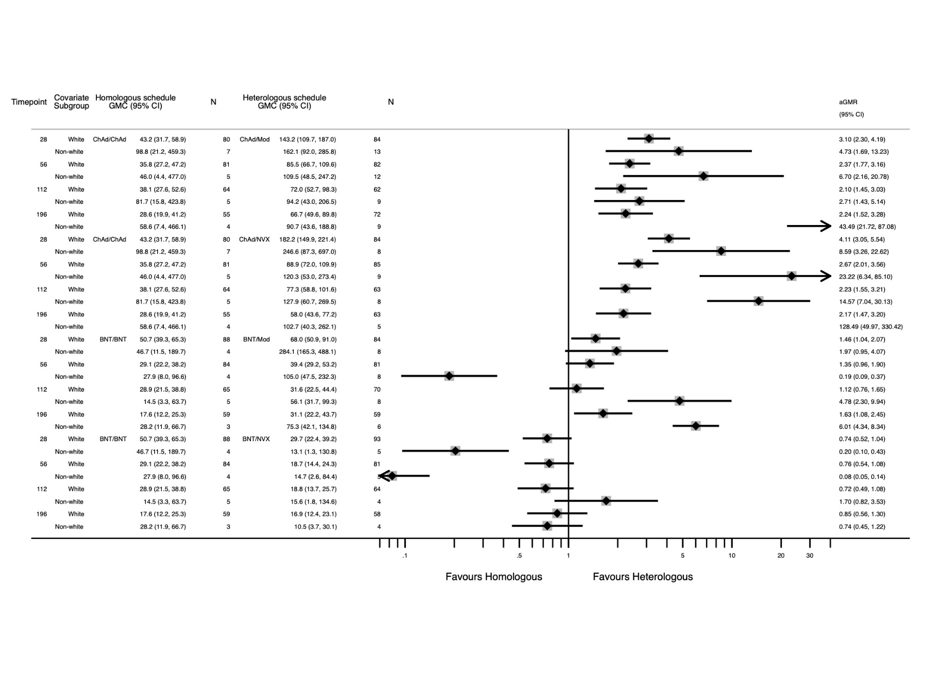
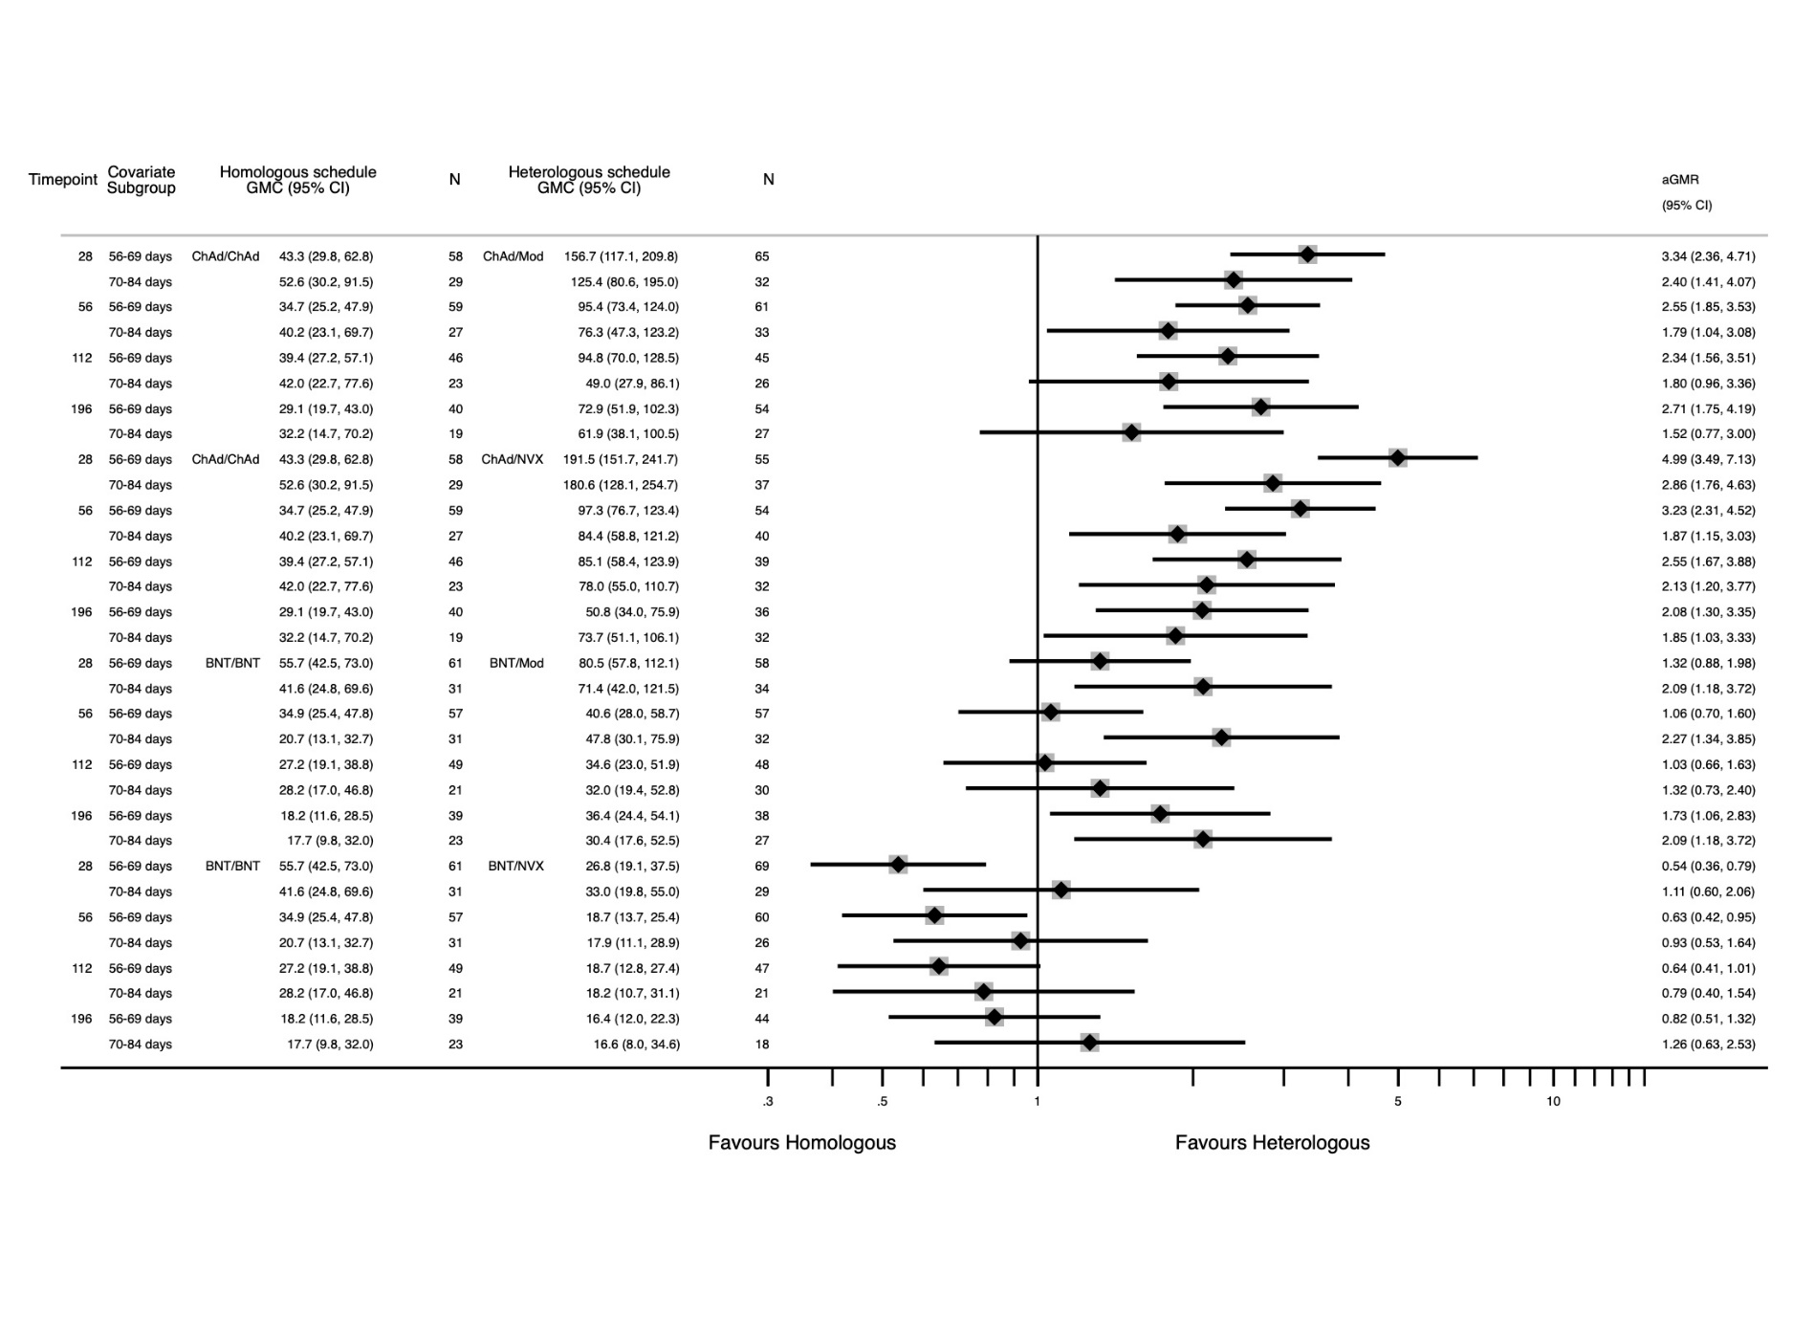
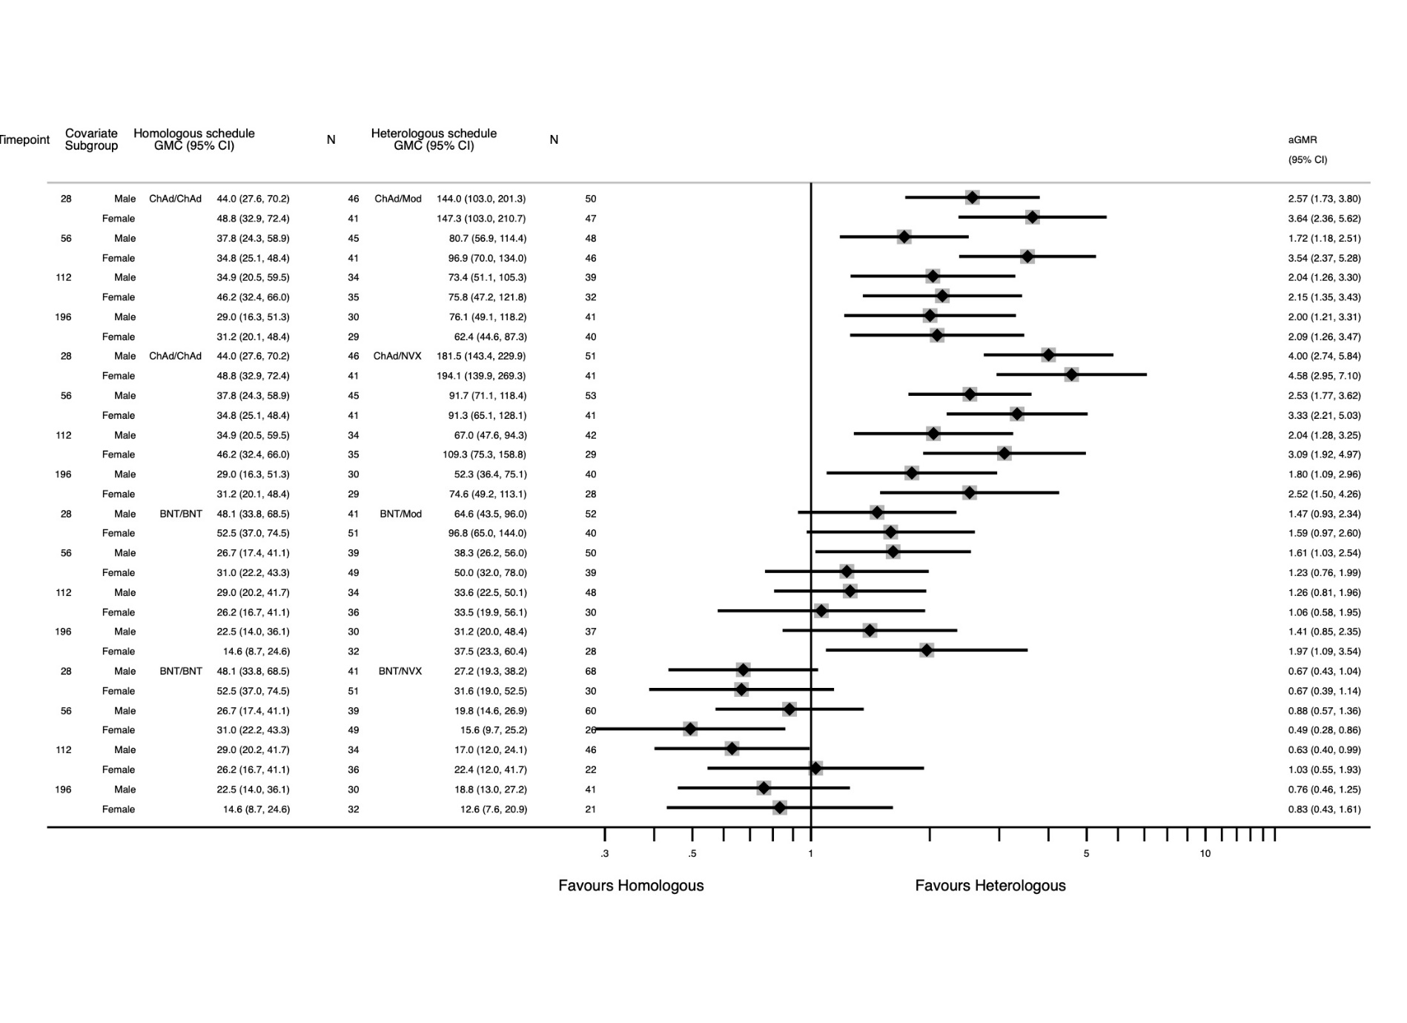
Supplementary Table 1 – Baseline characteristics of analysis population
Characteristic | Prime with ChAd |  |  |  | Prime with BNT
 | ChAd  (N=180) | mRNA-1273  (N=181) | NVX-CoV2373  (N=179) | Overall  (N=540) | BNT  (N=175) | mRNA-1273  (N=177) | NVX-CoV2373  (N=180) | Overall  (N=532)
Age
Mean (SD) | 63.0 (5.51) | 63.3 (5.55) | 63.1 (5.76) | 63.2 (5.60) | 61.9 (5.37) | 62.0 (5.92) | 62.2 (5.56) | 62.0 (5.61)
Median (range) | 64.4 (50.1, 74.2) | 64.1 (50.2, 74.4) | 64.2 (50.1, 74.6) | 64.2 (50.1, 74.6) | 62.3 (50.4, 77.1) | 62.4 (50.0, 77.7) | 62.7 (50.2, 78.1) | 62.4 (50.0, 78.1)
Gender
Female | 87 (48.3%) | 80 (44.2%) | 74 (41.3%) | 241 (44.6%) | 80 (45.7%) | 68 (38.4%) | 62 (34.4%) | 210 (39.5%)
Male | 93 (51.7%) | 101 (55.8%) | 105 (58.7%) | 299 (55.4%) | 95 (54.3%) | 109 (61.6%) | 118 (65.6%) | 322 (60.5%)
Ethnicity
White | 169 (93.9%) | 159 (87.8%) | 162 (90.5%) | 490 (90.7%) | 166 (94.9%) | 166 (93.8%) | 172 (95.6%) | 504 (94.7%)
Black | 1 (0.6%) | 1 (0.6%) | 3 (1.7%) | 5 (0.9%) | 3 (1.7%) | 2 (1.1%) | 3 (1.7%) | 8 (1.5%)
Asian | 4 (2.2%) | 11 (6.1%) | 9 (5.0%) | 24 (4.4%) | 3 (1.7%) | 5 (2.8%) | 2 (1.1%) | 10 (1.9%)
Mixed | 3 (1.7%) | 7 (3.9%) | 3 (1.7%) | 13 (2.4%) | 1 (0.6%) | 1 (0.6%) | 2 (1.1%) | 4 (0.8%)
Other | 3 (1.7%) | 3 (1.7%) | 2 (1.1%) | 8 (1.5%) | 2 (1.1%) | 3 (1.7%) | 1 (0.6%) | 6 (1.1%)
Comorbidities
Cardiovascular | 49 (27.2%) | 55 (30.4%) | 40 (22.3%) | 144 (26.7%) | 63 (36.0%) | 46 (26.0%) | 57 (31.7%) | 166 (31.2%)
Respiratory | 15 (8.3%) | 18 (9.9%) | 19 (10.6%) | 52 (9.6%) | 30 (17.1%) | 34 (19.2%) | 31 (17.2%) | 95 (17.9%)
Diabetes | 9 (5.0%) | 10 (5.5%) | 14 (7.8%) | 33 (6.1%) | 22 (12.6%) | 21 (11.9%) | 24 (13.3%) | 67 (12.6%)
Prime-boost interval (weeks)
Mean (SD) | 9.4 (0.96) | 9.5 (0.95) | 9.5 (1.01) | 9.5 (0.97) | 9.5 (0.98) | 9.5 (0.95) | 9.6 (0.96) | 9.5 (0.96)
Median (range) | 9.4 (8.0, 12.0) | 9.4 (8.0, 12.0) | 9.4 (4.7, 11.9) | 9.4 (4.7, 12.0) | 9.6 (8.0, 11.9) | 9.4 (8.0, 12.0) | 9.6 (8.0, 11.9) | 9.6 (8.0, 12.0)

Supplementary Table 2 – Lower bound censoring of VOC assays
VOC | Timepoint | ChAd/ChAd | ChAd/Mod | ChAd/NVX | BNT/BNT | BNT/Mod | BNT/NVX
Victoria | 28 | 7 | 0 | 1 | 0 | 0 | 0
B1351 | 28 | 22 | 2 | 8 | 1 | 1 | 2
B16171 | 28 | 15 | 0 | 6 | 0 | 0 | 1
B11529 | 28 | 18 | 0 | 0 | 1 | 0 | 0
Victoria | 112 | 13 | 0 | 4 | 0 | 0 | 2
B1351 | 112 | 30 | 7 | 17 | 10 | 6 | 10
B16171 | 112 | 25 | 2 | 14 | 4 | 3 | 7
B11529 | 112 | 40 | 32 | 41 | 33 | 28 | 26

Supplementary Table 3 - Tabulation of Live virus neutralising assay results for wild type, Beta, Delta and Omicron variants
Arm | Timepoint | Victoria | B1351 | B16171 | B11529
ChAd/ChAd | 28 | 120.3 (75.1 - 192.6) | 26.1 (18.3 - 37.1) | 46.2 (29.0 - 73.6) | 10.6 (9.4 - 12.0)
ChAd/ChAd | 112 | 62.1 (37.4 - 103.1) | 15.9 (11.8 - 21.4) | 24.8 (15.3 - 40.2) | 10.0 (10.0 - 10.0)
ChAd/Mod | 28 | 1659.7 (1279.8 - 2152.4) | 368.2 (250.4 - 541.4) | 661.0 (492.1 - 887.9) | . (. - .)
ChAd/Mod | 112 | 589.7 (421.7 - 824.8) | 80.6 (54.0 - 120.4) | 142.9 (102.4 - 199.5) | 14.7 (12.0 - 18.0)
ChAd/NVX | 28 | 467.8 (323.7 - 676.1) | 125.1 (81.0 - 193.2) | 165.5 (104.3 - 262.7) | . (. - .)
ChAd/NVX | 112 | 182.2 (118.0 - 281.4) | 43.4 (29.1 - 64.7) | 62.6 (39.4 - 99.4) | 11.3 (10.0 - 12.7)
BNT/BNT | 28 | 1497.4 (1171.3 - 1914.3) | 401.5 (282.9 - 569.9) | 683.2 (503.9 - 926.4) | 75.7 (42.4 - 135.0)
BNT/BNT | 112 | 392.9 (298.0 - 518.0) | 57.7 (39.5 - 84.3) | 125.8 (85.4 - 185.2) | 14.3 (11.2 - 18.3)
BNT/Mod | 28 | 1926.7 (1570.6 - 2363.4) | 630.3 (454.5 - 874.1) | 930.4 (730.5 - 1185.1) | . (. - .)
BNT/Mod | 112 | 608.0 (450.9 - 819.9) | 99.3 (67.3 - 146.5) | 171.1 (118.7 - 246.5) | 16.7 (13.3 - 20.9)
BNT/NVX | 28 | 1118.0 (799.3 - 1563.6) | 449.8 (298.6 - 677.7) | 625.9 (434.6 - 901.5) | . (. - .)
BNT/NVX | 112 | 385.5 (245.6 - 604.9) | 86.0 (52.6 - 140.6) | 150.2 (89.2 - 252.8) | 17.5 (13.5 - 22.8)

Supplementary Table 4 – Mixed regression outputs for A) ChAd-primed schedules at Day 28 for Anti-Spike IgG, B) BNT-primed schedules at Day 28 for Anti-Spike IgG, C) ChAd-primed schedules at Day 28 for T-cell ELISpot, D) BNT-primed schedules at Day 28 for T-cell ELISpot, E) ChAd-primed schedules fold change Day 196 from Day 28 (decay rate) for Anti-Spike IgG, F) BNT-primed schedules fold change Day 196 from Day 28 (decay rate) for Anti-Spike IgG, G) ChAd-primed schedules fold change Day 196 from Day 28 (decay rate) for T-cell ELISpot, F) BNT-primed schedules fold change Day 196 from Day 28 (decay rate) for T-cell ELISpot
Peak Log10(Anti-Spike IgG) at Day 28 for ChAd-primed Schedules
Covariate | Beta Coefficient | SE | 95% CI | p-value
White Ethnicity Baseline
Non-White Ethnicity | 0.0313 | 0.0568 | -0.0800, 0.143 | 0.581
Days | -0.0118 | 0.00874 | -0.0289, 0.00537 | 0.179
Baseline | 0.372 | 0.0343 | 0.304, 0.439 | <0.0001
Interval | 0.00105 | 0.00243 | -0.00372, 0.00581 | 0.667
BMI | -0.00858 | 0.00325 | -0.0149, -0.00221 | 0.00827
No Comorbidity Baseline
≥1 Comorbidity | -0.0303 | 0.0336 | -0.0962, 0.0357 | 0.368
Male Sex Baseline
Female Sex | 0.0689 | 0.0317 | 0.00665, 0.131 | 0.03
Age | 0.000435 | 0.00302 | -0.00548, 0.00635 | 0.885
ChAd/ChAd Baseline
ChAd/Mod | 0.987 | 0.0377 | 0.913, 1.061 | <0.0001
ChAd/NVX | 0.472 | 0.0381 | 0.397, 0.546 | <0.0001
Constant | 2.778 | 0.357 | 2.079, 3.478 | <0.0001
Observations | 475

Peak Log10(Anti-Spike IgG) at Day 28 for BNT-primed Schedules
Covariate | Beta Coefficient | SE | 95% CI | p-value
White Ethnicity Baseline
Non-White Ethnicity | -0.104 | 0.065 | -0.231, 0.0236 | 0.11
Days | 0.000588 | 0.00808 | -0.0153, 0.0164 | 0.942
Baseline | 0.542 | 0.0304 | 0.482, 0.601 | <0.0001
Interval | 0.0112 | 0.00238 | 0.00651, 0.0159 | <0.0001
BMI | -0.00285 | 0.00249 | -0.00773, 0.00203 | 0.252
No Comorbidity Baseline
≥1 Comorbidity | -0.0203 | 0.0284 | -0.0760, 0.0355 | 0.476
Male Sex Baseline
Female Sex | 0.0252 | 0.0285 | -0.0306, 0.0811 | 0.376
Age | -0.0105 | 0.00289 | -0.0161, -0.00479 | 0.000302
BNT/BNT Baseline
BNT/Mod | 0.134 | 0.0336 | 0.0679, 0.200 | <0.0001
BNT/NVX | -0.261 | 0.0335 | -0.326, -0.195 | <0.0001
Constant | 2.718 | 0.33 | 2.071, 3.364 | <0.0001
Observations | 484

Peak Log10(T-cell ELISpot) at Day 28 for ChAd-primed Schedules
Covariate | Beta Coefficient | SE | 95% CI | p-value
White Ethnicity Baseline
Non-White Ethnicity | 0.142 | 0.0874 | -0.0289, 0.314 | 0.103
Days | -0.0326 | 0.0151 | -0.0622, -0.00306 | 0.0306
Baseline | 0.476 | 0.0436 | 0.391, 0.562 | <0.0001
Interval | -0.00398 | 0.00401 | -0.0118, 0.00388 | 0.321
BMI | -0.0105 | 0.00568 | -0.0216, 0.000658 | 0.0652
No Comorbidity Baseline
≥1 Comorbidity | -0.0509 | 0.0568 | -0.162, 0.0603 | 0.369
Male Sex Baseline
Female Sex | 0.0261 | 0.0523 | -0.0765, 0.129 | 0.618
Age | 0.00465 | 0.00496 | -0.00506, 0.0144 | 0.348
ChAd/ChAd Baseline
ChAd/Mod | 0.473 | 0.0636 | 0.348, 0.597 | <0.0001
ChAd/NVX | 0.625 | 0.0637 | 0.500, 0.749 | <0.0001
Constant | 2.103 | 0.597 | 0.933, 3.273 | 0.000428
Observations | 272

Peak Log10(T-cell ELISpot) at Day 28 for BNT-primed Schedules
Covariate | Beta Coefficient | SE | 95% CI | p-value
White Ethnicity Baseline
Non-White Ethnicity | 0.137 | 0.126 | -0.109, 0.384 | 0.275
Days | -0.0212 | 0.0222 | -0.0646, 0.0222 | 0.339
Baseline | 0.526 | 0.0612 | 0.406, 0.646 | <0.0001
Interval | 0.00222 | 0.00515 | -0.00788, 0.0123 | 0.666
BMI | -0.0178 | 0.00551 | -0.0286, -0.00695 | 0.00128
No Comorbidity Baseline
≥1 Comorbidity | 0.155 | 0.0628 | 0.0318, 0.278 | 0.0137
Male Sex Baseline
Female Sex | 0.095 | 0.0623 | -0.0271, 0.217 | 0.127
Age | -0.014 | 0.0066 | -0.0269, -0.00107 | 0.0339
BNT/BNT Baseline
BNT/Mod | 0.187 | 0.0739 | 0.0421, 0.332 | 0.0114
BNT/NVX | -0.181 | 0.074 | -0.326, -0.0359 | 0.0145
Constant | 2.812 | 0.803 | 1.239, 4.385 | 0.000458
Observations | 277

Fold change D196 from D28 of Log10(Anti-Spike IgG) for ChAd-primed Schedules
Covariate | Beta Coefficient | SE | 95% CI | p-value
White Ethnicity Baseline
Non-White Ethnicity | -5.77e-05 | 0.0632 | -0.124, 0.124 | 0.999
Days | 0.0119 | 0.0099 | -0.00754, 0.0313 | 0.231
Peak Result at D28 | -0.141 | 0.0437 | -0.226, -0.0549 | 0.0013
Interval | 0.000787 | 0.0025 | -0.00412, 0.00569 | 0.753
BMI | -0.00968 | 0.00335 | -0.0162, -0.00311 | 0.00388
No Comorbidity Baseline
≥1 Comorbidity | 0.0196 | (0.0345) | -0.0480 - 0.0872 | (0.570)
Male Sex Baseline
Female Sex | 0.00163 | (0.0325) | -0.0620 - 0.0653 | (0.960)
Age | -0.00121 | (0.00330) | -0.00768 - 0.00525 | (0.713)
ChAd/ChAd Baseline
ChAd/Mod | -0.0249 | (0.0569) | -0.137 - 0.0867 | (0.661)
ChAd/NVX | -0.0363 | (0.0446) | -0.124 - 0.0511 | (0.416)
Constant | -0.228 | (0.407) | -1.026 - 0.570 | (0.576)
Observations | 361

Fold change D196 from D28 of Log10(Anti-Spike IgG) for BNT-primed Schedules
Covariate | Beta Coefficient | SE | 95% CI | p-value
White Ethnicity Baseline
Non-White Ethnicity | -0.0179 | (0.0747) | -0.164 - 0.128 | (0.811)
Days | -0.00907 | (0.00986) | -0.0284 - 0.0102 | (0.357)
Peak Result at D28 | -0.18 | (0.0405) | -0.260 - -0.101 | (8.33e-06)
Interval | 0.00578 | (0.00274) | 0.000411 - 0.0112 | (0.0349)
BMI | -0.00539 | (0.00278) | -0.0108 - 5.87e-05 | (0.0525)
No Comorbidity Baseline
≥1 Comorbidity | -0.0423 | (0.0333) | -0.108 - 0.0229 | (0.204)
Male Sex Baseline
Female Sex | 0.0234 | (0.0325) | -0.0403 - 0.0872 | (0.471)
Age | -0.000390 | (0.00338) | -0.00702 - 0.00624 | (0.908)
BNT/BNT Baseline
BNT/Mod | 0.0965 | (0.0389) | 0.0202 - 0.173 | (0.0132)
BNT/NVX | 0.0236 | (0.0410) | -0.0568 - 0.104 | (0.565)
Constant | -0.0719 | (0.411) | -0.877 - 0.733 | (0.861)
Observations | 360

Fold change D196 from D28 of Log10(T-cell ELISpot) for ChAd-primed Schedules
Covariate | Beta Coefficient | SE | 95% CI | p-value
White Ethnicity Baseline
Non-White Ethnicity | -0.0492 | (0.113) | -0.271 - 0.173 | (0.664)
Days | 0.00132 | (0.0229) | -0.0435 - 0.0461 | (0.954)
Peak Result at D28 | -0.382*** | (0.0613) | -0.502 - -0.262 | (4.82e-10)
Interval | 0.00269 | (0.00512) | -0.00734 - 0.0127 | (0.599)
BMI | 0.0131** | (0.00665) | 7.49e-05 - 0.0261 | (0.0487)
No Comorbidity Baseline
≥1 Comorbidity | -0.0364 | (0.0680) | -0.170 - 0.0970 | (0.593)
Male Sex Baseline
Female Sex | 0.0385 | (0.0629) | -0.0848 - 0.162 | (0.540)
Age | -0.00798 | (0.00682) | -0.0213 - 0.00538 | (0.242)
ChAd/ChAd Baseline
ChAd/Mod | 0.0818 | (0.0813) | -0.0775 - 0.241 | (0.314)
ChAd/NVX | 0.00183 | (0.0865) | -0.168 - 0.171 | (0.983)
Constant | 0.366 | (0.870) | -1.340 - 2.072 | (0.674)
Observations | 193

Fold change D196 from D28 of Log10(T-cell ELISpot) for BNT-primed Schedules
Covariate | Beta Coefficient | SE | 95% CI | p-value
White Ethnicity Baseline
Non-White Ethnicity | 0.0717 | (0.143) | -0.208 - 0.352 | (0.616)
Days | 0.0181 | (0.0308) | -0.0422 - 0.0784 | (0.556)
Peak Result at D28 | -0.573*** | (0.0610) | -0.692 - -0.453 | (0)
Interval | 0.00390 | (0.00617) | -0.00820 - 0.0160 | (0.527)
BMI | 0.00350 | (0.00627) | -0.00878 - 0.0158 | (0.577)
No Comorbidity Baseline
≥1 Comorbidity | -0.222*** | (0.0770) | -0.373 - -0.0713 | (0.00390)
Male Sex Baseline
Female Sex | -0.158** | (0.0734) | -0.302 - -0.0141 | (0.0314)
Age | -0.0137* | (0.00758) | -0.0286 - 0.00118 | (0.0712)
BNT/BNT Baseline
BNT/Mod | 0.205** | (0.0877) | 0.0326 - 0.376 | (0.0197)
BNT/NVX | 0.0808 | (0.0913) | -0.0981 - 0.260 | (0.376)
Constant | 0.649 | (1.048) | -1.404 - 2.703 | (0.536)
Observations | 179

Supplementary Table 5 – Numbers of participants per assay per timepoint
 | ChAd/ChAd |  |  | ChAd/Mod |  |  | ChAd/NVX |  |  | BNT/BNT |  |  | BNT/Mod |  |  | BNT/NVX
Median Timepoint (range) | Anti-spike IgG | Anti-spike IgG sensitivity | T-cell ELISpot | Anti-spike IgG | Anti-spike IgG sensitivity | T-cell ELISpot | Anti-spike IgG | Anti-spike IgG sensitivity | T-cell ELISpot | Anti-spike IgG | Anti-spike IgG sensitivity | T-cell ELISpot | Anti-spike IgG | Anti-spike IgG sensitivity | T-cell ELISpot | Anti-spike IgG | Anti-spike IgG sensitivity | T-cell ELISpot
0 (0-0) | 159 | 154 | 93 | 165 | 160 | 100 | 160 | 159 | 100 | 162 | 161 | 99 | 159 | 157 | 97 | 169 | 158 | 101
28 (18-42) | 159 | 154 | 91 | 162 | 157 | 99 | 158 | 157 | 95 | 162 | 161 | 93 | 160 | 158 | 95 | 167 | 156 | 99
56 (47-77) | 157 | 153 | 87 | 161 | 156 | 95 | 159 | 158 | 95 | 159 | 158 | 89 | 157 | 155 | 92 | 161 | 150 | 87
112 (99-155) | 153 | 148 | 81 | 155 | 150 | 86 | 153 | 152 | 87 | 156 | 155 | 76 | 156 | 154 | 85 | 150 | 140 | 74
196 (168-239) | 108 | 105 | 59 | 142 | 137 | 81 | 116 | 116 | 71 | 115 | 114 | 64 | 125 | 123 | 66 | 122 | 113 | 63

Supplementary Table 6 - Summary of adverse events, by group and boost vaccine
 |  | ChAd/ChAd  (N=180) |  | ChAd/Mod  (N=181) |  | ChAd/NVX  (N=179) |  | BNT/BNT  (N=175) |  | BNT/Mod  (N=177) |  | BNT/NVX  (N=180) |  | Total  (N=1072)
Number of adverse events | 140 |  | 148 |  | 116 |  | 122 |  | 122 |  | 108 |  | 756
Number of unique participants | 83 (45.6%) |  | 81 (44.8%) |  | 65 (36.3%) |  | 70 (40.0%) |  | 71 (40.1%) |  | 66 (36.7%) |  | 436 (40.7%)
AE within 28 days post boost | 96 (68.6%) |  | 119 (80.4%) |  | 90 (77.6%) |  | 91 (74.6%) |  | 93 (76.2%) |  | 81 (75.0%) |  | 570 (75.4%)
AE within 3 months post boost | 129 (92.1%) |  | 143 (96.6%) |  | 112 (96.6%) |  | 115 (94.3%) |  | 117 (95.9%) |  | 102 (94.4%) |  | 718 (95.0%)
Adverse of special interest | 12 (8.6%) |  | 7 (4.7%) |  | 6 (5.2%) |  | 5 (4.1%) |  | 5 (4.1%) |  | 7 (6.5%) |  | 42 (5.6%)
Serious adverse event | 4 (2.9%) |  | 5 (3.4%) |  | 1 (0.9%) |  | 3 (2.5%) |  | 5 (4.1%) |  | 3 (2.8%) |  | 21 (2.8%)
Severity
Grade 1 | 79 (56.4%) |  | 90 (60.8%) |  | 62 (53.4%) |  | 62 (50.8%) |  | 66 (54.1%) |  | 53 (49.1%) |  | 412 (54.5%)
Grade 2 | 46 (32.9%) |  | 47 (31.8%) |  | 45 (38.8%) |  | 49 (40.2%) |  | 43 (35.2%) |  | 44 (40.7%) |  | 274 (36.2%)
Grade 3 | 13 (9.3%) |  | 10 (6.8%) |  | 8 (6.9%) |  | 10 (8.2%) |  | 9 (7.4%) |  | 10 (9.3%) |  | 60 (7.9%)
Grade 4 | 2 (1.4%) |  | 1 (0.7%) |  | 1 (0.9%) |  | 1 (0.8%) |  | 4 (3.3%) |  | 1 (0.9%) |  | 10 (1.3%)
Causality
No relationship | 52 (37.1%) |  | 43 (29.1%) |  | 48 (41.4%) |  | 52 (42.6%) |  | 51 (41.8%) |  | 44 (40.7%) |  | 290 (38.4%)
Unlikely | 52 (37.1%) |  | 60 (40.5%) |  | 46 (39.7%) |  | 51 (41.8%) |  | 43 (35.2%) |  | 40 (37.0%) |  | 292 (38.6%)
Possible | 26 (18.6%) |  | 25 (16.9%) |  | 16 (13.8%) |  | 9 (7.4%) |  | 18 (14.8%) |  | 12 (11.1%) |  | 106 (14.0%)
Probable | 8 (5.7%) |  | 18 (12.2%) |  | 4 (3.4%) |  | 6 (4.9%) |  | 6 (4.9%) |  | 6 (5.6%) |  | 48 (6.3%)
Definite | 2 (1.4%) |  | 2 (1.4%) |  | 2 (1.7%) |  | 4 (3.3%) |  | 4 (3.3%) |  | 6 (5.6%) |  | 20 (2.6%)
Type of SAE
An important medical event | 1 (0.7%) |  | 3 (2.0%) |  |  |  | 1 (0.8%) |  | 1 (0.8%) |  | 1 (0.9%) |  | 7 (0.9%)
Hospitalisation | 2 (1.4%) |  | 2 (1.4%) |  | 1 (0.9%) |  | 2 (1.6%) |  | 3 (2.5%) |  | 2 (1.9%) |  | 12 (1.6%)
Life threatening | 1 (0.7%) |  |  |  |  |  |  |  | 1 (0.8%) |  |  |  | 2 (0.3%)
Outcome
Ongoing |  |  | 2 (1.4%) |  |  |  | 1 (0.8%) |  |  |  | 1 (0.9%) |  | 4 (0.5%)
Recovered | 2 (1.4%) |  | 3 (2.0%) |  | 1 (0.9%) |  | 1 (0.8%) |  | 4 (3.3%) |  |  |  | 11 (1.5%)
Recovered with sequelae | 2 (1.4%) |  |  |  |  |  | 1 (0.8%) |  | 1 (0.8%) |  | 2 (1.9%) |  | 6 (0.8%)

Supplementary Table 7 - Non-serious adverse events of grade ≥3 (excluding SAEs)
Prime vaccine | Study arm | Days to onset from boost | MedDRA Preferred Term | MedDRA System Order Class | Duration (days) | Severity | Causality assessment
ChAd | ChAd | 9 | Wrist fracture | Musculoskeletal and connective tissue disorders | 39 | Grade 3 | No relationship
ChAd | ChAd | 0 | Hyperkalaemia^ | Metabolism and nutrition disorders | 2 | Grade 3 | No relationship
ChAd | ChAd | 9 | Dental caries | Gastrointestinal disorders | 49 | Grade 3 | No relationship
ChAd | ChAd | 65 | Polytrauma | Injury, poisoning and procedural complications | 107 | Grade 3 | No relationship
ChAd | ChAd | 2 | Vertigo | Ear and labyrinth disorders | 1 | Grade 3 | Probable
ChAd | ChAd | 39 | Lower respiratory tract infection bacterial~ | Infections and infestations | 13 | Grade 3 | Unlikely
ChAd | ChAd | 3 | Fatigue | General disorders and administration site conditions | 9 | Grade 3 | Probable
ChAd | ChAd | 0 | Headache | Nervous system disorders | 2 | Grade 3 | Definite
ChAd | ChAd | 1 | Musculoskeletal chest pain | Musculoskeletal and connective tissue disorders | 35 | Grade 3 | Possible
ChAd | ChAd | 7 | Sleep apnoea syndrome | Respiratory, thoracic and mediastinal disorders | 29 | Grade 3 | Unlikely
ChAd | ChAd | 126 | COVID-19* | Infections and infestations | 62 | Grade 3 | No relationship
ChAd | mRNA-1273 | 9 | Headache | Nervous system disorders | 1 | Grade 3 | Possible
ChAd | mRNA-1273 | 11 | Prostate cancer | Neoplasms benign, malignant and unspecified (incl cysts and polyps) | 178 | Grade 3 | Unlikely
ChAd | mRNA-1273 | 0 | Fever | General disorders and administration site conditions | 2 | Grade 3 | Definite
ChAd | mRNA-1273 | 23 | Limb injury | Injury, poisoning and procedural complications | . | Grade 3 | No relationship
ChAd | mRNA-1273 | 1 | Fever | General disorders and administration site conditions | 2 | Grade 3 | Probable
ChAd | mRNA-1273 | 58 | UTI | Infections and infestations | 4 | Grade 3 | No relationship
ChAd | NVX-CoV237 | 48 | Pacemaker insertion (cardiac) | Surgical and medical procedures | 1 | Grade 3 | Unlikely
ChAd | NVX-CoV237 | 27 | Fatigue | General disorders and administration site conditions | 2 | Grade 3 | Unlikely
ChAd | NVX-CoV237 | 65 | Dizziness | Nervous system disorders | 4 | Grade 4 | No relationship
ChAd | NVX-CoV237 | 1 | Menopausal symptoms | Reproductive system and breast disorders | 31 | Grade 3 | Possible
ChAd | NVX-CoV237 | 91 | Head injury | Injury, poisoning and procedural complications | . | Grade 3 | Unlikely
ChAd | NVX-CoV237 | 26 | Chest pain | General disorders and administration site conditions | . | Grade 3 | Unlikely
ChAd | NVX-CoV237 | 52 | Urinary tract infection | Infections and infestations | 4 | Grade 3 | No relationship
ChAd | NVX-CoV237 | 43 | Cystitis | Renal and urinary disorders | 8 | Grade 3 | No relationship
BNT | BNT | 5 | Tooth repair | Surgical and medical procedures | 1 | Grade 3 | No relationship
BNT | BNT | 11 | Back pain | Musculoskeletal and connective tissue disorders | 17 | Grade 3 | Unlikely
BNT | BNT | 64 | Eyelid operation | Surgical and medical procedures | 1 | Grade 3 | No relationship
BNT | BNT | 0 | Hypomagnesaemia | Metabolism and nutrition disorders | 15 | Grade 3 | No relationship
BNT | BNT | 42 | Back injury | Injury, poisoning and procedural complications | 2 | Grade 3 | No relationship
BNT | BNT | 21 | Tooth extraction | Surgical and medical procedures | 4 | Grade 3 | No relationship
BNT | BNT | 74 | Orthostatic hypotension | Vascular disorders | 40 | Grade 3 | Unlikely
BNT | BNT | 27 | Labyrinthitis | Ear and labyrinth disorders | 8 | Grade 3 | Unlikely
BNT | BNT | 16 | Muscle spasms | Musculoskeletal and connective tissue disorders | 3 | Grade 3 | Unlikely
BNT | mRNA-1273 | 10 | Tooth extraction | Surgical and medical procedures | 16 | Grade 3 | No relationship
BNT | mRNA-1273 | 9 | Tooth extraction | Surgical and medical procedures | 6 | Grade 3 | No relationship
BNT | mRNA-1273 | 24 | Fatigue | General disorders and administration site conditions | 7 | Grade 3 | Possible
BNT | mRNA-1273 | 19 | Chest pain | General disorders and administration site conditions | 2 | Grade 4 | Unlikely
BNT | mRNA-1273 | 24 | Joint injury | Injury, poisoning and procedural complications | 4 | Grade 3 | No relationship
BNT | mRNA-1273 | 5 | Joint dislocation | Musculoskeletal and connective tissue disorders | 5 | Grade 4 | No relationship
BNT | mRNA-1273 | 11 | Back pain | Musculoskeletal and connective tissue disorders | 3 | Grade 3 | Unlikely
BNT | mRNA-1273 | 1 | Fever | General disorders and administration site conditions | 2 | Grade 3 | Definite
BNT | NVX-CoV237 | 12 | Oropharyngeal pain | Respiratory, thoracic and mediastinal disorders | 3 | Grade 3 | Unlikely
BNT | NVX-CoV237 | 12 | Fatigue | General disorders and administration site conditions | 1 | Grade 3 | Unlikely
BNT | NVX-CoV237 | 12 | Abdominal discomfort | Gastrointestinal disorders | 3 | Grade 3 | Unlikely
BNT | NVX-CoV237 | 12 | Myalgia | Musculoskeletal and connective tissue disorders | 3 | Grade 3 | Unlikely
BNT | NVX-CoV237 | 16 | Fatigue | General disorders and administration site conditions | 4 | Grade 3 | Unlikely
BNT | NVX-CoV237 | 16 | Abdominal discomfort | Gastrointestinal disorders | 4 | Grade 3 | Unlikely
BNT | NVX-CoV237 | 77 | Basal cell carcinoma | Neoplasms benign, malignant and unspecified (incl cysts and polyps) | 33 | Grade 3 | Unlikely
BNT | NVX-CoV237 | 37 | Tendon sheath incision | Surgical and medical procedures | 1 | Grade 3 | No relationship
*COVID-19 Grade 3 AE is also included in Supplementary Table 9 as a COVID-19 AESI, but Supplementary Table 6 containing the summary data does not double count this.
Supplementary Table 8 - Adverse events of special interest* in all study arms
Prime vaccine | Study arm | Days to onset from boost | MedDRA Preferred Term | MedDRA System Order Class | Duration (days) | Severity | Causality assessment
ChAd | mRNA-1273 | 75 | Seizure | Nervous system disorders | 1 | Grade 2 | Unlikely
ChAd | NVX-CoV237 | 28 | Acute kidney injury | Renal and urinary disorders | 12 | Grade 1 | Unlikely
BNT | mRNA-1273 | 29 | Eosinophilia | Blood and lymphatic system disorders | 105 | Grade 2 | Possible
BNT | NVX-CoV237 | 105 | Contusion | Vascular disorders | Ongoing | Grade 1 | Unlikely
BNT | NVX-CoV237 | 83 | Retinal vein thrombosis | Eye disorders | Ongoing | Grade 2 | Unlikely
* Excluding SAEs
Supplementary Table 9 - Adverse events of special interest - COVID-19 cases, by study arm
Prime vaccine | Study arm | Days to onset from boost | Severity
ChAd | ChAd | 174 | Grade 2
ChAd | ChAd | 130 | Grade 1
ChAd | ChAd | 68 | Grade 1
ChAd | ChAd | 183 | Grade 2
ChAd | ChAd | 96 | Grade 1
ChAd | ChAd | 67 | Grade 2
ChAd | ChAd | 84 | Grade 1
ChAd | ChAd | 151 | Grade 1
ChAd | ChAd | 104 | Grade 1
ChAd | ChAd | 118 | Grade 1
ChAd | ChAd | 126 | Grade 3
ChAd | mRNA-1273 | 77 | Grade 1
ChAd | mRNA-1273 | 134 | Grade 2
ChAd | mRNA-1273 | 108 | Grade 1
ChAd | mRNA-1273 | 180 | Grade 2
ChAd | mRNA-1273 | 173 | Grade 1
ChAd | mRNA-1273 | 70 | Grade 2
ChAd | NVX-CoV237 | 168 | Grade 1
ChAd | NVX-CoV237 | 148 | Grade 1
ChAd | NVX-CoV237 | 91 | Grade 2
ChAd | NVX-CoV237 | 109 | Grade 2
ChAd | NVX-CoV237 | 117 | Grade 2
BNT | BNT | 137 | Grade 1
BNT | BNT | 82 | Grade 1
BNT | BNT | 177 | Grade 2
BNT | BNT | 217 | Grade 2
BNT | BNT | 155 | Grade 2
BNT | mRNA-1273 | 76 | Grade 1
BNT | mRNA-1273 | 165 | Grade 2
BNT | mRNA-1273 | 144 | Grade 1
BNT | mRNA-1273 | 142 | Grade 1
BNT | NVX-CoV237 | 197 | Grade 2
BNT | NVX-CoV237 | 194 | Grade 1
BNT | NVX-CoV237 | 166 | Grade 2

Supplementary Table 10 - Serious adverse events
Prime vaccine | Study arm | Days to onset from boost | MedDRA Preferred Term | MedDRA System Organ Class | Duration (days) | Severity | Causality assessment | SAE Type
ChAd | mRNA-1273 | 28 | Neutropaenia | Blood and lymphatic system disorders | 10 | Grade 4 | No relationship | An important medical event
ChAd | ChAd | 142 | Diverticulitis | Gastrointestinal disorders | 8 | Grade 3 | No relationship | Hospitalisation
BNT | mRNA-1273 | 84 | Renal colic | Renal and urinary tract disorders | 2 | Grade 3 | Unlikely | Hospitalisation
BNT | mRNA-1273 | 183 | Dog bite | Injury, poisoning and procedural complications | 3 | Grade 3 | No relationship | Hospitalisation
BNT | mRNA-1273 | 184 | Penicillin allergy | Immune system disorders | 1 | Grade 3 | No relationship | An important medical event
BNT | NVX-CoV237 | 94 | Intervertebral disc protrusion  Intervertebral disc operation | Musculoskeletal and connective tissue disorders  Surgical and medical procedures | . | Grade 3 | Unlikely | Hospitalisation
ChAd | mRNA-1273 | 39 | Coronary arterial stent insertion | Surgical and medical procedures | 143 | Grade 3 | Unlikely | An important medical event
ChAd | mRNA-1273 | 67 | Jaw fracture | Injury, poisoning and procedural complications | 133 | Grade 3 | Unlikely | Hospitalisation
ChAd | NVX-CoV237 | 56 | Sebaceous cyst excision | Surgical and medical procedures | 3 | Grade 3 | No relationship | Hospitalisation
ChAd | ChAd | 109 | Humerus fracture | Injury, poisoning and procedural complications | 22 | Grade 3 | No relationship | Hospitalisation
ChAd | mRNA-1273 | 21 | Headache | Nervous system disorders | . | Grade 3 | Unlikely | Hospitalisation
BNT | BNT | 179 | Hysterectomy | Surgical and medical procedures | 42 | Grade 2 | No relationship | Hospitalisation
BNT | NVX-CoV237 | 18 | Transient ischaemic attack** | Nervous system disorders | 1 | Grade 3 | Unlikely | An important medical event
BNT | mRNA-1273 | 45 | Aortic dissection | Vascular disorders | 33 | Grade 4 | No relationship | Life threatening
BNT | BNT | 133 | Hysteroscopy | Investigations | . | Grade 3 | Unlikely | Hospitalisation
ChAd | ChAd | 52 | Acute myocardial infarction** | Cardiac disorders | 10 | Grade 4 | Unlikely | Life threatening
ChAd | ChAd | 111 | Breast cancer | Neoplasms benign, malignant and unspecified (incl cysts and polyps) | 77 | Grade 4 | No relationship | An important medical event
BNT | mRNA-1273 | 0 | Cholecystitis | Hepatobiliary disorders | 4 | Grade 4 | Unlikely | Hospitalisation
BNT | BNT | 94 | Retinal detachment | Eye disorders | . | Grade 4 | No relationship | An important medical event
BNT | NVX-CoV237 | 134 | COVID-19** | Infections and infestations | 14 | Grade 4 | No relationship | Hospitalisation
ChAd | mRNA-1273 | 179 | Varices oesophageal | Gastrointestinal disorders | . | Grade 3 | No relationship | An important medical event
* See protocol for causality assessment guidance ** Also AESI

