Increasing maternal age associates with lower placental CPT1B mRNA expression and acylcarnitines, particularly in overweight women
Running title (5 words max): Maternal age and placental CPTs
Hannah E. J. Yong^{1†}, Oliver C. Watkins^{2†}, Tania K. L. Mah¹, Victoria K. B. Cracknell-Hazra^{1, 3}, Reshma Appukuttan Pillai², Preben Selvam², Mohammad O. Islam², Neha Sharma², Amaury Cazenave-Gassiot^{4.5}, Anne K. Bendt⁵, Markus R. Wenk^{4,5}, Keith M. Godfrey^{3,6}, Rohan M. Lewis^{3,7}, Shiao-Yng Chan^{1,2*}
¹Singapore Institute for Clinical Sciences (SICS), Agency for Science, Technology and Research (A*STAR), Singapore.
²Department of Obstetrics and Gynaecology, Yong Loo Lin School of Medicine, National University of Singapore, Singapore
³NIHR Southampton Biomedical Research Centre, University of Southampton and University Hospital Southampton NHS Foundation Trust, Southampton, UK
⁴Department of Biochemistry and Precision Medicine Translational Research Programme, Yong Loo Lin School of Medicine, National University of Singapore, Singapore
⁵Singapore Lipidomics Incubator, Life Sciences Institute, National University of Singapore, Singapore.
⁶MRC Lifecourse Epidemiology Centre, University of Southampton, Southampton, UK
⁷Institute of Developmental Sciences, Faculty of Medicine, University of Southampton, Southampton, UK
† Equal contributions
*Correspondence:
Shiao-Yng Chan
obgchan@nus.edu.sg
Keywords: placenta; maternal age; lipid metabolism; carnitine palmitoyltransferases; CPT1B; acylcarnitines; obesity; overweight
Abstract (200 words)
Older pregnant women have increased risks of complications including gestational diabetes and stillbirth. Carnitine palmitoyl transferase (CPT) expression declines with age in several tissues and is linked with poorer metabolic health. Mitochondrial CPTs catalyze acylcarnitine synthesis, which facilitates fatty acid oxidization as fuel. We hypothesized that the placenta, containing maternally-inherited mitochondria, shows an age-related CPT decline that lowers placental acylcarnitine synthesis, increasing vulnerability to pregnancy complications. We assessed CPT1A, CPT1B, CPT1C and CPT2 mRNA expression by qPCR in 77 placentas and quantified 10 medium and long-chain acylcarnitines by LC-MS/MS in a subset of 50 placentas. Older maternal age associated with lower expression of placental CPT1B, but not CPT1A, CPT1C or CPT2. CPT1B expression positively associated with 8 acylcarnitines and CPT1C with 3 acylcarnitines, CPT1A negatively associated with 9 acylcarnitines, while CPT2 did not associate with any acylcarnitine. Older maternal age associated with reductions in 5 acylcarnitines, only in those with BMI≥ 25kg/m², and not after adjusting for CPT1B expression. Our findings suggest that CPT1B is the main transferase for placental long-chain acylcarnitine synthesis, and age-related CPT1B decline may underlie decreased placental metabolic flexibility, potentially contributing to pregnancy complications in older women, particularly if they are overweight.

Introduction
More women are entering pregnancy at an older age worldwide, particularly in developed countries. These women are at increased risk of pregnancy complications including gestational diabetes, pre-eclampsia and stillbirth (1-3). Nonetheless, the mechanistic pathways by which older age contributes to adverse pregnancy outcomes are still unclear (4, 5). It is thus important to examine potential mechanisms by which advanced maternal age might affect pregnancy outcomes to aid development of strategies to reduce risk.

Outside of pregnancy, several studies have reported that expression and activity of carnitine palmitoyltransferases (CPTs) decline with age in multiple tissues and that these changes associate with poorer metabolic health. Aging is associated with decreased CPT1 activity in rodent hearts (6, 7), where the predominant CPT1 isoform is CPT1B. In mice, genetically-induced deficiency or age-associated reduction of skeletal muscle CPT1B expression leads to the development of insulin resistance provoked by a high fat diet challenge (8, 9). Such relationships are consistent with a study in elderly humans showing that higher skeletal CPT1B mRNA expression associated with insulin sensitivity and better metabolic health (10). A negative association of CPT1 expression with age is also observed in peripheral blood mononuclear cells (11).

CPTs catalyze the synthesis of acylcarnitines from fatty-acyl CoAs, a process essential to facilitate the transport of fatty acids into mitochondria for fatty acid oxidation (also known as beta oxidation), and for the production of acylcarnitines for cellular use, secretion and signaling (12, 13). CPTs are expressed in most tissues with the ratios of isoforms dependent on the tissue type and species (12, 13). CPT1 and CPT2 are present on the outer and inner mitochondrial membrane respectively and together enable fatty acids to be transported across the mitochondrial membrane as acylcarnitines for utilization (12, 13). CPT1 is the main regulator of fatty acid oxidation and occurs as three isoforms – CPT1A, CPT1B and CPT1C; their individual characteristics remain under investigation (12-14). CPTs are also active in peroxisomes and the endoplasmic reticulum, but their role in these organelles is not well understood (12, 13, 15).

In the placenta, CPTs are important for generating acylcarnitines, for use locally as well as for release into both fetal and maternal circulations to serve as both a fuel source and a precursor of activated fatty acids for lipid remodeling and protein palmitoylation (16-21). These exported acylcarnitines act as signaling molecules, anti-oxidants and as an alternative fetal fuel source to glucose (18, 22, 23). Hence, acylcarnitine supply is vital to the fetus when glucose and oxygen supply is limited and when anaerobic metabolism and oxidative stress is high such as during parturition (18, 22, 23). Indeed, increased umbilical cord blood acylcarnitines are associated with both extremes of birthweight (24-27), where there is often either a lack or oversupply of nutrients relative to fetal needs.

Therefore, given that developmentally, mitochondria in conceptuses and, hence, placental mitochondrial CPTs are maternally-inherited, we hypothesized that a maternal age-related decline in placental CPT expression and activity may contribute to the development of pregnancy adversity. As an initial step, our study aimed to determine the relationship between maternal age and the placental expression of four CPT isoforms, and associated alterations in placental acylcarnitine abundance.

Materials and methods

Subject recruitment and placental collection
Placentas were collected at term elective cesarean sections of singleton pregnancies at the National University Hospital, Singapore with written informed consent. Only elective cesarean section cases were included to reduce the possible effects of labor on placental expression of CPTs and acylcarnitine content. Indications for elective cesarean section were previous cesarean section, breech presentation, suspected macrosomia or maternal request/social reasons. Participants were of Asian ethnicity (classified as Chinese and non-Chinese: Malay or Indian), self-reported non-smokers, conceived spontaneously and delivered neonates that were not small-for-gestational age (birthweight >10th centile). All participants underwent a routine 75g oral glucose tolerance test (OGTT) after an overnight fast during pregnancy. Gestational diabetes mellitus (GDM) was diagnosed according to World Health Organization 2013 criteria of a fasting glucose 5.1 – 6.9 mmol/L, and/or 1 hour glucose ≥10.0 mmol/L, and/or 2 hour glucose 8.5 – 11.0 mmol/L (28). With the exception of GDM in 39 subjects, all participants were otherwise healthy and had uncomplicated pregnancies (Table 1). Ethics approval was granted by the National Healthcare Group Domain Specific Research Board (References 2000/00524 and 2016/00183).

Sample processing
Five villous tissue biopsies were obtained from random sampling across each placenta. Following removal of the maternal decidua, biopsies were snap frozen in liquid nitrogen within 10 minutes of delivery and stored at −80°C until use. Considering variation across each placenta, biopsies for each placenta were subsequently pulverized in liquid nitrogen and mixed together for RNA and lipid extractions.

RNA extraction, cDNA synthesis and real-time quantitative polymerase chain reaction (RT-qPCR)
Placental mRNA expression of carnitine palmitoyltransferases was determined as described previously (29). Briefly, following phenol-chloroform extraction, placental RNA was purified with the RNeasy Mini Kit (Qiagen) and reverse transcribed to cDNA with Superscript III reverse transcriptase (Thermo Fisher Scientific) according to manufacturer’s instructions. RT-qPCR was performed with TaqMan Fast Advanced Master Mix (Thermo Fisher Scientific) on an Applied Biosystems 7500 Fast Real-Time PCR System (Thermo Fisher Scientific). Samples were run in duplicate 10 µl reactions containing 5 ng cDNA at the following settings: 95°C for 20 s, followed by 45 cycles of 95°C for 3 s and 60°C for 30 s. Inventoried FAM-labeled TaqMan probes were used for 3 housekeeping genes – CYC1 (cytochrome C1, Hs00357718_m1), SDHA (succinate dehydrogenase complex, subunit A, Hs00188166_m1) and TBP (TATA-box binding protein, Hs00427620_m1); and 4 CPT family genes – CPT1A (Hs00912671_m1), CPT1B (Hs00993896_g1), CPT1C (Hs00380581_m1) and CPT2 (Hs00988962_m1). The average threshold cycle (C_{T}) value of non-GDM subjects served as the calibrator (assigned value of 1) for relative quantification. Relative expression of each CPT isoform was calculated using the formula 2^{(-ΔCT)} and normalized to the geometric mean expression of the 3 housekeeping genes.

Lipid extraction and quantification by liquid chromatography tandem mass spectrometry (LC-MS/MS)
Lipid extraction and quantification by LC-MS/MS was performed on a subset of 50 placentas using methods similar to previous work on the placental lipidome (29, 30). In brief, approximately 250 mg of each placental sample was freeze-dried, weighed and homogenized in 1 ml phosphate buffered saline. Following an addition of 800 µl butanol/methanol (1:1) to 40 µl of placental homogenate and 10 µl of internal standard mix containing 151.1 pmol acylcarnitine 16:0 d3 (Larodan Chemicals, Solna, Sweden), samples were vortexed briefly, sonicated for 30 minutes in an ice bath and shaken for 30 minutes at 4°C. After centrifugation at 13,000 rpm for 10 minutes, the supernatant was collected into a La-Pha-Pack HPLC tube (Langerwehe, Germany) and stored at -80°C until LC-MS/MS analysis. Quality control (QC) samples were similarly prepared from placental homogenates pooled from several subjects. Lipid extracts (5 µl) were then injected into an Agilent 6490 triple quadrupole LC-MS/MS instrument with chromatography performed as described in Supplementary Methods. Metabolite peak areas were integrated using Mass Hunter QQQ Quantitative Analysis Version 10. Lipids were considered quantifiable if their %RSD in QC samples was less than 25% and the peak area at least 10 times that of a blank sample extracted under the same conditions. Placental lipid content was expressed as µmol lipid / mg tissue dry weight. Ten medium and long chain acylcarnitines (12:0, 14:0, 14:1, 14:2, 15:0, 16:0, 16:1, 18:0, 18:1 and 18:2) were measured.

Statistical analysis
To ensure a normal distribution and to standardize comparisons between genes and lipids that had different degrees of interindividual variability, gene expression and lipid data were log₂-transformed and then converted to Z-scores for analysis. Linear regression models were run in R version "Kick Things" with ‘tidyverse’Version: 1.3.1 (31). To account for multiple testing and minimize false discovery, Benjamini-Hochberg correction was applied with statistical significance set at p<0.05. For each CPT, linear regression was first performed between gene expression (outcome) and maternal age. This model was then rerun with covariate adjustment for maternal fasting glycemia, ethnicity, maternal BMI, gestational age and infant sex. To determine how CPT expression might influence the production of placental acylcarnitines, linear regression was performed between placental acylcarnitine abundance (outcome) and gene expression (for each CPT). Lastly, to explore if maternal factors such as high maternal glycemia and BMI affected the relationship between placental CPT expression with maternal age and acylcarnitine abundance, these associations were examined in the study population as a whole, as well as following stratification by GDM or BMI status, as decided a priori.

Results

Clinical characteristics of study participants
Study participants (n=77) for the RT-qPCR analysis were predominantly of Chinese ethnicity, with a mean age of 33 years, a mean BMI in early pregnancy of 25.5kg/m² and delivered at an average of 38.6 weeks of gestation (Table 1). Approximately 50% of these women had GDM, with an average antenatal OGTT fasting and 2h glucose of 4.5 and 7.4 mmol/L respectively. The maternal characteristics of the subset (n=50) used for the lipidomic analysis were similar to those used for the RT-qPCR analysis. The proportion of male to female infants, birthweight mean and average birthweight centiles were also comparable between both groups.

Participant characteristics associated with placental expression of CPT isoforms
Older maternal age was associated with lower placental CPT1B expression [coefficient estimate: -0.107 (-0.167, -0.047) Z-score of expression per year, p=0.001], but not with that of CPT1A [0.043 (-0.021, 0.108), p>0.05], CPT1C [0.018 (-0.047, 0.083), p>0.05] or CPT2 [0.003 (-0.062, 0.068), p>0.05] (Figure 1). Associations remained similar [CPT1B coefficient estimate: -0.111 (-0.173, -0.049), p=0.006] after covariate adjustment for maternal fasting glycemia, ethnicity, maternal BMI, gestational age and infant sex. No associations were observed between maternal fasting glycemia, ethnicity, maternal BMI, gestational age or fetal sex and the expression of any CPT isoform.

Association of expression of CPT isoforms with acylcarnitines in the placenta
To determine whether variations in CPT isoform expression related to differences in transferase activity represented by placental acylcarnitine content, we examined the relationship between expression of each CPT isoform with 10 medium and long-chain acylcarnitines in the placenta (Figure 2). Placental CPT1A expression negatively associated with 9 acylcarnitines (12:0, 14:0, 14:1, 14:2, 15:0, 16.0, 16:1, 18:0, 18:1), while CPT1B positively associated with 8 acylcarnitines (12:0, 14:0, 14:1, 14:2, 16.0, 16:1, 18:0, 18:1) and CPT1C positively associated with 3 long chain acylcarnitines (16:0, 18:0 and 18:2). The exception was CPT2, which showed no associations with any acylcarnitine.

Associations between CPT1B expression and maternal age with placental acylcarnitines following stratification by maternal BMI or GDM status
Both a high maternal BMI (≥ 25kg/m²) and GDM are known to increase the supply and availability of fatty acids to the placenta (32), which could place greater stress on the placenta’s capacity for fatty acid processing. Thus, to determine whether such factors altered the relationships of CPT1B expression and maternal age with placental acylcarnitines, we examined these associations following stratification by BMI (Figure 3) and GDM status (Supplementary Figure 1).

In BMI-stratified analyses (Figure 3), among participants with a healthy BMI (< 25kg/m²; n=25), CPT1B expression positively associated with only one acylcarnitine (12:0). In contrast, in those with a high BMI (≥ 25kg/m²; n=25), CPT1B expression remained strongly positively associated with 7 acylcarnitines (12:0, 14:1, 14:2, 16.0, 16:1, 18:0, 18:1). Only acylcarnitine 12:0 was significantly associated with CPT1B expression with similar coefficient estimates in both BMI groups. Differences by GDM status were less apparent, with the normoglycemic group showing significant positive associations for 2 acylcarnitines (12:0, 14:1) and the GDM group for 3 acylcarnitines (14:1, 16:0, 16:1), with an overlap observed for acylcarnitine 14:1 (Supplementary Figure 1A).

Since placental CPT1B expression declined with older maternal age, it was expected that placental acylcarnitines would be negatively associated with age. However, no direct relationships between maternal age and placental acylcarnitines were observed (Supplementary Table 3). Instead, we only observed such a relationship of older maternal age with lower acylcarnitines (12:0, 14:1, 16:0, 16:1, 18:1) in those with a high BMI and not in those with a normal BMI (Figure 3B). No relationships were seen when stratified by GDM status (Supplementary Figure 1B). The associations seen for the high BMI group remained similar after adjusting for maternal ethnicity, fasting glycaemia, gestational age at delivery and infant sex. Following adjustment for placental CPT1B expression, all associations between maternal age and placental acylcarnitines were attenuated and no longer significant.

Discussion

Main findings
Our study demonstrates that older maternal age is associated with lower placental expression of CPT1B, but not that of CPT1A, CPT1C or CPT2. Furthermore, placental CPT1B expression positively associated with 8 out of 10 acylcarnitines quantified in the placenta, suggesting it may play a prominent role in placental long-chain acylcarnitine synthesis. Placental acylcarnitines were only reduced with older maternal age in overweight/obese participants. These associations between maternal age and placental acylcarnitines were attenuated after accounting for CPT1B expression.

Implications of reduced CPT1B expression in the placenta
The inverse relationship between maternal age and placental CPT1B mRNA expression is consistent with past studies in elderly humans and aged rodents demonstrating decreased expression and activity of CPT in tissues such as the heart and skeletal muscles, where the CPT1B is the predominant isoform (6, 7, 9, 10). Curiously, despite the relatively “young” age of placental tissue (originating from the recent conception), the conceptus and placenta inherits maternal mitochondria – a major site where CPT1B is active. Thus, in certain respects, the placenta may share maternal age-related physiological characteristics.

In a human study, participants with lower skeletal muscle CPT1B mRNA expression were less able to oxidize lipids in a fasted state and were more insulin-resistant (10). In mice, the age-associated decrease in skeletal muscle CPT1B protein exacerbated insulin resistance induced by a high fat diet, indicating that older mice had reduced metabolic flexibility in response to an obesogenic dietary challenge compared with their younger counterparts (9). Meanwhile, loss of CPT1B activity in the heart increases myocardial lipids in obese mice and causes cardiac lipotoxicity in a heart failure mouse model (33, 34). These studies particularly highlight the importance of CPT1B in buffering metabolic stress and its contribution to overall metabolic health. As such, the age-related decline in placental CPT1B may similarly impair the placenta’s ability to appropriately regulate fatty acid oxidation in response to metabolic challenges such as maternal obesity; this could lead to dysregulated placental lipid metabolism and altered lipid-derived signaling, and ultimately placental dysfunction. Nonetheless, while our sample population encompassed a range of maternal BMI and glycemia, our study was restricted to those with relatively uncomplicated pregnancies with a livebirth following an elective cesarean section and thus not representative of the general obstetric population. Therefore, we were unable to test for associations of placental CPT1B expression with adverse pregnancy outcomes such as pre-eclampsia and stillbirth that are linked with placental dysfunction and advanced maternal age. Future studies in large cohorts that are adequately powered could be used to further investigate the link between placental CPT1B expression with these relatively infrequent adverse pregnancy outcomes.

Significance of the role of maternal BMI in influencing placental fatty oxidation
In addition to advanced maternal age, high BMI is another risk factor for stillbirth and antenatal complications such as GDM (1, 5). Studies of placentas from women with obesity generally report lower expression of CPTs, reduced acylcarnitines and impaired fatty acid oxidation, although the changes in expression of specific CPT isoforms differed between studies. For instance, Calabuig-Navarro et al. found that obesity increased placental CPT2 mRNA expression, but decreased that of CPT1B and acylcarnitine content (35), while Bucher et al. showed that CPT1A and CPT2 protein expression and acylcarnitines (16:0, 18:2, and 20:4) were reduced only in the placentas of female offspring (female placenta) among women with obesity (36). In contrast, Powell et al. did not observe any changes with placental protein expression of CPTs, though they also demonstrated less fatty acid oxidation in female placentas of women with obesity (37). Similarly, we did not identify any associations of maternal BMI or infant sex with placental expression of CPTs. The discrepancies between studies may arise from different BMI cutoffs (i.e. overweight versus obese) and baseline population differences (e.g. Asian and non-Asian). Nonetheless, our finding of a maternal age-associated decline in placental acylcarnitines only among overweight women, provides additional supporting evidence that high BMI may contribute to reduced ability to process excess fatty acids.

Therefore, while maternal age is associated with decreased placental CPT1B expression, this only appears to impact acylcarnitine production when BMI is high, when the placenta is presumably already experiencing an increased fatty acid load. Hence, CPT1B may become the limiting factor in acylcarnitine production in an environment of excess fatty acids. Indeed, placental CPT1B mRNA expression positively associated with more acylcarnitines among overweight participants (BMI ≥ 25kg/m²) as compared to just one significant association seen among the non-overweight participants (BMI < 25kg/m²), further highlighting the close relationship between maternal BMI, CPT1B expression and acylcarnitines in the placenta. Moreover, while placental fatty acid oxidation is reportedly reduced with GDM (38), GDM status had minor implications on the associations of placental CPT1B expression and of maternal age with placental acylcarnitines in our cohort, which suggests that differences in BMI are more important than differences in maternal glycemia.

Role of other placental CPTs
In addition to being the only CPT associated with age, CPT1B mRNA expression was positively associated with the largest number of placental acylcarnitines, suggesting it may be the main transferase for converting medium and long-chain fatty acids into acylcarnitines in the human placenta. This is similar to a previous finding showing that placental CPT1B mRNA expression positively correlated with total placental acylcarnitine content (35). The positive relationships of placental CPT1C mRNA expression with only the longer chain acylcarnitines (16:0, 18:0 and 18:2) suggests its particular importance in generating the very long chain acylcarnitines. This is corroborated by the localization of CPT1C mainly in the endoplasmic reticulum, hinting at its role in biosynthesis as opposed to catabolism (in mitochondria) and that the loss of CPT1C results in decreased long chain signaling endocannabinoid production (15, 39). Unexpectedly, placental CPT1A expression was negatively associated with acylcarnitines. The underlying reasons remain unclear, but one possibility is that placental increases in CPT1A enhances fatty acid oxidation overall, such that longer chain acylcarnitines become depleted. This is similar to the negative relationship seen in patients with chronic kidney disease, where decreased kidney CPT1A mRNA expression was linked with increased accumulation of short and middle chain acylcarnitines (40). In contrast, CPT2 was not associated with any placental acylcarnitine in our cohort, which suggests it is not the limiting factor in the placenta for synthesis of the medium and long-chain acylcarnitines examined. Nonetheless, as there are no inhibitors currently available to selectively block the activity of each CPT in isolation, we are limited in our ability to determine the specific role of each CPT in in vitro studies of the human placenta.

Possible mechanisms for CPT1B decline with age and potential reversal with carnitine supplementation
The mechanisms by which maternal age affects placental CPT1B expression are unknown. However, insights may be gained from non-placental studies. For example, decreased CPT1 expression with increasing age in tissues such as the heart and skeletal muscle is speculated to result from cumulative mitochondrial oxidative damage over time (7, 9). As such, oxidative damage accumulated in the maternal mitochondria of the aging oocyte that are subsequently inherited by the fetus may be one contributing factor. In vitro studies conducted on placental explants show that acute oxidative stress of up to 4 hours does not affect placental CPT1B expression at the mRNA or protein level (41), but the effects of chronic oxidative stress remain to be investigated. Direct signaling from the maternal tissues to the placenta may also influence placental CPT expression, given that advanced maternal age can impair decidualisation and thus alter the biochemical and hormonal environment that the developing placenta is exposed to (42, 43). Alternatively, a decline in CPT may be due to deficiency of micronutrients needed for optimal fatty acid oxidation. For instance, in conjunction with the age-associated drop in CPT (9, 10), skeletal muscle carnitine content also decreases with age in humans and mice (44). Interestingly, carnitine supplementation was able to enhance CPT1 transcription in the liver of aged rats (45). In humans, pregnancy also results in a decline in circulating carnitine (46), and dietary carnitine supplementation can increase hepatic CPT1B activity in pregnant pigs (47). Furthermore, carnitine supplementation was previously shown to decrease the stillbirth rate in sows (48). Exercise can also increase skeletal muscle and adipose tissue CPT1B mRNA expression in young and middle adults across the BMI spectrum (49, 50) but whether exercise in pregnancy can increase placental CPT1B remains to be investigated. The notion that maternal physical activity can influence fetal-placental tissues at a molecular level was suggested in a study by Chaves (51), which demonstrated that maternal exercise altered metabolism in isolated umbilical cord mesenchymal stromal cells. It is thus tantalizing to speculate that the CPT-promoting effects of carnitine supplementation and exercise individually or in combination may be able to counter the age-associated placental CPT decline in pregnancy and possibly reduce advanced maternal age-linked stillbirths and other pregnancy adversity, which could be explored in future studies. Therefore, further studies are warranted to improve understanding of CPT regulation at the maternal-fetal interface.

Conclusion
In summary, older maternal age is specifically associated with lower placental CPT1B expression and CPT1B appears to be the main CPT that catalyzes acylcarnitine production in the placenta. However, placental acylcarnitines are only lower with older maternal age in overweight/obese women. These findings may underlie decreased placental metabolic flexibility and ability to adapt to adverse intrauterine environments, which may contribute to greater risk of pregnancy complications in older women, particularly if they are overweight/obese.

Conflict of Interest
SYC and KMG are part of an academic consortium that has received research funding from Société Des Produits Nestlé S.A. and BenevolentAI Bio Ltd for work unrelated to this manuscript. SYC and KMG are co-inventors on patent filings by Nestlé S.A. which covers the use of inositol in human health applications, but which do not draw on the work in this manuscript. The other authors have no financial or personal conflict of interest to declare.

Author Contributions
Conception and/or study design: HEJY, OCW and SYC. Data acquisition: HEJY, OCW, TKLM, VKBC-H, RAP, PS, MOI, NS. Data analysis and interpretation: HEJY, OCW, TKLM, VKBC-H, SYC. Drafting the manuscript: HEJY and OCW. Critical revision of the manuscript for intellectual content: HEJY, OCW, TKLM, VKBC-H, RAP, PS, MOI, NS, AC-G, AKB, MRW, KMG, RML and SYC. Funding acquisition: AC-G, AKB, MRW, KMG, RML and SYC. All authors have approved the submitted version of the manuscript.

Funding
This research is supported by a Clinician Scientist Award awarded to SYC from the Singapore National Medical Research Council (NMRC/CSA-INV/0010/2016, MOH-CSAINV19nov-0002), by the National University of Singapore, National University Health System Singapore and the Singapore Institute for Clinical Sciences A*STAR. The Singapore Lipidomics Incubator receives funding from the Life Sciences Institute, the National University of Singapore Yong Loo Lin School of Medicine, the National Research Foundation (NRFI2015-05) and A*STAR (IAF-ICP I1901E0040). KMG is supported by the UK Medical Research Council (MC_UU_12011/4), the National Institute for Health Research (NIHR Senior Investigator (NF-SI-0515-10042) and NIHR Southampton Biomedical Research Centre (NIHR203319)), the European Union (Erasmus+ Programme ImpENSA 598488-EPP-1-2018-1-DE-EPPKA2-CBHE-JP), and the US National Institute On Aging of the National Institutes of Health (Award No. U24AG047867). For the purpose of Open Access, the authors have applied a Creative Commons Attribution (CC BY) licence to any Author Accepted Manuscript version arising from this submission. Funders played no role in study design; in the collection, analysis, and interpretation of data; in the writing of the report; and in the decision to submit the paper for publication.

Acknowledgments
The authors would like to thank Samantha Grace Loon Magadia, Celes Maria Catherine Dado and Zhenzhi Chen in coordinating the recruitment of the women involved in this study, the staff of the National University Hospital who kindly assisted with placental collection, and the women who generously donated their placentas for research.

Supplementary Material
Supplementary material is available online at: link after publication

Data Availability Statement
The data that support the findings of this study are available upon reasonable request from the corresponding author.

References
1. Flenady V, Koopmans L, Middleton P, Froen JF, Smith GC, Gibbons K, et al. Major risk factors for stillbirth in high-income countries: a systematic review and meta-analysis. Lancet. 2011;377(9774):1331-40.
2. Lean SC, Derricott H, Jones RL, Heazell AEP. Advanced maternal age and adverse pregnancy outcomes: A systematic review and meta-analysis. PLoS One. 2017;12(10):e0186287.
3. Saccone G, Gragnano E, Ilardi B, Marrone V, Strina I, Venturella R, et al. Maternal and perinatal complications according to maternal age: A systematic review and meta-analysis. International Journal of Gynecology & Obstetrics. 2022;n/a(n/a).
4. Huang L, Sauve R, Birkett N, Fergusson D, van Walraven C. Maternal age and risk of stillbirth: a systematic review. Canadian Medical Association Journal. 2008;178(2):165.
5. Plows JF, Stanley JL, Baker PN, Reynolds CM, Vickers MH. The Pathophysiology of Gestational Diabetes Mellitus. Int J Mol Sci. 2018;19(11).
6. McMillin JB, Taffet GE, Taegtmeyer H, Hudson EK, Tate CA. Mitochondrial metabolism and substrate competition in the aging Fischer rat heart. Cardiovascular research. 1993;27(12):2222-8.
7. Odiet JA, Boerrigter METI, Wei JY. Carnitine palmitoyl transferase-I activity in the aging mouse heart. Mechanisms of Ageing and Development. 1995;79(2):127-36.
8. Kim T, Moore JF, Sharer JD, Yang K, Wood PA, Yang Q. Carnitine Palmitoyltransferase 1b Deficient Mice Develop Severe Insulin Resistance After Prolonged High Fat Diet Feeding. Journal of diabetes & metabolism. 2014;5.
9. Vieira-Lara MA, Dommerholt MB, Zhang W, Blankestijn M, Wolters JC, Abegaz F, et al. Age-related susceptibility to insulin resistance arises from a combination of CPT1B decline and lipid overload. BMC Biology. 2021;19(1):154.
10. Bétry C, Meugnier E, Pflieger M, Grenet G, Hercberg S, Galan P, et al. High expression of CPT1b in skeletal muscle in metabolically healthy older subjects. Diabetes & Metabolism. 2019;45(2):152-9.
11. Karlic H, Lohninger A, Laschan C, Lapin A, Böhmer F, Huemer M, et al. Downregulation of carnitine acyltransferases and organic cation transporter OCTN2 in mononuclear cells in healthy elderly and patients with myelodysplastic syndromes. Journal of Molecular Medicine. 2003;81(7):435-42.
12. Houten SM, Wanders RJA, Ranea-Robles P. Metabolic interactions between peroxisomes and mitochondria with a special focus on acylcarnitine metabolism. Biochimica et Biophysica Acta (BBA) - Molecular Basis of Disease. 2020;1866(5):165720.
13. Ceccarelli SM, Chomienne O, Gubler M, Arduini A. Carnitine palmitoyltransferase (CPT) modulators: a medicinal chemistry perspective on 35 years of research. Journal of medicinal chemistry. 2011;54(9):3109-52.
14. Virmani A, Pinto L, Bauermann O, Zerelli S, Diedenhofen A, Binienda ZK, et al. The Carnitine Palmitoyl Transferase (CPT) System and Possible Relevance for Neuropsychiatric and Neurological Conditions. Molecular Neurobiology. 2015;52(2):826-36.
15. Sierra AY, Gratacós E, Carrasco P, Clotet J, Ureña J, Serra D, et al. CPT1c is localized in endoplasmic reticulum of neurons and has carnitine palmitoyltransferase activity. Journal of Biological Chemistry. 2008;283(11):6878-85.
16. Arduini A, Denisova N, Virmani A, Avrova N, Federici G, Arrigoni-Martelli E. Evidence for the Involvement of Carnitine-Dependent Long-Chain Acyltransferases in Neuronal Triglyceride and Phospholipid Fatty Acid Turnover. Journal of Neurochemistry. 1994;62(4):1530-8.
17. Arduini A, Mancinelli G, Radatti GL, Dottori S, Molajoni F, Ramsay RR. Role of carnitine and carnitine palmitoyltransferase as integral components of the pathway for membrane phospholipid fatty acid turnover in intact human erythrocytes. Journal of Biological Chemistry. 1992;267(18):12673-81.
18. Jones LL, McDonald DA, Borum PR. Acylcarnitines: Role in brain. Progress in Lipid Research. 2010;49(1):61-75.
19. Lahjouji K, Elimrani I, Lafond J, Leduc L, Qureshi IA, Mitchell GA. L-Carnitine transport in human placental brush-border membranes is mediated by the sodium-dependent organic cation transporter OCTN2. American Journal of Physiology-Cell Physiology. 2004;287(2):C263-C9.
20. Novak M, Monkus EF, Chung D, Buch M. Carnitine in the perinatal metabolism of lipids I. Relationship between maternal and fetal plasma levels of carnitine and acylcarnitines. Pediatrics. 1981;67(1):95-100.
21. Schmidt-Sommerfeld E, Penn D, Sodha RJ, Prögler M, Novak M, Schneider H. Transfer and metabolism of carnitine and carnitine esters in the in vitro perfused human placenta. Pediatric research. 1985;19(7):700-6.
22. Kolb H, Kempf K, Röhling M, Lenzen-Schulte M, Schloot NC, Martin S. Ketone bodies: from enemy to friend and guardian angel. BMC medicine. 2021;19(1):1-15.
23. Yli BM, Kjellmer I. Pathophysiology of foetal oxygenation and cell damage during labour. Best Practice & Research Clinical Obstetrics & Gynaecology. 2016;30:9-21.
24. El-Wahed MA, El-Farghali O, ElAbd H, El-Desouky E, Hassan S. Metabolic derangements in IUGR neonates detected at birth using UPLC-MS. Egyptian Journal of Medical Human Genetics. 2017;18(3):281-7.
25. Giannacopoulou C, Evangeliou A, Matalliotakis I, Relakis K, Sbirakis N, Hatzidaki E, et al. Effects of gestation age and of birth weight in the concentration of carnitine in the umblical plasma. Clinical and Experimental Obstetrics and Gynaecology. 1998;25(1):42-5.
26. Sánchez-Pintos P, de Castro M-J, Roca I, Rite S, López M, Couce M-L. Similarities between acylcarnitine profiles in large for gestational age newborns and obesity. Scientific reports. 2017;7(1):1-9.
27. Sánchez-Pintos P, Perez-Munuzuri A, Cocho JÁ, Fernández-Lorenzo JR, Fraga JM, Couce ML. Evaluation of carnitine deficit in very low birth weight preterm newborns small for their gestational age. The Journal of Maternal-Fetal & Neonatal Medicine. 2016;29(6):933-7.
28. Diagnostic criteria and classification of hyperglycaemia first detected in pregnancy: a World Health Organization Guideline. Diabetes Res Clin Pract. 2014;103(3):341-63.
29. Watkins OC, Yong HEJ, Mah TKL, Cracknell-Hazra VKB, Pillai RA, Selvam P, et al. Sex-Dependent Regulation of Placental Oleic Acid and Palmitic Acid Metabolism by Maternal Glycemia and Associations with Birthweight. Int J Mol Sci. 2022;23(15).
30. Wong G, Weir JM, Mishra P, Huynh K, Nijagal B, Gupta V, et al. The placental lipidome of maternal antenatal depression predicts socio-emotional problems in the offspring. Transl Psychiatry. 2021;11(1):107.
31. Wickham H, Averick M, Bryan J, Chang W, McGowan LDA, François R, et al. Welcome to the Tidyverse. Journal of open source software. 2019;4(43):1686.
32. Duttaroy AK, Basak S. Maternal Fatty Acid Metabolism in Pregnancy and Its Consequences in the Feto-Placental Development. Front Physiol. 2021;12:787848.
33. He L, Kim T, Long Q, Liu J, Wang P, Zhou Y, et al. Carnitine palmitoyltransferase-1b deficiency aggravates pressure overload-induced cardiac hypertrophy caused by lipotoxicity. Circulation. 2012;126(14):1705-16.
34. Zhang Y, Fang X, Dai M, Cao Q, Tan T, He W, et al. Cardiac-specific down-regulation of carnitine palmitoyltransferase-1b (CPT-1b) prevents cardiac remodeling in obese mice. Obesity (Silver Spring). 2016;24(12):2533-43.
35. Calabuig-Navarro V, Haghiac M, Minium J, Glazebrook P, Ranasinghe GC, Hoppel C, et al. Effect of Maternal Obesity on Placental Lipid Metabolism. Endocrinology. 2017;158(8):2543-55.
36. Bucher M, Montaniel KRC, Myatt L, Weintraub S, Tavori H, Maloyan A. Dyslipidemia, insulin resistance, and impairment of placental metabolism in the offspring of obese mothers. J Dev Orig Health Dis. 2021;12(5):738-47.
37. Powell TL, Barner K, Madi L, Armstrong M, Manke J, Uhlson C, et al. Sex-specific responses in placental fatty acid oxidation, esterification and transfer capacity to maternal obesity. Biochim Biophys Acta Mol Cell Biol Lipids. 2021;1866(3):158861.
38. Visiedo F, Bugatto F, Sanchez V, Cozar-Castellano I, Bartha JL, Perdomo G. High glucose levels reduce fatty acid oxidation and increase triglyceride accumulation in human placenta. Am J Physiol Endocrinol Metab. 2013;305(2):E205-12.
39. Lee J, Wolfgang MJ. Metabolomic profiling reveals a role for CPT1c in neuronal oxidative metabolism. BMC Biochemistry. 2012;13(1):23.
40. Miguel V, Tituaña J, Herrero JI, Herrero L, Serra D, Cuevas P, et al. Renal tubule Cpt1a overexpression protects from kidney fibrosis by restoring mitochondrial homeostasis. The Journal of Clinical Investigation. 2021;131(5).
41. Thomas MM, Haghiac M, Grozav C, Minium J, Calabuig-Navarro V, O'Tierney-Ginn P. Oxidative Stress Impairs Fatty Acid Oxidation and Mitochondrial Function in the Term Placenta. Reprod Sci. 2019;26(7):972-8.
42. Mendes S, Timoteo-Ferreira F, Soares AI, Rodrigues AR, Silva AMN, Silveira S, et al. Age-related oxidative modifications to uterine albumin impair extravillous trophoblast cells function. Free Radic Biol Med. 2020;152:313-22.
43. Woods L, Perez-Garcia V, Kieckbusch J, Wang X, DeMayo F, Colucci F, et al. Decidualisation and placentation defects are a major cause of age-related reproductive decline. Nat Commun. 2017;8(1):352.
44. Costell M, O'Connor JE, Grisolía S. Age-dependent decrease of carnitine content in muscle of mice and humans. Biochemical and Biophysical Research Communications. 1989;161(3):1135-43.
45. Karlic H, Lohninger S, Koeck T, Lohninger A. Dietary L-carnitine Stimulates Carnitine Acyltransferases in the Liver of Aged Rats. Journal of Histochemistry & Cytochemistry. 2002;50(2):205-12.
46. Keller U, van der Wal C, Seliger G, Scheler C, Röpke F, Eder K. Carnitine status of pregnant women: effect of carnitine supplementation and correlation between iron status and plasma carnitine concentration. European Journal of Clinical Nutrition. 2009;63(9):1098-105.
47. Xi L, Brown K, Woodworth J, Shim K, Johnson B, Odle J. Maternal Dietary L-Carnitine Supplementation Influences Fetal Carnitine Status and Stimulates Carnitine Palmitoyltransferase and Pyruvate Dehydrogenase Complex Activities in Swine. The Journal of Nutrition. 2008;138(12):2356-62.
48. Eder K. Influence of l-carnitine on metabolism and performance of sows. British Journal of Nutrition. 2009;102(5):645-54.
49. Lohninger A, Sendic A, Litzlbauer E, Hofbauer R, Staniek H, Blesky D, et al. Endurance Exercise Training and L-Carnitine Supplementation Stimulates Gene Expression in the Blood and Muscle Cells in Young Athletes and Middle Aged Subjects. Monatshefte für Chemie / Chemical Monthly. 2005;136(8):1425-42.
50. Otero-Díaz B, Rodríguez-Flores M, Sánchez-Muñoz V, Monraz-Preciado F, Ordoñez-Ortega S, Becerril-Elias V, et al. Exercise Induces White Adipose Tissue Browning Across the Weight Spectrum in Humans. Frontiers in Physiology. 2018;9.
51. Chaves A, Weyrauch LA, Zheng D, Biagioni EM, Krassovskaia PM, Davidson BL, et al. Influence of Maternal Exercise on Glucose and Lipid Metabolism in Offspring Stem Cells: ENHANCED by Mom. J Clin Endocrinol Metab. 2022;107(8):e3353-e65.

Tables
Table 1: Participant characteristics by molecular analysis method
Characteristicsª | RT-qPCR analysis (n=77) | Lipidomic analysis (n=50)
Maternal age (years) | 33.1 ± 3.5 | 32.8 ± 3.8
Maternal ethnicity (n) | 45 Chinese, 32 non-Chinese | 27 Chinese, 23 non-Chinese
Maternal BMI in early pregnancy (kg/m²) | 25.5 ± 5.1 | 25.7 ± 5.1
Gestational diabetes mellitus status (n, %) | 39 (50.6%) | 24 (48.0%)
Antenatal fasting glycemia (mmol/L)^{b} | 4.5 ± 0.3 | 4.5 ± 0.4
Antenatal 2h glycemia (mmol/L)^{b} | 7.4 ± 1.8 | 7.3 ± 2.0
Gestational age at delivery (weeks) | 38.6 ± 0.6 | 38.5 ± 0.5
Infant sex (n males, n females) | 44 Males, 33 Females | 30 Males, 20 Females
Infant birthweight (g) | 3276.9 ± 313.3 | 3310.8 ± 297.3
Customized infant birthweight percentiles (%)^{c} | 56.8 ± 25.5 | 60.2 ± 23.4
ªData presented as mean ± standard deviation unless stated otherwise. ^{b}Subjects underwent a 75g oral glucose tolerance test conducted during pregnancy. ^{c}Customized for maternal BMI, ethnicity, parity, gestational age at delivery and infant sex.

Figure legends
Figure 1. Associations between placental mRNA expression of CPT isoforms and maternal age in n=77 placentas. Forest plot (A) shows coefficient estimates and 95% confidence intervals of associations between each CPT isoform (outcome) and age (years), after adjusting for maternal fasting glycemia, ethnicity, maternal BMI, gestational age and fetal sex. Scatter plot (B) shows the unadjusted relationship between maternal age and Z-score for CPT1B mRNA expression. A black line denotes a significant association. The shaded grey area represents the 95% confidence interval of the regression. Placental mRNA expression data of CPTs were log₂-transformed then converted to Z-scores prior to linear regression.
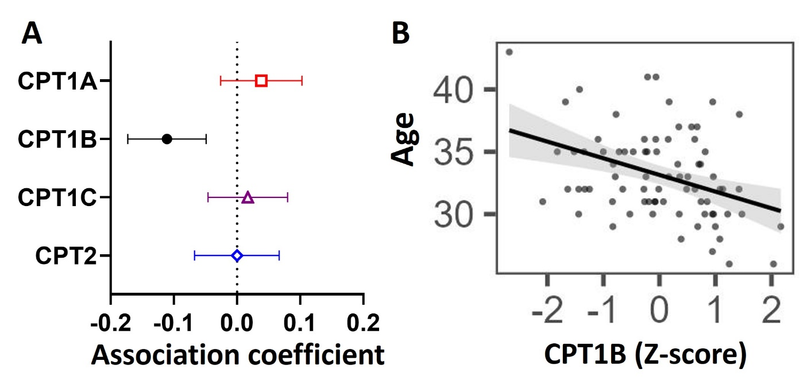
Figure 2. Associations between mRNA expression of CPT isoforms and placental acylcarnitines by linear regression. The forest plot shows coefficient estimates and 95% confidence intervals of associations between CPT isoforms and placental acylcarnitines (outcome, n=50 placentas). Filled symbols show acylcarnitines that are significantly associated after adjustment by Benjamini-Hochberg’s correction. Data for placental acylcarnitine abundance and mRNA expression data of CPT isoforms were log₂-transformed then converted to Z-scores prior to linear regression.
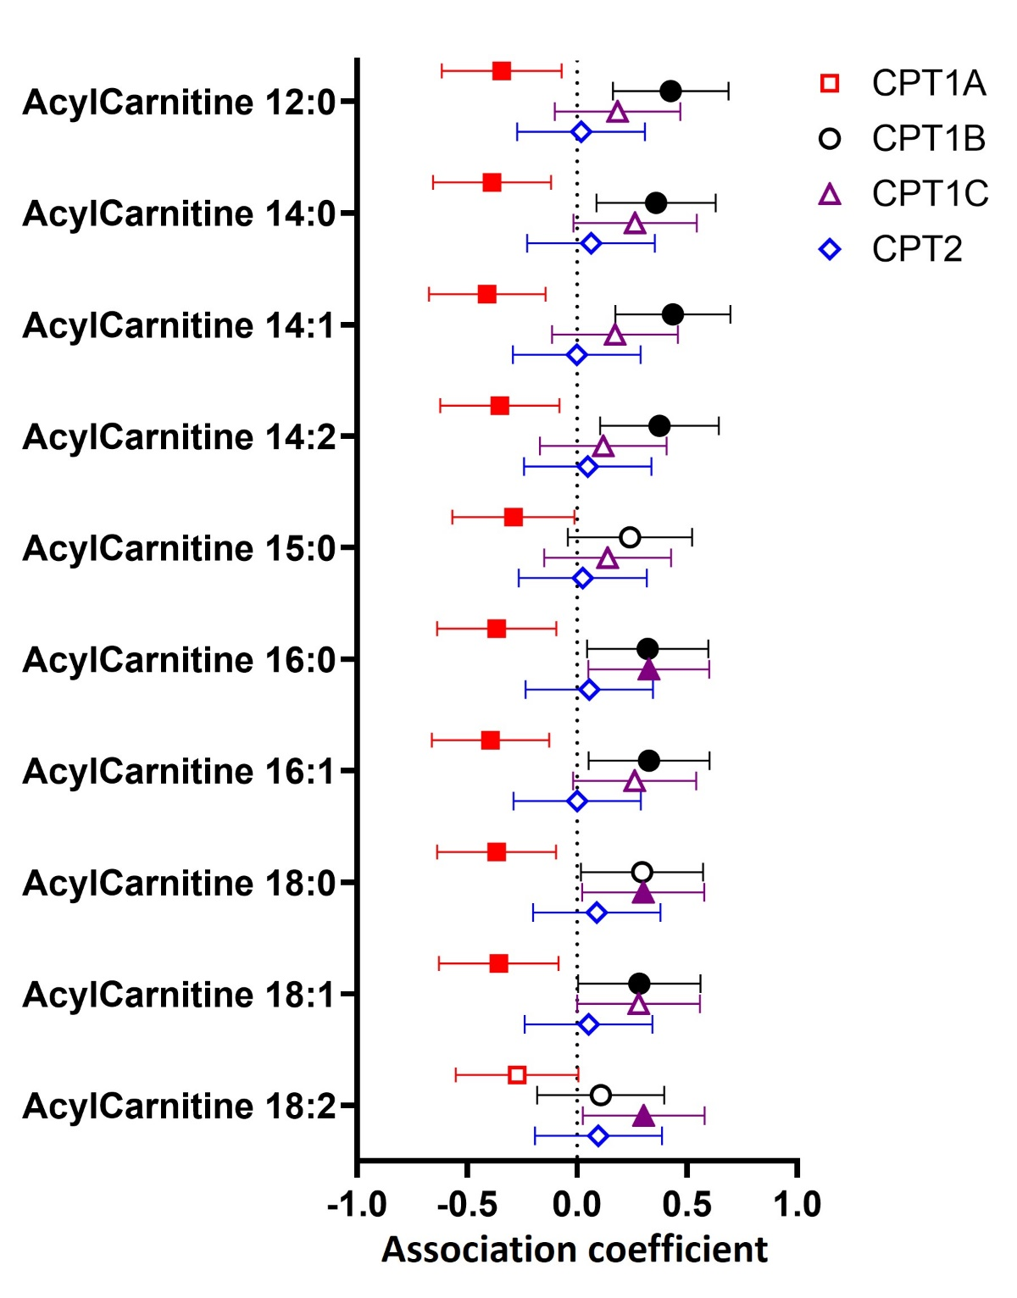

Figure 3. Associations between (A) placental CPT1B mRNA expression or (B) maternal age with the abundance of placental acylcarnitines by linear regression stratified by maternal BMI status. The forest plots show coefficient estimates and 95% confidence intervals of associations between placental CPT1B mRNA expression (A) or maternal age (years, B) with placental acylcarnitines (outcome) in subjects with healthy (< 25kg/m², n=25) and high (≥ 25kg/m², n=25) BMI. Filled symbols show acylcarnitines that are significantly associated after adjustment by Benjamini-Hochberg’s correction. Data for placental acylcarnitine abundance and mRNA expression data of CPT1B were log₂-transformed then converted to Z-scores prior to linear regression.
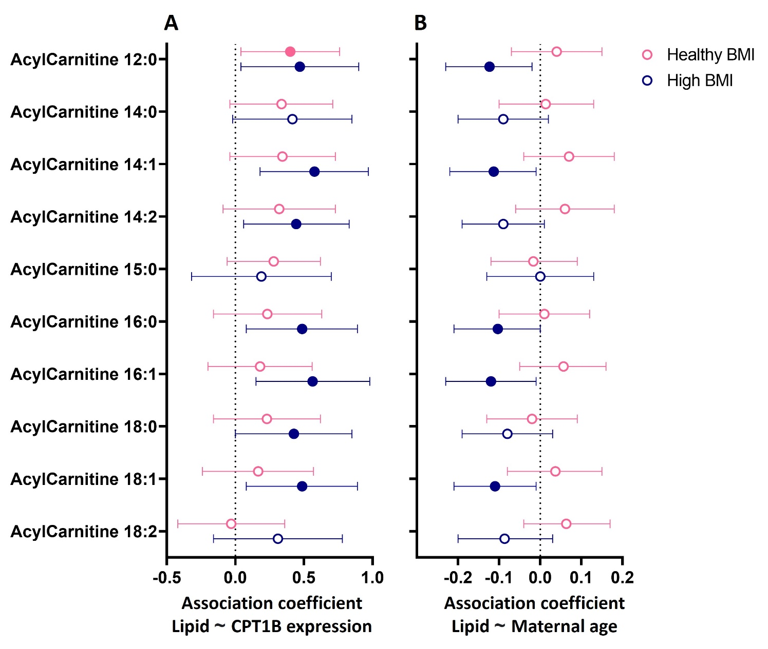

Supplementary information
Supplementary methods
Chromatography was performed using a 2.1 x 100 mm 1.8 μm Zorbax Eclipse Plus C18 RRHD (Agilent Technologies) column at 60°C, and the following gradients and settings: Mobile phase A: 50% water, 30% acetonitrile, 20% isopropanol, 10 mmol/L ammonium formate and Mobile phase B: 90% isopropanol, 9% acetonitrile, 1% water, 10 mmol/L ammonium formate; Start (0.4 ml/min): 90% A, 0-2.7minutes: decrease to 55% A, 2.7-2.8 minutes: decrease to 47% A, 2.8-9 minutes: decrease to 35% A, 9-9.1 minutes: decrease to 11% A, 9.1-11 minutes: decrease to 8% A, 11-11.1 minutes: decrease to 0% A, 11.1-11.9 minutes: 0% A, 11.9-12 minutes: Increase to 90% A, 12-15 minutes: 90% A. The Agilent 6490 triple quadrupole was run with the following settings - Gas temperature: 150 °C; gas flow: 17 L/min; nebulizer: 20 psi; sheath gas temperature: 200°C; sheath gas flow: 10 L/min; positive capillary voltage: 3500 V; negative capillary voltage: 3000 V; positive nozzle voltage: 1000 V; negative nozzle voltage: 1500 V; positive high pressure RF (iFunnel): 100 V; negative high pressure RF (iFunnel): 90 V; positive low pressure RF (iFunnel): 100 V; negative low pressure RF (iFunnel): 60 V; fragmentor: 380; polarity: positive. Acylcarnitines were measured using the transitions shown in Supplementary table 1.
Supplementary Table 1. Transitions used for the measurement of placental acylcarnitines.
Name | Retention time (min) | Collision Energy | Precursor Ion (m/z) | Product Ion (m/z)
AcylCarnitine 12:0 | 1.3 | 30 | 344.3 | 85.1
AcylCarnitine 13:0 | 1.7 | 30 | 358.3 | 85.1
AcylCarnitine 14:0 | 2.0 | 30 | 372.3 | 85.1
AcylCarnitine 14:1 | 1.5 | 30 | 370.3 | 85.1
AcylCarnitine 14:2 | 1.2 | 30 | 368.3 | 85.1
AcylCarnitine 15:0 | 2.3 | 30 | 386.3 | 85.1
AcylCarnitine 16:0 | 2.5 | 30 | 400.4 | 85.1
AcylCarnitine 16:0 d3 (Internal standard) | 2.5 | 30 | 403.3 | 85.1
AcylCarnitine 16:1 | 2.2 | 30 | 398.3 | 85.1
AcylCarnitine 17:0 | 2.9 | 30 | 414.4 | 85.1
AcylCarnitine 18:0 | 3.6 | 30 | 428.4 | 85.1
AcylCarnitine 18:1 | 2.7 | 30 | 426.4 | 85.1
AcylCarnitine 18:2 | 2.2 | 30 | 424.3 | 85.1
AcylCarnitine 20:4 | 2.3 | 30 | 448.4 | 85.1
AcylCarnitine 22:6 | 3.6 | 30 | 472.4 | 85.1

Supplementary Figure 1. Associations between abundance of placental acylcarnitines with placental CPT1B mRNA expression or maternal age by linear regression stratified by maternal GDM status. The forest plots show coefficient estimates and 95% confidence intervals of associations between placental acylcarnitines (outcome) with placental CPT1B mRNA expression (A) or maternal age (years, B) in subjects with normoglycemia (n=26) and GDM (n=24). Filled symbols show acylcarnitines that are significantly associated after adjustment by Benjamini-Hochberg’s correction. Data for placental acylcarnitine abundance and mRNA expression data of CPT1B were log₂-transformed then converted to Z-scores prior to linear regression.
