Di-n-butyl phthalate stress hampers compost multifunctionality by reducing microbial biomass, diversity and network complexity
Ping Wang^{a,b}, Zhen Wang^{a,b}, Miaomiao Zhuª, Chaosheng Zhu^{a,b}, Wenli Feng^{a,b}, Guilan Duan^{c,d}, Tomislav Cernava^{e, f}, Decai Jin^{c,d,}*
ª School of Chemistry and Chemical Engineering, Zhoukou Normal University, Zhoukou, 466001, China
^{b} Zhoukou Key Laboratory of Environmental Pollution Control and Remediation, Zhoukou Normal University, Zhoukou, 466001, China
^{c} Key Laboratory of Environmental Biotechnology, Research Center of Eco-Environmental Sciences, Chinese Academy of Sciences, Beijing, 100085, China
^{d} College of Environment and Resources, University of Chinese Academy of Sciences, Beijing, 100049, China
^{e} Institute of Environmental Biotechnology, Graz University of Technology, Petersgasse 12, Graz 8010, Austria
^{f} School of Biological Sciences, Faculty of Environmental and Life Sciences, University of Southampton, Southampton, SO17 1 BJ, United Kingdom
Abstract:
Phthalate esters are common pollutants in agriculture. Here, we assessed the influence of di-n-butyl phthalate (DBP) on microbiome multifunctionality during composting. Results indicated that DBP stress (100 mg/kg) hampered multifunctionality from the thermophilic phase onwards and resulted in a 6.5% reduction of the temperature. DBP stress also significantly reduced microbial biomass (P < 0.05), altered microbial composition (P < 0.05), and decreased network complexity (P < 0.01). Multifunctionality was found to be strongly correlated (P < 0.001) with microbial biomass, diversity, and network complexity. In addition, keystone taxa responsive to DBP were identified as Streptomyces, Thermoactinomyces, Mycothermus, and Lutispora. These taxa were significantly (P < 0.001) affected by DBP stress, and a correlation between them and multifunctionality was shown. This study contributes to a better understanding of the negative implications of phthalates during composting processes, which is of great significance to the development of new treatment strategies for agricultural waste.
Keywords: Composting; Di-n-butyl phthalate; Microbial Diversity; Multifunctionality; Network complexity
1. Introduction
Phthalates (PAEs) are used worldwide to improve the plasticity of plastics (Zhang et al., 2021b). However, their use has raised some environmental concerns. PAE pollutants can be detected in food waste, agricultural waste and other organic solid wastes (Lü et al., 2021). If these organic solid wastes polluted by PAEs are not properly treated, they can become a new source of pollution. At present, the proper disposal of PAE-contaminated organic solid waste has attracted increased attention. Composting is considered as an environmentally friendly technology for recycling organic solid waste (Chen et al., 2022; Lü et al., 2021), because materials such as farm straw and manure are highly suitable microbial degradation (Chen et al., 2022; Zhang et al., 2020). Moreover, the finished compost products can improve soil properties and enhance soil fertility (Feng et al., 2020). Previous studies confirmed that composting can be successfully applied to degrade PAE-contaminated organic wastes (Lü et al., 2021). Although a composting system is a man-made ecosystem, several ecological functions can be found therein, similar to a natural ecosystem such as soil. These multiple ecosystem functions (referred to as ‘multifunctionality’) including matter cycling, organic waste humification, and contaminant degradation should be ideally maintained during composting of PAE-contaminated organic wastes (Chen et al., 2022; Lü et al., 2021). In recent years, multifunctionality was defined as an ecological concept that evaluates multiple ecosystem functions that are present simultaneously (Byrnes et al., 2014). This concept is widely used to describe functionality in various ecosystems (such as soil and forest) and to assess the effects of environmental stress on ecosystem functions such as primary production, matter cycles, and degradation processes (Han et al., 2022; Tresch et al., 2019). Environmental pollution was previously identified as one of the main factors leading to changes in soil multifunctionality by strongly altering soil microbial diversity, community composition, and ecological clusters (Ma et al., 2020; Li et al., 2021a). However, no studies have so far used this index to assess the effects of environmental stress on the composting process. Therefore, systematically evaluating the effect of PAE stress on the multifunctionality of the microbiome during composting and analyzing the causes of the changes therein could provide valuable knowledge. Such knowledge could not only help to understand the harm of PAE pollutants to composting systems, but also provide additional support for the development of organic solid waste composting strategies.
Composting is a biological oxidation process in which microorganisms play an irreplaceable role in regulating nutrient circulation, pollutant degradation and where they contribute to compost quality (Zhang et al., 2020; Lü et al., 2021). The biomass of microorganisms, especially functional genes related to the cycling of nutrients such as carbon and nitrogen, was found to be directly related to organic matter humification and pollutant degradation during composting (Wang et al., 2022a; Wang et al., 2022b; Liu et al., 2019b). In addition, microorganisms that coexist in the composting ecosystem fulfill many functions, which are essential for the process of converting solid waste into stable humus and producing high quality compost products (Wu et al., 2017). Changes in microbial community can affect greenhouse gas emissions, nutrient cycling, and pollutant degradation, thus having important wide-ranging effects on the environment (Lü et al., 2021; Zhang et al., 2020; Liu et al., 2019b). Therefore, it is of great significance for future optimization of solid waste composting technologies to systematically analyze the relationship between microbes (biomass and community diversity) and multifunctionality as well as the response to PAE stress as common pollutant.
Microbial communities that occur during composting are highly diverse (Wang et al., 2022a; Wu et al., 2017; Zhang et al., 2021a), but diversity is often insufficient to understand microbial functioning. Functioning is realized through individual contributions as well as by various groups of microorganisms (Qiu et al., 2021). Microbes involved in the composting process are often associated with each other, and functionally interlinked, which is required to complete the composting process (Li et al., 2021b). Connections between microorganisms can be analyzed through co-occurrence analyses (Meng et al., 2022; Zhu et al., 2020). Such analyses can be implemented to understand microbial community complexity and how this complexity changes during composting (Chen et al., 2022; Zhang et al., 2020). One of the aims of this study was to assess the negative effects of PAEs on composting systems by investigating if microbial network connections change as a response to their presence. This knowledge is important because network connectivity is a good indicator of the stability of microbial communities during composting (Qiu et al., 2021; Fanin et al., 2018), and thus directly connected to multifunctionality of the resulting compost. Furthermore, key microbial taxa can be highly interrelated and have a significant influence on the microbial community structure and function (Banerjee et al., 2018; Wang et al., 2020). Network connectivity can be negatively affected by the loss of key microbial taxa. Therefore, it is worth evaluating whether certain levels of PAE stress may cause such losses.
Here, the response of microbial communities to PAE pollutants was evaluated by analyzing how the biomass, diversity, composition and network complexity differ between a PAE-exposed composting group and a control group. Furthermore, it was assessed whether PAE-exposed changes in microbial communities are associated with multifunctionality of composting systems. It was hypothesized that PAE pollutants would hamper multifunctionality via negative effects on the microbial community. To test this hypothesis, di-n-butyl phthalate (DBP) was used as a model for PAEs, and corn stalks mixed with chicken manure was used as composting material. Lab-scale experiments were carried out with different levels of DBP stress. The effects were evaluated by: (1) analyzing the changes in microbial biomass, diversity, composition and network complexity under DBP stress, (2) exploring the relationship between microbes and multifunctionality as a response to DBP, and (3) identifying keystone taxa and their potential implications for multifunctionality of composting systems. The findings of this study will contribute to a better understanding of the negative implications of PAEs during composting processes.

2. Materials and methods
2.1. Composting procedure
Corn stalks and chicken manure were used as composting raw materials, which were respectively collected from a farmland and a small-scale chicken farm in Zhoukou, China. The corn stalk was shredded into fragments (approx. 1–2 cm length) using a hay pulverizer. Fresh, air-dried (10–25ºC) chicken manure that was adjusted to a water content < 30% was passed through a 5-mm sieve. In order to adjust the C/N ratio to about 30:1, corn stalks and chicken manure (w:w=2:1) were mixed thoroughly by hand.
Four composting systems utilizing equal amounts of the raw material were set up and the only variable factor was the DBP stress level. High DBP stress (CRH), moderate DBP stress (CRM), light DBP stress (CRL), and a control group without DBP stress (CR0) were simulated in laboratory scale composting reactors. DBP stress in CRH, CRM, CRL, and CR0 was induced by adding 100 mg/kg, 10 mg/kg, 1 mg/kg, and 0 mg/kg of DBP to the raw material based on its dry mass, respectively. Each composting group included three duplicate reactors. The composting reactors were mechanically ventilated stainless steel buckets (50 L) and each composting reactor was filled with about 20 kg of mixed material. Mechanical ventilation (about 0.8 L/kg/min) was maintained during composting (Hui et al., 2018), which provided aerobic conditions during the composting process. Meanwhile, the moisture of the compost was maintained at about 60% by adding water in order to provide optimal conditions for microbial activity (Wang et al., 2022b). The composting process lasted 85 days. A total of 24 samples were collected from the initial (day 0), mesothermal (day 6), thermal (days 14, 24 and 32), cooling (day 52) and maturation (day 84) phases from the four composting groups. All described measurements and analyses were conducted in triplicates.
2.2. Physicochemical analyses
Physicochemical factors including total organic carbon (TOC), pH, temperature, total nitrogen (TN), C/N ratio (the ratio of TOC and TN), HA/FA ratio (the ratio of humic acid and fulvic acid), germination index (GI), and typical enzyme activity (cellulase and protease) were analyzed following previously published protocols (Zhang et al., 2020; Wang et al., 2022b). In addition, the quality of the finished product from all four composting systems was analyzed according to previously published methods (Zhang et al., 2020; Wang et al., 2021). The physicochemical properties assessed for the final compost products included pH, electrical conductivity (ES), TN, total phosphorus (TP), total potassium (TK), C/N ratio, HA/FA ratio, moisture, bulk density, water-holding capacity, and the GI value.
Multifunctionality of the composting system was assessed using these variables, because they provide information on a wide range of functions during the composting process. It was assessed according to the method presented by Fanin et al. (2018). The values for each of the nine measurements were standardized by z-transformation before averaging to eliminate the impacts of the measurement scale differences between variables. The null hypothesis in this study was that the level of multifunctionality was affected due to an increase in the quantity of microbial taxa or functional species. Each of the nine variables was standardized by dividing it by the maximum obtained value, which resulted in equal weighting of all the functions. The mean of standardized values was used to calculate the average multifunctionality. This method is widely used (Qiu et al., 2021; Fanin et al., 2018).
2.3. DNA extraction, qPCR, and amplicon sequencing
Total community DNA was obtained from compost samples by using the FastDNA Spin Kit (MP Biomedical, CA), and a NanoDrop 2000 spectrophotometer (Thermo Scientific, USA) was used to determine DNA quality. All DNA samples were stored at −80ºC until qPCR or amplicon sequencing analyses were conducted. An ABI 7300 qPCR System (Applied Biosystems) was used to determine the bacterial biomass, fungal biomass, and the biomass of microbes with functional genes related to N₂-fixation (nifH) (Fan et al., 2017) and C-fixation (cbbLG and cbbLR) (Selesi et al., 2005). Negative controls (no template controls) were implemented to assess and eliminate any possible contamination (Wang et al., 2022b). Gene copy numbers were calculated based on the constructed calibration curves, and then converted into copies per gram of compost sample. To analyze the influence of DBP stress on the succession of microbial communities during composting, bacterial communities and fungal communities were investigated using bacteria-specific primers (515F/806R) and fungi-specific primers (ITS3/ITS4) (Zhang et al., 2020). Amplicon libraries were prepared by using the Illumina Nextera Kit. Paired-end sequencing (2 × 250) was conducted with a MiSeq PE250 Sequencer (Illumina, USA) at Major Biopharm Biotechnology Co., Ltd., located in Shanghai, China. The raw data resulting from the sequencing approach was uploaded to NCBI. It can be retrieved via the accession number PRJNA761922.
2.4. Statistical analysis
Mothur (software version 8.0) was used to calculate alpha diversity indices including the abundance-based coverage estimate (ACE), Chao1, Shannon, and Coverage index. The WGCNA package based on Spearman’s correlation matrices was used to construct co-occurrence networks of microbial communities occurring during composting under various levels of PAE stress. The igraph package was used to obtain network properties and to explore network features of each sample as described in a previous study (Selesi et al., 2005). The node number, betweenness, and closeness were used to describe network features in the present study. Microbial keystone OTUs were identified by taking node numbers, betweenness centrality, and closeness centrality into account (Berry et al., 2014). Correlations between compost multifunctionality and microbial biomass, alpha-diversity, microbial co-occurrence, and keystone taxa abundance were assessed by linear regression analysis.
3. Results and discussion
3.1. Performance and multifunctionality of different composting reactors
DBP stress significantly altered the performance of composting reactors. Results showed that the highest temperatures in CR0, CRL, CRM, and CRH were 66.5ºC, 65.5 ºC, 64.5 ºC, and 65 ºC, respectively. In addition, the duration of the thermophilic stage in CR0 was respectively 2 days, 5 days, and 6 days longer than in CRL, CRM, and CRH (see E-Supplementary data). These findings provided evidence that the DBP-exposed composting reactors had a shorter thermophilic phase and a lower maximum temperature. Furthermore, the pH value of CRH was slightly higher than that of the other composting groups at the early stage (see E-Supplementary data). This might be due to the fact that a higher concentration of DBP inhibited the production and transformation of NH₄⁺. Meanwhile, the pH values of CRH, CRM, and CRL were higher than that of CR0 (P < 0.01) in the maturation phase (see E-Supplementary data), which might be due to the influence of DBP stress on the nitrification and denitrification processes during composting (Zhang et al., 2020). In addition, the percentage of TOC in composting systems exposed to different levels of DBP stress was lower than that in the control reactor. The TOC content in CR0 was significantly lower than that in three the DBP-stress-exposed groups from day 6 to day 52 (P < 0.05) (see E-Supplementary data), which indicated that DBP stress hampered the biodegradation rate of TOC during agricultural waste composting. Furthermore, from day 52, the GI value, C/N ratio and HA/FA ratio under DBP stress were significantly lower than those in the control group (P < 0.05) (see E-Supplementary data). These findings indicated that the presence of DBP slowed down the composting process, which not only might negatively affect the quality of compost, but also increase the operating costs. Moreover, the results also indicated that DBP stress hampered the cellulase and protease activity during composting (see E-Supplementary data), which was linked to a decrease and change in the number and structure of prevailing microorganisms (Wang et al., 2022b).
To further characterize the effects of DBP stress on agricultural waste composting, correlations between DBP stress and compost multifunctionality during the composting process were also determined. As shown in Fig. 1a, DBP stress significantly reduced compost multifunctionality during the composting process. More specifically, it was observed that multifunctionality decreased with the increase of DBP concentration. Notably, on day 24 of composting, the compost multifunctionality under DBP stress was significantly lower than that of the control group; the trend continued until day 84 (Fig. 1b). This suggests DBP stress has an inhibitory effect on compost multifunctionality beginning with the thermophilic phase of composting. In addition, the multifunctionality of composting ecosystem also showed a positive correlation with different composting properties (e.g., TOC degradation, the C/N ratio, and GI value) (P < 0.001, see E-Supplementary data).
One of the main aims of agricultural waste composting is to obtain high quality marketable compost (Walsh et al., 2020; Wang et al., 2021). Compost quality is known to be directly affected by microbial processes during the whole production process (Walsh et al., 2020). In this study, the quality of the finished product (including pH, ES, TN, TP, TK, C/N ratio, HA/FA ratio, moisture, bulk density, water-holding capacity, and GI value) from all four composting systems was analyzed to further determine the effects of DBP. The results showed that all assessed indicators of the analyzed samples were within normal to ideal ranges for compost that is typically sold in the agricultural industry (the composting standard of China) (see E-Supplementary data). It is worth noting that the quality of compost (e.g. C/N ratio, HA/FA ratio, water-holding capacity, and GI value) from DBP-exposed composting groups was lower than those from the control group, suggesting that the reduction of PAE pollutants might be beneficial to improve the quality of final product. Therefore, implementing degradation strategies, especially such that are based on microbes, of PAEs during the composting process should be considered in the future.
3.2. Microbial biomass and its contribution to multifunctionality
Previous data indicate at microbial biomass during composting directly affects conversion of nutrients and degradation of organic pollutants (Wang et al., 2022b; Sardar et al., 2021; Lü et al., 2021). In order to evaluate the response of microbial biomass to DBP stress and the contribution of microbial biomass to multifunctionality during the composting process, a qPCR-based approach was implemented as shown in Fig. 2a and 2b. The highest 16S rRNA gene and ITS region copy numbers were observed in the control group, which indicated that a decrease in the bacterial and fungal gene copy numbers under DBP occurred during the composting process. Nevertheless, bacterial biomass and fungal biomass were correlated positively and significantly with multifunctionality during composting (P < 0.001, Fig. 2c and 2d), and also positively correlated to most indicators for good composting performance (e.g., TOC degradation percentage, the rate of HA/FA, and GI) (P < 0.01, see E-Supplementary data). Hence, a decrease of microbial biomass in DBP-exposed groups was correlated to a decrease in composting multifunctionality. This was mainly because DBP stress resulted in a decrease of microbial biomass, which inhibited TOC decomposition and nutrient conversion as previously shown (Wang et al., 2022b), which is connected to decreased compost multifunctionality. These results also indicated that the degradation efficiency of PAE pollutants can be improved by increasing microbial diversity, thus restoring of multifunctionality in composting systems.
In addition, the impact of DBP on nitrogen fixation (nifH abundance) was also analyzed during composting. Gene copy numbers of nifH were higher during the cooling and maturation phases than during other phases of the process (see E-Supplementary data). The gene copy number of the nifH gene was significantly reduced from day 52 in the 100 mg/kg DBP group. This was even more pronounced on day 84, indicating that the carriers of the nifH gene might be sensitive to high concentrations of DBP during composting. There was no significant difference between CRM, CRL, and CR0. Genes related to the Calvin-Benson-Bassham (CBB) cycle were also analyzed, which is an important pathway for fixation of carbon dioxide (Zhou et al., 2019). The key enzyme RubisCO in the CBB cycle is encoded by the cbbL genes (including cbbLG and cbbLR) (Selesi et al., 2005). The gene copies of cbbLG and cbbLR were significantly higher in CR0 than in other samples on day 84 (see E-supplementary data). Meanwhile, the results also showed that the effect of DBP on the cbbLG and cbbLR genes changed to some extent from day 24. Notably, in mature compost, the copy numbers of the cbbLG and cbbLR genes were significantly higher in the control group than in DBP-exposed mature composts. These results suggested that the presence of PAEs hampered nitrogen fixation as well as carbon fixation in compost, indicating that PAE stress might influence greenhouse effects and matter cycling processes in general.
3.3. Microbial diversity and its contribution to multifunctionality
In addition to microbial biomass, microbial diversity has also an impact on the conversion of nutrients and the degradation of organic pollutants during composting (Wang et al., 2022a; Sardar et al., 2021; Lü et al., 2021). However, there is little data related to the influence of DBP stress on microbial diversity during composting (Wang et al., 2022b), and it is still unclear if DBP stress can cause changes in microbial diversity and multifunctionality during composting. Thus, the change of microbial (bacterial and fungal) diversity within the four composting groups was explored via amplicon sequencing. In the present study, 1,373,408 bacterial sequences and 1,311,310 fungal sequences were obtained after quality filtering of the data. The dynamics of microbial diversity were assessed for all four composting groups. Fig. 3a shows that the ACE, Chao1, and Shannon indices for bacteria under different concentrations of DBP were significantly lower than those in the control group from the 24th day onwards. In terms of the fungal community, a decrease in diversity occurred from the 14th day of composting (Fig.3c). This indicates that the presence of DBP causes a significant decrease in microbial diversity beginning with the thermophilic stage. In addition, compost multifunctionality was significantly positively correlated with bacterial and fungal diversity indices (including ACE, Chao1, and Shannon) during composting (P < 0.01, Fig. 3b and 3d). The impact of DBP stress on microbial diversity followed the same pattern as observed with TOC and TN content as well as enzyme activity in the composting system. In conclusion, the results indicated that the presence of DBP reduced microbial diversity during composting, which is linked to decrease of multifunctionality. Therefore, microbial inoculation at the beginning of composting to increase the abundance and diversity of microorganisms may support PAE degradation and restore multifunctionality.
3.4. Microbial composition changes
The impact of DBP stress on the microbial community composition was assessed at phylum level as well as family level. Bacterial communities were mainly composed of the phyla Actinobacteria and Firmicutes, accounting for 75.00%-80.84% of the overall bacterial community in all analyzed groups (Fig. 4a). Similar results were previously shown for maize straw composting (Wei et al., 2018), sewage sludge composting (Jiang et al., 2021) and pig manure composting (Jiang et al., 2020). DBP significantly reduced the relative abundance of Actinobacteria during composting, which indicated that Actinobacteria might be sensitive to DBP stress (Wang et al., 2022b). Previous studies have shown that some Actinobacteria can withstand high temperatures and might play important in the degradation of refractory organics (Zhang et al., 2020; Hui et al., 2018); thus, their abundance was linked to changes in TOC. On the contrary, the relative abundance of Firmicutes was significantly increased during composting under DBP stress (Fig. 4a). Proteobacteria (10.36%-13.01%) was found to be the third dominant bacterial phylum during composting, while DBP stress was shown to increase their abundance (Fig. 4a). The other dominant phyla (abundance > 0.1%) were Gemmatimonadota, Bacteroidota, Deinococcota, Chloroflexi, Myxococcota, and Planctomycetota. DBP decreased the abundance of Chloroflexi, but increased the abundance of Deinococcota during composting. At family level, DBP stress caused a decrease in the abundance of Pseudonocardiaceae, Micromonosporaceae, not further characterized Actinomarinales, and Fodinicurvataceae (all members of the phylum Actinobacteria), but increased the abundance of Trueperaceae (phylum: Deinococcota) and Steroidobacteraceae (phylum: Proteobacteria). These bacterial families were previously shown to decompose refractory organic compounds such as hemicellulose (Zhang et al., 2020). In addition, the abundance of Micromonosporaceae and Steroidobacteraceae was found to be positively correlated with compost multifunctionality (P=0.0698 and 0.0523, respectively).
Ascomycota was identified as the predominant fungal phylum in all four composting groups, accounting for 92.75%-94.60% of the fungal community (Fig. 4c). Previous studies have shown that this fungal phylum is commonly found during composting (Liu et al., 2021; Zhang et al., 2016; Wang et al., 2018). Basidiomycota (1.96%-5.41%), Blastocladiomycota (0.07%-0.20%), and Mortierellomycota (0.03%-0.18%) were other dominant phyla found in the present study. Unclassified fungi account for 0.94%-5.17% in the four composting groups. Notably, DBP significantly decreased the relative abundance of unclassified fungi during composting (P < 0.05). In contrast, the abundance of Ascomycota and Basidiomycota increased under DBP stress. It's worth noting that the abundance of Trichocomaceae in the control group (38.44%) was significantly higher than in the DBP-exposed groups (CRL: 19.82%, CRM: 9.53%, and CRH: 8.26%), indicating that Trichocomaceae might be sensitive to DBP stress. In addition, the abundance of this family was positively correlated with multifunctionality (P = 0.0747).
3.5. DBP stress affects microbial networks complexity and keystone taxa
Microbial network analysis can reveal complex connections within microbial communities and indicate how connections between different microbial taxa change in response to changes in environmental conditions (Banerjee et al., 2021; Hu et al., 2019). Microbial networks can also reveal associations and spatial effects within microbial groups (Faucon, 2020). In ecological networks, a node is the central unit (Berry et al., 2014; Liu et al., 2019a), while closeness centrality shows the average shortest path, therefore revealing the significance of a node (Freeman, 1978). Inversely, betweenness centrality indicates that a node is a bridge between network elements (Newman, 2003). The importance of certain nodes in a network is determined by the combined score of high node number, high closeness centrality, and low betweenness centrality. Bacterial as well as fungal networks were analyzed during composting by implementing a co-occurrence network analysis (Fig. 5a and 5b). The node number, closeness centrality, and betweenness centrality were used to reveal microbial network complexity, with greater node numbers, greater closeness, and lower betweenness representing higher network complexity (Banerjee et al., 2021). Notably, the betweenness centrality was higher in the DBP-exposed composting groups when compared to the control group, while the node numbers and closeness were lower (Fig. 5c–e). In addition, these tendencies increased with increasing DBP concentrations (Fig. 5c–e). These results indicated that DBP stress affected microbial connections, and therefore decreased the microbial network complexity during composting. A decrease of network complexity might be due to harmful effects caused by DBP that resulted in lower microbial biomass and diversity, which in turn reduced nutrient utilization. Moreover, network complexity was found to be significantly correlated (P < 0.001) with compost multifunctionality (Fig. 5f–k). Therefore, restoring microbial network structures may improve the performance of composting systems.
Keystone taxa are highly connected microorganisms that play an important role in the microbial community (Banerjee et al., 2019; Gibbons et al., 2020) and can be used as microbial indicators for the composting performance (Yin et al., 2018), that therefore were likely to have implications for compost multifunctionality. Keystone taxa are represented by network nodes with the highest standardized score for closeness centrality and low betweenness centrality. In this study, Streptomyces, Thermoactinomyces, and Flaviflexus (all members of the phylum Actinobacteria), Cellvibrio (phylum: Proteobacteria), and Lutispora (phylum: Firmicutes) were identified as bacterial keystone taxa (Fig. 6a). Co-occurrence network analysis also revealed that Mycothermus and Orpinomyces (both members of the phylum Ascomycota) were fungal keystone taxa during composting (Fig. 6a). The relative abundances of Streptomyces, Thermoactinomyces, and Mycothermus was positively correlated with multifunctionality, but decreased with the increase of the DBP concentration (P < 0.001, Fig. 6b). On the contrary, the relative abundance of the Lutispora increased with the increase of DBP dose and was negatively correlated with compost multifunctionality (P < 0.001, Fig. 6b). In addition, keystone OTUs assigned to Flaviflexu, Cellvibrio, and Orpinomyce were neither affected by DBP stress nor showed a correlation with multifunctionality during composting. The overall results indicated that several keystone taxa responded to DBP stress during composting. They might therefore be used as a microbial indicator for the influence of DBP stress on microbial communities and compost multifunctionality. In addition, they might be used as functional inoculants for improving composting technologies and enhancing the performance during PAE-contaminated agricultural waste composting.
4. Conclusion
This study is the first to analyz the influence of DBP on multifunctionality of composting systems. Compared to the control group, the DBP-exposed groups harbored a lower microbial biomass and diversity as well as lower network complexity. Notably, the multifunctionality was significantly reduced under DBP stress, which strongly correlated with microbial biomass, diversity, and network complexity. Moreover, keystone taxa that were affected by DBP stress were identified and showed a correlation with compost multifunctionality. These findings contribute to a better understanding of the negative implications of PAEs during composting. They could also serve as a basis for the design of future industrial composting reactors that are suitable for the degradation and reuse of PAE-contaminated waste.
CRediT authorship contribution statement
Ping Wang: Methodology, Formal analysis, Investigation, Data curation, Writing-original draft, Conceptualization, Funding acquisition. Zhen Wang, Miaomiao Zhu, Chaosheng Zhu, and Wenli Feng: Investigation, Data curation. Guilan Duan: Reviewing. Tomislav Cernava: Writing-review & editing. Decai Jin: Supervision, Conceptualization, Writing-review & editing, Funding acquisition.
Declaration of Competing Interest
The authors declare that they have no known competing financial interests or personal relationships that could have appeared to influence the work reported in this paper.
Acknowledgements
This work was supported by the National Natural Science Foundation of China (grant No. 41977122), and the Science and Technology Project of Henan Province (grant No. 212102310531).
Appendix A. E-Supplementary data
E-Supplementary data for this work can be found in the e-version of this paper online.
References
Banerjee, S., Walder, F., Büchi, L., Meyer, M., Held, A.Y., Gattinger, A., Keller, T., Charles, P., Heijden, M.A., 2019. Agricultural intensification reduces microbial network complexity and the abundance of keystone taxa in roots. ISME J. 13, 1722-1736.
Banerjee, S., Zhao, C., Kirkby, C.A., Coggins, S., Zhao, S., Bissett, A., Heijden, M.A., Kirkegaard, J.A., Richardson, A.E., 2021. Microbial interkingdom associations across soil depths reveal network connectivity and keystone taxa linked to soil fine-fraction carbon content. Agric. Ecosyst. Environ. 320, 107559.
Banerjee, S., Schlaeppi, K., Heijden, M.G.A., 2018. Keystone taxa as drivers of microbiome structure and functioning. Nat. Rev. Microbiol. 16, 567-576
Berry, D., Widder, S., 2014. Deciphering microbial interactions and detecting keystone species with co-occurrence networks. Front. Microbiol. 5 (219), 00219.
Byrnes, J.E.K., Gamfeldt, L., Isbell, F., Lefcheck, J.S., Griffin, J.N., Hector, A., Cardinale, B.J., Hooper, D.U., Dee, L.E., Duffy, J.E., 2014. Investigating the relationship between biodiversity and ecosystem multifunctionality: Challenges and solutions. Methods Ecol. Evol. 5 (2), 111-124.
Chen, X.H., Huang, Y.H., Lü, H., Mo, C.H., Xiang, L., Feng, N.X., Zhao, H.M, Li, H., Li, Y.W., Cai, Q.Y., 2022. Plant-scale hyperthermophilic composting of sewage sludge shifts bacterial community and promotes the removal of organic pollutants. Bioresour. Technol. 347, 126702.
Fan, L., Feng, Y., Weaver, D.B., Delaney, D.P., Wehtje, G.R., Wang, G., 2017. Glyphosate effects on symbiotic nitrogen fixation in glyphosate-resistant soybean. Appl. Soil Ecol. 121, 11-19.
Fanin, N., Gundale, M.J., Farrell, M., Ciobanu, M., Baldock, J.A., Nilsson, M.C., Kardol, P., Wardle, D.A., 2018. Consistent effects of biodiversity loss on multifunctionality across contrasting ecosystems. Nat. Ecol. Evol. 2, 269-278.
Faucon, M.P., 2020. Plant-soil interactions as drivers of the structure and functions of plant communities. Diversity 12 (12), 452.
Feng, N.X., Liang, Q.F., Feng, Y.X., Xiang, L., Wong, M.H, 2020. Improving yield and quality of vegetable grown in PAEs-contaminated soils by using novel bioorganic fertilizer. Environ. Sci. Technol. 739, 139883.
Freeman, L.C., 1978. Centrality in social networks conceptual clarification. Soc. Networks 1 (3), 215-239.
Gibbons, S.M., 2020. Keystone taxa indispensable for microbiome recovery. Nat. Microbiol. 5 (10), 1307.
Han, Z., Xu, P., Li, Z., Lin, H., Zhu, C., Wang, J., Zou, J., 2022. Microbial diversity and the abundance of keystone species drive the response of soil multifunctionality to organic substitution and biochar amendment in a tea plantation. GCB Bioenergy 14 (4), 481-495.
Hu, T., Wang, X., Zhen, L., Gu, J., Zhang, K., Wang, Q., Ma, J., Peng, H., Lei, L., Zhao, W., 2019. Effects of inoculating with lignocellulose-degrading consortium on cellulose-degrading genes and fungal community during co-composting of spent mushroom substrate with swine manure. Bioresour. Technol. 291, 121876.
Hui, M., Lv, Z., Sun, H., Li, R., Zhai, B., Wang, Z., Awasthi, M.K., Zhou, L., 2018. Improvement of biochar and bacterial powder addition on gaseous emission and bacterial community in pig manure compost. Bioresour. Technol. 258, 195-202.
Jiang, J., Wang, Y., Yu, D., Yao, X., Han, J., Cheng, R., Cui, H., Yan, G., Zhang, X., Zhu, G., 2021. Garbage enzyme s effectively regulated the succession of enzymatic activities and the bacterial community during sewage sludge composting. Bioresour. Technol. 237, 124792.
Jiang, J., Yu, D., Wang, Y., Zhang, X., Dong, W., Zhang, X., Guo, F., Li, Y., Zhang, C., Yan, G., 2020. Use of additives in composting informed by experience from agriculture: Effects of nitrogen fertilizer synergists on gaseous nitrogen emissions and corresponding genes (amoA and nirS). Bioresour. Technol. 319, 124127.
Li, X.X., Wang, S.P., Sun, Z.Y., Wang, S.T., Shuai, W.L., Shen, C.H., Tang, Y.Q., 2021a. Performance and microbial community dynamics during rice straw composting using urea or protein hydrolysate as a nitrogen source: A comparative study. Waste Manage. 135, 130-139.
Li, Y., Ge, Y., Wang, J., Shen, C., Wang, J., Liu, Y., 2021b. Functional redundancy and specific taxa modulate the contribution of prokaryotic diversity and composition to multifunctionality. Mol. Ecol. 30 (12), 2915-2930.
Liu, F., Li, Z., Wang, X., Xue, C., Tang, Q., Li, R.W., 2019a. Microbial co-occurrence patterns and keystone species in the gut microbial community of mice in response to stress and chondroitin sulfate disaccharide. Int. J. Mol. Sci. 20 (9), 2130.
Liu, N., Hou, T., Yin, H., Han, L., Huang, G., 2019b. Effects of amoxicillin on nitrogen transformation and bacterial community succession during aerobic composting. J. Hazard. Mater. 362, 258-265.
Liu, T., Awasthi, M.K., Jiao, M., Awasthi, S.K., Qin, S., Zhou, Y., Liu, H., Li, J., Zhang, Z., 2021. Changes of fungal diversity in fine coal gasification slag amendment pig manure composting. Bioresour. Technol. 325 (3), 124703.
Lü, H., Chen, X.H., Mo, C.H., Huang, Y.H., He, M.Y., Li, Y.W., Feng, N.X., Katsoyiannis, A., Cai, Q.Y., 2021. Occurrence and dissipation mechanism of organic contaminants during the composting of sewage sludge: A critical review. Bioresour. Technol. 328, 124847.
Ma, L., Jiang, X., Liu, G., Yao, L., Liu, W., Pan, Y., Zou, Y., 2020. Environmental factors and microbial diversity and abundance jointly regulate soil nitrogen and carbon biogeochemical processes in Tibetan wetlands. Environ. Sci. Technol. 54 (6), 3267-3277.
Meng, Q., Liu, S., Guo, Y., Hu, Y., Yu, Z., Bello, A., Wang. Z., Xu. W., Xu. X., 2022. The co-occurrence network patterns and keystone species of microbial communities in cattle manure-corn straw composting. Environ. Sci. Pollut. Res. 1-12.
Newman, M.E.J., 2003. The structure and function of complex networks. SIAM Rev. 45 (2), 176.
Qiu, L., Zhang, Q., Zhu, H., Reich, P.B., Banerjee, S., Heijden, M.J.A., Sadowsky, M.J., Ishii, S., Jia. X., Shao. M., Liu, B., Jiao, H., Li, H., Wei, X., 2021. Erosion reduces soil microbial diversity, network complexity and multifunctionality. ISME J. 15, 2474-2489
Sardar, M.F., Li, H., Zhu, C., Dar, A.A., Zhang, B., Waqas, M.A., 2021. Differential effects of sulfamethoxazole concentrations on the enzymatic dynamics of aerobic composting. Bioresour. Technol. 336, 125330.
Selesi, D., Schmid, M., Hartmann. A., 2005. Diversity of green-like and red-like ribulose-1, 5-bisphosphate carboxylase/oxygenase large-subunit genes (cbbL) in differently managed agricultural soils. Appl. Environ. Microbiol. 71 (1), 175-184.
Tresch, S., Frey, D., Bayon, R.C.L., Mäder, P., Stehle, B., Fliessbach, A., Moretti, M., 2019. Direct and indirect effects of urban gardening on aboveground and belowground diversity influencing soil multifunctionality. Sci. Rep. 9, 9769.
Walsh, K.T., Waliczek, T.M., 2020. Examining the quality of a compost product derived from sargassum. HortTechnology 30 (3), 331-336.
Wang, B., Zheng, X., Zhang, H., Xiao, F., He, Z., Yan, Q., 2020. Keystone taxa in the water microbiome respond to environmental quality and predict water contamination. Environ. Res. 187, 109666.
Wang, G., Liu, H., Gong, P., Wang, J., Dai, X., Wang, P., 2022a. Insight into the evolution of antibiotic resistance genes and microbial community during spiramycin fermentation residue composting process after thermally activated peroxydisulfate pretreatment. J. Hazard. Mater. 424, 127287.
Wang, K., Yin, X., Mao, H., Chu, C., Tian, Y., 2018. Changes in structure and function of fungal community in cow manure composting. Bioresour. Technol. 225, 123-130.
Wang, P., Wang, Z., Ren, Z., Ding, Y., Pan, J., Wang, Y., Jin, D., 2022b. Effects of di-n-butyl phthalate on aerobic composting process of agricultural waste: Mainly based on bacterial biomass and community dynamics analysis. Environ. Res. 212, 113290.
Wang, W., Zhang, L., Sun, X., 2021. Improvement of two-stage composting of green waste by addition of eggshell waste and rice husks. Bioresour. Technol. 320, 124388.
Wei, H., Wang, L., Hassan, M., Xie, B., 2018. Succession of the functional microbial communities and the metabolic functions in maize straw composting process. Bioresour. Technol. 256, 333-341.
Wu, J., Zhao, Y., Zhao, W., Yang, T., Zhang, X., Xie, X., Cui, H., Wei. Z., 2017. Effect of precursors combined with bacteria communities on the formation of humic substances during different materials composting. Bioresour. Technol. 226, 191-199.
Yin, Y., Gu, J., Wang, X., Tuo, X., Zhang, K., Zhang, L., Guo, A., Zhang, X., 2018. Effects of copper on the composition and diversity of microbial communities in laboratory-scale swine manure composting. Can. J. Microbiol. 64(6), 409-419.
Zhang, C., Gao, Z., Shi, W., Li, L., Tian, R., Huang, J., Lin, R., Wang, B., Zhou, B., 2020. Material conversion, microbial community composition and metabolic functional succession during green soybean hull composting. Bioresour. Technol. 316, 123823.
Zhang, J., Zhang, T., Ying, Y., Yao, X., 2021a. Effects of different additives on the chemical composition and microbial diversity during composting of Camellia oleifera shell. Bioresour. Technol. 330, 124990.
Zhang, L., Jia, Y., Zhang, X., Feng, X., Wu, J., Wang, L., Chen, G., 2016. Wheat straw: An inefficient substrate for rapid natural lignocellulosic composting. Bioresour. Technol. 209, 402-406.
Zhang, Y., Jiao, Y., Li, Z., Tao, Y., Yang, Y., 2021b. Hazards of phthalates (PAEs) exposure: A review of aquatic animal toxicology studies. Sci. Total Environ. 771 (6), 145418.
Zhou, Z.F., Wei, W.L., Shi, X.J., Li, Y.M., Liu, X.H., Wang, M.X., 2019. Twenty-six years of chemical fertilization decreased soil RubisCO activity and changed the ecological characteristics of soil cbbL-carrying bacteria in an entisol. Appl. Soil Ecol. 141, 1-9.
Zhu, P., Li, Y., Gao, Y., Yin, M., Wu, Y., Liu, L., Du, N., Liu, J., Yu, X., Wang, L., Guo, W., 2020. Insight into the effect of nitrogen-rich substrates on the community structure and the co-occurrence network of thermophiles during lignocellulose-based composting. Bioresour. Technol. 319, 124111.

Figures

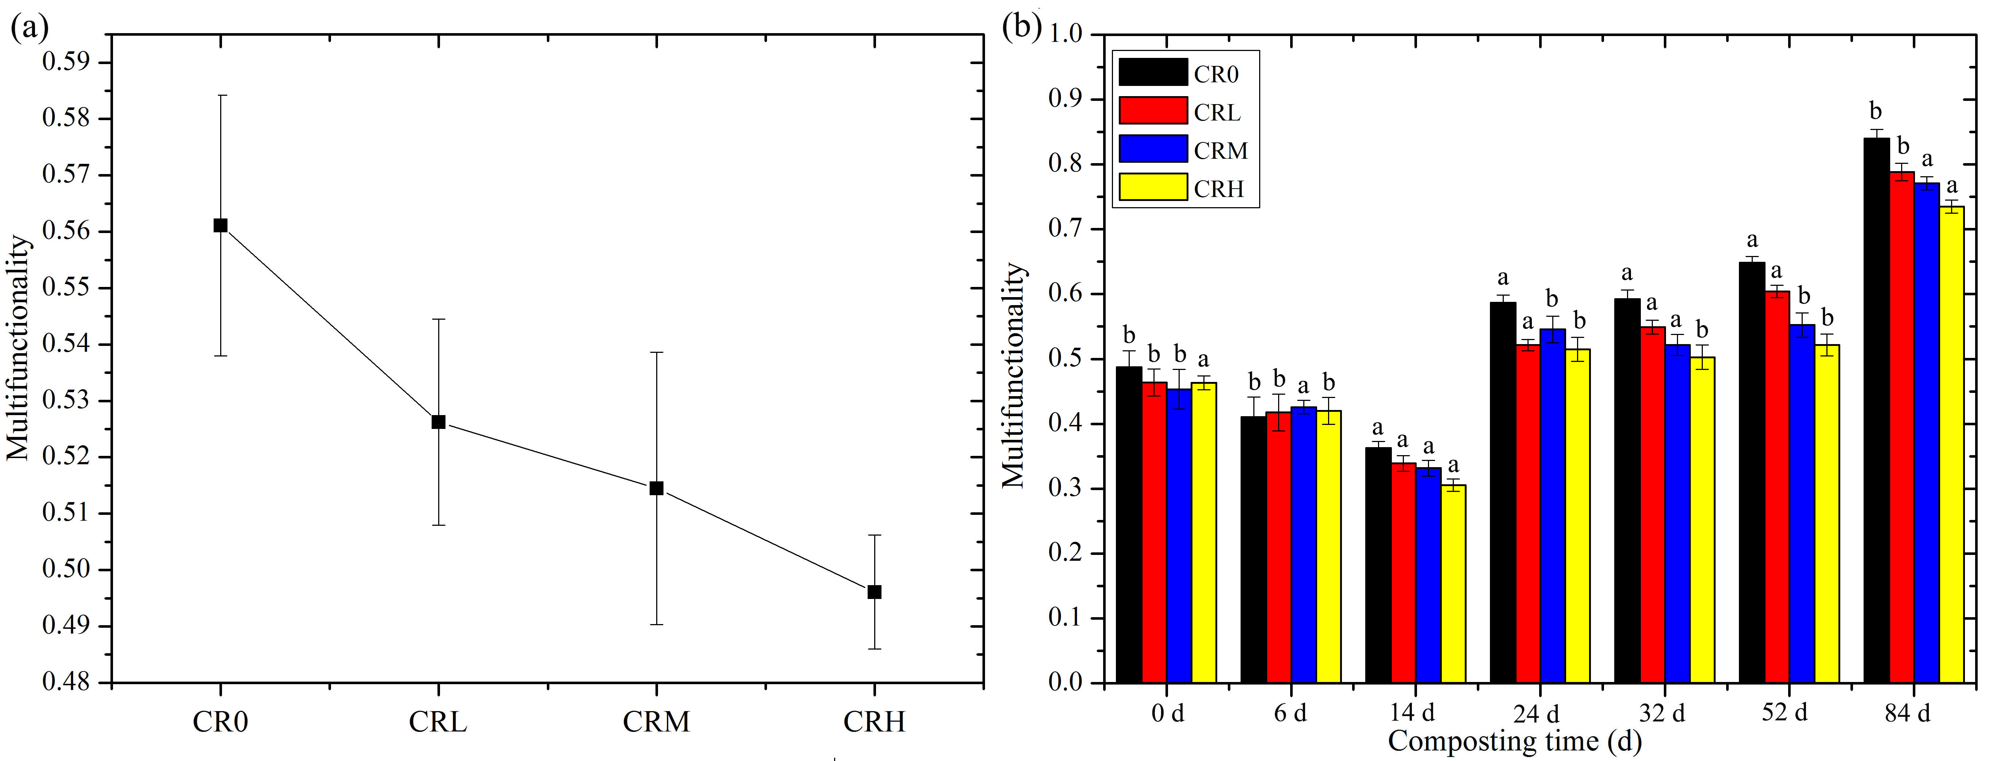
Fig.1. Effects of DBP stress on multifunctionality during composting. CR0: control group, CRL: low DBP stress, CRM: moderate DBP stress, HCR, high DBP stress.

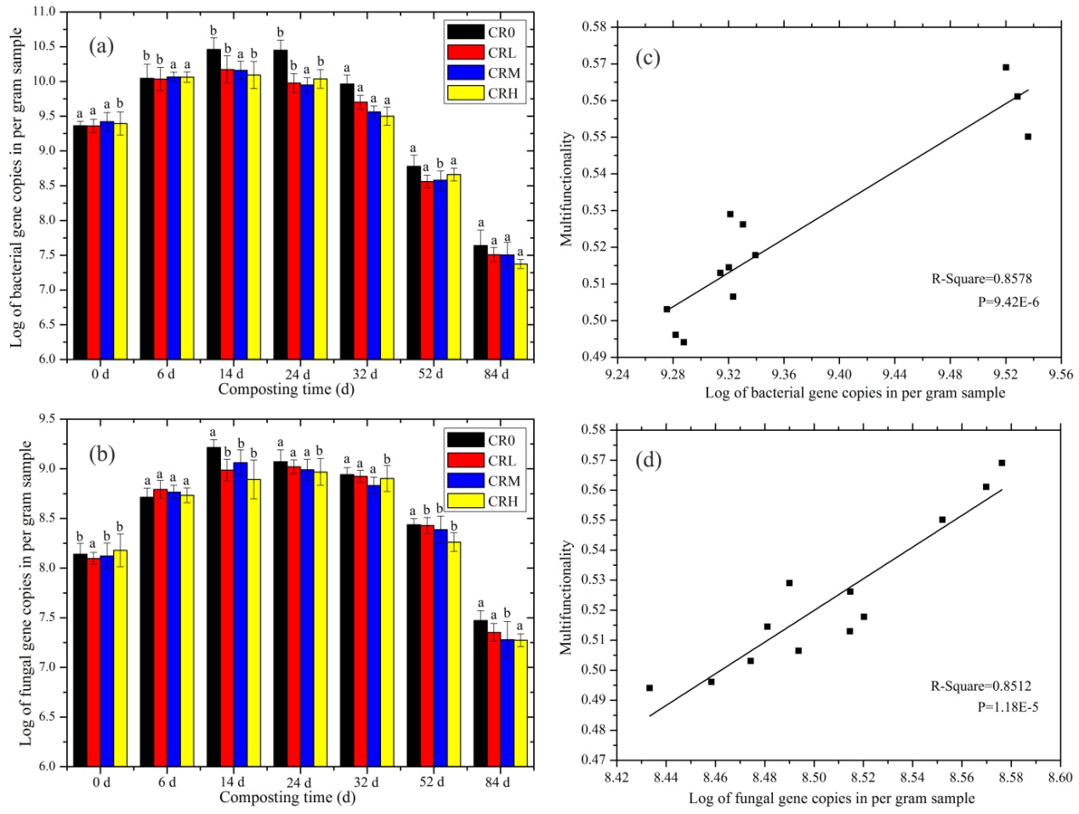
Fig.2. Bacterial and fungal biomass at different DBP concentration and the correlation with multifunctionality. Bacterial and fungal biomass during composting under absence of DBP stress (CR0), low DBP stress (CRL), moderate DBP stress (CRM), and high DBP stress (HCR) (a and b), and the correlation between multifunctionality and microbial biomass (c and d).

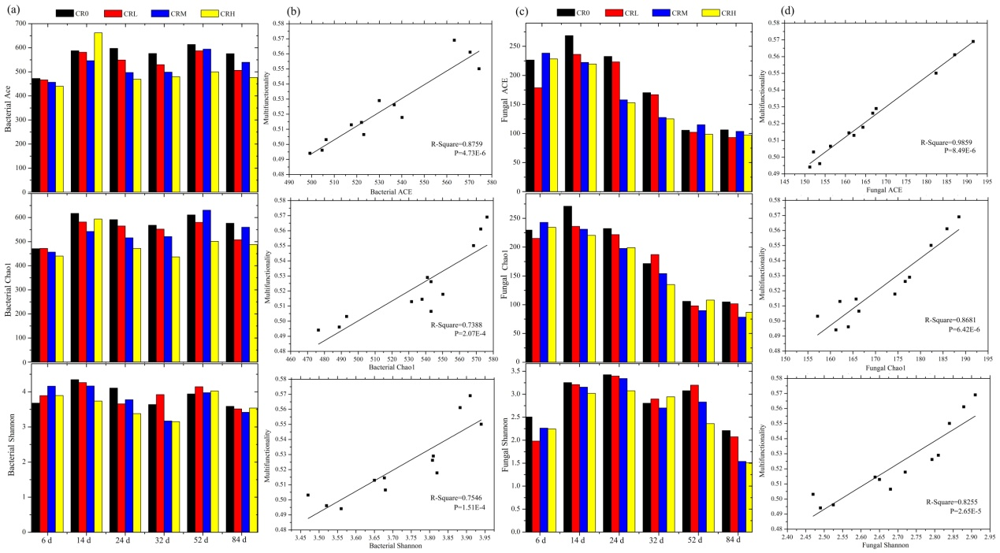
Fig.3. Alpha diversity of bacterial and fungal communities exposed to DBP and the correlation between multifunctionality and alpha diversity during composting. Diversity of bacterial and fungal communities (abundance-based coverage estimate (ACE), Chao1, and Shannon index) during composting absence of DBP stress (CR0), low DBP stress (CRL), moderate DBP stress (CRM), and high DBP stress (HCR) (a and c), and the correlation between multifunctionality and microbial diversity (b and d).

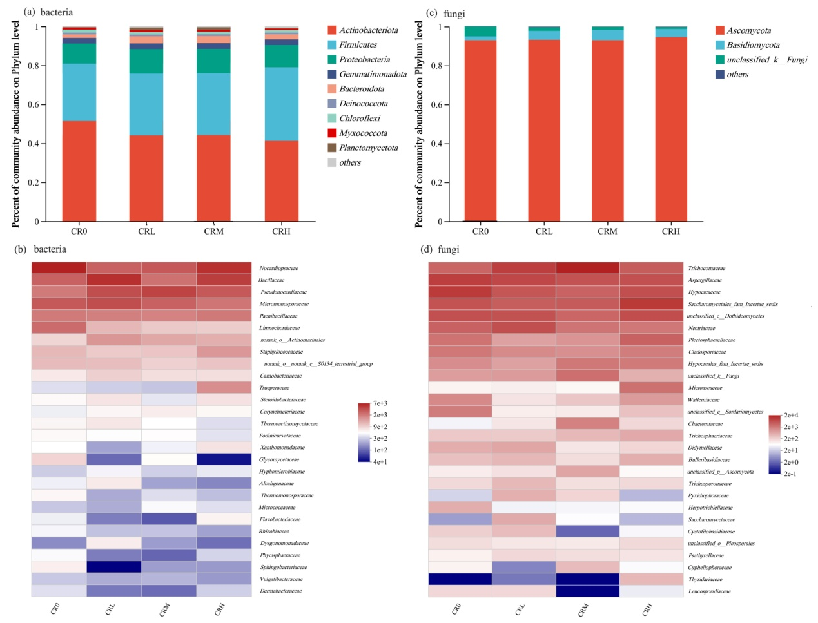
Fig.4. Bacterial and fungal composition under DBP stress during composting. The relative abundance of the dominant phyla (a: bacteria; c: fungi) and of the dominant families (b: bacteria; d: fungi) in composting under absence of stress (CR0), low DBP stress (CRL), moderate DBP stress (CRM), and high DBP stress (HCR). Phyla with an abundance <1% and families with an abundance <5% were not listed.

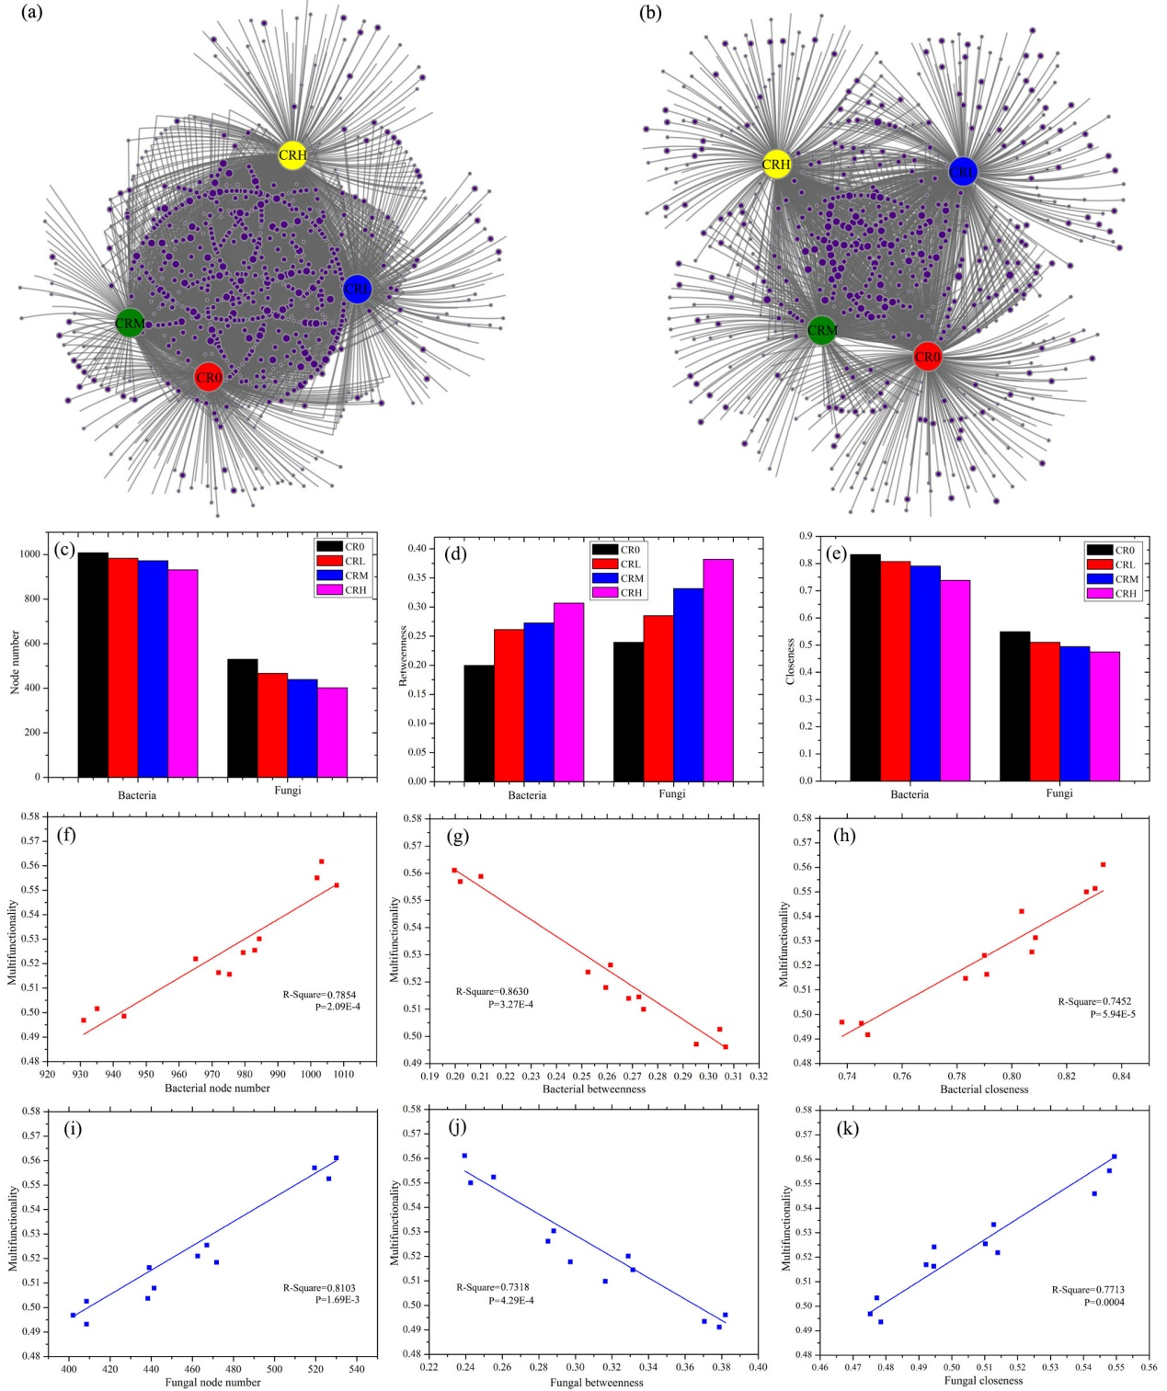
Fig.5. Co-occurrence networks of the bacterial (a) and fungal (b) community during composting under absence of DBP stress (CR0), low DBP stress (CRL), moderate DBP stress (CRM), and high DBP stress (HCR). The sizes of the nodes (OTUs) are proportional to the number of connections. Number of network nodes (c) and the degree of betweenness (d) and closeness (e) of bacterial and fungal co-occurrence networks during composting. Correlations between multifunctionality and the number of nodes (f: bacteria; i: fungi), the degree of betweenness (g: bacteria; j: fungi), and closeness (h: bacteria; k: fungi) of co-occurrence networks.

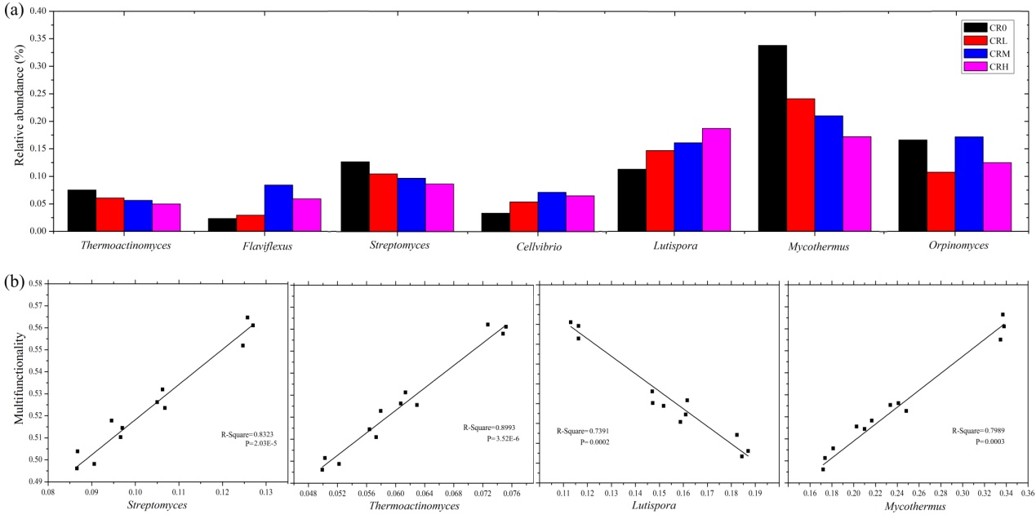
Fig.6. Relative abundance of keystone taxa identified by network analysis in composting processes without DBP stress (CR0), low DBP stress (CRL), moderate DBP stress (CRM), and high DBP stress (HCR) (a), and the correlation between compost multifunctionality and the abundance of keystone taxa (b).

* Corresponding authors at: Research Center of Eco-Environmental Sciences, Chinese Academy of Sciences, Beijing 100085, China E-mail addresses: dcjin@rcees.ac.cn (D. Jin)

