Petrogenesis of Late Campanian Alkaline Igneous Rocks in Eastern Anatolia: Magmatism related to a subduction transform edge propagator (STEP) fault?

Yalçın E Ersoyª, İbrahim Uysal^{b}, Osman Candanª, Martin R. Palmer^{c} and Dirk Müller^{d}

ªDepartment of Geological Engineering, Dokuz Eylül University, İzmir, Turkey;
^{b}Department of Geological Engineering, Karadeniz Technical University, Trabzon, Turkey; ^{c}School of Ocean and Earth Science, University of Southampton, Southampton, UK; ^{d}Department of Earth and Environmental Sciences, Ludwig-Maximilians-University, München, Germany

ABSTRACT
In eastern Anatolia, the Divriği-Hekimhan Magmatic Province (DHMP) includes ~77–69 Ma alkaline rock units which are located to the NW of the Baskil Arc of ~85–74 Ma. The magmatic rocks are composed of nepheline (Ne)–to quartz (Q)–normative alkaline basaltic to trachytic/syenitic units. Among them, the basaltic rocks are composed of plagioclase (Or_{2–11}Ab_{32–51}An_{39–64}) + clinopyroxene (Wo_{47–51}En_{35–42}Fs_{9–16}) + Fe-Ti oxide ± alkali feldspar (Or_{57–98}Ab_{2–42}An₁) ± biotite ± olivine. Their ⁸⁷Sr/⁸⁶Sr_{(I)} ratios and ɛNd_{(I)} values vary in the ranges of 0.70591–0.70871 and−3.2–1.6, respectively. The subvolcanic trachytic rocks are composed of perthitic alkali feldspar phenocryst in a matrix of feldspar (Or_{45–61}Ab_{38–54}An_{0–2}), biotite, and Fe-Ti oxides. The trachytic volcanic rocks are made up of feldspar (Or_{38–63}Ab_{34–59}An_{1–4}) in a fine-grained matrix. Their ⁸⁷Sr/⁸⁶Sr_{(I)} ratios and ɛNd_{(I)} values vary in the ranges of 0.70532–0.70952 and−3.2–0.7, respectively. The syenitic rocks in the region contain both quartz- and nepheline-sodalite-bearing syenites. Geochemical features reveal that the Ne-normative basaltic magmas have undergone mafic mineral fractionation coupled with crustal contamination to produce the Q-normative derivatives. Enhanced differentiation of the Ne- and Q-normative fractionated magmas via feldspar-dominated fractionation created the silica-undersaturated and -oversaturated trachytic magmas, respectively. During the feldspar-dominated differentiation, the re-melting of accumulated alkali feldspars in the magma chamber likely gave rise to the formation of trachytic rocks with alkali feldspar-like whole rock compositions. The final products of the Ne-normative magmas are represented by the phonolites and foid-syenites with silica-undersaturated eutectic compositions. A geochemical evaluation of the basaltic rocks revealed that the alkaline magmatism mainly originated from a shallow asthenospheric mantle source which had previously been metasomatized by oceanic to continental subduction. We suggest that the DHMP was formed in response to STEP fault-controlled rolling back of the northward subducting slab of the Baskil Arc, which created a localized gap for asthenospheric upwelling.

1. Introduction
Magmatic activity in orogenic belts is frequently characterized by mainly calc-alkaline and lesser amounts of alkaline rock suites developed during subduction, syn-collision to post-collisional processes (e.g. Bonin 1990; Foley 1992; Hole et al. 1994; Whalen and Hildebrand 2019; Liu et al. 2022). The first group of rocks is generally derived from high-degrees of melting of a metasomatized lithospheric mantle source, while the second group includes asthenospheric mantle-derived low-degree melts. The alkaline magmatism is generally seen during the final stages of the subduction or early stages of the continental collision, due to rolling-back or breaking-off (or detachment) of the subducted slab (Bonin 1987; Davies and von Blanckenburg 1995), or delamination of the lithospheric roots after the continental collision (Kay and Kay 1993). Alternatively, developing a tear along the subducted slab (e.g. Prelević et al. 2015), or subduction-transform edge propagator (STEP) faults (Govers and Wortel 2005) may create a gap along which hot asthenospheric material rises and produces alkaline melts.
In southeastern Anatolia, a subduction-related Late Cretaceous continental magmatic arc, known as Baskil Arc (Yazgan and Chessex 1991) extends ~500 km in a ~WSW – ENE direction along the southern margin of the Tauride Belt. The magmatic rocks yielded ~84–74 Ma radiometric ages (e.g. Yazgan and Chessex 1991; Rızaoğlu et al. 2009; Karaoğlan et al. 2016; Topuz et al. 2017; Beyarslan and Bingöl 2018; Sar et al. 2019). An extensional Late Cretaceous volcano-sedimentary basin (the Hekimhan Basin) with some granitoid intrusions (the Divriği plutons) lies ~80–100 km N-NE of the Baskil Arc. These features are widely interpreted as formed in a back-arc setting (Gürer 1996; Kuşçu et al. 2010; Liu et al. 2022). This magmatic province, however, has a rather limited extension with respect to the preceding Baskil Arc (Figure 1). The magmatic rocks have been dated as ~77–69 Ma (Leo et al. 1978; Eyüboğlu et al. 2019; Kuşçu et al. 2010; Liu et al. 2022). While the Baskil Arc magmatics are composed of low-K (tholeiitic) to high-K calc-alkaline rocks (e.g. Parlak 2006; Beyarslan and Bingöl 2018; Nurlu et al. 2022), the northeasterly located magmatic rocks in and around the Hekimhan Basin include silica-undersaturated to oversaturated alkaline magmatic rocks (Leo et al. 1978; Yılmaz et al. 1993; Gürer 1996; Ozgenc and Ilbeyli 2009; Boztuğ et al. 2009; Eyüboğlu et al. 2009; Kuşçu et al. 2010). Geodynamically, it is inferred that the rolling-back of the subducting slab of the Baskil Arc in the Late Cretaceous gave rise to the development of the alkaline magmatic activity in the Hekimhan Basin and Divriği area in a back-arc setting (Gürer 1996; Kuşçu et al. 2010; Liu et al. 2022).
The Hekimhan Basin includes basaltic and trachytic volcanic-subvolcanic rocks with syenite intrusions. The volcanic rocks in the basin are mildly K-alkaline including both silica-undersaturated (nepheline-normative) and silica-oversaturated (quartz-normative). The highly evolved trachytes and syenites show two different evolutionary trends reaching up to Na-alkaline nepheline-bearing syenites and K-alkaline quartz-bearing syenites.
In order to better understand the petrogenetic evolution of this alkaline suite, we have performed petrographic and electron microprobe (EMP) studies (more than 1000 points on 9 rock samples), whole-rock major oxide, trace element (49 rock samples) and Sr-Nd isotopic analyses (16 rock samples) from the magmatic units in the Hekimhan Basin. In the light of the findings, we also discuss the Late Cretaceous geodynamic evolution of the region and speculate that there was a ~N–S transform fault across the Anatolide-Tauride Block during the Late Cretaceous. This faulting should have been formed in response to a subduction-transform edge propagator (STEP) fault limiting the Bitlis slab to the west.

2. Regional geology
In the area shown in Figure 1, the main tectonostratigraphic units of eastern Anatolia comprise, from N to S, of (1) Pontides, (2) the easternmost part of the Kırşehir Block, (3) Anatolide-Tauride Block, and (4) Arabian Plate. The Pontides is separated from both the Kırşehir and Anatolide-Tauride Block by the İzmir-Ankara-Erzincan Suture which represents the closure of the northern branch of the Neotethys during the latest Cretaceous to Palaeocene times (e.g. Okay and Tüysüz 1999). The Inner Tauride Suture represents the amalgamation of the Kırşehir Block and the Anatolide-Tauride Block during the latest Cretaceous (e.g. Pourteau et al. 2013). This suture joins with the İzmir-Ankara-Erzincan suture in the east and is now buried under the Palaeocene- Eocene Sivas Basin which developed as a foreland basin following the closure of the ocean (e.g. Darin and Umhoefer 2021).
In the investigated region, the Anatolide Tauride Block (ATB) is composed of (1) the metamorphic rocks of the Malatya and Keban metamorphics, and (2) the eastern Taurides. These units are regarded as the lower to middle and upper crustal units of the ATB, respectively (e.g. Topuz et al. 2017). The Taurides is characterized by a thick carbonate platform deposited during Late Triassic to Late Cretaceous times. In the Munzur part of the Taurides (Figure 1) the ophiolite obduction was followed by emplacement of the late Campanian granitoid intrusions (Divriği granitoids), cutting both the obducted ophiolites and the Taurides. The Divriği granitoids yielded ~77–69 My zircon U-Pb (Eyüboğlu et al. 2019; Liu et al. 2022) and 75–72 My Ar–Ar cooling (Marschik et al. 2008; Boztuğ et al. 2009; Kuşçu et al. 2013) ages.
The Hekimhan Basin and its magmatic products, as well as the Divriği granitoids, are all located in an area between the Munzur and Gürün parts of the Taurides to the NW edge of the Baskil Arc (Figure 1). These magmatic suites are named Divriği-Hekimhan Magmatic Province (DHMP) here. The Hekimhan Basin is represented by a Late Campanian-Maastrichtian volcano-sedimentary succession deposited on the ophiolites derived from the northern branch of the Neotethys. The correlative sedimentary units (without magmatic intercalation) also cover unconformably the Malatya metamorphics and the magmatic rocks of the Baskil Arc in the south.
The southern margin of the ATB is represented by a continental arc (the Baskil Arc) developed at ~85–74 Ma in response to the northward subduction of the Tethys Ocean beneath the eastern Taurides (e.g. Yazgan and Chessex 1991; Parlak 2016 Beyarslan and Bingöl 2018; Karaoğlan et al. 2016; Topuz et al. 2017). The Baskil Arc lies from Hınıs in the NE to Kahramanmaraş in the SW and importantly does not continue further west (Figure 1). The Hekimhan Basin is interpreted as a back-arc basin with respect to the active magmatism along the southerly located Late Cretaceous Andean-type Baskil Arc (Gürer 1994; Kuşçu et al. 2010; Liu et al. 2022).

3. Age data and stratigraphy of the Hekimhan Basin
The Hekimhan Basin contains a thick (up to 2 km) Campanian-Maastrichtian volcano-sedimentary infill (the Hekimhan Group) and is located in the southern part of the Divriği-Hekimhan Magmatic Province (DHMP) (Figure 2). The basin fill rests unconformably on an ophiolitic basement (Leo et al. 1978; Bozkaya and Yalçın 1992; Yılmaz et al. 1993; Gürer 1994; Booth et al. 2014; Sarı et al. 2016). The sequence begins with reddish to greenish, ophiolite-derived alluvial conglomerate and sandstone. The thickness of this unit varies from >1000 m in the west to 1–10 m in the east and is overlain by rudist-bearing reef-type limestone patches indicating a transgressive deposition. Upward, the section transitionally changes into a flysch-type mudstone-sandstone alternation. This unit is intercalated with alkaline basaltic rocks (Hasançelebi volcanic member – HVM; Gürer 1994). The field relations reveal that the deepening of the basin was associated with the inception of the basic magmatic activity. The available radiometric age data from the basic volcanic rocks (mostly diabasic) of the unit vary in the range of ~76.8–74.3 Ma (Leo et al. 1978; Kuşçu et al. 2010; Table 1).
Field studies show that the basaltic rocks gradually change into trachyte/trachyandesite and aphanitic trachyte varieties in the upper part of the section. Upper parts of the flysch-type sediments are intercalated and are also cut by wide-spread trachytic flows and intrusives (the Sivritepe volcanic member – SVM; Gürer 1994). The trachytic to syenite porphyry rocks yielded ~75.7–71.1 Ma radiometric ages (Leo et al. 1974; Kuşçu et al. 2010) (Table 1).
North of Hekimhan, the volcano-sedimentary succession is cut by quartz-syenite plutons (Yüceşafak syenite member – YSM; Gürer 1994). There are no published age data from the main pluton of the unit, but porphyry syenitic dikes around the YSM, which are geochemically correlated with the SVM yielded ~76–71 Ma zircon U-Pb ages (Kuşçu et al. 2010).
The volcano-sedimentary succession is conformably overlain by reddish mudstone-dolomite alternations, and then by dolomites and finally by evaporites in the east of the basin. These field relations indicate that the volcanic activity ceased with the emplacement of the trachytic flows and dikes, contemporaneously with shallowing of the basin. There is no geological evidence of volcanic activity in the basin, while the carbonates and evaporites were deposited during the late Maastrichtian (Ayyıldız et al. 2015; Sarı et al. 2016) in the Hekimhan Basin. However, the last product of the Late Cretaceous magmatism in the Hekimhan Basin is the Başören syenite member (BSM), which is made up of nepheline-sodaline-syenites. This unit intruded the Munzur part of the Tauride limestones in the Başören area (Figure 2). Leo et al. (1978) obtained a 65.2 My K-Ar age from this unit (Table 1).
In summary, the Late Cretaceous magmatic products of the DHMP in the Hekimhan Basin are represented by the (1) Hasançelebi and (2) Sivritepe volcanic members, and Yüceşafak, and (4) the late-stage Başören syenite members. The age data from the Hekimhan Basin and the Divriği plutons, as well as from the Baskil Arc magmatics are summarized in Figure 3.

4. Analytical methods
Mineral analyses on nine samples from the study area were undertaken with an electron probe micro analyser (EPMA) at the Ludwig-Maximilian University, Munich, Germany, using an accelerating voltage of 15 kV and a beam current of 20 nA. A beam diameter of 1 μm was used for the analyses of olivine and pyroxene, but it was defocused to 10 μm during the feldspar and foid measurements. The measurements of Si, Ti, Al, Cr, Fe, Mn, Ni, Mg, Ca, Na, and K were carried out using the Kα lines. Wollastonite, ilmenite, albite, chromite, K-feldspar, and metallic Ni standards were used for calibration. The counting times for peak and background were 20 and 10 s, respectively. Compiled results are given in Supplementary Table 1.
Forty-nine samples from the study area were powdered in a tungsten carbide shatter box at Dokuz Eylül University. The analyses were carried out in the ACME Laboratory, Canada, and the Geoscience Laboratories (Geo Labs), Ontario, Canada. Element abundances were determined by inductively coupled plasma – atomic emission spectrometry (ICP – AES) (major elements) and ICP – MS (trace elements), following lithium borate fusion and dilute nitric acid digestion of a 0.1 g sample. Loss on ignition (LOI) was determined as the weight difference after ignition at 1000°C.
Analyses of Sr and Nd isotope ratios of 16 samples were carried out at the Central laboratory of the Middle East Technical University (METU, Ankara, Turkey), using procedures similar to those described by Romer et al. (2001). ⁸⁷Sr/⁸⁶Sr data were normalized to ⁸⁶Sr/⁸⁸Sr of 0.1194. During the course of the study, Sr standard NIST SRM 987 was measured as 0.710247 ± 10 (n = 3). ¹⁴³Nd/¹⁴⁴Nd data were normalized to ¹⁴⁶Nd/¹⁴⁴Nd of 0.7219. Measurement of the Nd La Jolla standard gave a value of 0.511846 ± 5 (n = 3). The results of whole rock analyses (both geochemical compositions and Sr-Nd isotopic ratios) together with the previously published data are given in Supplementary Table 2.

5. Petrography and mineral chemistry
5.1. Hasançelebi volcanic member – HVM
The Hasançelebi volcanic member (HVM) is composed of submarine basic lava flows and dikes. Three types of texture have been observed in these rocks: (1) ophitic/ subophitic mafic rocks which are most abundant in the field (Figure 4a), (2) hypocrystalline mafic or intermediate rocks (Figure 4b), and (3) trachytic fluidal hypocrystalline rocks (Figure 4c) which are less abundant. The main mineral assemblages of these rocks are plagioclase + clinopyroxene + Fe-Ti oxide ± alkali feldspar ± biotite ± olivine in a descending order. Most of these rock types were affected by uralitization, chloritization, and/or carbonatization depending on their primary mineralogical compositions. The textures of the rocks are independent of their chemical characteristics, so there is no correlation between the texture and chemical classification.
The clinopyroxene in the most basic rocks (e.g. the tephrite sample BR-156 and K-trachybasalt sample BR- 80) of the HVM is mainly diopside in composition (Wo_{47–51}En_{35–42}Fs_{9–16}), while those in the more evolved rocks (e.g. latite sample BR-72) are classified as augite (Wo_{39–45}En_{39–44}Fs_{15–20}) (Figure 5a and Supplementary Table S1). There is no chemical zoning in the pyroxene of the HVM rocks. The pyroxenes in the sample BR-156 are replaced by greenish amphibole (uralitized) with ferrogedrite composition.
Most of the basic rocks of the HVM contain plagioclase phenocrysts and microliths with labradorite to andesine compositions varying from core to rims. However, the feldspars in the tephrite sample BR-156 have plagioclase composition (labradorite to oligoclase) in the core and alkali feldspar composition (anorthoclase to pure sanidine) in the rims (Figure 5c).
The mica measured from the sample BR-156 (Figure 4a) is classified as biotite with Fe# [atomic Fe/(Fe + Mg)] values varying from 0.47 in the core to 0.90 in the rims (Figure 5d). The olivine has only been found as iddingsite pseudomorphs in the porphyritic latite sample BR-72 (Figure 4d).

5.2. Sivritepe volcanic member – SVM
The volcanic/subvolcanic rocks of this unit are composed mainly of (1) trachytic volcanic-subvolcanic rocks with porphyritic textures and (2) less abundant microcrystalline or aphanitic phonolitic rocks. The trachytic subvolcanic rocks are made up of perthitic (albite + sanidine) alkali feldspar phenocryst (up to 5 cm) embedded in a matrix of feldspar (Or_{45–61}Ab_{38–54}An_{0–2}), biotite (Fe# = 0.32–0.41), and Fe-Ti oxides (Figures 4e and 5c). In the trachytic volcanic rocks, the feldspar phenocrysts (Or_{38–63}Ab_{34–59}An_{1–4}) occur in a fine-grained matrix. It is important to note that some samples also contain spheroidal glomeroporphyritic alkali feldspar assemblages and partially corroded anhedral feldspars (Figure 4f). The microcrystalline phonolites are made up of small pyroxene (aegirine to aegirine-augite; Figures 4g and 5b) and oriented alkali feldspar (albite, anorthoclase, and sanidine; Figure 5c). The aphanitic phonolitic rocks include tiny (<1 mm) sanidine microphenocryst in a glassy matrix (Figure 4h).

5.3 Yüceşafak syenite member – YSM
Yüceşafak syenite member (YSM) is composed of equigranular quartz-syenites with feldspar (oligoclase and orthoclase), quartz and minor biotite, sphene and Fe-oxide phases (Figures 6a and 5c). Secondary amphibole (actinolite) is also observed.

5.4. Başören syenite member – BSM
The Başören syenite member (BSM) has a distinctive mineralogical composition with alkali feldspar, albite, pyroxene, nepheline, sodalite, fluorite, biotite, and Rare Earth Element (REE) – phases (Figure 6b–d). The pluton also contains late-stage magmatic rocks with needle-like, long (up to 10 cm) pyroxene and cumulate-like pegmatitic textures. These type rocks will not be discussed here as their mineralogical features and the origin are out of the scope of this study.
The large alkali feldspars (<5 mm) are euhedral and always perthitic with near pure orthoclase (Or_{88–98}Ab_{2–12}An₀) and albite (Or_{0.8–2.8}Ab_{97.1–99.1}An_{0–0.2}). Albite also occurs as smaller euhedral crystals (Or_{1–3}Ab_{97–99}An₀) (Figure 6b). Pyroxene is found as subhedral and euhedral crystals with aegirine-augite composition (Figure 6b,c). Nepheline (2–3 mm) is found mainly subhedral shapes and is poikilitic with the inclusions of early formed pyroxene, feldspars, and biotite. Sodalite occurs interstitial among the early formed feldspars and pyroxenes and partially altered to analcime. Fluorite occurs in all samples as small interstitial phase. Biotite is rarely found and has very high Fe# (>0.99) with annite composition (Figure 5d). The Başören syenite also contains euhedral/subhedral REE-bearing rinkite minerals. The details of the REE bearing phases of the unit are not discussed further here.

6. Whole rock geochemistry
6.1. Major element characteristics and classification
As shown in the petrography section, the volcanic rocks from the Hasançelebi volcanic member (HVM) show uralitization, chloritization, and/or carbonatization, and hence, they have high Loss on Ignition (LOI) values (up to 11.2 wt. %). This is resulted in a scattering of the samples on a Na₂O+K₂O vs SiO₂ wt. % (TAS) plot (Figure 7a). On a Zr/Ti vs Nb/Y classification plot, the samples mostly plot along the basalt/alkaline basalt border revealing a mildly alkaline-subalkaline transitional affinity (Figure 7b). Indeed, these samples are either olivine (Ol) – or mostly nepheline (Ne)-normative chemistry. The evolved samples with quartz (Q)- normative compositions lie to the trachyandesite field on both classification plots. K₂O vs. SiO₂ and K₂O vs. Na₂O systematics of the samples (Figure 7c,d) reveal a K-alkaline affinity, although some samples (e.g. BR- 132) seem to have undergone K-loss due to alteration. MgO and Fe₂O₃ contents of the rocks of the HVM vary in the ranges of 1.1–7.5 and 5.2–10.3 wt. %, respectively.
The porphyritic samples from the Sivritepe volcanic member (SVM) are more uniformly classified as trachyandesite to trachyte on classification plots (Figure 7a,b). The microcrystalline phonolitic rocks and the aphanitic samples are classified as phonolite on TAS plot (or alkali rhyolite on Zr/Ti vs. Nb/Y plot). Regardless, all the samples show K-alkaline character (Figure 7c,d). Some samples of the unit (e.g. BR-62) underwent K-loss and are not considered further here. The trachytic rocks of the unit show mostly metaluminous character (with two peraluminous samples), while the two phonolite samples show peralkaline character on the basis of their molar Al₂O₃/(Na₂O+K₂O) and Al₂O₃/(CaO+Na₂O+K₂O) values (Figure 7e). The samples have highly variable composition with respect to saturation in silica, and hence, they can further be classified on a normative mineralogical basis. The phonolites are characterized by normative nepheline contents higher than 5 wt. %, and they are referred to as silica undersaturated. The trachytic samples with normative Ne <5% and Q <10%, and the samples with Q > 10% are referred as silica saturated and oversaturated, respectively.
We have only analysed two samples from the Yüceşafak syenite member (YSM), but literature data are available (Yılmaz et al. 1993; Gürer 1996; Ozgenc and Ilbeyli 2009). Although our samples appear to be fresh in thin sections, sample BR-88 was affected by K loss. The samples are classified as syenite and are geochemically comparable with the quartz-normative (silica saturated or oversaturated) rocks of the Sivritepe volcanic member (Figure 7). The YSM has mainly metaluminous character (Figure 7e).
The nepheline-sodalite-bearing syenite samples from the Başören syenite member (BSM) are classified as foid syenite. The samples are characterized by very low MgO (<0.5 wt. %) and P₂O₅ (<0.01 wt. %), but variably high Fe₂O₃ contents (3.5–7.4 wt. %). The BSM distinctively possesses a sodic alkaline affinity (Figure 7b) with silica-undersaturated compositions (normative Ne > 10%) and a metaluminous to peralkaline character (Figure 7e). The late-stage magmatic samples are also classified as foid syenite or foidolite, but these are not considered here.

6.2. Trace element characteristics
The volcanic rocks of the Hasançelebi volcanic member (HVM) contain low concentrations of transition metals (e.g. Ni < 50 ppm; Cr and V < 200 ppm; Supplementary Table 2). Their incompatible trace element abundances are shown on Primitive Mantle (PM)-normalized multi-element plot (Figure 8a). The samples show slight depletions of Ba and Sr, and small troughs in Nb and Ta with respect to the neighbouring K and La. REE abundances decrease from light to heavy REE (La_{n}/Yb_{n} = 6.5–22.8) and do not show significant Eu anomalies (Eu/Eu* = 0.8–1.0). They have near-flat patterns from medium to heavy REE (e.g. Tb_{n}/Yb_{n} = 1.3–1.6).
The Ni contents of the more evolved Sivritepe volcanic member are <20 ppm. In contrast to the HVM, these rocks are characterized by deep troughs in Ba, Sr, P, and Ti and more evolved Eu negative anomalies (Eu/Eu* = 0.2–0.8) on a PM-normalized trace element plot (Figure 8b). Their La_{n}/Yb_{n} ratios are 7.8–18.0 and show flat patterns in heavy REE (Tbn/Ybn = 0.7–1.8). The available data from the Yüceşafak syenite member (YSM) reveal that they have similar trace element characteristics to those of the SVM. The only difference between them is the more depleted Rb abundances of some YSM samples (Figure 8c).
The foid syenites of the Başören syenite member (BSM) have essentially similar trace element patterns to those of the SVM and YSM, with highly depleted Ba, Sr, P, and Ti abundances (see below), but they have distinctively more variable REE (especially medium to heavy REEs) and Ba abundances (Figure 8d). The variable REE and Ba abundances are likely related to the modal abundances of REE-bearing phases (i.e. rinkite), and alkali feldspars in the samples.

6.3. Whole rock Sr-Nd Isotope systematics
The Sr and Nd isotopic data obtained from the magmatic units in the Hekimhan Basin (Supplementary Table 2) are summarized on Figure 9a. The wide range of ⁸⁷Sr/⁸⁶Sr_{(i)} varying from 0.705315 to 0.714597 against the ¹⁴³Nd/¹⁴⁴Nd_{(i)} of 0.51238–0.51263 (ɛNd_{(i)} = −3.2 − +1.6) points out ⁸⁷Sr/⁸⁶Sr was highly affected by subsolidus alteration (sea-water alteration) processes. The ɛNd_{(i)} values of the samples show a clear decrease from ~0 to−3.5 with the increasing silica contents (Figure 9b). This is also true for the ɛNd_{(i)} - Zr/Ti systematics of the samples (not shown), revealing that their Nd isotopic ratios decrease from basaltic to trachytic/syenitic units. The Nd Depleted Mantle model ages (σNd_{(DM)}; DePaolo (1988) of the samples vary in a range of 655–1086 Ma (Supplementary Table 2).

7. Discussion
Since the rock samples in the Hekimhan Basin (especially the HVM samples) were variably affected by subsolidus alteration/weathering processes, as indicated by variable high LOI values and K₂O/Na₂O (e.g. the samples 132, 62, and 88) and highly variable Sr isotopic ratios, the geochemical compositions of the samples will be discussed with caution. In the following sections, the interpretations made using the major element oxides have been assessed by comparing them with the relevant trace element ratios. For example, variation in the SiO2 contents as a differentiation index has been tested with Th which is a highly incompatible but immobile trace element, as well as the ratio of Zr/Ti (e.g. Pearce 1996).
In order to clarify the petrogenetic relationship among the Campanian-Maastrichtian magmatic rock units, and their origin, the possible role of fractional crystallization and assimilation processes will be tested first in the following sections. Then, the mantle origin of the mafic magmas will be discussed, together with the geological features of the region during the Campanian- Maastrichtian.

7.1. Fractional crystallization and crustal assimilation
The most basaltic samples in the Hekimhan Basin have very low MgO (<8 wt. %), Mg# (atomic ratio of Mg/[Mg +Fe] < 0.60), Ni (<50 ppm), and Cr (<200 ppm) compositions, and therefore, they represent fractionated melts instead of direct partial melts from the mantle. A positive correlation between the alteration-independent Zr/Ti vs. Nb/Y ratios (Figure 7b; Pearce 1996) of the basaltic to trachytic (syenitic) rocks may indicate that the SVM, YSM, and BSM were derived by fractionation from the more mafic magmas represented by the basaltic samples of the HVM.
MgO and Ni contents of the basaltic rocks in the Hekimhan Basin sharply decrease with increasing SiO₂ or Th contents (Supplementary Figure S1) indicating olivine was an early fractionating phase during the evolution of the HVM. Similarly, decreasing Fe₂O₃, TiO₂, CaO, and V contents of these rocks (Supplementary Figure S1c–f) are indicative of clinopyroxene and Fe-Ti oxide fractionation. Additionally, the coupled decrease in CaO (from ~12 to 4 wt. %) and Eu/Eu* values (from ~1 to 0.8) with respect to the differentiation indexes reveal a possible role of Ca-plagioclase in the late stages of the fractionation history of the HVM (Suplementary Figure S1f,g). P₂O₅ contents of the samples do not change with the increasing SiO₂ (or Th) contents (not shown). However, the absence of an increase in the P₂O₅ contents of the samples from the HVM indicates that P₂O₅ was buffered by some extent of apatite fractionation in the genesis of the basaltic rocks of the HVM.
Most of the HVM samples contain clinopyroxene, Fe- Ti oxide, olivine, and apatite in descending order. These rocks have Ne- or Ol-normative compositions (silica- undersaturated to -saturated). The porphyritic samples (e.g. BR-72 and BR-80) with Q-normative compositions (Si-oversaturated) also contain plagioclase phenocrysts. Together with the petrographic features, the element variations among the HVM samples indicate that they have evolved through olivine + clinopyroxene + Fe-Ti oxide + Ca-plagioclase + apatite fractionation. However, the silica-oversaturated magmas cannot be produced by closed-system fractionation from a Si-undersaturated basaltic magma, because the liquid line of descent cannot cross the diopside-albite thermal barrier shown on diopside-nepheline-SiO₂ ternary plot (Figure 10a; Schairer 1950; Schairer and Yoder 1960). Hence, this process requires open-system fractionation, such as fractional crystallization coupled with crustal contamination (AFC).
Crustal contamination during the genesis of the HVM samples is suggested by the decreasing Nd isotopic ratios with the increasing SiO₂ contents (Figure 9b) or Zr/Ti ratios (not shown). Furthermore, on the basis of xenocrystic zircon and baddeleyite in the granitoid rocks in the Divriği region, Liu et al. (2022) proposed that assimilation was active in the genesis of these plutons.

7.1.2.Sivritepe volcanic member (SVM)
All the trachytic and phonolitic rocks of the Sivritepe volcanic member (SVM) are characterized by deep troughs in Ba, Sr, P, Eu, and Ti abundances on the Primitive Mantle-normalized multi-element diagram (Figure 8b). Their Al₂O₃ and Na₂O contents, as well as the Eu/Eu* values, also show large decreases with respect to the differentiation indices (Suplementary Figure S1g). These variations reveal an advanced fractionation of feldspars (both alkali feldspar and plagioclase) with minor amounts of Fe-Ti oxides and apatite. However, the K₂O vs. SiO₂ and Ba vs. Th systematics of the samples are too complex to be explained simply by feldspar-dominated fractionation (Supplementary Figures S1h,i). In detail, two distinct evolutionary trends can be identified in these plots that show both enrichment and depletion in K₂O (and Ba) contents that can be related to the accumulation and fractionation of alkali feldspar, respectively.
The K₂O-enrichment trend of the SVM is represented by highly evolved samples BR-140 and 142. These samples are classified as silica critically saturated with normative quartz contents <5% (e.g. Wolff 2017). The K₂O-depletion trend (Supplementary Figure S1h) ends with sample BR-64, which is one of the silica- oversaturated trachytic samples among the SVM. This sample contains the highest concentration of normative quartz (20.6 wt %). The SVM also contains silica- undersaturated phonolite samples with normative nepheline >10% (samples BR-91, 114, and 154). These samples have lower K₂O and SiO₂ contents than the other trachytic rocks, and hence could be interpreted to represent the most primitive rocks of the SVM, but as will be shown below, this is not the case.
On a diopside-nepheline-SiO₂ ternary plot, the two Ne-normative SVM samples locate close to the silica- undersaturated eutectic (thermal minimum MU; Figure 10a), indicating that these rocks represent the highly evolved phonolites. However, the other samples with Q-normative composition plot in a dispersed field in the silica-saturated part of the diagram and do not converge to the silica-saturated thermal minimum (MS; Figure 10a).
In order to better understand the effects of the fractional crystallization processes on the genesis of these rock groups of the SVM, their geochemical features are plotted onto the Si-Ne-Kal (silica-nepheline-kalsilite) ternary plot (Figure 10b), which is known as petrogeny’s residua (Tuttle and Bowen 1958; Hamilton and MacKenzie 1965). This plot is divided into two parts by the tie line located between the Ab and Or end- members (the feldspar line), which represents an additional thermal barrier for the evolved system. As shown in Figure 10c, the fractionation paths follow the lines drawn from the Ab-Or tie line to either silica-saturated (MS) or undersaturated (MU) thermal minimum points. The phase relations are shown for 1 atm and 1 kbar pressure (Hamilton and MacKenzie 1965).
The silica-undersaturated phonolite samples BR-91, 114, and 159 from the SVM (labelled in Figure 10b) clearly follow the 1 atm cotectic lying between the leucite and feldspar fields. Therefore, these samples can be considered to represent crystallization of the residual liquids formed during fractionation of the silica-undersaturated parent magma. The main fractionating phases in their genesis were alkali feldspar, apatite, and Ti-rich minerals such as clinopyroxene, as revealed by highly depleted abundances in Ba, Sr, P, and Ti (Figure 8b). Alkali feldspar fractionation can also explain their lower contents of K₂O and SiO₂ with respect to the other SVM samples.
Although the position of the silica-oversaturated SVM samples located in the Si-Ab-Or sub-triangle does not follow the fractionation trends shown in Figure 10c, these samples may represent crystallization from the liquids formed during fractionation of the silica-oversaturated parent magma. However, the samples which define the K₂O-enrichment trend in Supplementary Figures S1h (samples BR-140 and 142) lie along the Ab-Or thermal barrier. This observation precludes their derivation by fractional crystallization.
It is also noteworthy that the Nd isotopic ratios of the SVM samples decrease with their increasing differentiation indexes of SiO₂ and Zr/Ti, revealing the involvement of crustal contamination in their genesis. However, the Ne-normative phonolites of the SVM should be less affected from crustal contamination process. Instead, they should be derived from silica-undersaturated basaltic rocks of the HVM with lesser amounts of crustal contribution. Furthermore, the position of the data in Figure 10b, indicate that the SVM samples, as a whole, cannot represent crystallization from melts produced by variable degrees of AFC from a common parent magma. The details of this situation will be discussed in the section ‘Crystal Accumulation and Re-melting of cumulates’ below.

7.1.3. Yüceşafak syenite member (YSM)
The quartz syenites of the Yüceşafak syenite member (YSM) have similar major and trace element compositions to those of the silica oversaturated (Q-normative) trachytic rocks of the SVM (Figures 8c, and 10). Therefore, this unit is interpreted to represent the plutonic equivalents of these trachytes. Considering their highly depleted abundances of Ba, Sr, Eu, P, and Ti, as well as petrographic features, it is envisaged that the YSM evolved from silica-saturated basaltic parent magmas via fractionation of alkali feldspar, plagioclase, apatite, and Fe-Ti oxides, coupled with some degree of crustal contamination.

7.1.4. Başören syenite member (BSM)
The samples of the Başören syenite member are characterized by deep troughs in Ba, Sr, and Eu. Additionally, the P₂O₅ contents of the samples are below the detection limits. The samples also have lower SiO₂ and K₂O than the other syenitic (and trachytic) rocks in the region (Suplementary Figure S1h). Similar to the Ne-normative phonolites of the SVM, the BSM samples also cluster around the undersaturated thermal minimum (MU) of the Di-Ne-Si and Si-Ne-Kal ternary plots (Figure 10a). Furthermore, some samples follow the nepheline-leucite cotectic (Figure 10b). All these chemical features indicate that the BSM represents highly evolved melts formed by extensive fractionation of alkali feldspar, apatite, and a Ti-rich phase, which was likely pyroxene. In these respects, the unit has a similar petrogenetic history to that of the SVM phonolites. It is also worth noting that most of the BSM samples have lower REE abundances than the SVM phonolites (Figure 8d). The highly variably REE abundances of the BSM samples may be attributed to the modal abundances of the REE-phase rinkite, with the lower REE abundances (Figure 8d) resulting from rinkite fractionation.

7.2. Crystal accumulation and re-melting of cumulates
The K₂O-rich SVM samples BR-140 and 142 (Supplementary Figure S1h), as well as BR-115 and 138, are located on the Ab-Or thermal barrier on the Si-Ne-Kal ternary (Figure 10b). This means that their whole-rock composition is nearly identical to that of the feldspars. These samples contain distinct xenocrystic alkali feldspars (Afs) with corroded rims and enclave-like cumulative Afs glomeroporphyritic assemblages together with euhedral phenocrytic Afs (see Figure 4f). Sample BR-29 is also located on the Ab-Or thermal barrier, but it does not contain xenocrystic Afs. Samples BR-29 and BR-148 are from the same outcrop, and both contain Afs as phenocryst and matrix (Figure 4e). The phenocrystic Afs in sample BR-148 is perthitic, with exsolution of a higher amount of Ab_{0.3–19.2}Or_{80.8–99.6} and a lesser amount of Ab_{97.8–99.1}Or_{0.6–2.1}. These features are indicative of crystallization and low-temperature exsolution at a shallow-depth. The Afs in the matrix of sample BR-148 is Ab_{38.4–53.7}Or_{44.9–61.3} in composition. These mineral compositions have been plotted in Figure 10b and compared with the whole-rock compositions of the samples.
The whole-rock compositions of samples BR-140 and 142 are similar to the composition of the K-rich parts of the Afs from sample BR-148. If the phenocrystic Afs represents the early generations of minerals crystallized in the magma chamber (as proposed by Wolff (2017)), the accumulated Afs assemblages in the trachytic magma chamber may have been re-melted by a thermal perturbation, possibly related to recharging mafic magma. This resultant remelted liquid would have an Afs composition, lying on the Ab-Or barrier, and have a highly enriched K₂O whole-rock composition, as shown by the BR-140 and 142. Hence, we believe this model best explains the unusual geochemical trends of some samples of the SVM.

7.3. Source characteristics
Although the basaltic volcanic rocks of the HVM are not mantle-derived primary melts and represent the fractionated basalts, their geochemical characteristics can be still used to infer the source characteristics of the Late Cretaceous alkaline magmatism in the Hekimhan Basin and surrounding area. The source characteristics of the HVM were first tested using fluid-immobile element ratios of TiO₂/Yb vs. Nb/Yb, as proposed by Pearce (2008) (Figure 11a). On this plot, a fractionation trend defined by a line lying from the HVM to the SVM samples indicates that the primary melts of the volcanic rocks were derived from an OIB source with transitional tholeiitic – alkaline character, or at least, from an enriched MORB source. Note that the Baskil Arc volcanics are characterized by lower Nb/Yb ratios and plot in a normal MORB field.
In another discriminant plot, proposed recently by Pearce et al. (2021), a plot of Th/Nb vs. TiO₂/Yb reveals an evolutionary trend from a transitional field between the MORB and OIB, with some samples plotting in the Back Arc Basin Basalt (BABB) field (Figure 11b). The ratio of TiO₂/Yb reflects both the fertility of the source and the presence (and amount) of garnet in the source. The near flat medium- to heavy-REE enriched patterns of the HVM samples (or their low Tb_{N}/Yb_{N} ratios of 1.3–1.6; where the subscript ‘N’ indicates mantle-normalized values) imply the absence or very low amounts of residual garnet in their source (e.g. Ellam 1992). This interpretation is tested on Tb/Yb vs La/Yb plot on which non-modal batch melts from a mantle source with Primitive Mantle (PM)-like (Palme and O’Neill 2004) trace element abundances for both garnet- and spinel-lherzolite mineralogy are also shown (Figure 11c). A comparison with the HVM data suggests that the unfractionated Tb/ Yb ratios of the HVM samples require a garnet-free source (more detailed models will be discussed in the section Mantle Melting Models below). These geochemical data reveal an enriched (or relatively undepleted by high-degree melt extraction) mantle source for the HVM. Note, however, that the Tb/Yb vs La/Yb systematics of the Baskil Arc volcanics indicate more depleted sources.
The elevated Th/Nb ratios of the HVM (Figure 11b) reveal a crustal component in their genesis. This is also seen in the classical Th/Yb vs. Nb/Yb plot of Pearce (2008) (not shown) and is commonly termed as the ‘subduction zone component (SZC)’ in the genesis of the basaltic rocks (Gill 1981; Pearce 1983; Hawkesworth et al. 1991; Pearce and Parkinson 1993). This feature is also reflected in the negative anomalies in Nb and Ta on the Primitive Mantle (PM)-normalized diagrams and can also be expressed, for example, in terms of Nb_{N}/La_{N} ratios of <1. The Nb_{N}/La_{N} ratios of the HVM samples decrease from 1.2 to 0.4, in accord with the weakly developed Nb-Ta negative anomalies on a (PM)-normalized diagram (e.g. Pearce and Parkinson 1993; Figure 8a). The presence of a SZC in the genesis of the HVM also implies that the source had high La/Yb ratios, which results in shifting the potential mantle compositions (originally depleted or primitive sources) to the right side of Figure 11c along the mantle enrichment trend.
An alternative approach to studying the enriched mantle source for the HVM uses the ΔNb parameter for basaltic lavas proposed by Fitton et al. (1997) [ΔNb = 1.74 + log(Nb/Y) − 1.92 log(Zr/Y)]. Positive values of ΔNb indicate an enriched source (deep, asthenospheric) whereas negative values imply a depleted (lithospheric) mantle source. ΔNb parameters of the HVM samples are compared with their Nb_{N}/La_{N} ratios in Figure 11d, and indicate the presence of both enriched and depleted mantle sources, as well as the effects of the SZC in their genesis. The HVM samples plotted mainly in the asthenospheric mantle field that had been contaminated by crustal materials during the subduction processes (i.e. they have an orogenic asthenospheric mantle source). However, most of the Baskil Arc volcanics plot in the orogenic mantle lithosphere quadrant of the diagram.
These plots indicate that the mafic volcanic rocks in the Hekimhan Basin likely derived from a shallow, relatively undepleted (asthenospheric) mantle source, reflecting an intra-plate origin. This interpretation is supported by the geochemical features of the evolved syenitic plutons (and trachytic volcanics). The syenitic (and trachytic) rocks in the Hekimhan Basin, and also the Divriği plutons in the NE of the region (Eyüboğlu et al. 2019; Liu et al. 2022) show ferroan (low Mg# values, mostly <0.4), and A-type (Alkaline- or Anorogenic-type) granitoid geochemistry (Figure 11e; Whalen et al. 1987; Chappell and White 1992; Frost and Frost 2011). Biotite chemistry from the volcanic rocks of the SVM and HVM and the syenitic rocks of the BSM also reflect these low Mg concentrations (Figure 5d). A-type granitoids can be further divided into two groups: (1) those produced in continental rift or ocean island environments and (2) those derived from mafic lower crustal lithologies during orogenic continental collisions or island arc magmatism (A1- and A2-types, respectively; Eby 1992). All the evolved rocks (trachytic to syenitic rocks) in the DHMP are classified as A1-type on the basis of the discrimination diagram (Figure 11f) proposed by Eby (1992), while the Baskil Arc granitoids have mainly I-type geochemistry (Figure 11e).
Overall, the Late Cretaceous magmatic rocks in the Hekimhan Basin and the Divriği area were likely derived from a crustally contaminated (with subduction zone component, SZC) intraplate-like asthenospheric mantle source which was melted in shallow depths. However, the Baskil Arc magmatics have more depleted orogenic mantle source (lithospheric) which also melted at shallow depths.

7.4. Mantle melting models
Geodynamic evolution of the region (see below) indicates that the magmatic rocks of the Hekimhan Basin were penecontemporaneously emplaced in a back-arc setting. Based on the geochemical implications above, the trace element compositions of the HVM samples have been modelled to study the effects of variable modes of partial melting processes. In order to reach a reasonable result in forward modelling, we have used the non-modal Open System (open to fluid influx or metasomatism) Dynamic Melting (OSDM) equation for the accumulated melt proposed by Ozawa and Schimizu (1995). This model considers the trace element composition of fluxing material (subduction zone component as fluid and/or melt; CA), mass influx rate (β), and critical porosity for segregation of the melt (Φ), in addition to the other parameters used in closed-system melting models (e.g. Zou 1998). Therefore, it is well-placed to evaluate the geochemical evolution of magmatic rocks in orogenic zones. The parameters used in the models below are summarized in Supplementary Table 3.
The HVM samples have distinctly high Rb/Sr and low Ba/Rb ratios (Figure 12a), which implies that phlogopite was a dominant metasomatic phase in the source (Furman and Graham 1999). Taking into account the trace element abundances of the HVM, which indicate an asthenospheric source, we have used a phlogopite-bearing spinel-lherzolite assemblage (Condamine and Médard 2014) with an Enriched-type Depleted-MORB Mantle (E-DMM) trace element composition (Workman and Hart 2005) in the first step (Figure 12b). The best-fitting model most elements were obtained using parameters of Φ = 1% and β = 1.0, with melting degrees of 1% to 10% (OSDM-1). However, the resultant melts have too low Rb and Ba (and K, not shown) and slightly higher medium- to heavy-REE abundances than the HVM samples. The low Rb and Ba abundances in this model, principally, reflect the effect of residual phlogopite in the source during melting. This is related to the modal mineralogical composition used for the starting material and the produced melt (ol_{56.3(−58.0)} + opx_{20.6(56.0)} + cpx_{11.1(47.0)} + phl_{10.0(49.0)} + sp_{2.0(5.0)}), according to which phlogopite is consumed after ~20% partial melting. However, low degrees of melting (1% to 10%) have been preferred in the models, because higher degrees of melting are not appropriate to generate the mildly alkaline nature of the HVM samples.
To study the role of upwelling of dry asthenosphere (phlogopite-free) and coeval subduction in the genesis of the Hekimhan Basin magmatic rocks, we performed a second model, in which a spinel-lherzolite assemblage with E-DMM composition source was melted simultaneously with fluxing by the SZC. In this model, we only changed the modal mineralogy of the source to spinel lherzolite (ol_{53.0(−6.0)} + opx_{27.0(28.0)} + cpx_{17.0(67.0)} + sp_{3.0(11.0)}) (Kinzler 1997). The obtained melts (OSDM-2) have similar trace element patterns to those of the HVM (Figure 12c). However, the similar abundances of heavy-REE of the HVM samples to those obtained from the model are deceptive, because the HVM samples represent fractionated magmas (MgO<8 wt.%; Mg# <0.60; Ni < 50 ppm, and Cr < 200 ppm) rather than primary melts. To study the effects of differentiation processes (AFC) on the trace element abundances, a melt composition is also shown in Figure 12c that reflects 20% removal of an assemblage of ol_{0.30} + cpx_{0.69} + mag_{0.01}, coupled with contamination by average Upper Continental Crust (Taylor and McLennan 1995). In this case, the ratio of fractionated to assimilated material, r, is 0.15 and a mantle-derived partial melt of 2% obtained from open-system melting is used.
As shown in Figure 12c, the trace element patterns obtained from the partial melts (OSDM-2) and the fractionated melt (AFC-1), the medium- to heavy-REE compositions of the HVM samples still cannot be reproduced using the parameters listed above. Hence, the mantle source of the HVM was either highly depleted in medium- to heavy-REE, or contained low amounts of garnet. Considering the observations summarized in the section on ‘Source Characteristics’ above, the first option of a highly depleted source can be eliminated. More reasonably, an upwelling asthenospheric mantle source in the garnet stability field might have been transformed into a spinel stability field with a low amounts of garnet at shallow depths (<85 km; e.g. Robinson and Wood 1998; Klemme and O’Neill 2000) before undergoing partial melting. On these assumptions, we have produced a third model in which 1.5% residual garnet was present in the source present (ol_{53.0(−6.0)} + opx_{27.0(28.0)} + cpx_{17.0(66.0)} + sp_{1.5(3.0)} + gt_{1.5(9.0)}; Figure 12d). The presence of even the small amount of garnet in the spinel-facies source can produce partial melts (OSDM-3) with similar medium- to heavy-REE abundances to those of the HVM. Furthermore, the 20% AFC of the low-degree partial melt, as applied in the previous model, can reproduce reasonable agreement with the REE abundances of the HVM samples that have the lowest large ion lithophile elements and light REE contents (i.e. the samples that represent the primary magmas).

7.5. Derivation of the trachytic/syenitic magmas from the HVM
All the geochemical features described in the previous sections (major and trace element compositions and their ratios, as well as the Nd isotopic variations) suggest that the trachytic and syenitic rocks in the region formed by differentiation of the mafic magmas represented by the HVM samples. The HVM contains both silica-undersaturated and - oversaturated rocks; the latter were derived from the former by crustal assimilation. The SVM samples also include silica-undersaturated and -oversaturated samples. If the HVM represents the parental magmas for the SVM, both the silica-undersaturated and - oversaturated magmas should have evolved separately. The undersaturated suites would have evolved by limited crustal contribution during differentiation, but these complex processes cannot be constrained with the limited data set that is available.
The inferences from the petrographic and geochemical data can be tested using a simple fractional crystallization and assimilation (AFC) model. In the previous sections, it was inferred that the trachytic/ syenitic rocks formed by extensive fractionation of alkali feldspar, plagioclase, apatite, and Fe-Ti oxides from the basaltic magmas, accompanied by crustal contamination. On this basis, a fractionation assemblage was set to Afs_{(0,60)}+ pl_{(0,29)}+mag_{(0,09)}+ap_{(0,02)} for the trachytic/syenitic rocks. The starting composition was chosen from the AFC-1 results modelled on Figure 12d. The two models, using different starting compositions (20% and 70% fractionated melts by AFC-1 model), are shown on the Zr/Ti vs. Nb/Y classification plot of Pearce (1996) (Figure 12e). A positive correlation on this plot, as shown by the SVM data, results from the involvement of apatite and Fe-Ti oxide (e.g. magnetite) in the fractionation assemblage. Although the model vectors (AFC-2a and AFC-2b) do not fit exactly with the dispersed SVM data, the first order trend of steeply increasing Zr/Ti with Nb/Y is reproduced. Finally, the trace element abundances of an AFC model melt, obtained from 50% fractionation from the 70% AFC-1 model melt, are compared with those of the SVM samples (AFC-2b in Figure 12f). The deep troughs on Ba and Sr (and partly on Eu), and enrichments in Th, U, Pb, Zr, and the REEs have been reproduced successfully by this model. It is worth noting, however, that the magnitudes of the negative anomalies (as well as the enrichments) in the patterns strictly depend on the mineral-melt partition coefficients used in the models.

7.6. Geodynamic implications
The Hekimhan Basin is characterized by Late Cretaceous alkaline magmatic units, which are geochemically correlated with the coeval plutonic rocks that crop out around the Divriği region. The region containing these ~76–69 Ma magmatic units is named here as the Divriği-Hekimhan Magmatic Province (DHMP). The DHMP is geologically located on the NW edge of the Late Cretaceous Baskil Arc and there is no continuation elsewhere (Figure 1). Note that the late Cretaceous alkaline plutonic rocks that intrude the Kırşehir Block (Boztuğ 2000) cannot be correlated with the DHMP, because this Block was separated from the Anatolide-Tauride Block (ATB) by the Inner Tauride Ocean until at least the latest Cretaceous-Palaeocene (Darin and Umhoefer 2021). The Baskil Arc developed at ~85–74 Ma and represents an Andean-type active continental margin developed along the south of the ATB in response to the northward subduction of the southerly-located Tethyan Oceanic branch (e.g. Yazgan and Chessex 1991).
The Baskil Arc fades out around Kahramanmaraş and disappears further west (Figure 1). Here, the arc-related units are split into two pieces by the left-lateral active Sürgü Fault (SF; Koç and Kaymakçı 2013), as well as by the possible effects of the southward thrusting of the Tauride units. When the left-lateral offset of the SF movement is restored, it is apparent that the DHMP is located along the western edge of the Baskil Arc.
It is important to note that the eastern Taurides in the study area shown in Figure 1 are represented by Late Cretaceous stratigraphic successions with distinct depositional ages and depositional environments. In the Munzur part of the Taurides, the ophiolite obduction must have occurred before the late Campanian granitoid intrusions (Divriği granitoids) that cut both the obducted ophiolites and the underlying platform limestones of the Taurides (Kuşçu et al. 2013; Eyüboğlu et al. 2019; Liu et al. 2022). Platform-type deposition here ends with the Turonian-Campanian pelagic sediments and the subsequent ophiolite obduction (Özer et al. 2004), while deposition in the west continued without interruption up to the Maastrichtian (e.g. Atabey 1993). These observations suggest that the eastern Taurides of the ATB underwent distinct geodynamic events that require transform faulting. Thus, we propose that the eastern part of the region is represented by the Andean-type Baskil Arc, and therefore the northward subducting Tethyan slab was torn in the west by a transform fault. These events accord with the tectonic model known as a ‘subduction-transform edge propagator’ (STEP; Govers and Wortel 2005) fault (Figure 13).
Geochemical evaluation of the magmatic units in the Hekimhan Basin in this study is most compatible with a shallow-asthenospheric mantle origin that was contaminated during subduction. The localized ~77–69 Ma alkaline magmatic activity of the DHMP developed during the final stages of the ~85–74 Ma Baskil Arc magmatism (Figure 2). This time also corresponds to continental subduction beneath the Baskil Arc (Bitlis HP metamorphism at ~79–75 Ma; Oberhänsli et al. 2012). Following this, the westerly limited subducted slab should began to roll back (Figure 13). The presumed STEP fault in the west of the slab would have allowed it to roll-back rapidly, creating a gap to be infilled by the upwelling asthenosphere which was also contaminated by the subducted slab. The location of the DHMP fits well with the upwelling area. Furthermore, the sedimentary record from the Hekimhan Basin indicates a transition from deep-sea turbidites in the late Campanian to shallow-marine limestones and finally to terrestrial conditions in the latest Cretaceous-Palaeocene boundary, which may reflect the effects of regional uplift.

8. Conclusions
The late Campanian-Maastrichtian magmatic units of the Hekimhan Basin include nepheline (Ne)- to quartz (Q)-normative alkaline basaltic to trachytic/syenitic units. The geochemical features of these units reveal that the magmatism mainly originated from a shallow (upwelled) asthenospheric mantle source, which had been metasomatized by subduction zone geochemical components. The Ne-normative basaltic magmas underwent extensive olivine + pyroxene + Fe-Ti oxide fractionation coupled with crustal contamination to produce the Q-normative derivatives. Feldspar-dominated further differentiation of the Ne- and Q-normative fractionated magmas separately created the Ne- and Q-normative trachytic magmas, respectively. Some trachytic rocks with alkali feldspar-like whole rock compositions were likely formed by the re-melting of accumulated alkali feldspars in the magma chamber. The final products of the Ne-normative magmas are represented by the phonolites and foid-syenites.
The alkaline magmatic rocks of the Hekimhan Basin are petrologically well-correlated with the coeval granitoids in the north of the region (Divriği), and hence we named this Late Cretaceous alkaline province as the Divriği-Hekimhan Magmatic Province (DHMP). We propose that the geodynamic evolution of the DHMP between ~77 to 69 Ma was related to STEP fault-controlled roll-back of the northward subducting slab that produced the ~85–74 Ma Baskil Arc and created a localized gap for asthenospheric upwelling under the DHMP.

Acknowledgments
We thank Ayça Yıldırım, Kubilay İsmet Çakar, Efe Gürsoy, Göktuğ Yavuz, and Yiğit Kocaayan for their bits of help during the sample preparation. Dr Serhat Köksal is acknowledged for his support with the isotopic measurements. Dr Hossein Azizi and an anonymous reviewer are thanked for their constructive suggestions. Dr Robert J. Stern is thanked for his editorial handling.

References
Atabey, E., 1993, Gürün Otoktonu’nun Stratigrafisi (Gürün-Sarız-Arası), Doğu Toroslar - GB Sivas: Geological Bulletin of Turkey, v. 36, p. 99–113.
Ayyıldız, T., Varol, B., Önal, M., Tekin, E., and Gündoğan, İ., 2015, Cretaceous-Tertiary (K-T) boundary evaporites in the Malatya Basin, Eastern Turkey: Carbonates Evaporites, v. 30, no. 4, p. 461–476. 10.1007/s13146-015-0254-5
Beyarslan, M., and Bingöl, A.F., 2018, Zircon U-Pb age and geochemical constraints on the origin and tectonic implications of late cretaceous intra-oceanic arc magmatics in the Southeast Anatolian Orogenic Belt (SE-Turkey: Journal of African Earth Science, v.147, p. 477–497, 10.1016/j. jafrearsci.2018.07.001
Bonin, B., 1987, From orogenic to anorogenic magmatism: A petrological model for the transition Calc-Alkaline - Alkaline Complexes: Revista Brasileira de Geociências, v. 17, p. 366–371.
Bonin, B., 1990, From orogenic to anorogenic settings: Evolution of granitoid suites after a major orogenesis: Geological Journal, v. 25, no. 3–4, p. 3–4. 10.1002/gj. 3350250309
Booth, M.R.G., Robertson, A.H.F., Tasli, K., and İ̇nan, N., 2014, Late Cretaceous to Late Eocene Hekimhan Basin (Central Eastern Turkey) as a supra-ophiolite sedimentary/magmatic basin related to the later stages of closure of Neotethys: Tectonophysics, v.635, p. 6–32, 10.1016/j.tecto.2014.05.039
Bozkaya, Ö., and Yalçın, H., 1992, Geology of the Cretaceous-Tertiary Sequence of Hekimhan Basin (Northwestern Malatya: The Bulletin of Turkish Association of Petroleum Geologists, v. 4, p. 59–80.
Boztuğ, D., 2000, S-l-A-type intrusive associations: Geodynamic significance of synchronism between metamorphism and magmatism in Central Anatolia, Turkey: Geological Society of London, Special Publications, Vol. 173, pp. 441–458.
Boztuğ, D., Harlavan, Y., Arehart, G.B., Satır, M., and Avcı, N., 2007, K–ar age, whole-rock and isotope geochemistry of A-type granitoids in the Divriği–Sivas region, eastern-central Anatolia, Turkey: Lithos, Vol. 97, pp. 193–218.
Boztuğ, D., Jonckheere, R.C., Heizler, M., Ratschbacher, L., Harlavan, Y., and Tichomirova, M., 2009, Timing of post-obduction granitoids from intrusion through cooling to exhumation in central Anatolia, Turkey: Tectonophysics, Vol. 473, pp. 223–233.
Chappell, B.W., and White, A.J.R., 1992, I- and S-Type Granites in the Lachlan Fold Belt: Earth and Environmental Science Transactions of the Royal Society of Edinburgh, v. 83, no. 1–2, p. 1–26. 10.1017/S0263593300007720
Condamine, P., and Médard, E., 2014, Experimental melting of phlogopite-bearing mantle at 1GPa: Implications for potassic magmatism: Earth and Planetary Science Letters, v.397, p. 80–92, 10.1016/j.epsl.2014.04.027
Darin, M.H., and Umhoefer, P.J., 2021, Palaeogene stratigraphy and chronology of the western Sivas Basin, central Anatolia (Turkey): Tectono-sedimentary evolution of a well-preserved basin along the northern Neotethys suture zone: Basin Research, v. 33, no. 2, p. 903–932. 10.1111/bre.12498
Davies, J.D., and von Blanckenburg, F., 1995, Slab breakoff: A model of lithosphere detachment and its test in the magmatism and deformation of collisional orogens: Earth and Planetary Science Letters, v. 129, no. 1–4, p. 85–102. 10. 1016/0012-821X(94)00237-S
DePaolo, D.J., 1988, Age dependence of the composition of continental crust: Evidence from Nd isotopic variations in granitic rocks: Earth and Planetary Science Letters, v. 90, no. 3, p. 263–271. 10.1016/0012-821X(88)90130-6
Eby, G.N., 1992, Chemical subdivision of the A-type granitoids: Petrogenesis and tectonic implications: Geology, v. 20, no. 7, p. 641–644. 10.1130/0091-7613(1992)020<0641:CSOTAT>2. 3.CO;2
Eiler, J.M., Schiano, P., Valley, J.W., Kita, N.T., and Stolper, E.M., 2007, Oxygen-isotope and trace element constraints on the origins of silica-rich melts in the subarc mantle: Geochemistry: Geophysics, Geosystems, v. 8, no. 9, p. Q09012. 10.1029/2006GC001503
Ellam, R.M., 1992, Lithospheric thickness as a control on basalt geochemistry: Geology, v. 20, no. 2, p. 153–156. 10.1130/ 0091-7613(1992)020<0153:LTAACO>2.3.CO;2
Eyüboğlu, Y., Dudas, F.O., Zhu, D.-C., Liu, Z., and Chatterjee, N., 2019, Late Cretaceous I- and A-type magmas in eastern Turkey: Magmatic response to double-sided subduction of Paleo- and Neo-Tethyan lithospheres: Lithos, v.v, p. 326–327, 10.1016/j.lithos.2018.12.017
Fitton, J.G., Saunders, A.D., Norry, M.J., Hardarson, B.S., and Taylor, R.N., 1997, Thermal and chemical structure of the Iceland plume: Earth and Planetary Science Letters, v. 153, no. 3–4, p. 197–208. 10.1016/S0012-821X(97)00170-2
Foley, S., 1992, Vein-plus-wall-rock melting mechanisms in the lithosphere and the origin of potassic alkaline magmas: Lithos, v. 3, no. 6, p. 435–453. 10.1016/0024-4937(92) 90018-T
Frost, C.D., and Frost, B.R., 2011, On ferroan (A-type) granitoids: Their compositional variability and modes of origin: Journal of Petrology, v. 52, no. 1, p. 39–53. 10.1093/petrology/ egq070
Furman, T., and Graham, D., 1999, Erosion of lithospheric mantle beneath the East African Rift system: Geochemical evidence from the Kivu volcanic province: Lithos, v. 48, no. 1–4, p. 237–262. 10.1016/S0024-4937(99)00031-6
Gallais, F., Graindorge, D., Gutscher, M.-A., and Klaeschen, D., 2013, Propagation of a lithospheric tear fault (STEP) through the western boundary of the Calabrian accretionary wedge offshore eastern Sicily (Southern Italy: Tectonophysics, v.602, p. 141–152, 10.1016/j.tecto.2012.12.026
Gill, J.B., 1981, Orogenic Andesites and Plate Tectonics, New York: Springer, p. 292.
Govers, R., and Wortel, M.J.R., 2005, Lithosphere tearing at STEP faults: Response to edges of subduction zones: Earth and Planetary Science Letters, v. 236, no. 1–2, p. 505–523. 10. 1016/j.epsl.2005.03.022
Gürer, Ö.F., 1994, Upper Cretaceous statigraphy of Hekimhan- Hasançelebi region and the basin evolution: Geological Bulletin of Turkey, v. 37, no. 2, p. 135–148.
Gürer, Ö.F., 1996, Geological position and the genesis of Hasançelebi Alkaline Magmatism at the Eastern Taurides (NW Malatya): Turkish Journal of Earth Sciences, v. 5, no. 3, p. 71–88, [Geological and Petrological Investigation of the Alkali magmatic Rocks in Hekimhan Region. 10.55730/1300-0985.1729
Hamilton, D.L., and MacKenzie, W.S., 1965, Phase-equilibrium studies in the system NaAlSiO₄ (nepheline)–KAlSiO₄ (kalsilite)–SiO₂ -H₂O: Mineralogical Magazine, v. 34, no. 268, p. 214–231. 10.1180/minmag.1965.034.268.17
Hawkesworth, C.J., Hergt, J.M., Ellam, R.M., and McDermott, F., 1991, Element fluxes associated with subduction related magmatism: Philosophical Transactions of the Royal Society of London, Series A, v. 335, p. 393–405.
Hole, M.J., Saunders, A.D., Rogers, G., and Sykes, M.A., 1994, The relationship between alkaline magmatism, lithospheric extension and slab window formation along continental destructive plate margins: Geological Society, London: Special Publications, Vol. 81, pp. 265–285.
Karaoğlan, F., Parlak, O., Hejl, E., and Klötzli, U., 2016, The temporal evolution of the active margin along the Southeast Anatolian Orogenic Belt (SE Turkey): Evidence from U–Pb, Ar–Ar and fission track chronology: Gondwana Research, v.33, p. 190–208, 10.1016/j.gr.2015.12.011
Kay, R.W., and Kay, S.M., 1993, Delamination and delamination magmatism: Tectonophysics, v. 219, no. 1–3, p. 177–189. 10. 1016/0040-1951(93)90295-U Kinzler, R.J., 1997, Melting of mantle peridotite at pressures approaching the spinel to garnet transition: Application to mid-ocean ridge basalt petrogenesis: Journal of Geophysical Research, v. 102, no. B1, p. 853–874. 10.1029/96JB00988
Klemme, S., and O’Neill, H.C., 2000, The near-solidus transition from garnet lherzolite to spinel lherzolite: Contributions to Mineralogy and Petrology, v. 138, no. 3, p. 237–248. 10.1007/ s004100050560
Koç, A., and Kaymakçı, N., 2013, Kinematics of Sürgü Fault Zone (Malatya, Turkey): A remote sensing study: Journal of Geodynamics, v.65, p. 292–307, 10.1016/j.jog.2012.08.001
Kürüm, S., and Tanyıldızı, Ö., 2017, Geochemical and Sr-Nd isotopic characteristics of Upper Cretaceous (calc-alkaline) and Miocene (alkaline) volcanic rocks: Elazığ, Eastern Taurides, Turkey: Journal of African Earth Science, v.134, p. 332–344, 10.1016/j.jafrearsci.2017.06.020
Kuşçu, İ., Gençalioğlu-Kuşçu, G., Tosdal, R.M., Ulrich, T.D., and Friedman, R., 2010, Magmatism in the southeastern Anatolian orogenic belt: Transition from arc to post-collisional setting in an evolving orogen, London: Geological SocietySpecial Publications, Vol. 340, pp. 437–460.
Kuşçu, İ., Tosdal, R.M., Gençalioğlu-Kuşçu, G., Friedman, R., and Ulrich, T.D., 2013, Late cretaceous to middle eocene magmatism and metallogeny of a portion of the Southeastern Anatolian Orogenic Belt, East-Central Turkey: Economic Geology, v. 108, no. 4, p. 641–666. 10.2113/econgeo.108.4. 641
LeBas, M.J., LeMaitre, R.W., Streckeisen, A., and Zanettin, B., 1986, A chemical classification of volcanic rocks based on the total alkali-silica diagram: Journal of Petrology, v. 27, no. 3, p. 745–750. 10.1093/petrology/27.3.745
Leo, G.W., Önder, E., and Kılıç, M., 1978, Geology and Mineral Resources of the Kuluncak-Sofular Area (Malatya K39-a1 and K39-a2 Quadrangles), Turkey: Bulletin of the United States Geological Survey, p. 1429.
Liu, Z., Zhu, D.-C., Rezeau, H., Jagoutz, O., Wang, Q., and Eyuboglu, Y., 2022, Late Cretaceous Transition from Calc-Alkaline to Alkaline Magmatism in the Eastern Anatolian Plateau: Implications for Microblock Collision Timing: Journal of Petrology, v. 63, no. 12, p. egac119. 10. 1093/petrology/egac119
Marschik, R., Spikings, R., and Kuşçu, I., 2008, Geochronology and stable isotope signature of alteration related to hydrothermal magnetite ores in Central Anatolia, Turkey: Mineralium Deposita, v. 43, no. 1, p. 111–124. 10.1007/ s00126-007-0160-4
Nurlu, N., Köksal, S., and Kohut, M., 2022, Late Cretaceous volcanic arc magmatism in southeast Anatolian Orogenic Belt: Constraints from whole-rock, mineral chemistry, Sr– Nd isotopes and U–Pb zircon ages of the Baskil Intrusive Complex (Malatya, Turkey: Geological Journal, v. 57, no. 8, p. 3048–3073. 10.1002/gj.4460
Oberhänsli, R., Bousquet, R., Candan, O., and Okay, A., 2012, Dating Subduction Events in East Anatolia, Turkey: Turkish Journal of Earth Sciences, v. 21, p. 1–17. Okay, A.I., and Tüysüz, O., 1999, Tethyan sutures of northern Turkey: Geological Society of London: Special Publications, v. 156, no. 1, p. 475–515. 10.1144/GSL.SP.1999.156.01.22
Ozawa, K., and Schimizu, N., 1995, Open-system melting in the upper mantle: Constraints from the Hayachine-Miyamori ophiolite, northeastern Japan: Journal of Geophysical Research, v. 100, no. B11, p. 22315–22335. 10.1029/ 95JB01967
Özer, E., Koç, H., and Ozsayar, T.Y., 2004, Stratigraphical evidence for the depression of the northern margin of the Menderes–Tauride Block (Turkey) during the Late Cretaceous: Journal of Asian Earth Science, v. 22, no. 5, p. 401–412. 10.1016/S1367-9120(03)00084-1
Ozgenc, I., and Ilbeyli, N., 2009, Geochemical constraints on petrogenesis of Late Cretaceous alkaline magmatism in east-central Anatolia (Hasancelebi–basören, Malatya), Turkey: Turkey: Mineralogy and Petrology, v. 95, no. 1–2, p. 71–85. 10.1007/s00710-008-0027-0
Palme, H., and O’Neill, H.C., 2004, Cosmochemical estimates of mantle composition. in Holland, H., and Turekian, K. eds. Treatise on Geochemistry 2, Amsterdam: Elsevier, pp. 1–38.
Parlak, O., 2016, The Tauride Ophiolites of Anatolia (Turkey): A Review: Journal of Earth Science, v. 27, no. 6, p. 901–934. 10. 1007/s12583-016-0679-3
Pearce, J.A., 1983, Role of the sub-continental lithosphere in magma genesis at active continental margins. in Hawkesworth, C.J, and Norry, M.J. eds. Continental basalts and mantle xenoliths, Nantwich, UK: Shiva Publishing, p. 230–249.
Pearce, J.A., 1996, A users guide to basalt discrimination diagrams. in Wyman, D.A., ed. Trace Element Geochemistry of Volcanic Rocks: Applications for Massive Sulphide Exploration. The Geological Association of Canada, Short Course Notes, v. 12, p. 79–113. https://gac.ca/product/ trace-element-geochemistry-of-volcanic-rocks-applications-for-massive-sulphide-exploration/
Pearce, J.A., 2008, Geochemical fingerprinting of oceanic basalts with applications to ophiolite classification and the search for Archean oceanic crust: Lithos, v. 100, no. 1–4, p. 14–48. 10.1016/j.lithos.2007.06.016
Pearce, J.A., Ernst, R.E., Peate, D.W., and Rogers, C., 2021, LIP printing: Use of immobile element proxies to characterize Large Igneous Provinces in the geologic record: Lithos, v.392-393, p. 392–393, 106068, 10.1016/j.lithos.2021.106068
Pearce, J.A., and Parkinson, I.J., 1993, Trace element models for mantle melting: Application to volcanic arc petrogenesis: Geological Society, London: Special Publications, v. 76, p. 373–403.
Peccerillo, A., and Taylor, S.R., 1976, Geochemistry of eocene calc-alkaline volcanic rocks from the Kastamonu area, Northern Turkey: Contributions to Mineralogy and Petrology, v. 58, no. 1, p. 63–81. 10.1007/BF00384745
Pourteau, A., Sudo, M., Candan, O., Lanari, P., Vidal, O., and Oberhansli, R., 2013, Neotethys closure history of Anatolia: Insights from ⁴⁰Ar-³⁹Ar geochronology and P-T estimation in high-pressure metasedimentary rocks: Journal of Metamorphic Geology, v. 31, no. 6, p. 585–606. 10.1111/jmg.12034
Prelević, D., Akal, C., Romer, R.L., Mertz-Kraus, R., and Helvacı, C., 2015, Magmatic Response to Slab Tearing: Constraints from the Afyon Alkaline Volcanic Complex, Western Turkey: Journal of Petrology, v. 56, no. 3, p. 527–562. 10.1093/petrol ogy/egv008
Rızaoğlu, T., Parlak, O., Höck, V., Koller, F., Hames, W.E., and Billor, Z., 2009, Andean-type active margin formation in the eastern Taurides: Geochemical and geochronogical evidence from the Baskil granitoid, (Elazığ, SE Turkey): Tectonophysics, Vol. 473, pp. 188–207.
Robinson, J.A.C., and Wood, B.J., 1998, The depth of the spinel to garnet transition at the peridotite solidus: Earth and Planetary Science Letters, v. 164, no. 1–2, p. 277–284. 10. 1016/S0012-821X(98)00213-1
Romer, R.L., Forster, H.-J., and Breitkreuz, C., 2001, Intracontinental extensional magmatism with a subduction fingerprint: The late Carboniferous Halle volcanic complex (Germany: Contributions to Mineralogy and Petrology, v. 141, no. 2, p. 201–221. 10.1007/s004100000231
Sar, A., Ertürk, M.A., and Rizeli, M.E., 2019, Genesis of Late Cretaceous intra-oceanic arc intrusions in the Pertek area of Tunceli Province, eastern Turkey, and implications for the geodynamic evolution of the southern Neo-Tethys: Results of zircon U-Pb geochronology and geochemical and Sr-Nd isotopic analyses: Lithos, v. v, p. 350–357, 105263.
Sarı, B., Yıldız, A., Korkmaz, T., and Petrizzo, M., 2016, Planktonic foraminifera and calcareous nannofossils record in the upper Campanian-Maastrichtian pelagic deposits of the Malatya Basin in the Hekimhan area (NW Malatya, eastern Anatolia: Cretaceous Research, v.61, p. 91–107, 10.1016/j. cretres.2015.12.012
Schairer, J.F., 1950, The Alkali-Feldspar Join in the System NaAlSiO₄-KAlSiO₄-SiO₂: The Journal of Geology, v. 58, no. 5, p. 512–517. 10.1086/625759
Schairer, J.F., and Yoder, H.S., 1960, The Nature of Residual Liquids from Crystallization, with Data on the System Nepheline-Diopside-Silica: American Journal of Science, v. 258A, p. 273–283.
Shand, S.J., 1927, Eruptive Rocks: Their genesis, composition, classification, and their relation to ore-deposits; with a chapter on meteorites: Nature, v. 120, p. 872.
Taylor, S.R., and McLennan, S.M., 1995, The geochemical evolution of the continental crust: Reviews of Geophysics, v. 33, no. 2, p. 241–265. 10.1029/95RG00262 Topuz, G.,
Candan, O., Zack, T., and Yılmaz, A., 2017, East Anatolian plateau constructed over a continental basement: No evidence for the East Anatolian accretionary complex: Geology, v. 45, no. 9, p. 791–794. 10.1130/G39111.1
Tuttle, O.F., and Bowen, N.L., 1958, Origin of Granite in the Light of Experimental Studies in the System NaAlSi₃O₈–KAlSi₃O₈–SiO₂–H₂O: Geological Society of America Bulletin, v. 74, p. 153.
Whalen, J.B., Currie, K.L., and Chappell, B.W., 1987, S-type granites: Geochemical characteristics, discrimination and petrogenesis: Contributions to Mineralogy and Petrology, v. 95, no. 4, p. 407–419. 10.1007/ BF00402202
Whalen, J.B., and Hildebrand, R.S., 2019, Trace element discrimination of arc, slab failure, and A-type granitic rocks: Lithos, v.348-349, p. 348–349, 105179, 10.1016/j.lithos. 2019.105179
Wolff, J.A., 2017, On the syenite-trachyte problem: Geology, v. 45, no. 12, p. 1067–1070. 10.1130/G39415.1
Workman, R.K., and Hart, S.R., 2005, Major and trace element composition of the depleted MORB mantle (DMM: Earth and Planetary Science Letters, v. 231, no. 1–2, p. 53–72. 10.1016/j. epsl.2004.12.005
Yazgan, E., and Chessex, R., 1991, Geology and tectonic evolution of the Southeastern Taurides in the region of Malatya: The Bulletin of Turkish Association of Petroleum Geologists, v. 3, no. 1, p. 1–42.
Yılmaz, S., Boztuğ, D., and Öztürk, A., 1993, Geological setting, petrographic and geochemical characteristics of the Cretaceous and Tertiary igneous rocks in the Hekimhan- Hasançelebi area, north-west Malatya, Turkey: Geological Journal, v. 28, no. 3–4, p. 383–398. 10.1002/gj.3350280316
Zou, H., 1998, Trace element fractionation during modal and nonmodal dynamic melting and open-system melting: A mathematical treatment: Geochimica et cosmochimica acta, v. 62, no. 11, p. 1937–1945. 10.1016/S0016-7037(98)00115-X

Figures
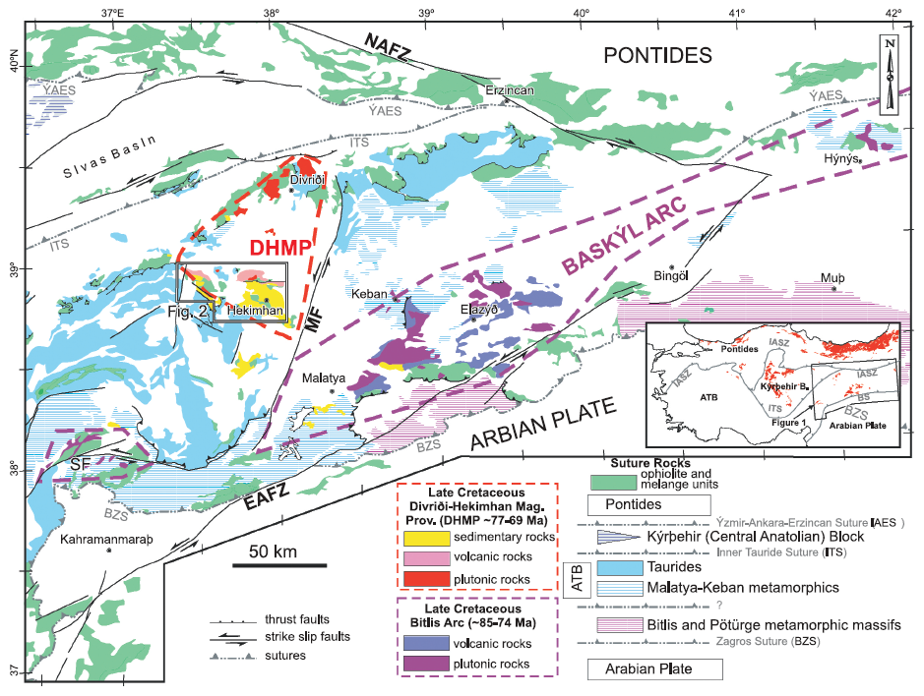

Figure 1.
Simplified regional geological map of central-eastern Anatolia showing the pre-Cenozoic rock units and main tectonic structure. The Inset map shows the distribution of the Upper Cretaceous magmatic units in Anatolia (compiled from a 1:500.000 scaled geological map of Turkey, MTA, and the references in the text). ATB: Anatolide-Tauride Block; İASZ: İzmir-Ankara-Erzincan Suture; ITS: Inner Tauride Suture; BS: Bitlis Suture; DHMP: Divriği-Hekimhan Magmatic Province, NAFZ: North Anatolian Fault Zone; EAFZ: East Anatolian Fault Zone; SF: Sürgü Fault.

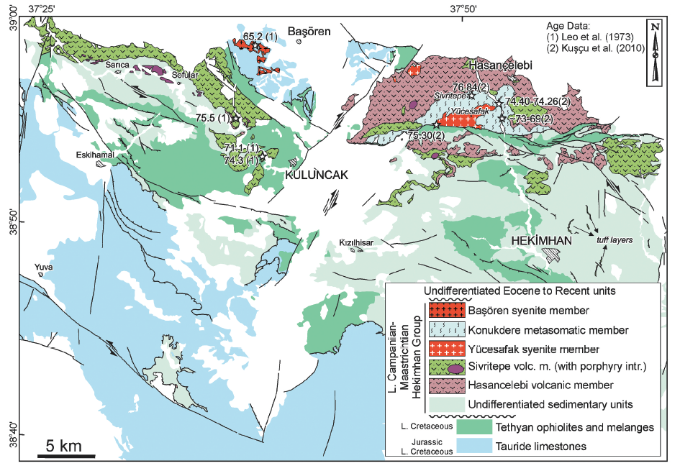
Figure 2.
Geological map of the Hekimhan Basin. Compiled from this study and the references in the text.

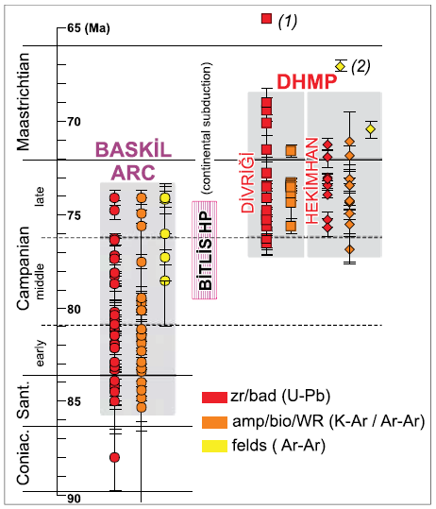

Figure 3.
Compiled age data from the Baskil Arc, Divriği plutons and the Hekimhan Basin (see text for the data source). (1): late-stage gabbro from Divriği region. (2) late-stage foid syenites of the Hekimhan Basin.

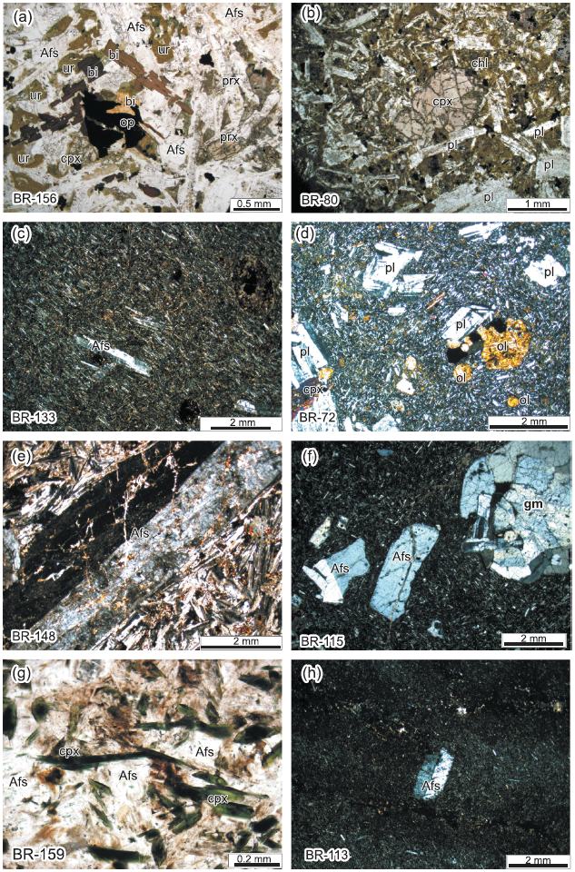
Figure 4.
Photomicrographs of the Hasançelebi (a to d) and Sivritepe (e to g) volcanic members. Afs: alkali feldspar, bi: biotite, chl: chlorite (secondary), cpx: clinopyroxene, gm: glomerophyric Afs, ol: olivine (iddingsitized), pl: plagioclase, sa: sanidine. See text for details.
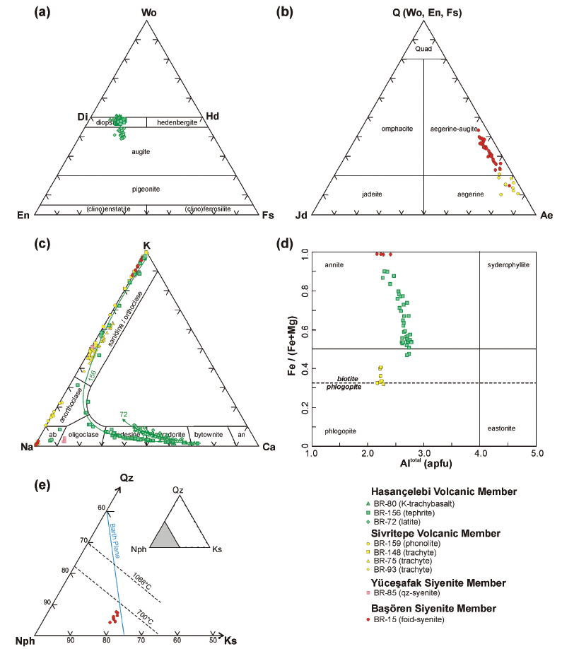

Figure 5. (a) Quadrilateral pyroxene, (b) alkali pyroxene, (c) feldspar, (d) mica, and (e) nepheline classification plots for the magmatic units in the Hekimhan Basin.

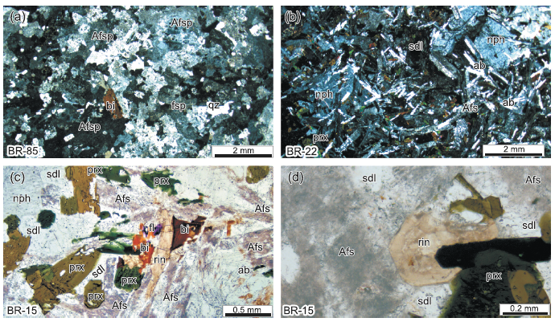

Figure 6. Photomicrographs of the Yüceşafak (a) and Başören (b-d) syenite members. ab: albite, Afs: alkali feldspar, bi: biotite, fl: fluorite, nph: nepheline, prx: pyroxene (aegirine-augite), qz: quartz, rin: rinkite, sdl: sodalite. See text for details.

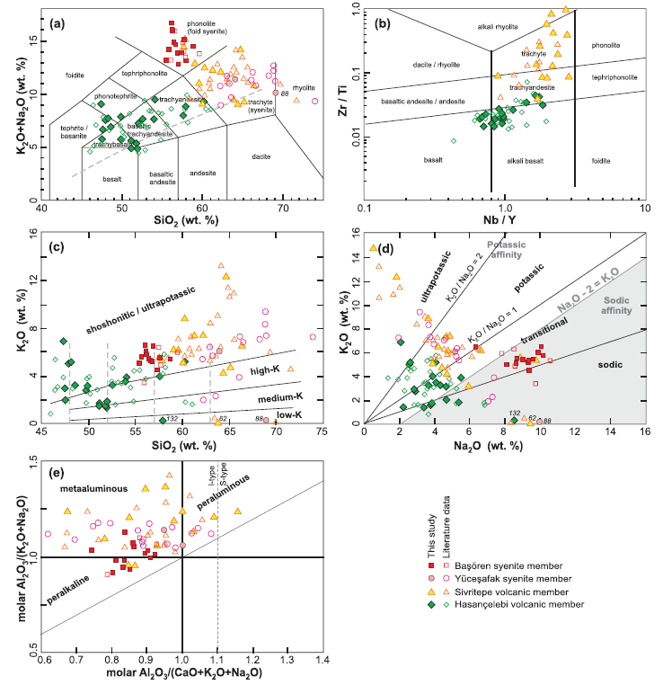

Figure 7. (a) total alkali (K₂O+Na₂O wt. %) vs. silica (SiO₂ wt. %) (TAS) (LeBas et al. 1986), (b) Zr/Ti vs. Nb/Y (Pearce 1996), (c) K₂O vs. SiO₂ (wt. %) (Peccerillo and Taylor 1976), (d) K₂O vs. Na₂O (wt. %), (e) Al₂O₃/Na₂O+K₂O (A/NK) vs. Al₂O₃/CaO+Na₂O+K₂O (A/CNK) (Shand 1927) classification plots for the magmatic units in the Hekimhan Basin.

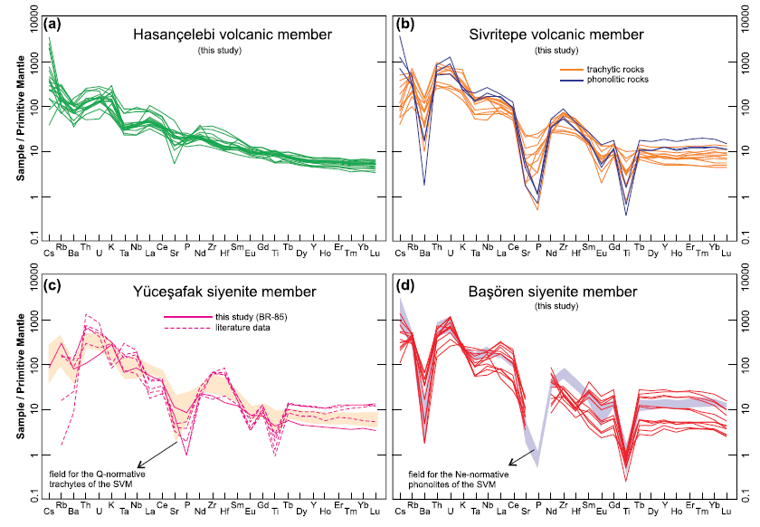

Figure 8. (a to d) Primitive Mantle (PM)-normalized multi-element diagrams for the magmatic units in the Hekimhan Basin. Normalizing factors are from Palme and O’Neill (2004).

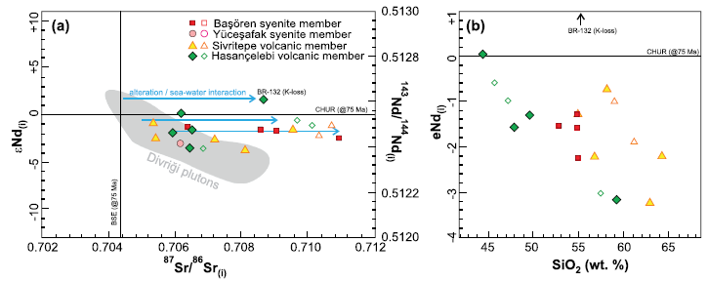

Figure 9. (a) Initial Sr-Nd isotopic ratios and (b) ɛNd vs. SiO₂ (wt. %) plot for the magmatic units in the Hekimhan Basin. The data for the Dİvriği plutons are from Boztug et al. (Boztuğ et al. 2007) and Eyüboğlu et al. (2019).

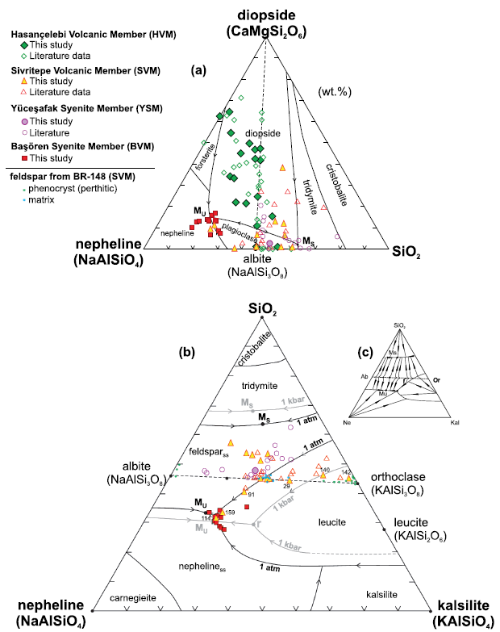

Figure 10. (a) Diopside – Nepheline–SiO₂ (Schairer 1950)and (b) SiO₂–Nepheline – Kalsilite (Tuttle and Bowen 1958; Hamilton and MacKenzie 1965) ternary phase diagrams for the magmatic units in the Hekimhan Basin. (c) Closed-system fractionation paths in the SiO₂–Nepheline – Kalsilite system. See text for details.

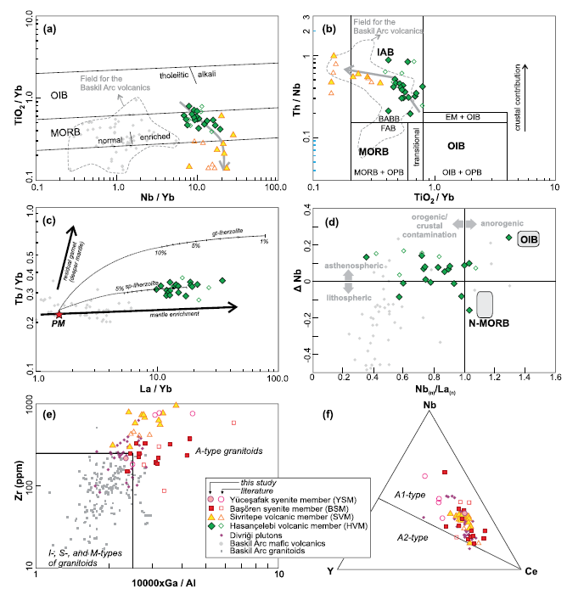

Figure 11. (a) TiO₂/Yb vs. Nb/Yb (Pearce 2008), (b) Th/Nb vs. TiO₂/Yb (Pearce et al. 2021), (c) Tb/Yb vs. La/Yb (Ellam 1992), (d) ΔNb [ = 1.74 + log(Nb/Y) − 1.92 log(Zr/Y); (Fitton et al. 1997)] vs. Nb(n)/La(n) (e) Zr (ppm) vs. 10000×Ga/Al (Whalen et al. 1987), and (f) Nb-Y-Ce ternary (Eby 1992) discrimination plots for the magmatic units in the Hekimhan Basin. The data for the field of Baskil Arc volcanics are from Kürüm and Tanyıldızı (2017), Beyarslan and Bingöl (2018), and Sar et al. (2019). The simple melting models on (c) are calculated using the same parameters in Figure 12.

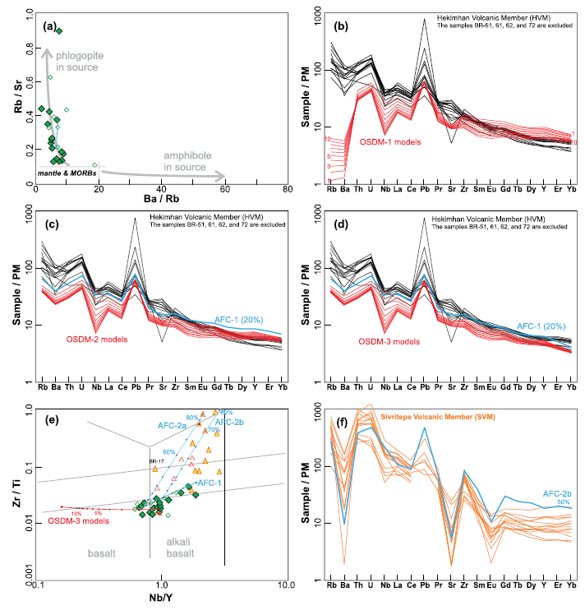

Figure 12. (a) Rb/Sr vs. Ba/Rb plot for the HVM samples (Furman and Graham 1999). (b) Comparison of the Primitive Mantle (PM)- normalized trace element abundances of the HVM with the 1% to 10% partial melts obtained from Open System Dynamic Melting-1 (OSDM-1; Ozawa and Schimizu 1995) of a phlogopite lherzolite (Condamine and Médard 2014) source with Enriched-type Depleted MORB Mantle (E-DMM; Workman and Hart 2005) trace element composition. (c) Comparison of the HVM data with the 1% to 10% partial melts obtained from OSDM-2 of a spinel lherzolite (Kinzler 1997) source with E-DMM composition. Residual melt composition after 20% fractionation (AFC) of the 2% partial melt is also shown. In the AFC-1 model, an assemblage of ol_{0.30}+cpx_{0.69}+mag_{0.01} is fractionated coupled with contamination (r = 0.15) by average Upper Continental Crust (Taylor and McLennan 1995). (d) Comparison of the HVM data with the 1% to 10% partial melts obtained from OSDM-3 of a spinel-garnet lherzolite and the fractionated melt from the AFC-1 model. (e) Zr/Ti vs. Nb/Y ratios of the OSDM-3 and AFC-1 is compared with the samples of the HVM. Additionally, two AFC models (AFC-2a and 2b) calculated from starting compositions of 20% and 70% AFC-1 melts are also compared with the SVM samples. Fractionating mineral assemblage in the AFC-2 models is Afsp₀₆₀+p_{l0.29}+mag_{0.09}+ap_{0.02}. (f) Comparison of the SVM data with the AFC- 2 model melt remained after 50% fractionation. The samples BR-51, 61, 62, and 72 are excluded in (b), (c), and (d). The subduction fluid composition proposed by Eiler et al. (2007) is used as a ‘Subduction Zone Component’ in the OSDM models. Critical porosity for segregation of the melt (Φ), and mass influx rate (β) in all melting models are assumed 1% and 1.0, respectively. See Supplementary Table 3 for the parameters and numerical output.

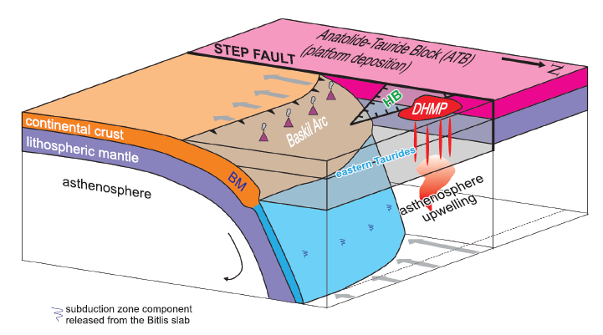
Figure 13. Geodynamic model proposed for the Eastern Anatolian region at~76–72 Ma (adapted from Gallais et al. 2013). BM: Bitlis Massif; HB: Position of the extensional Hekimhan Basin; DHMP: Divriği-Hekimhan alkaline Magmatic Province. See text for the details and discussions.

Tables
Table 1. Summary of the radiometric age data from the magmatic units in the Hekimhan Basin.

Unit | Sample | Rock type | Age | material | method | ref
HVM | 122B | diabase | 75.50±2.10 | Pl | K-Ar | Leo et al. 1978
 | 331 | basanite | 76.84±0.67 | Bio | Ar-Ar | Kuşçu et al. 2010
 | 535335 | diabase | 75.30±0.40 | Zr | U-Pb | Kuşçu et al. 2013
 | 323 | diabase | 74.40±0.51 | Hbl | Ar-Ar | Kuşçu et al. 2010
 | 323 | diabase | 74.26±0.45 | Bio | Ar-Ar | Kuşçu et al. 2010
SVM | 124A | trachyte | 74.30±1.70 | Afs | K-Ar | Leo et al. 1978
(or YSU) | 27D | trachyte | 71.10±1.60 | Afs | K-Ar | Leo et al. 1978
 | 318 | syenite | 71.27±0.29 | Zr | U-Pb | Kuşçu et al. 2010
 | 535319 | syenite | 75.70±0.50 | Zr | U-Pb | Kuşçu et al. 2013
 | 321 | syenite | 71.85±0.48 | Afs | Ar-Ar | Kuşçu et al. 2010
BSU | 53C | neph-syenite | 65.20±1.60 | Afs | K-Ar | Leo et al. 1978

