06 Mar 2023

RH: Meliane et al. • Gazelle ecology in the Sahara

Temporal and spatial distribution of dorcas and slender-horned gazelles in a Saharan habitat
Mohamed Khalil Meliane, Faculty of Science of Tunis, Research Laboratory of Biodiversity, Management and Conservation of Biological Systems, University of Tunis El Manar, El Manar II, 2092 Tunis, Tunisia
Marwell Wildlife, Colden Common, Winchester, SO21 1JH, UK
Amira Saidi, Faculty of Science of Tunis, Research Laboratory of Biodiversity, Management and Conservation of Biological Systems, University of Tunis El Manar, El Manar II, 2092 Tunis, Tunisia
Marwell Wildlife, Colden Common, Winchester, SO21 1JH, UK
Marie Petretto, Marwell Wildlife, Colden Common, Winchester, SO21 1JH, UK
Tania Gilbert, Marwell Wildlife, Colden Common, Winchester, SO21 1JH, UK
School of Biological Sciences, Faculty of Environmental and Life Sciences, University of Southampton, Southampton, UK
Karima Nasri-Ammar, Faculty of Science of Tunis, Research Laboratory of Biodiversity, Management and Conservation of Biological Systems, University of Tunis El Manar, El Manar II, 2092 Tunis, Tunisia

Correspondence: Mohamed Khalil Meliane, Marwell Wildlife, Colden Common, Winchester, SO21 1JH, UK. Email: meliane.medkhalil@gmail.com

ABSTRACT Saharan ungulates have suffered from long-term extensive poaching across their range leading to severe population declines. Low abundance and habitat inaccessibility have limited the availability of empirical data on desert ungulate ecology in the wild. Here, we report results from a study comprising 14,398 camera-days collected between April 2019 and October 2021 in the 7,700 ha fenced area of Jbil National Park (Jbil NP), Tunisia. We aimed to evaluate temporal and spatial distribution, and home-range sizes of wild dorcas gazelles (Gazella dorcas) and slender-horned gazelles (Gazella leptoceros) under natural conditions. Our results showed that both gazelle species exhibited nocturnal activity patterns in summer, but diurnal activity patterns dominated in the winter months. We also detected both species more frequently in the plain habitat than the mountains. Water presence was influential in determining distribution only for dorcas gazelles. Gazelles in Jbil NP were individually identified using unique horn morphology. Minimum Convex Polygons (MCP 95%) areas were 2,062 ha for both the male and female of the most frequently detected dorcas gazelle pair and 1,527 ha for another solitary male. For slender-horned gazelles, areas were 2,280 ha and 2,041 ha respectively for one male and female detected in Jbil NP. The decline and rarity of gazelles in the Sahara Desert have limited the sample size of our observed populations. However, our study provides hitherto unknown data on wild populations of rapidly declining gazelle species and contributes to ongoing conservation efforts.
KEYWORDS Antelope, Conservation, Gazella dorcas, Gazella leptoceros, Home-range, North Africa, Tunisia, Activity patterns

The antelopes of the Sahelo-Saharan region are highly threatened by a combination of anthropogenic factors (Van Velden et al. 2018; Ripple et al. 2019), with scimitar-horned oryx (Oryx dammah), addax (Addax nasomaculatus) and dama gazelle (Nanger dama) extirpated from Tunisia. The remaining species, slender-horned gazelle (Gazella leptoceros), dorcas gazelle (Gazella dorcas), and Cuvier’s gazelle (Gazella cuvieri) are at risk from unsustainable hunting practices, competition with domestic livestock, drought, and climate-change both within Tunisia and more widely across their range (International Union for Conservation of Nature (IUCN) 2016; 2017; IUCN SSC Antelope Specialist Group and Royal Zoological Society of Scotland (RZSS), 2020; Meliane et al. 2023).

Southern Tunisia incorporates the eastern part of the Grand Erg Oriental, the great oriental sand sea, and supports small and declining remnant populations of dorcas and slender-horned gazelle (Meliane et al. 2023). The Cuvier’s gazelle inhabits montane habitat in the North-West of Tunisia, outside of our focal study area of Southern Tunisia. Dorcas gazelles have a wider range across the Sahara and Sahel, but the slender-horned gazelle is a true desert specialist with most of its remaining population restricted to the Saharan ergs in southern Tunisia and eastern Algeria (IUCN 2016).

Recent monitoring of the Saharan habitat in southern Tunisia, has confirmed the rarity of gazelles as only nine slender-horned gazelles were detected over a sampling effort of 1,365 km of aerial transects and 351 km on the ground (Meliane et al. 2023). The significant population decline of gazelles in the wild Saharan habitat has prompted local and international organizations to increase conservation action. Current plans aim to enhance management of protected areas to favor gazelle restoration success, support ex situ conservation, and reintroduce and supplement wild populations with confiscated and ex situ-bred animals (IUCN SSC Antelope Specialist Group and RZSS 2020).

Difficulties in accessing the sand-dominated Saharan habitat along with the declining numbers of animals in the wild have limited the collection of essential empirical data on the ecology of both species. Contrary to other African antelopes such as the mhorr gazelle (Nanger dama mhorr) (Abáigar et al. 2020) or the gemsbok (Oryx gazella) (Ruckstuhl and Neuhaus 2009), activity patterns, spatial distributions and home range sizes of the dorcas and slender-horned gazelles remain largely unknown in their Saharan habitats.

Sourcing ex situ animals for reintroductions has become an increasingly popular conservation tool in restoring extinct or declining wild populations (Gilbert et al. 2017; Lloyd et al. 2019; Roznik and Reichling 2021). These efforts can face difficulties due to differences in behavior exhibited between wild and ex situ-bred animals when released into wild unmanaged conditions (McPhee 2004). Animal behavior can have a dramatic impact on reintroduction success, and it is critical that empirical behavioral data for wild populations is available at the planning stage (Jachowski et al. 2016). Reintroduced animals may exhibit behaviors not previously recorded under ex situ conditions and an understanding of the full behavioral repertoire of a species is crucial to the monitoring, evaluation, and success of reintroduction projects (Rantanen et al. 2015). Available ecological data from wild populations is therefore used to evaluate habitat suitability, assess the speed of adaptation to changing environmental conditions, and evaluate behavioral inconsistencies in reintroduced captive-bred animals (Rantanen et al. 2010; Abáigar et al. 2020).

Part of the remnant dorcas and slender-horned gazelle populations in the Tunisian Sahara, naturally co-occurred in Jbil National Park (Jbil NP) during our study period. The park is located within the Sahara Desert at the north-eastern edge of the Grand Erg Oriental thus offering a unique opportunity for us to collect empirical data on the ecology of dorcas and slender-horned gazelles in their natural habitat. We used motion-sensitive camera data to evaluate the gazelles’ daily activity patterns, spatial distribution, resource use, home range size and their responses to seasonality to provide critical information to target limited conservation resources and develop robust conservation plans for both species.

Thermal stress is a predominant environmental factor determining animal behavior in Saharan habitats. Endothermic species employ a range of metabolic and behavioral adaptations to mitigate thermal stress, notably avoiding the heat of the day during the hottest seasons (Williams et al. 2001, Veldhuis et al. 2020). We hypothesized that dorcas and slender-horned gazelles in Jbil NP will exhibit predominantly nocturnal activity in the summer to reduce exposure to high temperatures. There is no prior investigation on the water utilization of either gazelle species. Unlike species that occur in a wider range of habitats, those endemic to hyper arid habitats are often able to rely on water obtained from their food rather than free water sources (Letnic et al. 2015). Historical anecdotal reports indicate that slender-horned gazelles can survive on water from succulent plants alone (Loder 1894; Schomber and Kock 1960). We therefore hypothesized that the Sahara-specialist slender-horned gazelle would show lower detection rate at artificial water sources than the aridland generalist dorcas gazelle in Jbil NP.

STUDY AREA
Jbil NP (33.102N; 9.061E) is located in the governorate of Kebili, Tunisia, 70 km from the closest town, Douz. The nearest permanent human settlement to Jbil NP is a small military base 5 km away, but temporary nomadic settlements are occasionally found closer to its fences. The legal designation for Jbil NP covers an area of 150,000 ha, but sand dunes have restricted infrastructure building, monitoring, and law enforcement over most of the legally protected area resulting in active conservation management being limited to a 7,700 ha fenced area.
We collected data between April 2019 and October 2021 within the 7,700 ha fenced area of Jbil NP. This area mainly encompasses silt plains interspersed with small dunes and low rocky mountains of c. 60 m in height. Overall site elevation varies between 118 and 184 m above sea level and water sources are exclusively limited to three leaks in a water pipe transferring water from the only well to the main guard post in Jbil NP.
The climate is Saharan with high temperatures and very low precipitation. Mean annual temperature is 21.4° C. The maximum of 39.3° C is recorded in July and the minimum of 5° C in January. Mean annual precipitation is c. 80 mm, with the maximum of 15 mm in January and no precipitation in June and July (Climate-data.org 2022). Conventional seasons in Tunisia are defined as: winter as December, January and February; spring as March, April and May; summer as June, July and August; and autumn as September, October and November (Bargaoui et al. 2014).
Land cover was mainly composed of low Saharan shrub plants namely Arfaj (Rhanterium suaveolens), Beguel (Hammada schmittiana), Jradd (Gymnocarpos decander) and Yesrif (Salsola vermiculata). The only tree species present was Rtamm (Retama raetam), an arid adapted woody plant that grows up to 3 m tall and 6 m wide that occurs less frequently than other shrubs. Predators in Jbil NP included Rüppell’s fox (Vulpes rueppellii), fennec fox (Vulpes zerda), and the more generalist African wolf (Canis lupaster), but it is possible that the area also supported red foxes (Vulpes vulpes) (Meliane et al. 2021). Herbivores were restricted to small rodents, the Cape hare (Lepus capensis), dorcas gazelle, and slender-horned gazelle.

Methods
We deployed motion-sensitive cameras across the study site following a point grid developed in QGIS (QGIS Geographic Information System, 2018) placing 20 cameras (11 Bushnell Aggressor, 4 Bushnell Natureview, 2 Moultrie MCG12631, 1 Moultrie M880, 1 Stealthcam STCD54K and 1 Victure) approximately 2 km from each other to systematically cover the whole of the study area (Figure 1). The position of four cameras, namely CT031, CT122, CT171 and CT201, was offset by c. 500 m to minimise their visibility from outside the park and reduce the risk of interference. We additionally placed three cameras (Bushnell Core Cam) within 50 m of the only water sources in the study area that resulted from leaks in the main water pipe.
Differences in Fresnel lens characteristics across the motion-sensitive camera models can impact detection probabilities especially in multi-species studies (Hofmeester et al. 2019). Camera-model homogeneity is hard to achieve as manufacturers periodically discontinue production of older models and equipment has shorter lifespans in arid sandy environments. We maintained a fixed camera-height and angle, using the shortest possible trigger and recovery times, and targeted species with similar body size, home-range size and diet to reduce detection-related biases as recommended for studies of spatial distributions (Hofmeester et al. 2019; Apps and McNutt 2018). We placed cameras on standard photography tripods at c. 60 cm of height to capture medium to large-bodied animals (>1kg) (Lyra-Jorge et al. 2010). To favor detection of animals under low densities, we aimed cameras at visible repetitive animal passage tracks. We set all cameras to take a series of three photographs at the highest image quality when triggered. We also set the intervals between triggers to the lowest value allowed by the camera model (0.6 seconds to 5 seconds) to reduce biases in detection probability and enhance the probability of obtaining several photos of an animal to enable individual identification using horn morphology.
We checked the cameras 24h after setup, and bi-monthly thereafter to reduce disturbance at the study site whilst ensuring correct functioning and positioning of the devices. We compiled a database summarising each capture event by camera ID/location, time, date and temperature as recorded by the device, identified species and number of visible animals in each event. In the case where we obtained repeated consecutive captures of the same individual e.g. a dorcas gazelle grazing in front of the camera for an extended period of time, we created a new record after each 30-minute period to account for the species activity during that time of day.

Daily activity patterns
The motion-sensitive cameras only detected animals when they were active. For the following analysis, we assumed the detection of an animal as indicative of its activity and considered variation in temporal detection frequency a reflection of the activity pattern of the focal species (Rowcliffe et al. 2014).
We calculated kernel densities of species’ activity patterns using R package “Activity” (Rowcliffe et al. 2014), with 95% confidence intervals from 1000 bootstrap samples.

Spatial distribution
To describe the gazelles’ spatial distribution in Jbil NP, we focused on two main environmental variables in the park: habitat type and water availability. We set motion-sensitive cameras within 50 m of water aimed at animal passage trails to optimize species identification and monitor water source usage in Jbil NP. We also categorised habitat type as either ‘mountain’, for motion-sensitive cameras set on mountains, or ‘plain’. Whilst the targeting of animal passage trails likely improves the detection of gazelles especially under low abundance conditions, it reduces applicability when extrapolating detection rates to the area surrounding the sampled microsite (e.g. larger quadrat around the sampled site).
Visualisation of the data revealed few detections indicative of small population sizes. Additionally, monitoring of Jbil NP’s fence lines by park staff indicated that sand dunes had accumulated across fences allowing the migration of approximately 60% of gazelles out of the study area in the latter stages of our study in August 2020. Very small population sizes and the openness of the gazelle populations in Jbil NP limited options for statistical analyses of their spatial distributions. To account for these factors, we calculated the Relative Abundance Index (RAI) for each of the previously defined environmental categories by dividing the number of detections by the number of days the camera was active x100 (O’Connell et al. 2010). RAI has limitations for use as an index in comparing relative abundance between different species and sites, but Sollmann et al. (2013) attributed these limitations to interspecific changes in life history traits amongst the monitored species and to differences in study design across sites. Here, we used a consistent sampling design at one site and focused on two ecologically and morphologically similar gazelle species (Furley et al. 1986) thus limiting life history trait and sampling design related biases.
We calculated naïve occupancy as a second measure of relative abundance. Here we define naïve occupancy within each environmental category as the ratio of monitored stations that detected the focal species. Compared to the more statistically demanding “Occupancy” that requires a large closed population for robust model fitting (MacKenzie et al. 2002), RAI and naïve occupancy do not have such stringent underlying assumptions. Whilst not correcting for imperfect detections, these indexes are appropriate and enable us, through careful sampling setup and interpretation, to offer insights into the species’ distribution despite small populations in the wild. The use of fixed sampling designs in combination with high sampling effort and targeting species with similar life history traits reduces the effect of imperfect detection on derived relative abundance estimates (Ewing and Gangloff 2016).

Naïve occupancy values vary between 0 and 1 indicating that detections were either absent (0) or present (1) across all surveyed stations. RAI can also equal 0 when there are no detections for the surveyed stations and increases with the number of detections per sampling effort. Linear regression analysis was applied to the RAI data of both species to examine the statistical difference in relative abundance of the two gazelle species between habitat variables.

Home-range size
We carried out individual identification of gazelles in Jbil NP using horn morphology variations. This criterion is applied in the individual identification of antelopes when ear-tags or other more obvious markings are absent (Gibbon et al. 2015). Whilst horn shapes are not as obvious as unique pelage patterns, there are sufficient morphological differences and horn breakages between animals to enable individual identification. Two authors of this study who had extensive direct experience working with North African antelopes and gazelles independently individually identified gazelles and reached a consensus. We considered the shape of the tip of the horn, its initial slope, or bi-lateral symmetry as our main criteria (Figure 2).
We used the package AdehabitatHR (Calenge 2011) to calculate MCP 95% in R software (R Core Team 2022), then used Raster package (Hijmans 2015) to export shapefiles for mapping and computation of overlap areas. Minimum Convex Polygons (MCP) at 95% are often used to estimate home-range sizes from camera-trapping data especially for species with limited abundance (Srivathsa et al. 2017; Kumbhojkar et al. 2020). The method offers insight into threatened and cryptic species home-range sizes without the need for intrusive capture, manipulation, tagging and tracking.

Results
We obtained 1,150 animal detections over a sampling effort of 14,398 camera-days. Of these, 254 detections were of dorcas gazelles and 19 of slender-horned gazelles.

Daily activity patterns
Dorcas gazelle seasonal detection counts were distributed as follows: 22 in winter, 49 in spring, 152 in summer, and 31 in autumn; and for slender-horned gazelles: 7 in winter, none in spring, 10 in summer, and 2 in autumn.
To ensure that plots were representative, we applied kernel density estimation to data of the dorcas gazelle and limited our graphical presentation for slender-horned gazelles to the summer and winter detections. We observed a noticeable shift in daily activity for the dorcas gazelle between winter and summer (Figure 3). Day-time activity was more prevalent in the colder season with limited nocturnal activity. During the summer, nocturnal activity increased at the expense of day-time activity most noticeably around mid-day when no activity was detected. Activity levels were comparable between autumn and winter where day-time activity was favoured. During spring, patterns were dispersed throughout the day.
Whilst the lower detection rate of slender-horned gazelles prevented us from statistically estimating kernel densities and confidence intervals, plots indicate a similar response to seasonality as observed for the dorcas gazelle. The higher number of detections during winter days suggests a higher activity during this phase compared to the summer when nocturnal activity becomes more prevalent (Figure 3).

Spatial distribution
Naïve occupancy values for the dorcas gazelle were equal to 1 indicating detections of the species across all surveyed stations in Jbil NP in both plain and mountain habitats. The RAI values were 4.75 in the plain habitat around four times higher than those calculated for mountain habitat (1.14). RAIs calculated near water sources (21.27) were more than thirty times higher than those calculated away from water sources within the same plain habitat (0.62; table 1A).
For slender-horned gazelles, naïve occupancy values were lower than those for the dorcas gazelle. Both naïve occupancy and RAI values for slender-horned gazelle were higher in the plain habitat than the mountains suggesting a higher occurrence in the former habitat type. In contrast to the dorcas gazelles, the slender-horned gazelle’s spatial distribution in the plain habitat, showed no use of water resources with RAI and naïve occupancy values equal to 0 for cameras near water, indicating no detections (table 1B).

Home-range size
We mostly observed solitary dorcas gazelles (92.1%) or pairs (6.7%) whilst we observed a group of three twice (0.8%) and a group of four only once (0.4%). For slender-horned gazelles we either observed solitary animals (63.2%) or pairs (36.8%). Of the total 254 dorcas and 19 slender-horned gazelle detections, only 101 and 16, respectively, included photos of sufficient quality to enable individual identification through horn-morphology variations. This revealed the presence of at least eight dorcas and two slender-horned gazelle individuals. The number of independent photographic detections of individual gazelles varied between 1 and 56 for four male and four female dorcas individuals, and between 9 and 13 for one male and one female slender-horned gazelle individuals (Appendix A).
We used detection data for three dorcas gazelles with a minimum of four camera locations in their MCP 95% and the detections data of the slender-horned gazelle pair to estimate home-range sizes (Figure 4; Appendix B).
We observed a complete overlap between the home-ranges of the male (DM1) (n=56 detections) and the female (DF1; n=9 detections) indicating a stable social group of a pair over an area of 2,062 ha (Figure 5A, 5B). Dorcas gazelle male DM2 was solitary with a home-range area of 1,527 ha. Home range estimates showed similar sizes for the slender-horned gazelle pair (SHM1 and SHF1; Figure 5D and 5E) with the male’s (n = 13 detections) home-range covering 2,280 ha whilst the female’s (n = 9 detections) home range covered 2,041 ha.
The dorcas and slender-horned gazelle males showed an overlap of 653 ha of their home-ranges. This constitutes 31.66% of the former’s and 28.63% of the latter’s home-range.

Discussion
The arid Saharan habitat presents considerable challenges to naïve individuals necessitating rapid behavioral adaptation to substantial temperature variations across daily and yearly cycles (Castillo-Ruiz et al. 2012). These challenges become apparent and can be addressed through adaptive conservation management once we understand how wild individuals respond to the complex environmental conditions found in their native habitat. Responses to heat stress are a critical factor shaping diel activity patterns of endothermic species. Species shift their diel patterns to avoid hotter times of the day depending on habitat characteristics (Veldhuis et al. 2020; Vellejo-Vargas et al. 2022). In our study, daily activity patterns demonstrated a noticeable response to seasonality from both dorcas and slender-horned gazelles. Whilst not as conclusive, the less abundant slender-horned gazelle increased its nocturnal activity during the summer at the expense of the high day-time presence observed during the winter. The shifting of activity patterns in response to environmental variables should be a major component of both species’ fitness in the Saharan environment and activity patterns should be assessed in future reintroductions to evaluate behavioral inconsistencies in ex situ-bred animals (McPhee 2004; Macdonald, 2009).
Our study of the spatial distribution of dorcas and slender-horned gazelles revealed water presence as a partitioning factor of habitat use for gazelles. Dorcas gazelles exhibited exclusive and very high relative abundance at sites with free water whilst slender-horned gazelles were not detected near this resource. Such segregation could be indicative of the importance of the resource to the potentially more water-dependent dorcas gazelles whilst also indicating the capacity of the slender-horned gazelles to rely completely on other sources such as succulent perennial plants for their water requirements.
We applied non-invasive individual identification using camera captures to estimate population and home-range sizes (Kumbhojkar et al. 2020). The method’s limitations may have resulted in an underestimate of the true size of the home-range as unlike other monitoring tools (telemetry collars, etc.), stationary motion-sensitive cameras do not account for the animal’s movements past and between surveyed stations (Srivathsa et al. 2017). By focusing on the most detected animals, we aimed to reduce such bias. Our calculation of MCP 95% areas estimated home-range sizes that exceed 2,000 ha for pairs of dorcas and slender-horned gazelles. In the Negev desert a previous study estimated comparable home-range sizes equal to 2,500 hectares with pairs being the largest social structure in harsh conditions (Baharav 1980; Yom-tov et al. 1995). Gazelle home-range sizes in the Sahelo-Saharan region are known to be large probably because of the low habitat productivity (Leith 1975). For the Mhorr gazelle, home-range sizes were previously estimated using GPS collars in a Saharan national park in Morocco to range between 8,200 ha and 15,330 ha (Abaigar et al. 2020). Whilst our results indicate that dorcas and slender-horned gazelles seem to exhibit around 30% of inter-species home-range overlap, their high area needs in arid habitats indicate the current insufficiency of the conservation area within Jbil NP to host viable populations of either species. The fenced conservation area covers only 7,700 ha, and the home-range areas for one pair of slender-horned or dorcas gazelle therefore exceeded 25% of the available area.

Conservation Implications
Dorcas and slender-horned gazelles suffer a lack of empirical data on their ecology in their indigenous Saharan habitat in North-Africa. To address this knowledge gap, we took advantage of a unique opportunity to evaluate the temporal and spatial distribution of both gazelle species in their indigenous range in key protected area north-east in the Sahara desert, Tunisia. Our results contribute vital information to the ongoing international efforts to conserve and restore populations of dorcas and slender-horned gazelle. Availability of activity pattern data for wild populations will facilitate an improved understanding of behavior and activity in restored populations especially those that utilize captive-bred gazelles. Water management should be a central part of dorcas gazelle conservation in similar arid habitats and future management decisions should account for the large home-range sizes and area requirements of both species to ensure viable populations and impactful conservation action.

Acknowledgments
We would like to acknowledge the long-term research and conservation partnership between Marwell Wildlife and the Direction Générale des Forêts (Ministry of Agriculture, Fisheries and Water Resources, Tunisia) which made this work possible. Thanks go to M. Boufaroua, E. Taghouti, H. Guidara, M. Bourouba, B. Ben Amor and I. Ben Jlila for their assistance in permitting and facilitating fieldwork. We also thank O. Meliane for her beautiful illustration of gazelle horn variations in Jbil’s gazelles.
This work was funded by Marwell Wildlife, Dublin Zoo, Safari Parc Monde Sauvage, Fossil Rim, Parco Faunistico Le Cornelle, Wrocław Zoo, Foundation DODO, Artis Amsterdam Royal Zoo and Branféré Parc Animalier et Botanique.

ETHICS STATEMENT

Gazelle monitoring for the purpose of this study was achieved through motion-sensitive cameras. No animals were caught or manipulated for the purpose of this study. Motion-sensitive Camera studies in Southern Tunisia have been subject to Marwell Wildlife’s ethical review process.

REFERENCES
Abáigar, T., C. Martínez, Z. Amaouch, M. Alifal, A. Lemdimigh, S. El Makki, M. El Mokhtar, M. L. Samlali, P. Fernández de Larrínoa, and E. Rodriguez-Caballero Almería. 2020. Habitat requirements of the Mhorr gazelle: What does this species need to survive in the wild? Global Ecology and Conservation 24:e01389.
Apps, P.J. and McNutt, J.W. 2018. How camera traps work and how to work them. African Journal of Ecology, 56:702-709.
Baharav, D. 1980. Habitat utilization of the dorcas gazelle in a desert saline area. Journal of Arid Environments 3:161-167.
Bargaoui, Z., Tramblay, Y., Lawin, E. A., & Servat, E. 2014. Seasonal precipitation variability in regional climate simulations over Northern basins of Tunisia. International Journal of Climatology, 34(1), 235-248.
Calenge, C. 2011. The package “adehabitat” for the R software: a tool for the analysis of space and habitat use by animals. Ecological modelling 197(3-4), 516-519
Castillo-Ruiz, A., Paul, M. J., and Schwartz, W. J. 2012. In search of a temporal niche: social interactions. Progress in brain research 199, 267-280.
Climate data org. 2022. Climate data database. < https://en.climate-data.org>. Accessed 8 Dec 2022.
Ewing, T., and Gangloff, M. 2016. Using changes in naïve occupancy to detect population declines in aquatic species; case study: Stability of Greenhead Shiner in North Carolina. Journal of the Southeastern Association of Fish and Wildlife Agencies 3, 1-5.
Furley, C. W. 1986. Reproductive parameters of African gazelles: gestation, first fertile matings, first parturition and twinning. African Journal of Ecology, 24(2), 121-128.
Gibbon, G. E., Bindemann, M., and Roberts, D. L. 2015. Factors affecting the identification of individual mountain bongo antelope. PeerJ 3, e1303.
Gilbert, T., Gardner, R., Kraaijeveld, A.R. and Riordan, P. 2017. Contributions of zoos and aquariums to reintroductions: historical reintroduction efforts in the context of changing conservation perspectives. International Zoo Yearbook 51: 15-31.
Hijmans, R. J., Van Etten, J., Cheng, J., Mattiuzzi, M., Sumner, M., Greenberg, J. A. and Hijmans, M. R. J. 2015. Package ‘raster’. R package, 734.
Hofmeester, T.R., Cromsigt, J.P., Odden, J., Andrén, H., Kindberg, J. and Linnell, J.D. 2019. Framing pictures: A conceptual framework to identify and correct for biases in detection probability of camera traps enabling multi‐species comparison. Ecology and Evolution, 9(4), pp.2320-2336.
IUCN SSC Antelope Specialist Group. 2016. Gazella leptoceros. The IUCN Red List of Threatened Species 2016. Accessed on 08 Dec 2022.
IUCN SSC Antelope Specialist Group. 2017. Gazella dorcas. The IUCN Red List of Threatened Species 2017. Accessed on 08 Dec 2022.
IUCN SSC ASG and RZSS. 2020. Gazelle leptocère (Gazelle leptoceros): Stratégie de conservation 2020-2029. IUCN SSC Antelope Specialist Group and Royal Zoological Society of Scotland.
Jachowski, D. S., Bremner-Harrison, S., Steen, D. A., & Aarestrup, K. 2016. Accounting for potential physiological, behavioral, and community-level responses to reintroduction. In Reintroduction of fish and wildlife populations: 185-215. University of California Press.
Kumbhojkar, S., Yosef, R., Mehta, A. and Rakholia, S. 2020. A Camera-Trap Home-Range Analysis of the Indian Leopard (Panthera pardus fusca) in Jaipur, India. Animals 10(9), 1600.
Letnic, M., Laffan, S. W., Greenville, A. C., Russell, B. G., Mitchell, B. and Fleming, P. J. 2015. Artificial watering points are focal points for activity by an invasive herbivore but not native herbivores in conservation reserves in arid Australia. Biodiversity and Conservation 24(1), 1-16.
Lieth, H. 1975. Modeling the primary productivity of the world. In Primary productivity of the biosphere (pp. 237-263). Springer, Berlin, Heidelberg.
Lloyd, N. A., Hostetter, N. J., Jackson, C. L., Converse, S. J., and Moehrenschlager, A. 2019. Optimizing release strategies: a stepping‐stone approach to reintroduction. Animal Conservation 22(2), 105-115.
Loder E.G. 1894. On the “Reem” antelope of Algeria. Pages 473–476 in Proceedings of the 1894 convention of Zoological Society of London. .
Lyra-Jorge, M. C., Ribeiro, M. C., Ciocheti, G., Tambosi, L. R. and Pivello, V. R. 2010. Influence of multi-scale landscape structure on the occurrence of carnivorous mammals in a human-modified savanna, Brazil. European Journal of Wildlife Research 56(3), 359-368.
Macdonald, D.W. 2009. Lessons learnt and plans laid: seven awkward questions for the future of reintroductions. In: Hayward, M., Somers, M. (Eds.), Reintroduction of Top-Order Predators. Wiley-Blackwell, Oxford, pp. 411–448.
MacKenzie, D. I., Nichols, J. D., Lachman, G. B., Droege, S., Andrew Royle, J., & Langtimm, C. A. 2002. Estimating site occupancy rates when detection probabilities are less than one. Ecology 83(8), 2248-2255.
McPhee, M. E. 2004. Generations in captivity increases behavioral variance: considerations for captive breeding and reintroduction programs. Biological conservation 115(1), 71-77.
Meliane, M. K., M. Petretto, A. Saidi, P. Riordan, T. Woodfine, H. Guedara, S. Mahdhi, and T. Gilbert. 2023. Finding slender-horned gazelles in the Sahara’s Grand Erg Oriental, Tunisia. Journal of Arid Environments 208:104874.
Meliane, M. K., Saidi, A., Boufaroua, M., Petretto, M., Riordan, P., and Gilbert, T. 2021. Rüppell's fox (Vulpes rueppellii) and its habitat in Jbil National Park, Tunisia. African Journal of Ecology 59(2), 535-537.
O’Connel, A., Nichols, J. D., and Karanth, K. U. 2011. Camera traps in animal ecology: methods and analyses (Vol. 271). A. F. O'Connell (Ed.). New York: Springer.
QGIS.org 2018. QGIS Geographic Information System. QGIS Association. http://www.qgis.org
R Core Team, 2022. R: A language and environment for statistical computing. R Foundation for Statistical Computing, Vienna, Austria. https://www.R-project.org/.
Rantanen, E. M., Buner, F., Riordan, P., Sotherton, N., and Macdonald, D. W. 2010. Habitat preferences and survival in wildlife reintroductions: an ecological trap in reintroduced grey partridges. Journal of Applied Ecology 47(6), 1357-1364.
Rantanen, E., D. W. Macdonald, N. Sotherton, and F. Buner. 2015. Improving reintroduction success of the grey partridge using behavioral studies. Pages 241–254 in D. W. Macdonald and R. E. Feber, editors. Wildlife Conservation on Farmland. Oxford University Press.
Ripple, W. J., Wolf, C., Newsome, T. M., Betts, M. G., Ceballos, G., Courchamp, F. and Worm, B. 2019. Are we eating the world's megafauna to extinction?. Conservation Letters 12(3), e12627.
Rowcliffe, J. M., Kays, R., Kranstauber, B., Carbone, C. and Jansen, P. A. 2014. Quantifying levels of animal activity using camera trap data. Methods in ecology and evolution 5(11), 1170-1179.
Roznik, E. A., and Reichling, S. B. 2021. Survival, movements and habitat use of captive‐bred and reintroduced dusky gopher frogs. Animal Conservation 24(1), 51-63.
Ruckstuhl, K. E., and Neuhaus, P. 2009. Activity budgets and sociality in a monomorphic ungulate: the African oryx (Oryx gazella). Canadian Journal of Zoology, 87(2), 165-174.
Schomber H.W., Kock D. 1960. The wildlife of Tunisia. Part 2. Some larger mammals. African Wildlife 14:277-82.
Sollmann, R., Mohamed, A., Samejima, H., and Wilting, A. 2013. Risky business or simple solution–Relative abundance indices from camera-trapping. Biological Conservation 159, 405-412.
Srivathsa, A., Kumar, N. S. and Karanth, K. U. 2017. Home range size of the dhole estimated from camera-trap surveys. Canid Biology and Conservation.
van Velden, J., Wilson, K., and Biggs, D. 2018. The evidence for the bushmeat crisis in African savannas: a systematic quantitative literature review. Biological Conservation 221, 345-356.
Veldhuis, M.P., Hofmeester, T.R., Balme, G., Druce, D.J., Pitman, R.T. and Cromsigt, J.P. 2020. Predation risk constrains herbivores’ adaptive capacity to warming. Nature Ecology & Evolution, 4(8).1069-1074.
Vallejo-Vargas, A.F., Sheil, D., Semper-Pascual, A., Beaudrot, L., Ahumada, J.A., Akampurira, E., Bitariho, R., Espinosa, S., Estienne, V., Jansen, P.A. and Kayijamahe, C. 2022. Consistent diel activity patterns of forest mammals among tropical regions. Nature Communications, 13(1), p.7102.
Williams, J. B., Ostrowski, S., Bedin, E. and Ismail K. 2001. Seasonal variation in energy expenditure, water flux and food consumption of Arabian oryx Oryx leucoryx. Journal of Experimental Biology 204(13), 2301-2311.
Yom-Tov, Y., Mendelssohn, H. and Groves, C. P. 1995. Gazella dorcas. Mammalian species (491), 1-6.

Figure Captions
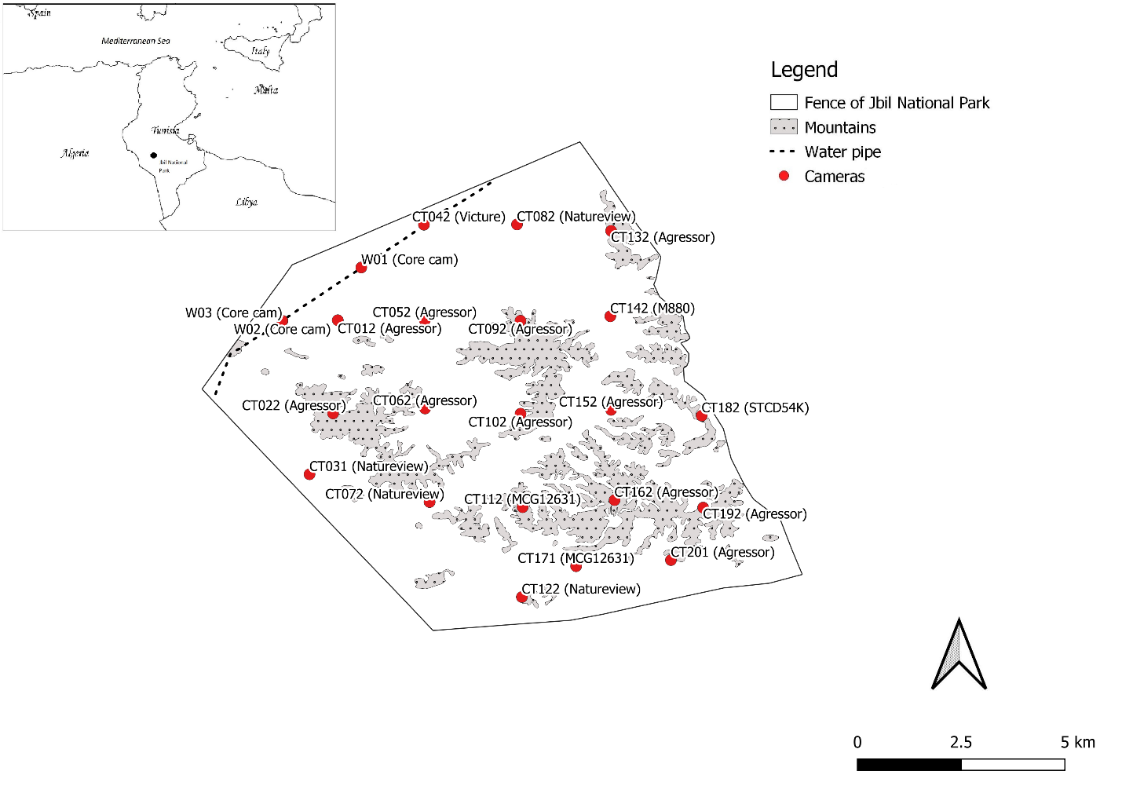
Figure 1. Camera locations and models set between April 2019 and October 2021 within the fenced area of Jbil National Park, Tunisia. “CT” designates systematically placed cameras. CT 042 was placed near a water source in addition to cameras designated by “W” that were placed to monitor water source use. At the top left corner: map of the north-African region and location of Jbil National Park in Tunisia.
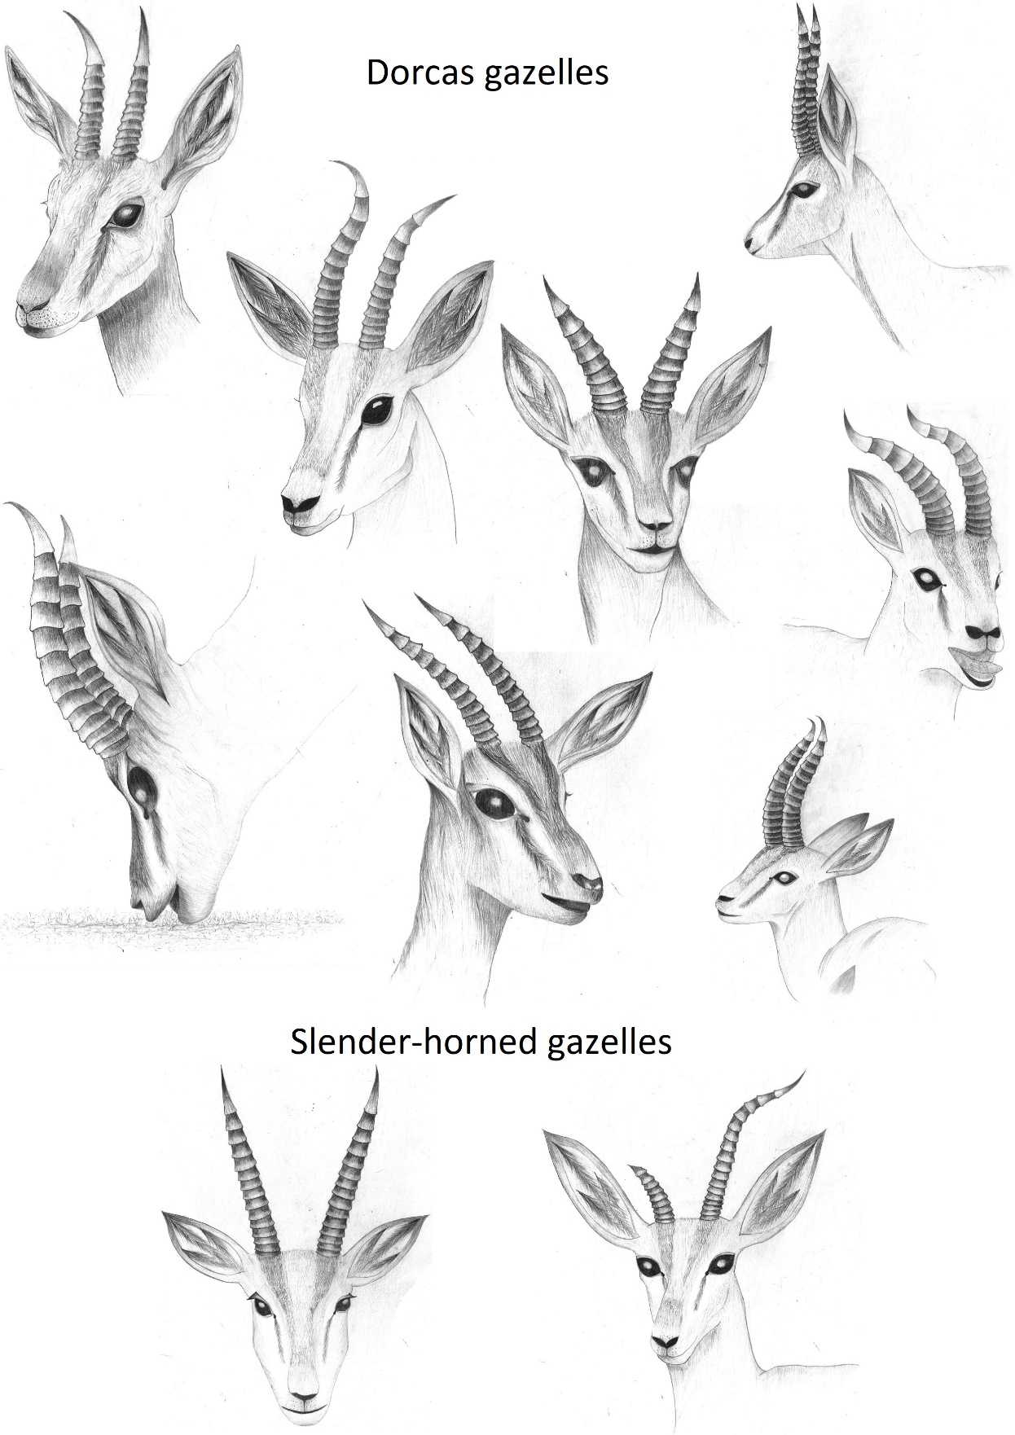
Figure 2. Morphological variations of dorcas and slender-horned gazelle horns observed in Jbil National Park, Tunisia 2019-2021.
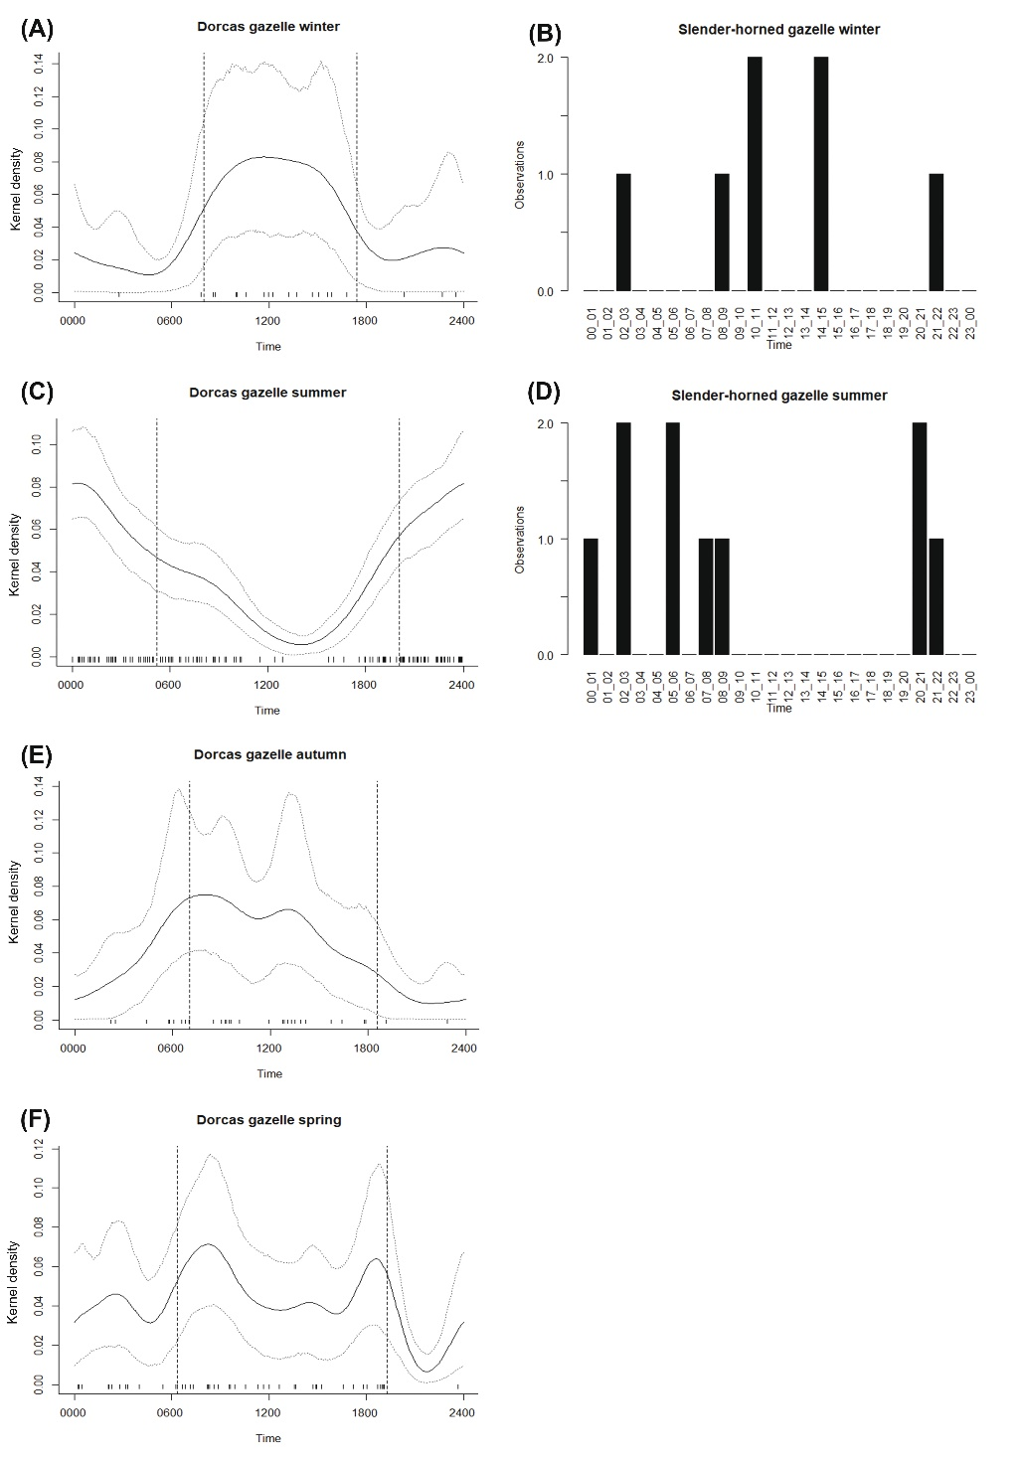
Figure 3. Seasonal patterns of daily activity of dorcas gazelles and slender-horned gazelles in Jbil National Park, Tunisia 2019-2021. Kernel density activity estimates for dorcas gazelles on y-axis with 95% confidence intervals in dotted grey lines. Tick marks on the x-axis show times of independent observations used to estimate the activity pattern. Average sunrise and sunset times for each season in black dashed vertical lines. The number of observations on y axis for slender-horned gazelles.
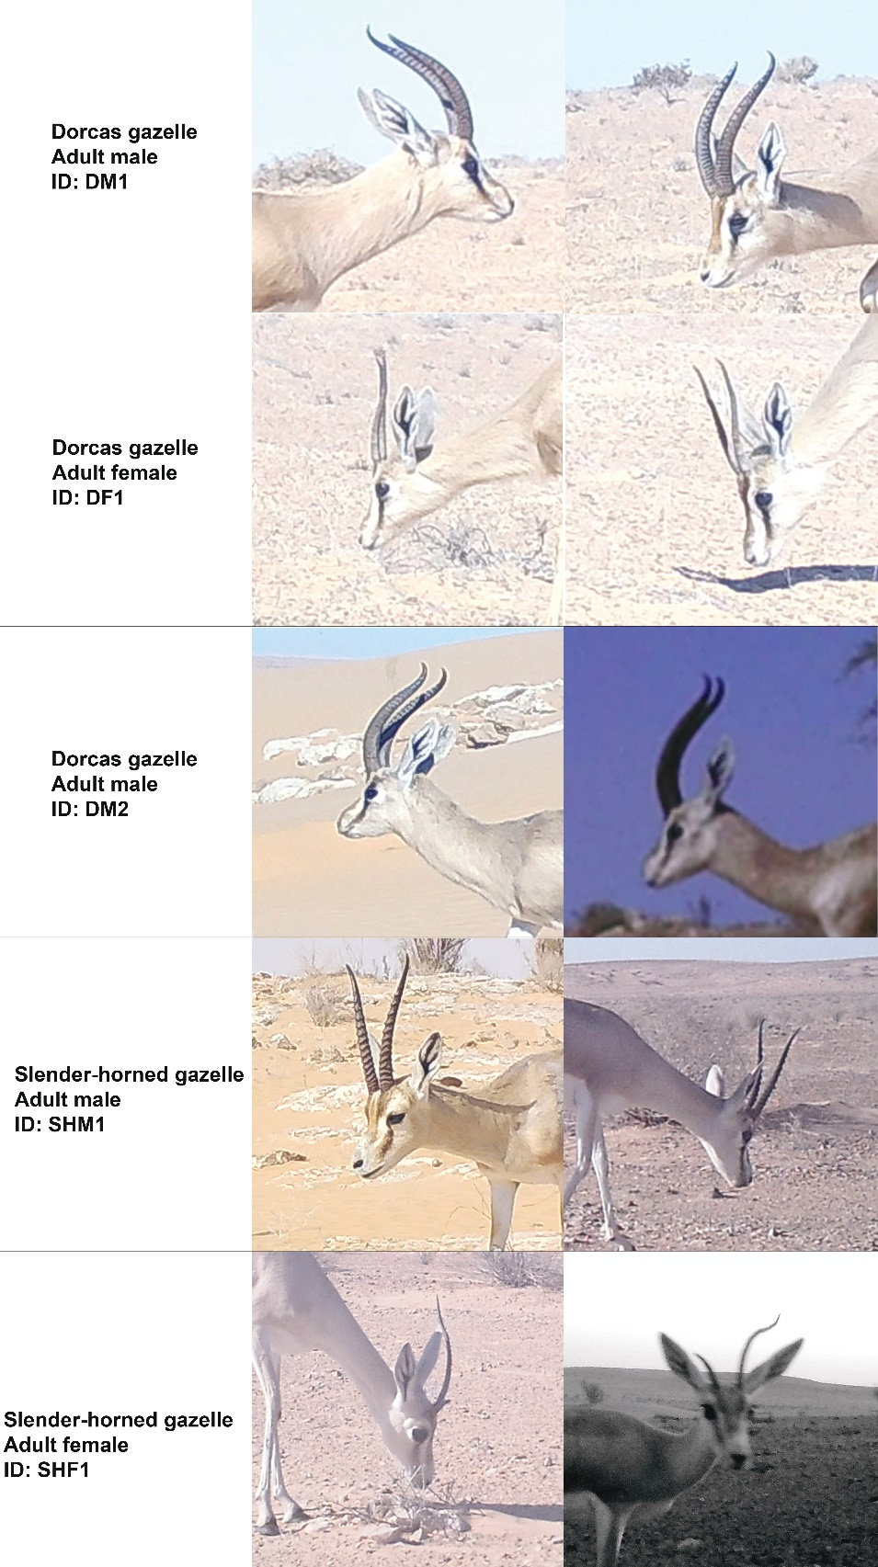
Figure 4. Close-ups of camera-trap photos highlighting horn morphology differences observed in the most frequently detected dorcas and slender-horned gazelles identified in Jbil National Park, Tunisia 2019-2021. Each row shows two photographs for the same individual gazelle.
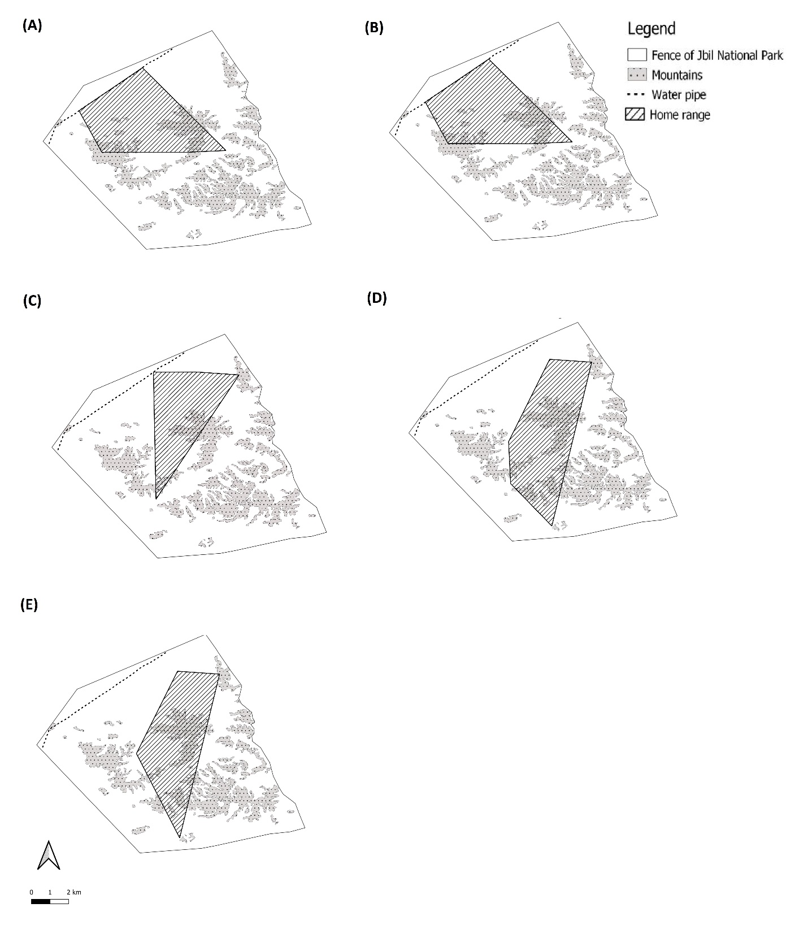
Figure 5. Home-range maps of the most detected dorcas (plots A, B & C) and slender-horned gazelle pairs (plots D & E) in Jbil National Park, Tunisia 2019-2021.

Tables

Table 1. Average (standard error) values of relative abundance indexes and naive occupancy of dorcas and slender-horned gazelles in Jbil national park, Tunisia 2019-2021. Significant differences (p < 0.05) are indicated by an asterisk after the values.
A. Dorcas gazelle spatial distribution
Analysis | Environmental variable | Number of camera stations | Effort Camera days | Number of detections | Relative Abundance Index | Naïve Occupancy
Mountains and plains | Mountains | 7 | 5173 | 60 | 1.14 (0.57) | 1
 | Plains | 16 | 9225 | 194 | 4.75 (2.23) | 1
Plains near water and plains far from water | Near water | 4 | 770 | 144 | 21.27 (1.5)* | 1
 | Far from water | 12 | 8455 | 50 | 0.62 (0.15) | 1

B. Slender-horned gazelle spatial distribution
Analysis | Environmental variable | Number of camera stations | Effort Camera days | Number of detections | Relative Abundance Index | Naïve Occupancy
Mountains and plains | Mountains | 7 | 5173 | 2 | 0.04 (0.04) | 0.14
 | Plains | 16 | 9225 | 17 | 0.2 (0.14) | 0.33
Plains near water and plains far from water | Near water | 4 | 770 | 0 | 0 | 0
 | Far from water | 12 | 8455 | 17 | 0.24 (0.18) | 0.42

