**Efficacy and safety of fitusiran prophylaxis in people with severe haemophilia A or B without inhibitors (ATLAS-A/B): a multicentre, open-label, randomised Phase 3 trial**

Prof. Alok Srivastava, MD1,2; Prof. Savita Rangarajan, MD3,4; Prof. Kaan Kavakli, MD5; Robert Klamroth, MD6; Prof. Gili Kenet, MD7; Liane Khoo, MD, PhD8; Prof. Chur-Woo You, MD9; Weiqun Xu, MD, PhD10; Niel Malan, MD11; Laurent Frenzel, MD, PhD12; Catherine N. Bagot, MD13; Oleksandra Stasyshyn, MD, PhD14;Chia-Yau Chang, MD15; Stacey Poloskey, MD16; Zhiying Qiu, PhD17; Shauna Andersson, MD, PhD16; Baisong Mei, MD, PhD16; Prof. Steven W. Pipe, MD18

*1Department of Haematology, Christian Medical College, Vellore, India; 2Centre for Stem Cell Research (a unit of inStem, Bengaluru), CMC Campus, Vellore, India; 3KJ Somaiya Super Specialty Hospital, Mumbai, India; 4Faculty of Medicine, University of Southampton, Southampton, UK; 5Department of Haematology, Ege University Faculty of Medicine, Children's Hospital, Izmir, Turkey; 6Department for Internal Medicine and Vascular Medicine, Haemophilia Treatment Centre, Vivantes Hospital im Friedrichshain, Berlin, Germany; 7The National Haemophilia Centre, The Amalia Biron Thrombosis Research Institute, Sheba Medical Centre, Tel Hashomer, Tel Aviv University, Tel Aviv, Israel; 8Haematology Department, Royal Prince Alfred Hospital, Sydney, Australia; 9Department of Pediatrics, Daejeon Eulji Medical Center, Eulji University School of Medicine, Daejeon, South Korea; 10Department of Hematology and Oncology, The Children's Hospital, Zhejiang University School of Medicine, National Clinical Research Center for Child Health, Hangzhou, People's Republic of China; 11Phoenix Pharma, Port Elizabeth, South Africa; 12Centre de Traitement de l'Hémophilie, AP-HP, Hôpital Necker Enfants Malades, Paris, France; 13Department of Haematology, Glasgow Royal Infirmary, Glasgow, UK; 14Institute of Blood Pathology and Transfusion Medicine, Lviv, Ukraine; 15Haemophilia Centre, Department of Pediatric Hematology/Oncology, Taipei Medical University Hospital; Department of Pediatrics, School of Medicine, College of Medicine, Taipei Medical University, Taipei, Taiwan; 16Sanofi, Cambridge, MA, United States; 17Sanofi, Bridgewater, NJ, United States; 18Departments of Pediatrics and Pathology, University of Michigan, Ann Arbor, MI, United States.*

**Corresponding author:**

Alok Srivastava, Department of Haematology, Christian Medical College, Vellore, Tamil Nadu,India

Email: [aloks@cmcvellore.ac.in](mailto:aloks@cmcvellore.ac.in)

Phone: +91-416-2282352

**Word count:4493**

**4 figures and tables**

**30/30 references**

**Research in context**

**Evidence before this study:**

Prophylaxis is recommended as the standard of care for people with haemophilia A or B with a severe bleeding phenotype. However, prophylaxis with clotting factor concentrates can be burdensome due to the need for frequent intravenous infusions. Efficacy of clotting factor concentrates can be limited by low trough levels and the development of inhibitors, both of which may result in breakthrough bleeding, potentially leading to musculoskeletal complications. Emicizumab is a prophylactic subcutaneous non-factor therapy which has demonstrated effective bleed protection in people with haemophilia A, with or without inhibitors. Additional therapeutic options are needed to address unmet needs in haemophilia and enhance quality of care, to allow more effective prevention of bleeding in all people with haemophilia so they may achieve quality of life comparable to non-haemophilic individuals.

Fitusiran is a subcutaneous investigational siRNA therapeutic that rebalances haemostasis in haemophilia by lowering antithrombin levels so sufficient thrombin is generated to provide a stable clot in people with haemophilia A or B, irrespective of inhibitor status. We searched for clinical trials published up to July 2022 in PubMed using the terms “siRNA OR RNAi”, “haemophilia OR hemophilia”, and “clinical trial”; there were no trial results for siRNA molecules other than fitusiran in haemophilia. In Phase 1/2 studies of fitusiran prophylaxis, dose-dependent reductions in antithrombin resulted in increased thrombin generation and markedly reduced bleeding episodes in people with haemophilia A or B, with or without inhibitors.

**Added value of this study:**

The Phase 3 ATLAS-A/B trial was designed to investigate fitusiran prophylaxis in people with haemophilia A or B without inhibitors versus episodic (on-demand) treatment with clotting factor concentrates. Our findings demonstrate that subcutaneous fitusiran prophylaxis provides sustained protection against bleeding and results in markedly improved bleeding phenotype in participants with haemophilia A or B without inhibitors, with approximately 50% of participants experiencing zero bleeds with fitusiran prophylaxis. These efficacy outcomes were accompanied by a meaningful improvement in quality of life and an overall reduction of both treatment and disease burden. Reported treatment-emergent adverse events were generally consistent with previously reported risks of fitusiran or what is anticipated in an adult and adolescent population with severe haemophilia A or B.

**Implications of all the available evidence**

The evidence from available Phase 3 fitusiran studies (NCT03417245, NCT03417102, NCT03549871) indicate that subcutaneous fitusiran prophylaxis is the first haemostatic agent to provide effective bleed protection for all people with haemophilia, A or B, with or without inhibitors, resulting in a reduced treatment burden. Fitusiran has the potential to be the first prophylactic therapy effective in all people with haemophilia, irrespective of subtypes, thereby potentially advancing health equity and progress in closing the quality of life gap between people with and without haemophilia.

**Summary**

**Background**: Fitusiran, a subcutaneous investigational siRNA therapeutic, targets antithrombin to rebalance haemostasis in people with haemophilia A or B, irrespective of inhibitor status. We evaluated the efficacy and safety of fitusiran prophylaxis in people with severe haemophilia without inhibitors.

**Methods**: This multicentre, randomised, open-label Phase 3 study was conducted at 45 sites in 17 countries. Males aged ≥12 years with severe haemophilia A or B without inhibitors previously treated on-demand with clotting factor concentrates (CFCs) were randomised 2:1 to receive once-monthly 80 mg subcutaneous fitusiran prophylaxis or to continue on-demand CFCs for 9 months. In order to protect against bias, randomisation was stratified by the number of bleeding episodes in the 6 months prior to screening (≤10 vs >10) and haemophilia type (haemophilia A or B). Upon signing the informed consent form, each participant was assigned a unique identifier by an interactive response system. The investigator contacted the interactive response system after confirming that the participant fulfilled all the inclusion criteria. The trial was open-label, with both participants and investigators aware of treatment assignment. Primary endpoint was annualised bleeding rate (ABR; intent-to-treat analysis set). Safety and tolerability were assessed. This trial (Clinicaltrials.gov; NCT03417245)has completed.

**Findings**: Between March 1, 2018 andJuly 14, 2021, 177participants were screened and 120 participants were randomised to fitusiran prophylaxis (n=80) or on-demand CFCs (n=40). Median follow-up (IQR) was 7.8 months in the fitusiran group (7**·**8; 7**·**8) and 7.8 months in the on-demand CFC group (7**·**8; 7**·**8). Median ABR (IQR) was 0·0 (0·0; 3·4) in the fitusiran group and 21·8 (8·4; 41·0) in the on-demand CFC group. Estimated mean ABR (95% CI) was statistically significantly lower in the fitusiran prophylaxis group (3·1 [95% CI: 2·3; 4·3]) versus the on-demand CFC group (31·0 [95% CI: 21·1; 45·5]; rate ratio: 0.101; p<0·0001). In the fitusiran group, 40 participants (51%) experienced zero treated bleeds versus two (5%) in the on-demand CFC group. Increased alanine aminotransferase (18 participants; 23%) was the most common treatment-emergent adverse event (TEAE) in the fitusiran group. No TEAEs of thrombosis or deaths were reported.

**Interpretation**: Fitusiran prophylaxis resulted in statistically significant reductions in ABR versus on-demand CFCs and zero bleeds in approximately half of participants with haemophilia A or B without inhibitors. Reported TEAEs were generally consistent with previously identified risks of fitusiran.

**Funding**: Sanofi

**Introduction**

Haemostasis depends on balanced procoagulant and anticoagulant pathways that generate thrombin sufficient to control bleeding.1 Haemophilia A and haemophilia B are bleeding disorders arising from deficiency of coagulation factors VIII or IX, respectively, resulting in insufficient thrombin generation.1,2 Prophylaxis sufficient to prevent bleeds at all times is recommended in people with haemophilia A or B with a severe bleeding phenotype.2 However, prophylaxis with clotting factor concentrates (CFCs) requires frequent intravenous infusions to ensure sufficient plasma levels to provide bleed protection.3 Such regimens can be burdensome and limited by the development of inhibitory antibodies in approximately 30% of people with haemophilia A and 10% of people with haemophilia B, which render treatment ineffective.2,4,5 Clinical trial data suggests 27–50% of people with haemophilia receiving mostly high doses of frequently administered intravenous CFC prophylaxis achieve zero bleeds,6-10 demonstrating that bleeding events may still occur despite CFC prophylaxis, which can result in subsequent joint damage.11 Thus, development efforts on alternative therapies are underway to potentially overcome these limitations of efficacy, safety and convenience. One alternative is subcutaneous emicizumab prophylaxis, which has been shown to provide effective bleed protection in people with haemophilia A only, irrespective of inhibitor status, with a less burdensome regimen than prophylaxis with CFCs; however, breakthrough bleeds may still occur with emicizumab.12-14 More therapeutic options are needed to overcome remaining limitations of prophylaxis with CFCs for people with haemophilia A or B, particularly those with inhibitors.2,15,16

Fitusiran is an investigational subcutaneous prophylactic small interfering ribonucleic acid (siRNA) therapeutic based on Nobel Prize-winning technology that is designed to lower antithrombin (AT) with the goal of generating sufficient thrombin to rebalance haemostasis in people with haemophilia A or B, with or without inhibitors.17,18 Fitusiran works through a novel mechanism in the haemophilia field, whereby it leverages natural cellular RNA interference mechanisms to cleave and degrade AT messenger RNA and reduce AT synthesis. Previous studies showed fitusiran lowered AT, resulting in increased thrombin generation, translating to enhanced clinical haemostasis.19,20 This Phase 3 trial evaluated the efficacy and safety of fitusiran prophylaxis compared with on-demand (episodic) treatment with CFCs in people with severe haemophilia A or B without inhibitors.

**Methods**

**Study Design**

This multicentre, multinational, open-label, randomised, Phase 3 trial was conducted at 45 sites across 17 countries (table S1). The trial was conducted in accordance with the protocol and ethical principles derived from international guidelines including the Declaration of Helsinki, Council for International Organizations of Medical Sciences International Ethical Guidelines, and the International Council for Harmonisation of Technical Requirements for Pharmaceuticals for Human Use guidelines for Good Clinical Practice. The study protocol was approved by the Institutional Review Board or Independent Ethics Committee at each participating centre, and an external Data Monitoring Committee oversaw the safety and overall conduct of the trial and performed periodic reviews of data during the trial. A Study Steering Committee, composed of experts in the field of hemophilia, advised the sponsor on study design and conduct.

**Participants**

Eligible participants included males aged ≥12 years with severe haemophilia A or B without inhibitors (central laboratory measurement or documented medical record evidence of FVIII <1% or FIX level ≤2% at screening; Nijmegen modified Bethesda assay inhibitor titre of <0·6 BU/mL at screening), who were not receiving prophylaxis and had ≥6 bleeding episodes requiring on-demand treatment with CFCs six months prior to screening. Key exclusion criteria included known co-existing bleeding disorders other than haemophilia A or B, AT activity <60% at screening, presence of clinically significant liver disease, including active viral hepatitis, cirrhosis, or as indicated by any of the following conditions; international normalised ratio >1.2, alanine aminotransferase (ALT) and/or aspartate aminotransferase (AST) >1.5x upper limit of normal (ULN), total bilirubin >ULN, history of portal hypertension, esophageal varices, or hepatic encephalopathy, the presence of ascites by physical exam, presence of a co-existing thrombophilic disorder, history of antiphospholipid syndrome and history of arterial or venous thromboembolism, atrial fibrillation, significant valvular disease, myocardial infarction, angina, transient ischemic attack, or stroke. Participants with a history of thrombosis associated with indwelling venous access were permitted to enrol (full inclusion/exclusion criteria in appendix pp 4–5). Informed consent was obtained prior to the conduct of any study-related procedures. The participant informed consent form was modified according to local regulations and requirements where applicable.

**Randomisation and masking**

Eligible participants were randomised 2:1, using an interactive response system, to receive either once-monthly 80 mg subcutaneous fitusiran prophylaxis with use of reduced dose on-demand CFCs for treatment of breakthrough bleeding episodes (table S2, appendix pp 5–6), or on-demand CFCs for treatment of bleeding episodes for 9 months. In order to protect against bias, randomisation was stratified by the number of bleeding episodes in the 6 months prior to screening (≤10 vs >10) and haemophilia type (haemophilia A or B). Upon signing the informed consent form, each participant was assigned a unique identifier (combination of the site number and participant identification number) by an interactive response system. The investigator contacted the interactive response system after confirming that the participant fulfilled all the inclusion criteria. The trial was open-label, with both participants and investigators aware of treatment assignment.

**Procedures**

Participant demographics and medical history, including CFC prescriptions and number of bleeding episodes reported in the last 6 months, were collected at baseline. Number of exposure days to on-demand CFCs prior to enrolment were not collected as part of the study. The trial consisted of the onset period, 28 days post-first fitusiran dose, during which fitusiran reaches target pharmacodynamic effect of antithrombin lowering;20 the efficacy period, Day 29 post-first fitusiran dose up to Day 246; and the treatment period, including the onset and efficacy periods (figure S1). The follow-up period lasted from 1–6 months post-final fitusiran dose, until antithrombin activity level returned to 60%. In lieu of the follow-up period, participants who completed the study were eligible to enrol in the extension study.

Fitusiran dose modifications were not permitted. Investigators were able to voluntarily pause fitusiran dosing if a TEAE occurred in a participant that an investigator judged to present a potential risk to the participant if dosing continued. Participants were free to discontinue treatment or withdraw from the study at any time and for any reason. Investigators were able to withdraw a participant at any time if this was considered to be in the participant’s best interest. Investigators were able to discontinue dosing if the participant was in significant violation of the protocol, was non-adherent to the treatment regimen, experienced a serious or intolerable adverse event or required a prohibited medication.

Participants recorded all bleeding events and doses of CFCs administered during the conduct of the trial in an eDiary (appendix p 6). A treated bleeding episode was defined as any occurrence of haemorrhage that required administration of clotting factor concentrates. The definitions of bleeding episode types were according to the recommendations of the International Society on Thrombosis and Haemostasis (definitions in appendix p 5).21

Health-related quality of life was assessed at Day 1 and end of the treatment period in adults aged 17 years or older using the validated Haemophilia Quality of Life Questionnaire for Adults (Haem-A-QoL) instrument (appendix p 6).

Safety assessments consisted of treatment-emergent adverse events (TEAEs), including treatment-emergent serious adverse events (TESAEs) and treatment-emergent adverse events of special interest (TEAESIs), which were collected throughout the study; physical examinations, including vital signs and electrocardiograms; and laboratory tests, including markers of coagulation, which were collected at every study visit and evaluated by a central laboratory.

For pharmacodynamic assessments, antithrombin activity levels were measured from blood samples collected within 4 hours before dosing and monitored at monthly intervals from Day 1 until returning to an approximate activity level of 60% after the final fitusiran dose (unless participants opted to continue fitusiran in an open-label extension study). Peak thrombin generation was also assessed at monthly intervals. Antidrug antibodies (ADA) to fitusiran were measured from serum blood samples collected within 4 hours of treatment administration on Day 1, Months 1 and 3, and at end of treatment using a validated enzyme-linked immunosorbent assay method. Minor and urgent surgery was permitted during the trial (appendix pp 6–7).

**Outcomes**

The primary endpoint was annualised bleeding rate (ABR) of treated bleeds in the efficacy period. ABR was defined as the number of qualifying bleeding episodes divided by total number of days in the efficacy period multiplied by 365·25. Secondary endpoints included ABR in the treatment period, annualised spontaneous bleeding rate (AsBR) in the efficacy period, annualised joint bleeding rate (AjBR) in the efficacy period, change in Haem-A-QoL physical health and total scores in the treatment period and ABR in the onset period. Subgroup analysis included ABR by haemophilia type (A or B), age category (12–<18 years, 18–<65 years, or ≥65 years), and by the number of treated bleeds during the 6 months prior to screening (≤10 or >10) in the efficacy period. Exploratory endpoints included number of treated target joint bleeds, change in AT levels and peak thrombin generation over time, incidence and titre of ADA to fitusiran and haemostatic response during surgery, as defined according to recommendations of the International Society on Thrombosis and Haemostasis.21

Safety and tolerability endpoints included incidence, severity, seriousness, and relatedness of adverse events. TEAESIs were defined as ALT or AST elevations >3× ULN, suspected or confirmed thrombosis, severe or serious injection site reactions, and systemic injection associated reactions (Appendix p 6).

**Statistical analysis**

All statistical analyses were performed using SAS statistical software Version 9·4. Using a negative binomial regression model with a two-sided type I error rate of 0·05, we estimated that a sample size of 32 participants in the on-demand CFC group and 64 in the fitusiran group would provide >90% power for detecting treatment difference in the primary endpoint, Assuming a mean ABR of 18 with standard deviation (SD) = 14 in the on-demand CFC group and a mean ABR of ≤4 with SD = 6 in the fitusiran group in either the efficacy period or treatment period. The planned sample size was 120 participants assuming a 20% drop-out rate.

Analysis sets included the intent-to-treat analysis set, safety analysis set, per protocol analysis set, operative procedure analysis set and COVID-19 unaffected set (see appendix pp 7–8 for details). The primary endpoint was based on bleeding episodes during the efficacy period. The primary analysis was performed on the intent-to-treat analysis set and included all bleeding episodes that occurred during the efficacy period. The number of bleeding episodes were analysed using a negative binomial model with fixed effects of treatment group and the number of bleeding episodes in the 6 months prior to study entry (≤10 vs >10) and haemophilia type (haemophilia A or B). The logarithm number of days that each participant spent in the efficacy period matching the bleeding episode data being analysed was included as an offset variable to account for unequal follow-up time due to early withdrawal or surgery, etc. The P-value comparing bleeding rates in the fitusiran and on-demand CFC groups and 95% confidence intervals (CIs) were calculated. The estimated mean ABR in each of the two groups and 95% CIs were calculated from this model. No imputation was applied to the analyses. Summary statistics for ABR, including median and interquartile range (IQR), were calculated for each group.

ABR in the treatment period, ABR in the onset period, AsBR and AjBR were analysed using the same methodology as the primary analysis. Least square (LS) mean change from baseline in physical health and total scores of Haem-A-QoL were analysed using an analysis of covariance model with fixed effects of treatment group, baseline Haem-A-QoL physical health and total scores, number of bleeding episodes 6 months prior to enrolment (≤10 vs >10) and haemophilia type. To control for the familywise error rate in testing of primary and secondary endpoints, a hierarchical testing approach was used (Appendix p 8). Safety and exploratory results were summarised descriptively. Sensitivity analyses were performed on the primary efficacy endpoint in the ITT, per protocol and COVID-19 unaffected analysis sets (further details in appendix p 8). Major and critical protocol deviations are shown in Table S3. The study protocol is available from <https://clinicaltrials.gov/ProvidedDocs/45/NCT03417245/Prot_000.pdf>. The trial was registered at [www.clinicaltrials.gov](http://www.clinicaltrials.gov) (identifier: NCT03417245).

**Role of the funding source**

The funder was involved in the study design, data collection, data analysis and interpretation, and drafting of the report.

**Results**

Between March 1, 2018 andJuly 14, 2021, 177participants were screened and 120 were randomised to fitusiran prophylaxis (n=80) or on-demand CFCs (n=40). One participant was randomised to the fitusiran group but not treated due to withdrawal of consent. Thirty-seven participants (93%) in the on-demand CFC group and 79 participants (99%) in the fitusiran group completed the trial (figure 1). Of the 79 participants who completed the trial in the fitusiran group, 69 completed fitusiran therapy and ten discontinued fitusiran. Reasons for discontinuation included: voluntary pause in dosing initiated by the sponsor (the voluntary pause in dosing initiated by the sponsor was in response to reports of non-fatal vascular thrombotic events in separate trials within the fitusiran clinical development program; n=6), adverse event (n=2), any reason related to COVID-19 (n=1) and withdrawn consent (n=1). Baseline demographics and characteristics were similar between groups; overall 93 participants had haemophilia A and 27 had haemophilia B (table 1).

Median observed ABR (IQR) was 0·0 (0·0; 3·4) in the fitusiran group and 21·8 (8·4; 41·0) in the on-demand CFC group in the efficacy period (figure 2A). Mean ABR estimated by the negative binomial model was statistically significantly lower in the fitusiran group (3·1 [95% CI 2·3; 4·3]) versus the on-demand CFC group (31·0 [95% CI: 21·1; 45·5]) in the efficacy period, representing a 90% reduction in bleeding events (rate ratio: 0·101 [95% CI: 0·064; 0·159]; p<0·0001) (figure 2B). In the efficacy period, 40 participants (51%) had zero treated bleeds and 66 participants (84%) had ≤3 treated bleeds in the fitusiran group versus two (5%) and six participants (15%) in the on-demand CFC group, respectively (figure 2C).

ABR in the treatment period demonstrated similar results to the primary endpoint; ABR in the onset period was higher than the ABR in the treatment and efficacy periods (further details in Appendix, p 9). In the efficacy period, median observed AsBR (IQR) was 0·0 (0·0; 1·7) and 16·1 (3·4; 27·6) in the fitusiran and on-demand CFC groups, respectively. Median observed AjBR (IQR) in the efficacy period was 0·0 (0·0; 3·4) and 15·9 (4·2; 33·5) in the fitusiran and on-demand CFC groups, respectively. In the fitusiran group, the median observed ABR (IQR) was 0·0 (0·0; 3·4) for participants with haemophilia A and 2·7 (0·0; 5·0) for participants with haemophilia B versus 21·8 (8·4; 38·5) and 25·1 (8·4; 46·9) for the on-demand CFC group, respectively, in the efficacy period (table S4). All subgroup analyses demonstrated a consistent effect in favour of fitusiran prophylaxis versus on-demand CFCs (figure S2). In participants with ≥1 target joint identified at baseline, 14/53 (26%) and 24/29 (83%) participants in the fitusiran and on-demand CFC groups had a treated spontaneous target joint bleeding event in the efficacy period; 74% participants in the fitusiran group had zero target joint bleeding events versus 17% of participants in the on-demand CFC group.

There was a statistically significant improvement in the Haem-A-QoL transformed physical health score in the fitusiran group (-23·07 [95% CI: -28·00; -18·14]) versus the on-demand CFC group (-3·32 [95% CI: -9·67; 3·04]), with a LS mean difference of -19·75 (95% CI: -27·00; -12·50; P<0·001). For the Haem-A-QoL transformed total score, there was a statistically significant improvement in the fitusiran group (-9·68 [95% CI: -12·51; -6·86]) versus the on-demand CFC group (-2·62 [95% CI: -6·27; 1·03]), with an LS mean difference of -7·07 (95% CI: - 11·23; -2·90; P=0·001) (figure S3).

Overall, 62 (79%) participants in the fitusiran group and 18 (45%) participants in the on-demand CFC group experienced ≥1 TEAE. The most common TEAEs in the fitusiran group are reported in Table 2. TESAEs were reported in five (6%) participants in the fitusiran group and five (13%) participants in the on-demand CFC group. In the fitusiran group, 2 (3%) participants experienced a TEAE that resulted in treatment discontinuation (cholecystitis and increased ALT; one participant each). In the on-demand CFC group, one (3%) participant experienced a TEAE that resulted in trial withdrawal (suicidal ideation). There were no TEAEs leading to death (table 2).

In the fitusiran group, TEAESIs of ‘any ALT or AST elevations >3× ULN’ were reported in 15 (19%) participants. All were classified by the investigator as non-serious and mild-to-moderate in severity. Initial events resulted in interruption or withdrawal of fitusiran prophylaxis in five participants. In all five of these participants, the initial events were reported by the investigator as recovered or resolved; median time to event resolution was 57 days (minimum 15 days; maximum 243 days). In one of these participants, recurrent elevations >3x ULN were reported and in two of these participants, initial events of ALT increased were ongoing while additional events of AST increased were reported (see appendix p 9 for further details).

Of the ten participants who continued on fitusiran prophylaxis, initial TEAESIs of ‘any ALT or AST elevations >3x ULN’ were reported by the investigator as recovered or resolved in nine participants; median time to event resolution was 106 days (minimum 13 days; maximum 262 days; see appendix p 9 for further details). Recurrent elevations >3x ULN were reported in one of these participants. Laboratory abnormalities consistent with Hy’s Law were not identified; there were no participants in the study with ALT or AST >3x ULN and total bilirubin >2x ULN. One (3%) participant in the CFC group experienced a TEAESI of ‘any ALT or AST elevations >3x ULN.’ There were no TEAESIs of suspected or confirmed thromboembolism, severe or serious injection site reactions, or injection associated systemic reactions reported.

Of the 79 participants exposed to fitusiran, five experienced TEAEs of cholecystitis and/or cholelithiasis. Of those five participants, cholecystitis and cholelithiasis were reported concomitantly in two participants, acalculous cholecystitis was reported in one participant, and cholelithiasis alone was reported in two participants. Events of cholecystitis and/or cholelithiasis were managed by cholecystectomy in two participants (see appendix p 9 for further details). There were no events of cholecystitis or cholelithiasis in the on-demand CFC group.

The mean values of coagulation parameters at baseline were generally similar between the two treatment arms. A trend towards increased values for D-dimer (figure S4) was observed in the fitusiran group compared with the on-demand CFC group (further coagulation parameter results are reported in the supplementary appendix p 9; figure S5).

On Day 15, mean AT levels were 29% (standard deviation [SD]: 10.35) in the fitusiran group, with a further reduction to 20% (8.40) on Day 29 and mean AT levels remained between 12% and 14% from Day 43 to trial end (figure S6A). There was a mean (SD) increase in peak thrombin generation of 17·1 nM (14·4) from baseline in the fitusiran group on Day 15, increasing to 24·4 nM (18·0) on Day 29, and maintained a mean increase of 29·8–43·1 nM from Day 43 to trial end (figure S6B). Four participants (5%) in the fitusiran group and three (8%) in the on-demand CFC group had ≥1 sample(s) that were confirmed ADA positive, all with a titre of 50, equivalent to the minimum required dilution of the assay. In the fitusiran group, three (4%) participants had positive samples post-fitusiran prophylaxis; one participant had pre-existing antibodies and in two participants the ADA responses were transient. However, these had no effect on AT reduction in these participants.

In the fitusiran group, three participants underwent four surgeries during the study, of which, two participants had a total of two major surgeries and two participants had a total of two minor surgeries. In on-demand CFC group, a total of 12 surgeries were reported by five participants, including two participants with eight major surgeries and three participants with four minor surgeries. No treatment pauses occurred in either group. Haemostatic ratings were consistently good to excellent for both groups on the day of surgery and final postoperative visit and during all surgery visits (table S5).

Sensitivity analyses of the intent-to-treat analysis set, the per-protocol analysis set and the COVID-19 unaffected set were consistent with the primary analysis (table S6).There was no notable impact on the primary analysis due to the COVID-19 pandemic.

**Discussion**

Once-monthly 80 mg subcutaneous fitusiran prophylaxis resulted in a median ABR of zero, with zero treated bleeds in approximately half of the participants who received fitusiran and ≤3 treated bleeds in >80% of participants during the 9-month study period, demonstrating fitusiran prophylaxis provided sustained protection against bleeding and improved bleeding phenotype in participants with haemophilia A or B without inhibitors compared with on-demand CFCs. Subgroup and sensitivity analyses were consistent with the primary efficacy endpoint, which was also supported by clinically meaningful reductions in spontaneous and joint bleeding events. These positive outcomes confirm previously reported results from Phase 1/2 studies.19,20,22 Furthermore, in the ATLAS-INH trial in people with haemophilia A or B with inhibitors, fitusiran prophylaxis also resulted in a median ABR of zero.23 Results from both Phase 3 trials suggest fitusiran may provide an effective, subcutaneous, prophylactic option for people with haemophilia A or B, irrespective of inhibitor status.

Prevention of spontaneous and joint bleeds are an indicator of a significant level of protection in severe haemophilia and a primary goal of prophylactic therapy.2 Recurrent joint bleeds lead to the development of haemophilic arthropathy, a leading cause of morbidity in people with haemophilia, and worsening quality of life.24 Fitusiran prophylaxis demonstrated low annualised spontaneous and joint bleeding rates, which resulted in statistically significant and clinically meaningful improvements in health-related quality of life as measured by Haem-A-QoL.25 Further studies are needed to assess the long-term impact of fitusiran prophylaxis on joint health and quality of life.

Fitusiran prophylaxis was well tolerated and reported TEAEs were generally consistent with what is anticipated in an adult and adolescent population with severe haemophilia A or B or with previously identified risks of fitusiran, including hepatotoxicity, cholecystitis, and symptomatic cholelithiasis. ALT and AST elevations >3× ULN occurred in participants who received fitusiran. Similar results have been reported in previous fitusiran studies;19,20 transaminase elevations have also been reported in approved siRNA therapies outside of haemophilia.26,27 The underlying pathophysiologic mechanism for events of transaminase elevations and gallbladder-related findings is currently unknown; these events remain under investigation in participants exposed to fitusiran in ongoing clinical studies. There were no thromboembolic events reported during this trial; however, these have been previously reported in participants receiving fitusiran.28 To minimise the risk of vascular thrombotic events in the clinical program, the CFC dose to treat breakthrough bleeding episodes in the fitusiran prophylaxis group was reduced based on modelling. Additional risk mitigation strategies, including a revised fitusiran dose and regimen aimed at enhancing the benefit/risk profile of fitusiran, are being evaluated in ongoing Phase 3 clinical studies. The potential for personalisation and optimisation of fitusiran therapy based on an individual’s response, as assessed by AT levels as a specific biomarker, is currently under investigation.

The pharmacokinetic profile of fitusiran has been reported previously.19,20 Fitusiran reached target pharmacodynamic effect of AT lowering and increased peak thrombin generation by Day 29. Fitusiran demonstrated a consistent effect of AT lowering during the efficacy period, with mean AT levels between 12–20%. As previously reported, thrombin generation values associated with lowering in AT levels >75% are consistent with those reported for mild haemophilia.20,29 These findings and a low ABR suggest that fitusiran rebalances haemostasis and provides continuous steady-state bleed protection in people with haemophilia regardless of inhibitors and may allow for the functional change of severe haemophilia to a mild clinical phenotype.

The main limitation of this study was the comparator arm receiving on-demand (episodic) replacement therapy rather than prophylaxis. Prophylaxis is recommended as the standard of care for people with haemophilia A or B with a severe bleeding phenotype2; therefore, this study does not provide a comparison of fitusiran prophylaxis with the standard of care. Additionally, a regimen of regularly administered therapeutics aimed at maintaining haemostasis and preventing bleeding is expected to result in a greater reduction in bleeding events than treatment with on-demand CFCs. However, at the time of design and initiation of this study, international guidelines were not as unequivocal regarding prophylaxis as the only standard of care for people with haemophilia with a severe bleeding phenotype,30 as they are currently.2 It has also been standard practice to compare all new haemophilia therapies with an on-demand group first rather than a prophylaxis group as it would be unconventional for people responding to prophylaxis to switch to an investigational agent. Even though the relative reduction in bleeding episodes may be expected in such a comparison, the parameters used to demonstrate high levels of haemostatic efficacy in this study are not just the ABR but also the number of people with zero bleeds and those with ABR <3, both of which are the new benchmarks for efficacy assessment in haemophilia being the best predictors of long-term outcomes. While a comparison with prophylaxis is warranted and is part of the wider fitusiran ATLAS Phase 3 program (NCT03549871), these parameters suggest that the haemostatic efficacy of fitusiran compares well with currently available haemostatic therapies.6-10,12-14 Furthermore, the association of fitusiran efficacy with AT levels provides additional corroboration of its clinical efficacy.

The open-label nature of this study is a further limitation due to potential biases, particularly in patient-reported outcomes. Blinding was not considered feasible for this study since the differences in the treatment of breakthrough bleeds for each group could not be blinded. However, this design was consistent with previous trials in haemophilia. Additionally, participants were required to have had ≥6 bleeding episodes requiring episodic treatment with clotting factor concentrates 6 months prior to screening. These participants may have had the potential to demonstrate a substantial decrease in bleeding events than participants with lower pre-trial bleeding rates, had they been eligible. To mitigate this potential bias, randomisation was stratified by number of bleeds 6 months prior to screening (≤10 and >10). Even though this trial had only 18 participants with haemophilia B in the fitusiran prophylaxis group, this is consistent with numbers evaluated for previous products for haemophilia B, reflective of the lower prevalence of haemophilia B.2

In conclusion, subcutaneous fitusiran prophylaxis resulted in a low median ABR in people with severe haemophilia A or B without inhibitors and approximately half of the participants receiving fitusiran experienced zero treated bleeds, demonstrating a significant level of protection against bleeding associated with a meaningful improvement in quality of life, resulting in an overall reduction of treatment and disease burden. Reported TEAEs were generally consistent with previously identified risks of fitusiran or what is anticipated in an adult and adolescent population with severe haemophilia. Fitusiran prophylaxis is the first therapy to demonstrate haemostatic efficacy in both haemophilia A or B, irrespective of inhibitor status, and therefore has the potential to be transformative in the management of all people with haemophilia.

**Author contributions**

AS, SR, KK, GK, C-WY, WX, NM, ZQ, SA, BM and SWPcontributed substantially to the conception and design of the trial. AS, SR, KK, RK, GK, C-WY, WX, NM, LF, CB, OS, C-YC, ZQ, BM and SWP contributed substantially to the data acquisition. AS, SR, KK, RK, GK, LK, C-WY, NM, LF, C-YC, SP, ZQ, SA, BM and SWP contributed substantially to data analysis or interpretation of data. All authors revised the manuscript critically for important intellectual content and approved the final submitted version.

A. Srivastava and B. Mei directly accessed and verified the underlying data reported in the manuscript.

**Declarations of interest**

Alok Srivastava has membership on advisory committees/ grant review committee for Sanofi, Takeda, Novo Nordisk, Roche, Pfizer and Bayer Healthcare and received research funding from Roche, Novo Nordisk, Sanofi and Pfizer. Savita Rangarajan received honoraria for consulting from Reliance Life Sciences, has participated in a speaker's bureau for Takeda and advisory boards for Pfizer, Sanofi and Sigilon. Kaan Kavakli received honoraria from Pfizer, Bayer, Takeda, Roche and Novo Nordisk, has attended speaker bureau’s for Pfizer, Bayer, Takeda, Roche and Novo Nordisk and has a membership on an entity's Board of Directors or advisory committees for Pfizer, Bayer, Takeda, Roche and Novo Nordisk. Robert Klamroth received research funding from Bayer and Leo. honoraria from Bayer, Biotest, Biomarin, BMS, CSL Behring, Daiichi Sankyo, LEO, Novo Nordisk, Octapharma, Pfizer, Roche, Sanofi, SOBI, and Takeda and attended speaker bureaus for Bayer, Biotest, Biomarin, BMS, CSL Behring, Daiichi Sankyo, Novo Nordisk, Octapharma, Pfizer, Roche, Sanofi, SOBI and Takeda. Gili Kenet consults for Alnylam, Bayer, BioMarin Pharmaceutical, CSL, Novo Nordisk, Opko Biologics, Pfizer, Takeda, Roche, Sanofi and Uniquore and received research funding from Alnylam, Bayer, BPL, Opko Biologics, Pfizer, Roche and Takeda and attended speaker bureaus for Bayer, Pfizer, CSL, Shire, Novo Nordisk and Roche, and has a membership on an entity's Board of Directors or advisory committees for Alnylam, Bayer, BioMarin Pharmaceutical, CSL, Novo Nordisk, Opko Biologics, Pfizer, Takeda, Roche, Sanofi and Uniquore. Liane Khoo received research funding from Roche, honoraria from Sanofi, Novo Nordisk and Roche, participated in speaker's bureau’s for Roche, Sanofi, Novo Nordisk and Takeda, and holds a membership on an entity's Board of Directors or advisory committees for Roche, Sanofi and Novo Nordisk. Chur-Woo You, Weiqun Xu and Catherine N. Bagot have no disclosures to declare. Chia-Yau Chang received research funding from Bayer and Sanofi, honoraria from Bay, Sanofi, Novo Nordisk, Takeda, Chugai and Pfizer, and participated in advisory boards for Sanofi, Novo Nordisk, Bayer and Chugai. Niel Malan received research funding for clinical research to be conducted and is vice-chair of St Francis Hospice in South Africa. Laurent Frenzel received research funding from Pfizer, Roche, Sobi and CSL Behring. Oleksandra Stasyshyn received research funding and honoraria from Novo Nordisk, Shire, CSL Behring, Sanofi, Pfizer and LFB and participated in speaker bureau’s for Novo Nordisk, Pfizer, Shire, Octapharma and Roche. Stacey Poloskey, Zhiying Qiu and Shauna Andersson are current employees of Sanofi and equity holders in Sanofi. Baisong Mei was an employee and equity holder in Sanofi at the time of the study, he also has divested equity in Sanofi in the past 24 months; he is an employee of Editas Medicine. Steven W. Pipe has received consultancy fees from for Apcintex, ASC Therapeutics, Bayer, BioMarin, CSL Behring, GeneVentiv, HEMA Biologics, Freeline, Novo Nordisk, Pfizer, Regeneron/Intellia, Roche/Genentech, Sanofi, Takeda, Spark Therapeutics and uniQure, and research funding from Siemens and holds a membership on a Scientific advisory committee for GeneVentiv.

Efficacy and safety data were presented in part at the 63rd American Society of Hematology (ASH) Annual Meeting and Exposition, December 11–14, 2021 and as an encore at the 15th Congress of the European Association for Haemophilia and Allied Disorders (EAHAD) February 2–4, 2022. Pharmacodynamic data was presented at the 30th Congress of the International Society on Thrombosis and Haemostasis (ISTH), July 9–12, 2022.

**Data Sharing**

Qualified researchers may request access to patient-level data and related study documents including the study protocol with any amendments, statistical analysis plan, and dataset specifications. Further details on Sanofi’s data sharing criteria, eligible studies, and process for requesting access can be found at: <https://www.vivli.org/>

**Acknowledgements**

The authors would like to thank all the participants, their families, and the investigators and staff from participating sites involved in this trial. The authors would like to thank Sajida Iqbal, PhD, for contributions to the analysis and interpretation of pharmacodynamics and antidrug antibody analysis, José Bartelt-Hofer, PhD, for analysis and interpretation of the health-related quality of life data, and Julia Xiong, PhD, and Yue Cui, PhD, for contributions to the statistical analysis and critical review of the manuscript. Medical writing support for the development of this manuscript, under the direction of the authors, was provided by Jack Wigham, of Ashfield MedComms, an Inizio company, and funded by Sanofi in accordance with Good Publication Practice guidelines.

**References**

1. Negrier C, Shima M, Hoffman M. The central role of thrombin in bleeding disorders. *Blood reviews* 2019; **38**: 100582.
2. Srivastava A, Santagostino E, Dougall A, et al. WFH Guidelines for the Management of Hemophilia, 3rd edition. *Haemophilia : the official journal of the World Federation of Hemophilia* 2020; **26 suppl 6**:1-158.
3. Peyvandi F, Garagiola I, Seregni S. Future of coagulation factor replacement therapy. *Journal of Thrombosis and Haemostasis* 2013; **11 Suppl 1**:84-98.
4. Bauer KA. Current challenges in the management of hemophilia. *The American Journal of Managed Care* 2015; **21**:S112-22.
5. Male C, Andersson NG, Rafowicz A, et al. Inhibitor incidence in an unselected cohort of previously untreated patients with severe hemophilia B: a PedNet study. *Haematologica* 2021; **106**(1): 123–12.
6. Collins PW, Quon DVKm Makris M, et al. Pharmacokinetics, safety and efficacy of a recombinant factor IX product, trenonacog alfa in previously treated haemophilia B patients. *Haemophilia* 2018; **24**:104-12.
7. Kavakli K, Smith L, Kuliczkowski K, et al. Once-weekly prophylactic treatment vs. on-demand treatment with nonacog alfa in patients with moderately severe to severe haemophilia B. *Haemophilia* 2016; **22**:381-8.
8. Kavakli K, Yang R, Rusen L, et al. Prophylaxis vs. on-demand treatment with BAY 81-8973, a full-length plasma protein-free recombinant factor VIII product: results from a randomized trial (LEOPOLD II). *Journal of Thrombosis and Haemostasis* 2015; **13**:360-9.
9. Lissitchkov T, Hampton K, von Depka M, et al. Human cell line-derived recombinant factor VIII (human-cl rhFVIII; Nuwiq(®) ) in adults with severe haemophilia A: efficacy and safety. *Haemophilia* 2016; **22**:225-31.
10. Mahlangu J, Kuliczkowski K, Karim FA, et al. Efficacy and safety of rVIII-SingleChain: results of a phase 1/3 multicenter trial severe hemophilia A. *Blood* 2016; **128**:630-7.
11. Warren BB, Thornhill D, Stein J, et al. Young adult outcomes of childhood prophylaxis for severe hemophilia A: results of the Joint Outcome Continuation Study. *Blood Advances* 2020; **4**:2451-9.
12. Mahlangu J, Oldenburg J, Paz-Priel I, et al. Emicizumab Prophylaxis in Patients Who Have Hemophilia A without Inhibitors. *The New England Journal of Medicine* 2018; **379**:811-822.
13. Oldenburg J, Mahlangu J, Kim B, et al. Emicizumab Prophylaxis in Hemophilia A with Inhibitors. *The New England Journal of Medicine* 2017; **377**:2194-5.
14. Callaghan MU, Negirer C, Paz-Priel I, et al. Long-term outcomes with emicizumab prophylaxis for hemophilia A with or without FVIII inhibitors from the HAVEN 1-4 studies. *Blood* 2021; **137**:2231-42.
15. Arruda VR, Doshi BS, Samelson-Jones BJ. Novel approaches to hemophilia therapy: successes and challenges. *Blood* 2017; **130**:2251-6.
16. Mannucci PM. Hemophilia therapy: the future has begun. *Haematologica* 2020; **105**:545-53.
17. Machin N, Ragni MV. An investigational RNAi therapeutic targeting antithrombin for the treatment of hemophilia A and B. *Journal of Blood Medicine* 2018; **9**:135-40.
18. Sehgal A, Barros S, Ivanciu L, et al. An RNAi therapeutic targeting antithrombin to rebalance the coagulation system and promote hemostasis in hemophilia. *Nature Medicine* 2015; **21**:492-7.
19. Pasi KJ, Lissitchkov T, Mamonov V, et al. Targeting of antithrombin in hemophilia A or B with investigational siRNA therapeutic fitusiran- Results of the phase 1 inhibitor cohort. *Journal of Thrombosis and Haemostasis* 2021; **19**:1436-46.
20. Pasi KJ, Rangarajan S, Georgiev P, et al. Targeting of Antithrombin in Hemophilia A or B with RNAi Therapy. *The New England Journal of Medicine* 2017; **377**:819-28.
21. Blanchette VS, Key NS, Ljung LR, Manco-Johnson MJ, et al. Definitions in hemophilia: communication from the SSC of the ISTH. *Journal of Thrombosis and Haemostasis* 2014; **12**:1935-9.
22. Pipe SW, Pasi J, Lissitchkov T, et al. Long-term durability, safety and efficacy of fitusiran prophylaxis in people with hemophilia A or B, with or without inhibitors – results from the phase II study. *Blood* 2020; **126 (suppl 1)**:3-4.
23. Young G, Srivastava A, Kavakli K, et al. Efficacy and Safety of fitusiran prophylaxis, an siRNA therapeutic, in a multicenter phase 3 study (ATLAS-INH) in people with hemophilia A or B, with inhibitors (PwHI). *Blood* 2021; **138 (suppl 1)**:4.
24. Mannucci PM, Iacobelli M. Progress in the contemporary management of hemophila: The new issue of patient aging. *European Journal of Internal Medicine* 2017; **43**:16-21
25. von Mackensen S, Catalani O, Asikanius E, et al. Determining meaningful health-related quality-of-life improvement in persons with hemophilia A using the Haemophilia Quality of Life Quetionnaire for Adults (Haem-A-QoL). *Haemophilia* 2020; **26**:1019–30.
26. Food and Drug Administration. GIVLAARI Prescribing information. 2019.
27. Setten RL, Rossi JJ, Han S-p. The current state and future directions of RNAi-based therapeutics. *Nature Reviews Drug Discovery* 2019; **18**:421-46.
28. Negrier C, Pasi KJ, RAgni MV, et al. Fitusiran, an SiRNA Therapeutic Targeting Antithrombin for the Treatment of Haemophilia: Proposed revisions to dose and regimen as a risk mitigation for vascular thrombosis. Presented at Virtual Congress of the European Association for Haemophilia and Allied Disorders 2021, 3–5 February 2021.
29. Dargaud Y, Beguin S, Lienhart A, et al. Evaluation of thrombin generating capacity in plasma from patients with haemophilia A and B. *Thrombosis and Haemostasis* 2005; **93**:475-80.
30. Srivastava A, Brewer AK, Mauser-Bunschoten EP, et al. Guidelines for the management of hemophilia. *Haemophilia* 2013; **19**:e1-47.

**Table 1: Demographics and baseline characteristics (intent-to-treat analysis set)**

|  |  |  |
| --- | --- | --- |
| **Characteristics** | **On-demand clotting factor concentrates (n=40)** | **Fitusiran 80 mg prophylaxis (n=80)** |
| Age, years, mean (SD)  [minimum-maximum] | 33·6 (13·6)  [12; 60] | 33·9 (14·6)  [12; 68] |
| Weight, kg, mean (SD) | 75·3 (17·3) | 73·0 (19·1) |
| Haemophilia type, n (%) |  |  |
| Haemophilia A | 31 (78) | 62 (78) |
| Haemophilia B | 9 (23) | 18 (23) |
| Follow-up time, months, median (IQR) [minimum-maximum] | 7**·**8 (7**·**8; 7**·**8)  [0**·**04, 7**·**8] | 7.8* (7**·**8; 7**·**8)  [3**·**3, 7·8] |
| Bleeding episodes in the last 6 months prior to screening, median (IQR) | 10 (7·0; 14·5) | 10 (8·0; 16·5) |
| Target joints at baseline, median (IQR) | 1·0 (0·0; 2·0) | 1·0 (0·0; 2·0) |

*n=79; one participant was randomised but not treated in the fitusiran 80 mg prophylaxis group.  
IQR, interquartile range; SD, standard deviation.

**Table 2: Summary of treatment-emergent adverse events (safety analysis set)**

|  |  |  |
| --- | --- | --- |
| **TEAE category, n (%)** | **On-demand clotting factor concentrates (n=40)** | **Fitusiran 80 mg prophlyaxis (n=79)** |
| Participants with any TEAE | 18 (45) | 62 (79) |
| Most common TEAEs in fitusiran group* |  |  |
| ALT increased | 1 (3) | 18 (23) |
| Upper respiratory tract infection | 0 (0) | 9 (11) |
| Nasopharyngitis | 3 (8) | 7 (9) |
| Abdominal pain | 1 (3) | 6 (8) |
| AST increased | 2 (5) | 6 (8) |
| Cough | 0 (0) | 6 (8) |
| Arthralgia | 1 (3) | 5 (6) |
| Asthma | 0 (0) | 5 (6) |
| Gastritis | 1 (3) | 5 (6) |
| Headache | 0 (0) | 5 (6) |
| Abdominal pain upper | 0 (0) | 4 (5) |
| Blood bilirubin increased | 0 (0) | 4 (5) |
| Participants with any TESAE† | 5 (13) | 5 (6) |
| Participants with any severe TEAE‡ | 3 (8) | 2 (3) |
| Any TEAE leading to fitusiran discontinuation§ | - | 2 (3) |
| Any TEAE leading to trial withdrawal**¶** | 1 (3) | - |
| Any TEAE leading to death | 0 (0) | 0 (0) |

*Events that occurred in at least 5% of participants who received fitusiran prophylaxis.  
†TESAEs in the fitusiran group included cholelithiasis (n=2, 3%), cholecystitis (n=1, 1%), lower respiratory tract infection (n=1, 1%) and asthma (n=1, 1%). TESAEs in the on-demand factor group included gastroenteritis, pneumonia, suicidal ideation, diplopia, osteoarthritis, epidural haemorrhage, humerus fracture, subdural haemorrhage and tibia fracture (all n=1, 3%).  
‡Severe TEAEs in the fitusiran group included cholelithiasis and pruritus (both n=1, 1%). §In the fitusiran group, 2 participants (3%) experienced TEAEs that resulted in fitusiran discontinuation (cholecystitis and ALT increased, in 1 participant each). Fitusiran was stopped at the discretion of the investigator due to an event of ALT increased and the participant subsequently resumed fitusiran in the extension study.  
¶In the on-demand factor group, 1 participant (3%) experienced a TEAE (suicidal ideation) that resulted in trial withdrawal.  
ALT, alanine aminotransferase; AST, aspartate aminotransferase; TEAE, treatment-emergent adverse event; TESAE, treatment-emergent serious adverse event.

**Figure 1: Participant disposition**

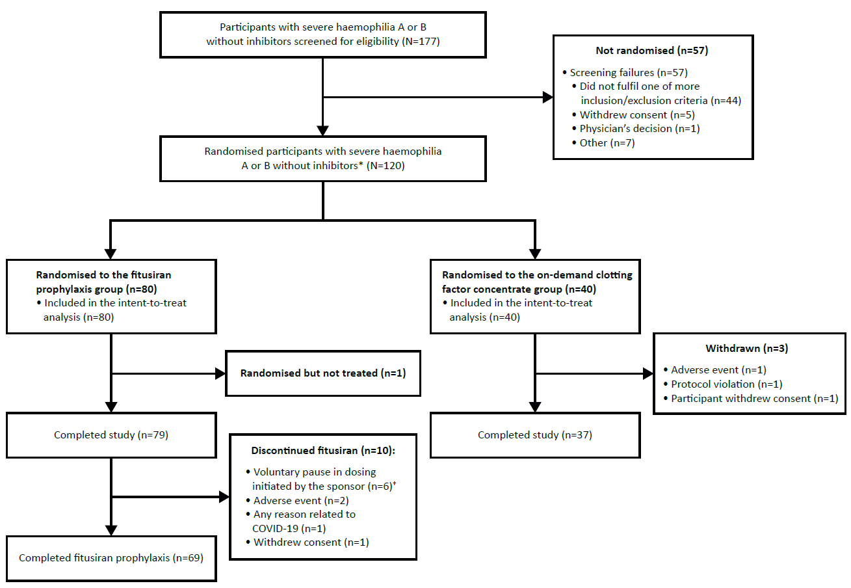*Had a minimum of 6 bleeding episodes requiring on-demand treatment with clotting factor concentrates within the last 6 months prior to screening.  
Diagnosis of severe haemophilia A or B is based on a central laboratory measurement or documented medical record evidence of FVIII level <1% or FIX level ≤2% at screening.   
†The voluntary pause in dosing initiated by the sponsor was in response to reports of non-fatal vascular thrombotic events in separate trials within the fitusiran clinical development program.

**Figure 2: Bleeding events in the efficacy period (intent-to-treat analysis set)**

1. **Median observed annualised bleeding rates for treated bleeds in the efficacy period**

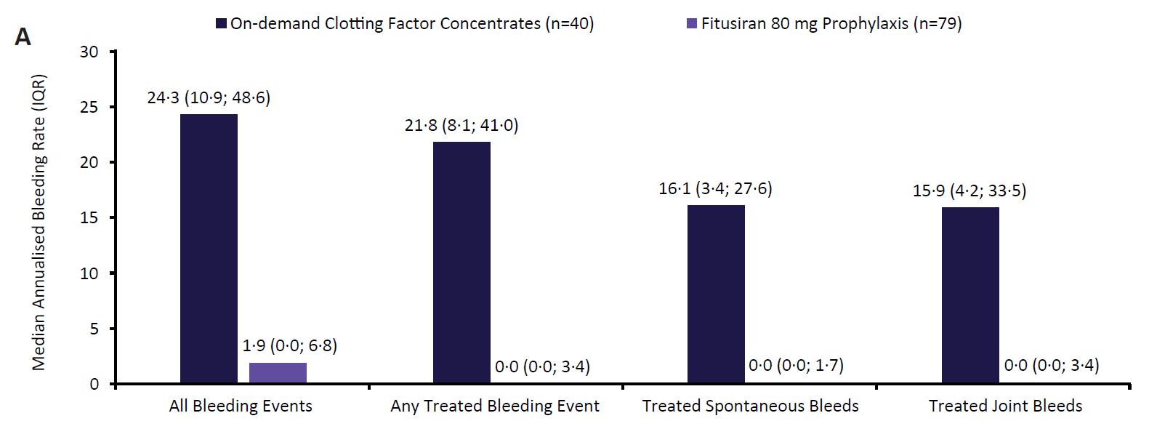

1. **Annualised bleeding rates for treated bleeds in the efficacy period estimated by negative binomial model**

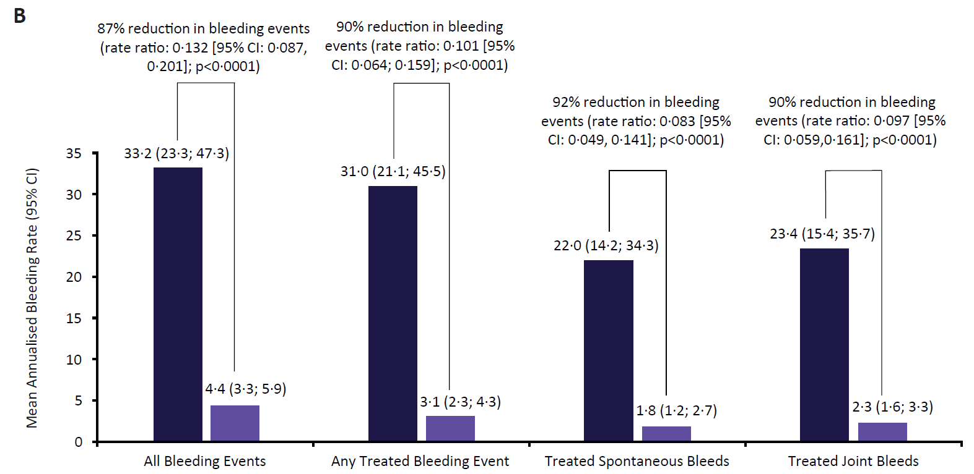

1. **Proportion of participants with zero and ≤3 treated bleeds in the efficacy period**

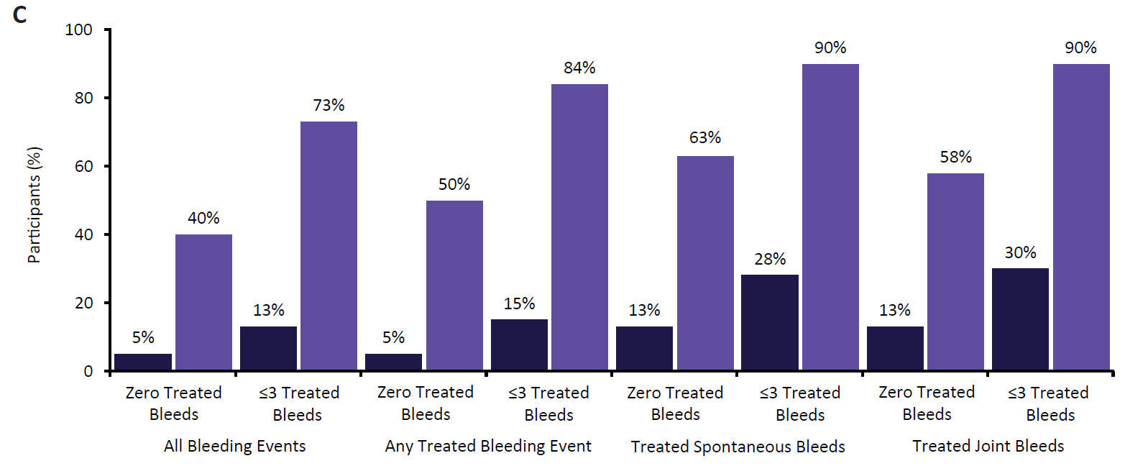

Rateratio is the Fitusiran rate divided by on-demand clotting factor concentrate rate.P-value from a negative binomial regression model with treatment group, randomisation strata of number of bleeds in the 6 months prior to study (<=10, > 10) and randomisation strata of haemophilia type (A vs. B) as fixed effects, and the logarithm of the duration that each participant spent in the efficacy period matching the bleeding episode being analysed as an offset variable (P-value versus null hypothesis of ratio = 1). CI, confidence interval; IQR, interquartile range.