Supplementary appendix
Contents
List of Independent Ethics Committees/Institutional Review Boards | 2
Methods | 4
Results | 9
ATLAS-A/B Investigators | 10
Figure S1: Study design | 11
Figure S2: Estimated ABR ratio for treated bleeds in the efficacy period subgroup analysis | 12
Figure S3: Improvement from baseline to end of trial in Haem-A-QoL total and physical health domain transformed scores | 13
Figure S4: Mean D-dimer over time | 14
Figure S5: Laboratory coagulation parameters over time | 15
Figure S6: Pharmacodynamic measurements over time | 17
Table S1: Distribution of participants randomised and treated by country and site | 20
Table S2: Bleed management dosing guidelines during fitusiran prophylaxis | 22
Table S3: Major protocol deviations in randomised participants | 23
Table S4: Bleeding events in the efficacy period based on haemophilia subtype | 25
Table S5: Hemostatic efficacy rating and perioperative safety summary | 27
Table S6: Sensitivity analysis: Estimated ABR for treated bleeds in the efficacy period | 28
Table S7: Details of clotting factor concentrates used to treat breakthrough bleeding | 29
Supplementary references | 36

List of Independent Ethics Committees/Institutional Review Boards
Independent Ethics Committees/Institutional Review Boards | Country
Rush University Medical Center, 707 S. Wood Street, 0 Annex, Chicago, Illinois 60612 | United States
St Joseph's Children's Hospital of Tampa, 4600 N. Habana Avenue, Suite 30, Tampa, Florida 033614 | United States
Childrens Hospital Medical Center of Akron, 1019 39th Avenue Southeast, Puyallup, Washington 98374 | United States
Advarra IRB, 6940 Columbia Gateway Drive, Suite 110, Columbia, Maryland 21046 | United States
University of Michigan, 2800 Plymouth Rd.,Bldg 520 Ann Arbor, Michigan 48109 | United States
Wits Ethics Committee, 8 Blackwood Ave, Parktown, Johannesburg 2193 | South Africa
Phoenix Pharma, 123 Amcor Road, Pretoria 0157 | South Africa
Comité de Protection des Personnes Sud-Est V, CHU de Grenoble, Rez de chaussée haut – Hall Vercors, 6 Boulevard de la Chantourne La Tronche, Isère 38700 | France
Intezeti Kutatasetikai Bizottsag, Magyar Honvédség Egészségügyi Központ, Róbert Károly körút 44., Intezeti Kutatasetikai Bizottsag, Budapest 01134 | Hungary
Azienda Ospedaliera Di Padova, comitato etico per la sperimentazione clinica della, Via Giustiniani 1, Padova, 35128 | Italy
Barlow House, 3rd Floor, 4 Minshull Street Manchester, M1 3DZ | United Kingdom
Kontakt Region, Hovedstaden Kongens vænge 2, Hillerød, 3400 | Denmark
Ethik Kommission, Vivantes Klinikum Im Friedrichshain Turmstr. 21, Berlin, 10559 | Germany
Ethik Kommission, Theodor-Stern-Kai 7, Frankfurt am Main, Hessen 60590 | Germany
Geschäftsstelle der Ethikkommission an der Medizinischen, Fakultät der Universität Leipzig, c/o Zentrale Poststelle, Liebigstraße 18, Leipzig Sachsen, 04103 | Germany
Medical Research & Ethics Committee, Ministry of Health Malaysia, d/a Kompleks Institut Kesihatan Negara, Blok A, No 1, Jalan Setia Murni U13/52, Seksyen U13, Bandar Setia Alam, Shah Alam, Selangor 40170 | Malaysia
Alfred Research and Ethics Unit, 55 Commercial Road, Alfred Hospital Melbourne, Victoria 03004 | Australia
CNE Kyiv City Clinical Hospital, #9 of Exec. Body of Kyiv City Council, Kyiv City State Admin 1 Ryzhska St., Kyiv, 04112 | Ukraine
State Institution Institute of Blood Pathology and Transfusion Medicine of NAMS of Ukraine, 45 Henerala Chuprynky St., Lviv, 79044 | Ukraine
Commission on Ethics Questions of Ukrainian Pediatric Special Clinical Hospital, Ohmatdyt, 28/1 Chornovola street, Kyiv, 01135 | Ukraine
Municipal Non-profit Enterprise Mykolayiv Regional Clinical Hospital the Mykolayiv Regional Council, 1, Kyivska St., Mykolaiv, 54058 | Ukraine
Saitama Children's Medical Center IRB, Saitama Children's Medical Center 1-2 Shintoshin Chuo-ku, Saitma, 330-8777 | Japan
Tokai University Hospital Institutional Review Board, Tokai University Hospital, 143 Shimokasuya, Isehara-Shi, Kanagawa 259-1143 | Japan
Pusan National University Hospital IRB, 179 Gudeok-Ro Seo-Gu, Busan 49241 | Korea
Eulji University Hospital IRB, 95, Dunsanseo-ro, Seo-gu, Daejeon 35233 | Korea
Kyung Hee University Hospital at Gangdong IRB, 881, Dongnam-ro, Gangdong-gu, Seoul 05269 | Korea
Children's Hospital of Zhejiang, University School of Medicine, No.57, Zhugan Alley Hangzhou, 310020 | China
Taipei Medical University - Joint Institutional Review Board (TMU-Joint IRB), Taipei Medical University Hospital, 252 Wu Hsing Street, Taipei, 000110 | Taiwan
Research Ethics Committee of National Taiwan University Hospital, 2f, No. 1chang De Street, Zhongzheng District, Taipei, 000110 | Taiwan
Institutional Review Board of Taichung Veterans General Hospital, 1650 Taiwan Boulevard Sec. 4, Taichung, 40705 | Taiwan
Institutional Review Board of Taipei Veterans General Hospital, No.201, Section 2, Shih-Pai Road, Taipei | Taiwan
Institutional Review Board of China Medical University Hospital, 2 Yuh - Der Road Taichung, 000404 | Taiwan
Chang Gung Medical Foundation, Chang Gung Memorial Hospital, 199, Tung Hwa North Road Taipei, 000105 | Taiwan
Akdeniz Universitesi Tip Fakultesi Klinik Arastirmalar Etik Kurulu, Akdeniz Universitesi Tip Fakultesi, Dekanligi Morfoloji Binasi,Kat:1 Konyaalti`, Antalya 07070 | Turkey
St John's Medical College Hospital, Sarjapur Road, Bangalore, 560034 | India
B.J. Government Medical College and Sassoon General Hospital, Jai Prakash Narayan Road, Near Pune railway station, Pune, Maharashtra 411001 | India
Ethics Committee, IRB Christian Medical College, Ida Scudder Road, Vellore, Tamil Nadu 632004 | India
King George Medical University, Office of Research Cell, Adminstrative Block, King George's Medical University, Lucknow, Uttar Pradesh 226003 | India
K. J. Somaiya Hospital and Research Centre, 212 Waterfield road, 11 Guldev Sagar, Bandra West, Mumbai, Maharashtra 400050 | India
New UG-PG Hostel, 20 Storey Hostel Building Seth G.S. Medical College & K.E.M. Hospital, Parel, Mumbai, Maharashtra, 400012 | India
Sahyadri Super Speciality Hospital, 33/34B Makarand Bhave, Karve Road Pune, 411004 | India
Helsinki Committee for Clinical Trials, The Chaim Sheba Medical Centre, Derech Sheba 2, Tel Hashomer, Ramat Gan, Cabin 16 Gimel Ramat Gan, 0562000 | Israel

Methods
Inclusion criteria
Each participant must meet all the following inclusion criteria to be eligible for enrolment in the study:
- Males ≥12 years of age.
- Severe haemophilia A or B without inhibitors evidenced by:
  - A central laboratory measurement or documented medical record evidence of FVIII <1% or FIX level ≤2% at screening.
- On-demand use of clotting factor concentrates (CFCs) to manage bleeding episodes for at least the last 6 months prior to screening, and meet each of the following criterion:
  - Nijmegen modified Bethesda assay inhibitor titer of <0·6 BU/mL at screening
  - No use of bypassing agents to treat bleeding episodes for at least the last 6 months prior to screening
  - No history of immune tolerance induction therapy within the last 3 years prior to screening
  - A minimum of six bleeding episodes requiring clotting factor concentrate treatment within the last 6 months prior to screening
  - Willing and able to comply with the study requirements and to provide written informed consent and assent in the case of participants under the age of legal consent, per local and national requirements.
Exclusion criteria
Each participant must not meet any of the following exclusion criteria to be eligible for enrolment in the study:
- Known co-existing bleeding disorders other than haemophilia A or B, ie, Von Willebrand’s disease, additional factor deficiencies, or platelet disorders.
- Current use of CFCs as regularly administered prophylaxis designed to prevent spontaneous bleeding episodes.
- Antithrombin (AT) activity <60% at screening as determined by central laboratory measurement.
- Presence of clinically significant liver disease, or as indicated by any of the conditions below:
  - International normalized ratio >1·2
  - Alanine aminotransferase (ALT) and/or aspartate aminotransferase (AST) >1·5× upper limit of normal reference range (ULN)
    - Total bilirubin >ULN (>1·5× ULN in participants with Gilbert’s syndrome)
    - History of portal hypertension, esophageal varices, or hepatic encephalopathy
    - Presence of ascites by physical examination.
  - Hepatitis C virus antibody positive, except participants with a history of hepatitis C infection who meet both conditions:
    - Completed curative treatment at least 12 weeks prior to enrolment and attained sustained virologic response as documented by a negative hepatitis C RNA at screening, or they have spontaneously cleared infection as documented by negative hepatitis C RNA at screening.
  - No evidence of cirrhosis according to one of the following assessments:
    - FibroScan <12·5 kPa (where available), or
    - FibroTest score <0·75 and APRI <2 (if FibroScan unavailable)
    - Presence of acute hepatitis, ie, hepatitis A, hepatitis E
    - Presence of acute or chronic hepatitis B infection (IgM anti-HBc antibody positive or HBs Ag positive)
    - Platelet count ≤100,000/μL
    - Presence of acute infection at screening.
- Known to be HIV positive with CD4 count <200 cells/μL.
- Estimated glomerular filtration rate ≤45 mL/min/1·73 m² (using the Modification of Diet in Renal Disease formula).
- Co-existing thrombophilic disorder, as determined by presence of any of the below as identified at central laboratory (or via historical results, where available):
  - FV Leiden (homozygous or heterozygous)
  - Protein S deficiency
  - Protein C deficiency
  - Prothrombin mutation (G20210A; homozygous or heterozygous).
- History of antiphospholipid syndrome.
- History of arterial or venous thromboembolism, atrial fibrillation, significant valvular disease, myocardial infarction, angina, transient ischemic attack, or stroke.
- Had a malignancy within 2 years, except for basal or squamous cell carcinoma of the skin that has been successfully treated.
- Any condition (eg, medical concern), which in the opinion of the investigator, would make the participant unsuitable for dosing on Day 1 or which could interfere with the study compliance, the participant’s safety and/or the participant’s participation in the completion of the treatment period of the study. This includes significant active and poorly controlled (unstable) cardiovascular, neurologic, gastrointestinal, endocrine, renal or psychiatric disorders unrelated to haemophilia, identified by key laboratory abnormalities or medical history.
- At screening, anticipated need of surgery during the study or planned surgery scheduled to occur during the study.
- Completion of a surgical procedure within 14 days prior to screening, or currently receiving additional factor infusion for postoperative haemostasis.
- History of multiple drug allergies or history of allergic reaction to an oligonucleotide or N-acetylgalactosamine.
- Inadequate venous access, as determined by the Investigator, to allow the blood draws required by the study protocol.
- History of intolerance to subcutaneous injection(s).
- Current or future participation in another clinical study, scheduled to occur during this study, involving an investigational product other than fitusiran or investigational device; in order to participate in this study, participant must discontinue the investigational product at least 30 days (or 5× the investigational product half-life, whichever is longer) prior to dosing (Day 1).
- Current or prior participation in a gene therapy trial.
- History of alcohol abuse within the 12 months before screening. Alcohol abuse was defined as regular weekly intake of more than 14 units (unit: 1 glass of wine [approximately 125 mL] = 1 measure of spirits (approximately 1 fluid ounce) = ½ pint of beer [approximately 284 mL]).
Bleeding episode definitions
The definitions of bleeding episode types were based on the recommendations of the International Society on Thrombosis and Haemostasis (ISTH).¹ The start time of a bleeding episode was considered the time at which symptoms of a bleeding episode first developed. Bleeding, or any symptoms of bleeding at the same location, that occurred within 72 hours of the last injection used to treat a bleeding episode at that location were considered a part of the original bleeding event and will count as one bleeding episode towards the annualised bleeding rate. Any bleeding symptoms that begun more than 72 hours from the last injection used to treat a bleeding episode at that location constituted a new bleeding event. A spontaneous bleeding episode was defined as a bleeding event that occurred for no apparent or known reason, particularly into the joints, muscles, and soft tissues. A joint bleeding episode was characterized by an unusual sensation in the joint (“aura”) in combination with either 1) increasing swelling, or warmth over the skin over the joint, 2) increasing pain, or 3) progressive loss of range of motion or difficulty in using the limb as compared with baseline. A muscle bleed may be characterised by pain, swelling and loss of movement over the affected muscle group. A target joint was defined as a joint where 3 or more spontaneous bleeding episodes in a single joint within a consecutive 6-month period occurred; where there have been ≤2 bleeding episodes in the joint within a consecutive 12-month period the joint was no longer considered a target joint.
Breakthrough bleeding guidelines
Fitusiran group
To minimise the risk of vascular thrombotic events, the CFC dose necessary to effectively treat breakthrough bleeding episodes was reduced. Based on AT kinetics of fitusiran, it was recommended that participants continue with their standard CFC regimens for the first 7 days following initiation of fitusiran dosing, with institution of the protocol-specific bleed management guidelines with reduced CFC doses at Day 8 and beyond (Table S1). Participants receiving fitusiran were provided breakthrough bleeding instructions with appropriate dosing of CFCs for use during Day 1 through 7, as well as a bleed management plan in accordance with the protocol-specific bleed management guidelines for Day 8 and beyond. Thereafter the bleed management plan was reviewed and updated at monthly visits.
On-demand clotting factor concentrate group
For participants not receiving fitusiran (on-demand CFC group), bleeding management therapy with CFCs was managed based on the local standard practice for treating people with haemophilia without inhibitors, as routinely administered by the physician. Where clinical circumstances allowed, it was recommended that the participant contacted the investigator for all events that were suspected to be or characteristic of a bleeding episode. If adequate haemostasis did not occur after two doses of CFCs, the participant was advised to contact the site for further instruction. If the participant felt the need to administer doses higher than the individuals bleeding episode management plan recommended, or at a higher frequency, it was recommended that the participant contacted the site.
eDiary
Participants were individually supplied with an eDiary to record all bleeding events and all doses of CFCs administered during the conduct of the study. Participants were prompted to enter bleeding location, severity, causality (spontaneous or traumatic), doses of CFCs and reasons for dosing (prophylaxis, treatment of a bleed, and preventive dose for anticipated activity). Bleeding episodes recorded by the participant in the eDiary were reviewed by the Investigator (and Sponsor) continuously for the study duration. The sites contacted the participants at a minimum interval of every 2 weeks per schedule of assessments to review entries records and ensured that the participant was utilising the device appropriately. Sites were notified when participants entered initial treatments for bleeding events into their eDiaries. The participants clinical condition was also reviewed along with the dose and efficacy of the treatment given for breakthrough bleeds, and the Investigator or designee provided appropriate guidance regarding further management. On the eDiary device, it was not possible to leave questions unanswered or to enter partial data.
Haemophilia Quality of Life Questionnaire for Adults (Haem-A-QoL)
The Haemophilia Quality of Life Questionnaire for Adults (Haem-A-QoL) is a validated measure designed to assess aspects of health-related quality of life in persons with haemophilia A aged ≥17 years.² The Haem-A-QoL questionnaire was used to assess 46 items contributing to 10 health-related quality of life domains (physical health, feelings, view of yourself, sports and leisure, work, and school, dealing with haemophilia, treatment, future, family planning, partnership, and sexuality) in participants ≥17 years of age. Scoring for each item was based on a five-point Likert scale (never, rarely, sometimes, often, and all the time) and total transformed scores range from 0 to 100, where lower scores represent greater health-related quality of life. Clinically meaningful score changes for the physical health and total score domains were 10 and seven points, respectively.^{3,4}
Treatment-emergent adverse events of special interest
The following events were considered to be treatment-emergent adverse events of special interest:
- ALT/AST elevations >3× ULN.
- Suspected or confirmed thrombosis.
- Severe or serious injection site reactions; injection site reactions associated with a recall phenomenon (reaction at the site of a prior injection with subsequent injections), or those that led to temporary dose interruption or permanent discontinuation of fitusiran.
- Systemic injection associated reactions, defined as hypersensitivity reactions which are related or possibly related to fitusiran.
Surgery
If an urgent need for surgery arose during the study period, the study Medical Monitor was informed and the perioperative haemostatic treatment plan was communicated to the study Medical Monitor. It was recommended that any elective non-dental major surgery be performed at a clinical study centre, when possible. If the need for major surgery arose during the trial and the procedure was not an emergency or urgent, it was recommended that the procedure be postponed until after completion of the trial.
Perioperative Treatment Plan
In participants in both the on-demand CFC group and the fitusiran prophylaxis group undergoing surgery, a written perioperative treatment plan was reviewed with the study Medical Monitor before conducting the procedure. In participants receiving fitusiran, the perioperative treatment plan was developed using the same principles as bleed management guidelines. If the clinical circumstance was such that the recommended doses and/or dose intervals in the bleed management guidelines were deemed insufficient for haemostasis, replacement could be considered and thrombotic risk managed as per the Investigator’s practice for a haemophilia patient undergoing that particular surgery. Non-pharmacologic methods of thromboprophylaxis could also be employed as clinically indicated.
Fitusiran Treatment During the Perioperative Evaluation Period
For minor operative procedures, dosing with fitusiran may have been continued uninterrupted. If the need for emergency or urgent major surgery arose during the trial, the participant should have been managed according to the guidelines above. If a fitusiran dose was scheduled to occur on or in close proximity to the day of surgery, or anytime during the perioperative period, the dose should have been withheld. The Perioperative period was defined as the day of the surgery through the final day on which supplemental haemostatic or antithrombotic treatments were administered as part of the perioperative treatment plan. Fitusiran dosing was permitted to be resumed at the next scheduled visit following the Perioperative Evaluation Period at the discretion of the Investigator.
Minor and major surgery definitions
Minor surgery was defined as any invasive operative procedure in which only skin, mucous membranes, or superficial connective tissue was manipulated and did not meet the criteria for major surgery (eg, dental extraction of <3 non-molar teeth). Minor surgical procedures were permitted to be performed at a local health care provider institution. Major surgery was defined as any invasive operative procedure that requires any of the following:
- Opening into a major body cavity (eg, abdomen, thorax, skull)
- Operation on a joint
- Removal of an organ
- Dental extraction of any molar teeth or ≥3 non-molar teeth
- Operative alteration of normal anatomy
- Crossing of a mesenchymal barrier (eg, pleura, peritoneum, dura)
In participants who underwent operative procedures during the treatment period, safety and haemostatic efficacy assessments were performed according to the perioperative schedule of assessments After a review of medical and surgery history has been completed, participants had the following assessed: directed physical examination and assessment of vital sign measurements; clinical laboratory assessments including haematology (complete blood count, white blood count, red blood cell count, hemoglobin, hematocrit, platelets); coagulation (activated partial thromboplastin time, prothrombin time/ international normalised ratio, fibrinogen, D-dimer); hepatic assessments; and haemostatic efficacy assessments, as defined according to recommendations of the International Society on Thrombosis and Haemostasis.¹
Statistical analysis
Population analysis sets
The populations (analysis sets) were defined as follows:
- Intent-to-treat (ITT) Analysis Set: All randomised participants. All by-treatment analyses based on the ITT analysis set were performed according to the randomised treatment group. Efficacy Analyses was conducted using the ITT Analysis Set unless otherwise specified.
- Safety Analysis Set: All participants who received at least 1 dose of study drug or were randomised to the CFC on-demand group All by-treatment analyses based on the safety analysis set were according to the actual treatment received. Safety Analyses was conducted using the Safety Analysis Set unless otherwise specified.
- Per-protocol Analysis Set: All participants in the ITT set who did not have protocol deviations in the following categories:
  - Failure to meet key eligibility criteria
  - Actual treatment differed from IRS treatment assignment
  - Prophylactic use of factor
  - Other protocol deviations that may have significantly affect the completeness, accuracy and/or reliability of the bleeding data. The major or critical detail deviations included are as follows:
  - The participant was not male and/or is younger than 12 years, but the participant was randomized.
  - The participant did not have severe haemophilia A or B without inhibitors as evidenced by:
  - A laboratory FVIII level <1 % or FIX level ≤2 % at Screening.
  - On-demand use of CFCs to manage bleeding episodes for at least the last 6 months prior to Screening, or meeting one of the following criteria:
  - Nijmegen-modified Bethesda assay inhibitor titer of <0·6 BU/mL at Screening, no use of bypassing agents to treat bleeding episodes for at least the last 6 months prior to screening
  - No history of immune tolerance induction therapy within the last 3 years prior to Screening, but the participant was randomised.
  - The participant did not have a minimum of 6 bleeding episodes requiring factor concentrate treatment within the last 6 months prior to Screening, but the participant was randomised.
  - The participant had known co-existing bleeding disorders other than haemophilia A or B, but the participant was randomised.
  - The participant currently uses factor concentrates as regularly administered prophylaxis designed to prevent spontaneous bleeding episodes, but the participant was randomised.
  - The participants actual treatment differs from randomisation group.
  - Site provided incorrect stratification data in IRT for the participants randomisation
  - The participant initiated use of factor concentrates or bypassing agents as prophylaxis for bleeding episode prevention, including doses related to anticipated haemostatic challenges such as physical activity, during the treatment period but the study drug was not discontinued.
- Operative Procedure Analysis Set: All participants who received at least 1 dose of study drug or were randomised to the on-demand CFC group and underwent at least 1 operative procedure during the study.
- COVID-19 Unaffected Set: All participants who had no major or critical protocol deviations due to COVID-19 at any visits up to end of study (Month 9).
Hierarchical testing approach
To control for the familywise error rate in the testing of primary and secondary endpoints, a hierarchical testing approach was used in the following order:
- Annualised bleeding rate (ABR) in efficacy period (2-sided alpha = 0·05)
- ABR in treatment period (2-sided alpha = 0·05)
- Annualised spontaneous bleeding rate in efficacy period (2-sided alpha = 0·05)
- Annualised joint bleeding rate in efficacy period (2-sided alpha = 0·05)
- Change in physical health score and total score of Haem-A-QoL in treatment period (2-sided alpha = 0·05)
If testing of any of the endpoints was not statistically significant, testing of subsequent endpoints would stop and the null hypotheses for the subsequent tests would not be rejected.
Sensitivity analyses
Sensitivity analyses was performed based on the ITT analysis set and included all bleeding episodes collected through the end of the study, regardless of any premature treatment discontinuation, excluding only events due to major or minor surgeries. The same negative binomial model as in the primary analysis was used. It assessed the benefits of the fitusiran treatment policy strategy relative to on-demand CFC treatment. Sensitivity analysis was also performed on the per-protocol analysis set. To address the impact of COVID-19, efficacy analyses in the efficacy period was repeated on the COVID-19 unaffected set. A sensitivity analysis based on on-treatment strategy was performed excluding the bleeding events in the period of missing at least two fitusiran doses in consecutive scheduled visits due to COVID-19 which was defined as one month after last dose (ie, last dose date + 28 days) before missing doses due to COVID-19 to one month after starting of re-dosing (ie, first re-dose date + 28 days). The same negative binomial model as in the primary analysis was used.
Results
Annualised bleeding rate for all bleeds
The median ABR (IQR) for all bleeding episodes in the efficacy period was 1·9 (0·0, 6·8) and 24·3 (10·9, 48·6) in the fitusiran and on-demand CFC groups, respectively. Mean ABR estimated by a negative binomial model for all bleeding episodes was significantly lower in the fitusiran group compared with the on-demand CFC group: 4·4 (95% CI: 3·3; 5·9) and 33·2 (95% CI: 23·3; 47·3), respectively, corresponding to an 87% reduction in the bleeding rate associated with fitusiran prophylaxis during the efficacy period for all bleeds (rate ratio: 0·133 [95% CI: 0·088; 0·201]; p<0·001).
Annualised bleeding rate for treated bleeds in the treatment period
The treatment period was defined as the period of treatment including both the onset (28 days after the first dose of fitusiran, during which fitusiran gradually reaches target pharmacodynamic effect of AT lowering⁵) and efficacy period (Day 29–246). Median ABR (IQR) for treated bleeds was 1·8 (0·0; 4·5) in the fitusiran group and 25·2 (11·9; 43·8) in the on-demand CFC group during the treatment period. In the fitusiran group, mean ABR estimated by negative binomial model was 4·1 (95% CI: 3·1; 5·3), which was significantly lower than the estimated ABR of 31·4 (95% CI: 23·0; 43·0) for the on-demand CFC group, corresponding to an 87% reduction in bleeding rate associated with fitusiran prophylaxis during the treatment period (rate ratio: 0·130 [95% CI: 0·090; 0·188]; p<0·0001).
Annualised bleeding rate for treated bleeds in the onset period
The onset period was defined as 28 days after the first dose of fitusiran, during which fitusiran gradually reaches target pharmacodynamic effect of AT lowering⁵. Median ABR (IQR) during the onset period was. Mean ABR (95% CI) estimated by a negative binomial model was significantly lower in the fitusiran group (10·8 [95% CI: 8·1; 14·3]) compared with the on-demand CFC group (33·4 [95% CI: 25·6; 43·5]), corresponding to an 68% reduction in bleeding events associated with the fitusiran group during the onset period (rate ratio: 0·324 [95% CI: 0·231; 0·453]; p<0·0001).
Treatment-emergent adverse events of special interest
Of the five participants who experienced ALT or AST elevations >3x ULN that resulted in the interruption or withdrawal of fitusiran prophylaxis, one participant received one dose of fitusiran, two participants received two doses of fitusiran, one participant received three doses of fitusiran, and one participant received 5 doses of fitusiran, prior to event onset. One participant received corrective treatment for ALT elevations which included omeprazole. All five participants resumed fitusiran treatment.
Of the ten participants that continued on fitusiran prophylaxis with initial TEASIs of 'any ALT or AST elevations >3x ULN', four participants received one dose of fitusiran, one participant received two doses of fitusiran, two participants received four doses of fitusiran, and one participant each received five, six, and seven does of fitusiran, prior to event onset. Two participants received corrective therapy (Silybum marianum and Fumaria officinalis extract/Silybum marianum extract in one participant; ciprofloxacin and esomeprazole magnesium in one participant).
Clinical laboratory assessments of coagulation markers
The mean values of coagulation parameters (prothrombin time, prothrombin international normalised ratio, activated partial thromboplastin time, fibrinogen) at baseline were generally similar between the fitusiran group and the on-demand CFC group. The mean prothrombin fragment 1+2 value was elevated at baseline in both groups, with a greater magnitude of elevation in the fitusiran prophylaxis group. At Day 15, mean prothrombin fragment 1+2 values were within normal limits in both treatment groups (Fig S4A). In reference to the Day 15 value, there was a trend toward increased values for prothrombin fragment 1+2 in the fitusiran group compared with the on-demand CFC group. There was a trend toward decreased values for fibrinogen (Fig S4B) in the fitusiran group compared with the on-demand CFC group. As anticipated in participants with severe hemophilia A or B, activated partial thromboplastin time was consistently prolonged in the fitusiran group and the on-demand CFC group. There were no clinically meaningful patterns or trends observed in prothrombin time or prothrombin international normalised ratio during the course of the study.

ATLAS-A/B Investigators
Investigator (country)
Albayrak (Turkey), Ando (Japan), Antmen (Turkey), Apte (India), Averianov (Ukraine), Bagot (UK), Boggio (United States), Bia (Taiwan), Chang CY (Taiwan), Chang H (Taiwan), Chou (Taiwan), Cockrell (United States), Fargo (United States), Frenzel (France), Hsaio (Taiwan), Kampmann (Denmark), Kavakli (Turkey), Kenet (Israel), Khoo (Australia), Klamroth (Germany), Lasky (United States), Mahlangu (South Africa), Malan (South Africa), Miesbach (Germany), Nemes (Hungary), Okan (Turkey), Park (South Korea), Pfrepper (Germany), Pipe (United States), P’ng (Australia), Rangarajan (India), Romanyuk (Ukraine), Ross (India), Salvi (India), Sathar (Malaysia), Schmaier (United States), Shanmukhaiah (India), Sharif (Malaysia), Shin (South Korea), Srivastava (India), Stasyshyn (Ukraine), Tran (Australia), Verma (India), Vilchevska (Ukraine), Wang (Taiwan), Wong (Malaysia), Xu (China), You (South Korea), Zanon (Italy), Zulfikar (Turkey).
Figure S1: Study design
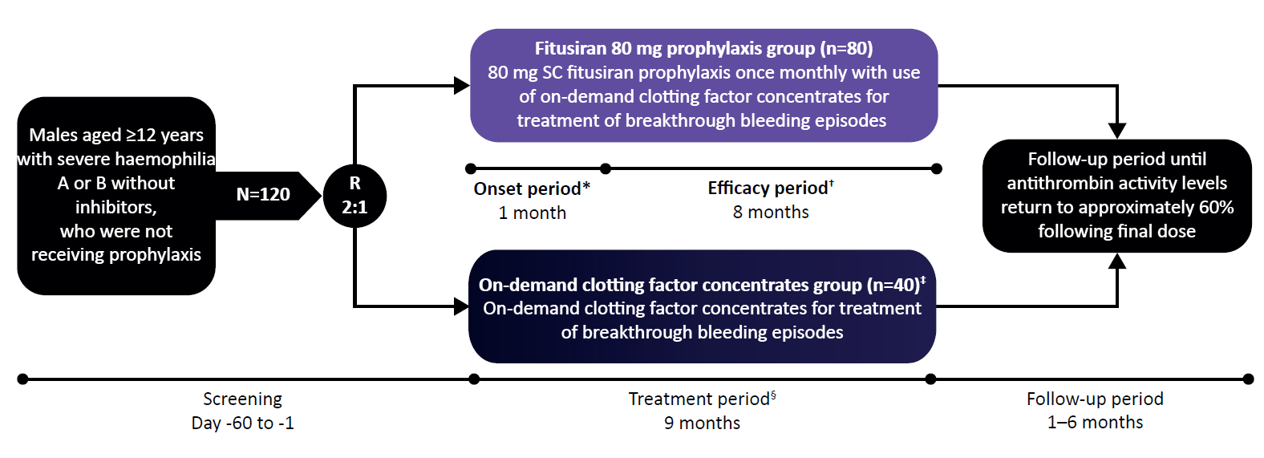
*Onset period was defined as the first 28 days after the first dose of fitusiran, during which fitusiran gradually reaches the target pharmacodynamic effect of antithrombin lowering.
†Efficacy period was defined as starting on Day 29 after the first dose of fitusiran up to Day 246.
‡On-demand factor concentrates as routinely prescribed by physician per local standard practice.
§Treatment period was defined as the period of treatment including both the onset and efficacy periods.

Figure S2: Estimated ABR ratio for treated bleeds in the efficacy period subgroup analysis (intent-to-treat analysis set)
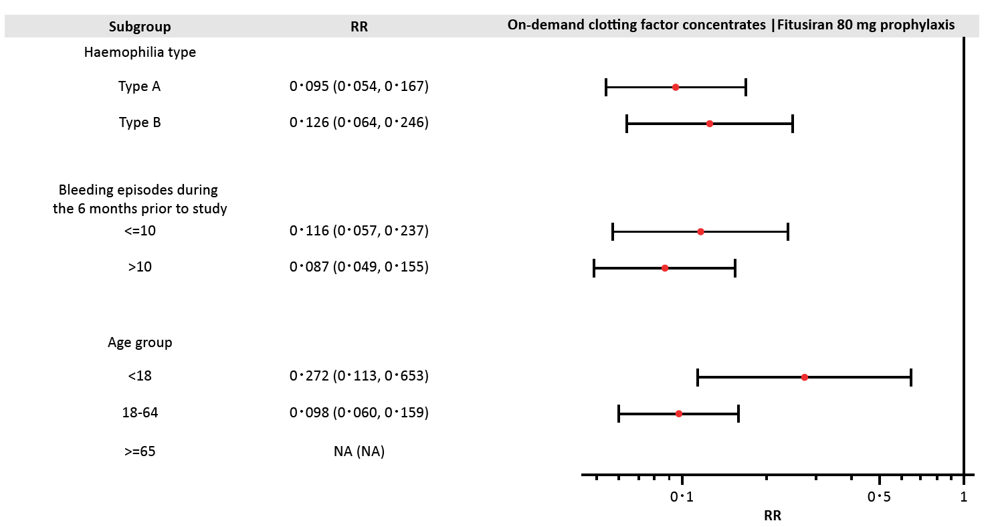
The efficacy period is from Day 29 to Day 246.
ABR, annualised bleeding rate; NA, not applicable; RR, rate ratio.

Figure S3: Improvement from baseline to end of trial in Haem-A-QoL total and physical health domain transformed scores (participants aged ≥17 years in intent-to-treat analysis set)
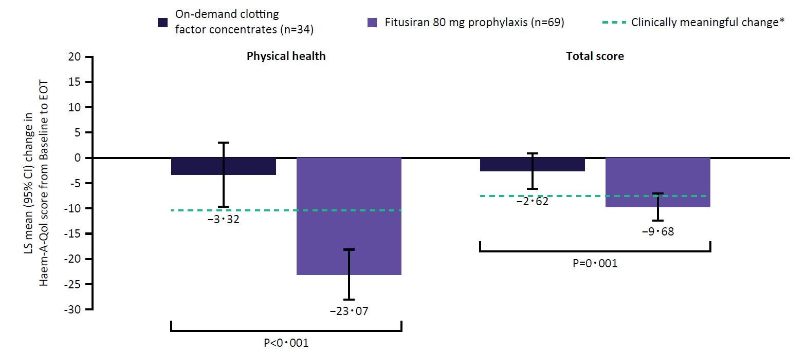
*Clinically meaningful improvements were defined as a 7-point decrease for total score and 10-point decrease for the physical health domain score (Wyrwich KW, et al. Haemophilia 2015;21:578–84).⁴
ANCOVA model includes fixed effects of treatment group, baseline Haem-A-QoL physical health score and total score, number of bleeding episodes 6 months prior to enrolment (≤10 vs >10) and haemophilia type. Haem-A-QoL scores range 0–100; lower scores = improved HRQoL.
ANCOVA, analysis of covariance model. CI, confidence interval; EOT, end of trial; Haem-A-QoL, Haemophilia Quality of Life Questionnaire for Adults; LS, least-square mean.

Figure S4: Mean D-dimer over time (mg/L) (Safety analysis set)
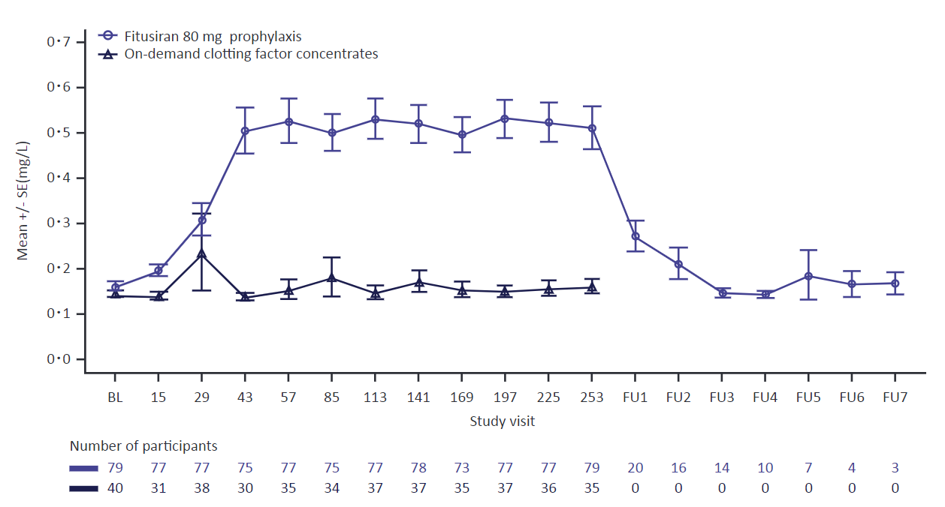
Only central laboratory values were used. BL, baseline; FU, follow-up; SE, standard error.

Figure S5: Laboratory coagulation parameters over time (safety analysis set)
A) Mean prothrombin fragments 1+2 (nmol/L)
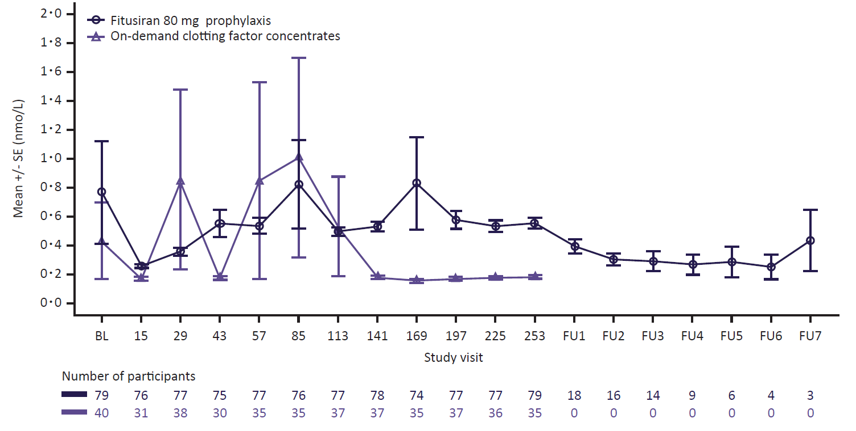

B) Mean fibrinogen (g/L)
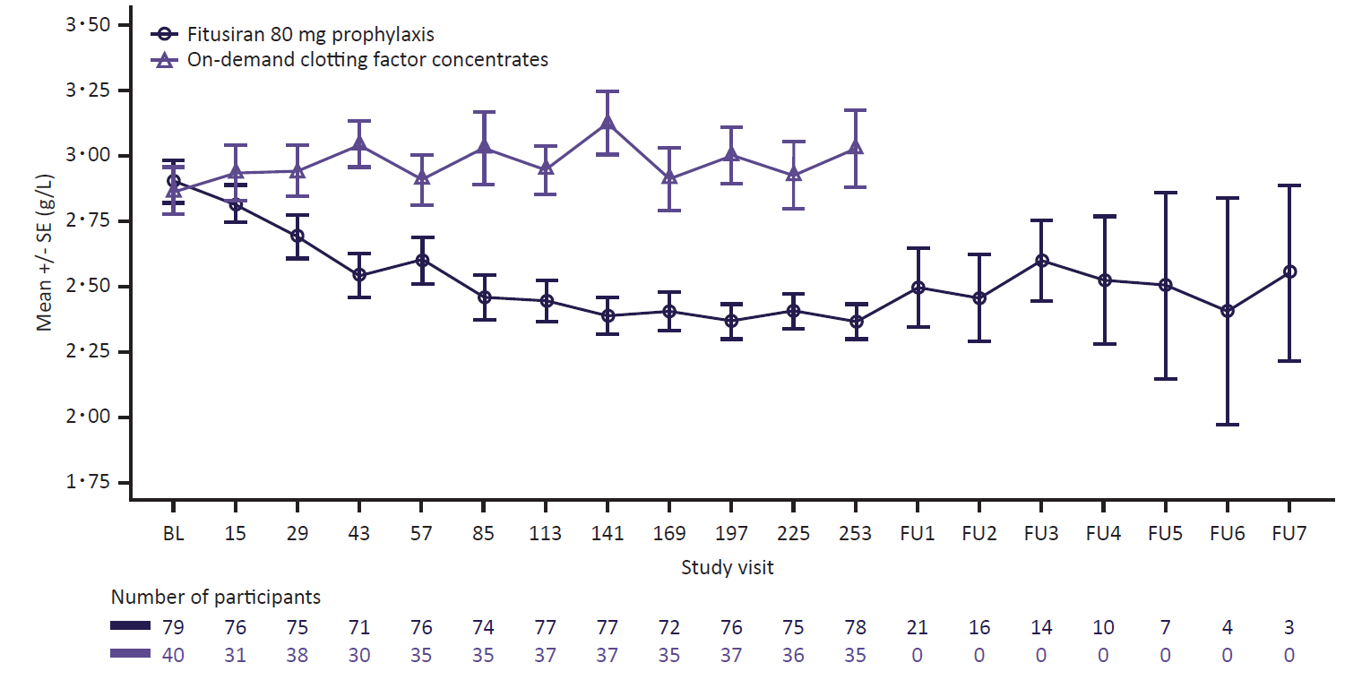

Only central laboratory values were used. BL, baseline; FU, follow-up; SE, standard error.

Figure S6: Pharmacodynamic measurements over time (safety analysis set)
A) Mean change in antithrombin levels from baseline
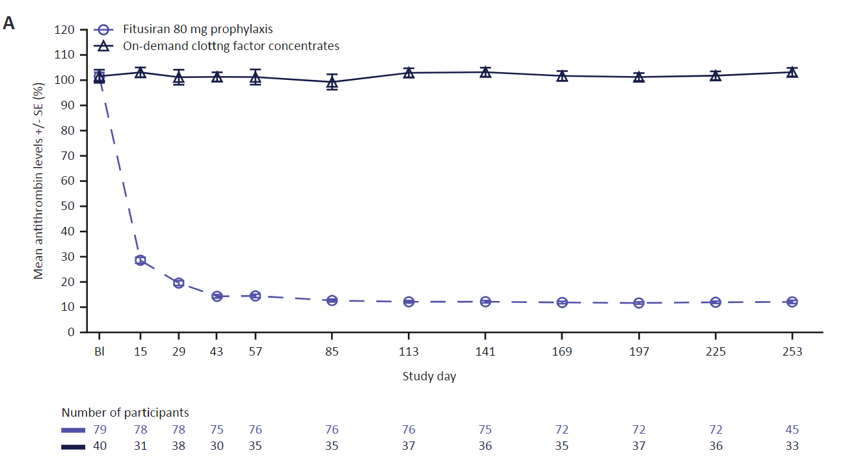

B) Mean change in peak thrombin generation from baseline

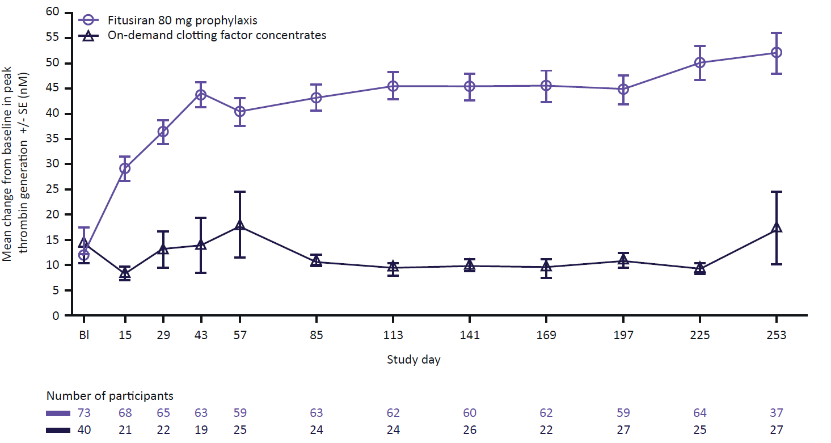
Only central laboratory assessments were included. Measurements without a corresponding area
under the thrombin generation curve value were deemed unreliable and excluded from analysis. BL,
baseline; SE, standard error.

Table S1. Distribution of participants randomised and treated by country and site
Country  Site, n (%) | On-demand clotting factor concentrates  (n=40) | Fitusiran 80 mg  prophylaxis  (n=80) | All  (N=120)
India | 11 (28) | 23 (29) | 34 (28)
Bangalore | 1 (3) | 1 (1) | 2 (2)
Pune | 0 | 2 (3) | 2 (2)
Vellore | 1 (3) | 1 (3) | 2 (2)
Lucknow | 2 (5) | 0 | 2 (2)
Mumbai | 7 (18) | 18 (23) | 25 (21)
Mumbai | 0 | 1 (1) | 1 (1)
Republic of Korea | 10 (25) | 7 (9) | 17 (14)
Busan | 1 (3) | 1 (1) | 2 (2)
Daejeon | 8 (20) | 6 (8) | 14 (12)
Seoul | 1 (3) | 0 | 1 (1)
Taiwan, Province of Republic of China | 3 (8) | 8 (10) | 11 (9)
Taipei | 2 (5) | 1 (3) | 3 (3)
Taipei | 0 | 1 (1) | 1 (1)
Taichung | 1 (3) | 2 (3) | 3 (3)
Taichung | 0 | 1 (1) | 1 (1)
Taichung | 0 | 2 (3) | 2 (3)
Taoyuan | 0 | 1 (1) | 1 (1)
Ukraine | 3 (8) | 7 (9) | 10 (8)
Lviv | 3 (8) | 5 (6) | 8 (7)
Kyiv | 0 | 1 (1) | 1 (1)
Mykolaiv | 0 | 1 (1) | 1 (1)
Turkey | 3 (8) | 6 (8) | 9 (8)
Adana | 1 (3) | 1 (1) | 2 (2)
Izmir | 0 | 3 (4) | 3 (3)
Samsun | 2 (5) | 2 (3) | 4 (3)
United States | 3 (3) | 4 (5) | 7 (6)
Chicago, Illinois | 1 (3) | 2 (3) | 3 (3)
Akron, Ohio | 2 (5) | 0 | 2 (2)
Las Vegas, Nevada | 0 | 1 (1) | 1 (1)
Ann Arbor, Michigan | 0 | 1 (1) | 1 (1)
Malaysia | 3 (8) | 3 (4) | 6 (5)
Johor Bahru | 1 (3) | 0 | 1 (1)
Kota Kinabalu | 1 (3) | 1 (1) | 2 (2)
Ampang | 1 (3) | 2 (3) | 3 (3)
Australia | 2 (5) | 3 (4) | 5 (4)
Camperdown | 0 | 1 (1) | 1 (1)
Murdoch | 2 (5) | 0 | 2 (2)
Prahran | 0 | 2 (3) | 2 (2)
France | 1 (3) | 3 (4) | 4 (3)
Paris | 1 (3) | 3 (4) | 4 (3)
Hungary | 0 | 3 (4) | 3 (3)
Budapest | 0 | 3 (4) | 3 (3)
Germany | 0 | 2 (2) | 2 (2)
Berlin | 0 | 1 (1) | 1 (1)
Leipzig | 0 | 1 (1) | 1 (1)
Italy | 0 | 2 (3) | 2 (2)
Padova | 0 | 2 (3) | 2 (2)
China | 0 | 1 (1) | 1 (1)
Hangzhou | 0 | 1 (1) | 1 (1)
Denmark | 0 | 1 (1) | 1 (1)
Copenhagen | 0 | 1 (1) | 1 (1)
Israel | 0 | 1 (1) | 1 (1)
Ramat-Gan | 0 | 1 (1) | 1 (1)
Japan | 0 | 1 (1) | 1 (1)
Isehara | 0 | 1 (1) | 1 (1)
South Africa | 0 | 5 (6) | 5 (4)
Parktown | 0 | 5 (6) | 5 (4)
United Kingdom | 1 (3) | 0 | 1 (1)
Glasgow | 1 (3) | 0 | 1 (1)

Table S2: Bleed management dosing guidelines during fitusiran prophylaxis
Guideline | Factor VIII | Factor IX standard half-life | Factor IX extended half-life
Recommended single dose | 10 IU/kg | 20 IU/kg | 20 IU/kg
Single dose should not exceed | 20 IU/kg | 30 IU/kg | 30 IU/kg
Repeat dose instructions | Mandatory to call the clinical study center prior to second dose
Repeat dose instructions | Should not repeat in less than 24 hours | Should not repeat in less than 24 hours | Should not repeat in less than 5–7 days
Repeat dose instructions | Should be seen at site within 48–72 hours if more  than 2 doses are required
For situations requiring higher doses, more frequent administration, multiple repeated doses, discussion with study Medical Monitor and Clinical Advisor was recommended, and antithrombin replacement considered. Antifibrinolytics were not recommended for use in combination with clotting factor concentrates.
Table S3: Major protocol deviations in randomised participants
Deviation category  Deviation term n (%) | On-demand clotting factor concentrates  (N=40) | Fitusiran 80 mg prophylaxis  (N=80)
Any major or critical deviations | 37 (93) | 66 (83)
Excluded concomitant medication | 1 (3) | 2 (3)
The participant initiated use of factor concentrates or bypassing agents as prophylaxis for bleeding episode prevention, including doses related to anticipated haemostatic challenges such as physical activity, during the treatment period but the study drug was not discontinued. | 1 (3) | 2 (3)
Procedure deviation | 29 (73) | 52 (65)
A monitoring assessment for follow up on LFT elevation >3x ULN was not performed as per protocol. | 0 | 5 (6)
A planned assessment (vital signs, ECG or physical examination) was not performed. | 5 (13) | 9 (11)
A planned laboratory assessment of LFT (ALT, AST, GGT, ALP, direct or indirect bilirubin) for dosing considerations was not performed. | 0 | 12 (15)
A planned laboratory test was not performed. | 9 (23) | 17 (21)
A planned PK and/or immunogenicity sample was not taken. | 1 (3) | 6 (8)
A planned questionnaire (EQ-5DD questionnaire, haemophilia quality of life questionnaire for adults, haemophilia quality of life questionnaire for children and adolescents, treatment satisfaction questionnaire for medication, haemophilia activities list, paediatric haemophilia activities list or participant resource use) was not completed. | 3 (8) | 9 (11)
A repeated dose of factor or BPA to treat a bleeding was given within less than the defined interval as per protocol. | 0 | 1 (1)
A third dose and/or additional repeated doses of factor or BPA was needed to treat a bleeding episode, but study centre was not visited. | 0 | 3 (4)
Telephone calls scheduled every 2 weeks in between visits by the site for the bleed management review and patient eDiary review were not performed. | 2 (5) | 3 (4)
The participant eDiary was not reviewed by the site for completeness and accuracy at every study visit. | 3 (8) | 3 (4)
The participant was non-compliant with eDiary completion. | 19 (48) | 30 (38)
The participant had missing visits. | 1 (3) | 3 (4)
Randomisation procedure | 2 (5) | 6 (8)
Site provided incorrect stratification data in IRT for participants randomisation. | 2 (5) | 6 (8)
Selection criteria not met | 2 (5) | 1 (1)
The participant had acute Hepatitis, ie, Hepatitis A, hepatitis E, but participant was randomised. | 0 | 1 (1)
The participant had acute or chronic Hepatitis B infection, but participant was randomised. | 0 | 1 (1)
The participant completed a surgical procedure within 14 days prior to screening or was receiving additional factor infusion for postoperative haemostasis, but participant was randomised. | 1 (3) | 0
The participant was Hepatitis C virus antibody positive except for participants with history of HCV infection, who met both conditions:  - completed curative treatment at least 12 weeks prior to enrolment and attained sustained virologic response as documented by a negative HCV RNA at screening, or they have spontaneously cleared infection as documented by negative HCV RNA at screening.  - no evidence of cirrhosis according to one of the following assessments:  - fibroscan < 12.5 kpa (where available)  - fibrotest score < 0.75 and APRI < 2 (if fibroscan unavailable) but participant was randomised. | 1 (3) | 0
Time window deviation | 0 | 1 (1)
The participant’s visit was done out of window. | 0 | 1 (1)
Treatment deviation | 0 | 2 (3)
Open deviations to the study drug storage conditions when administered to participant. | 0 | 2 (3)
Visit not performed | 13 (33) | 8 (10)
The participant has missing visits. | 13 (33) | 8 (10)
Other | 16 (40) | 32 (40)
Failure to report an SAE, AESI, pregnancy, overdose or update containing critical information to CRO within 24 hours, as required per protocol. | 2 (5) | 2 (3)
Site reported protocol deviation not specified elsewhere. | 15 (38) | 31 (39)
Percentages are calculated using the number of participants randomized as denominator.
A participant can be counted in several deviation categories.
Automatic deviations are identified based on pre-configured rules from the data available in the clinical database.
Manual deviations are detected based on monitoring activities at site level, and may also be detected during audits or inspections.
AESI, adverse event of special interest; ALP, alkaline phosphatase; ALT, alanine aminotransferase; AST, aspartate aminotransferase; BPA, bypassing agent; CRO, contract research organization; ECG, electrocardiogram; GGT, gamma-glutamyl transferase; HCV, hepatitis C virus; ICF, Informed Consent Form; IRT, interactive response technology; LFT, liver function test; PK, pharmacokinetics; RNA, ribonucleic acid; SAE, serious adverse event.

Table S4: Bleeding events in the efficacy period based on haemophilia subtype (intent-to-treat analysis set)
Event | On-demand clotting factor concentrates | Fitusiran 80 mg prophylaxis | Rate ratioª  (95%CI) | P-value^{b}
Participants with haemophilia A, n | 31 | 61
Any treated bleeding event
Median ABR (IQR) | 21·8 (8·4; 38·5) | 0·0 (0·0; 3·4)
Mean ABR estimated by negative binomial model (95% CI) | 30·8 (19·8; 47·9) | 2·9 (2·1; 4·2) | 0·095 (0·054, 0·167) | <0·001
Participants with zero treated bleeds, n (%) | 2 (7) | 34 (56)
Participants with ≤3 treated bleeds, n (%) | 5 (16) | 52 (85)
Treated spontaneous bleeds
Median ABR (IQR) | 15·1 (3·4; 28·5) | 0·0 (0·0; 1·7)
Mean ABR estimated by negative binomial model (95% CI) | 23·2 (14·2; 37·8) | 1·8 (1·2; 2·8) | 0·079 (0·042, 0·149) | <0·001
Treated joint bleeds
Median ABR (IQR) | 15·1 (3·4; 38·5) | 0·0 (0·0; 3,4)
Mean ABR estimated by negative binomial model (95% CI) | 22·9 (14·2; 36·9) | 2·1 (1·4; 3·1) | 0·090 (0·048, 0·167) | <0·001
Participants with haemophilia B, n | 9 | 18
Any treated bleeding event
Median ABR (IQR) | 25·1 (8·4; 46·9) | 2·74 (0·0, 5·0)
Mean ABR estimated by negative binomial model (95% CI) | 28·1 (17·1; 46·1) | 3·5 (2·2, 5·7) | 0·126 (0·064, 0·246) | <0·001
Participants with zero treated bleeds, n (%) | 0 (0) | 6 (33)
Participants with ≤3 treated bleeds, n (%) | 1 (11) | 14 (78)
Treated spontaneous bleeds
Median ABR (IQR) | 17·2 (6·7; 25·1) | 0·8 (0·0; 3·4)
Mean ABR estimated by negative binomial model (95% CI) | 19·5 (10·1; 37·8) | 1·9 (1·0; 3·7) | 0·099 (0·040, 0·244) | <0·001
Treated joint bleeds
Median ABR (IQR) | 23·5 (6·7; 31·8) | 1·7 (0·0; 3·4)
Mean ABR estimated by negative binomial model (95% CI) | 21·4 (12·5; 36·5) | 2·8 (1·6; 4·6) | 0·128 (0·062, 0·268) | <0·001
ªFitusiran rate divided by factor on-demand rate.
^{b}P-value from a negative binomial regression model with treatment group, randomization strata of number of bleeds in the 6 months prior to study (<=10, >10) and randomization strata of haemophilia type (A vs. B) as fixed effects, and the logarithm of the duration that each participant spends in the efficacy period matching the bleeding episode being analyzed as an offset variable (P-value versus null hypothesis of ratio = 1).
ABR, annualised bleeding rate; CI, confidence interval; IQR, interquartile range.

Table S5: Hemostatic efficacy rating and perioperative safety summary (operative procedure set)
 | On-demand clotting factor concentrates (N=5) | Fitusiran 80 mg prophylaxis (N=3)
Type of surgery, n (%)
Elective | 5 (100) | 2 (67)
Emergency | 1 (20) | 2 (67)
Major/minor surgery, n (%)
Minor | 3 (60) | 2 (67)
Major | 2 (40) | 2 (67)
Total number of surgeries | 12 | 4
Minor | 4 | 2
Major | 8 | 2
Total surgeries rating on surgical procedure visit
N | 6 | 3
Excellent | 2 (33) | 3 (100)
Good | 4 (67) | 0
Moderate | 0 | 0
None | 0 | 0
Total surgeries rating on surgical postoperative visit 1
N | 3 | 3
Excellent | 0 | 3 (100)
Good | 3 (100) | 0
Moderate | 0 | 0
None | 0 | 0
Total surgeries rating on surgical postoperative visit 2
N | 3 | 3
Excellent | 0 | 3 (100)
Good | 3 (100) | 0
Moderate | 0 | 0
None | 0 | 0
Total surgeries rating on final postoperative visit | 1 | 2
N | 0 | 2 (100)
Excellent | 1 (100) | 0
Good | 0 | 0
Moderate | 0 | 0
None | 1 | 2

Table S6: Sensitivity analysis: Estimated ABR for treated bleeds in the efficacy period
Event | On-demand clotting factor concentrates | Fitusiran 80 mg prophylaxis | Rate ratioª  (95% CI) | P-value^{b}
ITT analysis set sensitivity analysis^{c}
N | 40 | 80
Median ABR (IQR) | 21·8 (8·4; 41·0) | 0·8 (0·0; 3·4)
Mean ABR estimated by negative binomial model (95% CI) | 31·2 (21·2; 45·9) | 3·2 (2·3; 4·4) | 0·101 (0·064, 0·159) | <0·0001
COVID-19 Unaffected analysis set sensitivity analysis^{d}
N | 32 | 71
Median ABR (IQR) | 25·9 (7·5; 48·6) | 0·0 (0·0; 3·4)
Mean ABR estimated by negative binomial model (95% CI) | 34·5 (22·3; 53·5) | 3·1 (2·2; 4·4) | 0·090 (0·054, 0·150) | <0·0001
Per protocol analysis set sensitivity analysis^{e} | 37 | 72
Median ABR (IQR) | 21·8 (8·4; 38·5) | 0·0 (0·0; 3·4)
Mean ABR estimated by negative binomial model (95% CI) | 31·1 (21·1; 45·8) | 2·8 (2·0; 4·0) | 0·091  (0·057, 0·145) | <0·0001
ªFitusiran rate divided by factor on-demand rate.
^{b}P-value from a negative binomial regression model with treatment group, randomisation strata of number of bleeds in the 6 months prior to study (<=10, > 10) and randomization strata of haemophilia type (A vs B) as fixed effects, and the logarithm of the duration that each participant spent in the efficacy period matching the bleeding episode being analysed as an offset variable (p-value versus null hypothesis of ratio=1).
^{c}The analysis is based on treatment policy strategy which included all treated bleeding events in the efficacy period, regardless of any premature treatment discontinuation, excluding only events due to major or minor surgeries.
^{d}The COVID-19 unaffected set included all participants who had no major or critical protocol deviations due to COVID-19 at any visits up to end of study (Month 9). The analysis is based on on-treatment strategy which included all treated bleeding events in the corresponding period and excluded any bleeding events in the period of intercurrent events.
^{e}The per-protocol analysis set included All participants in the ITT set who did not have protocol deviations. The analysis is based on on-treatment strategy which included all treated bleeding events in the efficacy period and excluded any bleeding events in the period of intercurrent events.
The efficacy period was from Day 29 to Day 246.

Table S7: Details of clotting factor concentrates used to treat breakthrough bleeding
Bleed start date | Bleed type | Bleed location category | Bleed location | Standardised Medication Name | Start Date/Time of Medication | Standard dose  IU/kg
2019-10-02; 12:00:00 | Spontaneous | Joint | Knee joint | Nonacog alfa | 2019-10-02; 18:00 | 21.84707051
2019-11-15; 20:30:00 | Traumatic | Muscle | Forearm | Nonacog alfa | 2019-11-16; 10:32 | 22.56410256
2019-12-18; 22:40:00 | Spontaneous | Joint | Knee joint | Nonacog alfa | 2019-12-19; 10:00 | 22.89281998
2020-01-04; 21:33:00 | Spontaneous | Joint | Foot | Nonacog alfa | 2020-01-04; 23:48 | 22.89281998
2020-02-28; 11:03:00 | Spontaneous | Joint | Knee joint | Nonacog alfa | 2020-03-01; 11:03 | 21.82539683
2020-03-28; 10:51:00 | Spontaneous | Joint | Knee joint | Nonacog alfa | 2020-03-28; 10:51 | 20.85402185
2019-02-13; 22:30:00 | Traumatic | Joint | Ankle joint | Factor VIII, recombinant | 2019-02-14; 14:30 | 9.828393136
2019-06-17; 12:15:00 | Spontaneous | Joint | Foot | Factor VIII, recombinant | 2019-06-19; 12:15 | 3.883792049
2019-07-23; 20:00:00 | Sports/recreation | Joint | Ankle joint | Factor VIII, recombinant | 2019-07-24; 03:22 | 4.108527132
2019-07-23; 21:03:00 | Spontaneous | Joint | Shoulder | Factor VIII, recombinant | 2019-07-24; 08:04 | 7.496251874
2019-08-21; 20:09:00 | Traumatic | Joint | Elbow joint | Factor VIII, recombinant | 2019-08-22; 07:31 | 7.418397626
2019-08-04; 09:00:00 | Spontaneous | Muscle | Abdominal cavity | Factor VIII, recombinant | 2019-08-05; 13:00 | 11.4416476
2019-08-12; 05:00:00 | Spontaneous | Muscle | Back | Factor VIII, recombinant | 2019-08-12; 12:00 | 11.4416476
2019-08-15; 12:59:00 | Spontaneous | Joint | Elbow joint | Factor VIII, recombinant | 2019-08-18; 13:00 | 11.77856302
2019-08-28; 02:15:00 | Traumatic | Skin/mucosa | Knee joint | Factor VIII, recombinant | 2019-08-28; 12:00 | 12.09189843
2019-09-09; 08:00:00 | Spontaneous | Muscle | Foot | Factor VIII, recombinant | 2019-09-10; 12:00 | 12.09189843
2019-09-15; 04:00:00 | Traumatic | Joint | Foot | Factor VIII, recombinant | 2019-09-15; 12:00 | 12.09189843
2019-09-18; 20:30:00 | Traumatic | Muscle | Foot | Factor VIII, recombinant | 2019-09-20; 10:40 | 11.9474313
2019-10-03; 16:00:00 | Spontaneous | Joint | Foot | Factor VIII, recombinant | 2019-10-03; 20:30 | 5.973715651
2019-10-14; 14:00:00 | Spontaneous | Joint | Foot | Factor VIII, recombinant | 2019-10-14; 16:10 | 5.973715651
2019-11-03; 15:30:00 | Traumatic | Joint | Elbow joint | Factor VIII, recombinant | 2019-11-04; 10:40 | 5.868544601
2020-01-03; 17:30:00 | Traumatic | Joint | Foot | Factor VIII, recombinant | 2020-01-03; 17:30 | 11.56069364
2020-02-26; 12:00:00 | Spontaneous | Joint | Elbow joint | Factor VIII, recombinant | 2020-02-26; 12:30 | 5.760368664
8/22/2019 | Spontaneous | Skin/mucosa | Oral cavity | Factor VIII, recombinant | 2019-08-23 | 9.98003992
2019-09-09; 15:15:00 | Spontaneous | Skin/mucosa | Oral cavity | Factor VIII, recombinant | 2019-09-10; 05:10 | 5.165289256
9/29/2019 | Traumatic | Internal |  | Factor VIII, recombinant | 2019-09-29; 09:25 | 5.197505198
9/29/2019 | Traumatic | Internal |  | Factor VIII, recombinant | 2019-09-29; 16:30 | 5.197505198
2020-02-08; 20:30:00 | Traumatic | Skin/mucosa | Oral cavity | Factor VIII, recombinant | 2020-02-08; 22:30 | 5.08646999
2020-03-03; 20:30:00 | Spontaneous | Skin/mucosa | Oral cavity | Factor VIII, recombinant | 2020-03-04; 21:45 | 5.08646999
2020-03-16; 08:30:00 | Traumatic | Skin/mucosa | Oral cavity | Factor VIII, recombinant | 2020-03-17; 22:15 | 5
2019-12-19; 05:30:00 | Spontaneous | Joint | Knee joint | Factor VIII, recombinant | 2019-12-20; 12:30 | 9.708737864
2019-12-19; 05:30:00 | Spontaneous | Joint | Knee joint | Factor VIII, recombinant | 2019-12-27; 12:30 | 9.708737864
2020-02-25; 06:00:00 | Spontaneous | Joint | Knee joint | Factor VIII, recombinant | 2020-02-25; 12:30 | 9.615384615
2020-02-25; 06:00:00 | Spontaneous | Joint | Knee joint | Factor VIII, recombinant | 2020-02-26; 08:48 | 9.615384615
2020-02-25; 06:00:00 | Spontaneous | Joint | Knee joint | Factor VIII, recombinant | 2020-03-04; 13:30 | 9.615384615
2020-02-25; 06:00:00 | Spontaneous | Joint | Knee joint | Factor VIII, recombinant | 2020-03-04; 21:00 | 9.615384615
2020-03-30; 05:12:00 | Spontaneous | Joint | Elbow joint | Factor VIII, recombinant | 2020-03-30; 09:12 | 9.433962264
2020-04-16; 01:02:00 | Spontaneous | Joint | Elbow joint | Factor VIII (antihaemophilic factor) | 2020-04-16; 11:35 | 12.69035533
2020-04-16; 10:04:00 | Traumatic | Joint | Foot | Factor VIII (antihaemophilic factor) | 2020-04-16; 11:35 | 12.69035533
2019-10-26; 10:45:00 | Spontaneous | Joint | Knee joint | Factor VIII, recombinant | 2019-10-26; 13:15 | 10
2019-11-21; 20:30:00 | Spontaneous | Joint | Elbow joint | Factor VIII, recombinant | 2019-11-21; 21:15 | 10
2020-02-19; 07:30:00 | Spontaneous | Joint | Elbow joint | Factor VIII, recombinant | 2020-02-19; 08:00 | 10
2020-02-26; 07:00:00 | Spontaneous | Joint | Elbow joint | Factor VIII, recombinant | 2020-02-26; 07:25 | 10
2020-03-08; 21:30:00 | Spontaneous | Joint | Elbow joint | Factor VIII, recombinant | 2020-03-08; 22:15 | 10
2020-03-11; 16:00:00 | Spontaneous | Joint | Elbow joint | Factor VIII, recombinant | 2020-03-11; 16:30 | 10
2020-03-17; 20:00:00 | Spontaneous | Joint | Elbow joint | Factor VIII, recombinant | 2020-03-17; 20:30 | 10
2019-01-09; 01:00:00 | Spontaneous | Joint | Wrist joint | Factor VIII, recombinant | 2019-01-09; 09:03 | 14.38848921
2019-06-09; 08:10:00 | Traumatic | Internal |  | Factor VIII, recombinant | 2019-06-09; 09:00 | 13.90820584
2020-07-08; 21:30:00 | Sports/recreation | Joint | Ankle joint | Factor IX human | 2020-07-09; 12:00 | 15.46391753
2020-07-08; 21:30:00 | Sports/recreation | Joint | Ankle joint | Factor IX human | 2020-07-09; 12:00 | 15.46391753
2018-12-31; 18:00:00 | Spontaneous | Joint | Elbow joint | Nonacog alfa | 2019-01-01; 13:54 | 21.27659575
2018-12-31; 18:00:00 | Spontaneous | Joint | Elbow joint | Nonacog alfa | 2019-01-02; 16:15 | 21.27659575
2018-12-31; 18:00:00 | Spontaneous | Joint | Elbow joint | Nonacog alfa | 2019-01-04; 14:30 | 21.27659575
2018-12-31; 18:00:00 | Spontaneous | Joint | Elbow joint | Nonacog alfa | 2019-01-07; 14:10 | 22.05882353
2019-01-23; 09:00:00 | Spontaneous | Joint | Elbow joint | Nonacog alfa | 2019-01-23; 16:20 | 22.05882353
2019-01-31; 18:27:00 | Spontaneous | Joint | Hand digit 1 | Factor VIII, recombinant | 2019-01-31; 18:27 | 15.19756839
2019-02-28; 05:00:00 | Spontaneous | Joint | Knee joint | Factor VIII, recombinant | 2019-02-28; 06:00 | 15.33742331
2019-06-29; 15:20:00 | Traumatic | Joint | Elbow joint | Nonacog alfa | 2019-06-29; 17:40 | 26.66666667
2019-07-24; 15:00:00 | Traumatic | Skin/mucosa | Knee joint | Nonacog alfa | 2019-07-24; 17:00 | 26.63115846
2019-08-28; 15:30:00 | Traumatic | Muscle | Foot | Nonacog alfa | 2019-08-28; 20:30 | 26.59574468
2019-09-30; 18:30:00 | Sports/recreation | Skin/mucosa | Knee joint | Nonacog alfa | 2019-09-30; 20:00 | 25
2019-11-28; 15:30:00 | Traumatic | Joint | Sole/heel | Nonacog alfa | 2019-11-28; 17:30 | 24.96878901
2019-11-09; 07:30:00 | Traumatic | Joint | Shoulder | Factor VIII, recombinant | 2019-11-09; 08:30 | 14.92537313
2020-02-29; 21:40:00 | Spontaneous | Joint | Ankle joint | Nonacog alfa | 2020-02-29; 23:40 | 15.3609831
2020-03-22; 12:50:00 | Spontaneous | Joint | Shoulder | Nonacog alfa | 2020-03-22; 13:50 | 30.76923077
2020-03-28; 09:50:00 | Spontaneous | Joint | Shoulder | Nonacog alfa | 2020-03-28; 10:50 | 30.76923077
2020-06-14; 09:00:00 | Traumatic | Joint | Shoulder | Nonacog alfa | 2020-06-14; 10:00 | 29.6875
2020-08-03; 10:44:00 | Traumatic | Joint | Ankle joint | Nonacog alfa | 2020-08-03; 12:15 | 20.3125
2020-09-05; 08:54:00 | Traumatic | Joint | Ankle joint | Nonacog alfa | 2020-09-05; 10:00 | 15.50387597
2020-02-19; 20:30:00 | Traumatic | Muscle | Arm | Factor VIII, recombinant | 2020-02-19; 20:30 | 9.663250366
2020-03-10; 22:20:00 | Spontaneous | Internal |  | Factor VIII, recombinant | 2020-03-11; 08:20 | 8.928571429
2020-05-04; 00:45:00 | Traumatic | Internal |  | Factor VIII, recombinant | 2020-05-04; 01:00 | 9.836065574
2020-05-31; 19:00:00 | Sports/recreation | Joint | Knee joint | Factor VIII, recombinant | 2020-06-01; 07:00 | 12.18026797
2020-07-21; 13:00:00 | Traumatic | Skin/mucosa | Cheek/face | Factor VIII, recombinant | 2020-07-21; 15:25 | 12.03369434
2019-08-28; 19:30:00 | Spontaneous | Joint | Ankle joint | Factor VIII (antihaemophilic factor) | 2019-08-28; 21:30 | 9.422110553
2019-09-02; 15:00:00 | Spontaneous | Joint | Ankle joint | Factor VIII (antihaemophilic factor) | 2019-09-02; 21:00 | 9.640102828
2019-09-07; 17:30:00 | Spontaneous | Joint | Ankle joint | Factor VIII (antihaemophilic factor) | 2019-09-07; 22:30 | 9.640102828
2019-09-25; 20:00 | Spontaneous |  |  | Factor VIII (antihaemophilic factor) | 2019-08-25; 23:00 | 9.422110553
2019-09-25; 20:00:00 | Spontaneous | Internal |  | Factor VIII (antihaemophilic factor) | 2019-09-25; 23:00 | 9.664948454
2019-10-02; 16:00:00 | Spontaneous | Joint | Ankle joint | Factor VIII (antihaemophilic factor) | 2019-10-02; 22:00 | 9.727626459
2019-10-13; 12:30:00 | Spontaneous | Skin/mucosa | Palm | Factor VIII (antihaemophilic factor) | 2019-10-14; 16:30 | 9.727626459
2019-11-20; 17:40:00 | Spontaneous | Joint | Ankle joint | Factor VIII (antihaemophilic factor) | 2019-11-20; 22:40 | 9.881422925
2019-11-26; 20:00:00 | Spontaneous | Skin/mucosa | Sole/heel | Factor VIII (antihaemophilic factor) | 2019-11-26; 22:00 | 9.973404255
2019-12-19; 18:00:00 | Spontaneous | Joint | Ankle joint | Factor VIII (antihaemophilic factor) | 2019-12-19; 21:00 | 9.973404255
2020-01-14; 20:30:00 | Sports/recreation | Muscle | Forearm | Factor VIII (antihaemophilic factor) | 2020-01-16; 22:30 | 9.973404255
2020-02-08; 16:30:00 | Sports/recreation | Joint | Hand digit 4 | Factor VIII (antihaemophilic factor) | 2020-02-08; 17:30 | 9.973404255
2020-03-08; 18:00:00 | Traumatic | Joint | Foot digit 4 | Factor VIII (antihaemophilic factor) | 2020-03-08; 18:30 | 10.19021739
2020-03-30; 19:00:00 | Spontaneous | Joint | Ankle joint | Factor VIII (antihaemophilic factor) | 2020-03-30; 22:00 | 10.28806584
2019-03-10; 17:29:00 | Traumatic | Joint | Wrist joint | Nonacog alfa | 2019-03-11; 10:00 | 22.15189873
2019-04-05; 18:42:00 | Sports/recreation | Joint | Knee joint | Nonacog alfa | 2019-04-05; 19:30 | 25
2019-04-03; 11:00:00 | Spontaneous | Joint | Elbow joint | Factor VIII, recombinant | 2019-04-03; 11:00 | 9.360374415
2019-09-01; 08:30:00 | Spontaneous | Joint | Elbow joint | Factor VIII, recombinant | 2019-09-02; 22:40 | 9.56937799
2019-08-02; 13:30:00 | Spontaneous | Joint | Ankle joint | Factor VIII, recombinant | 2019-08-02; 19:30 | 7.496251874
2019-09-02; 09:00:00 | Spontaneous | Joint | Ankle joint | Factor VIII, recombinant | 2019-09-02; 13:30 | 7.462686567
2019-09-21; 18:30:00 | Spontaneous | Joint | Ankle joint | Factor VIII, recombinant | 2019-09-21; 22:00 | 7.462686567
2019-09-21; 18:30:00 | Spontaneous | Joint | Ankle joint | Factor VIII, recombinant | 2019-09-22; 05:00 | 7.462686567
2019-09-25; 09:00:00 | Spontaneous | Joint | Ankle joint | Factor VIII, recombinant | 2019-09-25; 22:00 | 14.92537313
2019-09-27; 14:00:00 | Spontaneous | Joint | Ankle joint | Factor VIII, recombinant | 2019-09-27; 22:00 | 14.92537313
2019-09-29; 15:00:00 | Spontaneous | Joint | Ankle joint | Factor VIII, recombinant | 2019-09-29; 22:00 | 14.92537313
2019-10-08; 22:30:00 | Spontaneous | Joint | Ankle joint | Factor VIII, recombinant | 2019-10-09; 09:38 | 14.7275405
2019-10-23; 10:00:00 | Spontaneous | Joint | Ankle joint | Factor VIII, recombinant | 2019-10-23; 20:00 | 14.7275405
2019-10-23; 10:00:00 | Spontaneous | Joint | Ankle joint | Factor VIII, recombinant | 2019-10-25; 20:00 | 14.7275405
2019-11-19; 19:00:00 | Spontaneous | Joint | Ankle joint | Factor VIII, recombinant | 2019-11-20; 16:00 | 14.7275405
2019-12-12; 21:30:00 | Spontaneous | Joint | Ankle joint | Factor VIII, recombinant | 2019-12-13; 13:30 | 52.23880597
2020-05-25; 16:45:00 | Traumatic | Skin/mucosa | Buttock | Nonacog alfa | 2020-05-25; 18:20 | 19.23076923
2020-03-15; 10:00:00 | Sports/recreation | Joint | Elbow joint | Factor VIII, recombinant | 2020-03-15; 10:45 | 19.30501931
2020-03-29; 23:00:00 | Spontaneous | Skin/mucosa | Oral cavity | Factor VIII, recombinant | 2020-03-29; 23:30 | 19.34235977
2020-04-03; 07:10:00 | Spontaneous | Skin/mucosa | Oral cavity | Factor VIII, recombinant | 2020-04-03; 09:25 | 19.34235977
2020-05-22; 20:50:00 | Spontaneous | Skin/mucosa | Oral cavity | Factor VIII, recombinant | 2020-05-22; 21:20 | 19.34235977
2020-06-24; 16:30:00 | Spontaneous | Skin/mucosa | Oral cavity | Factor VIII, recombinant | 2020-06-24; 16:40 | 19.76284585
2020-07-13; 06:35:00 | Spontaneous | Skin/mucosa | Oral cavity | Factor VIII, recombinant | 2020-07-13; 08:20 | 19.12045889
2020-08-01; 00:30:00 | Traumatic | Skin/mucosa | Oral cavity | Factor VIII, recombinant | 2020-08-01; 03:30 | 19.60784314
2020-08-21; 06:45:00 | Traumatic | Skin/mucosa | Oral cavity | Factor VIII, recombinant | 2020-08-21; 06:55 | 19.60784314
2020-08-28; 02:05:00 | Spontaneous | Joint | Foot | Factor VIII, recombinant | 2020-08-28; 02:15 | 20.04008016
2020-09-13; 14:00:00 | Spontaneous | Skin/mucosa | Oral cavity | Factor VIII, recombinant | 2020-09-13; 14:30 | 20.04008016
2020-03-16; 23:00:00 | Traumatic | Skin/mucosa | Oral cavity | Factor VIII, recombinant | 2020-03-16; 23:05 | 12.300123
2020-05-11; 00:00:00 | Sports/recreation | Muscle | Forearm | Factor VIII, recombinant | 2020-05-11; 00:00 | 12.13592233
2020-07-30; 14:59:00 | Sports/recreation | Joint | Hand digit 3 | Factor VIII, recombinant | 2020-07-30; 22:59 | 11.91895113
2020-08-07; 13:00:00 | Traumatic | Skin/mucosa | Foot digit 5 | Factor VIII, recombinant | 2020-08-07; 15:00 | 11.91895113
2020-09-23; 11:00:00 | Sports/recreation | Joint | Hand digit 2 | Factor VIII, recombinant | 2020-09-23; 13:00 | 12.23990208
2020-07-06; 12:30:00 | Sports/recreation | Joint | Ankle joint | Nonacog alfa | 2020-07-06; 19:00 | 10.91703057
2020-10-19; 16:00:00 | Sports/recreation | Muscle | Foot | Nonacog alfa | 2020-10-19; 19:10 | 10.57082452
2020-11-06; 14:02:00 | Sports/recreation | Joint | Ankle joint | Nonacog alfa | 2020-11-06; 21:30 | 10.57082452
2020-11-15; 16:15:00 | Spontaneous | Joint | Ankle joint | Nonacog alfa | 2020-11-15; 19:00 | 21.14164905
2020-02-01; 17:00:00 | Spontaneous | Joint | Knee joint | Nonacog alfa | 2020-02-02; 17:00 | 19.73684211
2020-04-24; 19:00:00 | Spontaneous | Joint | Elbow joint | Factor VIII, recombinant | 2020-04-25; 14:00 | 13.79944802
2020-04-24; 19:00:00 | Spontaneous | Joint | Elbow joint | Factor VIII, recombinant | 2020-04-26; 14:00 | 13.79944802
2020-04-24; 19:00:00 | Spontaneous | Joint | Elbow joint | Factor VIII, recombinant | 2020-04-27; 14:00 | 13.79944802
2020-04-21; 19:10:00 | Traumatic | Joint | Ankle joint | Factor VIII, recombinant | 2020-04-21; 21:10 | 13.35113485
2020-04-21; 19:10:00 | Traumatic | Joint | Ankle joint | Factor VIII, recombinant | 2020-04-22; 22:10 | 13.35113485
2020-04-21; 19:10:00 | Traumatic | Joint | Ankle joint | Factor VIII, recombinant | 2020-04-23; 22:10 | 20.02670227
2020-04-30; 09:05:00 | Spontaneous | Joint | Elbow joint | Factor VIII, recombinant | 2020-04-30; 09:47 | 13.49527665
2020-04-30; 09:05:00 | Spontaneous | Joint | Elbow joint | Factor VIII, recombinant | 2020-05-01; 11:05 | 13.49527665
2020-05-11; 21:37:00 | Traumatic | Joint | Elbow joint | Factor VIII, recombinant | 2020-05-11; 22:00 | 13.49527665
2020-05-29; 20:03:00 | Spontaneous | Joint | Ankle joint | Factor VIII, recombinant | 2020-05-30; 20:10 | 13.53179973
2020-05-29; 20:03:00 | Spontaneous | Joint | Ankle joint | Factor VIII, recombinant | 2020-05-31; 20:15 | 13.53179973
2020-05-29; 20:03:00 | Spontaneous | Joint | Ankle joint | Factor VIII, recombinant | 2020-06-01; 21:00 | 13.53179973
2020-06-17; 19:39:00 | Traumatic | Joint | Elbow joint | Factor VIII, recombinant | 2020-06-17; 19:45 | 13.5501355
2020-07-08; 18:38:00 | Spontaneous | Joint | Elbow joint | Factor VIII, recombinant | 2020-07-08; 22:38 | 13.5501355
2020-07-19; 22:32:00 | Traumatic | Joint | Elbow joint | Factor VIII, recombinant | 2020-07-19; 23:32 | 13.51351351
2020-07-30; 21:54:00 | Traumatic | Joint | Knee joint | Factor VIII, recombinant | 2020-07-30; 22:54 | 13.51351351
2020-08-16; 20:00:00 | Sports/recreation | Joint | Knee joint | Factor VIII, recombinant | 2020-08-16; 20:10 | 13.49527665
2020-08-16; 20:00:00 | Sports/recreation | Joint | Knee joint | Factor VIII, recombinant | 2020-08-17; 20:15 | 20.24291498
2020-08-16; 20:00:00 | Sports/recreation | Joint | Knee joint | Factor VIII, recombinant | 2020-08-19; 11:10 | 13.49527665
2020-08-30; 20:00:00 | Traumatic | Joint | Elbow joint | Factor VIII, recombinant | 2020-08-30; 20:00 | 20.24291498
2020-10-01; 13:10:00 | Traumatic | Joint | Knee joint | Factor VIII, recombinant | 2020-10-01; 14:00 | 20.27027027
2020-10-01; 13:10:00 | Traumatic | Joint | Knee joint | Factor VIII, recombinant | 2020-10-02; 22:00 | 13.6239782
2020-10-01; 13:10:00 | Traumatic | Joint | Knee joint | Factor VIII, recombinant | 2020-10-03; 23:00 | 13.6239782
2020-10-01; 13:10:00 | Traumatic | Joint | Knee joint | Factor VIII, recombinant | 2020-10-04; 23:00 | 13.6239782
2020-10-01; 13:10:00 | Traumatic | Joint | Knee joint | Factor VIII, recombinant | 2020-10-06; 10:31 | 13.6239782
2020-10-18; 21:00:00 | Spontaneous | Joint | Knee joint | Factor VIII, recombinant | 2020-10-18; 21:00 | 13.6239782
2020-10-18; 21:00:00 | Spontaneous | Joint | Knee joint | Factor VIII, recombinant | 2020-10-19; 22:00 | 13.6239782
2020-11-13; 17:56:00 | Traumatic | Joint | Knee joint | Factor VIII, recombinant | 2020-11-13; 18:56 | 13.58695652
2020-11-13; 17:56:00 | Traumatic | Joint | Knee joint | Factor VIII, recombinant | 2020-11-14; 19:00 | 13.58695652
2020-03-18; 03:00:00 | Traumatic | Joint | Elbow joint | Factor VIII, recombinant | 2020-03-19; 16:00 | 9.090909091
2019-07-08; 23:00:00 | Spontaneous | Joint | Knee joint | Factor VIII, recombinant | 2019-07-09; 17:00 | 11.90476191
2020-01-12; 23:30:00 | Spontaneous | Joint | Elbow joint | Factor VIII, recombinant | 2020-01-13; 14:00 | 11.49425287
2020-03-01; 11:00:00 | Spontaneous | Skin/mucosa | Foot | Factor VIII, recombinant | 2020-03-02; 12:30 | 9.433962264
2020-01-02; 10:27:00 | Spontaneous | Muscle | Arm | Factor IX human | 2020-01-02; 17:27 | 7.792207792
2020-01-02; 10:27:00 | Spontaneous | Muscle | Arm | Factor IX human | 2020-01-03; 15:45 | 7.792207792
2020-03-11; 06:00:00 | Spontaneous | Joint | Foot | Factor IX human | 2020-03-11; 20:00 | 7.566204288
2020-02-09; 12:19:00 | Spontaneous | Joint | Elbow joint | Factor VIII, recombinant | 2020-02-10; 03:19 | 7.507507508
2020-05-10; 18:30:00 | Spontaneous | Joint | Elbow joint | Factor VIII, recombinant | 2020-05-10; 23:45 | 7.598784195
2020-01-27; 10:00:00 | Traumatic | Muscle | Foot | Factor VIII, recombinant | 2020-01-27; 13:00 | 7.173601148
2020-01-31; 14:25:00 | Traumatic | Joint | Elbow joint | Factor VIII, recombinant | 2020-01-31; 14:25 | 5.66893424
2020-07-11; 21:20:00 | Traumatic | Joint | Foot | Factor VIII, recombinant | 2020-07-12; 10:00 | 5.555555556
2020-07-11; 21:20:00 | Traumatic | Joint | Foot | Factor VIII, recombinant | 2020-07-13; 10:00 | 5.555555556
2020-02-18; 19:04:00 | Traumatic | Joint | Elbow joint | Factor VIII, recombinant | 2020-02-19; 12:45 | 11.53846154
2020-02-29; 05:00:00 | Spontaneous | Joint | Shoulder | Factor IX human | 2020-02-29; 12:00 | 12.32032854
2020-03-14; 08:00:00 | Spontaneous | Joint | Elbow joint | Factor IX human | 2020-03-15; 00:00 | 12.32032854
2020-05-26; 09:12:00 | Spontaneous | Joint | Elbow joint | Nonacog alfa | 2020-05-26; 12:08 | 12.19512195
2020-07-12; 08:30:00 | Spontaneous | Joint | Hip | Nonacog alfa | 2020-07-12; 18:15 | 16.34877384
2020-08-18; 16:00:00 | Sports/recreation | Joint | Hip | Nonacog alfa | 2020-08-19; 17:00 | 16.66666667
2020-07-19; 05:00:00 | Spontaneous | Internal |  | Nonacog alfa | 2020-07-19; 12:00 | 5.660377359
2020-11-18; 08:00:00 | Spontaneous | Joint | Elbow joint | Nonacog alfa | 2020-11-18; 14:00 | 10.81081081
2020-05-28; 01:00:00 | Spontaneous | Joint | Elbow joint | Factor VIII, recombinant | 2020-05-28; 09:00 | 9.615384615
2020-05-28; 01:00:00 | Spontaneous | Joint | Elbow joint | Factor VIII, recombinant | 2020-05-28; 14:00 | 9.615384615
2020-05-28; 01:00:00 | Spontaneous | Joint | Elbow joint | Factor VIII, recombinant | 2020-05-29; 07:00 | 9.615384615

Supplementary References
1. Blanchette VS, Key NS, Ljung LR, Manco-Johnson MJ, van den Berg HM, Srivastava A. Definitions in hemophilia: communication from the SSC of the ISTH. J Thromb Haemost 2014; 12: 1935–9.
2. von Mackensen S, Eldar-Lissai A, Auguste P, et al. Measurement properties of the Haem-A-QoL in haemophilia clinical trials. Haemophilia 2017; 23: 383–91.
3. von Mackensen S, Catalani O, Asikanius E, Paz-Priel I, Lehle M, Trask P. Determining meaningful health-related quality-of-life improvement in persons with haemophilia A using the Haemophilia Quality of Life Questionnaire for Adults (Haem-A-QoL). Haemophilia 2020; 26: 1019–30.
4. Wyrwich KW, Krishnan S, Poon JL, et al. Interpreting important health-related quality of life change using the Haem-A-QoL. Haemophilia 2015; 21: 578–84.
5. Pasi KJ, Rangarajan S, Georgiev P, et al. Targeting of Antithrombin in Hemophilia A or B with RNAi Therapy. N Engl J Med 2017; 377: 819–28.

