**Zwitterionic inhaler with synergistic therapeutics for reprogramming of M2 macrophage to pro-inflammatory phenotype**

Sungwon Jung, Sungeun Heo, Yoogeong Oh, Kyungtae Park, Sohyeon Park, Woojin Choi, Yanghee Kim*, Seyong Jung* and Jinkee Hong*

S. Jung, S. Heo, Y. Oh, K. Park, S. Park, W. Choi, Prof J. Hong

School of Chemical & Biomolecular Engineering, Yonsei University, 50 Yonsei-ro, Seodaemun-gu, Seoul, 03722, Republic of Korea

E-mail: jinkee.hong@yonsei.ac.kr

Dr. Y. Kim

Bone and Joint Research Group, Centre for Human Development, Stem Cells and Regeneration, Institute of Developmental Sciences, University of Southampton, Southampton SO16 6YD, United Kingdom

E-mail: Yanghee.Kim@soton.ac.uk

Prof. S. Jung

Division of Pediatric Cardiology, Department of Pediatrics, Yonsei University College of Medicine, Seoul 03722, Republic of Korea

E-mail: JUNG811111@yuhs.ac

Keywords: zwitterionic inhaler, anti-mucus, anti-macrophage uptake, drug delivery, synergistic therapeutics, macrophage reprogramming

Myriad lung diseases are life threatening and macrophages are playing a key role in both physiological and pathological processes. Macrophages have each pro-/anti-inflammatory phenotype, and each lung disease can be aggravated by over-polarized macrophage. Therefore, development of a method for capable of mediating of macrophage phenotype is one of the solutions for lung disease treatment. For the mediating phenotype of macrophages, the pulmonary delivery system (PDS) is widely used due to its advantages, such as high efficiency and accessibility of the lungs. However, it has a low drug delivery efficiency ironically because of the perfect lung defense system consisting of the mucus layer and airway macrophages. In this study, zwitterion-functionalized poly(lactide-co-glycolide) (PLGA) inhalable microparticles (ZwPG) were synthesized to increase the efficiency of the PDS. The thin layer of zwitterions formed on PLGA surface has high nebulizing stability and showed high anti-mucus adhesion and evasion of macrophages. As a reprogramming agent for macrophages, ZwPG containing dexamethasone (Dex) and pirfenidone (Pir) were treated to over-polarized M2 macrophages. As a result, a synergistic effect of Dex/Pir induced reprogramming of M2 macrophage to pro-inflammatory phenotypes.

1. Introduction

Lung-related diseases such as pulmonary fibrosis (PF), tuberculosis, asthma, are serious, progressive and life-threatening disease[1] caused by various reasons (*e.g.,* epithelial injury, immune cell accumulation). The lung diseases usually cause failure to maintain pulmonary homeostasis or reduce the efficiency of O2/CO2 gas exchange. In fact, lung diseases are seriously progressed by over-polarized pro-/anti-inflammatory phenotype macrophages[2]. For example, in the case of IPF or connective tissue disease, over-polarized M2 macrophages release transforming growth factor (TGF-β1) and interleukin 10 (IL-10) which stimulates fibroblast proliferation[1b, 3]. The over-proliferated fibroblasts mainly positioned between alveoli and capillary, and induces massive accumulation of extracellular matrix (ECM) which create irreversible scars and significantly lowers the efficiency of O2/CO2 exchange[4]. These kinds of diseases caused by pathological consequences induced by imbalanced macrophage phenotypes, and the symptoms could be alleviated by reprogramming over-polarized M2 macrophage to pro-inflammatory (M1) phenotype and rebalancing macrophage phenotypes[5]. As the number of patients suffering from lung-related diseases has increased rapidly due to the recent SARS-CoV-2 viruses, demand for the various Food and Drug Administration (FDA)-approved drugs, such as pirfenidone (Pir)[5a, 6], and nintedanib (ND)[7] has increased. However, the delivery methods of these drugs, such as oral administration or intravenous injection, are not lung-targeted, so excessive amounts are used and lead to side effects, such as liver dysfunction. Moreover, the effect of dual-releasing Pir and another corticosteroid drug molecule, dexamethasone (Dex)[5b], also remains unexplored.

The pulmonary delivery system (PDS) delivers drugs through the lungs is an attractive route for therapeutic administration to treat various disorders, including heart disease[8]. PDS is a simple, rapid, targeted delivering method that can potentially enhance the therapeutic efficiency and bioavailability of drugs, especially in lung-specific diseases[9]. There are several advantages of drug administration through the lungs, including the large surface area, high vascularization, and low metabolic activity of the lungs[10]. However, these advantages also allow toxic and harmful substances (*e.g.,* bacteria, contaminants) to enter the lungs with the same high efficiency; hence, lungs have biological barriers for protection. First, there is a viscous mucus layer composed of mucin protein in the airways of the lungs. Mucin is a high molecular weight, heavily glycosylated protein with a fibrillar aggregated structure[11]. The harmful substances introduced during inhalation are excreted out of the body through mucociliary clearance via mucin. Second, if the harmful substances reach the alveolar region, they are removed via phagocytosis by alveolar macrophages[12]. These biological barriers of the lungs can effectively defend the human body from harmful substances. However, using the lungs for drug delivery, for instance, particle-based delivery, presents a problem as the biological barriers make it difficult for drugs to reach the alveolar region and have an effect. Hence, overcoming such a defensive system is one of the major concerns for the particle-based PDS to have a high therapeutic efficiency. As the representative delivery carrier for PDS, poly(lactide-co-glycolide) (PLGA) microparticles (MPs) are one of the most attractive materials due to their remarkable biocompatibility and enzymatic biodegradability[13]. However, PLGA use is limited as it can be easily removed from the alveolar region by macrophages, and vulnerability to mucociliary clearance still exists.

Consequently, several methods for overcoming the lung defense system have been developed, such as polyethylene glycol (PEG)-ylation of the PLGA surface[14]. However, pulmonary delivery applications of zwitterion-based PLGA remain unexplored. A zwitterion, a molecule that contains an equal number of positive and negative charges, can form a physical and energetic barrier called a hydration layer on the surface due to its strong affinity to water and has an antifouling effect[15]. In this study, two types of zwitterions, sulfobetaine methacrylate (SBMA) and 2-methacryloyloxyethyl phosphorylcholine (MPC), were functionalized on the surface of size-controlled PLGA particles (~ 3 μm). These zwitterionic-PLGA particles are expected to evade the mucin proteins and macrophages due to the hydration barrier (Fig. 1a). As proof of concept, the anti-mucus and anti-macrophage uptake property of zwitterionic-PLGA was investigated in this study (Fig. 1b). Moreover, we constructed Dex/Pir-loaded zwitterion-PLGA (DPPG) and observed that synergistic effect of DPPG led reprogramming of over-polarized M2 macrophages to pro-inflammatory phenotype (M1).

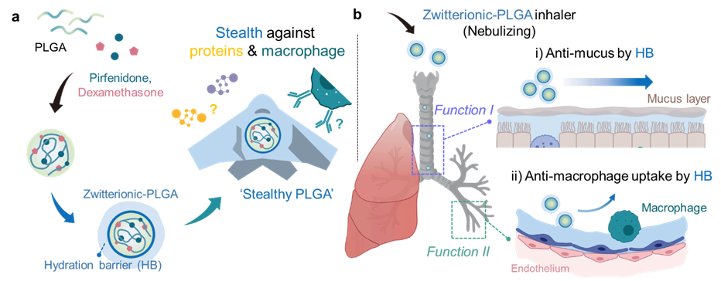

**Figure 1. Schematic illustration of multifunctional zwitterionic-PLGA MPs a**. Synthesis of zwitterionic-PLGA with stealth ability by hydration barrier. **b**. Multifunction (anti-mucociliary clearance, anti-macrophage uptake) of Zwitterionic-PLGA inhaler for pulmonary delivery

2. Results and discussion

2.1. Synthesis of zwitterion functionalized PLGA MPs

Inhalable particles must have an optimized particle size[8a, 16]. The efficiency of reaching the alveolar region is low for nano-sized particles (< 1 μm) due to exhalation, and particles larger than 5 μm are removed from the oropharyngeal region. Therefore, particles with a size of 1–5 μm are generally accepted as the optimal size to reach the alveolar region. Prior to functionalizing sulfobetaine methacrylate (SBMA) and 2-methacryloyloxyethyl phosphorylcholine (MPC) on PLGA MPs, the optimized size of PLGA MPs (mean size: 3.61 μm) for pulmonary delivery were constructed and overall preparation steps are briefly introduced in experimental section.

In practice, for the modifying surface of synthesized PLGA MPs, the solvent that cannot dissolve PLGA should be used. Therefore, zwitterion functionalization of PLGA MPs were conducted through an optimized process using non-solvent and organic solvent that does not dissolve PLGA. The process of zwitterion functionalization to PLGA MPs was carried out by the atom transfer radical polymerization (ATRP) method (**Fig. 2a**). First, an aminolysis reaction was performed using ethylenediamine (EDA) to form an amine group on the synthesized PLGA MPs by using IPA as solvent. The aminolysis process induces the degradation of PLGA MPs rapidly depending on the reaction time, and after 30 minutes of the aminolysis process, the MP morphology started to change, and aggregation also appeared (**Fig. S1a**). The surface charge of the amine functionalized PLGA MPs (NH2-PG) increases according to the reaction time, and further aminolysis was performed for 10 minutes in consideration of particle stability (**Fig. S1b**). Using fourier-transform infrared spectroscopy (FT-IR), the newly formed peak by the amine group and the decreased C-O peak indicated that aminolysis was successfully conducted (**Fig. S2a**)[17]. Through a 2,4,6-trinitrobenzene sulfonic acid (TNBS) assay, we quantitatively analyzed the amount of amine groups and found that 20.817 μM amine groups formed in 1 mg of NH2-PG (**Fig. S2b**). Then, ATRP initiation was performed by reacting with a-bromoisobutyryl bromide (BiBB) by using hexane as solvent. Lastly, zwitterion functionalized PLGA (ZwPG) was synthesized by the functionalization of SBMA and MPC on the surface of the Br-activated particles (SBPG, MPG, respectively) by using mixed solvent of MeOH and DW (1:9). Transmission electron microscopy (TEM) imaging indicated that the spherical structure of SBPG and MPG did not change due to the synthesizing process (**Fig. 2b**). The aerodynamic size of each particle is similar at 3.06 μm for PLGA MPs, 3.32 μm for SBPG, and 3.089 μm for MPG (**Fig. S3**). However, in the case of mean size of the particles, the SBPG and MPG slightly increased which is due to the increased hydrodynamic diameter by the hydration layer formed by zwitterion (**Fig. 2c**).

Through X-ray photoelectron spectroscopy (XPS), the N-H group of NH2-PG from aminolysis, and the additional -R3N+ peak formation in SBPG and MPG, were characterized (**Fig. 2d**). The aminolysis reaction increased the C-H group ratio, and the newly formed C-N group was also detected (**Fig. S4a**). Then, by reacting with BiBB during the ATRP initiation process, an additional Br peak was formed (Br-PG) (**Fig. 2e**). Lastly, through zwitterion functionalization, SBPG and MPG showed S atom and P atom peaks, respectively, for each sulfobetaine and phosphorylcholine zwitterion moiety (**Fig. 2f, g, Table 1**)[18]. The formation of the -SO3 and S-C groups in SBPG and the O-P=O group in MPG was verified and indicated that each zwitterion monomer reacted with Br-PG successfully. The ratio of Br atoms is further decreased after the Br-PG reaction with the zwitterionic monomer (**Fig. S4b**). Subsequently, energy dispersive x-ray spectroscopy (EDS) analysis of SBPG and MPG according to the overall zwitterion functionalization process on a flat silicon wafer was conducted, and each S and P atom formed on the PLGA-coated surfaces was confirmed (**Fig. S5**). Using Raman spectroscopy, the decreased glycolic acid (O-C=O) peak of PLGA and the newly formed broad methacrylate peak (820 cm-1) in SBMA and MPC were also investigated (**Fig. 2h**). Finally, the zeta potential of particles according to each process was analyzed, and SBPG and MPG featured a near-zero net charge at -4.8 mV and -2.3 mV, respectively, which indicates that the zwitterion is successfully functionalized on PLGA MPs (**Fig. 2i**). The hydration layer formed by the zwitterion was further analyzed by confocal microscopy. As a result, the hydration layer of SBPG and MPG capped the hydrophilic dye, methylene blue (MB), while the surface of PLGA MPs did not show any MB dye on surfaces (**Fig. S6**).

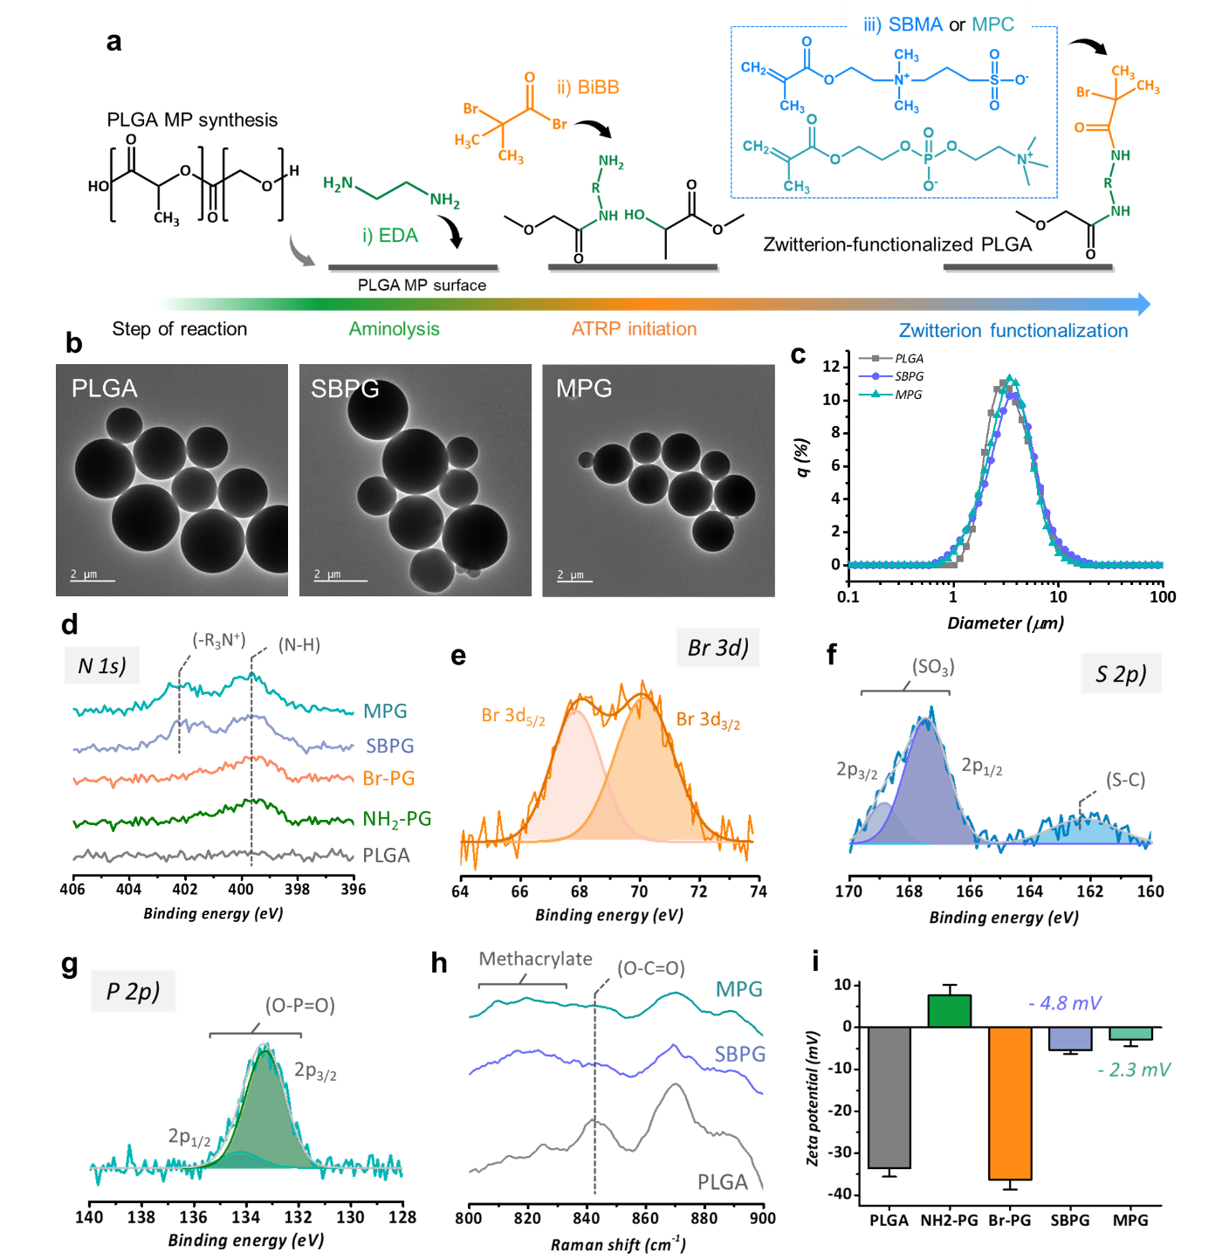

**Figure 2. Analysis of synthesized zwitterionic-PLGA MPs (ZwPG)** **a**. Schematic illustration of the synthesizing steps of zwitterion functionalization. **b**. Transmission electron microscopy (TEM) image of synthesized PLGA MPs, sulfobetaine zwitterion-functionalized PLGA MPs (SBPG), and phosphorylcholine zwitterion-functionalized PLGA MPs (MPG). **c**. Laser scattering size analyzer data of PLGA, SBPG and MPG **d-g**. X-ray photoelectron spectroscopy (XPS) data of PLGA, SBPG, and MPG. **h**. Raman spectroscopy analysis of PLGA, SBPG, and MPG. **i**. Zeta potential analysis of MPs (bare PLGA MPs, NH2-PG, Br-PG, SBPG, and MPG)

2.2. Anti-mucus adhesion ability of SBPG and MPG

In order to increase the efficiency of the PDS in reaching the alveolar region, it is necessary to overcome mucociliary clearance in the airway[11a, 19]. Thus, the interaction between mucin proteins and ZwPG in the mucus solution should be decreased to overcome this mucociliary clearance. The anti-mucus property of the hydration barrier of ZwPG is expected to prevent mucin protein adhesion[20]. Thus, a newly designed experiment for investigating the mucus stability of MPs was conducted. Since water-dispersed MPs naturally form a pellet over time due to gravity and mucin proteins are densely structured in a fibrillar aggregated network in a mucus solution, if MPs are dispersed in a mucus solution, most of the MPs will aggregate with mucin protein and not form a pellet. Therefore, we expected that if PLGA MP was dispersed in a mucus solution, PLGA would not evade the mucin proteins and would remain in the mucus layer or showing decreased rate of settlements[14a, 21]. Contrarily, ZwPG has a lower interaction with mucin protein due to the hydration barrier, which would prevent aggregation with mucin. Therefore, it was expected that ZwPG would penetrate a longer distance in a mucus solution than PLGA alone. As a proof of concept, a mixture of a mucus solution and rhodamine-B (RhB) labeled MPs (PLGA MPs, SBPG, and MPG) was prepared, and the intensity of RhB floating over the mucus solution per time point (in situ) was investigated. The average mobility of each MP in the mucus solution was quantitatively analyzed (**Fig. 3a**). As a result, it was verified that 57.45% of the PLGA MPs formed a pellet, whereas 87.07% and 78.27% of SBPG and MPG formed pellets, respectively (**Fig. 3b**).

To support the above experimental results, the amount of mucin protein adhered to the MP surface was quantitatively analyzed after incubating each particle in a mucus solution for 4 hours. As a result, 419.9 μg of mucin protein adhered to PLGA MPs, while 143.8 and 73.8 μg adhered to SBPG and MPG, respectively (**Fig. 3c**). Subsequently, the adhered mucin protein on MP surfaces were investigated by using raman spectroscopy. Consequently, it was verified that the PLGA MPs showed the highest intensity of Raman shift of mucin protein (1566 cm-1) than SBPG and MPG (**Fig. 3d**). Lastly, the mucus penetration ability of MPs was investigated by transwell experiments. As a result, only 15.29 % of PLGA MPs penetrated the mucus layer, whereas 62.8 and 46.6 % of SBPG and MPG penetrated the mucus layer, respectively (**Fig. 3e**). Overall results suggest that the hydration barrier of ZwPG can reduce the interaction with mucin protein and exhibit a high anti-mucus ability and high stability in a mucus solution. Therefore, ZwPG is expected to have great potential for evading mucociliary clearance.

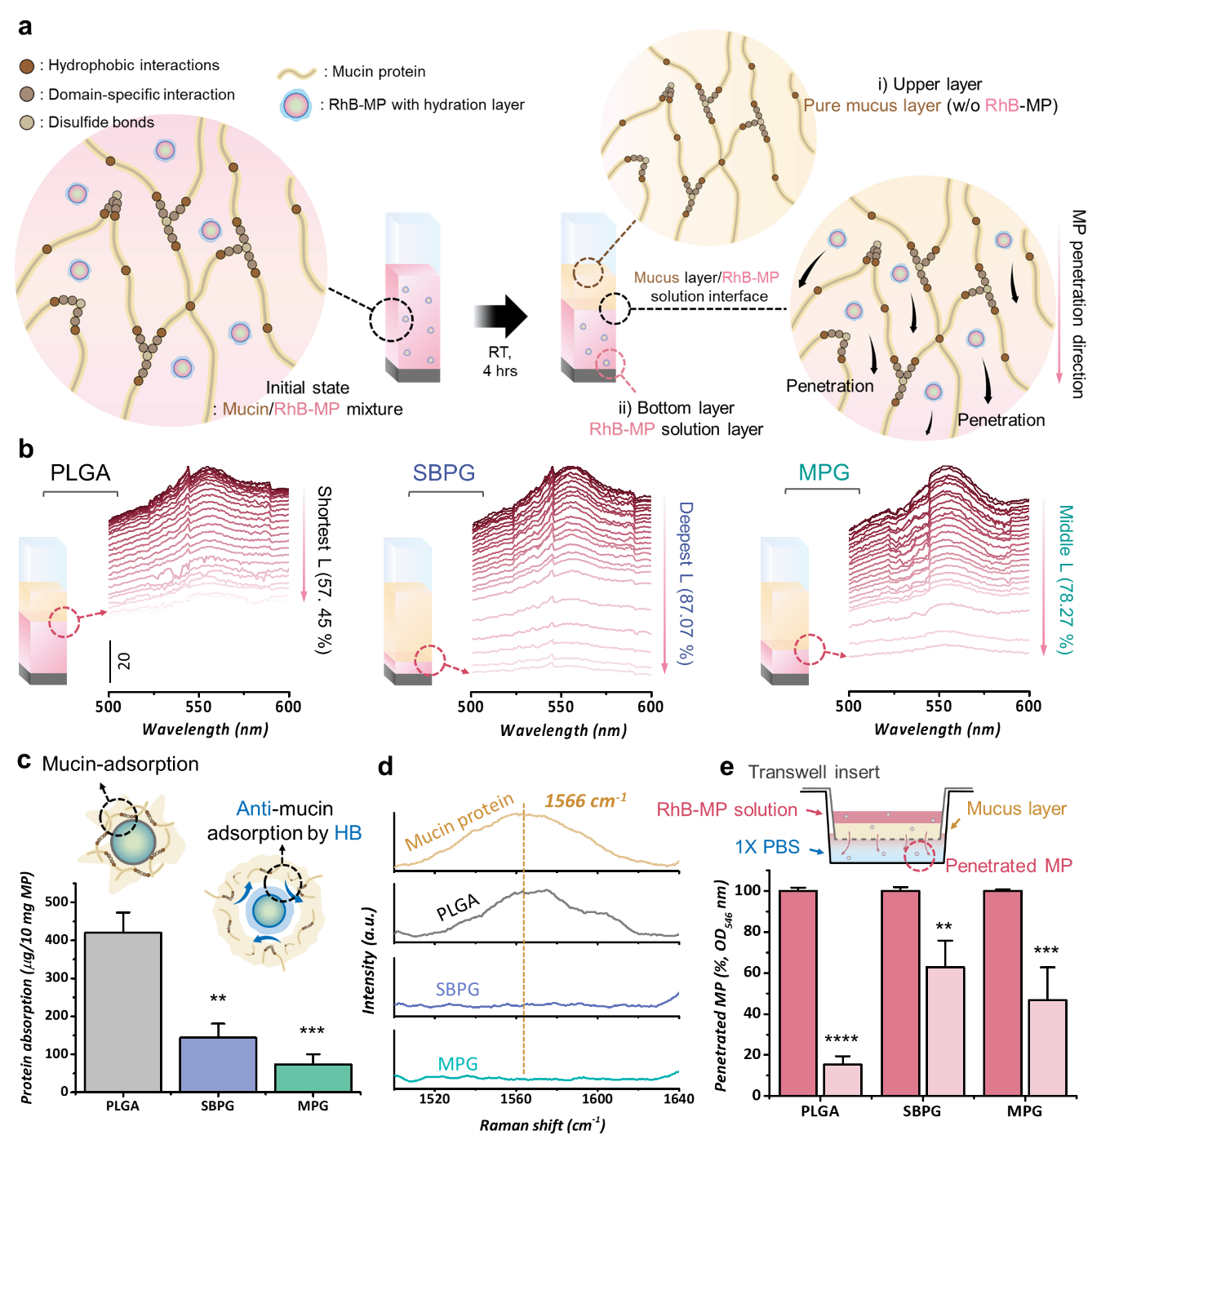

**Figure 3. Investigation of the anti-mucus function of ZwPG a**. Schematic illustration of the experimental setup for investigating the anti-mucus function of ZwPG. **b**. Quantitative analysis of the anti-mucus ability of PLGA MPs, SBPG, and MPG. **c**. Bicinchoninic acid (BCA) analysis of adhered mucin protein on MP surfaces. **d**. Raman spectroscopy data of adhered mucin protein of PLGA MPs, SBPG, and MPG. **e**. Investigation of the mucus penetration ability of PLGA MPs, SBPG, and MPG in a transwell experiment. Data are presented as mean ± standard deviation (SD, n = 3); *P<0.05, **P<0.01, ***P<0.001, ****P<0.0001 (One-way ANOVA with Turkey’s correction, all experiments were conducted independently).

2.3. Analysis of bioavaiability and nebulizing stability of ZwPG

Prior to investigate the synergistic effect of the drug-loaded PLGA particles in macrophage reprogramming, we inspected the nebulizing stability of the particles, bioavailability, and quantitative analysis of drug-loaded amount. For the analysis of nebulizing stability of particles, after nebulizing the prepared MP solution (5 mg/ml in 1X PBS) for 10 minutes, the nebulized MPs were collected, and the morphology and zeta potential were analyzed [22]. As a result, there was no morphological change in PLGA MPs, SBPG, and MPG (**Fig. 4a**). Moreover, there was no significant change in the surface charge of the MPs (**Fig. 4b**), which indicates that the MPs have high nebulizing stability.

The toxicity in lung-derived cells (MRC-5 and L132) of SBPG and MPG (particles and lysate, 1 mg/ml) was firstly investigated. We found that both SBPG and MPG showed excellent biocompatibility in lung cells (**Fig. 4c**). Additionally, the toxicity in human umbilical vein endothelial cells (HUVECs) of PLGA MP, SBPG and MPG was analyzed. As a result, the PLGA MP, SBPG and MPG showed high biocompatibility (**Fig. S7**). Subsequently, a macrophage uptake assay of PLGA MPs, SBPG, and MPG by confocal microscopy was firstly conducted. As a result, most of the PLGA MPs were internalized in the cells, while the SBPG and MPG were free around the macrophages without being phagocytosed (**Fig. 4d, Fig. S8, Fig. S9a**). Additionally, flow cytometry analysis of macrophage uptake was then conducted and decreased macrophage uptake of SBPG and MPG was indicated (**Fig. S9b**). The mean fluorescence intensity (MFI, × 104) was 3.3475 for PLGA MPs, 3.02 for SBPGs and 2.9216 for MPG which demonstrates the functionalized zwitterions on PLGA MPs have decreased macrophage uptake. These results were expected because the hydration barrier on the surface of SBPG and MPG zwitterions inhibited macrophage recognition of the particles as pathogens[23]. Through the macrophage uptake assay, it was verified that the MPs are not phagocytosed by the macrophages due to the zwitterion functionalization, and thus, they have excellent bioavailability for delivery to the lungs through nebulizing. The reduced phagocytosis indicate that Pir and Dex can be released by biodegradation of ZwPG.

Both hydrophilic and hydrophobic drug molecules can be loaded onto PLGA MPs during the synthesis process. The loaded drugs could be spontaneously released due to hydrolysis of ester linkages and biodegradation of PLGA particles[24]. Firstly, RhB (hydrophobic dye) and MB (hydrophilic dye) were used as model drugs and successfully loaded into PLGA MP (**Fig. 4e**). The Pir and Dex, were selected as drugs for the following experiments which both drugs are targeting macrophages reprogramming. Pir is an FDA-approved drug for IPF treatment, and Dex is a corticosteroid that has a potent effect on hyper-activated immune cells[5a, 5b]. However, Pir has side effects, such as nausea and stomach irritations[25], and Dex is a steroidal medicine that can cause serious problems in the endocrine system when administered in high concentrations[26]. Consequently, optimizing minimal doses of both Pir and Dex to maximize the effects is an important concern for drug administration. We hypothesized that mixed use of Pir and Dex could be maximized with minimal concentrations of both drugs for the mediation of phenotypes of macrophages. The synergistic effect of such dual drug delivery is so far undiscovered. Accordingly, Dex as a hydrophilic drug, and Pir as a hydrophobic drug, were loaded into PLGA MPs, followed by SBMA zwitterion functionalization. Finally, Dex/Pir-loaded SBPG (DPPG) was synthesized, and it was confirmed that 26.95 and 9.28 μg/mg of Dex and Pir were loaded in DPPG, respectively (**Fig. 4f**)[5b, 6, 27].

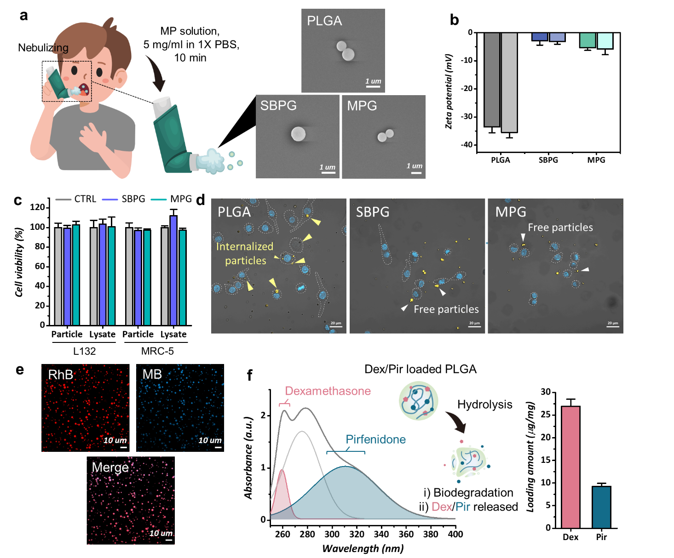

**Figure 4. Bioavailability test of inhalable ZwPG a-b**. Illustration of nebulizing ZwPG (left) and SEM image of collected microparticles after nebulizing (right, scale: 1 μm). **b**. Zeta potential analysis of each particle before nebulizing (left bar) and after nebulizing (right bar). **c**. Biocompatibility test of SBPG and MPG to lung-derived cells (L132, MRC-5). **d**. Macrophage uptake analysis of PLGA MP, SBPG and MPG by confocal microscopy (scale: 20 μm). **e**. Confocal image of rhodamine-B (RhB, hydrophobic) and methylene blue (MB, hydrophilic) loaded in PLGA MP. **f**. UV-vis spectroscopy analysis of dexamethasone phosphate (Dex) and pirfenidone (Pir) loaded in PLGA MP (left) and quantitative analysis of loading amount of Dex and Pir (right).

2.4. Investigating effect of Dexamethasone/Pirfenidone-loaded SBPG (DPPG)

As described previously, lung-related diseases mainly occur due to over-polarized macrophages. Among them, the diseases such as IPF, connective tissue disease, tuberculosis are known as progressed by over-polarized M2 macrophages, and asthma, chronic obstructive pulmonary disease (COPD) are known as progressed by over-polarized M1 macrophages[1c]. Therefore, regulation and reprogramming of phenotypes of macrophages is required, which can prevent serious progress of lung disease. In this study, the reprogramming of over-polarized M2 macrophages were targeted, and analyzed whether polarization of macrophage could be mediated through simultaneously delivered Pir and Dex both drugs by synergistic effect.

In order to analyze the effect of DPPG, flow cytometry analysis (FACS) was conducted. Prior to sample treatment, the macrophages (RAW 264.7) were over-polarized to M2 by treating IL-4. Then, the DPPG was administered to over-polarized M2 macrophages at different concentrations of 0.25 mg/ml (DPPG-25), 0.5 mg/ml (DPPG-50), and 1 mg/ml (DPPG-100). The detailed experimental setup for FACS was introduced in the experimental section. From the gathered FACS data, t-stochastic neighbor embedding (tSNE) maps were obtained by using the combined data from all experimental groups (**Fig. 5a**). The relevant cell populations were identified based on the surface marker expression of RAW264.7 cells (identification of cell populations are explained in the experimental section). When surface marker expressions were compared for each cell population, we observed that a high intensity of Pop 0, 1, and 7 indicates M2 polarization and a high intensity of Pop 2, 4, and 5 indicates M1 polarization of macrophages (**Fig. S10, S11**). As demonstrated in the tSNE map of each group (**Fig. 5b**), the increased intensity of Pop 0 and 1 of the CTRL+ group by IL-4 was expressed. PLGA MPs rarely displayed an influence on M2 polarized cells (**Fig. 5c**). On the contrary, DPPG-25 and 50 showed significant effectiveness for M1 polarization and DPPG-50 showed the highest synergistic effect of Dex and Pir (**Fig. 5d**) by dramatically decreasing ratio of M2 polarization. Moreover, DPPG-100 displayed the balanced polarization of M1 and M2 which indicates 26.95 and 9.28 μg of Dex and Pir is optimized concentration for the balanced macrophage phenotype regulation. Consequently, DPPG-25 and DPPG-50 showed an increased M1 polarization percentage (%), and DPPG-100 showed a similar M1 and M2 polarization percentage (**Fig. 5e**).

Further, cytokines secreted by the RAW264.7 cells were investigated by ELISA (**Fig. 5f**). The ELISA results demonstrated trends similar to the FACS results, and it was observed that TNF-α secretion increased almost 2.5 times when DPPG-25 and DPPG-50 was administered. Specifically, the expression of M1 did not significantly increase in the FACS results in the group treated with PLGA MPs (PG). However, secretion of TNF- α was increased 1.65 times with PLGA MPs. These results suggest that RAW264.7 macrophages have responsibility to PLGA MP and may contribute to the stronger effect of DPPG treatment. IL-6 secretion showed a different trend than TNF-α. In the DPPG-50-treated group, IL-6 secretion was slightly decreased compared to in the CTRL- group, which indicates that M2 polarization could be re-induced at a relatively high concentration. Impressively, it was observed that the expression levels of TGF-β and IL-10 were significantly decreased in DPPG-treated cells, indicating that DPPG (even at lower Pir and Dex doses than the effective doses) induced the polarization of M2 macrophages to M1.

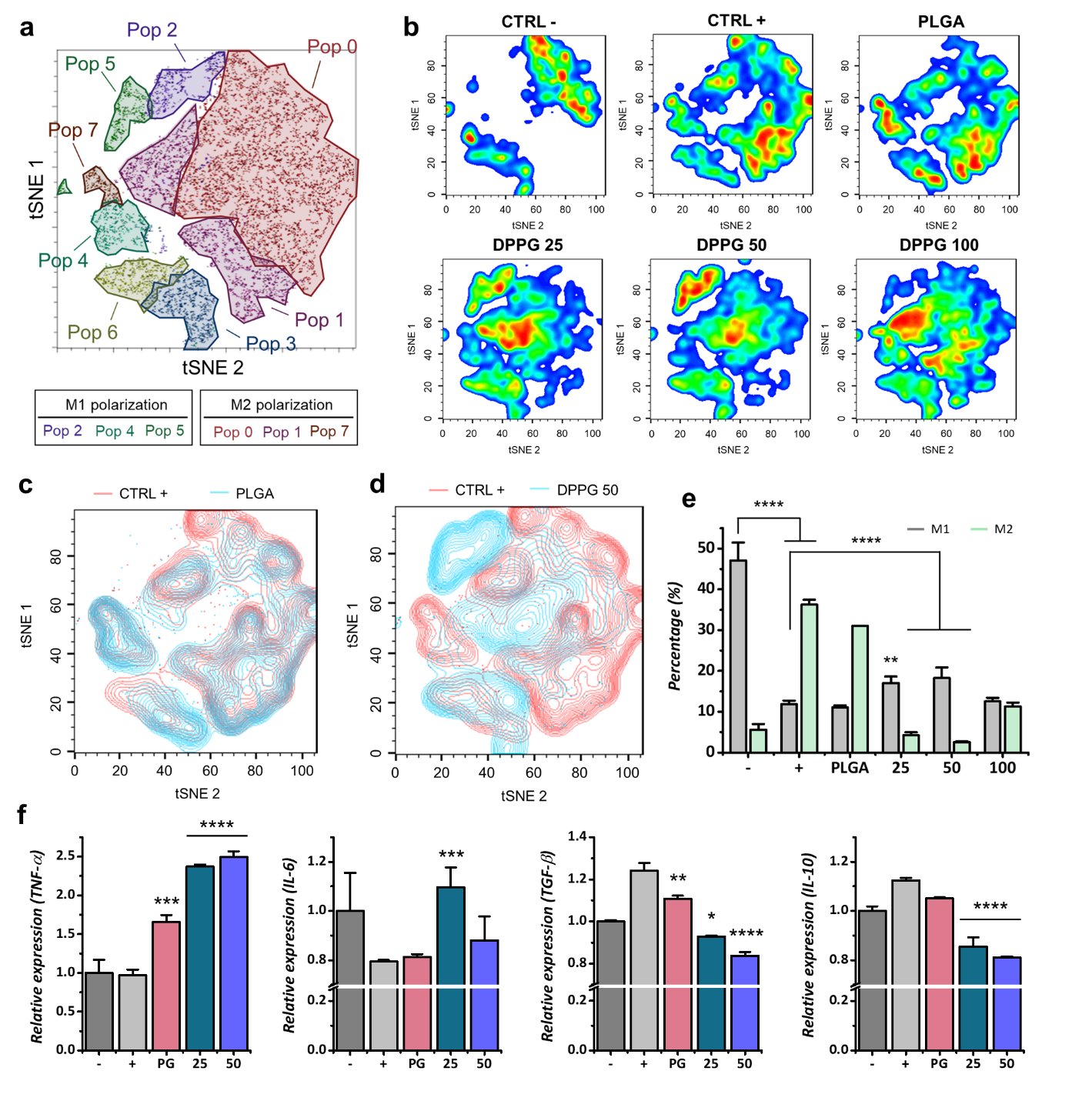

**Figure 5. Synergistic effect of DPPG on over-polarized M2 macrophage a**. t-Stochastic neighbor embedding (tSNE) plot from pooled macrophage samples of each cell population. **b**. tSNE plot of each sample. **c**. tSNE comparison of CTRL+/PLGA and **d.** CTRL+/DPPG 50. **e**. M1/M2 polarization percentage of each sample. **f**. ELISA results of each sample. Data are presented as mean ± standard deviation (SD, n = 3); *P<0.05, **P<0.01, ***P<0.001, ****P<0.0001 (One-way ANOVA with Turkey’s correction, all experiments were conducted independently).

As described previously, pulmonary fibrosis (PF) occurs due to increased M2 polarized alveolar macrophages, and cytokines such as TGF-β and IL-10 are excessively secreted, which induces over-proliferation of fibroblasts and collagen hypersecretion[1a]. The over-proliferated fibroblasts and thickly deposited collagen reduce the efficiency of O2/CO2 exchange in the alveoli region. To treat IPF, induction of M2-polarized macrophages to M1 polarization is required, which can inhibit fibroblast proliferation and induce degradation of the collagen layer by the secretion of tumor necrosis factor-alpha (TNF-α) and IL-6 (**Fig. 6a, b**). Therefore, as a study for model disease PF, we conducted an enzyme-linked immunosorbent assay (ELISA) to analyze the cytokines secreted when DPPG-50 was administered to macrophages (RAW264.7). We wanted to evaluate whether Dex and Pir have a synergistic effect on un-polarized macrophages when delivered simultaneously with DPPG (**Fig. 6c**). The concentration of Dex and Pir administered to the macrophages was the expected effective dose according to previous studies (20 and 10 μg/ml, respectively), while the Dex/Pir concentration of DPPG-50 was lower than the effective dose of both drugs (13.475 and 4.64 μg/ml, respectively). As a result, it was shown that TNF-α and IL-6 expression was higher in the DPPG treated group than in the groups where Dex or Pir was administered alone, which indicates that a higher ratio of M1 polarization was induced by the synergistic effect of simultaneous Dex and Pir administration. Furthermore, the effect of DPPG was observed at a lower concentration than the effective doses of Dex and Pir, which suggests that DPPG is more powerful for PF treatment than Dex or Pir alone. Previous studies have shown that Dex induces M2 polarization and increased IL-10 expression when Dex was administered alone was indicated[28]. However, IL-10 expression was not significantly different in the DPPG-treated group compared to the control group, which demonstrates that simultaneous delivery of Dex and Pir both did not induce M2 polarization.

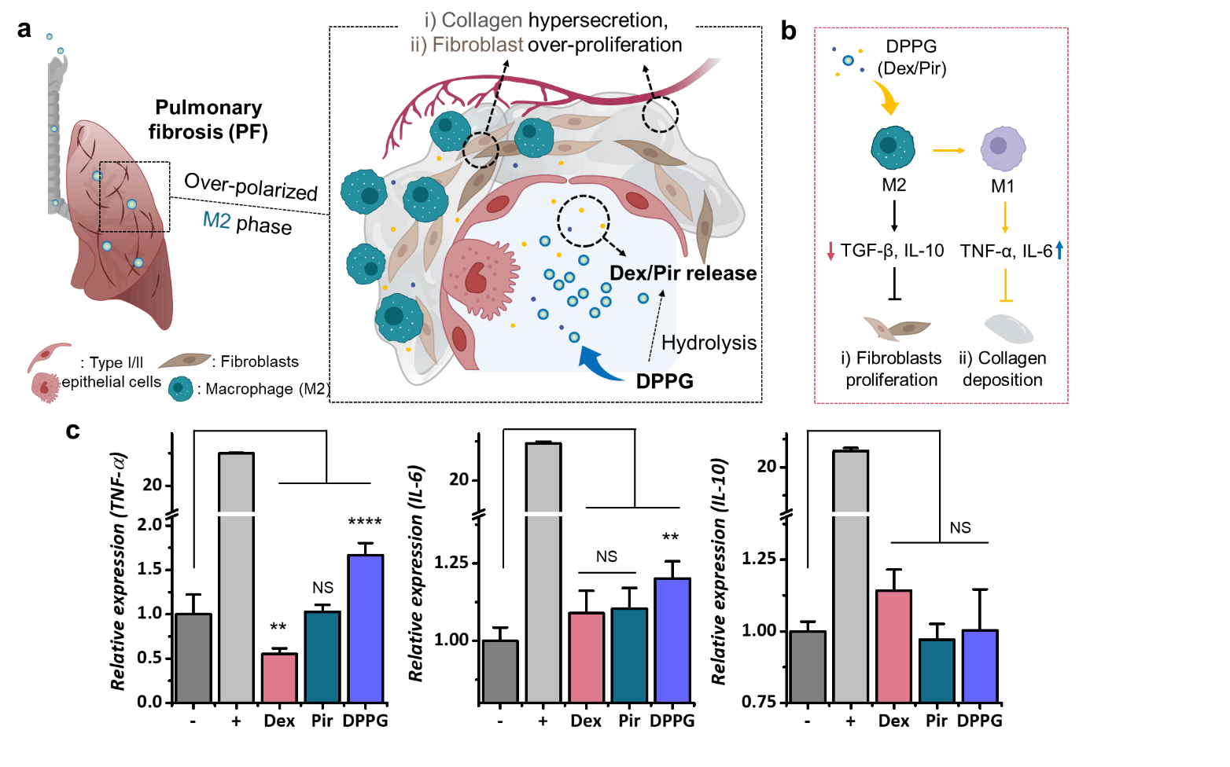

**Figure 6. Strategy for treatment of pulmonary fibrosis (PF) a**. Schematic illustration of over-polarized M2 phase-derived lung tissues and strategy for macrophage reprogramming. **b**. Functions of Dex/Pir loaded SBPG (DPPG) to macrophage and IPF. **c**. Enzyme-linked immunosorbent assay (ELISA) data of Dex, Pir (single drug, each) and DPPG to Raw264.7 macrophage. Data are presented as mean ± standard deviation (SD, n = 3); *P<0.05, **P<0.01, ***P<0.001, ****P<0.0001 (One-way ANOVA with Turkey’s correction, all experiments were conducted independently).

3. Conclusion

For a highly efficient particle-based PDS, the defense system of the lungs (*i.e.,* mucociliary clearance, macrophage uptake) must be overcome. In this study, PLGA MPs were functionalized with two types of zwitterions without damage to the PLGA particles through ATRP reaction by optimized solvent control. The synthesized zwitterion-functionalized PLGA MPs (ZwPG) showed high stability for nebulizing, and it has been verified that ZwPGs have excellent anti-mucus adhesion and anti-macrophage phagocytosis functions which are expected to dramatically increase drug delivery efficiency through PDS. In addition, Dex and Pir, were loaded into biocompatible ZwPG (DPPG), and the regulation of macrophage polarization was analyzed. As a result, a synergistic effect was shown through the simultaneous delivery of Dex/Pir by DPPG, and the over-polarized M2 macrophages were reprogrammed to pro-inflammatory phenotypes, which indicates the potential of DPPG for macrophage phenotype regulator. The overall results demonstrate that ZwPG is a highly attractive drug delivery carrier for the PDS, and the delivery of Dex/Pir through ZwPG has great potential for PF treatment.

4. Experimental Section/Methods

**4.1. Reagents and materials**

Poly(lactide-co-glycolide) (PLGA, 50:50, MW 30,000–60,000), poly(vinylalcohol) (PVA, Mw 13,000–23,000, 87–89% hydrolyzed), ethylenediamine (EDA), dichloromethane (DCM), dimethyl sulfoxide (DMSO, ≥ 99%), a-bromoisobutyryl bromide (BiBB), hexane (anhydrous, 95%), copper(II) bromide (CuBr2, 98%), triethylamine (TEA, ≥ 99.5%), 2,2’-bipyridyl (bpy, ≥ 99%), L-ascorbic acid (AA), sulfobetaine methacrylate (SBMA), 2-methacryloyloxyethyl phosphorylcholine (MPC, 97%), methanol (MeOH, anhydrous), mucin from porcine stomach (Type II), Roswell Park Memorial Institute (RPMI) 1640 amino acids solution (50X), egg yolk emulsion, sodium chloride (NaCl), potassium chloride (KCl), rhodamine B (RhB), methylene blue (MB), dexamethasone sodium phosphate (Dex), and pirfenidone (≥ 97%, HPLC) were purchased from Sigma Aldrich (Korea). Phosphate-buffered saline (10X) and 4’6-diamidino-2-phenylindole (DAPI) were obtained from Thermofisher Scientific (Korea). Isopropyl alcohol (IPA) was purchased from Daejung (Korea). PE anti-mouse F4/80 (Clone: 123110), Pacific BlueTM anti-mouse/human CD11b (Clone: 101224), fluorescein-5-isothiocyanate (FITC) anti-mouse CD80 (Clone: 104706), Alexa Fluor 647 anti-mouse CD206 (Clone: 141712), purified anti-mouse CD16/32 (Clone: 101302), and 7-AAD viability staining solution (Clone: 420403) were purchased from BioLegend (DaesungBio, Korea).

**4.2. Synthesis of PLGA MPs**

PLGA MPs were prepared using the double emulsion (W1/O/W2) solvent evaporation method[29]. In brief, 75 mg PLGA was dissolved in 3 ml DCM, and 1 ml of deionized water (DW, Human power 1 biotype, Human corporation, 18.3 MΩ) was added to the solution. The prepared solution was emulsified with an ultrasonic processor (VC-505, SONICS) to form a primary emulsion (W1/O). Then, the primary emulsion was added to the PVA solution (2 wt %) in a dropwise manner. The double emulsion (primary emulsion mixed with PVA, W1/O/W2) was formed by ultrasonication. The double emulsion was stirred for six hours to remove the DCM (800 rpm, 37℃) and solidify the microparticles. The PLGA MPs were collected by centrifuging and washing with DW three times (13000 rpm, 10 minutes, VARISPIN15R, Hanil Scimed) and frozen with liquid nitrogen. The frozen PLGA MPs were lyophilized (FreeZone 2.5 Liter – 50 C, LABCONCO) for two days, and finally, 3 μm sizes of PLGA MPs were constructed. The final product was stored at -20 ℃ until further use.

**4.3. Zwitterion functionalization of PLGA MPs**

For the amine functionalization of the PLGA MPs, the prepared PLGA MPs (10 mg/ml) and 0.5 M EDA were dissolved in IPA, and the aminolysis reaction was conducted for 10 minutes. The aminolyzed PLGA MPs (NH2-PG) were washed two times with IPA and once with DW (8000 rpm, 10 minutes), and lyophilized for two days. Then, atom transfer radical polymerization (ATRP) initiation was conducted. The dried NH2-PG (10 mg/ml) was suspended in 10 ml hexane, and 140 μL TEA (1 mmol) was added. The BiBB was then added dropwise to the suspension (10 μL) with gentle stirring and incubated for two hours in an ice bath (0℃) and an additional four hours at room temperature (RT). After the reaction, the remaining reagents were washed with pure hexane four times (3000 rpm, 5 minutes). The BiBB-functionalized PLGA MPs were vacuum-dried overnight at RT prior to washing with DW. The resultant MPs were washed with DW, lyophilized, and the obtained Br-PG was also stored in a freezer until use. For the ATRP reaction of SBMA and MPC, 2.23 mg CuBr2, 3.123 mg bpy, and 17.612 mg AA were dissolved in 10 ml MeOH and DW mixed solvent (1:9). Br-PG (10 mg/ml) was added to the solution and dispersed with sonication. Then, SBMA or MPC (6 mM) was added to the solution. The ATRP reaction was conducted for 8 hours at RT, and the resultant was washed with MeOH once and DW twice. The pellet was lyophilized for two days, and finally, zwitterion-functionalized PLGA MPs (ZwPG) were synthesized. The SBMA functionalized PLGA MPs were named SBPG, and MPC functionalized PLGA MPs were named MPG. ZwPG was also stored at -20℃ until further use.

**4.4. ZwPG characterization**

X-ray photoelectron spectroscopy (XPS) data were collected using a K-alpha+ microscope (ThermoFisher Scientific). Raman spectroscopy spectra were obtained using an XploRATM PLUS (Horiba). The hydrodynamic size and aerodynamic size of each particle was obtained by using laser scattering particle size distribution analyzer (LA-960, Horiba). Zeta potential experiments were carried out using an SZ-100 (Horiba). Transmission electron spectroscopy (TEM) images were obtained using NEOARM (JEM-ARM200F), and an energy dispersive X-ray spectrometer (EDS) analysis was conducted using a field emission scanning electron microscope (JEOL-7800F). A UV-vis spectroscopy analysis was conducted using a model Evolution 300 (ThermoFisher Scientific). For the analysis of the hydration layer on ZwPG, the dye-capping ability of MPs was investigated. Briefly, the MPs (1 mg/ml) were dispersed in methylene blue (MB) solution (1X PBS as solvent, 0.1 mg/ml) and incubated for 10 minutes. Then the MPs were thoroughly washed three times with 1X PBS and imaged using confocal microscopy (LSM 980, Carl Zeiss).

**4.5. Anti-mucus adhesion assay**

Prior to the anti-mucus adhesion assay, an artificial mucus solution was prepared as previously described with slight modifications[19, 21]. Briefly, 250 mg mucin, 1 ml RPMI amino acid solution, 250 μL egg yolk emulsion, 250 mg NaCl, and 110 mg KCl were dissolved in DW (50 ml). The mucus solution was stirred for two hours for equilibration at 37℃, centrifuged for 20 minutes (6000 rpm), and the supernatant was used for further analysis. For the labeling of ZwPG, RhB was added to the PLGA solution, which was dissolved in DCM, and the same zwitterion-functionalization step was performed, and RhB-labeled ZwPG (RhB-SBPG and RhB-MPG) were synthesized.

The lab-designed anti-mucus experiment was conducted following a simple experimental setup. The RhB-labeled ZwPG (1 mg/ml, SBPG and MPG) was dissolved in a prepared mucus solution (3 ml each). Then, the mixed solution was placed in UV-vis cuvettes, and the RhB intensity was measured every 10 minutes (λ = 500–600 nm) for 4 hours. For the bicinchoninic acid assay (BCA), 10 mg of ZwPG (SBPG or MPG) was dispersed in a mucus solution (1 ml, n = 3) and incubated for 4 hours at 37℃. After incubation, the mixed ZwPG solution was centrifuged (6000 rpm), and the supernatant used for the BCA assay (PierceTM BCA protein assay kit, ThermoFisher Scientific), and the mucin protein on the pellet was detected using Raman spectroscopy. The mucus penetration ability test was performed using a 24-well transwell plate (Corning®, 8 μm pore size). First, each RhB labeled MP (PLGA, SBPG, and MPG) was dispersed in 1X PBS (10 mg/ml). In the 24-well plate, 0.5 ml of pure 1X PBS was added. Next, the mucus solution (100 μL) was added to the transwell insert first, and the prepared RhB-ZwPG solution (100 μL) was added subsequently. After incubation for 4 hours, the inserts were removed, and 200 μL samples were collected and measured using a plate reader at 546 nm (SpectraMax 340 PC; Molecular Devices).

**4.6. Collection of nebulized MPs**

The PLGA MPs and ZwPG aerosols were collected by attaching a 50 ml tube to the outlet of a nebulizer (InnoSpire Elegance with SideStream, Philips), and the tube and nebulizer outlet were fixed using parafilm. For the aerosol, each particle was dispersed in 1X PBS with a concentration of 5 mg/ml. The nebulizing was conducted for at least 10 minutes, and after nebulizing, 10 ml 1X PBS was added to the aerosol-containing tube, and the nebulized MPs were collected. After centrifugation (8000 rpm), the supernatant was removed, and 1 ml of pure 1X PBS was added to resuspend the nebulized MPs for further analysis.

**4.7. Cell viability and macrophage uptake assay for ZwPG**

The cell viability of ZwPG was evaluated using L132 and MRC-5 cells, which are human lung-derived cells. The L132 cells were cultured in complete Dulbecco’s Modified Eagle’s Medium (DMEM, high glucose, pyruvate) with 10% fetal bovine serum (FBS) and 1% penicillin/streptomycin (PS), which were purchased from ThermoFisher Scientific. The cell culture medium for the MRC-5 cells was α-Minimum Essential Medium (αMEM, Thermofisher Scientific), containing the same concentration of FBS and PS as the L132 medium. The cell culture medium for the human umbilical vein endothelial cells (HUVECs) was Endothelial Cell Growth Basal Medium (EBM), containing the supplements (Endothelial Cell Growth Medium SingleQuotsTM Supplement Pack, Lonza) and 1% PS. The cells were cultured following the protocol from the cell supplier. After cell culture, the cells were seeded in 24-well plates at the same cell density (5 × 104 cells/well). After two days of cell incubation (5% CO2 atmosphere, 37℃), the MP samples were administered to each well (n = 3). The type of samples was separated with particles and lysate (dissolved MPs in 10 μL DMSO) of SBPG or MPG with the same concentration (1 mg/ml). To test the cell viability of the lysate, the same amount of DMSO was also administered to the control (CTRL) group. After two days of incubation, the cells were washed with 1X PBS twice, and 500 μL growth medium and 50 μL cell counting kit-8 (CCK-8) reagent (Donginbiotech Co., Korea) were added, followed by incubation for 1.5 hours. Then, the medium was collected, and the absorbance (λ = 450 nm) was measured using a plate reader. For the viability test of HUVECs, only particle samples were administered to each well (1 mg/ml, n = 3). After incubation for one day and two days, respectively, cell viability was confirmed through CCK assays as with L132 and MRC-5 cells.

The macrophage uptake test was conducted using RAW264.7 macrophages. The RAW264.7 cells were cultured using DMEM (low glucose) with 10% FBS and 1% PS. The cultured RAW264.7 cells were seeded in a 3-well chamber (Ibidi, 1 × 104 cells/well). Then, an equal concentration of RhB-labeled PLGA MPs, SBPG, and MPG was administered to each well (0.1 mg/ml) and incubated for 4 hours. After incubation, the chamber was washed three times with 1X PBS to remove the residual MPs, and the cells were fixed with formaldehyde (Sigma Aldrich, Korea) for 15 minutes. Then, the chamber was washed with 1X PBS three times, and the fixed cells were stained with DAPI (for nuclei staining, 1X, dissolved in 0.1% BSA in 1X PBS) for 45 minutes. The stained cells were imaged by confocal microscopy (LSM 980, Carl Zeiss). The quantitative analysis of macrophage uptake was investigated by flow cytometry analysis. Briefly, the RAW 264.7 macrophages were cultured and seeded to 24-well plate (1 × 105 cells/well). After 1 day, the rhodamine-labeled MPs (PLGA MP, SBPG and MPG) were treated to each well plate (100 μL of 0.1 mg/mL MP solution). After incubation 4 hours, each well was washed two times with 1X PBS and detached by using a cell scraper. Collected cells were centrifuged for 5 minutes at 1500rpm at 4 $℃$, and the supernatant was removed. Then, the cells were blocked with CD16/32 for 20 minutes, and the supernatant was removed. Subsequently, antibody for CD11b was added to each cell and incubated for 30 minutes. The cells were then centrifuged and washed with FACS buffer three times. Lastly, the cells were strained with FACS buffer and then analyzed using a flow cytometer (BD FACS verse I, Becton-Dickinson). The gathered data was analyzed using FlowJo software.

**4.8. Synthesizing Dex/Pir-loaded PLGA MPs (DPPG)**

For the drug loading of PLGA MPs, both drugs (Pir and Dex) are added in the initial PLGA MP synthesis process. The Pir (15 mg, hydrophobic) was dissolved in DCM with PLGA, and Dex (30 mg, hydrophilic) was dissolved in DW, followed by the same experimental steps for PLGA MP synthesis and SBMA functionalization. Finally, Dex/Pir-loaded SBMA functionalized PLGA MPs were synthesized (DPPG).

**4.9. Enzyme-linked immunosorbent assay of Dex, Pir, and DPPG treated to macrophages**

For the investigation of the effect of DPPG for reprogramming of macrophage phenotypes, the macrophages were M2-polarized prior to treatment with Dex, Pir, and DPPG. Briefly, the RAW264.7 cells were seeded in a 24-well plate (SPL, 1 × 105 cells/well) and incubated for one day. Then, interleukin-4 (IL-4, 40 ng/ml, ThermoFisher Scientific) was administered to all wells except the negative control group (CTRL-) and incubated for two days. After two days, the drugs and lysates of DPPG were administered by the following steps. For the positive control group (CTRL+), lipopolysaccharide (LPS, ThermoFisher Scientific) was added at a final concentration of 100 ng/ml. Dex was dissolved in 1X PBS and added to wells at a final concentration of 20 μg/ml. Pir was dissolved in DMSO (10 μL) and added to wells at a final concentration of 10 μg/ml. DPPG (0.5 mg) was dissolved in DMSO (10 μL) and added to wells at a final concentration of 12.5 μg/ml Dex and 4.5 μg/ml Pir. Additionally, 10 μL DMSO (the same amount in the samples and Pir treatment) was added to wells that had not been previously dosed with DMSO. After one day of incubation, the cell supernatant was collected, centrifuged (8000 rpm, 10 minutes, 4℃) and stored at 4℃ for the ELISAs.

In this study, ELISA kits for TNF-α (Mouse TNF-alpha Quantikine ELISA kit), TGF-β (Mouse TGF-beta 1 Quantikine ELISA kit), IL-6 (Mouse IL-6 Quantikine ELISA kit), and IL-10 (Mouse IL-10 Quantikine ELISA kit) were purchased from R&D systems (Korea). Before the TGF- β ELISA, the collected samples were activated using a sample activation kit 1 (R&D systems, Korea) following the activation procedure.

**4.10. Flow cytometry analysis and ELISAs for overly M2-polarized macrophages**

Prior to sample treatment for FACS, the RAW264.7 cells were also over-polarized to M2 by using the same experimental protocol as in the previous section. After M2 polarization of the macrophages, bare PLGA MPs (1 mg/ml dissolved in 10 μL DMSO), DPPG at different concentrations (0.25, 0.5, and 1 mg/ml dissolved in 10 μL DMSO) were administered, and 10 μL DMSO were administered to the negative control group (CTRL-) and positive control group (CTRL+). Except in the CTRL- group, IL-4 (40 ng/ml, final concentration) was added again after the sample treatment. Then, the cells were incubated for one day and collected following the experimental procedure for FACS sampling.

The surface expression markers for macrophages (F4/80, CD11b), M1 macrophages (CD80), and M2 macrophages (CD206) were examined using flow cytometry. Collected cells were centrifuged for 5 minutes at 1500rpm at 4 $℃$, and the supernatant was removed. Then, the cells were blocked with CD16/32 for 20 minutes, and the supernatant was removed. Subsequently, antibodies for F4/80, CD11b, CD80, and CD206 were added to each cell and incubated for 30 minutes. The cells were then centrifuged and washed with FACS buffer three times. To recognize live or dead cells, 7-AAD was added and incubated for 30 minutes. Lastly, the cells were strained with FACS buffer and then analyzed using a flow cytometer (BD FACS verse I, Becton-Dickinson). The gathered data was analyzed using FlowJo software.

**4.11. Flow cytometry data analysis**

FACS data were concatenated, and gating was performed using FlowJo. The dimensionality reduction was conducted from the concatenated samples by t-Stochastic neighbor embedding (tSNE) using surface markers (CD80, CD206, CD11b, and F4/80). The cell populations in the tSNE plots were identified using FlowSom, ClusterExplorer plugins, and a cluster heatmap table (**Fig. S10**), and tSNE data for each surface marker (**Fig. S**11) was obtained[22a].

**Supporting Information**

Supporting Information is available from the Wiley Online Library or from the author.

Acknowledgements

S. J. and J. H designed the research plan, S. J. performed all of the experiments and analyzed the data. S. H., Y. O, K. P and S. P worked on the figures and contributed to the writing of the manuscript. S. H., W. C. provided technical support. Y. K., W. K., SY. J. and J. H. supervised the project. All authors discussed and edited the manuscript at all stages. This research was supported by Korea-England Cooperative Development Program through the National Research Foundation of Korea (NRF) funded by the Ministry of Education (NRF-2021K1A3A1A88100035) and UK medical research council (MC_PC_21012), Bio & Medical Technology Development Program of the National Research Foundation (NRF) funded by the Ministry of Science & ICT (2019M3A9H1103786), Korea Drug Development Fund funded by Ministry of Science and ICT, Ministry of Trade, Industry, and Energy, and Ministry of Health and Welfare (HN21C1410000021, Republic of Korea) and faculty research grant of Yonsei University College of Medicine (6-2020-0098).

**Conflict of Interest**

The authors declare that they have no conflict of interest.

Received: ((will be filled in by the editorial staff))  
Revised: ((will be filled in by the editorial staff))  
Published online: ((will be filled in by the editorial staff))

**References**

[1] a) M. W. Konstan, P. J. Byard, C. L. Hoppel, P. B. Davis, *N. Engl. J. Med.* **1995**, 332, 848; b) J. S. Kim, J. Y. Lee, J. W. Yang, K. H. Lee, M. Effenberger, W. Szpirt, A. Kronbichler, J. I. Shin, *Theranostics* **2021**, 11, 316; c) P. P. Ogger, A. J. Byrne, *Mucosal Immunol.* **2021**, 14, 282.

[2] a) A. Kosyreva, D. Dzhalilova, A. Lokhonina, P. Vishnyakova, T. Fatkhudinov, *Front. Immunol.* **2021**, 12, 682871; b) E. Y. Bissonnette, J.-F. Lauzon-Joset, J. S. Debley, S. F. Ziegler, *Front. Immunol.* **2020**, 11, 583042.

[3] a) D. C. Fajgenbaum, C. H. June, *N. Engl. J. Med.* **2020**, 383, 2255; b) T. T. Braga, J. S. H. Agudelo, N. O. S. Camara, *Front. Immunol.* **2015**, 6, 602; c) M. Lech, H.-J. Anders, *Biochim. Biophys. Acta -Mol. Basis. Dis.* **2013**, 1832, 989.

[4] a) A. Andersson-Sjöland, C. G. De Alba, K. Nihlberg, C. Becerril, R. Ramírez, A. Pardo, G. Westergren-Thorsson, M. Selman, *Int. J. Biochem. Cell Biol.* **2008**, 40, 2129; b) T. E. King Jr, A. Pardo, M. Selman, *The Lancet* **2011**, 378, 1949.

[5] a) H. Ying, M. Fang, Q. Q. Hang, Y. Chen, X. Qian, M. Chen, *J. Cell. Mol. Med.* **2021**, 25, 8662; b) X. Sang, Y. Wang, Z. Xue, D. Qi, G. Fan, F. Tian, Y. Zhu, J. Yang, *Front. Immunol.* **2021**, 12, 613907; c) A. J. Byrne, T. M. Maher, C. M. Lloyd, *Trends Mol. Med.* **2016**, 22, 303; d) F. Hou, K. Xiao, L. Tang, L. Xie, *Front. Immunol.* **2021**, 12, 753940; e) A. J. Byrne, S. A. Mathie, L. G. Gregory, C. M. Lloyd, *Thorax* **2015**, 70, 1189.

[6] H. Kim, Y.-H. Choi, S. J. Park, S. Y. Lee, S. J. Kim, I. Jou, K. H. Kook, *Invest. Ophthalmol. Vis. Sci.* **2010**, 51, 3061.

[7] a) R. Li, Y. Jia, X. Kong, Y. Nie, Y. Deng, Y. Liu, *J. Control. Release* **2022**, 348, 95; b) L. Richeldi, R. M. Du Bois, G. Raghu, A. Azuma, K. K. Brown, U. Costabel, V. Cottin, K. R. Flaherty, D. M. Hansell, Y. Inoue, *N. Engl. J. Med.* **2014**, 370, 2071.

[8] a) J. S. Patton, P. R. Byron, *Nat. Rev. Drug Discov.* **2007**, 6, 67; b) L. Ding, S. Tang, T. A. Wyatt, D. L. Knoell, D. Oupický, *J. Control. Release* **2021**, 330, 977.

[9] a) J. L. Perry, S. Tian, N. Sengottuvel, E. B. Harrison, B. K. Gorentla, C. H. Kapadia, N. Cheng, J. C. Luft, J. P.-Y. Ting, J. M. DeSimone, *ACS nano* **2020**, 14, 7200; b) G. Kim, Y. Lee, J. Ha, S. Han, M. Lee, *J. Control. Release* **2021**, 330, 684; c) F. Andrade, D. Rafael, M. Videira, D. Ferreira, A. Sosnik, B. Sarmento, *Adv. Drug Deliv. Rev.* **2013**, 65, 1816.

[10] a) D. Groneberg, C. Witt, U. Wagner, K. Chung, A. Fischer, *Respir. Med.* **2003**, 97, 382; b) H. M. Mansour, Y.-S. Rhee, X. Wu, *Int. J. Nanomedicine.* **2009**, 4, 299.

[11] a) S. P. Bandi, S. Bhatnagar, V. V. K. Venuganti, *Acta Biomater.* **2021**, 119, 13; b) R. Bansil, B. S. Turner, *Curr. Opin. Colloid Interface Sci.* **2006**, 11, 164.

[12] a) T. Hussell, T. J. Bell, *Nat. Rev. Immunol.* **2014**, 14, 81; b) M. Ochs, J. Hegermann, E. Lopez-Rodriguez, S. Timm, G. Nouailles, J. Matuszak, S. Simmons, M. Witzenrath, W. M. Kuebler, *Int. J. Mol. Sci.* **2020**, 21, 3075.

[13] F. Ungaro, I. d'Angelo, A. Miro, M. I. La Rotonda, F. Quaglia, *J. Pharm. Pharmacol.* **2012**, 64, 1217.

[14] a) J. Li, H. Zheng, E.-Y. Xu, M. Moehwald, L. Chen, X. Zhang, S. Mao, *Acta Biomater.* **2021**, 123, 325; b) S. Hu, Z. Yang, S. Wang, L. Wang, Q. He, H. Tang, P. Ji, T. Chen, *Chem. Eng. J.* **2022**, 428, 132107; c) E. Secret, S. J. Kelly, K. E. Crannell, J. S. Andrew, *ACS Appl. Mater. Interfaces* **2014**, 6, 10313.

[15] a) J. B. Schlenoff, *Langmuir* **2014**, 30, 9625; b) A. Wu, Y. Gao, L. Zheng, *Green Chem.* **2019**, 21, 4290; c) E. Zhang, J. Yang, K. Wang, B. Song, H. Zhu, X. Han, Y. Shi, C. Yang, Z. Zeng, Z. Cao, *Adv. Funct. Mater.* **2021**, 31, 2009431.

[16] J. A. Champion, A. Walker, S. Mitragotri, *Pharm. Res.* **2008**, 25, 1815.

[17] M. Alvarez-Paino, M. H. Amer, A. Nasir, V. Cuzzucoli Crucitti, J. Thorpe, L. Burroughs, D. Needham, C. Denning, M. R. Alexander, C. Alexander, *ACS Appl. Mater. Interfaces* **2019**, 11, 34560.

[18] W. Choi, S. Park, J.-S. Kwon, E.-Y. Jang, J.-Y. Kim, J. Heo, Y. Hwang, B.-S. Kim, J.-H. Moon, S. Jung, *ACS Nano* **2021**, 15, 6811; W. Choi, J. Jin, S. Park, J.-Y. Kim, M.-J. Lee, H. Sun, J.-S. Kwon, H. Lee, S.-H. Choi, J. Hong, *ACS. Appl. Mater. Interfaces* **2020**, 12, 7951-7965

[19] A. Sharma, K. Vaghasiya, P. Gupta, A. K. Singh, U. D. Gupta, R. K. Verma, *J. Control. Release* **2020**, 324, 17.

[20] a) S. Jung, K. Park, S. Park, J. Heo, W. Choi, J. Hong, *ACS Appl. Mater. Interfaces* **2021**, 13, 54363; b) S. Jung, S. Park, D. Choi, J. Hong, *Adv. Mater. Interfaces.* **2020**, 7, 2001433.

[21] B. Porsio, E. F. Craparo, N. Mauro, G. Giammona, G. Cavallaro, *ACS Appl. Mater. Interfaces* **2018**, 10, 165.

[22] a) Y. Ju, C. Cortez‐Jugo, J. Chen, T. Y. Wang, A. J. Mitchell, E. Tsantikos, N. Bertleff‐Zieschang, Y. W. Lin, J. Song, Y. Cheng, *Adv. Sci.* **2020**, 7, 1902650; b) L. A. Dailey, T. Schmehl, T. Gessler, M. Wittmar, F. Grimminger, W. Seeger, T. Kissel, *J. Control. Release* **2003**, 86, 131.

[23] F. Ahsan, I. P. Rivas, M. A. Khan, A. I. T. Suárez, *J. Control. Release* **2002**, 79, 29.

[24] Y. Hua, Y. Su, H. Zhang, N. Liu, Z. Wang, X. Gao, J. Gao, A. Zheng, *Drug Deliv.* **2021**, 28, 1342.

[25] I. Hanta, A. Cilli, C. Sevinc, *Adv. Ther.* **2019**, 36, 1126.

[26] J. A. Polderman, V. Farhang‐Razi, S. Van Dieren, P. Kranke, J. H. DeVries, M. W. Hollmann, B. Preckel, J. Hermanides, *Cochrane Database Syst. Rev.* **2018**.

[27] F. Ai, G. Zhao, W. Lv, B. Liu, J. Lin, *Oncol. Rep.* **2020**, 43, 427.

[28] K. Jiang, J. D. Weaver, Y. Li, X. Chen, J. Liang, C. L. Stabler, *Biomaterials* **2017**, 114, 71.

[29] Y. Oh, H. Jeong, S. Lim, J. Hong, *Biomacromolecules* **2020**, 21, 4972.

For highly efficient pulmonary drug delivery, zwitterion-functionalized PLGA inhaler (ZwPG) with anti-mucus adhesion and evading macrophage properties are synthesized. The ZwPGs loaded with dexamethasone (Dex) and pirfenidone (Pir) (DPPG) showed synergistic effect than when used alone to reprogramming of over-polarized M2 macrophage to pro-inflammatory phenotype.

Sungwon Jung1, Sungeun Heo1, Yoogeong Oh1, Kyungtae Park1, Sohyeon Park1, Woojin Choi1, Yanghee Kim2*, Seyong Jung3* and Jinkee Hong1*

**Zwitterionic inhaler with synergistic therapeutics for reprogramming of M2 macrophage to pro-inflammatory phenotype**

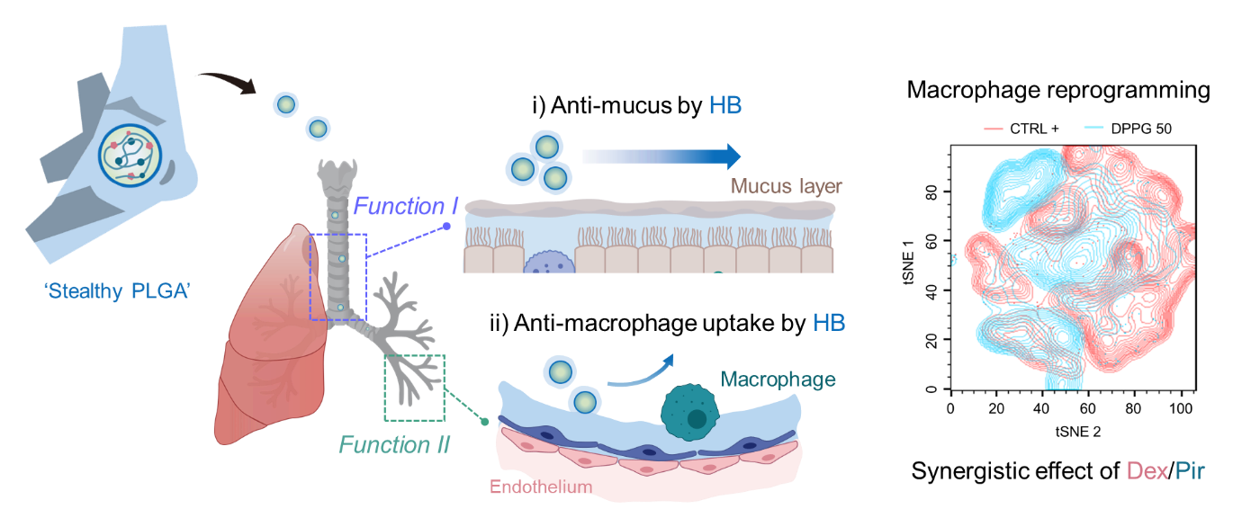

Supporting Information

**Zwitterionic inhaler with synergistic therapeutics for reprogramming of M2 macrophage to pro-inflammatory phenotype**

Sungwon Jung1, Sungeun Heo1, Yoogeong Oh1, Kyungtae Park1, Sohyeon Park1, Woojin Choi1, Yanghee Kim2*, Seyong Jung3* and Jinkee Hong1*

**Figure. S1. Aminolysis of PLGA MP a.** Transmission electron spectroscopy (TEM) image and **b.** Zeta potential analysis of according to reaction time (5, 10, 20, 30, 60 min).

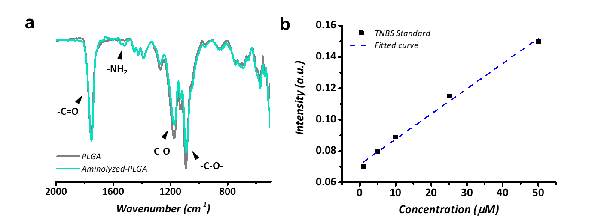

**Figure. S2. Analysis of aminolyzed-PLGA (NH2-PG) a**. Fourier transform infrared spectroscopy (FT-IR) data of PLGA MP and NH2-PG. **b**. Standard curve of 2,4,6-trinitrobenzene sulfonic acid (TNBS) assay

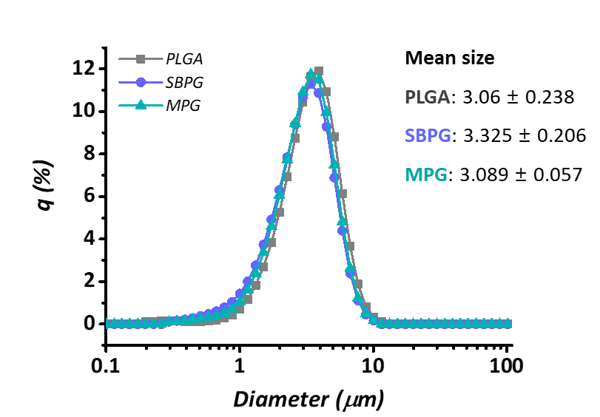

**Figure. S3. Aerodynamic sizes of PLGA MP, SBPG and MPG (n = 3)**

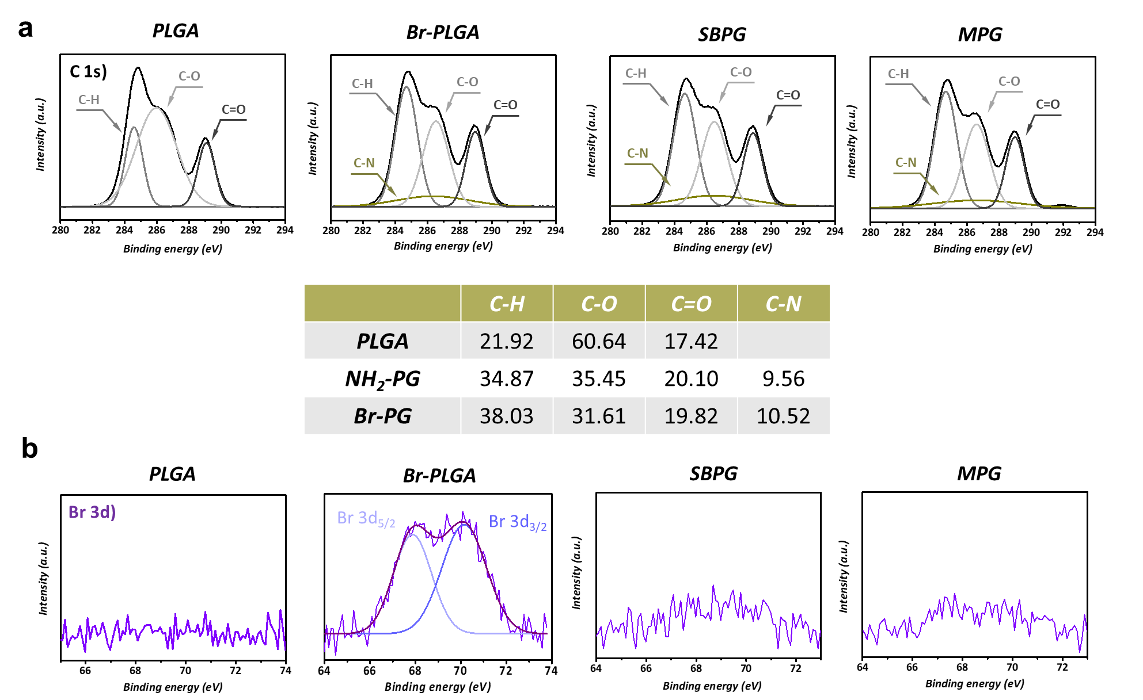

**Figure. S4. X-ray photoelectron spectroscopy (XPS) data a.** C 1s peaks and **b.** Br 3d peaks of PLGA MP, Br-PG, SBPG and MPG.

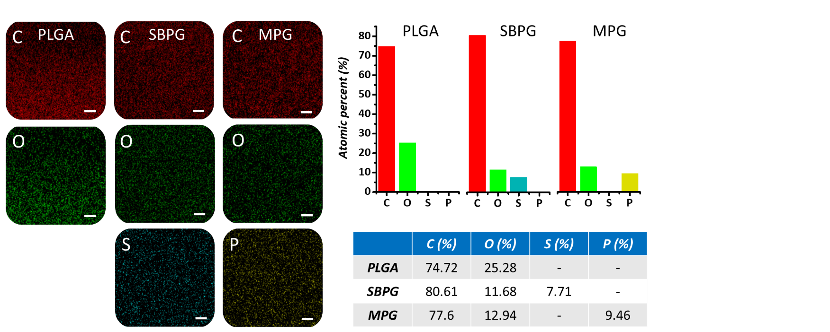

**Figure. S5. Energy-dispersive X-ray spectroscopy (EDS) analysis of PLGA MP, SBPG and MPG** (scale: 1 μm)

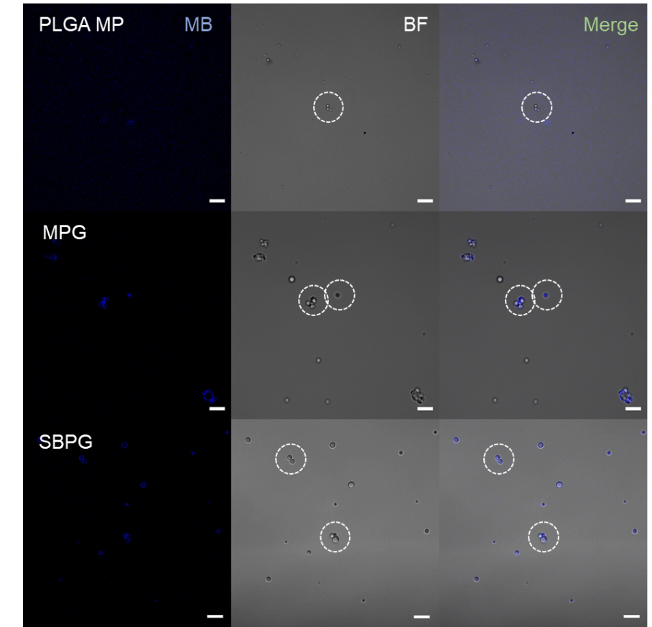

**Figure. S6. Confocal image of hydration layer on microparticles** (MB: methylene blue, scale: 10 μm)

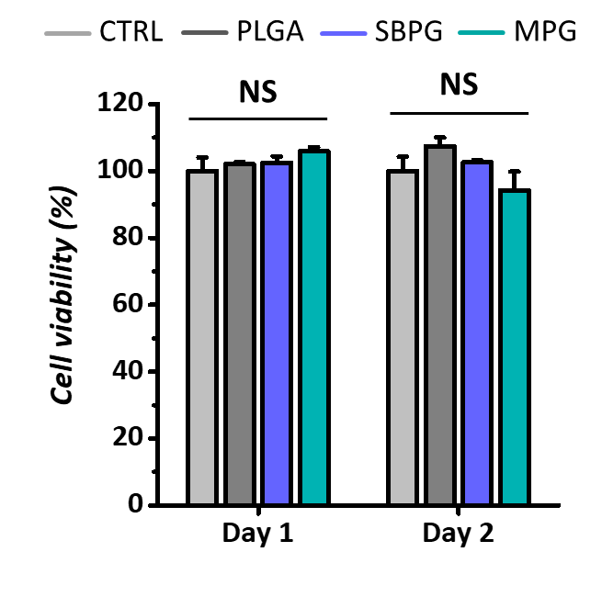

**Figure S7. Biocompatibility test of PLGA MP, SBPG and MPG to human umbilical vein endothelial cells (HUVECs).** Data are presented as mean ± standard deviation (SD, n = 3); NS indicates non-significant (One-way ANOVA with Turkey’s correction, all experiments were conducted independently).

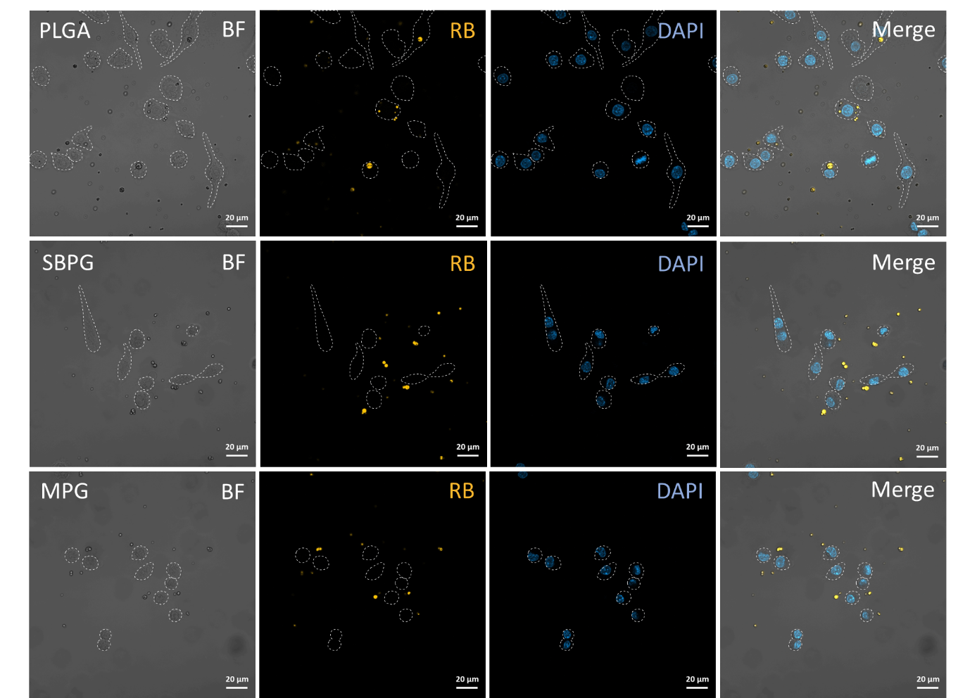

**Figure. S8. Macrophage uptake assay of PLGA MP, SBPG and MPG** (BF: bright filed, RB: rhodamine-B)

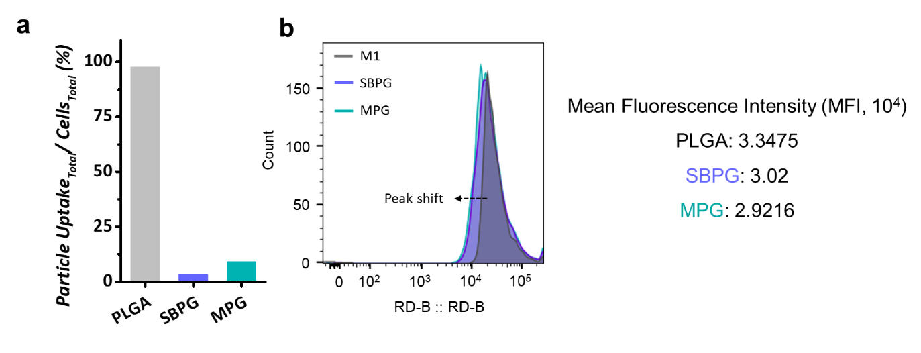

**Figure. S9. Macrophage uptake analysis a.** Quantitative analysis of particle uptake against RAW 264.7 cells by confocal analysis. **b.** Flow cytometry data analysis (FACS) of macrophage uptake.

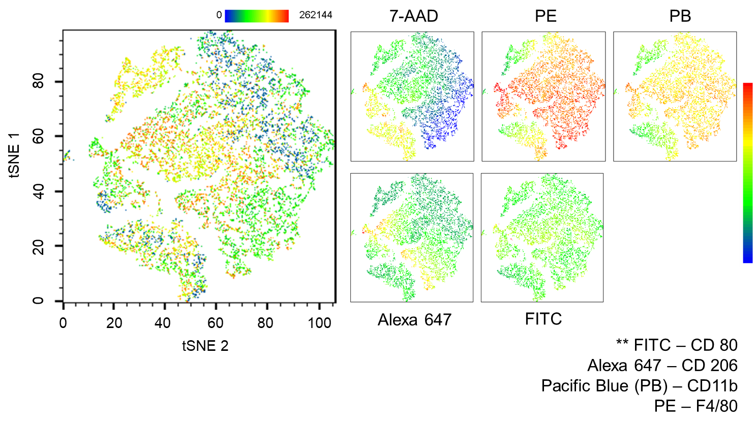

**Figure. S10. tSNE data of each surface markers**

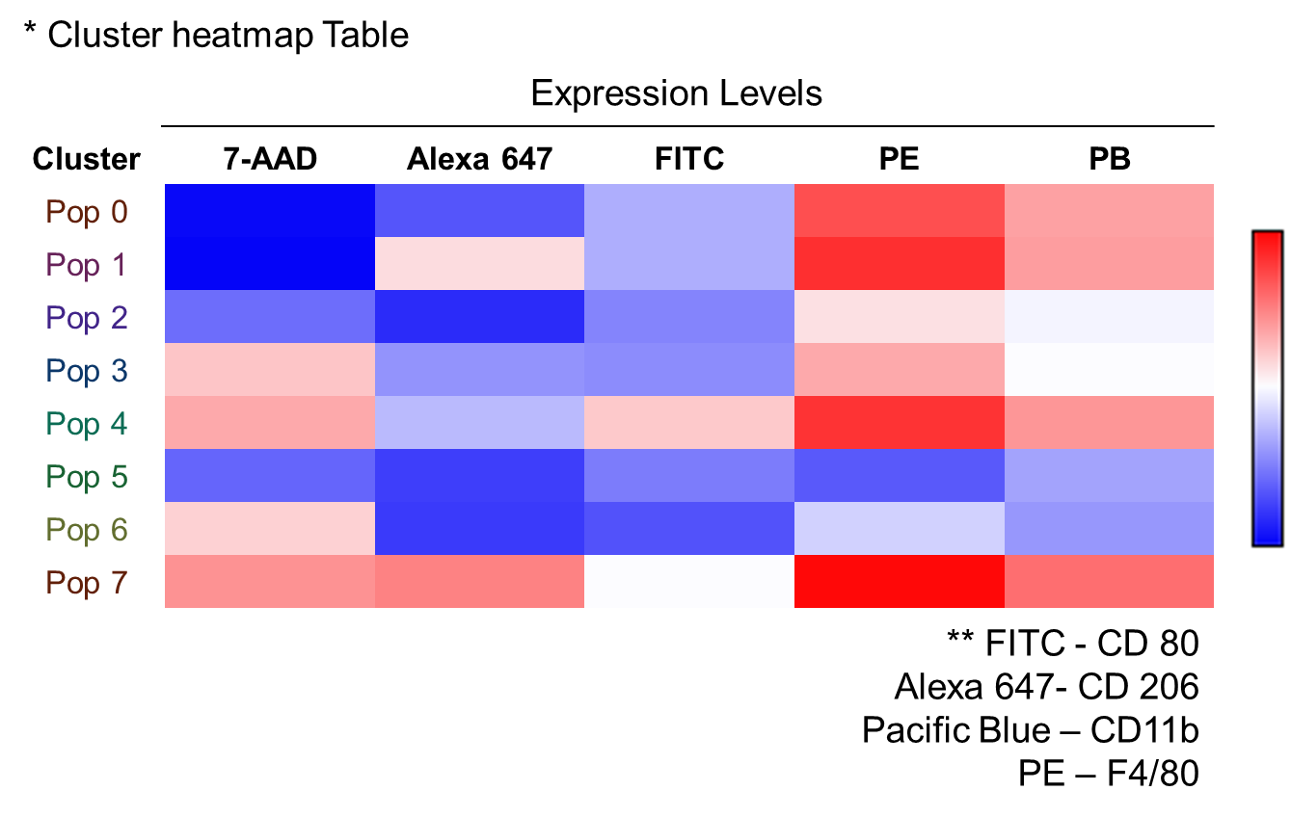

**Figure. S11. Cluster heatmap table of flow cytometry result**

|  |  |  |  |  |  |  |
| --- | --- | --- | --- | --- | --- | --- |
|  | ***C 1s*** | ***O 1s*** | ***N 1s*** | ***Br 3d*** | ***S 2p*** | ***P 2p*** |
| ***PLGA*** | 65.95 | 33.65 | - | - | - | - |
| ***NH2-PG*** | 63.26 | 36.17 | 0.57 | - | - | - |
| ***Br-PG*** | 63.69 | 35.4 | 0.57 | 0.34 | - | - |
| ***SBPG*** | 62.69 | 35.95 | 0.97 | 0.08 | 0.31 | - |
| ***MPG*** | 62.93 | 35.59 | 0.95 | 0.06 | - | 0.47 |

**Table. 1. X-ray photoelectron spectroscopy (XPS) data of PLGA MP, NH2-PG, Br-PG, SBPG and MPG**