Journal of Business Research

The application of multi-criteria decision analysis methods into talent identification process: A social psychological perspective
Yi-Ling Lai & Alessio Ishizaka
Abstract
This case study offers a new insight into application of multiple-criteria decision-making methods (MCDM) to social identity issues in the context of talent management. This study used MCDM to help a high-tech company to identify potential talents in its sale and marketing team (n=54). MCDM adjusted subjective information consisted of intangible organisational political issues into a transparent, objective benchmark. The transparency and consistency of this evaluation process reduced potential social identity disruption between individuals or groups. Furthermore, the involvement of multiple decision-makers (both managers and employees) in the talent identification procedure enhanced employees’ motivation for further development.

Keywords: Talent management, Multi-criteria decision making, AHP, Flowsort, GAIA, Visual management

1. Introduction
The phrase “War for Talent”, which was coined by a group of McKinsey consultants in the late 1990s, marked a new phase in human resource management strategy. Although the topic of talent management (TM) has attracted considerable attention from corporations and professional associations such as the Chartered Institute of Personnel and Development (CIPD) and the Society of Human Resource Management (SHRM) research in the field often lacks a theoretical foundation (Al Ariss, Cascio, & Paauwe, 2014). Psychological theories, such as social exchange theory and social identity theory have been used to explain the importance of having a transparent strategy for identifying and managing talents (Björkman, Ehrnrooth, Mäkelä, Smale, & Sumelius, 2013), yet most existing research focuses on the relationship between employees’ perceptions of TM practices (e.g. talent identification processes) and their psychological reactions (e.g. psychological contracts) to these. More contextualised empirical investigations are necessary to understand the factors that may affect the dynamic and complex talent identification process (Sonnenberg, van Zijderveld, & Brinks, 2014).
Our case study filled this research gap by applying multi-criteria decision-making methods (MCDM) to the talent identification process in a high-tech company with employees and suppliers from diverse backgrounds. MCDM is a collection of methods for comparing, selecting or ranking multiple options, typically with complex attributes (Kurilovas, Vinogradova, & Kubilinskiene, 2016) and is mainly used in analyses of business risk and costs and performance. This study takes an initial step to employ several approaches of MCDM (e.g. Analytic Hierarchy Process, AHP) to human performance reasoning and evaluative decision -making processes. The purpose was to explore the extent to which a transparent and explicit talent evaluation platform that included both subjective information and objective benchmarks could reduce disruption of social identity in an exclusive TM setting (Sheehan & Anderson, 2015).
This study built on the previous research that suggested that employees’ negative psychological reactions are mediated when the talent identification and selection process is transparent, so we first drew a four-dimensional psychological TM framework (Figure 1) by integrating both inclusive vs. exclusive and input vs. output approaches to talent evaluation. This framework outlines strengths and gaps of each dimension based on psychological theories (e.g. positive psychology and social identity theory). In general terms, we recognise that both inclusive and exclusive approaches involve interpersonal social processes; nevertheless, an exclusive approach that distributes development resources unequally amongst a group (i.e. talent pool) may provoke divergence of social identities (Sheehan & Anderson, 2015). More research into this area is required. Second, our case study indicates that MCDM, which comprises multiple evaluative procedures carried out by several raters, assures employees’ psychological safety and prevents identity disruption in an exclusive TM context. Third, the involvement of multiple senior management personnel in the talent identification process demonstrates an organisation’s commitment to running an effective TM scheme. In line with social exchange theory (Blau, 1964) one case study found that employees in the talent pool feel obligated to reciprocate with helpful attitudes and behaviours (Kuvaas & Dysvik, 2010). Furthermore, the explicit individual competence profiles (strengths and areas for improvement) generated by MCDM platforms also increase the motivation of employees not included in the talented group, and identified as having high potential, to learn and develop further (Lejeune, Beausaert, & Raemdonck, 2018). In practical terms, a visual, team-based competence profile offers an organisation a macro view of its current team’s capacity and a picture of its future optimal performance (Khilji, Tarique, & Schuler, 2015; Sheehan, Grant, & Garavan, 2018).

2. Literature and theoretical background

2.1 Current theoretical debates about talent management approaches
The diverse practices and ambiguity surrounding the concept of ‘talent’ makes it difficult to arrive at a consensus definition of TM (Lewis & Heckman, 2006; Thunnissen, Boselie, & Fruytier, 2013); we follow the resource-based view (Barney, 1991, 2001), which distinguishes TM from general human resource management (HRM) by interpreting TM as processes and actions that involve the systematic identification of positions which are key to an organisation’s sustainable competitive advantage. The TM process involves identifying talent and developing named individuals with high potential to fill these strategic positions (Collings & Mellahi, 2009).
Contemporary debate on TM focuses on theoretical boundaries of the definitions of talents, such as exclusive (i.e. distinguished talent pools) and inclusive (i.e. all employees) approaches. However, we argue that both approaches are considered as interpersonal interactions which incorporate psychological activities including negotiation and power control in this human capital decision making process (Dries, 2013). The inclusive approach to TM draws on positive psychology, which sees talents as strengths and posits that everyone has the potential (i.e. characteristics and abilities) to be developed as a talent (Wood, Linley, Maltby, Kashdan, & Hurling, 2011), from which it follows that all employees should be treated equally. Organisations which follow the strength-based approach embedded in positive psychology focus on identifying employees’ areas of natural talent and finding ways to help every employee develop the job-specific skills and knowledge to turn those talents into real performance, which increases employees’ workplace well-being and job satisfaction (Dries, 2013). However, we also agree with previous literature (Collings & Mellahi, 2009) that this sort of all-inclusive development and employee satisfaction-centred TM scheme is similar to HRM (e.g. performance management, learning and development and employee relationship) but involves a more strategic approach.
Exclusive approaches to TM, which classify people into “talent” or “non-talent” pools, have been widely applied in organisations. Although social identity theory implies that exclusive TM approaches may result in employees’ shared “organisational identity” being fractured by “opponent” relations (Collings, 2014) a survey found that 60% of organisations that had a TM strategy used exclusive approaches (CIPD, 2012). This can be explained by resource-based view (RBV) theory, which suggests that corporations should identify and develop internal unique and superior financial, psychological, human and organisational assets to maximise their competitive advantages (Barney, 1991, 2001). According to Barney (2001), valuable resources allow organisations to exploit opportunities; moreover, resources that are hard to duplicate should provide long-term advantages. Nevertheless, there is also substantial research indicating that identified talents were often unable to replicate their previous level of performance when they moved a new position or firm (Groysberg et al., 2008). Moreover, approximately 40% of high-potential assessments end in failure due to the lack of established and tools for assessing potential talents (Martin & Schmidt, 2010). Inkson (2008) argued that human resources cannot be treated like non-human related activities and that the human (e.g. psychological) perspective was missing from contemporary TM research. Overall, debates about contemporary TM approaches suggest that a contingency theory which considers social and human contextual factors should be applied in the study of individual and organisational performance (Cappelli & Keller, 2014).

2.2 A psychological framework for talent management
Following from the literature review of TM in the previous section, the definition of talent has become a key research area, as the way in which talent is defined determines the strategies that are used to identify and develop it. Nijs, Gallardo-Gallardo, Dries, and Sels (2014) proposed that there are two key elements of talent: ability and affective components. They regarded the ability component as a combination of innate abilities (e.g. IQ) and systematic development of such abilities. Previous research mainly used theories of giftedness (i.e. innate) to describe abilities of talents (Brown et al., 2005) however several studies have indicated that innate dispositions are necessary yet not sufficient to ensure high-level performance (Baldwin, 2005; Robinson, Zigler, & Gallagher, 2000). Meanwhile, affective factors, which can be predicted by individual’s motivation to invest and intrinsic interest, have also been identified as vital to excellence performance (Nijs et al., 2014). Bailey and Morley (2006) pointed out that the factors that are ultimately responsible for achievement are likely to be unique personal and behavioural dispositions that individuals bring to their actual performance, in accordance with positive and vocational psychology. There has been intense debate about the relative merits of input and output perspectives on talent (Dries, 2013), but Nijs et al.’s (2014) conceptual framework for excellent performance indicated measurements of talent are only valid if they capture both the ability component (i.e. output) and the affective component (i.e. input).
We integrate the theoretical arguments about the relative merits of inclusive and exclusive or input and output perspectives on TM and address the psychological issues raised by both inclusive and exclusive approaches, such as the group identity consequences of labelling employees as talented or non-talented (Figure 1). The theoretical foundation of the inclusive approach is mainly based on the strengths-based perspective of positive psychology, as stated in the section above (Bakker & Schaufeli, 2008). The positive psychology literature regards talents as strengths, namely the characteristics of a person that allow him or her to perform well or to his or her maximum (Wood et al., 2011). Under this approach the ultimate goal of TM is the self-actualisation of all employees, i.e. enabling them to reach their full potential (Bakker & Schaufeli, 2008). The inclusive TM approach advocates that resources should be distributed equally across employees, so it is usually believed to lead a more pleasant working environment (Dries, 2013; Warren, 2006), with fewer psychological disagreements between individuals or groups. However, we also argue the inclusive TM approach may erode employees’ motivation, based on a study of a “challenge stressor” model of work motivation study (Lepine, Podsakoff, & Lepine, 2005). Lepine et al.’s (2005) meta-analysis indicated that challenge stressors (e.g. job demands, pressure, time urgency and workload) have positive effects on work motivation and performance; conversely, employees may lose their motivation when there is a persistent lack of challenge and competition in the workplace.
Despite the presumed benefits of the inclusive approach, the exclusive approach, which is assumed to generate higher return on investment in terms of profit and productivity, is still preferred by the organisational stakeholders. Because disproportionate allocation of employee development resources (e.g. allocating 90% of the resources to 5% of employees) may easily trigger psychological disagreements between groups, this approach requires more research attention to ensure that selection processes are reliable, accurate and transparent (Dries, 2013; Sheehan & Anderson, 2015). In addition, we propose that making the TM strategy transparent enhances employees’ psychological contract with their organisation and increases their motivation for further development; this idea is in line with social exchange theory (Blau, 1964), which suggests that organisations’ investment in workforce development alters employees’ exchange expectations (King, 2016).
The following section explores the theoretical relationships between TM, social psychological theories and social exchange theory and uses these theories to explain the why talent identification needs to be a multiple-level decision-making process in order to avoid identity disruption and increase employees’ motivation for further improvement.

Insert Figure 1 here.

2.3 Social psychological perspectives in talent management
Social psychological issues have been discussed in several TM literature reviews. Dries (2013) indicated that talents do not exist until they are recognised and acknowledged (i.e. the perception of talents) on the basis of the social cognition theory (Dominick & Gabriel, 2009). This implies that examination of the ways in which expectations and judgements shape perception of talent (i.e. identification of talent in the organisational context) is an important research question. It is clear that the avoidance of rater bias in the talent identification process is important (Highhouse, 2008), given that the most common organisational approach to this kind of decision-making encompasses both analytical elements and intuitive cognitive processes (Hammond, 2000).
Disruption of social psychological relations may occur when employees are classified into talented and non-talented groups, particularly if, for example, an organisation grants the 5% of employees making up the talented group significant psychological power and status by allocating 90% of development resources to this so-called elite. This may cause divergence in social identities that has a detrimental effect on the well-being, job satisfaction, organisational commitment and task effectiveness of employees in the non-talented group (Sheehan & Anderson, 2015). Social identity theory, which was originally developed to explain the psychological basis of intergroup discrimination and what makes people believe their group is better than others (Tajfel & Turner, 1979), has also been used to explain the motivational and behavioural changes that occur in employees when organisations implement an exclusive TM scheme (Sheehan & Anderson, 2015). When the distinction between talented and non-talented groups is salient, people’s perception of the similarities of members of their group is enhanced, which explains why people usually favour their own group (the in-group) over other groups (out-groups).
Several literature reviews on TM propose that a clear distinction between talented and non-talented pools may provoke negative organisational identity and committee issues, but a large scale (n=1,040) quantitative study (Björkman et al., 2013) indicated that the effect on employees who are not identified as talents is not as destructive as predicted. For instance, the turnover intention of employees in the non-talent group was lower than that of people who were not informed whether they had been identified as talented or not. This study revealed that shared organisational identity and self-motivation only suffered when employees were left uncertain of their designation (e.g. whether or not they are regarded as talented). In other words, informing both talented and non-talented employees of their status enhances their motivation.
Björkman et al. (2013) specified that a transparent and fair talent identification procedure is the key to avoiding identity disruption but elicit motivation to change of the non-talented group. This finding is consistent with social identity theory, which indicates that conflicts between groups only occur when there is an injustice, improper and unclear resource distribution (Eggins, Haslam, & Reynolds, 2002). Eggins et al. (2002) also pointed out that the best determinant of the long-term success of an aligned agreement is the parties’ perception of the fairness of the procedure, rather than the actual distribution of material resources.
Some empirical studies have suggested that an exclusive TM approach enhances talented employees’ fulfilment of their psychological contract with their employer (Gelens, Hofmans, Dries, & Pepermans, 2014; Sonnenberg et al., 2014), based on the social exchange theory. However, all of these studies specified that a process that is perceived as objective, unbiased and transparent is the only factor that reduces negative reactions from employees in the non-talented group. The perception that the talent identification procedure and the distribution of resources are fair enhances employees’ motivation for further learning and development to achieve expected performance. Accordingly, we suggest that an integrative evaluation platform that considers both subjective information and objective benchmark is required to set up a substantial foundation for the following TM activities, such as talent identification, selection and development. In consequence, an exclusive TM approach should involve the systematic comparison, selection and ranking of options (e.g. MCDM) in order to minimise rater bias (Highhouse, 2008).

2.4 Multi-criteria decision-makings methods and HRM strategy
MCDM is a set of systematic and analytic procedures for dealing with different classes of decision problems - such as classification, sorting and ranking - to help experts and decision makers to find consistent and robust solutions for multi-criteria problems (Zare et al., 2016). MCDM have been applied extensively in science and industry to enhance the quality decisions by making the process more explicit, rational and efficient. Lately MCDM have also been applied to person-related issues to enable organisations to rationalise their decision-making with respect to recruitment and performance management. For instance, Analytic Hierarchy Process (AHP), a popular MCDM that uses pair-wise comparisons and rankings of options to derive priorities, has been applied to recruitment strategy (Saaty, Peniwati, & Shang, 2007). The AHP used by Saaty et al. (2007), which deals with both tangible (i.e. quantifiable) and intangible (i.e. non-quantifiable) factors in an integrated and comprehensive manner within a hierarchic structure, offers new ways of handling subjective information and intangibles to make the process more objective. Another method, PROMETHEE (Preference Ranking Organisation Method for Enrichment Evaluations), which is a method for selecting and ranking a finite set of options based on conflicting criteria, has been used to evaluate employee performance (Ishizaka & Pereira, 2016). Given that talent identification is a selective process based on employees’ performance and capability, we recognise the process of TM contains both recruitment (internally) and performance management purposes. We consider, therefore, that MCDM may offer an innovative, objective and coherent procedure for identifying talent that reduces the potential for psychological disagreements among groups.

2.5 Research objectives
In summary, the existing literature indicates that exclusive approaches to TM, which clearly distinguish talent pools in organisations, are favoured by the majority of organisations in accordance with resource-based theory (Crane & Hartwell, 2019). Nevertheless, psychological disruption, in the form of divergences in divergent organisational identity and commitment, is more likely to emerge when employees are assigned to groups, particularly when the talented group benefits from additional development resources (Sheehan & Anderson, 2015). The key to minimising potential intergroup conflict and enhancing all employees’ motivation is to have a systematic and transparent TM strategy that outlines explicit, long-term learning and career development goals (Björkman et al., 2013). Nevertheless, a contextualised and in-depth investigation in a specific organisational setting (e.g. case study) is necessary to give a better picture of the factors required for an effective talent identification process. MCDM have been widely used in research into improvement of decisions in HRM, so we decided to take the novel step of applying MCDM to talent identification. The main purpose was to explore whether MCDM can contribute to the talent identification process. In addition, this case study aimed to identify how MCDM can help to minimise the psychological disruption associated with assigning employees to groups on the basis of their talent status.

3. Research Methodology
We carried out a case study, because this was an exploratory investigation of the application of a systematic decision-making method to the allocation of human capital. A case study which observes and inspects common, natural occurring themes or interactions in a specific setting may capture the complexity of a process such as the talent identification process; it also provides us with a clearer picture the extent to which MCDM is an improvement on other approaches to identifying talents (Hyett, Kenny, & Dickson-Swift, 2014).
This study combined, for the first time, AHP and FlowSort to sort employees and identify those with talent. This new hybrid method was complemented with visual, descriptive methods: geometrical analysis for interactive aid (GAIA) and stacked bar diagrams. In the next sections we describe the background to the case study and the MCDM used.

3.1 Analytic Hierarchy Process
AHP is an approach of measurement based on pairwise comparisons; the judgements of experts are used to derive priority scales that measure intangibles in relative terms (Saaty, 2008). At the heart of the AHP method are the comparison matrices A = (a_{i,j}), i,j = 1,…, n, where a_{i,j} are pair-wise comparisons of criteria/alternatives provided by the decision-maker on a nine-point verbal scale (Table 1). The weights are calculated from the comparison matrix by using the eigenvalue method (1) developed by Saaty (1977).

Insert Table 1 here.

(1) A · p = λ · p
…where A is the comparison matrix
…p is the priorities (weight) vector
…λ is the maximal eigenvalue
If CR, the ratio of CI and RI (the average CI of 500 randomly filled matrices), is less than 10%, then the matrix can be regarded as having acceptable consistency.
(2) CI = ,
…where n = dimension of the matrix
…λ_{max} = maximal eigenvalue
(3) CR = CI/RI,
…where CR is the consistency ratio
…RI is the random index
Saaty (1977) calculated the following random indices:

Insert Table 2 here.

In our case study we used only the criteria matrix, to avoid making a large number of pair-wise comparisons. Performance on each criterion was calculated with FlowSort.

3.2 Flowsort
FlowSort is a variant of an outranking MCDM for sorting problems, PROMETHEE (Brans, 1982; Brans & Vincke, 1985). As it is from the same outranking family as PROMETHEE, it inherits PROMETHEE’s properties. It requires only few parameters and is easy for non-technical persons to understand and use; user-friendly software are available such as Smart Picker (Nemery, Ishizaka, Camargo, & Morel, 2012), D-Sight (Hayez, De Smet, & Bonney, 2012) and Visual Promethee. Scores do not need to be normalised, so evaluations of specific criteria can be expressed in specific units. This avoids the drawback of rankings being dependent on the normalisation method selected (Ishizaka & Nemery, 2011; Tofallis, 2008). The decision-maker needs to define a preference function that is generally characterised only by one indifference and one preference threshold. FlowSort has been already applied successfully in several contexts (Lolli et al., 2016; Rahmanimanesh, Nikabadi, Pourkarim, & Davoodifar, 2018; Sepulveda & Derpich, 2015; Verheyden & De Moor, 2014) but it has not previously being used in combination with AHP. There are three main stages to the Flowsort method, which are described below.
Problem modelling. We consider the multi-criteria decision problem with m possible actions or options A = {a₁, a₂, ... , a_{m}}to be assigned to o classes K= { k₁, k₂,.., k_{o}} based on a set of n criteria C = { c₁, c₂,.., c_{n}}. The K classes need to be completely ordered (k₁⊳ k₂⊳⋯⊳ k_{o}), where k₁ ⊳ k₂ means that class k₁ is preferred to class k₂. Each decision-maker characterises the K classes by defining a reference profile through a limiting profile, which represents the minimum value an option needs to achieve on each criterion to belong to a given class. For o classes, o-1 references profiles are needed R= {r₁, r₂,.., r_{o-1}}.
Preference degree. For each criterion the decision-maker selects a preference function, such as the linear, step or Gaussian preference function (Brans & Vincke, 1985). Every option is compared pairwise with the reference profiles using the preference function and a preference degree P_{i}(a,r) is derived. This indicates whether an option a is preferred or to the reference profile r with respect to criterion c_{i}.
Aggregated preference functions. In order to evaluate how much action a is preferred to r over all criteria a preference index π(a,r) is calculated as the weighted sum (4) of the preference degrees P_{i}(a,r). The weights w_{i}, calculated previously in section 3.2, represents the importance of each criterion to the decision.
(4) π(a,r) = $\sum_{i=1}^{n}{P_{i}(a,r)∙w_{i}}$
...where P_{i}(a,r) is the score of the preference function, w_{i} the weight of criterion c_{i} and n the number of criteria.
Outranking flows. Each action is compared with o reference profiles, so two flows can be defined with (4):
the positive flow:
(5) Φ⁺(a) = $\frac{1}{o}\sum_{x∈R}^{o}{π(a,x)}$
This score represents the global strength of action a relative to all the reference profiles and needs to be maximised.
the negative flow:
(6) Φ⁻(a) = $\frac{1}{o}\sum_{x∈R}^{o}{π(x,a)}$
This score represents the global weakness of a relative to all the other actions and needs to be minimised.
Sorting. We can then calculate the complete PROMETHEE II ranking with the net flow given by:
(7) Φ(a) = Φ⁺(a) – Φ⁻(a)
The assignment of action a to a class k_{h} is based on its position relative to the reference profiles r_{h} and r_{h+1}.
(8) a_{i} ϵ k_{h}, if Φ(r_{h}) > Φ(a) ≥ Φ(r_{h+1})

3.4 GAIA
The aim of the GAIA method is to visualise, in two dimensions, as much as possible about the decision-maker’s preferences and their implications (Brans & Mareschal, 1994). For this purpose, a plane in hyperspace is found through principal component analysis (PCA) of the matrix Φ containing the one-criterion net flows of all the actions of the decision problem. The first step in the PCA is to calculate the variance-covariance matrix of the decision problem. This matrix can be obtained from the following equation:
(9) nC= Φ’ Φ
…where C: variance-covariance matrix
Φ’: the transposed matrix of Φ
n: positive integer
Then two eigenvectors with the greatest eigenvalues, denoted $\vec{u}$ and $\vec{v}$, are selected. These two eigenvectors are orthogonal ($\vec{u⊥\vec{v}}$) and define the best plane, called the GAIA plane, to use to show the actions (represented by points) whilst minimising the loss of information (Brans & Mareschal, 1994).
Every action of the decision problem will be projected onto this plane and their coordinates are obtained as follows:
(10) $\left\{\begin{matrix}\left|\overset{→}{{Op}_{i}}\right|=\overset{→}{{a'}_{i}}∙\overset{→}{u} \\ \left|\overset{→}{{Op}_{i}}\right|=\overset{→}{{a'}_{i}}∙\overset{→}{v}\end{matrix}\right.$ $\left\{\begin{matrix}\left|\vec{Op_{i}}\right|=\vec{a_{i}^{'}}*\vec{u} \\ \left|\vec{Oq_{i}}\right|=\vec{a_{i}^{'}}*\vec{v}\end{matrix}\right.$
…where $\overset{→}{{a^{'}}_{i}}$: transposed row i of matrix Φ
In order to represent the intra-criteria information, each criterion c_{j} is projected to f_{j} on the GAIA plane. The angle between the projections of two criteria represents the degree of convergence between the criteria: the smaller the angle, the more similar the two criteria; a large angle indicates conflicting criteria.
Finally, the information on the weights chosen by the decision-maker can be added by finding the projection of the weights vector: : (w₁, w₂, …, w_{j},…,w_{k})$\vec{w}:\left(w_{1},w_{2},…,w_{j},…,w_{k}\right)$. The obtained vector is called the decision stick, denoted $\overset{→}{D},$ and represents the decision-maker’s priorities:
(11) $\overset{→}{D}:(\overset{→}{w}∙\overset{→}{u},\overset{→}{w}∙\overset{→}{v})$
The GAIA plane facilitates the decision-making process, because conclusions can be drawn from a visual representation. Nearby actions on the plane will often have very similar rows in the variance-covariance matrix Ф, so the decision-maker can easily identify actions with similar or opposite performance. Moreover, the decision-maker can compare criteria since their position on the plane is an indication of the extent to which they are conflicting or convergent. Their length represents their power to distinguish between actions. A non-discriminating criterion has a short arrow; a discriminating criterion has a long arrow.

4. Research process

4.1 Case study background
This case study is based on a LED secondary optical lens company, LedLink, in the Asia Pacific region. LedLink was established in 2008 in Taipei, Taiwan and its main products are secondary optics (plastic/silicon) and plastic housing components; Ledlink provides business-to-business (B2B) model service. In 2012 and 2013 LedLink set up branch offices in mainland China (Yang Zhou and Dong Guan), which employ a total of 800 people. There are five main departments under the General Manager (GM): sales and marketing, product research and development (R&D), manufacturing, applied product development and general administration (human resources, finance, legal and information systems). The company’s sales and marketing department is split into two groups, an international team (non-Chinese-speaking regions) and a mainland China team in view of linguistic and market cultural differences. Nevertheless all employees are from a similar cultural background and speak the same language, Mandarin. The majority of LedLink’s clients and suppliers are global companies, which means that frontline employees (e.g. the sales and marketing team) have to deal with clients or collaborators from multiple cultural backgrounds on a daily basis. This study focuses on LedLink’s process for identifying talent within the sales marketing department (n=56), which became urgent when the director of the sales and marketing department was promoted to be the general manager in September 2017. Because the size and scope of the company have increased, LedLink decided to establish a talent pool and pipeline to make the talent management process more effective. This talent management project started with the sales and marketing team due to their urgent need.

4.2 Problem modelling
As discussed in section 2.1, an organisation’s talent management process should be aligned with its strategy. To ensure the application of MCDM was implemented smoothly, the authors acted as independent consultants, working with the new GM (M1) and two senior department line managers (M2 and M3) to construct a competence model on the basis of one-to-one interviews (n=3). The interviews concentrated on the company’s existing and forthcoming business focus and strategy and the key competences the leader of the sales and marketing team would require in order to fulfil the objectives specified by senior managements in the company. The interviews lasted approximately 60 minutes and were conducted via Skype. Three business focuses for the next five years were identified. First, the company is developing a new LED application and aims to expand its current market. Second, it has faced intense global competition in recent years, so maintaining existing clients and providing better lighting solutions were its main concerns. Third, the company’s employee turnover rate is usually very high (approximate 20% pa) and all three interviewees suggested that this was probably caused by insufficient employee rewards and lack of opportunities for development within LedLink. On the basis of the interview material a total of ten key competences for a leadership role in the sales and marketing team were identified: integrity, critical thinking, delegation, people development, result driving, problem solving, being curious and innovative, business analysis, interpersonal skills and performance management.
In line with the theoretical debate about definitions of talent, we regard both innate abilities and systematic development as important criteria for talent (Nijs et al., 2014). Some of the competences are more likely to be present in individuals with particular characteristics, such as curiosity and a propensity for innovation, and innate skills, such as interpersonal skills (Bailly & Léné, 2012; DiLiello & Houghton, 2008). The new GM (M1) referred repeatedly to integrity, because he regarded the ability to ensure that the company’s external and internal operations meet its ethical standards as a fundamental competence for all employees (Leroy, Palanski, & Simons, 2012). Moreover, because the company had a slightly higher than average employee turnover rate; both the two senior line managers in the sales and marketing team (M2 and M3) suggested that more comprehensive performance management (e.g. reward scheme and career progress) and employee development (e.g. training and learning opportunity) strategies were needed to strengthen employees’ commitment to the company (Gruman & Saks, 2011; Kompaso & Sridevi, 2010).
Next, the authors developed a questionnaire to capture how the three interviewees weighed the importance of the ten identified competences. They were required to compare the competences pairwise (e.g. integrity vs. critical thinking) with respect to their importance to fulfilment of the company’s business objectives (Figure 2).

4.3 Criteria evaluation
We used AHP to evaluate the weights of the criteria. A pairwise comparison questionnaire was sent to the three senior managers. Figure 2 shows an extract from the questionnaire.
Insert Figure 2 here
The weights of the criteria were calculated and are shown in Table 3. The competences rated most important by the interviewees were “problem solving” (M1), “interpersonal skills” (M2) and “integrity” (M3). The average criteria weight classified by three managers is then calculated to establish equivalent weight. When the evaluations of the three managers were combined, the top three most important competences were “problem solving”, “delegation” and “integrity”.
Table 3 here

4.4 Talent classification
A second questionnaire was sent to the line managers, who were asked to rate all staff member’s competence (n=54) with respect to the 10 criteria using a 1-10 scale. The limiting profile for membership of the talented group was set as scores of at least 7 on all criteria. The limiting profile to belong to the group with potential was set as scores of at least 4 on all criteria. Using the Flowsort method we assigned ten members of staff to the talented class (n=10) and ten others (n=10) to the “has potential” class.
Insert Table 4 here
Visual representations can be used to give better, more intuitive feedback to employees. The stacked bar chart in Figure 3 shows where each member of staff needs to improve. For example, staff 2 needs to improve in “performance management” and “business analysis”.
Insert Figure 3 here
The GAIA plane gives an overview of the position of the staff members (Figure 4). The talented group scores highly on all criteria. The group with potential scores more highly on integrity, delegation, critical thinking, interpersonal skills and problem solving than the other competences and to move into the talented group members would need training in business analysis, performance management, people development and being curious and innovative and driven.
Insert Figure 4 here

4.5 The follow-up discussion with employees
In order to understand how this novel talent identification process affected employees’ attitudes and feelings, we carried out semi-structured one-to-one interviews with some employees in the talented and high-potential pools. A total of eight employees (n=8) agreed to be interviewed and the interviews lasted approximately 30 minutes. They focused on employees’ views of the new TM approach, their feelings about it and their reactions to it. Basic content analysis was used to interpret the interview data. Three frequent, concurrent themes were “trust”, “psychological safety” and “encouragement”. In general, the MCDM process was perceived to demonstrate the company’s commitment to establish a transparent and objective process. Employees who had been involved in the talent identification process believed that the company was genuinely interested in identifying and developing talent in order to achieve sustainable business outcomes. They also voiced their appreciation of the new process and the effort the company had put into it. Most of the participants noted that the transparency and consistency of the evaluation process alleviated the worries and doubts they had had in the beginning. The involvement of three senior managers in the process and the fact that there were multiple stages to the evaluation process established a degree of trust in it. Employees who were assigned to the high-potential group indicated that they felt they were being encouraged to change and grow due to their individual competence profile. They said they had a much clearer ideas of their strengths and areas for improvement as a result of the talent identification process. Some employees suggested that in future the rating process should involve broader ranges of assessors (e.g. peers and the individual concerned).

5. Discussion
Overall, this case study has demonstrated that MCDM have a positive effect on the talent identification procedure, helping to make it clear, objective and efficient. According to (Saaty, 2008), people’s interpretation on data is always subjective and influenced by previous experiences, life incidents or personal values when making judgements. AHP, which requires raters to compare two options at a time, mitigates the potential bias in the evaluation stage. The transparency and consistency of the process also allayed ratees’ concerns and promoted trust in the company. The clarity of the competence profiles also enhanced employees’ work motivation. In accordance with our objectives the MCDM procedure outlined here will enable the organisation to identify talent more accurately. In addition, this case study indicates that transparency and consistency are the most important attributes of an exclusive TM process, if psychological disruption is to be avoided.

5.1 Theoretical contributions
First, this case study deepens our understanding of TM as a social process associated with varied psychological perspectives (Figure 1). Regardless of whether an inclusive (everyone is a talent) or exclusive (distinguished talent pool) approach is used, the process of TM concentrates on allocating organisational resources to some or all employees in order to improve work motivation, organisational commitment and job performance through a series of strategic actions. It follows that factors related to this social interactive activity, such as power dynamics, organisational objectives and decision-makers’ and employees’ characteristics and values, should be considered in the decision-making process. For instance, the GM in this case study, M1, who is two levels above M2 and M3, exhibited his power implicitly in the problem modelling interview by specifying that integrity was the most important competence in LedLink and that no one should challenge this point. However, M2 and M3 emphasised people-orientated competences (e.g. interpersonal skills and people development) in their individual interviews. In other words, three interviewees’ expectations of a senior leader of sales and marketing team in LedLink drew upon their respective experiences and different angles during their tenure in the company. Furthermore, some political intensions among these three senior managers were observed in the problem modelling stage because they all attempted to highlight their own perspectives are the most significant competencies in which the other two managers neglected. Considering that the criteria evaluation process through AHP balanced the influence of subjective information that may cause the bias in the talent identification process; this case study offers a more in-depth insight of TM by extending TM from a people management (e.g. HRM) and business strategy (e.g. competitive advantages) angles into social interactive relationship matters. It follows that theories of power dynamics, social relationship or work motivation (e.g. social identity and social exchange theory) should be included in the study of TM.
Second, this study revealed that the multiples analytic decision-making methodology originate in business operation discipline may resolve the issues emerged from human capital decision-making activities. MCDM has been studied in cognitive psychology because it offers a way of balancing absolute and comparative judgements (Saaty, 2008). As human interactions are usually understood with subjective and irrational perspectives (e.g. bias and perception distortions) that may affect the significant judgements. MCDM methodology indeed balances this continuum between subjective perception and objective benchmark in the talent identification process. In addition, MCDM can be used to aggregate the individual judgements of group members into a single, representative group judgement or to construct a group choice from individual choices (Saaty, 2008). In this study we expanded MCDM to study the social relationship between decision-makers (i.e. raters) and ratees. Since social identity theory has been used to explain the psychological reactions to exclusive TM procedures, we can initially conclude that MCDM offer a new possibility way of resolving in-group vs. out-group conflicts. According to social identity theory conflicts arise due to injustice, unequal distribution of resources, and status differences between groups; the strongest determinant of the long-term success of an aligned arrangement is the parties’ perception of procedural fairness, rather than the actual distribution of material resources (Eggins et al., 2002), so the negotiation process to resolve conflicts should focus on perceptions of psychological resources instead of material resources, and all parties should be recognised and treated as legitimate entities. This case study enhances our understanding of how an analytic hierarchy approach can adjust the intuitions, emotions and feelings that influence strategic decision-making processes (Elbanna, 2006).
Third, our MCDM approach offers insight into social exchange theory because we involved two levels of management in the talent identification process. Having a multi-stage evaluative procedure, from the problem modelling stage to criteria evaluation, demonstrates organisational commitment. In line with social exchange theory, the application of MCDM to an exclusive TM strategy enhanced ratees’ trust in the organisation and their motivation to improve their work performance.
Fourth, the paper provides a new, integrated, hybrid AHP-FlowSort model. Stephen and Labib (2018) noted that in hybrid models the output from one technique becomes an input to another technique, whereas ‘hybrid modelling’ is the use of independent techniques to study a single problem in different ways. This distinction between hybrid models and hybrid modelling was originally proposed by Shanthikumar and Sargent (1983). Hence our study contributes to the body of work on hybrid models and complements applications of other hybrid models in other contexts (Ishizaka & Labib, 2014; Ishizaka & Nemery, 2013; Ishizaka, Siraj, & Nemery, 2016; Labib & Read, 2015; López & Ishizaka, 2019; Modak, Ghosh, & Pathak, 2018).

5.2 Practical implications
The application of MCDM extends existing talent identification practice from the micro-management (individual-based) level to the macro-organisational level (Al Ariss et al., 2014) by displaying overviews of the staff members’ potential positions across the sales and marketing team as a GAIA plan chart (Figure 3). Instead of focusing on individuals’ abilities and potential to fulfil development objectives, this visualised approach provided the organisation with a clear picture of the readiness of the entire team, this can be used as a reference for the future recruitment, selection and strategy for talent development. This case study builds on several recent reviews of TM (Al Ariss et al., 2014; Collings & Mellahi, 2009) and we would encourage organisations to take a strategic approach to TM (i.e. to involve key stakeholders in the profiling process).

6. Conclusion
TM has received considerable attention from organisations and scholars since the beginning of this century, with different theoretical perspectives being brought to bear, for example the resource-based view from the field of management studies and the personal strengths-based approach of positive psychology. Our study takes a cutting-edge approach, proposing that TM should be viewed as a social process because most of the decisions and activities are based on interpersonal interactions. In other words, subjective information (e.g. personal values and experiences) may play a critical role in TM processes such as defining and identifying talent. In order to ensure a transparent and consistent process, we applied MCDM from the business operation area to the study of talent identification to resolve the potential psychological issues arising from this social activity. This was an exploratory investigation combining three research disciplines, business decision-making, HRM and social psychology, and our aim was to draw attention to other cross-disciplinary research collaborations in the study of TM.
As stated at the beginning of this paper, this was an exploratory investigation into the application of MCDM to the talent identification process. We acknowledge that future research should expand the participation pool and include different evaluation methods (e.g. 360 degree) in the process. In addition, longitudinal, multi-level assessments are necessary to examine the effectiveness of MCDM as part of a long-term TM strategy.

References
Al Ariss, A., Cascio, W., & Paauwe, J. (2014). Talent management: Current theories and future research directions. Journal of World Business, 49(2), 173-179. doi: https://doi.org/10.1016/j.jwb.2013.11.001
Bailey, R., & Morley, D. (2006). Towards a model of talent development in physical education. Sport, Education and Society, 11(3), 211-230. doi: 10.1080/13573320600813366
Bailly, F., & Léné, A. (2012). The personification of the service labour process and the rise of soft skills: a French case study. Employee Relations, 35(1), 79-97. doi: doi:10.1108/01425451311279429
Bakker, A., & Schaufeli, W. (2008). Positive organizational behavior: engaged employees in flourishing organizations. Journal of Organizational Behavior, 29(2), 147-154. doi: doi:10.1002/job.515
Baldwin, A. (2005). Identification concerns and promises for gifted students of diverse populations. Theory Into Practice, 44(2), 105-114. doi: 10.1207/s15430421tip4402_5
Barney, J. (1991). Firm resources and sustained competitive advantage. Journal of Management, 17(1), 99-120. doi: 10.1177/014920639101700108
Barney, J. (2001). Is the resource-based “view” a useful perspective for strategic management research? Yes. Academy of Management Review, 26(1), 41-56. doi: 10.5465/amr.2001.4011938
Björkman, I., Ehrnrooth, M., Mäkelä, K., Smale, A., & Sumelius, J. (2013). Talent or not? Employee reactions to talent identification. Human Resource Management, 52(2), 195-214. doi: doi:10.1002/hrm.21525
Blau, P. (1964). Power and exchange in social life. New York: John Wiley & Sons.
Brans, J.-P. (1982). L'ingénierie de la décision: Elaboration d'instruments d'aide à la décision. In R. Nadeaeu & M. Landry (Eds.), L'aide à la décision: Nature, Instruments et Perspectives d'Avenir (pp. 183-213). Québec: Presse de l'Université de Laval.
Brans, J.-P., & Mareschal, B. (1994). The PROMCALC & GAIA decision support system for multicriteria decision aid. Decision Support Systems, 12(4-5), 297-310.
Brans, J.-P., & Vincke, P. (1985). A preference ranking organisation method. Management Science, 31(6), 647-656.
Brown, S., Renzulli, J., Gubbins, J., Siegle, D., Zhang, W., & Chen, C. (2005). Assumptions underlying the identification of gifted and talented students. Gifted Child Quarterly, 49(1), 68-79. doi: 10.1177/001698620504900107
Cappelli, P., & Keller, J. (2014). Talent management: conceptual approaches and practical challenges. Annual Review of Organizational Psychology and Organizational Behavior, 1(1), 305-331. doi: 10.1146/annurev-orgpsych-031413-091314
CIPD. (2012). Learning and talent development London Chartered Institute of Personnel and Development London.
Collings, D. (2014). Toward mature talent management: Beyond shareholder value. Human Resource Development Quarterly, 25(3), 301-319. doi: doi:10.1002/hrdq.21198
Collings, D., & Mellahi, K. (2009). Strategic talent management: A review and research agenda. Human Resource Management Review, 19(4), 304-313. doi: https://doi.org/10.1016/j.hrmr.2009.04.001
Crane, B., & Hartwell, C. (2019). Global talent management: A life cycle view of the interaction between human and social capital. Journal of World Business, 54(2), 82-92. doi: https://doi.org/10.1016/j.jwb.2018.11.002
DiLiello, T., & Houghton, J. (2008). Creative potential and practised creativity: Identifying untapped creativity in organizations. Creativity and Innovation Management, 17(1), 37-46. doi: 10.1111/j.1467-8691.2007.00464.x
Dominick, P., & Gabriel, A. (2009). Two sides to the story: An interactionist perspective on identifying potential. Industrial and Organizational Psychology, 2(4), 430-433. doi: doi:10.1111/j.1754-9434.2009.01168.x
Dries, N. (2013). The psychology of talent management: A review and research agenda. Human Resource Management Review, 23(4), 272-285. doi: https://doi.org/10.1016/j.hrmr.2013.05.001
Eggins, R., Haslam, A., & Reynolds, K. (2002). Social identity and negotiation: subgroup representation and superordinate consensuss. Personality and Social Psychology Bulletin, 28(7), 887-899. doi: 10.1177/014616720202800703
Elbanna, S. (2006). Strategic decision-making: Process perspectives. International Journal of Management Reviews, 8(1), 1-20. doi: doi:10.1111/j.1468-2370.2006.00118.x
Gelens, J., Hofmans, J., Dries, N., & Pepermans, R. (2014). Talent management and organisational justice: employee reactions to high potential identification. Human Resource Management Journal, 24(2), 159-175. doi: 10.1111/1748-8583.12029
Groysberg, B., Lee, L.-E., & Nanda, A. (2008). Can they take it with them? The portability of star knowledge workers' performance. Management Science, 54(7), 1213-1230. doi: 10.1287/mnsc.1070.0809
Gruman, J., & Saks, A. (2011). Performance management and employee engagement. Human Resource Management Review, 21(2), 123-136. doi: http://dx.doi.org/10.1016/j.hrmr.2010.09.004
Hammond, K. (2000). Human judgment and social policy: Irreducible uncertainty, inevitable error, unavoidable injustice. New York: Oxford University Press.
Hayez, Q., De Smet, Y., & Bonney, J. (2012). D-Sight: A new decision making software to address multi-criteria problems. International Journal of Decision Support System Technology, 4(4), 1-23. doi: 10.4018/jdsst.2012100101b
Highhouse, S. (2008). Stubborn reliance on intuition and subjectivity in employee selection. Industrial and Organizational Psychology, 1(3), 333-342. doi: doi:10.1111/j.1754-9434.2008.00058.x
Hyett, N., Kenny, A., & Dickson-Swift, V. (2014). Methodology or method? A critical review of qualitative case study reports. International journal of qualitative studies on health and well-being, 9, 23606-23606. doi: 10.3402/qhw.v9.23606
Inkson, K. (2008). Are humans resources? Career Development International, 13(3), 270-279. doi: doi:10.1108/13620430810870511
Ishizaka, A., & Labib, A. (2014). A hybrid and integrated approach to evaluate and prevent disasters. Journal of the Operational Research Society, 65(10), 1475–1489.
Ishizaka, A., & Nemery, P. (2011). Selecting the best statistical distribution with PROMETHEE and GAIA. Computers & Industrial Engineering, 61(4), 958-969. doi: 10.1016/j.cie.2011.06.008
Ishizaka, A., & Nemery, P. (2013). A Multi-Criteria Group Decision Framework for Partner Grouping when sharing Facilities. Group Decision and Negotiation, 22(4), 773-799.
Ishizaka, A., & Pereira, V. (2016). A fair and transparent employee performance management system based on multi-criteria decision analysis and visual techniques. International Journal of Manpower, 37(4), 628-659.
Ishizaka, A., Siraj, S., & Nemery, P. (2016). Which energy mix for the UK? An evolutive descriptive mapping with the integrated GAIA-AHP visualisation tool. Energy, 95, 602–611.
Khilji, S., Tarique, I., & Schuler, R. (2015). Incorporating the macro view in global talent management. Human Resource Management Review, 25(3), 236-248. doi: https://doi.org/10.1016/j.hrmr.2015.04.001
King, K. (2016). The talent deal and journey: Understanding how employees respond to talent identification over time. Employee Relations, 38(1), 94-111. doi: doi:10.1108/ER-07-2015-0155
Kompaso, S., & Sridevi, S. (2010). Employee engagement: The key to improving performance. International Journal of Business and Management, 5(12), 89-96.
Kurilovas, E., Vinogradova, I., & Kubilinskiene, S. (2016). New MCEQLS fuzzy AHP methodology for evaluating learning repositories: a tool for technological development of economy. Technological and Economic Development of Economy, 22(1), 142-155. doi: 10.3846/20294913.2015.1074950
Kuvaas, B., & Dysvik, A. (2010). Exploring alternative relationships between perceived investment in employee development, perceived supervisor support and employee outcomes. Human Resource Management Journal, 20(2), 138-156. doi: 10.1111/j.1748-8583.2009.00120.x
Labib, A., & Read, M. (2015). A hybrid model for learning from failures: The Hurricane Katrina disaster. Expert Systems with Applications, 42(21), 7869-7881. doi: https://doi.org/10.1016/j.eswa.2015.06.020
Lejeune, C., Beausaert, S., & Raemdonck, I. (2018). The impact on employees’ job performance of exercising self-directed learning within personal development plan practice. The International Journal of Human Resource Management, 1-27. doi: 10.1080/09585192.2018.1510848
Lepine, J., Podsakoff, N., & Lepine, M. (2005). A meta-analytic test of the challenge stressor–hindrance stressor framework: An explanation for inconsistent relationships among stressors and performance. Academy of Management Journal, 48(5), 764-775. doi: 10.5465/amj.2005.18803921
Leroy, H., Palanski, M., & Simons, T. (2012). Authentic leadership and behavioral integrity as drivers of follower commitment and performance. Journal of Business Ethics, 107(3), 255-264. doi: 10.1007/s10551-011-1036-1
Lewis, R., & Heckman, R. (2006). Talent management: A critical review. Human Resource Management Review, 16(2), 139-154. doi: https://doi.org/10.1016/j.hrmr.2006.03.001
Lolli, F., Ishizaka, A., Gamberini, R., Rimini, B., Ferrari, A., Marinelli, S., & Savazza, R. (2016). The waste treatment: an environmental, economic and social analysis with a group fuzzy-PROMETHEE approach. Clean Technologies and Environmental Policy, advance online publication, DOI: 10.1007/s10098-10015-11087-10096.
López, C., & Ishizaka, A. (2019). A hybrid FCM-AHP approach to predict impacts of offshore outsourcing location decisions on supply chain resilience. Journal of Business Research, advance online publications, https://doi.org/10.1016/j.jbusres.2017.1009.1050. doi: https://doi.org/10.1016/j.jbusres.2017.09.050
Martin, J., & Schmidt, C. (2010). How to keep your top talent. Harvard Business Review, 88, 54 – 61.
Modak, M., Ghosh, K., & Pathak, K. (2018). A BSC-ANP approach to organizational outsourcing decision support-A case study. Journal of Business Research. doi: https://doi.org/10.1016/j.jbusres.2018.01.040
Nemery, P., Ishizaka, A., Camargo, M., & Morel, L. (2012). Enriching descriptive information in ranking and sorting problems with visualizations techniques. Journal of Modelling in Management, 7(2), 130-147.
Nijs, S., Gallardo-Gallardo, E., Dries, N., & Sels, L. (2014). A multidisciplinary review into the definition, operationalization, and measurement of talent. Journal of World Business, 49(2), 180-191. doi: https://doi.org/10.1016/j.jwb.2013.11.002
Peterson, C. (2000). The future of optimism. American Psychologist, 55(1), 44-55. doi: 10.1037/0003-066X.55.1.44
Rahmanimanesh, M., Nikabadi, M., Pourkarim, F., & Davoodifar, G. (2018). Using fuzzy flowsort inference system to rank the factors leading to failure for ERP projects among Iranian enterprises. Journal of Information Technology Management, 9(4), 787-808. doi: 10.22059/jitm.2017.232070.2019
Robinson, N., Zigler, E., & Gallagher, J. (2000). Two tails of the normal curve: Similarities and differences in the study of mental retardation and giftedness. American Psychologist, 55(12), 1413-1424. doi: 10.1037/0003-066X.55.12.1413
Saaty, T. (1977). A scaling method for priorities in hierarchical structures. Journal of Mathematical Psychology, 15(3), 234-281.
Saaty, T. (2008). Decision making with the analytic hierarchy process. International Journal of Services Sciences, 1(1), 83-98. doi: 10.1504/IJSSci.2008.01759
Saaty, T., Peniwati, K., & Shang, J. (2007). The analytic hierarchy process and human resource allocation: Half the story. Mathematical and Computer Modelling, 46(7-8), 1041-1053. doi: DOI: 10.1016/j.mcm.2007.03.010
Sepulveda, J., & Derpich, I. (2015). Multicriteria supplier classification for DSS: Comparative analysis of two methods. International Journal of Computers, Communications and Control, 10(2), 238-247.
Shanthikumar, J., & Sargent, R. (1983). A Unifying View of Hybrid Simulation/Analytic Models and Modeling. Operations Research, 31(6), 1030-1052. doi: 10.1287/opre.31.6.1030
Sheehan, M., & Anderson, V. (2015). Talent management and organizational diversity: a call for research. Human Resource Development Quarterly, 26(4), 349-358. doi: doi:10.1002/hrdq.21247
Sheehan, M., Grant, K., & Garavan, T. (2018). Strategic talent management: A macro and micro analysis of current issues in hospitality and tourism. Worldwide Hospitality and Tourism Themes, 10(1), 28-41. doi: doi:10.1108/WHATT-10-2017-0062
Sonnenberg, M., van Zijderveld, V., & Brinks, M. (2014). The role of talent-perception incongruence in effective talent management. Journal of World Business, 49(2), 272-280. doi: https://doi.org/10.1016/j.jwb.2013.11.011
Stephen, C., & Labib, A. (2018). A hybrid model for learning from failures. Expert Systems with Applications, 93, 212-222. doi: https://doi.org/10.1016/j.eswa.2017.10.031
Tajfel, H., & Turner, J. (1979). An integrative theory of intergroup conflict. In W. Austin & S. Worchel (Eds.), The social psychology of intergroup relations. Monterey, Calif: Brooks/Cole Pub. Co.
Thunnissen, M., Boselie, P., & Fruytier, B. (2013). A review of talent management: ‘infancy or adolescence?’. The International Journal of Human Resource Management, 24(9), 1744-1761. doi: 10.1080/09585192.2013.777543
Tofallis, C. (2008). Selecting the best statistical distribution using multiple criteria. Computers & Industrial Engineering, 54(3), 690-694.
Verheyden, T., & De Moor, L. (2014). Sorting mutual funds with respect to process-oriented social responsibility: A FLOWSORT application. Decision Science Letters, 3(4), 551-562. doi: 10.5267/j.dsl.2014.5.004
Warren, C. (2006). Curtain call: Talent management. People management, March, 24-29.
Wood, A., Linley, A., Maltby, J., Kashdan, T., & Hurling, R. (2011). Using personal and psychological strengths leads to increases in well-being over time: A longitudinal study and the development of the strengths use questionnaire. Personality and Individual Differences, 50(1), 15-19. doi: https://doi.org/10.1016/j.paid.2010.08.004
Zare, M., Pahl, C., Rahnama, H., Nilashi, M., Mardani, A., Ibrahim, O., & Ahmadi, H. (2016). Multi-criteria decision making approach in E-learning: A systematic review and classification. Applied Soft Computing, 45, 108-128. doi: https://doi.org/10.1016/j.asoc.2016.04.020

Figures and Tables:
Figure 1. A psychological conceptual framework of talent management.

- Challenge stressor and work motivation (Lepine et al., 2005)
- Social exchange theory

Strength-based TM
Positive psychology

Inclusive
Replicate issues
(Groysberg, Lee, & Nanda, 2008)
Unrealistic and blind optimism (Peterson, 2000)
Ability:
IQ
Systematic development

Affective:
Motivation to invest
Intrinsic interest
Exclusive

Multiple Criteria Decision Making

- In-group vs. outgroup issues
- Social exchange theory
Resource-based TM
Social psychology

Figure 2 Extract of the questionnaire

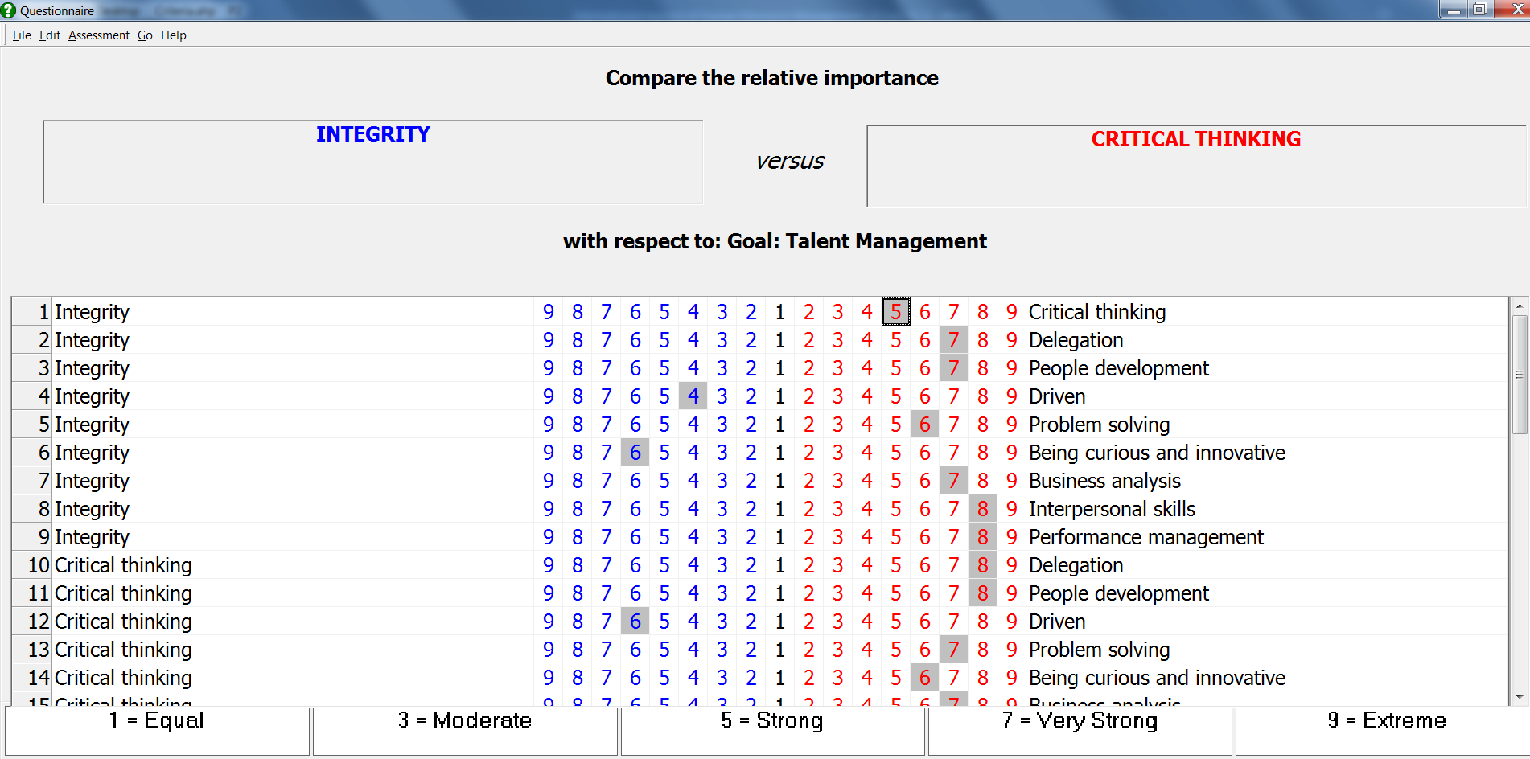

Figure 3 Stacked bar chart of talent performance

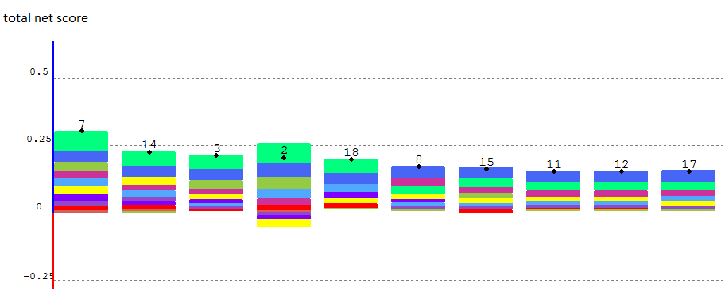
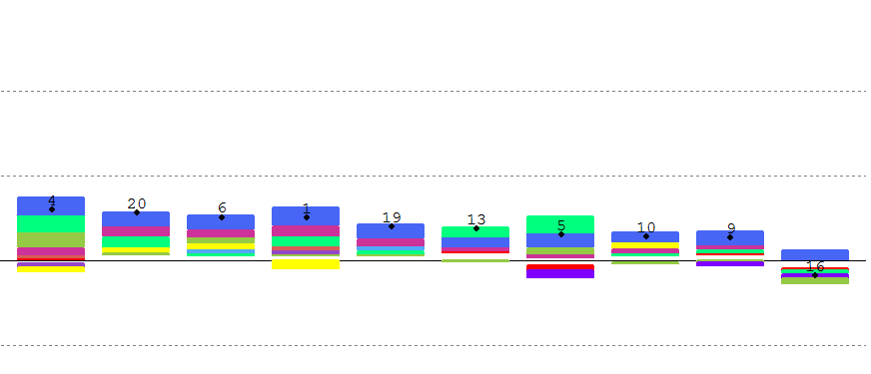
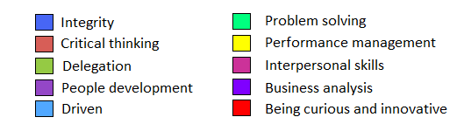

Figure 4 Gaia plane of the employees
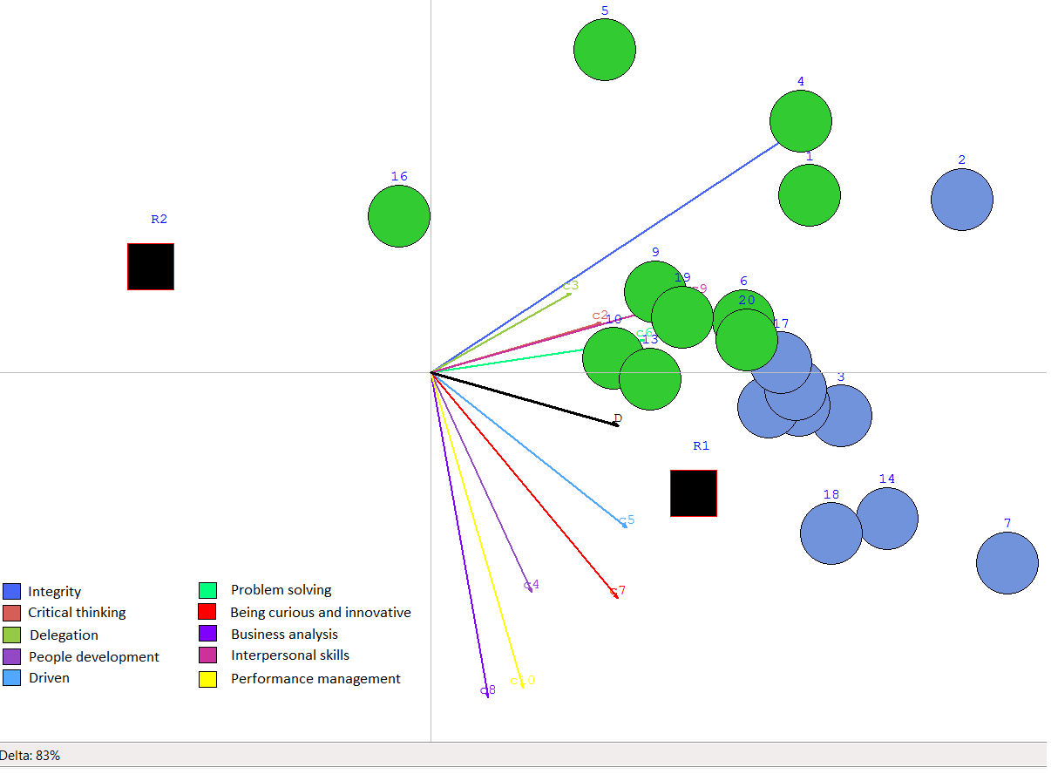

Table 1 Verbal scale of nine levels
Levels | Definitions
1 | Equal importance
2 | Equal - weak importance
3 | Weak importance
4 | Weak – strong
5 | Strong importance
6 | Strong - very strong importance
7 | Very strong importance
8 | Very strong - absolute importance
9 | Absolute importance

Table 2 Random index
N | 3 | 4 | 5 | 6 | 7 | 8 | 9 | 10
RI | 0.58 | 0.9 | 1.12 | 1.24 | 1.32 | 1.41 | 1.45 | 1.49

Table 3 Weights of the criteria

Criteria | M1 | M2 | M3 | Average
Integrity | 0.013 | 0.046 | 0.297 | 0.119
Critical thinking | 0.015 | 0.038 | 0.054 | 0.036
Delegation | 0.206 | 0.118 | 0.056 | 0.127
People development | 0.018 | 0.155 | 0.064 | 0.079
Driven | 0.147 | 0.017 | 0.091 | 0.085
Problem solving | 0.294 | 0.085 | 0.242 | 0.207
Being curious and innovative | 0.029 | 0.059 | 0.049 | 0.046
Business analysis | 0.139 | 0.102 | 0.047 | 0.096
Interpersonal skills | 0.017 | 0.204 | 0.049 | 0.090
Performance management | 0.122 | 0.177 | 0.051 | 0.117

Table 4 Classification of talents
Staff number | Score | Class
7 | 0.304 | Talent
14 | 0.227 | Talent
3 | 0.216 | Talent
2 | 0.205 | Talent
18 | 0.201 | Talent
8 | 0.174 | Talent
15 | 0.164 | Talent
11 | 0.157 | Talent
12 | 0.157 | Talent
17 | 0.155 | Talent
4 | 0.149 | Potential
20 | 0.145 | Potential
6 | 0.130 | Potential
1 | 0.129 | Potential
19 | 0.101 | Potential
13 | 0.095 | Potential
5 | 0.077 | Potential
10 | 0.072 | Potential
9 | 0.067 | Potential
16 | -0.045 | Potential

