An investigation into the absence of ancient Greek triremes in the archaeological record and a study of the battlefield deposition at the site of the Battle of the Aegates, off the Egadi Islands, to determine whether this example could direct future exploration for evidence of ancient Greek sea battles.

Mark. C. Davies, MA, BA (Hons), CTA. PhD Candidate, Centre for Maritime Studies, University of Southampton.

Abstract
Triremes enjoyed a long military history. However, no Greek trireme wrecks have been found, despite many thousands being built and lost. This short report seeks to explain this phenomenon. Many scholars hold that rammed triremes floundered rather than sank. I contend that there is little evidence to support this notion.
Recent finds from the Battle of the Aegates (241 B.C.E.) demonstrate that ancient warships did sink, and this article examines the specific conditions of the battle which caused the rammed warships to sink. Therefore, I propose an approach to target investigations on ancient Greek sea battles of the Classical period with similar conditions, where remains could be found.

Key Words
Trireme, bronze rams, battlefield deposition, Battle of the Aegates, Battle of the Egadi Islands.

Introduction
The invention of the trireme (Greek trieres), a wooden oared warship armed with a waterline bronze ram (embolus), had a profound effect on naval warfare in the Mediterranean in the Classical period. They were designed from the keel up to be “ship killers” and deployed in fleets or squadrons, which demonstrated a leap in tactical progress from hand-to-hand combat between ships’ crews to ship-to-ship combat by ramming in fleet actions (Rankov 2017:16, de Souza 2013). Triremes were invented sometime between the late eighth century B.C.E. (Morrison & Williams 1968:129, Casson 1971:80-1) and the second half of the sixth century B.C.E. (Rankov 2017:16-17) and were the standard ship of the line of the Classical period until the Hellenistic period when they were superseded by larger, heavier warships (Morrison et al. 1986:3). The last sea battle between triremes was fought during the civil war between Constantine and Licinius in 323 C.E. (Zosimus 2.22.1-2,24.1). However, despite the long and successful military career of triremes, their frequent depiction on coins, vases and reliefs (Fig. 1) and the narrative of ancient historians, which demonstrates that many thousands were built (and lost), very little physical evidence of triremes has been found by maritime archaeologists.
There have been several unsuccessful attempts to find triremes or ancient warships. The typical explanation for the absence of triremes in the archaeological record is that it is assumed that triremes were unballasted and therefore so buoyant that they did not sink once rammed and thus were salvaged in antiquity. However, this short report argues that ancient warships could and did sink, evidenced by the several bronze rams which have been recovered. The wooden hull of a trireme is unlikely to survive when exposed on the seabed, due to the effects of unstable environments and the actions of wood-eating microbes and fauna, unless it is found in anoxic conditions at depth or beneath sediment. However, the bronze ram, metal fittings, amphorae and military equipment are likely to be recoverable, as demonstrated at the battlefield site at the Egadi Islands, off the coast of Sicily.
This site was discovered under the joint auspices of the Soprintendenza del Mare, Regione Siciliana and the RPM Nautical Foundation. The chance discovery of a bronze ram by a fisherman, which was later impounded by the authorities in 2004, led to a systematic investigation of the area of the find over many seasons. These underwater searches have proved fruitful: several dozen bronze rams of Carthaginian and Roman warships, probably triremes, have been found together with military equipment, amphorae and ballast. Tusa and Royal (2012) claim that this is the site of the Battle of the Aegates fought in 241 B.C.E., the last decisive battle of the First Punic War. The Carthaginians were travelling Eastwards towards Sicily, carrying supplies to relieve their besieged troops. The Roman fleet, rowing in heavy seas, met and defeated them off the Egadi Islands, to the West of Levanzo Island. This short report will evaluate contributing factors on the day of the battle, in particular the facts that the Carthaginian ships were heavy-laden and that the weather conditions were rough. There are also the peculiarities of the site to consider, that it is neither too deep nor too shallow and that most of the artefacts have been discovered surrounded by rocky outcrops which have protected them from dragnet fishing.
This report will conclude that the assumption that all triremes floated and did not sink when rammed is simplistic and unrealistic. Therefore, many triremes would have sunk and some would have been recovered in antiquity, leaving only a few to be discovered. It will assess whether the conditions of the Battle of the Aegates are unique by conducting a review of the historical narrative of the Greco-Persian Wars and the Peloponnesian War to identify sites for future targeted underwater investigation. The evidence of the deposition at the Egadi Islands demonstrates that a trireme battlefield site is likely to be highly fragmented and thus particularly sensitive to dragnet fishing. Therefore, a targeted systematic underwater survey is most likely to be successful where the seafloor geology protects the artefacts from dragnet fishing, and where the site is sufficiently remote from shore to avoid sedimentation and is at a depth which discourages recreational divers.
Solving the “trireme question”
The Athenian triremes played a pivotal role in the Battle of Salamis in 480 B.C.E. (Muckelroy 1979:3) and the victory of Athens’ fledgling democracy led to a blossoming of Athenian art, theatre, and philosophy which has had a profound effect on Western culture to this day. However, despite the frequent depictions of warships on coins, vases (Fig. 2), reliefs, and repeated references in the contemporary historical narratives, no detailed description of a trireme exists. As ancient iconographic evidence rarely contains helpful labels, it is not always certain that the warship being portrayed is even a trireme. Morrison (1996:279) ruefully admits that “a naval architect attempting to reconstruct Mediterranean warships is offered scant literary and iconographic evidence on which to draw”. Thus, the origins and development of triremes remains shrouded in mystery, and even the meaning of their name trieres (plural triereis) which means “fitted with three” is debated. It is assumed that the name refers to the arrangement of the oars (Morrison et al. 2000:xx), but whether it refers to three levels of oarsmen or some other arrangement, the “trireme question”, is debated to this day (see Tarn (1905) and more recently Tilley (1970, 2004, 2007, 2012)). Therefore, there is much that could be learned from finding a trireme wreck. However, prior to the successes at the Egadi Islands, very little relating to ancient warships had been found in modern times, despite several attempts to find them. Of course, in ancient times, the salvage of goods and wreckage from sunken ships by free divers was a normal part of life (Parker 1992:2) and therefore many triremes would have been salvaged in antiquity.
Attempts to find an elusive trireme wreck
One of the earliest underwater archaeological surveys was conducted in 1884 by the Ephor of Antiquities in Greece, Christos Tsoundas. The project was a search of the waters around the Island of Salamis (Fig. 3) using divers in standard diving dress (Catsambis 2006:104; Tourtas 2014). Sadly, the survey was not a success, due partially to the lack of light at depth and the deep sediment that covers the seabed in that area (Annals of the Archaeological Society 1885:14-17, translated in Catsambis 2006:105).
Then in 1993, 1994 and 1997 the Actium Project attempted to find evidence of the Battle of Actium between Octavian and the joint forces of Mark Antony and Cleopatra in 31 B.C.E. (Murray & Hadjidaki 1994:320). This investigation was jointly directed by Professor William Murray, University of Florida, and Dr Elphida Hadjidaki, Greek Ministry of Culture. The research vessel was equipped with a 330 kHz side-scan sonar and a remotely operated vehicle (ROV). In the 1994 season, Murray (1997) reported finding three ovoid stones, which Murray identified as catapult projectiles, and two objects that appeared to be man-made and metallic at Target 136.1 (Fig. 4). The investigations resumed in 1997, this time with a professional diver who failed to find and recover these items for further research due to the recent deposition of spoils from tunnelling underneath the Straits of Aktion (Murray 1998:66).
From 2003 to 2006 the Persian Wars Shipwreck Survey attempted to find shipwrecks dating to the Greco-Persian Wars. This was a joint project between the Canadian Institute in Greece under Professor Shelley Wachsmann, the Greek Ephorate of Maritime Antiquities, and the Hellenistic Centre for Maritime Research (Kennell 2004, 2005; Rupp 2006, 2007). The research vessel Aigaio was equipped with a side-scan sonar, the submersible Thetis, and a ROV. The focus of the investigations was specific areas around Greece where Herodotus reported that there had been storms resulting in great loss of ships, and the waters near the Battle of Artemisium. The 1993 season surveyed the Southern tip of Mount Athos, off Cape Phonias (Fig. 5), where two Corinthian style helmets of the Classical or Hellenistic period had been found by fishermen several years before. Kennell (2004:343) reported that at a depth of 96m they found a Classical or Hellenistic amphora, home to an acquisitive octopus, containing seabed detritus. Within the contents was a bronze sauroter (spear-butt) (Fig. 6). However, little else was found. Professor Wachsmann explained that the failure to find more tangible remains “has to do with degrees of sedimentation”. He said, “I have no doubt that our survey went over many trireme wrecks but that they were buried so deeply in sediment that they did not show up in sonar” (Wachsmann 2021 elec. comms.).
In summary, attempts to find triremes have been largely unsuccessful and in consequence relatively poorly reported. Regrettably, this provides little information to maritime archaeologists as to why these investigations failed. However, both Murray and Wachsmann refer to the effects of sediment. Frost (1973a:33) explains, “The reason why no classical warship has, hitherto, been discovered on the seabed is that the decks of fighting ships were kept clear for action. Consequently, when they sank, their hulls became waterlogged, then collapsed and were covered and hidden by sand. Neither a tumulus, nor any projecting solids (such as a cargo of amphoras) remain to mark the site on the surface of the bottom”.
However, prior to 2008 four waterline rams had been found by chance: they are the Athlit Ram (Fig. 7), the Bremerhaven Ram (Fig. 8), the Piraeus Ram (Fig. 9), and the Egadi 1 Ram (Fig. 10) (Tusa and Royal 2012:12). A secondary ram (proembolion), the Belgammel (previously called Fitzwilliam) Ram, which would have been located above the waterline, has also been found (Pridemore 1996:38).
Explanations for the absence of triremes in the archaeological record
A common explanation for why such little evidence of warships has been found is that it is assumed that they floated after they were rammed and did not sink. Landels (1978:148) writes that triremes “tended when holed by the enemy to settle in the water without actually sinking”. Similarly, Casson (1991:82) writes, “a rammed galley [….] normally did not get holed, did not get broken apart, but filled with water, not necessarily rapidly, but inexorably […] and once swamped could be captured and towed away by the victors.”. Morrison et al. (2000:127) agree, writing that “the trieres had a positive buoyancy and did not sink when flooded”.
There is support for these contentions in the historical narrative. Various ancient historians describe triremes which have been described as “sunk” or “destroyed” being subsequently towed away by the victors. The historian Thucydides, who was a strategos (an elected military commander) and commanded a squadron of triremes in the Peloponnesian war (Finlay 1972:10-11), sometimes uses the verb katadyein, which is taken to mean “to sink” or “put out of action”. However, describing the Battle of Sybota (433 B.C.E.) he writes, “The Corinthians, instead of taking into tow and dragging away the ships they had put out of action, they turned their attention to the men” and killed the swimming crews (Thucydides 1.50.1). Gomme’s commentary on this passage describes the ships which had been put out of action, “they had sunk to the waterline, waterlogged and helpless” (Gomme 1945:185). Thus, katadyein does not necessarily mean sink to the bottom, rather, it may mean “to be awash” or “swamped” (Landels 1978:148; Morrison 1985:101, Casson 1991:82). The victor of a land battle could easily demonstrate possession of the battlefield, however the victor of a sea battle was whoever controlled the corpses and the wreckage (van Wees 2004:226), which is more open to disagreement (see, for example, Thucydides 1.50-4, where both the Corcyrans and the Corinthians erected a victory trophy), and also susceptible to exaggeration in the historical narrative (Davies 2021:29). Murray demonstrates this point by listing the differences in reported casualties at the Battle of the Aegates across the five ancient sources who refer to the battle (Murray 2019:37, table 2.1).
Tusa and Royal dismiss the claims that ancient warships could not sink and did not sink, calling this “a common misconception” (Tusa & Royal 2012:36) and demonstrated to be false by the fact that warship rams have been found on the seabed. A simplistic explanation of the historical narrative to rationalise why a warship would not sink is that (most) wood has a specific gravity less than water and therefore floats (Tusa & Royal 2012:36; Royal 2019b:297). However, in time the wooden fibres of an immersed hull absorb water, which increases its mass and raises its specific gravity, and there is a point where the waterlogged hull cannot support its own weight, and that of the fittings and equipment, and will sink (Tusa & Royal 2012:36). Nevertheless, opinions are divided on how much equipment and ballast a trireme would carry, which could be a catalyst to a trireme’s sinking.
Triremes were built to be fast and manoeuvrable, and therefore excess weight would be undesirable (Landels 1978:148). This is supported by Xenophon (Hellenica 6.2.27) who refers to the strategos Iphicrates’ order to his men to leave their sails behind as if expecting a fight. Landels (1978:151) asserts that there were no officers’ cabins, crew quarters, food stores or a galley on a trireme. Morrison et al. (2000:95) concur and declare that the crews ate and slept ashore. This view is supported in the historical narratives, such as Diodorus (13.106), where the entire Athenian fleet was captured at Aegospotami (405 B.C.E.) because the crews were scavenging the surrounding countryside to find supplies. Morrison et al. (2000:95) even claim that triremes did not carry supplies of drinking water. However, Sleeswyk and Meijer disagree and argue that triremes would carry terracotta kadoi to collect water, supported by the evidence from the records of the Athenian naval boards which includes kadoi in the inventory for the fleet and the engraving on the “Cista Ficoronica” which shows Jason and the Argonauts ashore collecting water (Sleeswyk & Meijer 1998, Sleeswyk 2012:117). In addition, the sea trials of the Olympias (Fig. 11), a reconstruction of a Fifth Century Athenian trireme, demonstrated that the crew would drink a litre of water an hour while rowing in warm weather (Morrison et al. 2000:238; Coates 2012:90). This signifies that there would be a practical need to carry water.
The question of ballast is also problematic. Casson (1971:90) claims that “some ballast, probably in the form of sand, was carried”. However, Landels (1978:148) took the view that a trireme was built to be as fast and light as possible at the expense of stability. Steffy (1985:56) takes a similar position and calls ballast “unnecessary”. Morrison (1985:99) likewise, states, “I think that there was no ballast in triremes as lightness was so often emphasised as a basic requirement”. Gifford (2012:98) concludes “no remains of a trireme have yet been discovered, probably because being unballasted they could not sink, and thus become preserved, when abandoned”.
However, contra, Tusa and Royal (2012:37) argue “the notion that any vessel operated by both oar and sail propulsion, with numerous individuals on board, and in conflict situations, did so without equipment, stores and ballast on board is contrary to a basic understanding of how a ship operates”. They argue that “ballast was mandatory to counter the forces placed on the vessel by the sails, and weight must have been concentrated below the waterline in warship’s hulls, particularly as they were long and narrow.” (Tusa & Royal 2012:37).
In summary, although the historical narrative suggests that many holed triremes were recovered, it is unrealistic to believe that no triremes sank. Triremes have been compared to racing eights (Landells 1978:146, Casson 1971:89), yet aside from the primary means of propulsion there is little in common between a vessel designed for competitive racing along a short course, and a warship designed to be a projectile and to conduct amphibious missions across the Mediterranean.
Investigations at the Egadi Islands
A lucky confiscation of an ancient warship ram (the Egadi 1 ram, see Fig. 10) by the Italian authorities in 2004 has changed the perspective of maritime archaeologists once and for all. This ram was found originally by a fisherman to the Northwest of Levanzo Island, near Sicily.
This fortunate find led the late Sebastiano Tusa, the then Soprintendenza Del Mare, Regione Siciliana, to team up with Dr. Jeffrey Royal of RPM Nautical Foundation to conduct a systematic underwater survey of the area, to search for traces of the Battle of Aegates which took place in 241 B.C.E. (Tusa & Royal 2012:11). The survey started with a desk-based review of the historical narrative and the archaeological finds in Sicily (Tusa & Royal 2012:11; Tusa 2019:21). They determined that the Carthaginians were travelling in an Easterly direction from Marettimo Island towards their besieged forces in Sicily (Fig. 12), where they were intercepted and defeated by the Roman fleet. They concluded that the battlefield was most likely to be to the West or Northwest of Levanzo Island, which was roughly where the Egadi 1 ram was found (Tusa & Royal 2012:11).
Fieldwork between 2005 and 2007 determined that the area had been heavily drag-net fished, creating long furrows along the seabed devoid of artefacts and macrofauna (Tusa & Royal:2012:11; 2019a:26). From 2008, they concentrated their efforts in a rocky zone, denoted PW-B, approximately 10 km Northwest of Levanzo Island (Fig. 12) (Tusa & Royal 2012:12,15-16). Here, the Egadi 2 ram was found, the first ram to be deliberately found by systematic searching, together with fragments of Greco-Italic amphorae.
Thereafter, the search moved to zone PW-A, approximately 7 km West of Levanzo (Fig. 13) (Tusa & Royal 2012:12). This is a rocky area, defined by rocky projections and gullies, creating irregular obstructions which would make the area difficult to fish. Several rams and shards of Greco-Italic amphorae were found in the protective rocky niches. Excavations around the ram and amphorae revealed many fist-sized stones which are consistent with ballast stones (Tusa & Royal 2012:20). Petrological analysis of these stones has determined their origin to be from the mountainous areas of Algeria and Tunisia, which would suggest that they came from Carthaginian ships (Tusa & Royal 2019b:205-207,212-217).
These discoveries led Tusa & Royal to conclude that PW-A was the site of the Battle of the Aegates, as “the artefacts in sector PW-A are thus either where they were originally deposited or only slightly disturbed”, whereas the artefacts in sector PW-B “represent secondary deposition of material from the battle zone” deposited by fishing nets as the artefacts show signs of movement (Tusa & Royal 2012:12, 2019a:26). The scattered distribution on the seabed of the amphorae intermingled with the rams suggests that the wrecks quickly fragmented as they descended to the bottom, spilling out their cargoes as they sank (Murray 2019:40-41).
In the seasons which have followed up to 2019, Murray & Robb (2021) report that 852 Greco-Italic and 80 Punic amphorae have been recovered, together with tableware, helmets, swords, coins and twenty-one bronze rams (see Fig. 14), by the Soprintendenza del Mare-Sicilia and RPM Nautical Foundation, and more recently assisted by the technical divers at Global Underwater Explorers. Two more rams have been recovered by fishermen and two more rams were recovered in the 2021 season (RPM Nautical Foundation 2021), bringing the total of rams found to twenty-five. Surprisingly, because Polybius describes the battle as having been fought between quinqueremes, these rams have been categorised as having been fitted to Roman or Carthaginian triremes (Tusa & Royal 2012:39-42, Polakowsky 2016:99, Murray 2019).
These successes must lead maritime archaeologists to the conclusion that if one battlefield site can be found by targeted systematic surveying, then perhaps others could be also.

Can we describe the Battle of the Egadi Islands as a unique event?
Potentially, this remarkable discovery could be applied to other theatres of war if it could be determined that the particulars of this battle, and the site, are not unique. Royal (2019b:301-3) concluded that the site formation demonstrates that the warships either sank whole or in large sections, possibly bisected, because of catastrophic hull breaches on being rammed. The hulls fragmented near the surface and sank quickly and did not drift (Royal 2019b:303, Murray & Robb 2021). The destructive outcome of ramming is evident in the playwright Aeschylus’ eyewitness account of the Battle of Salamis (480 B.C.E.). Aeschylus refers to a Greek trireme chopping the stern off a Phoenician galley on impact. (The Persians 410), contra Steffy (1991:38), who imagines that rams were designed to rupture the watertight seals between strakes, rather than pierce the enemy hull. The Greek historian Polybius, writing seventy years after the First Punic War, is the main ancient historical source of the battle. He writes that the Carthaginian warships were heavily loaded with supplies and munitions, and that the seas were rough because there was a strong breeze from the West (Histories, 1.60-1). Thus, the weather on the day of the Battle of Aegates may have been a contributing factor to the site formation processes. The rough seas could mean that “a swamped trireme would not last long in a swell. Being so heavy, its back would be easily broken” (Coates 1985:101). Landels (1978:148) argues that another reason why triremes have not been found is because they lack the cargo which would carry them to the seabed. If true, then the heavy-laden Carthaginian warships would have quickly flooded and sank. Nevertheless, Tusa & Royal (2012:37, note 61) disagree. They argue that it is common to find an ancient hull without a cargo on the seabed, and they provide the example of the Marsala wreck (Frost 1974). However, it is possible that in this case the cargo may have been perishable or recovered in antiquity.
In summary, it is difficult to judge to what extent the factors of sea conditions and carrying cargo had on the wrecking process. However, it is a reasonable hypothesis to investigate the historical narratives describing Classical sea battles to find similar factors present.
Proximity to shore
The discoveries of the battlefield at the Egadi Islands are due in part to the location. Tusa & Royal (2019a:26) explain that the artefacts were discovered at this site because they were exposed or only partially buried due to the absence of sediment, which in turn is due to the depth of circa. 80 m, and the distance from land. They observe that “Shipwreck sites close to shore are generally found in thick layers of sediment resulting from run-off and fluvial transport” (Tusa & Royal,2012:38). Sedimentation depends on many factors including currents, wave action, tidal activity, proximity to depositional rivers and tributaries and depth (Atkinson, 2012:39). Thus, a naval battlefield site close to land is more likely to be covered by sediment which would impede its discovery and it is more probable that shallow wrecks would have been salvaged in antiquity or looted by recreational divers. However, research by Brennan et al. (2012:65), focussed on Southwestern Turkey, has demonstrated that wrecks in deeper waters are more susceptible to damage from bottom-trawlers’ nets and other types of mobile fishing gear. Thus, the geology of the seabed will determine the level of impact by trawlers (Atkinson 2012:47). In sandy areas ancient underwater cultural heritage can be destroyed or re-deposited, whereas in rocky areas such damage might not occur because the fishing industry avoids terrain which might snag nets (Atkinson 2012). The surveying off the Egadi Islands revealed areas where drag-net fishing had scored long furrows in the sandy seabed (Tusa & Royal 2012:11. 2019:26). However, the bulk of the artefacts were found in zone PW-A, near the rocky outcrops where drag-net fishing was avoided to prevent damage to nets (Tusa & Royal 2012:11-12).
The discoveries at Egadi demonstrate that a naval battlefield is widely dispersed and therefore is likely to be adversely affected by drag-net fishing and sediment. With this knowledge, maritime archaeologists have a better idea how to find other battlefield sites through systematic survey, perhaps with the aid of statistical analysis.
Are there potential Classical battlefield sites worthy of systematic survey?
Between 480 and 322 B.C.E. over eighty naval engagements were recorded in the historical narratives (Potts 2008:274-276, Appendix 3). Therefore, at first glance, a desktop survey ought to provide numerous potential targets for further investigation.
It is evident that two causal factors were present at the Battle of the Aegates. Namely, that the Carthaginian ships were heavy laden, and the seas were rough. In which case either or both factors may have contributed to the warships sinking. It is a reasonable assumption that the weather may be the most important factor (Davies 2021:84), as both Roman and Carthaginian rams have been found (Pragg 2014), and it is unlikely that the Roman warships would have carried any excess munitions. However, there are relatively few battles where the weather is mentioned. This can be explained by Rankov (2017:3) who explains that naval campaigning was only conducted in the summer months due to the “vulnerability of long warships to high waves and bad weather”. This assertion is supported by ancient authors such as Vegetius (Epitome of Military Science, 4.43) who wrote that “naval battles are staged in calm seas”.
A desktop analysis of Classical sea battles can quickly dismiss skirmishes where there were few triremes lost, or those battles fought near a river or on a narrow stretch of water due to the likelihood of thick sediment. The result of this analysis is that there are only two Classical sea battles, Sybota (433 B.C.E.) and Arginusae (406 B.C.E.), which may be worthy of further underwater investigation (Davies 2021:84-92).
Battle of Sybota
The Battle of Sybota was fought between Corinth and her former colony Corcyra (Corfu) (Kagan 2003:34-36). The islands of Sybota (modern Sivota) are an archipelago between mainland Greece and Corfu (Fig. 15). The Corinthians had a fleet of triremes laden with hoplites and supplies to invade Corfu (Thucydides 1.46,48). Thucydides (1.54) writes that both sides claimed victory. However, the Corinthians “sank” seventy Corcyraean triremes, whereas the Corcyrans “sank” only thirty Corinthian triremes. Thucydides (1.50) records that the Corinthians recovered their dead and disabled ships but refrained from capturing the Corcyraean ships which had either sunk or swamped and focussed their attention on killing the swimming bereft crew. Thucydides (1.54) writes that a wind arose in the night and scattered the wreckage and Corcyraean dead towards Corfu where they were recovered.
This narrative suggests that potentially two factors are present, that the Corinthians were heavy-laden and there were strong winds overnight. The disabled Corinthian ships may have been recovered at the time, but some of the swamped and abandoned Corcyraean ships may have sunk overnight, and the effects of wind and current may mean that wreckage may have been deposited over a large area, aligned to the direction of the wind towards Corfu (Davies 2021:88).

Battle of Arginusae
The Battle of Arginusae was fought between the Athenians and the Spartans (Kagan 2003:454-458). The two islands of Arginusae lie parallel to each other in the straits between Lesbos and Turkey (Fig. 16). The battle was a decisive victory for the Athenians, sinking seventy Spartan ships, however, the battle was interrupted by a “heavy storm” (Xenophon, Hellenica 1.6.35) which prevented them from recovering their own twenty-five Athenian ships and their stranded crews. Diodorus (13.100.4) writes that corpses and wreckage were littered from Cyme (modern Nemrut Limani) to Phocaea (modern Foça), to the South of the battlefield.
It is a reasonable assumption that many triremes sank in that storm (Davies 2021:90). However, Xenophon (Hellenica 1.6.33) writes that the fighting was over a long time, which suggests that the battlefield is spread over a large area, making it difficult to find.
A review of modern charts of these battlefields suggests that Sybota may be a suitable location for further investigation because there are reefs to the South of Corfu, in the line of the drifting wreckage, which might protect artefacts from dragnet fishing. The battlefield at Arginusae may be more difficult to investigate, as any wreckage from the dispersed fighting might be covered by a modern dumping ground (Davies 2021:90).
Conclusion
The introduction of the trireme had profound economic and political consequences in the Classical period. Davison (1947:18) compared it to the introduction of the Dreadnought battleships of the early twentieth century and the arm’s race to the First World War that followed. Any ship, such as a trireme, reflects the society which built it (Adams 2001) and therefore the discovery of the remains of a Greek trireme would be of huge significance to archaeology. Yet prior to the successes at Egadi all previous expeditions to find evidence of ancient warships had failed.
The belief that ancient warships did not sink has been proved to be false by the recovery of numerous bronze rams, and therefore the scarcity of triremes in the archaeological record must be explained by other reasons.
Ancient naval battles were often fought within sight of land, in relatively shallow water, and there is a reasonable expectation that many wrecks would have been either washed ashore or salvaged in antiquity. However, some warships would have sunk and could be still waiting to be discovered.
Finding them will not be easy, because the wooden parts of the ancient warships which reached the seabed are highly likely to have been consumed by aquatic fauna and bacteria, leaving only the metal parts of the ship together with military equipment and munitions. Also, the discoveries at Egadi have demonstrated that it is probable that the remains are likely to be highly fragmented over a large area. In addition, the site will be difficult to find or identify, lacking the amphorae mound of a typical merchant shipwreck, which could otherwise protect and shield a wooden hull. Thus, a nautical battlefield site is likely to be highly susceptible to damage from drag-net fishing and looting from recreational divers; and those wrecks close to shore may be blanketed in a thick layer of sediment. In short, an ancient nautical battlefield is difficult to find.
Considering these challenges, the success at Egadi is due to the astonishing luck of finding the Egadi 1 ram, coupled with meticulous desktop analysis of the historical narrative, to pinpoint the search area. Yet, the success of the methodology of targeted systematic surveying was founded on persistence. Tusa & Goold (2019:15) explain, “it took time for the results to begin to appear. Indeed, it was not until the fourth year (2008) that the first in-situ ram was located, and it took a further two years to locate the second. Thereafter, the pace of discoveries quickened.” Previous unsuccessful investigations in Greece looking for warship wrecks do not seem to have had the same resources as the investigations in Sicily, but until the successes at Egadi it was not entirely clear what to look for.
This short report has suggested a means by which historical narrative could be reviewed to identify potential naval battlefield sites. This could be achieved by focussing on causal factors, such as the weather during the battle, and site conditions, such as proximity to shore and seabed geology. My research into Classical naval battles suggests that they were generally fought during good weather and identified Sybota and Arginusae as potential targets as bad weather was mentioned. Sybota may be worthy of further investigation, potentially using mathematical probability theory. However, this desk-top research could be extended to the Hellenistic and Roman eras, where more targets for investigation could be found.
Acknowledgements
This short report is based on my dissertation, which was submitted in partial fulfilment of my master’s degree in Maritime Archaeology at Southampton University. I would like to thank Professor Jon Adams for supervising my dissertation and Yvonne Marshall for her support and suggestions.
I want to also thank Professor Phil de Souza, Professor Bill Murray, Professor Boris Rankov, Lt. Commander Alec Tilley R.N. (Retired) and Professor Shelley Wachsmann, who all very kindly took time to reply to my emails to give me their invaluable perspectives on triremes and Ancient Greek warfare.
Thanks to Mateusz Polakowski who was kind to share his knowledge on the investigations in the Egadi Islands with me, and his willingness to discuss triremes.

Ancient References Cited
Aeschylus. Promethius Bound and Other Plays. Translated with an Introduction by P. Vellacott. 1961. London: Penguin Group
Diodorus Siculus. The Persian Wars to the Fall of Athens. Books 11 – 14.34. Translated with Introduction and Notes by P. Green. 2010. Austin Texas: University of Texas Press.
Herodotus. The Histories. Translated by A. de Selincourt. 1954. London: Penguin
Polybius. The Rise of the Roman Empire. Translated by I. Scott-Kilvert. 1979. London: Penguin.
Thucydides. History of the Peloponnesian War. Translated by R. Warner (1954) with an Introduction and Notes by M. I. Finley (1972). London: Penguin.
Vegetius. Epitome of Military Science. Translated by N. P. Milner. 1993. Liverpool: Liverpool University Press.
Xenophon. Hellenica. Translated by R. Warner with an Introduction and Notes by G. Cawkwell. 1966. London: Penguin.
Zosimus, Historia Nova. Open Greek and Latin Perseus Digital Library Scaife Viewer [online] available at https://scaife.perseus.org/reader/urn:cts:greekLit:tlg4084.tlg001.opp-grc1:1/ [Accessed 27 September 2021].
References Cited
Acropolis Museum. 2021. [online] Available at: https://www.theacropolismuseum.gr/en/relief-depicting-trireme-lenormant-relief [Accessed 24 July 2021].
Adams, J. R., 2001. Ships and Boats as Archaeological Source Materials. World Archaeology. Vol. 32. No. 3: 292-310.
Atkinson, C. M., 2012. Impacts of Bottom Trawling on Underwater Cultural Heritage. Master’s Thesis. Texas A&M University.
Brennan, M. L. et al, 2012. Evaluation of the modern submarine landscape off southwestern Turkey through the documentation of ancient shipwreck sites. Continental Shelf Research 43: 55-70
Casson, L., 1971. Ships and Seamanship in the Ancient World. Princeton: Princeton University Press. (rev. ed. 1995).
Casson, L., 1991. The Ram and Naval Tactics. In L. Casson & J. R. Steffy (eds), The Athlit Ram: 76-82. Texas: Texas A&M University Press.
Catsambis, A., 2006. Before Antikythera: The First Underwater Archaeological Survey in Greece. The International Journal of Nautical Archaeology 35.1: 104-107.
Coates, J., 1985. General Discussion. In J. Coates & S. McGrail (eds) The Greek Trireme of the 5th Century B.C. Discussion of a projected reconstruction. Pp 95-103. Greenwich, National Maritime Museum.
Coates, J., 2012. The Proposed Design of any Second Reconstruction. In B. Rankov (ed.), Trireme Olympias - The Final Report: 82-93. Oxford and Oakville: Oxbow Books.
Davies, M. C., 2021. An archaeological investigation into the absence of Classical Greek Triremes in the archaeological record and the paradox of numerous finds from the Battle of the Aegates (241 B.C.E.) at the Egadi Islands. Master’s Thesis. Southampton University.
Davison, J. A., 1947. The First Greek Triremes. The Classical Quarterly. Vol. 41 No. 1 / 2: 18-24
De Souza, P., 2013. War at Sea. In B. Campbell & L. A. Tritle (eds). The Oxford Handbook of Warfare in the Classical World. Oxford: Oxford University Press.
Frost, H., 1973a. First Season of Excavation on the Punic Wreck in Sicily. International Journal of Nautical Archaeology and Underwater Exploration. 2.1: 33-49.
Frost, H., 1974. The Punic Wreck in Sicily, Second Season of Excavation. International Journal of Nautical Archaeology and Underwater Exploration. 3.1:35-54.
Gifford, E., 2012. Comments on Olympias. In B. Rankov (ed.), Trireme Olympias - The Final Report: 97-99. Oxford & Oakville: Oxbow Books.
Global Underwater Explorers, 2021 [online] Available at: https://www.gue.com/battle-egadi-2018 [Accessed 11 September 2021].
Gomme, A. W., 1945 A Historical Commentary on Thucydides. Vol. 1. Introduction and Commentary on Book 1. Oxford: Clarendon Press.
Kagan, D., 2003. The Peloponnesian War. London. Penguin Books.
Kennell, S. A. H., 2004. The Fieldwork of the Canadian Institute in Greece 2003. Mouseion. Vol. 4, No. 3: 331-344.
Kennell, S. A. H., 2005. The Fieldwork of the Canadian Institute in Greece 2004. Mouseion. Vol. 5, No. 3: 287-301.
Landels, J. G., 1978. Engineering in the Ancient World. London: Chatto & Windus.
Livius.org. Articles on Ancient History. [online] Available at: https://www.livius.org/pictures/greece/piraeus/piraeus-ram-of-a-warship/ [Accessed 22 August 2021].
Morrison, J.S., 1985. General Discussion. In J. Coates & S. McGrail (eds) The Greek Trireme of the 5th Century B.C. Discussion of a projected reconstruction: 95-103. Greenwich: National Maritime Museum.
Morrison. J. S. & J. F. Coates, 1996. Greek and Roman Oared Warships. Oxford: Oxbow Books. (2016 reprint).
Morrison. J. S. & R. T. Williams, 1968. Greek Oared Ships 900-322 BC. Cambridge: Cambridge University Press.
Morrison, J. S., et al, 2000. The Athenian Trireme – The History and Reconstruction of An Ancient Greek Warship (Second Edition). Cambridge: Cambridge University Press.
Muckelroy, K., 1978. Maritime Archaeology. Cambridge: Cambridge University Press.
Murray, W. M., 1991. Classification of the Athlit Ship: A Preliminary Report. In L. Casson & J. R. Steffy (eds), The Athlit Ram: 72-75. Texas: Texas A&M University Press.
Murray, W. M., 1997. The Actium Project. [Online] Available at: http://luna.cas.usf.edu/~murray/actium/brochure.html [Accessed 16 July 2021].
Murray, W. M., 1998. Actium. In D Blackman, J Baker & N Hardwick (eds). Archaeology in Greece 1997-98, Archaeological Reports 1997-1998. Society for the Promotion of Hellenistic Studies. No. 44: 66-68.
Murray, W. M., 2012. The Age of Titans: The Rise and Fall of the Great Hellenistic Navies. Oxford: Oxford University Press.
Murray, W. M., 2019. The Ship Class of the Egadi Rams and Polybius’ account of the First Punic War. In J. G. Royal & S. Tusa (eds). The Site of the Battle of the Aegates Islands at the End of the First Punic War: Fieldwork, Analyses and Perspectives, 2005-2015. Bibliotheca Archaeologica 60: 31-42. Rome, Italy/Bristol, CT: L’Erma Di Bretschneider.
Murray, W. M. & E. Hadjidaki, 1994. The Actium Project: A Search for Remains from the Battle of Actium. Proceedings of the 95th Annual Meeting of the Archaeological Institute of America in American Journal of Archaeology 98.2: 320-320.
Murray, W. M. & G. Robb Jr., 2021. From Debris Field to 1st Punic War Battle Map: Site Formation in the Egadi Battle Zone. In International Journal of Nautical Archaeology: 1-16.
Oron, A., 2006. The Athlit ram bronze casting reconsidered: scientific and technical re-examination. Journal of Archaeological Science. 33: 63-76.
Parker, A. J., 1992. Ancient Shipwrecks of the Mediterranean and the Roman Provinces. British Archaeological Reports S580. Oxford: Tempus Reparatum.
Persian Wars Shipwreck 2003-2006. 2021. [online] Available at https://nautarch.tamu.edu/pwss/homepage/ [Accessed 28 August 2021].
Polakowski, M., 2016. Warships of the First Punic War: An Archaeological Investigation and Contributory Reconstruction of the Egadi 10 Warship from the Battle of Egadi Islands (241 B.C.). Master’s Thesis. East Carolina University.
Potts, S., 2008. The Athenian Navy: An investigation into the operations, politics and ideology of the Athenian fleet between 480 and 322 BC. Master’s Thesis. Cardiff University.
Pridemore, M. G., 1996. The Form, Function and Interrelationships of Naval Rams: A Study of Naval Rams From Antiquity. Master’s Thesis: Texas A & M University.
Pritchett, W. K., 1963. Xerxes’ Fleet at the “Ovens”. American Journal of Archaeology. Vol. 67. No. 1: 1-6.
Rankov, B., 2017. Ancient Naval Warfare, 700 BC - AD 600 in M. Whitby & H. Sidebottom (eds) The Encyclopedia of Ancient Battles: 1-41. Malden, MA/Oxford: John Whiley & Sons.
Royal, J. G., 2019a. Amphoras and tablewares. In J. G. Royal & S. Tusa (eds). The Site of the Battle of the Aegates Islands at the End of the First Punic War: Fieldwork, Analyses and Perspectives, 2005-2015. Bibliotheca Archaeologica 60: 185-200. Rome, Italy/Bristol, CT: L’Erma Di Bretschneider.
Royal, J. G., 2019b. Perspectives on the Battle of the Aegates Islands. In J. G. Royal & S. Tusa (eds). The Site of the Battle of the Aegates Islands at the End of the First Punic War: Fieldwork, Analyses and Perspectives, 2005-2015. Bibliotheca Archaeologica 60: 297-313. Rome, Italy/Bristol, CT: L’Erma Di Bretschneider.
Royal, J. G. & S. Tusa, 2019. The Warship rams: depositional contexts and descriptions. In J. G. Royal & S. Tusa (eds). The Site of the Battle of the Aegates Islands at the End of the First Punic War: Fieldwork, Analyses and Perspectives, 2005-2015. Bibliotheca Archaeologica 60: 43-75. Rome, Italy/Bristol, CT: L’Erma Di Bretschneider.
RPM Nautical Foundation. 2021. [online] Available at: www.rpmnautical.org [Accessed 22 August 2021].
Rupp, D., 2006. The Fieldwork of the Canadian Institute in Greece 2005. Mouseion. Vol 6, No. 2: 203-217.
Rupp, D., 2007. The Fieldwork of the Canadian Institute in Greece 2006. Mouseion. Vol 7, No. 2: 131-153.
Sleeswyk, A. W., 2012. Beyond Olympias: an outsider’s view. In B. Rankov (ed.), Trireme Olympias - The Final Report: 109-120. Oxford and Oakville: Oxbow Books.
Sleeswyk, A. W. & F. Meijer, 1998. The Water Supply of the Argo and other Oared Ships. The Mariner’s Mirror Vol. 84. No. 2: 131-138.
Steffy, J. R., 1985. Structural philosophy and technology – clues from shipwrecks. In J. F. Coates & S. McGrail (eds) The Greek Trireme of the 5th c B.C. – Discussion of a projected reconstruction: 25-38. Greenwich; National Maritime Museum.
Steffy, J. R., 1991. The Ram and Bow Timbers: A Structural Interpretation. In L. Casson & J. R. Steffy (eds), The Athlit Ram: 6-39. College Station, Texas: Texas A&M University Press.
Tarn, W. W., 1905. The Greek Warship. Journal of Hellenistic Studies. 25: 137-156.
Tilley, A. F., 1970. The Ship of Odysseus. Antiquity 44: 100-107.
Tilley, A. F., 2004. Seafaring on the Ancient Mediterranean. Oxford.
Tilley, A. F., 2007. Rowing Ancient Warships: Evidence from a Newly-Published Ship Model. The International Journal of Nautical Archaeology 36:2: 293-299.
Tilley, A. F., 2012. An Unauthentic Reconstruction. In B. Rankov (ed.), Trireme Olympias - The Final Report: 121-132. Oxford and Oakville: Oxbow Books.
Tourtas, A., 2014. The Discovery of the Antikythera Shipwreck: The Social Aspect. Master’s Thesis, University of Southampton, Centre for Maritime Archaeology.
Trireme Trust. 2021.[online] Available at: www.triremetrust.org.uk [Accessed 30 August 2021].
Tusa, S., 2019. Archaeological finds as true evidence of the Egadi battle. In J. G. Royal & S. Tusa (eds). The Site of the Battle of the Aegates Islands at the End of the First Punic War: Fieldwork, Analyses and Perspectives, 2005-2015. Bibliotheca Archaeologica 60: 17-22. Rome, Italy/Bristol, CT: L’Erma Di Bretschneider.
Tusa, S & J. Goold, 2019. Forward. In J. G. Royal & S. Tusa (eds). The Site of the Battle of the Aegates Islands at the End of the First Punic War: Fieldwork, Analyses and Perspectives, 2005-2015. Bibliotheca Archaeologica 60: 15-16. Rome, Italy/Bristol, CT: L’Erma Di Bretschneider
Tusa, S & J. Royal, 2012. The landscape of the naval battle at the Egadi Islands (241 B.C.) Journal of Roman Archaeology 25. 7-48.
Tusa, S & J. Royal, 2019a. History of the Project and overview of the site. In J. G. Royal & S. Tusa (eds). The Site of the Battle of the Aegates Islands at the End of the First Punic War: Fieldwork, Analyses and Perspectives, 2005-2015. Bibliotheca Archaeologica 60: 23-30. Rome, Italy/Bristol, CT: L’Erma Di Bretschneider.
Tusa, S & J. Royal, 2019b. The small finds. In J. G. Royal & S. Tusa (eds). The Site of the Battle of the Aegates Islands at the End of the First Punic War: Fieldwork, Analyses and Perspectives, 2005-2015. Bibliotheca Archaeologica 60: 201-217. Rome, Italy/Bristol, CT: L’Erma Di Bretschneider,
Van Wees, H., 2004. Greek Warfare Myths and Realities. London: Gerald Duckworth & Co. Ltd.
Wachsmann, S., 2006. Persian Wars Shipwreck 2003-2006. [online] Available at: https://nautarch.tamu.edu/pwss/homepage/ [Accessed 28 August 2021]

Figures

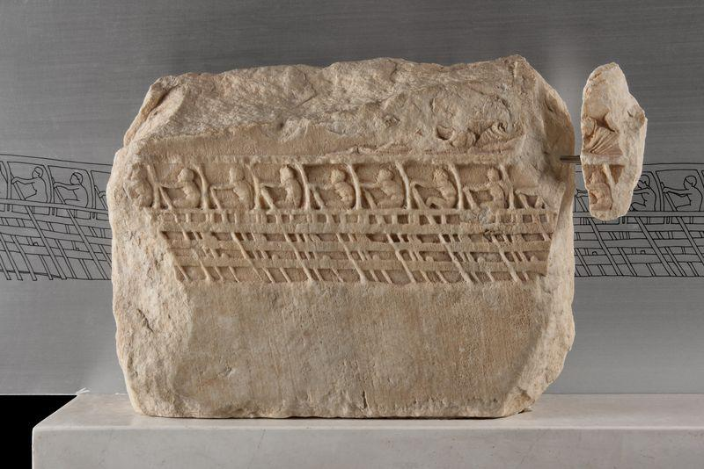
Figure 1. The Lenormant Relief, a fragment from a 5th century sculptural relief found on the Acropolis, now in the Acropolis Museum, Athens, Greece. It has been interpreted as an Athenian trireme in profile, showing three banks of oars. (Source: Acropolis Museum 2021).

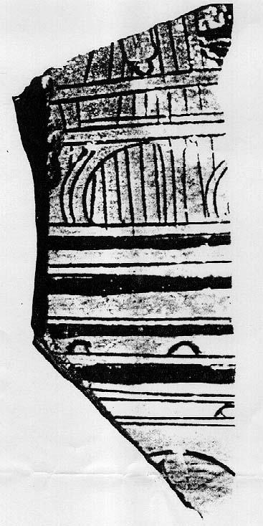

Figure 2. Fragment of red-figure pottery circa 450 B.C.E., interpreted as showing part of the side of a trireme, with semi-circular oar holes and an outrigger. (Morrison et al, 2000:149).

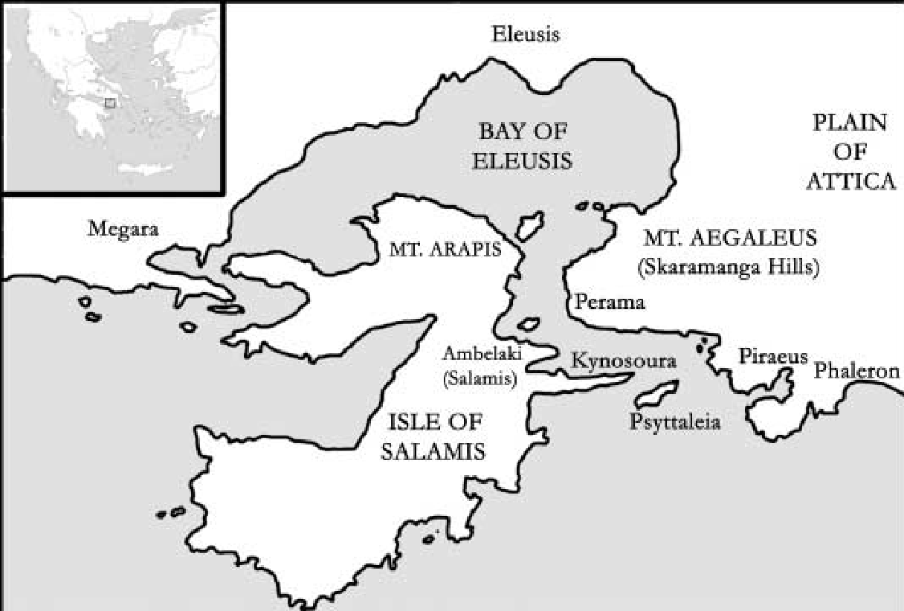
Figure 3. Map of the Island of Salamis and mainland Greece. The exact location of the battlefield is unknown, but the Greeks probably met the Persians in the straits of Salamis, above the promontory of Kynosoura on Salamis and the island of Psyttaleia (now a sewage treatment plant) (Catsambis 2006:105).

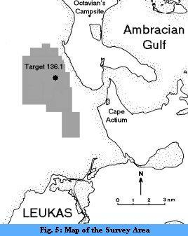

Figure 4. Map of the 1993 and 1994 survey area of 110 square km, approximately 3.3 km off the Preveza Peninsula, West Coast of Greece. (Murray 2007).

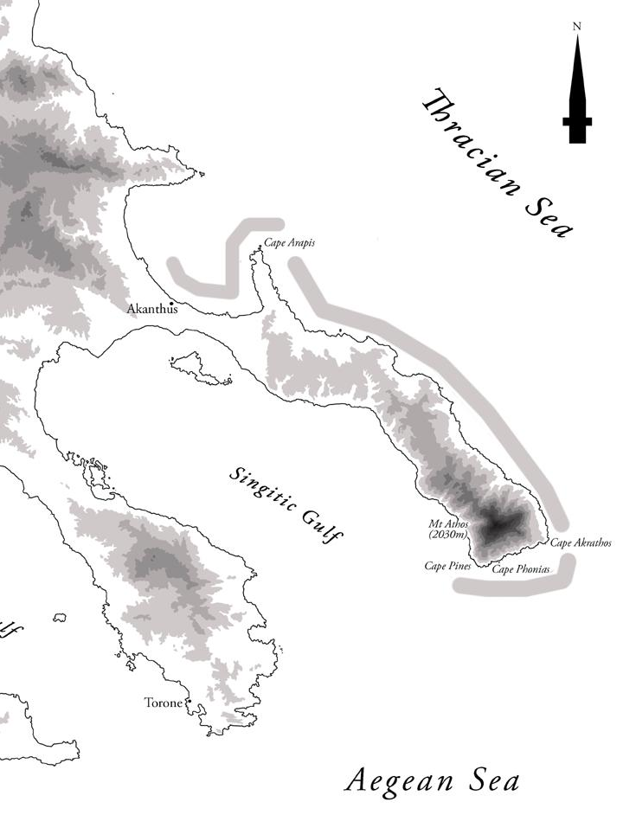
Figure 5. Map of the Halkidiki and Mount Athos, Northern Greece, showing the areas surveyed in the Thracian Sea. Cape Arapis is to the North. Cape Phonias is at the Southern tip of the Mount Athos promontory, where the Corinthian helmets and sauroter were found. (Wachsmann 2006: 2003 Season: Mount Athos).

Figure 6. Bronze sauroter or spear-butt spike found off Cape Phonias, at the Mount Athos promontory. (Wachsmann 2006: 2003 Season; Mount Athos)

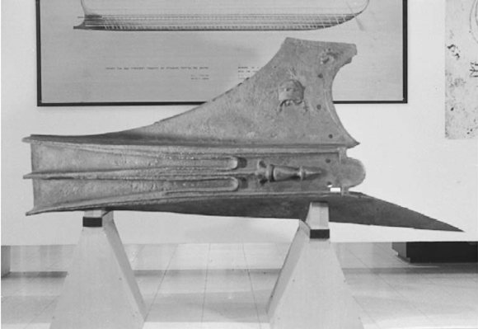
Figure 7. Photograph of the Athlit Ram, at the National Maritime Museum, Haifa, Israel. This is a ram of substantial size, weighing 465 kgs. (Oron 2006:64 Fig. 1)

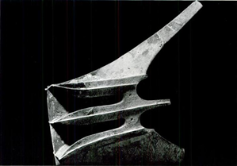
Figure 8. Photograph of the Bremerhaven Ram, at the Deutsches Shiffahrtsmuseum, Bremerhaven, Germany. Acquired from the Galeria Nefer, Zurich in 1987 with provenance unknown. It weighs only 53 kgs and probably came from a “two” or a “one” (Murray 1991:75) (Photograph from Galeria Nefer).

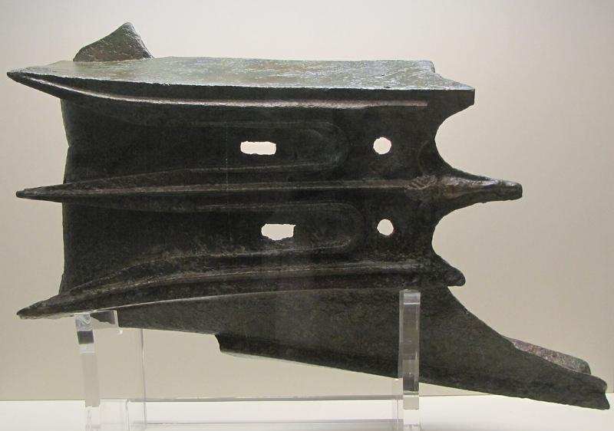
Figure 9. Photograph of the (damaged) Piraeus Ram, Piraeus Archaeological Museum, Piraeus Port of Athens, Greece. Reportedly found near Cape Artemision in Northern Euboea. Donated to the Piraeus Archaeological Museum in 1996 by Vasilis Kallios. (Murray 2012:49). (www.livius.org Photographer Lauren van Zoonen)

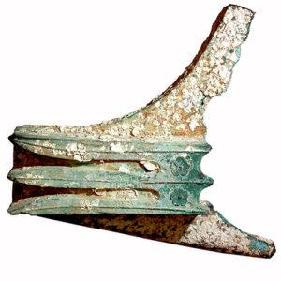
Figure 10. Photograph of the Egadi 1 Ram. Originally known as the Trapani Ram, recovered from a smuggler of antiquities on 15 June, 2004, in Trapani, Sicily. Reportedly retrieved by a fisherman from the sea, North of Levanzo Island, N. W. Sicily (Murray 2012). (Photograph: RPM Nautical Foundation).

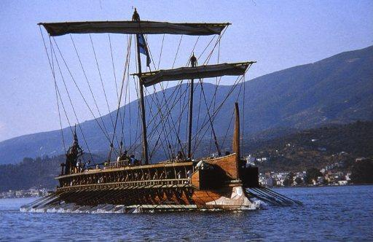
Figure 11. Photograph of a reconstruction of a Fifth Century BCE Athenian trireme Olympias, underway at Poros (Trireme Trust 2021, Photograph Alexandra Guest)

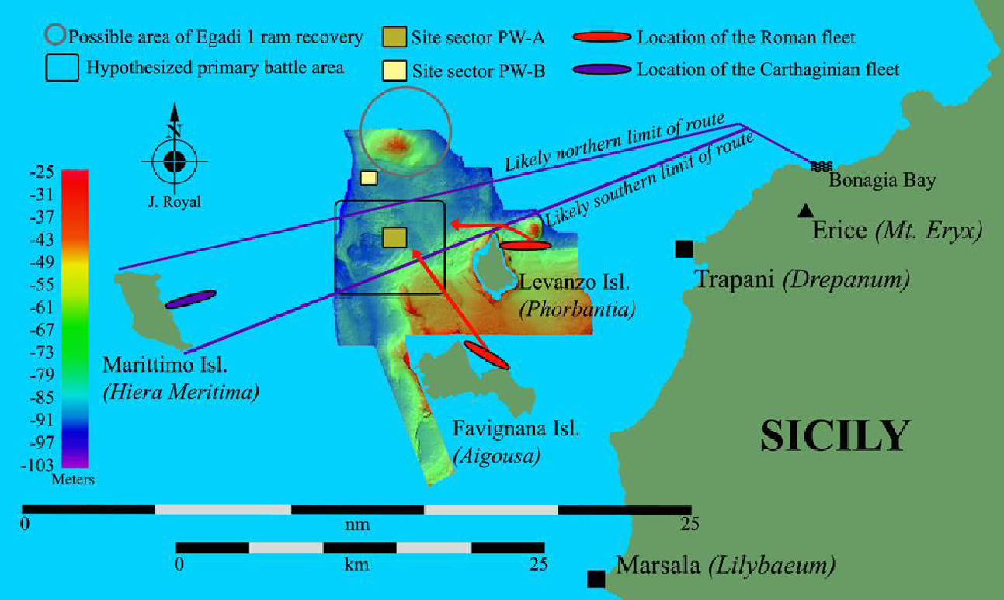
Figure 12. Map of the battle area during the Battle of the Aegates, showing the two areas PW-A and PW-B. (Tusa & Royal 2012:9)

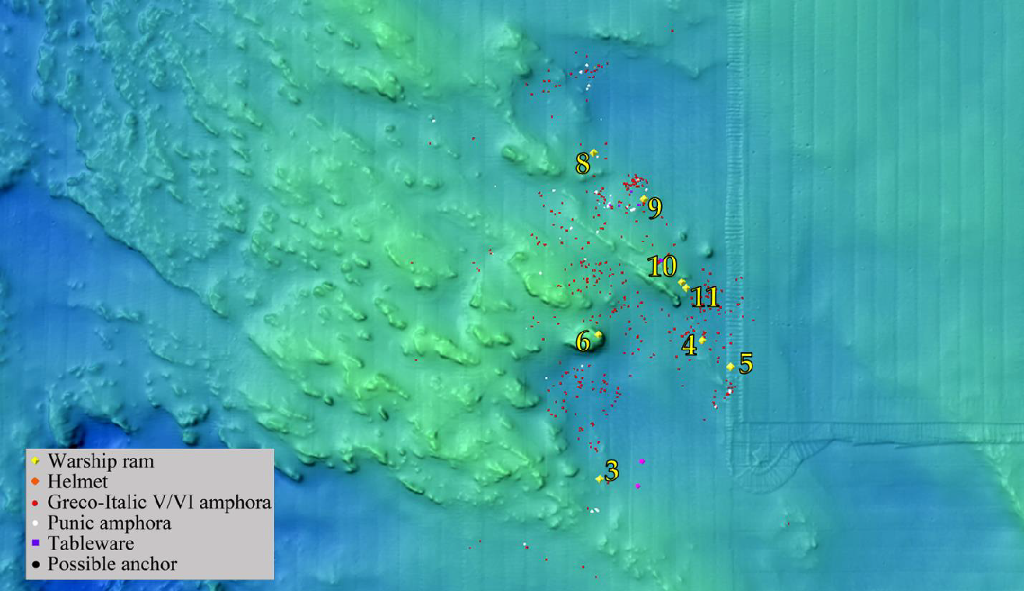
Figure 13. Map of site sector PW-A showing the cluster of rams 3-6, and 8-11 and other artefacts. (Polakowski 2016:43, courtesy of Dr. Jeffrey Royal and the Sopritendenza del Mare, 2014)

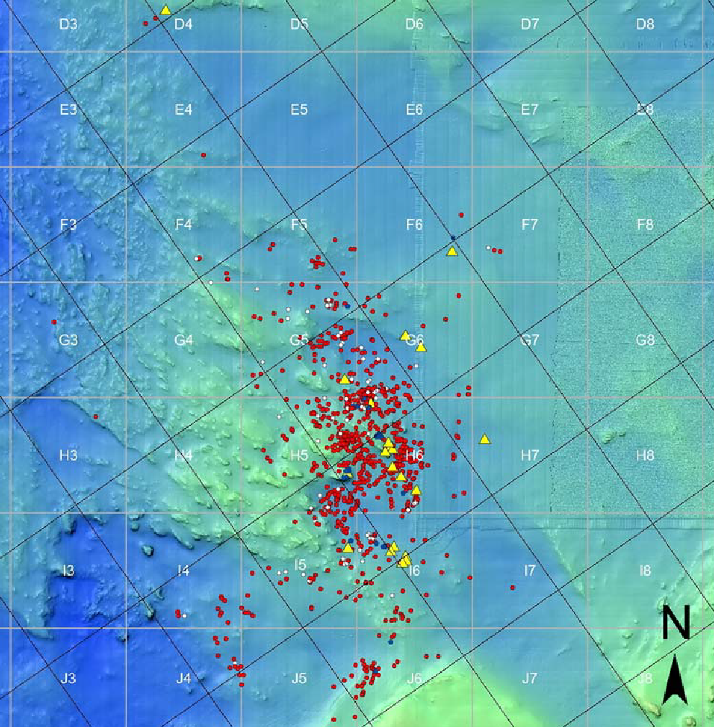
Figure 14. Map of debris field at the Egadi Islands, Zone PW-A. Site grid of 1000 m squares in grey; course grid in black angled at 35° to match likely orientation of Carthaginian fleet. Yellow triangles = rams; red dots = GI amphoras; white dots = Punic amphoras; blue dots = helmets. (Murray & Robb 2021:3 Fig. 3)

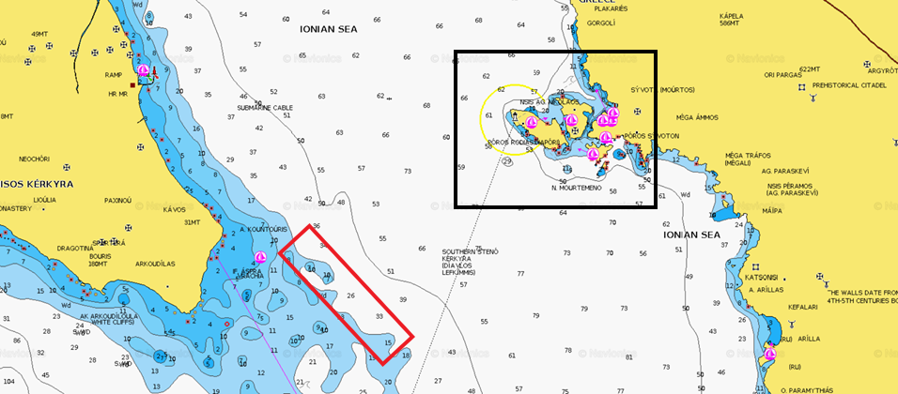
Figure 15. Chart of Sybota Islands (Sivota) on the right in a black square and Corcyra (Corfu) to the left. Note the reefs to the South of Corfu. A potential target area is marked in a red rectangle denoting the start of the reef. (Chart from Navionics ChartViewer)
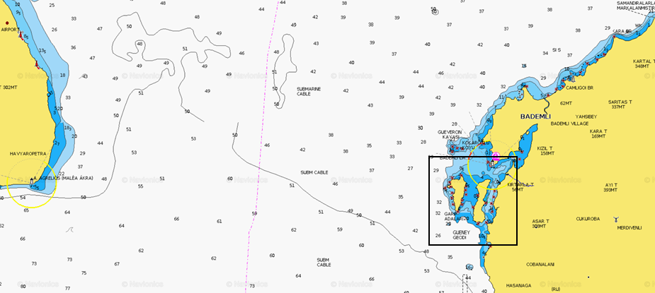
Figure 16. Chart of the two Arginusae Islands in the square box and mainland Turkey (right) and Lesbos (left) (Chart from Navionics ChartViewer).

