Energy-related clean and green framework for shipbuilding community towards zero-emissions: A strategic analysis from concept to case study

Seyed Vahid Vakili^{1,**}, Aykut I. Ölçer¹, Alessandro Schönborn¹, Fabio Ballini¹, Anh Tuan Hoang^{2,*}
¹World Maritime University, Malmo, Sweden
²Institute of Engineering, Ho Chi Minh city University of Technology (HUTECH), Ho Chi Minh city, Vietnam

*Corresponding author
*Institute of Engineering, Ho Chi Minh city University of Technology (HUTECH), Ho Chi Minh city, Vietnam (Anh Tuan Hoang; hatuan@hutech.edu.vn)
**World Maritime University, Malmo, Sweden (Seyed Vahid Vakili; svv@wmu.se)

Abstract
Shipping is looking to progressively develop into a zero-emissions industry, in agreement with pledges made under the Initial IMO Strategy on reduction of greenhouse gas emissions from ships, and its vision to phasing out greenhouse gas emissions as soon as possible during this century. International regulations currently focus on the design and operational phases of the industry, which carry the largest life-cycle climate impact of a ship. As the level of emissions from the operational phase are reduced, the inclusion of emissions from shipyards during construction, maintenance and disposal becomes increasingly important. The main objective of this study is to improve energy efficiency and reduce air emissions in the shipbuilding industry through the development of an energy-management framework. A systematic literature review was used to define criteria for clean and green shipyards and to develop a novel, holistic, systematic and transdisciplinary framework for energy management. The energy-management framework is aimed at creating a decision-support mechanism for complex situations, using a multiple criteria decision making approach. The energy-management framework was applied to case-studies of a Bangladeshi and an Italian shipyard. The potential implementation of the framework in yards of different size, type and geographical location demonstrates that it has the potential to improve energy management and thereby energy efficiency, while increasing productivity and profitability in shipyards.

Key words: Zero-emissions; Energy management framework; Energy policy; Transdisciplinary; Life cycle; Sustainable shipyard
Highlights
- A new concept for an environmentally sustainable shipyard was developed.
- A holistic, systematic and multidisciplinary approach must be considered to promote a green shipyard.
- The implementation of the framework will accelerate maritime decarbonisation from a life-cycle perspective.
List of Abbreviations
CGT: Compensated Gross Tonnage
CoP: Communication of Practice
COP: Conference Of the parties
DSS: Decision Support System
EC: EU Commission
EEDI: Efficiency Design Index
EnMF: Energy Management Framework
EnMS: Energy Management System
ETS: Emission Trading System
EU: European Union
FAHP: Fuzzy Analytical Hierarchy Process
FMAGDM: Fuzzy Multiple Attribute Group Decision Making
IHOP: Integrated Hull Construction, Outfitting, and Painting
IMO: International Maritime Organization
GHG: GreenHouse Gas
KPI: Key Performance Indicator
LCOE: Levelized Cost of Energy
MCDM: Multiple Criteria Decision Making
NDC: National Determined Contribution
NOx: Nitrogen oxides
OECD: Organization for Economic Co-operation and Development
PDCA: Plan-Do-Check-Act
PM: Particulate matter
SEEMP: Ship Energy Efficiency Management Plan
SMEs: Small and Medium-sized Enterprises
SOx: Sulphur oxides
(NM)VOC: (Non Methane)Volatile Organic Compound

1. Introduction
For many years, shipping has played a crucial role in global trade and economic growth [1]. It currently stands for approximately 80% of cargo volume and 70% of cargo value traded around the world [2]. At the same time, shipping exhibits considerable negative externalities which are threatening sustainable development. Amongst these, air pollution and climate impact is considered to be one of the most significant ones [3]. Tackling climate change and reducing Greenhouse Gas (GHG) emissions are urgent tasks that have been attracting the interest of the scientific community, policymakers, and international organizations. Shipping currently consumes close to 265 million tons of fuel annually [4]. The consumption of fuel is associated with the emission of around 1056 million tons of CO₂ per year, representing 2.89 % of global GHG emissions. This level of GHG emissions is projected to increase by 50 % until 2050 relative to 2018, despite further efficiency gains, due to the expected growth in transport demand [5]. Acknowledging the above-mentioned problems, the initial strategy has been adopted by International Maritime Organization (IMO) aiming to reduce the global GHG emissions from international shipping. The measures adopted under the Initial IMO Strategy focus on addressing the operational phase of ships,and currently ignore the production, maintenance, and disposal operations of ships. A ships’ life cycle can be divided into ship design, shipbuilding, ship operation, and ship scrapping. Whilst ship operation currently has the largest GHG contribution within its life, there exist emissions from the production, maintenance, and scrapping of the ships, which are currently not accounted for in the Fourth IMO GHG study. Chatzinikolaou et al. [6] estimate that 96% of a ship’s life cycle GHG emissions are produced by the ship’s operation, while approximately 2% are produced during shipbuilding, and 1% during maintenance operations, and 1% during ship dismantling. While this provides an important initial indication of the scale of GHG emissions from shipyards as a fraction of the ship’s life cycle, emissions are likely to be sensitive to the types of ships on which work is performed, as well as on work methods used. This warrants more comprehensive research in this area, in the future. Fig. 1 shows that the mitigation of GHG emissions over a ship's life-cycle needs to take the life cycle of ships into account [7]. In the design, operation, and scrapping cycles, there are a number of regulations such as Energy Efficiency Design Index (EEDI), Ship Energy Efficiency Management Plan (SEEMP), IMO strategy, and Hong Kong Convention adopted or implemented to reduce GHG emissions from ships [8][9]; however, there is no such a comprehensive and effective regulation on the ship construction cycle [10].
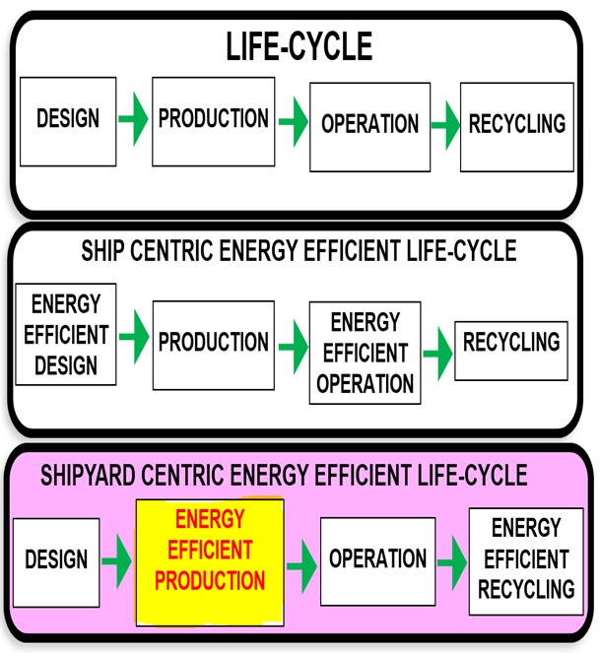
Fig. 1. Stages of Ship Life Cycle and Energy Management Source [11]
It is clear that for fossil-fuel powered ships, their operational cycle constitutes the majority of its life-cycle air emissions; however, as shipping is anticipated to move towards zero-carbon fuels, electricity and sail and solar power, the fraction of shipyard operations in a ship’s life cycle will become larger than their operational phase by the next decades. Nordtveit [12] showed that if a car ferry was propelled by batteries using electricity from the Norwegian electricity grid, its construction bore a greater life-cycle climate impact than its operation. In the future, using a complete “cradle to grave” approach [13] covering the lifespan of the ship from the design stage to scrapping is expected to become more important. Moreover, based on the Paris Agreement, not only the nations but also individuals and industries are responsible for the mitigation of GHG emissions and shipyards are no exception, and it is required that states consider the shipyards emissions within their National Determined Contributions (NDCs).
In the literature, no structured and holistic method for the integration of disciplines for improvement of energy efficiency and reduction of emissions at shipyards has found and most studies in shipyards had a one-dimensional approach. However, in order to achieve zero emissions at shipyards, a holistic, systematic and transdisciplinary approach must be considered [14]. In order to improve energy efficiency and reduce air emissions at shipyards, the authors address some issues in the context of shipping air emissions in this study. What are the gaps in defining a green ship and how can the concept of a green ship be extended over the lifetime of a ship to support sustainable shipping? The answer identified in this work is to distinguish air emissions from other types of environmental pollution to provide new definitions of clean, green and sustainable shipyards. Using this approach, this study focuses on how to manage energy in the long term and how to reduce air emissions from energy sources in shipyards. The present work proposes an innovative, holistic, systematic and transdisciplinary energy management framework (EnMF) to extend the conept of a green ship to the lifetime of the ship.
The novelty of the paper is to classify the yards into two categories: clean and green yards and to change a one-dimensional thinking to a holistic, systematic and transdisciplinary one in order to break the silos between different disciplines and improve energy efficiency within the cluster. In addition, the study designed and developed a holistic, systematic and transdisciplinary energy management framework to support shipyard managers in an uncertain environment to make rational and optimal decisions to improve energy efficiency and reduce air emissions by considering the relationship between energy efficiency and air emission reduction measures in five disciplines, namely human element, technology and innovation, policy and regulation, operations and economics. Finally, the validity of the proposed energy management framework was examined through its implementation in the studied shipyards.
The adoption of the proposed framework in this paper will promote the Green shipping concept within the ships’ lifecycle and support sustainable shipping for a sustainable planet. Moreover, as the EnMF considers all aspects of energy and mitigation of air emissions, the framework can boost both business and socio-economic perspectives for shipyards and plays a win-to-win deal and become interested in the shipyards’ owners. Meanwhile, as IMO strives to reduce the shipping carbon intensity and air pollutants and in alignment with that EU Green Deal emphasizes decarbonisation, the topic has local, regional, and international interest for policy makers both in the maritime cluster and shipbuilding industry. Within this context, the rest of the paper is organized as follows: Section 2 provides an overview of the actions taken by the IMO as the regulatory body for international shipping in the ship operation cycle and ports to develop energy efficiency and to identify research gaps by studying articles related to energy efficiency improvement and air emissions reduction in shipyards. Section 3 summarizes the systematic literature review conducted regarding the main contribution on presenting the definition of “environmentally sustainable shipyard” and designing the Energy Management System (EnMS) as well as the proposed methodology and methods to develop the EnMF. Section 4 provides the definition of environmentally sustainable shipyards and their two concepts, i.e. “Green” and “Clean”. Moreover, to promote Green shipyard, EnMF and EnMS are introduced that have the potential to contribute to the states’ NDCs under the Paris Agreement, as well as EU Green Deal in helping zero carbon footprint products and decarbonisation in the transport sector. Case studies and discussions are provided in section 5 and conclusions are carried in 6.
  - Research objectives
The objectives of the present research work may be summarized as follow:
- How to define and design an environmentally sustainable (clean and green) shipyard?
- What are the the main disciplines of the holistic, systematic, and transdisciplinary EnMF?
- How to design an EnMS by choosing the appropriate measures and tools for a shipyard?
- How to implement EnMF?

Literature review
Negative externalities to the environment consist of (GHG) emission [15] that causes global warming and air pollutant [16], which has a direct effect on human health [17][18], as well as caused a strong negative impact on the economic life of both individuals and society. While shipping operation contributes to 2.89% of global emission [5], ports’ contribute to 2% of related shipping’s GHG emissions. However, by considering the “business as usual” flow, it might rise four times by 2050 [19]. Moreover, Shipping contributes 5-10% and 17-31% for sulphur oxides (SOx) and nitrogen oxides (NOx) emissions, respectively [20]. Based on the study of Sharma [21], 230 million people in 100 ports are affected by Shipping’s emissions (e.g. due to port and shipment of cargo activities, 3700 premature deaths occur annually in California) and annual external cost of EUR 12 billion from non-GHG-emission (NOx, SOx, and Particulate matter (PM)) is estimated for 50 largest ports in the Organization for Economic Co-operation and Development States (OECD) [19]. IMO as a regulator of international shipping strives to control and mitigate emissions from shipping. IMO applied multi-disciplinary measures of technical, operational, and economical for reducing GHG emissions. EEDI is a technical measure in reductions of emission while SEEMP is an operational measure. The third dimension is Market Based Measures, which is an economic perspective and considers the carbon market, such as Emission Trading System (ETS) [22]. Moreover, MARPOL Annex VI introduces the measures for controlling and mitigating other types of emissions such as SOx, NOx, and PM. Meanwhile, in April 2018, IMO by adopting the initial IMO strategy on reduction of GHG emissions from ships, demonstrates its priority in tackling GHG emissions from shipping. IMO set a vision to reduce the total annual GHG emissions by at least 50% by 2050 compared to 2008 [23]. Ports decarbonisation as vital players in the logistic supply chain with high negative environmental impacts is important to achieve the IMO’s initial GHG strategy [24]. However, ports’ success depends on different factors such as geographical location, regulatory and political framework, and port governance [25].
Normally, substantial cycles of a typical ship could be included some processes such as design, construction, operation, and scrapping [26]. Based on such substantial cycles, the shipyards could be categorized into three types like Newbuilding, Conversion and Repair, and Dismantling [27]. Shipyard operations consist of various manufacturing processes such as cutting, bending, blasting, and welding [28]. Moreover, considered as one of the important global industries, shipbuilding is a significant energy-consuming and polluting industry and releases a substantial CO₂ (4% of ships’ life cycle emission), as well as air pollutants such as CO (29% of ships’ life cycle emission [6]), SOx and NOx footprint on the environment [7]. The total amount of ships’ life cycle CO₂ emission in building, maintenance, and dismantling stages is higher than the ports’ contribution with around 2% [19] of operational CO₂ emissions.
There is a big gap between East Asian shipbuilding companies and European ones in manufacturing ships [29][30]. Based on Clarkson’s report, while 20 top shipbuilders companies could deliver a vessel per day (365) with a total 14,598 K Compensated Gross Tonnage (KCGT) in 2019, the European shipbuilder companies contribution was only 10 (1,400 KCGT) vessels, and the Asian ones delivered 355 (13,198 KCGT) vessels in the same year. Meanwhile, after China, South Korea, and Japan with a contribution of 57.7 m. CGT (2,309 vessels) order book in 2020, five European countries of Italy, Germany, France, Finland, and Russia are placed in fourth to eight ranks with only 10.7 m. CGT (96 vessels). To fill the gap and maintain competitiveness is crucial that European shipbuilding companies consider innovation and sustainability measures such as energy efficiency, life cycle oriented and green products perspectives in their portfolio. Moreover, there is a great emphasis that the industry considers Life Cycle Assessment regarding their environmental footprint from “cradle to grave” with the integration of “Green” and “Safe” products [31]. Despite some large shipyards are heading toward sustainable development by reducing their footprint on the environment [32], a large number of shipyards especially smaller ones as Small and Medium-sized Enterprises (SMEs) have not taken appropriate actions accordingly [33]. As such a gap exists especially relating to SME shipyards, an institutional report has emphasized industrial products with low or zero-carbon emission processes through the life cycle analysis to promote energy-efficient use, to substantially reduce or avoid GHG emissions and air pollutants. Furthermore, in the EU Green Deal and in the new “Fit for 55” package, as well as in the Conference Of the Parties (COP) (25), the EU has declared their plan that by 2050, they will become the first climate-neutral continent [34]. Indeed, the EU insists that they need to carry out their research systematically and comprehensively to enhance energy efficiency and to reduce air pollution aiming to obtain such an ambitious goal [35][36]. In this regard development of EnMF as a “radical novelties” [37] within shipyards can be an appropriate response to comply with the EU’s Green Deal concept in transport cluster by helping to improve both economic competitiveness and reduce the negative environmental impacts, and enhance sustainability and promote Green shipping concept within the lifecycle time of ships [38].
However, according to the extensive literature review, there is a lack of academic studies and discussions to improve the concept of green ships from a life cycle perspective, sustainability, energy efficiency and air emission reduction in shipyards, and if there are any studies, they are focused on a one-dimensional approach [14].
Liesen et al., [39] provided the technical approach and emphasized energy savings, implementation of energy efficiency measures in Portsmouth Naval Shipyard and Jeong et al., [40] described the power grid and the simulation of applying flywheel energy storage system on the power grid at the shipyard for shore power to ships and offshore facilities to save fuel consumption and reduce air emissions. In addition, the development of smart shipyards using data envelopment analysis has been shown by Woo et al., [41] and the implementation of Industry 4.0 at shipyards using fuzzy AHP-TOPSIS hybrid method has been explained by Cil et al., [42].
Utilization of different types of renewable energy in shipyards has been investigated in various studies. Hadžić et al. [43] identified the feasibility of investments in renewable energy systems for shipyards and the use of a photovoltaic power plant for a shipyard, and the potential of wave power parks for shipyards in Portugal was explored by Miglietta [44] and Neumann et al., [45], respectively. At the same time, the implementation of floating offshore wind platforms in shipyards was addressed by Castro-Santos et al., [46] and Castro-Santos et al., [47].
Energy efficiency decisions and the selection of main engines in a sustainable shipyard supply chain were addressed by Xie et al., [48] and Krishnan et al., [49] examined optimal cargo handling in a shipyard. Meanwhile, the utilization of data for maintenance and repair activities in shipyards was investigated by Mayo et al., [50] and Praharis et al., [51] studied the improvement of energy efficiency with respect to the material supply chain through the development of modeling.
2.1. Research gaps
Given the extensive literature review, the authors have identified the following research gaps:
- There is a wealth of information on improving energy efficiency and reducing air emissions in the shipbuilding industry, but there is a lack of a holistic, systematic and transdisciplinary approach to integrating these factors.
- There is generally a one-dimensional approach to improving energy efficiency and reducing air emissions in shipyards.
- There is a lack of synergies and integration concepts between different stakeholders and disciplines to improve energy efficiency and reduce air emissions in shipyards.
- There is no holistic, systematic and transdisciplinary implementation of an EnMF applicable to shipyards of different types, sizes and geographical locations.

3. Methodology
This paper consists of a two-step research process. First, a systematic literature review regarding designing of a sustainable (clean and green) shipyard as well as identifying the main disciplines of the EnMF, which are human element, technology and innovation, policy and regulation, operation, and economics and in align with that choosing the appropriate measures and tools, i.e. EnMS to design the procedures that shipyards strategically work on energy, i.e. EnMF. The second part contains the proposed methodology that gives the opportunity to the shipyards’ DMs to choose the best measures and tools based on their preferences and priorities to develop the procedures for the long-term energy strategy.

3.1. Systematic literature review
A systematic literature review (SRL) is conducted in the first step of the study. The SRL uses systematic methods to identify, evaluate and integrate the results of studies related to one or more
research questions [52]. In the first step the “research questions” formulated” as follow:
- How to define and design an environmentally sustainable (clean and green) shipyard?
- What are the the main disciplines of the holistic, systematic, and transdisciplinary EnMF?
- How to design an EnMS by choosing the appropriate measures and tools for a shipyard?
- How to implement EnMF?
In the next step the “research protocol” (inclusion (criterion 1) and exclusion (criterion 2)) with respect to reseach questions was developed. Table 1 shows the inclusion (criterion 1) and exclusion (criteron 2). The inclusion contained peer reviwed articles and high quality conference papers, books, industrial and technical reports, which are relevant to research questions and address energy efficiency and exclusion contained duplicate articles, non peer reviewed articles, low quality industrial and technical reports, and articles that not totally covered and improved energy efficiency.

Table 1. Inclusion and exclusion criteria.
Criterion | Criterion one (inclusion) | Criterion two (exclusion)
 | Peer reviwed articles and high quality conference papers, books, industrial and technical reports, which are relevant to research questions and address energy efficiency. | Duplicate articles, non peer reviewed articles, low quality industrial and technical reports, and articles that not totally covered and improved energy efficiency.

Refer to “research questions” the “literature search” was conducted.The main goal of this section was to find all relevant studies related to the topic. The literature was found through searching for keywords in “Scopus”, “Science Direct”, “Google Scholar”, “Research Gate”, and “EBSCO” databases with respect to criterion one (see table 1). The following keywords or combination of keywords were used to identify the literature; “shipyard”, “green shipyards”, “clean shipyard”, “sustainable shipyard”, “ship building”, “ environmental sustainability”, “energy intensive”, “energy efficiency”, “energy barriers”, “ energy conservation”, “energy policy”, “energy management”, “energy system”, “renewable energy”, “sustainable shipping”, “sustainable ports”, “port industry”, “environmental performance”, “reduction of air emission”, “socio-technical”, “interdisciplinary”, “transdisciplinary” and “ Life cycle assessment in shipping”. Total number of 1266 literature was identified. In the next step “studies per protocol” were selected. The selected literature in “literature search” was screened by authors. The criteria which have been developed in “research protocol” were used. Three filteration steps were applied in this section (See table 2).

Table 2. Filtering steps
Filtering steps | Filtering one | Filtering two | Filtering three
 | Exluding of duplicates and other none related studies. | Abstract and conclusion scan, and application of criterion 1. | Full paper reading and application of criterion two
In the first round of filtering 336 literature were exluded. In the second filtering step 469 more literature was excluded. In the next step (filtering 3), 461 full paper read completely and criterion 2 was applied and 213 literature was excluded. Additionally, through forward and backward snowballing 23 more literature was added to the list. Total number of 271 (during the period 1996-2021) literature was selected as the final number of literature. In the next steps the studies were “appraised per protocol”. The authors evaluated the methodological quality of the selected full-text articles to determine whether the selected literature met the criteria for the protocol and topic and “extract data” the required data with refer to “formulated research questions”. In the next step, the extracted data were “analysed” and 117 number of the selected literature (n=271) was excluded and 157 literature with respect to limitation and strenght of litearture was interpreted to answer the “research questions” (see Fig 2).
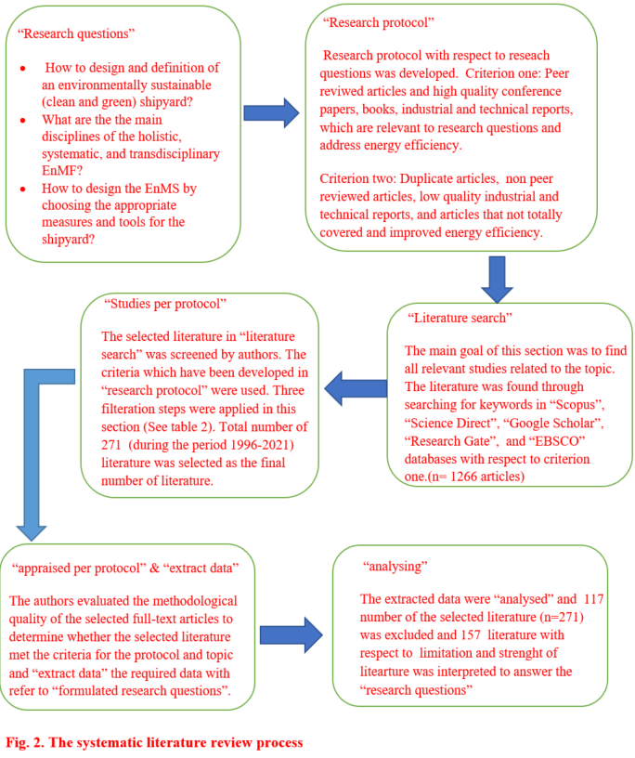

3.2. Transdisciplinary approach and Multiple Criteria Decision Making (MCDM) to develop EnMF
The EnMF could be considered as a multi-sectoral framework acting on the contribution of various agents in fuzzy logic. The framework helps the Decision-Makers (DMs) to have a better and justify decision while confronted with a complicated situation [53]. To structure a process and as well as create a strategically specific plan with all playing makers' participation, as well as to optimize the decision to a complex problem, the transdisciplinary approach in aligning with the optimizing decision methods must be considered and developed [54]. The transdisciplinary approach could be included two parts:
- Identifying the potential problems existing in the complex and large system via the application of the scientific methods, and “use the complementary feature of multiple established methods”;
- Designing, developing, and implementing the communication, co-operation plan by considering all perspectives, ideas, interests, priorities, and preferences of stakeholders involved in the system [55], which can be achieved by creating Communication of Practice (CoP) [56].
As seen from Fig. 3, the process of transdisciplinary planning should comprise two key factors such as forwarding operating and backward planning. As reported, forming the goal, analyzing the system, constructing the scenario, evaluating the multi-criteria, and building the core strategy are the main components of the forward operating. Besides, forming the strategic goal, assessing the scenario and the spectrum of scenarios, evaluating system models and sectors are considered as the task of backward planning [54]. In a vague atmosphere, lack of information, and inconsistency, DMs generally fail to make appropriate decisions and define their preferences [57]. The Multiple Criteria Decision Making (MCDM) can help DMs to understand problems and choosing the options in a fuzzy atmosphere among different alternatives by considering and evaluating different attributes [58] and the Fuzzy Analytic Hierarchy Process (FAHP) is one of the techniques to tackle the fuzziness of the information that might affect in deciding the preferences of DMs in the various variables [59]. The reason for choosing the fuzzy approach is back to limitation of AHP method, which can not accurately reflect the human mindset [60] and can not vividly express the DMs opinions in choosing among different alternatives [61]. The lack of support in expressing DMs opinion leads to unbalanced judgements and enhances uncertaintities in creation of precise pairwise comparison process [62]. However, implementation of the fuzzy approach provides more confidence to DMs to have interval assessments instead of fixed value assessments [63].
Moreover, the technique for Order of Preference by Similarity to Ideal Solution (TOPSIS) is another method that is used within the MCDM in different criteria [64][65]. The DMs by identifying the problems and applying their priorities for each attribute can evaluate the alternatives, develop the preferences and finally choose the best options among the others. Based on the study of Strantzali et al. [66], there were around 41% of studies on decision-making topic with regard to the investments in renewable energy sectors during the period of 2005-2014 used individually or in the combination of AHP, multiple criteria, TOPSIS, and fuzzy methods. In designing and developing the EnMF, the FAHP and FTOPSIS methods within MCDM methodologies and techniques are proposed to justify the transdisciplinary and tailor off capacities of the framework, identify the priorities of DMs to trade-off solutions, make the Key Performance Indicator (KPI) for shipyards, as well as optimize the decision. However, depending on type of data and the number of DMs , exceptional MCDM techniquies may be used [67].
As Fig. 4 shows the MCDM consisting of five different combinations could be divided into Multi-Attributes Decision Making (MADM) and Multi-Objective Decision Making (MODM) [64]. Depending on the type of data (explicit or linguistic) and the number of DMs, any combination of MCDM techniques can be used. The number of respondents may also vary depending on many factors, such as ownership and the organizational form of the yard [14]. To overcome the challenge of various priorities of multi actors within the energy regime, the Fuzzy Multiple Attribute Group Decision Making (FMAGDM) might be used to promote Decision Support System (DSS), to support the DMs in making decisions more rational, and to optimize the fuzzy multi-criteria areas. In this study, the FMAGDM-based algorithm consists of priorities of experts within the criteria by considering the various importance degree, attribute weight, and fuzzy assessments [68]. Three different methods of a questionnaire, interview, and observation or combination of them might be used, to identify the priorities of the multi actors in the shipyard. By analyzing data and information that is achieved from the methods and interviewees, the attribute weight of disciplines along with sub-criteria in each main criteria could be obtained. Furthermore, the most feasible alternatives in each primary criteria could be ranked by FMAGDM method. In continuation, based on the experts and DMs’ priorities and using the FMAGDM method, alternatives could be ranked and the best trade-off solutions would be achieved. Therefore, such criteria could become the KPI in designing and developing process of the energy management framework and system of each shipyard. More interestingly, the Plan-Do-Check-Act (PDCA) cycle has assisted these approaches, making more dynamic EnMS and EnMF so that they could be smoothly operated with the continuously-updated technologies and DMs priorities.
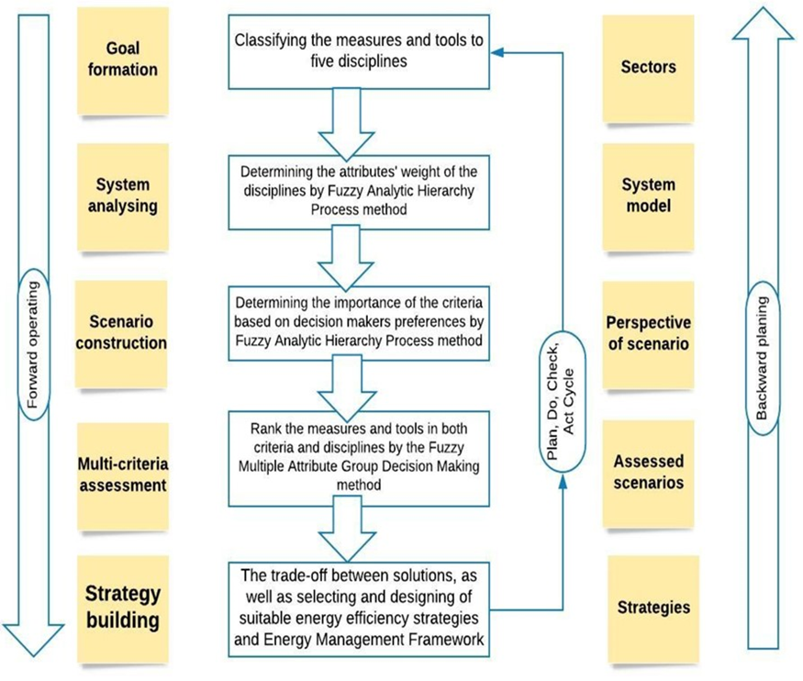
Fig. 3. Transdisciplinary approach to design and develop Energy Management Framework and Energy Management System in shipyards.

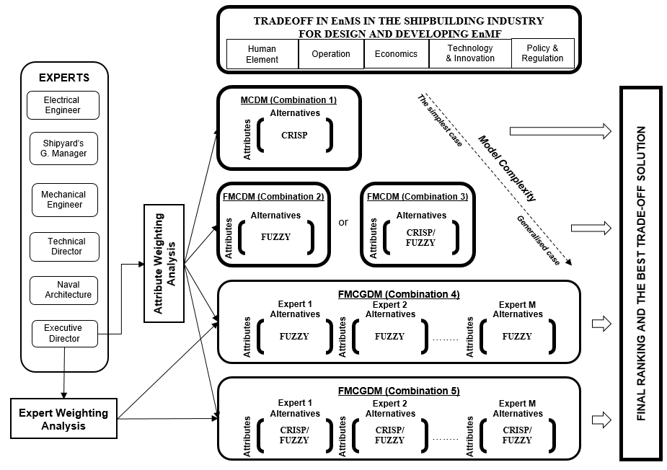
Fig. 4. Different combinations of MCDM for evaluating trade-off solution in shipyards. Adapted from [64]

4. Results
After a systematic literature review and identifying the lack of study and research about environmental sustainable shipyards and the presence of long term energy strategy at shipyards, the following findings are presented in this section:
- The importance of a sustainable shipyard in mitigation of shipping air emissions footprint as well as promoting Green and sustainable shipping in the life cycle perspective is presented.
- Two concepts of a sustainable shipyard, which are “Green” and “Clean” are discussed in detail.
- The important role of the EnMF to promote a “Green” shipyard is discussed and the concept and methods to develop the EnMF for the shipyards are presented and based on the systematic literature review the required measures and tools to form the EnMS is provided.
- As the EnMF is an innovative instrument in the socio-technical system and acts as a niche in the micro-level, it is essential to be supported by the society till the EnMF is adopted by the related social group, which is the shipbuilding industry. The adoption procedure, stages, as well as related threats and opportunities for each stage are elaborated.

4.1. Environmentally sustainable shipyard

4.1.1 Why environmentally sustainable shipyard?
Shipbuilding produces a large amount of waste and pollutants that each has negative impacts on human health and the environment [7][27]. Shipyards must play the role and take appropriate action in the mitigation of their negative impacts. To minimize such negative impacts is crucial that shipyards promote their sustainability and follow the “sustainable concept” within their portfolio. As the shipyards introduce a considerable amount of pollutants to the land, soil, water, and air [28], following the “sustainable concept” could minimize the environmental and societal impacts of shipyards’ operations. The attribute ‘Green’ is often being used instead of sustainability; however, there is no uniform definition and interpretation for the “Green” concept and its relation with sustainability [69]. The rationale used to provide a rational taxonomy for environmentally friendly shipyards is as follows: In this study, the authors divided the pollutants from shipyards into two categories of waste and air emissions. At the moment there exist national and international regulations on waste disposal, water treatment, and air pollution limits from engines and boilers. However, there currently exist no binding regulations for the maximum amount of GHG and air pollutants emissions permitted from individual shipyards [10]. The shipyards that become successful in eliminating waste from their operations are called “Clear” and the ones as the current state of the art. The shipyards which eliminate air emissions from their operations, as may be anticipated for future shipyards are called “Green” shipyards. The main scope and border of the study and proposing EnMF is related to the “Green” concept.
As shown in Fig. 5, due to the crucial role of energy consumption in energy productivity [33][70] and environmental and socio-economic aspects [71], and to mitigate the negative impacts of energy consumption in shipbuilding, as well as the negative impacts of non-energy related emissions such as Volatile Organic Compounds (VOC) and Non Methane Volatile Organic Compounds (NMVOC) the authors propose the “Green” concept for shipyards accordingly. While the Clean concept deals with systematic assessment of the environmental aspects and impacts of production and supports the process to mitigate pollutants and reduce their negative impacts on water, soil and land, the Green concept deals in mitigation of air emissions. Combination of both concepts leads to a boost of environmental sustainability and the competitive advantage of shipyards. By separating the air emissions from other types of pollutants and extracting energy criteria from the environmental management and consider energy as an independent pillar, the policymakers and shipyards’ managers will pay more attention to the energy consumption and its relevant emissions during ship manufacturing [14]. Implementing this policy will lead to adopting sufficient international, regional, and national regulations for mitigation of shipping air emission footprint [38], as well as promote Green and sustainable shipping in the life cycle perspective.

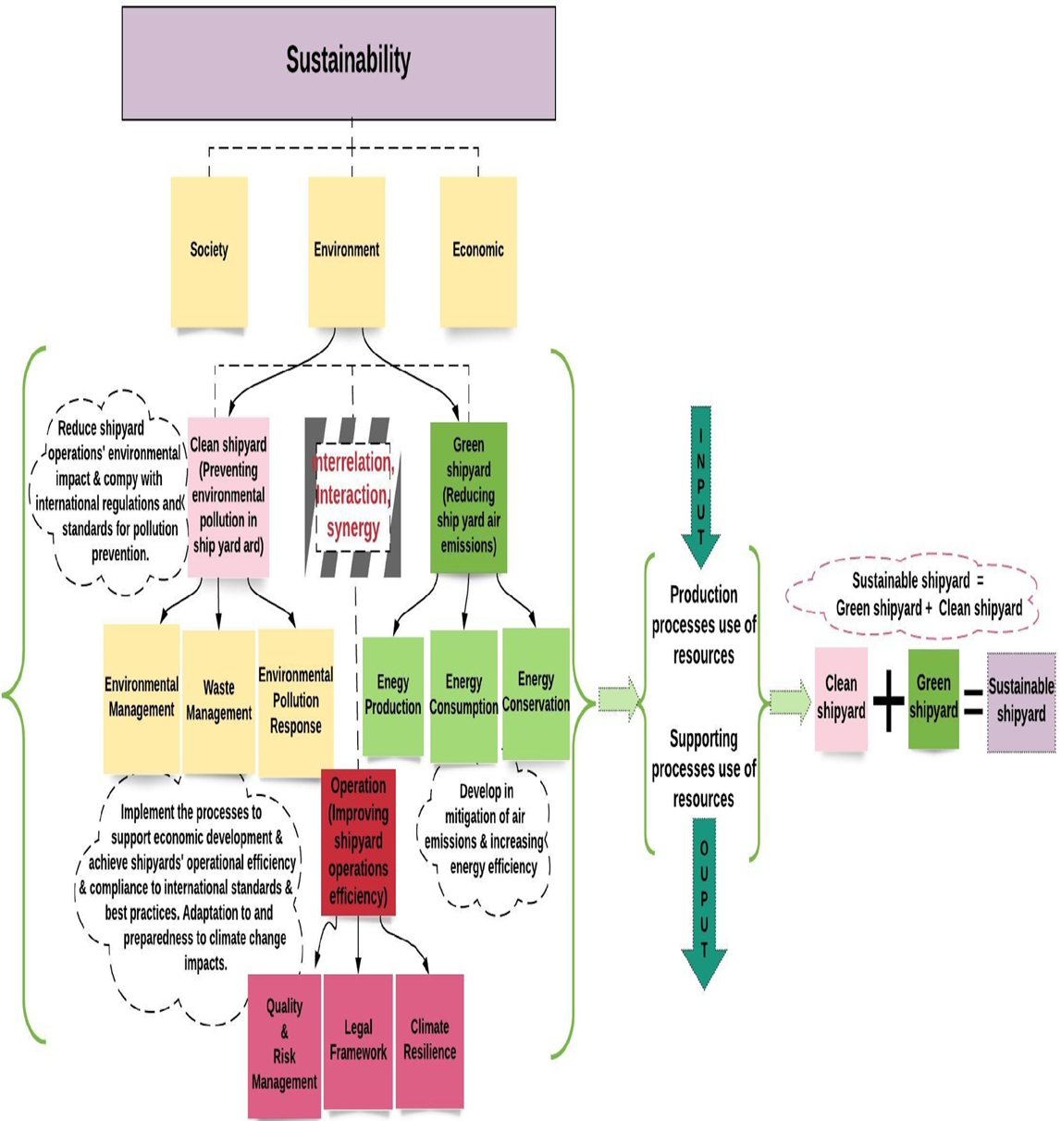
Fig. 5. Sustainable Shipyard (Clean and Green Shipyard) aspects

4.1.1.1 Clean shipyard
The clean shipyard by applying a systematic approach and complying with international, regional, and local regulations such as the water service Act, waste Act, and waste Decree, Land use and building Act [10] strives to evaluate the environmental aspects, and prevent, reduce and minimize its operations’ ecological impacts on the soil, land, and water. It includes but is not limited to the management of environment and waste, and the in-time response to the environmental pollution aiming to control, monitor, and mitigate the negative and adverse influences on shipyard activities. The primary elements of a clean shipyard in ship manufacturing are 3R, as depicted in Fig. 6a:
To implement well the 3R strategy in Fig. 6a, any input resources in activities of shipyard should be divided into two processes as the production one (including resources/energy used directly in manufacturing ships) and the support one (including resources/energy used indirectly in manufacturing ships) [72]. As given in Table 3, the criteria associated with minimizing, recyclable, and reusable ability should be put on top for the input resources of any production and support processes aiming to vanish waste in a clean shipyard. However, in the case of releasing waste, those waste types should satisfy the requirements of environmentally friendly nature, recyclability, and reusability. Based on this approach, a clean Shipyard could be defined as follows: “A shipyard is considered absolute Clean when any production and supporting processes in manufacturing a ship have zero environmental impacts”. However, to achieve a clean shipyard, the yard's DMs must design, develop and implement management frameworks, such as environmental management [73], waste management [74], water management [75], air noise management and underwater noise management [76], sweat management [77], garbage management [78], waste to energy management [79], industrial symbiosis and circular economy framework [80], and environmental pollution response mangement [81].
4.1.1.2. Green Shipyard
The fact shows that the consumed energy in each shipyard could be divided into three branches serving production process, support process, and intermediate process (such as transportation in the shipyard) [26]. As illustrated in Fig. 5 with the energy-intensive nature of shipyards [6][7], the consumed energy degree is believed to play a critical role and take an important place in evaluating the criteria of a Green shipyard; therefore, the criteria associated with the consumed energy degree and ability to exclude pollutant types seem to be a pillar in the Green shipyard concept. According to this opinion, highlight the energy role and the importance of mitigating/eliminating pollutant emissions could raise the awareness of society, shipyard managers, and policymakers [14]. Undeniably, Green Shipyards should strive to minimize energy consumption along with related pollutant emissions, as well as non-energy resource emissions such as VOC from coating and paints [82], and dust from surface treatment, cutting, and welding [83]. Due to this reason, Green Shipyards should consist of three core principles with regard to the energy chain such as production, consumption, and conservation. Indeed, the key elements and goal of a Green shipyard could be illustrated in Fig. 6b:
Fig. 6. (a) - 3R and (b) - 3E criteria for clean and green shipyard
Obviously, the 3E approach (so-called Trias Energetica [84]) shown in Fig. 6b not only reduces air emissions but also helps to design and implement an transdisciplinary EnMF for promoting socioeconomic criteria towards sustainable development [85]. To achieve such Green shipyard strategies, energy sources must be used the most efficiently and sustainably to minimize pollutant emissions as well as improve the air quality through the nearly zero-emission/zero-emission pathway. Based on the 3E criterion, the definition of Green Shipyard could be indicated that “A shipyard is considered absolute Green when any production and supporting processes in manufacturing a ship have zero air emissions”. To achieve a green shipyard, the yard's DMS must design, develop and implement a holistic energy management framework that includes measures and tools such as energy production [86], energy performance and audit [87], energy conservation [88], energy monitoring system [89], air pollution monitoring system [90], alternative clean fuel [91], smart micro grid [92]. In general, the critical nature and elements, and the definition of a Clean and Green shipyard could be summarized in Table 3.

Table 3. The critical nature and elements of shipyard based on clean, green, and environmentally sustainable criteria
Shipyard’s Concept | Inputs | Critical Elements | Type of Processes | Expected Results | Definition
Clean Shipyard | Material | -Recyclability of materials  -Minimizing the use of materials  -Reusability of materials | -Production process  -Support process | -Recyclability and reusability of waste sources  -Environmental friendly waste | A shipyard is considered Clean when any production and supporting processes in manufacturing a ship have zero environmental impacts.
Green Shipyard | Energy | -Promoting the use of renewables and transition toward clean and green energies  -Minimizing the use of fossil-based energy/fuels  -Efficiency in the energy use |  | -Mitigating the pollutant emissions | A shipyard is considered Green when any production and supporting processes in manufacturing a ship have zero air emissions.
Environmentally Sustainable Shipyard | Material and Energy | -Recyclability of materials  -Minimizing the use of materials  -Reusability of materials  - Promoting the use of renewables and transition toward clean and green energies  -Minimizing the use of fossil-based energy/fuels  -Efficiency in the use of energy |  | -Recyclability and reusability of waste sources  -Environmental friendly waste  -Mitigating the pollutant emissions | A shipyard is considered sustainable when any production and support processes in the ship manufacturing satisfy both criteria of Clean Shipyard and Green Shipyard

Based on the above-mentioned analysis, it could be concluded that improving shipyard’s operational efficiency such as lean manufacturing could have a significant contribution to the promotion of Clean and Green shipyards [7][93]. Besides, every single operation in Clean and Green shipyards should be efficiently performed to enhance competitiveness and to develop the economy [94]. Moreover, complying with local, national, regional, and international standards and adopting best practices are also the tasks of Clean and Green shipyards to becomes prepared for unpredicted consequences from climate change as well as the related negative impacts [95]. However, in the preparation process of a scenario to respond to such consequences and related impacts, it should evaluate climate resilience, take into account the legal framework, and analyze the quality and risk of the system to propose the appropriate management policy and solution. Therefore, it could define a Sustainable Shipyard as: “A shipyard is considered sustainable when any production and supporting processes in manufacturing a ship have both zero environmental impacts (Clean shipyard) and air emissions (Green shipyard)”.
It is evident that there is interrelation, intertwined, interaction, and synergy between clean and green shipyards, as demonstrated in Fig. 5. It means that a shipyard cannot be a sustainable one if only consider air pollution mitigation measures and improve energy efficiency aspects of the activities or in contrast if only strives to minimize other types of pollutants. It means that when a shipyard follows the Green and Clean concepts, it becomes a Sustainable shipyard. Furthermore, there might be some measures in Clean shipyards affecting and promoting Green aspects of the shipyard and vice-versa. For example, recycling assists in reducing both emissions and solid waste. If a shipyard considers these measures cannot claim that it is both Clean and Green, because it is compiled and fulfills only one measure of Green and Clean shipyard.

4.2. Energy Management Framework and Energy Management System in a Green Shipyard

4.2.1. Why EnMF in the Green shipyards?
To promote sustainability, economic and ecological values must be combined to achieve a win-win result [96]. This needs improving in resource and energy efficiency and developing innovative solutions such as management frameworks and clean and renewable technologies [43] [97]. To tackle climate change which is the priority of this century, as well as to promote human health, considering a holistic approach in sustainable energy production and energy policy [98] are crucial and by referring to ramifications of climate change can justify having such policy in the maritime energy sector [99]. An example of such energy policy at the regional level is the recently agreed EU Green Deal, in which the EU Green Deal is based on four pillars, i.e., carbon pricing (marine traffic will be considered in ETS), sustainable investment, industrial policy, and transition [34][100]. The main concerns of the EU Green Deal are promoting energy efficiency, which acts a pivotal role to increase energy productivity and in reducing air emissions from industries [101][102] and circular economy performance within each industrial sector [38][103][104]. The EU strives to address pollution from heavy industries (e.g. shipbuilding) by adopting related policies inconsistent with climate change, energy, and circular economy policies [31] [105] and by focusing on energy and circular economy measures [106]. Furthermore, at the industrial level, the primary concern of industrial managers is economic prosperity, competitiveness, profit, safety, and stability of their business [35][107]. Due to increasing awareness about environmental aspects and Corporate Social Responsibility, businesses pay increasing attention to the environmental elements and strive to reduce their negative impacts by managing energy consumption [108]. To achieve the efficient-energy use, every shipyard needs to have a long-term energy strategy and fulfill an energy management program [109]. It is clear that only a holistic and integrated approach could mitigate pollutant emissions in shipyards. Alternatively, to fulfill decarbonisation from the shipping industry, it should take into account the role of lifecycle measures in the mitigation of emissions [14].
Relating to the EnMF of shipyards, it could be utilized to determine the procedures aiming to have a long-term strategy associated with energy production, consumption, and conservation. The EnMS is considered as one of the measures and tools, which could be employed for implementing the procedures to achieve the strategic goals [33]. The framework provides the shipyards’ managers with an opportunity to make a simple and rational decision in a complicated situation. However, in order to support the EnMF in the shipyards, the related EnMS must be appropriately adopted in the shipyards’ organizations. The framework by considering holistic, and the transdisciplinary approach could be applied to break the silos and provide depth (knowledge extent), breadth (knowledge criteria), and synthesis (integrating different knowledge/perspective into uniform knowledge/experience) to optimize the decision of DMs [54]. Employing the framework leads to mitigate industrial air pollutions and GHG emissions from shipyards. This type of approach promotes the “Green Shipyard” concept and supports sustainable shipping [14]. In addition, The framework with taking into account the life cycle analysis of the procedures in shipyards would support the zero-emission shipbuilding industry, green products, and mitigation of emissions. To reach the EU’s ambitious goal (climate-neutral continent by 2050) [110], developing, implementing, and complying with EnMF within shipyards can be part of industrial policy in alignment with the EU Green Deal into decarbonisation of transportation. Moreover, applying the EnMS leads to the improvement of energy efficiency and air quality and reduction of air emissions within the shipyards that make it cost-effective measures concerning ETS [100]. Meanwhile, shifting to green technologies and using renewable sources of energy to provide the necessary power of the shipyards is a sustainable investment that fosters job creation, innovations promote and support the EU’s innovative companies, as well as assist in the transition process and export of the EU Green Deal [34].
EnMF can be designed and developed for different sizes of shipyards and other industrial sectors. Shipyard size, location and type of operations play an important role in selecting priorities for improving energy efficiency in shipyards [67]. As flexibility is one of the key features of the framework and as there is no “one-size-fits-all” approach to improve energy efficiency [111], the framework could be adapted based on the shipyards’ portfolio and DMs’ priorities, as well as trading-off between issues to adjust the framework to any sizes and types of shipyards. The final EnMF and EnMS for each shipyard could be designed and developed by comparing the present case and alternatives concerning the defined criteria. MCDM methods could be used [39][66] to identify the best alternatives to support DSS and assist the DMs in making more rational and optimized decisions in multi-criteria and fuzzy areas. Moreover, the design, development, and implementation of such a holistic framework could raise policymakers’ awareness to adopt policies by considering energy management to enhance energy efficiency potential [112] and create a movement to meet the zero-emission goal in the life cycle of ships. Furthermore, as shipbuilding is an energy-intensive industry [7], developing and implementing such a framework not only promote the position of shipyards in economic competitiveness in the market and improve their financial benefits in both business economic (reduction of energy cost and improve the industrial capacity in ETS) and socio-economic (external cost) perspectives but also create both capacity building and development for any enterprises that comply with the framework to present and train the personnel of other interested shipyards and even other industries.

4.2.2. Concept of EnMF
As Fig. 7 shows, the EnMF is placed on the top, and through the five pillars (disciplines), it will result in the development of the Green shipyard in life cycle time. A systematic approach has been used to design the framework. It means that to solve the problem, we look to energy through the other stakeholders’ perspectives [33][113] and substitute the single dimension of thinking with a multi-dimensional one. As the energy is categorized in the socio-technical system [35][114], it is essential to consider the solution, which is technology within the related environment and social context.
The EnMF is an transdisciplinary framework and contributes bridging socio-technical aspects and a variety of perspectives, methods, and models can be used to synthesize the improvement of energy efficiency in shipyards. Accordingly, based on the systematic literature review, it could be understood that the five disciplines of the human element, technology and innovation, policy and regulation, operation, and economics are the most important disciplines among the others to improve energy efficiency in shipyards [14], and accordingly the framework is based on the five mentioned pillars, which are complementary and each contains various measures and tools to support and promote the EnMF.
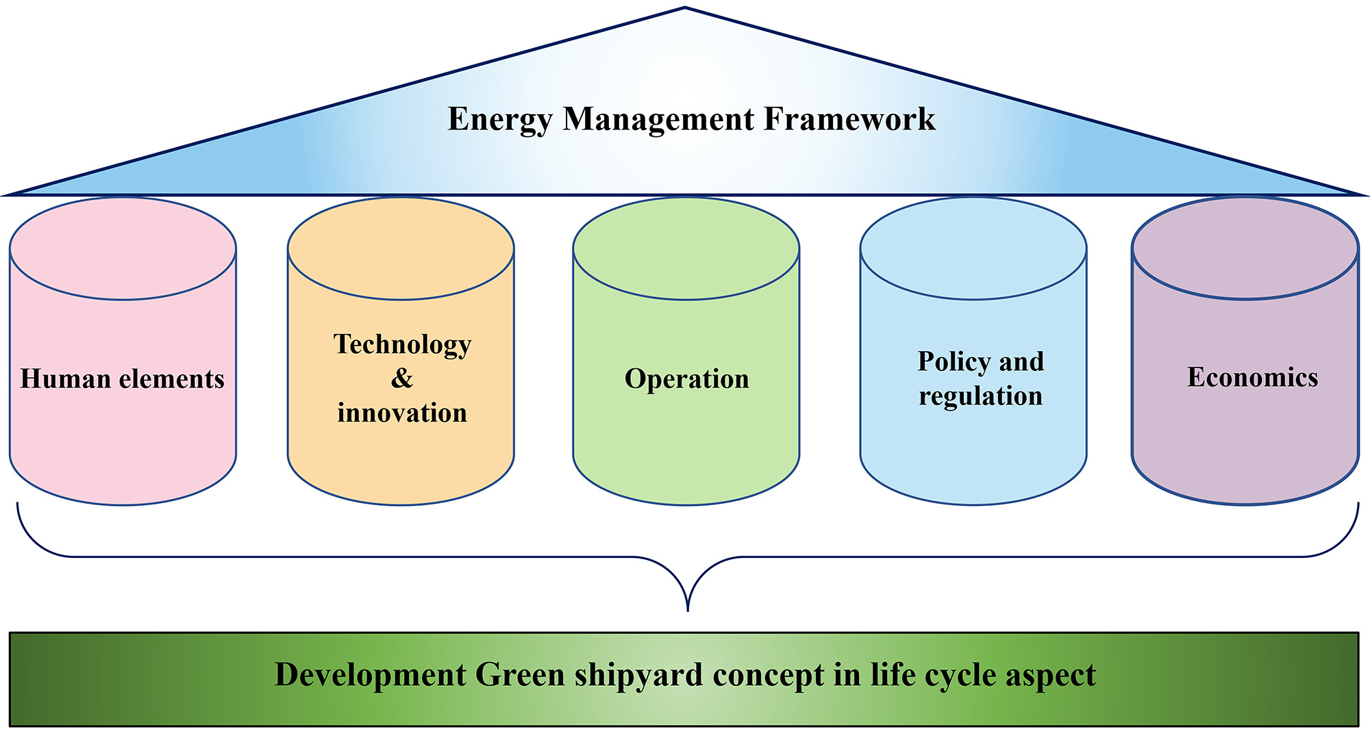
Fig. 7. The Energy Management Framework concept
The human element (such as Training) [115], Governance and Corporate Social Responsibility [116], Education [117], Capacity building [118], Awareness Raising [119], Research and Development (R&D) [120]) was chosen as one of the disciplines in the EnMF because within the complex socio-technical system and shipyard sectors plays a crucial role and is continually being transformed and redefined by technological advancement [121]. Moreover, technology and innovation (including Digitalization (4th Industrial revolution)) [42][122][123], Micro Grid [41][124], Renewable Energy [43][44][45][47], Electrification (Battery, Fuel cell etc.) [125], Alternative clean fossil fuel (Natural gas etc.) [126], Carbon Capture and Storage (CCS) [127]) was chosen as another discipline in the EnMF because it is essential for sustainable energy transitions to necessarily comprise socio-technical aspects [128] as well as effects on changing market requirements and evolving maritime curriculum [129]. In alignment with that operation of the shipyards (such as Resource Management ( Demand response management) [50][130], Project Management [51][131], Lean Approach [132][133], Production Planning and Strategy e.g. Integrated Hull Construction, Outfitting, and Painting (IHOP) [32], Optimizing shipyard design [134]) was chosen as another column in the EnMF, because it can potentially influence productivity, efficiency, and manpower requirements in shipyards [50]. Moreover, policy and regulation discipline (including Environmental regulations (International, Regional, National, and Local) [135], Life Cycle orientation [136], Green Products [137], Innovation, sustainability, and competitiveness [138], Energy Management System (ISO 50001) [139], Environment Management System (ISO 14001) [140], Cyber security [141], Circular Economy [142], Voluntarily agreement [143]) is one of the most important factors to assist the shipping industry in achieving its ambitious goal for a substantial and swift reduction for carbon emissions reduction and the socio-technical transition within the sector [144]. Finally, economic factors and analysis (including Financial Source [145], Cost of energy [146], Levelized cost of energy [46], Lifecycle cost [43], Societal cost [147], Economic competitiveness [26], Cost saving [146], Incentive [148]) due to its important role in decision making and competitiveness within the shipyard and the maritime cluster [149] were chosen as the fifth discipline in the EnMF.

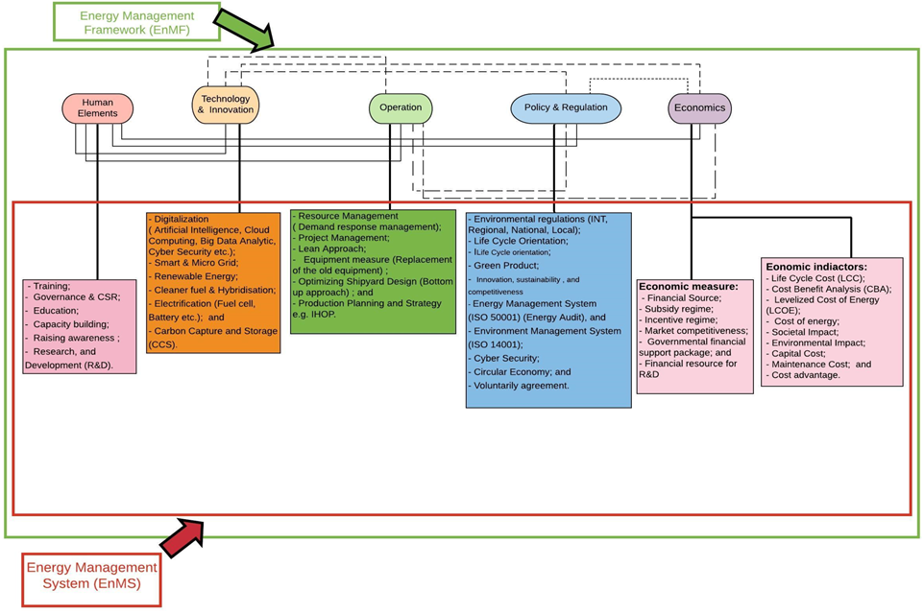
Fig. 8. Energy Management Framework and Energy Management System in shipyards

Fig. 8 shows the EnMF and EnMS and their specific components. Although each discipline has its tools and measures, they are interlinked, intertwined, and have interaction with each other and even some measures might be common in different criteria. For example, at policy and regulation criteria circular economy is placed; however, at the same time, it is crucial that required technology and innovation measures be placed to implement this policy. Another important feature of the framework is its dynamic characteristic. It means that the framework continuously is updated based on the feedback and results of implementation and new benchmarks and requirements are set accordingly. The dynamic vision can be achieved by complying with the Plan-Do-Check-Act (PDCA) cycle [85]. Fig. 9 illustrates PDCA cycle sequences that make the framework become a living document. These features of the framework lead to continuous improvement and adaptation.

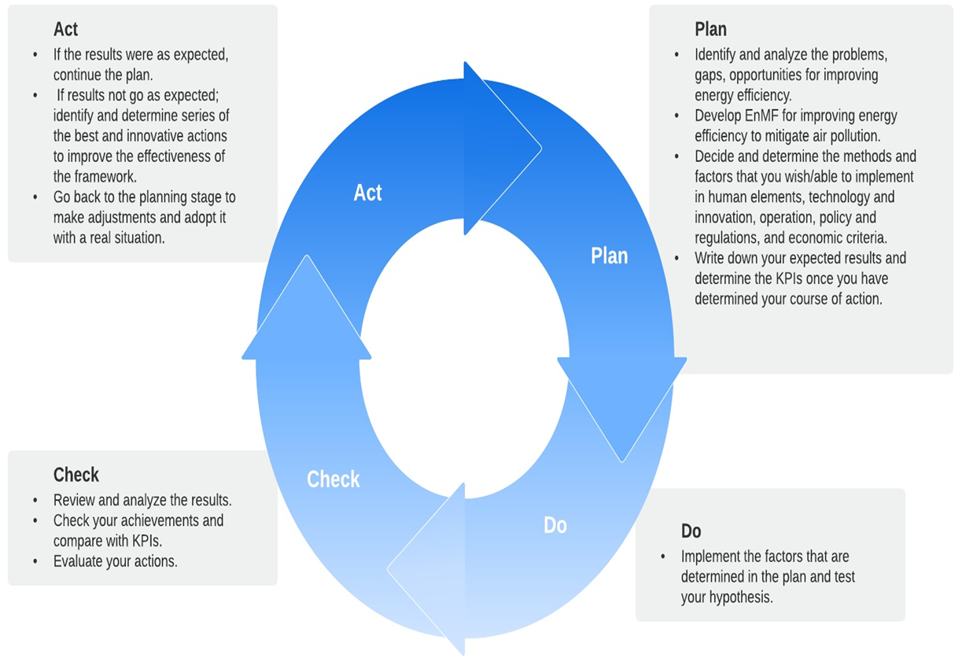
Fig. 9. Plan, Do, Check, and Act (PDCA) cycle

4.2.3. Adoption of the EnMF
Innovation means introducing any new idea, material, policy, measures, etc. to a system to improve productivity and efficiency [150]. The most critical factor for the success of any innovation is its adoption. As shipping is a complex criterion with the engagement of multi actors, any innovation must be accepted by the relative social group. There are different types of approaches to innovation; the linear process is about introducing the innovation to problematic criteria until to solve the problem [151]. However, in the energy system, the process is more complex and does not occur through the linear approach [152]. The innovation must be adopted by the end-users, as well as be supported for both marketing and seek user acceptance [153]. Furthermore, the innovation must be adopted in different phases and multilevel models from micro-level with abrupt changes to macro-level with long-term changes [154].
The EnMF is an innovative instrument in the socio-technical system to support the DSS in shipyard operations, in order to manage energy consumption and provide the DMs with a framework to make a simple, rational, and optimized decision in a complex atmosphere [14]. As the framework is a niche at the microlevel, it is essential to be supported by society till the EnMF be adopted by the related social group, which is the shipbuilding industry.
Fig. 10 shows the adoption process of the framework within three different levels of the micro (niches), meso (regime), and macro (landscape). The EnMF is an innovative measure and is placed at the micro-level of adoption. In order to be adopted at a higher level, it requires more time and effort. In the regime, the stakeholders in shipbuilding define their priorities, aims, and goals within the structural format [33]. As much as the multi-actors priorities in the different systems such as human element, economy, policy, technology, operation, etc. are homogeneous, the adoption takes less time and energy. Meanwhile, the landscapes in different criteria such as climate change, competitiveness, and human health act as the main driver to affect and pressure the direction of investment and introduce innovations in both meso and micro levels [155]. Furthermore, the growth of models (S curves) in the maturity of the innovation is essential to make the progression evolutionary [37][156]. It consists of three different phases of infancy, rapid growth, and maturity, and in each stage, there are opportunities and threats for the EnMF.

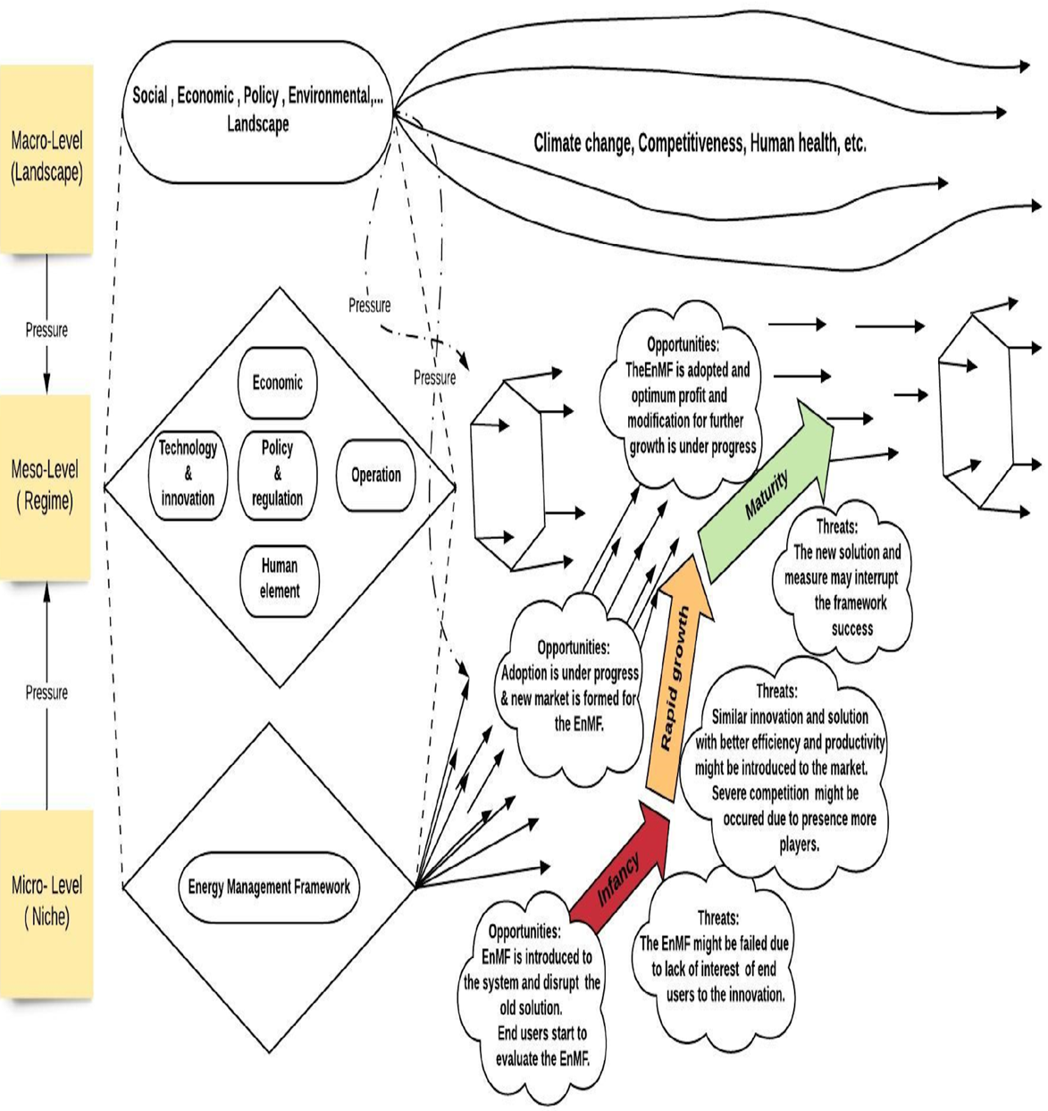
Fig. 10. Multi-level Energy Management Framework adoption

5. Case studies and discussions
To understand how shipyards can develop and improve energy management related to the proposed framework, we conducted an in-depth case study for two different sizes of shipyards. A Bangladeshi shipyard and an Italian shipyard. To identify the size of shipyard the European Union (EU) definition was taken into consideration. The shipyard with less than fewer than 50 employees was considered as a small shipyard and a medium-sized shipyards were considered as ones with less than 250 employees. Shipyards with more than 250 employees were categorized into a big shipyard [157].
A Bangladeshi shipyard
The shipyard is one of the first ship exporters from Bangladesh to produce both steel and aluminum ships. As a large private-sector enterprise, the shipyard is equipped with modern production facilities and has a capacity to produce ten 15,000 DWT ships of various types annually and based on European Union (EU) definition the shipyard is categorized as a small shipyard. The shipyard’s product range covers the marine structure, watercraft as well as steel fabrication of a reasonably complex nature. Multipurpose Container Ships, Dry Cargo Ships, Tankers of 150 m in length with a capacity of 15000 DWT, Passenger Vessels, Ro-Ro Ferries, and Ferries, 100-ton Pull Tugs, Dredgers, Crane Boats, Floating Workshops, Pilot Boats, Supply Ships, Survey Vessels, Inspection Craft, Fast Patrol Craft, Fishing Vessels, and bi-metal ships are some types of ships produced. Refer to the proposed transdisciplinary approach to design and develop EnMF and EnMS in shipyards (see Fig. 3) the energy strategy of the shipyard developed. A questionnaire designed and an interview conducted with 3 DMs of the shipyard. The following results are achieved and following worth reporting:
Goal formation: Based on the shipyard’s operation profile measures and tools are identified and classified into five main disciplines, which are human element, technology and innovation, regulation and policy, operation, and economics.
System analysing: Through FAHP method the attributes’ weight of each discipline was determined [59]. The economic discipline had the highest importance and policy and regulation were placed in the second rank. Technology and innovation and operation with a minor difference in the weights were set in the third and fourth ranks, respectively, and the human element discipline had the least importance.
Scenario construction: The importance of the criteria weights’ i.e. cost, air emission, safety and security, and societal based on the DMs board were assigned through FAHP method [59]. The societal became the highest priority and the safety and security criterion was in second place. Cost and air emission became the third and fourth priorities, respectively.
Multi-criteria assessment: The measures and tools in each discipline through FMAGDM method were ranked [64].
Human element criterion: Training, capacity building, and Corporate Social responsibility (CSR) were placed in the top three ranks, and awareness-raising and R&D were recognized as the fourth and fifth top priorities, respectively.
Technology & Innovation criterion: The top three priorities in this criterion were changing the old equipment, digitalization, and electrification, respectively. Carbon Capture Storage (CCS) was placed in fourth place, and after that, Renewable Energy (RE) was ranked as the fifth priority. Alternative fuel and micro and smart grid were the last preferred alternatives, respectively.
Operation criterion: RMGM, production strategy plan, e.g. IHOP and lean approach were the top three priorities, and optimizing the shipyard design was the last option.
Policy & Regulations: Cybersecurity was placed as the priority in the policy criterion. These results prove the conceptual connection among different disciplines and sections of the framework. As the shipyard’s DMs had a plan to replace the old equipment with modern and digitized equipment, they had a rational concern about vulnerability to cyberattacks, and they raise the cybersecurity policy [141] as a top priority in the regulation part. The second and third top priorities were ISO 14001 and ISO 50001, respectively. It seems that general environmental management (ISO 14001) was a more significant concern than the only energy criterion for the DMs, and they believe that by implementing ISO14001 they can promote energy consumption and reduce its negative impacts in alignment with other types of environmental issues [140]. Life cycle orientation and circular economy were ranked fourth and fifth priority.
Economic criterion: The economic criterion had the top priority among the other criteria. This criterion contains the economic indicators (LCOE, LCC, Societal cost, and CBA), as well as measures such as financial resource, competitiveness, and incentive regime. In choosing the economic indicator, the DMs preferred to have Cost-Benefit Analysis (CBA) rather than the other types of analysis. It means that DMs consider benefits and costs by weighing all aspects and gains or losses that are created by the project [146]. However, CBA was very close to the Levelized Cost of Energy (LCOE) that DMs consider as the second top priority in the criterion, and LCC was ranked third in the table. In the measure options, financial source and incentive regime were ranked first and second, respectively; however, they were the fourth and fifth priorities in the economic criterion. Finally, the societal cost was chosen as the last economic alternative.
Strategy building: In continuation of the analysis, the top three alternatives from each primary discipline had been chosen and by applying the assigned weights of the primary disciplines and by referring to the linguistic answers of the DMs in different sections of the interview through the FMAGDM method [64], the top 15 alternatives were ranked. As Table 4 shows, LCOE, CBA, and LCC were the first top priorities as economic indicators which belong to the economic criterion. This means that the DMs prefer to have LCOE, CBA, and LCC analysis while choosing the measures and tools. In aligning with that policy and regulations alternatives, i.e. ISO 14001, ISO 50001, and cybersecurity were ranked fourth, fifth and sixth, respectively. The ranking of the cybersecurity alternative as the 6th top priority of DMs can be justified by the higher weight of the policy and regulations discipline in comparison with the technology and innovation discipline's weight as well as the position of the changing old equipment alternative (7th top priority), which tend to be replaced by modern and digitized equipment, as digitalization was the 8th top priority of the DMs. As the operation criterion had the higher importance weight in comparison with the human element, production planning strategies, resource management, and lean approach from the operation criterion were ranked 9th 10th, and 11th, respectively. Meanwhile, capacity building, training, and CSR were the last priorities of DMs, respectively.

Table 4. Top 15 best alternatives
Disciplines | Alternatives | Ci* | Ranking
Human element | A1=Training | 0.1416114 | 14
 | A2=Capacity Building | 0.1564658 | 13
 | A3=CSR | 0.1078328 | 15
Technology & Innovation | B6= Electrification | 0.2177468 | 12
 | B7= Changing the old EQP | 0.3848825 | 7
 | B1=Digitalization | 0.3499421 | 8
Operation | C1=Resource MGM | 0.2656415 | 10
 | C2= Lean App | 0.2612489 | 11
 | C4= Production planning strategy eg. IHOP | 0.2714914 | 9
Regulations & Policy | D5= ISO50001 | 0.6780492 | 5
 | D6= Cyber security | 0.6756687 | 6
 | D7= ISO14001 | 0.7460836 | 4
Economic | E2= LCOE | 0.9021863 | 1
 | E3=LCC | 0.8588121 | 3
 | E5= CBA | 0.8839763 | 2

Compliance with international, regional, national, and local legislative requirements, as well as maintaining and improving economic growth and prosperity to support sustainable development and improve efficiency and productivity are main challenges in shipyard activities [14]. There is a lack of study and research that addresses the energy management framework and system in the shipyard industry. In the shipyard community, there is not any uniform and holistic approach for energy planning to provide required models, methods, measures, and instruments to DMs and stakeholders [67]. Development and conducting such studies and design and development of long term strategy in energy and lifecycle emissions within shipyards is essential in the development of Green ship aspects and sustainable shipping. To improve sustainable shipping is crucial to consider environmental issues in all parts of the shipping value chain. To reduce the shipping contribution to climate change, a systematic, holistic, and life span approach must be met by the participation of all stakeholders [14].
Shipyards, as one of the mother industries, are energy-intensive and material consumers [6] and introduce a large number of environmental pollutants that contaminate land, water, soil, and air [10]. It is essential that shipyards promote both Clean and Green concepts within their portfolio. While the Clean concept deals to mitigate pollutants and reduce their negative impacts on water, soil, and land, the Green concept deals with the mitigation of air emissions. The combination of both concepts leads to a boost of sustainability and the competitive advantage of shipyards. The challenge to maintain a good quality of products and reduce the relation cost within shipyards can be obtained by improving energy efficiency [35]. This can be achieved by investment in energy-efficient technologies and developing energy management systems to optimize energy-efficient practices [33]. Implementing such investment has been claimed to lead to benefit from and increase in productivity, prosperity, as well as environmental benefits.
The proposed EnMF is a systematic, transdisciplinary approach that can improve the energy efficiency of shipyards’ activities based on their portfolio and DMs priorities. It combines the five disciplines human element, technology and innovation, policy and regulation, operation, and economics in order to ensure a holistic solution is applied to the problem. This prevents one discipline to be strongly prioritised over the others, in order to highlight that optimising the view of one of these disciplines may come at a cost for the others. By including “Human Element” this framework contributes to ensuring that the implemented solutions can be practically implemented and that they will benefit the workforce as well as energy efficiency simultaneously [116]. As the EnMF considers all aspects of energy and mitigation of air emissions, the framework can boost both business and socio-economic perspectives for shipyards and plays a win-to-win deal, as well as fill the gap between Asian and European shipyards and can promote their competitiveness [29][30]. Furthermore, developing, implementing, and monitoring such innovative measures can help in promoting NDCs of states under the Paris Agreement for shipyards [14], as well as in accomplishing the EU’s Green Deal and relevant directives for green products and considering the environmental impacts from a design period, production process, and operation to dismantling/recycling process in the maritime cluster and support the EU ambitious goal for having a climate-neutral by 2050 [34]. It is crucial that shipyards consider the dynamic aspects of the framework and monitor the progress of implementation and act to promote and update the benchmark measures based on the portfolio, condition, and new technologies [67].
An Italian shipyard
The second case study concerns an Italian shipbuilding company. The yard builds merchant ships, passenger ships, offshore vessels and naval vessels and is also active in ship conversion and repair. According to the EU definition [157], the yard is categorised as a large shipyard. In the same way as in the previous case study and with reference to the proposed transdisciplinary approach, EnMF and EnMS were developed for the yard (see Fig 3). One of the main outcomes of the EnMF was DM's willingness to use renewable energy in its energy supply chain [43]. The feasibility study was carried out with regard to wind and solar energy. The results showed that 45% of the yard's annual electricity consumption, which was 1,270 MWh, could be covered by solar energy. However, the share of wind power was only 4%. While the levelised cost of energy (LCOE) for solar energy was $ 0.053 and the payback period was 6.2 years with an internal rate of return of 11%, the LCOE for wind energy was USD 0.411 and had a negative net present value of 25 years, making it not cost-effective to harness it.
The analysis showed that the annual electricity consumption cost was USD 2,085,918 and the carbon dioxide emissions were 8,687 tCO2 eq. However, if the yard uses only solar energy to provide the required electricity, the yard can reduce the electricity cost by $938,663 and reduce emissions by 138 tCO2e per year.

6. Conclusions and future perspective
This work highlights the importance of using a holistic, and transdisciplinary approach in addressing the air emissions of maritime industry. It was shown that an energy-management framework can be useful in designing, developing and implementing energy policies to achieve this objective. While current focus has been on the operational stage of ships in mitigation of its negative environmental impacts especially air emissions, it is essential to change the mindset of policy makers to life cycle aspects and strives to minimize ships’ climate impact over their life cycle. The life cycle approach requires a holistic view with the contribution of all stakeholders to break the silos and establish transdisciplinary measures. The detailed examination of literature review shows that a large volume of information about improving energy efficiency and reduction of air emissions in shipyard industry is available, but that there is lack of holistic, systematic, and transdisciplinary approach to integrate of these elements.
In this current work, the discussion of the way forward for a more thorough understanding of environmentally sustainable (Green and Clean concepts) shipyards and energy management at shipyards was conducted, indicating insights into socio-technical aspects. Indeed, these socio-technical aspects were synthesized into five bridging elements, i.e. human element, technology and innovation, policy and regulation, operation and economics materiality, and relationality as they are present in interrelated and overlapping ways in shipyards in various cases.
The novelties of this study are:
- Classification of shipyards into two categories: clean and green shipyards;
- Changing one-dimensional thinking with holistic, systematic and transdisciplinary thinking to break the silos between different disciplines in shipbuilding industry;
- Providing and classifing energy efficiency and air emission reduction measures into five main areas;
- Design and develop a holistic, systematic and transdisciplinary energy management framework to support shipyards’ DMs in the uncertain atmosphere to make rational and optimal decisions to improve energy efficiency and reduce air emissions;
- Implement and test the validity of the framework in case studies.
The first main contribution of this paper is introducing new concepts of “Green” and “Clean” shipyards through a systematic literature review. A shipyard becomes sustainable if it is in line with both these Green and Clean concepts. As the Clean shipyards have the plan to mitigate all negative environmental pollutions (except air emissions) during ship manufacturing in both production and supporting processes, the Green shipyards extract the energy criteria out from the environmental umbrella and promote it as a pillar in developing a sustainable concept by mitigation the air emissions resulting from production and supporting processes of shipyards’ activities.
The second main contribution of this current work is designing and developing an transdisciplinary EnMF in shipyards. This study provides bridging measures, tools, and elements which could be mobilized across the five defined disciplines and emphasizes on the transdisciplinary approach. However, it is challenging to break out of the silos created by the conceptual apparatus of individual disciplines and needs communities between bodies of knowledge and experts, i.e. CoP. The EnMF as the central pillar of Green shipyards leads to enhancing productivity, profitability, and mitigate GHG and air pollutants and promotes the green reputation of the shipbuilding industry and improves shipyards' competitiveness.
The third important contribution to the study is the implementation of the proposed EnMF model on two yards of different type and size in different geographical locations. The detailed analysis of the case studies shows that the framework can be adopted and implemented in yards of different types and sizes. Furthermore, it shows that the implementation of EnMF can increase productivity and profitability and reduce environmental problems.
The authors would like to highlight the study's limitations and future research agenda as follows: This study focuses on promoting green shipyards by developing an EnMF. Further research can be considered to promote clean shipyards. Secondly, this study on improving energy efficiency in shipyards within a life-cycle perspective of the maritime cluster, and is not a comprehensive solution to these challenges, but is intended to open the way to a new era. Such an approach has the advantage of promoting different disciplines depending on what is required in specific contexts. However, adaptations may be needed for different types of yards due to their different geographical areas, characteristics and portfolios, as well as different stakeholders. The limitation of this study is that more case studies on different types and sizes of yards in different geographical locations are needed to explore more research on the implementation of EnMF in different types and sizes of yards. For future research, the proposed framework can be designed, developed and used by managers in other industries and sectors, such as ports. As the framework is transdisciplinary, other disciplines, measures and tools can be considered based on the vision and priorities of managers and the nature of other industries and sectors.

Acknowledgments:
The author would like to thank the reviewers and the journal’s editor for their valuable comments, which have greatly improved the study. The authors would also like to express their appreciation to the managers of the Bangladeshi and Italian shipyards who gave us their constructive comments.

References
[1] United Nation Conference on Trade and Development (UNCTAD), “Review of Maritime Transport 2018,” 2018.
[2] S. Hassen, O. Anis, Z. Taha, and S. Yosra, “Trade openness and economic growth: The case of Tunisia,” international Journal of Advances in Management and Economics, vol. 2, no. 2, pp. 24–32, 2013.
[3] Z. Tan, Air pollution and greenhouse gases: from basic concepts to engineering applications for air emission control. Springer, 2014.
[4] M. Maloni, J. A. Paul, and D. M. Gligor, “Slow steaming impacts on ocean carriers and shippers,” Maritime Economics & Logistics, vol. 15, no. 2, pp. 151–171, Jun. 2013, doi: 10.1057/mel.2013.2.
[5] International Maritime Organization (IMO), “REDUCTION OF GHG EMISSIONS FROM SHIPS. Fourth IMO GHG Study 2020 – Final report,” 2020. .
[6] S. D. Chatzinikolaou and N. P. Ventikos, “Applications of life cycle assessment in shipping,” 2014.
[7] J. Ang, C. Goh, A. Saldivar, and Y. Li, “Energy-Efficient Through-Life Smart Design, Manufacturing and Operation of Ships in an Industry 4.0 Environment,” Energies, vol. 10, no. 5, p. 610, Apr. 2017, doi: 10.3390/en10050610.
[8] J. Hsuan and C. Parisi, “Mapping the supply chain of ship recycling,” Marine Policy, vol. 118, p. 103979, Aug. 2020, doi: 10.1016/j.marpol.2020.103979.
[9] M. Zhu, K. X. Li, W. Shi, and J. S. L. Lam, “Incentive policy for reduction of emission from ships: A case study of China,” Marine Policy, vol. 86, pp. 253–258, Dec. 2017, doi: 10.1016/j.marpol.2017.09.026.
[10] J. Pulli, “Environmental legislation and regulations of shipbuilding: case Finland and Spain,” 2013.
[11] A. I. Ö lçer,. World Maritime University (WMU), Maritime Energy Management (MEM) course, class, EGY 108.
[12] E. Nordtveit, “Life Cycle Assessment of a Battery Passenger Ferry,” 2017. .
[13] W. Klöpffer and B. Grahl, Life cycle assessment (LCA): a guide to best practice. John Wiley & Sons, 2014.
[14] Vakili SV, Ölçer AI, Schönborn A. Identification of Shipyard Priorities in a Multi-Criteria Decision-Making Environment through a Transdisciplinary Energy Management Framework: A Real Case Study for a Turkish Shipyard. Journal of Marine Science and Engineering. 2021 Oct;9(10):1132.
[15] S. Vakili, A. I. Ölcer, and F. Ballini, “The trade-off analysis for the mitigation of underwater noise pollution from commercial vessels: Case study–Trans Mountain project, Port of Vancouver, Canada,” Proceedings of the Institution of Mechanical Engineers, Part M: Journal of Engineering for the Maritime Environment, vol. 234, no. 2, pp. 599–617, 2020.
[16] M. Meinshausen, N. Meinshausen, W. Hare, S. C. B. Raper, K. Frieler, et al., “Greenhouse-gas emission targets for limiting global warming to 2 °C,” Nature, vol. 458, no. 7242, pp. 1158–1162, Apr. 2009, doi: 10.1038/nature08017.
[17] M. Kampa and E. Castanas, “Human health effects of air pollution,” Environmental Pollution, vol. 151, no. 2, pp. 362–367, Jan. 2008, doi: 10.1016/j.envpol.2007.06.012.
[18] K. Andersson, S. Brynolf, J. F. Lindgren, and M. Wilewska-Bien, Shipping and the Environment: Improving Environmental Performance in Marine Transportation. Berlin, Heidelberg: Springer Berlin Heidelberg, 2016.
[19] O. Merk, “Shipping Emissions in Ports,” The international Transport Forum’s Discussion paper, 2014.
[20] T. W. P. Smith, J. P. Jalkanen, B. A. Anderson, J. J. Corbett, J. Faber, et al., “Third IMO Greenhouse Gas Study 2014,” London, UK, 2015.
[21] D. C. Sharma, “Ports in a Storm,” Environmental Health Perspectives, vol. 114, no. 4, Apr. 2006, doi: 10.1289/ehp.114-a222.
[22] H. Selin, Y. Zhang, R. Dunn, N. E. Selin, and A. K. H. Lau, “Mitigation of CO2 emissions from international shipping through national allocation,” Environmental Research Letters, vol. 16, no. 4, p. 45009, 2021.
[23] International Maritime Organization (IMO), “INITIAL IMO STRATEGY ON REDUCTION OF GHG EMISSIONS FROM SHIPS,” 2018. .
[24] M. Langenus and M. Dooms, “Creating an industry-level business model for sustainability: The case of the European ports industry,” Journal of Cleaner Production, vol. 195, pp. 949–962, Sep. 2018, doi: 10.1016/j.jclepro.2018.05.150.
[25] H. Dadashpoor and M. Arasteh, “Core-port connectivity: Towards shaping a national hinterland in a West Asia country,” Transport Policy, vol. 88, pp. 57–68, Mar. 2020, doi: 10.1016/j.tranpol.2020.01.015.
[26] C. R. Harish and S. K. Sunil, “Energy consumption and conservation in shipbuilding,” International Journal of Innovative Research & Development, vol. 4, no. 7, pp. 26–31, 2015.
[27] A. Rahman and M. M. Karim, “Green shipbuilding and recycling: Issues and Challenges,” International Journal of Environmental Science and Development, vol. 6, no. 11, p. 838, 2015.
[28] W. Zhou, J. Wang, and X. Zhu, “Research on Environmental Assessment Model of Shipyard Workshop Based on Green Manufacturing,” Journal of Coastal Research, vol. 94, no. SI, pp. 16–20, Sep. 2019, doi: 10.2112/SI94-004.1.
[29] J. Parc and M. Normand, “Enhancing the Competitiveness of the European Shipbuilding Industry: A Critical Review of its Industrial Policies,” Asia-Pacific Journal of EU Studies, vol. 14, no. 1, pp. 73–92, 2016.
[30] J. W. Strandhagen, S.-V. Buer, M. Semini, E. Alfnes, and J. O. Strandhagen, “Sustainability challenges and how Industry 4.0 technologies can address them: a case study of a shipbuilding supply chain,” Production Planning & Control, pp. 1–16, Oct. 2020, doi: 10.1080/09537287.2020.1837940.
[31] European Comission (EC), “LeaderSHIP 2020 and Related Policies,” 2013. .
[32] D. I. Janson, “The development of a green shipyard concept,” Construction Management and Engineering, Faculty of Engineering Technology, University of Twente, 2016.
[33] P. Thollander and J. Palm, Improving energy efficiency in industrial energy systems: An interdisciplinary perspective on barriers, energy audits, energy management, policies, and programs. Springer Science & Business Media, 2012.
[34] European Union (EU), “COP25: MEPs push for CO2 neutrality by 2050,” 2019.
[35] P. Thollander, M. Karlsson, P. Rohdin, J. Wollin, and J. Rosenqvist, Introduction to Industrial Energy Efficiency: Energy Auditing, Energy Management, and Policy Issues. Academic Press, 2020.
[36] European Union (EU), “Horizon Europe - the next research and innovation framework programme (The Commission’s proposal for Horizon Europe, strategic planning, implementation, news, related links),” 2019. .
[37] R. Adner and R. Kapoor, “Innovation ecosystems and the pace of substitution: Re-examining technology S-curves,” Strategic Management Journal, vol. 37, no. 4, pp. 625–648, Apr. 2016, doi: 10.1002/smj.2363.
[38] L. Wuisan, J. van Leeuwen, and C. S. A. (Kris) van Koppen, “Greening international shipping through private governance: A case study of the Clean Shipping Project,” Marine Policy, vol. 36, no. 1, pp. 165–173, Jan. 2012, doi: 10.1016/j.marpol.2011.04.009.
[39] R. J. Liesen, M. M. Swanson, M. P. Case, A. Zhivov, A. R. Latino, et al., Energy Master Planning Toward Net Zero Energy Installation: Portsmouth Naval Shipyard. ASHRAE, 2015.
[40] Jeong HW, Ha YS, Kim YS, Kim CH, Yoon KK, Seo DH. Shore power to ships and offshore plants with flywheel energy storage system. Journal of the Korean Society of Marine Engineering. 2013;37(7):771-7.
[41] Woo JH, Zhu H, Lee DK, Chung H, Jeong Y. Assessment Framework of Smart Shipyard Maturity Level via Data Envelopment Analysis. Sustainability. 2021 Jan;13(4):1964.
[42] Cil I, Arisoy F, Kilinc H, Özgürbüz E, Cil AY. Fuzzy AHP-TOPSIS Hybrid Method for Indoor Positioning Technology Selection for Shipyards. In2021 5th International Symposium on Multidisciplinary Studies and Innovative Technologies (ISMSIT) 2021 Oct 21 (pp. 766-771). IEEE.
[43] N. Hadžić, H. Kozmar, and M. Tomić, “FEASIBILITY OF INVESTMENT IN RENEWABLE ENERGY SYSTEMS FOR SHIPYARDS,” Brodogradnja, vol. 69, no. 2, pp. 1–16, Jun. 2018, doi: 10.21278/brod69201.
[44] Miglietta M. Analysis and design of a photovoltaic power plant for a shipyard (Doctoral dissertation, Politecnico di Torino). 2021
[45] Neumann F, Brito-Melo A, Sarmento A. The Potential of Ocean Wave Energy to Contribute to the Portuguese RE-Mix. InNew and Renewable Energy Technologies for Sustainable Development 2020 Dec 17 (pp. 95-104). CRC Press.
[46] L. Castro-Santos, E. Martins, and C. Guedes Soares, “Cost assessment methodology for combined wind and wave floating offshore renewable energy systems,” Renewable Energy, vol. 97, pp. 866–880, Nov. 2016, doi: 10.1016/j.renene.2016.06.016.
[47] Castro-Santos L, Diaz-Casas V, Brage RY. The importance of the activity costs in a shipyard: a case study for floating offshore wind platforms. Ships and Offshore Structures. 2020 Jan 2;15(1):53-60.
[48] Xie G, Yue W, Wang S. Energy efficiency decision and selection of main engines in a sustainable shipbuilding supply chain. Transportation Research Part D: Transport and Environment. 2017 Jun 1;53:290-305.
[49] Krishnan A, Foo YE, Gooi HB, Wang M, Huat CP. Optimal load management in a shipyard drydock. IEEE Transactions on Industrial Informatics. 2018 Oct 23;15(6):3277-88.
[50] G. Mayo, O. Shoghli, and T. Morgan, “Investigating Efficiency Utilizing Data Envelopment Analysis: Case Study of Shipyards,” Journal of Infrastructure Systems, vol. 26, no. 2, p. 04020013, Jun. 2020, doi: 10.1061/(ASCE)IS.1943-555X.0000541.
[51] Praharsi Y, Jami’in MA, Suhardjito G, Wee HM. Modeling of an Industrial Ecosystem at Traditional Shipyards in Indonesia for the Sustainability of the Material Supply Chain. In2020 IEEE International Conference on Industrial Engineering and Engineering Management (IEEM) 2020 Dec 14 (pp. 1-4). IEEE.
[52] Clarke M, Horton R. Bringing it all together: Lancet-Cochrane collaborate on systematic reviews. The Lancet. 2001 Jun 2;357(9270):1728.
[53] A. Padilla-Rivera, B. B. T. do Carmo, G. Arcese, and N. Merveille, “Social circular economy indicators: Selection through fuzzy delphi method,” Sustainable Production and Consumption, vol. 26, pp. 101–110, Apr. 2021, doi: 10.1016/j.spc.2020.09.015.
[54] A. Wiek and A. I. Walter, “A transdisciplinary approach for formalized integrated planning and decision-making in complex systems,” European Journal of Operational Research, vol. 197, no. 1, pp. 360–370, Aug. 2009, doi: 10.1016/j.ejor.2008.06.013.
[55] F. B. Losa and V. Belton, “Combining MCDA and conflict analysis: an exploratory application of an integrated approach,” Journal of the Operational Research Society, vol. 57, no. 5, pp. 510–525, May 2006, doi: 10.1057/palgrave.jors.2602034.
[56] B. Suldovsky, B. McGreavy, and L. Lindenfeld, “Evaluating Epistemic Commitments and Science Communication Practice in Transdisciplinary Research,” Science Communication, vol. 40, no. 4, pp. 499–523, Aug. 2018, doi: 10.1177/1075547018786566.
[57] L. A. Zadeh, G. J. Klir, and B. Yuan, Fuzzy sets, fuzzy logic, and fuzzy systems: selected papers, vol. 6. World Scientific, 1996.
[58] I. Lazakis and A. Ölçer, “Selection of the best maintenance approach in the maritime industry under fuzzy multiple attributive group decision-making environment,” Proceedings of the Institution of Mechanical Engineers, Part M: Journal of Engineering for the Maritime Environment, vol. 230, no. 2, pp. 297–309, May 2016, doi: 10.1177/1475090215569819.
[59] C. Kahraman, U. Cebeci, and Z. Ulukan, “Multi‐criteria supplier selection using fuzzy AHP,” Logistics Information Management, vol. 16, no. 6, pp. 382–394, Dec. 2003, doi: 10.1108/09576050310503367.
[60] Kahraman, Cengiz, Ufuk Cebeci, and Da Ruan. "Multi-attribute comparison of catering service companies using fuzzy AHP: The case of Turkey." International journal of production economics 87, no. 2 (2004): 171-184.
[61] Wang TC, Chen YH. Applying consistent fuzzy preference relations to partnership selection. Omega. 2007 Aug 1;35(4):384-8.
[62] Kuo MS, Liang GS, Huang WC. Extensions of the multicriteria analysis with pairwise comparison under a fuzzy environment. International Journal of Approximate Reasoning. 2006 Dec 1;43(3):268-85.
[63] Sun CC. A performance evaluation model by integrating fuzzy AHP and fuzzy TOPSIS methods. Expert systems with applications. 2010 Dec 1;37(12):7745-54.
[64] A. Ölçer and F. Ballini, “The development of a decision making framework for evaluating the trade-off solutions of cleaner seaborne transportation,” Transportation Research Part D: Transport and Environment, vol. 37, pp. 150–170, Jun. 2015, doi: 10.1016/j.trd.2015.04.023.
[65] H. Han and S. Trimi, “A fuzzy TOPSIS method for performance evaluation of reverse logistics in social commerce platforms,” Expert Systems with Applications, vol. 103, pp. 133–145, Aug. 2018, doi: 10.1016/j.eswa.2018.03.003.
[66] E. Strantzali and K. Aravossis, “Decision making in renewable energy investments: A review,” Renewable and Sustainable Energy Reviews, vol. 55, pp. 885–898, Mar. 2016, doi: 10.1016/j.rser.2015.11.021.
[67] Vakili SV, Ölçer AI, Schönborn A. The Development of a Transdisciplinary Framework to Overcome Energy Efficiency Barriers in Shipbuilding: A Case Study for an Iranian Shipyard. Journal of Marine Science and Engineering. 2021 a Oct;9(10):1113
[68] P. Gupta, M. K. Mehlawat, and N. Grover, “A Generalized TOPSIS Method for Intuitionistic Fuzzy Multiple Attribute Group Decision Making Considering Different Scenarios of Attributes Weight Information,” International Journal of Fuzzy Systems, vol. 21, no. 2, pp. 369–387, Mar. 2019, doi: 10.1007/s40815-018-0563-7.
[69] R. M. Dangelico and P. Pontrandolfo, “From green product definitions and classifications to the Green Option Matrix,” Journal of Cleaner Production, vol. 18, no. 16–17, pp. 1608–1628, Nov. 2010, doi: 10.1016/j.jclepro.2010.07.007.
[70] S. Safarzadeh and M. Rasti-Barzoki, “A game theoretic approach for pricing policies in a duopolistic supply chain considering energy productivity, industrial rebound effect, and government policies,” Energy, vol. 167, pp. 92–105, Jan. 2019, doi: 10.1016/j.energy.2018.10.190.
[71] D. Silva Herran, K. Tachiiri, and K. Matsumoto, “Global energy system transformations in mitigation scenarios considering climate uncertainties,” Applied Energy, vol. 243, pp. 119–131, Jun. 2019, doi: 10.1016/j.apenergy.2019.03.069.
[72] Damen Shipyards Group, “Sustainability report 2014,” 2014.
[73] Puig M, Michail A, Wooldridge C, Darbra RM. Benchmark dynamics in the environmental performance of ports. Marine pollution bulletin. 2017 Aug 15;121(1-2):111-9.
[74] Svaetichin I, Inkinen T. Port waste management in the Baltic Sea area: A four port study on the legal requirements, processes and collaboration. Sustainability. 2017 May;9(5):699.
[75] Tjahjono A, Bambang AN, Anggoro S. Analysis of heavy metal content of Pb in ballast water tank of commercial vessels in port of Tanjung Emas Semarang, Central Java Province. InAIP Conference Proceedings 2017 Mar 9 (Vol. 1818, No. 1, p. 020061). AIP Publishing LLC.
[76] Vakili, S. V., Ölçer, A. I., and Ballini, F. (2020). The development of a policy framework to mitigate underwater noise pollution from commercial vessels: The role of ports. Marine Policy, 120, 104132.
[77] Vaneeckhaute C, Fazli A. Management of ship-generated food waste and sewage on the Baltic Sea: A review. Waste Management. 2020 Feb 1;102:12-20.
[78] Binafeigha TR, Enwin A. The state of solid waste management in Port Harcourt City, Nigeria. American journal of civil engineering and architecture. 2017;5(4):160-6.
[79] Van Caneghem J, Van Acker K, De Greef J, Wauters G, Vandecasteele C. Waste-to-energy is compatible and complementary with recycling in the circular economy. Clean Technologies and Environmental Policy. 2019 Jul;21(5):925-39.
[80] Gravagnuolo A, Angrisano M, Fusco Girard L. Circular economy strategies in eight historic port cities: Criteria and indicators towards a circular city assessment framework. Sustainability. 2019 Jan;11(13):3512.
[81] Di Vaio A, Varriale L. Management innovation for environmental sustainability in seaports: Managerial accounting instruments and training for competitive green ports beyond the regulations. Sustainability. 2018 Mar;10(3):783.
[82] G. Li, W. Wei, X. Shao, L. Nie, H. Wang, et al., “A comprehensive classification method for VOC emission sources to tackle air pollution based on VOC species reactivity and emission amounts,” Journal of Environmental Sciences, vol. 67, pp. 78–88, 2018.
[83] T. Halatek, M. Stanislawska, I. Kaminska, M. Cieslak, R. Swiercz, et al., “The time-dependent health and biochemical effects in rats exposed to stainless steel welding dust and its soluble form,” Journal of Environmental Science and Health, Part A, vol. 52, no. 3, pp. 265–273, Feb. 2017, doi: 10.1080/10934529.2016.1253397.
[84] A. G. Entrop and H. J. H. Brouwers, “Assessing the sustainability of buildings using a framework of triad approaches,” Journal of Building Appraisal, vol. 5, no. 4, pp. 293–310, Mar. 2010, doi: 10.1057/jba.2009.36.
[85] K. Oung, Energy Management in Business: The Manager’s Guide to Maximising and Sustaining Energy Reduction. Routledge, 2016.
[86] Gellert A, Florea A, Fiore U, Palmieri F, Zanetti P. A study on forecasting electricity production and consumption in smart cities and factories. International Journal of Information Management. 2019 Dec 1;49:546-56.
[87] Teerawattana R, Yang YC. Environmental performance indicators for green port policy evaluation: case study of Laem Chabang port. The Asian Journal of Shipping and Logistics. 2019 Mar 1;35(1):63-9.
[88] Ying, H., Lu, H., Ren, J., Li, K., and Chen, J. Research on energy conservation of port public buildings. 2020. In IOP Conference Series: Earth and Environmental Science (Vol. 545, No. 1, p. 012037). IOP Publishing.
[89] Christodoulou A, Cullinane K. Identifying the main opportunities and challenges from the implementation of a port energy management system: A SWOT/PESTLE analysis. Sustainability. 2019 Jan;11(21):6046.
[90] Bermúdez FM, Laxe FG, Aguayo-Lorenzo E. Assessment of the tools to monitor air pollution in the Spanish ports system. Air Quality, Atmosphere & Health. 2019 Jun;12(6):651-9.
[91] Sun H, Wang W, Koo KP. The practical implementation of methanol as a clean and efficient alternative fuel for automotive vehicles. International Journal of Engine Research. 2019 Mar;20(3):350-8.
[92] Jafari M, Malekjamshidi Z, Lu DD, Zhu J. Development of a fuzzy-logic-based energy management system for a multiport multioperation mode residential smart microgrid. IEEE Transactions on Power Electronics. 2018 Jun 26;34(4):3283-301.
[93] C. Mascaraque-Ramírez, L. Para-González, and P. Marco-Jornet, “Management of a Ferry Construction Project Using a Production- Oriented Design Methodology,” Journal of Ship Production and Design, vol. 35, no. 04, pp. 309–316, Nov. 2019, doi: 10.5957/JSPD.07180023.
[94] M. Fareza, “Study of Shipbuilding Competitiveness: Benchmarking analysis as a tool to measure shipyards’ competitiveness with a focus on Asian yards,” The Delft University of Technology, 2020.
[95] J. VanDervort, “Sea level rise and beyond: Is the US military prepared for climate change?,” Bulletin of the Atomic Scientists, vol. 76, no. 3, pp. 145–149, May 2020, doi: 10.1080/00963402.2020.1751971.
[96] Q. Wang, Z. Zhao, N. Shen, and T. Liu, “Have Chinese cities achieved the win–win between environmental protection and economic development? From the perspective of environmental efficiency,” Ecological Indicators, vol. 51, pp. 151–158, Apr. 2015, doi: 10.1016/j.ecolind.2014.07.022.
[97] S. Nižetić, N. Djilali, A. Papadopoulos, and J. J. P. C. Rodrigues, “Smart technologies for promotion of energy efficiency, utilization of sustainable resources and waste management,” Journal of cleaner production, vol. 231, pp. 565–591, 2019.
[98] T. Rayner and A. Jordan, “Climate Change Policy in the European Union,” in Oxford Research Encyclopedia of Climate Science, Oxford University Press, 2016.
[99] S. Hughes, “Principles, drivers, and policy tools for just climate change adaptation in legacy cities,” Environmental Science & Policy, vol. 111, pp. 35–41, Sep. 2020, doi: 10.1016/j.envsci.2020.05.007.
[100] S. Storm, “The EU’s Green Deal: Bismarck’s ‘what is possible’ versus Thunberg’s ‘what is imperative’*,” Institute for New Economic Thinking Working Paper Series, pp. 1–31, Mar. 2020, doi: 10.36687/inetwp117.
[101] A. G. Hernandez and J. M. Cullen, “Exergy: A universal metric for measuring resource efficiency to address industrial decarbonisation,” Sustainable Production and Consumption, vol. 20, pp. 151–164, Oct. 2019, doi: 10.1016/j.spc.2019.05.006.
[102] L. S. Meng, “Data Collection to Establishment of Energy Efficiency Indicators,” Edited by Shigeru Kimura Han Phoumin, 2020. .
[103] J. Malinauskaite, H. Jouhara, D. Czajczyńska, P. Stanchev, E. Katsou, et al., “Municipal solid waste management and waste-to-energy in the context of a circular economy and energy recycling in Europe,” Energy, vol. 141, pp. 2013–2044, Dec. 2017, doi: 10.1016/j.energy.2017.11.128.
[104] P. Mhatre, R. Panchal, A. Singh, and S. Bibyan, “A systematic literature review on the circular economy initiatives in the European Union,” Sustainable Production and Consumption, vol. 26, pp. 187–202, Apr. 2021, doi: 10.1016/j.spc.2020.09.008.
[105] EUROPEAN COMMISSION (EC), “COMMUNICATION FROM THE COMMISSION TO THE EUROPEAN PARLIAMENT, THE COUNCIL, THE EUROPEAN ECONOMIC AND SOCIAL COMMITTEE AND THE COMMITTEE OF THE REGIONS - A European agenda for the collaborative economy,” 2016. .
[106] B. Zlaugotne, L. Ievina, R. Azis, D. Baranenko, and D. Blumberga, “GHG Performance Evaluation in Green Deal Context,” Environmental and Climate Technologies, vol. 24, no. 1, pp. 431–441, Jan. 2020, doi: 10.2478/rtuect-2020-0026.
[107] S. Hennekam and D. Bennett, “Creative industries work across multiple contexts: common themes and challenges,” Personnel Review, vol. 46, no. 1, pp. 68–85, Feb. 2017, doi: 10.1108/PR-08-2015-0220.
[108] S. Schaltegger, R. Burritt, and H. Petersen, An introduction to corporate environmental management: Striving for sustainability. Routledge, 2017.
[109] P. Thollander and M. Ottosson, “Energy management practices in Swedish energy-intensive industries,” Journal of Cleaner Production, vol. 18, no. 12, pp. 1125–1133, Aug. 2010, doi: 10.1016/j.jclepro.2010.04.011.
[110] G. Claeys, S. Tagliapietra, and G. Zachmann, How to make the European Green Deal work. Bruegel, 2019.
[111] C. Russell, “Energy Management Pathfinding: Understanding Manufacturers’ Ability and Desire to Implement Energy Efficiency,” Strategic Planning for Energy and the Environment, vol. 25, no. 3, pp. 20–54, Dec. 2005, doi: 10.1080/10485230509509690.
[112] M. Schulze, H. Nehler, M. Ottosson, and P. Thollander, “Energy management in industry – a systematic review of previous findings and an integrative conceptual framework,” Journal of Cleaner Production, vol. 112, pp. 3692–3708, Jan. 2016, doi: 10.1016/j.jclepro.2015.06.060.
[113] P. H. Rossi, M. W. Lipsey, and G. T. Henry, Evaluation: A systematic approach. Sage publications, 2018.
[114] F. Lachhab, M. Bakhouya, R. Ouladsine, and M. Essaaidi, “Energy-Efficient Buildings as Complex Socio-technical Systems: Approaches and Challenges,” 2017, pp. 247–265.
[115] E. Demirel, “Maritime Education and Training in the Digital Era,” Universal Journal of Educational Research, vol. 8, no. 9, pp. 4129–4142, 2020.
[116] L. Para‐González, C. Mascaraque‐Ramírez, and C. Cubillas‐Para, “Maximizing performance through CSR: The mediator role of the CSR principles in the shipbuilding industry,” Corporate Social Responsibility and Environmental Management, vol. 27, no. 6, pp. 2804–2815, Nov. 2020, doi: 10.1002/csr.2004.
[117] N. Nikitakos, D. Papachristos, M. V Isaeva, and P. Y. Kovalishin, “A conceptual educational framework for shipyard workers based education 4.0,” Морские интеллектуальные технологии, vol. 4, no. 4, pp. 111–119, 2019.
[118] I. Atanasova, T. Damyanliev, P. Georgiev, and Y. Garbatov, “Analysis of SME Ship Repair Yard Capacity in Building New Ships,” in Progress in Maritime Technology and Engineering, CRC Press, 2018, pp. 431–438.
[119] B. Costa, C. Jacinto, A. P. Teixeira, and C. G. Soares, “Causal analysis of accidents at work in a shipyard complemented with Bayesian nets modelling,” in Progress in Maritime Technology and Engineering: Proceedings of the 4th International Conference on Maritime Technology and Engineering (MARTECH 2018), May 7-9, 2018, Lisbon, Portugal, 2018, p. 421.
[120] MHIG, “Business Strategy Office Corporate Communication Department,” CSR DATA BOOK, 2017. .
[121] S. C. Mallam, S. Nazir, and A. Sharma, “The human element in future Maritime Operations – perceived impact of autonomous shipping,” Ergonomics, vol. 63, no. 3, pp. 334–345, Mar. 2020, doi: 10.1080/00140139.2019.1659995.
[122] A. G. Frank, L. S. Dalenogare, and N. F. Ayala, “Industry 4.0 technologies: Implementation patterns in manufacturing companies,” International Journal of Production Economics, vol. 210, pp. 15–26, Apr. 2019, doi: 10.1016/j.ijpe.2019.01.004.
[123] M. Ramirez-Peña, A. J. Sánchez Sotano, V. Pérez-Fernandez, F. J. Abad, and M. Batista, “Achieving a sustainable shipbuilding supply chain under I4.0 perspective,” Journal of Cleaner Production, vol. 244, p. 118789, Jan. 2020, doi: 10.1016/j.jclepro.2019.118789.
[124] J. K. Juntunen, “Prosuming energy–User innovation and new energy communities in renewable micro-generation,” 2014.
[125] G. Sulligoi and A. K. Rathore, “Guest Editorial Marine Systems Electrification,” IEEE Transactions on Transportation Electrification, vol. 2, no. 4, pp. 504–506, Dec. 2016, doi: 10.1109/TTE.2016.2626838.
[126] D. M. Aspen and M. Sparrevik, “Evaluating alternative energy carriers in ferry transportation using a stochastic multi-criteria decision analysis approach,” Transportation Research Part D: Transport and Environment, vol. 86, p. 102383, Sep. 2020, doi: 10.1016/j.trd.2020.102383.
[127] M. Bui, C. S. Adjiman, A. Bardow, E. J. Anthony, A. Boston, et al., “Carbon capture and storage (CCS): the way forward,” Energy & Environmental Science, vol. 11, no. 5, pp. 1062–1176, 2018, doi: 10.1039/C7EE02342A.
[128] S. Sareen and H. Haarstad, “Bridging socio-technical and justice aspects of sustainable energy transitions,” Applied Energy, vol. 228, pp. 624–632, Oct. 2018, doi: 10.1016/j.apenergy.2018.06.104.
[129] E. M. Smith Johnson, “Exploring the effects of technology and innovation on changing market requirements and the evolving maritime curriculum,” Worldwide Hospitality and Tourism Themes, vol. 12, no. 1, pp. 69–79, Jan. 2020, doi: 10.1108/WHATT-10-2019-0065.
[130] J. Li, M. Sun, D. Han, X. Wu, B. Yang, et al., “A governance platform for multi-project management in shipyards,” Computers & Industrial Engineering, vol. 120, pp. 179–191, 2018.
[131] J. Sender, S. Klink, and W. Flügge, “Method for integrated logistics planning in shipbuilding,” Procedia CIRP, vol. 88, pp. 122–126, 2020, doi: 10.1016/j.procir.2020.05.022.
[132] Y. J. Song and J. H. Woo, “New shipyard layout design for the preliminary phase &amp; case study for the green field project,” International Journal of Naval Architecture and Ocean Engineering, vol. 5, no. 1, pp. 132–146, Mar. 2013, doi: 10.2478/IJNAOE-2013-0122.
[133] S. Sharma and P. J. Gandhi, “Scope and Impact of Implementing Lean Principles &amp; Practices in Shipbuilding,” Procedia Engineering, vol. 194, pp. 232–240, 2017, doi: 10.1016/j.proeng.2017.08.140.
[134] Y. Chung, C. Paik, H. Kim, and Y. J. Kim, “Bottom-up Analysis of GHG Emissions from Shipbuilding Processes for Low-carbon Ship Production in Korea,” Journal of Ship Production and Design, vol. 33, no. 03, pp. 221–226, Aug. 2017, doi: 10.5957/JSPD.33.3.160013.
[135] W. Warsilan, “Shipyard Industrial Development Studies East Kalimantan,” 2018.
[136] C. Favi, M. Germani, F. Campi, M. Mandolini, S. Manieri, et al., “Life Cycle Model and Metrics in Shipbuilding: How to Use them in the Preliminary Design Phases,” Procedia CIRP, vol. 69, pp. 523–528, 2018, doi: 10.1016/j.procir.2017.11.071.
[137] S. P. Estiasih, B. Sutejo, and P. Wing Hendroprasetyo Akbar, “LEAN AND GREEN MANUFACTURING DESIGN AT SMES’S MADURA SHIPYARD WITH VALUE STREAM MAPPING TOOL AND SIMULATION MODEL,” LEAN AND GREEN MANUFACTURING DESIGN OF SMES’S MADURA SHIPYARD WITH VALUE STREAM MAPPING TOOL AND SIMULATION MODEL, vol. 8, no. 9, pp. 194–202, 2017.
[138] C. A. Miller and C. Wyborn, “Co-production in global sustainability: Histories and theories,” Environmental Science & Policy, vol. 113, pp. 88–95, Nov. 2020, doi: 10.1016/j.envsci.2018.01.016.
[139] K.-H. Chai and C. Yeo, “Overcoming energy efficiency barriers through systems approach—A conceptual framework,” Energy Policy, vol. 46, pp. 460–472, Jul. 2012, doi: 10.1016/j.enpol.2012.04.012.
[140] R. Mahzun, T. Thamrin, B. Bahruddin, and N. Nofrizal, “Effect of Ecological, Economic and Social Factors on the Implementation of ISO 14001 Environmental Management System in Heavy Industries in Indonesia,” International Journal of Energy Economics and Policy, vol. 10, no. 6, p. 469, 2020.
[141] R. Candell, Y. Liu, M. Hany, and K. Montgomery, “Industrial Wireless Deployments in the Navy Shipyard,” 2020. .
[142] K. Jansson, “Circular Economy in Shipbuilding and Marine Networks – A Focus on Remanufacturing in Ship Repair,” 2016, pp. 661–671.
[143] C. J. Abeelen, “Implementation of energy efficiency projects by manufacturing companies in the Netherlands,” Utrecht University, 2019.
[144] S. Pettit, P. Wells, J. Haider, and W. Abouarghoub, “Revisiting history: Can shipping achieve a second socio-technical transition for carbon emissions reduction?,” Transportation Research Part D: Transport and Environment, vol. 58, pp. 292–307, Jan. 2018, doi: 10.1016/j.trd.2017.05.001.
[145] E. Manea and M. G. Manea, “The Risk Concept and the Impact on the Organizational Performance of Maritime Shiprepairs Shipyards,” Advanced Engineering Forum, vol. 34, pp. 300–308, Oct. 2019, doi: 10.4028/www.scientific.net/AEF.34.300.
[146] E. Uyan, “A holistic framework for improved energy performance in marine manufacturing plants,” Newcastle University, 2019.
[147] P. Gualeni and M. Maggioncalda, “Life cycle ship performance assessment (LCPA): A blended formulation between costs and environmental aspects for early design stage,” International Shipbuilding Progress, vol. 65, no. 2, pp. 127–147, Dec. 2018, doi: 10.3233/ISP-180144.
[148] S. Castelle, K. M., Bradley, J. M., & Gupta, “Leveraging Contracting Strategies with Private Shipyards for Increasing Naval Fleet Operational Availability,” 2019. .
[149] J. A. M. Dono, A. L. Rodríguez, and D. C. Álvarez, “Collaborative training in a virtual environment to increase productivity in a shipyard,” International Journal of Simulation and Process Modelling, vol. 14, no. 2, p. 137, 2019, doi: 10.1504/IJSPM.2019.099904.
[150] Y. Bhatti, R. Basu, D. Barron, and M. Ventresca, Frugal Innovation: Models, Means, Methods. Cambridge University Press, 2018.
[151] K. Lyytinen, Y. Yoo, and R. J. Boland Jr., “Digital product innovation within four classes of innovation networks,” Information Systems Journal, vol. 26, no. 1, pp. 47–75, Jan. 2016, doi: 10.1111/isj.12093.
[152] F. W. Geels, T. Schwanen, S. Sorrell, K. Jenkins, and B. K. Sovacool, “Reducing energy demand through low carbon innovation: A sociotechnical transitions perspective and thirteen research debates,” Energy Research & Social Science, vol. 40, pp. 23–35, Jun. 2018, doi: 10.1016/j.erss.2017.11.003.
[153] P. Ma and F. Ding, “New gradient based identification methods for multivariate pseudo-linear systems using the multi-innovation and the data filtering,” Journal of the Franklin Institute, vol. 354, no. 3, pp. 1568–1583, Feb. 2017, doi: 10.1016/j.jfranklin.2016.11.025.
[154] J. van Wijk, C. Zietsma, S. Dorado, F. G. A. de Bakker, and I. Martí, “Social Innovation: Integrating Micro, Meso, and Macro Level Insights From Institutional Theory,” Business & Society, vol. 58, no. 5, pp. 887–918, May 2019, doi: 10.1177/0007650318789104.
[155] C. Roberts and F. W. Geels, “Conditions for politically accelerated transitions: Historical institutionalism, the multi-level perspective, and two historical case studies in transport and agriculture,” Technological Forecasting and Social Change, vol. 140, pp. 221–240, Mar. 2019, doi: 10.1016/j.techfore.2018.11.019.
[156] N. Wijnolst and T. Wergeland, Shipping innovation. IOS Press, 2009.
[157] OECD. Enterprises by business size (indicator). doi: 10.1787/31d5eeaf-en (Accessed on 26 November 2021).Retrieved from Entrepreneurship - Enterprises by business size - OECD Data.

