**Techno-economic feasibility of photovoltaic, wind and hybrid electrification systems for stand-alone and grid-connected shipyard electrification in Italy**

**Abstract**

As the environmental impact from ship operations is being reduced, the fraction which the shipbuilding industry contributes to is expected to increase. It is therefore important to reduce the negative impacts resulting from energy consumption during shipbuilding, and to replace existing energy sources with renewable energy. In this study, the potential use of solar photovoltaic power, wind turbines and generators in stand-alone and grid-connected hybrid systems were assessed for a large Italian shipyard, using a microgrid design optimisation software. As a standalone system, a solar photovoltaic (PV) power system offered a Levelised Cost of Electricity (LCOE) of 0.053 ($/kWh), an Internal Rate of Return (IRR) of 11% and a discounted payback period of 6.2 years. As a hybrid system with grid connection, a configuration using solar PV, a wind turbine and a diesel generator offered an LCOE of 0.109 ($/kWh), an IRR of 28.9% and a discounted payback period of 3.53 years. The sensitivity analysis showed that cases with one configuration of generators were more sensitive to the diesel price than to the cost of renewable energy technologies.

**Keywords:** Maritime Decarbonisation, Clean production, Hybrid system, Renewable energy, Ship building, Sustainability

1. **Introduction**

With continued economic and population growth and the use of fossil fuels, the concentration of greenhouse gases (GHG) in the atmosphere has increased, leading to climate change (Ueda et al., 2019), and thereby addressing climate change, promoting low-carbon development and using sustainable energy have become the top priorities of humanity and industry worldwide (Mahmoudan et al., 2021). In response, there has been a significant increase in the use of Renewable Energy (RE) to reduce GHG emissions and promote a low-zero emissions economy (IRENA, 2016; Hoseinzadeh and Garcia, 2022). The decade 2010-2020 represented a remarkable period of cost reduction for solar and wind technologies (IRENA, 2021) and the contribution of RE increased by 3% in 2020 while the demand for other types of fuels has decreased (IEA, 2021). However, the contribution of renewables in the electricity sector is 26%, with the remainder coming from fossil fuels (REN21, 2021). In the industrial sector, renewables contribute to about 14.8% of total industrial energy demand and their contribution amounts to less than 1% in heavy industries, such as shipbuilding, in 2018 (REN21, 2021).

Despite the impact of the COVID-19 pandemic, the ambition to accelerate decarbonisation and expansion to reach zero emissions targets has been raised. Some 151 countries responded by submitting new or revised versions of Nationally Determined Contributions (NDCs) to the UN and industries were incentivised to decarbonise (Rees, 2021). Industry contributes 24% of global GHG emissions and accounts for one-third of the world's energy consumption (IEA, 2020). On the other hand, transport contributes to 16.2% of global carbon dioxide (CO2) emissions (Ritchie et al., 2021) and uses 36% of energy consumption (IEA, 2019). Maritime transport, the backbone of the global trade and the most fuel-efficient mode of transport, contributes 11% of CO2 emissions in the transport sector (Statista, 2021) and is responsible for 2.89% of global GHG emissions (IMO, 2020). However, projections show that the related emissions from shipping could incease by 90-130% compared to 2018 levels by 2050 (IMO, 2020). The International Maritime Organization (IMO), as the regulatory authority for international shipping, has proposed measures in various disciplines such as the Energy Efficiency Design Index (EEDI) and the Energy Efficiency Existing Ship Index (EEXI) (technical measures) and the Enhanced Ship Energy Efficiency Management Plan (ESEEMP) (operational measure) (Ölçer A.I., 2018; Vakili et al., 2021; Vakili et al., 2022). It is predicted that with the introduction of the European Emissions Trading Scheme (ETS) in the shipping cluster, the IMO has been pressured to adopt market-based measures in the near future (economic measures) to improve efficiency and reduce its contribution to global CO2 emissions (Vakili et al., 2020). Although the ship life cycle consists of design, manufacturing, operation and recycling, the associated regulations, measures, studies and investments are more focused on the design and operation cycle of the ship life cycle (Vakili et al., 2021a).

Shipbuilding is a crucial industry for securing jobs and improving the economy of the states. Investments in shipbuilding create an added value of about 4.5 times in terms of the whole supply chain and contribute directly and indirectly to one million jobs in Europe. As an example, in 2018, the turnover of only four major shipyards in China and South Korea was around €78 billion, and this is equivalent to €115 billion for Europe's maritime engineering industry, which includes European shipbuilding (SEA Europe, 2019).

The shipbuilding industry is positioned in a tough market that forces shipyards to promote their productivity, efficiency and quality (SEA Europe, 2020). A shipyard is an industrial production facility that uses materials and energy to design, build, repair, maintain and dismantle a ship (Vakili et al., 2021b) and is an energy-intensive industry that generates significant air emissions (Mandal., 2017). Shipyard processes are complex and include cutting, finishing, bending, welding, blasting, painting and coating with significant environmental and climate impacts (Vakili et al., 2021a). The shipbuilding industry accounts for approximately 4% of the lifecycle carbon emissions of ships and 29% of the lifecycle carbon emissions of ships (Chatzinikolaou and Ventikos, 2014). However, due to the transition of ship operation to decarbonisation through the use of carbon-free fuels, electricity and renewable energy such as solar and wind power, in some applications the contribution of the shipbuilding industry may be greater than the operational phase (Vakili et al., 2022a). For example, Nordtveit (2021) shows that a ferry powered by batteries and using electricity from the Norwegian grid has a higher climate impact during its entire life cycle than during the operational cycle. Another real example is the Yara Birkeland, which is the world's first zero-emission electric and self-propelled container ship that can reduce carbon emissions by 1,000 tonnes and replace 40,000 trips by diesel-powered trucks per year (Nordal, 2022). This means that the ship's air emissions during the construction phase can be significantly higher than during the operational phase.

In view of the above and to the authors' knowledge, there is no comprehensive work on the technical, environmental and economic evaluation of hybrid power systems (photovolatic, wind, diesel and battery system) in shipyards. However, the use of RE sources can promote clean production in shipyards and accelerate the digitalisation of shipbuilding processes and promote their competitiveness in the market (Vakili et al., 2021). The main objective of this study is therefore to analyse the use of RE sources in shipbuilding in a case study of an Italian shipyard and to analyse the use of the microgrid in both stand-alone and grid-connected conditions at the shipyard in order to identify the best combination of available RE sources to meet the electricity demand in a reliable and sustainable way for the shipyard. Solar irradiation, wind speed and electricity demand were presented to the yard to apply technical-environmental analysis. A microgrid simulation model software (HOMER) was used to perform the analysis and net present cost (NPC), levelized cost of energy (LCOE), internal rate of return (IRR) and discounted payback period have been considered as the main optimization objectives. Section 2 contains a description of the yard and an estimation of the load on the current yard, the availability of investigated RE sources and the main components and scenarios. Section 3 discusses the criteria for assessing the economic model and results and discussions are presented in Section 4. Section 5 presents the conclusions.

1. **Methodology**

2.1. Description of the yard and estimation of the load

Italy plays an important role in the shipbuilding industry and its role has grown and strengthened as the most important player in the cruise shipbuilding industry (OECD, 2016). Based on Clarkson, Italy has been ranked among the top five European countries with the highest order backlog in 2020 among European country. The study focused on an Italian shipbuilding company. The yard builds merchant ships, passenger ships, offshore vessels and warships and is also active in ship conversion and repair. According to the EU definition, the shipyard is considered a large shipyard (OECD, 2019).

The yard uses three energy sources, namely electricity from the national grid, diesel oil (DO) and oxyacetylene (OA) provided by external suppliers. To calculate the energy demand, the monthly consumption of DO and OA was converted into electricity and a monthly load variation of 5% was taken into account. The average monthly electricity load for the yard is shown in Fig. 1 for each month. As shown in Table 1, the average electricity consumption, average load and peak load are 34 816 (kWh/day), 1 450.6 (kW) and 3 377.7 (kW), respectively, and the load factor is 43%. Purchases to the national grid amount to 8 760 000 kWh/year with a price of $0.17/kWh. The annual cost of electricity purchases is $1 489 200 and the carbon dioxide emissions amount to 5.53 tons.

Fig. 1. Monthly average load on the shipyard.

Table 1. Characteristics for electrical load on the shipyard

|  |  |  |
| --- | --- | --- |
| Metric Baseline | |  |
| Average (kWh/day) | 34 816 | |
| Average (kW) | 1 450.6 | |
| Peak (kW) | 3 377.7 | |
| Load factor (%) | 43 | |

2.2. Access to renewable energy resources (solar and wind power)

Using the solar and wind atlas for the shipyard area, the average monthly solar radiation and wind speed for the shipyard have been determined and are shown in Fig. 2.a and 2.b respectively. In addition, to obtain an accurate estimate of the solar access, the average number of solar hours per day for the site has been taken from the European Union Earth Observation Programme (Copernicus) (EU, 2021).

Fig. 2a. Monthly average wind speed.

Fig. 2b. Monthly average solar radiation.

2.3. Major Components

The components of the microgrid, i.e. solar panels, Wind Turbines (WT), diesel generator, batteries and inverters, have been identified and their prices have been found through various suppliers and valid references. Based on the collected information, capital costs, replacement costs, operation and maintenance costs have been identified. Table 2 shows the selected components and their associated costs.

Table 2. The characteristics of the components and the corresponding costs. References (Mamaghani et al., 2016; Boxwell, 2017; Hossain et al., 2017; Uyan, 2019; Alizadeh et al., 2020; Sheha et al., 2021; IRENA, 2021, Mahmoudan et al., 2022).

|  |  |  |  |  |
| --- | --- | --- | --- | --- |
| Component | Size | Capital cost | O&M cost | Replacement cost |
| PV pannel | 2.7 MW | 883($/kW) | $17.66($/kW) | 0 |
| Diesel Generator | 1 MW | $173 530 | $0.002 ($/op.hr) | $156 177 |
| Wind turbine | 1.5 MW | $2 032 500 | 40 650($/yr) | 0 |
| Inverter | 5 kW | $4 650 | $120 | $4185 |
| Batteries | 1MWh Li-Ion | $2 171 | 217($/yr) | $1 953 |

Controller $103 000 150($/yr) 0

Solar PV panels

The trend of falling costs continues for solar energy. Despite the impact of COVID-19, the LCOE for solar PV fell by 7% compared to 2019 (IRENA, 2021). Monthly solar irradiance data has been collected for the yard location (see Fig. 2b), which is very important for developing and calculating generation capacity (Sheha et al., 2021). As shown in Fig. 2b, there is great potential for harvesting solar energy in the region. The electrical energy production can be calculated as follows (Alizadeh et al., 2020):

E= A x r x H x PR (1)

Where E is the energy (kWh) and A is the total photovoltaic (PV) area (m2), which due to the available area for the yard and taking into account the yard's limitations in transferring the ships’blocks from the workshop spaces, 27 775 (m2) have been considered for the installation of PV panels. r is the photovoltaic panel yield (%), H is the annual average solar radiation (kW/m2) and PR is the coefficient of performance, i.e. the coefficient of losses. In addition, the maximum power from a solar panel can be calculated as follows (Alizadeh et al., 2020):

Pmp= pv x Gß x A (2)

Where ŋpv is the efficiency of the solar cell, A is the surface area of the solar cell module and Pmp is the maximum power of the solar cell. Gß is the global horizontal solar irradiance. In this study, considering the available surface of the yard and in order to exploit the maximum capacity to harness the solar energy, a flat plate solar PV system with a nominal capacity of 2 700 kW has been used. The lifetime of solar cells was assumed to be 25 years and its capital cost for 1 kW capacity assumed to be $883 and its operation and maintenance cost $17.66/year (Hossain et al., 2017; IRENA, 2021).

Wind turbine

The trend of falling costs continues for wind power. Despite the impact of COVID-19, LCOE for onshore and offshore wind fell by 13% and 9% respectively (IRENA, 2021). A wind turbine can convert the kinetic energy of wind into electrical energy. To calculate the electrical energy production from a wind turbine, the geographical location and, as shown in equation (3), the wind speed in the region are important factors. For this study, statistics about time availability of wind speeds for the geographical location of the yard for the period 1980-2020 were collected from the European Union's Earth Observation Programme (Copernicus) (EU, 2021). Fig. 2b shows the average monthly wind speed at 50 m height for the shipyard. The electrical energy production from a wind turbine can be calculated as follows (Franke et al., 2021):

P turbine = 0.5 x ρ x A x ν 3 (wind) (3), where ρ is the air density (kg/m3), ν is the wind speed (m/s) and A is the cross-sectional area (swept area) of the wind turbine rotor (m2).

As shown in Table 3, five different types of WTs have been considered to select an appropriate type and their parameters have been taken from manufacturers' manuals and reports. In order to obtain a fair assessment and to avoid bias in the results, the brand of the WTs has not been mentioned in the manuscript, only their parameters have been considered. In order to select the best size of the WT, the capacity factor of each nominated wind turbine was calculated. The capacity factor is an important indicator to estimate in order to provide a basis for wind turbine feasibility studies. The detailed wind profile of the yard position and the power curves of the WTs are important to calculate the capacity factor of the WTs (Lledó et al., 2019).

Table 3. The nominated WTs for use on the yard.

|  |  |  |  |  |  |
| --- | --- | --- | --- | --- | --- |
| Parameters | WT1 | WT2 | WT3 | WT4 | WT5 |
| Power rating (MW) | 2 | 1.8 | 1.5 | 1.25 | 0.9 |
| Cut in speed (m/s) | 4 | 4 | 3 | 4 | 4 |
| Cut out speed (m/s) | 22 | 23 | 25 | 23 | 23 |
| Rotor diameter (m) | 90 | 90 | 90 | 44 | 44 |

To represent the wind speed distribution, the Weibull distribution method has been used (Justus et al., 1978). The generalized wind climate characteristics for the yard position were obtained from the global wind atlas. Considering equation 3, the turbine energy can be calculated by the following equation: E turbine= P turbine x time (4),

Using the general wind climate characteristics of the yard position, the information (k and A) required for the weibull distribution (equation 5) was obtained for 12 different wind direction sectors, and by developing a computational script (written in the Python 3 programming language), wind speed frequency data, such as the probability of wind speed (m/s), the annual number of hours with different wind speeds (m/s) and the power curve of wind turbines for different wind directions (12 sectors) were calculated and plotted, and using equation (4), the annual energy production from a wind turbine was calculated. Table 4 shows A, k factors, and wind probility for each directional 12 sectors in the shipyard location.

Table 4. A and k factors, and wind probability for 12 directional sectors for the shipyard area.

|  |  |  |  |  |  |  |  |  |  |  |  |  |
| --- | --- | --- | --- | --- | --- | --- | --- | --- | --- | --- | --- | --- |
| Sectors | 1 | 2 | 3 | 4 | 5 | 6 | 7 | 8 | 9 | 10 | 11 | 12 |
| A factor | 4.01 | 3.48 | 2.78 | 3.33 | 3.32 | 2.07 | 7.81 | 6.91 | 6.21 | 10.01 | 8.05 | 5.85 |
| K factor | 1.17 | 1.197 | 1.396 | 1.572 | 1.33 | 0.607 | 0.924 | 0.986 | 1.037 | 1.881 | 1.994 | 1.467 |
| Wind probability | 4.6 | 5.29 | 8.49 | 9.4 | 5.41 | 5.22 | 6.09 | 8.95 | 12.56 | 13.88 | 13.5 | 6.6 |

(k-1k (5) (k-factor and A-factor are used to determine the frequency distribution of the wind speed).

Subsequently, the capacity factor (ratio of annual energy production to nominal peak power) of each WTs was calculated taking into account the total annual energy production potential of the selected WT. Figs. 3. and 4 show the annual wind speed at the location of the yard and the power curves of the nominated turbines, respectively.

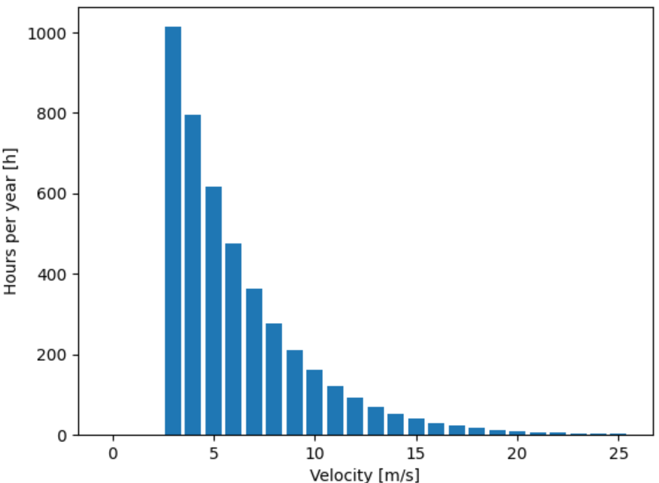

Fig. 3. Annual wind speed at the location of the shipyard

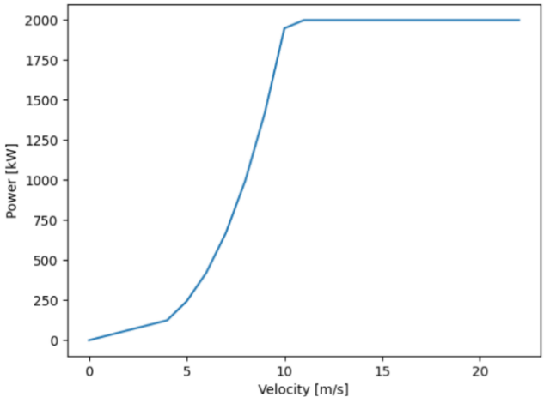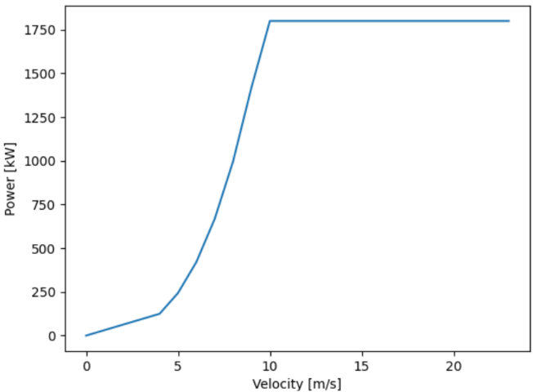

Power curve WT1  Power curve WT2

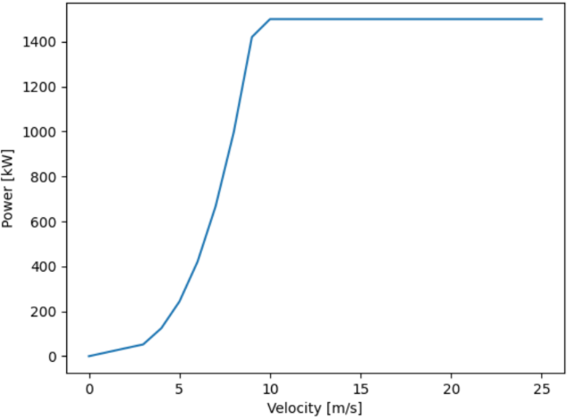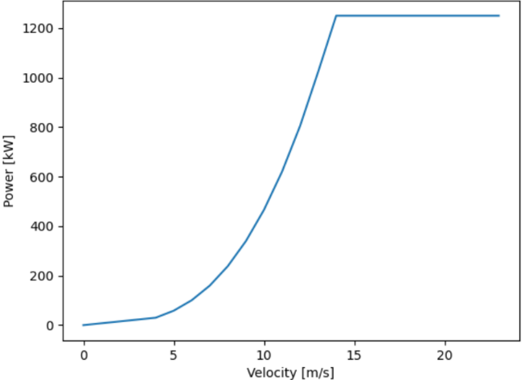

Power curve WT3 Power curve WT4

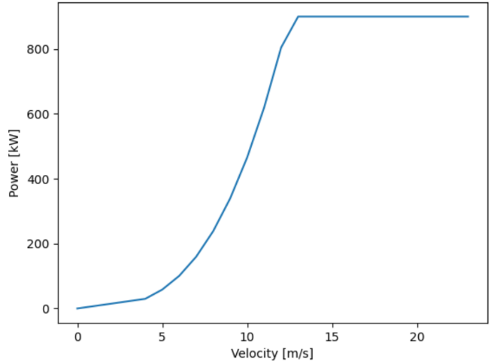

Power curve WT5

Fig. 4 .WTs’ Power curves

The computational script developed also calculated the sum of the annual energy produced by each WT and the maximum potential energy production of the WTs. Table 5 and Fig. 5 show the sum of the annual energy production, the maximum potential energy production and the capacity factor for each nominated WT.

Table 5. Annual energy production, maximum potential energy production and capacity factor for each nominated hydropower plant.

|  |  |  |  |  |  |
| --- | --- | --- | --- | --- | --- |
| Parameters | WT1 | WT2 | WT3 | WT4 | WT5 |
| Maximum potential energy production (kW) | 1752 X 104 | 15768X103 | 1314X104 | 1095X104 | 7884X103 |
| Annual energy production (kW) | 2557545 | 2444073 | 2997221 | 856744.9 | 856744.9 |
| capacity factor (%) | 14.6% | 15.5% | 22.8% | 7.82% | 9.85% |

Fig. 5. Annual energy production, maximum potential energy production and capacity factor for each nominated WT.

As shown in Table 5 and Fig. 5 WT3, which is a 1.5 MW onshore WT, shows the highest capacity factor with 22.8% and has been selected as the best option for use in the designed microgrid. The capital cost and O&M cost of the turbine over its 25-year lifetime are US$2.03 million and US$0.04 million, respectively (IRENA, 2021).

Diesel generator (DG)

The low reliability of RE sources is one of the main barriers to investment in renewables and microgrids (Elavarasan, 2020). When the microgrid is stand-alone, a shortage of energy to meet demand can be expected. Therefore, the use of a DG in line with renewable energy sources can be a good safeguard to promote the reliability of the microgrid and prevent power outages on the yard. As energy demand varies on a yard, generators are usually operated at different load intervals. The yard's load and electricity demand have been taken into account when selecting the best size and number of generators to ensure that no capacity shortage occurs during the yard's operations. (Mobarra et al., 2020). In this study, 1MW DG with 90 000 hours lifetime is considered and the number depends on the configuration of the microgrid. The capital, replacement, operation and maintenance costs are $0.173 million, $0.156 million and $0.002/op.hour respectively (Boxwell, 2017) and the diesel price is taken from the World Bank which is $1.87/litre (World Bank, 2022).

Battery

RE sources are intermittent (Elavarasan et al., 2020), which reduces the reliability of MG integrated with renewable energy sources (wind and solar in this study). In order to improve the reliability of the MG and increase its operational capability and support a constant power supply to the shipyard, it is important to use a good battery to store the generated electricity (Salman et al., 2020). A Li-ion battery of 1 MWh has been chosen for the system. The capital, replacement, operation and maintenance costs of the selected battery are $2 171, $193 and $217/year respectively (Mamaghani et al., 2016).

Inverter

An inverter converts direct current into alternating current. It is an important component of the system because solar modules produce direct current and it must convert it into alternating current. The capital, replacement, operation and maintenance costs of the selected inverter are $4 650, $4 185 and $120 respectively (Mamaghani et al., 2016).

Controller

With Micro grid controller you can manage the grid. The micro grid contains software and physical devices. The controller can automatically select the most cost-effective and cleanest energy sources and manage the required information between loads and supply (Aghajani and Ghadimi, 2018). The load starting strategy was a dispatch strategy, when the generator is operating it produces only enough power to meet the primary load. Charging of the battery is left to RE sources. The capital cost and operation and maintenance cost of the selected regulator are $103 000 and $150/year, respectively (Uyan, 2019).

2.4. Scenarios

A microgrid simulation software (HOMER v.XY) has been used for economic analysis and optimisation taking into account different configurations of major components. Technical, economic and environmental analyses were conducted for six scenarios, including combinations of PV cells, WT, generators and batteries, to determine the best configuration for electricity generation in the case company. The simulations were carried out for the following configurations:

* Case 1: PV cells

In this case, the energy is supplied by solar panels. The electricity produced is direct current and is used for low-voltage direct current equipment. However, the electricity can also be stored in batteries and then converted through the AC voltage gain (AV) inverter to alternating current (AC ) power for high voltage devices (Mamaghani et al., 2016).

* Case 2: WT

WTs can produce alternating current and convert it into direct current, which is then fed into batteries. However, the batteries can supply the necessary electricity to AC inverters and then power appliances with high voltage requirements.

To increase the reliability and availability of a microgrid, it is important to provide the energy needed from different sources. In this respect, hybrid systems for cases 3-6 have been considered. The surplus energy produced by the hybrid system can be stored in batteries or even sold to the national grid.

* Case 3: PV cell & DGs (stand alone mode) & Case 4: WT & DGs (stand alone mode)

In cases 4 and 5, a combination of DG with solar PV and WT has been considered together with batteries. Due to the intermittent availability of RE sources, a DG can help to increase the reliability of the system. However, the capital, operation and maintenance costs and the negative climate impact of the systems may increase (Das et al., 2017).

* Case 5: PV cell & WT & DG (stand alone mode)

This hybrid system incorporates solar cells, WT, generators and battery storage to promote system reliability and provide a constant power supply to the shipyard.

* Case 6: PV cell & WT & DG (grid –connected mode)

The system includes a combination of solar cells, WT and generators. In order to manage supply and demand and to evaluate the purchase of electricity from the national grid and the sale of electricity to the national grid, grid-connected mode has been chosen in this case.

1. **Evaluation criteria for the economic model**

In this study, the lifetime of the project was assumed to be 25 years with an annual deterioration rate of 1%. The discount rate and inflation rate for this study have been assumed to be 3% and 2% respectively per year. Solar PV, WT and DG were considered as the main configurations of the power generation system. If Et is considered as total energy produced, the share of each component in energy production can be calculated as follows:

$Spv=\frac{Epv}{Et}$ (6)

$Swt=\frac{Ewt}{Et}$ (7)

$SDG=\frac{Ewt}{Et}$ (8)

Where, EPV is the energy generated by PV cells, EWT is the energy generated by WT, and EDG is the energy generated by DG.

Three economic indicators have been used to carry out the economic analysis. Net Present Cost (NPC), LCOE and initial capital cost (Lambert et al., 2006; Lu et al., 2017). The NPC can be calculated as follows (Das and Zaman, 2019):

$NPC=\frac{C_{ann, tot}}{CRF (I, N)}$ (9)

here C ann, tot is the total annual cost ($/year), I is the annual real interest rate (%), N is the life of the project (years) and CRF is the Capital Recovery Factor (CRF), which is used to convert the present value into equal annual cash flows. The equation for CRF can be described as follows (Ahmed et al., 2021):

$CRF \left(I, N\right)=\frac{{i\left(1+i\right)}^{N}}{{\left(1+i\right)}^{N}-1}$ (10), where i and N are the real discount rate and the number of years, respectively.

LCOE is also a popular economic measure for evaluating different energy sources in a hybrid energy system (Nissen and Harfst, 2019). It is defined as the ratio of the total annual cost of electricity generation to the total electrical load demand and can be calculated as follows (Patel et al., 2022):

$LCOE=\frac{C_{ann, tot}}{Edemand}$ (11).

The Net Present Value (NPV) is an economic indicator that is the sum of a project's cash flows and inflows, discounted year by year at a constant interest rate. The indicator shows that the monetary value in the future has less value than the same amount in the present. If NPV>0, the project is economically feasible and if NPV<0, the project is economically infeasible. However, if NPV=0, the investment is economically indifferent (Gilani and Hoseinzadeh, 2021). Equation (12) describes the calculation of NPV. Where, $CFt$ is the cash flow in year $t$ in $ and $t$ is the year related to the cash flow of the year and $i$ is the annual interest rate or opportunity cost (de Oliveria, 2022).

NPV= $\sum_{i=0}^{n}{\frac{CFt}{{\left(1+i\right)}^{t}}}$ (12).

To calculate the environmental impact of the proposed systems, the following equation has been used for the carbon factor of diesel oil:

TCO2 = 3.667 × mf × HVf × CEFf × OXc (13)

Where TCO2 is the total carbon dioxide emission, mf is the fuel volume (litres), HVf is the higher calorific value of the fuel (MJ/L), CEFf is the carbon emission factor of the fuel (tonnes of carbon/TJ) and OXc is the fraction of oxidised carbon. Finally, the factor 3.667 indicates that 3.677 g of carbon dioxide contains 1 g of carbon (Hossain et al., 2017).

1. **Results and discussions**

4.1. Results

An optimally designed system among seven cases has been modelled. NPC, initial capital cost, operating cost and LCOE were considered in the cases, and the costs of distributed electricity, surplus generated electricity and recycling were integrated into the NPC cost to analyze the cases. Fig. 6 shows the system costs associated with each case studied.

4.1.1. Case 1: (PV cell) & Case 2 (WT)

The feasibility study was carried out with regard to wind and solar energy. Due to the size and design of the yard, there was a limitation for the installation of solar panels and WTs. Taking into account the available space on the yard for the installation of solar panels and the size of the panels, the maximum capacity that can be used in the system is 2700 kW. In addition, it is only possible to install one wind turbine on the farm.

The analysis shows that the annual electricity production from solar energy can cover on average 60.2 % of the annual energy demand of the yard and that this is 43.6 % for wind power. Fig. 7 shows that in the period May-September wind power contributes less than 30%. The wind contribution varies between 40 and 65 % in January, February, October, November and December, while solar energy contributes less than 40 % of the yard's energy needs in the same period. In March-September the situation changes and solar energy contributes more than 40 % of the yard's energy needs, reaching even 96.2 % in July.

The economic analysis showed that although the LCOE of solar energy is $/kWh 0.053 and the payback period is 6.2 years with an internal rate of return of 11%, the LCOE of wind energy is $ 0.195 per energy unit and has a negative NPV of 25 years, making it not cost-effective to exploit. The analysis shows that the annual cost of electricity consumption is $ 1 489 200 and the CO2 emissions are 5.53 tCO2. If the yard uses solar energy, the annual electricity cost and emissions will be reduced by $ 361 667 and 1.34 tCO2, respectively $ 616 608 and 2.18 tCO2 for wind power.

Fig. 7. Monthly energy consumption and share of wind and solar energy.

The solar and hydropower system could not support the system on its own and to provide the required energy, the use of stand-alone and grid-connected generators has been considered.

4.1.2. Case 3: PV cell & DG (stand- alone mode)

The system is a combination of PV systems and generators to supply the electricity the yard needs. The system includes three generators (1 MW) and a 1.5 MW PV system. The initial capital cost is $1.96 million and the operating cost is $4.21 million. The NPC is $94.9 million, of which $92.1 million is fuel cost. The LCOE of the system is $0.491 per energy unit with a renewable energy share of 4.4%. The system's emissions are 4.33 tCO2. The solar PV system contributes 2 290 637 kWh/year, which is 21.5% of the electricity produced, and the generators contribute 78.5% of the electricity produced, which is 8 372 916 kWh/year. 1 882 631 kWh/year of the additional electricity produced can be stored in battery systems for use in other periods. The IRR of the system is 10.9% with a discounted payback period of 8.9 years.

4.1.3. Case 4: WT & DG (stand alone mode)

The optimized system in this case includes a 1.5 MW WT and two generators (1 MW). The initial capital and operating costs of the system are $3.39 million and $2.9 million, respectively, and the NPC is $67.4 million. The reason for the high NPC is the fuel cost, which is $62.12 million. The LCOE is $0.348 per energy unit if 34% of the electricity generation comes from renewable sources. The system can produce 647 775 kWh/year which can be stored in the battery. By consuming 4 123 m3 of fuel per day, the system produces 2.92 tCO2/year.

4.1.4. Case 5: PV cell & WT & DG (stand- alone mode)

The optimised system is a combination of a 1.5 MW photovoltaic system, two 1 MW generators and a 1.5 MW WT. The system can produce 9 923 549 kWh/year with a 31.5% share of RE sources, i.e. 11.7%, which is more than the electricity needed and which can be stored in batteries. The system's NPC ($73.4 million), capital cost ($3.82 million), operating cost ($3.15 million) and LCOE ($0.380) per energy unit. The system with a fuel consumption of 4 471 m3/day puts a burden of $67.81 million on the system and produces 3.18 tCO2/year. The IRR of the system is 10.6% and the discounted payback period of the designed system is 11.79 years.

4.1.5. Case 6: PV cell & WT & DG (grid connected mode)

The system is a grid-based system that includes solar cells, WT and generators. The optimal system size for this case is: a combination of a 1.5 MW solar PV system, a 1 MW DG and a 1.5 MW WT. The WT and solar PV contribute 3 698 167 kWh/year (32.7%) and 2 290 637 kWh/year (20.3%) of the electricity production and 47% of the required electricity (5 313 785 kWh/year) is purchased from the national grid. The general energy production remains on standby and can support the microgrid to provide the additional load if needed. The national cost of the system is $22.6 million with an initial capital and operating cost of $3.65 million and $0.859 million respectively. The LCOE for the system is $0.109 per energy unit and produces 3.35 tons of carbon dioxide per year. The IRR of the system is 28.9% and the discounted payback period is 3.53 years.

Fig. 6. System costs associated with each investigated case.

4.2. Sensitivity analysis

Cost reductions continued for solar and wind power in 2020 and are expected to continue thanks to improved technology and stricter environmental regulations (IRENA, 2021). In addition, the implementation of the EU's Green Deal rules and growing geopolitical issues are leading to an increase in oil prices in Europe (Mehmet and Yorucu, 2020; Puaschunder, 2021).

Taking into account the above, a sensitivity analysis of the initial capital cost of renewable technologies and the diesel oil price for the total NPC and LCOE was performed. The initial capital cost of solar PV and WT was considered to decrease by 10% and the diesel price to increase by 10% with an uncertainty of ±2%. As shown in Fig. 8, the LCOE decreased for cases 1, 2, 4 and 6, but the rate of decrease differs significantly. The largest decrease is for solar PV (0.028 ($/kWh)) with 47.17%, which is the largest decrease among the other scenarios. This is due to the lower ratio between the cost of photovoltaic installations and total electricity production. The second largest reduction in LCOE is case 4 (0.307 ($/kWh)) with a reduction of 11.8%, while case 2 and case 6 with a reduction of 8.21% and 0.92% have an LCOE of 0.179 ($/kWh) and 0.108 ($/kWh) respectively. Due to the consumption of diesel oil in cases 3 and 5, their LCOE increased by 9.16% and 7.63% to 0.536 ($/kWh) and 0.409 ($/kWh) respectively.

In terms of total NPC changes, the largest decrease was for case 2 (WT) with a decrease of 10.46% and amounted to $2.14 million. This is due to the high initial capital cost of WT, which has decreased to $1,829,250. In addition, NPC in cases 1 and 6 decreased by 5.19% and 1.33% to $2.72 million and $22.3 million, respectively. On the other hand, NPC for cases 3, 4 and 5 has increased by 9.59%, 19.88% and 7.77% respectively due to increased fuel consumption. The largest increase in NPC is for case 4, which is due to the presence of more generators in the system compared to cases 3 and 5.

Fig. 8. Sensitivity analysis associated with each investigated case.

4.3. Discussions

As shown in Fig. 6, despite having a higher initial capital cost compared to Case 2 (WT) and Case 3 (PV-cell and DG), Case 1 (PV-cell and DG) is the most economical microgrid design (stand-alone mode) for the shipyard due to its lower LCOE (0.053 USD/kWh), higher IRR (11%) and shorter discounted payback period (6.2 years). The designated WT can only produce 22.8% of its maximum capacity, which in relation to its capacity (1.5 MW) leads to a lower LCOE ($0.195($/kWh)) compared to the other cases (except cases 1 and 6). However, due to the negative internal rate of return and payback period of more than 25 years, it is an infeasible design of the microgrid. Moreover, the sensitivity analysis shows that case 1 with the highest reduction (47.17%) has the lowest LCOE (0.028 ($/kWh)) and is more sensitive to a reduction in technology costs.

Case 3 has the lowest initial capital cost (1.96 M$/kW). However, due to the design of the system, which includes three generators to provide the electricity required for the shipyard and the associated fuel costs ($92 M), it has the highest NPC ($94.9 M) and LCOE (0.491 ($/kWh)). Case 4 also has the same conditions, but due to the design of the system, which includes two generators, it has lower fuel costs ($62.12), lower NPC ($67.4 M) and LCOE (0.34 ($/kWh)) compared to case 3. Similarly, due to its design with solar PV, a WT and two generators and the related fuel cost ($67.81 million), Case 5 has the highest initial capital cost ($3.82 million) and the second highest NPC ($73.4 million) and operating cost ($3.15 million/kw/year) and the third highest LCOE ($0.380 ($/kWh)). The sensitivity analysis showed that the cases containing generators are more sensitive to an increase in fuel prices than a decrease in the initial capital cost of RE technologies. The LCOE for cases 3 and 5 increased by 9.16% and 7.63% to 0.536 ($/kWh) and 0.409 ($/kWh), respectively.

Although case 6, which is grid-connected, includes all the elements of solar PV, WT and generators, it has the second highest initial capital cost ($3.65 million) and a significantly lower operating cost ($0.86 million) compared to the other cases (except cases 1 and 2). This is due to the generator's standby mode, which uses no fuel. It has the second lowest LCOE (0.109($/kWh)), the highest IRR (28.9%) and the shortest discounted payback period (3.53 years). Due to the role of the national grid in providing electricity to the shipyard and the associated cost, the LCOE for case 6 has only decreased by 0.92% as a result of the technical capital reduction to 0.108($/kWh).

In the stand-alone grid mode, case 1 (PV cell) with NPC ($2.87 million), LCOE ($0.053 kWh), IRR (11%) and a discounted payback period of 6.2 years is the most economical off-grid design, and case 6 with LCOE ($0.109/kWh), highest IRR (28.9%) and shortest discounted payback period (3.53 years) is the best off-grid design after case 1. As in the presented study, the sensitivity analysis showed the same results, namely that case 1 (solar PV) with NPC ($2.72 million) and LCOE (0.028) ($/kWh) is the most economical off-grid design and that case 6 (grid-connected mode) comes second among the best system designs with NPC ($22.30 million) and LCOE (0.108) ($/kWh).

1. **Conclusions**

A shipyard is an industrial production facility that uses materials and energy to design, build, repair, maintain and dismantle ships with a significant environmental footprint. In order to move towards a green and sustainable shipyard, more holistic and interdisciplinary approaches and relevant policies are required. To accelerate the decarbonisation of shipbuilding and the transition to digitalisation, the share of RE sources in producing the energy needed in the process needs to be increased, and a comprehensive technical, environmental and economic assessment of the use of RE sources needs to be carried out in the industry.

This paper presents a systematic evaluation of different configurations of RE sources in grid-connected and stand-alone operations in a large Italian shipyard. Six design cases were proposed and the systems included photovoltaic, WT and diesel generators. The HOMER software was used to develop dynamic models for the shipyard in order to select the most cost-effective system. NPC, initial capital cost, operating cost, LCOE, IRR and discounted payback period were considered as economic indicators.

The results showed that the use of solar PV with an LCOE of 0.053 ($/kWh), an IRR of 11% and a discounted payback period of 6.2 years was the most economical microgrid design (stand-alone mode) for the shipyard (Case 1). The grid-connected system includes a 1.5 MW photovoltaic system, a 1 MW generator system, and a 1.5 MW WT, with an NPC of $22.6 million and an initial capital and operating cost of $3.65 million and $0.859 million, respectively. The LCOE for the system is $0.109 and produces 3.35 tonnes of carbon dioxide per year. The IRR for the system is 28.9% and the discounted payback period is 3.53 years.

The sensitivity analysis showed that the generator configuration cases were more sensitive to the diesel price than to the initial capital cost of RE technologies and yielded similar results to the original analysis. Case 1 with NPC ($2.72 million) and lowest LCOE (0.028) ($/kWh) is the most economical off-grid configuration and is the case most sensitive to a reduction in the capital cost of the technology with a 47.17% reduction in LCOE. Although case 6 (grid-connected mode) is the least sensitive to a reduction in the capital cost of the technology (0.92%), it is the second best system with NPC ($22.30 million) and LCOE (0.108) ($/kWh).

Currently, the problem is that energy efficiency measures are not always implemented on a yard-by-yard basis, as there are a number of barriers that prevent implementation, of which economic researchers consider market failures to be the most important. Although the use of RE sources and hybrid systems can reduce the environmental impact of shipyards and be considered as a long-term investment, the high investment costs are the main obstacle to their implementation in shipyards. International, regional and governmental involvement by providing the necessary financial incentives and adopting “the polluter pays” principle in the industry can facilitate and reduce the commercial risk of introducing hybrid configurations based on RE sources for the electrification of shipyards. In addition, feasibility and performance analyses of grid-connected and stand-alone hybrid RE systems can help decision-makers in shipyards to accelerate the green transition in their processes. In the future, we will conduct feasibility and performance analyses of grid-connected and stand-alone hybrid renewable energy systems for other shipyards and maritime indutries in other parts of the world.

**Acknowledgement**

The authors would like to thank the Italian shipyard for willing to share the relevant data and information. In addition, the authors would like to express their gratitude to the reviewers and the editor of the journal for their valuable comments, which have greatly improved the study.

**References**

Aghajani, G., & Ghadimi, N. (2018). Multi-objective energy management in a micro-grid. *Energy Reports*, *4*, 218-225.

Ahmed, D., Ebeed, M., Ali, A., Alghamdi, A. S., & Kamel, S. (2021). Multi-objective energy management of a micro-grid considering stochastic nature of load and renewable energy resources. *Electronics*, *10*(4), 403.

Alizadeh, H., Nazari, M. A., Ghasempour, R., Shafii, M. B., & Akbarzadeh, A. (2020). Numerical analysis of photovoltaic solar panel cooling by a flat plate closed-loop pulsating heat pipe. *Solar Energy*, *206*, 455-463.

Boxwell, M. (2017). The Solar Electricity Handbook-2017 Edition: A simple, practical guide to solar energy–designing and installing solar photovoltaic systems. Greenstream Publishing.

Chatzinikolaou, S.D.; Ventikos, N.P. (2014). *Applications of Life Cycle Assessment in Shipping*; INT-NAM 2014At: Istanbul, Turkey,

Das, B. K., Hoque, N., Mandal, S., Pal, T. K., & Raihan, M. A. (2017). A techno-economic feasibility of a stand-alone hybrid power generation for remote area application in Bangladesh. *Energy*, *134*, 775-788.

Das, B. K., & Zaman, F. (2019). Performance analysis of a PV/Diesel hybrid system for a remote area in Bangladesh: Effects of dispatch strategies, batteries, and generator selection. *Energy*, *169*, 263-276.

de Oliveira, A. C. L., Fernandes, O. R., dos Santos Renato, N., & Borges, A. C. (2022). Feasibility of using different renewable energy sources in Brazilian swine farmings. *Journal of Cleaner Production*, *333*, 130040.

Elavarasan, R.M., Afridhis, S., Vijayaraghavan, R.R., Subramaniam, U. and Nurunnabi, M., (2020). SWOT analysis: A framework for comprehensive evaluation of drivers and barriers for renewable energy development in significant countries. *Energy Reports*, *6*, pp.1838-1864.

EU. (2021). Copernicus. Access to data. Retrieved from [Access to data | Copernicus](https://www.copernicus.eu/en/access-data).

Franke, K., Sensfuß, F., Deac, G., Kleinschmitt, C. and Ragwitz, M., 2021. Factors affecting the calculation of wind power potentials: A case study of China. *Renewable and Sustainable Energy Reviews*, *149*, p.111351.

Gilani, H. A., & Hoseinzadeh, S. (2021). Techno-economic study of compound parabolic collector in solar water heating system in the northern hemisphere. Applied Thermal Engineering, 190, 116756.

Hossain, M., Mekhilef, S., & Olatomiwa, L. (2017). Performance evaluation of a stand-alone PV-wind-diesel-battery hybrid system feasible for a large resort center in South China Sea, Malaysia. *Sustainable cities and society*, *28*, 358-366.

Hoseinzadeh, S., & Garcia, D. A. (2022). Techno-economic assessment of hybrid energy flexibility systems for islands’ decarbonization: A case study in Italy. Sustainable Energy Technologies and Assessments, 51, 101929.

IEA. (2019). Retrieved from; <https://www.iea.org/reports/world-energy-outlook>.

IEA. (2020). Retrieved from; https://www.iea.org/reports/tracking-industry-2020.

IEA. (2021). [Renewables – Global Energy Review 2021 – Analysis - IEA](https://www.iea.org/reports/global-energy-review-2021/renewables).

International Maritime Organization (IMO). MEPC\75\MEPC 75-7-15. REDUCTION of GHG EMISSIONS FROM SHIPS. Fourth IMO GHG Study 2020- Final Report. 2020. Available online: http://www.imo.org/en/About/Pages/Default.aspx (accessed on 7 January 2021). IRENA. (2016). Roadmap for a Renewable Energy Future, International Renewable Agency.

IRENA, (2021). Renewable Power Generation Costs in 2020, International Renewable Energy Agency, Abu Dhabi.

Lambert, T., Gilman, P., & Lilienthal, P. (2006). Micropower system modeling with HOMER. *Integration of alternative sources of energy*, *1*(1), 379-385.

Lu, J., Wang, W., Zhang, Y., & Cheng, S. (2017). Multi-objective optimal design of stand-alone hybrid energy system using entropy weight method based on HOMER. *Energies*, *10*(10), 1664.

Mahmoudan, A., Esmaeilion, F., Hoseinzadeh, S., Soltani, M., Ahmadi, P., & Rosen, M. (2022). A geothermal and solar-based multigeneration system integrated with a TEG unit: Development, 3E analyses, and multi-objective optimization. *Applied Energy*, *308*, 118399.

Mahmoudan, A., Samadof, P., Hosseinzadeh, S., & Garcia, D. A. (2021). A multigeneration cascade system using ground-source energy with cold recovery: 3E analyses and multi-objective optimization. *Energy*, *233*, 121185.

Mamaghani, A. H., Escandon, S. A. A., Najafi, B., Shirazi, A., & Rinaldi, F. (2016). Techno-economic feasibility of photovoltaic, wind, diesel and hybrid electrification systems for off-grid rural electrification in Colombia. *Renewable Energy*, *97*, 293-305.

Mobarra M, Tremblay B, Rezkallah M, Ilinca A. (2020). Advanced control of a compensator motor driving a variable speed diesel generator with rotating stator. Energies. 13(9):2224.

Mandal, N. R. (2017). *Ship construction and welding* (pp. 170-174). Singapore:: Springer.

Mehmet, O., & Yorucu, V. (2020). Modern Geopolitics of Eastern Mediterranean Hydrocarbons in an Age of Energy Transformation (Vol. 78). Springer Nature.

Nissen, U., & Harfst, N. (2019). Shortcomings of the traditional “levelized cost of energy”[LCOE] for the determination of grid parity. *Energy*, *171*, 1009-1016.

Nordal, K. (2022). Yara to start operating the world’s first fully emission-free container ship. Retrieved from: [Yara to start operating the world’s first fully emission-free container ship | Yara International](https://www.yara.com/corporate-releases/yara-to-start-operating-the-worlds-first-fully-emission-free-container-ship/).

Nordtveit, E. (2017). Life Cycle Assessment of a Battery Passenger Ferry. Masters Thesis. University of Agder. <http://hdl.handle.net/11250/2493457>.

OECD. (2016). Imbalances in the shipbuilding industry and assessment of policy responses. Retrieved from: [IMBALANCES IN THE SHIPBUILDING INDUSTRY AND ASSESSMENT OF POLICY RESPONSES.](https://www.oecd.org/industry/ind/Imbalances_Shipbuilding_Industry.pdf)

OECD. (2019). Enterprises by business size (indicator). Retrieved from: https://data.oecd.org/entrepreneur/enterprises-by-businesssize. htm (accessed November 26, 2021).

OECD. (2021). Enterprises by business size (indicator). doi: 10.1787/31d5eeaf-en (Accessed on 26 November 2021).Retrieved from [Entrepreneurship - Enterprises by business size - OECD Data](https://data.oecd.org/entrepreneur/enterprises-by-business-size.htm).

Ölçer A.I., (2018) Introduction. In: Ölçer A., Kitada M., Dalaklis D., Ballini F. (eds) Trends and Challenges in Maritime Energy Management. WMU Studies in Maritime Affairs, Vol 6. Springer, Cham DOI: 10.1007/978-3-319-74576-3_1

Patel, M., Roy, S., Roskilly, A. P., & Smallbone, A. (2022). The techno-economics potential of hydrogen interconnectors for electrical energy transmission and storage. *Journal of Cleaner Production*, 130045.

Puaschunder, J. M. (2021, March). Monitoring and evaluation (M&E) of the green new deal (GND) and European Green Deal (EGD). In *Proceedings of the 21st International RAIS Conference on Social Sciences and Humanities* (pp. 202-206). Scientia Moralitas Research Institute.

Rees, W. E. (2021). COP-26: Stopping Climate Change and Other Illusions. *Buildings and Cities*.

REN21, (2021). Renewables 2021 Global Status Report (Paris: REN21 Secretariat). ISBN 978-3-948393-03-8

Ritchie, H., Roser, M., Mathieu,E., and Macdonald, B. (2021). Our World Data. Emissions by sectors. Retrieved from [Emissions by sector - Our World in Data](https://ourworldindata.org/emissions-by-sector).

Salman, U. T., Al-Ismail, F. S., & Khalid, M. (2020). Optimal sizing of battery energy storage for grid-connected and isolated wind-penetrated microgrid. *IEEE Access*, *8*, 91129-91138.

SEA Europe. (2019). The Shipyards’ & Maritime Equipment Association of Europe, (SEA) Europe. (2020). EUROPEAN SHIPBUILDING INDUSTRY STATEMENT. Brussels, 25 November 2019. Retrieved from: [European_Shipbuilding_Industry_Statement_251119.pdf (portalmorski.pl)](https://www.portalmorski.pl/images/European_Shipbuilding_Industry_Statement_251119.pdf).

SEA Europe. (2020). The Shipyards’ & Maritime Equipment Association of Europe, (SEA) Europe. (2020). EUROPEAN SHIPBUILDING INDUSTRY STATEMENT. Retrieved from: [SEA_Europe_Annual_Report_2020.pdf (seaeurope.eu)](https://www.seaeurope.eu/images/SEA_Europe_Annual_Report_2020.pdf).

Sheha M, Mohammadi K, Powell K. Techno-economic analysis of the impact of dynamic electricity prices on solar penetration in a smart grid environment with distributed energy storage. Applied Energy. 2021 Jan 15;282:116168.

Statista, (2021). Retrieved from  [Global transport CO2 emissions breakdown 2020 | Statista](https://www.statista.com/statistics/1185535/transport-carbon-dioxide-emissions-breakdown/).

Ueda, T., Roberts, E. S., Norton, A., Styles, D., Williams, A. P., Ramos, H. M., & Gallagher, J. (2019). A life cycle assessment of the construction phase of eleven micro-hydropower installations in the UK. *Journal of cleaner production*, *218*, 1-9.

Uyan, E. (2019). A Holistic Framework for Improved Energy Performance in Marine Manufacturing Plant. PhD. Newcastle University.

Vakili, S. V., Ölcer, A. I., & Ballini, F. (2020). The development of a policy framework to mitigate underwater noise pollution from commercial vessels. *Marine Policy*, *118*, 104004.

Vakili, S., Ölçer, A. I., & Ballini, F. (2021). The development of a transdisciplinary policy framework for shipping companies to mitigate underwater noise pollution from commercial vessels. *Marine Pollution Bulletin*, *171*, 112687.

Vakili, S. V., Ölçer, A. I., & Schönborn, A. (2021a). Identification of shipyard priorities in a multi-criteria decision-making environment through a Transdisciplinary energy management framework: A real case study for a Turkish shipyard. *Journal of Marine Science and Engineering*, *9*(10), 1132.

Vakili, S. V., Ölçer, A. I., & Schönborn, A. (2021b). The development of a transdisciplinary framework to overcome energy efficiency barriers in shipbuilding: A Case study for an Iranian shipyard. *Journal of Marine Science and Engineering*, *9*(10), 1113.

Vakili, S. V., Ballini, F., Dalaklis, D., & Ölçer, A. I. (2022). A Conceptual Transdisciplinary Framework to Overcome Energy Efficiency Barriers in Ship Operation Cycles to Meet IMO’s Initial Green House Gas Strategy Goals: Case Study for an Iranian Shipping Company. Energies, 15(6), 2098.

Vakili, S., Ölçer, A. I., Schönborn, A., Ballini, F., & Hoang, A. T. (2022a). Energy‐related clean and green framework for shipbuilding community towards zero‐emissions: A strategic analysis from concept to case study. *International Journal of Energy Research*.

World Bank. (2022). Retrieved from: [Pump price for diesel fuel (US$ per liter) | Data (worldbank.org)](https://data.worldbank.org/indicator/EP.PMP.DESL.CD).