SUPPORTING INFORMATION
Rapid fabrication and screening of tailored functional 3D biomaterials – part 2
Antonio Conde-González,‡ Michael Glinka,‡ Deepanjalee Dutta,‡ Robert Wallace, Anthony Callanan, Richard O.C. Oreffo,* and Mark Bradley*

Figure S1. Pore connectivity density (µm⁻³) calculated with Euler characteristic (using ImageJ – BoneJ) for scaffolds with medium (MPS) and high (MPS) porosity for polymers 1 to 6. Mean ± SD, n=2.
Figure S2. Pore size distribution (µm) calculated with computed spheres that fitted the pore space (using ImageJ – BoneJ) for scaffolds with medium (MPS) and high (MPS) porosity of polymers 1 to 6. Mean ± SD, n=2.

Figure S3. Indentation moduli for the porous scaffolds (MPS and HPS) and their non-porous controls (CPS). Macro-indentation approach using an Instron mechanical test equipment (model 3367) equipped with a flat indenter (Ø = 1mm). Indentation moduli were calculated from the gradient of the load-displacement curves using a linear model locally between 0%-5%, 5%-10%, 10%-15% and 15%-20% of strain for polymers 1 (A), 2 (B), 3 (C), 4 (D), 5 (E) and 6 (F). One-way ANOVA with Bonferroni post-test (* p ≤ 0.05, ** p ≤ 0.01, *** p ≤ 0.001 and **** p ≤ 0.0001). Mean ± SD, n=4.

Figure S4. Load relaxation (%) calculated as the percentage reduction of load at maximum strain (20% strain) for 5 min, from the load-time curves obtained by macro-indentation. One-way ANOVA with Bonferroni post-test (* p ≤ 0.05, ** p ≤ 0.01, *** p ≤ 0.001 and **** p ≤ 0.0001). Mean ± SD, n=4.

Figure S5. Calibration curve of the number of FSSCs correlated to fluorescence intensity (alamarBlue™). Cells were counted using a haemocytometer and seeded in a tissue culture 96-well plate with basal medium. AlamarBlue™ in basal medi(10% v/v) was added to the wells 2 hours after seeding to ensure cell attachment to the plate. Incubation was performed for 4 hours in a humidified atmosphere (37 °C and 5% CO2). The supernatant was collected and, subsequently, fluorescence was read in a microplate reader (λ_{ex/em} = 530/590 nm). Mean ± SD, n=3.

Figure S6. FBMSCs proliferation on the 3D polymer arrays. Fold change of fluorescence between day 0 (10,000 cells/well) and the scaffolds at day 2, 7 and 21 (n=3 biological replicates with 4 technical replicates). FBMSCs were cultured in basal medium. Two-way ANOVA with Bonferroni post-test (* p ≤ 0.05, ** p ≤ 0.01, *** p ≤ 0.001 and **** p ≤ 0.0001) was carried out between day 2 and day 21. Mean ± SD.
Figure S7. FBMSCs total collagen on the 3D polymer arrays. Fold change of absorbance (picro-sirius red staining of collagen) between the TC control and the 3D scaffolds after 21 days of incubation in basal medium (n=3 biological replicates with 3 technical replicates). Two-way ANOVA with Bonferroni post-test (* p ≤ 0.05, ** p ≤ 0.01, *** p ≤ 0.001 and **** p ≤ 0.0001) was carried out between the control (TC) and the scaffolds. Mean ± SD.

Figure S8. FBMSCs alkaline phosphatase (ALP) on the 3D polymer arrays. Fold change of absorbance (chromogenic enzymatic cleavage of phosphatase substrate) between the TC control at day 2 and the scaffolds at day 2, 7 and 21 (n=2 biological replicates with 4 technical replicates). FBMSCs were cultured in basal medium. Two-way ANOVA with Bonferroni post-test (* p ≤ 0.05, ** p ≤ 0.01, *** p ≤ 0.001 and **** p ≤ 0.0001) was carried out between the control (TC) and the scaffolds. Mean ± SD.

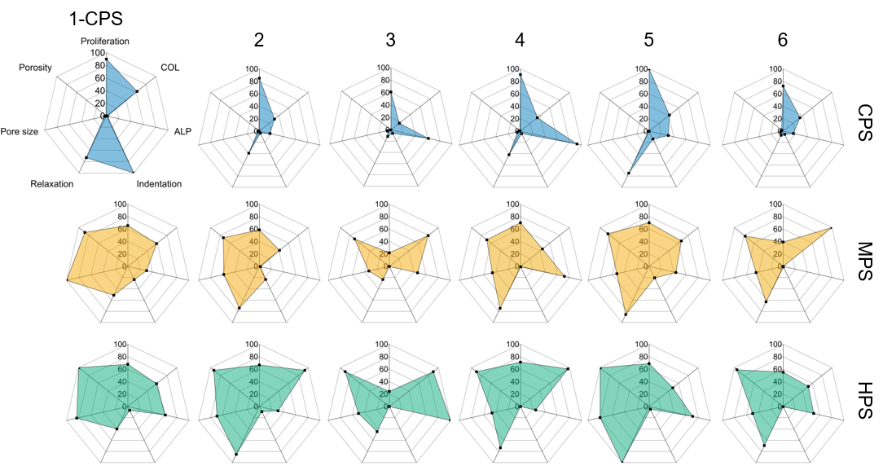
Figure S9. Analysis of FBMSCs behaviour on the 3D polymer scaffolds (polymers 1-6 with no (control) and medium (orange) and high porosities (blue/green)). FBMSCs behaviour on the polymers (proliferation rate at day 21, total collagen at day 21 and alkaline phosphatase at day 7) were compared with mechanical properties (indentation and relaxation load) and scaffold 3D structure (pore size and porosity). Each property interrogated was normalised (%) with the highest value identified (Table S2).

Table S2. Analysis of FBMSCs behaviour on the 3D polymer scaffolds. Highest and lowest value of each property interrogated i.e. proliferation, total collagen (COL), alkaline phosphatase (ALP), indentation modulus, relaxation load, pore size and porosity.
Property | Highest | Lowest
Proliferation (between day 0 and 21) | 8.7-fold | 1.9-fold
COL (between TC day 21 and scaffolds day 21) | 4.8-fold | 0.8-fold
ALP (between TC day 2 and scaffolds day 7) | 4.0-fold | 0-fold
Indentation modulus | 96.4 MPa | 22.8 kPa
Relaxation load | 53.1% | 3.9%
Pore size | 175.3 µm | 2 µm
Porosity | 82.4% | 0%

Figure S10. Analysis of FBMSCs behaviour on the 3D polymer array for polymers 2 and 3 with high porosity. A) Fold change of fluorescence between day 0 (10,000 cells/well) and the scaffolds at day 21 (n=3 biological replicates with 4 technical replicates). B) Fold change of absorbance (picro-sirius red staining of collagen) between the TC control and the 3D scaffolds after 21 days of incubation in basal medium (n=3 biological replicates with 3 technical replicates). C) Fold change of absorbance (chromogenic enzymatic cleavage of phosphatase substrate) between the TC control at day 2 and the scaffolds at day 7 (n=2 biological replicates with 4 technical replicates). FBMSCs were cultured in basal medium. One-way ANOVA with Bonferroni post-test (** p ≤ 0.01 and **** p ≤ 0.0001). Tissue culture plates (TC) were used as a control. Mean ± SD.

Figure S11. Quantification of FBMSCs proliferation and ALP expression. Porous scaffolds with high porosity (2-HPS and 3-HPS) were seeded with FBMSCs (40,000 cells/scaffold) and incubated for 2 and 7 days in basal medium. FBMSCs in the scaffolds were stained using DAPI and immunofluorescence assay for ALP, subsequently, confocal microscopy was carried out. The software Imaris was used to analyse the representative images of the scaffold. A) Number of FBMSCs nuclei and B) ALP fluorescence intensity normalised by number of cells. Two tailed t-test (* p ≤ 0.05, ** p ≤ 0.01, *** p ≤ 0.001 and **** p ≤ 0.0001). Mean ± SD, n=2 biological replicates.

Figure S12. Scanning electron microscopy (SEM) images of FBMSCs on the 3D porous scaffolds. Scaffolds with high porosity (HPS) for polymers 2 and 3 were analysed after 7 and 21 days of incubation. Scaffolds without cells was used as a control. Squares indicate magnified areas. FBMSCs were observed on the surface as well as in the interior parts of the scaffold (arrows). Scale bar 400 µm.
Figure S13. Chick CAM ex vivo model implantation of scaffolds 2-HPS and 3-HPS with (+FBMSCs) and without (No FBMSCs) cells. A) In situ macrographs. B) Histology analysis with Alcian blue and Sirius red where blue, red and black stainings show proteoglycans, collagen and nuclei. Black dashed squares, black and red arrows indicate areas magnified, proteoglycans and collagen respectively. C) Goldner’s Trichrome where green, red, black and orange stainings show collagen, cell cytoplasm, nuclei and erythrocytes. Black dashed square, black and flue arrows indicate areas magnified, collagen and erythrocytes respectively. Scale bar (i) = 500 µm and (ii) = 100 µm. Histological analysis showed extracellular matrix deposition evidenced by extensive proteoglycans expression as well as collagenous protein. Furthermore, the presence of erythrocytes confirmed vasculature network formation. The presence of cells in all samples, including scaffolds without cells prior to implantation, showed avian host cellular penetration and recruitment in the scaffolds containing enhanced pore sizes and interconnectivity.

Figure S14. In vitro evaluation of FBMSCs osteogenesis markers in tissue culture plates (TC) cultured in basal and osteogenic media for 7 and 21 days. Immunofluorescence assessment for expression of collagen I and osteopontin (stained red) along with DAPI nuclear staining (stained cyan). Scale bar 100 µm.

Figure S15. Live/Dead (green/red) assay of FBMSCs in 2-HPS. Scale bar 100 µm.

Table S3. ELISA against Type I collagen on 2-HPS scaffolds seeded with FBMSCs and cultured for 21 days in basal medium. Mean ± SD, n=3
Type I collagen/total protein (pg/µg) | Type I collagen/DNA (pg/ng) | Total protein/DNA (µg/ng)
45.0 ± 6.0 | 32.8 ± 4.4 | 0.7 ± 0.3

Supplementary Method
Addendum #1 - In vivo subcutaneous implantation in mice and analysis
As per our plan and ethics evaluation it was deemed that a blank control (no material implanted in the animals after surgery) was unnecessary. As advised by our licence holder as well as the animal facility manager, blank controls are used in case it is uncertain if the material is toxic to the animal used in the study. Prior to the mouse model we performed an ex vivo chorioallantoic membrane assay (CAM) chick model study (Supplementary Figure S13) to check the toxicity of the polymeric scaffolds and their effect on the developing animal as well as formation of vasculature within the scaffolds [REF #1]. In this case, the evidence from CAM chick model was sufficient to drop the blank control group from the animal study, allowing to reduce the number of animals used and refine the experiments hypothesis (the 3 R’s of animal studies).

[REF #1] Moreno-Jiménez, I., Hulsart-Billstrom, G., Lanham, S. et al. The chorioallantoic membrane (CAM) assay for the study of human bone regeneration: a refinement animal model for tissue engineering. Sci Rep 6, 32168 (2016). https://doi.org/10.1038/srep32168

