Is high sensitivity troponin, taken regardless of a clinical indication, associated with 1 year mortality in critical care patients?

Jonathan Hinton BM ^{1,2}, Maclyn Augustine BM^{1,2}, Lavinia Gabara BM^{1,2}, Mark Mariathas BM^{1,2}, Rick Allan MSc³, Florina Borca MFin⁴, Zoe Nicholas BSc (Hons)¹, Neil Gillett³, Chun Shing Kwok PhD⁶, Paul Cook PhD³, Michael PW Grocott MD^{2,5}, Mamas Mamas PhD^{6,7}, Nick Curzen PhD^{1,2} *
¹Coronary Research Group, University Hospital Southampton NHS Foundation Trust, UK
²Faculty of Medicine, University of Southampton, Southampton, UK
³Department of Biochemistry, University Hospital Southampton NHS Foundation Trust, UK
⁴NIHR Biomedical Research Centre, University Hospital Southampton NHS Foundation Trust, UK
⁵Anaesthesia and Critical Care Group, NIHR Biomedical Research Centre, University Hospital Southampton NHS Foundation Trust, UK
⁶Keele Cardiovascular Research Group, Centre for Prognosis Research, Keele University, Stoke on Trent, UK
⁷ Department of Cardiology, Jefferson University, Philadelphia, USA

Funding:
Unrestricted Research Grant – Beckman Coulter (BC) for the high sensitivity troponin assays. BC had no role in the design, execution, analysis or interpretation of the study
*corresponding author
Prof. N Curzen BM(Hons) PhD FRCP
Professor of Interventional Cardiology
E Level North Wing
University Hospital Southampton NHS Trust
Southampton SO16 6YD, UK
+442381204972
nick.curzen@uhs.nhs.uk

Potential conflicts of interest:
M. P. W. Grocott – unrestricted research grants from Pharmacosmos Ltd and Sphere Medical Ltd as well honoraria for speaking and/or travel expenses from: Astra Zeneca, Edwards Lifescience, Fresenius-Kabi, BOC Medical (Linde Group), Ely-Lilly Critical Care, and Cortex GmBH.
N. Curzen – unrestricted research grants from: Boston Scientific; Heartflow; Beckman Coulter. Speaker fees/consultancy from: Abbot Vascular; Heartflow; Boston Scientific;
travel sponsorship – Edwards; Biosensors, Abbot, Lilly/D-S; St Jude Medical, Medtronic.

Abstract
The aim of this study was to assess whether high sensitivity troponin (hs-cTnI) is associated with 1 year mortality in critical care (CC). One year mortality data were obtained from NHS Digital for a consecutive cohort of patients admitted to general CC unit (GCCU) and neuroscience CC unit (NCCU) who had hs-cTnI tests performed throughout their CC admission, regardless of whether the test was clinically indicated. Cox proportional hazards were used to estimate the risk of 1-year mortality. A landmark analysis was undertaken to assess whether any relationship at one year was driven by mortality within the first 30 days. A total of 1033 consecutive patients were included. At one year 254 (24.6%) patients had died. The admission log(10)hs-cTnI concentration in the entire cohort (HR 0.30 (95%CI 0.05 – 0.56) p = 0.009 with a bootstrap of 1000 samples) was independently associated with one year mortality. On landmark analysis the association with one year mortality was driven by 30 day mortality. These results indicate that admission hs-cTnI concentration is independently associated with 1 year mortality in CC and this relationship is driven by differences in mortality at 30 days.
Keywords
High sensitivity troponin, myocardial infarction, critical care
Data sharing statement
The data used in this study cannot be shared due to the nature of the data sharing agreement with NHS Digital

Introduction
The increased sensitivity and usage of high sensitivity troponin (hs-cTn) assays has resulted in concentrations above the manufacturer defined upper limit of normal (ULN) being seen in a range of different clinical contexts not traditionally associated with myocardial infarction (1-5). Furthermore, there is an accumulating body of evidence demonstrating that hs-cTn is associated with medium term outcomes in several disease groups (6-14). Specifically, this research group showed that in a population of 20,000 consecutive patients undergoing a blood test for any reason, inpatient or outpatient, the hs-cTnI concentration was above the ULN in 1 in 20 (4). Furthermore, this concentration was independently associated with 1 year mortality in this population (14). In critical care (CC) environments, hs-cTn concentrations above the ULN are frequent and have been associated with adverse in hospital outcomes including mortality (15-19). In our previous work we demonstrated that the hs-cTnI concentration on admission to CC, taken outside the context of routine clinical indications, was independently associated with CC mortality (15). The aim of this study was to assess whether there was an association in this cohort between hs-cTnI and mortality at one year of follow up, in order to determine if the assay may be of potential value as a marker of elevated risk in CC patients.
Method
The methodology of this study has been described in detail in our previously published work (15). In brief, this is a prospective, observational study that enrolled consecutive adult patients admitted to one of two CC environments (general critical care unit (GCCU) or the neuroscience critical care unit (NCCU)) within our institution over a six month timeframe. A hs-cTnI request was added to the first biochemistry sample received and, following this, on day 1 and day 2 and after that every alternate day of the admission. These tests were performed on every patient regardless of whether there was a clinical indication for doing so, and, unless requested by the supervising clinical team, the results were hidden and not revealed to the patient or clinical team (15). Patients with an established diagnosis of type 1 myocardial infarction (T1MI) were excluded from this analysis. Only the first admission for each patient was included.
The Beckman Coulter Access hsTnI assay (Brea, CA, USA) was used to measure hs-cTn concentrations in this study. The manufacturer’s 99th centile is 18 ng/L (at which level the coefficient of variation (CV) is <10%) and this is used as the ULN in our institution.
The original study received ethical approval from the East of Scotland Research Ethics Service (18/ES/0118). The original ethical application included an agreement to allow collection of one year outcome data from NHS Digital. In addition to the standard ethical review, the project was reviewed and approved by the national Confidentiality Advisory Group (18CAG0156), given both the lack of informed consent from participants and because the results would be withheld from the patient and clinical team. One year after the last patient was enrolled in the study, NHS Digital were sent each patient’s NHS number, date of birth, sex and a study specific identifier. NHS Digital then returned the date and cause of death at one year alongside the study specific identifier.
Summary variables are displayed as the median with the interquartile range (IQR) where the variable was continuous or as the number (percentage) for categorical variables. Variables were compared between those patients that died and those that survived at one year using the chi squared test (for categorical variables, or where the number of cases was small using Fisher’s exact test) or the Mann Whitney U test for continuous variables. Kaplan Meier curves were created for one year mortality based on whether the hs-cTnI concentration on admission was above or below the ULN and this was interrogated using the log rank test for the entire cohort. A Cox proportional hazards model (with a bootstrap of 1000 samples) was then created including all variables that were associated with one year mortality (with 90% confidence) on univariable analysis (using a Cox proportional hazard model with bootstrap of 1000 samples). Given the highly skewed distribution of hs-cTnI concentrations the admission hs-cTnI concentration was log (10) transformed for the multivariable analysis. In order to prevent collinearity, variables that form part of any of the scores used in this study (e.g. APACHE II score) were only included in the model if the score itself was not associated with one year mortality. Further, dot plots for the continuous variables in the model were created to evaluate the risk of collinearity. Outputs are displayed as hazard ratios (HR) with 95% confidence intervals (95%CI) presented to two decimal places. A landmark analysis was then performed to assess whether any association between the hs-cTnI concentration and one year mortality was driven by mortality within 30 days. Specifically Kaplan Meier curves were drawn for mortality at 30 days comparing mortality between patients with a hs-cTnI above and below the ULN using the log rank test. Following this, cases that died during 30 days were excluded and then a further Kaplan Meier curve was drawn to assess mortality from 30 days to one year and the mortality for those with hs-cTnI concentrations above the ULN was compared using a log rank test. All analysis was performed using SPSS v27.0 (SPSS, IBM Corporation, Armonk, NY, USA). Due to the data sharing agreement with NHS Digital and the nature of the ethical approvals the data from this study cannot be shared.
Results
There were a total of 1033 patients included in the final study cohort (after planned exclusions: patients who were already in CC at the start of the study (26 patients), those who did not have a biochemistry sample requested within 24 hours of admission (1 patient), those still in CC after close of the study (two patients) and those diagnosed with T1MI (15 patients)(15)), with 750 in GCCU and 283 in NCCU (figure 1). The median age of the entire cohort was 62 (IQR 49 – 73) with 429 (41.5%) female and the median APACHE II score was 14 (IQR 8 – 20). There was one patient in GCCU whose admission hs-cTnI was not analysable. Table 1 demonstrates the differences in baseline demographics, admission characteristics and organ support between patients who were alive at one year and those that had died.
At one year 254 (24.6%) patients from the entire cohort had died. In the GCCU cohort 204 (27.2%) and in NCCU cohort 50 (17.7%) had died at one year. Table 2 demonstrates the cause of death at one year, with the most frequent being malignancy (30.7%). There was a significant difference in one year mortality between patients with a hs-cTnI concentration above and below the ULN on admission in the overall cohort (Figure 2). The admission log(10)hs-cTnI concentration was independently associated with the hazard of one year mortality on multivariable Cox analysis with a bootstrap of 1000 samples (HR 0.30 (95% 0.05 – 0.56) p =0.009) (table 3). Supplementary figure 1a demonstrates the dot plots for continuous variables in the multivariable model.
There were 160 deaths from any cause at 30 days in the entire cohort (124 in GCCU and 36 in NCCU). At 30 days whether the admission hs-cTnI concentration was above or below the ULN was associated with mortality in the entire cohort (log rank p=1.72x10⁻²¹). Once those patients who died within 30 days were excluded from the analysis this relationship was lost (log rank p=0.074, figure 3).
Discussion
This follow up study of the largest consecutive cohort of CC patients to have hs-cTnI concentrations throughout their admission demonstrates that whilst the admission hs-cTnI concentration taken during CC admission was independently associated with one year mortality, this relationship was driven by differences in mortality at 30 days.
An increasing body of evidence has reported the association between hs-cTnI and medium/long term mortality (6, 8, 11-13). This has been demonstrated on a population basis and in several cohorts with various chronic conditions including diabetes, chronic obstructive pulmonary disease, heart failure and renal impairment (6, 10-13, 20). This group has previously demonstrated a link between hs-cTnI concentration and short term mortality in patients in the emergency department and those on critical care, even those in whom there was no traditional indication to measure the assay (2, 15). Furthermore, in the CHARIOT study, we previously demonstrated that hs-cTnI was independently associated with 1 year mortality in a consecutive cohort of 20,000 patients undergoing a blood test for any reason at the hospital (14).
The current results are consistent with a previous study, which enrolled 1124 (89%) of patients presenting to CC with sepsis, and found that hs-cTnI concentrations were independently associated with 14 day outcome but not after this timeframe, regardless of whether there was any clinical indication for performing the test (21). The authors of that study suggested that this maybe the result of their cohort of patients having a high burden of acute disease. An association between short term, but not longer term, mortality has also been reported in studies using standard sensitivity troponin assays, but these were in patients in whom the test had been requested for clinical reasons, unlike our study that included all patients, regardless of an indication for testing (22).
Metkus et al, in a study of 1057 patients intubated for acute respiratory distress syndrome, demonstrated that the hs-cTnI concentration taken within 24 hours was not associated with 60 day mortality once markers of illness severity were taken into account on multivariable analysis (23). This clearly contrasts with our study and maybe the result of the different study inclusion criteria or varied thresholds for admission to critical care. Furthermore it is possible that different critical care conditions have different relationships between hs-cTn concentrations and outcomes. Further work is required to evaluate the relationships in specific cohorts of critical care.
Whilst the data from this study demonstrate a clear short term relationship between admission hs-cTnI concentration and 30 day mortality further data are required before this can be recommended as a routine test to aid prognostication. Specifically, a further prospective multicentre study would be beneficial to ensure that these findings are more widely applicable. Indeed, future studies should include admission reason in their analyses to allow a better understanding as to whether the relationship between hs-cTnI concentration and mortality is seen across all critical care conditions or a specific subset. The lack of a longer term relationship with mortality in this study, which could of course be affected by the loss of power after 30 days, would suggest that hs-cTnI assays are likely a marker of short term prognosis and not a marker of overall health. If future studies were to demonstrate a longer term relationship this would potentially provide a further area of interest as to whether any medical intervention, most likely with already proven prognostic cardiovascular medications, could adjust the risk in this cohort.
Although the consecutive cohort and the one year outcome data from NHS Digital provide robust data, this study does have some limitations, in particular the principal limitation is the sample size. This combined with the number of mortalities within 30 days limits the power of the study after this timeframe. Second, this was a single centre study and therefore has limitations on its generalisability, in particular it is likely that different centres will have different thresholds for admission. Third, and of particular importance, the study did not take into account admission diagnoses which could have provided additional prognostic data that could conceivably have altered the multivariable analysis. Whilst the use of APACHE score allows an assessment of illness severity, the addition of admission diagnoses, particularly the presence of sepsis, could provide additional prognostic data (17, 21). Finally the multivariable analysis was performed using an univariable screening method which has limitations when used as a primary method for building models and therefore future similar studies should adopt models based on apriori knowledge.
In conclusion these results indicate that admission and peak hs-cTnI concentration are independently associated with 1 year mortality in a CC population when taken without clinical indication. Landmark analysis indicates that this is driven by death within the first 30 days.

References
1. Hinton J, Gabara L, Curzen N. Is the true clinical value of high sensitivity troponins as a biomarker of risk? The concept that detection of high-sensitivity troponin "never means nothing". Expert Rev Cardiovasc Ther. 2020:1-15.
2. Hinton J, Mariathas M, Gabara L, Nicholas Z, Allan R, Ramamoorthy S, et al. Distribution of contemporary sensitivity troponin in the emergency department and relationship to 30-day mortality: The CHARIOT-ED substudy. Clin Med (Lond). 2020;20(6):528-34.
3. Hinton J, Mariathas M, Grocott MP, Curzen N. High Sensitivity troponin measurement in critical care: Flattering to deceive or 'never means nothing'? Journal of Intensive Care Society. 2019.
4. Mariathas M, Allan R, Ramamoorthy S, Olechowski B, Hinton J, Azor M, et al. True 99th centile of high sensitivity cardiac troponin for hospital patients: prospective, observational cohort study. BMJ. 2019;364:l729.
5. Mariathas M, Curzen N. Troponin assays: developing indications. Lancet. 2018;391(10138):2398-9.
6. Ford I, Shah AS, Zhang R, McAllister DA, Strachan FE, Caslake M, et al. High-Sensitivity Cardiac Troponin, Statin Therapy, and Risk of Coronary Heart Disease. J Am Coll Cardiol. 2016;68(25):2719-28.
7. Melki D, Lugnegård J, Alfredsson J, Lind S, Eggers KM, Lindahl B, et al. Implications of Introducing High-Sensitivity Cardiac Troponin T Into Clinical Practice: Data From the SWEDEHEART Registry. J Am Coll Cardiol. 2015;65(16):1655-64.
8. Mariathas M, Gemmell C, Olechowski B, Nicholas Z, Mahmoudi M, Curzen N. High sensitivity troponin in the management of tachyarrhythmias. Cardiovasc Revasc Med. 2017.
9. Høiseth AD, Neukamm A, Karlsson BD, Omland T, Brekke PH, Søyseth V. Elevated high-sensitivity cardiac troponin T is associated with increased mortality after acute exacerbation of chronic obstructive pulmonary disease. Thorax. 2011;66(9):775-81.
10. Neukamm A, Einvik G, Didrik Høiseth A, Søyseth V, Henrik Holmedahl N, Kononova N, et al. The prognostic value of measurement of high-sensitive cardiac troponin T for mortality in a cohort of stable chronic obstructive pulmonary disease patients. BMC Pulm Med. 2016;16(1):164.
11. Faiz KW, Thommessen B, Einvik G, Omland T, Rønning OM. Prognostic value of high-sensitivity cardiac troponin T in acute ischemic stroke. J Stroke Cerebrovasc Dis. 2014;23(2):241-8.
12. Scheven L, de Jong PE, Hillege HL, Lambers Heerspink HJ, van Pelt LJ, Kootstra JE, et al. High-sensitive troponin T and N-terminal pro-B type natriuretic peptide are associated with cardiovascular events despite the cross-sectional association with albuminuria and glomerular filtration rate. Eur Heart J. 2012;33(18):2272-81.
13. van der Linden N, Klinkenberg LJ, Bekers O, Loon LJ, Dieijen-Visser MP, Zeegers MP, et al. Prognostic value of basal high-sensitive cardiac troponin levels on mortality in the general population: A meta-analysis. Medicine (Baltimore). 2016;95(52):e5703.
14. Hinton J, Mariathas M, Gabara L, Allan R, Nicholas Z, Kwok CS, et al. Relation of High-Sensitivity Troponin to 1 Year Mortality in 20,000 Consecutive Hospital Patients Undergoing a Blood Test for Any Reason. Am J Cardiol. 2021.
15. Hinton J, Augustine M, Gabara L, Mariathas M, Allan R, Borca F, et al. Distribution of High-Sensitivity Troponin Taken Without Conventional Clinical Indications in Critical Care Patients and Its Association With Mortality. Crit Care Med. 2021.
16. Docherty AB, Alam S, Shah AS, Moss A, Newby DE, Mills NL, et al. Unrecognised myocardial infarction and its relationship to outcome in critically ill patients with cardiovascular disease. Intensive Care Med. 2018;44(12):2059-69.
17. Andersson P, Frigyesi A. High-sensitivity troponin T is an important independent predictor in addition to the Simplified Acute Physiology Score for short-term ICU mortality, particularly in patients with sepsis. J Crit Care. 2019;53:218-22.
18. Ostermann M, Ayis S, Tuddenham E, Lo J, Lei K, Smith J, et al. Cardiac Troponin Release is Associated with Biomarkers of Inflammation and Ventricular Dilatation During Critical Illness. Shock. 2017;47(6):702-8.
19. Docherty AB, Sim M, Oliveira J, Adlam M, Ostermann M, Walsh TS, et al. Early troponin I in critical illness and its association with hospital mortality: a cohort study. Crit Care. 2017;21(1):216.
20. Cavender MA, White WB, Jarolim P, Bakris GL, Cushman WC, Kupfer S, et al. Serial Measurement of High-Sensitivity Troponin I and Cardiovascular Outcomes in Patients With Type 2 Diabetes Mellitus in the EXAMINE Trial (Examination of Cardiovascular Outcomes With Alogliptin Versus Standard of Care). Circulation. 2017;135(20):1911-21.
21. Frencken JF, Donker DW, Spitoni C, Koster-Brouwer ME, Soliman IW, Ong DSY, et al. Myocardial Injury in Patients With Sepsis and Its Association With Long-Term Outcome. Circ Cardiovasc Qual Outcomes. 2018;11(2):e004040.
22. Vasile VC, Chai HS, Abdeldayem D, Afessa B, Jaffe AS. Elevated cardiac troponin T levels in critically ill patients with sepsis. Am J Med. 2013;126(12):1114-21.
23. Metkus TS, Guallar E, Sokoll L, Morrow D, Tomaselli G, Brower R, et al. Prevalence and Prognostic Association of Circulating Troponin in the Acute Respiratory Distress Syndrome. Crit Care Med. 2017;45(10):1709-17.

Tables
Variable | Entire cohort (1033)
Variable | Alive at one year (779) | Died at one year (254) | P Value
Age | 60 (46 – 72) | 68 (58 – 76) | 2.71x10⁻¹⁰
Female sex | 333 (42.7) | 96 (37.8) | 0.164
Body mass index | 26.1 (23.1 – 30.4) | 26.0 (22.0 – 29.4) | 0.084
Planned admission | 182 (23.4) | 33 (13.0) | 4.07x10⁻⁴
Smoking status *  Never  Current  Ex-smoker | 266 (43.6)  55 (9.0)  289 (47.4) | 67 (36.2)  22 (11.9)  96 (51.9) | 0.160
Hypertension | 256 (32.9) | 98 (38.6) | 0.095
Dyslipidaemia | 97 (12.5) | 41 (16.1) | 0.133
Diabetes mellitus | 112 (14.4) | 41 (16.1) | 0.492
Chronic kidney disease | 42 (5.4) | 27 (10.6) | 0.004
Asthma | 92 (11.8) | 26 (10.2) | 0.494
Chronic obstructive pulmonary disease | 77 (9.9) | 44 (17.3) | 0.001
Heart failure | 47 (6.0) | 19 (7.5) | 0.413
Ischaemic heart disease | 83 (10.7) | 38 (15.0) | 0.064
Cerebrovascular disease | 115 (14.8) | 40 (15.7) | 0.703
Previous percutaneous coronary intervention | 14 (1.8) | 4 (1.6) | 1.000
Previous coronary artery bypass graft | 16 (2.1) | 6 (2.4) | 0.803
Atrial fibrillation | 72 (9.2) | 39 (15.4) | 0.006
Rheumatoid arthritis | 15 (1.9) | 5 (2.0) | 1.000
Peripheral vascular disease | 34 (4.4) | 17 (6.7) | 0.137
Inflammatory bowel disease | 22 (2.8) | 6 (2.4) | 0.694
APACHE II score | 12 (8 – 18)^ | 19 (13 – 24)+ | 3.74x10⁻²³
SOFA score | 4 (2 – 7) | 7 (4 – 10) | 9.72x10⁻¹⁹
Creatinine (mmol/L) | 67 (52 – 93) | 83 (59 – 139) | 5.20x10⁻⁸
White blood cell count (10⁹/L) | 12.5 (9.5 – 16.6) | 13.6 (9.9 – 18.2) | 0.052
Haemoglobin (g/L) | 120 (105 – 133) | 112 (96 – 128) | 1.17x10⁻⁴
C reactive protein (mg/L) | 24 (6 – 130) ~ | 34 (9 – 133)# | 0.063
Lactate (mmol/L)@ | 1.2 (0.7 -1.9) | 1.6 (1.0 – 3.2) | 3.21x10⁻¹²
Admission hs-cTnI (g/dL) ** | 14 (6 – 52) | 54 (18 – 244) | 1.97x10⁻²⁰
Peak hs-cTnI (g/dL) | 21 (8 – 81) | 99 (25 – 587) | 8.95x10⁻²³
Haemofiltration during admission | 31 (4.0) | 41 (16.1) | 3.83x10⁻¹¹
Invasive ventilation during admission | 332 (42.6) | 138 (54.3) | 0.001
Vasopressor or inotrope use during admission | 308 (39.5) | 140 (55.1) | 1.4x10⁻⁵
Length of stay (days) | 2 (1 – 5) | 3 (1 – 5) | 0.327
Table 1: Baseline demographics, admission characteristics and outcomes across the two CC environments (SOFA=sequential organ failure assessment, APACHE=acute physiology and chronic health evaluation)(^ 25 patients missing APACHE score (21 alive at one year and 4 dead) ~ 11 patients missing C reactive protein results (8 alive and 3 dead), @ 17 patients missing lactate results (16 alive and 1 dead), ** one patient missing admin hs-cTn in dead cohort).

Cause | Number (percentage)
Neoplasm | 78 (30.7)
Accident | 31(12.2)
Gastrointestinal | 29 (11.4)
Neuroscience | 27 (10.6)
Cardiology | 23 (9.1)
Respiratory | 20 (7.9)
Vascular | 15 (5.9)
Unrecorded | 8 (3.1)
Infection | 7 (2.8)
Other | 6 (2.3)
Alcohol | 4 (1.6)
Stroke | 3 (1.2)
Urinary | 3 (1.2)
Table 2: Cause of one year mortality

Variable
Variable | Univariable HR (95% CI) | Univariable p value | Multivariable HR (95%CI) | Multivariable p value
Age | 0.026 (0.017 – 0.034) | 0.01 | - | -
Male sex | 0.179 (-0.060 – 0.422) | 0.16 | - | -
Body mass index | -0.012 (-0.037 – 0.009) | 0.244 | - | -
GCCU | 0.457 (0.155 – 0.804) | 0.003 | -0.109 (-0.645 – 0.391) | 0.631
Planned admission | -0.687 (-1.050 – -0.363) | 0.001 | -0.018 (-0.573 – 0.497) | 0.934
Smoking status *  Never  Current  Ex-smoker | Reference  0.434 (-0.075 – 0.877)  0.224 (-0.066 – 0.528) | 0.083  0.161 | Reference  0.293 (-0.314 – 0.822)  0.055 (-0.323 – 0.440) | 0.250  0.762
Hypertension | 0.206 (-0.40 – 0.443) | 0.119 | - | -
Dyslipidaemia | 0.262 ( -0.062 – 0.615) | 0.262 | - | -
Diabetes mellitus | 0.980 (-0.270 – 0.422) | 0.564 | - | -
Chronic kidney disease | 0.556 (0.152 – 0.899) | 0.005 | 0.033 (-0.610 – 0.513) | 0.911
Asthma | -0.155 (-0.636 – 0.224) | 0.478 | - | -
Chronic obstructive pulmonary disease | 0.537 (0.197 – 0.843) | 0.001 | 0.411 (-0.034 – 0.820) | 0.047
Heart failure | 0.169 (-0.377 – 0.590) | 0.460 | - | -
Ischaemic heart disease | 0.346 (-0.003 – 0.686) | 0.055 | 0.306 (-0.762 – 1.020) | 0.306
Cerebrovascular disease | 0.107 (-0.257 – 0.431) | 0.518 | - | -
Previous percutaneous coronary intervention | -0.145 (-1.526 – 0.645) | 0.773 | - | -
Previous coronary artery bypass graft | 0.122 (-0.799 – 0.730) | 0.766 | - | -
Atrial fibrillation | 0.492 (0.112 – 0.832) | 0.006 | 0.008 (-0.815 – 0.839) | 0.983
Rheumatoid arthritis | 0.016 (-1.240 – 0.708) | 0.975 | - | -
Peripheral vascular disease | 0.404 (-0.210 – 0.872) | 0.113 | - | -
Inflammatory bowel disease | -0.139 (-1.171 – 0.539) | 0.726 | - | -
APACHE II score | 0.090 (0.072 – 0.111) | 0.001 | 0.083 (0.045 – 0.134) | 0.001
SOFA score | 0.154 (0.124 – 0.184) | 0.001 | - | -
Creatinine (mmol/L) | 0.001 (0.001 – 0.003) | 0.004 | - | -
White blood cell count (10⁹/L) | 0.020 (0.009 – 0.026) | 0.001 | - | -
Haemoglobin (g/L) | -0.009 (-0.015 – -0.003) | 0.007 | - | -
C reactive protein (mg/L) | 0.000 (-0.001 – 0.001 | 0.999 | - | -
Lactate (mmol/L)@ | 0.160 (0.120 – 0.237) | 0.001 | 0.079 (-0.015 – 0.207) | 0.080
Admission hs-cTnI (g/dL) ** | 0.619 (0.501 – 0.754) | 0.001 | 0.300 (0.050 – 0.557) | 0.009
Haemofiltration during admission | 1.211 (0.828 – 1.550) | 0.001 | 0.261 (-0.521 – 1.023) | 0.425
Invasive ventilation during admission | 0.467 (0.238 – 0.710) | 0.001 | -0.730 (-1.172 – -0.377) | 0.003
Vasopressor or inotrope use during admission | 0.591 (0.333 – 0.821) | 0.001 | 0.006 (-0.411 – 0.453) | 0.972
Length of stay (days) | -0.007 (-0.027 – 0.009) | 0.400 | - | -
Table 3: Cox univariable and multivariable outputs for the entire cohort with a bootstrap of 1000 samples (APACHE acute physiology and chronic health evaluation AF atrial fibrillation, COPD chronic obstructive pulmonary disease, CKD chronic kidney disease).

Figures
50 died at one year
204 died at one year
36 died at 30 days
124 died at 30 days
1 sample unsuitable for analysis
283 NCCU
750 GCCU
15 excluded as T1MI in CC
1,048 patients
2 excluded as in CC after close of study
1 without biochemistry sample within 24 hours
39 excluded due to incorrect location identifier on sample
26 patients excluded as in CC prior to start of study
1,116 patients recruited using the blood test request

Figure 1: Study recruitment and outcomes

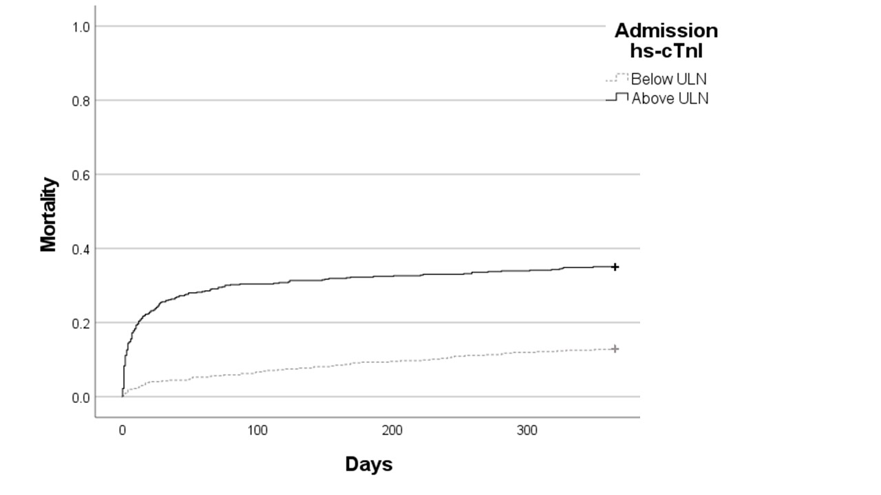
Figure 2: Kaplan Meier curve comparing one year outcomes depending on whether the admission hs-cTnI concentration was above the ULN (log rank p=5.98x10⁻¹⁸) Number at risk:
Days | 0 | 100 | 200 | 300 | 365
Below ULN | 493 | 460 | 446 | 434 | 429
Above ULN | 539 | 375 | 364 | 356 | 350

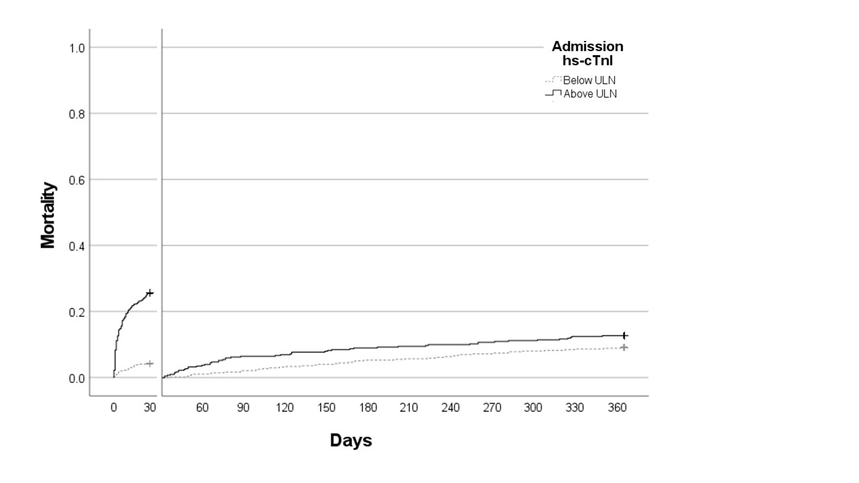Figure 3: Landmark analysis comparing 30 day and one year outcomes depending on whether the admission hs-cTnI concentration was above the upper limit of normal (ULN). Number at risk:
Days | 0 | 30 | 60 | 90 | 120 | 150 | 180 | 210 | 240 | 270 | 300 | 330 | 360
Below ULN | 493 | 472 | 467 | 462 | 456 | 453 | 447 | 445 | 442 | 437 | 434 | 431 | 429
Above ULN | 539 | 401 | 386 | 375 | 373 | 368 | 365 | 363 | 361 | 358 | 356 | 351 | 350

Appendix figures

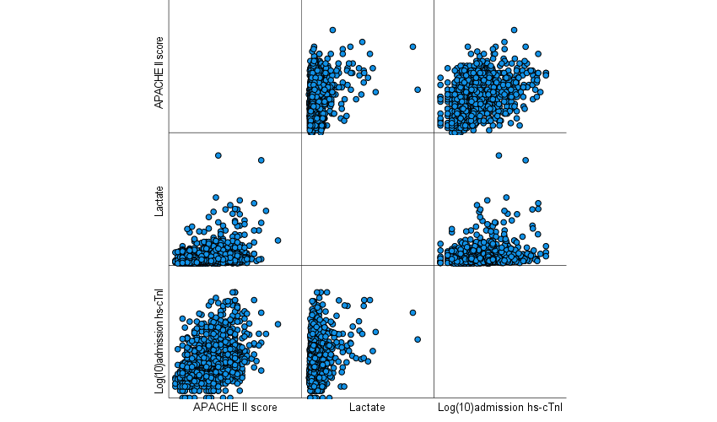

Figure 1a: Dot plot of continuous variables in multivariable model

