Evaluation of European Union carbon and energy networks: Evidence from market efficiency

Xiaohang Ren¹, Yiying Li², Kun Duan³ and Tapas Mishra⁴

Abstract
This article investigates dynamic networks of the informational efficiency between European Union carbon and energy markets in a quantile-based framework. The market (in)efficiency degree is gauged by capturing the potentially fractional integration order of the market price series using the Feasible Exact Local Whittle estimator on a rolling basis. Rather than relying on a mean-based method, we employ the causality-in-quantiles approach, through which the cross-market linkage of the inefficiency degree is uncovered in a full-distributional characterization. The 4dynamic linkage is identified through the perspectives of data in return and volatility, respectively. We find that both carbon and energy markets are inefficient, while the inefficiency degree of the former is slightly higher. The inefficiency degree of the two types of markets is featured by asymmetry and non-linearity over the data distribution, while its cross-market linkage is found to be bi-directional. The spillover degree of the dynamic linkage remains the highest at around the median quantile of the “information giver,” while such the degree weakens at the extreme quantiles. Our findings possess insightful implications for effective operations of the emission trading toward a low carbon transition.

Keywords
Market efficiency, European Union emission trading scheme, energy market, network, causality-in quantiles

¹School of Business, Central South University, Changsha, Hunan, China
²School of Finance, Renmin University of China, Beijing, China
³School of Economics, Huazhong University of Science and Technology, Wuhan, China
⁴Southampton Business School, University of Southampton, Southampton, UK
Corresponding author:
Kun Duan, School of Economics, Huazhong University of Science and Technology, Luoyu Road, Wuhan, 430074, China.
Email: kduan15@outlook.com

Introduction
Over recent decades, climate warming has been claimed to be the most serious environmental issue worldwide that not only weakens the stability of the natural ecosystem but also hinders economic development and even threatens the safety of human beings. To combat the global warming, the emission trading scheme (ETS) of carbon allowances has been manifested as an effective tool in reductions of carbon emissions with a minimum economic cost. Initialized in 2005, European Union (EU) ETS is known to be the first and the largest trading market of carbon allowances worldwide, which has demonstrated its effectiveness in internalizing environmental costs of carbon emissions to the production of installations powered by fossil fuels, and then confronting the climate challenge.^{1–3} Thus, it is evident that an accurate interpretation of the naturally-interlinked (fossil) energy consumption and carbon emissions is crucial. Despite a policy significance, it still has been devoid of in-depth research in this regard.
The existing research by far studies the relationship between carbon and energy markets through the price channel on both aspects of return and volatility. It nevertheless imposes a strict assumption that the market price is an unbiased information indicator for resource allocations, that is, the market is assumed to be efficient. However, this is far from the reality since the status of an efficient market is usually hard to achieve. It indicates that the price dynamics may only be a partial reflection of available market information,^{4,5} and, therefore, inferences drawn by the price linkage between markets would lead to unreliable inferences. To what extent can the target asset/commodity price reflect relevant information depends on the extent to which the market is efficient.⁶ This suggests that studying the interaction of the market (in)efficiency degree can better identify the real cross-market linkage by capturing the extent of market information reflected by the price, while existing related research is surprisingly scant. In addition, extensive evidence has shown the asymmetric pattern of the linkage between carbon and energy market,^{7,8} indicating that the conventional mean-based method would lose the micro-level information. To this end, our paper fills the gap by gauging the inefficiency degree of both carbon and energy markets, and then investigating the cross-market causal linkage of the informational efficiency over the entire data distribution.
Identifying the linkage of informational inefficiency degree between carbon and energy markets is important to various stakeholders. Specifically, a clear linkage identification could help carbon-intensive sectors gain reliable information between carbon and energy market relationship to adjust their energy consumption structures towards low-carbon compliance with minimum adjustment cost.^{9,10} Importantly, a precise understanding of the carbon and energy market linkage could contribute to an effective climate policy against global warming and for the promotion of cleaner energy inputs.⁷ As for financial investors, in the face of globalization and market financialization, accurately interpreting information transmission between the two markets is helpful for risk diversification in their investment portfolios.¹¹ Since an inefficient market suggests the presence of arbitrage opportunities, an accurate grasp of the linkage would offer valuable information for arbitragers to pursue excess profits across markets, and eventually contributing to a co-movement between markets towards an efficient status.¹²
According to the efficient market hypothesis (EMH),¹³ when available market information can be entirely and instantly reflected in the current dynamics of the price series, the market is defined to be efficient; in this case, the price series has one unit root, that is, an I(1) series. However, the dynamics of energy and carbon markets, in reality, tend to be featured by various frictions, which indicate that the current market price may be only a partial reflection of relevant information, suggesting that the market is inefficient (see, e.g. Daskalakis et al.,¹⁴). Following the extant literature (see e.g. Duan et al.,⁶) the market (in)efficiency degree, that is, the closeness to the efficient market status, is computed as the absolute difference between the (fractional) integration order of the price series and 1.¹ Clearly, the measure of the market inefficiency degree is realized by relaxing the traditional assumption of integer integration order to capture its fractionality and the associated longmemory feature of the¹⁵ in carbon and energy markets.² In addition, the informational inefficiency in carbon and energy markets is also found to possess a time-varying property (see e.g. Fan et al.¹⁶).
Therefore, our paper studies the causal relationship of the informational efficiency between EU carbon and (fossil) energy (i.e. crude oil, natural gas, and coal) markets in a quantile-based framework. The market inefficiency degree is gauged by estimating the (fractional) integration order of the price series using the Feasible Exact Local Whittle (FELW) estimator developed by Shimotsu¹⁷ on a rolling-window basis. Unlike many existing results drawn by using the mean-based method, we employ the causality-in-quantiles (CIQs) approach proposed by Jeong et al.,¹⁸ through which the relationship of the informational inefficiency degree between carbon and energy markets is uncovered in a full distributional characterization. It is worth mentioning that, in addition to the data in levels (i.e. data in mean), we further investigate the dynamic relationship in the second moment of the data over the distribution by using the realized volatility of the market inefficiency degree. Through this, a comprehensive study of the cross-market linkage of the inefficiency degree on perspectives of its levels data and volatility is conducted, respectively.
Our paper contributes to the existing literature on the following aspects. First, unlike the existing research on the causal relationship between carbon and energy markets that mostly relies on the price channel, we extend the above research by relaxing the conventional assumption of the efficient market to study the market linkage using the informational inefficiency degree. It is known that the latter considers the presence of market inefficiency that can better identify the real crossmarket relationship by capturing the extent of market information reflected by the price. Second, our employed nonparametric CIQs method provides a comprehensive way to examine the Granger causality of potentially bi-directional cross-market spillovers of the inefficiency degree over the data distribution. In contrast to the mean-based approach that would result in information loss due to the neglect of the asymmetry of the relationship, our employed method tests the Granger causality of the potential bidirectional market linkage on different data quantiles. In addition, based on such a quantile-based method, we can produce robust results even in the face of the complex nonlinear dynamics of carbon and energy prices, notably involving the feature of “fat-tails,” “volatility-clustering,” and “outliers” in the real data. To the best of our knowledge, our research is among the first to study the spillover of the informational efficiency between carbon and energy markets over the entire data distribution.
We find that carbon and energy markets are featured by informational inefficiency, while the inefficiency degree of the carbon market is slightly higher than that of all energy markets. This is attributed to the shorter time period of development of the carbon market compared to that of the fossil energy markets. The inefficiency degree of carbon and energy markets depicts a significant and bi-directional causal relationship both in levels (i.e. mean) and variance over different quantiles of the data distribution. The intensity of the relationship demonstrates a dynamic and asymmetric pattern over the data distribution: its highest value achieves at the median quantile of the specific market served as the “information” giver, while the spillover intensity weakens at the extreme quantiles. Our results possess important implications for various stakeholders for effective climate policy design, sensible cost-evaluation for carbon-intensive sectors, as well as effective arbitrage activities and risk diversification for market investors.
The remainder of the paper proceeds as follows. Section “Literature review” reviews the extant related literature; Section “Methodology and data” describes our employed methods and the dataset; Section “Empirical results” discusses the empirical results; Section “Conclusion” concludes.

Literature review
Our research is closely linked with two strands of literature, that is, the linkage between carbon and (fossil) energy markets, and the informational (in)efficiency degree of the two markets. As for the carbon and energy market relationship, Zhang and Wei¹⁹ find that there exists a time-varying cointegrating relationship between prices of carbon and energy sources. Among others, the crude oil price acts as the most significant factor driving the dynamics of carbon prices. Hammoudeh et al.⁷ point out the significant impact of fossil energy prices on carbon prices, and find that the impact is featured by evident asymmetry over different quantiles of the carbon price distribution. Creti et al.²⁰ study the carbon price determination and find the significant impact of crude oil prices in both Phases I and II of the EU ETS, while prices of natural gas and coal also play an important role.
At the same time, it is known that carbon prices can also impact energy prices, suggesting the two markets could be linked in a bi-directional manner.²¹ Fezzi and Bunn²² find that the dynamics of natural gas prices are governed by the level of carbon prices. Kim et al.²³ hold that carbon costs either in the form of emission permits or tax would be reflected in a higher electricity price, which then induce the production cost of various electricity-powered industries, eventually leading to a fuel switching from high-carbon coal to low-carbon natural gas.²⁴ Such a switching will further raise both the demand and price of natural gas. Marimoutou and Soury²⁵ examine the carbon and energy market dependence between carbon and energy price volatility, and find that the dependence is fluctuating over time, especially during the period of financial turmoil. Wang and Guo²⁶ identify the dynamic interaction between carbon and energy markets by constructing the spillover index in both perspectives of return and volatility. They provide quantitative evidence to show that the crude oil market contributes to the strongest spillover effect on the carbon market, while markets of both natural gas and coal also play an important role in the information transmission to the carbon market.
The research on the carbon and energy market efficiency has raised increasing attention with the ongoing development of carbon trading and rapid financialization of these commodity markets worldwide.^{8,27–29} Previous studies using early market transaction data find that the EU ETS was far from being efficient in Phase I.⁵ The empirical evidence on characteristics of price dynamics that favor inefficient carbon market notably includes the jump behavior¹⁴ and the short-memory.³⁰ Daskalakis and Markellos⁵ attribute the inefficiency of the EU ETS during Phase I to the banking limitation of carbon allowances over phases. Montagnoli and De Vries³¹ perform a series of variance ratio tests to conclude the inefficiency in Phase I of the EU ETS, while they also find the extent of efficiency of EU ETS gradually increases towards an efficient market in the following phases. This finding is consistent with existing literature,³² and also confirms the time-varying property of the efficiency degree of the carbon market.³³
In terms of energy markets, empirical evidence also supports the time-varying market efficiency degree of fossil energy sources (i.e. crude oil, natural gas, and coal) (see e.g. Alvarez-Ramirez et al.³⁴, Kuruppuarachchi et al.,³⁵ Kristoufek and Vosvrda³⁶). Among others, Kuruppuarachchi et al.³⁵ proposes a novel index to gauge the informational efficiency in energy futures markets of crude oil, natural gas, heating oil, and gas oil, and find dynamic degrees of the market efficiency across terms and energy types. They find that the gas oil futures market is ranked as the most efficient and the natural gas futures market has the lowest efficiency, while the efficiency degree across markets is shown to be interacted. Kristoufek and Vosvrda³⁶ find that markets of energy commodities possess higher efficiency degrees compared to that of agricultural commodities. Focusing on the crude oil market, Alvarez-Ramirez et al.³⁴ provide mix empirical results on whether the market is efficient, indicating that conclusions of the oil market efficiency degree are still not definite. By reviewing the extant related literature, it is clear that while studying the interaction of the informational (in) efficiency degree can better identify the cross-market linkage than the inferences drawn by simply relying on the price information, existing research in this regard is still scant, especially with regard to the markets of energy and carbon. In addition, the potentially asymmetric market interaction still entails an in-depth investigation through a quantile-based framework.
Methodology and data

Methodology
The market (in)efficiency degree. As previously discussed, the degree of the market (in)efficiency is measured by gauging the closeness of the actual market condition to the theoretical efficient market status. And the theoretical efficient market status can be achieved when the market price series follows a random walk shown as an I(1) process. In other words, what we are measuring is the difference between the performance of the actual and the theoretical efficient market price series. To ensure an accurate and simple calculation, we follow Duan et al.³⁷ by relaxing the conventional assumption of integer integration order (d) to fully capture the potential existence of fractional d value of the price series. This approach enables longer-term market price information to be captured, reducing information interference and facilitating comparisons between individual markets.⁶ Through this, a comprehensive measurement of d values is provided, and the market inefficiency degree (D) can be then computed by taking the absolute difference between d of the price series and 1 (representing the standard value of the theoretical efficient market).
D_{t} = |1 − d_{t}| (1)
To explain the term of the market efficiency degree, the larger the distance between the actual market condition and the efficient status, the more inefficient the market, and the greater the market inefficiency degree (D) will be. Following Duan et al.,⁶ each of the rolling-window sizes is set as a whole year.
Regarding the calculation of (fractional) integration order (d), we follow the extant literature by estimating d through the Feasible Exact Local Whittle (FELW) estimator developed by Shimotsu.¹⁷ Specifically, the FELW estimator is built based on the ELW estimator developed by Shimotsu et al.,³⁸ through which the d value of the target price series (Y_{t}) is estimated by minimizing the following objective function.
λ ) 1/GI (
Q_{m}(G, d) = m1 i=m1 log(G _{j}⁻2d + (1−L)dYt λj) (2)
Concentrating Q_{m}(G, d) with regard to G, the ELW estimator is exhibited as
dˆ 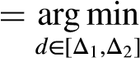R(d) (3)
where m is the truncation parameter of function (2), Δ₁ and Δ₂, respectively, denote lower and upper bounds of admissible values of d subject to −∞ < Δ₁ < Δ₂ < +∞, and
1 m
R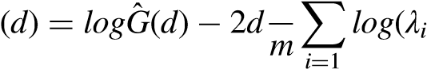) (4)
G^{ˆ} 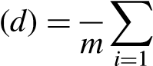1 ^{m I}_{Δ}dYt log(λ_{i}) (5)
In certain conditions notably when 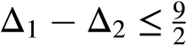, the ELW estimator is consistent following an asymptotic normal distribution such that √m(dˆ 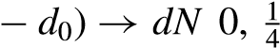 , n ∞, where n stands for the sample size and d₀ stands for the true value of d, d₀ ∈ (Δ₁, Δ₂).
The ELW estimator can be further extended to the FELW estimator, which estimates the unknown mean value (μ) of Y_{t} using the following function
} (6)
where Y denotes the sample average of Y_{t}, L{.} denotes an indicator function with c 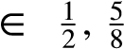 . Overall, it is clear that the FELW estimator for (fractional) integration order (d) of Y_{t} can be established through the ELW d estimator of the demeaned Y_{t}, that is, Y_{t} − μˆ(d).
The CIQs approach. In this section, we introduce our employed causality-in-quality approach initially developed by Jeong et al.,¹⁸ through which the relationship of the market inefficiency degree between carbon and three energy markets is studied. It is worth mentioning that Balcilar et al.³⁹ extendJeong et al.¹⁸ by modeling the causality between target series based on the first-order moment to that based on the second-order moment.
The different quartiles in many cases represent different market states, bear or bull markets, or the level of shocks, and so on (see e.g. Peng et al.,⁴⁰ Scarcioffolo and Etienne,⁴¹ Ren et al.⁴²). Therefore, our use of quantile Granger causality tests can help us to understand more fully the correlation between different levels of market efficiency across carbon markets and each of the three energy markets. Unlike the causality test in the first-order moment, which is usually questioned by significant uncertainty and confusion, we investigate the linkage of the market inefficiency degree between these markets through a comprehensive manner on both the first- and second-order moments, that is, data in levels and volatility, respectively.
Denote the market efficiency of carbon futures as y_{t} and the market efficiency of the other three energy futures markets is defined as x^{n}_{t} , where n = 1, 2, 3 represent crude oil futures, natural gas futures, and coal futures, respectively. Then, using the definition of quantile causality of Jeong et al.¹⁸ and taking their lag terms {yt₋1, ..., yt₋p, x^{n}_{t}−1, ..., x^{n}_{t}−p} in to account, x^{n}_{t} does not Granger cause y_{t} in the θ_{-th quantile if:}
Qθy_{t}|y_{t−}1, , y_{t−}p (7)
where^{n} ≡Q(x_{θt}(−y1_{t},|)...is the, x_{t}−pθ)-,th quantile ofZ_{t} = (X_{t}^{n}, Y_{t}), andy_{t} in tiimeF_{yt}|Z_{t−}1(yt_{t}|and 0Z_{t}−1) denote the conditional distribution func< θ < 1³ . Let Y_{t}−1 ≡ (y_{t}−1, ..., y_{t}−p)-,
X_{t}−1 tions of y_{t} in a given Z_{t}−1. In this way, we can express the hypothesis in the following form:
H0 = P F yt|Zt−1{Qθ(Yt−1)|Zt−1} = θ = 1  H1 = P Fyt|Zt 1{Qθ(Yt−1)|Zt−1} = θ < 1 | (8)  (9)
−
In this step, Jeong et al.¹⁸ considers the following form of distance measurement
J = E Fyt |Zt−1{Qθ(Yt−1)|Zt−1} − θ2fZ(Zt−1) (10)
where f_{Z}(Z_{t}−1) is the marginal density function of Z_{t}−1. Note that J ≥ 0, if and only if, H₀ is true.
Therefore, we can use J to test H₀ consistently. The kernel-based test statistic for J is
T T
JˆT 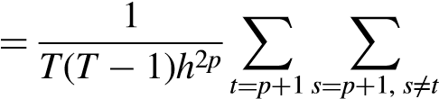 Ktsεˆtεˆs (11)
T T
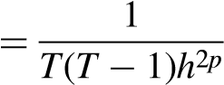
Kts1 yt ≤ Qˆ θ( )xt − θ1 ys ≤ Qˆ θ( )xs − θ (12)
t=p+1 s=p+1, s≠t
where K_{ts} = K( ^{Zt}−¹⁻_{h}^{Zs}−¹ ) is the kernel function, h is a bandwidth and T is the sample size. p represents the number of lags, and εˆ_{t} is an estimate of the error of the regression process.
Balcilar et al.³⁹ further expands Jeong et al.¹⁸ by putting forward a null and alternative test hypothesis about the causal relationship in variances. The specific equation is as follows
H0 = P F y2t |Zt−1{Qθ(Yt−1)|Zt−1} = θ = 1 (13)
H1 = P F y2t |Zt−1{Qθ(Yt−1)|Zt−1} = θ < 1 (14)
The extended test method enables researchers to observe the Granger causal correlations among x^{n}_{t} and y_{t} in θth quantile at higher moments while using equation (13) to formulate the feasible kernelbased test statistic following Jeong et al.¹⁸. This article focuses on the interaction between the market efficiency of crude oil, natural gas, and coal, which are the three dominant energy futures markets, and the market efficiency of carbon futures markets. For each energy futures market, we will conduct the quantile causality test above with the carbon futures.

Data
To study the dependence of market inefficiency degree between carbon and (fossil) energy (i.e. crude oil, natural gas, and coal) markets, we accordingly collect daily price data of ECX EUA carbon futures prices, Brent crude oil futures prices, UK natural gas futures prices, and Rotterdam coal futures prices. The data are retrieved from the Intercontinental Exchange (ICE) covering the period of 6 June 2014 to 16 April 2021. As previously discussed in “Methodology” section, the market inefficiency degree is computed using equation (1) as the absolute difference between the fractional integration order (d) of the price series and 1 where d is estimated using the FELW estimator. Following extant literature,^{43,44} we focus on futures rather than spot contracts to eliminate risks notably including abnormal price jumps and structural breaks potentially being exposed in the spot price series.⁴
Figure 1 plots the daily dynamics of the market inefficiency degree of the ECX EUA carbon futures, Brent crude oil futures, UK natural gas futures, and Rotterdam coal futures, respectively. It is intuitive that there is no definite moving tendency in the dynamics of the inefficiency degree of the four markets during the sample period. Corresponding descriptive statistics are reported in Table 1. Intuitively, the statistical property of the series of market inefficiency
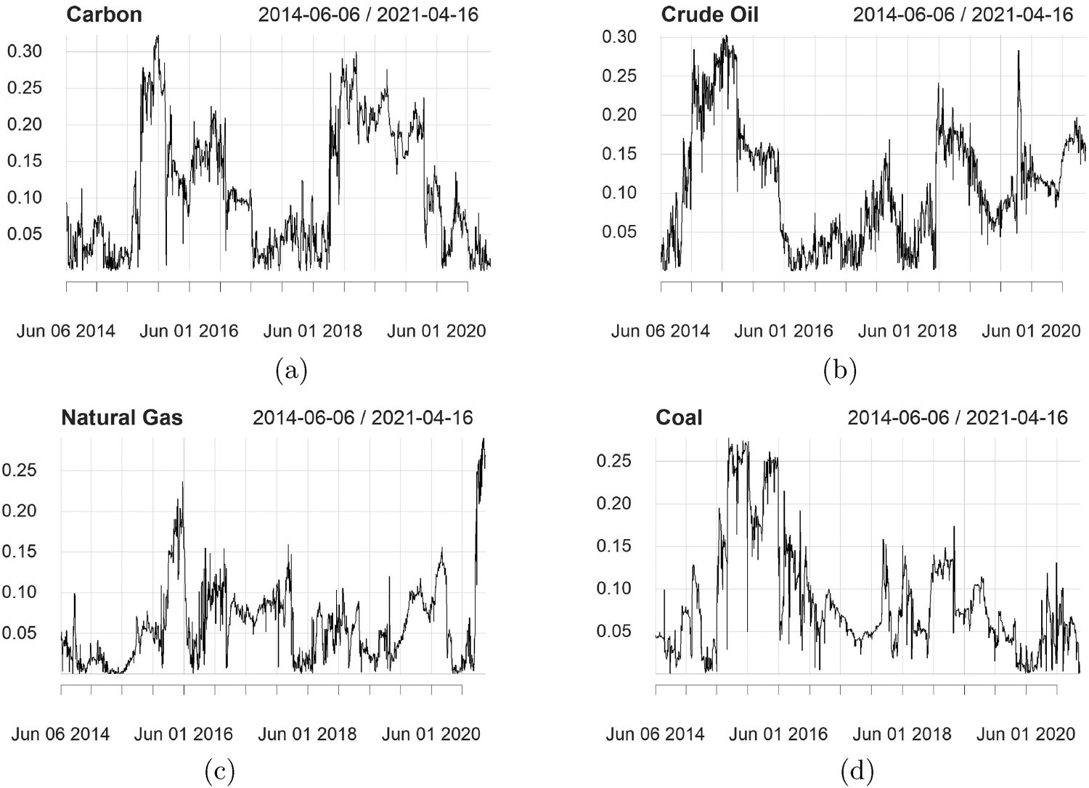
Figure 1. Time series plots of the inefficiency degree of carbon futures, Brent crude oil futures, natural gas futures, and coal futures markets from 2014-06-06 to 2021-04-16. (a) Carbon futures market. (b) Brent crude oil futures market. (c) Natural gas futures market. (d) Coal futures market.
Table 1. Descriptive statistics.
 | Oil | Carbon | Gas | Coal
Minimum | 0.0003 | 0.0002 | 0.0000 | 0.0000
Maximum | 0.3032 | 0.3231 | 0.2903 | 0.2776
1. Quartile | 0.0441 | 0.0329 | 0.0207 | 0.0432
3. Quartile | 0.1584 | 0.1836 | 0.0854 | 0.1142
Mean | 0.1086 | 0.1099 | 0.0607 | 0.0864
Stdev | 0.0745 | 0.0839 | 0.0505 | 0.0650
Skewness | 0.5392 | 0.4980 | 1.5336 | 1.2655
Kurtosis  JB test |  |  | 3.4054  1549.5612∗∗∗ | 0.9803  543.2381∗∗∗
ADF test | −2.7187∗∗∗ | −2.4700∗∗∗ | −2.9887∗∗∗ | −3.3670∗∗∗
Note: (i) This table summarizes descriptive statistics of the daily market efficiency of carbon futures, Brent crude oil futures, natural gas futures and coal futures markets. (ii) The sample period is from 2014-06-06 to 2021-04-16. (iii) The Jarque-Bera (JB) statistics test for the null hypothesis of normality of target series. The Augmented Dickey-Fuller (ADF) test reports unit root test results with the null hypothesis of non-stationarity. (iv) ∗ denotes the 10% significance level; ∗∗ denotes the 5% significance level; ∗∗∗ denotes the 1% significance level.
degrees of carbon and energy markets appears to be highly similar. Specifically, as the latest emerging market, the carbon futures market has the largest average market inefficiency degree (0.1099), while its volatility is also ranked as the highest (0.0839). Among others, the kurtosis value is positive, indicating that the data is featured by evident asymmetry with heavier tails compare to the normal distribution. The rejection of the null of the Jarque-Bera (JB) test further manifests the non-normal distribution of our empirical data. In addition, the significant rejection of the null of the Augmented Dickey-Fuller (ADF) test suggests the stationarity of each of the target series.
To further visualize the distribution of our empirical data, we report the density plot of the four series of the market inefficiency degree as shown in Figure 2. Each of the sub-plot offers an intuitive comparison between the distribution of each of the target series and the normal distribution. It is clear that the data distribution of the market inefficiency degree is featured by positive skewness with a presentation of “fat-tails,” indicating the asymmetry of the distribution. Such the asymmetric data distribution is also consistent with the existing research on the efficiency of the energy and European carbon markets (see e.g. Zou and Zhang⁴⁵). Overall, empirical evidence from both the
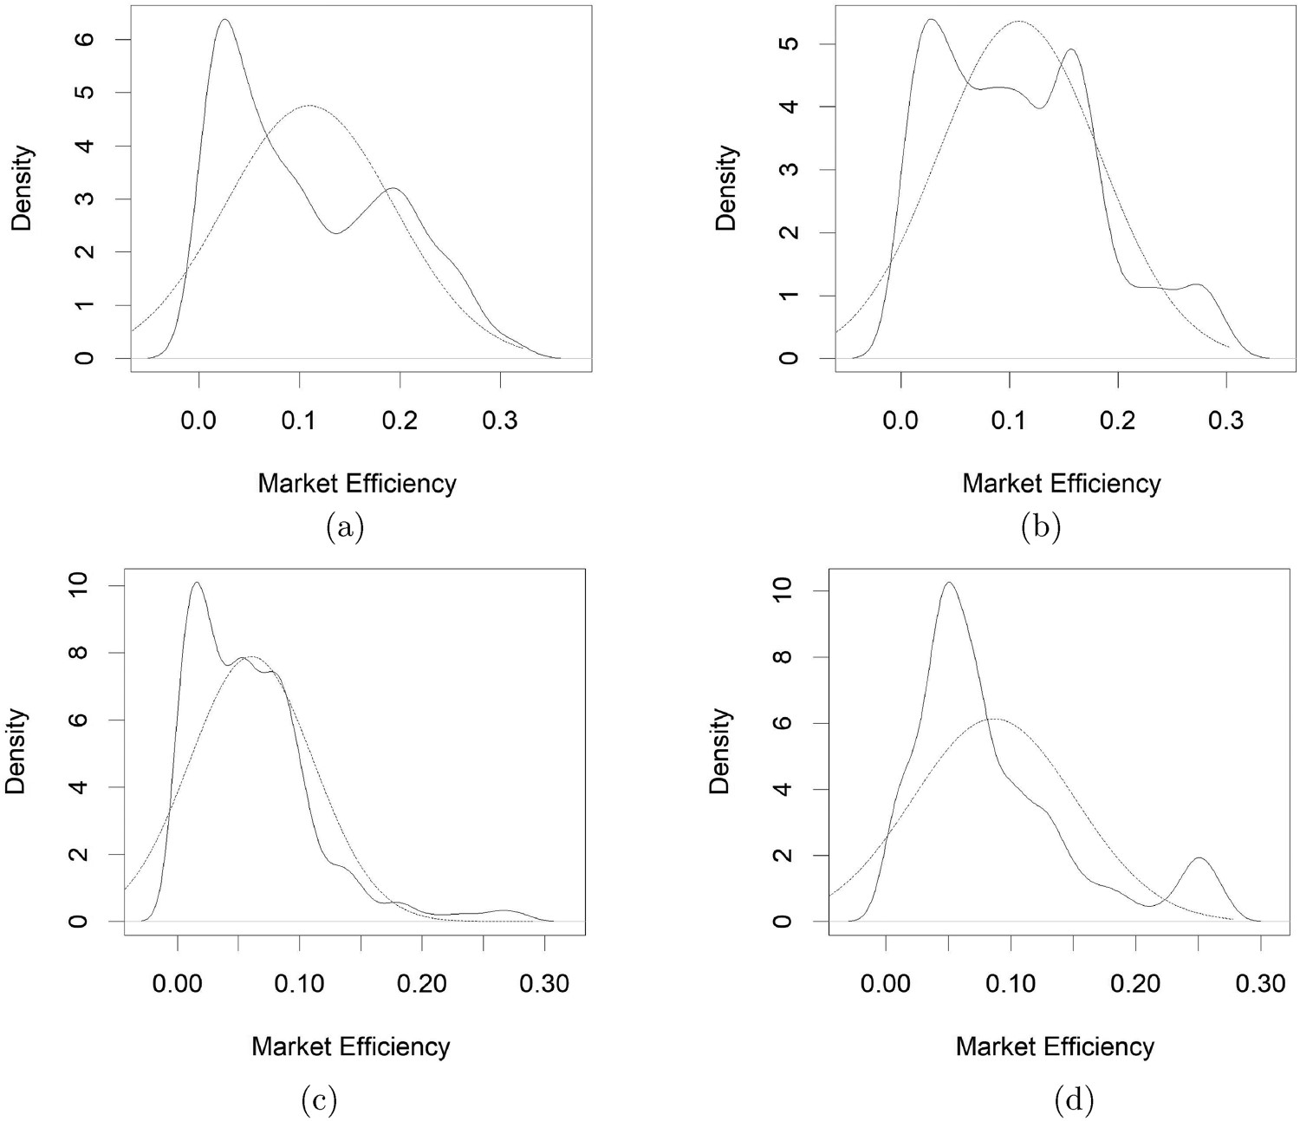
Figure 2. Density plots of the inefficiency degree of carbon futures, Brent crude oil futures, natural gas futures, and coal futures markets from 2014-06-06 to 2021-04-16. (a) Carbon futures market. (b) Brent crude oil futures market. (c) Natural gas futures market. (d) Coal futures market.
statistical nature of the data and the data visualization demonstrates the presence of evident asymmetry of our data, further indicating the appropriateness of employing a quantile method rather than conventional mean-based ones in our study.

Empirical results
Motivated by asymmetry and non-linearity in the data distribution, and in the light of Jeong et al.¹⁸, Balcilar et al.³⁹, we employ the non-parametric CIQ test to study the pairwise and causal relationship of the inefficiency degree between carbon and energy (i.e. crude oil, natural gas, and coal) markets. The bi-directional and causal relationship of the inefficiency degree is, respectively, studied using the data in levels (i.e. mean) and volatility with the corresponding results reported in Figures 3 to 5. Through this, both the direction and magnitude of the
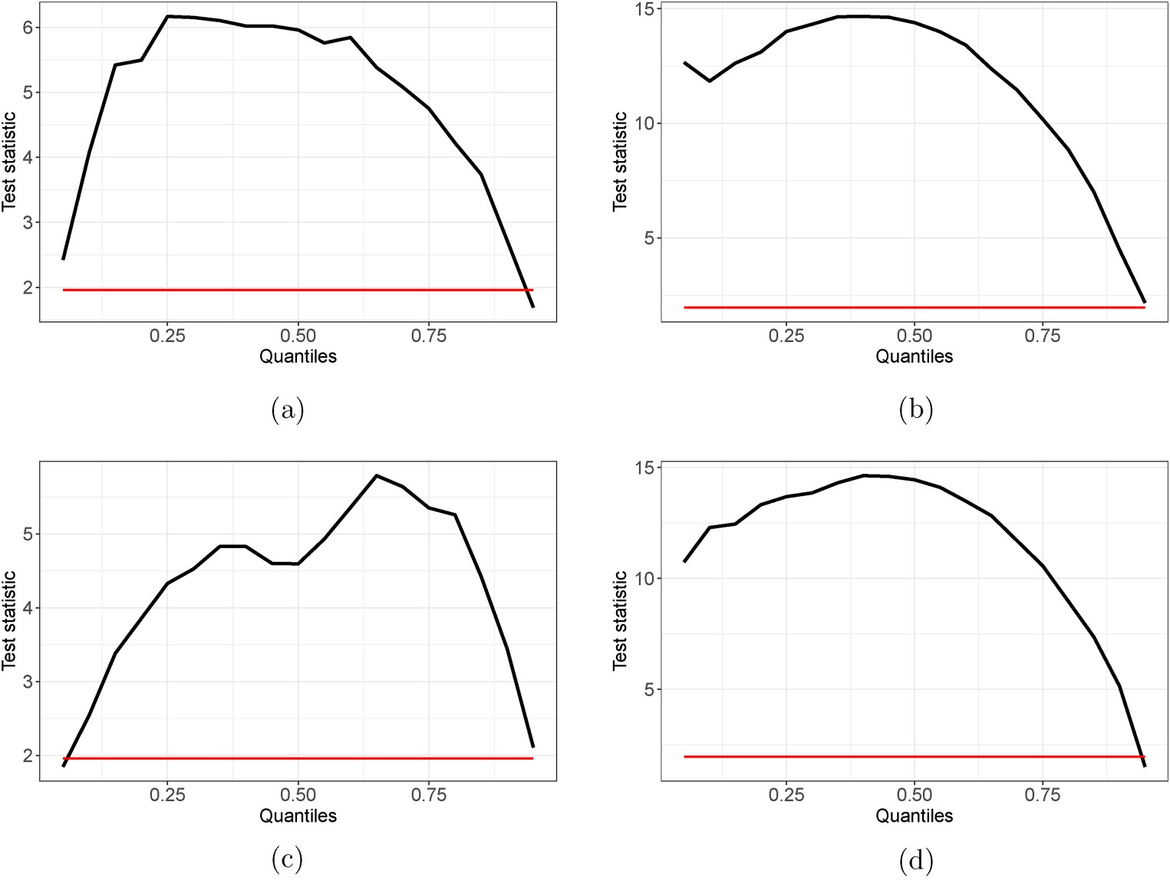
Figure 3. Causality-in-quantiles (CIQs) test results for the relationship of the inefficiency degree between the carbon and crude oil markets. (a) Mean (Oil → Carbon); (b) Variance (Oil → Carbon); (c) Mean (Carbon → Oil); and (d) Variance (Carbon → Oil).
Note: (i) This figure plots the CIQ test results of the spillover effect of the inefficiency degree between the carbon and crude oil markets formed by both data in levels (i.e. mean) and volatility, respectively. The corresponding results in the data format of levels (shown in (a) and (c)) and volatility (shown in (b) and (d)) are: , respectively, reported. The estimated critical value (CV) at 5% level is represented as the horizontal red solid line in each sub-plot. (ii) The vertical axis reports the test statistics of the null hypothesis of the CIQ test, and the horizontal axis indicates the different quantile levels of the specific market of the information “giver” (from q = 0.05 to q = 0.95).
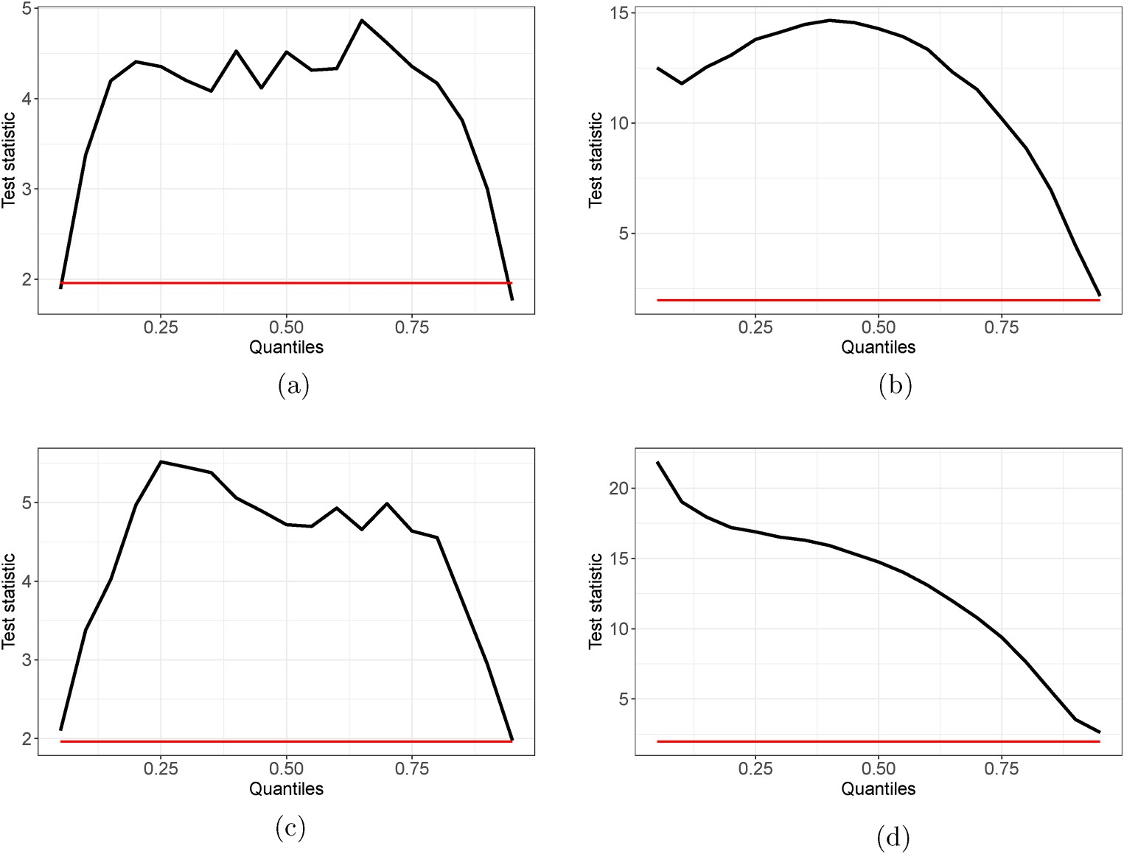
Figure 4. Causality-in-quantiles (CIQs) test results for the relationship of the inefficiency degree between the carbon and natural gas markets. (a) Mean (Natural Gas → Carbon); (b) Variance (Natural Gas → Carbon); (c) Mean Carbon → Natural Gas); and (d) Variance (Carbon → Natural Gas).
Note: (i) This figure plots the CIQ test results of the spillover effect of the inefficiency degree between the carbon and natural gas markets formed by both data in levels (i.e. mean) and volatility, respectively. The corresponding results in the data format of levels (shown in (a) and (c)) and volatility (shown in (b) and (d)) are, respectively, reported. The estimated critical value (CV) at 5% level is represented as the horizontal red solid line in each sub-plot. (ii) The vertical axis reports the test statistics of the null hypothesis of the CIQ test, and the horizontal axis indicates the different quantile levels of the specific market of the information “giver” (from q = 0.05 to q = 0.95).
causal relationship between markets are investigated. That is, both the information “giver” and “receiver,” as well as their impact magnitude, during the transmission are identified. We then discuss our research findings.

Information spillover of the inefficiency degree across markets
We first conduct a quantile decomposition on the inefficiency degree of carbon, crude oil, natural gas, and coal futures markets both in levels (i.e. mean) and volatility. Then, the CIQ test is employed to identify the potentially bi-directional causal linkage of the inefficiency degree on the perspectives of mean and variance between carbon and each of the energy markets. An associated discussion is provided to summarize our findings. In terms of the relationship between carbon and crude oil markets, as shown in Figure 3, except for minor and extreme status (i.e.
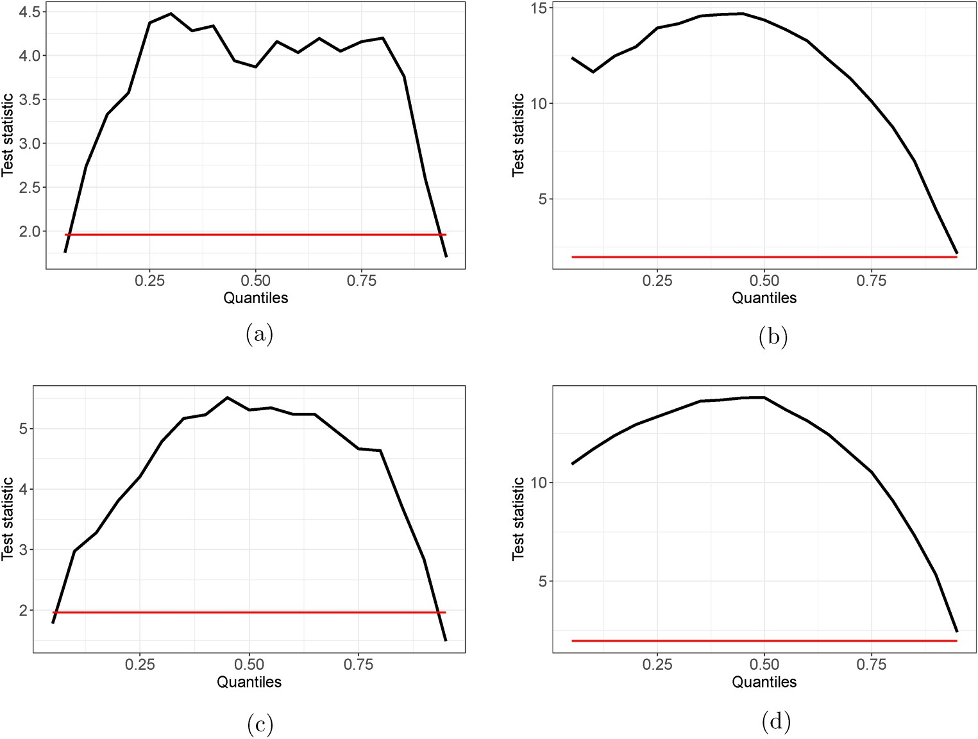
Figure 5. Causality-in-quantiles (CIQs) test results for the relationship of the inefficiency degree between the carbon and coal markets. (a) Mean (Coal → Carbon); (b) Variance (Coal → Carbon); (c) Mean (Carbon → Coal); and (d) Variance (Carbon → Coal).
Note: (i) This figure plots the CIQ test results of the spillover effect of the inefficiency degree between the carbon and coal markets formed by both data in levels (i.e. mean) and volatility, respectively. The corresponding results in the data format of levels (shown in (a) and (c)) and volatility (shown in (b) and (d)) are: , respectively, reported. The estimated critical value (CV) at 5% level is represented as the horizontal red solid line in each sub-plot. (ii) The vertical axis reports the test statistics of the null hypothesis of the CIQ test, and the horizontal axis indicates the different quantile levels of the specific market of the information “giver” (from q = 0.05 to q = 0.95).
extreme high or low quantiles), the efficiency degree of the two markets is causally and significantly related to each other in both directions across different locations of the data distribution at 5% level. Such the bidirectional causal relationship of the market inefficiency degree is found in the data format of levels (i.e. mean) (shown in Figure 3(a) and (c)) and volatility (shown in Figure 3(b) and (d)), respectively.
Importantly, while the causal relationship obtained by using both mean and volatility data shows the highest magnitude at about the median quantile, the spillover pattern of the inefficiency degree using the two data types differ at low quantiles. When the inefficiency degree of the information “giver” market is low, the intensity of the cross-market spillover is also weak using the levels (i.e. mean) data, while being relatively strong using the volatility data. The cross-market spillover intensity is consistently weak using both the two types when the inefficiency degree of the information “giver” is at high quantiles. Our results are consistent with the extant literature, which has widely reported the significant bi-directional correlation between carbon and crude oil markets^{46,47}. On top of that, we clearly identify the potential asymmetry and non-linearity of the correlation.
Regarding the relationship of the inefficiency degree of the carbon market with that of gas and coal markets, it is highly similar to such the relationship between carbon and oil markets. The causal linkage between carbon and gas markets, as well as between carbon and coal markets are shown in Figures 4 and 5, respectively. For each pairwise linkage, the magnitude and direction of the causality are examined by using the data format of levels (i.e., mean) and variance. Specifically, as for the carbon and gas market interaction, the spillover of the inefficiency degree is shown to be significant and asymmetric on both directions at most quantiles of the data distribution at 5% level, except for minor status at extremely high or low quantiles. Moreover, the intensity of the spillover exhibits the highest at around the median quantile, except for the specific spillover from carbon to gas markets when using volatility data. Although being significant, the spillover formed by levels data tends to be weak at both extremely high and low quantiles of the information “giver” market, while a weak spillover when using volatility data only occurs at extremely high quantiles.
Similarly, the spillover of the inefficiency degree between carbon and coal markets formed by both levels and volatility data depicts an asymmetric and nonlinear pattern over the data distribution, while having the highest intensity at around the median quantile. The spillover intensity weakens and approaches to the lowest value at extremely (high and low) quantiles when using levels data, but the intensity reduces to the lowest level only at extremely high quantiles when using volatility data. Except when the inefficiency degree of the specific information “giver” market is at very low or high levels, the spillover remains significant over the entire distribution at 5% level. Our findings in favor of the significant linkage between the carbon market and both gas and coal markets are in line with the existing literature (see e.g. Li and An⁴⁸, Jiang et al.⁴⁹, Chen et al.⁵⁰).
Overall, we find that the spillover effect of the inefficiency degree between the carbon market and the target fossil energy markets formed by both data in levels and volatility is bi-directional, asymmetric, nonlinear, and significant over the data distribution. Generally, the spillover intensity tends to be the highest at around the median quantile, while the intensity weakens and approaches to the lowest value at extreme quantiles. In particular, as for the spillover from energy to carbon markets, the interdependence remains highest at around normal values, that is, the median quantile of the inefficiency degree of the carbon market. The lowest intensity of the spillover achieves when the carbon market is either highly inefficient, that is, high quantiles of the carbon inefficiency degree, or high efficient, that is, low quantiles. It indicates that the spillover of the inefficiency degree from energy to the carbon markets is the highest when the carbon market inefficiency degree is at the normal quantile of its distribution. In parallel, the carbon market is far from a mere information “receiver”; instead, it could also serve as a “giver” and provide information to energy markets, forming a bi-directional and important impacting loop.

Robustness checks
How robust will our findings behave in the face of research alternations such as the data transformation and the estimation technique? To examine the robustness, we accordingly conduct two additional analyses. First, instead of using the demeaned and detrended data, we apply the raw series to the estimation of (fractional) integration order (d) of the target price series and the following analysis of the interaction of the inefficiency degree between carbon and energy markets. The corresponding CIQ test results of the cross-market spillover effect are shown in Figures 1 to 3.
Second, as for the d estimation, we replace the FELW estimator employed in the main analysis to another popular semi-parametric d estimator, that is, Exact Local Whittle (ELW) estimator initially developed by Shimotsu et al.³⁸, and then generate the d series for the carbon and energy markets. The CIQ test results regarding the cross-market spillover of the inefficiency degree based on the newly generated d series are accordingly exhibited in Figures 4 to 6. Overall, with regard to the cross-market spillover of the inefficiency degree formed by both data in levels and volatility, it is clear that the conclusions from the above additional analyses are highly consistent with that of our main analysis as well as the extant related literature. Thus, the robustness of our findings is reassured that the carbon market is far from being independent; instead, it forms a dynamic system with energy markets where the spillover of the informational (in)efficiency degree exists in a bi-directional manner.

Conclusion
This article estimates the inefficiency degree of carbon and (fossil) energy (i.e. crude oil, natural gas, and coal) markets using the FELW estimator, and then investigate the possibly bi-directional causal linkage of the cross-market inefficiency degree formed by both data in levels (i.e. mean) and volatility, respectively. The potential asymmetric and non-linear feature of the cross-market causal linkage over the data distribution is captured by employing the recently developed CIQs test.
We find that both the carbon and energy markets are featured by informational inefficiency. While being similar, both the mean and variance of the inefficiency degree of the carbon market are higher than that of all energy markets. This is in line with our expectations that the carbon market tends to be more inefficient and immature due to its shorter period of development against fossil energy markets. The inefficiency degree of carbon and energy markets exhibits a bi-directional and asymmetric causal relationship, which is significant over the data distribution except at a minor status of extremely high or low quantiles. The spillover intensity is the highest at around normal values, that is, the median quantile of the specific market served as the “information giver,” while its intensity weakens and approaches to the lowest at the extreme quantiles. The above findings confirm that the carbon market forms a dynamic system with energy markets where the cross-market spillover pattern of the informational (in)efficiency degree is bi-directional, asymmetric, and nonlinear.
Our findings have important implications for various stakeholders. In general, our findings of the strong co-movement of the (in)efficiency degree between carbon and energy (i.e. crude oil, natural gas, and coal) markets indicate high predictability of the market dynamics by using the information from one another. This may be due to the fact that there exist certain common factors that drive the dynamics of the (in)efficiency degree of carbon and energy markets simultaneously. The above findings question the function of the “safe haven” of carbon and/or energy markets when building the investment portfolio by using assets/commodities from these markets. This is because that variations in the (in)efficiency degree from one market could quickly transmit to another market, and investors may have insufficient time to respond accordingly. The findings also help market investors identify the potentially close linkage of the carbon and energy related assets, and then contribute to the risk mitigation when building a portfolio. In parallel, an accurate interpretation of the carbon and energy market linkage with regard to the inefficiency degree also offers valuable information to policymakers for effective operations of the ETS and sensible climate policy implementation. The findings also provide valuable information to carbon-intensive sectors for reliable assessment of their production cost, adjusting their energy consumption structures towards the low carbon target with a minimum economic cost.

Compliance with ethical standards
The authors declare no relevant financial or non-financial interests to disclose. The authors confirm that their research in the manuscript involves no human participants and/or animals. They can also confirm that the manuscript has not been previously published, is not currently submitted for review to any other journal, and will not be submitted elsewhere before a decision is made by this journal.

Declaration of conflicting interests
The author(s) declared no potential conflicts of interest with respect to the research, authorship, and/or publication of this article.
Funding
The author(s) received no financial support for the research, authorship, and/or publication of this article.

ORCID iD
Kun Duan https://orcid.org/0000-0003-3897-4081

Notes
- The I(1) price series indicates that the market is efficient. Any deviation of the integration order from 1 indicates the presence of inefficiency, and the market inefficiency degree indicates the extent of the deviation. The greater the market inefficiency degree, the large deviation of the market from the efficiency status.
- There exists an increasing evidence showing the presence of fractional integration order of carbon andenergy prices, and the associated long-memory property (see e.g. Liu and Chen,⁵¹ Elder and Serletis,⁵² Tiwari et al.⁵³).
- In this article, each of the individual sequences are divided into 19 quantile points, specifically: 0.05, 0.1,
0.15,…, 0.95.
- Prior to the empirical analysis including the d estimates and the analysis of the interaction of the inefficiency degree between carbon and energy markets, each of the raw series is demeaned and detrended to make it be more comparable over time⁶.

References
- Ren X, Dou Y, Dong K, Li Y, et al. Information spillover and market connectedness: multi-scalequantile-on-quantile analysis of the crude oil and carbon markets. Appl Econ 2022a; 54: 4465–4485.
- Wei P, Qi Y, Ren X, Duan K, et al. Does economic policy uncertainty affect green bond markets?Evidence from wavelet-based quantile analysis. Emerg Mark Financ Trade 2022; 58(15): 4375–4388.
- Yu L, Li J and Tang L. Dynamic volatility spillover effect analysis between carbon market and crude oilmarket: a DCC-ICSS approach. Int J Glob Energy Issues 2015a; 38: 242–256.
- Chen J, Wang Y and Ren X. Asymmetric effects of non-ferrous metal price shocks on clean energy stocks: evidence from a quantile-on-quantile method. Resour Policy 2022; 78: 102796.
- Daskalakis G and Markellos RN. Are the European carbon markets efficient. Rev Futures Mark 2008; 17: 103–128.
- Duan K, Li Z, Urquhart A, Ye J, et al. Dynamic efficiency and arbitrage potential in bitcoin: a longmemory approach. Int Rev Financ Anal 2021a; 75: 101725.
- Hammoudeh S, Nguyen DK and Sousa RM. Energy prices and CO2 emission allowance prices: a quantileregression approach. Energ Policy 2014; 70: 201–206.
- Ren X, Duan K, Tao L, Shi Y, Yan C, et al. Carbon prices forecasting in quantiles. Energ Econ 2022b; 108: 105862.
- Duan K, Ren X, Shi Y, Mishra T, Yan C, et al. The marginal impacts of energy prices on carbon pricevariations: evidence from a quantile-on-quantile approach. Energ Econ 2021b; 95: 105131.
- Zhang YJ and Sun YF. The dynamic volatility spillover between European carbon trading market andfossil energy market. J Clean Prod 2016; 112: 2654–2663.
- Subramaniam N, Wahyuni D, Cooper BJ, Leung P, Wines G, et al. Integration of carbon risks and opportunities in enterprise risk management systems: evidence from Australian firms. J Clean Prod 2015; 96: 407–417.
- Fan JH and Todorova N. Dynamics of China’s carbon prices in the pilot trading phase. Appl Energy 2017; 208: 1452–1467.
- Fama EF. Efficient capital markets: a review of theory and empirical work. J Finance 1970; 25: 383–417 10.1111/j.1540-6261.1970.tb00518.x. http://arxiv.org/abs/https://onlinelibrary.wiley.com/doi/pdf/10. 1111/j.1540-6261.1970.tb00518.x.
- Daskalakis G, Psychoyios D and Markellos RN. Modeling CO2 emission allowance prices and derivatives: evidence from the European trading scheme. J Bank Financ 2009; 33: 1230–1241.
- Wu L and Chen S. Long memory and efficiency of bitcoin under heavy tails. Appl Econ 2020; 52: 5298– 5309.
- Fan X, Lv X, Yin J, Tian L, Liang J, et al. Multifractality and market efficiency of carbon emission trading market: analysis using the multifractal detrended fluctuation technique. Appl Energy 2019; 251: 113333. 17. Shimotsu K. Exact local Whittle estimation of fractional integration with unknown mean and time trend. Econ Theory 2010; 26: 501–540.
- Jeong K, Härdle WK and Song S. A consistent nonparametric test for causality in quantile. Econ Theory 2012; 28: 861–887 10.1017/s0266466611000685.
- Zhang YJ and Wei YM. An overview of current research on EU ETS: evidence from its operating mechanism and economic effect. Appl Energy 2010; 87: 1804–1814.
- Creti A, Jouvet PA and Mignon V. Carbon price drivers: phase I versus phase II equilibrium? Energy Econ 2012; 34: 327–334.
- Yu L, Li J, Tang L, Wang S, et al. Linear and nonlinear Granger causality investigation between carbonmarket and crude oil market: a multi-scale approach. Energy Econ 2015b; 51: 300–311.
- Fezzi C and Bunn DW. Structural interactions of European carbon trading and energy prices. J Energy Mark 2009; 2: 53.
- Kim W, Chattopadhyay D and Park Jb. Impact of carbon cost on wholesale electricity price: a note onprice pass-through issues. Energy 2010; 35: 3441–3448.
- Squalli J. Renewable energy, coal as a baseload power source, and greenhouse gas emissions: evidencefrom US state-level data. Energy 2017; 127: 479–488.
- Marimoutou V and Soury M. Energy markets and CO2 emissions: analysis by stochastic copula autoregressive model. Energy 2015; 88: 417–429.
- Wang Y and Guo Z. The dynamic spillover between carbon and energy markets: new evidence. Energy 2018; 149: 24–33.
- Duan K, Ren X, Wen F, Chen J, et al. Evolution of the information transmission between Chinese andinternational oil markets: a quantile-based framework. J Commodity Mark 2023; 29: 100304.
- Ren X, Li Y, Qi Y, Duan K, et al. Asymmetric effects of decomposed oil-price shocks on the EU carbonmarket dynamics. Energy 2022c; 254: 124172.
- Ren X, Wang R, Duan K, Chen J, et al. Dynamics of the sheltering role of bitcoin against crude oil marketcrash with varying severity of the Covid-19: a comparison with gold. Res Int Bus Financ 2022e; 62: 101672.
- Feng ZH, Zou LL and Wei YM. Carbon price volatility: evidence from EU ETS. Appl Energy 2011; 88: 590–598.
- Montagnoli A and De Vries FP. Carbon trading thickness and market efficiency. Energy Econ 2010; 32: 1331–1336.
- Daskalakis G. On the efficiency of the European carbon market: new evidence from phase II. Energy Policy 2013; 54: 369–375.
- Wu R and Qin Z. Assessing market efficiency and liquidity: evidence from China’s emissions trading scheme pilots. Sci Total Environ 2021; 769: 144707.
- Alvarez-Ramirez J, Alvarez J and Solis R. Crude oil market efficiency and modeling: insights from the multiscaling autocorrelation pattern. Energy Econ 2010; 32: 993–1000.
- Kuruppuarachchi D, Premachandra I and Roberts H. A novel market efficiency index for energy futures and their term structure risk premiums. Energy Econ 2019; 77: 23–33.
- Kristoufek L and Vosvrda M. Commodity futures and market efficiency. Energy Econ 2014; 42: 50–57.
- Duan K and Urquhart A. The instability of stablecoins. Finance Res Lett 2023; 52: 103573.
- Shimotsu K, Phillips PC and et al. Exact local Whittle estimation of fractional integration. Ann Stat 2005; 33: 1890–1933.
- Balcilar M, Bekiros S and Gupta R. The role of news-based uncertainty indices in predicting oil markets: ahybrid nonparametric quantile causality method. Empir Econ 2017; 53: 879–889.
- Peng C, Zhu H, Guo Y, Chen X, et al. Risk spillover of international crude oil to china’s firms: evidence from Granger causality across quantile. Energy Econ 2018; 72: 188–199.
- Scarcioffolo AR and Etienne X. Testing directional predictability between energy prices: a quantile-basedanalysis. Resour Policy 2021; 74: 102258.
- Ren X, Li Y, Wen F, Lu Z, et al, et al. The interrelationship between the carbon market and the greenbonds market: evidence from wavelet quantile-on-quantile method. Technol Forecast Soc Change 2022d; 179: 121611.
- Bredin D and Muckley C. An emerging equilibrium in the EU emissions trading scheme. Energy Econ 2011; 33: 353–362.
- Mansanet-Bataller M, Pardo A and Valor E. CO2 prices, energy and weather. Energy J 2007; 28: 73–92.
- Zou S and Zhang T. Multifractal detrended cross-correlation analysis of the relation between price andvolume in European carbon futures markets. Physica A: Stat Mech Appl 2020; 537: 122310.
- Alberola E, Chevallier J and Chèze B. Price drivers and structural breaks in European carbon prices 2005– 2007. Energy Policy 2008; 36: 787–797.
- Yu L, Li J, Tang L, Wang S, et al. Linear and nonlinear granger causality investigation between carbonmarket and crude oil market: a multi-scale approach. Energy Econ 2015c; 51: 300–311.
- Li H and An H. How does the coal stock market, carbon market and coal price co-movement with eachother in china: a co-movement matrix transmission network perspective. Energy Procedia 2017; 105: 3479–3484.
- Jiang H, Xue MM, Dong K, Liang QM, et al. How will natural gas market reforms affect carbon marginalabatement costs? Evidence from China. Econ Syst Res 2022; 34(2): 129–150.
- Chen S, Conejo AJ and Wei Z. Conjectural-variations equilibria in electricity, natural-gas, and carbon-emissionmarkets. IEEE Trans Power Syst 2021; 36(5): 4161–4171.
- Liu H-H and Chen Y-C. A study on the volatility spillovers, long memory effects and interactions betweencarbon and energy markets: the impacts of extreme weather. Econ Model 2013; 35: 840–855.
- Elder J and Serletis A. Long memory in energy futures prices. Rev Financ Econ 2008; 17 2): : 146–155. 53. Tiwari AK, Umar Z and Alqahtani F. Existence of long memory in crude oil and petroleum products: Generalised hurst exponent approach. Res Int Bus Financ 2021; 57: 101403.

Author biographies
Xiaohang Ren is an Associate Professor at School of Business, Central South University. His research interests include econometrics, green finance, energy finance, energy economics, and environmental economics. He has published more than 70 papers in journals such as Journal of the American Statistical Association, Transportation Research Part A: Policy and Practice, Energy Economics, International Review of Financial Analysis, Technological Forecasting and Social Change, and Journal of Environmental Management.
Yiying Li is a doctoral student at the School of Finance, Renmin University of China. Her research interests include corporate finance, green finance, energy market, and climate risk. She has published some papers in journals, such as Bussiness Strategy and the Environment, Technological Forecasting and Social Change, Resources Policy, etc.
Kun Duan is an Assistant Professor at School of Economics, Huazhong University of Science and Technology. His research interests mainly involves behavioral economics, and asset market. He has recently published mover 20 papers in internationally-renowned journals such as Journal of International Financial Markets, Institutions and Money, Energy Economics, International Review of Financial Analysis, European Journal of Finance, etc.
Tapas Mishra is a Professor of Financial Economics, Head of Banking and Finance and the
Director of the Centre for Empirical Research in Finance and Banking at the Southampton Business School, University of Southampton. His main research interests are climate change, sustainable dimensions of finance and growth, theoretical and applied aspects of time series and panel data econometrics. He has published over 60 research papers in many world leading journals such as the Nature, the Energy Economics, the Journal of Economic Behaviour and Organisation, the Review of International Economics, among others.

Appendix A. Estimation of the Monetary Policy in China
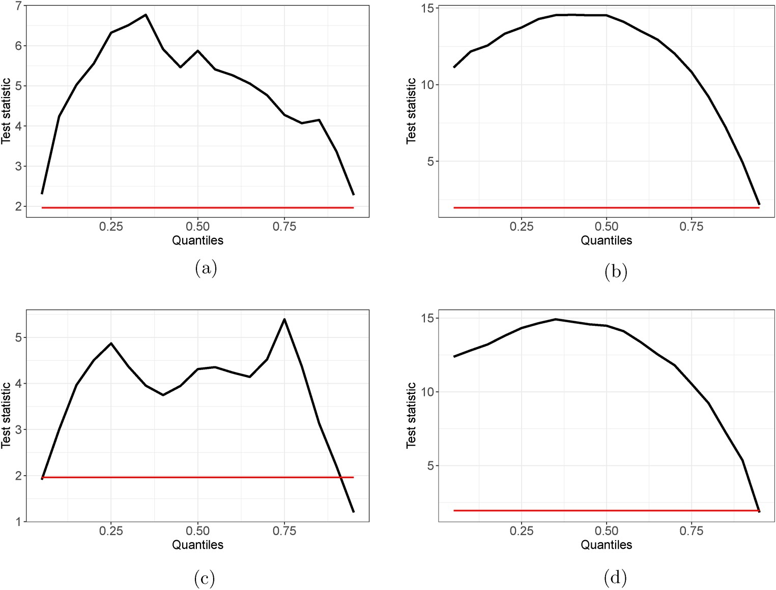
Figure A1. Robust result I: Causality-in-quantiles (CIQs) test results for the relationship of the inefficiency degree between the carbon and crude oil markets. (a) Mean (Oil → Carbon); (b) Variance (Oil → Carbon); (c) Mean (Carbon → Oil); and (d) Variance (Carbon → Oil).
Note: (i) This figure plots the CIQ test results of the spillover effect of the inefficiency degree between the carbon and crude oil markets formed by both data in levels (i.e. mean) and volatility, respectively. The corresponding results in the data format of levels (shown in (a) and (c)) and volatility (shown in (b) and (d)) are: , respectively, reported. The estimated critical value (CV) at 5% level is represented as the horizontal red solid line in each sub-plot. (ii) The vertical axis reports the test statistics of the null hypothesis of the CIQ test, and the horizontal axis indicates the different quantile levels of the specific market of the information “giver” (from q = 0.05 to q = 0.95).

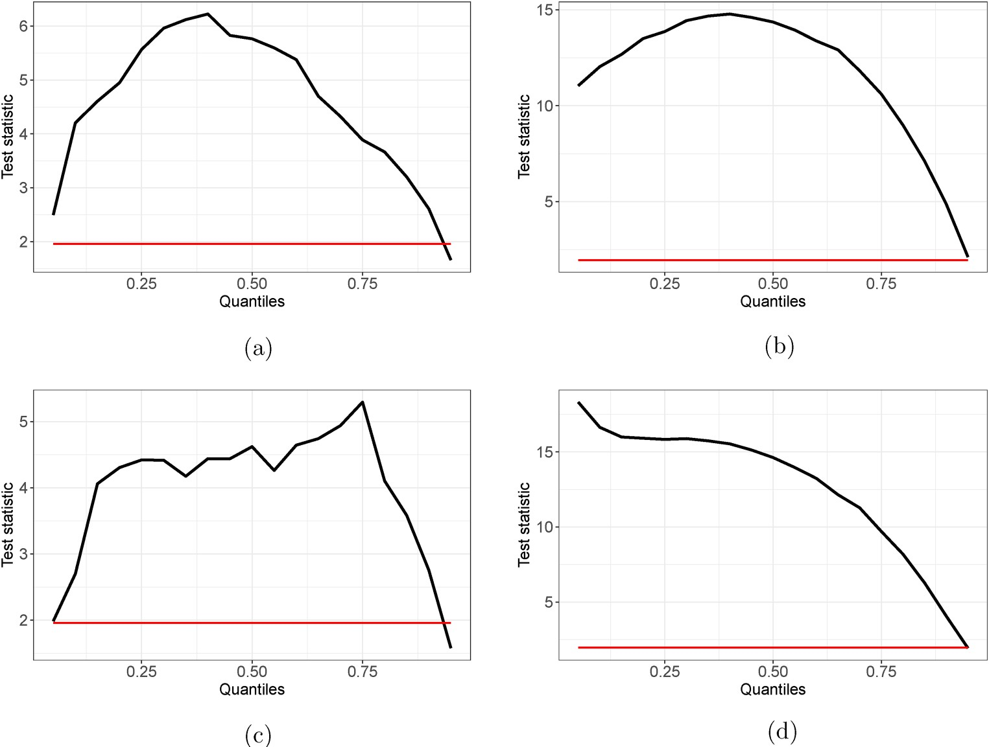
Figure A2. Robust result I: Causality-in-quantiles (CIQs) test results for the relationship of the inefficiency degree between the carbon and natural gas markets. (a) Mean (Natural Gas → Carbon); (b) Variance (Natural Gas → Carbon); (c) Mean (Carbon → Natural Gas); and (d) Variance (Carbon → Natural Gas).
Note: (i) This figure plots the CIQ test results of the spillover effect of the inefficiency degree between the carbon and natural gas markets formed by both data in levels (i.e. mean) and volatility, respectively. The corresponding results in the data format of levels (shown in (a) and (c)) and volatility (shown in (b) and (d)) are, respectively, reported. The estimated critical value (CV) at 5% level is represented as the horizontal red
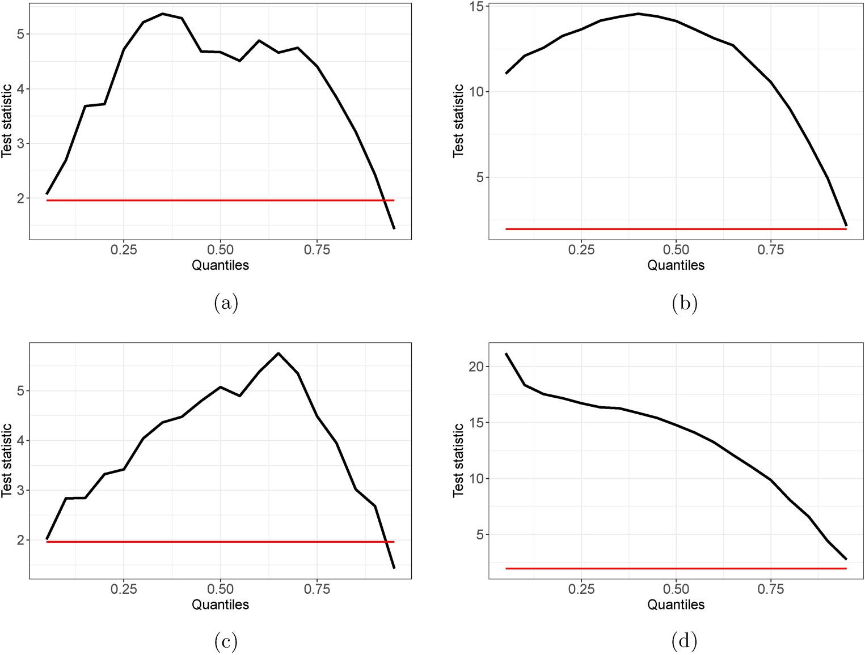
Figure A3. Robust result I: Causality-in-quantiles (CIQs) test results for the relationship of the inefficiency degree between the carbon and coal markets. (a) Mean (Coal → Carbon); (b) Variance (Coal → Carbon); (c) Mean (Carbon → Coal); and (d) Variance (Carbon → Coal).
Note: (i) This figure plots the CIQ test results of the spillover effect of the inefficiency degree between the carbon and coal markets formed by both data in levels (i.e. mean) and volatility, respectively. The corresponding results in the data format of levels (shown in (a) and (c)) and volatility (shown in (b) and (d)) are: , respectively, reported. The estimated critical value (CV) at 5% level is represented as the horizontal red solid line in each sub-plot. (ii) The vertical axis reports the test statistics of the null hypothesis of the CIQ test, and the horizontal axis indicates the different quantile levels of the specific market of the information “giver” (from q = 0.05 to q = 0.95).
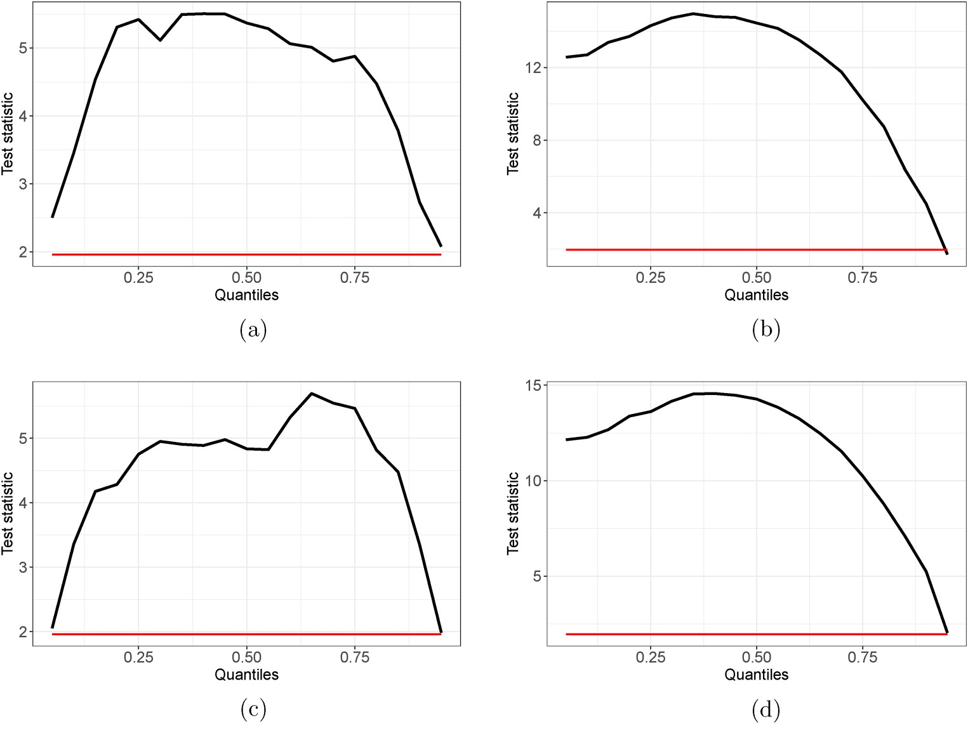
Figure A4. Robust result II: Causality-in-quantiles (CIQs) test results for the relationship of the inefficiency degree between the carbon and crude oil markets. (a) Mean (Oil → Carbon); (b) Variance (Oil → Carbon); (c) Mean (Carbon → Oil); and (d) Variance (Carbon → Oil).
Note: (i) This figure plots the CIQ test results of the spillover effect of the inefficiency degree between the carbon and crude oil markets formed by both data in levels (i.e. mean) and volatility, respectively. The corresponding results in the data format of levels (shown in (a) and (c)) and volatility (shown in (b) and (d)) are:, respectively, reported. The estimated critical value (CV) at 5% level is represented as the horizontal red
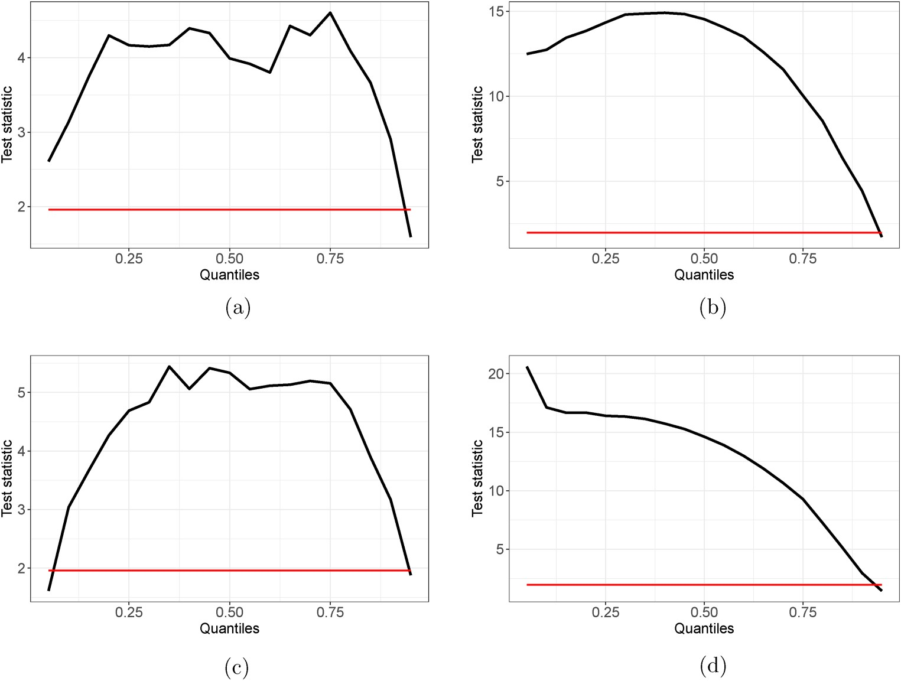
Figure A5. Robust result II: Causality-in-quantiles (CIQs) test results for the relationship of the inefficiency degree between the carbon and natural gas markets. (a) Mean (Natural Gas → Carbon); (b) Variance (Natural Gas → Carbon); (c) Mean (Carbon → Natural Gas); and (d) Variance (Carbon → Natural Gas).
Note: (i) This figure plots the CIQ test results of the spillover effect of the inefficiency degree between the carbon and natural gas markets formed by both data in levels (i.e. mean) and volatility, respectively. The corresponding results in the data format of levels (shown in (a) and (c)) and volatility (shown in (b) and (d)) are:, respectively, reported. The estimated critical value (CV) at 5% level is represented as the horizontal red solid line in each sub-plot. (ii) The vertical axis reports the test statistics of the null hypothesis of the CIQ test, and the horizontal axis indicates the different quantile levels of the specific market of the information “giver” (from q = 0.05 to q = 0.95).
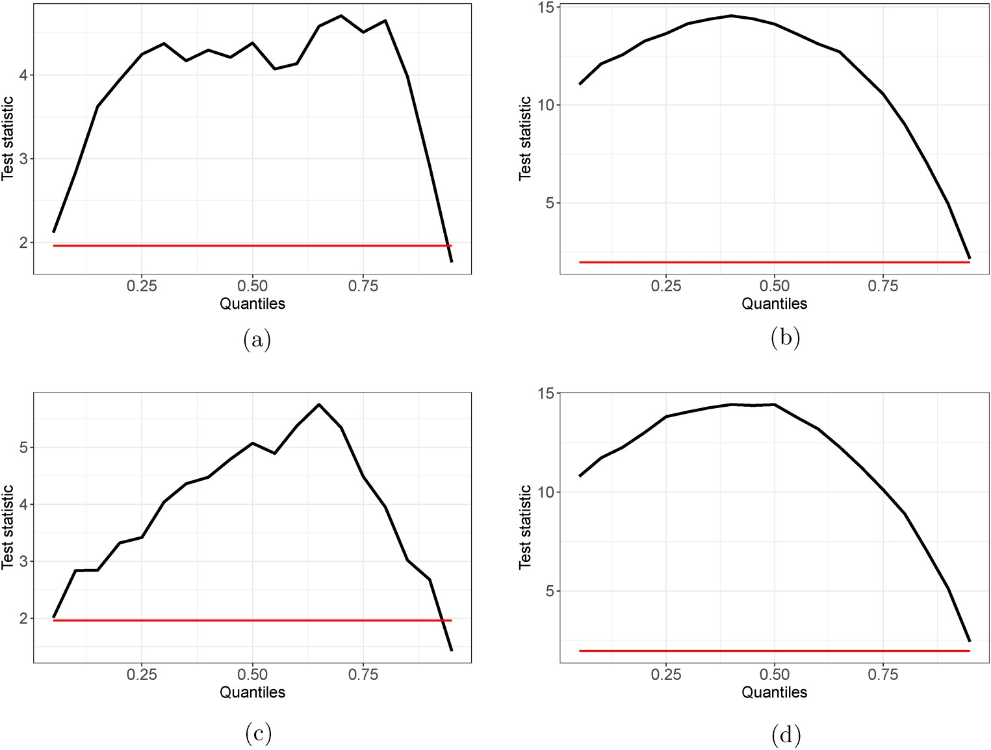
Figure A6. Robust result II: Causality-in-quantiles (CIQs) test results for the relationship of the inefficiency degree between the carbon and coal markets. (a) Mean (Coal → Carbon); (b) Variance (Coal → Carbon); (c) Mean (Carbon → Coal); and (d) Variance (Carbon → Coal).
Note: (i) This figure plots the CIQ test results of the spillover effect of the inefficiency degree between the carbon and coal markets formed by both data in levels (i.e. mean) and volatility, respectively. The corresponding results in the data format of levels (shown in (a) and (c)) and volatility (shown in (b) and (d)) are:, respectively, reported. The estimated critical value (CV) at 5% level is represented as the horizontal red

