Appendix

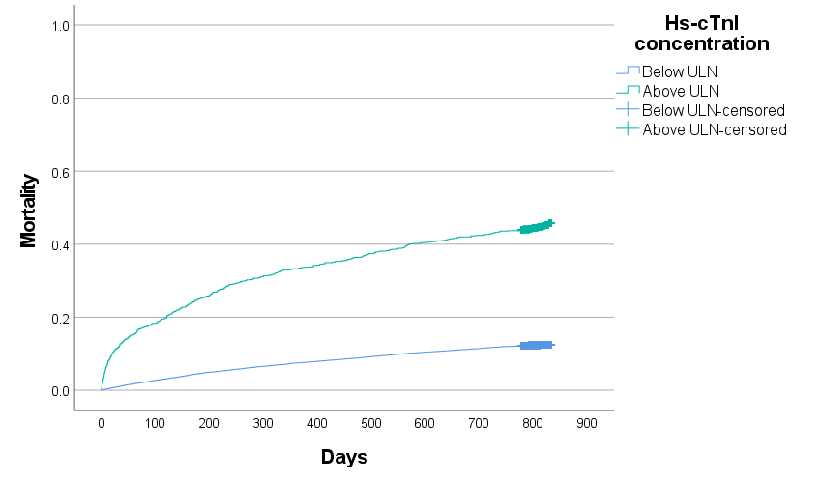
Supplementary figure 1: Kaplan Meier curve of mortality depending on whether the cTnI concentration was above or below the ULN. Number at risk:
Days | 0 | 100 | 200 | 300 | 400 | 500 | 600 | 700 | 800
Hs-cTnI below ULN | 18915 | 18399 | 17975 | 17671 | 17415 | 17175 | 16943 | 16753 | 10308
Hs-cTnI above ULN | 1085 | 886 | 803 | 745 | 713 | 679 | 646 | 625 | 393

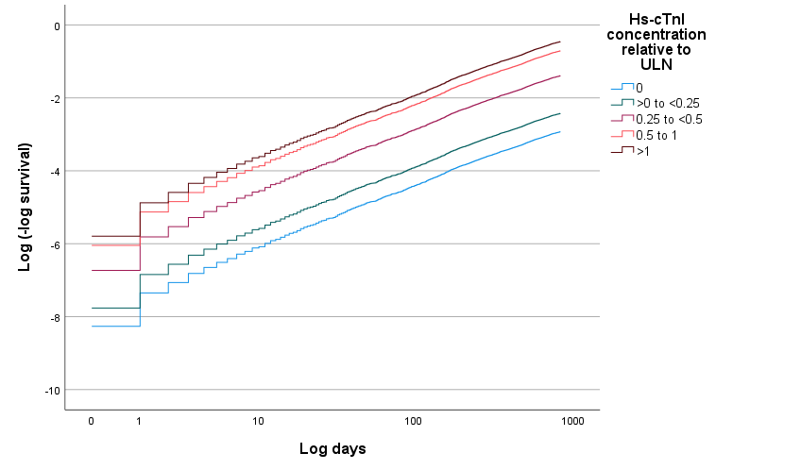

Supplementary figure 2: Log (minus log survival) versus time (log days) graph for different categories of cTnI concentration relative to the ULN

Variable |  | Mortality HR (95% CI)
Age |  | 1.046 (1.042 – 1.049)
Male gender |  | 1.222 (1.128 – 1.324)
eGFR |  | 0.998 (0.996 – 1.000)
cTnI requested by clinical team |  | 0.559 (0.471 – 0.664)
Clinical location | OPD | Reference
 | IPD | 2.031 (1.844 – 2.238)
 | ED | 1.515 (1.359 – 1.688)
cTnI concentration relative to ULN | 0 | Reference
 | > 0 to <0.25 | 0.986 (0.820 – 1.185)
 | 0.25 to <0.5 | 1.505 (1.244 – 1.821)
 | 0.5 to 1 | 1.941 (1.577 – 2.390)
 | >1 | 2.516 (2.034 – 3.112)
Supplementary Table 1: Multivariable outputs for the entire cohort when the cTnI variable was split into its relationship with the ULN
OPD=outpatients department; IPD=inpatients department; ED=emergency department; eGFR=estimated glomerular filtration rate, ULN=upper limit of normal

Variable | Mortality HR (95% CI)  IPD | Mortality HR (95% CI)  OPD | Mortality HR (95% CI)  ED
Age | 1.040 (1.035 – 1.045) | 1.048 (1.042 – 1.055) | 1.055 (1.049 – 1.061)
Male gender | 1.196 (1.057 – 1.354) | 1.294 (1.124 – 1.488) | 1.183 (1.031 – 1.358)
eGFR | 0.996 (0.993 – 1.000) | 0.996 (0.992 – 1.000) | 0.991 (0.988 – 0.995)
cTnI requested by clinical team | 0.461 (0.313 – 0.677) | 1.754 (0.246 – 12.493) | 0.689 (0.581 – 0.817)
Log(10)cTnI concentration | 1.533 (1.389 – 1.693) | 2.182 (1.839 – 2.589) | 1.968 (1.766 – 2.192)
Supplementary table 2: Multivariable outputs by patient location for all-cause mortality

Variable |  | Mortality HR (95% CI)
Age |  | 1.046 (1.043- 1.050)
Male gender |  | 1.198 (1.103 – 1.301)
eGFR |  | 0.996 (0.994 – 0.999)
cTnI requested by clinical team |  | 0.537 (0.451 – 0.640)
Clinical location | OPD | Reference
 | IPD | 2.063 (1.866 – 2.281)
 | ED | 1.600 (1.433 – 1.787)
Log (10) cTnI |  | 1.627 (1.511 – 1.751)
Supplementary table 3: Multivariable outputs for non-cardiovascular mortality for the entire cohort

Variable |  | Mortality HR (95% CI)
Age |  | 1.066 (1.055 – 1.077)
Male gender |  | 1.339 (1.133 – 1.728)
eGFR |  | 0.981 (0.977 – 0.986)
cTnI requested by clinical team |  | 1.066 (0.771 – 1.473)
Clinical location | OPD | Reference
 | IPD | 1.679 (1.279 – 2.203)
 | ED | 1.287 (0.965 – 1.717)
Log (10) cTnI |  | 2.537 (2.198 – 2.904)
Supplementary table 4: Multivariable outputs for cardiovascular mortality for the entire cohort

OPD=outpatients department; IPD=inpatients department; ED=emergency department; eGFR=estimated glomerular filtration rate

