Consent and Participant Information Documents

Study Title: Can an imagined contact intervention be used to improve children’s responses towards their autistic peers?
Researcher: Soraya Khanna
ERGO Number: 70871

Contents Page

Document Name | Date [Version] | Page
PIS and Consent for Parents, Carers or Guardians | 09.09.22 [v4] | 2
Child Information Sheet (Hayden Doll) | 09.09.22 [v4] | 7
Child Information Sheet (Hattie Doll) | 09.09.22 [v4] | 8
Child Assent Form | 09.09.22 [v4] | 9

Participant Information Sheet

Study Title: Can an imagined contact intervention be used to improve children’s responses towards their autistic peers?
Researcher: Soraya Khanna
ERGO number: 70871 Date: 09.09.22 Version: 4

Dear Parent, Carer or Guardian,

My name is Soraya Khanna and I am currently a second year trainee educational psychologist studying for a Doctorate in Educational Psychology (DEdPsy) at the University of Southampton. I would like to invite your child to take part in a research study that I am currently doing as part of my doctoral thesis. All children in Year [2, 3 and/or 4] have also been invited to take part in this study.

You are welcome to ask questions if anything is not clear or you would like more information before you decide whether you are happy for your child to take part (an email address for asking questions is included below). To help you decide whether you wish to allow your child to take part or not, it is important that you understand why the research is being done and what it will involve. Please read the information below carefully.

If you are happy for your child to participate, please complete and return the included consent form. If you do provide your consent, your child will also be provided with a child-friendly information sheet about the study to enable them to make a choice about whether they would like to participate or not. If you do not wish your child to take part, you do not need to take further action.

What is the research about?
- I am conducting this research to explore whether a potential intervention (imagined contact) could be used to encourage positive friendship strategies among children and their autistic peers.
- The ultimate goal of this type of research is to find out how to reduce prejudice against various vulnerable groups and thereby create a more positive environment for all children.
- An example of a previous study using an imagined contact intervention can be found at: https://bit.ly/3DgeqnO

Why has my child been chosen and do they have to take part?
- All children in Year [2, 3 and/or 4] have been invited to take part.
- After signing the consent form, you may still withdraw your child from this study up until the point at which the data have been collected. If you do not want your child to take part, they do not have to.

What will happen to my child if they take part?
- If you choose to consent, your child will be asked to take part in the study with the researcher who is a trainee educational psychologist. This researcher holds a valid DBS certificate.
- The researcher is planning to recruit 20 pupils from each year group: Year [2, 3 and/or 4]. If there are more than 20 pupils who have been provided with consent from a parent/carer/guardian to participate and wish to take part, all names will be pulled out of a hat to randomly select 20 pupils in total.
- This study involves children using 3-D toys (Lottie Dolls) to imagine they are playing with a child who is or is not autistic and they will be randomly allocated to either of these two groups.
- Your child will be assigned with a participant identification number that is not linked to their name.
- At the beginning of the study, your child will be provided with information about the project and asked if they would like to take part. They will be reassured that they do not have to take part if they do not want to. If they are happy to participate, they will be asked to tick a box on a consent form that has their ID number written on it.
- Children will be asked some questions about their feelings towards the imagined characters that the researcher will complete on a laptop. Then they will engage in a 3-minute play session with the dolls. Next, they will be asked some more questions about their feelings towards the imagined characters.
- The individual session should last around 20 minutes.
- The purpose of the research activity fits with the school’s work on inclusion.

Are there any benefits in my taking part?
- Each child who participates in the intervention be thanked for taking part with a sticker and a book token will be provided to the school for each child.
- If your child takes part in the research, they will support our understanding of the effectiveness of imagined contact on children’s attitudes and behavioural intentions towards their peers with disabilities. Imagined contact has the potential to be a low-cost intervention that promotes these positive responses towards autistic peers, therefore it is important for us to understand its effectiveness to support other children in the future.

Are there any risks involved?
- There are no specific risks to taking part in this study, but it will involve asking your child to take part in the study during the school day, however participation in this research project will support the school’s work on promoting equality, diversity and inclusion. Furthermore, the activity will be relatively short (approximately 20 minutes) and the researcher will liaise with your child’s school to discuss the best time of day for the study to take place.
- I (the researcher) am experienced with working with primary aged children, previously being a Year 2 teacher in a local primary school, and will be able to provide support if your child does experience discomfort during the activity. For example, I will reassure your child that it is fine to end the study early or have a break at any time and I will let relevant school staff know about this.

What data will be collected?
- Information that will be collected from children will include their gender, age, ethnicity and responses to the questions about their feelings towards the 3-D dolls.
- All data collected will be recorded anonymously on a password-protected laptop and stored within a password-protected folder.
- This data will be accessible to the researcher and the supervisory team only.
- I would be able to share a summary of the findings with you once the research study is complete. There is an opportunity for you to provide your email address on the consent form should you wish to receive this.

Will my child’s participation be confidential?
- It is possible that other children in your child’s class will observe your child leaving the lesson for the study.
- All information we collect about your child will be kept strictly confidential. Paper consent forms will be scanned and sent securely to the researcher’s password protected university system. They will then be shredded.
- All digital documents will be stored securely within a password protected laptop and within a password protected folder.
- Only members of the research team and responsible members of the University of Southampton may be given access to data about your child for monitoring purposes and/or to carry out an audit of the study to ensure that the research is complying with applicable regulations. Individuals from regulatory authorities (people who check that we are carrying out the study correctly) may require access to your child’s data. All of these people have a duty to keep your child’s information, as a research participant, strictly confidential.

What happens if I change my mind about my child taking part?
- You have the right to change your mind and withdraw up until the point at which the data have been collected. At this point, the data will have been anonymised.
- If you would like to withdraw your consent prior to this point, please contact the lead researcher, Soraya Khanna, s.g.khanna@soton.ac.uk

What will happen to the results of the research?
- Your/your child’s personal details will be kept anonymous. Research findings made available in any reports or publications will not include information that can directly identify your child.
- This research will be written up as part of the researcher’s doctoral thesis project. The researcher may also seek to publish this research as a research article (e.g., in a research journal). A summary of research will be shared with all schools that are involved in the research.
- It is possible that data collected in this study could be used in future studies. Anonymised data collected from this study will be stored in the University of Southampton’s data repository, Pure. This data will be accessible to future researchers who are also trying to explore research into the effectiveness of imagined contact.

Where can I get more information?
- If you have any further questions, please contact the lead researcher: Soraya Khanna, s.g.khanna@soton.ac.uk

What happens if there is a problem?
- If you have a concern about any aspect of this study, you should speak to the researchers who will do their best to answer your questions.
- If you remain unhappy or have a complaint about any aspect of this study, please contact the University of Southampton Research Integrity and Governance Manager (023 8059 5058, rgoinfo@soton.ac.uk).

Data Protection Privacy Notice
- The University of Southampton conducts research to the highest standards of research integrity. As a publicly-funded organisation, the University has to ensure that it is in the public interest when we use personally-identifiable information about people who have agreed to take part in research. This means that when you agree to take part in a research study, we will use information about you in the ways needed, and for the purposes specified, to conduct and complete the research project. Under data protection law, ‘Personal data’ means any information that relates to and is capable of identifying a living individual. The University’s data protection policy governing the use of personal data by the University can be found on its website (https://www.southampton.ac.uk/legalservices/what-we-do/data-protection-and-foi.page).
- This Participant Information Sheet tells you what data will be collected for this project and whether this includes any personal data. Please ask the research team if you have any questions or are unclear what data is being collected about you.
- Our privacy notice for research participants provides more information on how the University of Southampton collects and uses your personal data when you take part in one of our research projects and can be found at http://www.southampton.ac.uk/assets/sharepoint/intranet/ls/Public/Research%20and%20Integrity%20Privacy%20Notice/Privacy%20Notice%20for%20Research%20Participants.pdf
- Any personal data we collect in this study will be used only for the purposes of carrying out our research and will be handled according to the University’s policies in line with data protection law. If any personal data is used from which you can be identified directly, it will not be disclosed to anyone else without your consent unless the University of Southampton is required by law to disclose it.
- Data protection law requires us to have a valid legal reason (‘lawful basis’) to process and use your Personal data. The lawful basis for processing personal information in this research study is for the performance of a task carried out in the public interest. Personal data collected for research will not be used for any other purpose.
- For the purposes of data protection law, the University of Southampton is the ‘Data Controller’ for this study, which means that we are responsible for looking after your information and using it properly. The University of Southampton will keep identifiable information about you for 10 years after the study has finished after which time any link between you and your information will be removed.
- To safeguard your rights, we will use the minimum personal data necessary to achieve our research study objectives. Your data protection rights – such as to access, change, or transfer such information - may be limited, however, in order for the research output to be reliable and accurate. The University will not do anything with your personal data that you would not reasonably expect.
- If you have any questions about how your personal data is used, or wish to exercise any of your rights, please consult the University’s data protection webpage (https://www.southampton.ac.uk/legalservices/what-we-do/data-protection-and-foi.page) where you can make a request using our online form. If you need further assistance, please contact the University’s Data Protection Officer (data.protection@soton.ac.uk).

Thank you for taking the time to read this information sheet and considering your child taking part in this research.

PARENT, CARER OR GUARDIAN CONSENT FORM

Study title: Can an imagined contact intervention be used to improve children’s responses towards their autistic peers?
Researcher name: Soraya Khanna
ERGO number: 70871

Please initial the box(es) if you agree with the statement(s):

I have read and understood the information sheet (09.09.22, V4) and have had the opportunity to ask questions about the study.
I agree for my child to take part in this research project and agree for his/her/their data to be used for the purpose of this study.
I understand my agreement for my child’s participation is voluntary and I may withdraw him/her/them from this study up until the point at which the data have been collected, without my participation rights being affected.
I agree that data from the questionnaires gathered from my child in this study may be stored (after it has been anonymised) in a specialist data centre and may be used for future research.
I would like to receive a summary of the findings of this project via email.
My email address: __________________________________________________________

Child’s name: |  | _____________________________________
Child’s year group and teacher: |  | _____________________________________
Name of parent/carer/guardian: |  | _____________________________________________
Date: | _____________________ |  | Signature: | _____________________________
Name of researcher: |  | ______________________________________________
Date: | _____________________ |  | Signature: | _____________________________

Child Information Sheet (Hayden)
ERGO ID: 70871, Date: 09.09.22, Version: 4

Hello, my name is Soraya and I am exploring how school pupils think, feel and behave around other children.

As part of this study, you will be introduced to a 3-D doll called Hayden and told some information about who he is.
You will also be asked to a choose a doll that you think is most like you.
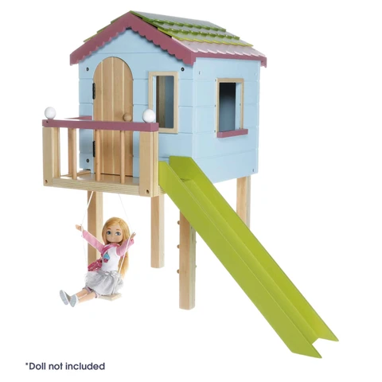
I will ask you questions about what you think about Hayden. Next, I will ask you to play with the doll you have chosen and Hayden in this pretend treehouse. Then, I will ask you some more questions.

There are no right or wrong answers! I would just like to hear your thoughts and feelings about this experience.

You do not have to take part if you do not want to. If you do not want to take part, you can let the researcher (Soraya) know. You can also stop the study whenever you like if you change your mind.

Thank you for reading this letter.
Soraya Khanna (Researcher)
Child Information Sheet (Hattie)
ERGO ID: 70871, Date: 09.09.22, Version: 4
Hello, my name is Soraya and I am exploring how school pupils think, feel and behave around other children.

As part of this study, you will be introduced to a 3-D doll called Hattie and told some information about who she is.
You will also be asked to a choose a doll that you think is most like you.
I will ask you questions about what you think about Hattie. Next, I will ask you to play with the doll you have chosen and Hattie in this pretend treehouse. Then, I will ask you some more questions.

There are no right or wrong answers! I would just like to hear your thoughts and feelings about this experience.
You do not have to take part if you do not want to. If you do not want to take part, you can let the researcher (Soraya) know. You can also stop the study whenever you like if you change your mind.

Thank you for reading this letter.
Soraya Khanna (Researcher)
Child Assent Form

Secret ID number: ___________________

Date: __________________


I have read the information about this study with the researcher (Soraya) and I would like to take part.

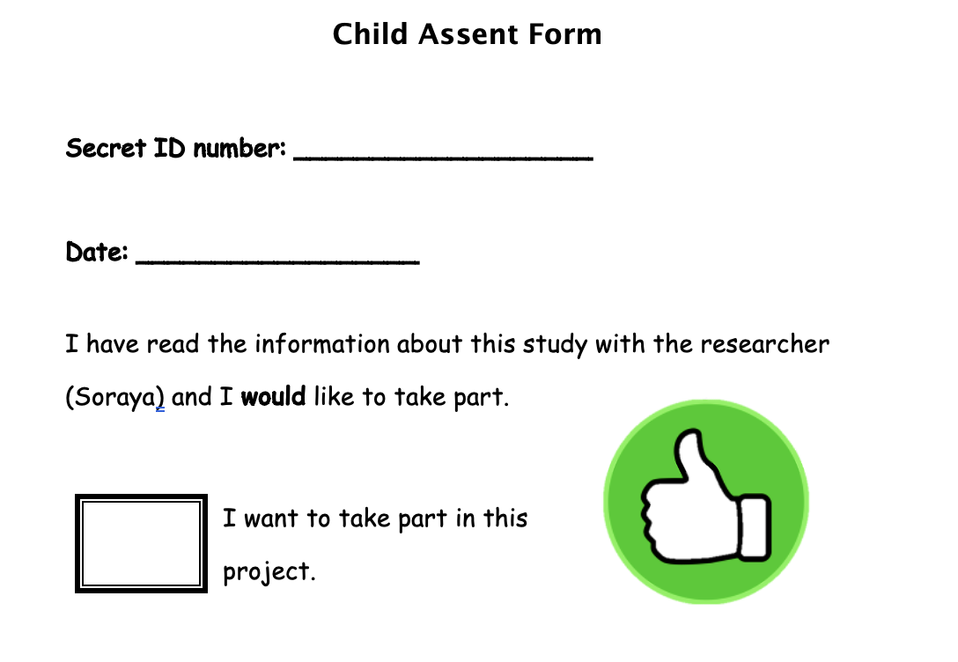
I want to take part in this project.

