Insights into hyperbolic phonon polaritons in hBN using Raman scattering from encapsulated transition metal dichalcogenide layers
Jacob J.S. Viner ¹, Liam P. McDonnell ¹, Pasqual Rivera ², Xiaodong Xu ², David C. Smith ^{1*}
¹ School of Physics and Astronomy, University of Southampton, Southampton SO17 1BJ, United Kingdom
² Department of Physics, University of Washington, Seattle, Washington 98195, United States of America

Abstract
New techniques for probing hyperbolic phonon polaritons (HPP) in 2D materials will support the development of the emerging technologies in this field. Previous reports have shown that it is possible for WSe₂ monolayers in contact with the hexagonal boron nitride (hBN) to generate HPP in the hBN via Raman scattering. In this paper, we set out new results on HPP Raman scattering induced in hBN by WSe₂ and MoSe₂ monolayers including new resonances at which the Raman scattering is enhanced. Analysis of the observed Raman lineshapes demonstrates that Raman scattering allows HPP with wavevectors with magnitudes significantly in excess of 15000 cm⁻¹ to be probed. We present evidence that the Raman scattering can probe HPP with frequencies less than the expected lower bound on the Reststrahlen band suggesting new HPP physics still waits to be discovered.

Intro
The unique properties of hyperbolic phonon polaritons (HPPs) [1–4] are leading to their exploitation in a range of important applications [5,6]. For instance, in the production of a new class of mid-infrared sources [7] which, whilst thermally excited, produce radiation which is narrowband [8] and spatially coherent [9,10]. Work on related sources indicates that it should be possible to combine these properties with high modulation frequencies; up to 10 MHz [11]. Another field in which HPPs are being exploited is MIR integrated nanophotonics for applications in surface-enhanced infrared spectroscopy [12] as well as sub-diffraction imaging [6,13]. A recent highlight in this field has been the creation of reconfigurable waveguides and lenses for hyperbolic phonon polaritons [14,15] using phase change materials. Hyperbolic phonon polaritons allow subwavelength volume confinement [6,16,17] of mid-infrared radiation by as much as a factor of 86. This confinement is not only being exploited for miniaturisation but also allows the concentration of electromagnetic energy, allowing for strong coupling [18,19] and nonlinear effects [20–22]. By analogy with plasmonics, which are more lossy than HPP [23], an even wider range of HPP applications, e.g. biosensors [24] and improving signal to noise photodetectors^{7,8}, are likely to emerge soon.

The two main techniques used to study HPP are FTIR spectroscopy [25] and scattering-type scanning near-field optical microscopy (s-SNOM) [26–28]. FTIR is simpler however it either requires specially prepared microfabricated structures [5] or prism coupling [5,29] to access the large wavevector HPP. The former is not suitable for probing HPP in devices and the latter limits the wavevector that can be accessed. s-SNOM [26–28] allows HPPs to be imaged in real space with impressive resolution and thus access to wavevectors of the order of ~ 1000 times the free space wavevector [27,28]. However, this technique is complex and requires physical contact with the sample.

A HPP measurement method based upon the conversion of MIR to visible radiation would enable a wide range of new opportunities. The relative maturity of visible photonics means that such a method is likely to be much simpler. It should allow high-resolution (0.5 µm) imaging without the need for a near-field probe and because many of the key HPP are wide band gap materials it should allow imaging of sub-surface HPP. Due to the much shorter wavelength of visible light such a method might allow access to even larger wavevector HPPs. Actually, it has already been shown that transition metal dichalcogenide (TMD) layers allow the probing of HPPs via Raman scattering of visible radiation [30–32]. However, no one has explored what information about HPP can be obtained from the Raman spectra. In this paper we present significant new results on HPP Raman scattering in TMDs. These include new resonances at which the HPP Raman features are enhanced in WSe₂ monolayers and the first measurements of HPP Raman features in Mo based TMDs. Based upon these new results we discuss the mechanism for HPP Raman scattering; the fact that it can access much higher wavevector HPP than IR based techniques; and what Raman scattering of HPP might bring to the field of HPP technologies.

Main Body
Figure 1a) shows a Raman spectrum of the encapsulated WSe₂ monolayer taken with an excitation energy of 1.866 eV. The observed Raman features can be separated into one-phonon peaks (E′′_{TO}(M) at 196 cm⁻¹; E′′_{TO}(K) at 209 cm⁻¹; E′_{TO}(M) at 229 cm⁻¹; E′(Γ)/A₁′(Γ) at 250 cm⁻¹; A′′₂(M)/ E′_{LO}(K) at 258 cm⁻¹.) and two-phonon peaks (range of shifts up to 500 cm⁻¹) and two features at around 730-850 cm⁻¹ and 1000-1080 cm⁻¹. Further discussion of the WSe₂ phonon Raman peaks and their attribution can be found in literature [31,33–36]. The 730-850 cm⁻¹ and 1000-1080 cm⁻¹ features have previously been associated with scattering of excitons in the monolayer by hBN HPP (lower shift feature) and a combination of a hBN HPP and a monolayer A₁′ phonon (upper shift feature). This hypothesis is strongly supported by the facts that no Raman scattering is observed at comparable Raman shifts [31,32] in samples where WSe₂ monolayers are not in intimate contact with hBN and the only peak observed in Raman spectra of hBN [30,32,37] is at 1380 cm⁻¹. The peaks at smaller Raman shifts, which only involve phonons, are characteristically narrower with widths of the order of 0.25 meV (2 cm⁻¹), whereas the HPP related features are significantly broader, at 10 meV (80 cm⁻¹). The Raman features can also be observed in Figure 1b) and c) where we present colourmaps of the resonance Raman spectra of an encapsulated WSe₂ monolayer. All the features show clear resonance behaviour in the colourmaps. For instance the Raman peak at 250 cm⁻¹, assigned to the degenerate A₁′/E’ phonons [35,38], has four resonances; when the incoming and scattered photons are resonant with the A1s and A2s bright excitonic states. As previously reported, the 730-850 cm⁻¹ features shows a clear outgoing resonance with the A1s state and incoming resonance with the A2s state [31,32]. As also previously reported, the 1000-1080 cm⁻¹ shows a strong resonance at ~1.865 eV which is both an outgoing resonance with the A1s and an incoming resonance with the A2s, i.e. a double resonance. In addition, the same features have at least two other resonances at higher laser energies which have not been reported before. The clearest of these is an outgoing resonance associated with the A2s exciton. There is also a weaker resonance, approximately 20 meV higher in energy corresponding to the A3s exciton. As more clearly shown in Figure 1b), the features at the outgoing resonances show a characteristic behaviour in which the higher shift scattering is resonant at higher laser energies. This is particularly visible from 1.95 to 2 eV. This is clear proof that the two broad features, with Raman shifts centred at approximately 800 and 1050 cm⁻¹, can be associated with a band of excitations rather than a single underlying excitation.
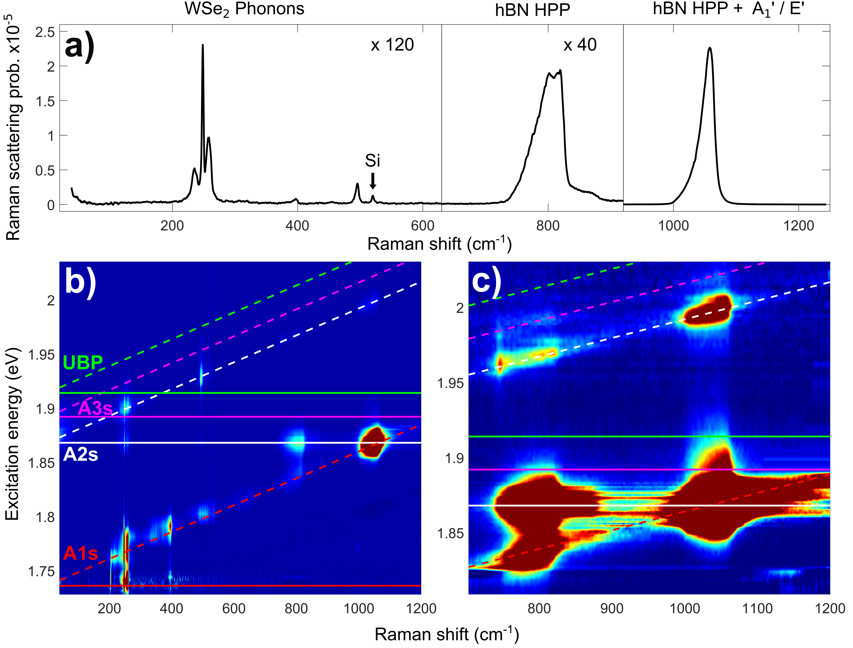
Figure 1: a) An individual Raman spectrum from the hBN encapsulated WSe₂ sample with an excitation energy of 1.866 eV. The first two parts of the spectrum are scaled by a factor of 120 and 40 for visibility. b) and c) show colourmaps of the resonance behaviour of the 800 and 1050 cm⁻¹ hBN Raman features b) presents the full spectral width including lower Raman shift features from the WSe₂ phonons, such as the strong 250 cm⁻¹ A₁′(Γ)/E’(Γ) peak, as well as the higher shift hBN modes. c) Presents a zoom of the higher shift part of the spectra presented in b) with the colours adjusted to show a narrower range of intensities. The colour indicates the intensity of the Raman scattering in logarithmic scale, with blue corresponding to lowest and red to highest intensity. The energies of the incoming and outgoing Raman resonances (solid and dashed lines) associated with the A1s, A2s and A3s excitonic states are shown with red, white and pink lines respectively. The green lines correspond to the resonance conditions for the lowest energy unbound electron hole pair (UBP). The signal around 1.87 eV between the 800 and 1050 cm⁻¹ peaks and shifts above 1100 cm⁻¹ are from photoluminescence from the A1s exciton, which follows the A1s outgoing resonance.
In order to better understand the resonance behaviour and to determine the energy of the excitonic states involved, resonance profiles of the Raman scattering were determined for the two features as presented in Figure 2. As each feature is associated with a band of excitations, the extracted resonance profile changes at different Raman shifts across the feature. For both of these hBN features, 3 resonance profiles were determined; each by integrating the Raman scattering for a 5 cm⁻¹ band around a centre Raman shift. This process is described in the supplementary section S1 [39]. The resonance profiles presented in Figure 2 clearly show the A1s outgoing and A2s incoming resonances previously observed [30–32], as well as the new higher energy resonances. Interestingly there is no statistically significant Raman scattering associated with the hBN related features at the A1s incoming resonance. However, the significant additional noise due to the strong A1s luminescence means the upper limit on any scattering at these laser energies is comparable with the strength of the Raman scattering at the highest energy resonances. In the case of the 730-850 cm⁻¹ feature, shown in Figure 2a), the A1s outgoing resonance near 1.83 eV shifts to lower energy, as expected, for the lower centre Raman shifts. The two higher energy resonances above 1.95 eV show the same behaviour indicating they are also both outgoing resonances. For the 1000-1080 cm⁻¹ feature profiles shown in Figure 2b), the A1s outgoing and A2s incoming resonances fall at the same energy, creating a double resonance with the measured Raman scattering two orders of magnitude greater than that of the Raman feature at 730-850 cm⁻¹.
The resonance profiles were all fitted using the standard third-order perturbation theory prediction for Raman scattering [39] that assumes that the exciton-phonon scattering occurs in a single step. In order to fit all of the resonances, the model requires a minimum of three excitonic states. Unfortunately, this requires six exciton-phonon scattering matrix elements. This makes getting a unique fit for these parameters impossible. However, the energy and lifetime parameters for the three excitons obtained from the six independent resonance profiles, with and without setting some of the scattering matrix elements to zero, were remarkably consistent as shown in supplementary section S2 [39] (see, also, references [40–42] therein). These fits give the energy (with fit estimated errors) for the three excitonic states to be 1.735 ± 0.002, 1.867 ± 0.001 & 1.892 ± 0.005 The first two energies are to within experimental error the same as the A1s and A2s energies obtained from fits to reflectivity spectra [43] and separate fits to the A₁′ phonon’s resonance profiles shown in Figure 2c) The third energy is in agreement to within a few meV with previously published values for the A3s excitonic state [44,45] as well as values obtained from reflectivity measurements of the sample [39]. This is the first time that a Raman resonance with the A3s state has been reported.
Based upon the agreement between the measured energies of the first three excitonic energies and our model for the Rydberg series [46] we can predict the energy of the remaining excitonic states and the minimum energy unbound electron-hole states. As shown with green lines in Figure 1, the threshold for excitation of unbound electron-hole states is less than the laser energy associated with the A2s and A3s outgoing resonances. Thus, it is possible that the initial optically excited state at these resonances is a real, unbound pair excitation rather than a virtual excitonic state.
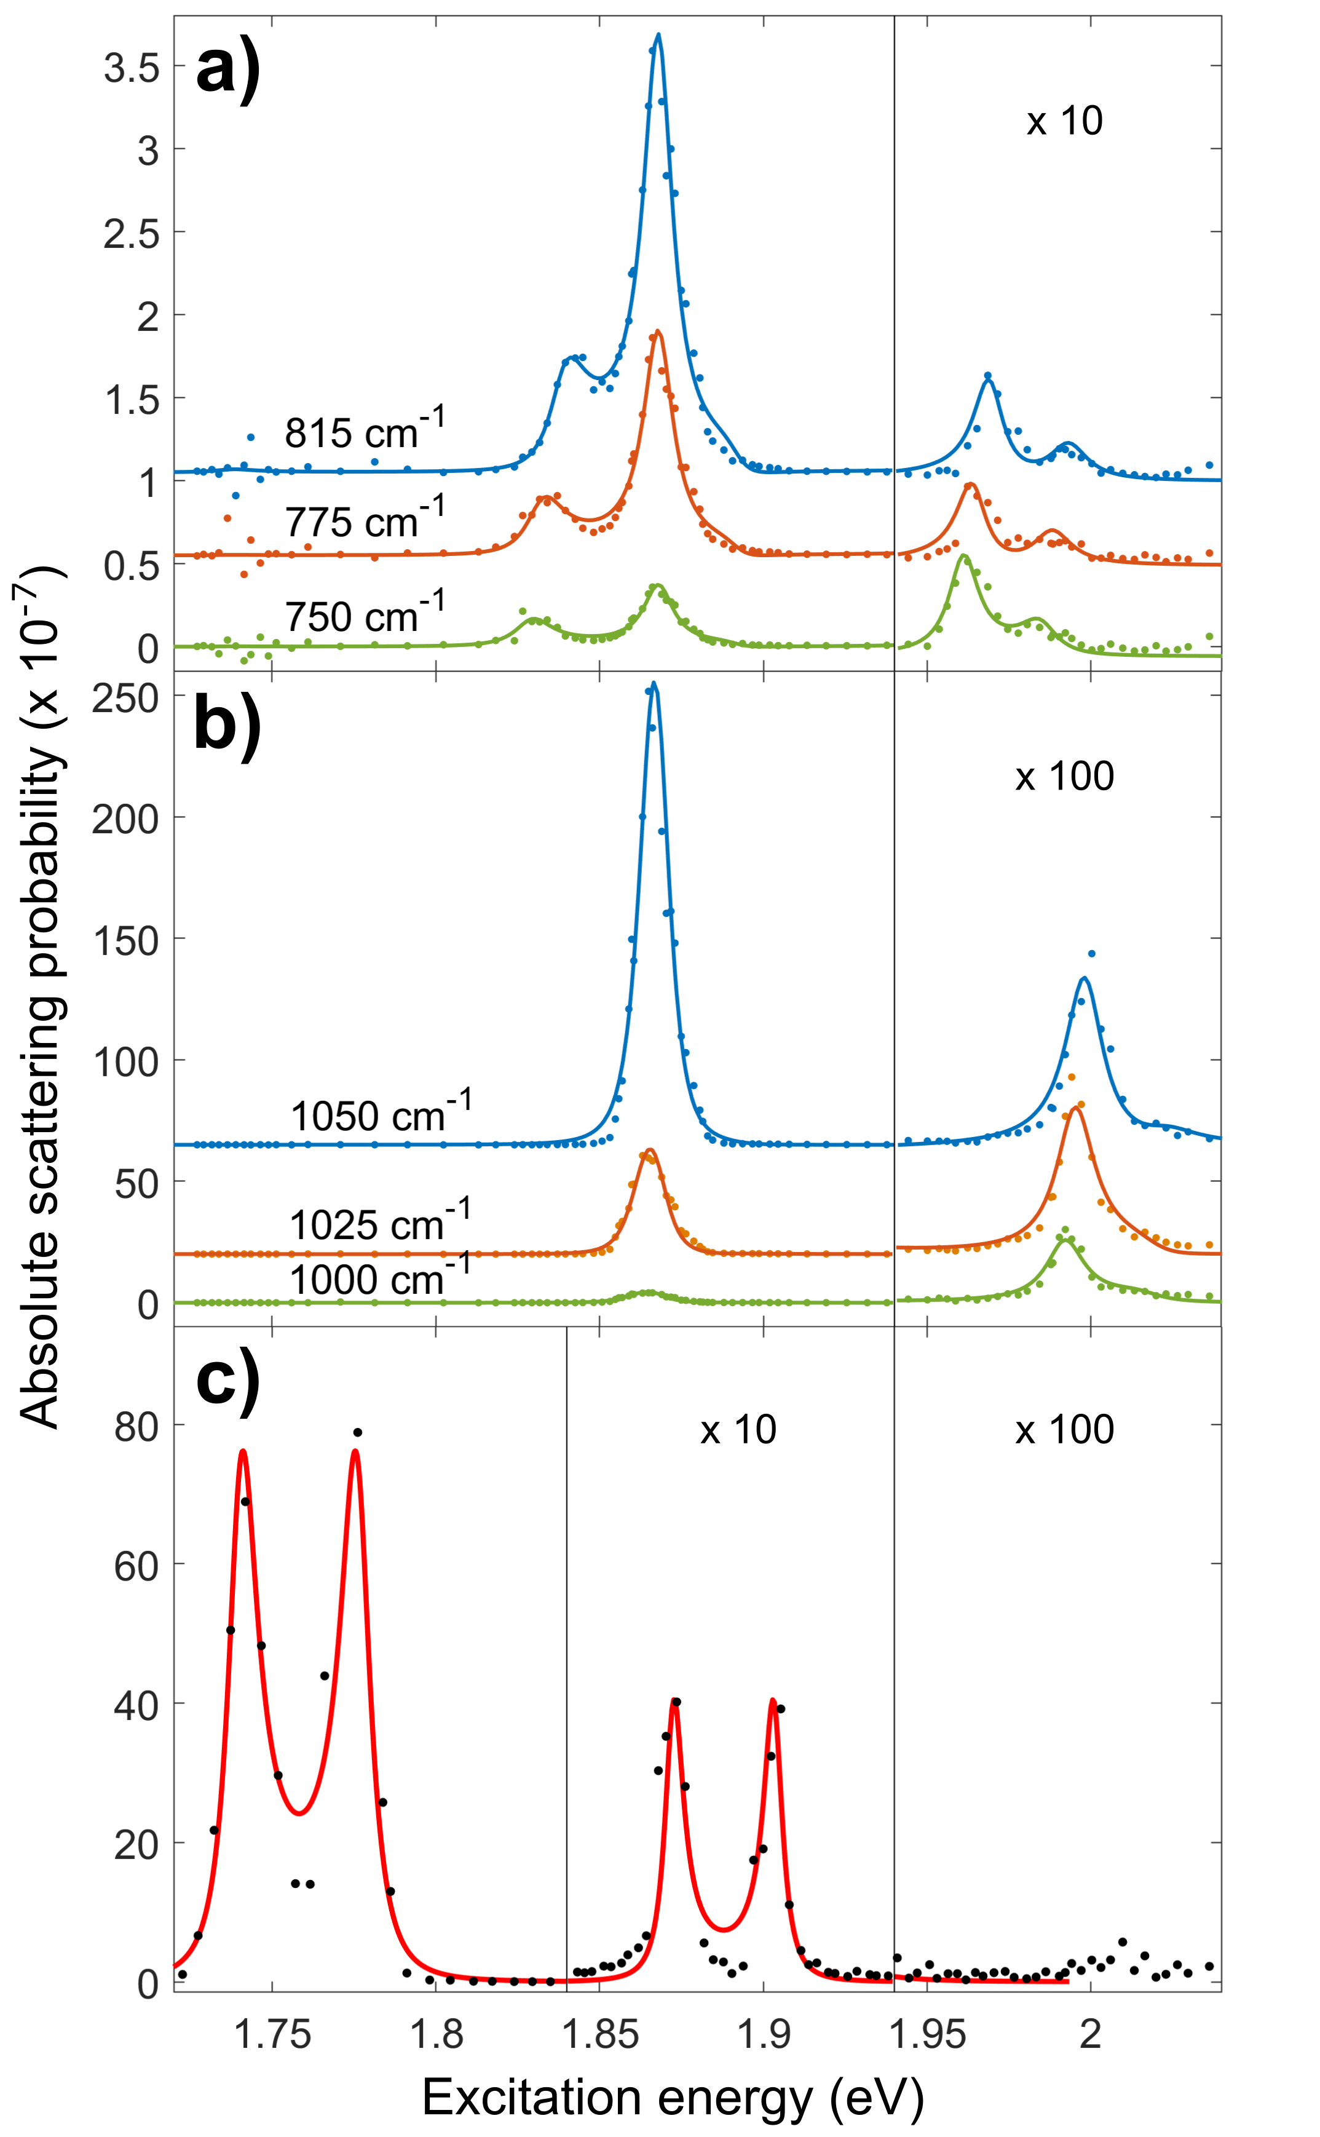
Figure 2: Resonance profiles for the a) 800 cm⁻¹ or b) 1050 cm⁻¹ hBN Raman features determined at different Raman shifts within the feature. The insets present vertically scaled subsections of the 815 and 1050 cm⁻¹ resonance profiles. Peaks in the resonance profile observed in this range are associated with the A2s and A3s outgoing resonance conditions. The solid lines show fits to the resonance behaviour using 3-state, third-order, perturbation-theory resonant Raman scattering models where the three states are the A1s, A2s & A3s excitons in WSe₂. The resonances at ~1.84 eV and between 1.95 and 2.0 eV are outgoing resonances and thus change energy with Raman shift. The resonance at ~1.85 eV is the A2s incoming resonance. The A1s incoming resonance would fall around 1.74 eV but no statistically significant Raman signal is observed. The noise in the resonance data at the energy of the A1s exciton is photoluminescence signal from the A1s exciton and trion. c) Resonance profiles of the WSe₂ 250 cm⁻¹ single gamma point phonon over the same energy range. The left side of the plot shows the A1s incoming and outgoing resonances. The right shows the A2s resonance with intensity scaled up by a factor of 20.

One of the key characteristic features of the hBN related Raman scattering are their broad lineshapes. However, as shown in Figure 3, the observed lineshape depends on the resonance and the energy of the laser relative to the peak of the resonance. This is more obvious at the outgoing resonance but also true at the incoming resonances. The qualitative differences between the resonances can be rationalised as being due to the variation of the resonance conditions across the lineshape and how these depend on laser energy. For instance, the relative suppression of the higher Raman shift scattering at an outgoing resonance for lower laser energies is because the lower shift scattering is closer to resonance with the outgoing state. However, attempts to quantitatively correct for this effect to obtain a single underlying lineshape did not produce a consistent lineshape independent of the laser energy. Despite this, it is possible to draw some general conclusions about the underlying lineshape. In particular, for the 730-850 cm⁻¹ feature the lineshape covers the whole of the Reststrahlen band. In fact, at the low shift side of peak the lineshape continues smoothly beyond the Reststrahlen band. In general, the highest scattering is closer to the upper bound of the Reststrahlen band however the exact form of the peak varies with the resonance. The lineshape of the 1000-1080 cm⁻¹ feature is very similar to the 730-850 cm⁻¹ feature. In this case spanning, and at lower shifts extending beyond, the Reststrahlen band shifted up by 250 cm⁻¹ as would be expected if this feature is a due to an emission of a combination of the HPP responsible for the 730-850 cm⁻¹ feature and the A₁′/E’ phonon.

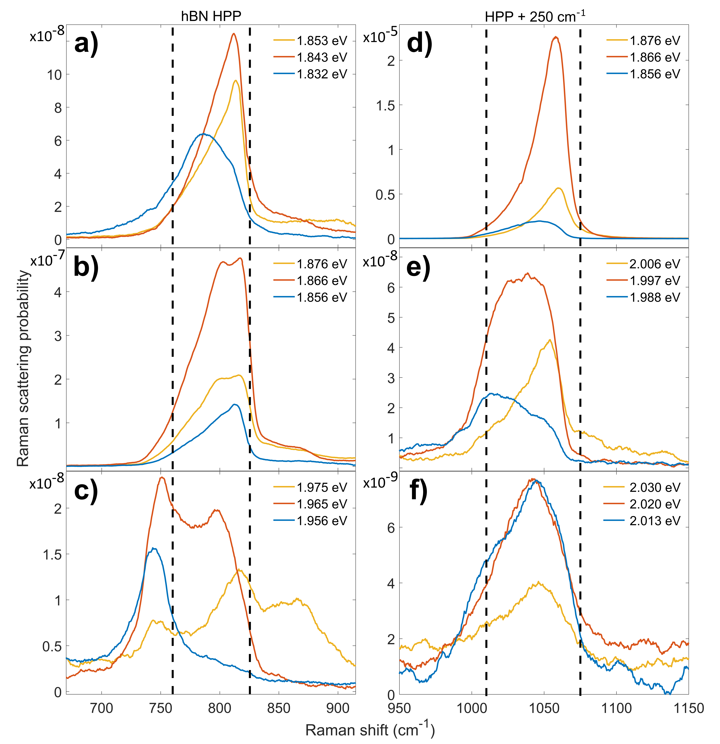
Figure 3: Raman spectra showing the lineshapes of the 800 [a, b, c)] and 1050 cm⁻¹ [d, e, f)] hBN associated Raman peaks at various resonances. The orange curve shows the spectrum at the peak of the specified resonance and the blue and yellow curves show spectra taken at ± 10 meV either side of the resonance. a) A1s outgoing b) A2s incoming c) A2s outgoing d) A1s outgoing = A2s incoming e) A2s outgoing f) A3s outgoing. The lower shift peak observed in c), in the 1.956 eV spectra, at about 750 cm⁻¹ is associated with a multi-phonon peak rather than hBN HPP as can be seen more clearly in Fig 1c. This is only observed at the A2s outgoing resonance. The agreement of the shift of this peak with three times the shift of the A₁′ peak suggests that it is due to emission of 3 A₁′ phonons.
Having fully analysed the data for the encapsulated WSe₂ we now turn our attention to the results for encapsulated MoSe₂. The strength of the hBN related Raman peaks in encapsulated MoSe₂ is significantly weaker; Fig 4. In MoSe_{2,} the features are observed only when the laser energy is tuned to the A2s or B2s excitons. In both cases, the resonances are near double resonances with the A1s and B1s excitons respectively however not fully doubly resonant. The fact that in MoSe₂ the resonances are significantly further from double resonance compared to WSe₂ is likely to be the main reason why these features are so much weaker in MoSe₂. Due to the weak scattering, it was not possible to obtain clear spectra apart from at the peak of the resonance or fully analyse the resonance behaviour. However, there is considerable new information available from the resonant spectra. In particular, the upper shift feature in MoSe₂ is considerably broader than the lower shift feature. As shown on Fig 4, it is possible to explain this if the upper shift feature is in fact due to a combination of a HPP and either an A₁′ (lower Raman shifts) or E’ phonon (higher Raman shifts). In the case of the WSe₂ these phonons are degenerate and so it is possible that the upper shift feature also involves a contribution from the E’ phonon. In addition, and importantly, the lineshape of the lower shift feature is very similar to the same feature in WSe₂ and in particular extends beyond the Reststrahlen band at lower shifts. Thus, the observation of Raman scattering outside of the Reststrahlen band is not a feature of a single material or sample but is more general.

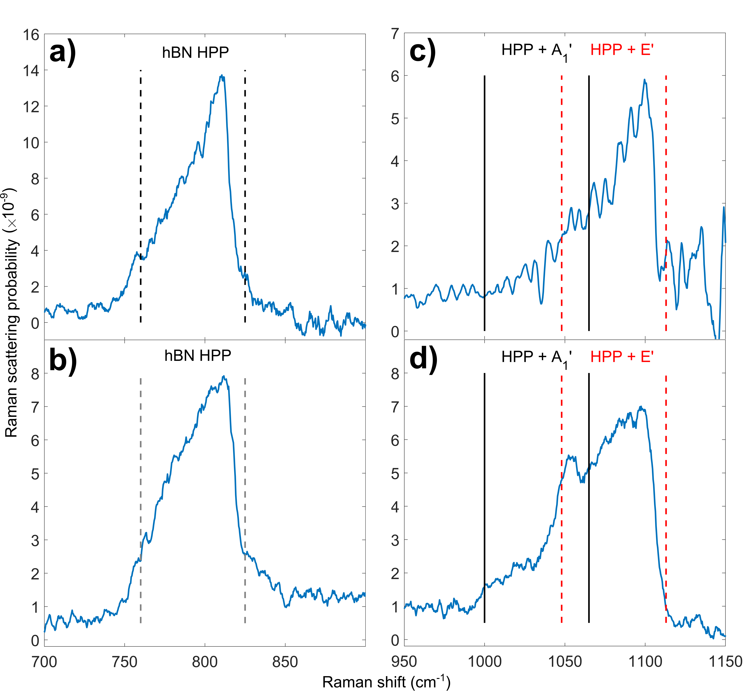
Figure 4: Raman spectra of the hBN encapsulated MoSe₂ monolayer sample. Panels a) & b) show the broad 800 cm⁻¹ hBN Raman peak with Reststrahlen band shifts marked with dashed lines. Panels c) & d) show the spectra around 1050 cm⁻¹, with markings at the Reststrahlen band shifts plus the MoSe₂ A₁′(Γ) phonon (240 cm⁻¹) in black and plus the MoSe₂ E’(Γ) phonon (288 cm⁻¹) in red. Panels a) & c) are from spectra taken around the A1s outgoing / A2s incoming resonances at 1.80 eV. Panels b) & d) are from spectra taken with the laser energy between the B1s outgoing resonance and the B2s incoming resonance at 2.01 eV.

Whilst the attribution of the hBN features to HPP is not new, so far no one has tried to understand the lineshape in terms of this model. In order to fully model the Raman lineshape would require a model not only for the HPPs but also a model for TMD excitons and for the HPP-exciton interaction. However, it is reasonable to expect that the density of states of the HPP may well dominate the lineshape. Therefore we have used a T-matrix model, developed by Passler et al. [47] , to predict the IR absorption spectrum of HPP for our structure, measured in an Otto configuration experiment, as a function of in-plane wavevector of the absorbed light. The absorption spectrum predictions were made using the hBN dielectric function determined by Caldwell et al. [16] and layer thicknesses constrained by atomic force microscopy and fitting to the optical reflectivity spectra. The predicted spectra were fitted to extract the dispersion relation for the HPP, i.e. the energy of the HPP as a function of in-plane wavevector. For some in-plane wavevectors it is possible to observe multiple, different energy, HPP which have different mode profiles in the direction normal to the plane. As shown in Fig 5a as the in-plane wavevector increases the number of possible modes increases and the energy of a specific mode decreases. In a Raman scattering momentum conservation should apply to the wavevector of the incoming photon and the sum of the wavevectors of the outgoing phonon and HPPs generated during the scattering process. This places a limit on the maximum wavevector HPP that can be generated by Raman scattering comparable to the wavenumber of visible light ~15000 cm⁻¹. If we use the wavelength of light resonant with the A2s exciton in WSe₂ and based upon back scattering of radiation incident at 30 °, reasonable for our objective lens, we predict that the maximum wavevector HPP we should generate in momentum conserving Raman scattering would have a magnitude of 15050 cm⁻¹. As shown on Fig 5 HPP with wavevectors with magnitude are restricted to the energy range 800-820 cm⁻¹ which is clearly too small a range to explain the observed Raman feature which extends below 750cm⁻¹. Defects and other effects can lead to non-momentum conserving Raman scattering. As shown on Fig 4, if we assume the maximum wavevector of HPP observed in Raman scattering is five times that of the momentum conserving limit the range of the HPP Raman feature would be predicted to increase significantly to 760-820 cm⁻¹. Therefore, it is difficult to believe that Raman scattering does not probe HPP with wavevectors significantly bigger than the momentum conserving limit of 15050 cm⁻¹. However even if we place no upper limit on the wavevectors of the HPP which can be detected by Raman the range the theory predicts a feature which is narrower than observed. Fundamentally, it is not possible for the current model to produce scattering below the lower Reststrahlen band edge. Thus, whilst it is highly likely that HPP are responsible for the two features associated with them in Raman spectra of hBN encapsulated TMDs layers the simple HPP model set out above cannot explain the width of these features.
We now need to consider why the simple HPP model fails and what additional physics is required to explain the observed Raman features. An obvious possibility is that we have used the incorrect parameters for the Reststrahlen band. However a review of the literature gives multiple independent measurements of these parameters based on IR spectroscopy [16,37,48,49] and whist there are variations in the extracted parameters none of the measurements support the lower bound of the Reststrahlen band being below 760 cm⁻¹. Another alternative is that the 730-850 cm⁻¹ feature is a combination peak involving absorption of a thermal phonon. However, the measurements were performed at 4 K and the thermal energy, which corresponds to ~3 cm^{-1,} is insufficient to significantly extend the feature to lower shifts. Another possibility is that at very large wavevectors the ZO phonon responsible for the HPP disperses to lower energy. However, there is no obvious mechanism allowing us to couple to such large wavevector HPP. Thus, currently we do not have a good explanation of the width of the two Raman features associated with HPP in these structures. Whilst it is possible, the resolution of this issue is associated with the TMD layers it is also possible that the ability of Raman scattering to access large wavevector HPP is allowing us to access new HPP effects not yet understood.
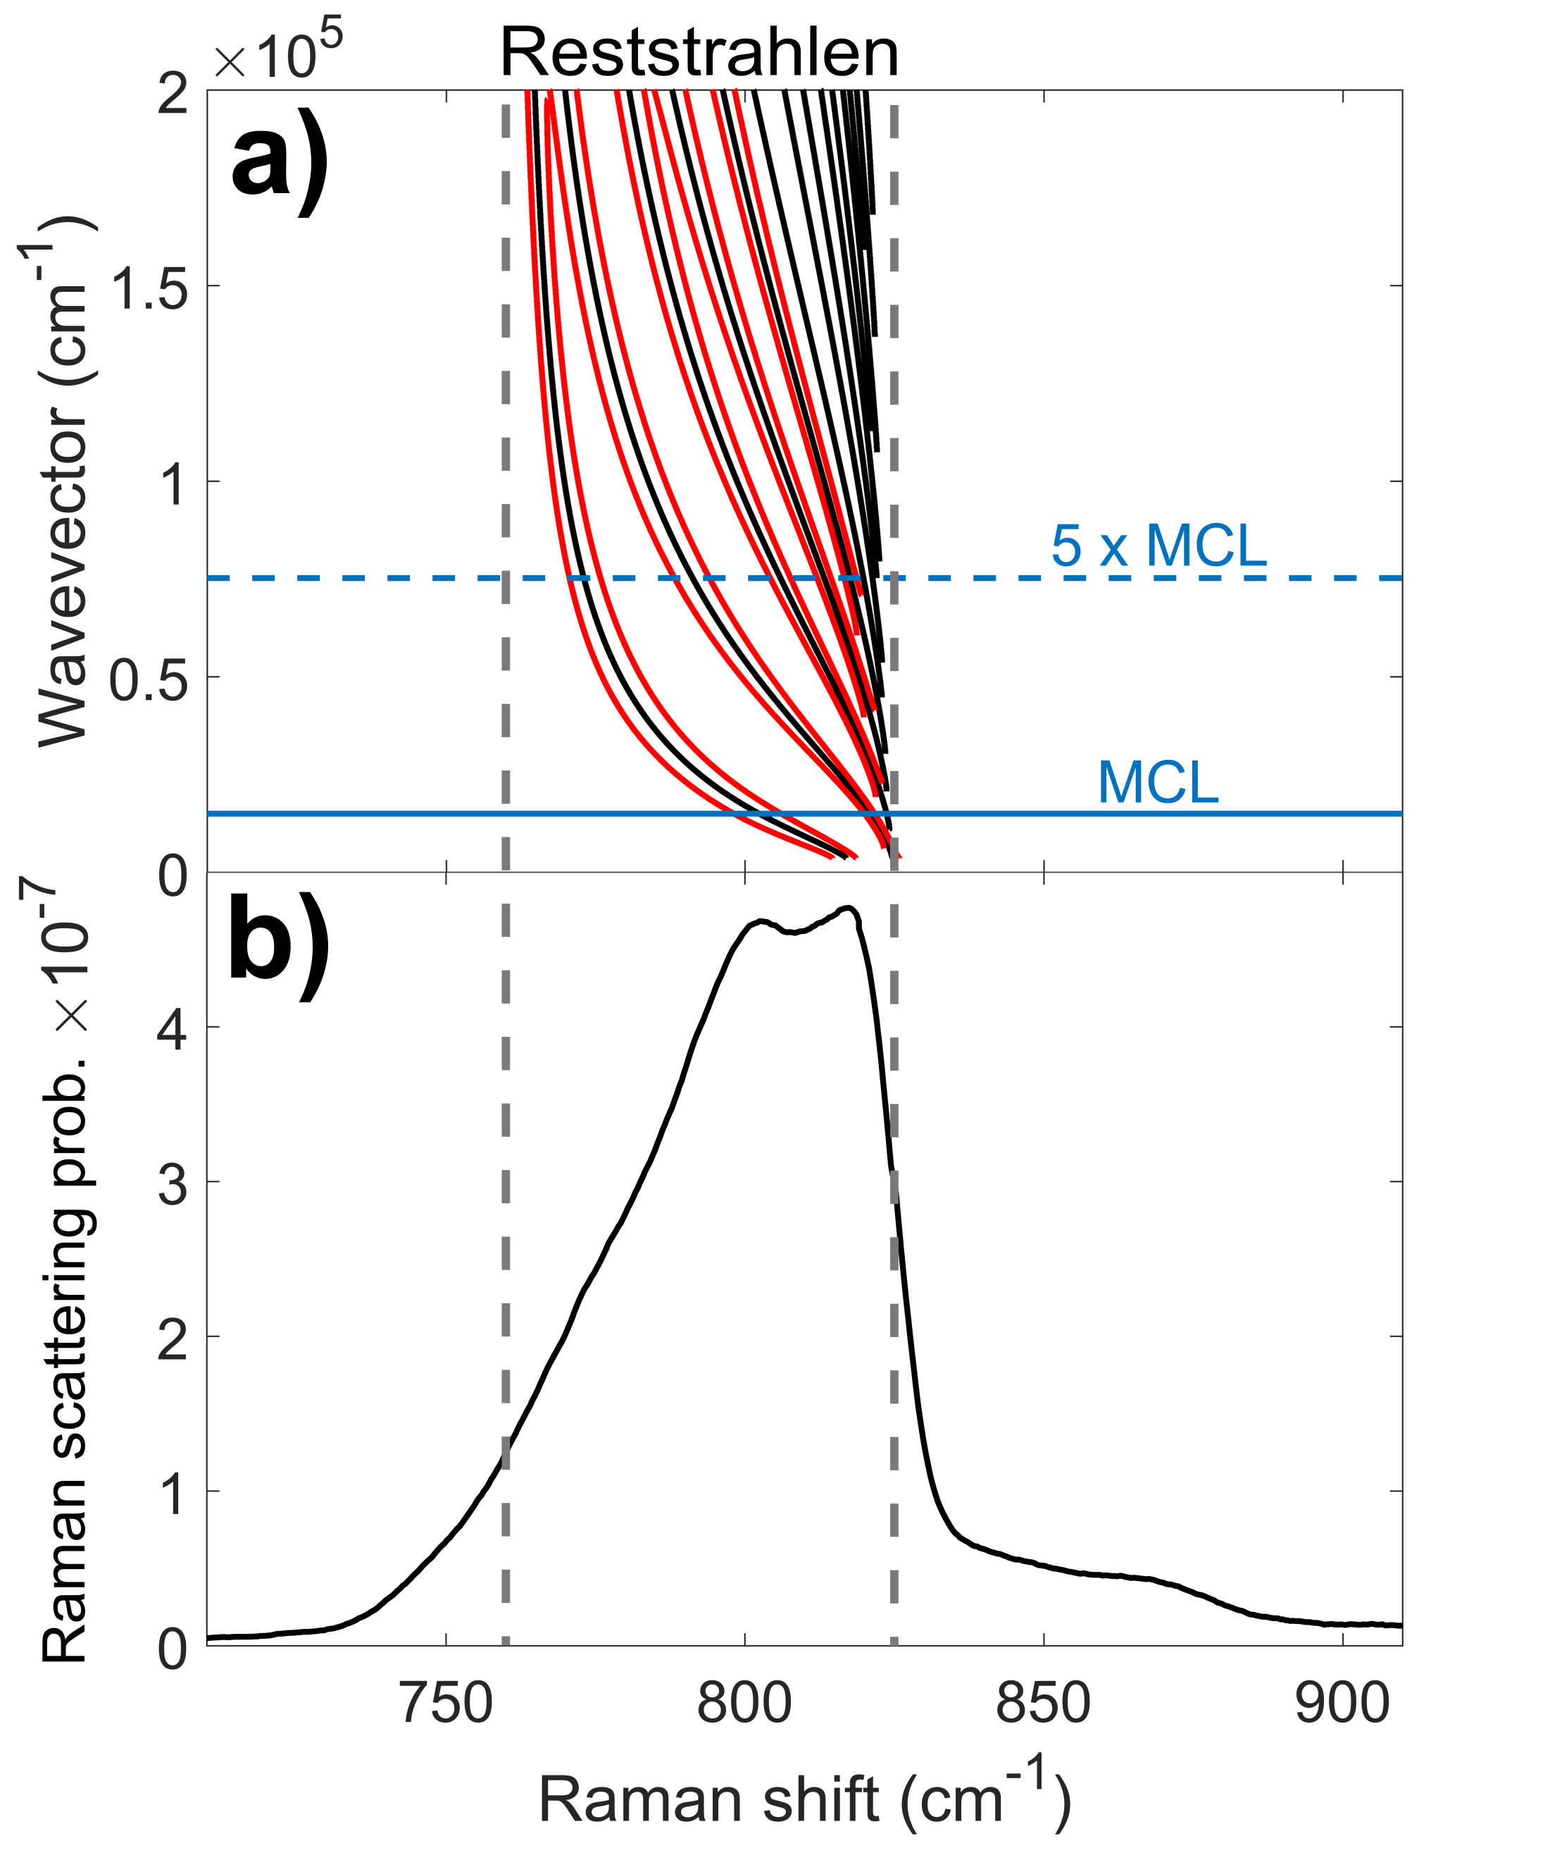
Figure 5: a) Dispersion relation for the hyperbolic phonon polariton modes, determined using the 4x4 transfer matrix approach of Passler et. al. [47] The black lines show the bands of allowed modes and the red lines indicate their widths (at half magnitude) for the first five allowed HPP modes. The maximum in-pane momentum available in a single phonon Raman process based on the incident angle of the beam from the 0.5 NA objective is 15050 cm⁻¹ at the A2s energy. This momentum conserving limit is marked with a solid blue line labelled MCL. Five times this limit is also marked with a dashed blue line. b) shows a Raman spectrum taken on the hBN encapsulated WSe₂ monolayer sample with an excitation energy of 1.866 eV, on resonance with the WSe₂ A2s exciton. The hBN TO and LO frequencies of 760 and 825 cm⁻¹ are marked with dashed vertical lines, between which is the Reststrahlen band.
The results set out in this paper add considerably to our knowledge about the hBN HPP Raman features observed previously in hBN encapsulated WSe₂ structures. In WSe_{2,} we have observed outgoing resonances with the A2s and A3s excitonic states for the first time. The outgoing resonance with the A3s exciton is the first time this exciton has been detected in resonance Raman. In MoSe_{2,} we have observed hBN HPP features for the first time. In this material, they are associated with double resonances with the incoming photons resonant with the A2s or B2s excitons and the outgoing photons resonant with the A1s or B1s excitons respectively. From the MoSe₂ spectra, we can deduce that in this material the upper HPP feature involves emission of a HPP and either an A₁′ or E′ phonon, with both cases contributing to the overall lineshape. It is quite likely that this is also true for WSe₂ but the degeneracy of the phonons in this material makes this difficult to confirm.
However, the most important outcomes of this study are associated with the HPP. Firstly, it is clear that compared to IR reflectivity measurements, resonance Raman scattering allows access to a much greater range of HPP with larger wavevectors. Even momentum conserving Raman allows access to wavevectors a factor of ten greater than accessible by IR measurements and there is good evidence that Raman scattering is not momentum conserving allowing even larger wavevector modes to be studied. In addition, there is a mystery as to how Raman scattering can occur at Raman shifts below the lower bound on the Reststrahlen band determined from IR measurements. The solution to this mystery may give us insights into HPP that cannot be achieved via other techniques. The insights need not be restricted to HPP associated with the layers of hBN. It is possible to transfer exfoliated TMD flakes onto a wide range of substrates. This suggests they could make an ideal probe for HPP associated with a wide range of materials and metamaterials. This paper shows that doing this will give an insight into HPP in these structures that is difficult to achieve in other ways.

Methods
The hBN encapsulated monolayer MoSe₂ and WSe₂ samples were fabricated by hot pickup using a dry polycarbonate on PDMS stamp from individual mechanically exfoliated monolayers [50]. The WSe₂ sample was encased within a top 36 nm, and bottom 27 nm, thick hBN layer. The bottom hBN layer was on top of a 20 nm graphite layer which sat atop a 300 nm thick SiO₂ coated Si wafer. The MoSe₂ sample followed the same structure, with top and bottom hBN thicknesses of 30 and 20 nm respectively and a 4 nm graphite thickness. These are the same samples that feature in a larger resonance Raman study [43,51] with the same experimental setup. The measurements presented here were performed with the sample under vacuum at 4 K in a helium flow cryostat. A Coherent Mira 900 Ti:Sapphire laser in CW mode and a Coherent CR-599 CW dye laser were used to excite the samples in backscattering geometry via a 50x 0.5 NA long working distance microscope objective. This allowed Raman spectra to be taken with excitation energies from 1.60 to 2.24 eV. The incident power on the sample was 100 µW. The Raman spectra were measured with a TriVista 555 spectrometer with the first two stages of the spectrometer set in subtractive mode and a liquid nitrogen cooled CCD.

Linear polarisers were placed in the exciting laser beam before the sample and in between the sample and spectrometer. For each excitation energy, Raman spectra were taken with these polarisers set co-linear and with them crossed. The crossed polariser spectra were subtracted from the co-linear spectra which had the effect of removing the photoluminescence (PL) signal whilst preserving the Raman signal. At energies where PL signal in the spectrum was many orders of magnitude greater than the Raman, such as near the A1s exciton energy, residual PL was present after subtraction.

The Raman signal from the SiO₂ coated Si substrate was used to calibrate the Raman spectra for frequency. The intensity of the Si peak was used with Si resonance Raman data from literature [52] to convert the data to absolute scattering probability. A transfer matrix model of the stack of layers in the samples was used to correct for the effect of thin film interference on the Raman intensity. The details of these corrections are given in the supplementary information of our previous paper [43].

Supplementary Information
The supplementary information [39] contains discussion of the hBN modes in a hBN encapsulated MoSe₂ monolayer sample, including a resonance Raman colourmap and resonance profile of the 800 cm⁻¹ mode. Reflectivity spectra are also discussed for the MoSe₂ and WSe₂ samples, with exciton energies extracted from those spectra presented with comparative literature values from [44,53–56]. Additional detail on the extraction and fitting of resonance profiles from the Raman spectra is also provided.
Data Availability
The data presented in this paper is openly available from the University of Southampton Repository DOI: https://doi.org/10.5258/SOTON/D1734
Corresponding Author
*D.C.Smith@soton.ac.uk

Author Contributions
Samples were fabricated by P.R. The experimental measurements were performed by J.V and L.P.M. Experimental data analysis and interpretation was carried out by J.V., L.P.M and D.C.S. The paper was written by D.C.S and J.V. All authors discussed the results and commented on the manuscript.
The manuscript was written through contributions of all authors. All authors have given approval to the final version of the manuscript.

Funding Sources
Research at the University of Southampton was supported by the Engineering and Physical Science Council of the UK via programme grant EP/N035437/1. Both L.P.M and J.V were also supported by EPSRC DTP funding. The work at University of Washington was mainly supported by the Department of Energy, Basic Energy Sciences, Materials Sciences and Engineering Division (DE-SC0018171).

Bibliography
[1] Z. Jacob, Nanophotonics: Hyperbolic Phonon-Polaritons, Nat. Mater. 13, 1081 (2014).
[2] E. Yoxall, M. Schnell, A. Y. Nikitin, O. Txoperena, A. Woessner, M. B. Lundeberg, F. Casanova, L. E. Hueso, F. H. L. Koppens, and R. Hillenbrand, Direct Observation of Ultraslow Hyperbolic Polariton Propagation with Negative Phase Velocity, Nat. Photonics 9, 674 (2015).
[3] T. Low, A. Chaves, J. D. Caldwell, A. Kumar, N. X. Fang, P. Avouris, T. F. Heinz, F. Guinea, L. Martin-Moreno, and F. Koppens, Polaritons in Layered Two-Dimensional Materials, Nat. Mater. 16, 182 (2017).
[4] D. N. Basov, M. M. Fogler, and F. J. García De Abajo, Polaritons in van Der Waals Materials, Science (80-. ). 354, aag1992 (2016).
[5] T. G. Folland, L. Nordin, D. Wasserman, and J. D. Caldwell, Probing Polaritons in the Mid- to Far-Infrared, J. Appl. Phys. 125, 191102 (2019).
[6] P. Li, M. Lewin, A. V. Kretinin, J. D. Caldwell, K. S. Novoselov, T. Taniguchi, K. Watanabe, F. Gaussmann, and T. Taubner, Hyperbolic Phonon-Polaritons in Boron Nitride for near-Field Optical Imaging and Focusing, Nat. Commun. 6, 7507 (2015).
[7] A. C. Jones and M. B. Raschke, Thermal Infrared Near-Field Spectroscopy, Nano Lett. 12, 1475 (2012).
[8] G. Lu, J. R. Nolen, T. G. Folland, M. J. Tadjer, D. G. Walker, and J. D. Caldwell, Narrowband Polaritonic Thermal Emitters Driven by Waste Heat, ACS Omega 5, 10900 (2020).
[9] R. Carminati and J. J. Greffet, Near-Field Effects in Spatial Coherence of Thermal Sources, Phys. Rev. Lett. 82, 1660 (1999).
[10] J. J. Greffet, R. Carminati, K. Joulain, J. P. Mulet, S. Mainguy, and Y. Chen, Coherent Emission of Light by Thermal Sources, Nature 416, 61 (2002).
[11] L. Wojszvzyk, A. Nguyen, A.-L. Coutrot, M. Besbes, J.-P. Hugonin, B. Vest, and J.-J. Greffet, Fast Modulation and Polarization Control of Infrared Emission by Incandescent Metasurfaces, in Plasmonics: Design, Materials, Fabrication, Characterization, and Applications XVIII, edited by T. Tanaka and D. P. Tsai (SPIE, 2020).
[12] M. Autore, P. Li, I. Dolado, F. J. Alfaro-Mozaz, R. Esteban, A. Atxabal, F. Casanova, L. E. Hueso, P. Alonso-González, J. Aizpurua, A. Y. Nikitin, S. Vélez, and R. Hillenbrand, Boron Nitride Nanoresonators for Phonon-Enhanced Molecular Vibrational Spectroscopy at the Strong Coupling Limit, Light Sci. Appl. 7, 17172 (2018).
[13] S. Dai, Q. Ma, T. Andersen, A. S. McLeod, Z. Fei, M. K. Liu, M. Wagner, K. Watanabe, T. Taniguchi, M. Thiemens, F. Keilmann, P. Jarillo-Herrero, M. M. Fogler, and D. N. Basov, Subdiffractional Focusing and Guiding of Polaritonic Rays in a Natural Hyperbolic Material, Nat. Commun. 6, 6963 (2015).
[14] K. Chaudhary, M. Tamagnone, X. Yin, C. M. Spägele, S. L. Oscurato, J. Li, C. Persch, R. Li, N. A. Rubin, L. A. Jauregui, K. Watanabe, T. Taniguchi, P. Kim, M. Wuttig, J. H. Edgar, A. Ambrosio, and F. Capasso, Polariton Nanophotonics Using Phase-Change Materials, Nat. Commun. 10, 4487 (2019).
[15] T. G. Folland, A. Fali, S. T. White, J. R. Matson, S. Liu, N. A. Aghamiri, J. H. Edgar, R. F. Haglund, Y. Abate, and J. D. Caldwell, Reconfigurable Infrared Hyperbolic Metasurfaces Using Phase Change Materials, Nat. Commun. 9, 4371 (2018).
[16] J. D. Caldwell, A. V. Kretinin, Y. Chen, V. Giannini, M. M. Fogler, Y. Francescato, C. T. Ellis, J. G. Tischler, C. R. Woods, A. J. Giles, M. Hong, K. Watanabe, T. Taniguchi, S. A. Maier, and K. S. Novoselov, Sub-Diffractional Volume-Confined Polaritons in the Natural Hyperbolic Material Hexagonal Boron Nitride, Nat. Commun. 5, 5221 (2014).
[17] I. H. Lee, M. He, X. Zhang, Y. Luo, S. Liu, J. H. Edgar, K. Wang, P. Avouris, T. Low, J. D. Caldwell, and S. H. Oh, Image Polaritons in Boron Nitride for Extreme Polariton Confinement with Low Losses, Nat. Commun. 11, 3649 (2020).
[18] C. R. Gubbin, R. Berte, M. A. Meeker, A. J. Giles, C. T. Ellis, J. G. Tischler, V. D. Wheeler, S. A. Maier, J. D. Caldwell, and S. De Liberato, Hybrid Longitudinal-Transverse Phonon Polaritons, Nat. Commun. 10, 1682 (2019).
[19] N. C. Passler, C. R. Gubbin, T. G. Folland, I. Razdolski, D. S. Katzer, D. F. Storm, M. Wolf, S. De Liberato, J. D. Caldwell, and A. Paarmann, Strong Coupling of Epsilon-Near-Zero Phonon Polaritons in Polar Dielectric Heterostructures, Nano Lett. 18, 4285 (2018).
[20] A. Paarmann, I. Razdolski, A. Melnikov, S. Gewinner, W. Schöllkopf, and M. Wolf, Second Harmonic Generation Spectroscopy in the Reststrahl Band of SiC Using an Infrared Free-Electron Laser, Appl. Phys. Lett. 107, 081101 (2015).
[21] I. Razdolski, Y. Chen, A. J. Giles, S. Gewinner, W. Schöllkopf, M. Hong, M. Wolf, V. Giannini, J. D. Caldwell, S. A. Maier, and A. Paarmann, Resonant Enhancement of Second-Harmonic Generation in the Mid-Infrared Using Localized Surface Phonon Polaritons in Subdiffractional Nanostructures, Nano Lett. 16, 6954 (2016).
[22] N. C. Passler, I. Razdolski, S. Gewinner, W. Schöllkopf, M. Wolf, and A. Paarmann, Second-Harmonic Generation from Critically Coupled Surface Phonon Polaritons, ACS Photonics 4, 1048 (2017).
[23] J. D. Caldwell, O. J. Glembocki, Y. Francescato, N. Sharac, V. Giannini, F. J. Bezares, J. P. Long, J. C. Owrutsky, I. Vurgaftman, J. G. Tischler, V. D. Wheeler, N. D. Bassim, L. M. Shirey, R. Kasica, and S. A. Maier, Low-Loss, Extreme Subdiffraction Photon Confinement via Silicon Carbide Localized Surface Phonon Polariton Resonators, Nano Lett. 13, 3690 (2013).
[24] D. Rodrigo, O. Limaj, D. Janner, D. Etezadi, F. J. García De Abajo, V. Pruneri, and H. Altug, Mid-Infrared Plasmonic Biosensing with Graphene, Science (80-. ). 349, 165 (2015).
[25] A. J. Giles, S. Dai, I. Vurgaftman, T. Hoffman, S. Liu, L. Lindsay, C. T. Ellis, N. Assefa, I. Chatzakis, T. L. Reinecke, J. G. Tischler, M. M. Fogler, J. H. Edgar, D. N. Basov, and J. D. Caldwell, Ultralow-Loss Polaritons in Isotopically Pure Boron Nitride, Nat. Mater. 17, 134 (2018).
[26] S. Dai, Z. Fei, Q. Ma, A. S. Rodin, M. Wagner, A. S. McLeod, M. K. Liu, W. Gannett, W. Regan, K. Watanabe, T. Taniguchi, M. Thiemens, G. Dominguez, A. H. Castro Neto, A. Zettl, F. Keilmann, P. Jarillo-Herrero, M. M. Fogler, and D. N. Basov, Tunable Phonon Polaritons in Atomically Thin van Der Waals Crystals of Boron Nitride, Science (80-. ). 343, 1125 (2014).
[27] Z. Fei, A. S. Rodin, G. O. Andreev, W. Bao, A. S. McLeod, M. Wagner, L. M. Zhang, Z. Zhao, M. Thiemens, G. Dominguez, M. M. Fogler, A. H. Castro Neto, C. N. Lau, F. Keilmann, and D. N. Basov, Gate-Tuning of Graphene Plasmons Revealed by Infrared Nano-Imaging, Nature 487, 82 (2012).
[28] J. Chen, M. Badioli, P. Alonso-González, S. Thongrattanasiri, F. Huth, J. Osmond, M. Spasenović, A. Centeno, A. Pesquera, P. Godignon, A. Zurutuza Elorza, N. Camara, F. J. García, R. Hillenbrand, and F. H. L. Koppens, Optical Nano-Imaging of Gate-Tunable Graphene Plasmons, Nature 487, 77 (2012).
[29] T. G. Folland, T. W. W. Ma, J. R. Matson, J. R. Nolen, S. Liu, K. Watanabe, T. Taniguchi, J. H. Edgar, T. Taubner, and J. D. Caldwell, Probing Hyperbolic Polaritons Using Infrared Attenuated Total Reflectance Micro-Spectroscopy, MRS Commun. 8, 1418 (2018).
[30] L. Du, Y. Zhao, Z. Jia, M. Liao, Q. Wang, X. Guo, Z. Shi, R. Yang, K. Watanabe, T. Taniguchi, J. Xiang, D. Shi, Q. Dai, Z. Sun, and G. Zhang, Strong and Tunable Interlayer Coupling of Infrared-Active Phonons to Excitons in van Der Waals Heterostructures, Phys. Rev. B 99, 205410 (2019).
[31] C. M. Chow, H. Yu, A. M. Jones, J. Yan, D. G. Mandrus, T. Taniguchi, K. Watanabe, W. Yao, and X. Xu, Unusual Exciton-Phonon Interactions at van Der Waals Engineered Interfaces, Nano Lett. 17, 1194 (2017).
[32] C. Jin, J. Kim, J. Suh, Z. Shi, B. Chen, X. Fan, M. Kam, K. Watanabe, T. Taniguchi, S. Tongay, A. Zettl, J. Wu, and F. Wang, Interlayer Electron–Phonon Coupling in WSe2/HBN Heterostructures, Nat. Phys. 13, 127 (2016).
[33] H. Terrones, E. Del Corro, S. Feng, J. M. Poumirol, D. Rhodes, D. Smirnov, N. R. Pradhan, Z. Lin, M. A. T. Nguyen, A. L. Elías, T. E. Mallouk, L. Balicas, M. A. Pimenta, and M. Terrones, New First Order Raman-Active Modes in Few Layered Transition Metal Dichalcogenides, Sci. Rep. 4, 4215 (2014).
[34] X. Zhang, X.-F. Qiao, W. Shi, J.-B. Wu, D.-S. Jiang, and P.-H. Tan, Phonon and Raman Scattering of Two-Dimensional Transition Metal Dichalcogenides from Monolayer, Multilayer to Bulk Material, Chem. Soc. Rev. 44, 2757 (2015).
[35] S. Y. Chen, C. Zheng, M. S. Fuhrer, and J. Yan, Helicity-Resolved Raman Scattering of MoS2, MoSe2, WS2, and WSe2 Atomic Layers, Nano Lett. 15, 2526 (2015).
[36] L. Du, M. Liao, J. Tang, Q. Zhang, H. Yu, R. Yang, K. Watanabe, T. Taniguchi, D. Shi, Q. Zhang, and G. Zhang, Strongly Enhanced Exciton-Phonon Coupling in Two-Dimensional WSe2, Phys. Rev. B 97, 235145 (2018).
[37] R. Geick, C. H. Perry, and G. Rupprecht, Normal Modes in Hexagonal Boron Nitride, Phys. Rev. 146, 543 (1966).
[38] W. Zhao, Z. Ghorannevis, K. K. Amara, J. R. Pang, M. Toh, X. Zhang, C. Kloc, P. H. Tan, and G. Eda, Lattice Dynamics in Mono- and Few-Layer Sheets of WS2 and WSe2, Nanoscale 5, 9677 (2013).
[39] See Supplemental Material at [URL Will Be Inserted by the Production Group] for MoSe2 and WSe2 Reflectivity and MoSe2 HBN Resonance Raman Measurements.
[40] I. Bilgin, A. S. Raeliarijaona, M. C. Lucking, S. C. Hodge, A. D. Mohite, A. De Luna Bugallo, H. Terrones, and S. Kar, Resonant Raman and Exciton Coupling in High-Quality Single Crystals of Atomically Thin Molybdenum Diselenide Grown by Vapor-Phase Chalcogenization, ACS Nano 12, 740 (2018).
[41] D. Nam, J. U. Lee, and H. Cheong, Excitation Energy Dependent Raman Spectrum of MoSe2, Sci. Rep. 5, 17113 (2015).
[42] P. Soubelet, a. E. Bruchhausen, A. Fainstein, K. Nogajewski, and C. Faugeras, Resonance Effects in the Raman Scattering of Monolayer and Few-Layer MoSe2, Phys. Rev. B 93, 155407 (2016).
[43] L. P. McDonnell, J. Viner, P. Rivera, X. Xu, and D. C. Smith, Observation of Intravalley Phonon Scattering of 2s Excitons in MoSe2 and WSe2 Monolayers, 2D Mater. 7, 045008 (2020).
[44] M. Manca, M. M. Glazov, C. Robert, F. Cadiz, T. Taniguchi, K. Watanabe, E. Courtade, T. Amand, P. Renucci, X. Marie, G. Wang, and B. Urbaszek, Enabling Valley Selective Exciton Scattering in Monolayer WSe2 through Upconversion, Nat. Commun. 8, 14927 (2017).
[45] S. Y. Chen, Z. Lu, T. Goldstein, J. Tong, A. Chaves, J. Kunstmann, L. S. R. Cavalcante, T. Woźniak, G. Seifert, D. R. Reichman, T. Taniguchi, K. Watanabe, D. Smirnov, and J. Yan, Luminescent Emission of Excited Rydberg Excitons from Monolayer WSe2, Nano Lett. 19, 2464 (2019).
[46] J. J. S. Viner, L. P. McDonnell, D. A. Ruiz-Tijerina, P. Rivera, X. Xu, V. I. Fal’Ko, and D. C. Smith, Excited Rydberg States in MoSe2 /WSe2 Heterostructures, 2D Mater. 8, 035047 (2021).
[47] N. C. Passler and A. Paarmann, Generalized 4 × 4 Matrix Formalism for Light Propagation in Anisotropic Stratified Media: Study of Surface Phonon Polaritons in Polar Dielectric Heterostructures, J. Opt. Soc. Am. B 34, 2128 (2017).
[48] S. V. Ordin, B. N. Sharupin, and M. I. Fedorov, Normal Lattice Vibrations and the Crystal Structure of Anisotropic Modifications of Boron Nitride, Semiconductors 32, 924 (1998).
[49] E. Franke, M. Schubert, H. Neumann, T. E. Tiwald, D. W. Thompson, J. A. Woollam, J. Hahn, and F. Richter, Phase and Microstructure Investigations of Boron Nitride Thin Films by Spectroscopic Ellipsometry in the Visible and Infrared Spectral Range, J. Appl. Phys. 82, 2906 (1997).
[50] P. J. Zomer, M. H. D. Guimarães, J. C. Brant, N. Tombros, and B. J. Van Wees, Fast Pick up Technique for High Quality Heterostructures of Bilayer Graphene and Hexagonal Boron Nitride, Appl. Phys. Lett. 105, 013101 (2014).
[51] L. P. McDonnell, J. J. S. Viner, D. A. Ruiz-Tijerina, P. Rivera, X. Xu, V. I. Fal’ko, and D. C. Smith, Superposition of Intra- and Inter-Layer Excitons in Twistronic MoSe2 /WSe2 Bilayers Probed by Resonant Raman Scattering, 2D Mater. 8, 035009 (2021).
[52] R. L. Aggarwal, L. W. Farrar, S. K. Saikin, A. Aspuru-Guzik, M. Stopa, and D. L. Polla, Measurement of the Absolute Raman Cross Section of the Optical Phonon in Silicon, Solid State Commun. 151, 553 (2011).
[53] J. Horng, T. Stroucken, L. Zhang, E. Y. Paik, H. Deng, and S. W. Koch, Observation of Interlayer Excitons in MoSe2 Single Crystals, Phys. Rev. B 97, 241404 (2018).
[54] A. Arora, K. Nogajewski, M. Molas, M. Koperski, and M. Potemski, Exciton Band Structure in Layered MoSe2: From a Monolayer to the Bulk Limit, Nanoscale 7, 20769 (2015).
[55] E. Liu, J. Van Baren, T. Taniguchi, K. Watanabe, Y. C. Chang, and C. H. Lui, Magnetophotoluminescence of Exciton Rydberg States in Monolayer WSe2, Phys. Rev. B 99, 205420 (2019).
[56] A. Arora, J. Marcus, K. Nogajewski, M. Koperski, C. Faugeras, M. Potemski, K. Nogajewski, J. Marcus, C. Faugeras, and M. Potemski, Excitonic Resonances in Thin Films of WSe2 : From Monolayer to Bulk Material, Nanoscale 7, 10421 (2015).

