Introduction to the Cultural Strategies in England database
This document should be cited as:
Ashton, D. and Bell, M. (2023) Introduction to the Cultural Strategies in England database. Public Policy Southampton. University of Southampton. DOI: https://doi.org/10.5258/SOTON/P1121

Table of Contents
Creating and updating the Cultural Strategies in England overview database 3
The Cultural Strategies in England overview spreadsheet 4
How the search was conducted 5
Overview of search results 6
Search results for ‘cultural strategies’ by council type 6
Councils with joint cultural strategies 6
Cultural strategies published per year 7

Creating and updating the Cultural Strategies in England overview database
This database was created as part of the University of Southampton Public Policy Funded Southampton Project, Cultural strategies, compacts and futures: The role of local government in connecting culture with place, health and the environment (project identification number: 86272). The creation of the database responds to findings from the project. Please see the project website.
Should any copyright holder object to a cultural strategy document being included in the database, then it will be removed. Please University of Southampton Takedown Policy: https://library.soton.ac.uk/openaccess/policies#s-lg-box-wrapper-3001663
- The University of Southampton Pure Board will review any takedown requests.
- If there is proof of copyright violation then the research output in question will immediately be removed from public view.
At the time of writing (July 2023) the database is an archive of 147 strategies that were downloaded in January 2023.
The Cultural Strategies in England overview spreadsheet will however be periodically updated with links to new cultural strategies as they are identified. This is set out in the following:
Title | Search conducted | Uploaded to project page | Changes made
Cultural Strategies in England overview (Version 1 Jan 2023) | January 2023 | July 2023 | Not applicable as version 1.

The Cultural Strategies in England overview spreadsheet

- The Cultural Strategies in England overview spreadsheet consists of four tabs: introduction and notes; cultural strategies; cultural compacts; and both strategies and compacts.

- The Introduction tab includes links to project website for context and information on the Creative Commons licence and takedown notice.

- The Cultural Strategy tab is a database of the located and publicly accessible cultural strategies to date. The spreadsheet contains columns for: council, council type, do they have a cultural strategy? (Yes/Can’t Find/Not Yet), type of document found, title of document, date published, version/issue number, years covered, authoring consultants, do they have a Cultural Compact? (Yes/Can’t Find/Not Yet), date added to the database, and link.
- The Cultural Compacts tab is a database of cultural compacts located and publicly accessible to date. The spreadsheet contains tabs for: council, council type, do they have a Cultural Compact? (Yes/Can’t Find/Not Yet), date published, version/issue number, years covered, authoring consultants, PDF downloaded or made, date added to the database, and link.
- The Both Strategies and Compacts tab contains a list of councils with both strategies and compacts published and publicly available. It also lists the year the documents were published.
- Not all information in each tab will be fully filled out. For example, some strategies do not list authoring consultants or date published. The information is as complete as possible at the time of authorship.

How the search was conducted
In stage 1, we used secondary data analysis (SDA) of publicly accessible local authority websites in England to identify and archive cultural strategy and Cultural Compact documents.
A searched was conducted in January 2023 for Cultural Strategies from all 332 councils in England using the List of Councils in England (2021). The search was 'cultural strategy + council name' on Google and 'cultural strategy' on individual council websites. Results were organised into: Yes; Can't Find; and Not Yet. Rather than providing a definitive ‘no’ category, these distinctions take account of where there is a stated intention to develop a cultural strategy (‘not yet’) and where a cultural strategy may exist, but our searches did not locate it (‘can’t find’).
A total of 147 strategies were found. Some cultural strategies are joint strategies between councils (i.e., Adur and Worthing Joint Strategy). If there is a joint strategy, this does not mean the council does not have its own individual strategies (i.e., Oldham and Tameside have individual strategies, that may be outdated, even though they are in the joint Greater Manchester Strategy).
Each strategy is the most recent we can find.
We found that cultural strategies could be described in different ways, but that “cultural strategy” was the most common at 61% (90 out of 147).
Types of documents included as a 'cultural strategy':
- Cultural Strategy
- Cultural Framework
- Cultural Manifesto
- CCI Strategy
- Cultural Plan
- Cultural Ambition
- Combination of culture, leisure, heritage and arts strategy, but included “cultural”
Examples of documents not included:
- Leisure Strategy
- Arts strategy
- Heritage Strategy
We encountered the following challenges with locating, accessing and positioning some strategies:
  - 23 out of 147 don’t have a publication year
  - 31 out of 147 do not include what years the strategy covers
  - 125 of 147 strategies do not list consultants or authors
  - Some websites or council documents list having a cultural strategy, but the actual document cannot be located
  - In one case the strategy document was made ‘public’ but is located behind password protection

Overview of search results

Search results for ‘cultural strategies’ by council type
The 2021 List of Councils in England divides the councils into their type: Metropolitan District, London Boroughs, Unitary Authorities, County Councils, and District Councils. Table 1 below outlines the results for searching for cultural strategies for each council according to the council type. In the ‘yes’ column, there are a total of 152 councils with strategies, yet we only found 147 strategies. Some strategies are joint strategies, meaning one strategy covers two or more councils. This explains the discrepancy between 147 cultural strategies found for 152 councils. Future iterations of the search will look at other formulations (e.g., Combined Mayoral Authorities).
 | Yes | Can’t Find | No/Not Yet
Metropolitan Districts | 25 | 10 | 1
London Boroughs | 23 | 8 | 2
Unitary Authority | 37 | 18 | 4
County Councils | 13 | 11 | 1
District Councils | 55 | 114 | 10
GRAND TOTAL | 152 | 162 | 18

Table 1: Search results for ‘cultural strategies’ by council type.

Councils with joint cultural strategies
Table 2 below identifies which councils have a joint strategy. The column on the right outlines which councils are involved in each strategy. If the collection of councils have a name, this is in the column on the left. For example, Kent Thameside refers to Gravesham and Dartford Borough Councils. The joint strategies can have different kinds of councils in the same strategy.
Joint Name: | Councils Involved
Greater Manchester | Bolton; Bury; Manchester; Oldham; Rochdale; Salford; Stockport; Tameside; Trafford; Wigan
 | East Lindsey; Boston Borough
Cambridge sub-region | Fenland; East Cambridgeshire; Cambridge City; South Cambridgeshire; Huntingdon; Cambridgeshire County
 | Copeland; Allerdale; West Cumbria
Kent Thameside | Gravesham; Dartford
 | Adur; Worthing

Table 2: Councils with joint cultural strategies.

Cultural strategies published per year
Our findings show that most cultural strategies that are available have been published in the last three years from 2020-2022 (with 2023 incomplete). As we are identifying the most recent strategy for each place, this does not mean that more strategies were published in these years. It does however show that many places are either publishing or updating their cultural strategy. This is seen in the data in table 3 where between 2002 and 2019 there are less than 10 places each year which are still to update their cultural strategy. Overall, the concentration of publications in the last three years from 2020-2022 evidences the drive for places to have current cultural strategies.

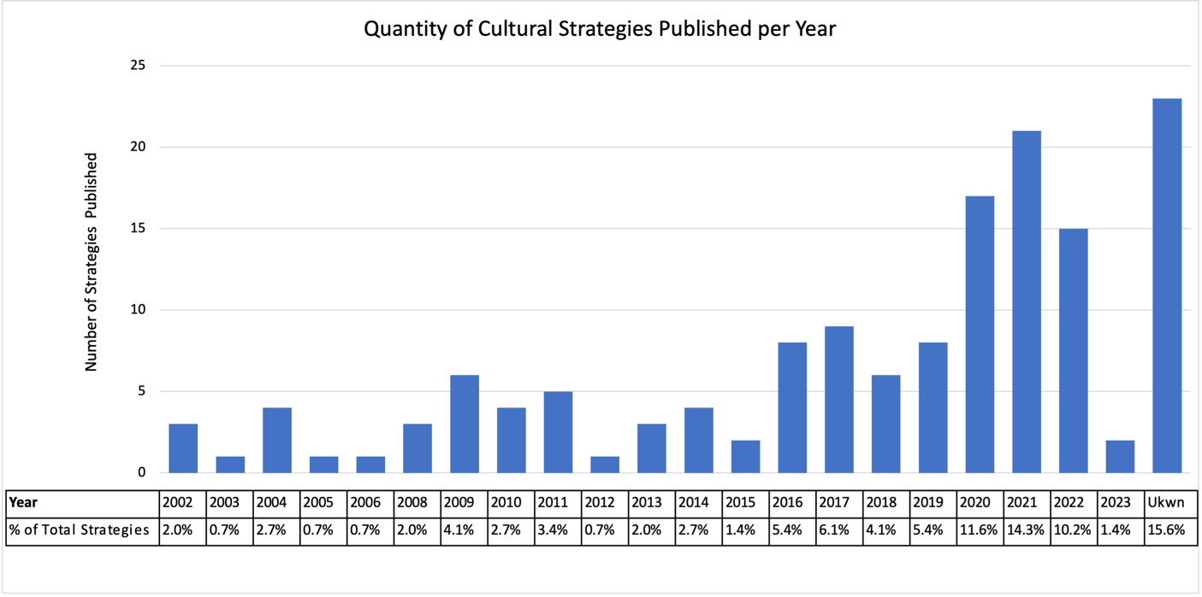
Table 3: Quantity of cultural strategies published per year with the percentage of the total collection of strategies (147) per year beneath.

From table 3, we summarise the following points:
- It was difficult to discern if a cultural strategy was new or updated.
- 23 strategies did not have publication years (15.6%), which is more than any publication year.
- 2019-2022 account for 36.7% of all cultural strategies published.
- No cultural strategies were published in 2007.
- Strategies cover between two and twenty years (i.e. 2014-2016).

Most cultural strategies cover five-year periods (27%; 40 strategies), although not all cultural strategies indicate the years covered.

