Daniel Cid-Moragas
Sigmund Freud, André Breton

Visual Essay

Sigmund Freud, 19 Berggasse, Vienna. André Breton, 42 Rue Fontaine, Paris
Daniel Cid-Moragas
One day in the month of October 1921 a young André Breton visited Sigmund Freud at his Viennese studio and consulting room at 19 Berggasse—the writer tells this story in a text published in 1924 (Breton 1996). The waiting room where the writer was seated awaiting the opening of the double door leading to the consulting room and the arrival of the professor contained armchairs of different styles. Allegorical prints, diplomas, and photographs hung from the walls—decoration that was as humdrum, tacky, and petit bourgeois as that of the remaining family rooms. Funnily enough, he who had challenged cultural restrictions, the malaise of the arts and therefore the idealization of the patriarchal home, had done so in the bosom of a placid petit bourgeois interior of fin-de-siècle Vienna (Casals 2003: 154–55). To a certain extent, the twentieth century was more Freudian than Freud, to quote Roudinesco (2016: 303). In his everyday life, he who had called into question the image of the home as a haven of peace was himself a man of order and self-control, an established man who had acted slowly and systematically on spaces where every nook and cranny revealed signs of their dweller. Be that as it may, the spot where the young writer sat was also the meeting room of the Wednesday Society, origin of the Vienna Psychoanalytic Society. This room had witnessed all sorts of discussions. It was also the place where those who had betrayed the principles of the movement were excommunicated rather dictatorially, which reminds us to some degree of the purges that Breton practiced in his own group. Patients like the Rat Man or Lou-Andreas Salomé had previously sat in exactly the same place, waiting for the doctor to open the double doors that led to the room with the divan to begin the session. The doors were lined with felt and reinforced by thick heavy curtains.
Eventually, the doors opened. Freud appeared and invited young Breton to cross the threshold of the consulting room (fig. 1). Once inside, he found himself in a space that contained countless antique statues, half-hidden by carpets and rugs, and original artworks and reproductions hanging from the walls, most of them from Antiquity. Unlike the waiting room and, as we shall see later, the other family rooms in the house, the professor’s chamber had a distinct air, reminiscent of the home of an artist. Upon entering the space, which was all but spotless, filled with bibelots and sporting a comfortable divan, many patients confessed that their first impression was of visiting a witch doctor rather than a scientist. And yet for this precise reason, if Freud transformed the typical dispensary seat designed to facilitate medical operations into a cross between the Western and the Eastern couch, he did so in order to escape from clinical frugality (Marinelli 2006: 245–66). Padded with cushions and covered in rugs that surprisingly even spread over the wall like a desert tent, he had conceived the space to encourage free association. Ever since, enveloped in the continuous clouds of smoke of the professor’s Havana cigars, this piece of furniture would become one of modernity’s most debated spaces.
Thanks to the pictures that young photographer Edmund Engelman took at the last moment—a few months before the flat was dismantled—we know what the home where the theory of psychoanalysis developed in 1891 was like (Engelman 1993; Werner 2002: 445–48). It was a rainy morning in May 1938, a few weeks before Freud was forced to seek exile in London having fled from the Nazis. A Gestapo patrol was stationed on the corner and a banner bearing a swastika hung from the façade of the professor’s building. After having photographed the exterior, Engelman went up to the first floor where Freud lived and worked in order to document each room. Taking advantage of the daylight that entered through the windows and the artificial light provided by lamps, he captured the scenes without using a flash to make sure he didn’t draw the attention of the men watching on the street corner. Using long expositions and taking care to disturb nothing, he calmly took pictures of every room. In spite of the limitations, his sensitivity enabled him to discover a domestic peace, so still that it was almost upsetting. The penetration of the camera in these spaces brought the privacy of the consulting room out into the open, disclosing signs of occupancy and domestic rituals. The intimacy was thus revealed in the absence of the dweller, through the traces of his former presence.
Thanks to this photographic feature we note that one side of the dwelling contained the family apartment, where the decoration of the salons, dining room, and bedrooms was unremarkable, despite the abundance of souvenirs, children’s photographs, and ornamental glass objects. The other side of the dwelling accommodated the consulting room—the one that Breton was about to penetrate—crammed with antiques. As we said earlier, on the one hand, the household family, on the other, the psychoanalytic family, comprising petite sculpted gods who also posed for Engelman’s camera, unable to conceal the unease they felt at not knowing for sure where they would be sent when the removal van arrived. During its process of bringing to light, of revealing what was destined to remain hidden, Engelman’s camera captured a similarly revealing scene that must have caught Breton’s attention—a pastel painting of the temples of Abu Simbel hanging over the divan. Placing it in that position was Freud’s way of associating archaeology as a study of the human past with the archaeological exploration of the soul. In the case of psychoanalysis, the beauty of the discoveries of the practice didn’t lie so much in the eventual aesthetic interest of the recovered material as in the ability to unearth what had remained long hidden in the unconscious mind (Kuspit 1989). To further emphasize this archaeological message, to one side of the couch were two fragments of a mural painting of Pompeii—to be precise, of a centaur and a faun—while to the other side hung a reproduction of a fourth-century BC Greek relief featuring a walking woman kept in the Chiaramonti Museum, a part of the Vatican Museums, the same work that would inspire Jensen’s character in the novel Gradiva that Freud so admired. We should not forget that the story was about a sculpted female figure strolling around the ruins of Pompeii in the dreams of an archaeologist. This is the exact point where photography, psychoanalysis, and archaeology come together in surroundings as domestic as they are disturbing. In the first century AD, the lava from Mount Vesuvius suddenly covered the town in ash, burying it alive. Similarly, given that the volcanic stone was so easy to extract, the eighteenth-century archaeologists who appraised the vestiges also met with an immediate surprise. Being buried alive is the height of uncanniness (Vidler 1994: 43–55). The houses discovered were just that—houses containing everyday objects that offered the disquieting possibility of reinhabiting and remaining. Somehow, the interiors of this city remind us of the photographs of the Berggasse apartment where silence floated over the rooms like an unnerving reference of the daily movements of one who was absent. Here, as in Pompeii, activity could begin again at any moment. In fact, the abundance of everyday objects discovered in the archaeological excavations heightened the feeling of domesticity, while many of the recovered items actually became an inspiration for the bibelots found in middle-class homes, as in the case at hand. But all this would be even more disturbing when the petrified bodies, the paintings, and objects of a sexual nature appeared out of the blue. Startled neoclassical scholars who considered themselves the heirs of the ancient world briskly hid the dildos in the Secret Museum in Naples (Kendrick 1987). In any event, the one who combated this repressive morality in Vienna chose to decorate his room with scenes that would have been approved of by self-righteous neoclassical archaeologists.
That everything is slightly disturbing in these photographs is an impression similar to the one we experience when gingerly opening a door to a room, unaware of whether or not it is occupied. Indeed, in the essay on the uncanny the same dweller of the studio, Freud, pointed out that such strange feelings of attraction and rejection sprang from the confusion of the presences created by absences (i.e., phantasmagoria). This feeling of the uncanny also emerges when all that was once familiar becomes strange, when that which by definition was hidden, destined not to be contemplated, is brought to light. Heimlich (i.e., homely, familiar, intimate, and hence secret) was opposed to unheimlich (i.e., sinister but also hidden). The former evoked well-being and comfort; the latter was unsettling. It is when we approach the Berggasse apartment through Engelman’s photographs that we discover that what was once homely and therefore secret shows its most disturbing face. We find ourselves before a home photographed in its commonplaceness, where everything seemed to respond to the repetition of the same everyday acts that had not only been altered by police searches but would actually soon be taken apart. With time ticking away and yet without losing his patience, Engelman set up his camera to capture the intimate, private nature of those rooms for the last time. And yet precisely because he acted so carefully, the apartment ended up revealing its true mood, or oddly recoiling almost at the last minute in order to avoid showing itself.
But let’s get back to Breton, whom we left crossing the threshold to the consulting room. Among the decorative objects that no doubt also caught the attention of the young writer was the reproduction of André Brouillet’s painting A Clinical Lesson at La Salpêtriére, an image that transported him back to the origins of psychoanalysis, hence to the moment when the Berggasse dweller-turned-amateur decorator reinvented the divan as a therapeutic object. The artist portrayed one of the hypnosis sessions conducted by French neurologist Jean-Martin Charcot with women from the slums of Paris who had lost their minds. Freud was very familiar with such public performances given that he himself learned the technique of submission from Charcot at La Salpêtriére hospital. Interested in exploring the facts of a concealed past in the minds of his patients, during the last years of the nineteenth century he and Breuer experimented with the suggestions produced by this artificial drowsiness. It was through this explorative exercise that the free association technique was quietly intimated, a slower method than hypnosis, based on the privacy of a reserved conversation (Gay 1989: 97). Conversely, his patients were well-dressed high-class ladies that would never have taken part in a spectacle such as those held in the Parisian hospital on Tuesdays. Those were against-the-clock sessions, whereas the ladies, who by no means wished to be identified with their underpaid and exploited servants, required a time and place where everything transpired slowly: a time essential for listening and a place outside of the public gaze (Didi-Huberman 2003: 230). Thanks to the existential disdain they showed for those women and thanks also to their upper-class bank accounts, Freud was able to develop a new theory of subjectivity (Roudinesco 2016: 64), a new clinical practice based on listening that called for a private space capable of conjuring up revealing memories, images, and vital impressions in an uncensored and relaxed environment.
This all took place beside the aforementioned Egyptian, Greek, Roman, Near Eastern, and Asian statuettes filling the shelves and tables of the consulting room, deities plundered from their tombs and forced to confront the world of the living. Time and again, in ghostly gestures these hundred-odd figures, motionless and unable to utter a single word, became silent witnesses to patients’ disclosures (Gamwell 1989: 21–23; Gay, 1989: 4). Familiar with the early and inarticulate stage of human existence, these legendary beings confirmed the extent to which their primitive features and trends still formed an intrinsic part of the minds of the reclining patients (Steiner 1998: 37). To these listening sessions we should add Freud’s writing sessions on the desk he had in the studio (fig. 2). The figures, a reflection of our instincts, shed light on the complexes and mental phenomena studied by Freud. Through the myths they represented he strove to make the nocturnal activity of the mind understandable (Roudinesco 2016: 216). Many considered the psychoanalyst a collector of jokes, manias, and perversions rather than of archaeological artifacts. According to Zweig (1964: 420), a medical boycott against Freud had been brewing for some time in Viennese fashion, trivializing and satirizing his theories that became jocular conversation topics over coffee.
Somehow, the silent audience raised awareness of all those discussions (Forrester 1997: 225–49). Indeed, it comes as no surprise that in order to advance the pursuit of such obscure intimations he should have decided to create an architecture within architecture in his consulting room cum boudoir, an allusion to the early image of the home as resembling that of an Oriental rug bazaar. A comforting piece of furniture, warm and soft, in which to seek primeval truths. A small fold in the world, a place in which to be with oneself and, through listening, focus on the life of the soul and express hidden tensions frankly and openly. Zweig (1964: 422) said that entering the consulting room meant leaving the madness of the outside world behind. The werewolf also had the feeling that the room was pervaded by a serene, secret peace (Gardiner 1991: 139).
Breton, however, thought the place was horrible. The room where the writer anticipated discovering a unique world gave him the impression of a local doctor’s surgery. Musty and tacky. Indeed, he was disappointed by the man who showed no interest in discussing Dada, in recalling the hypnotic experiences in La Salpêtriére evoked in that very room by the reproduction of Brouillet’s picture, or in any of the topics that the guest had been wanting to share with him for days. He found all his host’s answers futile and his farewell, “We expect much from the young,” somewhat enervating. Breton, who barely a few minutes earlier had been burning with the desire to meet that modern agency, the workplace of psychoanalysis, ended up concluding that the legend was simply a badly dressed man living in a mediocre-looking house in a dull, godforsaken Viennese neighborhood. His attempt to project himself on the man who had succeeded in rocking contemporary thought had failed. He had stumbled upon taciturn gods he thought had become drowsy after so much psychoanalysis and clouds of cigar smoke, when in point of fact what he had wanted to share were the stories about the mad girls from the Parisian slums wandering around La Salpêtriére. Indeed a few years later, a rebellious paranoid like Nadja—whom he managed to cure and with whom he was eventually conflated—succeeded in introducing him to the forms of a new genre (Roundinesco 1986: 41). In Breton’s writings, women were always passive objects, never active subjects of revelations. But then, perhaps if the polite professor—a clear heir of classical rationalism—showed little warmth toward the young writer, this was precisely a result of the Surrealist desire to combine art and science. By the same token, he must have considered such conscious games with the unconscious pure madness (Starobinski 1970: 320).
But before we continue to delve into this failed meeting, let’s touch on another photographic session also tinged with phantasmagoria that was staged years later in the presence of Breton’s writing desk (figure -fig. o figure? (see fig. 1 and 2) 3). A desk that reminds us of Freud’s insofar as it was the place where the writer also built up a silent audience that would accompany him during his writing sessions. Shortly after his death in 1966, before it all vanished, the writer’s widow Elisa invited Gilles Ehrmann to secretly photograph what had been her husband’s studio, a workspace located in the family home at 42 Rue Fontaine in Paris. Once again, photography became the last chance to capture something of the inner soul of the man who up until shortly before then had inhabited that room, a space crammed with all sorts of white elephants. Taken with a four-by-five-inch camera in artificial light, Ehrmann’s feature would remain deliberately secret for thirty years. By express desire of the widow, it continued under lock and key until the year 1997, when Au fil de l’encre publishers was granted permission to produce a confidential edition, limited to fifteen numbered copies, printed in Cibachrome and accompanied by an essay by Julien Gracq (2003). As we contemplate these photographs we can’t help feeling that the moment we turn away from the objects, strange paranormal phenomena will ensue in this virtually secret place. All this seems to confirm the suspicions voiced by Wittgenstein in his essay on certainty, to be precise, in note 214, where he wonders whether anyone can assure us that the shape and color of an object or an item of furniture will not change as soon as we stop looking at it. Alarmingly, as in the case of the photographs of the house on Berggasse taken by Engelman at the last moment, it seems as if the inhabitant could appear at any moment and resume his work. But this time the silent audience that accompanied the writing and strove to capture the dweller’s impressions as he arranged his thoughts wasn’t formed by the statuettes of ancient gods but by the accumulation of everyday objects obtained on the streets and in flea markets. In some cases they even appeared to be items forgotten by Nadja in her comings and goings: walking sticks, cake molds, crystal balls for fortune-tellers, bottles, all sorts of curios, boxes of butterflies, a Dutch canary, two wooden hands, a panel advertising Martini, decks of Tarot cards, pipes, cigarette packets, a packet of Strepsils, a vernier scale, and a varied collection of minerals full of agates. Equally abundant were Art Nouveau objects made of cast iron or other simple materials such as brass—bibelots that in their day endeavored to imitate the tastes of the upper classes. This range of objects coexisted with two huge sculptures from Papua and all kinds of idols and masks from different continents, a disparate collection that also accumulated exemplary books and works by artists like De Chirico, Picabia, Dalí, Ernst, or Duchamp. The writer’s home had been an extension of his wanderings through the city in search of chance discoveries that would eventually pile up on his desk, knick-knacks that on that desk precisely acquired meaning as the keywords of automatic writing, that is, thanks to their association with other unmentionable or unpronounced words.
When Breton described his feeling of living in a house of glass in his novel Nadja, he could have been thinking of the crystal ball of fortune tellers—those who allow their thoughts to wander—that he kept in his studio with all sorts of other thingamajigs. Like the one belonging to hypnotist Madame Sacco, the famous clairvoyant whose photograph was reproduced in the novel. In fact, in a controversial essay Starobinski (1970) upheld that the terms in which the first manifesto defined Surrealism are more indebted to parapsychology than to Freudian theories. When all is said and done, to a certain degree parapsychology is the bazaar of the mind, as exemplified by the parallel desks. If Freud, a collector of jokes and unspeakable dreams, hoped to privately transform his ancient gods into precious items, Breton gathered abandoned items from rubbish bins or flea markets, released them from their normal functions and transformed them into oneiric objects (Beaumelle 1991). A host of tawdry old bibelots, objects once cherished by others and yet scattered around second-hand street markets upon the death of their owners.
Sanctified souvenirs (Yourcenar, 1974: 70–71), treasured knick-knacks that became banal once their owner had passed away because nothing proves so revealing about the fragility of human individuality as the speed with which the objects that have represented and comforted someone deteriorate or get lost in flea markets over the course of time.
To a certain extent, this need to recover secondhand items, hoard them in a studio, and elevate them to the category of collection began with the frequent visits the young André Breton made in 1918 to 202 Boulevard Saint-Germain, Parisian residence of Guillaume Apollinaire, shortly before the latter passed away (Breton 1996: 35–39). A key referent in his aesthetic apprenticeship, Breton assured that that apartment was the place where his awareness of bygone, against-the-grain objects was heightened. All this took place in a crooked little flat at the entrance to which a notice pinned to the wall told people not to “piss off.” Having crossed the threshold it was a question of weaving one’s way through pieces of furniture holding a great many African and Polynesian fetishes, along with bizarre objects and piles of old books whose yellow covers resembled blocks of butter. Pictures by Picasso, Derain, and De Chirico covered the walls, although he also kept “tasteless” objects like the ones that would later be found in Breton’s flat. Such was the case of a frightful golden bronze inkwell, a portrayal and souvenir of the Sacré-Coeur, Basilica of the Sacred Heart of Paris, accompanied by a penholder in the shape of a branch—Apollinaire’s widow gave this last object to the young friend, Breton. In a way, the poet felt that the old objects he had hoarded were charged with revolutionary energies. The experiences involving these objects in the small flat on Boulevard Saint-Germain foreshadowed those that would arise in their future home on Rue Fontaine, representing one of the tenets of Surrealism—the attraction to things that were beginning to fall into disuse.
In 1929 Walter Benjamin, drawn by the interest that the Surrealist group felt for such old items, wrote an essay on Surrealism that he saw as the last snapshot of the European intelligentsia. A poetic text with strange, captivating twists, Benjamin’s essay showed a fascination with the group’s ability to reshape history starting from the debris it encountered on its wanderings (Benjamin 1989; Löwy 1996). A story created out of the refuse of history, what had been cast aside, dispensed with, and rejected, reemerged as a dialectic image. Awareness of the past wasn’t enough; the past had to be elicited. The linearity of time had to be broken, and objects had to be ejected from the continuum of history for their revolutionary nature to be revealed and their latent energy to be triggered. Those humiliated objects we discover in Breton’s office, disowned by the bourgeois homes from which they originally came, would once again captivate the world, establishing a ritual relationship with bygone days in search of a new beginning that had been foreshadowed in Apollinaire’s small flat and that through the subversive power of street markets the Surrealists strove to transform into revolutionary nihilism. It was almost as if a reverse archaeology—in this case, and unlike Freud, it would be a full-fledged archaeological work, crouching down and rummaging through secondhand objects—furthered progress by revealing the rebellious energies of the foregone. The utopias of a dazzling future drifted through consumed trinkets; fragments were unexpectedly rescued from olden days, not in order to return to a nonexistent past but to vigorously develop in the beyond, to pave the way for the revolt. A forward and backward transformation of the world performed by the obsolete, by objects found on the streets and liberated from the life they had previously led. Bibelots repudiated by modern rationalists, most of which were ornamental baubles of little note, badly shaped imbroglios that appeared to have descended from the unoccupied rooms on the second floor of the Goncourt brothers’ apartment. The place where Edmond and Jules built their famous artist’s house was marked by deliberate chaos; filled with beautiful objects, it was an aestheticization of the world with its own dunghill. In La maison d’un artiste, Edmond describes how they had a cabinet on the second floor to store the items they had purchased on what they called “mistaken days,” that is, items that, once paid for, they discovered to be of no interest or simply of petit-bourgeois taste. In other words, unsophisticated versions of bibelots that in the nineteenth century could be bought in department stores, refined shopping centers for those who lacked but wanted to acquire refinement (Saisselin 1985). Tats that in themselves confused nature and artifice, animate and inanimate, now transformed into phantasmagorias of lost houses, invaded the flat on Rue Fontaine. Behind this disapproval of the functionalism imposed by the moderns lay an against-the-grain desire to revisit such images abandoned over the course of time—and here we could include the spiritualism and prophetic magic mentioned earlier. Without abandoning the elitist idea of the artist’s home, Breton aspired to celebrate a more complete expression of human reality, to defend architecture as machine, psychic space (Vidler 2003: 4), a human drive, a living organism that would also turn against those members of the petite bourgeoisie who forthrightly made the home the exclusive object of their desire.
As a digression, I would like to add that that whole revolt ended up in auction houses. Upon the death of Breton’s widow, a part of the collections kept in the author’s studio was acquired by the French state as payment for inheritance taxes, and the rest was scattered throughout a number of private collections. Freud’s case was different. Two house museums would be opened in his honor, one in the Viennese flat that had been deliberately stripped of all possessions and the other in London, which contained its owner’s objects and furnishings, including the divan and the gods. The former is an absence comprising a postal address, where memory is expressed through invisibility and emptiness (Marinelli 2009). The latter, painstakingly restored and open to the public, has become memory, the individual’s double, in keeping with the idea of the inner phantasmagoria. Yet without warning, before this fact, one can’t help thinking that the continuous inauguration of house museums in our days suggests that dwelling is still a matter of leaving traces—traces that are highlighted in domestic interiors. If the conversion of the intimate space of the home into a private museum is a cultural practice still on the rise, then the model nineteenth-century bourgeois home described by Benjamin at “Louis-Philippe or the Interior” (The Arcades Project) continues to be valid, modernity did not entail a break, simply a reduction in the size of houses, and the home today remains a casing that protects the values and preserves the gestures of its dweller.

References
Benjamin, Walter. 1989. “Surrealism: The Last Snapshot of the European Intelligentsia.” In Critical Theory Society: A Reader, edited by Stephen E. Bronner, and Douglas MacKay Kellner, 172–183. Abingdon, UK: Routledge
Breton, André. 1996. “Interview with Doctor Freud.” In The Lost Steps, 71–72. Lincoln: University of Nebraska Press.
Breton, André. 1996. “Ombre non pas serpent mais d’arbre, en fleurs.” In Perspective cavaliere, 35–40. Paris: Gallimard.
Casals, Josep. 2003. Afinidades vieneses. Sujeto, lenguaje, arte (Viennese Affinities: Subject, Language, Art). Barcelona: Editorial Anagrama.
Didi-Huberman, Georges. 2003. Invention of Hysteria: Charcot and the Photographic Iconography of the Salpêtière. Cambridge, MA: MIT Press
Engelman, Edmund. 1993. Sigmund Freud. Wien IX. Bergasse 19 Vienna: Verlag Christian Brandstätter.
Forrester, John. 1997. “Mille e tre: Freud and Collecting” In The Cultures of Collecting, edited by John Elsner and Roger Cardinal, 224–299. London: Reaktion.
Gay, Peter. 2017. Freud: A Life for Our Time. Cambridge: Cambridge University Press
Gamwell, Lynn. 1998. “The Origin of Freud’s Antiquities Collection.” In Sigmund Freud and Art: His Personal Collection of Antiquities, edited by Lynn Gamwell and Richard Wells, 21–29. London: Thames and Hudson.
Gardiner, Muriel, ed. 1991. The Wolf Man, by the Wolf Man. New York: Noonday.
Gracq, Julien. 2003. 42 rue Fontaine, l’atelier d’André Breton. Paris: Biro.
Kendrick, Walter. 1987. The Secret Museum: Pornography in Modern Culture Berkeley: University of California Press.
Kuspit, Donald. 1989. “A Mighty Metaphor: The Analogy of Archaeology and Psychoanalysis.” In Sigmund Freud and Art: His Personal Collection of Antiquities, edited by Lynn Gamwell and Richard Wells, 133–44. London: Thames and Hudson.
Löwy, Michael. 1996. “Walter Benjamin et le surréalisme: Histoire d’un enchantement révolutionnaire.” Europe, no. 804: 79–90.
Marinelli, Lydia, ed. (2006) Die Couch. Vom Denken im Liegen. Munich: Verlag Prestel.
Roudinesco, Élisabeth. 1986. Histoire de la psychanalyse en France II: La Bataille de cent ans, 1925–1985. Paris: Seuil
Roudinesco, Élisabeth. 2016. Freud: In His Time and Ours. Cambridge, MA: Harvard University Press.
Saisselin, Rémy G. 1984. Bricabracomania. The Bourgeois and the Bibelot. New Brunswick, NJ: Rutgers University Press.
Starobinski, Jean. 1970. “Freud, Breton, Myers” In L’oeil vivant. La relation critique, 320–41 Paris: Gallimard.
Steiner, George. 1998. Language and Silence: Essays on Language, Literature, and the Inhuman. New Haven, CT: Yale University Press
Vidler, Anthony. 1994. The Architectural Uncanny: Essays in the Modern Unhomely Cambridge, MA: MIT Press.
Vidler, Anthony. 2003. “Fantasy, the Uncanny and Surrealist Theories of Architecture.” Papers of Surrealism, no. 1
All texts start on page 1. How would I cite it?
]]
Werner, Arnold. 2002. “Edmund Engelman. Photographer of Sigmund Freud’s Home and Offices.” International Journal of Psychoanalysis, 83, no. 2: 445–51.
Yourcenar, Marguerite. 1974. Souvenirs pieux: Le labyrinthe du monde.Paris: Gallimard
Zweig, Stefan. 1964. The World of Yesterday. Lincoln: University of Nebraska Press.
Daniel Cid-Moragas is associate professor of design studies at Winchester School of Art, University of Southampton. Between theory and practice, Daniel conducts multidisciplinary research on the politics and poetics of inhabiting and social practices.
Figure 1. Daniel Cid, drawing of Freud’s consulting room in Vienna inspired by Engelman’s photograph taken in 1938. View of the consulting room as you enter from the waiting room.
Figure 2. Daniel Cid, drawing of Freud’s writing desk inspired by Engelman’s photograph taken in 1938. The desk was in a space adjacent to the couch room.
Figure 3. Daniel Cid, drawing of Breton’s writing desk inspired by Gracq’s photograph taken in 1966.

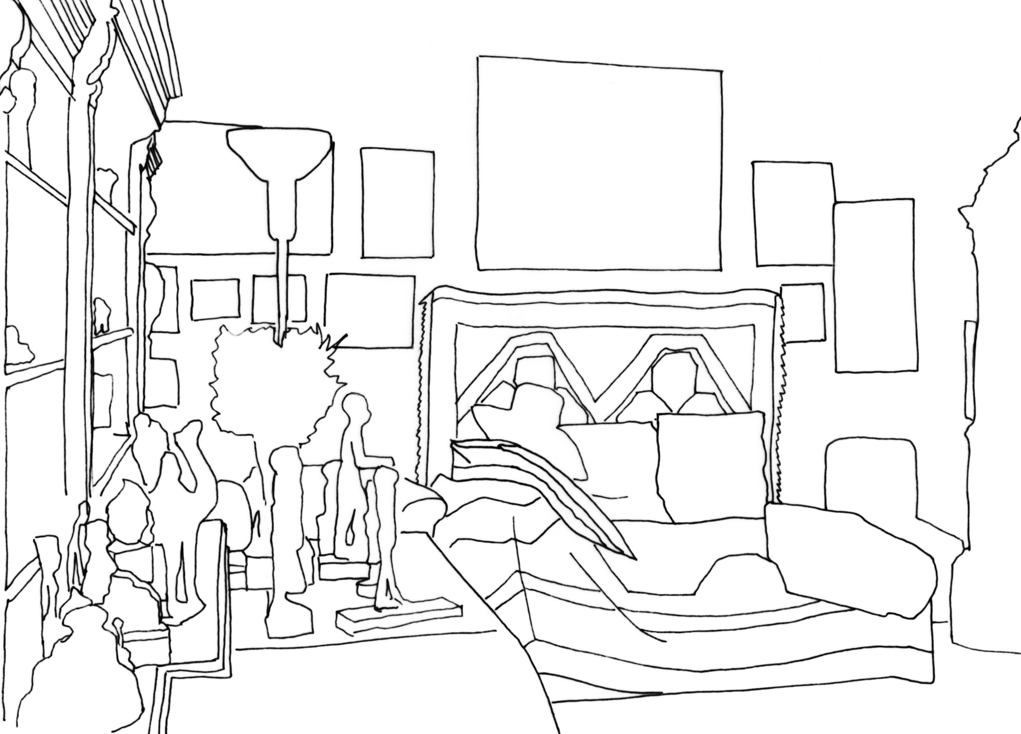

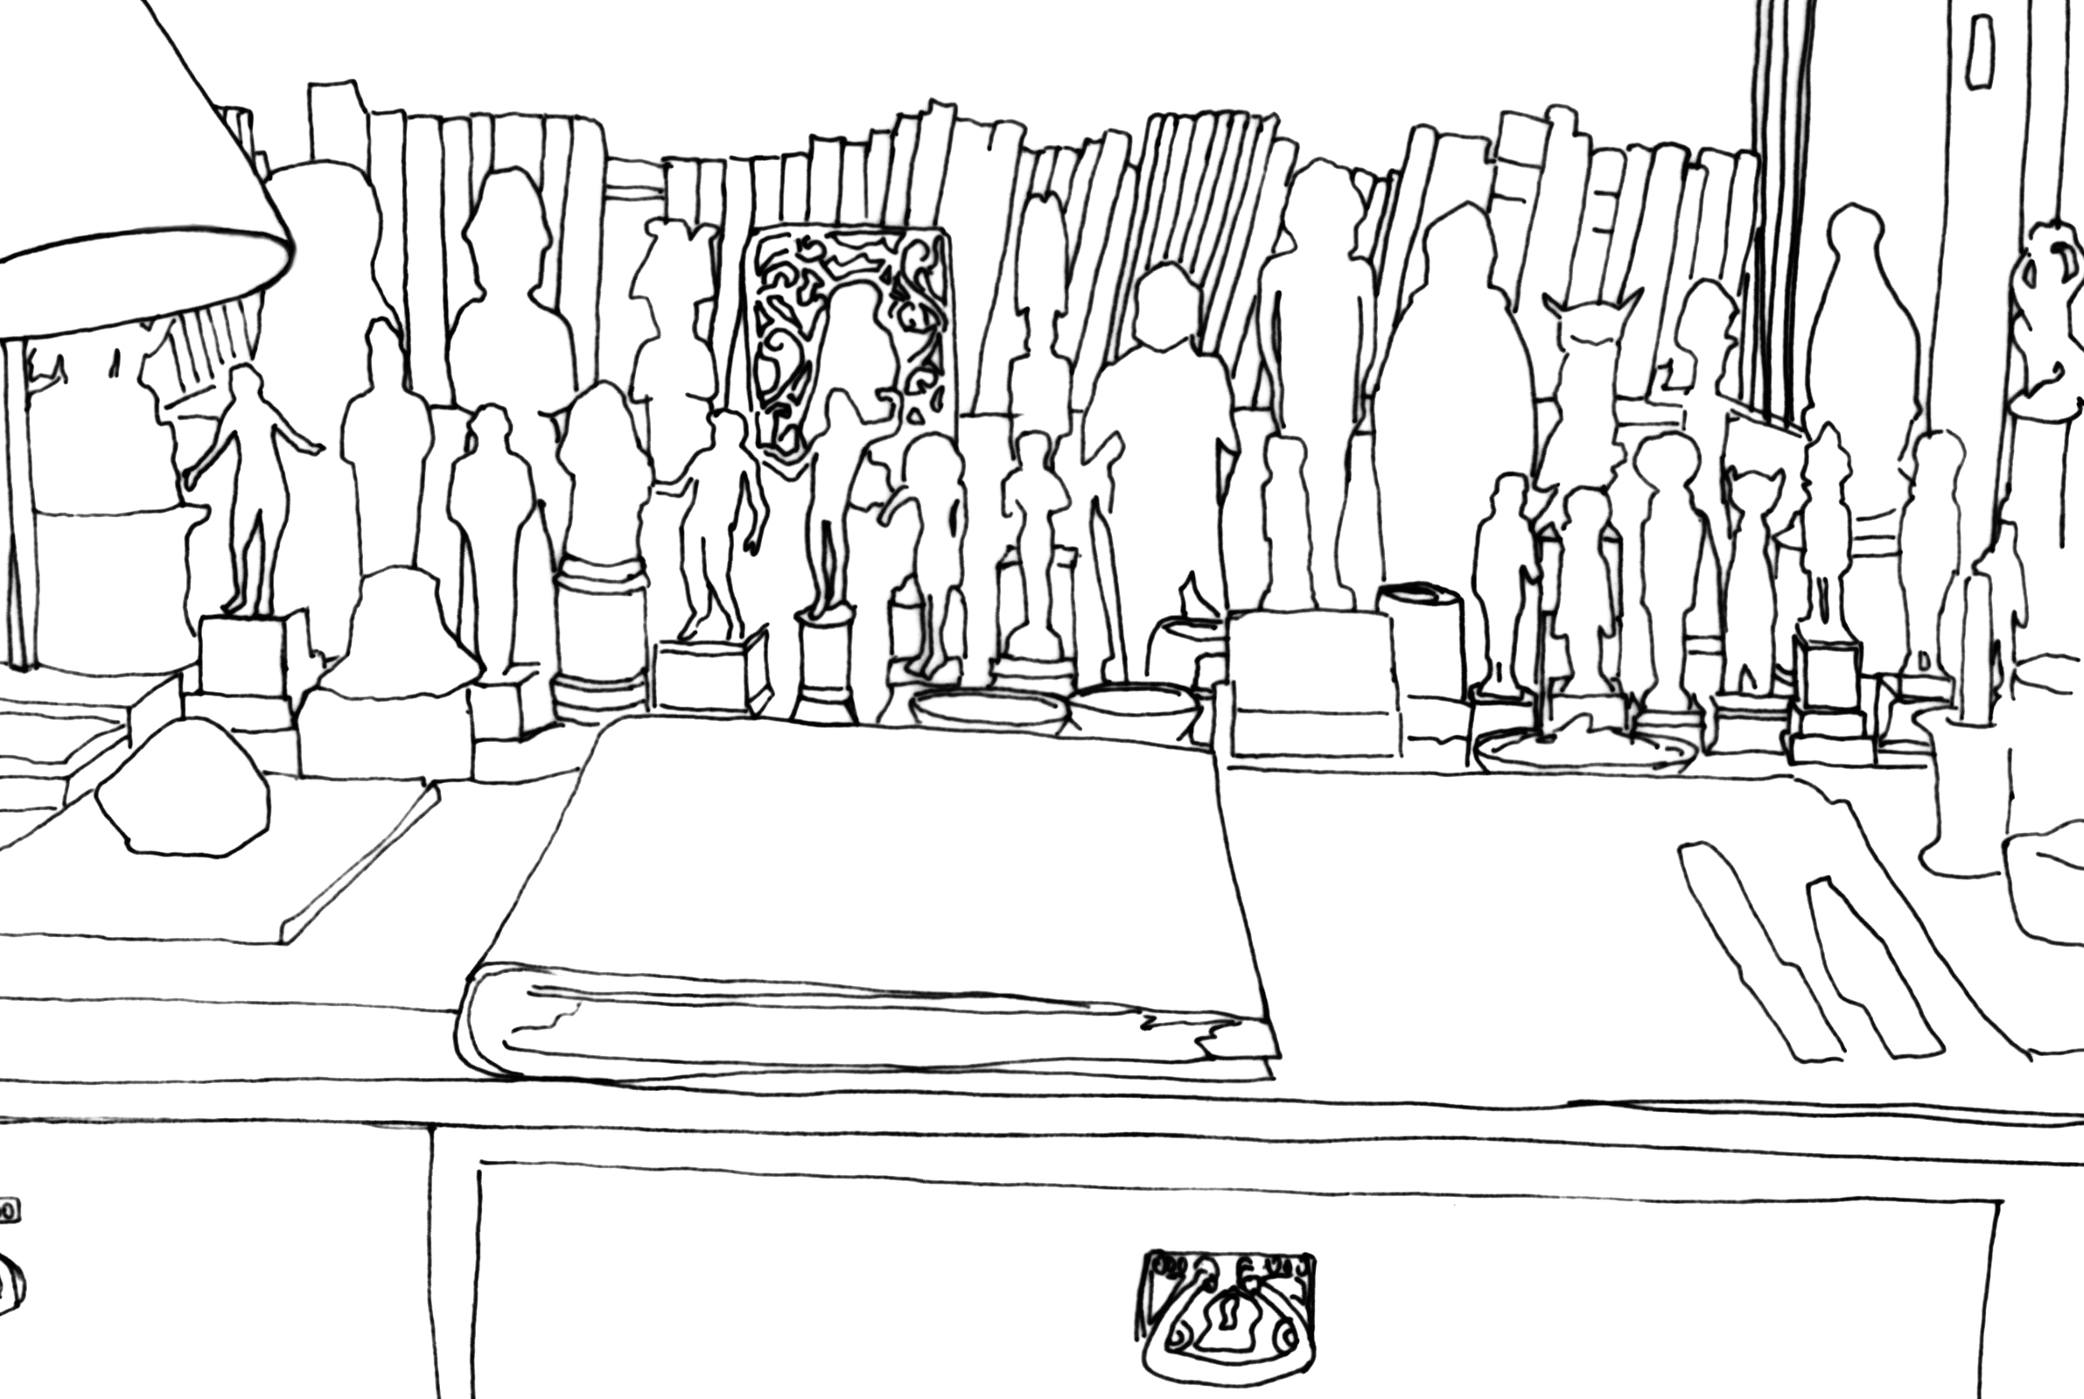

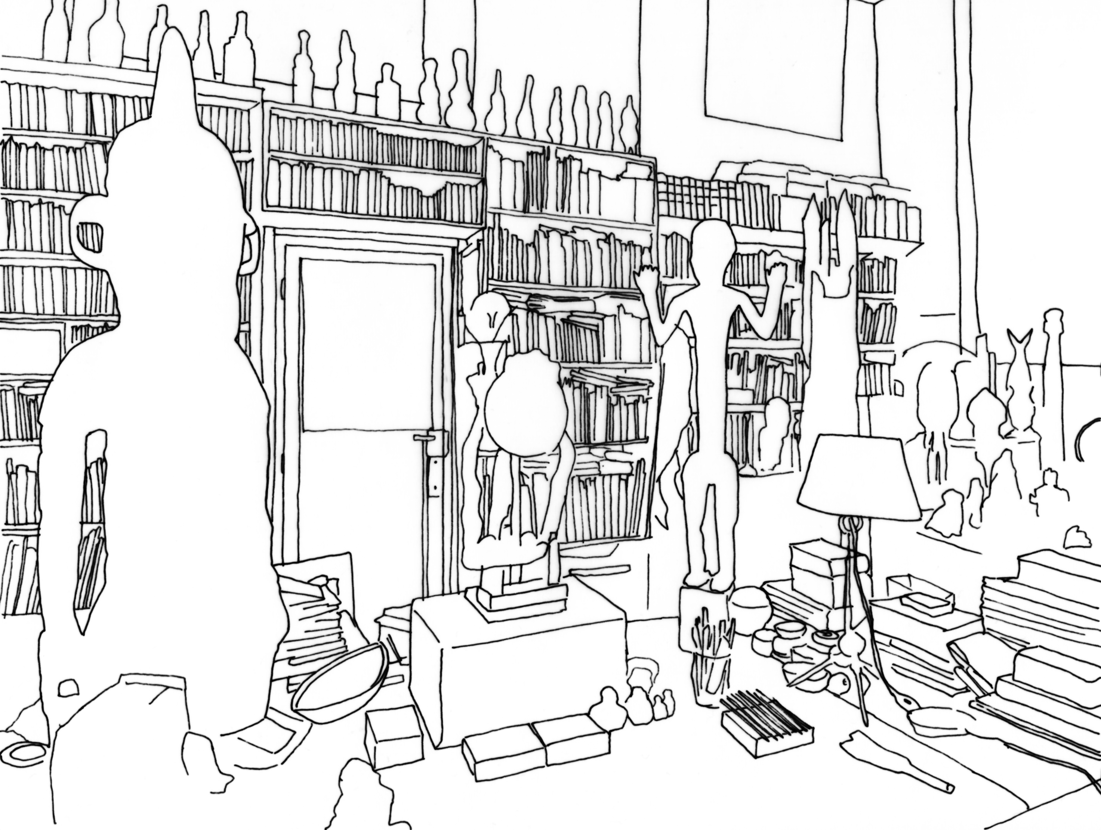

This essay strikes up a dialogue between two of the chapters in the book I published in Spanish entitled La casa dispersa: Historias marginales del habitar (The Dispersed House: Marginal Stories of the Inhabiting) (Madrid: Asimétricas, 2020) one dedicated to Freud and the other devoted to Breton.

