Anisotropic and isotropic friction on atomically flat surfaces

Mengzhou Liao^{1*}, Paolo Nicolini^{1, 2*}, Tomas Polcar^{1, 3}

¹ Department of Control Engineering, Faculty of Electrical Engineering, Czech Technical University in Prague, Technicka 2, 16627 Prague 6, Czech Republic
²Institute of Physics, Czech Academy of Sciences, Na Slovance 2,
182 21 Prague 8, Czech Republic
³National Centre for Advanced Tribology (nCATS), Department of Mechanical Engineering, University of Southampton, Highfield, SO17 1BJ, Southampton, United Kingdom

* Corresponding author. E-mail: mengzlia@fel.cvut.cz; nicolini@fzu.cz

Abstract
Friction has complex origins. However, most experimental methods only give total friction force and cannot separate friction forces from different origins. Thus, revealing underly friction mechanisms becomes a challenge. Here, we combine a two-dimensional friction force atomic force microscope method and a two-dimensional friction model to separate anisotropic and isotropic friction forces on atomically flat surfaces. We found that the friction force of most atomically flat surfaces is anisotropic, and the total force on the tip misaligns with the scan direction. The misalign angle can be used to calculate the ratio of anisotropic and isotropic friction components and the ratio of resistance forces from different elemental hopping combinations. The separation of anisotropic and isotropic components in the total friction force makes it possible to study friction forces from different origins, which is critical for further revealing the friction mechanism.

Introduction
Global warming calls for a unified response to reduce fossil energy consumption. Friction causes massive energy dissipation and mechanical abrasion every year (approximately 103 EJ in total)¹. Thus, understanding the mechanism of friction processes and reducing energy dissipation is essential. Before being known as two-dimensional materials, layered materials like graphite, hexagonal boron nitride (h-BN), molybdenum disulfide (MoS₂), etc., have been used as solid lubricants for a long time. 2D materials have extraordinary lubricating properties because of their atomically flat surfaces and weak van der Waals (vdW) interlayer interactions, making them ideal platforms for studying the nano- to micro-friction mechanism. In the past thirty years, abundant interesting friction phenomena like atomic "stick-slip"², thermal effects³⁻⁶, and superlubricity⁷⁻¹⁰ were found. These phenomena are critical for bridging nano- and micro-friction worlds.
As a nature of the crystal, crystalline 2D materials show significant anisotropies in their electrical, optical, and mechanical properties^{11,12}. Simulations also predicted a remarkable friction anisotropy on the surface of crystalline 2D materials^{13,14} but were poorly supported by experiments¹⁵⁻²². The gap between simulations and experiments, on the one hand, comes from the intrinsic limitation of the standard lateral-force atomic force microscope (LF-AFM). The sample needs to be rotated to measure friction forces of different crystal orientations, making it impossible to keep the same scan area and contact in each measurement. On the other hand, friction mechanisms other than "stick-slip" (like edge pining effects¹⁰, chemical bonds^{23,24}, and interface steps²⁵) also play an essential role in the total friction but were barely discussed. Thus, in situ measuring friction forces of any crystal orientation and separating contributions from different friction mechanisms are essential.
Here, we report a method to separate the anisotropic and isotropic friction components by combining a two-dimensional friction-force atomic force microscope (2DFF-AFM) method and a 2D friction model supported by multiscale simulations. In the 2DFF-AFM method, we collected the lateral force of the tip like in the normal LF-AFM and used the Z-piezo feedback signal to calculate the tip force parallel to the long direction of the cantilever ^{17,26}. Then, the total force at any scan angle can be calculated by knowing the lateral and parallel forces on the tip. We measured friction properties on several 2D materials by the 2DFF-AFM method. We found that: first, total forces misalign with scan directions for all atomically flat surfaces; second, friction forces of most surfaces are anisotropic; third, the friction anisotropy disappears as the scan velocity decreases. A 2D friction model is introduced to explain those phenomena in experiments. We made two new assumptions in the model: the existence of elemental hopping combinations (EHCs) and the isotropic component in the total friction force. Our model points out that the misalign angle provides critical information, such as the ratio of resistance forces from different EHCs and the ratio of anisotropic and isotropic friction components in the total friction force. Our work reveals the complex origin of friction force on 2D crystals. The separation of anisotropic and isotropic friction forces opens the door to studying the property of individual components, which is critical for further revealing the friction mechanism behind them.

- Experiment results of friction anisotropy on multiple atomically flat surfaces

1.1 The 2DFF-AFM method
As shown in Fig.1a, in our 2DFF-AFM method, the sample is fixed, and the AFM tip changes scan directions to measure the friction properties of different orientations. Here we define the force perpendicular to the long direction of the cantilever as $F_{y}$ and the force along the long direction of the cantilever as $F_{x}$. As shown in Fig. 1b, $F_{y}$ can be calculated in the same way as the standard LF-AFM method: ${2F}_{y}=k_{y}\left(V_{\left(A+C\right)-\left(B+D\right)}^{Forward}-V_{\left(A+C\right)-\left(B+D\right)}^{Backward}\right)=k_{y}∆V_{F-B}$, where V_{(A+B)-(C+D)} is the lateral torsion signal of the cantilever and k_{y} is the lateral sensitivity parameter. For $F_{x}$, when the force on the AFM tip is parallel to the long direction of the cantilever, as shown in Fig. 1c, there is an extra vertical bending. The function of Z feedback control is to keep the vertical bending signal V_{(A+B)-(C+D)} constant (which is the setpoint). Thus, the Z piezo will move for a distance $∆Z_{F-B}=Z_{Forward}-Z_{Backward}$ to cancel the extra bending signal caused by $F_{x}$. So that ${2F}_{x}=k_{x}∆Z_{F-B}$, where k_{x} is the X-direction sensitivity parameter. With known $F_{x}$ and $F_{y}$, we can then calculate the value and angle of the total force $F_{t}$, and the misalign angle $∆θ$ between the total force and the scan direction. The friction force $F_{r}=F_{t}\cos{∆θ}.$ In Fig. S4, we used the 2DFF-AFM method to measure the amorphous SiO₂ surface with a silicon tip. The results show that $F_{y}$ and $F_{x}$ are ideal cosine and sine functions with scan angle; $F_{t}$ is near a constant, and $∆θ$ is zero, which demonstrates the validity of the 2DFF-AFM method. For more details on the 2DFF-AFM method, please refer to Supplementary Note 1.

  - The friction properties of atomically flat surfaces
We used the 2DFF-AFM method to measure the friction anisotropy properties of different exfoliated 2D materials, including MoS₂, graphite, h-BN, and mica. Fig. 1d shows the microscope image of the exfoliated MoS₂ flake on the silicon substrate with 300nm SiO₂. The tip position and coordinate axes are marked in the image. The thickness of the MoS₂ flake in Fig. 1d is about 47.66 nm (Fig. S7). We used the sharp edges of the MoS₂ flakes to determine the zig-zag direction²⁷ and defined one of the zig-zag directions as the zero degree of the sample angle. For more details on the sample preparation, please refer to Supplementary Note 2.
Fig. 1e-i show typical friction properties of the MoS₂ surface. We used a standard contact mode silicon tip ARROW-CONTR(NANO WORLD) to perform the measurement with a normal load 216.83 nN and a scan velocity of 60 μm/s under ambient conditions. Unlike the isotropic amorphous SiO₂ surface, Fig. 1e and f show that $F_{y}$ and $F_{x}$ change discontinuously with the scan angle. Sudden jumps happen in zig-zag directions. Fig.1g shows that the total force $F_{t}$ has a periodic structure combining 60° and 180° period signals. In Fig.1h, the direction of $F_{t}$ misaligns with the scan direction, and the misalign angle $∆θ$ presents a sawtooth shape with sudden jumps in zig-zag directions. The period of $∆θ$ is 60°, and its amplitude is about ± 20°. The friction force $F_{r}$ in Fig. 1i shows that the zig-zag and armchair directions have the lowest and highest friction forces, respectively. We also notice that $F_{r}$ is a modulation of two components with 60° and 180° periodicities. In Fig. S9, we repeated the same measurement after rotating the MoS₂ sample through an angle about 33°. After the rotation, $F_{x}$, $F_{y}$, $∆θ$, and the 60° period signals in $F_{t}$ and $F_{r}$ shift with the rotating angle, but the 180° period signals in $F_{t}$ and $F_{r}$ remain the same.
We also used a stiffer silicon tip 240AC-NA (OPUS), a 150 nm diamond-like carbon tip NT B150 (Nanotools), and a 2 μm SiO₂ ball tip CP-CONT-SiO (NANOSENSORS) to perform the 2DFF-AFM measurements on the MoS₂ surface (see Figs. S10-S12). Results from these tips are similar to the standard silicon tip (Fig. 1), which means that the tip material, the cantilever stiffness, and the contact area will not play a decisive role in the friction anisotropy of atomically flat surfaces. However, there are still some differences: first, in Fig. S10, the 180° period signals in $F_{t}$ and $F_{r}$ vanish when measured by the stiffer silicon tip 240AC-NA (OPUS); second, the amplitudes of $∆θ$ in each measurement are different. For more details, please refer to Supplementary Note 3.

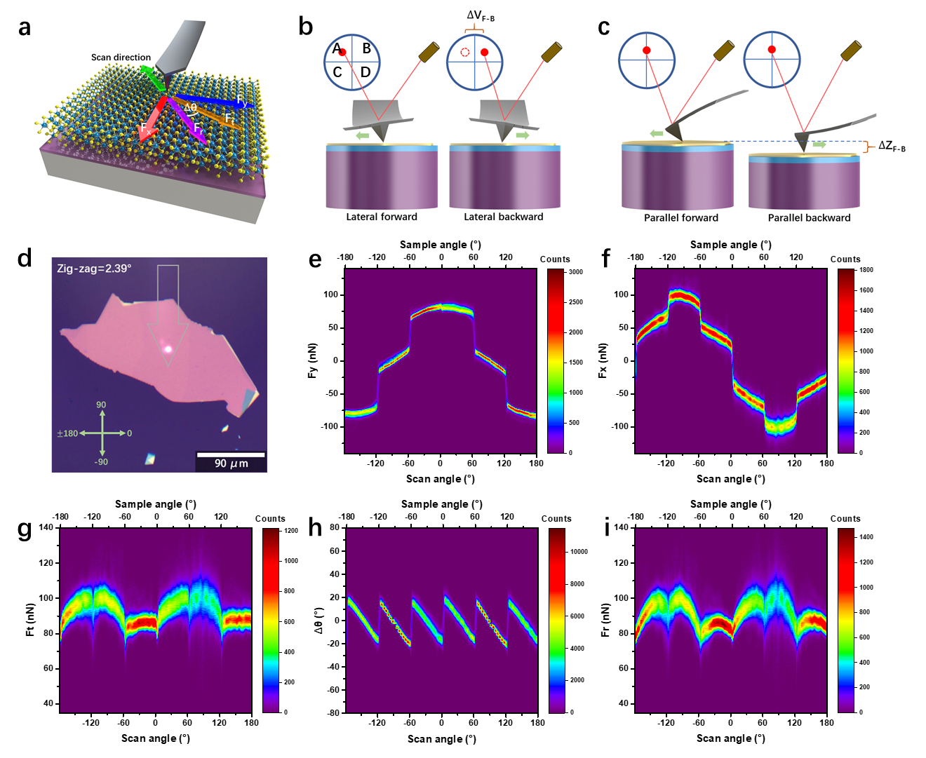
Figure 1 ▏Friction anisotropy of the MoS₂ surface. a Diagram of the 2DFF-AFM friction measurement. b-c Diagrams depicting the measurement of the signals in the Y and X directions. d Image of an exfoliated MoS₂ flake on a Si substrate with 300 nm SiO₂. e-i Y-direction force (e), X-direction force (f), total force (g), misalign angle (h), and friction force (i) as a function of the scan and sample angles.

We also performed 2DFF-AFM measurements on other 2D materials: graphite, h-BN, and mica, with the same silicon tip and scan parameters as in Fig. 1. In Fig. 2, we show only scan angles as the sharp edges cannot be used to determine the crystal orientation²⁷ for these 2D materials. As shown in Fig. 2a-d, results from graphite show distinct friction anisotropy properties. In Fig. 2c, the period and amplitude of $∆θ$ are about 60° and ±30°, respectively. Fig. 2e-h show results from h-BN. The friction anisotropy of the h-BN surface is much weaker than that of the MoS₂ or graphite surface. From Fig. 2f, we can see that jumps in $F_{y}$ and $F_{x}$ are not so obvious. In Fig. 2g, the period of $∆θ$ is still 60°, but the amplitude is just ±10°. As shown in Fig. 2h, the 60° period signal in $F_{r}$ of the h-BN surface is barely noticeable. As reported in Fig. 2i-l, the 2DFF-AFM measurements on the mica surface show a nearly isotropic friction behavior consistent with the previous report²⁸. There are still small jumps in Fig. 2j. However, $F_{t}$ and $F_{r}$ (Fig. 2l) are without any visible periodic pattern. Although friction anisotropy has vanished on the mica surface in all kinds of force, we can still observe a distinct pattern in $∆θ$ with a 60° period and about ±3° amplitude (Fig. 2k). Unlike other 2D materials we presented before, mica has small jumps (of about 0.4°) in $∆θ$ at the middle of each 60° period. Our results demonstrate that friction anisotropy is a universal phenomenon of atomically flat surfaces.

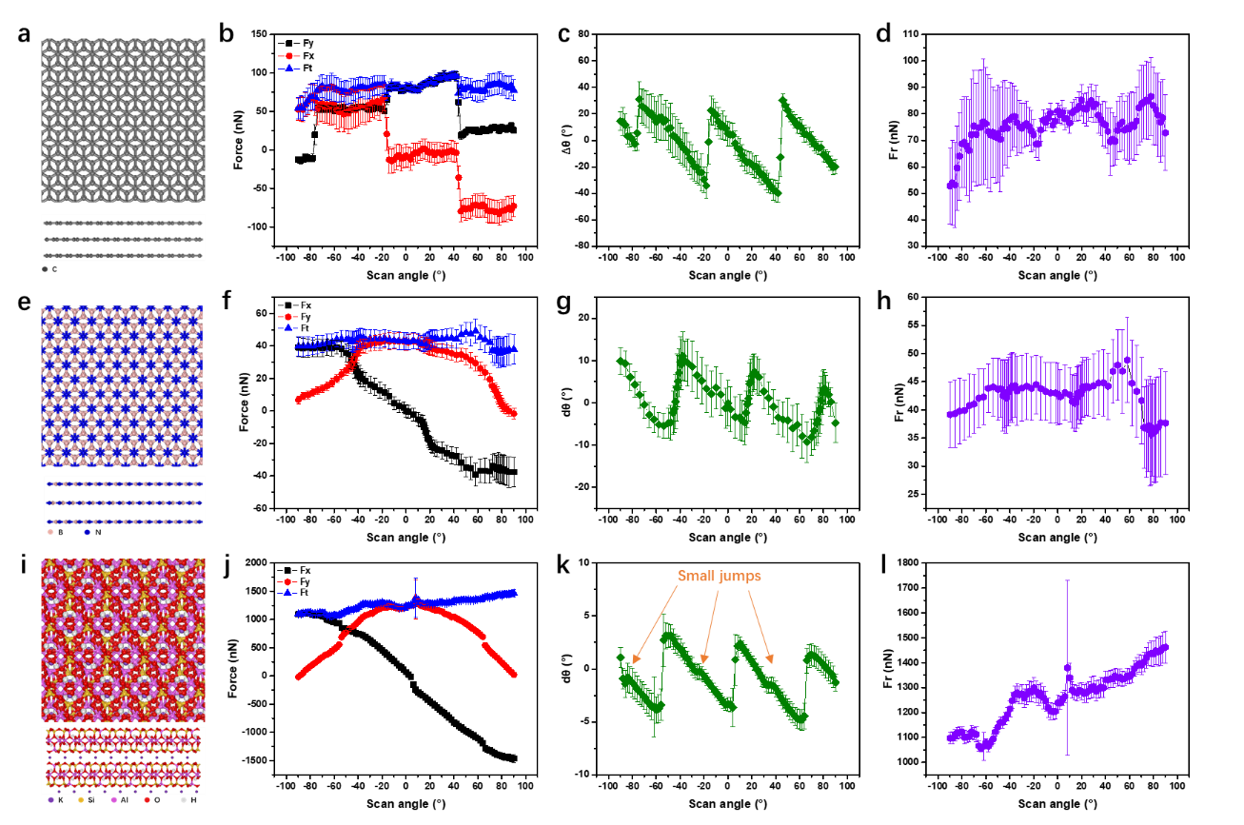
Figure 2 ▏Friction anisotropy of other 2D surfaces: graphite, h-BN and mica. a Top and side view of the graphite structure. b-d Friction anisotropy results between the silicon tip and the graphite surface: x, y directions and total force (b), misalign angle (c), and friction force (d) as a function of the scan angle. e Top and side views of the h-BN structure. f-h Friction anisotropy results between the silicon tip and the h-BN surface: x, y directions and total force (f), misalign angle (g), and friction force (h) as a function of the scan angle. i Top and side views of the mica structure. j-l Friction anisotropy results between the silicon tip and the mica surface: x, y directions and total force (j), misalign angle (k), and friction force (l) as a function of the scan angle.

  - The effect of the scan velocity and the load
To further reveal the friction anisotropy properties of atomically flat surfaces, we performed 2DFF-AFM measurements on the MoS₂ surface with different normal loads and scan velocities. As shown in Fig. S13, the basic friction properties do not change significantly even when the normal load ranges from positive to negative values, except that the 180° period signals in $F_{t}$ and $F_{r}$ are different. Our results indicate that the normal load (pressure) that the AFM tip can apply does not strongly influence the friction anisotropy properties. However, as shown in Fig. 3, when we fix the normal load, the level of friction anisotropy of the MoS₂ surface monotonously decreases as the scan velocity lows down. The friction of the MoS₂ surface becomes near isotropic when the scan velocity reduces to 1.4 μm/s. However, as shown in Fig. 3e, the value of the friction force is still nonzero.

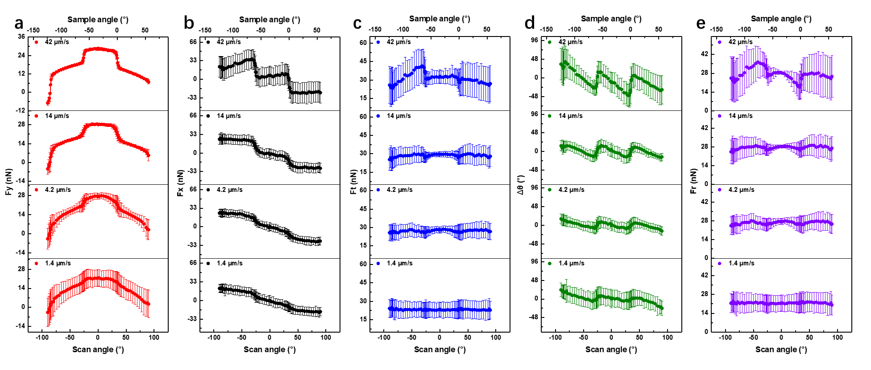
Figure 3 ▏The evolution of the friction anisotropy on the bulk MoS₂ surface with different sliding velocities. a-e Y-direction force (a), X-direction force (b), total force (c), misalign angle (d), and friction force (e) as a function of the scan and sample angles with different sliding velocities.

- Theoretical explanation and discussion
  - A two dimensional friction model
We have shown that the friction anisotropy phenomenon varies with 2D materials and vanishes as velocity decreases. Former theories or simulations cannot explain our observations well^{13,14,17}. Here we introduce a two dimensional friction model with thermal effects to enhance the understanding of the friction anisotropy phenomenon on atomically flat surfaces. Our model has two basic assumptions: the existence of elemental hopping combinations (EHCs) and isotropic components in the total friction force.
First, we address the geometrical decomposition into hopping modes, following the approach exploited in the 2D Prandtl–Tomlinson model^{14,29}. We assume that the interaction between tip and substrate can be described by an effective potential energy surface (PES), an elemental hopping mode (EHM) is represented by a path that connects two neighbor minima in the PES. For the example reported in Fig. 4a, there are one global (marked with “1”) and one local (marked with “2”) minima in the unit cell (highlighted with the gray dashed line). Consequently, two possible independent EHMs: 1→2 and 2→1 (all other possible EHMs can be derived by applying crystal symmetry considerations). Notice that, in this case, all EHMs are aligned along armchair directions. In order to span the 2D space, we need to consider sequences of four subsequent EHMs producing a net translation along e.g., the y direction. Considering the hexagonal symmetry of the example in Fig 4a, two possible combinations can be chosen: i) the path 1→2→1’→2’→1’’’, which we call non-identical combinations (in white) and is overall aligned along an armchair direction; and ii) the path 1→2→1’’→2’’→1^{iv}, termed identical combinations (in red) and is overall aligned along a zig-zag direction. The directions identified by these two paths are referred to as elemental hopping combinations (EHCs), and any sliding motion between global minima can then be decomposed into a sequence of EHCs (and by taking into account the symmetry of the substrate).
Moreover, the direction of an EHC always aligns with a crystal orientation and has a particular barrier. Thus, sliding along different EHC directions can offer different sliding resistances, and the total resistance force for an arbitrary sliding direction can be considered as the resultant resistance forces from all EHC directions. In Fig. S17, the simulation results of a particle/MoS₂ contact show that the friction forces resulting from sliding along the zig-zag and armchair directions are different, which supports the assumption that identical and non-identical hoppings of the tip on the MoS₂ surface offer different sliding resistances. The properties of the EHCs mainly depend on the PES and can be strongly modulated by many parameters^{16,30-32}. A more detailed discussion is provided in the Discussion section.
The isotropic component in total friction force can originate from mechanisms that the Prandtl–Tomlinson model cannot describe, such as the edge pining effect, chemical bonds^{10,24}, contaminations³³, etc. We assume these kinds of friction will not change with the sliding direction.
For simplicity, here we use the surface with two EHCs as an example. Fig. 4b shows the diagram of the 2D surface with two EHCs, O₁ and O₂, which identify an angle of α between them. Consider a tip sliding with speed v. The velocity components along the O₁ and O₂ directions (v₁ and v₂) are then
$v_{1}=v\frac{\sin{(α-θ_{v})}}{\sin{α}}$; $v_{2}=v\frac{\sin{θ_{v}}}{\sin{α}}$; (1)
where θ_{v} is the angle between the sliding direction and O₁. Let us decompose the total force $F_{t}$ experienced by the tip into an isotropic component $F_{v}$ (aligned along the sliding direction) and an anisotropic one $F_{c}$ (which originates from the EHCs). The $F_{c}$ can be projected onto the O₁ and O₂ directions, identifying the vectors $F_{c1}$ and $F_{c2}$. In all generality, these depend on the velocity components v₁ and v₂, the effective stiffness of the contact k₁ and k₂, the normal load L, and the temperature T. From the decomposition above, it follows that
$F_{c1}=f_{c1}\left(L,v_{1},k_{1},T\right)$; $F_{c2}=f_{c2}\left(L,v_{2},k_{2},T\right)$; (2)
and
$F_{c}=F_{c1}\frac{\sin{α}}{\sin{(α-θ_{c})}}=F_{c2}\frac{\sin{α}}{\sin{θ_{c}}};$ (3)
$\frac{sinθ_{c}}{sin\left(α-θ_{c}\right)}=\frac{F_{c2}}{F_{c1}}=\frac{f_{c2}\left(L,v2,T\right)}{f_{c1}\left(L,v1,T\right)}=G$; (4)
where $θ_{c}$ is the angle between $F_{c}$ and O₁. With a few steps of algebra, it can be shown that the relation
$θ_{c}=\tan^{-1}\left(\frac{G\sin{α}}{1+G\cos{α}}\right)$; (5)
holds. Let us define
$θ_{cv}=θ_{c}-θ_{v}$; (6)
so that the total tip force $F_{t}$ (which is the resultant force of $F_{c}$ and $F_{v}$) can be expressed as
$F_{t}=F_{v}\frac{\sin{θ_{cv}}}{\sin{(θ_{cv}-∆θ)}}=F_{c}\frac{\sin{θ_{cv}}}{\sin{∆θ}}$; (7)
then
$\frac{\sin{∆θ}}{\sin{(θ_{cv}-∆θ)}}=\frac{F_{c}}{F_{v}}=P$; (8)
with $∆θ$ being the misalign angle between the scan direction and the total force. So
$∆θ=\tan^{-1}{(\frac{\text{P}\sin{θ_{cv}}}{1+\text{P}\cos{θ_{cv}}})}$; (9)
The friction force $F_{r}$ is
$F_{r}=F_{t}\cos{∆θ}$; (10)
Notice that the direction of EHC is periodical because of the lattice symmetry. Thus, O₁ and O₂ switch directions under different sliding angles, leading to jumps in $F_{x}$ and $F_{y}$ at nα (n is an integer) sliding angles.
With thermal effects taking place during sliding, previous works^{5,6} provided an expression of the mean friction force $F_{ci}$ along an elemental hopping direction O_{i} as follows:
$\frac{1}{β_{i}k_{B}T}{({F_{i}}^{*}-F_{ci})}^{3/2}=\ln{\frac{v_{0_{i}}}{v_{i}}}-\frac{1}{2}ln(1-\frac{F_{ci}}{{F_{i}}^{*}})$; (11)
where k_{B} is the Boltzmann constant, T is the temperature, and ${F_{i}}^{*}$ is the mean friction force along the O_{i} direction at 0 K. The $v_{0_{i}}$, $β_{i}$ And critical frequency $f_{0_{i}}$ are related via:
$v_{0_{i}}=\frac{2f_{0_{i}}β_{i}k_{B}T}{3k_{{series}_{i}}\sqrt{{F_{i}}^{*}}}$; (12)
with $k_{{series}_{i}}$ being the effective stiffness of the contact along the EHC direction. From these equations, one can see that the friction anisotropy phenomenon naturally originates from the existence of EHCs. For a more intuitive understanding, we will discuss the possible scenarios with and without thermal effects in the following.

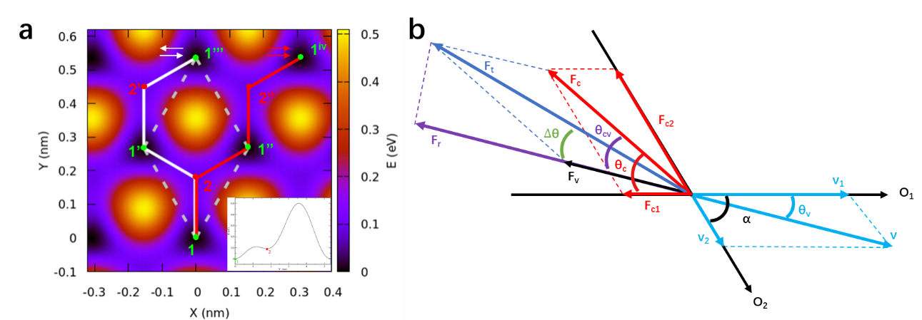
Figure 4 ▏Diagrams of EHCs. a Potential energy surface of an amorphous SiO₂ slab interacting with a MoS₂ layer. b Diagram illustrating the 2D sliding model with two EHCs.

  - Discussion of the 0K condition.
Let us address first the 0 K condition.$F_{c1}$ and $F_{c2}$ are constant for all velocities as the thermal effects vanish:
$F_{c1}=\left\{\begin{aligned}F_{1}^{*} θ_{v}≠(2n+1)α \\ 0 θ_{v}=(2n+1)α\end{aligned}\right.$, $F_{c2}=\left\{\begin{aligned}F_{2}^{*} θ_{v}≠2nα \\ 0 θ_{v}=2nα\end{aligned}\right.$
with n being an integer number. In the simplest case: $F_{v}$ = 0, and $F_{t}$ = $F_{c}$. $∆θ$ and $F_{r}$ only change with the ratio $F_{2}^{*}{/F}_{1}^{*}$. In Fig. 5a, the period of the misalign angle is 2α, and there is a "jump" at $θ_{v}=α$. When the ratio ${F_{2}^{*}}/{F_{1}^{*}}$ grows, the amplitude of the $∆θ$ monotonically increases from α to 2α, and the scale of the jump at $θ_{v}=α$ monotonically decreases from α to 0. In Fig. 5b, the amplitude of the friction force ($θ_{v}≠n$α) increases with the$F_{2}^{*}{/F}_{1}^{*}$ ratio. When fixing the $F_{2}^{*}{/F}_{1}^{*}$ to 10 and increasing $F_{v}$, the isotropic friction force $F_{v}$ can eliminate friction anisotropy. As shown in Fig. 5c-e, the total force changes with $F_{v}$, the amplitude and the scale of jump at $θ_{v}=α$ of the misalign angle monotonically decreases as $F_{v}$ increases, and the friction force variation vanishes as $F_{v}$ increases.
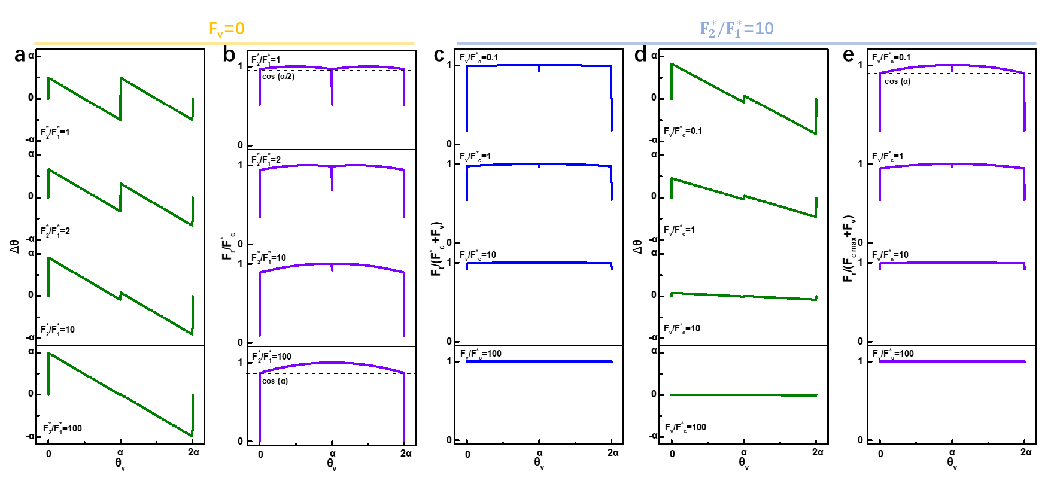
Figure 5 ▏Theoretical calculations of friction anisotropy with two EHCs at 0 K. a and b Misalign angle (a) and normalized friction force (b) as a function of the sliding angle with $F_{v}$=0 and different ${F_{2}^{*}}/{F_{1}^{*}}$ ratios, $F_{c}^{*}=F_{2}^{*}\frac{\sin{α}}{\sin{θ_{c}}}$ ($θ_{v}≠n$α). c-d Normalized total force (c), misalign angle (d), and normalized friction force (e) as a function of the sliding angle with ${F_{2}^{*}}/{F_{1}^{*}}$ =10 and different $F_{v}$, $F_{c max}=F_{2}^{*}\frac{\sin{α}}{\sin{θ_{c}}}$.

  - Discussion of the T > 0K condition.
Thermal effects need to be considered for finite temperatures. According to equation (11):
$v_{i}=v_{0_{i}}{\left(1-\frac{F_{ci}}{{F_{i}}^{*}}\right)}^{-1/2}e^{-\frac{{\left({F_{i}}^{*}-F_{ci}\right)}^{3/2}}{β_{i}k_{B}T}}$; (13)
Two critical velocities $v_{TLi}$ and $v_{TMi}$ can be identified. For $v_{TLi}$, when $v_{i}≤v_{TLi}$, $F_{ci}=0$. So
$v_{TLi}=v_{0_{i}}e^{-\frac{{\left({F_{i}}^{*}\right)}^{3/2}}{β_{i}k_{B}T}}$; (14)
$v_{TMi}$ is the critical velocity at which friction saturates $F_{ci}≈{F_{i}}^{*}$. Then we can set
$v_{TMi}=\frac{v_{0_{i}}}{\sqrt{1-m}}e^{-\frac{{\left[{F_{i}}^{*}\left(1-m\right)\right]}^{3/2}}{β_{i}k_{B}T}}$; (15)
where $m=\frac{F_{ci}}{{F_{i}}^{*}}$, and in the following, we choose $m=0.99$. The relation between the scan velocity v and $v_{TMi}$,$v_{TLi}$ determines the friction properties of each direction of the EHC. Below we will discuss example scenarios with two EHCs below to better understand the effect of temperature on friction anisotropy.
The first scenario is shown in Fig. 6a, in which we set $F_{2}^{*}=10F_{1}^{*}$, and $F_{c2}{>F}_{c1}$. We divide Fig. 6a into five regions: regionⅠ: ${v_{i}≤v}_{TL2}$, $F_{c1}{=F}_{c2}=0$; regionⅡ: $v_{TL2}<{v_{i}≤v}_{TL1}$, $F_{c1}=0$, $F_{c2}$ increase logarithmically with the velocity; region Ⅲ: $v_{TL1}<{v_{i}≤v}_{TM1}$, $F_{c1}$ and $F_{c2}$ both increase logarithmically with the velocity; region Ⅳ: $v_{TM1}<{v_{i}≤v}_{TM2}$, $F_{c1}≈F_{1}^{*}$, $F_{c2}$ increases logarithmically with the velocity; and regionⅤ:$v_{i}>v_{TM1}$, $F_{c1}≈F_{1}^{*}$, $F_{c2}≈F_{2}^{*}$. We first discuss the simplest case without the isotropic force, i.e., $F_{v}$ = 0. For ${v<v}_{TL2}$, $v_{1}$ and $v_{2}$ are in regionⅠfor all sliding angles, the sliding is frictionless. For $v_{TL2}<{v<v}_{TL1}$, only $F_{c2}$ provides a friction force for all sliding angles, similar to the identical O₁ and O₂ conditions (see Fig. S15). When $v>v_{TL1}$, both EHC directions contribute to friction. As shown in Fig. 6b₁₋₃, we use $v= v_{TM1}, v_{TM2}, 10v_{TM2}$, and 400$v_{TM2}$, which $v_{1}$ and $v_{2}$ are primarily in regions Ⅲ, Ⅳ, Ⅴ, and Ⅴ(ultrahigh-speed), respectively, as examples to show the influences of the sliding velocity. In Fig. 6b₁, the amplitude of the total force increases monotonously with the sliding velocity. In Fig. 6b₂, velocity does not change the amplitude significantly, but the jump scale at θ_{v} = α increases with velocity. In Fig. 6b₃, the amplitude of friction force increases monotonously with the sliding velocity. In general, the friction anisotropy properties evolve towards the 0K condition as the velocity increases, and this evolution is not homogenous. When $v<$ $v_{TM2}$, the amplitudes of total and friction forces increase with sliding velocity, intensifying the friction anisotropy. When $v>v_{TM2}$, both $F_{c1}$ and $F_{c2}$ reach plateaus, and further increasing the velocity will make total and friction forces variations sharper near the O₁ or O₂ directions, narrowing the transition windows. When the transition windows near the O₁ or O₂ directions become small enough, friction variation cannot be experimentally detected due to the limited resolution of the device, which explains why superlubric directions are predicted in previous simulations but not yet found in experiment^{29,34}.
Now considering the condition with isotropic friction force $F_{v}$ = $F_{c}^{*}$ ($F_{c}^{*}$ is the maximum anisotropic friction force at 0 K, same as in Fig.5). When ${v<v}_{TL2}$, then $F_{c1}{=F}_{c2}=0$ and $F_{t}{=F}_{r}{=F}_{v}$, the friction is isotropic. When $v_{TL2}<{v<v}_{TL1}$, then only $F_{c1}$ provides friction force, and it can be considered the same as identical O₁ and O₂ with $F_{v}$ = $F_{c}^{*}$ (see Fig. S15). As shown in Fig. 6c₁₋₃, when $v>v_{TL1}$, if compared with the condition with $F_{v}$ = 0: first, the amplitudes of $F_{t}$ and $F_{r}$ are the same, but the ratio between maxima and minima decreases; second, the amplitude of $∆θ$ is smaller, and it decreases as velocity lowers down. Therefore, friction anisotropy will vanishes with a nonzero isotropic friction force as the sliding velocity decreases, which perfectly fits our observations in Fig. 3.
The second scenario is shown in Fig. 6d, where $F_{c1}$ is more sensitive to the velocity than $F_{c2}$, and they have an intersection at $v_{CM}$. In Fig. 6e, we show the results with $F_{v}$ = 0, and $v_{CM}<{v<v}_{TM2}$, where the scale of the transition windows to observe the friction change around O₁ (0, 2α) and O₂ (α) directions are different. If the friction of one EHC direction changes much slower with velocity than others, the transition window in the other direction may be too narrow to be detected in the experiment.
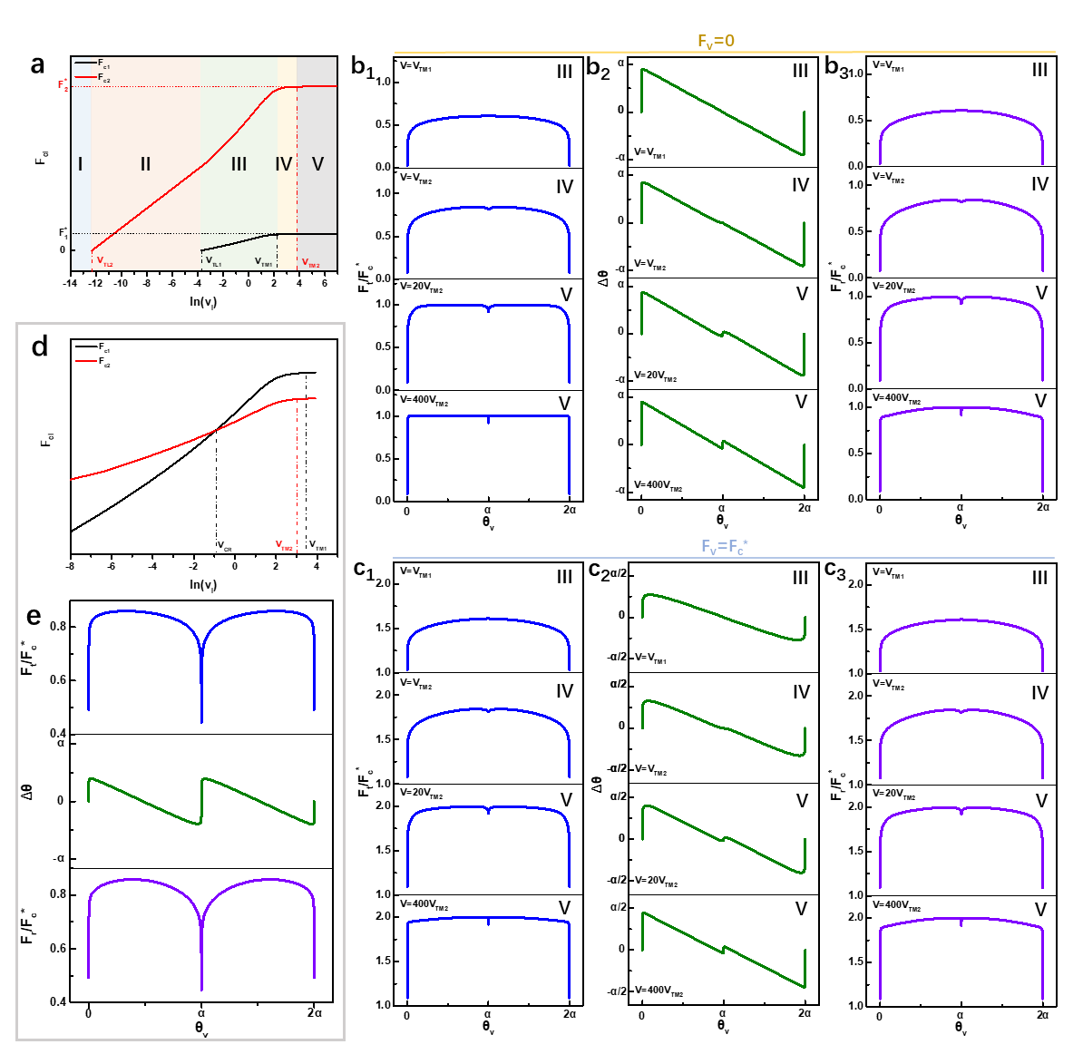
Figure 6 ▏Theoretical calculations of friction on an atomically flat surface with two EHCs at T > 0 K. a $F_{c1}$ and $F_{c2}$ as functions of ln($v_{i}$) for the first scenario, parameters come from ref. 5. b₁-b₃ Normalized total force (b₁), misalign angle (b₂), and normalized friction force (b₃) as functions of sliding angles at different sliding velocities, with $F_{v}$=0. c₁-c₃ Normalized total force (c₁), misalign angle (c₂), and normalized friction force (c₃) as functions of sliding angles at different sliding velocities, with $F_{v}$=$F_{c}^{*}$. d $F_{c1}$ and $F_{c2}$ as functions of ln($v_{i}$) for the second scenario. e Normalized total force, misalign angle, and normalized friction force as functions of the sliding angle with $F_{v}$=0 and with $v_{CM}<{v<v}_{TM1}$. $F_{c}^{*}$ has same definition as 0 K condition.

- Calculation of the isotropic and anisotropic friction force components
The model presented above reveals that many parameters, like the ratio between $F_{c1}$ and $F_{c2}$, the temperature, the sliding velocity $v$, and the isotropic friction force $F_{v}$, control the friction anisotropy phenomenon on atomically flat surfaces. Therefore, it is complex to study the mechanism. However, the misalign angle $∆θ$ can give critical friction information. Fig. 6 shows that thermal effects are negligible for high enough scan velocity. Considering two EHCs with $F_{c2}>F_{c1}$ (the first scenario), according to equations (4)-(9), the maximum of $∆θ$ is
$∆θ_{max}=\tan^{-1}{(\frac{\text{P}\sin{θ_{c}}}{1+\text{P}\cos{θ_{c}}})}$; (16)
and the scale of the jump at $θ_{v}=α$ is
$∆θ_{jump}=2\tan^{-1}{(\frac{\text{P}\sin{(α-θ_{c})}}{1+\text{P}\cos{(α-θ_{c})}})}$; (17)
Thus, we can get the ratio between isotropic and anisotropic friction force $P=\frac{F_{v}}{F_{c}^{*}}$ and the ratio of the maximum friction forces along the EHCs $G=\frac{F_{c2}^{*}}{F_{c1}^{*}}$ (calculated from $θ_{c}$) by measuring the amplitude and the scale of jumps in $∆θ$. If no jump is detected, then we can directly derive that $θ_{c}≈α$.
The 60 μm/s scan velocity in our experiments is high enough to apply equations (16) and (17)⁵. In Fig. 1h, no jump is observed, and the amplitude is about ±20°. We can conclude that: on the MoS₂ surface, the friction force along the zig-zag direction is negligible compared to the armchair direction, which agrees with the simulation results²⁹; and the ratio between isotropic and anisotropic friction force ($P)$ is about 0.5, showing the MoS₂ surface is probably slightly contaminated. From Fig. 2, graphite and h-BN surfaces both have no jumps in $∆θ$ means one EHC direction has much higher sliding resistance than the other. For graphite, the ±30° amplitude of $∆θ$ shows that the isotropic friction is negligible, and indicates the surface is prefect and clean. For h-BN, the amplitude is about ±10°, and therefore $P$ is about 2, indicates that h-BN surface is probably contaminated. The results from the mica surface is complex: the profile of $∆θ$ has around ±3° amplitude and a 0.4° jump. According to equations (16) and (17), $G$ is about 13.0 and $P$ is about 8.1 for mica, which means both EHCs on mica contribute to friction, and the friction on mica surface is dominated by contaminations.

- Discussion
The model presented above can explain the origin of the friction anisotropy phenomenon we observed on atomically flat surfaces, including the jumps in $F_{x}$ and $F_{y}$, anisotropic friction and total force, and the misalign angle between the total force and the sliding direction. Here we will have a further discussion of our model.
First, we performed two-dimensional Prandtl–Tomlinson (2D P-T) simulations to support our assumptions of EHCs. Fig. S18 shows sliding route maps of the point contact at 0 K condition. Fig. S18a and b show that when sliding along zig-zag (0°) and armchair directions (30°), the motion of the point contact follows the EHC directions strictly. For the 15° sliding direction, the route is a 1:1 combination of identical and non-identical EHCs (Fig. S18b), further supporting our assumption. For temperatures above 0K, the hopping is not limited from one to another minimum due to thermal effects. As shown in Fig. S19, the motion of the point contact becomes more erratic at 300K for low sliding velocities, which means that the friction anisotropy vanishes. However, when we increase the sliding velocity, the level of the random hopping monotonously decreases. The trajectory follows a minimum-to-minimum path strictly when the sliding velocity is above 2000 nm/s. The 2D P-T simulation results support our assumption of EHCs and point out that friction anisotropy may vanish quickly with speed due to the random hopping arising from thermal effects. For more details about the 2D P-T simulation, please refer to Supplementary Note 7.
Second, the environment and measurement parameters may influence the anisotropic and isotropic friction forces. For example, equation (11) shows that the effective stiffness of the contact $k_{{series}_{i}}$ can influence the friction force. On the one hand, $k_{{series}_{i}}$ can be tuned by the normal load; on the other hand, most tips we used in our experiments do not have equivalent stiffness in X and Y directions, making the effective contact stiffness a periodic variable under a specific normal load. The changing of $k_{{series}_{i}}$ explains the origin of the 180° period signal in Fig. 1i and the normal load effect in Fig. S13.

- Conclusion
Our work introduces a 2DFF-AFM method and a two dimensional friction model useful to characterize the friction properties of atomically flat surfaces. Our results indicate that the friction anisotropy phenomenon is complex and influenced by both environment and scan parameters. The measured misalign angle can be used to calculate the ratio of friction forces at different EHCs and the contributions from anisotropic and isotropic friction forces. This separation makes it possible to study the origin of isotropic friction further, which is critical for fully understanding the friction mechanism.

Method
Sample preparation. In this experiment, the MoS₂, graphite, and h-BN samples were produced by mechanically exfoliating Synthetic Molybdenum Disulfide (2Dsemiconductors), Graphenium graphite (Manchester Nanomaterials), and h-BN crystals (2Dsemiconductors), respectively. The substrate is silicon with 300nm SiO₂.
Sample characterizations. AFM measurements were performed on a WITec alpha300 RAS. We used theoretical calculation to calibrate the cantilever in the vertical direction. PL and Raman characterizations were performed on a Horiba XploRA™ PLUS Raman system. The laser wavelength was 532 nm.

Acknowledgments
ML thanks the support from ESI Fund, OPR DE International Mobility of Researchers MSCA-IF III at CTU in Prague (No: CZ.02.2.69/0.0/0.0/20_079/0017983). ML, PN and TP acknowledge support from the project Novel nanostructures for engineering applications CZ.02.1.01/0.0/0.0/16_026/0008396. This work was supported by the Ministry of Education, Youth and Sports of the Czech Republic through the e-INFRA CZ (ID:90140). TP acknowledges support from the European Union's Horizon2020 research and innovation program under grant agreement No. 721642: SOLUTION.

Author contributions
Mengzhou Liao performed the AFM measurements, data analysis, and theory development; Paolo Nicolini performed the simulations; Tomas Polcar supervised the research; Mengzhou Liao and Paolo Nicolini wrote the manuscript; All authors commented on the manuscript.

Competing interests
The authors declare no competing interests.

Reference

1 Holmberg, K. & Erdemir, A. The impact of tribology on energy use and CO2 emission globally and in combustion engine and electric cars. Tribol Int 135, 389-396, doi:https://doi.org/10.1016/j.triboint.2019.03.024 (2019).
2 Mate, C. M., McClelland, G. M., Erlandsson, R. & Chiang, S. Atomic-scale friction of a tungsten tip on a graphite surface. Physical Review Letters 59, 1942-1945, doi:10.1103/PhysRevLett.59.1942 (1987).
3 Gnecco, E. et al. Velocity Dependence of Atomic Friction. Physical Review Letters 84, 1172-1175, doi:10.1103/PhysRevLett.84.1172 (2000).
4 Sang, Y., Dubé, M. & Grant, M. Thermal Effects on Atomic Friction. Physical Review Letters 87, 174301, doi:10.1103/PhysRevLett.87.174301 (2001).
5 Riedo, E., Gnecco, E., Bennewitz, R., Meyer, E. & Brune, H. Interaction Potential and Hopping Dynamics Governing Sliding Friction. Physical Review Letters 91, 084502, doi:10.1103/PhysRevLett.91.084502 (2003).
6 Li, Q., Dong, Y., Perez, D., Martini, A. & Carpick, R. W. Speed Dependence of Atomic Stick-Slip Friction in Optimally Matched Experiments and Molecular Dynamics Simulations. Physical Review Letters 106, 126101, doi:10.1103/PhysRevLett.106.126101 (2011).
7 Dienwiebel, M. et al. Superlubricity of graphite. Phys Rev Lett 92, 126101, doi:10.1103/PhysRevLett.92.126101 (2004).
8 Li, H. et al. Superlubricity between MoS2 Monolayers. Adv Mater 29, 1701474-n/a, doi:10.1002/adma.201701474 (2017).
9 Song, Y. et al. Robust microscale superlubricity in graphite/hexagonal boron nitride layered heterojunctions. Nature Materials 17, 894-899, doi:10.1038/s41563-018-0144-z (2018).
10 Liao, M. et al. UItra-low friction and edge-pinning effect in large-lattice-mismatch van der Waals heterostructures. Nat Mater 21, 47-53, doi:10.1038/s41563-021-01058-4 (2022).
11 Gong, C. et al. Electronic and Optoelectronic Applications Based on 2D Novel Anisotropic Transition Metal Dichalcogenides. Adv Sci 4, 1700231, doi:https://doi.org/10.1002/advs.201700231 (2017).
12 Du, L. et al. Engineering symmetry breaking in 2D layered materials. Nature Reviews Physics 3, 193-206, doi:10.1038/s42254-020-00276-0 (2021).
13 Fajardo, O. Y., Gnecco, E. & Mazo, J. J. Anisotropy effects and friction maps in the framework of the 2d PT model. Physica B: Condensed Matter 455, 44-48, doi:https://doi.org/10.1016/j.physb.2014.07.042 (2014).
14 Gnecco, E., Fajardo, O. Y., Pina, C. M. & Mazo, J. J. Anisotropy Effects in Atomic-Scale Friction. Tribol Lett 48, 33-39, doi:10.1007/s11249-012-9923-x (2012).
15 Choi, J. S. et al. Friction anisotropy-driven domain imaging on exfoliated monolayer graphene. Science 333, 607-610, doi:10.1126/science.1207110 (2011).
16 Miura, K., Sasaki, N. & Kamiya, S. Friction mechanisms of graphite from a single-atomic tip to a large-area flake tip. Physical Review B 69, doi:10.1103/physrevb.69.075420 (2004).
17 Balakrishna, S. G., De Wijn, A. S. & Bennewitz, R. Preferential sliding directions on graphite. Physical Review B 89, doi:10.1103/physrevb.89.245440 (2014).
18 Almeida, C. M. et al. Giant and Tunable Anisotropy of Nanoscale Friction in Graphene. Sci Rep-Uk 6, 31569, doi:10.1038/srep31569 (2016).
19 Vazirisereshk, M. R., Hasz, K., Carpick, R. W. & Martini, A. Friction Anisotropy of MoS2: Effect of Tip–Sample Contact Quality. The Journal of Physical Chemistry Letters 11, 6900-6906, doi:10.1021/acs.jpclett.0c01617 (2020).
20 Lee, C. et al. Frictional Characteristics of Atomically Thin Sheets. Science 328, 76-80, doi:doi:10.1126/science.1184167 (2010).
21 Song, Y. et al. Directional anisotropy of friction in microscale superlubric graphite/$h\mathrm{BN}$ heterojunctions. Phys Rev Mater 5, 084002, doi:10.1103/PhysRevMaterials.5.084002 (2021).
22 Xu, K. et al. Shear anisotropy-driven crystallographic orientation imaging in flexible hexagonal two-dimensional atomic crystals. Applied Physics Letters 115, 063101, doi:10.1063/1.5096418 (2019).
23 Deng, Z., Smolyanitsky, A., Li, Q., Feng, X.-Q. & Cannara, R. J. Adhesion-dependent negative friction coefficient on chemically modified graphite at the nanoscale. Nature Materials 11, 1032-1037, doi:10.1038/nmat3452 (2012).
24 Tian, K. et al. Load and Time Dependence of Interfacial Chemical Bond-Induced Friction at the Nanoscale. Physical Review Letters 118, 076103, doi:10.1103/PhysRevLett.118.076103 (2017).
25 Hölscher, H., Ebeling, D. & Schwarz, U. D. Friction at Atomic-Scale Surface Steps: Experiment and Theory. Physical Review Letters 101, 246105, doi:10.1103/PhysRevLett.101.246105 (2008).
26 Campione, M., Trabattoni, S. & Moret, M. Nanoscale Mapping of Frictional Anisotropy. Tribol Lett 45, 219-224, doi:10.1007/s11249-011-9871-x (2012).
27 Guo, Y. et al. Distinctive in-Plane Cleavage Behaviors of Two-Dimensional Layered Materials. Acs Nano 10, 8980-8988, doi:10.1021/acsnano.6b05063 (2016).
28 Hirano, M., Shinjo, K., Kaneko, R. & Murata, Y. Anisotropy of frictional forces in muscovite mica. Physical Review Letters 67, 2642-2645, doi:10.1103/PhysRevLett.67.2642 (1991).
29 Claerbout, V. E. P., Polcar, T. & Nicolini, P. Superlubricity achieved for commensurate sliding: MoS2 frictional anisotropy in silico. Comp Mater Sci 163, 17-23, doi:https://doi.org/10.1016/j.commatsci.2019.03.019 (2019).
30 Kerssemakers, J. & De Hosson, J. T. M. Influence of spring stiffness and anisotropy on stick‐slip atomic force microscopy imaging. J Appl Phys 80, 623-632, doi:10.1063/1.362870 (1996).
31 Ding, M., Cong, Y., Li, R. & Xu, F. Effect of surface topography on anisotropic friction of graphene layers. Extreme Mechanics Letters 40, 100988, doi:https://doi.org/10.1016/j.eml.2020.100988 (2020).
32 Takoutsing, C. S., Djuidjé Kenmoé, G. & Kofané, T. C. Effects of Anisotropy and Substrate Shape on Atomic Friction Force in Two-Dimensional Model. Tribol Lett 65, doi:10.1007/s11249-017-0889-6 (2017).
33 Pálinkás, A. et al. (2022).
34 Steiner, P. et al. Two-dimensional simulation of superlubricity on NaCl and highly oriented pyrolytic graphite. Physical Review B 79, 045414, doi:10.1103/PhysRevB.79.045414 (2009).

