Normalization of measured energy consumption to inform both design and operational decisions
Massimiliano Manfren¹, Giorgia Marenzi², Lavinia Chiara Tagliabue³, Giuseppe Martino Di Giuda³, Marta Boscariol³
¹University of Southampton, United Kingdom.
²Politecnico di Milano, Milano, Italy
³University of Turin, Italy

Abstract
The building sector is one of the most resource-intensive and carbon-intensive sectors in the European Union and globally. Reliable building performance data are essential for providing the evidence needed in the design of energy efficiency interventions and planning of decarbonisation strategies for the existing stock. Indeed, the development of effective solutions aimed at lowering energy consumption, emissions and costs in existing buildings is an open challenge where actual performance characterisation is crucial. The normalisation of measured energy consumption with respect to weather and usage patterns may be performed in a straightforward and scalable manner leveraging state-of-the-art approaches that can, in turn, be linked to more detailed simulation techniques and used to inform both design and operational decisions. In this study, 10 public buildings in the Italian city of Melzo were analysed and modelled to address the above-mentioned challenges while streamlining and partially automating the process of building stock digitalisation.

Introduction
Data-driven building energy modelling methods that use machine-learning techniques have been shown to be useful in a variety of applications (Hong et al., 2020), from design (Westermann and Evins, 2019) to operation (Manfren et al., 2020b). As a result, they have the potential to become a key tool for accelerating the ongoing process of building stock decarbonisation (Norton et al., 2021) as well as an integral part of innovative services and technologies (Manfren et al., 2021a), where digitalisation is a key component.
Nonetheless it is challenging to introduce data-driven methods effectively and reliably in the process of digital transformation of built environment. Establishing a robust baseline data-driven energy model using measured energy consumption (with data collected on a continuous basis) at the whole facility or sub-facility/sub-meter level over a given period and calibrating (Chong et al., 2021) simulations of the energy consumption using more detailed tools, for example, is a challenging task in and of itself and becomes even more daunting if this is not done using a simple, interpretable, and reproducible methodology.
For this reason, in this research, regression models trained on measured building energy consumption are used in combination with simulated building performance to highlight the potential use of (interpretable) data-driven methods with more detailed simulation techniques. A cohort of 10 public buildings located in Melzo, which is a town in the northern Italian province of Milan, was selected as a test. The goal of this research was testing a way to streamline and making the energy model calibration process more robust, considering the evidence collected in previous research and the request from the public administration, described in the background and motivation section hereafter.

Background and motivation
This article is the result of a multi-year research contract between Politecnico di Milano (ABC Department) and the Melzo Municipal Administration. The primary objective of the study is the digitalisation of a portion of the municipal existing building stock, and the study's title is “Informative Modeling of the Real Estate Assets for Strategic Planning and Programming of Energy Retrofit Interventions and Redevelopment of the Built Environment”. Politecnico di Milano research group has carried out the following activities:
- Survey and acquisition of available information (building geometry, construction technology, building services, energy consumption, etc.).
- Verification of the adequacy of the spaces in accordance with current legislation (school construction, fire protection, accessibility, state of conservation).
- Creation of a simplified model for calculating energy performance that can be used to hypothesise targeted retrofit interventions, connected to an economic analysis, and validated with dynamic simulations.
- Creation of simplified BIM models to be used as a single digital archive of building information to support technical evaluation.
- Development of an electronic building dossier that collects and organises the documentation supplied to the BIM model of each building.

The research procedure involved 21 structures, such as schools, libraries, town halls, theatres, senior centres, bowling alleys, youth centres, sports centres, and gyms, among others. The experimental work reported in this study, which considers a group of 10 buildings for brevity, does not include all the buildings. Regarding point 3, different computation methods have been employed over the duration of the research, and some of them have been abandoned as unsuitable (due to time, effort, and cost constraints). One of the goals of the digitalisation process is to provide useful analytics regarding buildings' energy consumption and costs, so that the administration can allocate funds appropriately. The strategy can be periodically revised in light of the evolution of the building stock. The most recent iteration of the modelling approach proposed in relation to point 3 mentioned above requires few input data and is structured based on measured consumption; the work presented here aims to expand this concept with data-driven methods to support and streamline the calibration process further in its development, in relation to the integration of simple baseline data-driven energy models to be used in combination with more detailed dynamic simulation tools.

Literature review
Providing the administration with the ability to allocate financial resources for efficiency measures appropriately is among the goals of the project; hence, the concept of structuring the modelling tools around measured energy performance is crucial. However, due to the dynamic variability of operational conditions, metered energy consumption must be normalised by weather and other factors affecting operation (occupancy, periods of operation, etc.).
This part of the energy modelling workflow is frequently indicated as baseline energy modelling and it is indeed crucial also in the case of building retrofit because it guarantees the correct estimation of the energy performance better retrofit and the related costs (Manfren et al., 2022b). Multiple techniques can be used for this purpose and have been reviewed recently by (Grillone et al., 2020) and (Alrobaie and Krarti, 2022). Focusing on data-driven methods (Fu et al., 2021) indicated how, over the years, a large part of researchers and analysts have continued to prefer piecewise linear (change-point, segmented) regression models using outdoor air temperature as an independent variable and additional variables to subset data with respect to operation modes. Further, as shown by (Afroz et al., 2021), other techniques may outperform piecewise linear regression, but regression is more insightful do to its interpretability (ISO/IEC, 2020). This issue has been reviewed by (Chen et al., 2023), indicating the issue of “ante-hoc” (or intrinsic) and “post-hoc” interpretability. Piecewise linear models are intrinsically (ante-hoc) interpretable, so they are the preferred approach in this case, if they respect the criteria for model acceptability specified later in this section.
The starting point for the analysis of measured energy consumption is the consolidated variable-based degree-days regression, originally proposed by Kissock et al. in the Inverse Modeling Tool (IMT) (Kissock et al., 2003) which has been included in standard ASHRAE 14:2014 (ASHRAE, 2014) and has been steadily evolving with different algorithmic formulations, that offer some benefits in relation, for example, to the improved scalability (temporal and spatial) of the modelling approaches (Manfren et al., 2021b), and to the possibility to be used across different phases of the building life cycle (Manfren et al., 2020b).
At the same time, regression-based formulations could enable the approximate physical interpretation of the quantities estimated (Rasmussen et al., 2020; Tronchin et al., 2019), including components of the building energy balance energy balance's components (Vesterberg et al., 2016a, 2016b). Further, as demonstrated by (Pistore et al., 2019; Westermann et al., 2020), building energy data can also be used effectively in unsupervised learning workflows, for instance to cluster the behaviour of buildings with respect to a set of characteristics, and as a function of outdoor air temperature, which is inherent to the process of weather normalisation (Fazeli et al., 2016) and can be easily interpreted graphically. Normalisation with respect to occupancy can also be considered; however, this variable is rarely recorded, and higher resolution data techniques typically enable automated detection of occupied hours based on electricity consumption, such as the Time Of Week and Temperature (TOWT) regression algorithm (Borgeson, 2013; Mathieu et al., 2011; Price, 2010). In a more simplistic way, dummy variables can be introduced to differentiate between days of the week (daily interval models), or months/seasons (monthly interval models).

Methodology
Overall, the purpose of this study is to support and simplify the process of building energy model calibration (Chong et al., 2021) using as a starting point a regression-based method which is employed for the normalization of measured energy consumption and originates from the Inverse Modeling Tool (IMT) (Kissock et al., 2003), now included in standard ASHRAE 14:2014 (ASHRAE, 2014). However, differently from its original implementation, in this paper energy signature is used (i.e. energy divided by the number of operating hours in the time interval of the analysis, corresponding to an average power), as defined in ISO 16346 (‘ISO 16346:2013). Further, data are scaled by building size (gross volume and net floor area) as indicated later in this section. Finally, the methods implemented use a piecewise linearization technique (Lin et al., 2013) employing dummy variables to tackle nonlinearity and change points, as shown in related research (Manfren et al., 2022a). The proposed changes compared to the standard approach are aimed at simplifying the process of model fitting that can be applied to a heterogeneous stock of buildings, while retaining "interpretability" (ISO/IEC, 2020), i.e. the possibility to be easily understood in human terms. Following are further details regarding model construction and calibration.

Data-driven building performance analysis & building performance simulation
The proposed method is designed for the analysis of existing buildings with heterogeneous characteristics and end-uses for which specific information that can be used in building energy modelling is lacking. In previous phases of the study, the usage of detailed and complex simulation models was deemed too time-consuming and expensive in relation to the goals of the public administration. A combination of regression-based data-driven methodologies and simplified dynamic simulations has been applied in the research to avoid the shortcomings of using excessively detailed and unsuitable modelling approaches. Recent research on this topic has shown promising results in terms of quantification of savings due to energy efficiency measures (Grillone et al., 2020; Manfren et al., 2020a) and, more generally, the use of whole-building statistical energy consumption models (Fu et al., 2021) to aid in decision-making processes.
As indicated before, the building stock considered is heterogeneous and, for this reason, energy signature data are divided by gross volume as shown in research by (Tronchin et al., 2016) and (Pistore et al., 2019). In general, by scaling the quantities in this way it become easier to visualise energy signature across different sets of building as will be shown in the results and discussion section. In general, this approach is suitable in combination with archetypes (representing average statistical buildings) and supervised modelling techniques (Pasichnyi et al., 2019) as well as less “structured” data and unsupervised techniques (Westermann et al., 2020) to find clustering, or eventually a combination of unsupervised and supervised techniques (Lumbreras et al., 2023).
Another fundamental advantage of energy signature analysis is its ability to leverage approximated physical interpretation of slopes and intercepts in the model (Rasmussen et al., 2020), or even approximations of energy balance's components (Vesterberg et al., 2016a, 2016b). Considering both the thermal transmittance of the envelope (opaque and transparent) and infiltration/natural ventilation air-change rates, the interpretation of the regression slope is crucial to determining the heat transfer coefficient of the building. Even though these building parameters can be measured in situ, this cannot be done economically at scale, so approximations are used to estimate them from energy metered and weather data (Manfren and Nastasi, 2019), resulting inherently in a higher level of uncertainty regarding the estimated quantities.
Following these considerations, regression models used in the research are a modified version of the 3-parameter model described in (ASHRAE, 2014), but the constant term (i.e. base load) has been eliminated. The presence of a consumption equal to zero in certain months (e.g. summer months, since we are modelling metered heating services) is handled by using dummy variables (0-1 binary variables) used as interaction terms, as shown in previous research (Manfren et al., 2022a). The binary variables multiply the original variables and enable to “turn on and off” the independent variable when necessary. Two types of models are tested, type 1 and type 2, whose formulas are reported in Table 1.

Table 1: Formulation of regression models
Mode  type | Model  formula
1 | $$q_{h}=a_{0}\left(X_{h}\right)+a_{1}\left(X_{h}θ_{e}\right)+ε_{h}$$
2 | $$q_{h}=a_{0}\left(X_{h}\right)+a_{1}\left(X_{h}θ_{e}\right)+\sum_{j=1}^{n-1}{b_{j}m_{j}}+ε_{h}$$

In the first case the independent variable is outdoor air temperature, in the second case the independent variables are outdoor air temperature and an additional dummy variable corresponding the month of the year, used essentially to detect seasonality in the behaviour (Hyndman and Athanasopoulos, 2018), depending on different months of the year.
In both cases, the dependent variables are the energy signatures calculated from the monitored heating energy consumption and divided by building gross volume, as will be illustrated later in relation to the case study. The calculation of statistical indicators reported later clear excluded the time intervals when consumption is equal to zero (e.g. summer months) and output solutions are constrained to be positive, because small negative values can be calculated sometimes near to the change-point, but clearly they have no physical meaning.
The diagram in Figure 1 illustrates the two different parts of the workflow, the one involving measured data (top) and the one involving simulated data (bottom). Regression (model training) is used to normalize performance and, if the model is within the calibration limits reported at the end of this Section (model evaluation), can make measured and simulated data correctly comparable (model prediction). The difference between measured and simulated (normalized) results can inform the calibration process (as a feed-back loop), leveraging basic interpretability (e.g. slope and balance-point of the regression model) or more detailed physical interpretation of quantities, as indicated before.

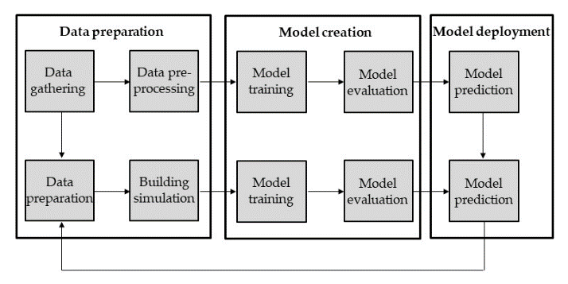Figure 1: Modelling workflow diagram

Calibration criteria for models’ acceptability
Table 2 provides the acceptability thresholds for regression models calibrated with monthly data, as suggested by Measurement and Verification (M&V) protocol ASHRAE 14:2014 (ASHRAE, 2014), considered as reference.
Table 2 – Model calibration criteria, ASHRAE Guidelines 14:2014
Data interval | Metric | Threshold
Monthly | NMBE | ±5 %
 | Cv(RMSE) | 15 %

Similar thresholds can be found in other protocols such as Efficiency Value Organization (EVO) by IPMVP (EVO, 2003) and Federal Energy Management Program (FEMP) (FEMP, 2008). This demonstrates that the calibration criteria employed in this study are well established and based on empirical methodologies, i.e. the measured energy consumption and monitored operational conditions.

Case study
The case study consists of 10 public buildings in Melzo, which is located in the northern Italian province of Milan. These buildings were picked from a broader group of facilities that have been examined as part of the research. The essential building facts are displayed in Table 3, including the building's name, end use, gross floor area, and net floor area.

Table 3: Summary data for the case study buildings
N. | Building name | End-use | Net floor area | Gross volume
 |  |  | m² | m³
1 | Bocciodromo | Sport facilities | 610 | 4510
2 | Mensa | Catering | 1015 | 5285
3 | Centro Anziani | Public spaces | 1355 | 6440
4 | Centro Giovani | Public spaces | 720 | 3555
5 | Casa Associazioni | Public spaces | 535 | 2810
6 | Palestra | Sport facilities | 435 | 3245
7 | Materna Boves | Education | 1400 | 6680
8 | Materna Cervi | Education | 1540 | 6635
9 | Villa Nogara | Public spaces | 340 | 1425
10 | Municipio | Local authorities | 3120 | 12420

The buildings have been monitored for 3 years with data acquisition at monthly interval and concentrating the analysis on natural gas demand for heating service.

Results and discussion
In this Section the results of the regression models’ training are reported, indicating both numerical results represented by statistical indicators, referring to the thresholds in Table 2, and visualization of energy signatures for the different models fitted. The use of both visual and numerical analysis is aimed at enabling a more intuitive interpretation of results, which is on the motivations for the research work, as discussed in the methodology section.

Data-driven analysis from EDA to regression models type 1 and 2
The energy signature of natural gas consumption per unit of gross volume is shown in Figure 2 for the various buildings, which are coloured according to their end use (i.e. grouped). The goal of providing data per unit of volume is to enable a comparison that is independent of the building's size and reliable, given the presence of diverse typologies (built-forms) with varying heights. This would reduce the "fitness for purpose" of a representation per unit of net floor area, considering also the potential for a more in depth analysis of quantities based on their approximated physical interpretation (Rasmussen et al., 2020; Tronchin et al., 2019). In addition, the choice to colour them by end-use is intended to highlight potential data patterns with a distinct separation, which is not visible in this instance. A further classification could be based on the age of the building, which is not given here for the sake of brevity but was considered as part of the research.
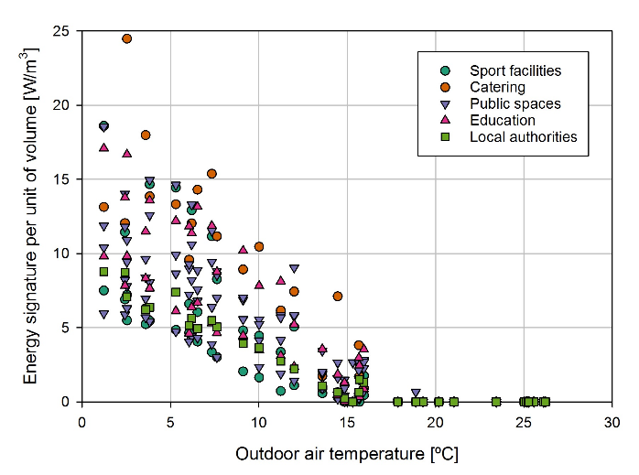
Figure 2: Monthly energy signature per unit of gross volume, measured data
Monthly energy signatures in Figure 2 indicates that linear regression as a function of outdoor air temperatures may fit measured data in a satisfactory way and the results of the model fitting process is shown in Table 4 for model type 1, using 3 years of monthly data and considering the thresholds for model acceptability reported in Table 2 in the methodology section. Building 7 is indicated as non-calibrated even if it is just slightly outside the calibration threshold for CV(RMSE), 15%. Buildings 2, 5 and 6 have much higher CV(RMSE) values indicating a much less predictable behaviour.

Table 4: Statistical indicators for type 1 model fitting
N. | End-use | R² | NMBE | Cv(RMSE) | Calibrated
 |  | % | % | %
1 | Sport facilities | 98.61 | 0.03 | 9.04 | Yes
2 | Catering | 88.07 | -0.06 | 30.32 | No
3 | Public spaces | 97.38 | -0.02 | 10.05 | Yes
4 | Public spaces | 98.30 | 0.09 | 9.39 | Yes
5 | Public spaces | 84.79 | 0.25 | 28.51 | No
6 | Sport facilities | 83.27 | 0.39 | 37.52 | No
7 | Education | 96.66 | 0.08 | 15.13 | No
8 | Education | 97.95 | 0.09 | 10.04 | Yes
9 | Public spaces | 96.14 | 0.15 | 13.84 | Yes
10 | Local authorities | 97.04 | -0.11 | 11.96 | Yes

It can be clearly seen that model type 1 after 3 years obtains values for the indicators NMBE and CV(RMSE) that make them acceptable as calibrated (according to the thresholds in Table 2) for 6 buildings out of 10. The model predictions plotted in Figure 3 show clearly a more regular patterns compared to measured data.
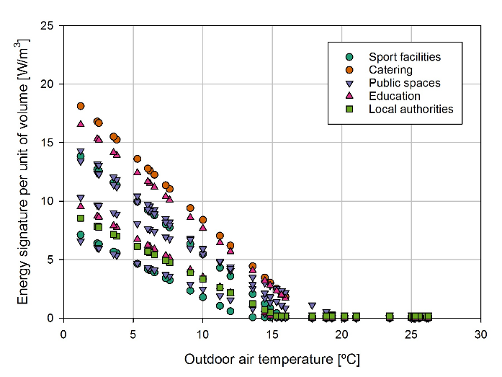
Figure 3: Monthly energy signature per unit of gross volume, type 1 model prediction
The analysis process is then continued with model type 2, with the inclusion of dummy monthly variables to detect possible seasonal patterns, as explained in the methodology section. In this case the number of calibrated buildings is 7 out of 10, indicating that some small seasonal variations in operations are present. The performance of model type 2, reported in Table 5.

Table 5: Statistical indicators for type 2 model fitting with additional dummy variables
N. | End-use | R² | NMBE | Cv(RMSE) | Calibrated
 |  | % | % | %
1 | Sport facilities | 98.96 | 0.00 | 8.59 | Yes
2 | Catering | 90.86 | 0.01 | 27.18 | No
3 | Public spaces | 98.67 | 0.00 | 7.61 | Yes
4 | Public spaces | 98.70 | 0.00 | 8.61 | Yes
5 | Public spaces | 90.09 | 0.00 | 23.01 | No
6 | Sport facilities | 88.19 | 0.41 | 33.03 | No
7 | Education | 98.05 | 0.00 | 11.79 | Yes
8 | Education | 98.78 | 0.00 | 10.16 | Yes
9 | Public spaces | 97.70 | 0.00 | 13.08 | Yes
10 | Local authorities | 98.50 | 0.00 | 10.52 | Yes

The performance of type 2 model is slightly better than type 1 but while building 7 is now calibrated, buildings 2, 5 and 6 have still CV(RMSE) values much higher than the calibration threshold (15%), highlighting the fact that the variations in consumption are not due to a specific seasonal pattern but rather to a lower predictability of their operation. Therefore, the root cause of performance anomaly should be investigated further.
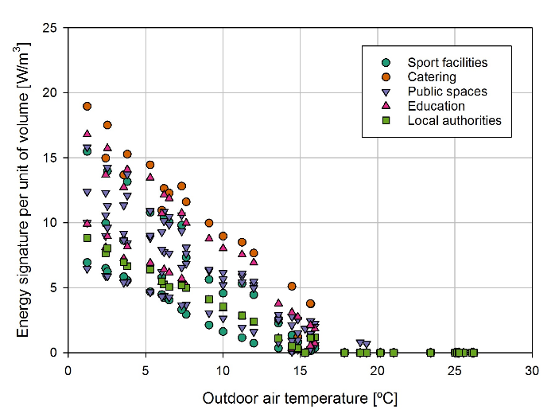
Figure 4: Monthly energy signature per unit of gross volume, type 2 model prediction
The predicted energy signatures in Figure 4 for Model type 2 are less regular than those for Model type 1 (which are on a straight line), but they are still highly recognisable and less dispersed than the original measured data. If measured solar radiation data were available, the regression modelling procedure might have been continued using it as an additional variable.

Fitting regression model type 1 to simulated data and partial calibration
In this section, the type 1 regression model is fitted to dynamic simulation data results. Instead of calibrating the dynamic simulation directly to measured monthly data, which would have required the reconstruction of weather data files with average monthly data matching the ones for the monitored period (time consuming and not easy to do in practice), we attempted to fit a linear regression to the simulated data for a typical standard meteorological year and then compared the results, in particular slope and base temperature (when heating demand is equal to zero), to the ones achieved on measured data. This was due to the fact that regression models are usually employed for weather normalisation of energy demand for heating and cooling, as discussed in the methodology section. The regression type 1 can be calibrated to dynamic simulation data and compared to the measured one in terms of slope and balance-point, which have an approximated physical interpretation (Rasmussen et al., 2020; Tronchin et al., 2019), and could therefore give insights in the calibration process. The Cv(RMSE) is quite smaller compared to the measured case, lower than 10% for all the buildings, as shown in Table 6. On simulated data, the simple regression calibration performed better than on measured data that are more scattered, demonstrating the difficulties of simulating a dynamic regime that accurately reflects reality in the absence of sufficient data.

Table 6: Statistical indicators for type 1 model fitted on simulated
N. | End-use | R² | NMBE | Cv(RMSE) | Calibrated
 |  | % | % | %
1 | Sport facilities | 98.76 | -0.19 | 9.06 | Yes
2 | Catering | 99.93 | -0.01 | 2.08 | Yes
3 | Public spaces | 99.42 | -0.05 | 5.92 | Yes
4 | Public spaces | 98.10 | -0.13 | 9.61 | Yes
5 | Public spaces | 99.90 | -0.02 | 1.89 | Yes
6 | Sport facilities | 99.80 | -0.04 | 2.65 | Yes
7 | Education | 99.78 | -0.06 | 3.53 | Yes
8 | Education | 99.51 | -0.10 | 4.48 | Yes
9 | Public spaces | 99.70 | -0.03 | 4.61 | Yes
10 | Local authorities | 99.30 | -0.06 | 6.77 | Yes

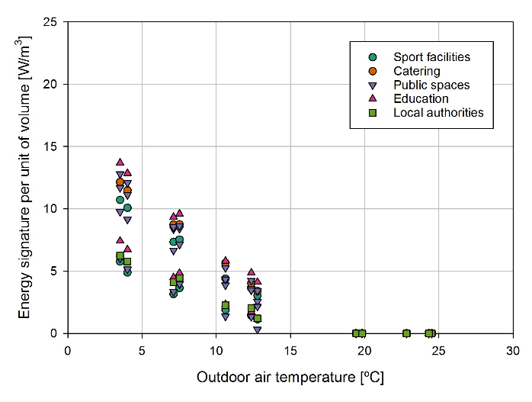
Figure 5: Monthly energy signature per unit of gross volume, simulated data on typical meteorological year
The results of the dynamic simulation are displayed in Figure 5, and it can be observed that they tend to be more clustered than the measured in Figure 2 but with a similar dispersion as in Figure 3 and 4 for the regression model type 1 and 2 respectively. In this sense, a simple visual analysis can help quickly identify the differences between the regressions conducted on measured and simulated data (representation as a function of outdoor air temperature is used in weather normalization).

Energy model predictions comparison
In order to provide an accurate comparison of performance, the annual heating energy consumption determined by the various models is projected for a typical meteorological year and reported in Table 7.

Table 7: Energy consumption per unit of net floor area predicted for a typical meteorological year
N. | End-use | Type 1 | Type 2 | Simulation
 |  | kWh/m² | kWh/m² | kWh/m²
1 | Sport facilities | 108.8 | 104.6 | 117.9
2 | Catering | 273.5 | 276.9 | 206.4
3 | Public spaces | 156.2 | 155.4 | 148.4
4 | Public spaces | 83.8 | 81.5 | 77.4
5 | Public spaces | 208.4 | 202.8 | 200.5
6 | Sport facilities | 270.5 | 274.9 | 253.8
7 | Education | 228.8 | 228.8 | 210.4
8 | Education | 104.5 | 103.0 | 89.8
9 | Public spaces | 158.0 | 159.0 | 158.5
10 | Local authorities | 91.4 | 88.2 | 75.4

The results are now given per unit of net floor area, as in Energy Performance Certificates (which, however, are based on a standard evaluation technique and are not calibrated to the specific conditions, like in this case), to show the wider range of values as opposed to the initial scaling by gross volume. Apart from building 2, which was among those that were not calibrated using both model type 1 and 2, it is possible to observe that the variation in findings is relatively small, less than 20% in all cases (except for building 2). Based on the existing evidence and the methods at the state-of-the-art reported in the methodology, the workflow for calibration can be refined further, and this will be the focus of future research.

Conclusions
Building energy modelling techniques based on machine learning have proven effective in a variety of applications. However, streamlining the process of calibrating building energy models, which may be employed for both design (e.g. deep retrofit) and operational optimization, continues to be an issue.
In addition, it is essential that machine learning algorithms retain interpretability, simplicity, and scalability, improve generalisation capabilities, and are human-comprehensible (i.e. avoiding the "black box" effect). To enable wider implementation of these techniques, which could make the model calibration process more appealing and competitive in terms of time, effort, and cost, several challenges must be considered. In this study, monitored data from a cohort of ten public buildings in Melzo, a municipality in the northern Italian province of Milan, were analysed using an interpretable piecewise linear regression modelling approach. These buildings were selected from a larger range of facilities studied as part of the investigation.
All the buildings were monitored for three years, and while the proposed formulations were quite simple to implement, their results were encouraging and opened the door to further investigation, particularly in regard to the process of ML-supported calibration of detailed building performance simulation. In particular, the visualisation of energy signatures scaled by gross volume is advantageous for comprehending the comparability of buildings with significantly varied attributes and size, as well as the real distribution of measured data in comparison to that of simulated data.
To effectively handle the challenges of interpretability (in approximations of physical concepts) and generalisation, additional efforts including the classification of construction data according to archetypes may be undertaken. Interpretability is crucial due to the need to promote a "human-in-the-loop" approach when using ML tools, and the transparent link between regression model formulation and other analytical techniques at the state-of-the-art could represent an interesting research area, with clear advantages over the use of ML and simulation tools in a "black-box" manner.
In the continuation of this research, we aim to make the modelling workflow as streamlined as possible and to employ a combination of numerical and visual tools so that the process is easily understood by analysts.

Nomenclature
Symbol | Quantity | Unit
a₀ | regression coefficients, intercept | kW/m³
a₁ | regression coefficients, temperature dependence term | kW/(m³K)
b_{j} | regression coefficients, dummy monthly variable | kW/m³
Cv(RMSE) | coefficient of variation of RMSE | -
m_{j} | monthly dummy variable (binary 0-1) | -
NMBE | normalized mean bias error (expressed in percentage) | -
q_{h} | energy signature heating | kW/m³
R² | determination coefficient (expressed in percentage) | -
X_{h} | dummy variable (binary 0-1) heating | -
θ_{e} | outdoor air temperature | ºC
ε_{h} | error term heating | kW/m³

References
Afroz, Z., Burak Gunay, H., O’Brien, W., Newsham, G., Wilton, I., 2021. An inquiry into the capabilities of baseline building energy modelling approaches to estimate energy savings. Energy Build 244, 111054.
Alrobaie, A., Krarti, M., 2022. A Review of Data-Driven Approaches for Measurement and Verification Analysis of Building Energy Retrofits. Energies 15(21), 7824.
ASHRAE, 2014. ASHRAE Guideline 14-2014: Measurement of Energy, Demand, and Water Savings; American Society of Heating, Refrigerating and Air-Conditioning Engineers: Atlanta, GA, USA, 2014.
Borgeson, S.D., 2013. Targeted efficiency: Using customer meter data to improve efficiency program outcomes. University of California, Berkeley.
Chen, Z., Xiao, F., Guo, F., Yan, J., 2023. Interpretable machine learning for building energy management: A state-of-the-art review. Advances in Applied Energy 9, 100123.
Chong, A., Gu, Y., Jia, H., 2021. Calibrating building energy simulation models: A review of the basics to guide future work. Energy Build 253, 111533.
EVO, 2003. IPMVP New Construction Subcommittee. International Performance Measurement & Verification Protocol: Concepts and Option for Determining Energy Savings in New Construction, Volume III; Efficiency Valuation Organization (EVO): Washington, DC, USA, 2003.
Fazeli, R., Ruth, M., Davidsdottir, B., 2016. Temperature response functions for residential energy demand – A review of models. Urban Clim 15, 45–59.
FEMP, 2008. FEMP. Federal Energy Management Program, M&V Guidelines: Measurement and Verification for Federal Energy Projects Version 3.0, U.S. Department of Energy Federal Energy Management Program.
Fu, H., Baltazar, J.-C., Claridge, D.E., 2021. Review of developments in whole-building statistical energy consumption models for commercial buildings. Renewable and Sustainable Energy Reviews 147, 111248.
Grillone, B., Danov, S., Sumper, A., Cipriano, J., Mor, G., 2020. A review of deterministic and data-driven methods to quantify energy efficiency savings and to predict retrofitting scenarios in buildings. Renewable and Sustainable Energy Reviews 131, 110027.
Hong, T., Wang, Z., Luo, X., Zhang, W., 2020. State-of-the-art on research and applications of machine learning in the building life cycle. Energy Build 212, 109831.
Hyndman, R.J., Athanasopoulos, G., 2018. Forecasting: principles and practice. OTexts.
ISO 16346:2013, Energy performance of buildings — Assessment of overall energy performance, 2013.
ISO/IEC, 2020. ISO/IEC TR 29119-11:2020(en) Software and systems engineering — Software testing — Part 11: Guidelines on the testing of AI-based systems.
Kissock, J.K., Haberl, J.S., Claridge, D.E., 2003. Inverse modeling toolkit: numerical algorithms. ASHRAE Trans 109, 425.
Lin, M.-H., Carlsson, J.G., Ge, D., Shi, J., Tsai, J.-F., 2013. A Review of Piecewise Linearization Methods. Math Probl Eng 2013, 101376.
Lumbreras, M., Diarce, G., Martin, K., Garay-Martinez, R., Arregi, B., 2023. Unsupervised recognition and prediction of daily patterns in heating loads in buildings. Journal of Building Engineering 65, 105732.
Manfren, M., Aste, N., Leonforte, F., Del Pero, C., Buzzetti, M., Adhikari, R.S., Zhixing, L., 2020a. Parametric energy performance analysis and monitoring of buildings-HEART project platform case study. Sustain Cities Soc 102296.
Manfren, M., James, P.A.B., Tronchin, L., 2022a. Data-driven building energy modelling – An analysis of the potential for generalisation through interpretable machine learning. Renewable and Sustainable Energy Reviews 167, 112686.
Manfren, M., Nastasi, B., 2019. From in-situ measurement to regression and time series models: An overview of trends and prospects for building performance modelling. AIP Conf Proc 2123, 20100.
Manfren, M., Nastasi, B., Tronchin, L., 2020b. Linking Design and Operation Phase Energy Performance Analysis Through Regression-Based Approaches. Front Energy Res 8, 288.
Manfren, M., Nastasi, B., Tronchin, L., Groppi, D., Garcia, D.A., 2021a. Techno-economic analysis and energy modelling as a key enablers for smart energy services and technologies in buildings. Renewable and Sustainable Energy Reviews 150, 111490.
Manfren, M., Sibilla, M., Tronchin, L., 2021b. Energy Modelling and Analytics in the Built Environment—A Review of Their Role for Energy Transitions in the Construction Sector. Energies 14(3), 679.
Manfren, M., Tagliabue, L.C., Re Cecconi, F., Ricci, M., 2022b. Long-Term Techno-Economic Performance Monitoring to Promote Built Environment Decarbonisation and Digital Transformation; A Case Study. Sustainability 14(2), 644.
Mathieu, J.L., Price, P.N., Kiliccote, S., Piette, M.A., 2011. Quantifying changes in building electricity use, with application to demand response. IEEE Trans Smart Grid 2, 507–518.
Norton, B., Gillett, W.B., Koninx, F., 2021. Decarbonising Buildings in Europe: A Briefing Paper. Proceedings of the Institution of Civil Engineers - Energy 174, 147–155.
Pasichnyi, O., Wallin, J., Kordas, O., 2019. Data-driven building archetypes for urban building energy modelling. Energy 181, 360–377.
Pistore, L., Pernigotto, G., Cappelletti, F., Gasparella, A., Romagnoni, P., 2019. A stepwise approach integrating feature selection, regression techniques and cluster analysis to identify primary retrofit interventions on large stocks of buildings. Sustain Cities Soc 47, 101438.
Price, P., 2010. Methods for analyzing electric load shape and its variability, Lawrence Berkeley National Laboratory Report LBNL-3713E.
Rasmussen, C., Bacher, P., Calì, D., Nielsen, H.A., Madsen, H., 2020. Method for Scalable and Automatised Thermal Building Performance Documentation and Screening. Energies 13(15), 3866.
Tronchin, L., Manfren, M., Nastasi, B., 2019. Energy analytics for supporting built environment decarbonisation. Energy Procedia 157, 1486–1493.
Tronchin, L., Manfren, M., Tagliabue, L.C., 2016. Optimization of building energy performance by means of multi-scale analysis – Lessons learned from case studies. Sustain Cities Soc 27, 296–306.
Vesterberg, J., Andersson, S., Olofsson, T., 2016a. Calibration of low-rise multifamily residential simulation models using regressed estimations of transmission losses. J Build Perform Simul 9, 304–315.
Vesterberg, J., Andersson, S., Olofsson, T., 2016b. A single-variate building energy signature approach for periods with substantial solar gain. Energy Build 122, 185–191.
Westermann, P., Deb, C., Schlueter, A., Evins, R., 2020. Unsupervised learning of energy signatures to identify the heating system and building type using smart meter data. Appl Energy 264, 114715.
Westermann, P., Evins, R., 2019. Surrogate modelling for sustainable building design – A review. Energy Build 198, 170–186.

