Title: Evaluation of in-shoe plantar pressure and shear during walking for diabetic foot ulcer prevention

Jinghua Tang, Researcher Fellow¹
Dan L Bader, Emeritus Professor of Bioengineering and Tissue Health²
Daniel J Parker, Lecturer in Digital Health ³
Saeed Forghany, Research Fellow⁴
Christopher J Nester, Professor of Rehabilitation⁴
David Moser, Visiting Professor¹
Liudi Jiang, Professor of Materials & Electromechanical System¹

¹School of Engineering, University of Southampton, Southampton SO17 1BJ, United Kingdom
²School of Health Sciences, University of Southampton, Southampton, SO17 1BJ, United Kingdom
³School of Health and Society, University of Salford, Salford, M6 6PU, United Kingdom
⁴ School of Allied Health Professions, Keele University, Keele, Newcastle ST5 5BG, United Kingdom

Corresponding author: Dr. Jinghua Tang, Jinghua.tang@soton.ac.uk, (+44) 023 8059 2551

Abstract
Aims: To investigate reliability and changes of in-shoe plantar pressure and shear during walking at three cadences with two insole designs. This was a precursor to investigate plantar loading in people with diabetes for potential foot ulcer prevention.
Methods: A sensorised insole system, capable of measuring plantar pressure and shear at the heel, fifth metatarsal head (5MH), first metatarsal head (1MH) and hallux, was tested with ten healthy participants during level walking. Reliability was evaluated, using intra-class correlation coefficient (ICC), while varying the cadences and insole types. Percentage changes in pressure and shear relative to values obtained at self-selected cadence with a flat insole design were investigated.
Results: Mean (SD) of maximum pressure, medial-lateral and anterior-posterior shear of up to 380 (24) kPa, 46 (2) kPa and -71 (4) kPa, respectively, were measured. The ICC in ranges of 0.762~0.973, 0.758~0.987 and 0.800~0.980 were obtained for pressure, anterior-posterior and medial-lateral shear, respectively. Opposite anterior-posterior shear directions between 5MH and 1MH (stretching), and between 1MH and hallux (pinching) were observed for some participants. Increasing cadence increased pressure and anterior-posterior shear (up to +77%) but reduced medial-lateral shear at the heel and hallux. Slower cadence increased anterior-posterior shear (+114%) but decreased medial-lateral shear (-46%) at the hallux. The use of a flexible contoured insole resulted in pressure reduction at the heel and 5MH but an increase in anterior-posterior shear at the heel (+69%) and hallux (+75%).
Conclusion: The insole system demonstrated good reliability and is comparable to reported pressure-only systems. Pressure measurements were sensitive to changes in cadence and insole designs in ways that are consistent with literature. However, our novel plantar shear showed localised shear changes with cadences and insoles for the first-time, as well as stretching and pinching effects on plantar tissue. This opens new possibilities to investigate plantar tissue viability, loading characteristics and orthotic designs aimed towards foot ulcer prevention.
Key words: Pressure, Shear, Plantar, In-shoe, Walking, Insole
Acknowledgement
We would like to thank Yudan Zhang for her assistance in data collection and support.
Conflicts of Interest
The authors declare no conflict of interest.
Funding Statement
This study is funded by the NIHR Invention for Innovation (i4i) Programme (NIHR201315). The views expressed are those of the authors and not necessarily those of the NIHR or the Department of Health and Social Care.
Data availability
All data supporting this study are openly available from the University of Southampton repository at https://doi.org/10.5258/SOTON/D2710.
Ethical statement
The study was approved by the University Research Ethics Committee of the University of Southampton (ERGO ID: 63303). Written informed consent was obtained from the participants to publish this paper.

Introduction
Excessive and prolonged external loading are key factors associated with tissue injury and cell death. For people with diabetes (PWDs), additional internal factors such as peripheral neuropathy, impaired microcirculatory response, foot deformity and reduced tissue response to loading contribute to a greatly increased risk of foot ulceration (DFU).¹ DFUs have a very significant impact and there are over 60,000 people with diabetic foot ulcers in England at any given time.² This is associated with 100 DFU-related amputations every week and a 60% five-year mortality rate.³ Yet, 75% of DFUs may be preventable⁴ by better management of the load applied to the sole of the foot during load bearing activities. The particular priorities are at heel, metatarsal heads and toes which are areas most commonly affected by ulceration due to excessive external loads.⁵
The pathogenesis of DFU is a multi-factorial process with peripheral neuropathy and arterial disease being the two dominant internal factors.⁶ Elevated pressure is known to be associated with risk of DFU. This is further exacerbated by foot deformity^{7, 8} (e.g., hammer toe) and musculoskeletal dysfunction⁹ (e.g., reduced ankle dorsiflexion), which were observed on PWDs, especially those suffer from neuropathy. In additional to pressure, studies also reported that plantar shear plays a clinically significant role in DFU formation. Indeed, de Wert et al., reported a significant increase in interleukin-1α release, a tissue damage-associated molecular pattern, after shear loading, comparing to the response to pressure-only loading.¹⁰ Therefore, utilising both pressure and shear measurement could play a key role towards more effective DFU prevention solutions.⁶ Yavuz reported elevated shear stress in patients with diabetic neuropathy,¹¹ as well as those who previously ulcerated,¹² comparing to their counterparts. In addition, a greater range of anterior-posterior components of ground reaction forces were revealed on PWDs who previously ulcerated.¹³ A randomised control trial involving 299 patients suggested that the standard group was over three times more likely to develop a DFU as compared with those using shear-reducing insoles. Indeed, in the general field of skin ulceration, e.g., pressure ulcers, shear has also long been identified as an important factor because tissue and blood vessels are distorted under shear more easily than compressive pressure load, resulting in occlusion and tissue ischaemia and thereafter increasing the risk of cell death. Tissue deformation, as a result of shear, can also negatively impact lymphatic flow and obstruct transportation of metabolic waste away from an area at risk of ulceration.¹⁴ Bader et al. also reported that the repetitive pressure and shear applied to load-sensitive tissue, adjacent to a bony prominence, is likely to lead to pressure ulcers and DFUs.¹⁵
To date, several international guidelines, and other literature¹⁶, emphasize the importance of shear combined with pressure as the leading external risk factor for DFUs.¹⁷⁻¹⁹ However, the lack of pressure and shear sensing systems means that most DFU risk assessment and prevention research has focused only on the impact of pressure. In addition, orthotic insoles and footwear were primarily designed with pressure relive features. Perry et al.²⁰ reported the simultaneous measurement of plantar pressure and shear during unshod walking, at fore-foot locations. Greatest pressure and shear occurred at medial (189kPa) and lateral (33kPa) metatarsal head, respectively. Wang et al.²¹ reported a SLIPS system, used with a modified footwear, capable of measuring three-dimensional (3D) stresses. Despite the advancement in sensing technologies, in-shoe pressure and shear have rarely been reported during real-world walking where walking speed fluctuates. In most cases, real-time plantar pressure and shear assessments have been conducted when walking barefoot²² and under laboratory conditions.²¹ There is very limited data on in-shoe plantar pressure and shear during shod natural walking, and the transferability of data from barefoot to shod contexts is known to be problematic.^{23, 24}
This work uses a first-of-its-kind in-shoe plantar pressure and shear measurement insole system.²⁵ The system design, calibration and technical validity have recently been reported.²⁵ The system was also shown to not adversely impact the loads being measured, i.e., did not adversely elevate pressures under the foot and was therefore safe to use in clinical populations. The system collects pressure and shear data at plantar sites associated with normal ambulation and those most commonly affected by DFUs, i.e., heel, fifth metatarsal head (5MH), first metatarsal head (1MH) and hallux. The aim of this work was to continue to report on its reliability during real-world walking and analyse plantar pressure and shear changes with cadence and insole types.
Methods
Ten healthy individuals were recruited and participated in two data collection sessions: (1) variations in cadence and (2) effect of insole design on plantar loads. Participants were self-reported free of clinical foot deformity and mobility impairment (Table 1).
The Sensorised Insole System
Fig 1. (a) A photo showing the sensorised insole system comprising a sensorised insole and a hub. (b) A schematic illustrating the layered structure of the sensorised insole, including four sensors, ethyl vinyl acetate (EVA) layer for housing the sensors, a top synthetic leather layer and bottom Lycra layer.
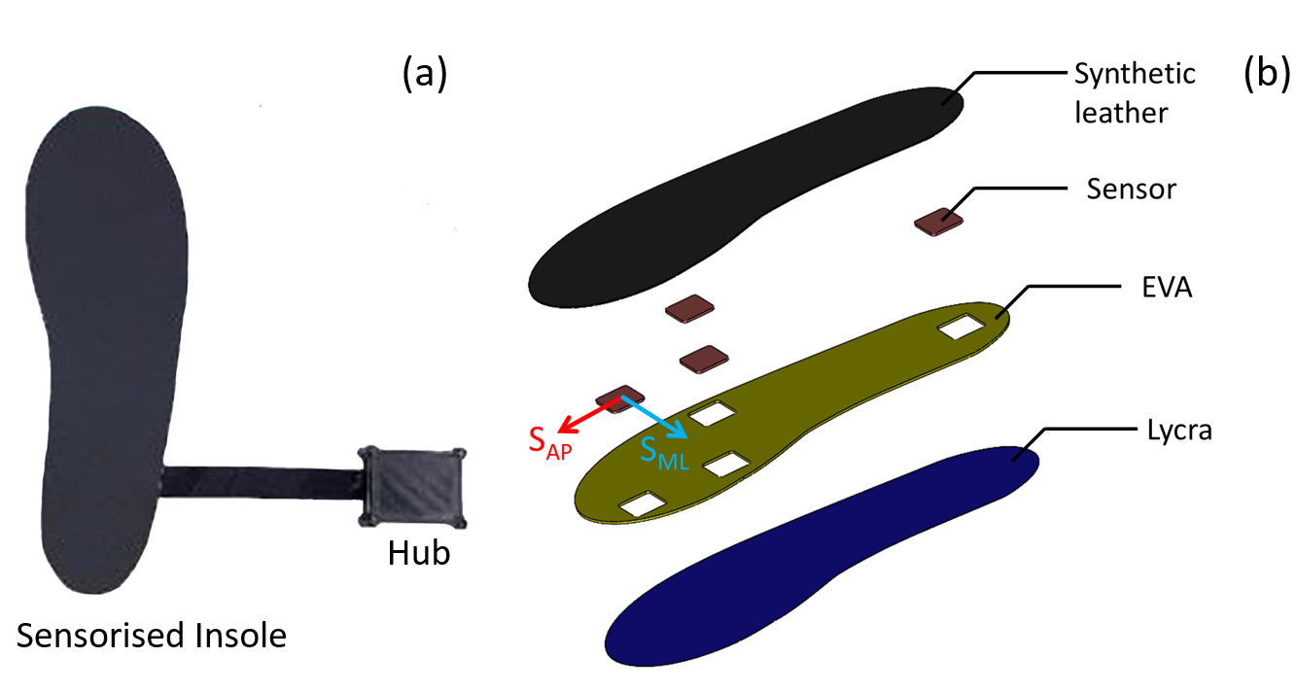
Fig 1. Illustrates the sensorised insole system. The insole system consists of four thin and flexible capacitance-based sensors, embedded between a synthetic leather layer and a Lycra layer. The four sensors were located at approximate locations of the heel, 5MH, 1MH and hallux of the particular insole sizes. These locations were chosen not only because they are at risk of ulceration but also they are needed to detect key gait events. For instance, load on the heel sensor was used to identify initial contact event, while the hallux was used to identify toe-off event. This allows the study of localised loading characteristics at these vulnerable sites, as well as the temporal characteristics, e.g. foot roll-over, which PWD present abnormality.²⁶ Each sensor has area dimensions of 20mm x 20mm and 1mm thickness, which is sufficient to accommodate the length variations of the metatarsal heads (15mm) and hallux (20mm).²⁷ Further details on the sensorised insole system performance were described in a previous publication.²⁸ The sensor signals were processed and stored in a wireless hub worn on the shoe, which incorporated data acquisition electronics. The system was calibrated with an accuracy error of up to 5% for pressure (range: 0∼300kPa) and shear (range: -50∼+50kPa) measurements.

Experimental Protocol
Fig 2. shows the insole with embedded sensor locations. Standard footwear (Lambo Trainers, Lonsdale, UK) was used for all participants. The original insole was removed and replaced with a 3mm thick flat medium density ethylene vinyl acetate (EVA) insole or a Slimflex contoured insole. Subsequently, appropriate foot/shoe size version of the sensorised insole, intended for the right foot, was adhered to the top of the flat or the contoured insole. A wireless data hub (50mm x 40mm x 25mm) was attached to the lateral collar of the footwear. All participants used their own socks.
Fig 2. Photo of the footwear with a sensorised insole system attached. The sensorised insole was placed on top of the flat EVA insole and the contoured Slimflex insole, respectively.
Table 1. Participant demographics.
 | P01 | P02 | P03 | P04 | P05 | P06 | P07 | P08 | P09 | P10 | Mean (SD)
Age (years) | 32 | 25 | 29 | 25 | 23 | 31 | 27 | 65 | 25 | 50 | 33 (14)
Weight (kg) | 96 | 85 | 72 | 75 | 79 | 60 | 100 | 67 | 58 | 80 | 77 (14)
Height (cm) | 177 | 176 | 164 | 174 | 180 | 162 | 170 | 170 | 155 | 160 | 169 (8)
Foot size (UK) | 8 | 8.5 | 6 | 8 | 8 | 5 | 7 | 9 | 5 | 5 | 7.0 (1.6)
Gender | M | M | F | M | M | F | F | M | F | F | n/a

Prior to data collection, participants walked for at least five minutes using the provided footwear with the sensorised insole system in place to ensure there was no discomfort. Subsequently, each participant was asked to walk at a self-selected walking pace to establish their individual walking speed and cadence. The latter was used to drive a digital metronome and assist the control of walking during data collection. Each participant conducted two sessions on the same day. In session 1, each participant used the flat insole. They were instructed to walk along a 28m indoor level walkway with the metronome set at their self-selected cadence, followed by walking with cadence 20% slower and 20% faster. The controlled cadence and corresponding walking speed were illustrated in Table 2. In session 2, the same protocol was repeated by each participant but using a flexible contoured insole (Slimflex Green, A. Algeos Ltd, United Kingdom) with a sensorised insole adhered on top. The Slimflex insole had a heel thickness of approximately 10mm, arch height of 32mm and forefoot thickness of 2.5mm.
Table 2. The controlled walking cadence and the corresponding walking speed for each participant.
 | Slow |  | Self-Selected |  | Fast
 | Cadence (steps/min) | Speed  (m/s) | Cadence (steps/min) | Speed  (m/s) | Cadence  (steps/min) | Speed  (m/s)
P01 | 80 | 0.82 | 100 | 1.05 | 120 | 1.43
P02 | 81 | 0.98 | 101 | 1.18 | 121 | 1.43
P03 | 96 | 1.05 | 120 | 1.73 | 144 | 2.00
P04 | 90 | 1.03 | 112 | 1.33 | 134 | 1.63
P05 | 88 | 0.95 | 110 | 1.25 | 132 | 1.90
P06 | 88 | 0.98 | 110 | 1.25 | 132 | 1.54
P07 | 80 | 0.98 | 100 | 1.48 | 120 | 1.54
P08 | 84 | 1.14 | 105 | 1.41 | 126 | 1.82
P09 | 83 | 1.21 | 104 | 1.35 | 125 | 1.66
P10 | 101 | 1.03 | 126 | 1.74 | 151 | 1.82
Mean (SD) | 87 (7) | 1.01 (0.11) | 109 (9) | 1.38 (0.22) | 131 (10) | 1.68 (0.20)

Data collection and analysis
Pressure, shear in medial-lateral direction (S_{ML}) and anterior-posterior direction (S_{AP}) at the heel, 5MH, 1MH and hallux were collected simultaneously at 100Hz. Data pre-processing removed the first five and last five steps to eliminate the effects of walking acceleration and deceleration, resulting in approximately 30 remaining steps (or 15 steps on the right side containing the sensorised insole) for further processing. Pressure of 25kPa, i.e. approximately 10N force, from the heel sensor was used to define initial contact, and two consecutive initial contact events were used to define a gait cycle.²⁹ Magnitude of maximum pressure, individual shear components (|S_{AP}| and |S_{ML}|) and resultant shear magnitudes, when using the flat insole at self-selected cadence, were calculated, to show mean (SD) across the plantar loading sites. To investigate effects of cadence and insole type, the percentage change (change %) for maximum pressure and shear compared to self-selected cadence and flat insole was calculated using the overall mean values.
Statistical analysis
Reliability was assessed using Intra-class Correlation Coefficient (ICC), based on maximum pressure and shear values obtained across a total of 150 steps taken from 10 participants. A two-way mixed model with consistency analysis was chosen. Interpretation of the ICCs was based on Portney and Watkins³⁰ (>0.75 good reliability, 0.5-0.75 moderate reliability and <0.5 poor reliability). ICC and its 95% confidence interval were calculated.

Results
Table 2 confirms that, although we controlled cadence in tests, for all participants the increase in cadence corresponded to increased walking speeds, and vice versa. Table 3 illustrates the maximum values obtained from each participant. Typical biomechanical profiles of pressure and shear as a function of gait cycles were reported previously.²⁵ Pressure values are always positive, while shear revealed both positive and negative values during stance (Table 3), consistent with ground reaction force data. In those cases, we present the magnitude of the maximum peak shear value irrespective of direction of shear. The highest mean peak pressure (380kPa) and S_{AP} (-71kPa) was reported for the hallux, while the highest mean S_{ML} (+46kPa) was at the 5MH.
Table 3. Mean (SD) (kPa) for each participant obtained using flat insole at self-selected cadence. Magnitude of shear was used to calculate mean (SD).
 | Heel |  |  |  | 5MH |  |  |  | 1MH |  |  |  | Hallux
 | Pressure | S_{ML} | S_{AP} | Pressure |  | S_{ML} | S_{AP} | Pressure |  | S_{ML} | S_{AP} | Pressure |  | S_{ML} | S_{AP}
P01 | 195 (3) | -15 (2) | -14 (3) | 205(9) |  | 46 (2) | -36 (6) | 129 (9) |  | 13 (2) | 17 (2) | 201 (11) |  | 10 (2) | -12 (2)
P02 | 226 (11) | -17 (2) | 11 (1) | 100 (13) |  | 32 (4) | -27 (4) | 180 (31) |  | 9 (5) | 30 (9) | 163 (32) |  | 18 (5) | 7 (5)
P03 | 278 (9) | 8 (2) | -38 (5) | 132 (5) |  | 10 (1) | 17 (4) | 173 (14) |  | 32 (4) | 6 (1) | 380 (24) |  | 19 (5) | -19 (4)
P04 | 255 (7) | -14 (2) | -1 (0) | 136 (12) |  | 28 (3) | -15 (2) | 175 (30) |  | 5 (4) | 21 (2) | 167 (16) |  | 16 (3) | 12 (3)
P05 | 165 (8) | -11 (2) | -3 (2) | 169 (3) |  | 2 (2) | -3 (2) | 119 (15) |  | 39 (8) | -18 (2) | 224 (13) |  | 2 (2) | -7 (2)
P06 | 275 (4) | 28 (5) | -48 (2) | 119 (21) |  | 38 (7) | -19 (5) | 235 (13) |  | 18 (5) | -11 (1) | 273 (25) |  | -14 (2) | -36 (5)
P07 | 166 (7) | 2 (1) | 4 (1) | 117 (22) |  | 39 (7) | -27 (3) | 154 (24) |  | 17 (5) | -10 (4) | 191 (16) |  | 22 (1) | -18 (4)
P08 | 251 (4) | 14 (3) | -40 (3) | 132 (10) |  | 14 (2) | 14 (2) | 155 (11) |  | 32 (4) | 17 (2) | 353 (13) |  | 33 (4) | -71 (4)
P09 | 249 (7) | 6 (2) | -15 (1) | 155 (9) |  | 28 (3) | -27 (2) | 187 (7) |  | 11 (4) | -25 (2) | 200 (16) |  | 19 (2) | -8 (2)
P10 | 244 (5) | -12 (3) | -21 (4) | 147 (4) |  | 33 (2) | -34 (2) | 174 (21) |  | 23 (2) | 23 (1) | 332 (12) |  | 16 (2) | -31 (3)
Mean (SD) | 221 (48) | 19 (17) | 14 (11) | 126 (36) |  | 32 (8) | 26 (13) | 163 (33) |  | 16 (9) | 18 (10) | 243 (86) |  | 19 (7) | 22 (8)

Fig. 3 (a) Peak plantar pressure, (b) absolute peak |S_{AP}|, (c) |S_{ML}| and (d) magnitude of resultant shear stresses, obtained across all participants.
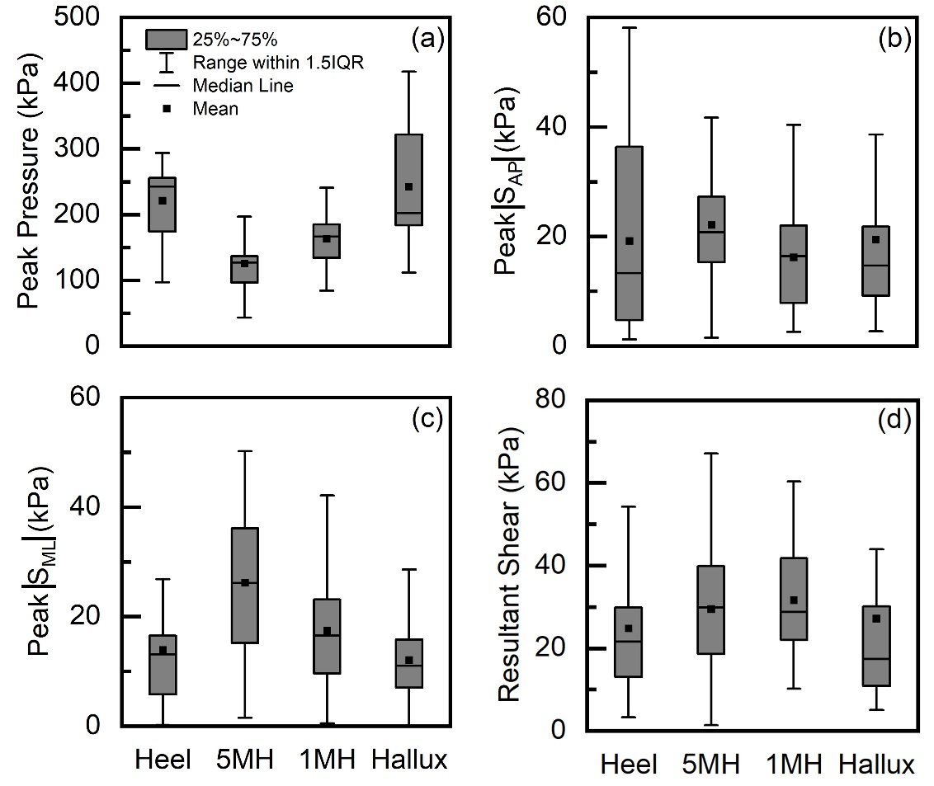
Fig 3. Summarizes maximum plantar pressure and shear obtained across all participants walking at self-selected cadence using flat insoles. Pressure was consistently greater (126~243kPa) than S_{AP} (18~22kPa) and S_{ML} (15~28kPa). Mean peak pressure at heel and hallux were up to 36~92% higher than those at the two metatarsal locations (Fig 3a.). |S_{AP}| was around 20kPa with small variations across the four plantar locations. |S_{ML}| was higher at the two metatarsal locations (by 27~87%) compared to those at heel and hallux. The mean peak resultant shear magnitudes were higher at the two metatarsal locations (up to 30~33kPa) than those at the heel (25kPa) and hallux (29kPa) locations.

Table 4. Intra-class Correlation Coefficient (ICC) based on maximum pressure and shear values obtained in all tests.
Test Condition |  | ICC (95% CI)
 |  | Pressure | S_{AP} | S_{ML}
Self-selected Cadence  Flat Insole | Heel | 0.973 (0.939, 0.993) | 0.946 (0.875, 0.987) | 0.980 (0.950, 0.995)
 | 5MH | 0.952 (0.894, 0.987) | 0.931 (0.848, 0.981) | 0.966 (0.923, 0.991)
 | 1MH | 0.869 (0.732, 0,962) | 0.891 (0.772, 0.969) | 0.941 (0.861, 0.988)
 | Hallux | 0.953 (0.987, 0.999) | 0.889 (0.765, 0.968) | 0.968 (0.925, 0.991)
Slow Cadence  Flat Insole | Heel | 0.938 (0.864, 0.983) | 0.984 (0.962, 0.996) | 0.960 (0.909, 0.989)
 | 5MH | 0.874 (0.743, 0.963) | 0.936 (0.869, 0.982) | 0.867 (0.732, 0.961)
 | 1MH | 0.762 (0.566, 0.925) | 0.932 (0.852, 0.981) | 0.800 (0.621, 0.938)
 | Hallux | 0.931 (0.850, 0.981) | 0.829 (0.668, 0.949) | 0.862 (0.722, 0.959)
Fast Cadence  Flat Insole | Heel | 0.936 (0.867, 0.979) | 0.758 (0.559, 0.924) | 0.963 (0.917, 0.990)
 | 5MH | 0.779 (0.591, 0.931) | 0.898 (0.785, 0.971) | 0.917 (0.812, 0.977)
 | 1MH | 0.820 (0.650, 0.946) | 0.980 (0.954, 0.995) | 0.873 (0.739, 0.963)
 | Hallux | 0.954 (0.898, 0.988) | 0.978 (0.948, 0.994) | 0.805 (0.630, 0.940)
Self-selected Cadence  Contoured Insole | Heel | 0.909 (0.080, 0.974) | 0.987 (0.969, 0.996) | 0.969 (0.929, 0.991)
 | 5MH | 0.906 (0.801, 0.973) | 0.976 (0.946, 0.994) | 0.902 (0.793, 0.972)
 | 1MH | 0.860 (0.719, 0.959) | 0.969 (0.930, 0.992) | 0.878 (0.751, 0.965)
 | Hallux | 0.958 (0.906, 0.988) | 0.977 (0.947, 0.994) | 0.871 (0.738, 0.962)
Table 4 illustrates that the ICC values are greater than 0.76 in all test conditions. ICCs in ranges of 0.869~0.973 for pressure and 0.889~0.980 for shear were obtained when walking at self-selected cadence using the flat insole. Either increase or decrease in walking cadence led to slight reductions in pressure ICCs and S_{ML} ICCs at all four locations. There was no clear change of ICC when using the contoured insole.
Table 5. Mean (SD) and change % for slow and fast walking. Change % was relative to mean values at self-selected cadence.
 | Pressure (kPa)
 | Heel | Change (%) | 5MH | Change (%) | 1MH | Change (%) | Hallux | Change (%)
Slow | 196 (38) | -11% | 130 (50) | +3% | 157 (38) | -3% | 204 (92) | -16%
Fast | 258 (46) | +17% | 113 (50) | -10% | 180 (36) | +11% | 263 (97) | +8%
 | |S_{AP}| (kPa)
 | Heel | Change (%) | 5MH | Change (%) | 1MH | Change (%) | Hallux | Change (%)
Slow | 18 (15) | +27% | 21 (8) | -9% | 16 (8) | -10% | 26 (25) | +114%
Fast | 20 (16) | +42% | 19 (10) | -27% | 19 (13) | +6% | 21 (24) | +77%
 | |S_{ML}| (kPa)
 | Heel | Change (%) | 5MH | Change (%) | 1MH | Change (%) | Hallux | Change (%)
Slow | 10 (6) | -46% | 27 (14) | +24% | 17 (15) | +8% | 10 (9) | -46%
Fast | 13 (8) | -34% | 22 (15) | -1% | 21 (12) | +32% | 13 (14) | -29%

Table 5 illustrates the maximum pressure, |S_{AP}| and |S_{ML}| as well as their changes with walking cadences. Slow walking resulted in pressure reduction at heel (-11%) and hallux (-16%). Fast walking resulted in pressure increase at heel (+17%) and hallux (+8%). When walking at non-self-selected cadences, notable increase in |S_{AP}| at heel (up to +42%) and hallux (+114%) were revealed, respectively, but reduction (-27%) at 5MH. |S_{ML}| reduced at heel (-46% and -34%) and hallux (-46% and -29%) for both slow and fast cadences, while that at 1MH increased (up to +32%).
Table 6. Mean (SD) and change % obtained using the flat and contoured insoles. Change % was calculated relative to mean values at self-selected cadence.
 | Pressure (kPa) |  | Change (%) | |S_{AP}| (kPa) |  | Change (%) | |S_{ML}| (kPa) |  | Change (%)
 | Flat | Contoured |  | Flat | Contoured |  | Flat | Contoured
Heel | 221 (48) | 211 (43) | -5% | 14 (11) | 24 (18) | +69% | 19 (17) | 11 (6) | -39%
5MH | 126 (36) | 108 (41) | -14% | 26 (13) | 22 (8) | -16% | 22 (8) | 17 (8) | -23%
1MH | 163 (33) | 164 (35) | +1% | 18 (10) | 13 (9) | -29% | 16 (9) | 16 (10) | -3%
Hallux | 243 (86) | 274 (79) | +13% | 12 (8) | 21 (23) | +75% | 19 (17) | 14 (13) | -25%
Table 6 illustrates the maximum pressure, |S_{AP}| and |S_{ML}| obtained from the flat insole and the contoured insole. A reduction of pressure at heel (-5%) and 5MH (-14%) was revealed when using the contoured insole. However, the usage of the contoured insoles resulted in notable increase of |S_{AP}| at heel (+69%) and hallux (+75%) but reduced (up to -29%) at the two metatarsal locations. A reduction in |S_{ML}| of up to -39% was evident across all locations.
Discussion
The peak plantar pressure in range of 100kPa~380kPa (Table 3) and its distribution, i.e., pressure at hallux (mean: 243kPa) and heel (mean: 221kPa) are greater than that at 1MH (mean: 163kPa) (Fig.3), aligns well with reported in-shoe plantar pressure studies.^{9, 31, 32} This reinforces earlier results on the technical validity of data from the new sennsorised insole measurement system.²⁵ High ICCs for pressure (0.869~0.973), S_{ML} (0.941~0.980) and S_{AP} (0.889~0.946) were obtained when walking at self-selected cadence with the flat insole (Table 4). Pressure ICCs are comparable with commercially available pressure-only measurement systems.³³ Despite the lack of in-shoe shear measurement systems in the literature, high ICCs for our shear measurements (0.758~0.987) were shown in Table 4, confirming good reliability. Both increase and decrease in cadence/walking speed led to slight reduction in ICCs compared with those obtained at self-selected natural speeds. This is expected as participants walked in non-preferred speeds whereby variations in cycle-to-cycle patterns might be greater. No notable ICC fluctuations were observed for using contoured insoles compared to flat insole conditions at self-selected, preferred speeds, further supporting the above discussion.
Shear magnitude of up to 46kPa (|S_{ML}|) at the two metatarsal locations were notably higher than those at heel (28kPa) and hallux (33kPa), as shown in Table 3, perhaps suggesting a medial-lateral balancing function at these forefoot locations, or the effects of internal foot dynamics on the skin interface loads. Table 3 shows that the direction of shear (S_{AP} and S_{ML}) differs across participants, although it is consistent for each participant. For example, S_{AP} at hallux locations vary from -71kPa (P08) to +12kPa (P04). Furthermore, Table 3 also shows that, for some participants, e.g., P01, S_{AP} occurred in opposite directions between the 5MH (-36kPa) and the 1MH (+17kPa). This suggests the forefoot tissue between the 1MH and 5MH experienced opposite shear S_{AP} forces, pulling it apart, i.e., stretching. Shear induced stretching^{16, 34} was reported to cause blood occlusion and inter-tissue plane movement, contributing to tissue injury. In addition, for P01, positive S_{AP} (+17kPa) at 1MH and negative S_{AP} (-12kPa) at hallux were shown in Table 3. This means that tissue between 1MH and hallux were subjected to opposite S_{AP} shear forces, pulling it towards each other, thus creating localised tissue distortion, i.e., pinching. Shear induced pinching was also reported and known to be associated with pressure ulcers¹⁶ and blister formation.³⁵ Pinching and stretching effects may co-exist (e.g., in four out of ten participants) and may exacerbate the localised reciprocal tissue strain, resulting in ischemia-induced tissue injury.¹⁴ In addition, it is important to note that although our sensors measure AP and ML shear, in reality, it is the resultant shear exerted at each location which should be considered for potential plantar tissue damage assessment. Indeed, when comparing shear stress across the four locations as shown in Fig. 3d, greater resultant shear stresses were revealed at the two metatarsal locations. This may be associated with the high occurrence of DFU at the plantar aspect of the metatarsal head locations.^{36, 37} Resultant shear could also provide indication of localised rotations during activities. It is interesting to note that, despite high resultant shear at 5MH and 1MH, peak pressure at these fore-foot sites were consistently lower than those at heel and hallux (Fig 3a), further indicating pressure measurement alone may not be sufficient to evaluate DFU risk. Nonetheless, the exact risk metrics involving pressure and shear would require comprehensive studies which should also consider other key parameters, e.g., loading duration, load/unload patterns and bespoke plantar tissue load bearing characteristics, which will be included as part of future research. Furthermore, it is important to consider all other real-world factors that may affect in-shoe foot biomechanics. For instance, thickness of socks or different sock fabrics may affect tightness of the foot within shoes and/or tribological conditions at the skin-sock interface,⁴⁰ affecting overall pressure and shear exerted at plantar areas. The objective measures provided by our sensorised insole system could also help advise PWDs when prescribing insoles or footwear to reduce foot ulceration risk.
By controlling the cadence, fast (mean: 1.01m/s) and slow (mean: 1.68m/s) walking speeds were achieved, corresponding to 27% reduction and 22% increase relative to self-selected walking speed (mean: 1.38m/s) in Table 2. Table 5 shows pressure increases at the heel and hallux with increased walking speed, aligning with previous studies, attributable to extra braking and propulsive effort.^{41, 42} This further confirms that our system is sufficiently sensitive to measure these changes. Notable |S_{AP}| increases at slow (+77%) and fast speeds (+114%) were revealed at hallux, while |S_{ML}| reduced (-46%) at slow speeds. The highest hallux |S_{ML}| and the lowest hallux |S_{AP}| were obtained at self-selected speed, perhaps suggesting the biomechanical role of hallux may alter with different walking speeds, which may need to be separately assessed for patients who have an elevated risk in hallux ulceration.
Achieving pressure re-distribution has been identified as a key strategy for orthotic insole designs for PWDs.⁴³ In this preliminary study, pressure reduction at heel and 5MH with a flexible contoured Slimflex insole were shown (Table 6), further demonstrating our insole was sufficiently sensitive to measure this. However, we also observed increased |S_{AP}| at the heel (+69%) and hallux (+75%) with this insole, further suggesting necessity of future research in this area. The contoured insole revealed an overall reduction in |S_{ML}| across all four plantar sites suggesting better medial-lateral support and stability during dynamic weight transfer in walking.

Limitations and Future Work
The main limitation is that all data and analysis was based on healthy participants. Our focus was to report different pressure and shear loading behaviour across plantar sites and impacts of speeds and insole types. Nonetheless, this study reports novel shear data which evidenced foot biomechanics plantar loading behaviour, e.g., localised tissue pinching and stretching effects during walking, which warrants further studies involving PWDs. Our future research will also seek to build on current pressure-based thresholds for loads that elevate risk of DFU (specifically 200kPa pressure)³⁸, creating quantitative (i.e., kPa value) or categorical (i.e., presence of stretch/pinch effects) criteria for DFU risk.
It is also worth noting that greater variations in the locations of anatomical landmarks due to foot structural deformity were reported for PWDs,³⁹ which might also warrant investigation. In addition, the influence of thickness of plantar tissue⁴⁴ and micro-climate⁴⁵, e.g., moisture level, on plantar shear characteristics may also be included as part of the future work.
Conclusions
This preliminary study demonstrated the in-shoe plantar pressure and shear measurement during walking across ten healthy participants. The sensorised insole system showed good reliability in all tests and was able to measure known pressure variations with changes in speed and insole types. The novelty lies in a range of shear measurements which help identify localised tissue stretching and pinching as well as shear variation when using a contoured insole, which opens a new paradigm of investigation for plantar foot tissue research and potential DFU prevention.

Reflective questions
- How does plantar in-shoe pressure and shear look like in real-world walking?
- How would these localised pressure and shear help assess DFU risk?
- What is the specific role of shear, in addition to pressure, affecting plantar tissue health for people with diabetes?

References
1. Balasubramanian GV, Chockalingam N and Naemi R. The Role of Cutaneous Microcirculatory Responses in Tissue Injury, Inflammation and Repair at the Foot in Diabetes. Front Bioeng Biotechnol 2021; 9: 732753.
2. Spampinato SF, Caruso GI, De Pasquale R, et al. The Treatment of Impaired Wound Healing in Diabetes: Looking among Old Drugs. Pharmaceuticals (Basel) 2020; 13.
3. Armstrong DG, Swerdlow MA, Armstrong AA, et al. Five year mortality and direct costs of care for people with diabetic foot complications are comparable to cancer. J Foot Ankle Res 2020; 13: 16.
4. Bus SA and van Netten JJ. A shift in priority in diabetic foot care and research: 75% of foot ulcers are preventable. Diabetes Metab Res Rev 2016; 32 Suppl 1: 195-200.
5. Bader DL, Worsley PR and Gefen A. Bioengineering considerations in the prevention of medical device-related pressure ulcers. Clin Biomech (Bristol, Avon) 2019; 67: 70-77.
6. Jones AD, De Siqueira J, Nixon JE, et al. Plantar shear stress in the diabetic foot: A systematic review and meta-analysis. Diabet Med 2022; 39: e14661.
7. Jeffcoate WJ and Harding KG. Diabetic foot ulcers. Lancet 2003; 361: 1545-1551.
8. Edmonds M and Foster A. Diabetic foot ulcers. BMJ 2006; 332: 407-410.
9. Chatwin KE, Abbott CA, Boulton AJM, et al. The role of foot pressure measurement in the prediction and prevention of diabetic foot ulceration-A comprehensive review. Diabetes Metab Res Rev 2020; 36: e3258.
10. de Wert LA, Geerts M, van der Brug S, et al. The Effect of Shear Force on Skin Viability in Patients with Type 2 Diabetes. J Diabetes Res 2019; 2019: 1973704.
11. Yavuz M. Plantar shear stress: Is it the H pylori of diabetic foot ulcers? Clin Biomech (Bristol, Avon) 2022; 92: 105581.
12. Yavuz M, Ersen A, Hartos J, et al. Plantar Shear Stress in Individuals With a History of Diabetic Foot Ulcer: An Emerging Predictive Marker for Foot Ulceration. Diabetes Care 2017; 40: e14-e15.
13. Fernando ME, Crowther RG, Lazzarini PA, et al. Gait parameters of people with diabetes-related neuropathic plantar foot ulcers. Clin Biomech (Bristol, Avon) 2016; 37: 98-107.
14. Gefen A, Brienza DM, Cuddigan J, et al. Our contemporary understanding of the aetiology of pressure ulcers/pressure injuries. Int Wound J 2022; 19: 692-704.
15. Bader DL and Worsley PR. Technologies to monitor the health of loaded skin tissues. Biomed Eng Online 2018; 17: 40.
16. Bhattacharya S and Mishra RK. Pressure ulcers: Current understanding and newer modalities of treatment. Indian J Plast Surg 2015; 48: 4-16.
17. Wang A, Lv G, Cheng X, et al. Guidelines on multidisciplinary approaches for the prevention and management of diabetic foot disease (2020 edition). Burns Trauma 2020; 8: tkaa017.
18. Kaminski MR, Golledge J, Lasschuit JWJ, et al. Australian guideline on prevention of foot ulceration: part of the 2021 Australian evidence-based guidelines for diabetes-related foot disease. J Foot Ankle Res 2022; 15: 53.
19. Schaper N, van Netten JJ, Apelqvist J, et al. IWGDF Guideline on the prevention and management of diabetic foot disease. 2019. IWGDF.
20. Perry JE, Hall JO and Davis BL. Simultaneous measurement of plantar pressure and shear forces in diabetic individuals. Gait Posture 2002; 15: 101-107.
21. Wang L, Jones D, Jones A, et al. A Portable Insole System to Simultaneously Measure Plantar Pressure and Shear Stress. IEEE Sensors Journal 2022; 22: 9104-9113.
22. Yavuz M. American Society of Biomechanics Clinical Biomechanics Award 2012: plantar shear stress distributions in diabetic patients with and without neuropathy. Clin Biomech (Bristol, Avon) 2014; 29: 223-229.
23. Hollander K, Petersen E, Zech A, et al. Effects of barefoot vs. shod walking during indoor and outdoor conditions in younger and older adults. Gait Posture 2022; 95: 284-291.
24. Zhang X, Paquette MR and Zhang S. A comparison of gait biomechanics of flip-flops, sandals, barefoot and shoes. J Foot Ankle Res 2013; 6: 45.
25. Tang J, Bader DL, Moser D, et al. A Wearable Insole System to Measure Plantar Pressure and Shear for People with Diabetes. Sensors (Basel) 2023; 23.
26. Sacco IC, Hamamoto AN, Gomes AA, et al. Role of ankle mobility in foot rollover during gait in individuals with diabetic neuropathy. Clin Biomech (Bristol, Avon) 2009; 24: 687-692.
27. Patil S, Hanumantharaya GH, Desai SP, et al. Radiological Biometric Study of Metatarsals and Phalanges. J Clin Diagn Res 2017; 11: AC05-AC09.
28. Laszczak P, McGrath M, Tang J, et al. A pressure and shear sensor system for stress measurement at lower limb residuum/socket interface. Med Eng Phys 2016; 38: 695-700.
29. Tirosh O and Sparrow WAT. Identifying heel contact and toe-off using forceplate thresholds with a range of digital-filter cutoff frequencies. Journal of Applied Biomechanics 2003; 19: 178-184.
30. Portney L and Watkins M. Foundations of Clinical Research: Applications to Practice. 3rd ed. Philadelphia, PA: F. A. Davis Company, 2015.
31. Altayyar SS. Bare Foot and In-shoe Plantar Pressure in Diabetic Males and Females - Is There Difference? Med Devices (Auckl) 2021; 14: 271-276.
32. Shah KM and Mueller MJ. Effect of selected exercises on in-shoe plantar pressures in people with diabetes and peripheral neuropathy. Foot (Edinb) 2012; 22: 130-134.
33. Price C, Parker D and Nester C. Validity and repeatability of three in-shoe pressure measurement systems. Gait Posture 2016; 46: 69-74.
34. Agrawal K and Chauhan N. Pressure ulcers: Back to the basics. Indian J Plast Surg 2012; 45: 244-254.
35. Morris C. Blisters: Identification and Treatment in Wound Care. Wound Essentials 2008; 3: 125-127.
36. Armstrong DG and Lavery LA. Diabetic foot ulcers: prevention, diagnosis and classification. Am Fam Physician 1998; 57: 1325-1332, 1337-1328.
37. Petersen BJ, Rothenberg GM, Lakhani PJ, et al. Ulcer metastasis? Anatomical locations of recurrence for patients in diabetic foot remission. J Foot Ankle Res 2020; 13: 1.
38. Owings TM, Apelqvist J, Stenstrom A, et al. Plantar pressures in diabetic patients with foot ulcers which have remained healed. Diabet Med 2009; 26: 1141-1146.
39. Rogers LC, Frykberg RG, Armstrong DG, et al. The Charcot foot in diabetes. Diabetes Care 2011; 34: 2123-2129.
40. DeBois IJ, Agarwal E, Kapoor A, et al. Tribology of the sock-skin Interface - the influence of different fabric parameters on sock friction. J Foot Ankle Res 2022; 15: 61.
41. Taylor AJ, Menz HB and Keenan A-M. The influence of walking speed on plantar pressure measurements using the two-step gait initiation protocol. The Foot 2004; 14: 49-55.
42. Segal A, Rohr E, Orendurff M, et al. The effect of walking speed on peak plantar pressure. Foot Ankle Int 2004; 25: 926-933.
43. Tsung BY, Zhang M, Mak AF, et al. Effectiveness of insoles on plantar pressure redistribution. J Rehabil Res Dev 2004; 41: 767-774.
44. Abouaesha F, van Schie CHM, Griffths GD, et al. Plantar tissue thickness is related to peak plantar pressure in the high-risk diabetic foot. Diabetes Care 2001; 24: 1270-1274.
45. Jones P, Bibb R, Davies M, et al. Prediction of Diabetic Foot Ulceration: The Value of Using Microclimate Sensor Arrays. J Diabetes Sci Technol 2020; 14: 55-64.

