Dai, Y., Jiang, T., Wildschut, T., & Sedikides, C. (2023). Nostalgia counteracts social anxiety and enhances interpersonal competence. Social Psychological and Personality Science. Advance online publication. https://doi.org/10.1177/19485506231187680

Nostalgia Counteracts Social Anxiety and Enhances

Interpersonal Competence

Yuwan Dai,¹ Tonglin Jiang,¹ Tim Wildschut,² and Constantine Sedikides²

¹ School of Psychological and Cognitive Sciences, Beijing Key Laboratory of
Behavior and Mental Health, Peking University, China
² Center for Research on Self and Identity, School of Psychology, University of
Southampton, UK

Author Note
This research was supported by the grant awarded to Tonglin Jiang by the National Natural Science Foundation of China (Grant No.: 32271127). The authors have no known conflict of interest to disclose. All studies presented in this article have been conducted according to APA ethical standards for the treatment of human subjects. We preregistered Study 3S (Supplemental Material: https://aspredicted.org/XKM_JLT), Study 4 (https://aspredicted.org/DQP_5WL), and Study 5 (https://aspredicted.org/MZK_HV4). Corresponding author: Tonglin Jiang, School of Psychological and Cognitive Sciences, and Beijing Key Laboratory of Behavior and Mental Health, Peking University, Beijing, 100087, China. Email: tljiang@pku.edu.cn

Abstract
Socially anxious individuals struggle with establishing and maintaining social relationships. We hypothesized that, when socially anxious, people often turn to nostalgia, which alleviates the interpersonal competence deficits that accompany social anxiety. We tested and supported this hypothesis in six studies (N = 1,858), three preregistered. In cross-sectional Study 1, higher (compared to lower) social anxiety individuals more frequently identified interpersonal incompetence as a trigger of nostalgia. In cross-sectional Study 2, social anxiety was associated negatively with interpersonal competence, but positively with nostalgia, which in turn predicted higher interpersonal competence. In the final four studies, we tested causation. Although social anxiety reduced interpersonal competence, it also triggered nostalgia (Studies 3–3S), and nostalgia increased interpersonal competence (Studies 4–5).
Keywords: nostalgia, social anxiety, interpersonal competence, emotions

Nostalgia Counteracts Social Anxiety and Enhances

Interpersonal Competence
Social anxiety is observed across ages (Gretarsdottir et al., 2004; Mohammadi et al., 2020) and cultures, as 23% of individuals worldwide report suffering from it (Jefferies & Ungar, 2020). Due to fear of unfavorable interpersonal evaluation, social anxiety stands in the way of establishing and maintaining social relationships (Alden & Taylor, 2004), and even conduces to substance abuse (Buckner et al., 2021). Thus, effective strategies to alleviate it are needed. Nostalgia is a psychological resource that counteracts discomfort, strengthening social connectedness and interpersonal competence (Sedikides et al., 2015). We propose and test the idea that nostalgia counteracts reductions in interpersonal competence caused by social anxiety.

Social Anxiety and Interpersonal Competence
Social anxiety is characterized by fear and avoidance of unfavorable evaluation in social situations (Morrison & Heimberg, 2013). According to the Cognitive-Behavioral Model, social anxiety results from the gap between an undesirable self-image and high expected standards for social performance (Heimberg et al., 2010). On the one hand, people with social anxiety focus on and exaggerate the uncomplimentary aspects of their self-image (Mellings & Alden, 2000). Further, they actively reinforce an unfavorable self-evaluation by paying more attention to signals of negative (Staugaard, 2010) rather than positive (Dawel et al., 2019) judgments. On the other hand, people with social anxiety assume that others hold high standards for them and are inherently critical of them (Rapee & Heimberg, 1997). The overestimation of others’ unfavorable appraisals elevates their anxiety in social situations.
Interpersonal competence refers to one’s perceived ability to enact effective social behaviors within their relationships, such as starting conversations, expressing negative feelings, sharing appropriately with others, providing emotional support to others, and coping with conflict (Buhrmester et al., 1988). Such social behaviors contribute to relationship establishment, development, maintenance, and satisfaction (Lipton & Nelson, 1980).
Social anxiety may impede interpersonal competence. Due to fear of unfavorable evaluation, individuals high on social anxiety adopt withdrawal tendencies and avoidance behavior, further lowering their interpersonal competence (Moscovitch et al., 2013; Okajima et al., 2009). Uneasiness caused by social anxiety, such as blushing, sweating, and trembling, also engenders deficits in interpersonal competence (Morrison & Heimberg, 2013). Indeed, social anxiety is negatively associated with interpersonal competence (Kuder & Grover, 2014; Starr & Davila, 2008). Further, individuals high on social anxiety self-disclose less to family members, friends, partners, and strangers (Gee et al., 2013), and are less assertive (Spokas et al., 2009) as they believe that by expressing negativity in interactions they increase the likelihood of social rejection (Spokas et al., 2009). Relatedly, they often fail to manage interpersonal conflict effectively, minimizing eye contact and wanting to end conversation during conflict (Langer et al., 2016). However, no studies have addressed the causal impact of social anxiety on interpersonal incompetence. We aimed to do so.
The literature has been concerned with strategies to alleviate social anxiety (Chesham et al., 2018; Ștefan et al., 2018), such as cognitive reappraisals via imagery rescripts and video feedback (Kivity & Huppert, 2016; Warnock-Parkes et al., 2017). Such strategies require several weeks, or even months, of training, and so are not readily available to all. Mindfulness is another suggested strategy (Ștefan et al., 2018), but it also requires or benefits from professional instruction. Moreover, social media provide a plausible interaction platform for socially anxious persons, but it risks increasing the probability of internet use dependence or addiction (O’Day & Heimberg, 2021; Prizant-Passal et al., 2016). Thus, an easy-to-implement, accessible strategy for alleviating social anxiety is needed. We propose that nostalgia constitutes such a strategy. Not only can nostalgia counteract social anxiety, but it can also increase interpersonal competence

Nostalgia, Social Anxiety, and Interpersonal Competence: The Regulatory Model
We define nostalgia as a sentimental longing for one’s past. When people feel nostalgic, they think of their past fondly, warmly, and longingly (Leunissen, 2023; Sedikides & Wildschut, 2016). Nostalgic memories typically pertain to close others or momentous events from one’s life that were shared with close others (Juhl & Biskas, 2023). Prototype analyses of “nostalgia” reinforce the sociality of the emotion, showing that “social relationships” and “childhood/youth” are central features of it (Hepper et al., 2012). Individuals experience nostalgia frequently (several times a week; Hepper et al., 2021), and across ages (Madoglou et al., 2017) or cultures (Hepper et al., 2014).
Nostalgia is a psychological resource that can be implemented in time of need. Often, in the face of psychological discomfort (e.g., meaninglessness, loneliness, boredom), individuals resort to nostalgia; in turn, nostalgia soothes their discomfort (Abeyta et al., 2020; Routledge et al., 2011; Seehusen et al., 2013; Van Tilburg et al., 2013; Zhou et al., 2022). This is the regulatory model of nostalgia (Wildschut et al., 2023a). More formally, the model (depicted in Figure 1), postulates that an adverse event has a negative influence on one’s psychological state (path c), but also intensifies nostalgia (path a). Nostalgia, in turn, has a positive influence on one’s psychological state (path b). Nostalgia, then, functions as a balancing feedback mechanism that restores or maintains homeostasis. Statistically, these patterns amount to inconsistent (or suppressed) mediation (MacKinnon et al., 2000). Here, the direct effect of a predictor (i.e., an adverse event) is directionally opposite to its indirect effect via a mediator (i.e., nostalgia). Controlling the mediator’s countervailing influence, the opposing direct effect of the predictor is strengthened (path c’).
Applying the regulatory model to our research, the adverse event in Figure 1 is social anxiety, the psychological state is interpersonal competence, and the mediator is nostalgia. Social anxiety is associated with reductions in (or directly reduces) interpersonal competence, while being associated with rises in (or directly increasing) nostalgia. Nostalgia is associated with higher (or directly augments) interpersonal competence.
We reviewed literature on the negative link between social anxiety and interpersonal competence. No literature exists on the relation between social anxiety and nostalgia. However, given that aversiveness has been known to be associated with, or elicit, nostalgia (Sedikides et al., 2015; Wang et al., 2023), we expected a positive relation (correlational or experimental) between social anxiety and emotion. Socially anxious individuals would seek refuge in nostalgia.
Further, we expected that nostalgia would elevate (or be associated with rises in) interpersonal competence, thus counteracting the negative influence of social anxiety on interpersonal competence. Nostalgia is a social emotion (Sedikides & Wildschut, 2019). It is associated with or fosters a sense of social connectedness (Evans et al., 2021; Juhl & Biskas, 2023) and social support (Turner et al., 2013; Zhou et al., 2008), which raise interpersonal competence (Persich & Robinson, 2022). Further, nostalgia is associated with or fosters empathy (Juhl et al., 2019; Zhou et al., 2012), confidence to seek help from others (Juhl et al., 2021), and physical proximity with an anticipated social interactant (Stephan et al., 2014; Turner et al., 2012). Additionally, experimentally-induced nostalgia kindles willingness to launch a relationship, as well as confidence and optimism in resolving relationship conflict (Abeyta et al., 2015). More directly, experimentally-induced nostalgia increases interpersonal competence (as assessed by the Interpersonal Competence Questionnaire; Buhrmester et al., 1988), specifically initiating interactions and relationships, self-disclosing personal information, and providing emotional support to others (Wildschut et al., 2006).

Overview
We propose that nostalgia alleviates the interpersonal competence deficits associated with, or caused by, social anxiety. In a test of the regulatory model, we hypothesize that social anxiety conduces to reductions in, or decreases, interpersonal competence. At the same time, social anxiety is positively linked to, or instigates, nostalgia; in turn, nostalgia is positively related to, or raises, interpersonal competence. Stated otherwise, nostalgia counteracts the negative effect of social anxiety on interpersonal competence.
We tested the regulatory model in six studies, one of which (3S) we report in Supplemental Material. Following a proof-of-concept investigation (Study 1), we used both a measurement-of-mediation design (Study 2) and an experimental-causal-chain design (Studies 3, 3S, 4–5; Spencer et al., 2005). In Study 1, by analyzing nostalgia narratives, we examined whether individuals higher (than lower) on social anxiety more frequently list deficits in interpersonal competence as a trigger of nostalgia. In cross-sectional Study 2, we assessed social anxiety, nostalgia, and interpersonal competence at the trait level, testing the full regulatory model. In experimental Study 3 (and a high-powered replication, Study 3S), we manipulated social anxiety, and assessed nostalgia and interpersonal competence, in search of causal evidence for the model. Finally, in experimental Studies 4–5, we manipulated nostalgia and assessed interpersonal competence to examine whether the emotion augments interpersonal competence.
We obtained ethical approval from the corresponding author’s institution. We preregistered Study 3S (https://aspredicted.org/XKM_JLT), Study 4 (https://aspredicted.org/DQP_5WL), and Study 5 (https://aspredicted.org/MZK_HV4). We report participants’ ethnicity and education in Supplemental Material. We deposited data and materials at OSF (https://osf.io/5crpu/?view_only=62bfeaf266b7438e9bfb42832c590b67).
Study 1
In Study 1, we instructed participants to describe circumstances under which they felt nostalgic. We hypothesized that higher (than lower) social anxiety individuals would more frequently identify interpersonal competence deficits as a trigger of nostalgia.

Method

Participants
According to G*Power analysis (Faul et al., 2007), at least 208 participants were needed to detect a medium effect size (odds ratio = 1.5) for a logistic regression design with power of .80 (α = .05). We recruited 262 participants, all students at [MASKED] University, for 3RMB (≈$0.4). (We likewise over-recruited in all studies, hedging against attrition.) We excluded 27 participants for failing three attention checks, as determined a priori, leaving a final N = 235 (165 women, 70 men; M_{age} = 24.20, SD_{age} = 5.83).

Procedure and Materials
First, participants completed a measure of social anxiety, the 20-item Social Interaction Anxiety Scale (Mattick & Clarke, 1988; e.g., “I feel tense if I am alone with just one other person”; 0 = not at all characteristic or true of me, 4 = extremely characteristic or true of me; M = 1.75, SD = 0.75, α = .94). Next, they thought about what might trigger their nostalgic experiences and described circumstances under which they felt nostalgic (Wildschut et al., 2010). Three research assistants, unaware of the hypothesis, independently coded (0 = absent, 1 = present) descriptions in which participants identified interpersonal competence deficits as a trigger of nostalgia (e.g., “When I find it difficult to fit in with others, I will feel nostalgic”; α = .62). Coders resolved disagreements through discussion.

Results and Discussions
We conducted a logistic regression analysis and obtained a positive association between social anxiety and interpersonal competence deficits being coded “present” (odds ratio = 1.76, b = 0.56, SE = 0.26), χ²(1, 235) = 5.12, p = .024. Higher (than lower) social anxiety participants were more likely to identify interpersonal competence deficits as a nostalgia trigger. The results were consistent with the hypothesis.
Study 2
In Study 2, we tested the regulatory model—nostalgia counteracts interpersonal competence deficits associated with social anxiety—with a measurement-of-mediation design.

Method

Participants
We used the Monte Carlo Power Analysis for Indirect Effects application (https://schoemanna.shinyapps.io/mc_power_med/; Schoemann et al., 2017) to determine the requisite sample size. We needed at least 163 participants to reach power of .80, assuming correlations of r = .30 among the independent variable, mediator, and dependent variable. We recruited 265 participants via TurkPrime (Litman et al., 2017) for $0.30. We excluded 16 for non-completion and 33 for failing all three attention checks, resulting in N = 216 (135 women, 81 men; M_{age} = 34.79, SD_{age} = 7.65).

Procedure
We assessed social anxiety as in Study 1 (M = 1.49, SD = 0.94, α = .91). We assessed nostalgia with the 7-item Southampton Nostalgia Scale (Sedikides et al., 2015; Wildschut & Sedikides, 2022; e.g., “In general, how prone are you to feeling nostalgic?”; 1 = not at all, 7 = very much; M = 3.17, SD = 1.00, α = .92). We assessed interpersonal competence with the 15-item Brief Form of Interpersonal Competence Questionnaire (Coroiu et al., 2015; e.g., “Finding and suggesting things to do with new people whom you find interesting and attractive”; 1 = I’m poor at this, 5 = I’m EXTREMELY good at this; M = 3.06, SD = 0.70, α = .89).

Results and Discussion

Correlations
Social anxiety was negatively associated with interpersonal competence, r(216) = −.48, p < .001, but was positively associated with nostalgia, r(216) = .19, p = .005. Nostalgia was associated directionally, but non-significantly, with interpersonal competence, r(216) = .11, p = .11.

Mediation Analyses
We conducted a bootstrapping mediational analysis (Hayes, 2022; PROCESS 3.5, model 4) with 5,000 iterations. We entered social anxiety as independent variable, nostalgia as mediator, and interpersonal competence as dependent variable (Figure 2). Social anxiety was positively and significantly associated with nostalgia (path a), b = 0.20, SE = 0.07, 95% CI [0.06, 0.34], t(214) = 2.84, p = .005, b* = .19. Nostalgia, in turn, was positively and significantly associated with interpersonal competence when controlling for social anxiety (path b), b = 0.15, SE = 0.04, 95% CI [0.06, 0.23], t(213) = 3.49, p < .001, b* = .21. The indirect effect (denoted as ab) of social anxiety on interpersonal competence via nostalgia was positive and significant, ab = 0.03, SE = 0.01, 95% CI [0.01, 0.06]. Finally, the residual direct effect of social anxiety on interpersonal competence (controlling for nostalgia) was significant, b = −0.39, SE = 0.04, 95% CI [−0.48, −0.30], t(213) = −8.77, p < .001, b* = −.52, and more negative than the total effect, b = −0.36, SE = 0.04, 95% CI [−0.45, −0.27], t(214) = −8.04, p < .001, b* = −.48. These findings indicate inconsistent mediation: The direct effect was in the opposite direction from the indirect effect, and the absolute value of the direct effect was larger than the total effect.
We further tested the regulatory model via causal mediation methods (MacKinnon et al., 2020; Valente et al., 2020), as recently suggested (Wildschut & Sedikides, 2023a). Accordant with the regulatory model, these analyses revealed support for inconsistent mediation of the association between social anxiety and interpersonal competence by nostalgia. Social anxiety (the independent variable or X) and nostalgia (the mediator or M) did not interact to predict interpersonal competence (i.e., there was no indication of moderation or XM interaction; Supplemental Material).
Taken together, participants who felt socially anxious experienced lower interpersonal competence but higher nostalgia. Nostalgia, in turn, predicted higher interpersonal competence when social anxiety was controlled for. The results align with the possibility that nostalgia alleviates the interpersonal competence associated with social anxiety. Yet, these correlational findings are in need of experimental verification.
Study 3
In Study 3, we began testing the regulatory model—nostalgia alleviates interpersonal competence deficits caused by social anxiety—with an experimental-causal-chain design. We manipulated social anxiety, and measured nostalgia and interpersonal competence. We expected that high (compared to low) social anxiety would increase nostalgia which, in turn, would predict higher interpersonal competence.

Method

Participants
We needed at least 216 participants to reach power of .80, based on the correlations among the independent variable, mediator, and dependent variable of Study 2 (Schoemann et al., 2017). We recruited 300 participants via Credamo for 3RMB (≈$0.4). We excluded three for failing an attention check and three for not complying with instructions, leaving 294 participants (161 women, 133 men; M_{age} = 27.73, SD_{age} = 5.93). We randomly allocated them to the experimental (n = 149) or control (n = 145) condition.

Procedure and Materials
We manipulated social anxiety with an imagination task we constructed. Participants imagined they were newcomers to a foreign country and were invited to a dinner party. In the high social anxiety (experimental) condition, they imagined that the social customs and social interaction practices were different from their home country, and so they had no idea whether they behaved properly or not. In the low social anxiety (control) condition, they imagined that the social customs and social interaction practices were similar to their home country, and so they were certain they behaved properly. The manipulation check followed. Participants responded to three social anxiety items we created (e.g., “Right now, I feel nervous talking”; 1 = strongly disagree, 5 = strongly agree; M = 3.15, SD = 1.16, α = .89).
Next, we assessed state nostalgia. Participants responded to three items we constructed to fit the manipulation (e.g., “Right now, to what extent do you feel longing for good old memories?”; 1 = not at all, 9 = very much; M = 7.11, SD = 1.37, α = .84). Finally, we assessed state interpersonal competence. We adapted 10 items from the Interpersonal Competence Questionnaire (Buhrmester et al., 1988) to capture interpersonal competence for the dinner party mentioned in the manipulation (e.g., “At the dinner party, I would like to confide in a new friend/date and letting him or her see my softer, more sensitive side”; 1 = strongly disagree, 9 = strongly agree; M = 5.69, SD = 1.60, α = .86).

Results and Discussion

Manipulation Check
Participants in the experimental condition (M = 3.82, SD = 0.88) reported more social anxiety than participants in the control condition (M = 2.46, SD = 1.01), F(1, 292) = 150.15, p < .001, η² = .34.

Social Anxiety, Nostalgia, and Interpersonal Competence
Participants in the experimental condition (M = 7.29, SD = 1.29) felt more nostalgic than those in the control condition (M = 6.92, SD = 1.43), F(1, 292) = 5.22, p = .023, η² = .02. Participants in the experimental condition (M = 5.38, SD = 1.58) reported less interpersonal competence than controls (M = 6.01, SD = 1.55), F(1, 292) = 11.80, p = .001, η² = .04. In all, social anxiety elicited nostalgia and weakened interpersonal competence. Moreover, nostalgia was positively associated with interpersonal competence, r(294) = .13, p = .028.

Mediation Analyses
We conducted a bootstrapping mediational analysis (Hayes, 2022; PROCESS 3.2, model 4) with 5,000 iterations. We entered the social anxiety manipulation as independent variable (1 = experimental condition, 0 = control condition), nostalgia as mediator, and interpersonal competence as dependent variable (Figure 3). The effect of social anxiety on nostalgia was significant (path a), b = 0.36, SE = 0.16, 95% CI [0.05, 0.67], t(292) = 2.28, p = .023, b* = .26. Nostalgia, in turn, was positively and significantly associated with interpersonal competence when controlling for social anxiety (path b), b = 0.18, SE = 0.07, 95% CI [0.05, 0.31], t(291) = 2.74, p = .007, b* = .16. The indirect effect of social anxiety on interpersonal competence via nostalgia was positive and significant, ab = 0.07, SE = 0.04, 95% CI [0.01, 0.14]. The residual direct effect of social anxiety on interpersonal competence was significant, b = −0.69, SE = 0.18, 95% CI [−1.05, −0.34], t(291) = −3.81, p < .001, b* = −.44, and more negative than the total effect, b = −0.63, SE = 0.18, 95% CI [−0.99, −0.27], t(292) = −3.44, p < .001, b* = −.39. As in Study 2, we obtained inconsistent mediation: The direct effect was in the opposite direction from the indirect effect, and the absolute value of the direct effect was larger than the total effect. Finally, the results of a causal mediation analysis also supported the regulatory model (Supplemental Material).
Study 4
In Study 2, nostalgia was directionally but non-significantly associated with interpersonal competence at the trait level, although it was associated with it significantly when controlling for social anxiety. In Studies 3 and 3S, nostalgia was positively linked to interpersonal competence at the state level. In Study 4, a further test of the regulatory model via an experimental-causal-chain design, we directly examined the nostalgia–interpersonal competence link: We manipulated nostalgia and assessed interpersonal competence.
Nostalgic episodes are typically social (e.g., a picnic, vacation, or festive dinner; Wildschut et al., 2006), reflecting interpersonal closeness or positive interpersonal interactions. We wondered whether reminders of positive interpersonal interactions per se are responsible for the hypothesized effect of nostalgia on interpersonal competence. Thus, we coded for positive interpersonal interactions in participants’ nostalgic narratives to test this alternative hypothesis.

Participants
We determined the sample size via G*Power (Faul et al., 2007). As the nostalgia manipulation has a medium-sized effect on initiation, disclosure, and emotional support (Wildschut et al., 2006), we surmised that the relations between nostalgia manipulation and interpersonal competence would be medium-sized as well. Thus, we estimated that at least 128 participants were needed to detect a medium effect size (f = 0.25) for a between-subjects design with power of .80 (α = .05). We recruited 180 participants via TurkPrime for $0.30. We excluded eight for failing an attention check and one for not complying with instructions, resulting in N = 171 (94 women, 77 men; M_{age} = 34.60, SD_{age} = 7.14). We randomly assigned participants to the experimental (n = 78) or control (n = 93) condition.

Procedure and Materials
We manipulated nostalgia (vs. control) with the Event Reflection Task (Sedikides et al., 2015). In the nostalgia condition, participants recalled a nostalgic event, and in the control condition an ordinary event, from their lives. Then they listed four keywords and described in writing the event and how it made them feel. Subsequently, they completed a 3-item manipulation check (Wildschut et al., 2006; e.g., “Right now, I am feeling quite nostalgic”; 1 = strongly disagree, 7 = strongly agree; M = 4.42, SD = 2.20; α = .99).
To code participants’ nostalgic narratives for positive interpersonal interactions, we relied on a 4-item coding scheme developed and used by Van Dijke et al. (2015). A sample item is “Degree of engagement in emotional exchange: e.g., arguing, laughing, the raising of emotions in others and in the self by others (such as making someone cry)”, with options ranging from 0 (none) to 3 (very much). Two research assistants, unaware of hypotheses, independently coded the narratives, r(171) = .88, p < .001. We averaged their scores to index positive interpersonal interactions (M = 1.21, SD = 1.30).
Next, we assessed state interpersonal competence with the 15-item Brief Form of Interpersonal Competence Questionnaire (Coroiu et al., 2015). We added the stem: “Thinking about this event makes me feel that I would be capable to …” (1 = strongly disagree, 9 = strongly agree; M = 5.40, SD = 2.00, α = .96).

Results and Discussion

Manipulation Check
Participants in the experimental condition (M = 5.92, SD = 1.29) felt more nostalgic than controls (M = 3.15, SD = 2.02), F(1, 169) = 109.12, p < .001, η² = .39.

Nostalgia and Interpersonal Competence
Participants in the experimental condition (M = 6.07, SD = 1.61) reported higher interpersonal competence than controls (M = 4.83, SD = 2.13), F(1, 169) = 17.97, p < .001, η² = .10.
Further, participants in the experimental condition recalled more positive interpersonal interactions (M = 1.92, SD = 1.23) than controls (M = 0.62, SD = 1.04), F(1, 169) = 56.59, p < .001, η² = .25, consistent nostalgia’s sociality. Positive interpersonal interactions were associated with increased interpersonal competence, r(171) = .16, p = .040. However, with positive interpersonal interactions controlled for, the effect of nostalgia on interpersonal competence remained significant, F(1, 168) = 13.26, p < .001, η_{p}² = .07. Nostalgia enhanced interpersonal competence.
Study 5
In Study 5, nostalgia strengthened interpersonal competence independently of the positive interpersonal interactions content of nostalgic narratives. In Study 5, we re-tested the alternative hypothesis that the impact of nostalgia in interpersonal competence is due to the emotion’s inherent sociality. That is, we moved away from the Event Reflection Task, which requires nostalgic narratives. In particular, we implemented a nostalgia manipulation that is free of sociality (Dang et al., 2023). We then assessed interpersonal competence.

Method

Participants
Based on Study 4, we expected a medium effect size. Targeting an N of at least 128, we recruited 180 participants via Credamo for 3RMB ((≈$0.4). We excluded four for failing two attention checks, leaving 176 participants (112 women, 64 men; M_{age} = 30.91, SD_{age} = 10.12). We randomly assigned them to the experimental (n = 87) or control (n = 89) condition.

Procedure and Materials
Our manipulation involved pictures (Yang et al., 2021) and features of the nostalgia prototype (Hepper et al., 2012). In the nostalgia condition, participants saw 20 pictures likely to elicit nostalgia (e.g., old banknotes) and 12 central nostalgia features (e.g., keepsakes). In the control condition, participants saw 20 pictures of daily necessities (e.g., chairs) and 12 peripheral nostalgia features (e.g., daydreaming). The authors and two expert colleagues consensually judged that the pictures and features were not social. The manipulation has been used effectively by Dang et al. (2023).
Subsequently, participants (1) brough to mind an event relevant to one of the pictures and characterized by at least three features, and (2) described in writing the event and how it made them feel. Finally, participants completed a nostalgia manipulation check (M = 5.47, SD = 1.50, α = .93) and the state Interpersonal Competence Questionnaire (1 = strongly disagree, 7 = strongly agree; M = 5.19, SD = 1.03, α = .94), as in Study 4.

Results and Discussion

Manipulation Check
As intended, participants in the experimental condition (M = 6.28, SD = 0.52) felt more nostalgic than controls (M = 4.67, SD = 1.70), F(1, 174) = 71.77, p < .001, η² = .29.

Nostalgia and Interpersonal Competence
Participants in the experimental condition (M = 5.57, SD = 0.75) reported higher interpersonal competence than controls (M = 4.83, SD = 1.14), F(1, 174) = 25.79, p < .001, η² = .13. Using a non-social induction, nostalgia enhanced interpersonal competence.
General Discussion
Individuals with social anxiety struggle in social interactions due to deficits in interpersonal competence (Alden & Taylor, 2004; Chiu et al., 2021; Rodebaugh, 2009). It is crucial to identify effective strategies to alleviate social anxiety. According to the regulatory model, nostalgia helps to alleviate psychological discomfort and maintain equanimity (Wildschut & Sedikides, 2023a,b). We tested the model in the context of social anxiety, nostalgia, and interpersonal competence.
We hypothesized that nostalgia counteracts reductions in interpersonal competence that are due to social anxiety. We evaluated this hypothesis in six studies involving both Chinese and U.S. participants. High social anxiety participants more frequently identified interpersonal competence deficits as a trigger of nostalgia (Study 1). Social anxiety was negatively associated with (Study 2) and decreased interpersonal competence (Studies 3–3S). Additionally, social anxiety was positively associated with (Study 2) and elicited (Studies 3–3S) nostalgia. Nostalgia, in turn, was positively associated with (Studies 2, 3, and 3S) and augmented interpersonal competence beyond positive interpersonal interactions (Studies 4–5). Taken together, and in support of the regulatory model, nostalgia counteracted deficiencies in interpersonal competence due to social anxiety.
Implications
Our research expands understanding of social anxiety. The literature has indicated that higher social anxiety is related to poorer memory for positive social events (Romano et al., 2020), raising the possibility that social anxious individuals are less likely to benefit from recall of their past. Our findings qualified this possibility. Social anxiety triggered a reliance on participants’ nostalgic past, which alleviated interpersonal competence deficits attributed to social anxiety. Social anxious individuals, then, benefit by resorting, not necessarily to autobiographical memory, but rather to nostalgic recollection. Future work might address whether nostalgia allays other deficits due to social anxiety, such as a poor self-image (Hulme et al., 2012).
Our research also enriches the nostalgia literature. The emotion has been known to assuage discomforting states such as disillusionment by increasing meaning in life (Maher et al., 2021), loneliness by increasing a sense of social support (Zhou et al., 2008) or happiness (Zhou et al., 2022), and limited time perspective by increasing psychological well-being (Hepper et al., 2021). These states are intrapersonal. Here, nostalgia assuaged social anxiety by augmenting interpersonal competence. The palliative role of nostalgia extended to the interpersonal domain. Follow-up work might test whether nostalgia palliates discomforting states in affiliations, such as insecurity in romantic relationships and marital burnout (Jafari et al., 2021; Overall et al., 2022).
Further, our findings have practical implications. More than one-in-five individuals is plagued by social anxiety (Jefferies & Ungar, 2020), which hinders integration into peer groups (Kashdan & McKnight, 2010), impedes the establishment of romantic relationships (Porter & Chambless, 2013), conduces to internet addiction (Weinstein et al., 2015), and precipitates substance abuse (Buckner et al., 2021). Nostalgia is a promising means for combating social anxiety. It is easy to implement as it is free of spatial-temporal restrictions, and it can be initiated in multiple ways—not only via brief reflection, pictures, or prototypical features (as here), but also via music, scents, or tastes (Reid et al., 2015, 2022; Sedikides & Wildschut, 2022).

Limitations and Future Directions
We relied on self-reports. Follow-up investigations could use multiple assessments of social anxiety, including heart rate and skin conductance (Shalom et al., 2015), and multiple measures of interpersonal competence, including informant reports and behavioral indicators (Buhrmester et al., 1988; Heerey & Kring, 2007). Also, follow-up investigations might implement longitudinal or experience sampling methodology designs to assess long-term or dynamic relations among the construct of interest, while recruiting participants from a broader range of cultures.

Coda
Social anxiety has several undesirable consequences, including hindering the formation and maintenance of social relationships. In a test of the regulatory model, nostalgia counteracted the negative influence of social anxiety on interpersonal competence. Nostalgia is an accessible and effective psychological resource that can be used to cope with social anxiety and its consequences.

References
Abeyta, A. A., Routledge, C., & Juhl, J. (2015). Looking back to move forward: Nostalgia as a psychological resource for promoting relationship goals and overcoming relationship challenges. Journal of Personality and Social Psychology, 109(6), 1029–1044. https://doi.org/10.1037/pspi0000036
Abeyta, A. A., Routledge, C., & Kaslon, S. (2020). Combating loneliness with nostalgia: Nostalgic feelings attenuate negative thoughts and motivations associated with loneliness. Frontiers in Psychology, 11, 1219. https://doi.org/10.3389/fpsyg.2020.01219
Alden, L. E., & Taylor, C. T. (2004). Interpersonal processes in social phobia. Clinical Psychology Review, 24(7), 857–882. https://doi.org/10.1016/j.cpr.2004.07.006
Buckner, J. D., Morris, P. E., Abarno, C. N., Glover, N. I., & Lewis, E. M. (2021). Biopsychosocial model social anxiety and substance use revised. Current Psychiatry Reports, 23(6), 35. https://doi.org/10.1007/s11920-021-01249-5
Buhrmester, D., Furman, W., Wittenberg, M. T., & Reis, H. T. (1988). Five domains of interpersonal competence in peer relationships. Journal of Personality and Social Psychology, 55(6), 991–1008. https://doi.org/10.1037/0022-3514.55.6.991
Chesham, R. K., Malouff, J. M., & Schutte, N. S. (2018). Meta-analysis of the efficacy of virtual reality exposure therapy for social anxiety. Behaviour Change, 35(3), 152–166. https://doi.org/10.1017/bec.2018.15
Chiu, K., Clark, D. M., & Leigh, E. (2021). Prospective associations between peer functioning and social anxiety in adolescents: A systematic review and meta-analysis. Journal of Affective Disorders, 279, 650–661. https://doi.org/10.1016/j.jad.2020.10.055
Coroiu, A., Meyer, A., Gomez-Garibello, C. A., Brähler, E., Hessel, A., & Körner, A. (2015). Brief form of the Interpersonal Competence Questionnaire (ICQ-15): Development and preliminary validation with a German population sample. European Journal of Psychological Assessment, 31(4), 272–279. https://doi.org/10.1027/1015-5759/a000234
Dang, J., Sedikides, C., Wildschut, T., & Liu, L. (2023). Social connectedness counteracts the adverse effect of nostalgia on attitudes toward innovative technology. Manuscript under review.
Dawel, A., Dumbleton, R., O’Kearney, R., Wright, L., & McKone, E. (2018). Reduced willingness to approach genuine smilers in social anxiety explained by potential for social evaluation, not misperception of smile authenticity. Cognition and Emotion, 33(7), 1342–1355. https://doi.org/10.1080/02699931.2018.1561421
Evans, N. D., Reyes, J., Wildschut, T., Sedikides, C., & Fetterman, A. K. (2021). Mental transportation mediates nostalgia’s psychological benefits. Cognition and Emotion, 35(1), 84–95. https://doi.org/10.1080/02699931.2020.1806788
Faul, F., Erdfelder, E., Lang, A. G., & Buchner, A. (2007). G*Power 3: A flexible statistical power analysis program for the social, behavioral, and biomedical sciences. Behavior Research Methods, 39(2), 175–191. https://doi.org/10.3758/bf03193146
Gee, B. A., Antony, M. M., & Koerner, N. (2013). Disclosure of anxiety in everyday life: Effects of social anxiety. Personality and Individual Differences, 54(3), 438–441. https://doi.org/10.1016/j.paid.2012.10.016
Gretarsdottir, E., Woodruff-Borden, J., Meeks, S., & Depp, C. A. (2004). Social anxiety in older adults: phenomenology, prevalence, and measurement. Behaviour Research and Therapy, 42(4), 459–475. https://doi.org/10.1016/s0005-7967(03)00156-6
Hayes, A. F. (2022). Introduction to mediation, moderation, and conditional process analysis: A regression-based approach (3rd ed.). Guilford Press.
Heerey, E. A., & Kring, A. M. (2007). Interpersonal consequences of social anxiety. Journal of Abnormal Psychology, 116(1), 125–134. https://doi.org/10.1037/0021-843x.116.1.125
Heimberg, R. G., Brozovich, F. A., & Rapee, R. M. (2010). A cognitive behavioral model of social anxiety disorder: Update and extension. In S. Hofmann & P. DiBartolo (Eds.), Social anxiety: Clinical, developmental, and social perspectives (2nd ed., pp. 395–422). Academic Press. https://doi.org/10.1016/B978-0-12-375096-9.00015-8
Hepper, E. G., Ritchie, T. D., Sedikides, C., & Wildschut, T. (2012). Odyssey’s end: Lay conceptions of nostalgia reflect its original homeric meaning. Emotion, 12(1), 102–119. https://doi.org/10.1037/a0025167
Hepper, E. G., Wildschut, T., Sedikides, C., Ritchie, T. D., Yung, Y. F., Hansen, N., Abakoumkin, G., Arikan, G., Cisek, S. Z., Demassosso, D. B., Gebauer, J. E., Gerber, J. P., González, R., Kusumi, T., Misra, G., Rusu, M., Ryan, O., Stephan, E., Vingerhoets, A. J. J., & Zhou, X. (2014). Pancultural nostalgia: Prototypical conceptions across cultures. Emotion, 14(4), 733–747. https://doi.org/10.1037/a0036790
Hepper, E. G., Wildschut, T., Sedikides, C., Robertson, S., & Routledge, C. D. (2021). Time capsule: Nostalgia shields psychological wellbeing from limited time horizons. Emotion, 21(3), 644–664. https://doi.org/10.1037/emo0000728
Hulme, N., Hirsch, C., & Stopa, L. (2012). Images of the self and self-esteem: Do positive self-images improve self-esteem in social anxiety? Cognitive Behaviour Therapy, 41(2), 163–173. https://doi.org/10.1080/16506073.2012.664557
Jafari, A., Alami, A., Charoghchian, E., Delshad Noghabi, A., & Nejatian, M. (2021). The impact of effective communication skills training on the status of marital burnout among married women. BMC Women’s Health, 21, 231. https://doi.org/10.1186/s12905-021-01372-8
Jefferies, P., & Ungar, M. (2020). Social anxiety in young people: A prevalence study in seven countries. PLoS One, 15(9), e0239133. https://doi.org/10.1371/journal.pone.0239133
Juhl, J., & Biskas, M. (2023). Nostalgia: An impactful social emotion. Current Opinion in Psychology, 49, 101545. https://doi.org/10.1016/j.copsyc.2022.101545
Juhl, J., Wildschut, T., Sedikides, C., Diebel, T., Cheung, W., & Vingerhoets, A. J. J. M. (2019). Nostalgia proneness and empathy: Generality, underlying mechanism, and implications for prosocial behavior. Journal of Personality, 88(3), 485–500. https://doi.org/10.1111/jopy.12505
Juhl, J., Wildschut, T., Sedikides, C., Xiong, X., & Zhou, X. (2021). Nostalgia promotes help seeking by fostering social connectedness. Emotion, 21(3), 631–643. https://doi.org/10.1037/emo0000720
Kashdan, T. B., & McKnight, P. E. (2010). The darker side of social anxiety: When aggressive impulsivity prevails over shy inhibition. Current Directions in Psychological Science, 19(1), 47–50. https://doi.org/10.1177/0963721409359280
Kivity, Y., & Huppert, J. D. (2016). Does cognitive reappraisal reduce anxiety? A daily diary study of a micro-intervention with individuals with high social anxiety. Journal of Consulting and Clinical Psychology, 84(3), 269–283. https://doi.org/10.1037/ccp0000075
Kuder, B. N., & Grover, R. L. (2014). Social anxiety, observed performance, and perceived social competencies in late-adolescent friendships. Psi Chi Journal of Psychological Research, 19(1), 10–19. https://doi.org/10.24839/2164-8204.jn19.1.10
Langer, J. K., Lim, M. H., Fernandez, K. C., & Rodebaugh, T. L. (2016). Social anxiety disorder is associated with reduced eye contact during conversation primed for conflict. Cognitive Therapy and Research, 41(2), 220–229. https://doi.org/10.1007/s10608-016-9813-x
Leunissen, J. M. (2023). Diamonds and rust: The affective ambivalence of nostalgia. Current Opinion in Psychology 2023, 49, 101541. https://doi.org/10.1016j.copsyc.2022.101541
Lipton, D. N., & Nelson, R. O. (1980). The contribution of initiation behaviors to dating frequency. Behavior Therapy, 11(1), 59–67. https://doi.org/10.1016/s0005-7894(80)80036-0
Litman, L., Robinson, J., & Abberbock, T. (2016). TurkPrime.com: A versatile crowdsourcing data acquisition platform for the behavioral sciences. Behavior Research Methods, 49(2), 433–442. https://doi.org/10.3758/s13428-016-0727-z
MacKinnon, D. P., Krull, J. L., & Lockwood, C. M. (2000). Equivalence of the mediation, confounding and suppression effect. Prevention Science, 1(4), 173–181. https://doi.org/10.1023/A:1026595011371
MacKinnon, D. P., Valente, M. J., & Gonzalez, O. (2020). The correspondence between causal and traditional mediation analysis: The link is the mediator by treatment interaction. Prevention Science, 21(2), 147–157. https://doi.org/ 10.1007/s11121-019-01076-4
Madoglou, A., Gkinopoulos, T., Xanthopoulos, P., & Kalamaras, D. (2017). Representations of autobiographical nostalgic memories: Generational effect, gender, nostalgia proneness and communication of nostalgic experiences. Journal of Integrated Social Sciences, 7(1), 60–88.
Maher, P. J., Igou, E. R., & Van Tilburg, W. A. P. (2021). Nostalgia relieves the disillusioned mind. Journal of Experimental Social Psychology, 92, 104061. https://doi.org/10.1016/j.jesp.2020.104061
Mattick, R. P., & Clarke, J. (1998). Development and validation of measures of social phobia scrutiny fear and social interaction anxiety. Behaviour Research and Therapy, 36(4), 455–470. https://doi.org/10.1016/s0005-7967(97)10031-6
Mohammadi, M. R., Salehi, M., Khaleghi, A., Hooshyari, Z., Mostafavi, S. A., Ahmadi, N., Hojjat, S. K., Safavi, P., & Amanat, M. (2020). Social anxiety disorder among children and adolescents: A nationwide survey of prevalence, socio-demographic characteristics, risk factors, and co-morbidities. Journal of Affective Disorders, 263, 450–457. https://doi.org/10.1016/j.jad.2019.12.015
Mellings, T. M., & Alden, L. E. (2000). Cognitive processes in social anxiety: the effects of self-focus, rumination and anticipatory processing. Behaviour Research and Therapy, 38(3), 243–257. https://doi.org/10.1016/s0005-7967(99)00040-6
Morrison, A. S., & Heimberg, R. G. (2013). Social anxiety and social anxiety disorder. Annual Review of Clinical Psychology, 9(1), 249–274. https://doi.org/10.1146/annurev-clinpsy-050212-185631
Moscovitch, D. A., Rowa, K., Paulitzki, J. R., Ierullo, M. D., Chiang, B., Antony, M. M., & McCabe, R. E. (2013). Self-portrayal concerns and their relation to safety behaviors and negative affect in social anxiety disorder. Behaviour Research and Therapy, 51(8), 476–486. https://doi.org/10.1016/j.brat.2013.05.002
O’Day, E. B., & Heimberg, R. G. (2021). Social media use, social anxiety, and loneliness: A systematic review. Computers in Human Behavior Reports, 3, 100070. https://doi.org/10.1016/j.chbr.2021.100070
Okajima, I., Kanai, Y., Chen, J., & Sakano, Y. (2009). Effects of safety behaviour on the maintenance of anxiety and negative belief social anxiety disorder. International Journal of Social Psychiatry, 55(1), 71–81. https://doi.org/10.1177/0020764008092191
Overall, N. C., Pietromonaco, P. R., & Simpson, J. A. (2022). Buffering and spillover of adult attachment insecurity in couple and family relationships. Nature Reviews Psychology, 1(2), 101–111. https://doi.org/10.1038/s44159-021-00011-1
Persich, M. R., & Robinson, M. D. (2022). Five approaches to understanding interpersonal competence: A review and integration. Review of General Psychology, 26(4), 464–486. https://doi.org/10.1177/10892680221085507
Porter, E., & Chambless, D. L. (2013). Shying away from a good thing: Social anxiety in romantic relationships. Journal of Clinical Psychology, 70(6), 546–561. https://doi.org/10.1002/jclp.22048
Prizant-Passal, S., Shechner, T., & Aderka, I. M. (2016). Social anxiety and internet use – A meta-analysis: What do we know? What are we missing? Computers in Human Behavior, 62, 221–229. https://doi.org/10.1016/j.chb.2016.04.003
Rapee, R. M., & Heimberg, R. G. (1997). A cognitive-behavioral model of anxiety in social phobia. Behaviour Research and Therapy, 35(8), 741–756. https://doi.org/10.1016/s0005-7967(97)00022-3
Reid, C.A., Green, J.D., Buchmaier, S., McSween, D.K, Wildschut, T., & Sedikides, C. (2022). Food-evoked nostalgia. Cognition and Emotion. Advance online publication. https://doi.org/10.1080/02699931.2022.2142525
Reid, C.A., Green, J.D., Wildschut, T., & Sedikides, C. (2015). Scent-evoked nostalgia. Memory, 23(2), 157–166. https://doi.org/10.1080/09658211.2013.876048
Rodebaugh, T. L. (2009). Social phobia and perceived friendship quality. Journal of Anxiety Disorders, 23(7), 872–878. https://doi.org/10.1016/j.janxdis.2009.05.001
Romano, M., Tran, E., & Moscovitch, D. A. (2019). Social anxiety is associated with impaired memory for imagined social events with positive outcomes. Cognition and Emotion, 34(4), 700–712. https://doi.org/10.1080/02699931.2019.1675596
Routledge, C., Arndt, J., Wildschut, T., Sedikides, C., Hart, C. M., Juhl, J., Vingerhoets, A. J. J. M., & Schlotz, W. (2011). The past makes the present meaningful: Nostalgia as an existential resource. Journal of Personality and Social Psychology, 101(3), 638–652. https://doi.org/10.1037/a0024292
Schoemann, A. M., Boulton, A. J., & Short, S. D. (2017). Determining power and sample size for simple and complex mediation models. Social Psychological and Personality Science, 8(4), 379–386. https://doi.org/10.1177/1948550617715068
Sedikides, C., & Wildschut, T. (2016). Nostalgia: A bittersweet emotion that confers psychological health benefits. In A. M. Wood & J. Johnson (Eds.), Wiley handbook of positive clinical psychology (pp. 25–36). Wiley Blackwell. https://dx.doi.org/10.1002/9781118468197.ch9
Sedikides, C., & Wildschut, T. (2019). The sociality of personal and collective nostalgia. European Review of Social Psychology, 30(1), 123–173. https://doi.org/10.1080/10463283.2019.1630098
Sedikides, C., Leunissen, J. M., & Wildschut, T. (2022). The psychological benefits of music-evoked nostalgia. Psychology of Music, 50(6), 2044-2062. https://doi.org/10.1177/03057356211064641
Sedikides, C., Wildschut, T., Routledge, C., Arndt, J., Hepper, E. G., & Zhou, X. (2015). To nostalgize: Mixing memory with affect and desire. Advances in Experimental Social Psychology, 51, 189–273. https://doi.org/10.1016/bs.aesp.2014.10.001
Seehusen, J., Cordaro, F., Wildschut, T., Sedikides, C., Routledge, C., Blackhart, G. C., Epstude, K., & Vingerhoets, A. J. J. M. (2013). Individual differences in nostalgia proneness: The integrating role of the need to belong. Personality and Individual Differences, 55(8), 904–908. https://doi.org/10.1016/j.paid.2013.07.020
Shalom, J. G., Israeli, H., Markovitzky, O., & Lipsitz, J. D. (2015). Social anxiety and physiological arousal during computer mediated vs. face to face communication. Computers in Human Behavior, 44, 202–208. https://doi.org/10.1016/j.chb.2014.11.056
Spencer, S. J., Zanna, M. P., & Fong, G. T. (2005). Establishing a causal chain: Why experiments are often more effective than mediational analyses in examining psychological processes. Journal of Personality and Social Psychology, 89(6), 845-851. https://doi.org/10.1037/0022-3514.89.6.845
Spokas, M., Luterek, J. A., & Heimberg, R. G. (2009). Social anxiety and emotional suppression: The mediating role of beliefs. Journal of Behavior Therapy and Experimental Psychiatry, 40(2), 283–291. https://doi.org/10.1016/j.jbtep.2008.12.004
Starr, L. R., & Davila, J. (2008). Differentiating interpersonal correlates of depressive symptoms and social anxiety in adolescence: Implications for models of comorbidity. Journal of Clinical Child and Adolescent Psychology, 37(2), 337–349. https://doi.org/10.1080/15374410801955854
Staugaard, S. R. (2010). Threatening faces and social anxiety: A literature review. Clinical Psychology Review, 30(6), 669–690. https://doi.org/10.1016/j.cpr.2010.05.001
Staugaard, S. R. (2010). Threatening faces and social anxiety: A literature review. Clinical Psychology Review, 30(6), 669–690. https://doi.org/10.1016/j.cpr.2010.05.001
Ștefan, C. A., Căpraru, C., & Szilágyi, M. (2018). Investigating effects and mechanisms of a mindfulness-based stress reduction intervention in a sample of college students at risk for social anxiety. Mindfulness, 9(5), 1509–1521. https://doi.org/10.1007/s12671-018-0899-y
Stephan, E., Wildschut, T., Sedikides, C., Zhou, X., He, W., Routledge, C., Cheung, W. Y., & Vingerhoets, A. J. J. M. (2014). The mnemonic mover: Nostalgia regulates avoidance and approach motivation. Emotion, 14(3), 545–561. https://doi.org/10.1037/a0035673
Turner, R. N., Wildschut, T., & Sedikides, C. (2012). Dropping the weight stigma: Nostalgia improves attitudes toward persons who are overweight. Journal of Experimental Social Psychology, 48(1), 130–137. https://doi.org/10.1016/j.jesp.2011.09.007
Turner, R. N., Wildschut, T., Sedikides, C., & Gheorghiu, M. (2013). Combating the mental health stigma with nostalgia. European Journal of Social Psychology, 43(5), 413–422. https://doi.org/10.1002/ejsp.1952
Yang, Z., Sedikides, C., Izuma, K., Wildschut, T., Kashima, E. S., Luo, Y. L. L., Chen, J., & Cai, H. (2021). Nostalgia enhances detection of death threat: Neural and behavioral evidence. Scientific Reports, 11, 12662. https://doi.org/10.1038/s41598-021-91322-z
Valente, M. J., Rijnhart, J. J. M., Smyth, H. L., Muniz, F. B., & MacKinnon, D. P. (2020). Causal mediation programs in R, Mplus, SAS, SPSS, and Stata. Structural Equation Modeling: A Multidisciplinary Journal, 27(6), 975–984. https://doi.org/10.1080/10705511.2020.1777133
Van Dijke, M., Wildschut, T., Leunissen, J. M., & Sedikides, C. (2015). Nostalgia buffers the negative impact of low procedural justice on cooperation. Organizational Behavior and Human Decision Processes, 127, 15–29. https://doi.org/10.1016/j.obhdp.2014.11.005
Van Tilburg, W. A. P., Igou, E. R., & Sedikides, C. (2013). In search of meaningfulness: Nostalgia as an antidote to boredom. Emotion, 13(3), 450–461. https://doi.org/10.1037/a0030442
Wang, Y., Sedikides, C., Wildschut, T., Yang, Y., & Cai, H. (2023). Distress prospectively predicts higher nostalgia, and nostalgia prospectively predicts lower distress. Journal of Personality. Advance online publication. https://doi.org/10.1111/jopy.12824
Warnock-Parkes, E., Wild, J., Stott, R., Grey, N., Ehlers, A., & Clark, D. M. (2017). Seeing is believing: Using video feedback in cognitive therapy for social anxiety disorder. Cognitive and Behavioral Practice, 24(2), 245–255. https://doi.org/10.1016/j.cbpra.2016.03.007
Weinstein, A., Dorani, D., Elhadif, R., Bukovza, Y., Yarmulnik, A., & Dannon, P. (2015). Internet addiction is associated with social anxiety in young adults. Annals of Clinical Psychiatry, 27(1), 4–9. https://doi.org/10.1093/med/9780199380183.003.0001
Wildschut, R. T., & Sedikides, C. (2022). Measuring nostalgia. In W. Ruch, A. B., Bakker, L. Tay, & F. Gander (Eds.), Handbook of positive psychology assessment (pp. 438–451). Hogrefe.
Wildschut, T., & Sedikides, C. (2023a). Water from the lake of memory: The regulatory model of nostalgia. Current Directions in Psychological Science, 32(1), 57–64. https://doi.org/10.1177/09637214221121768
Wildschut, T., & Sedikides, C. (2023b). Benefits of nostalgia in vulnerable populations. European Review of Social Psychology, 34(1), 44–91. https://doi.org/10.1080/10463283.2022.2036005
Wildschut, T., Sedikides, C., Arndt, J., & Routledge, C. (2006). Nostalgia: Content, triggers, functions. Journal of Personality and Social Psychology, 91(5), 975–993. https://doi.org/10.1037/0022-3514.91.5.975
Wildschut, T., Sedikides, C., Routledge, C., Arndt, J., & Cordaro, F. (2010). Nostalgia as a repository of social connectedness: The role of attachment-related avoidance. Journal of Personality and Social Psychology, 98(4), 573–586. https://doi.org/10.1037/a0017597
Zhou, X., Sedikides, C., Mo. T., Li, W., Hong, E. K., & Wildschut, T. (2022). The restorative power of nostalgia: Thwarting loneliness by raising happiness during the COVID-19 pandemic. Social Psychological and Personality Science, 13(4), 803–815. https://doi.org/10.17605/OSF.IO/U5RJB
Zhou, X., Sedikides, C., Wildschut, T., & Gao, D. G. (2008). Counteracting loneliness: On the restorative function of nostalgia. Psychological Science, 19(10), 1023–1029. https://doi.org/10.1111/j.1467-9280.2008.02194.x
Zhou, X., Wildschut, T., Sedikides, C., Chen, X., & Vingerhoets, A. J. J. M. (2012). Heartwarming memories: Nostalgia maintains physiological comfort. Emotion, 12(4), 678–684. https://doi.org/10.1037/a0027236
Figure 1
The Regulatory Model of Nostalgia

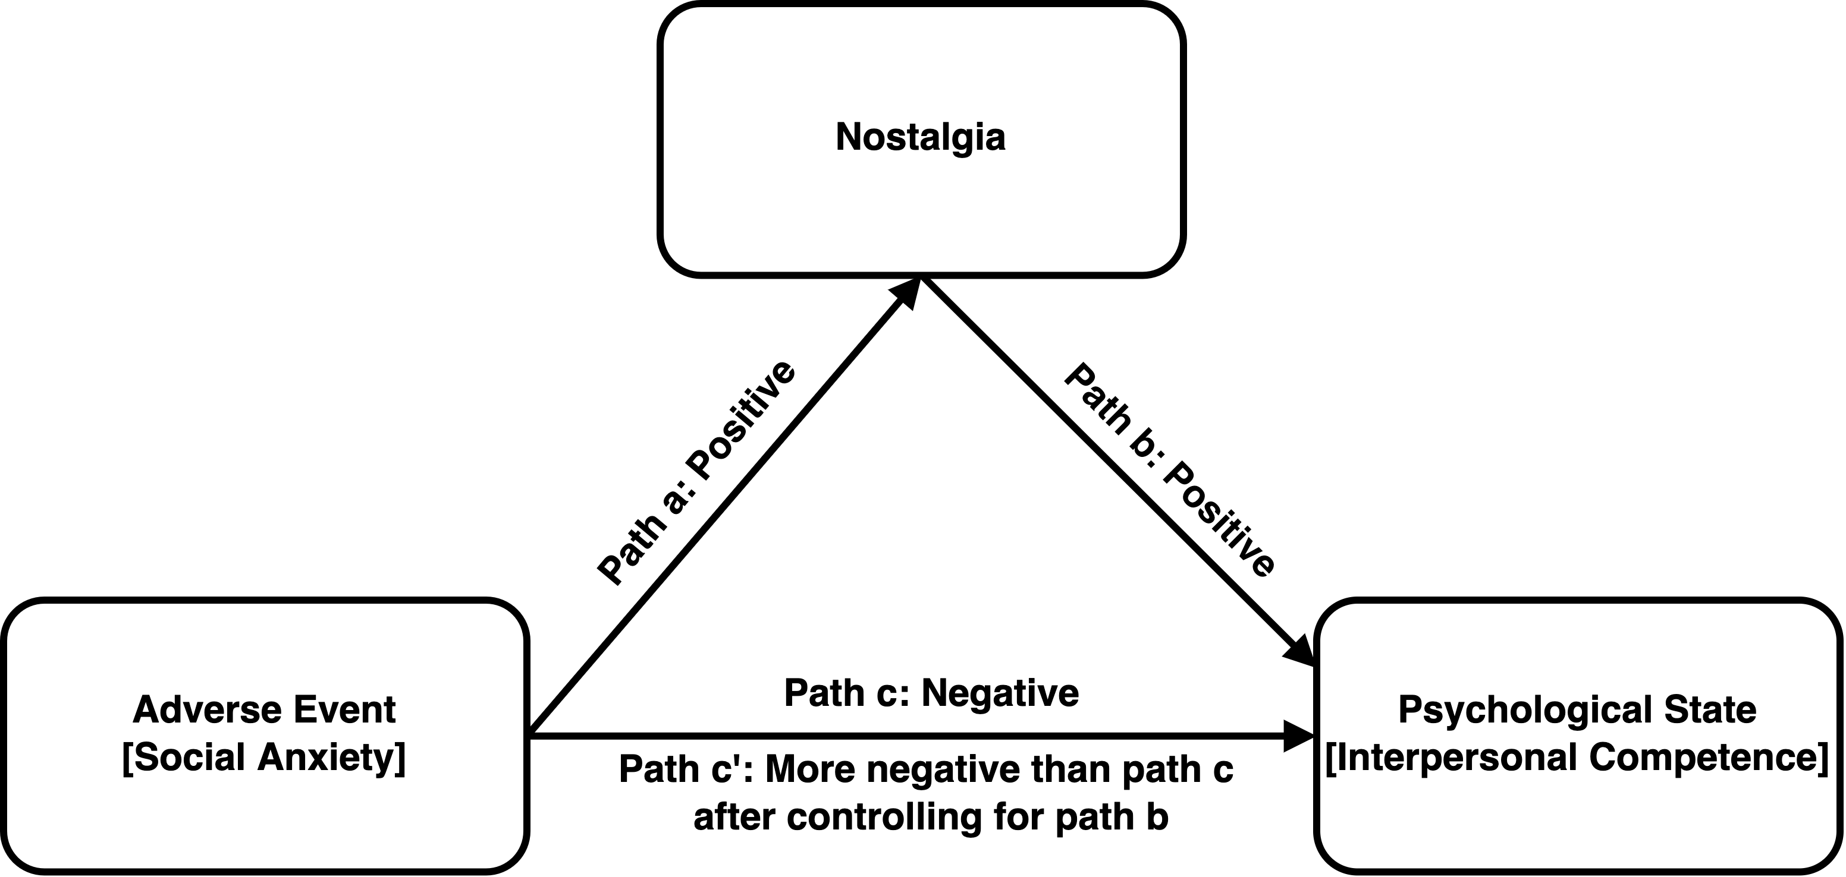

Figure 2
Nostalgia Mediates the Relation Between Social Anxiety and Interpersonal Competence in Study 2

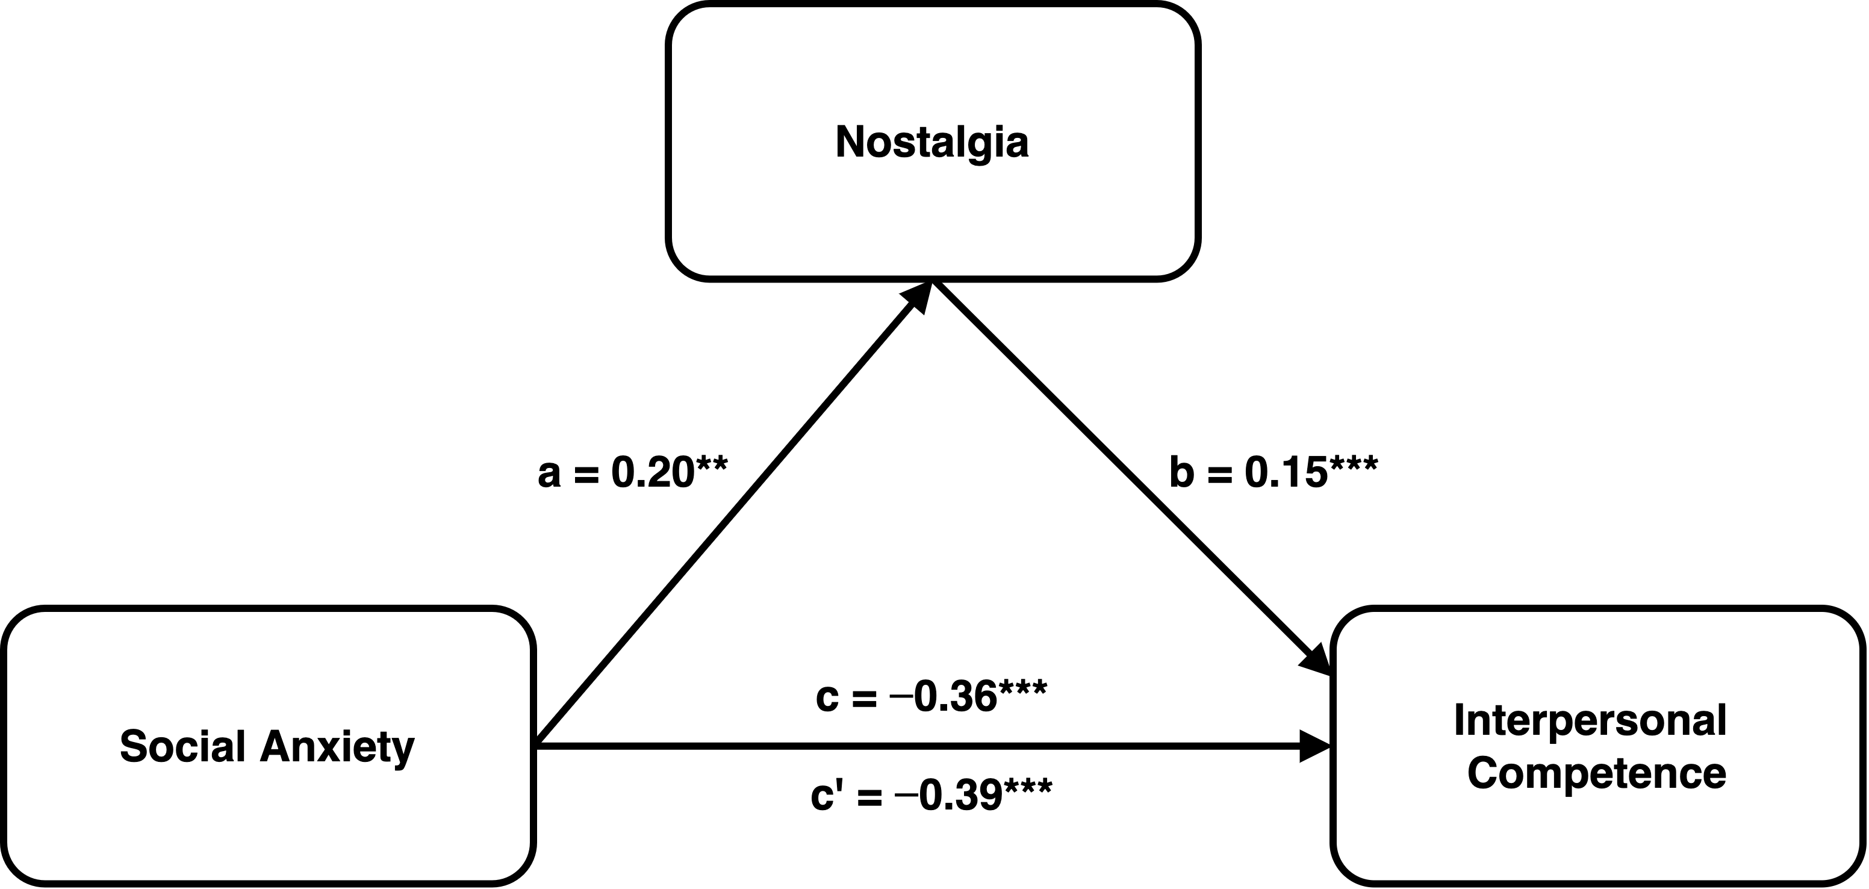

Note. We present unstandardized coefficients.
**p < .01, ***p < .001.

Figure 3
Nostalgia Mediates the Effect of Social Anxiety on Interpersonal Competence in Study 3

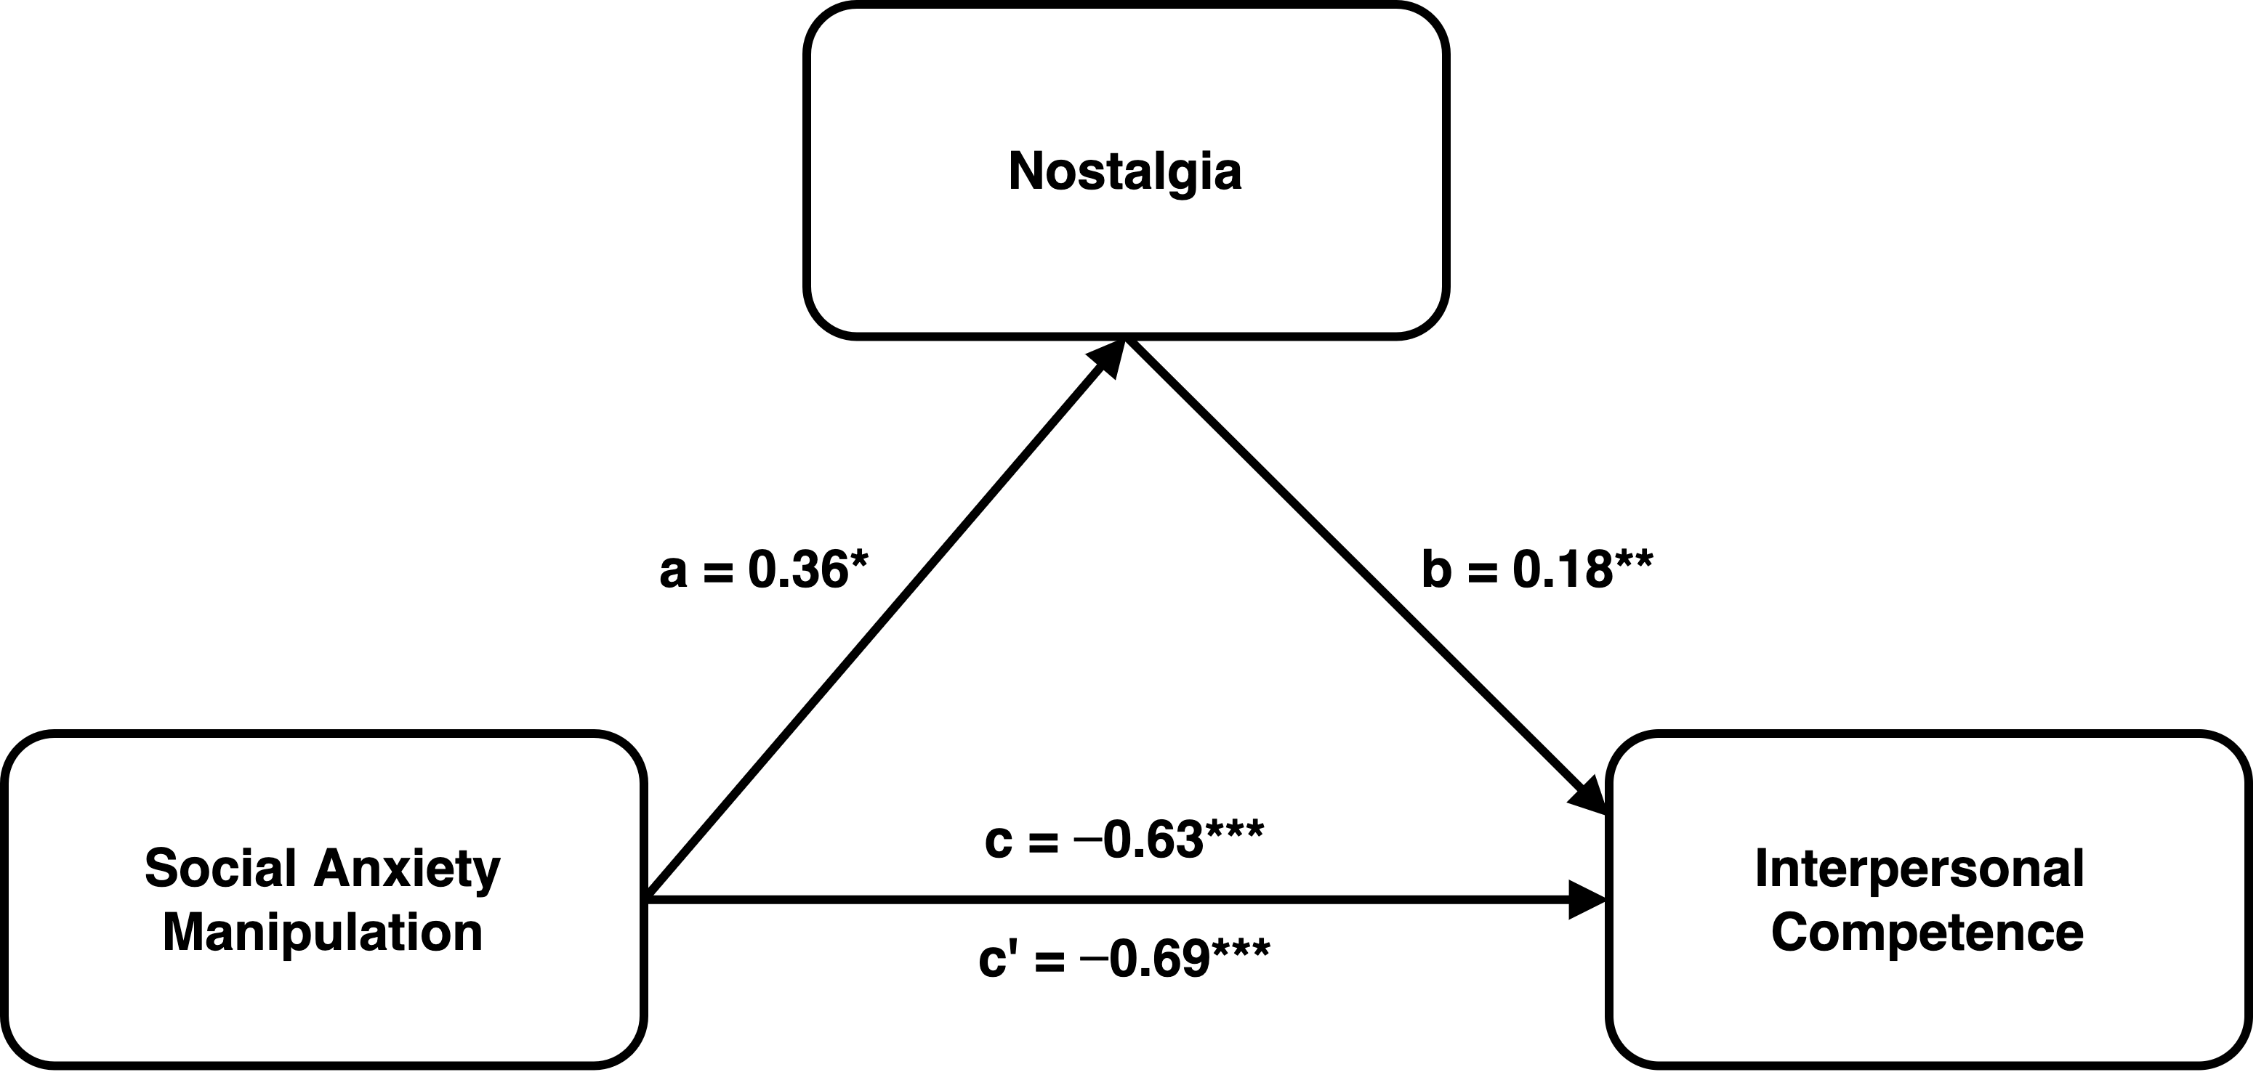

Note. We present unstandardized coefficients.
*p < .05, **p < .01, ***p < .001.

SUPPLEMENTAL MATERIAL

Nostalgia Counteracts Social Anxiety and Enhances Interpersonal Competence

Stimulus Materials 3
Study 1 3
Study 2 5
Study 3 8
Study 3S 10
Study 4 11
Study 5 15
Participant Ethnicity and Education 24
Ancillary Analyses. 25
Additional Study. 26

Stimulus Materials

Study 1
The Social Interaction Anxiety Scale
Please read the following statements and indicate the degree to which you feel the statement is characteristic or true of you.
0 = Not at all characteristic or true of me.
1 = Slightly characteristic or true of me.
2 = Moderately characteristic or true of me.
3 = Very characteristic or true of me.
4 = Extremely characteristic or true of me.
-I get nervous if I have to speak with someone in authority (teacher, boss, etc.).
-I have difficulty making eye contact with others.
-I become tense if I have to talk about myself or my feelings.
-I find it difficult to mix comfortably with the people I work with.
-I find it easy to make friends my own age. (R)
-I tense up if I meet an acquaintance in the street.
-When mixing socially, I am uncomfortable.
-I feel tense if I am alone with just one other person.
-I am at ease meeting people at parties, etc. (R)
-I have difficulty talking with other people.
-I find it easy to think of things to talk about. (R)
-I worry about expressing myself in case I appear awkward.
-I find it difficult to disagree with another’s point of view.
-I have difficulty talking to attractive persons of the opposite sex.
-I find myself worrying that I won’t know what to say in social situations.
-I am nervous mixing with people I don’t know well.
-I feel I’ll say something embarrassing when talking.
-When mixing in a group, I find myself worrying I will be ignored.
-I am tense mixing in a group.
-I am unsure whether to greet someone I know only slightly.
Writing About Circumstances That Evoked Nostalgia
According to the Oxford Dictionary, ‘nostalgia’ is defined as a ‘sentimental longing for one’s past.’
When do you bring to mind nostalgic experiences? What seems to trigger your memory of the nostalgic experiences? That is, under which circumstances do you think of nostalgic experiences?
Please answer the questions as carefully as possible.

Demographic Information
What is your age?
What is your gender? 1 = male, 2 = female
What is the highest degree you have received?
1 = Primary School and Under
2 = Junior Middle School
3 = Senior High School
4 = College
5 = Bachelor’s
6 = Master’s
7 = PhD

Attention Checks
-Please choose “1.”
-Please choose “3.”
-Please choose “0.”
Note: The attention checks (here and in other studies) appeared randomly in parts of the stimulus materials.

Study 2
The Social Interaction Anxiety Scale
As in Study 1.
Southampton Nostalgia Scale
According to the Oxford Dictionary, ‘nostalgia’ is defined as a ‘sentimental longing for the past.’ Based on this definition, answer the question below. (1 = not at all, 7 = very much)
-In general, how valuable is nostalgia for you?
-In general, how important is it for you to bring to mind nostalgic experiences?
-In general, how significant is it for you to feel nostalgic?
-In general, how prone are you to feeling nostalgic?
-In general, how often do you experience nostalgia?
-Generally speaking, how often do you bring to mind nostalgic experiences?
-Specifically, how often do you bring to mind nostalgic experiences? (Please check one.)
_____ Once or twice a year
_____ Once every couple of months
_____ Once or twice a month
_____ Approximately once a week
_____ Approximately twice a week
_____ Three to four times a week
_____ At least once a day
Brief Form of Interpersonal Competence Questionnaire
Please complete your answers to the following statements by choosing the number which best corresponds to how much you feel that the statement describes you.
1 = I’m poor at this; I’d feel so uncomfortable and unable to handle this
situation, I’d avoid it if possible.
2 = I’m only fair at this; I’d feel uncomfortable and would have lots of difficulty
handling this situation.
3 = I’m OK at this; I’d feel somewhat uncomfortable and have some difficulty
handling this situation.
4 = I’m good at this; I’d feel quite comfortable and able to handle this situation.
5 = I’m EXTREMELY good at this; I’d feel very comfortable and could handle
this situation very well.
-Being able to admit that you might be wrong when a disagreement with a close companion begins to build into a serious fight.
-Finding and suggesting things to do with new people whom you find interesting and attractive.
-Confiding in a new friend/date and letting him or her see your softer, more sensitive side.
-Helping a close companion get to the heart of a problem s/he is experiencing.
-Letting a new companion get to know the “real you.”
-Being able to take a companion’s perspective in a fight and really understand his or her point of view.
-Introducing yourself to someone you might like to get to know (or date).
-Letting down your protective “outer shell” and trusting a close companion.
-Calling (on the phone) a new date/acquaintance to set up a time to get together and do something.
-Confronting your close companion when he or she has broken a promise.
-Being able to say and do things to support a close companion when s/he is feeling down.
-Telling a companion that he or she has done something to hurt your feelings.
-Telling a date/acquaintance that he or she has done something that made you angry.
-When a close companion needs help and support, being able to give advice in ways that are well received.
-Not exploding at a close companion (even when it is justified) in order to avoid a damaging conflict.

Demographic Information
What is your age?
What is your gender? 1 = male, 2 = female
What is your race?
1 = White/Caucasian
2 = African American
3 = Hispanic
4 = Asian
5 = Native American
6 = Pacific Islander
7 = Other
What is the highest degree you have received?
1 = Less than High School
2 = High School / GED
3 = College Degree
4 = 2-year College Degree
5 = 4-year College Degree
6 = Master Degree
7 = Doctoral Degree
8 = Others

Attention Checks
-Please choose “0.”
-Please choose “2.”
-Please choose “1.”

Study 3
Social Anxiety Manipulation
High Social Anxiety Condition
Suppose you are a newcomer to a foreign country and are invited to attend a dinner party. The social customs and social interaction practices are different from those of your home country. As a result, you have no idea whether you behave properly or not, and this makes you feel uncomfortable.
Low Social Anxiety Condition
Suppose you are a newcomer to a foreign country and are invited to attend a dinner party. The social customs and social interaction practices are similar to those of your home country. As a result, you are certain that they behave properly, and this makes you feel comfortable.

Social Anxiety Manipulation Check
How do you feel right now? Please imagine the above experience as vividly as possible, and indicate your level of agreement with each of the following items.
(1 = strongly disagree, 5 = strongly agree)
-Right now, I feel nervous talking.
-Right now, I feel uncomfortable engaging in social context.
-Right now, I feel awkward to talk.

State Nostalgia
According to the Oxford Dictionary, “nostalgia” is defined as a “sentimental longing for one’s past.” How do you feel right now? Please respond to the following statements based on how you are feeling right now. (1 = not at all, 9 = very much)
-Right now, to what extent do you feel longing for good old memories?
-A nostalgic song plays nearby; to what extent do you want to keep listening to the song?
-To what extent do you want to go back to the past that you are longing for?

Interpersonal Competence Questionnaire (Adapted)
Please indicate your agreement or disagreement with the following statements depending on how you are feeling right now (1 = strongly disagree, 9 = strongly agree).
-At the dinner party, I would like to find and suggest things to do with new people whom I find interesting and attractive.
-At the dinner party, I would like to call (on the phone) a new date/acquaintance to set up a time to get together and do something.
-At the dinner party, I would like to say “no” when someone asks me to do something I don’t want to do.
-At the dinner party, I would like to stand up for my rights when someone is neglecting me or being inconsiderate.
-At the dinner party, I would like to confide in a new friend/date and letting him or her see my softer, more sensitive side.
-At the dinner party, I would like to let a new companion get to know the “real me.”
-At the dinner party, I am able to show genuine empathetic concern even when someone’s problem is uninteresting to me.
-At the dinner party, I am able to patiently and sensitively listen to someone “let off steam” about outside problems s/he is having.
-At the dinner party, when someone’s perspective is in a fight with others, I am able to really understand his or her point of view.
-At the dinner party, even if I don’t agree with someone’s view, I am able to accept that s/he has a valid point of view.

Demographic Information
Same as in Study 1.
Attention Check
Please choose “3.”

Study 3S
Social Anxiety Manipulation
Same as in Study 3.

Social Anxiety Manipulation Check
Same as in Study 3.

Vividness
Please indicate your disagreement or agreement with the following two statements. (1 = strongly disagree, 5 = strongly agree)
I can vividly imagine the experience.
I can imagine this experience well.

State Nostalgia
Same as in Study 3.

Interpersonal Competence Questionnaire (Adapted)
Same as in Study 3.

Demographic Information
What is your age?
What is your gender? 1 = male, 2 = female
Attention Check
Please choose “4.”
Please choose “2.”

Study 4

Nostalgia Manipulation
Nostalgia Condition
Think of a nostalgic event in your life. Specifically, try to think of a past event that makes you feel most nostalgic. Bring this nostalgic experience to mind. Immerse yourself in the nostalgic experience for a couple of minutes and think about how it makes you feel. Please write down four keywords relevant to this nostalgic event (i.e., words that describe the experience).
Using the space provided below, for the next few minutes, we would like you to write about the nostalgic event. Immerse yourself in this nostalgic experience. Describe the experience and how it makes you feel.
Control Condition
Think of an ordinary event in your life. Specifically, try to think of a past event that is ordinary, normal, and everyday. Bring this ordinary experience to mind. Immerse yourself in the ordinary experience for a couple of minutes and think about how it makes you feel. Please write down four keywords relevant to this ordinary event (i.e., words that describe the experience).
Using the space provided below, for the next few minutes, we would like you to write about the ordinary event. Immerse yourself in this ordinary experience. Describe the experience and how it makes you feel.

Nostalgia Manipulation Check
The following statements are about your feelings right now. Indicate how much you agree or disagree with the statements below. (1 = strongly disagree, 7 = strongly agree)
-Right now, I am feeling quite nostalgic.
-Right now, I am having nostalgic feelings.
-I feel nostalgic at the moment.
Positive Interpersonal Interactions (Coding Scheme)
-Degree of social interaction recalled:
Minimal, i.e., very rarely, lacking detail = 0
A little = 1
Quite a bit = 2
Very much, i.e., frequent, detailed anecdotes = 3
-Who else is primarily involved:
Only self = 0
Stranger(s) = 1
Acquaintance(s) (i.e., more than a stronger but less than a friend) = 2
Friend(s) = 3
Partner(s) = 4
Family member(s) = 5
-Degree of engagement in emotional exchange:
E.g., arguing, laughing, the raising of emotions in others and in the self by others (such as making someone cry).
None = 0
A little, i.e., infrequently = 1
Quite a bit = 2
Very much, i.e., very frequently = 3
-Degree of companionship expressed (explicit or implicit):
E.g., appreciation at not being alone, the sharing of things, a sense of belonging, joy at the “togetherness” in itself.
None = 0
A little, i.e., little expression made = 1
Quite a bit = 2
Very much, i.e., strongly expressed = 3
Brief Form of Interpersonal Competence Questionnaire
Please think about the event you have written on the previous page and indicate your agreement or disagreement with the following statements depending on how you are feeling right now. (1 = strongly disagree, 9 = strongly agree)
-Thinking about this event makes me feel that I would be capable to admit that I might be wrong when a disagreement with a close companion begins to build into a serious fight.
-Thinking about this event makes me feel that I would be capable to find and suggest things to do with new people whom I find interesting and attractive.
-Thinking about this event makes me feel that I would be capable to confide in a new friend/date and let him or her see my softer, more sensitive side.
-Thinking about this event makes me feel that I would be capable to help a close companion get to the heart of a problem s/he is experiencing.
-Thinking about this event makes me feel that I would be capable to let a new companion get to know the “real me.”
-Thinking about this event makes me feel that I would be capable to take a companion’s perspective in a fight and really understand his or her point of view.
-Thinking about this event makes me feel that I would be capable to introduce myself to someone I might like to get to know (or date).
-Thinking about this event makes me feel that I would be capable to let down my protective “outer shell” and trusting a close companion.
-Thinking about this event makes me feel that I would be capable to call (on the phone) a new date/acquaintance to set up a time to get together and do something.
-Thinking about this event makes me feel that I would be capable to confront my close companion when he or she has broken a promise.
-Thinking about this event makes me feel that I would be capable to say and do things to support a close companion when s/he is feeling down.
-Thinking about this event makes me feel that I would be capable to tell a companion that he or she has done something to hurt my feelings.
-Thinking about this event makes me feel that I would be capable to tell a date/acquaintance that he or she has done something that made me angry.
-Thinking about this event makes me feel that I would be capable to give advice in ways that are well received, when a close companion needs help and support.
-Thinking about this event makes me feel that I would be capable of not exploding at a close companion (even when it is justified) in order to avoid a damaging conflict.

Demographic Information
Age, gender, and ethnicity same as in Study 2.
What is the highest degree you have received?
1 = Less than High School
2 = High School / GED
3 = College Degree
4 = 2-year College Degree
5 = 4-year College Degree
6 = Master or Doctoral Degree
7 = Others
Attention Check
Please choose “3.”

Study 5

Nostalgia Manipulation
Nostalgia Condition
Please have a look at the following pictures.
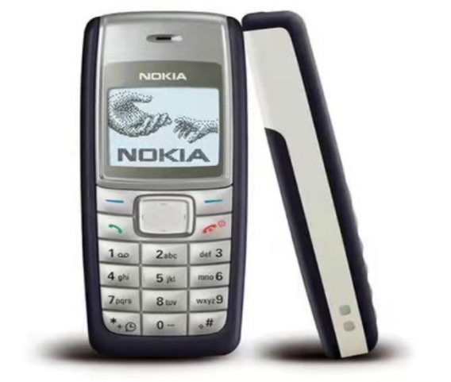
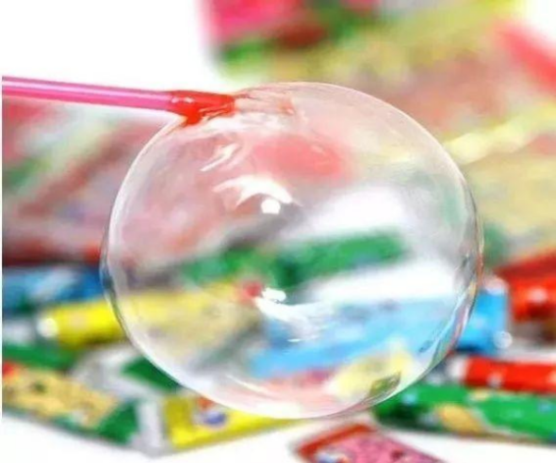
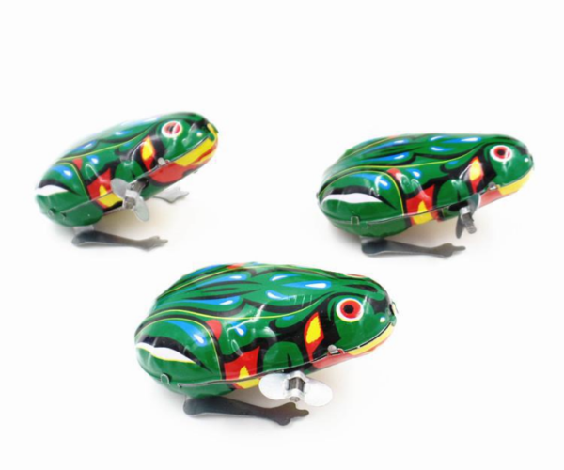
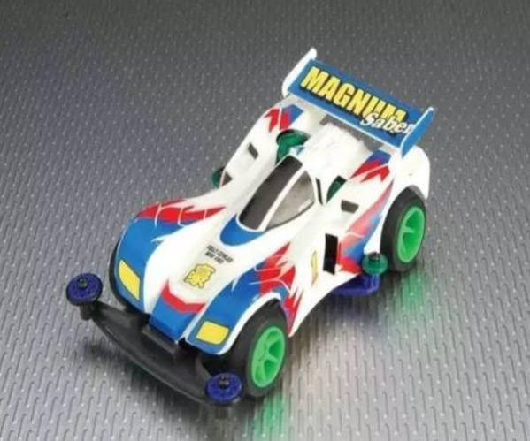
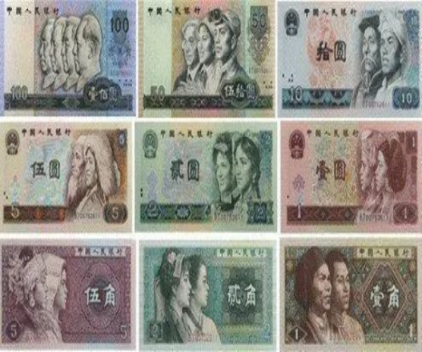
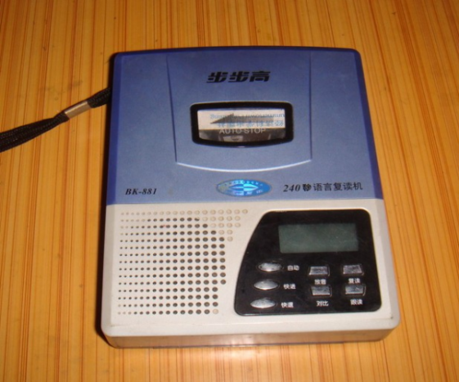

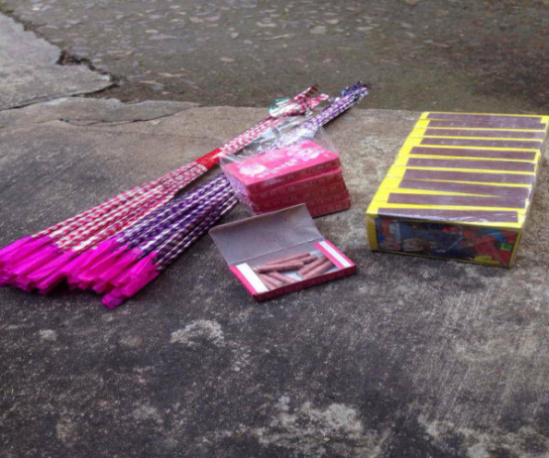
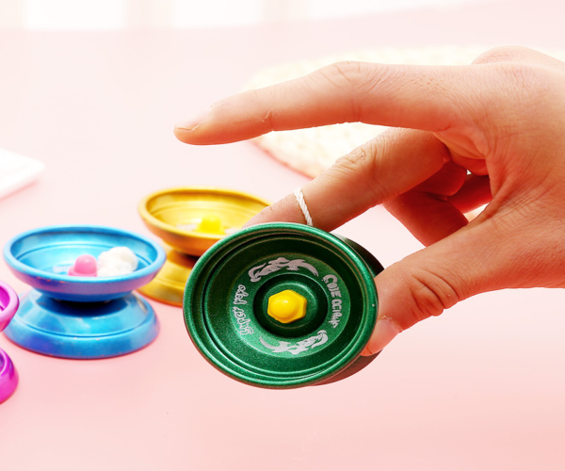
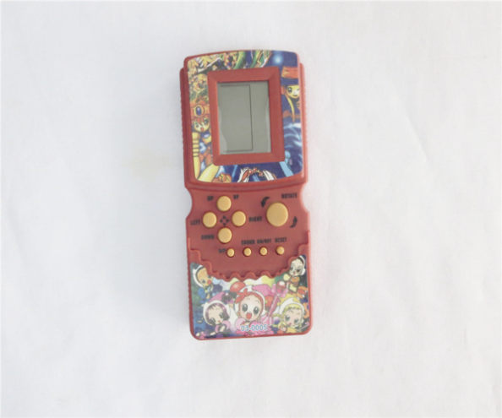
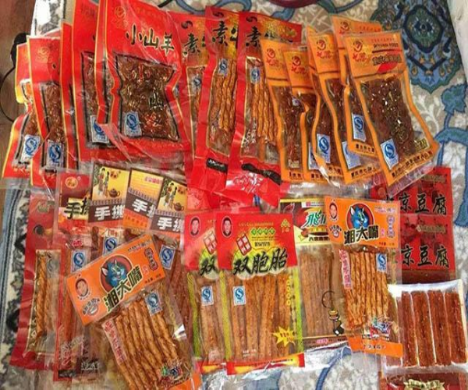
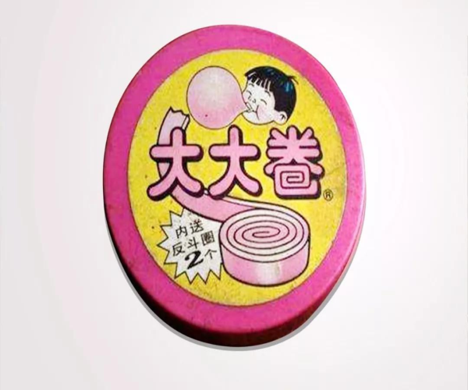

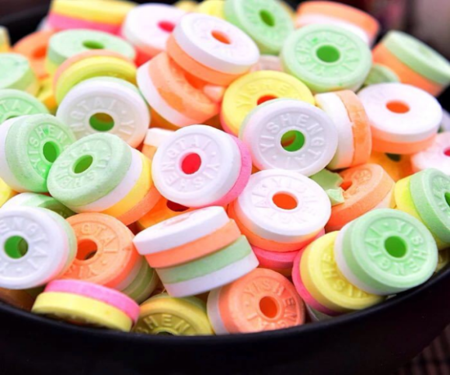
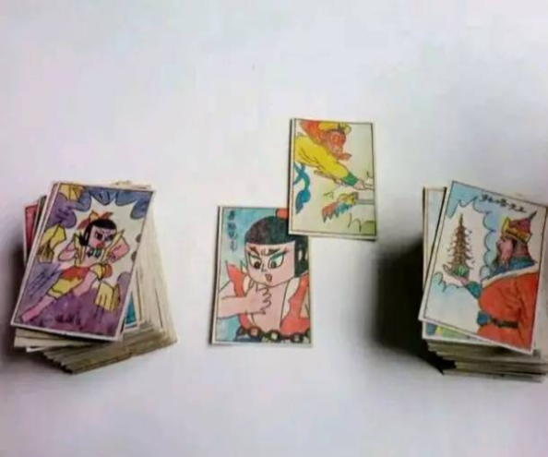
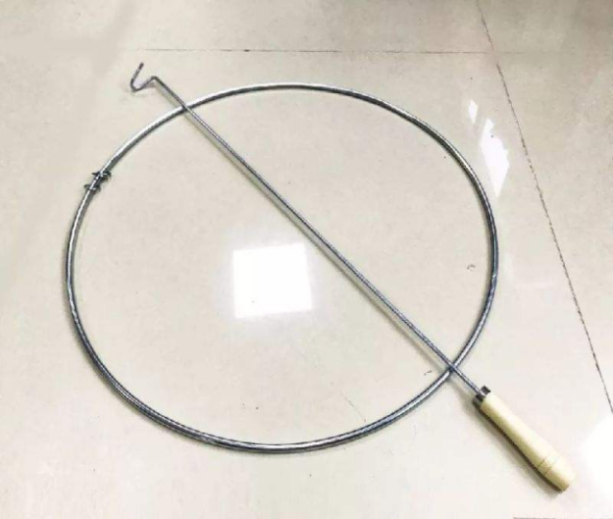
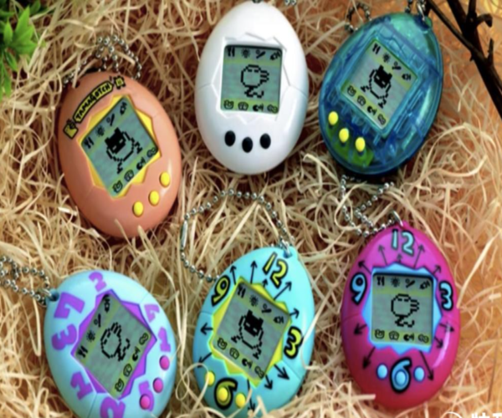
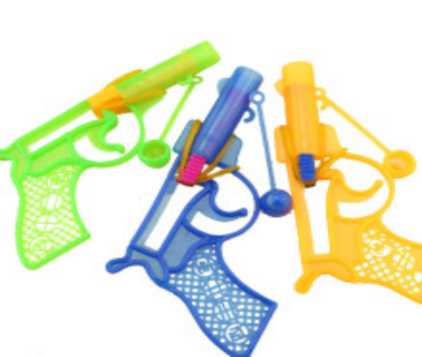

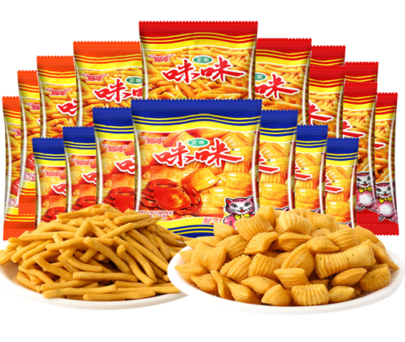
Below you will find 12 words that might describe or characterize experiences and memories that people have in their lives.
-reminiscence
-keepsakes
-dwelling
-rose-tinted memories
-familiar smell
-wanting to return to the past
-family/friends
-longing
-feeling happy
-childhood
-emotions
-personal
Please think of an event in your life. Specifically, try to think of a past event that is relevant to one of the pictures presented in the first task and is characterized by at least three features presented in the second task. Bring this experience to mind. Immerse yourself in the experience for a couple of minutes and think about how it makes you feel.
Using the space provided below, for the next few minutes, we would like you to write about the event. Describe the experience and how it makes you feel.
Control Condition
Please have a look at the following pictures.
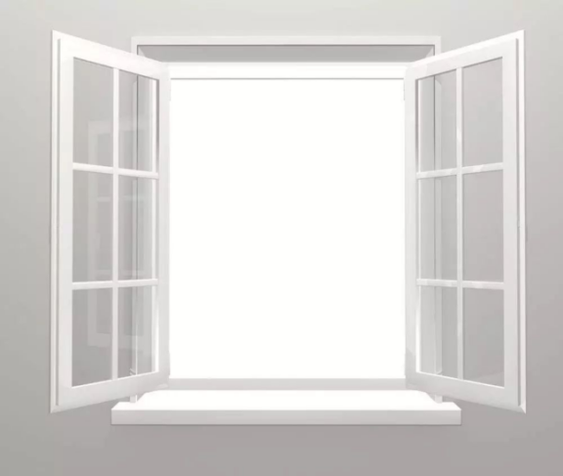
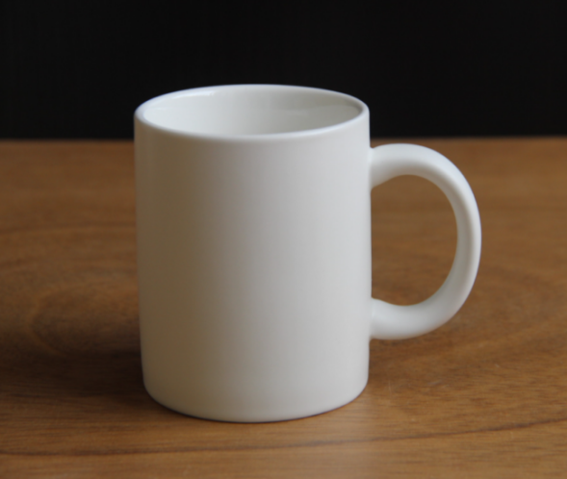
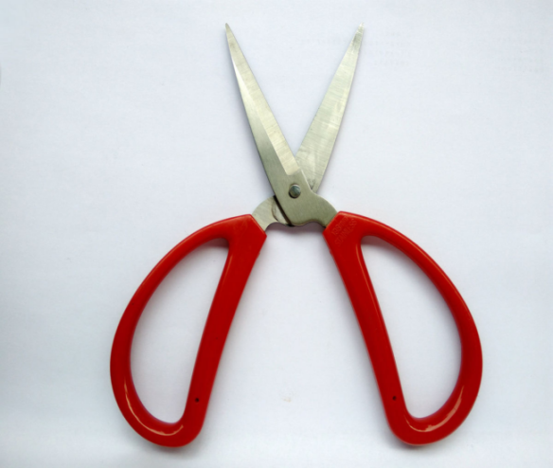
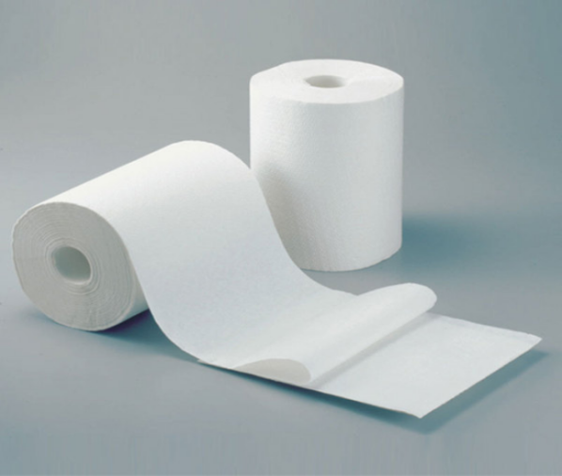
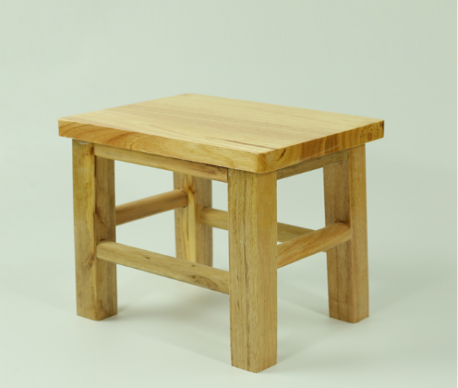

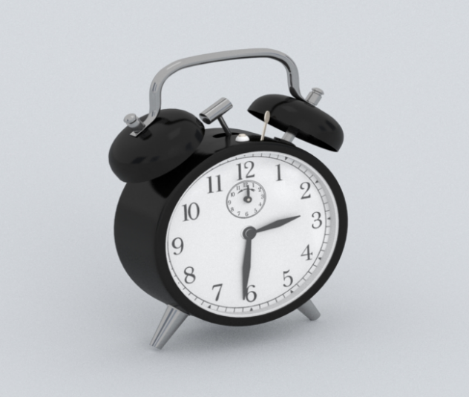
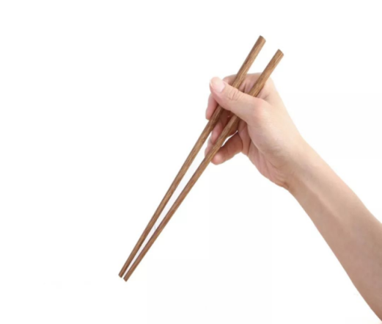
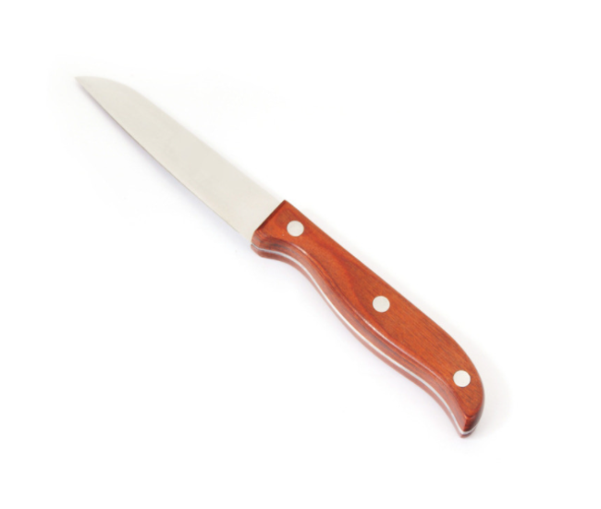
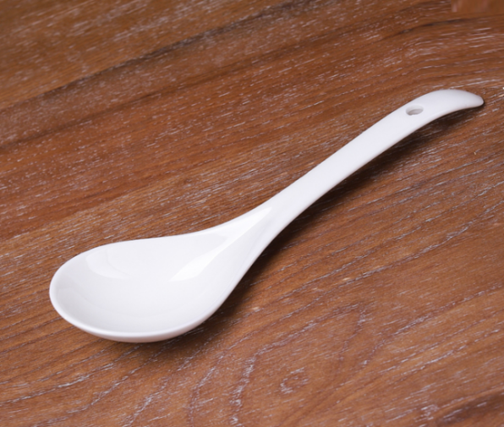
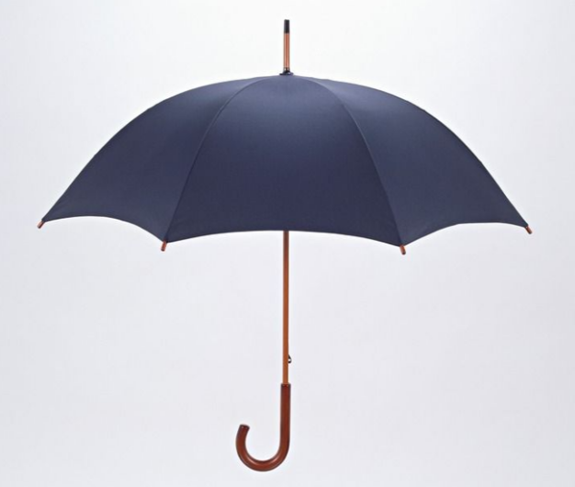

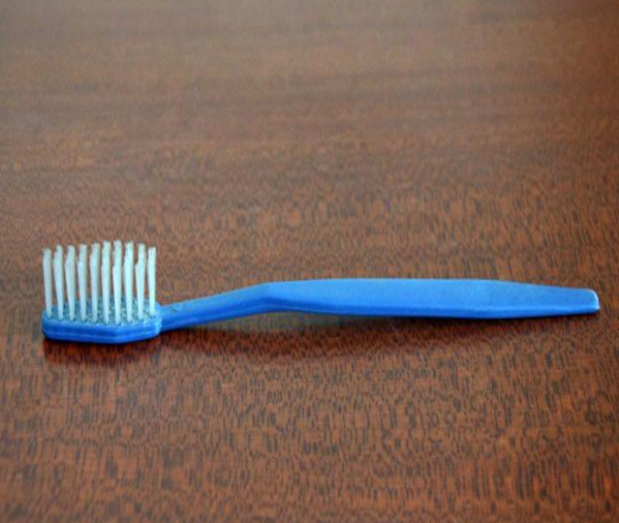
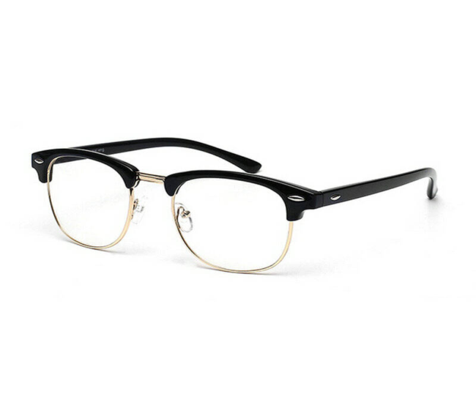
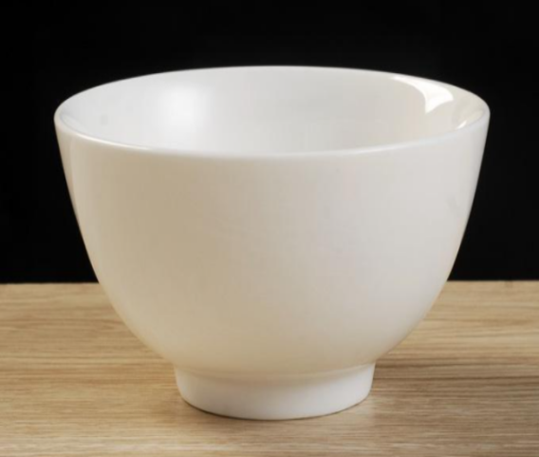
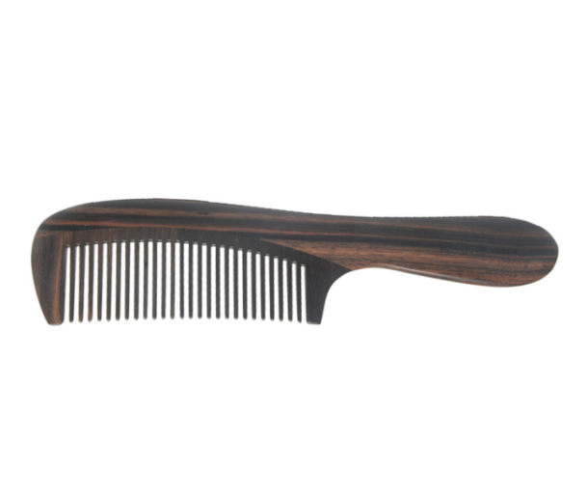

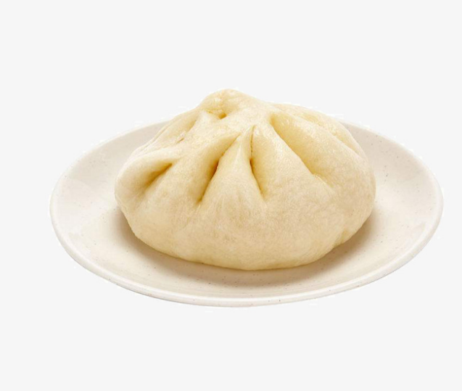
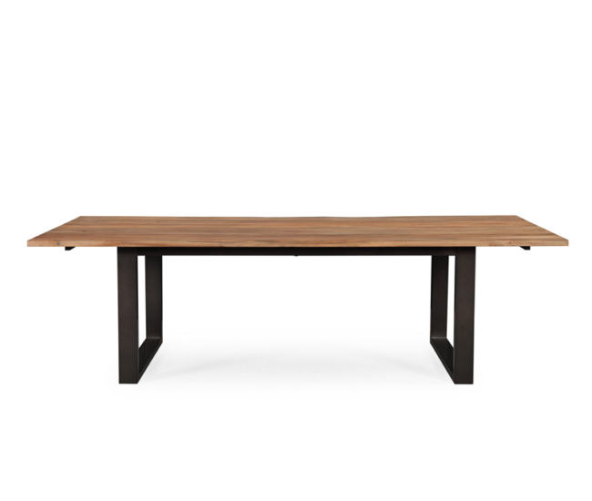
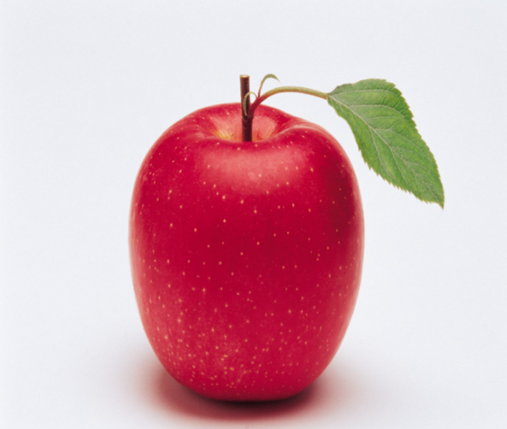
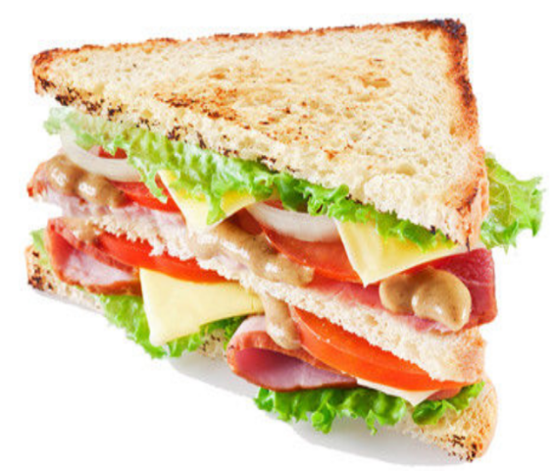
Below you will find 12 words that might describe or characterize experiences and memories that people have in their lives.
-reminiscence
-keepsakes
-dwelling
-rose-tinted memories
-familiar smell
-wanting to return to the past
-family/friends
-longing
-feeling happy
-childhood
-emotions
-personal
Please think of an event in your life. Specifically, try to think of a past event that is relevant to one of the pictures presented in the first task and is characterized by at least three features presented in the second task. Bring this experience to mind. Immerse yourself in the experience for a couple of minutes and think about how it makes you feel.
Using the space provided below, for the next few minutes, we would like you to write about the event. Describe the experience and how it makes you feel.

Nostalgia Manipulation Check
Same as in Study 4.
Brief Form of Interpersonal Competence Questionnaire
Same items as in Study 4, with a 7-point response scale.

Demographic Information
Same as in Study 1.
Attention Check
Please choose “5.”
Please choose “4.”

Participant Ethnicity and Education
Study 1
Participants were Chinese. We did not collect data pertaining to their education.
Study 2
Participants were U.S. residents. Of them, 69.91% were White/Caucasian, 10.65% African American, 6.94% Hispanic, 11.57% Asian, and 0.93% other. Also, 45.83% had a High School or College degree, 39.81% a Bachelor’s degree, 12.04% a Master’s or PhD degree, and 2.31% other.
Study 3
Participants were Chinese. Of them, 19.73% had a High School or College degree, 72.45% a Bachelor’s degree, 7.12% a Master’s or PhD degree, and 0.68% other.
Study 4
Participants were U.S. residents. Of them, 79.53% were White/Caucasian, 7.02% African American, 4.09% Hispanic, 6.43% Asian, 0.58% Native American, and 2.34% other. Also, 42.69% had a High School or College degree, 42.69% a Bachelor’s degree, 13.45% a Master’s or PhD degree, and 1.17% other.
Study 5
Participants were Chinese. Of them, 17.05% had a High School or College degree, 69.32% a Bachelor’s degree, 13.07% a Master’s or PhD degree, and 0.57% other.

Ancillary Analyses
Study 2
We conducted a causal mediation analysis, with 5,000 iterations via R Studio (MacKinnon et al., 2020; Valente et al., 2020). Causal mediation analysis allows researchers to model the interaction effect between the independent variable (X) and the mediator (M) on the outcome, and so to identify components of the total effect that are due to mediation and interaction. The average causal mediation effect was significant, b = 0.05, p = .01, 95% CI = [0.01, 0.11]. The average direct effect was significant, b = −0.72, p < .001, 95% CI = [−0.88, −0.54]. The total effect was significant, b = −0.66, p < .001, 95% CI = [−0.83, −0.49]. The test of the XM interaction was not significant, indicating that mediation did not differ between the treatment and control conditions, b = −0.05, p = .26. Whereas the simple mediated effect under the control condition (Pure Natural Indirect Effect; PNIE) was significant, b = 0.07, p = .006, 95% CI = [0.02, 0.13], and the simple mediated effect under the treatment condition (Total Natural Indirect Effect; TNIE) was not, b = 0.03, p = .14, 95% CI = [−0.01, 0.11], the difference between PNIE and TNIE was not significant, as shown in the nonsignificant mediated interaction, ha = −0.04, 95% CI = [−0.10, 0.04]. The direct effect under the control condition (Pure Natural Direct Effect; PNDE) was significant, b = −0.69, p < .001, 95% CI = [−0.88, −0.52], as was the direct effect under the treatment condition (Total Natural Direct Effect; TNDE), b = −0.72, p < .001, 95% CI = [−0.90, −0.56]. These findings support the mediating, but not the moderating, role of nostalgia.
Study 3
We conducted a causal mediation analysis with 5,000 iterations via R Studio (MacKinnon et al., 2020; Valente et al., 2020). The average causal mediation effect was significant, b = 0.07, p = .03, 95% CI = [0.01, 0.16]. The average direct effect was significant, b = −0.70, p < .001, 95% CI = [−1.05, −0.35]. The total effect was significant, b = −0.62, p < .001, 95% CI = [−0.98, −0.27]. The test of the XM interaction was not significant, indicating that the mediation did not differ between treatment and control conditions, b = 0.22, p = .07. Whereas the PNIE was not significant, b = 0.01, p = .73, 95% CI = [−0.07, 0.10], and the TNIE was so, b = 0.13, p = .02, 95% CI = [0.02, 0.29], the PNIE and TNIE did not differ, as shown in the nonsignificant mediated interaction, ha = 0.12, 95% CI = [−0.004, 0.32]. The PNDE was significant, b = −0.79, p < .001, 95% CI = [−1.12, −0.39], as was the TNDE, b = −0.67, p = .001, 95% CI = [−0.99, −0.28]. These findings are consistent with the mediating, but not the moderating, role of nostalgia.

Additional Study
Study 3S
In Study 3, the results showed evidence for mediation and a trend for moderation. In Study 3S, we conducted a high-powered preregistered replication of Study 3. We preregistered Study 3S at https://aspredicted.org/XKM_JLT. We manipulated social anxiety, and assessed nostalgia and interpersonal competence.

Method

Participants
According to Simonsohn’s (2013) criteria for determining the sample size for a replication study, our sample would need to be 2.5 times the original sample. Given Study 3’s N = 294, we needed at least 735 participants. We recruited 834 Chinese students from three universities in [MASKED]: [MASKED] University, [MASKED] University, and [MASKED]. We remunerated each participant with 3 RMB (approximately $0.40). We excluded 95 for failing two attention check questions, leaving 739 participants (394 women, 345 men; M_{age} = 21.18, SD_{age} = 2.77) in the sample. We randomly assigned them to the experimental (i.e., high social anxiety; n = 402) or control (n = 337) condition.

Procedure and Materials
The procedure and materials were identical to those of Study 3, with one exception: the inclusion of two vividness items (see below). We created a state social anxiety score (M = 3.22, SD = 1.06, α = .86), an index of state nostalgia (M = 6.50, SD = 1.62, α = .80), and a state interpersonal competence score (M = 5.95, SD = 1.58, α = .91). In divergence from Study 3, we asked participants to indicate how vividly they imagined their experience (Study 3S Stimulus Materials). We did so to be able to test an alternative explanation, namely, that differences between the social anxiety and control conditions are due to differences in vividness of mental imagery between the two conditions. We averaged responses to create a vividness of imagery score (M = 3.82, SD = 0.86, r(739) = .61, p < .001).

Results and Discussion

Manipulation Check
Experimental condition participants (M = 3.74, SD = 0.88) reported greater anxiety than control condition participants (M = 2.60, SD = 0.93), F(1, 737) = 296.74, p < .001, η² = .29. The manipulation was successful. Importantly, experimental condition participants (M = 3.77, SD = 0.93) did not differ significantly from control condition participants (M = 3.88, SD = 0.77) on vividness of mental imagery, F(1, 737) = 3.38, p = .07, η² = .01.

Social Anxiety, Nostalgia, and Interpersonal Competence
Participants in the experimental condition (M = 6.73, SD = 1.60) felt more nostalgic than controls (M = 6.21, SD = 1.61), F(1, 737) = 19.00, p < .001, η² = .03. Also, participants in the experimental condition (M = 5.62, SD = 1.72) felt less interpersonally competent than controls (M = 6.34, SD = 1.28), F(1, 737) = 40.36, p < .001, η² = .05. As in Study 3, social anxiety evoked nostalgia and decreased interpersonal competence. Nostalgia was positively linked with interpersonal competence, r(737) = .31, p < .001.

Mediation Analyses
We carried out a bootstrapping mediational analysis (Hayes, 2022; PROCESS 3.5, model 4) with 5,000 iterations. We entered the social anxiety manipulation as independent variable (1 = experimental condition, 0 = control condition), nostalgia as mediator, and interpersonal competence as dependent variable (Figure 3S). As reported above, social anxiety was positively and significantly associated with nostalgia (path a), b = 0.52, SE = 0.12, 95% CI [0.28, 0.75], t(737) = 4.36, p < .001, b* = .32. Nostalgia, in turn, was positively and significantly associated with interpersonal competence when controlling for social anxiety (path b), b = 0.35, SE = 0.03, 95% CI [0.28, 0.41], t(736) = 10.62, p < .001, b* = .36. The indirect effect (denoted as ab) of social anxiety on interpersonal competence through nostalgia was positive and significant, ab = 0.18, SE = 0.04, 95% CI [0.10, 0.26]. Finally, the residual direct effect of social anxiety on interpersonal competence (controlling for nostalgia) was significant, b = −0.90, SE = 0.11, 95% CI [−1.11, −0.69], t(736) = −8.41, p < .001, b* = −.57, and more negative than the total effect, b = −0.72, SE = 0.11, 95% CI [−0.94, −0.50], t(737) = −6.35, p < .001, b* = −.46.
Next, we conducted a causal mediation analysis with 5,000 iterations via R Studio (MacKinnon et al., 2020; Valente et al., 2020). The average causal mediation effect was significant, b = 0.18, p < .001, 95% CI = [0.10, 0.26]. The average direct effect was significant, b = −0.89, p < .001, 95% CI = [−1.08, −0.70]. The total effect was significant, b = −0.71, p < .001, 95% CI = [−0.93, −0.49]. The test of the XM interaction was not significant, indicating that the mediation did not differ between treatment and control conditions, b = 0.09, p = .19. The PNIE was significant, b = 0.15, p < .001, 95% CI = [0.08, 0.24], as was the TNIE, b = 0.21, p < .001, 95% CI = [0.11, 0.32], and the PNIE and TNIE did not differ, as shown in the nonsignificant mediated interaction, ha = 0.05, 95% CI = [−0.02, 0.15]. The PNDE was significant, b = −0.92, p < .001, 95% CI = [−1.11, −0.73], as was the TNDE, b = −0.86, p < .001, 95% CI = [−1.06, −0.67]. These findings support the mediating, but not the moderating, role of nostalgia.

References (not included in the Manuscript)
Simonsohn, U. (2013). Evaluating replication results. Available at SSRN: http://ssrn.com/ abstract=2259879

Figure 3S
Nostalgia Mediates the Effect of Social Anxiety on Interpersonal Competence in Study 3S
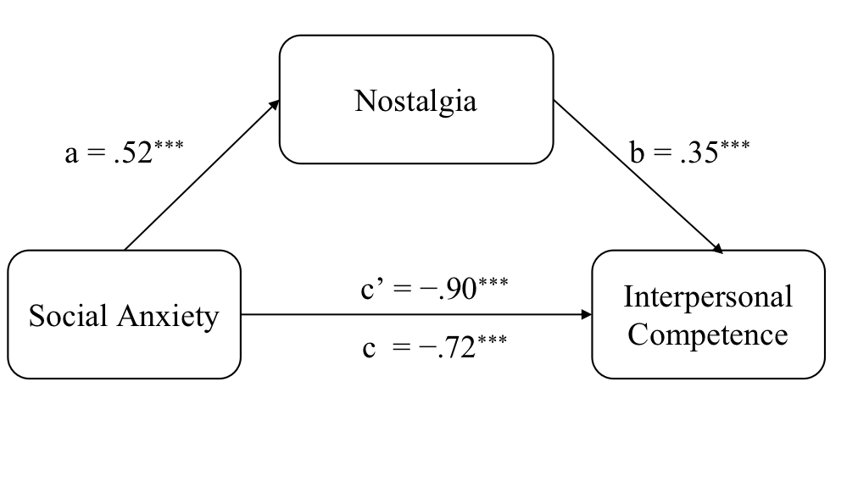
Note. We present unstandardized coefficients.
***p < .001.

In this and all studies, participants’ education did not influence the results.
The causal mediation analysis indicated a trend toward moderation of the social-anxiety effect on interpersonal competence by nostalgia (i.e., XM interaction). Thus, we conducted a preregistered, high-powered replication of Study 3, Study 3S (Supplemental Material). In line with the regulatory model, results of this replication study revealed support for inconsistent mediation of the social-anxiety effect on interpersonal competence by nostalgia. There was no indication of moderation.
Hedging against attrition, we recruited 834 participants instead of 780 as reported in the preregistration.

