Title:
Impact of post-translational modifications and subclass on IgG activity: From Immunity to Immunotherapy

Authors: Falk Nimmerjahn^{1,*,**}, Gestur Vidarsson^{2,3,*}, Mark S. Cragg^{4,*}

1 Division of Genetics, Friederich Alexander University Erlangen-Nürnberg, Erlangen, Germany
2 Immunoglobulin Research Laboratory, Department of Experimental Immunohematology, Sanquin Research, Amsterdam, The Netherlands.
3 Department of Biomolecular Mass Spectrometry and Proteomics, Utrecht Institute for Pharmaceutical Sciences and Bijvoet Center for Biomolecular Research, Utrecht University, Utrecht, The Netherlands.
4 Antibody and Vaccine Group, Centre for Cancer Immunology, School of Cancer Sciences, University of Southampton Faculty of Medicine, Southampton SO16 6YD, UK; Institute for Life Sciences, University of Southampton, Southampton SO17 1BJ, UK.

* all authors contributed equally

**Corresponding author: falk.nimmerjahn@fau.de

Abstract
Humoral immune responses are characterized by complex mixtures of polyclonal antibody species varying in their isotype, target epitope specificity and affinity. Post-translational modifications occurring during antibody production in both the antibody variable as well as constant domain create further complexity and can modulate antigen specificity or antibody Fc-dependent effector functions, respectively. Finally, modifications occurring to the antibody backbone post secretion may further impact antibody activity. An in-depth understanding of how these post-translational modifications impact antibody function, especially in the context of individual antibody isotypes and subclasses, is only starting to emerge. Indeed, only a minute proportion of this natural variability in the humoral immune response is currently reflected in therapeutic antibody preparations. In this review we summarize recent insights into how immunoglobulin G (IgG) subclass and post-translational modifications impact IgG activity and discuss how these insights may be used to optimize therapeutic antibody development.

Introduction

For many years, the major decision in developing a therapeutic antibody was whether to choose an antibody format allowing for efficient or limited interaction with cellular and/or humoral effector pathways. With the need to optimize existing cytotoxic antibody activities and the introduction of novel antibody classes, such as immune checkpoint blocking (ICB) or immune stimulatory antibodies (ISA), more complex scenarios had to be considered. Due to the prominent role of immunoglobulin G (IgG) in protective as well as autoreactive immune responses and its near-exclusive use in human therapeutics we will restrict our discussion to this antibody isotype. Indeed, a multitude of studies have highlighted how different IgG subclasses, as well as post-translational modifications, modulate IgG activity. Nevertheless, it is important to note that other antibody isotypes including IgA and IgE, alongside the B cell receptor itself, can be modulated in their activity by post-translational modifications as recently reviewed^{1, 2, 3}.
IgG antibodies are characterized by long serum half-life, the ability to penetrate most tissues, and the capacity to trigger pro- as well as anti-inflammatory effector pathways due to the interaction of the IgG Fc-portion with both cellular and humoral immune system pathways (Fig. 1)^{4, 5} . This includes binding to the neonatal Fc-receptor (FcRn), responsible for vesicular trafficking and long half-life of most IgG subclasses, specific cell surface Fc gamma receptors (FcγRs) as well as cytosolic Fc-receptors such as Trim21, and components of the complement pathway (Fig. 1b) ^{4, 5, 6}. Collectively, the four IgG subclasses in mice and humans show similar distinctive diversity in their capacity to trigger effector functions, such as toxin/virus neutralization, antibody- or complement-dependent cytotoxicity (ADCC or CDC, respectively), phagocytosis (ADCP) or the release of pro-inflammatory mediators⁷. However, due to historical reasons, their subclass designations do not functionally match between species⁸. For example, human (h) IgG1 and hIgG3 as well as mouse (m) IgG2a or mIgG2b broadly interact with most activating FcγRs and also efficiently activate complement (Fig. 2 and Table 1). In contrast, hIgG2 and hIgG4 and mIgG1 subclasses show more restricted binding to FcγRs and complement components. Although this functional diversification is clearly important, it is also redundant to some extent as individuals with immunoglobulin subclass deficiencies, for example lacking IgA1 and all IgG subclasses except IgG3, seem capable of compensating with the remaining antibody repertoire with respect to overall health^{9, 10}.
For cytotoxic antibodies intended to delete unwanted target cells, a common strategy is to have a long half-life, optimal interaction with activating FcγRs and/or the complement pathway, while diminishing binding to inhibitory FcγRs. The hIgG1 subclass fulfils most of these requirements (Table 1) and so is the frequent choice for this therapeutic antibody class. This “what? Choice?” is despite the fact that several hIgG3 variants display higher activity in all functional categories. hIgG3, however, has more than 15 known allotypic variants found at different frequencies globally, presumably because of evolutionary pressures from different infectious diseases¹¹. Therefore, the relatively less polymorphic nature of IgG1 makes it more suitable for application in humans^{5, 12}.
With the introduction of immunomodulatory antibodies (both ICB and ISA) intended to induce or restrict immune stimulation without causing excessive or off-target immune activation, more complex scenarios have evolved placing other IgG subclasses, such as hIgG2 or hIgG4 center stage. In turn, these requirements have led to new insights into IgG subclass biology, such as the ability for Fab arm exchange and high-affinity binding to FcγRI by hIgG4 and the impact of different hIgG2 isoforms on agonistic antibody activity ^{13, 14}. Moreover, accumulating evidence suggests that bone marrow-derived as well as tissue-resident myeloid cells, which express the most diverse sets of IgG receptors, play a major role in IgG-dependent effector functions, relevant for all therapeutic antibody classes ¹⁵. This “what” necessitates the adjustment of therapeutic IgG activity to various effector cells expressing different levels of both activating and inhibitory receptor systems ^{16, 17}. Of note, IgG responses occurring in vivo become further diversified by a complex set of post-translational modifications on the background of different IgG subclasses, which provides adjustment of IgG activity. In contrast, current therapeutic antibody preparations are designed – also for regulatory reasons - with the lowest possible level of heterogeneity. Thus, understanding how different IgG subclasses and their many post-translational modifications, occurring before or after IgG secretion, modulate IgG function holds great promise for optimizing therapeutic antibody activity.

Naturally occurring posttranslational modifications
All proteins in the human body are subject to post-translational modifications. The impact of post-translational modifications on IgG stability, half-life and function became increasingly clear during the development of therapeutic antibodies (Fig. 1a, c) ¹⁸. Changes include oxidations, charge distribution, aspartate isomerization, asparagine deamidation, cysteine introductions, lysine glycation, and introduction of N-linked glycosylation sites¹⁹. For reasons of space, we will focus largely on post-translational modifications affecting IgG-effector functions. Here, three major modifications of natural antibodies are relevant for all IgG subclasses and their allotypes⁵. First, the C-terminal lysine residues in IgG become rapidly clipped from at least human IgG1 and IgG2 after secretion in human plasma by carboxypeptidase N. In the absence of this processing step, IgG’s ability to activate the classical complement pathway is severely diminished because these charged residues interfere with the hexameric assembly of IgG required for optimal C1q binding (Fig. 1c) ^{20, 21}.
Second, involves the gradual accumulation of altered amino acid residues. In particular, this affects the exposed methionine residues at positions 252 and 428 which are localized in the CH2/CH3 interface that is involved in FcRn binding ²². Over time, a slow increase in oxidation occurs which negatively affects the interaction with FcRn, and hence IgG half-life ²³ (Fig. 1c). The rate of this conversion is also likely to occur faster in antibodies either produced or accumulating in inflamed areas, as can be the case for autoantibodies or therapeutic antibodies mediating their activity in inflamed tissue environments ²⁴. Moreover, oxidation of tryptophan 277 was suggested to correlate with IgG Fc flexibility which impacts FcγRIIIa binding ²⁵. Similarly, deamidation of asparagine 325 in the upper CH2, near the FcγR binding region can also affect FcγR effector functions negatively ²⁶.
Third, a sugar moiety is added in the endoplasmic reticulum at asparagine 297 (N297) in each of the two IgG heavy chains (Table 2). This glycan is trimmed and then extended in the Golgi, resulting in a biantennary glycan that occupies a large part of the cavity between the two heavy chains comprising the Fc domain (Fig. 1a-c). Its basic core structure consists of two N-acetylglucosamines (GlcNAc), followed by three mannoses forming two antennae, each extended with a GlcNAc residue. These GlcNAc residues can be further extended with a galactose and ultimately a terminal sialic acid. The core structure can also bear a bisecting GlcNAc residue, and generally contains a core fucose. While the biochemical pathway of IgG glycosylation is well understood, the genetic pathways and environmental and developmental cues underlying differential IgG glycosylation are only beginning to emerge ²⁷.
The glycan is important as it interacts directly with the FcγR backbone, while also altering the orientation of the two CH2 domains, and potentially their flexibility, to affect FcγR binding ^{28, 29}. While C1q binding is also substantially reduced without the N297 glycan, FcRn interactions remain intact and glycan composition does not impact FcRn-mediated half-life or trans-placental transport ^{30, 31}. Interestingly, for specific IgG subclasses, such as mouse IgG2c or human IgG1 a single GlcNac residue with, or without, a branching fucose residue is sufficient for functional interaction of mouse and human IgG with FcγRs ³².
Most IgG glycan changes occur within antibody-secreting B cell subsets such as plasmablasts and plasma cells. In line with this notion, antigen-specific IgG glycosylation patterns between different antigens in the same individual can vary enormously and genes associated with differential IgG glycosylation are all expressed in these B cell subsets ³³. Similarly, individual mIgG subclasses have subclass specific glycosylation profiles ^{34, 35, 36}. In contrast to exposed sugar moieties, the steric inaccessibility of the IgG-Fc glycan to enzymes after folding may explain the stability of these glycans after secretion (Fig. 1a,b) ³⁷. Of note, however, structural studies of IgG in solution suggest that the IgG sugar domain is highly dynamic and could be accessible for recognition by other proteins³⁸. Whether terminal sialic acid residues may be added after IgG secretion remains controversial ³⁹. However, this plasmablast/plasma cell-extrinsic IgG sialylation process is slow and predominantly affects the exposed F(ab) and not Fc-associated sugars ⁴⁰. Moreover, sialylation of individual antigen-specific IgG species differs within the same individual in mice and humans and may vary from the sialylation pattern of bulk IgG, suggesting that IgG sialylation is modulated in plasmablasts and plasma cells by external stimuli and occurs pre-secretion ^{33, 35, 36, 41}.
Of note, the differing N-linked glycans in the Fc-domain renders it more variable than initially appreciated. hIgG found in plasma is generally almost fully fucosylated (~94%, except in some immune responses as discussed below), largely devoid of bisecting GlcNAC (10-15%), but highly variable with regard to galactosylation (20-80%) and sialylation (2-10%) ⁴². Importantly, serum IgG glycosylation is not stable throughout life. For example, IgG galactosylation and sialylation reduces with advancing age, especially during menopause in females ^{43, 44, 45}. In contrast, during pregnancy, IgG galactosylation increases ⁴⁶. Of those changes, IgG-Fc fucosylation, galactosylation, and sialylation are particularly important for modulating IgG-effector functions (Table 1).

IgG-Fc-fucosylation – modulator of FcγR activity
It has been recognized for ~20 years that afucosylated IgG has a strongly enhanced affinity for hFcγRIIIa, but not hFcγRIIa or hFcγRIa, which leads to increased antibody-dependent effector functions ^{47, 48}. Selective enhancement of binding to hFcγRIIIa (and the neutrophil-specific GPI-linked hFcγRIIIb) is due to the unique presence of an N-linked glycan at position 162 in both hFcγRIIIa and hFcγRIIIb as well as mFcγRIV, the mouse orthologue. The absence of fucose allows a tighter interaction and enhances hIgG affinity 20-40 fold ^{49, 50}. Further increases in affinity can be achieved by increasing galactosylation on afucosylated sugar moieties ^{37, 48, 51} (Table 1). Depending on the expression level of hFcγRIIIa and co-expression of other activating hFcγRs, afucosylated IgG variants trigger stronger IgG-dependent effector functions including ADCC and ADCP ^{47, 52, 53, 54}. Of note, immune cell subset differences as well as hFcγRIIIa allotype-specific glycosylation variants exist, which can further modulate IgG glycovariant binding and downstream effector functions ^{55, 56, 57}.
Due to the virtual absence of afucosylated IgG in serum, the effect of IgG afucosylation on FcγR-mediated activities was largely considered only relevant for IgG engineering to enhance antibodies used in the therapy of cancer or autoimmune disorders. However, more recent insights coming from genome-wide association studies suggest that several SNPs in transcription factors such as the Ikaros zinc finger family (IKZF1 or IKZF3) may impact fucosyltransferase 8 expression in B cells and modulate IgG fucosylation ²⁷. Despite these first insights, a general, mechanistic understanding of how IgG fucosylation and IgG glycosylation are regulated is still largely missing. Moreover, further studies have shown that specific antibody responses can be almost exclusively due to afucosylated IgGs (Fig. 3). A prime example is IgG responses against red blood cell blood group and platelet antigens in pregnancy and during blood transfusion ^{58, 59, 60}. In the setting of fetal anemia or thrombocytopenia, triggered by alloantibodies transferred from mother to fetus, the level of alloantibody afucosylation rather than total alloantibody levels, correlates with disease severity (Fig. 3) ^{41, 58, 61}. More recently, afucosylated IgG responses against HLA have also been found in platelet-transfused patients with refractory thrombocytopenia and after kidney transplantation and associated antibody-mediated rejection ^{62, 63}. These alloimmune responses are all directed against antigens on the surface of cells, mimicking foreign antigens expressed by enveloped viral pathogens and intracellular parasites, such as Plasmodium falciparum during its facultative red blood cell stage ^{33, 64, 65, 66}. Afucosylated IgG responses to Dengue virus have been associated with enhancement of infection and progression to more pathogenic disease (Fig. 3) ^{67, 68}. In COVID-19, IgG antibodies promote entry into hFcγRIIIa positive cells, but instead of enhancement of infection, they trigger immunopathology via inflammasome activation and pyroptosis (Fig. 3) ^{69, 70}. It is tempting to speculate that this pathway is also excessively activated by afucosylated IgG which occurs during seroconversion in primary infections with SARS-COV-2, and is associated with increased severity, likely through enhanced hFcγRIIIa activation ^{33, 64}. Afucosylated IgG responses are not naturally generated against soluble, bacterial or non-enveloped targets, but are generated during hIgG1 and hIgG3 responses to protein antigens ^{65, 71}. Similarly, hIgG2 responses, largely triggered by T-independent polysaccharide antigens, are almost fully fucosylated ⁷². However, all glycoengineered hIgG subclasses, including hIgG2 and hIgG4, gain appreciable affinity for hFcγRIIIa after afucosylation, and, with the exception of hIgG2, also hFcγRIIIb, allowing fine-tuning of therapeutic IgG activity by modulating fucosylation ⁵².

IgG-Fc-galactosylation – modulator of complement activity
The hIgG1-Fc galactose content has been demonstrated to affect complement activation. This effect is independent of fucose or bisecting GlcNAc but can be amplified by further sialylation ^{37, 73}. Mechanistically, increased galactosylation enhances C1q binding, subsequent C3b/C4b deposition and activation of the lytic complement pathway (Fig. 14). This effect is not due to enhanced affinity for C1q, but rather to greater Fc-Fc interaction, facilitating hIgG1 hexamer formation on the surface, promoting C1q binding ^{20, 74, 75}. Accordingly, elevated galactosylation of anti-HLA alloantibodies is an important parameter of platelet clearance in platelet-transfused patients with alloantibodies ^{63, 76}. Interestingly, the effect of galactosylation on complement activation seems to be IgG subclass specific as an increase in galactosylation on hIgG2 and hIgG4 antibodies did not increase their ability to fix complement⁷³.
As mentioned earlier, IgG galactosylation is reduced during acute inflammation and with increasing age, which is driven at least in part by changes in sex hormones. Due to the close association with inflammation, agalactosylated hIgG has been assumed to be pro-inflammatory. Initial models suggested this effect might be due to the more exposed mannose core structure in agalactosylated IgG, resulting in enhanced complement activation via the lectin pathway ⁷⁷. However, this has not been confirmed in vivo in MBL-deficient mice ⁷⁸. Recent data in COVID-19 patients shows that anti-spike antibodies are highly galactosylated (~80%) at seroconversion in both mild and severe cases, but drop to 30-40% within 2-3 weeks in severely ill patients, mirrored, to a lesser extent, in bulk IgG ³³. In light of these data, it remains an open question if agalactosylated IgG is as a consequence or cause of inflammation. Similarly, how the effects of galactosylation on hIgG1 hexamerization and complement activation translate to other subclasses and species is currently unknown. Apart from enhanced C1q binding, hIgG1 galactosylation modestly elevates affinity for hFcγRIIa, hFcγRIIIa and hFcγRIIIb ^{48, 51, 79, 80}, with the strongest effect (~2x) for binding of afucosylated IgG1 to hFcγRIIIa ³⁷. Particularly afucosylated highly galactosylated immune complexes activate platelet-hFcγRIIa, suggesting that these small affinity changes are functionally relevant, likely through enhanced avidity ⁸¹.

IgG-Fc-sialylation – modulator of anti-inflammatory activity
Akin to IgG-Fc galactosylation, IgG Fc sialylation is reduced during acute inflammation and aging, which has led to the use of IgG sialylation as a biomarker for inflammatory conditions ^{82, 83}. Highly sialylated IgG antibodies suppress inflammation in various mouse models of allergy and autoantibody-driven inflammation, with supporting evidence in humans ^{4, 84, 85, 86, 87, 88}. Thus, replenishing this IgG glycoform through infusion of pooled serum IgG from healthy donors during intravenous IgG (IVIg) treatment, in diseases where IgG sialylation is reduced, may explain at least part of the therapeutic activity of IVIg ⁴. The different mIgG subclasses show a marked difference in sialylation, with mIgG2a/c and mIgG2b more sialylated than mIgG1 during steady state, suggesting that either mIgG subclass structure itself determines sialylation and/or that a link between IgG class switching and sialylation exists ^{34, 35, 36}. Supporting a model where external stimuli impact IgG sialylation are studies demonstrating that different immunization protocols lead to altered levels of IgG subclass sialylation; with T cell-independent immunization protocols in particular resulting in higher levels of sialylated IgG species ^{35, 89}. Moreover, vitamin A metabolites and estrogen can induce expression of the sialyltransferase St6Gal1 in B cells, which may explain at least in part why IgG sialylation levels drop in post-menopausal women ^{90, 91}. In contrast, pro-inflammatory cytokines, such as interleukin (IL)23 and Th17-derived cytokines down-modulate St6Gal1 expression, promoting the production of more active, asialylated IgG (auto)antibodies ⁹². In genome-wide association studies SNPs in the elongation factor 2, expressed in plasma cells, were found to correlate with serum IgG sialylation at least to some extent ²⁷.
Supporting that IgG subclass structure determines sialylation, it is known that exchanging phenylalanine 241 or 243 with alanine in hIgG1 or hIgG3 results in a considerable enhancement of IgG-Fc sialylation ^{93, 94}. Moreover, naturally occurring allotypic variations at position 291 strongly affect IgG galactosylation and thereby sialylation ¹², suggesting that IgG structure itself is an important determinant of IgG sialylation. While it has been suggested that high levels of sialylation alter IgG-Fc structure, the uniqueness of these structural alterations to highly sialylated IgG glycoforms has been debated ^{95, 96}. Consistent with an impact of sialylation on IgG function, non-sialylated but not highly sialylated autoantibody immune complexes enhanced osteoclastogenesis ⁹⁷. More recently, an IgG sialylation-dependent modulation of IgG binding to FcγRIIb expressed on endothelial cells was proposed to reverse obesity-induced insulin resistance ⁹⁸. Interestingly, feeding mice precursors of sialic acid, enhanced IgG sialylation and prevented obesity-induced insulin resistance and inflammatory bone loss, opening new therapeutic avenues to ameliorate autoimmune pathology via a dietary modulation of serum IgG sialylation ^{97, 98}.
In addition, several C-type lectin receptors, such as SIGN-R1, DC-SIGN and DCIR have been reported to be required for the immunomodulatory activity of highly sialylated IgG to suppress inflammation in mouse models of autoimmunity (Fig. 1c) ⁴. Very recently, sialylated IgG binding to DC-SIGN on Hofbauer cells, a type of fetal macrophage involved in maintaining tolerance at the maternal-fetal interface, was suggested to contribute to immune tolerance induction via NF-kB signaling and IL-10 production, further supporting a general immunomodulatory role of highly sialylated IgG ⁹⁹. During vaccination, such as against influenza virus, highly sialylated antigen-specific IgG antibodies were shown to feed-back on the B cell response via CD23, which may modulate affinity maturation leading to the optimal generation of broadly protective virus-specific IgG responses ¹⁰⁰. To what extent highly sialylated IgG binds directly to receptors such as DC-SIGN or CD23, however, remains a matter of debate ^{99, 101, 102, 103}.

Fab glycans
Germline sequences of antibody variable regions do not generally contain N-linked glycosylation sites (NxT/S, where x is any amino acid except proline), and those that do tend not to be glycosylated. However, upon affinity maturation, activation-induced deaminase can introduce these glycosylation sites, particularly as the top loops of the variable regions seem enriched in potential N-linked glycosylation sites after introduction of random mutations ¹⁰⁴. Hence, immune responses that undergo many rounds of selection and antigenic stimuli, often have elevated levels of Fab-glycosylation, especially if the Fab-region positively affects antigen binding ^{104, 105, 106}. Fab glycosylation seems most pronounced in hIgG4 (Table 2), the subclass often seen in response to repeated/prolonged antigenic exposures, such as allergens and autoantigens. Fab-associated glycans can also lower the threshold of B cell activation which may contribute to maintenance of autoreactive B cells and disease progression ^{107, 108}. However, Fab-glycans can also affect the biology of IgG by reducing stability and half-life. Fab-glycans can enhance binding to the asialoglycoprotein receptor in liver cells, for example, which can enhance their clearance. Whether Fab-associated glycans enhance or decrease half-life depends on the position of the sugar moiety ^{106, 109}. Although the mechanisms are not entirely clear, Fab glycan size and possibly charge may sterically interfere with IgG binding to the neonatal FcRn leading to reduced serum half-life and diminished transplacental transport ¹¹⁰. In addition, it has been reported in mice, that terminal sialic acid residues in the Fab-region of Listeria monocytogenes-specific IgG can be 9-O-acetylated ¹¹¹. Removing this modification by sialic acid acetylesterases allows recognition of the Fab-associated sugar moiety by CD22, which is essential for affording protection against Listeria monocytogenes infections in new-born mice (Fig. 1c). Mechanistically, the interaction of CD22 with Fab-associated sialylated sugar elicits suppression of B cell IL-10 production, affording optimal protection against listeria. In humans, however, this 9-O-acetylation is not evident in plasma IgG, neither the Fc, nor Fab linked N-linked glycans ¹¹².

The impact of IgG subclass on therapeutic IgG activity
In this final section, we will briefly highlight how recent insights into the functional diversity of IgG subclasses and posttranslational modifications may improve therapeutic antibody activity. With respect to cytotoxic antibodies, it has been known for >3 decades that the antibody isotype and subclass regulates antibody efficacy ¹¹³ and that the differential ability of individual IgG subclasses to interact with activating versus inhibitory FcγRs correlates with cytotoxic IgG activity in mice and humans (Fig. 4) ^{53, 114, 115}. Based on key studies identifying IgG1 Fc-domain variants with enhanced binding to selected or all activating FcγRs, glyco- or amino acid-engineered second-generation therapeutic antibodies with enhanced cytotoxic activity were introduced into the clinic ^{18, 116}.
With respect to ICBs and ISAs, however, the in vivo pathways underlying antibody activity have turned out to be more complex, requiring a reassessment of the role and function of different IgG subclasses and/or posttranslational modifications ¹¹⁷. A prime example for an ICB target is the programmed death (PD)-1:PDL1 axis, where the object is to block inhibitory PD-1 signaling in effector T cells, and where the isotype and FcγR requirements for targeting the receptor versus ligand are clearly different ¹¹⁸. Anti-PD-L1 antibodies are most effective when engaging activating FcγR, for example with mIgG2a. Although the molecular basis is not fully resolved, greater anti-tumor efficacy is associated with changes in the myeloid composition of the tumor in an activating FcγR-mediated manner. In contrast, PD-1-specific antibodies are most effective in the absence of FcγR interactions, which prevents the deletion of tumor-reactive PD-1+ cytotoxic lymphocytes, as well as macrophage-mediated removal of PD-1 antibodies from CD8+ T cells ^{119, 120}. Of note, currently approved PD-1-specific antibodies are on the hIgG4 backbone, which retains appreciable binding for FcγRI as a monomeric antibody and multimeric immune complex ^{116, 121, 122, 123}. In pre-clinical models, the use of FcγR non-binding variants such as mIgG1-N297A, which prevents post-translational glycosylation of the IgG Fc-domain, or hIgG4-LALA backbones, have resulted in improved immune stimulatory activity (Fig. 4) ¹²⁰. Indeed, FcγR non-binding anti-PD-1 reagents such as Tislelizumab have been developed and entered clinical testing. Similar complexities have appeared during studies investigating the mode of action of CTLA-4-specific ICB antibodies ¹²⁴. Although initially proposed to solely prevent inhibitory signals in T cells and restore stimulation from costimulatory CD80/CD86 receptors on antigen-presenting cells, subsequent studies demonstrated the importance of regulatory T cell (Treg) depletion in curative anti-tumour activity ¹²⁵. Isotypes with preferential binding to activating FcγRs (including antibodies engineered with enhanced binding to activating FcγRs) elicit intra-tumoral Treg cell depletion through macrophages and display greater tumor control ¹²⁶. In addition, more recent studies indicate that activating FcγR engagement also elicits innate immune signaling through type I IFNs evoking immune remodelling in addition to Treg cell deletion¹²⁷, building on earlier data showing CTLA-4 antibodies engage hFcγRIIIA on APCs for optimal responses ¹²⁸. These studies add weight to the development of anti-CTLA-4 antibodies with greater affinity for activating FcγRs through nonfucosylated IgG variants with enhanced binding for hFcγRIIIa.
ISAs target receptors on immune cells to elicit their activation and include multiple members of the TNF receptor superfamily (TNFRSF), including CD40, 4-1BB, OX40, CD27, and GITR, as well as members of the immunoglobulin superfamily, such as CD28 and ICOS ¹¹⁷. Most notably, they differ from their cytotoxic/direct targeting counterparts, by being most effectively activated with isotypes that engage the inhibitory FcγRIIb ^{129, 130, 131, 132, 133}. Mechanistically, FcγRIIb provides additional cross-linking, in trans, independent of inhibitory signaling, to the bivalent antibodies, replicating the interaction with their typically trimeric ligands ¹³⁴. Although mIgG1 provides optimal stimulation via mFcγRIIb in mouse models, no human isotype displays an equivalent FcγR binding profile ^{121, 122}. In evaluating human isotypes empirically, White et al discovered that hIgG2 displayed the highest agonistic activity for multiple receptor targets including CD40, 4-1BB, and CD28 ¹³⁵, even converting anti-CD40 antagonists into strong agonists ¹³⁶. Unexpectedly, this activity was independent of FcγRs with multiple anti-TNFR antibodies ^{136, 137} but directly correlated to receptor clustering ¹³⁸. However, other studies have indicated that hIgG2 may be further augmented by FcγR binding in a context-dependent manner ^{139, 140}. The ability of hIgG2 to deliver agonism relates to its unique hinge ^{135, 136}. It can undergo disulfide-switching as part of a dynamic post-translational process, adopting distinct isoforms, with hIgG2(A) and hIgG2(B) representing the extremes (Fig. 3) ^{141, 142}. In the context of ISAs, hIgG2(B) but not IgG2(A) isoforms are strongly agonistic ^{135, 136}. Building on earlier work ^{141, 142}, agonistic hIgG2(B) variants were shown to be less conformationally diverse, more compact and less flexible as a result of a disulfide cross-over between the opposing heavy and light chains ¹⁴. Thus, agonistic activity is likely delivered through the ability to restrict receptor mobility, fostering more efficient receptor clustering and therein activation. hIgG2 was also shown to be more compact than other isotypes with the most flexible isotype, hIgG3, shown to be agonistically inert (Fig. 4) ¹⁴³.
Although post-translational modifications, and particularly glyco-engineering has been implemented in cytotoxic therapeutic antibodies, these approaches are still relatively rare and under-exploited in ICB and ISA. Similarly, combining post-translational modifications and amino acid sequence modification to modulate Fc-effector function are in their infancy but likely to increase.

Summary, open questions and outlook
Recent research has generated fascinating new insights into the diversification and complexity of naturally occurring antibody responses. These results have highlighted that many post-translational modifications of the antibody amino acid backbone act as highly specific adaptions to fine tune IgG activity rather than arbitrary variations occurring during immune responses. Indeed, advanced technologies generating antibodies with specific post-translational modifications have allowed their functional assignment but have also shown that peculiarities of individual monoclonal antibodies may impact these effects. These insights have provided the basis for understanding natural immune responses as well as for optimizing therapeutic antibodies. The same notion applies to understanding IgG subclass activities especially in combination with post-translational modifications, greatly expanding possibilities for further improvement of IgG-based immunotherapy. If vaccine responses could be steered deliberately towards beneficial post-translational modifications, the generation of more effective vaccines for diseases such as those caused by HIV and Plasmodium subspecies may ultimately become possible. However, we are far from understanding how to achieve or prevent certain post-translational modifications, such as IgG fucosylation, which may increase protection against some infectious diseases but exacerbate disease pathology in others (e.g. SARS-CoV-2 and Dengue infections). Moreover, the entire antibody backbone including the antigen-binding domain, play a decisive role in the effect certain post-translational modifications have on antibody function. Thus, continuing to learn from pathogen-specific and autoreactive humoral immune responses and the respective post-translational modifications and IgG subclass responses occurring, at the level of the population and the individual patient, will be key for fully exploiting the post-translational toolbox for improving antibody therapies.

Acknowledgement
This work has been funded by grants from the German Research Foundation (TRR305-B02, CRC1181-A07, CRC1526-A07, FOR2886-B2, FOR2953-P3) to F.N. and by grants from CRUK (A20537, DRCDDRPGM-Apr2020\100005 and A24721) and NIH (grant UO1AI148153) to M.S.C.

Competing interests
None of the authors declare a competing financial interest.
References:
1. Ding, L., Chen, X., Cheng, H., Zhang, T. & Li, Z. Advances in IgA glycosylation and its correlation with diseases. Front Chem 10, 974854 (2022).

2. Shade, K.T., Conroy, M.E. & Anthony, R.M. IgE Glycosylation in Health and Disease. Curr Top Microbiol Immunol 423, 77-93 (2019).

3. Sun, Y., Li, X., Wang, T. & Li, W. Core Fucosylation Regulates the Function of Pre-BCR, BCR and IgG in Humoral Immunity. Front Immunol 13, 844427 (2022).

4. Pincetic, A. et al. Type I and type II Fc receptors regulate innate and adaptive immunity. Nat Immunol 15, 707-716 (2014).

5. Vidarsson, G., Dekkers, G. & Rispens, T. IgG subclasses and allotypes: from structure to effector functions. Front Immunol 5, 520 (2014).

6. Challa, D.K., Velmurugan, R., Ober, R.J. & Sally Ward, E. FcRn: from molecular interactions to regulation of IgG pharmacokinetics and functions. Curr Top Microbiol Immunol 382, 249-272 (2014).

7. Nimmerjahn, F. & Ravetch, J.V. Four keys to unlock IgG. J Exp Med 218 please complete (2021).

8. Black, C.A. A brief history of the discovery of the immunoglobulins and the origin of the modern immunoglobulin nomenclature. Immunol Cell Biol 75, 65-68 (1997).

9. Lefranc, G. et al. Simultaneous absence of the human IgG1, IgG2, IgG4 and IgA1 subclasses: immunological and immunogenetical considerations. Eur J Immunol 13, 240-244 (1983).

10. Pan, Q. & Hammarstrom, L. Molecular basis of IgG subclass deficiency. Immunol Rev 178, 99-110 (2000).

11. Jefferis, R. & Lefranc, M.P. Human immunoglobulin allotypes: possible implications for immunogenicity. MAbs 1, 332-338 (2009).

12. de Taeye, S.W. et al. FcgammaR Binding and ADCC Activity of Human IgG Allotypes. Front Immunol 11, 740 (2020).

13. Labrijn, A.F. et al. Therapeutic IgG4 antibodies engage in Fab-arm exchange with endogenous human IgG4 in vivo. Nat Biotechnol 27, 767-771 (2009).

14. Orr, C.M. et al. Hinge disulfides in human IgG2 CD40 antibodies modulate receptor signaling by regulation of conformation and flexibility. Sci Immunol 7, eabm3723 (2022).
- This study demonstrates how hinge disulfide orientation regulates agonistic IgG2 activity

15. Gordan, S., Biburger, M. & Nimmerjahn, F. bIgG time for large eaters: monocytes and macrophages as effector and target cells of antibody-mediated immune activation and repression. Immunol Rev 268, 52-65 (2015).

16. Kerntke, C., Nimmerjahn, F. & Biburger, M. There Is (Scientific) Strength in Numbers: A Comprehensive Quantitation of Fc Gamma Receptor Numbers on Human and Murine Peripheral Blood Leukocytes. Front Immunol 11, 118 (2020).

17. Vorsatz, C., Friedrich, N., Nimmerjahn, F. & Biburger, M. There Is Strength in Numbers: Quantitation of Fc Gamma Receptors on Murine Tissue-Resident Macrophages. Int J Mol Sci 22 (2021).

18. Kaplon, H., Chenoweth, A., Crescioli, S. & Reichert, J.M. Antibodies to watch in 2022. MAbs 14, 2014296 (2022).

19. Raybould, M.I.J. et al. Five computational developability guidelines for therapeutic antibody profiling. Proc Natl Acad Sci U S A 116, 4025-4030 (2019).

20. Diebolder, C.A. et al. Complement is activated by IgG hexamers assembled at the cell surface. Science 343, 1260-1263 (2014).

21. van den Bremer, E.T. et al. Human IgG is produced in a pro-form that requires clipping of C-terminal lysines for maximal complement activation. MAbs 7, 672-680 (2015).

22. Burmeister, W.P., Huber, A.H. & Bjorkman, P.J. Crystal structure of the complex of rat neonatal Fc receptor with Fc. Nature 372, 379-383 (1994).

23. Schjoldager, K.T., Narimatsu, Y., Joshi, H.J. & Clausen, H. Global view of human protein glycosylation pathways and functions. Nat Rev Mol Cell Biol 21, 729-749 (2020).

24. Grinnell, S., Yoshida, K. & Jasin, H.E. Responses of lymphocytes of patients with rheumatoid arthritis to IgG modified by oxygen radicals or peroxynitrite. Arthritis Rheum 52, 80-83 (2005).

25. More, A.S. et al. Impact of Glycosylation on the Local Backbone Flexibility of Well-Defined IgG1-Fc Glycoforms Using Hydrogen Exchange-Mass Spectrometry. J Pharm Sci 107, 2315-2324 (2018).

26. Lu, X. et al. Characterization of IgG1 Fc Deamidation at Asparagine 325 and Its Impact on Antibody-dependent Cell-mediated Cytotoxicity and FcgammaRIIIa Binding. Sci Rep 10, 383 (2020).

27. Klaric, L. et al. Glycosylation of immunoglobulin G is regulated by a large network of genes pleiotropic with inflammatory diseases. Sci Adv 6, eaax0301 (2020).
- This study identifies several genetic pathways associated with differential IgG glycosylation in humans

28. Lu, J. et al. Structure of FcgammaRI in complex with Fc reveals the importance of glycan recognition for high-affinity IgG binding. Proc Natl Acad Sci U S A 112, 833-838 (2015).

29. Subedi, G.P. & Barb, A.W. The Structural Role of Antibody N-Glycosylation in Receptor Interactions. Structure 23, 1573-1583 (2015).

30. Einarsdottir, H.K. et al. Comparison of the Fc glycosylation of fetal and maternal immunoglobulin G. Glycoconj J 30, 147-157 (2013).

31. Falck, D. et al. Glycoform-resolved pharmacokinetic studies in a rat model employing glycoengineered variants of a therapeutic monoclonal antibody. MAbs 13, 1865596 (2021).

32. Kao, D. et al. A Monosaccharide Residue Is Sufficient to Maintain Mouse and Human IgG Subclass Activity and Directs IgG Effector Functions to Cellular Fc Receptors. Cell Rep 13, 2376-2385 (2015).

33. Larsen, M.D. et al. Afucosylated IgG characterizes enveloped viral responses and correlates with COVID-19 severity. Science 371 please complete (2021).
- Together with ref. 64 this study provides evidence that afucosylated SARS-CoV2 specific antibody responses contribute to immune pathology

34. de Haan, N. et al. The N-Glycosylation of Mouse Immunoglobulin G (IgG)-Fragment Crystallizable Differs Between IgG Subclasses and Strains. Front Immunol 8, 608 (2017).

35. Kao, D. et al. IgG subclass and vaccination stimulus determine changes in antigen specific antibody glycosylation in mice. Eur J Immunol 47, 2070-2079 (2017).

36. Zaytseva, O.O. et al. Fc-Linked IgG N-Glycosylation in FcgammaR Knock-Out Mice. Front Cell Dev Biol 8, 67 (2020).

37. Dekkers, G. et al. Decoding the Human Immunoglobulin G-Glycan Repertoire Reveals a Spectrum of Fc-Receptor- and Complement-Mediated-Effector Activities. Front Immunol 8, 877 (2017).

38. Barb, A.W. & Prestegard, J.H. NMR analysis demonstrates immunoglobulin G N-glycans are accessible and dynamic. Nat Chem Biol 7, 147-153 (2011).

39. Oswald, D.M. et al. ST6Gal1 in plasma is dispensable for IgG sialylation. Glycobiology 32, 803-813 (2022).

40. Schaffert, A. et al. Minimal B Cell Extrinsic IgG Glycan Modifications of Pro- and Anti-Inflammatory IgG Preparations in vivo. Front Immunol 10, 3024 (2019).

41. Kapur, R. et al. A prominent lack of IgG1-Fc fucosylation of platelet alloantibodies in pregnancy. Blood 123, 471-480 (2014).

42. Arnold, J.N., Wormald, M.R., Sim, R.B., Rudd, P.M. & Dwek, R.A. The impact of glycosylation on the biological function and structure of human immunoglobulins. Annu Rev Immunol 25, 21-50 (2007).

43. Bakovic, M.P. et al. High-throughput IgG Fc N-glycosylation profiling by mass spectrometry of glycopeptides. J Proteome Res 12, 821-831 (2013).

44. Ercan, A. et al. Estrogens regulate glycosylation of IgG in women and men. JCI Insight 2, e89703 (2017).

45. Mijakovac, A. et al. Effects of Estradiol on Immunoglobulin G Glycosylation: Mapping of the Downstream Signaling Mechanism. Front Immunol 12, 680227 (2021).

46. van de Geijn, F.E. et al. Immunoglobulin G galactosylation and sialylation are associated with pregnancy-induced improvement of rheumatoid arthritis and the postpartum flare: results from a large prospective cohort study. Arthritis Res Ther 11, R193 (2009).

47. Shinkawa, T. et al. The absence of fucose but not the presence of galactose or bisecting N-acetylglucosamine of human IgG1 complex-type oligosaccharides shows the critical role of enhancing antibody-dependent cellular cytotoxicity. J Biol Chem 278, 3466-3473 (2003).

48. Subedi, G.P. & Barb, A.W. The immunoglobulin G1 N-glycan composition affects binding to each low affinity Fc gamma receptor. MAbs 8, 1512-1524 (2016).

49. Falconer, D.J., Subedi, G.P., Marcella, A.M. & Barb, A.W. Antibody Fucosylation Lowers the FcgammaRIIIa/CD16a Affinity by Limiting the Conformations Sampled by the N162-Glycan. ACS Chem Biol 13, 2179-2189 (2018).

50. Ferrara, C. et al. Unique carbohydrate-carbohydrate interactions are required for high affinity binding between FcgammaRIII and antibodies lacking core fucose. Proc Natl Acad Sci U S A 108, 12669-12674 (2011).

51. Lippold, S. et al. Glycoform-resolved FcɣRIIIa affinity chromatography-mass spectrometry. MAbs 11, 1191-1196 (2019).

52. Bruggeman, C.W. et al. Enhanced Effector Functions Due to Antibody Defucosylation Depend on the Effector Cell Fcgamma Receptor Profile. J Immunol 199, 204-211 (2017).

53. Nimmerjahn, F. & Ravetch, J.V. Divergent immunoglobulin g subclass activity through selective Fc receptor binding. Science 310, 1510-1512 (2005).

54. Temming, A.R. et al. Functional Attributes of Antibodies, Effector Cells, and Target Cells Affecting NK Cell-Mediated Antibody-Dependent Cellular Cytotoxicity. J Immunol 203, 3126-3135 (2019).

55. Patel, K.R., Roberts, J.T. & Barb, A.W. Allotype-specific processing of the CD16a N45-glycan from primary human natural killer cells and monocytes. Glycobiology 30, 427-432 (2020).

56. Patel, K.R., Roberts, J.T., Subedi, G.P. & Barb, A.W. Restricted processing of CD16a/Fc gamma receptor IIIa N-glycans from primary human NK cells impacts structure and function. J Biol Chem 293, 3477-3489 (2018).

57. Van Coillie, J. et al. Role of N-Glycosylation in FcgammaRIIIa interaction with IgG. Front Immunol 13, 987151 (2022).

58. Kapur, R. et al. Low anti-RhD IgG-Fc-fucosylation in pregnancy: a new variable predicting severity in haemolytic disease of the fetus and newborn. Br J Haematol 166, 936-945 (2014).

59. Kapur, R. et al. Prophylactic anti-D preparations display variable decreases in Fc-fucosylation of anti-D. Transfusion 55, 553-562 (2015).

60. Wuhrer, M. et al. Regulated glycosylation patterns of IgG during alloimmune responses against human platelet antigens. J Proteome Res 8, 450-456 (2009).

61. Sonneveld, M.E. et al. Glycosylation pattern of anti-platelet IgG is stable during pregnancy and predicts clinical outcome in alloimmune thrombocytopenia. Br J Haematol 174, 310-320 (2016).

62. Bharadwaj, P. et al. Afucosylation of HLA-specific IgG1 as a potential predictor of antibody pathogenicity in kidney transplantation. Cell Rep Med 3, 100818 (2022).

63. van Osch, T.L.J. et al. Altered Fc glycosylation of anti-HLA alloantibodies in hemato-oncological patients receiving platelet transfusions. J Thromb Haemost 20, 3011-3025 (2022).

64. Hoepel, W. et al. High titers and low fucosylation of early human anti-SARS-CoV-2 IgG promote inflammation by alveolar macrophages. Sci Transl Med 13 (2021).
- In combiantion with ref.33 and 69 this study identifies a role for afucosylated SARS-CoV2 antibodies in enhancing immune pathology

65. Larsen, M.D. et al. Afucosylated Plasmodium falciparum-specific IgG is induced by infection but not by subunit vaccination. Nat Commun 12, 5838 (2021).

66. Oosterhoff, J.J., Larsen, M.D., van der Schoot, C.E. & Vidarsson, G. Afucosylated IgG responses in humans - structural clues to the regulation of humoral immunity. Trends Immunol 43, 800-814 (2022).

67. Thulin, N.K. et al. Maternal Anti-Dengue IgG Fucosylation Predicts Susceptibility to Dengue Disease in Infants. Cell Rep 31, 107642 (2020).
- Together with ref. 68 this study demonstrates that afucosylated Dengue specific immune responses are responsible for antibody dependent enhancement of infection

68. Wang, T.T. et al. IgG antibodies to dengue enhanced for FcgammaRIIIA binding determine disease severity. Science 355, 395-398 (2017).

69. Junqueira, C. et al. FcgammaR-mediated SARS-CoV-2 infection of monocytes activates inflammation. Nature 606, 576-584 (2022).

70. Sefik, E. et al. Inflammasome activation in infected macrophages drives COVID-19 pathology. Nature 606, 585-593 (2022).

71. Sonneveld, M.E. et al. Fc-Glycosylation in Human IgG1 and IgG3 Is Similar for Both Total and Anti-Red-Blood Cell Anti-K Antibodies. Front Immunol 9, 129 (2018).

72. Plomp, R. et al. Subclass-specific IgG glycosylation is associated with markers of inflammation and metabolic health. Sci Rep 7, 12325 (2017).

73. Peschke, B., Keller, C.W., Weber, P., Quast, I. & Lunemann, J.D. Fc-Galactosylation of Human Immunoglobulin Gamma Isotypes Improves C1q Binding and Enhances Complement-Dependent Cytotoxicity. Front Immunol 8, 646 (2017).
- This study together with refs. 74-76 demonstrates that galactosylation enhances IgG dependent complement activation.

74. van Osch, T.L.J. et al. Fc Galactosylation Promotes Hexamerization of Human IgG1, Leading to Enhanced Classical Complement Activation. J Immunol 207, 1545-1554 (2021).

75. Wei, B. et al. Fc galactosylation follows consecutive reaction kinetics and enhances immunoglobulin G hexamerization for complement activation. MAbs 13, 1893427 (2021).

76. Van Osch, T.L.J. et al. Fc galactosylation of anti-platelet human IgG1 alloantibodies enhances complement activation on platelets. Haematologica 107, 2432-2444 (2022).

77. Malhotra, R. et al. Glycosylation changes of IgG associated with rheumatoid arthritis can activate complement via the mannose-binding protein. Nat Med 1, 237-243 (1995).

78. Nimmerjahn, F., Anthony, R.M. & Ravetch, J.V. Agalactosylated IgG antibodies depend on cellular Fc receptors for in vivo activity. Proc Natl Acad Sci U S A 104, 8433-8437 (2007).

79. Gstottner, C. et al. Affinity capillary electrophoresis - mass spectrometry permits direct binding assessment of IgG and FcgammaRIIa in a glycoform-resolved manner. Front Immunol 13, 980291 (2022).

80. Lippold, S. et al. Fc gamma receptor IIIb binding of individual antibody proteoforms resolved by affinity chromatography-mass spectrometry. MAbs 13, 1982847 (2021).

81. Bye, A.P. et al. Aberrant glycosylation of anti-SARS-CoV-2 spike IgG is a prothrombotic stimulus for platelets. Blood 138, 1481-1489 (2021).

82. Gudelj, I., Lauc, G. & Pezer, M. Immunoglobulin G glycosylation in aging and diseases. Cell Immunol 333, 65-79 (2018).

83. Kissel, T., Toes, R.E.M., Huizinga, T.W.J. & Wuhrer, M. Glycobiology of rheumatic diseases. Nat Rev Rheumatol 19, 28-43 (2023).

84. Anthony, R.M. et al. Recapitulation of IVIG anti-inflammatory activity with a recombinant IgG Fc. Science 320, 373-376 (2008).

85. Bartsch, Y.C. et al. Sialylated Autoantigen-Reactive IgG Antibodies Attenuate Disease Development in Autoimmune Mouse Models of Lupus Nephritis and Rheumatoid Arthritis. Front Immunol 9, 1183 (2018).

86. Epp, A. et al. Sialylation of IgG antibodies inhibits IgG-mediated allergic reactions. J Allergy Clin Immunol 141, 399-402 e398 (2018).

87. Kaneko, Y., Nimmerjahn, F. & Ravetch, J.V. Anti-inflammatory activity of immunoglobulin G resulting from Fc sialylation. Science 313, 670-673 (2006).

88. Washburn, N. et al. Controlled tetra-Fc sialylation of IVIg results in a drug candidate with consistent enhanced anti-inflammatory activity. Proc Natl Acad Sci U S A 112, E1297-1306 (2015).

89. Hess, C. et al. T cell-independent B cell activation induces immunosuppressive sialylated IgG antibodies. J Clin Invest 123, 3788-3796 (2013).

90. Engdahl, C. et al. Estrogen induces St6gal1 expression and increases IgG sialylation in mice and patients with rheumatoid arthritis: a potential explanation for the increased risk of rheumatoid arthritis in postmenopausal women. Arthritis Res Ther 20, 84 (2018).

91. Wang, J. et al. Fc-glycosylation of IgG1 is modulated by B-cell stimuli. Mol Cell Proteomics 10, M110 004655 (2011).

92. Pfeifle, R. et al. Regulation of autoantibody activity by the IL-23-T(H)17 axis determines the onset of autoimmune disease. Nat Immunol 18, 104-113 (2017).
- This study demonstrates how pro-inflammatory cytokines and IgG sialylation regulate the onset of autoimmunity.

93. Jefferis, R., Lund, J. & Goodall, M. Modulation of Fc(gamma)R and human complement activation by IgG3-core oligosaccharide interactions. Immunol Lett 54, 101-104 (1996).

94. Lund, J., Takahashi, N., Pound, J.D., Goodall, M. & Jefferis, R. Multiple interactions of IgG with its core oligosaccharide can modulate recognition by complement and human Fc gamma receptor I and influence the synthesis of its oligosaccharide chains. J Immunol 157, 4963-4969 (1996).

95. Ahmed, A.A. et al. Structural characterization of anti-inflammatory immunoglobulin G Fc proteins. J Mol Biol 426, 3166-3179 (2014).

96. Crispin, M., Yu, X. & Bowden, T.A. Crystal structure of sialylated IgG Fc: implications for the mechanism of intravenous immunoglobulin therapy. Proc Natl Acad Sci U S A 110, E3544-3546 (2013).

97. Harre, U. et al. Glycosylation of immunoglobulin G determines osteoclast differentiation and bone loss. Nat Commun 6, 6651 (2015).

98. Tanigaki, K. et al. Hyposialylated IgG activates endothelial IgG receptor FcgammaRIIB to promote obesity-induced insulin resistance. J Clin Invest 128, 309-322 (2018).
- This study highlights how IgG sialylation status modulates obesity induced insulin resistance via FcγRIIb

99. Choi, H. et al. Sialylated IVIg binding to DC-SIGN(+) Hofbauer cells induces immune tolerance through the caveolin-1/NF-kB pathway and IL-10 secretion. Clin Immunol 246, 109215 (2022).

100. Wang, T.T. et al. Anti-HA Glycoforms Drive B Cell Affinity Selection and Determine Influenza Vaccine Efficacy. Cell 162, 160-169 (2015).

101. Anthony, R.M., Wermeling, F., Karlsson, M.C. & Ravetch, J.V. Identification of a receptor required for the anti-inflammatory activity of IVIG. Proc Natl Acad Sci U S A 105, 19571-19578 (2008).

102. Temming, A.R. et al. Human DC-SIGN and CD23 do not interact with human IgG. Sci Rep 9, 9995 (2019).

103. Yu, X., Vasiljevic, S., Mitchell, D.A., Crispin, M. & Scanlan, C.N. Dissecting the molecular mechanism of IVIg therapy: the interaction between serum IgG and DC-SIGN is independent of antibody glycoform or Fc domain. J Mol Biol 425, 1253-1258 (2013).

104. van de Bovenkamp, F.S. et al. Adaptive antibody diversification through N-linked glycosylation of the immunoglobulin variable region. Proc Natl Acad Sci U S A 115, 1901-1906 (2018).

105. Kempers, A.C., Hafkenscheid, L., Scherer, H.U. & Toes, R.E.M. Variable domain glycosylation of ACPA-IgG: A missing link in the maturation of the ACPA response? Clin Immunol 186, 34-37 (2018).

106. van de Bovenkamp, F.S., Hafkenscheid, L., Rispens, T. & Rombouts, Y. The Emerging Importance of IgG Fab Glycosylation in Immunity. J Immunol 196, 1435-1441 (2016).

107. Kissel, T. et al. Surface Ig variable domain glycosylation affects autoantigen binding and acts as threshold for human autoreactive B cell activation. Sci Adv 8, eabm1759 (2022).

108. Kissel, T. et al. IgG Anti-Citrullinated Protein Antibody Variable Domain Glycosylation Increases Before the Onset of Rheumatoid Arthritis and Stabilizes Thereafter: A Cross-Sectional Study Encompassing ~1,500 Samples. Arthritis Rheumatol 74, 1147-1158 (2022).

109. Coloma, M.J., Trinh, R.K., Martinez, A.R. & Morrison, S.L. Position effects of variable region carbohydrate on the affinity and in vivo behavior of an anti-(1-->6) dextran antibody. J Immunol 162, 2162-2170 (1999).

110. Volkov, M. et al. IgG Fab Glycans Hinder FcRn-Mediated Placental Transport. J Immunol please complete (2022).

111. Erickson, J.J. et al. Pregnancy enables antibody protection against intracellular infection. Nature 606, 769-775 (2022).
- This study identifies a novel pathway of Fab-glycoslyation dependent immunomodulation via modulation of IL10 secretion by B cells

112. Bondt, A. et al. Immunoglobulin G (IgG) Fab glycosylation analysis using a new mass spectrometric high-throughput profiling method reveals pregnancy-associated changes. Mol Cell Proteomics 13, 3029-3039 (2014).

113. Dyer, M.J., Hale, G., Hayhoe, F.G. & Waldmann, H. Effects of CAMPATH-1 antibodies in vivo in patients with lymphoid malignancies: influence of antibody isotype. Blood 73, 1431-1439 (1989).

114. Clynes, R.A., Towers, T.L., Presta, L.G. & Ravetch, J.V. Inhibitory Fc receptors modulate in vivo cytoxicity against tumor targets. Nat Med 6, 443-446 (2000).

115. Lux, A. et al. A humanized mouse identifies the bone marrow as a niche with low therapeutic IgG activity. Cell Rep 7, 236-248 (2014).

116. Liu, R., Oldham, R.J., Teal, E., Beers, S.A. & Cragg, M.S. Fc-Engineering for Modulated Effector Functions-Improving Antibodies for Cancer Treatment. Antibodies (Basel) 9 please complete (2020).

117. Mayes, P.A., Hance, K.W. & Hoos, A. The promise and challenges of immune agonist antibody development in cancer. Nat Rev Drug Discov 17, 509-527 (2018).

118. Dahan, R. et al. FcgammaRs Modulate the Anti-tumor Activity of Antibodies Targeting the PD-1/PD-L1 Axis. Cancer Cell 28, 285-295 (2015).

119. Arlauckas, S.P. et al. In vivo imaging reveals a tumor-associated macrophage-mediated resistance pathway in anti-PD-1 therapy. Sci Transl Med 9 please complete (2017).

120. Moreno-Vicente, J. et al. Fc-null anti-PD-1 monoclonal antibodies deliver optimal checkpoint blockade in diverse immune environments. J Immunother Cancer 10 please complete (2022).

121. Bruhns, P. et al. Specificity and affinity of human Fcgamma receptors and their polymorphic variants for human IgG subclasses. Blood 113, 3716-3725 (2009).

122. Lux, A., Yu, X., Scanlan, C.N. & Nimmerjahn, F. Impact of immune complex size and glycosylation on IgG binding to human FcgammaRs. J Immunol 190, 4315-4323 (2013).

123. Reitinger, C. et al. Modulation of urelumab glycosylation separates immune stimulatory activity from organ toxicity. Front Immunol 13, 970290 (2022).

124. Hodi, F.S. et al. Improved survival with ipilimumab in patients with metastatic melanoma. N Engl J Med 363, 711-723 (2010).

125. Simpson, T.R. et al. Fc-dependent depletion of tumor-infiltrating regulatory T cells co-defines the efficacy of anti-CTLA-4 therapy against melanoma. J Exp Med 210, 1695-1710 (2013).

126. Arce Vargas, F. et al. Fc Effector Function Contributes to the Activity of Human Anti-CTLA-4 Antibodies. Cancer Cell 33, 649-663 e644 (2018).

127. Yofe, I. et al. Anti-CTLA-4 antibodies drive myeloid activation and reprogram the tumor microenvironment through FcgammaR engagement and type I interferon signaling. Nat Cancer please complete (2022).

128. Waight, J.D. et al. Selective FcgammaR Co-engagement on APCs Modulates the Activity of Therapeutic Antibodies Targeting T Cell Antigens. Cancer Cell 33, 1033-1047 e1035 (2018).

129. Hussain, K. et al. Upregulation of FcgammaRIIb on monocytes is necessary to promote the superagonist activity of TGN1412. Blood 125, 102-110 (2015).

130. Li, F. & Ravetch, J.V. Inhibitory Fcgamma receptor engagement drives adjuvant and anti-tumor activities of agonistic CD40 antibodies. Science 333, 1030-1034 (2011).

131. Li, F. & Ravetch, J.V. Apoptotic and antitumor activity of death receptor antibodies require inhibitory Fcgamma receptor engagement. Proc Natl Acad Sci U S A 109, 10966-10971 (2012).

132. White, A.L. et al. Interaction with FcγRIIB Is Critical for the Agonistic Activity of Anti-CD40 Monoclonal Antibody. The Journal of Immunology 187, 1754-1763 (2011).

133. Wilson, N.S. et al. An Fcgamma receptor-dependent mechanism drives antibody-mediated target-receptor signaling in cancer cells. Cancer Cell 19, 101-113 (2011).

134. White, A.L. et al. Fcγ Receptor Dependency of Agonistic CD40 Antibody in Lymphoma Therapy Can Be Overcome through Antibody Multimerization. The Journal of Immunology 193, 1828-1835 (2014).

135. White, A.L. et al. Conformation of the human immunoglobulin G2 hinge imparts superagonistic properties to immunostimulatory anticancer antibodies. Cancer cell 27, 138-148 (2015).

136. Yu, X. et al. Isotype Switching Converts Anti-CD40 Antagonism to Agonism to Elicit Potent Antitumor Activity. Cancer Cell 37, 850-866 e857 (2020).
- This study highlights the impact of IgG subclass on the immunomodulatory activity of IgG

137. Yu, X. et al. Complex Interplay between Epitope Specificity and Isotype Dictates the Biological Activity of Anti-human CD40 Antibodies. Cancer Cell 33, 664-675 e664 (2018).

138. Yu, X. et al. TNF receptor agonists induce distinct receptor clusters to mediate differential agonistic activity. Commun Biol 4, 772 (2021).

139. Dahan, R. et al. Therapeutic Activity of Agonistic, Human Anti-CD40 Monoclonal Antibodies Requires Selective FcgammaR Engagement. Cancer Cell 29, 820-831 (2016).

140. Richman, L.P. & Vonderheide, R.H. Role of crosslinking for agonistic CD40 monoclonal antibodies as immune therapy of cancer. Cancer Immunol Res 2, 19-26 (2014).

141. Dillon, T.M. et al. Structural and functional characterization of disulfide isoforms of the human IgG2 subclass. J Biol Chem 283, 16206-16215 (2008).

142. Wypych, J. et al. Human IgG2 antibodies display disulfide-mediated structural isoforms. J Biol Chem 283, 16194-16205 (2008).

143. Liu, X. et al. Human immunoglobulin G hinge regulates agonistic anti-CD40 immunostimulatory and antitumour activities through biophysical flexibility. Nat Commun 10, 4206 (2019).

Figures:
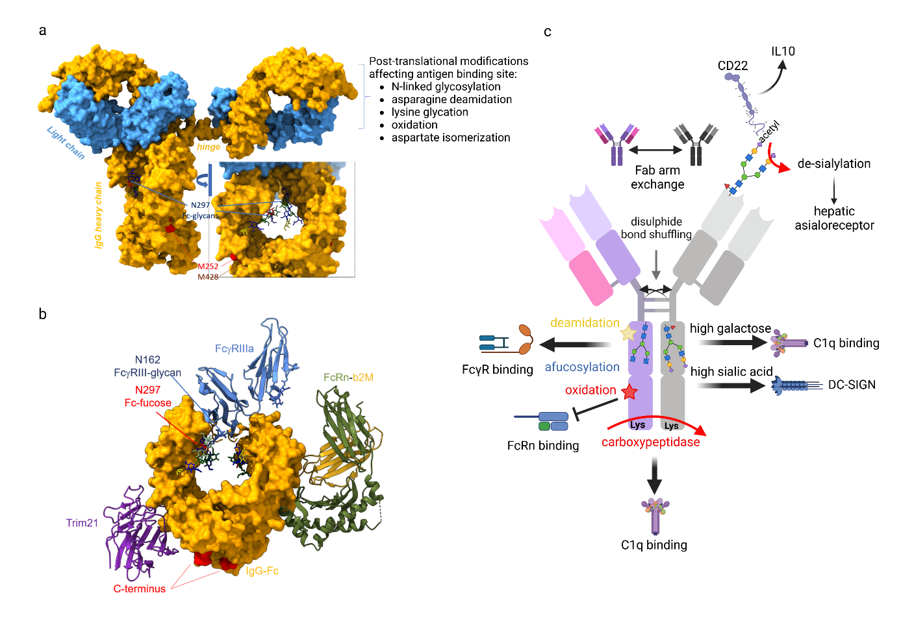

Figure 1: IgG structure, interaction partners and impact of post-translational modifications
a) Shown is the crystal structure of a human IgG1 antibody, depicting the two IgG heavy (yellow) and light (blue) chains as well as the hinge region. The sugar moiety attached to the asparagine 297 (N297) residue in each of the two IgG heavy chains is depicted as a stick model. The inset shows a rotation of the IgG Fc-domain to visualize the sugar domains. In addition, methionine residues 252 and 428 are marked, which become altered by oxidation after IgG secretion into the serum. Post-translational modifications occurring in the F(ab) region are summarized.
b) Depicted is the crystal structure of hFcγRIIIa (3SGJ) aligned with human FcRn, human IgG1-Fc (7Q15), and TRIM21 using ChimeraX v1.5. Sugar domains attached to hFcγRIIIa at position N162 as well as the sugar domains attached to the IgG-Fc domains are represented as stick models. The location of the fucose residue in the IgG-Fc sugar domain, causing steric clashes with theh FcγRIIIa-162 glycan, is indicated. The lower-IgG1 hinge is represented as an alpha helix swaying away from the viewer and links to the two Fab regions (not shown), and away from the asymmetrical binding pocket of hFcγRIIIa. The C terminus (without C-terminal lysine) is shown in red.
c) Schematic representation of an IgG molecule including post-translational modifications and how these modifications affect the binding to effector pathways via FcγRs, the neonatal FcRn, DC-SIGN, the complement pathway (C1q) as well as the potential binding to CD22. See text for further details. Figure was created with Biorender.com.

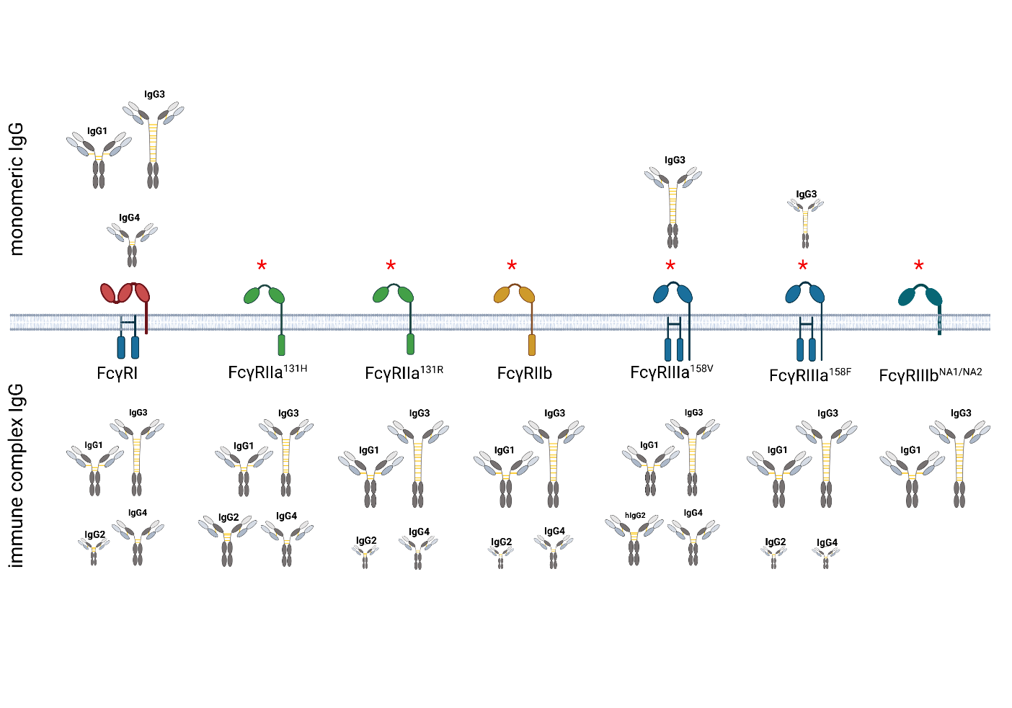
Figure 2: IgG subclass binding to cellular FcγRs in monomeric or immune complex form
The family of human FcγRs consting of one high affinity (FcγRI) and several low affinity receptors is depicted. While most FcγRs transmit activating signals, FcγRIIb (yellow) is an inhibitory FcγR. FcγRIIIb is a neutrophil-restricted GPI-linked receptor without intrinsic signaling function. Shown is the binding of human monomeric IgG subclasses (upper panel) or human IgG subclasses in the form of immune complexes (lower panel) to the indicated human FcγRs expressed on cells ^{119, 121} (see also Table 1 for affinity data from SPR analysis). The size of the respective IgG subclass indicates a stronger or weaker binding compared to other IgG subclass binding to the indicated FcγR. For FcγRIIa, FcγRIIIa, and FcγRIIIb allelic variants of the respective receptors are indicated. * indicates that due to the high concentration of IgG subclasses in the serum, IgG1, IgG3, but also IgG2 is found to be associated with low-affinity FcγRs. See text and Table 1 for further details. The figure was created with Biorender.com.

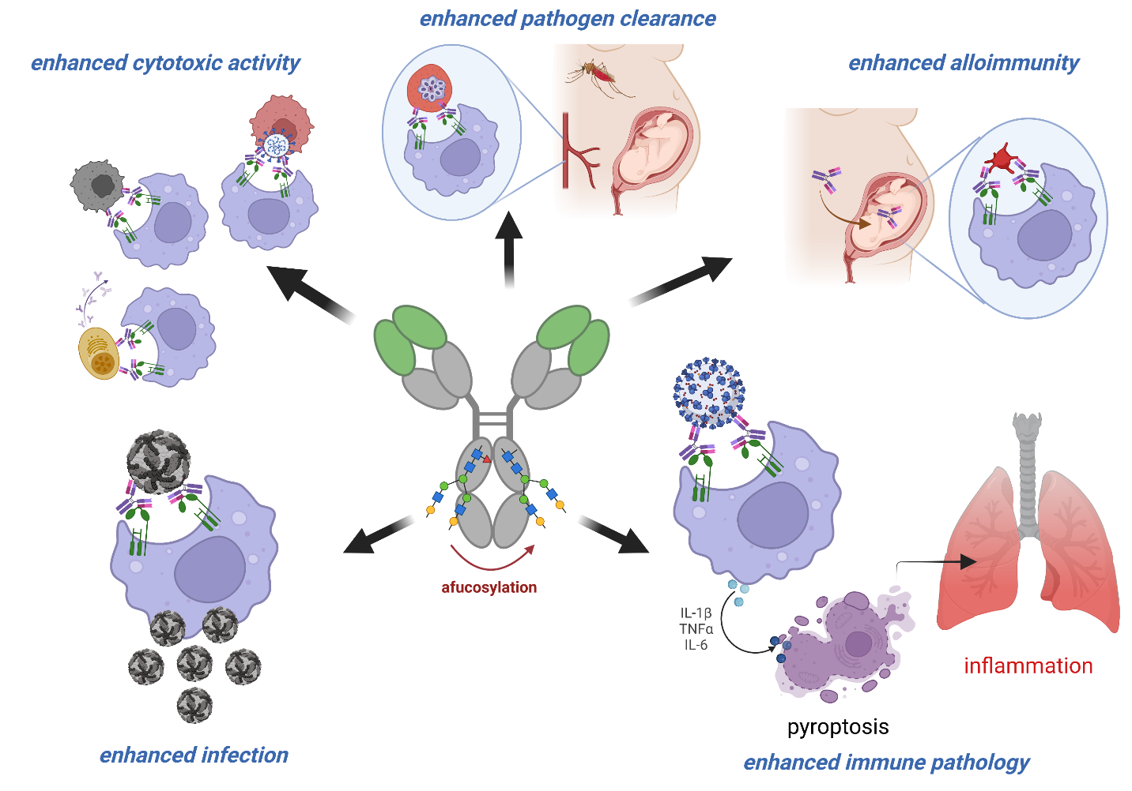
Figure 3: Impact of fucose residues on IgG-dependent effector functions
Impact of afucosylated IgG glycovariants on the outcome of different antibody mediated immune responses. As shown in the upper left, afucosylated IgG antibodies may strongly increase the activity of cytotoxic antibodies via enhanced affinity for FcγRIIIa resulting in a better clearance of target cells including tumor cells, autoreactive cells or virus infected cells. During immune responses against plasmodium ssp. infected red blood cells, or alloimmune responses (upper middle and right panels) occurring in pregnant women to paternal blood-groups on red blood cells or platelets, afucoslyated autoantibodies can be formed. In malaria this causes enhanced protection in the infected individual (middle panel), but increased pathology after FcRn-mediated transport of alloantibodies from the mother to the new-born (upper right panel). During certain virus infections, such as Dengue virus or SARS-CoV-2, afucosylated virus specific antibody responses may lead to the enhancement of virus infection and elevated myeloid cell-activation and thereby pathology via increased uptake into hFcγRIIIa positive immune cell subsets (lower left). For SARS-CoV-2 this also may induce pyroptosis of target cells, resulting in heightened immune pathology. See text for further details. The figure was created with Biorender.com.

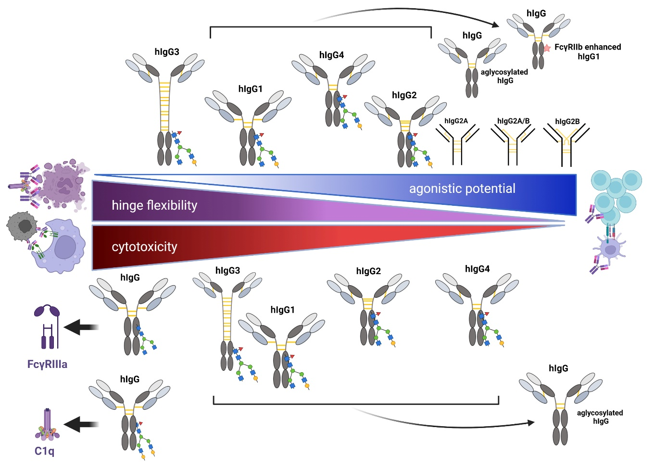
Figure 4: Impact of IgG subclass and glycosylation on therapeutic IgG activity
Shown is a schematic overview of how IgG subclass affects the activity of immunomodulatory agonistic (upper panel) or cytotoxic (lower panel) antibodies. Furthermore, the effect of IgG hinge flexibility on immunomodulatory antibody is depicted. Note that all IgG subclasses are glycosylated and that sugar moieties are only indicated if changes in glycosylation are associated with an impact of IgG activity, such as in the case of afucosylated or highly galactosylated sugar moieties. If no specific IgG subclass is mentioned the effect is relevant for all IgG subclasses. See text for further details. The figure was created with Biorender.com.

TABLE I: Effects of IgG subclass glycan changes on Fc-receptor binding affinity

 | hIgG1 |  |  |  |  | hIgG2 |  |  |  |  | hIgG3 |  |  |  |  |  |  | hIgG4
 | Affinity | F* | B | G | S | Affinity | F | B | G | S |  | Affinity | F | B | G | S | Affinity |  | F | B | G | S
FcγRIa | 65 $ | -† | - | - | - | - | - | ? | ? | ? |  | 61 | - | ? | ? | ? | 34 |  | - | ? | ? | ?
FcγRIIa^{H131} | 5.2 | - | - | (↑) | - | 0.45 | - | ? | ? | ? |  | 0.89 | - | ? | ? | ? | 0.17 |  | - | ? | ? | ?
FcγRIIa^{R131} | 3.5 | - | - | (↑) | - | 0.10 | - | ? | ? | ? |  | 0.91 | - | ? | ? | ? | 0.21 |  | - | ? | ? | ?
FcγRIIb/c | 0.12 | - | - | - | - | 0.02 | - | ? | ? | ? |  | 0.17 | - | ? | ? | ? | 0.20 |  | - | ? | ? | ?
FcγRIIIa^{F158} | 1.2 | ↓Θ  20x | - | ↑ Δ  2x | ↓▪  2x | 0.03 | ↓ | ? | ? | ? |  | 7.7 | ↓  20x | ? | ? | ? | 0.20 |  | ↓ | ? | ? | ?
FcγRIIIa^{V158} | 2.0 | ↓  10-20x | - | ↑  2x | ↓▪  2x | 0.07 | ↓ | ? | ? | ? |  | 9.8 | ↓Θ  10x | ? | ? | ? | 0.25 |  | ↓ | ? | ? | ?
FcγRIIIb | 0.2 | ↓  20x | - | - | ↓▪  2x | - | - | ? | ? | ? |  | 1.1 | ↓Θ  10x | ? | ? | ? | - |  | ↓ | ? | ? | ?
C1q | <0.05 | - | - | ↑ | (↑) | (-) | ? | ? | ? | ? |  | <0.05 | - | ? | ? | ? | (-) |  | ? | ? | ↑ | ?
* F: Fucose; B: Bisection; G: Galactose; S: Sialic acid; $: Association constant (×10⁶ M⁻¹) for monovalent binding given for fucosylated IgG ¹²² † -: No affinity change; ↓ decreased affinity; ↑ increased affinity, fold change based on ³⁸ generally agreeing with ⁴², when evaluated.
Δ: for afucosylated IgG; ▪: for afucosylated bisected IgG; Θ Effect of fucosylation on afucosylated IgG is shown. Can activate complement at very high epitope densities ⁵

TABLE II: Posttranslational modifications of human IgG subclasses
Subclass | hIgG1 | hIgG2 | hIgG3 | hIgG4
Characteristic
Molecular mass (kD) | 146 | 146 | 170 | 146
Amino acids in hinge region | 15 | 12 | 32-62 a) | 12
Inter-heavy chain disulfide bonds | 2 | 4 b) | 5-11 a) | 2
Fab-glycosylation | 11-18% | 10-16% | 11-16% | 40-50% c)
Hinge O-linked glycosylation c) | - | - | Yes | -

- Depends on allotype⁵
- For A/A isomer, depends on isomerization^{141, 142}.
- ¹⁰⁴

