Wear mechanisms of cold sprayed Stellite-6 during reciprocated dry sliding under different sliding speeds
P. Magarò ^{a,*}, F. Furgiuele ª, C. Maletta ª, M. Tului ^{b}, R.J.K. Wood ^{c}
ª University of Calabria, Department of Mechanical, Energy and Management Engineering, Arcavacata di Rende, 87036, Italy
^{b} CSM SpA, Lamezia Terme Branch Office, Zona Industriale San Pietro Lametino, 88046, Lamezia Terme, Italy
^{c} National Centre for Advanced Tribology Southampton (nCATS), faculty of Engineering and the Environment, University of Southampton, Southampton, SO17 1BJ, United Kingdom
* Corresponding author; pietro.magaro@unical.it
Keywords: Cold Gas Dynamic Spray, Stellite, Dry sliding, Pull-out, Platelet, Indentation

Abstract
Cobalt-chromium alloys are often employed in those environments that require reliable wear and friction properties. Cold Gas Dynamic Spray offers the opportunity to obtain good quality deposits of Stellite-6 that can be successfully used in harsh environments where good surface performance, in terms of wear resistance, is required. It is also well-known that Stellite-6 is subjected to several physical changes at the interface during dry sliding that are often related to the loading conditions. As a consequence, wear behavior of this alloy can undergo some variations that linear models could not capture because micro-structural modifications occur during operation. To better understand the wear mechanisms of cold sprayed Stellite-6 coatings together with physical phenomena that occur, a systematic experimental study was performed, in fact, to date, no such in-depth tribological studies have been performed. Tests were conducted under combinations of two sliding speeds (0.1 and 0.5 m/s) and four contact pressure in the range 2–5 MPa. In low-speed tests, abrasive wear is evident, where detachment and pull-out phenomena mainly affect the worn surface of coatings. On the other hand, subsurface cracking was observed in high-speed tests, as well as evidence of plastic deformation on the wear surface. These results suggest that the wear mechanisms observed are more likely a consequence of adhesive wear. Unique to this study, the cross-sectional nano-indentation tests showed how the stiffness of the coating near to wear interface increases significantly under the lowest value of sliding speed (i.e. v=0.1 m/s) whereas the stiffness tends to decrease at high speeds, that is v=0.5 m/s, mainly due to the presence of subsurface cracks into the coating thickness.

Introduction
Cobalt-based alloys are used in several applications, such as oil industry (critical components of drilling), electrical industry (energy-generating turbines), automotive industry (coatings on exhaust parts), and others [1,2] due to their excellent wear, corrosion and oxidation resistance [3]. In fact, in surface engineering, Stellite alloys are widely used in order to protect various components against wear, corrosion and oxidation. These properties are due to the high chromium content and thanks to the presence of carbides and borides coupled with lattice stress-induced transitions occurring in the contact region under high-load sliding conditions and provide remarkably high hardness and good wear properties thanks to the formation of a hexagonal close-packed structure which are caused by shear stress during contact in place of the parent face-centered one [4,5]. In order to obtain good Stellite coatings, different deposition technologies can be used, e.g. plasma transferred arc (PTA) [6] or tungsten inert gas (TIG) welding [7], thermal spraying [8–15] or laser cladding [16–23], that implies some differences in the coating microstructures and consequently in the coating properties. Within the class of thermal spraying technologies, Cold Gas Dynamic Spray (CGDS) represents an interesting option to deposit good Stellite coatings. This technology consists in a process in which solid powders are accelerated in a de Laval nozzle toward a substrate by a supersonic jet of high-pressure gas. Moreover, the temperature reached by the sprayed particles during the process is below the melting temperature of the material. Due to the adiabatic shear instability, that occurs thanks to the high strain rate, the particles are able to undergo large plastic deformation, so that material flow provides the required heat for bonding. This phenomenon, actually, represents the main driving force for the adhesion of the coating to the substrate [24–27]. In fact, CGDS technique has been successfully applied in the last years for the deposition of ductile metals such as copper and aluminum-based alloys, due to their remarkable ductility [28–31].
Particle bonding, in turn, occurs if particles velocity reaches a threshold value called critical velocity, which is influenced by the mechanical and physical properties of the sprayed material i.e. size, distribution and morphology. In this regard, Schmidt et al. developed an equation to find the critical velocity, as reported in ref. [25], as a function of temperature-dependent flow stress, density, heat capacity, and melting temperature of the sprayed material and of particles temperature upon impact.
This technique has the advantage, in spite of conventional ones, that it produces highly compact deposits and oxide-free structures and prevents tensile residual stresses and chemical contamination. Furthermore, there is still a limited understanding on how the loading conditions affect the physical response of the alloy and in turn how they influence the wear mechanisms.
While the general wear response of such alloys have been investigated experimentally, with a focus on common thermal sprayed Stellite coatings, before this paper, identifying wear mechanisms such as carbide pull-out and fracture [32], delamination [33] and fatigue of a wear-reducing oxide layer [34], there have not been many studies on the understanding of how these wear mechanisms occur as a result of the loading conditions for cold spray deposits. The use of a mechanistic model of wear that is able to capture the physical response of the system as a consequence of the loading conditions and environment would be useful to understand the coating behavior in-situ. Typically, the Archard wear equation [35] is used to estimate the material performance:
$V=K\frac{N×s}{H}$ (1)
where $V$ is the total volume of wear debris produced, $K$ is a dimensionless constant that is obtained from experimental results, $H$ is the hardness of the surface, $N$ is the normal load, and $s$ is the total sliding distance.
This latter suggests that, for a given system, the wear behavior is linear with sliding distance and normal load, like other literature wear models usually employed to characterize the wear behavior of the material system [35,36]. The latter do not capture the physic phenomena involved during the sliding, in fact, changes in the environment and loading conditions have to be considered for the development of a model that is able to take into account these conditions in the case of CoCr sliding systems. However, to date, no in-depth studies on the effects of load and sliding speed, at room temperature, have been performed in the case of cold-sprayed Stellite coatings. Therefore, this paper aims to understand how loading conditions can influence wear mechanisms of cold-sprayed Stellite deposits and to identify the significant physical phenomena occurring at the wear surface that can allow the development of proper models, able to predict the wear coefficient of these kinds of coatings. Several analysis techniques have been used to determine the wear mechanisms in this study. Wear surfaces and cross sections of the samples, tested under sliding conditions, were examined under light microscope. In addition, post-wear nano-indentation measurements into the subsurface of the coatings have been done to clarify how the wear mechanisms, involved during the sliding, can modify the mechanical properties of the coating after the test. Frictional data were also collected and analyzed. The experimental procedure is described in Section 2. Results are presented and discussed in Section 3. Finally, conclusions are provided in Section 4.

Materials and methods

Coating process
A commercial Stellite-6 powder (Diamalloy 4060NS, Oerlikon Metco, Switzerland) obtained by gas atomization, with particle size -45+15 µm, was employed as a feedstock. A high pressure CGDS equipment (Impact Spray System 5/11, Impact Innovation, Germany) was used and a pre-chamber of 135 mm in length was installed. Nitrogen was used as process gas. Spraying conditions were optimized from previous studies [37,38] and were as follows: gas temperature and pressure equal to 970 °C and 4 MPa respectively, stand-off distance equal to 20 mm, while traverse gun speed was set equal to 300 mm/s. The coating was obtained from three spraying layers.

Coating characterization
CGDS Deposits were examined by optical microscope (DM4000 M, Leica, Germany) equipped with a high-resolution camera (MC190 HD, Leica, Germany). For this purpose, samples were cut, mounted using epoxy resin, grinded using wet SiC grinding papers and polished using diamond solution and silica both with polishing cloths.
Coating microstructure was revealed by etching with a mixture of acids (15 ml HNO₃, 15 ml CH₃COOH, 60 ml HCl and 20 ml of H₂O) as highlighted in the following section.
Porosity content was also estimated using the image analysis software Image J. However, according to the standard ASTM E2109.

Tribological characterization
The experimental tests were carried out on a reciprocating sliding test rig, i.e. TE77 (Phoenix Tribology, Berkshire, UK) in dry room condition, i.e. temperature around 25 °C and relative humidity around 40 %. A schematic depiction of the test equipment can be seen in Fig. 1.
Fig. 1: Schematic depiction of the experimental equipment
Frictional data, i.e. the evolution of coefficient of friction, were recorded using a transducer connected to the TE77 rig. The wear tests were performed to evaluate the influence of the sliding speed and applied load on the wear mechanisms. The experimental campaign has been developed in order to deeply investigate the wear performance of Stellite-6 coating in the range between 2 and 5 MPa. Sliding distance was kept constant for all experiments and in particular was set equal to 500 m with a stroke length equal to 26.4 mm. The full test matrix is reported in Table 1. Finally, three experiments have been performed for each load condition.
Table 1: Range of parameters used in different combinations for wear tests
Load (N) | Pressure (MPa) | Velocity (m/s)
100 | 2 | 0.1
150 | 3
200 | 4
250 | 5
100 | 2 | 0.5
150 | 3
200 | 4
250 | 5
The sliding geometry chosen was an “area-on-flat” with a cylindrical pin of 7.94 mm diameter realized in chromium AISI 52100 steel. This latter material was hardened to 60-67 Rockwell Scale equivalent to 700-900 HV (Vickers Scale). Pins were slid against plates of dimension 20×60×3 mm. Each sample was polished using diamond solution obtaining a surface finish of 0.2 μm ± 0.05 average roughness (R_{a}), in order to replicate a contact system that reflects a typical industrial application. Surface roughness was measured using a contact profilometer (Talysurf, Taylor-Hobson, UK). Post-wear characterization consisted of weight measurements for both the plate and pin and, from this data, the wear coefficient $W$[mm³/Nm] was calculated using the following equation:
$W=\frac{V}{N×s}$ (2)
where $V$ is the volume loss [mm³], $N$ [N] is the load and $s$ [m] is the sliding distance. After each experiment, plates and pins were cleaned in an isopropanol ultrasonic bath to exclude the presence of debris in the weight measurement.
The post-wear surface of the Stellite coatings was characterized using a Scanning Electron Microscope (JEOL JSM-6500).
The evolution of microscopic material properties after wear tests was evaluated using the nano-indentation method, using a nano-indenter (NHT, CSM Instruments, Switzerland) equipped with a Berkovich diamond tip.

Results and discussion

Microstructure of the coating
Cross sections of Stellite-6 coatings are shown in Fig. 2, where high compactness can be observed with a porosity of 1.9% [37].
In particular, in Fig. 2(b) can be observed how the particle boundaries maintain their round shape and this result can be related to the resistance to deformation of the Stellite-6 powder.
In addition, Fig. 2(b)shows how the deposition mechanisms involve mechanical deformation of both sprayed particles and substrate at the impact interface. In fact, it is possible to observe that, despite the substrate has been just grounded before deposition, the substrate-coating interface is not flat but clearly shows the rounded profile of the impacted particles as a consequence of the higher Stellite-6 hardness compared to the steel substrate. Moreover, Fig. 2(c) e (d) report the detailed characteristics of the dendrite deformation within the particles, typical of the Co-Cr systems.
Fig. 2: Optical cross section of the coating at different magnifications: (a) 5×, (b) 20×, (c) & (d) detailed features of the dendrite deformation in the particles at 100× magnification

Friction and wear mechanisms
Fig. 3 reports the trends of the dynamic coefficient of friction obtained from reciprocating sliding wear experiments as a function of the sliding distance, at different values of the contact pressure and for the two investigated sliding speeds (see Table 1): v=0.1 m/s (Fig. 3(a)) and v=0.5 m/s (Fig. 3(b)).
Different trends are observed comparing the results obtained at low and high sliding speed. Non-uniform peak and valley trends were captured in the case of low speed, characterized by rapid increases followed by sudden drops, and these effects are more evident at low contact pressures (2 and 3 MPa). On the contrary, nearly constant trends were recorded at the higher sliding speed (0.5 m/s).
Fig. 3: Friction coefficient of Stellite-6 samples submitted to reciprocating sliding wear under different values of contact pressure and at different sliding speeds: a) v=0.1 m/s and b) v=0.5 m/s
Fig. 4 summarizes the average values of the frictional data, obtained through the entire sliding distance, for the different values of the contact pressure and speed reported in Table 1. Corresponding scatter bars are also shown. The coefficient of friction tends to decrease with increasing the contact pressure for low sliding speed (v=0.1 m/s), varying in the range of 0.4-0.65. On the contrary, a slight increase with the contact pressure is observed at higher speed (v=0.5 m/s), which is in the range of 0.35 to 0.45. In addition, very large scatters can be observed at low speed, especially for the experiments carried out setting the contact pressure equal to 2 and 3 MPa, due to the remarkable non-uniform trend shown in Fig. 3(a).
Fig. 4: Evolution of dynamic coefficient of friction as a function of contact pressure for both values of sliding speed tested
These behaviors are attributed to distinct wear mechanisms. To this aim, systematic analyses of the wear track were carried out by SEM micrographic investigations to understand the wear mechanisms and with the purpose to capture possible local effects like pull-out phenomena, abrasion, adhesion mechanisms, and crack propagation in the wear surface.
Fig. 5 shows representative cross-sections of worn samples, perpendicular to the sliding direction, obtained at v=0.1 m/s (Fig. 5(a), (b) and (c)) and at v=0.5 m/s (Fig. 5(d), (e) and (f)).
Fig. 5: Representative light micrographs of the samples cross-sections for different levels of contact pressure and sliding speed: (a) 2 MPa - 0.1 m/s, (b) 3 MPa - 0.1 m/s, (c) 4 MPa - 0.1 m/s, (d) 2 MPa - 0.5 m/s, (e) 3 MPa - 0.5 m/s, (f) 4 MPa - 0.5 m/s
Micrograph images of the cross-section of the samples tested at v=0.1 m/s do not show subsuperficial cracks along with the thickness of the coating (see Fig. 5(a), (b) and (c)). On the contrary, subsurface cracks are formed during tests carried out at high speed (see Fig. 5(d), (e), and (f)) suggesting that wear mechanisms are mainly affected by the sliding speed.
Nevertheless, the involved wear mechanisms will be better addressed in the following sections, where SEM micrographs of the wear surface are reported and discussed.

Low sliding speed
Fig. 6 shows post-wear SEM micrographs for the worn surface of samples tested at increasing values of the contact pressure, from 2 MPa to 5 MPa. The wear mechanism seems to be mainly abrasive throughout all experiments with the evidence of pull-out phenomena. This assumption seems to be confirmed by the micrographic observations of the cross section of the samples (see Fig. 5(a), (b) and (c)) that do not show subsuperficial cracks confirming the formation of pulled-out debris while running tests.
In the case of low sliding speed delamination phenomena were observed, as the worn surface appears to be characterized by visible sharp edges as a consequence of the abrasive effects. The higher magnification SEM images revealed that delamination occurred mainly on the intersplat boundaries (see Fig. 6 (b), (d), (f), and (h)), suggesting that this latter is the weak point of the coating. The sudden variations of COF (see Fig. 3(a)) during the tests correspond, in fact, with the delamination initiation and with the consequent pull-out phenomena occurring in the wear track. In addition, ploughing can be observed on the worn surface and can be considered as the main wear mechanism in those regions that are not affected by delamination and pull-out phenomena.
In addition, evidence of strained and displaced material across the wear surface is seen in all tests, therefore the creation of tribofilm consisting of oxidized wear debris can be expected on the wear surface. This observation is in agreement with the coefficient of friction results (see Fig. 3(a) and Fig. 4), in fact, the increase of oxidized material, as a consequence of the increasing the wear debris on the worn surface, can be considered the main reason for the decreasing trend of the COF as a function of the contact pressure, as it is reasonable to assume that oxidized pulled-out particles act as solid lubricant.
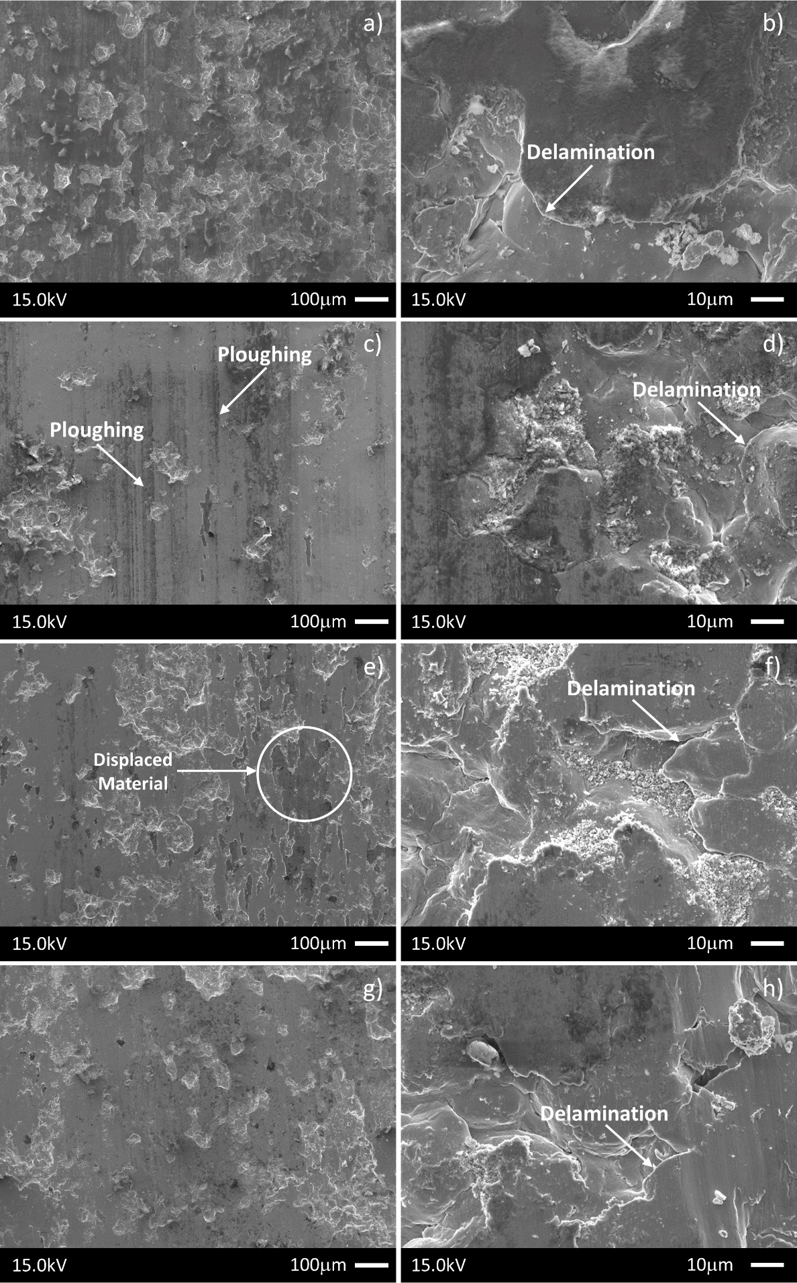
Fig. 6: Representative SEM micrograph of the wear surface on the samples tested at the sliding speed v=0.1 m/s under different contact pressure: a) and b) p=2MPa, c) and d) p=3MPa, e) and f) p=4MPa, g) and h) p=5MPa
Fig. 7 shows the post-wear SEM micrographs, from 2 MPa to 5 MPa, for the pin wear surface. Deformed material can be identified as trapped wear debris. These latter are visible on the worn surface and appear deformed, transferred, and adhered to the worn surface.
In addition, in Fig. 7(d) it is possible to observe how the material is displaced on the worn surface of the pin. This type of deformation is characteristic of the tests carried out setting the contact pressure equal to 5 MPa.
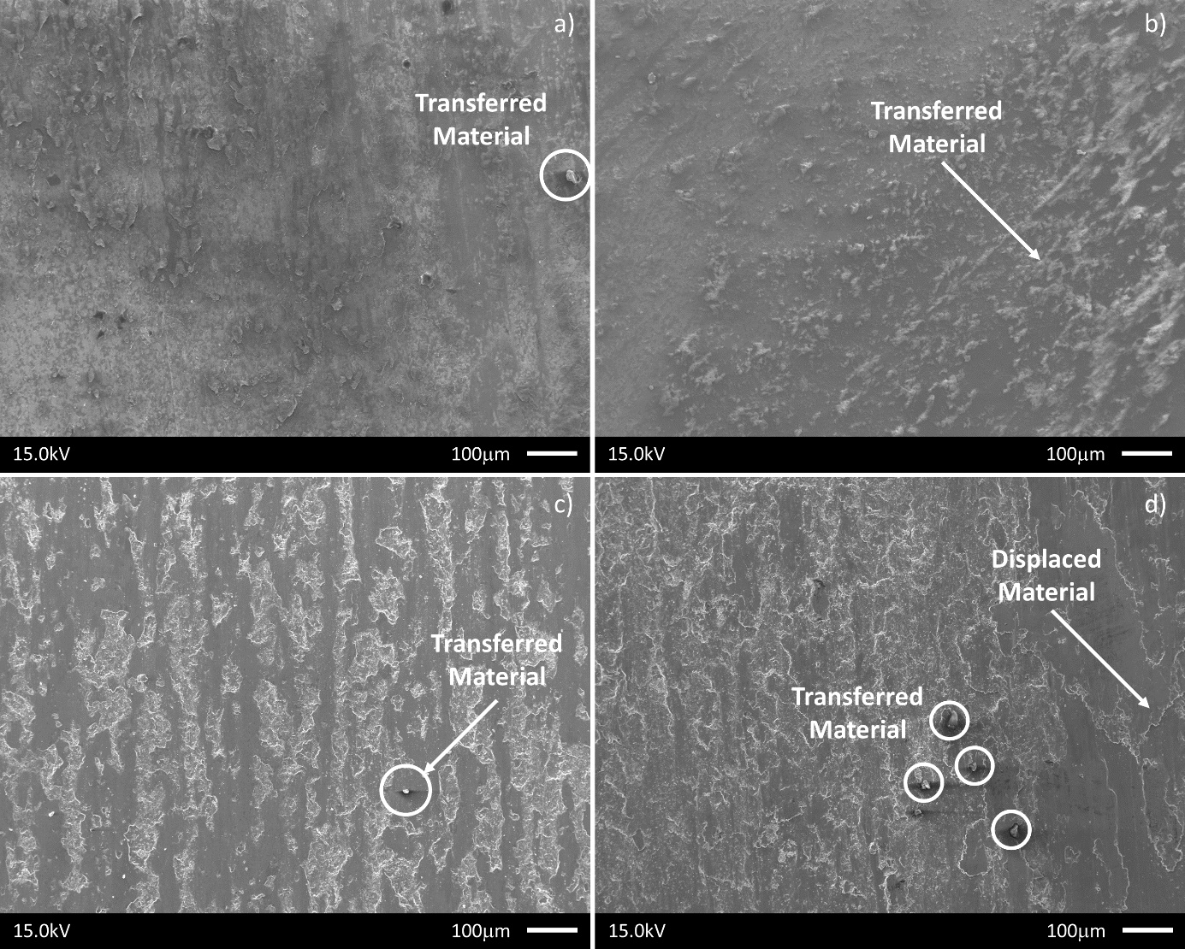
Fig. 7: Representative SEM micrograph of the wear surface on the pin at the sliding speed v=0.1 m/s under different contact pressure: a) p=2MPa, b) p=3MPa, c) p=4MPa, d) p=5MPa
It can be summarized that in all tests carried out at low sliding speed, i.e. v=0.1 m/s, wear mechanisms seem to be a consequence of the formation of solid debris on the worn surface resulting in pull-out phenomena, that are observable in all tested samples. This phenomenon appears to be typical after wear tests for CoCr alloys [3] and in particular for thermal-spray coating where the splat boundaries usually represent the weak point of the system, leading to a type of fatigue wear named “grain wear” [39], consisting of pulled-out grains that form small flattened oxidized particles on the wear surface. This phenomenon can be considered the main reason for the reduction of the dynamic coefficient of friction as a function of the contact pressure as shown in Fig. 4 since the oxidized pulled-out particles act as solid lubricant.
Finally, Fig. 8(a) and (b) report the evolution of volume loss and wear coefficient as a function of the contact pressure. The volume loss experienced corresponds to a wear coefficient of the order of 2 × 10⁻⁵ ÷ 5 × 10⁻⁵ mm³/Nm and 6.5 × 10⁻⁷ ÷ 2.5 × 10⁻⁶ mm³/Nm for the plate and pin respectively. It can be noted that both values tend to increase increasing the contact pressure as a consequence of the higher density of pull-out phenomena, as confirmed by the microscopic observation. The highest value of the contact pressure, in fact, leads to the greatest value of both volume loss and wear coefficient as a direct consequence of the increased pull-out phenomena and grain wear.
It is interesting to note how the obtained results show a non-linear trend in the volume loss, and so in a non-constant trend of the wear coefficient. Therefore this material system is not in agreement with the Archard’s model in its wear behavior and thus not Archard-like according to Eq. (1).
Moreover, a confirmation of the occurrence of pull-out phenomena during the sliding at low speed can be found in the evolution of the dynamic friction coefficient as a function of the sliding distance for all values of the contact pressure as shown in Fig. 3(a). The sudden variations of friction coefficient, observed during the low-speed tests, correspond with delamination ignition and consequent detachment of splats that tend to form a tribo-film consisting of oxidized wear debris that is observable on the wear track as displaced material. Therefore, the dynamic friction coefficient tends to decrease increasing the contact pressure as shown in Fig. 4.
This latter phenomenon can be attributed to the formation of an oxide layer, adherent to the surface, and to the presence of oxidized pulled-out particles that act as solid lubricant. In fact, due to the significant increase in both volume loss and wear coefficient value with the contact pressure (see Fig. 8), it is reasonable to assume that the amount of tribo-film and oxidized pulled-out particles on the wear track increase with the contact pressure.

Fig. 8: Volume loss and wear coefficient vs contact pressure plots for 0.1 m/s
Compared to the experiments carried out by Cross et al [40], where the material was processed using a HIPing cycle of 100 MPa at 1200 °C for 4 h, the average value of the measured wear coefficients is two orders of magnitude greater. This result can be considered a direct consequence of the weakness of the inter-particle boundaries that represents a technical issue to overcome when cold sprayed Stellite coating were used in sliding condition.
In fact, pull-out of splats contributes to increasing the mass loss at the end of the test whereas debris tends to increase the severity of the abrasion mechanism.

High sliding speed
Fig. 9 reports the representative post-wear micrographs of the wear surfaces for the samples tested at v=0.5 m/s and under increasing values of the contact pressure, i.e. from 2 to 5 MPa.
Adhesive wear can be seen in all tested samples. Formation of platelet can be seen on the worn surface, in particular for those samples tested under 2 MPa of the contact pressure. This latter can be considered peeling from the surface, as seen in Fig. 9 (b).
Moreover, material appears adhered and pushed on the wear track, with evidence of pressed and displaced material across the surface, as can be seen in Fig. 9 (d), (f), and (h). In addition, in Fig. 9 (h) it is clearly visible the presence of ridges that are due to the displacement of material.
The high magnification images show the presence of debris on the wear surface that tend to increase increasing the contact pressure. The below layers of the coating cannot be seen either at high magnifications, as can be observed in the wear surface of the samples tested in low-speed conditions, further suggesting that material has been highly strained and smeared across the surface covering the underlying sprayed material.
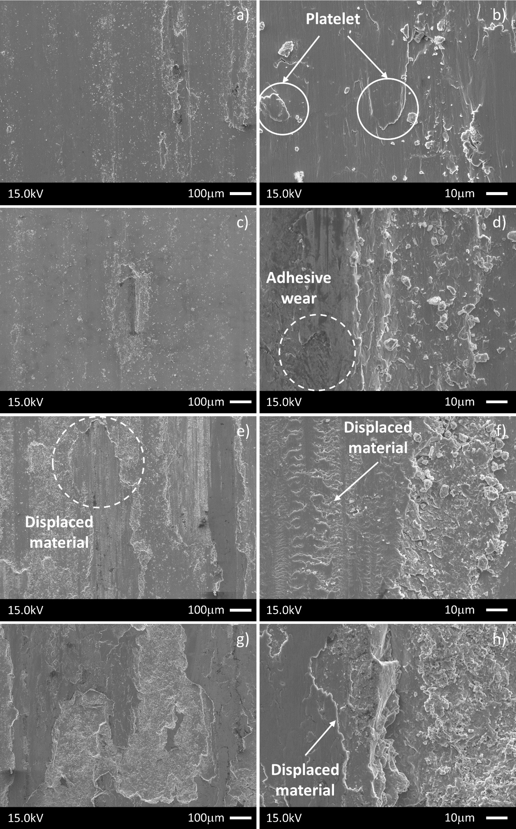
Fig. 9: Representative SEM micrographs of the wear surface of the samples tested at the sliding speed v=0.5 m/s under different contact pressure: a) and b) p=2MPa, c) and d) p=3MPa, e) and f) p=4MPa, g) and h) p=5MPa
A similar phenomenon, considered as “shear tongues”, can be seen in laser-clad stellites by Persson [4].
Debris observed throughout all high-speed tests appears to be “plate-like” and consists of smaller broken-up portions of debris that are characterized by a diameter no larger than 10 μm characterized by strained material, displaced across the surface as a consequence of the peeling-off or adhesion of plate-like wear particles. These latter seem to be the consequence of subsurface crack nucleation, observable in the micrograph images of the cross-section (see Fig. 5 (d), (e), (f)), leading to the formation of platelets.
These phenomena, i.e. platelets, subsurface fractures, and displacement of material, were noticeable in the high-speed tests. Due to the physical phenomena observed, the wear mechanisms can be considered a consequence of plastic ratcheting [41]. Plastic ratcheting, in fact, occurs under cyclic loading if the load is high enough to produce a unidirectional accumulation of plastic shear strain with each passing contact. This phenomenon is a consequence of the high stresses experienced under the contact point, because residual stresses or work-hardening introduced during the sliding are not enough to avoid further plastic deformation. These plastic strains are primarily responsible for the nucleation of cracks within the coating that propagate parallel to the substrate, as highlighted in Fig. 5. These latter, growing cycle by cycle, lead to the formation of wear particles and once detached are free to be displaced across the wear surface as shown in Fig. 9.
In these testing conditions, micrographs of the cross section (see Fig. 5(d), (e), and (f)) show subsurface large crack initiation for all tested samples. This is a consequence of the limited material toughness in the direction parallel to the substrate so the weak point of the coating can be found in the cohesion rather than the adhesion to the substrate. The internal porosity, in fact, represents a preferred site for crack initiation. Moreover, due to the higher temperature reached in the contact zone, the adhesion mechanisms occurring between pin and coating can be considered as the main reason for the crack propagation within the coating.
In Fig. 10 are shown the post-wear SEM micrographs of the pins’ worn surface and it can be summarized that adhesive wear is the main damage mechanism observable in all high-speed experiments. Deformed material can be identified as trapped wear particles that are visible on the worn surface as transferred and adhered material to the worn surface, especially in the tests carried out under 5 MPa of contact pressure (see Fig. 10(d)). On the contrary, on the worn surface related to the 4 MPa experiments, a type of fatigue wear known as “nano-grain wear” can be observed (see Fig. 10(c)). This phenomenon consists of pulled-out grains which form small globular particles on the wear surface typically clustered around grooves and oxide boundaries.
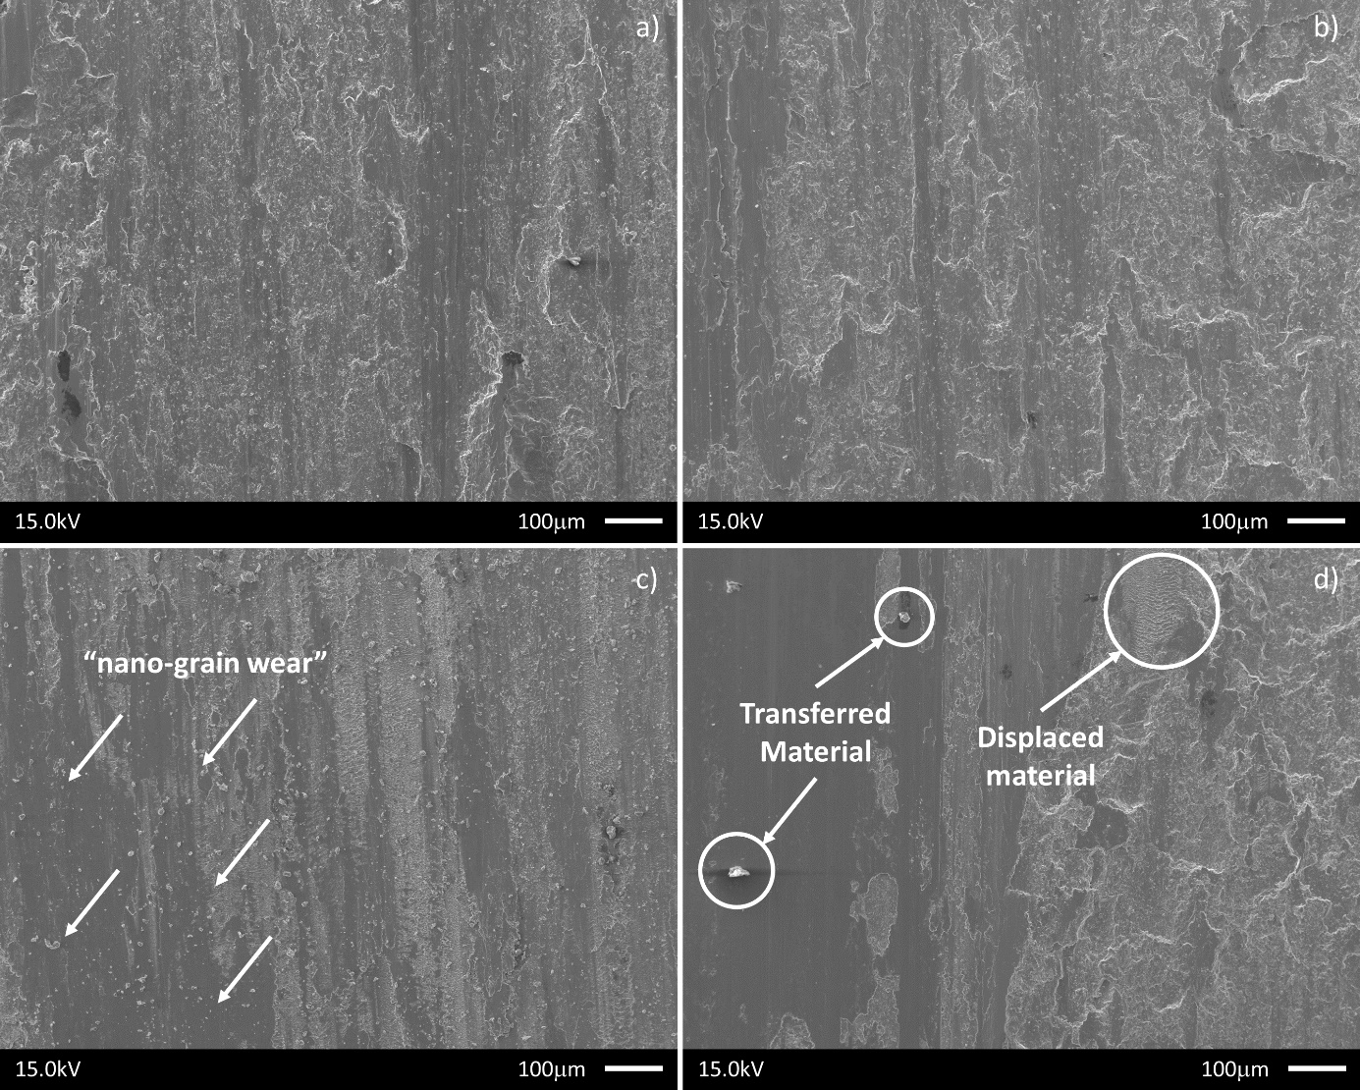
Fig. 10: Representative SEM micrograph of the wear surface on the pin at the sliding speed v=0.5 m/s under different contact pressure: a) p=2MPa, b) p=3MPa, c) p=4MPa, d) p=5MPa
It can be concluded that with increasing sliding speed, i.e. from 0.1 to 0.5 m/s, a mild-to-severe wear transition occurs. This phenomenon is facilitated by the high temperatures reached in the contact zone as a consequence of the higher value of the sliding speed. This latter is a common phenomenon observable by increasing the loading condition to which the coatings are subjected during wear tests [42]. In fact, increasing contact pressure, the worn surface appears to be less affected by pull-out phenomena while, due to increased average temperature together with the flash temperature of the pin, the adhesion is more likely to occur, and adhesive wear gradually dominates the wear mechanism. The increasing trend of friction coefficient with the contact pressure, reported in Fig. 4 further suggests an increase in adhesion between pin and sample. It is interesting to note that the evolution of the dynamic friction coefficient as a function of the sliding speed, reported in Fig. 3(b), is almost constant for all values of the contact pressure chosen, suggesting that the wear mechanism involved does not change during the tests.
Nevertheless, during high sliding speed tests Stellite-6 coating exhibited a linear trend of the volume loss, as reported in Fig. 11(a) and therefore an almost constant wear coefficient trend, as can be seen in Fig. 11(b).
Moreover, Fig. 4 shows that the dynamic friction coefficient at p=2 MPa is the lowest among all the experiments. This latter result can be attributed to two mechanisms: i) the higher temperatures reached in the contact zone as a consequence of the higher value of the sliding speed; ii) limited adhesion phenomena as a consequence of the low contact pressure that leave the place to the presence of oxidized material on the wear track tends to form a tribo-film consisting of highly-strained oxidized material [4] which tends to reduce the friction coefficient during the test.
Fig. 11: Volume loss and wear coefficient vs contact pressure plots for 0.5 m/s
In particular, the obtained results show a measured wear coefficient of the order of ~ 2 × 10⁻⁴ mm³/Nm and 2.75 × 10⁻⁶ ÷ 2 × 10⁻⁵ mm³/Nm for the plate and pin respectively, which are by an order of magnitude greater than literature data for the same testing conditions reported by Cross et al. [40] for a HIPed cobalt-chromium alloy. The presence of internal porosity, in fact, and the consequent crack initiation and propagation are responsible for the severe wear mechanisms discussed in this section.

Nano-indentation results
The evolution of mechanical properties at the nano-scale was also analyzed with the purpose to capture possible changes in the coating along with the thickness in the region immediately below the worn surface. In this regard, an experimental campaign was carried out by a matrix of 10🞩10 indentation points with 30 μm spacing between each indent, and with an indentation load of 50 mN.

Low-speed tests
The nano-indentation measurements, carried out on the cross section of samples tested under low sliding speed conditions (v=0,1 m/s), are reported in Fig. 12. An almost flat trend for both elastic and hardness responses can be observed. However, it is interesting to note that, reduced Young’s modulus, shown in Fig. 12(a), is lower in the samples tested at a contact pressure of 2 and 3 MPa than in the case of 4 and 5 MPa, with average values of around 218 GPa and 238 GPa, respectively. On the other hand, a different trend was observed in the hardness response, as highlighted in Fig. 12(b), where the measured hardness values seem to be mainly unaffected by the contract pressure.
Fig. 12: Plot of the nano-indentation results for reduced elastic modulus and hardness vs depth for low-speed tests
The trend observed for stiffness data can be explained considering that the higher value of the contact pressure tends to close any possible subsuperficial defects below the worn surface. In the previous section, in fact, it was shown that the cross-section of coatings tested at low speed is not characterized by the presence of longitudinal cracks unlike those tested at high speed (see Fig. 5).
These results can be explained considering that hardness response depends only on the plastically deformed volume. On the contrary, the reduced Young's modulus comes from a bigger volume of material, so the porosity content plays a very important role in the elastic response of the coating. In fact, inter-particle cohesion strength is improved when, as a consequence of the contact pressure, the defects below the worn surface tend to close and the reduced amount of pores and defects inside the coating prevents possible rigid motions of particles not perfectly adhered to the coatings.

High-speed tests
The nano-indentation measurements carried out on the coatings tested at high speed are pointed out in Fig. 13. The obtained results show a reduction in the stiffness (Fig. 13(a)) and a similar trend in the hardness response (Fig. 13(b)) as a function of the contact pressure.
Fig. 13: Plot of the nano-indentation results for reduced elastic modulus and hardness vs depth for high-speed tests
The trends in the hardness can be considered a direct consequence of the high temperature reached during the high-speed tests (v=0,5 m/s). High temperature, in fact, often implies noticeable modifications in the coating microstructure so, this behavior can be related to the grain size evolution of the microstructure. In fact, due to the Hall-Petch effect [43,44], the hardness of materials tends to increase with grain refinement as a consequence of enhanced dislocation pile-up at grain boundaries. It can be concluded that the decreasing trend observed in the nano-hardness response could be considered a consequence of grain growth phenomena. Moreover, the observed reduction in the hardness values along the thickness can be also related to the increased presence of cracks inside the coating, clearly observable in Fig. 5(d), (f) and (f).
Regarding the elastic response, the marked reduction of the reduced Young’s modulus can be explained by taking into account the presence of cracks and detached material below the surface occurring during the sliding. In fact, a reduction in the elastic modulus is mainly due to the allowed rigid motions of debonded particles from the coatings during the indentation and this phenomenon tends to increase by increasing the contact pressure between pin and sample.

Conclusions
A systematic in-depth study on tribological wear performance of Stellite-6 coatings, obtained by Cold Gas Dynamic Spray (CGDS), was carried out in order to better understand the occurring wear mechanisms in reciprocated dry sliding conditions. The experiments revealed that detachment and pull-out phenomena mainly affect the worn surface of coatings tested in low-speed conditions with the evidence of delamination phenomena that occur at the intersplat boundaries, which represent the weak point of the coating.
On the contrary, adhesive wear mechanism is operative for high-speed tests in accordance with the theory of wear for the Steel-CoCr system. These conclusions are supported by the following consideration:
- Plastic deformations occurring during the sliding cause the crack ignition and propagation within the coating, usually at splat boundaries or in correspondence of pores.
- Material is displaced towards the coating surface then, due to elastic fracture, detachment of the material results in wear-particles.
- Debris is thin and plate-like consisting of smaller broken-up portions of detached particles characterized by strained material, displaced across the surface.
The reduction of the dynamic coefficient of friction with the contact pressure at low speed may be explained considering that wear particles can be reintroduced into the wear track, as a consequence of pull-out phenomena, and the heating at the wear interface causes the formation of oxidized zones. This phenomenon has been attributed to the increase of strained oxidized pulled-out particles that act as solid lubricant.
Regarding samples tested at high speed, the dynamic coefficient of friction appears to be on average lower compared to low-speed experiments, as a consequence of the higher temperature reached during the high-speed tests. The slightly increasing trend of coefficient of friction with the applied load may be attributed to the adhesive wear mechanisms involved in this latter case, which tend to be more dangerous increasing the contact pressure.
Cross-sectional material analysis of the worn sample has been carried out using nano-indentation techniques. The experiments revealed a different response in the samples tested in low-speed conditions compared to those tested at high speed. When the sliding speed was set equal to 0.1 m/s an increase in stiffness with the applied load was observed, due to the closure of subsuperficial defects below the worn surface, with a consequent reduction of the porosity and an increase in the cohesion strength. However further study is needed to clarify this hypothesis. On the contrary, concerning high-speed tests, a reduction in the stiffness and hardness response as a function of the contact pressure was observed, due to the increased presence of cracks inside the coating.

Acknowledgment
Nanoindentation experiments were carried out in the "MaTeRiA Laboratory" (University of Calabria), funded by "Pon Ricerca e Competitività 2007/2013". Wear experiments were carried out in the national Centre for Advanced Tribology at Southampton (nCATS). The authors would like to give special thanks to Dr. Zaihao Tian for performing the SEM analysis.

References
[1] Crook P. Cobalt and Cobalt Alloys. Prop. Sel. Nonferrous Alloy. Spec. Mater., ASM International; 1990. https://doi.org/10.31399/asm.hb.v02.a0001073.
[2] Malayoglu U, Neville A, Lovelock H. Assessing the kinetics and mechanisms of corrosion of cast and HIPed Stellite 6 in aqueous saline environments. Corros Sci 2005;47:1911–31. https://doi.org/10.1016/j.corsci.2004.09.011.
[3] Houdková Š, Pala Z, Smazalová E, Vostřák M, Česánek Z. Microstructure and sliding wear properties of HVOF sprayed, laser remelted and laser clad Stellite 6 coatings. Surf Coatings Technol 2017;318:129–41. https://doi.org/10.1016/j.surfcoat.2016.09.012.
[4] Persson DHE. On the Mechanisms behind the Tribological Performance of Stellites (PhD dissertation). Acta Universitatis Upsaliensis, Uppsala, 2005.
[5] CHRISTIAN JW. Equilibrium and general kinetic theory. In: CHRISTIAN JW, editor. Theory Transform. Met. Alloy., Oxford: Pergamon; 2002, p. 1–22. https://doi.org/https://doi.org/10.1016/B978-008044019-4/50005-2.
[6] Shin JC, Doh JM, Yoon JK, Lee DY, Kim JS. Effect of molybdenum on the microstructure and wear resistance of cobalt-base Stellite hardfacing alloys. Surf Coatings Technol 2003;166:117–26. https://doi.org/10.1016/S0257-8972(02)00853-8.
[7] Arabi Jeshvaghani R, Shamanian M, Jaberzadeh M. Enhancement of wear resistance of ductile iron surface alloyed by stellite 6. Mater Des 2011;32:2028–33. https://doi.org/10.1016/j.matdes.2010.11.060.
[8] D’Oliveira ASCM, Vilar R, Feder CG. High temperature behaviour of plasma transferred arc and laser Co-based alloy coatings. Appl Surf Sci 2002;201:154–60. https://doi.org/10.1016/S0169-4332(02)00621-9.
[9] Kusmoko, Ȧ A, Dunne, Ȧ D, Li, Ȧ H. A Comparative Study for Wear Resistant of Stellite 6 Coatings on Nickel Alloy Substrate Produced by Laser Cladding , HVOF and Plasma Spraying Techniques. Int J Curr Eng Technol 2014;4:32–6.
[10] Sidhu TS, Prakash S, Agrawal RD. Hot corrosion studies of HVOF NiCrBSi and Stellite-6 coatings on a Ni-based superalloy in an actual industrial environment of a coal fired boiler. Surf Coatings Technol 2006;201:1602–12. https://doi.org/10.1016/j.surfcoat.2006.02.047.
[11] Sidhu TS, Prakash S, Agrawal RD. Hot corrosion resistance of high-velocity oxyfuel sprayed coatings on a nickel-base superalloy in molten salt environment. J Therm Spray Technol 2006;15:387–99. https://doi.org/10.1361/105996306X124392.
[12] Sidhu HS, Sidhu BS, Prakash S. Solid particle erosion of HVOF sprayed NiCr and Stellite-6 coatings. Surf Coatings Technol 2007;202:232–8. https://doi.org/10.1016/j.surfcoat.2007.05.035.
[13] Jegadeeswaran N, Bhat KU, Ramesh MR. Oxidation Studies on As-received and HVOF Sprayed Stellite-6 Coating on Turbine Alloys at 800ºC. Int J Sci Eng Res 2013;4:214–20.
[14] Moskowitz L, Trelewicz K. HVOF coatings for heavy-wear, high-impact applications. J Therm Spray Technol 1997;6:294–9. https://doi.org/10.1007/s11666-997-0061-1.
[15] Kumar A, Boy J, Zatorski R, Stephenson LD. Thermal spray and weld repair alloys for the repair of cavitation damage in turbines and pumps: A technical note. J Therm Spray Technol 2005;14:177–82. https://doi.org/10.1361/10599630523737.
[16] Frenk A, Vandyoussefi M, Wagniere JD, Zryd A, Kurz W. Analysis of the laser-cladding process for stellite on steel. Metall Mater Trans B Process Metall Mater Process Sci 1997;28:501–8. https://doi.org/10.1007/s11663-997-0117-0.
[17] Ocelík V, de Oliveira U, de Boer M, de Hosson JTM. Thick Co-based coating on cast iron by side laser cladding: Analysis of processing conditions and coating properties. Surf Coatings Technol 2007;201:5875–83. https://doi.org/10.1016/j.surfcoat.2006.10.044.
[18] Ocelík V, Eekma M, Hemmati I, De Hosson JTM. Elimination of Start/Stop defects in laser cladding. Surf Coatings Technol 2012;206:2403–9. https://doi.org/10.1016/j.surfcoat.2011.10.040.
[19] Kusmoko A, Dunne D, Li H, Nolan D. Effect of Two Different Energy Inputs for Laser Cladding of Stellite 6 on P91 and P22 Steel Substrates. Procedia Mater Sci 2014;6:26–36. https://doi.org/10.1016/j.mspro.2014.07.005.
[20] D’Oliveira ASCM, Da Silva PSCP, Vilar RMC. Microstructural features of consecutive layers of Stellite 6 deposited by laser cladding. Surf Coatings Technol 2002;153:203–9. https://doi.org/10.1016/S0257-8972(01)01687-5.
[21] de Oliveira U, Ocelík V, De Hosson JTM. Microstresses and microstructure in thick cobalt-based laser deposited coatings. Surf Coatings Technol 2007;201:6363–71. https://doi.org/10.1016/j.surfcoat.2006.12.013.
[22] Gholipour A, Shamanian M, Ashrafizadeh F. Microstructure and wear behavior of stellite 6 cladding on 17-4 PH stainless steel. J Alloys Compd 2011;509:4905–9. https://doi.org/10.1016/j.jallcom.2010.09.216.
[23] Singh R, Kumar D, Mishra SK, Tiwari SK. Laser cladding of Stellite 6 on stainless steel to enhance solid particle erosion and cavitation resistance. Surf Coatings Technol 2014;251:87–97. https://doi.org/10.1016/j.surfcoat.2014.04.008.
[24] Assadi H, Kreye H, Gärtner F, Klassen T. Cold spraying – A materials perspective. Acta Mater 2016;116:382–407. https://doi.org/10.1016/j.actamat.2016.06.034.
[25] Schmidt T, Assadi H, Gärtner F, Richter H, Stoltenhoff T, Kreye H, et al. From particle acceleration to impact and bonding in cold spraying. J Therm Spray Technol 2009;18:794–808. https://doi.org/10.1007/s11666-009-9357-7.
[26] Stoltenhoff T, Kreye H, Richter HJ. An analysis of the cold spray process and its coatings. J Therm Spray Technol 2002;11:542–50. https://doi.org/10.1361/105996302770348682.
[27] Assadi H, Gärtner F, Stoltenhoff T, Kreye H. Bonding mechanism in cold gas spraying. Acta Mater 2003;51:4379–94. https://doi.org/10.1016/S1359-6454(03)00274-X.
[28] Moridi A, Hassani-Gangaraj SM, Guagliano M, Dao M. Cold spray coating: Review of material systems and future perspectives. Surf Eng 2014;30:369–95. https://doi.org/10.1179/1743294414Y.0000000270.
[29] Sova A, Smurov I, Doubenskaia M, Petrovskiy P. Deposition of aluminum powder by cold spray micronozzle. Int J Adv Manuf Technol 2018;95:3745–52. https://doi.org/10.1007/s00170-017-1443-2.
[30] Fu SL, Li CX, Wei YK, Luo XT, Yang GJ, Li CJ, et al. Novel Method of Aluminum to Copper Bonding by Cold Spray. J Therm Spray Technol 2018;27:624–40. https://doi.org/10.1007/s11666-018-0707-1.
[31] Sirvent P, Garrido MA, Múnez CJ, Poza P, Vezzù S. Effect of higher deposition temperatures on the microstructure and mechanical properties of Al 2024 cold sprayed coatings. Surf Coatings Technol 2018;337:461–70. https://doi.org/10.1016/j.surfcoat.2018.01.055.
[32] Yu H, Ahmed R, Lovelock H de V, Davies S. Influence of manufacturing process and alloying element content on the tribomechanical properties of cobalt-based alloys. J Tribol 2009;131:1–12. https://doi.org/10.1115/1.2991122.
[33] Frenk A, Kurz W. Microstructural effects on the sliding wear resistance of a cobalt-based alloy. Wear 1994;174:81–91. https://doi.org/10.1016/0043-1648(94)90089-2.
[34] Roy T, Lai Q, Abrahams R, Mutton P, Paradowska A, Soodi M, et al. Effect of deposition material and heat treatment on wear and rolling contact fatigue of laser cladded rails. Wear 2018;412–413:69–81. https://doi.org/10.1016/j.wear.2018.07.001.
[35] Archard JF. Contact and rubbing of flat surfaces. J Appl Phys 1953;24:981–8. https://doi.org/10.1063/1.1721448.
[36] Hegadekatte V, Huber N, Kraft O. Finite element based simulation of dry sliding wear. Model Simul Mater Sci Eng 2005;13:57–75. https://doi.org/10.1088/0965-0393/13/1/005.
[37] Magarò P, Marino AL, Di Schino A, Furgiuele F, Maletta C, Pileggi R, et al. Effect of process parameters on the properties of Stellite-6 coatings deposited by Cold Gas Dynamic Spray. Surf Coatings Technol 2019;377:124934. https://doi.org/10.1016/j.surfcoat.2019.124934.
[38] Magarò P, Marino AL, Maletta C, Tului M, Schino A Di. Tribological properties of wear-resistant coatings obtained by cold gas dynamic spray. Procedia Struct Integr 2018;9:287–94. https://doi.org/10.1016/j.prostr.2018.06.030.
[39] Büscher R, Täger G, Dudzinski W, Gleising B, Wimmer MA, Fischer A. Subsurface microstructure of metal-on-metal hip joints and its relationship to wear particle generation. J Biomed Mater Res - Part B Appl Biomater 2005;72:206–14. https://doi.org/10.1002/jbm.b.30132.
[40] Cross PSG, Limbert G, Stewart D, Wood RJK. Ratcheting wear of a cobalt-chromium alloy during reciprocated self-mated dry sliding. Wear 2019;426–427:1142–51. https://doi.org/10.1016/j.wear.2018.12.077.
[41] Kapoor A. Wear by plastic ratchetting. Wear 1997;212:119–30.
[42] Gao W, Lian Y, Xie G, Huang J, Zhang L, Ma M, et al. Study of dry sliding wear characteristics of stellite 6B versus AISI M2 steel at various sliding velocities. Wear 2018;402–403:169–78. https://doi.org/10.1016/j.wear.2018.02.015.
[43] Kim HS, Bush MB. Effects of grain size and porosity on the elastic modulus of nanocrystalline materials. Nanostructured Mater 1999;11:361–7. https://doi.org/10.1016/S0965-9773(99)00052-5.
[44] Latapie A, Farkas D. Effect of grain size on the elastic properties of nanocrystalline α-iron. Scr Mater 2003;48:611–5. https://doi.org/10.1016/S1359-6462(02)00467-0.

