Participant Information Sheet

Study Title: Assessing the structural and functional response of skin to representative mechanical loads.
Researcher: Pakhi Chaturvedi
ERGO number: 71825

You are being invited to take part in the above research study. To help you decide whether you would like to take part or not, it is important that you understand why the research is being done and what it will involve. Please read the information below carefully and ask questions if anything is not clear or you would like more information before you decide to take part in this research. You may like to discuss it with others but it is up to you to decide whether or not to take part. If you are happy to participate you will be asked to sign a consent form.

What is the research about?
Skin sensitivity (SS) is a commonly occurring response to a range of stimuli, including environmental conditions, chemical irritants, and mechanical forces, e.g., shaving.
More than 50% of the population are reported to present with varying degrees of sensitive skin, with an increasing number of individuals attending dermatology clinics with specific skin sensitivities. Furthermore, consumer products such as electrical shavers interact with the skin while exerting a combination of dynamic loading in the form of pressure and shear. Differences in individual tolerance to these devices has led to a demand for personalised products.
The aim of this study is to use measurement tools to assess parameters of skin health before and after the application of a commercial shaver which incorporates as special sensor which depicts how hard you are pushing.

This work is carried out as part of the project “Skin Tissue Integrity under Shear” (STINTS) that is funded from the European Union’s Horizon 2020 research and innovation programme under the Marie Skłodowska-Curie Actions (MSCA) grant agreement no. 811965.

Why have I been asked to participate?
We are recruiting participants from the local university population. The sample we are looking for are males aged between 18 - 65 year. We are afraid if you have Eczema, Psoriasis, any facial trauma or malignancy you will be unable to take part, as the research process may cause further irritation to your skin. We also need to feel confident that you can give informed consent to take part in this study. We hope to use the data as part of preliminary research, as there is little information on objective markers of enhanced skin sensitivity.

What will happen to me if I take part?
This experiment will take place over three sessions of two hours for each participant based on the time interval from the last clean shave, i.e., 24 hours post shaving, 48 hours post shaving, 72 hours post shaving.

Each session will involve shaving on a patch of skin on your forearm, cheek, and neck using an electric shaver. The electric shaver may feel a little uncomfortable during the testing procedure. However, if this causes too much discomfort the testing will be stopped immediately.

On arrival to the lab, participants will be offered the chance to ask any questions. They will be asked to wear comfortable clothing including a short-sleeved tee-shirt. Their height and weight will be taken once consented. To allow the skin to acclimatize to the room temperature, the participant will be requested to wait for 20 minutes before the measurements can be initiated. During this time, the participant will be requested to complete a “Skin Sensitivity Questionnaire”. Furthermore, a square will be drawn on the left and right forearms (volar side), and only on one side of the face for the cheek and neck. This is done to standardize the location of the skin sample across multiple visits. A non-permanent eye-liner pencil will be used, and marks will be removed on completion of the testing. Then, a photograph will be taken of the skin sample highlighted. There will be no personal identifying features will be included in the image.

Before shaving, we will establish your baseline skin health using a range of tools. These include Optical Coherence Tomography imaging (OCT; for characterising skin layer thickness, pore count, and redness), Sebutapes (for collecting and analysing the biomarkers in the sebum), Tewameter (for characterizing TEWL and temperature), and Corneometer (for characterising surface hydration). These series of test procedures have been detailed below:

- OCT Imaging –
  - Participants will be seated with their forearm/cheek/neck in front of the OCT imaging probe such that the top layers of the skin are focused within the corresponding software (Figure 1a).
  - The researcher will record 2D/3D OCT scans using the software. The scan will take approximately one minute (Figure 1b).
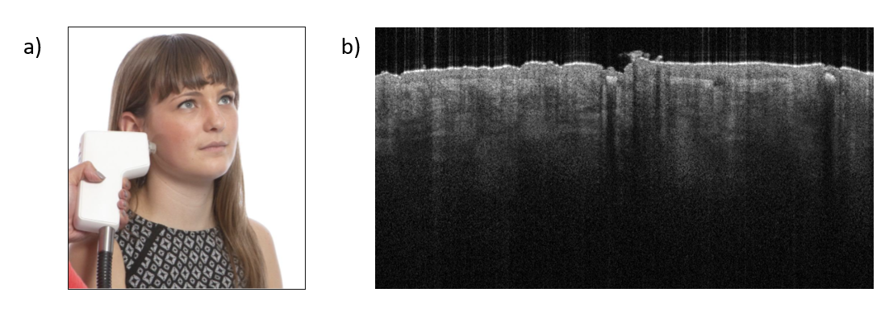
Figure 1 OCT measurement. a) Example of probe placement on the cheek from Vivosight catalogue, b) The outcome of the measurement as presented by the manufacturer’s software.

- Sebutape sampling –

  - The researcher will apply commercially available Sebutapes on the participant’s skin at a predefined site using gloved hands to avoid cross contamination of skin proteins.
  - The adhesive side of the tape will be placed directly on the skin surface for 2 minutes.
  - After the 2 minutes collection interval, the researcher will remove the tapes from the skin site using tweezers. Taking care not to crumple or fold the samples, each tape will be placed flat into individually labelled glass vials and immediately transferred to an Ultra-Low Temperature Freezer. The tape samples will be stored in the freezer until analysis of biomarkers can be performed.
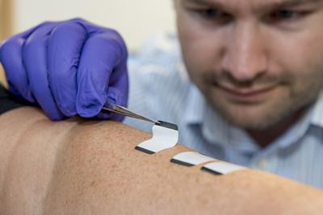
Figure 2 Example of placement of Sebutape on a participant’s forearm

- TEWL measurement –
  - The researcher will gently press the Tewameter probe (Figure 3a) on the skin area to be measured. The button on the side of the probe will be pressed to start the recording. The computer will show a signal and stores it while it plays a tone every second to indicate the signal was recorded.
  - TEWL and temperature will be continuously recorded for a period of 1 minute.
  - After 60 seconds, the researcher will press the button again to end the measurement.
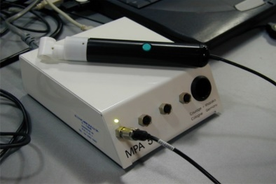
  - This will be repeated 2 times.
Figure 3 TEWL measurement. a) Open-chamber method, b) Temperature and humidity sensors inside the probe and C) The outcome of the measurement as presented by the manufacturer’s software.
a)
b)
c)

- Hydration measurement –
- The researcher will gently press the Corneometer probe on the skin area to be measured (Figure 4a). The computer shows a signal and stores it while it plays a tone to indicate the signal was recorded.
- This will be repeated 5 times.
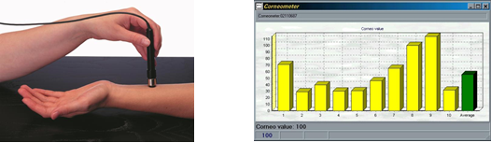
Figure 4 Hydration measurement. a) The Corneometer probe and b) the outcome of the measurement as presented by the manufacturer's software

Following this, the mechanical stimulus will be applied. For the left forearm, cheek, and neck,
you will be asked to shave at the specified skin site on the using the electric shaver for 60 seconds. For the right forearm, the researcher will conduct tape stripping at the specified site. We will then ask you to rate the level of skin sensitivity you feel on a scale from 1 to 10. After 20 minutes, the measurements methods from before shaving will be repeated to record the post-stimulus skin parameters.

Are there any benefits in my taking part?
A £25 John Lewis voucher will be available on completion of the research project.
Additionally, your participation will contribute to establishing individual thresholds of tolerance to external mechanical stimuli. This will benefit the development skin friendly consumer products.

Are there any risks involved?
To minimise risks associated with cross contamination of biological substances, the shaving unit will be cleaned as per manufacturer guidelines. Furthermore, to minimise risks associated with COVID-19, the shaver will be disinfected as well.
Additionally, all researchers and participants will be provided personal protective equipment (face masks, hand washing/gloves, and aprons). Facilities to wash hands and to maximise social distancing will also be available. All research will be conducted under the Clinical Academic Facility Method Statement for keeping researchers and participants safe during COVID-19.

What data will be collected?
Personal data including your name and signature (consent forms) will be kept in a locked cabinet in the lead researchers office (card access only). This will only be accessible to the lead researcher. Thereafter, you will be given an anonymised reference number, which will be linked to all subsequent data we collect from you during this study.

During the study we will collect data regarding your age, gender, height, and weight. In addition, we will collect data regarding your shaving habits (that is, frequency of shaving facial hair and type of tool used). We will also collect data to characterise the skin parameters at the forearm, cheek, and neck, at baseline and after shaving. Furthermore, we will place a small tape on your skin to collect sebum, which is a natural oil released from the skin surface. We will use this sebum to analyse whether your skin has reacted to the external mechanical stimuli.

To monitor the growth of hair between the sessions, we will capture close-up photographs of the skin surface. There will be no personal identification factors included in this photograph. This will be an optional element to the consent form, i.e., you may opt out of photos being taken.

Physical study forms will be kept in a study file, stored in the Clinical Academic Laboratories (AA80) in a locked cabinet. Electronic files will be stored on a password protected laboratory computer. Anonymised files from the data collection will be shared between researchers (only those named in the above application) using an encrypted data stick.

Will my participation be confidential?
Your participation and the information we collect about you during the course of the research will be kept strictly confidential.

Only members of the research team and responsible members of the University of Southampton may be given access to data about you for monitoring purposes and/or to carry out an audit of the study to ensure that the research is complying with applicable regulations. Individuals from regulatory authorities (people who check that we are carrying out the study correctly) may require access to your data. All of these people have a duty to keep your information, as a research participant, strictly confidential.

In accordance with data protection policy of the University of Southampton and the Data Protection Act 2018, your data will be kept anonymously (coded), and stored in a filing cabinet in the locked office of Dr Peter Worsley. Anonymous data will also be stored on computers and coded with an unidentifiable identification number in the laboratory, which is also locked. Only the investigators will have access to the data. Data will be stored securely for 10 years.

Do I have to take part?
No, it is entirely up to you to decide whether or not to take part. If you decide you want to take part, you will need to sign a consent form to show you have agreed to take part.

What happens if I change my mind?
You have the right to change your mind and withdraw at any time without giving a reason and without your participant rights being affected. If you withdraw from the study, we will keep the information about you that we have already obtained for the purposes of achieving the objectives of the study only.

What will happen to the results of the research?
Your personal details will remain strictly confidential. The data will be stored on an electronic database as per EU open access agreement. Research findings made available in any reports or publications will not include information that can directly identify you without your specific consent. After we have finished the study, we will write the findings up for publication in scientific journals and conference abstracts. These will present anonymised data from the study, where no personal information will be disclosed.

Where can I get more information?
If you would like further information before deciding if you would like to take part in our study, please contact the lead research, Dr Peter Worsley using the following email: p.r.worsley@soton.ac.uk.
p.chaturvedi@soton.ac.uk

What happens if there is a problem?
If you have a concern about any aspect of this study, you should speak to the researchers who will do their best to answer your questions.
If you remain unhappy or have a complaint about any aspect of this study, please contact the University of Southampton Research Integrity and Governance Manager (023 8059 5058, rgoinfo@soton.ac.uk).

For enquiries to the research team please contact
Dr Peter Worsley
Tel: 02381 208287
Email: P.R.Worsley@soton.ac.uk

Data Protection Privacy Notice
The University of Southampton conducts research to the highest standards of research integrity. As a publicly-funded organisation, the University has to ensure that it is in the public interest when we use personally-identifiable information about people who have agreed to take part in research. This means that when you agree to take part in a research study, we will use information about you in the ways needed, and for the purposes specified, to conduct and complete the research project. Under data protection law, ‘Personal data’ means any information that relates to and is capable of identifying a living individual. The University’s data protection policy governing the use of personal data by the University can be found on its website (https://www.southampton.ac.uk/legalservices/what-we-do/data-protection-and-foi.page).

This Participant Information Sheet tells you what data will be collected for this project and whether this includes any personal data. Please ask the research team if you have any questions or are unclear what data is being collected about you.

Our privacy notice for research participants provides more information on how the University of Southampton collects and uses your personal data when you take part in one of our research projects and can be found at http://www.southampton.ac.uk/assets/sharepoint/intranet/ls/Public/Research%20and%20Integrity%20Privacy%20Notice/Privacy%20Notice%20for%20Research%20Participants.pdf

Any personal data we collect in this study will be used only for the purposes of carrying out our research and will be handled according to the University’s policies in line with data protection law. If any personal data is used from which you can be identified directly, it will not be disclosed to anyone else without your consent unless the University of Southampton is required by law to disclose it.

Data protection law requires us to have a valid legal reason (‘lawful basis’) to process and use your Personal data. The lawful basis for processing personal information in this research study is for the performance of a task carried out in the public interest. Personal data collected for research will not be used for any other purpose.

For the purposes of data protection law, the University of Southampton is the ‘Data Controller’ for this study, which means that we are responsible for looking after your information and using it properly. The University of Southampton will keep identifiable information about you for 10 years after the study has finished after which time any link between you and your information will be removed.

To safeguard your rights, we will use the minimum personal data necessary to achieve our research study objectives. Your data protection rights – such as to access, change, or transfer such information - may be limited, however, in order for the research output to be reliable and accurate. The University will not do anything with your personal data that you would not reasonably expect.

If you have any questions about how your personal data is used, or wish to exercise any of your rights, please consult the University’s data protection webpage (https://www.southampton.ac.uk/legalservices/what-we-do/data-protection-and-foi.page) where you can make a request using our online form. If you need further assistance, please contact the University’s Data Protection Officer (data.protection@soton.ac.uk).

