Synthesis and characterization of lead metallated non- peripherally substituted octa-octyl tetrabenzo(aza)porphyrins showing face-to-face columnar stacking in the crystal phase

Lydia Sosa-Vargas^{a,b}, Simon J Coles^{c}, Graham J Tizzard^{c}, Isabelle Chambrierª,
Michael J Cook^{a,}* and Andrew N Cammidge^{a,}*
ªSchool of Chemistry, University of East Anglia, Norwich Research Park, Norwich NR4 7TJ, UK
^{b}Current address: Sorbonne Université, CNRS, Institut Parisien de Chimie Moléculaire (IPCM), Paris, France
^{c}EPSRC National Crystallography Service, School of Chemistry, University of Southampton, Southampton SO17 1BJ, IK

Dedicated to Prof. Jonathan L. Sessler on the occasion of his 65th birthday

ABSTRACT: The full range of porphyrin-phthalocyanine hybrids can be synthesized by treatment of 1,4-dioctylphthalonitrile with varying equivalents of MeMgBr to produce mixtures favoring specific hybrid structures and the tetrabenzoporphyrin in the extreme case. The individual macrocycles can be isolated in pure form as their magnesium derivatives and subsequently demetallated to give the parent metal-free compounds. Insertion of lead proceeded smoothly with all hybrids using lead (II) acetate. In the case of monoaza- and triaza-hybrids, the resulting materials could be recrystallized to give crystals suitable for X-ray diffraction. The crystal structures are distinctive from previously reported examples of non-peripherally substituted octaalkyl phthalocyanines and hybrids (metal-free and metallated, including with lead) and they each present infinite stacks of cofacial macrocycles linked through bridging lead ions which, as expected, lie outside of the macrocycle plane.
KEYWORDS: Lead phthalocyanines, phthalocyanine-porphyrin hybrids, crystal structure, columnar stacks.

INTRODUCTION
Tetrabenzo(aza)porphyrin hybrids are intermedi- ate structures that lie between phthalocyanines and (tetrabenzo)porphyrins, and they can be defined as the structures depicted when 1, 2 (two isomers), or 3 of the bridging (“meso”) nitrogens of a phthalocyanine are replaced by carbon bridges (Fig. 1). Early syntheses of hybrid compounds undertaken independently by Heil- berger, Dent, and Linstead [1] in the 1930s utilized reac- tions of phthalonitrile with methyl magnesium iodide, methyllithium, or phthalimidine acetic acid. The groups of Galanin [2], Leznoff [3], Luk’yanets [4], and oth- ers [5], extended both the chemistry and the range of

*Correspondence to: Andrew N Cammidge, email: a.cammidge@uea.ac.uk, tel: +44 (0)1603-592011.
derivatives available, leading to the synthesis of exam- ples of all four hybrid compounds. Particular attention has been given to the incorporation of substituents on the benzenoid rings and/or at the meso carbon atoms and the area has been reviewed [6]. In addition, our group and others have developed and studied new synthetic routes, significantly overcoming some of the initial issues [7–10]. Most recently we have disclosed additional con- trol in the synthesis of TBTAPs that permits direct access to meso-aryl 3:1 (ABBB-Ar) and 2:2 (ABBA-Ar) deriva- tives [11] (Fig. 1, inset).
In some of our earliest work on hybrids, we discov- ered that the introduction of (alkyl) substituents at the non-peripheral benzo positions prevented the incor- poration of any bulky functionality at the neighboring meso site [5c]. Indeed, when reactions with 1,4-dialkyl

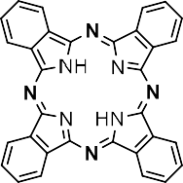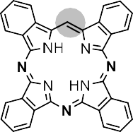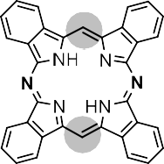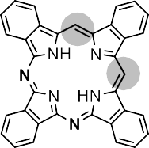
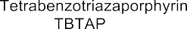
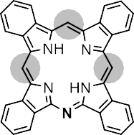
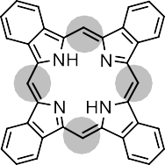

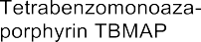
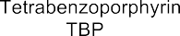
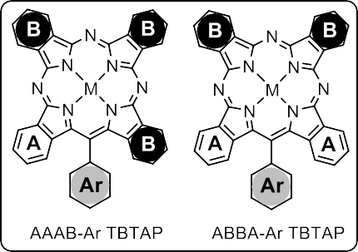
Fig. 1. The parent structures of the phthalocyanine-tetrabenzoporphyrin hybrids and a recent example of structural variation across benzo- and meso positions in tetrabenzotriazaporphyrins (TBTAPS) (inset [11]).

phthalonitriles were initiated with Grignard or lithium reagents other than methyl (i.e. other than MeMgX or MeLi), the resulting TBTAP hybrid that was isolated always only included hydrogen bonded at the meso posi- tion, with the rest of the initiator chain lost at some stage of the reaction [5c]. Consequently, in all subsequent reac- tion development, we employed only MeMgBr, finding that careful reaction control could favor the formation of specific hybrids. When a large excess of Grignard reagent
is used the major isolated macrocycle is, in fact, the tetra- benzoporphyrin [8] (Scheme 1).

EXPERIMENTAL

General methods
¹H NMR spectra at 400 MHz were recorded on an Ultrashield PlusTM 400 spectrometer and at 500 MHz

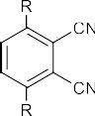
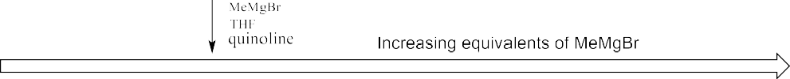
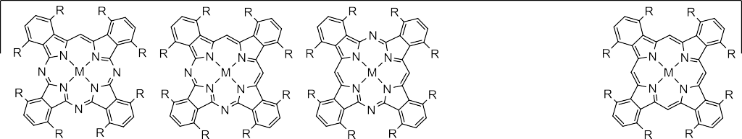
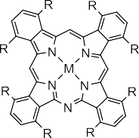

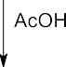
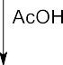

Scheme 1. Synthesis of the full range of magnesium and metal-free hybrid macrocycles bearing n-octyl chains (“8”) on the non- peripheral benzo-sites [8b].

on a Bruker Ascend 500 instrument. Signals are quoted in ppm as δ downfield from tetramethylsilane (δ= 0.00) with residual solvent peaks used as reference. ¹³C NMR spectra could not be obtained due to aggregation and pre- cipitation at higher concentrations. Ultra-violet spectra were recorded using a PerkinElmer Lambda 365 spectro- photometer. Mass analysis was undertaken using a Shi- madzu MALDI-TOF spectrometer with a TA1586Ade plate and DCTB as matrix and calibrated against 1,4,8,11,15,18,22,25-octaoctyl phthalocyanine. Isotopic distribution patterns matched calculated relative inten- sity profiles. Column chromatography was performed at ambient temperature using Aldrich® neutral alumina with solvent systems given as volume ratios.
X-Ray diffraction was performed at the EPSRC Ser-
vice Centre (University of Southampton) on a Rigaku FRE+ diffractometer equipped with VHF Varimax confo- cal mirrors and an AFC12 goniometer and an HG Saturn 724+ detector. The crystal was kept at a steady T = 100(2) K during data collection. The structure was solved with the ShelXT 2018/2 [12] structure solution program using the dual methods solution method and by using Olex2 1.5-alpha [13] as the graphical interface. The model was refined with olex2.refine 1.5-alpha [14] using full matrix least squares minimization on F² minimization.
Magnesium and metal-free octaoctyl hybrid macrocy- cles and tetrabenzoporphyrins were synthesized as previ- ously reported [8].

Synthesis

Synthesis of lead tetrabenzo(aza)-porphyrin derivatives – typical procedure for 1,4,8,11,15,18,22,25-octakis(octyl)- tetrabenzo[b,g,l,q]-[5,10,15]triaza porphinato lead 8PbTBTAP
1,4,8,11,15,18,22,25-Octakis(octyl)-tetrabenzo- [b,g,l,q][5,10,15]triazaporphyrin 8H₂TBTAP (20.0 mg, 0.014 mmol) was dispersed together with lead acetate trihydrate (8.1 mg, 0.022 mmol) in pentanol (10.0 mL) using an ultrasonic bath. The dispersed mixture was stirred and heated to reflux for 15 minutes. After cooling, the product was precipitated by the addition of distilled water, extracted with DCM, and washed repeatedly with water to remove inorganic residues. The organic extract was dried with Na₂SO₄ and the solvent evaporated to give the expected product as a light-green fine powder. Puri- fication by column chromatography using neutral alu- mina as the stationary phase and DCM as eluent gave the product as a single fraction which, after re-crystallization using DCM/MeOH, yielded 8PbTBTAP as fine, green crystals (16.0 mg, 70%). MALDI-MS: isotopic cluster at m/z 1615 [100%, M⁺], ¹H NMR (500 MHz, toluene-d₈, ppm) 11.07 (1H, s), 7.97-7.94 (6H, m), 7.85 (2H, br-d,
J = 7.0 Hz), 5.08-4.93 (6H, br-m), 4.92-4.67 (6H, br-m),
4.41-4.29 (2H, br-m), 4.13-4.04 (2H, br-m), 2.49-2.35
(16H, m), 1.86-1.68 (16H, br-m), 1.46-1.13 (64H, m),
0.94-0.79 (24H, m), λ_{max} (log ε) (dichloromethane) 744 (5.13), 710 (5.13), 677 (4.99), 498 (4.85) nm.

Crystal Data
C₉₇H₁₄₅N₇Pb, M_{r} = 1616.497, tetragonal, P4cc (No. 103), a = 23.4355(4) Å, b = 23.4355(4) Å, c = 7.8133(4) Å, a = b = g = 90°, V = 4291.2(2) Å³, T = 100(2) K, Z =
2, Z’ = 0.25, m(Mo K_{a}) = 2.016 mm⁻¹, 23363 reflections measured, 4512 unique (R_{int} = 0.0931) which were used in all calculations. The final wR₂ was 0.1412 (all data) and R₁ was 0.0520 (I≥2 s(I)). Further crystal structure detail is given in the Supporting Information.

1,4,8,11,15,18,22,25-Octakis(octyl)-tetrabenzo[b,g,l,q] [5,10] diazaporphinato lead 8PbTBcisDAP
Prepared as above from 8H₂TBcisDAP (10.0 mg, 0.007 mmol) and lead acetate trihydrate (4.0 mg, 0.011 mmol) to give 8PbTBcisDAP as a green solid (7.8 mg, 68%). MALDI-MS: isotopic cluster at m/z 1614
[100%, M⁺]. ¹H NMR (400 MHz, toluene-d₈, ppm) 11.17 (2H, s), 7.98 (2H, s), 7.96 (2H, d J = 8.0 Hz), 7.87 (2H, d,
J = 8.0 Hz), 7.82 (2H, s), 5.15 (2H, dt, J = 14.0, 7.0 Hz),
5.00 (4H, t, J = 7.0 Hz), 4.75 (2H, dt, J = 15.0, 6.0 Hz),
4.48-4.37 (4H, m), 4.25-4.07 (4H, m), 2.55-2.10 (16H,
m), 2.05-2.00 (16H, m), 1.50-1.20 (64H, m), 0.91-0.80
(24H, m). λ_{max} (dichloromethane) 698, 483 nm.

1,4,8,11,15,18,22,25-Octakis(octyl)- tetrabenzo[b,g,l,q]-[5,15] diazaporphinato lead 8PbTBtransDAP
Prepared as above from 8H₂TBtransDAP (10.0 mg, 0.007 mmol) and lead acetate trihydrate (4.0 mg, 0.011 mmol) to give 8PbTBtransDAP as a green solid (8.1 mg, 70%). MALDI-MS: isotopic cluster at m/z 1614
[100%, M⁺]. ¹H NMR (500 MHz, CD₂Cl₂, ppm) 11.20
(2H, s), 7.96 (8H, s), 4.80 (4H, dt, J = 14.0, 8.0 Hz), 4.68
(4H, dt, J = 14.0, 7.5 Hz), 4.46 (4H, dt, J = 15.0, 7.0 Hz),
4.25 (4H, dt, J = 16.0, 8.0 Hz), 2.48-239 (8H, m), 2.22-
2.11 (8H, m) 1.82-1.68 (8H, m), 1.63-1.54 (8H, m) 1.52-
1.12 (64H, m), 0.87-0.82 (12H, m), 0.79-0.74 (12H, m).
λ_{max} (dichloromethane) 737, 702, 655, 499 nm.

1,4,8,11,15,18,22,25-Octakis(octyl)-tetrabenzo[b,g,l,q]-
[5] monoazaporphinato lead 8PbTBMAP
Prepared as above from 8H₂TBMAP (20.0 mg, 0.014 mmol) and lead acetate trihydrate (8.1 mg, 0.022 mmol) to give 8PbTBMAP as small black nee- dle-like crystals (17.2 mg, 75%). MALDI-MS: isotopic cluster at m/z 1613 [100%, M⁺]. ¹H NMR (500 MHz, toluene-d₈, ppm) 11.51 (1H, s), 11.36 (2H, s), 8.05 (2H,
d, J = 8.0 Hz), 7.96 (2H, d, J = 8.0 Hz), 7.92 (4H, s), 5.22
(2H, dt, J = 14.0, 8.0 Hz), 5.08 (2H, dt, J = 14.0, 8.0 Hz),
4.63-4.53 (8H, m), 4.42-4.23 (4H, m), 2.60-2.43 (16H,
- , 1.88-1.77 (16H, m), 1.55-1.15 (64H, m), 0.95-0.77

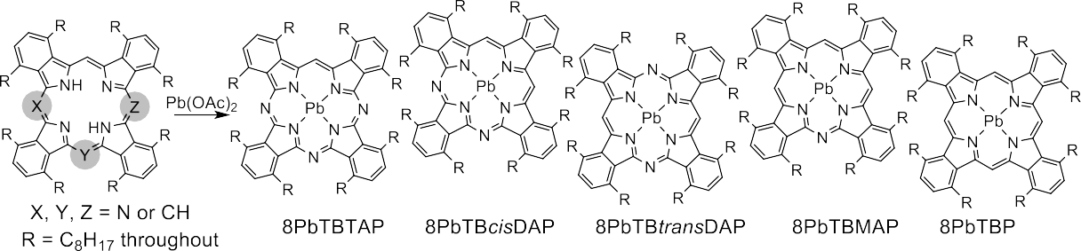

Scheme 2. Synthesis of the lead hybrid macrocycles.

(24H, m). λ_{max} (log ε) (dichloromethane) 699 (5.46), 680
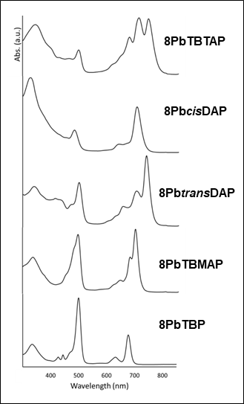 | 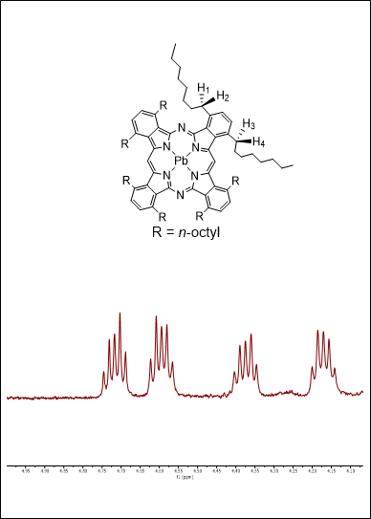
(a) | (b)

(5.24), 654 (5.15), 499 (5.43) nm.

Crystal Data
C₉₉H₁₄₇N₅Pb, M_{r} = 1614.521, tetragonal, P4cc (No. 103), a = 23.5055(4) Å, b = 23.5055(4) Å, c = 7.7588(4) Å, a = b = g = 90°, V = 4286.8(2) Å³, T = 100(2) K, Z =
2, Z’ = 0.25, m(Mo K_{a}) = 2.017 mm⁻¹, 24700 reflections measured, 4898 unique (R_{int} = 0.0766) which were used in all calculations. The final wR₂ was 0.1091 (all data) and R₁ was 0.0430 (I≥2 s(I)). Further crystal structure detail is given in the Supporting Information.

1,4,8,11,15,18,22,25-Octakis(octyl)-tetrabenzo[b,g,l,q]- porphinato lead 8PbTBP
Prepared as above from 8H₂TBP (10.0 mg, 0.007 mmol) and lead acetate trihydrate (4.0 mg, 0.011 mmol) to give 8PbTBP as a black-brown solid (6.9 mg, 60%). MALDI-MS: isotopic cluster at m/z 1612
[100%, M⁺]. ¹H NMR (500 MHz, CD₂Cl₂, ppm) 11.38
(4H, br-s), 8.02 (8H, s), 4.60-4.48 (8H, br-m), 4.44-4.32
(8H, br-m), 2.54-2.39 (16H, m), 1.83-1.70 (16H, m),
1.55-1.219 (64H, m), 0.92-0.78 (24H, m). λ_{max} (dichlo-
romethane) 677, 632, 500 nm.

RESULTS AND DISCUSSION
The full range of magnesium hybrids was prepared by treating 1,4-dioctylphthalonitrile with MeMgBr (varying equivalents) followed by heating in quinoline. The indi- vidual compounds were isolated in pure form by chro- matography and subsequently demetallated using acetic acid, as described earlier [8]. Each hybrid (and the tetra- benzoporphyrin) was treated with lead acetate in reflux- ing pentanol - conditions developed for the introduction of lead into the parent phthalocyanines [15]. Pure materi- als were obtained by chromatography on neutral alumina followed by recrystallization.
UV-visible spectra for the series of lead hybrids are shown in Fig. 2. They follow the general trends observed for other metalated hybrids but are each red-shifted by 40–50 nm compared to the magnesium and copper deriv- atives [8]. As expected, the spectra for mono- and triaza derivatives show a significant reduction of symmetry in

Fig. 2. a) UV-visible spectra of the series of hybrids in dichloro- methane. b) Expansion of the 4-5 ppm (benzylic proton) region of the ¹H NMR spectrum of 8PbtransDAP (in CD₂Cl₂).
the core, and the porphyrin-like Soret band at ca 500 nm increases in relative intensity as the core nitrogens are replaced by methines. The loss of symmetry is also clearly observed in the ¹H NMR spectra through the series. The spectra also demonstrate that the Pb lies out of the macro- cycle plane in each system, resulting in the benzylic pro- tons becoming diastereotopic. This is most clearly seen for the higher symmetry 8PbtransDAP derivative, and the relevant region of the expanded spectrum is shown in Fig. 2b. The 1H NMR spectra for all derivatives are shown in the Supporting Information.
The lead monoaza- and triaza-hybrids 8PbTBTAP and 8PbTBMAP were obtained as crystalline samples in sufficient quantity to allow a more detailed assessment of their properties. The non-peripherally octalkyl substi- tuted phthalocyanines are well known to exhibit diverse discotic liquid crystal behavior, and this has been shown to continue through the related hybrids [8]. Series of metal-free and copper derivatives have been character- ized and all show columnar mesophases. A preliminary analysis of the thermal properties by polarizing optical microscopy of the lead hybrids was performed and ini- tially indicated transitions at 63 °C and 70 °C for 8PbT- BTAP and 8PbTBMAP respectively, with clearing to isotropic liquids occurring at ~240 °C for both samples. The transitions initially appeared reversible but with

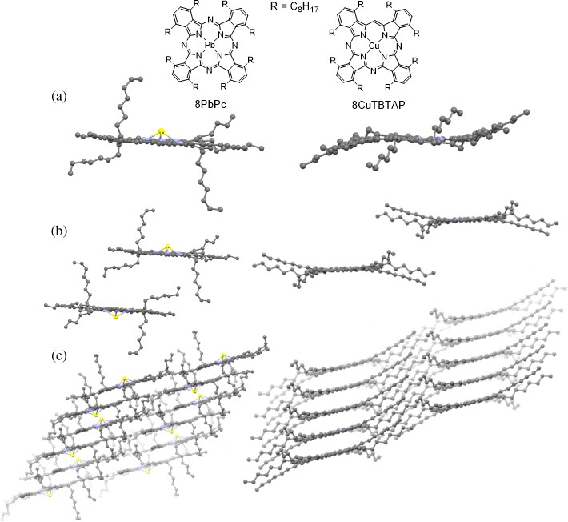
Fig. 3. X-ray crystal structures of 8PbPc [15] and 8CuTBTAP [8b] showing (a) a side-on view of a single molecule; (b) unit cell packing; (c) extended packing structure showing offset stacks in tilted parallel columns.

some hysteresis, producing textures that were ambigu- ous but consistent with the formation of columnar hex- agonal phases. For 8PbTBMAP, a further transition was observed at 116°C and a texture consistent with a columnar rectangular mesophase is produced. However, although analysis by DSC (Supporting Information) showed transitions at the same temperatures, the high- temperature transitions are unusually broad (15–50 °C) and not representative of transitions for pure liquid crys- talline materials. The assignments are therefore tentative and considered with caution. It is known that related lead phthalocyanines are prone to demetallation in moder- ately harsh conditions [15] and the results obtained here indicated that decomposition occurs on heating.
Crystals suitable for X-ray diffraction were obtained by slow crystallization from dichloromethane-methanol mixtures, and the solid-state structures show significant contrast to the known, closely related structures for the symmetrical non-peripherally substituted lead octaoc- tyl phthalocyanine (8PbPc) [15] and copper tetraben- zotriazaporphyrin (8CuTBTAP) [8b]. The structures of these two known derivatives are illustrated in Fig. 3. As expected, in 8PbPc the lead ion lies out of the macrocycle plane. The macrocycle itself deviates from planarity and a saddle-shaped conformation is observed. A similarly
distorted conformation has been reported for the related, shorter chain 6PbPc derivative [16]. In contrast, copper is located within the macrocycle in 8CuTBTAP and, overall, the macrocycle is essentially planar. Importantly, in both cases, the macrocycles are significantly offset in the crystal packing, with negligible interactions between the metal of one macrocycle and its neighbors.
The X-ray diffraction data for 8PbTBTAP and 8PbT- BMAP indicate elements of disorder and possible modu- lation, making them challenging to solve. The structures were both solved in P4cc with inversion twinning, and it is immediately apparent that, despite the minimal molec- ular structural changes, the macrocycle arrangements are very different to the parent 8PbPc. 8PbTBTAP and 8PbTBMAP are essentially isostructural. The molecu- lar structures and packing arrangements are shown in Fig. 4. Unusually and unlike other examples, the two new structures display stacks of face-to-face macrocycles in infinite columns in which the lead ions bridge between the central N4 units of the TBTAP/MAP macrocycles. In each case, the Pb sits on a crystallographic 4-fold axis and appears possibly disordered with large Q-peaks above and below the atom. All attempts to model this disorder failed, so the Pb atoms were refined anhar- monically, which accounts for the Q-peaks. Separation

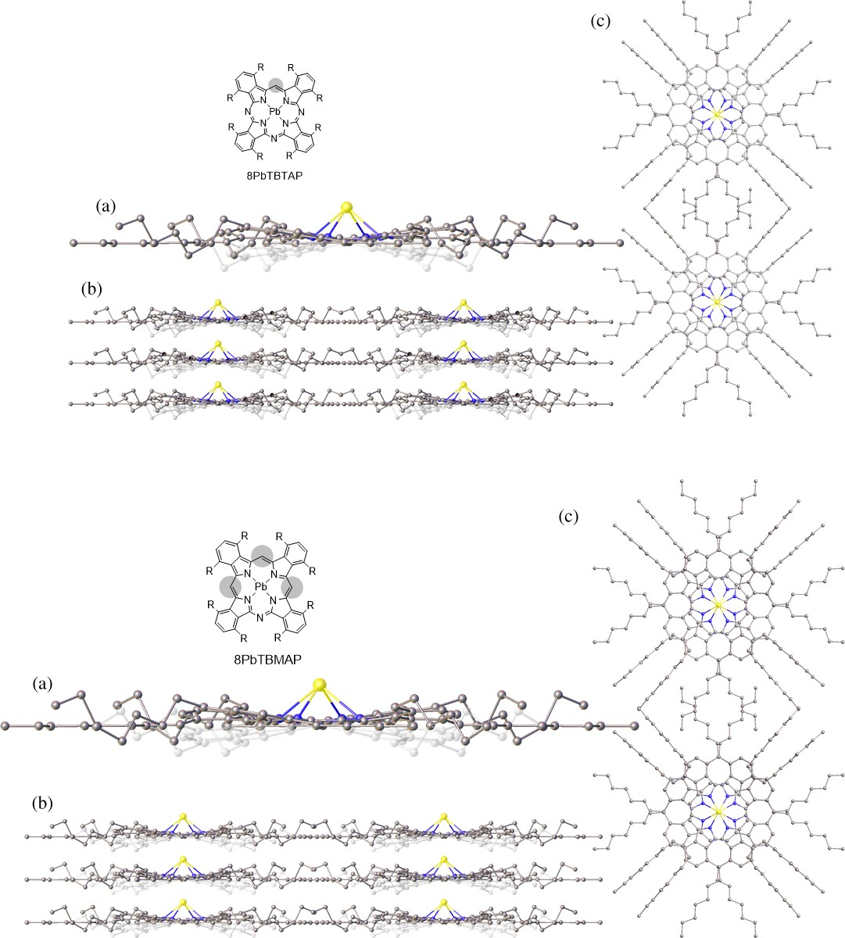

Fig. 4. X-ray crystal structures of 8PbTBTAP (top) and 8PbTBMAP (bottom) showing (a) Side-on view of a single molecule; (b) unit cell packing (side) and (c) top showing face-to-face stacking of the macrocycles and bridging of lead ions through the infinite columnar stacks. Ghosted atoms and bonds indicate the disorder (a and b).

along the stacks is closer in 8PbTBMAP compared to 8PbTBTAP, with calculated average Pb-Pb distances of 3.8794(2) Å and 3.9066(2) Å respectively. This observa- tion is in line with the previously observed increase in central cavity size as nitrogen bridges are replaced by methines [8a].

CONCLUSION
In conclusion, we report the synthesis of the full range of non-peripherally substituted lead phthalocyanine- tetrabenzoporphyrin hybrids. Lead insertion proceeds smoothly from the isolated metal-free hybrids and in the case of two derivatives (8PbTBTAP and 8PbTBMAP),
the final compounds were isolated as crystalline solids in sufficient quantity to allow more in-depth character- ization. The crystal structures of these two hybrids have been solved and are significantly distinct from the parent lead phthalocyanine (8PbPc). In the new hybrid struc- tures, the macrocycles form infinite co-facial stacks in which lead ions bridge between the N₄ planes.

Acknowledgments
We thank CONACYT, Mexico, and UEA for funding (LXS-V). MJC gratefully thanks the Leverhulme Foun- dation for the award of a Leverhulme Emeritus Fellow- ship. SJC and GJT thank the EPSRC for funding.

Supporting information
Additional data are given in the supplementary mate- rial. This material is available free of charge via the Internet at https://www.worldscientific.com/doi/suppl/ 10.1142/S1088424623500876
Crystallographic data have been deposited at the Cambridge Crystallographic Data Centre (CCDC) under the numbers CCDC 2238769 [8PbTBTAP] and CCDC 2238770 [8PbTBMAP]. Copies can be obtained on request, free of charge, via https://www.ccdc.cam.ac.uk/ structures/ or from the Cambridge Crystallographic Data Centre, 12 Union Road, Cambridge CB2 1EZ, UK (fax:
+44 1223-336-033 or email: deposit@ccdc.cam.ac.uk)

REFERENCES
  - (a) Helberger JH and von Rebay A. Liebigs Ann.
1937; 531: 279–287. (b) Helberger JH, von Rebay
A. Liebigs Ann. 1937; 531: 205–218. (c) Dent CE. J.
Chem. Soc. 1938; 1–6; (d) Barrett PA, Linstead RP, Tuey GAP and Robertson JM. J. Chem. Soc. 1939; 1809–1820; (e) Barrett PA, Linstead RP, Rundall FG and Tuey GAP. J. Chem. Soc. 1940; 1079–1092.
  - (a) Galanin NE, Kudrik EV and Shaposhnikov GP. Russ. J. Gen. Chem., 2004; 74: 282–285. (b)
Galanin NE, Yakubov LA, Kudrik EV and Sha- poshnikov GP. Russ. J. Gen. Chem., 2008; 78: 1436–1440. (c) Yakubov LA, Galanin NE and Shaposhnikov GP. Russ. J. Org. Chem., 2008; 44: 755–760. (d) Galanin NE, Kudrik EV and Shaposh- nikov GP. Russ. J. Gen. Chem., 2005; 75: 651–655.
(e) Galanin NE, Kudrik EV and Shaposhnikov GP. Russ. J. Org. Chem., 2002; 38: 1200–1203. (f)
Galanin NE and Shaposhnikov GP. Russ. J. Gen. Chem., 2007; 77: 1951–1954.
  - (a) Leznoff CC and McKeown NB. J. Org. Chem., 1990; 55: 2186–2190. (b) Tse Y-H, Goel A, Hu M,
Lever ABP and Leznoff CC. Can. J. Chem. 1993;
71: 742–753.
  - Makarova EA, Kopranenkov VN, Shevtsov VK and Lukyanets EA. Chem. Heterocycl. Compd. 1989; 25: 1159–1164.
  - (a) Khelivina OG, Berezin, BD, Petrov, OA and Glazunov AV. Koord. Khim. 1990; 16: 1047–1052.
    - Ivanova YB, Churakhina YI, Semeikin AS and Mamardashvili NZ. Russ. J. Gen. Chem., 2009; 79:
833–838. (c) Cammidge AN, Cook MJ, Hughes DL, Nekelson F and Rahman M. Chem. Commun., 2005; 930–932.
  - (a) Cammidge AN, Chambrier I and Cook MJ. Sosa- Vargas L in Handbook of Porphyrin Science, Vol. 16 (Eds.: Kadish KM, Smith KM, Guilard R), World Scientific, New Jersey, London, 2012; pp. 331–404;
    - Kalashnikov VV, Pushkarev VE and Tomilova LG. Russ. Chem. Rev. 2014; 83: 657–675.
  - (a) Kalashnikov VV, Pushkarev VE and Tomilova LG. Mendeleev Commun., 2011; 21: 92–93. (b) Kalashnikov VV and Tomilova LG. Macrohetero- cycles, 2011; 4: 209–210.
  - (a) Cammidge AN, Chambrier I, Cook MJ, Hughes DL, Rahman M, Sosa-Vargas L. Chem. – Eur. J., 2011; 17: 3136–3146; (b) Mack J, Sosa-Vargas L, Chambrier I, Hughes DL, Isare B, Poynter RJ, Pow- ell AK, Cook MJ and Kobayashi N. Inorg. Chem. 2012; 51: 12820–12833.
  - (a) Díaz-Moscoso A, Tizzard GJ, Coles SJ and Cammidge AN. Angew. Chem. Int. Ed., 2013; 52: 10784–10787.b) Alharbi N, Díaz-Moscoso A, Tiz- zard GJ, Coles SJ and Cook MJ. Cammidge AN, Tetrahedron, 2014; 70: 7370–7379. (c) Alharbi N, Tizzard GJ, Coles SJ, Cook MJ and Cammidge AN. Tetrahedron, 2015; 71: 7227–7232.
  - Tejerina L, Yamamoto S, López-Duarte I, Martínez- Díaz MV, Kimura M and Torres T. Helv. Chim. Acta, 103, e2000085.
  - Alkorbi F, Díaz-Moscoso A, Gretton J, Chambrier I, Tizzard GJ, Coles SJ and Hughes DL. Cammidge AN. Angew. Chem. Int. Ed., 2021; 60: 7632–7636.
  - Sheldrick GM. Acta Cryst., 2015; A71: 3–8.
  - Dolomanov OV, Bourhis LJ, Gildea RJ, Howard JAK and Puschmann H. J. Appl. Cryst., 2009; 42: 339–341.
  - Bourhis LJ, Dolomanov OV, Gildea RJ, Howard JAK and Puschmann H. Acta Cryst. A, 2015; A71: 59–71.
  - Sosa-Vargas LX, Chambrier I, MacDonald CJ, Coles SJ, Tizzard GJ, Cammidge AN and Cook MJ.
J. Porphyrins Phthalocyanines 2013; 17: 511–521.
  - Burnham PM, Chambrier I, Hughes DL, Isare B, Poynter RJ, Powell AK and Cook MJ. J. Porphyrins Phthalocyanines 206, 10: 1202–1211.

