Supplementary Material Appendices

Appendix A: Standards for Reporting Qualitative Research Checklist (22)
Title | Development of the ‘Diabetes Together’ Intervention
Abstract | Describing 2 qualitative studies  - Semi-structured interviews with both members of 10 couples  - Think-aloud interviews with pairs of participants viewing intervention content.
Problem formulation | In South Africa, there is a need for better self-management of type 2 diabetes. Tackling this problem should use a holistic approach, including patients’ partners.
Research Question | In these two studies, we  - Discover the barriers and facilitators to good diabetes self-management in couples in South Africa  - Elicit feedback from South African couples on a prototype couples-focused intervention to support diabetes self-management
Qualitative Approach | We use the Person-Based Approach, that, for our first study, uses thematic analysis to code the barrier’s and facilitators to a target behaviour, and for our second study uses a Table of Changes to identify and prioritise feedback to improve an intervention.
Researcher Characteristics | Two research fellows and one diabetes nurse educator conducted the interviews.
Context | Participants were couples from low-income neighbourhoods in South Africa, where one member of the couple had Type 2 diabetes.
Sampling Strategy | Participants were recruited through word-of-mouth. Interviews were conducted until data had reached saturation.
Ethical Issues | Ethical approval was obtained from institutional ethic’s committees prior to commencement of the studies.
Data collection methods | Data was collected via interview, either face-to-face or by telephone.
Data collection instruments | A topic guide was used to prompt responses.
Units of Study | Participant characteristics are reported in the results. (p15, p22)
Data processing | Data was recorded on audio recorders and transcribed and check prior to analysis. Where the interview was not in English, this was translated to English during transcription.
Data analysis | For study 1, KS performed a thematic analysis. This was checked and agreed by co-authors. For study 2, KS performed a Table of Changes analysis, checked and agreed by co-authors.
Techniques to ensure trustworthiness | Results were reviewed with the team on a fortnightly basis, and the data re-examined in response to feedback to refine data interpretation.
Synthesis and interpretation | Themes are given in the results section (pp15-24)
Link to empirical data | Quotes are provided in the results section and appendices (pp15-24, Appendix F)
Integration with prior work | Results strongly support prior findings on the roles of a patient’s partner in the management of Type 2 Diabetes
Limitation | Data collection and participant recruitment was limited by the Sars-Covid-19 pandemic.
Conflicts of interest | None
Funding | Funding reported (p29)

Appendix B: Example Topic Guides
Phase 1 Formative Interview Schedule (partner)

Ice-breaker/relationship questions
- Can you tell me about anything you do at the moment to look after your health?
- Ok and now can you tell me anything about your relationship with your partner?
  - What are some of your favourite things about your relationship?

- What do you think are some of the most important things for you in your life at the moment?

What’s it like living with someone who has Type 2 diabetes
- Can you tell me about what’s it like for you having a partner who has diabetes?
- How well-controlled do you feel your partner’s diabetes is?
- Is there anything that makes it easier for you to cope with your partner’s diabetes?
- What are some of the hardest things about living with a partner who has diabetes?
- How do you manage these challenges?
- How do you feel about living with someone about diabetes?
- Can you tell me about any fears you have around your partner’s diabetes?
- Is there anyone who helps your partner to manage their diabetes?
  - Probes: How do these people help your partner? Family, doctor, nurse, friends colleagues, support groups

Supporting your partner
- Can you tell me how you are involved in supporting your partner to manage their diabetes?
- What kinds of support do you usually offer? When/how often?
  - What about eating a healthy diet?
  - Doing physical activity?
  - Self-monitoring their blood sugar?
  - Taking their medication?
- How does your partner react to the support you offer them? How does it make you feel?
- What kind of support do you think your partner finds most helpful? And what do they find least helpful? Why?
- What changes would you like to see in how your partner manages their diabetes?
- How easy do you find it to talk about diabetes with your partner?
- What about talking about any fears or concerns with your partner?
- Do they talk to you about their diabetes? What things do they discuss?

How does diabetes affect your relationship?
- Can you tell me how diabetes has affected your relationship with your partner?
  - How has it affected your freedom to eat?
  - How has it affected your sleeping habits?
  - How has it affected your emotional reactions or your mood?
  - How has it affected your social life?
  - How has it affected your sexual relationship?
- Is there anything else that you want to talk about that we haven’t covered yet?

Phase 2 Think-aloud Interview Schedule (couple together)

Initial semi-structured interview questions
- Can you tell me about what’s it like for you both, as a couple, where one of you has diabetes?
- What do you understand about diabetes management? (What did you do differently after diagnosis?)
- How do you support each other in managing diabetes?

Think-aloud prompts (during video viewing)
- What are your first thoughts about this page/information/activity/session?
- What are you thinking now?
- Can you tell me a bit more about why you think that?
- Can you tell me what it is that you like/don’t like about that?

After they have finished viewing:
- Overall, how do you feel about this programme?
- Can you tell me about anything you felt was good about the programme?
- Can you tell me anything about the programme that you were less keen on?
- We’re aware that some people found parts of the programme challenging. Do you have any ideas about why that might have been?
  - Which parts do you think people found more challenging?
- What do you think should be changed?
- How would you feel about taking part in this programme with your partner?
  - Prompt about specific elements, e.g. diet changes, physical activity changes, medication adherence, relationship counselling
- Would you have any concerns about doing this?
- Can you tell me about anything else that you think might be useful for you and your partner in managing Type 2 diabetes?
- To finish with, I’d like you to try and think about which part of the programme you enjoyed most, and which you enjoyed least. Can you tell me about them?
  - Why was that?
- Is there anything else you would like to talk about that we haven’t already discussed?

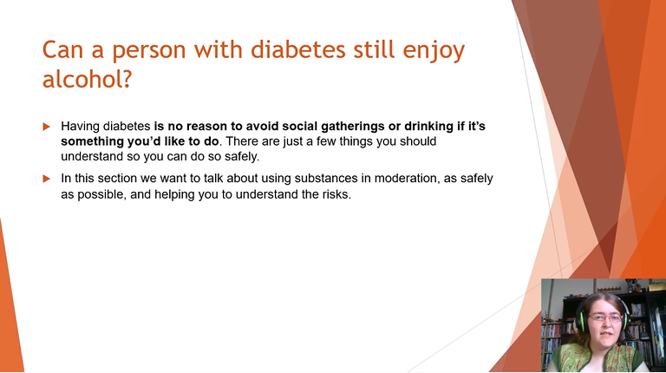
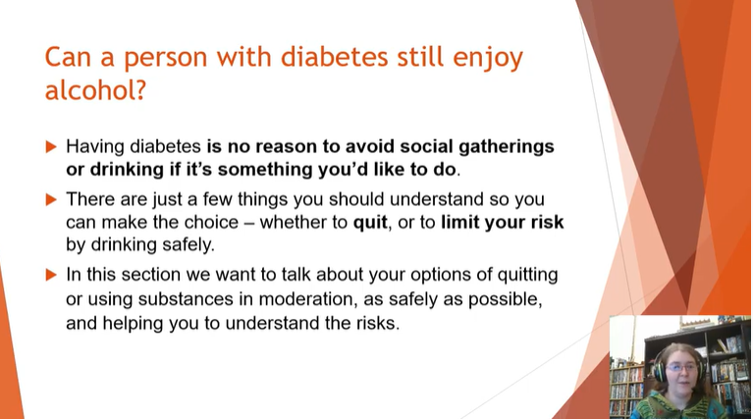
Appendix C: Changes to one of the ‘Substance Use’ slides to reflect participant preference for ‘Stop drinking’ advice alongside the ‘Reduce drinking’ message.

Appendix D: TIDIER Checklist for Diabetes Together.

- Name | Diabetes Together – couples programme to support T2D in South Africa
- Why? | All diseases occur in the context of a person’s lifestyle and relationships. T2D is complex to manage, involving medication, self-monitoring and lifestyle changes. Self-management of diseases can be improved by reaching a shared understanding with a partner and communicating together to support self-management. This programme educates people living with diabetes (PLWD) and their partners on T2D self-management, and provides instruction and support on communication and managing lifestyle pressures.
- What materials? | The intervention is two half-day workshops and up to 4 couples counselling sessions. Participants are provided with didactic information from a powerpoint presentation and guided discussion. For each workshop, participants were provided with a short hand-out booklet with important information from each section and a guided goal-setting and goal review handout, and a recipe book designed for PLWD in South Africa.  The intervention contains the following sections:  Workshop 1:  - Stories from Example Couples  - Diabetes Information  - Physical Activity  - Healthy Eating  - Couples’ Communication  - ‘SMARTER’ Goal Setting  Workshop 2:  - Substance Use  - Stress Management  - Fears and Complication  - Sexual Relationships  - Gender Roles  - Goal review  The intervention uses quizzes, discussion points and stories of similar couples in similar situations throughout. The ‘Couples’ communication’ section uses a roleplay demonstration and the ‘Stress Management’ section has a guided Mindfullness Meditation. Guided goal setting and goal planning at the end of workshop 1 is followed up by goal review in workshop 2.
- What procedures? | The two workshops take place on a Saturday morning 2 weeks apart. The couples’ counselling sessions take place every 2 weeks following the workshops.
- Who provided? | The workshops are delivered by experienced researchers in the field of public health. They are supported by clinicians with expertise in supporting diabetes in South Africa and a research support team. The couples counselling sessions are conducted by a trained couples’ counsellor, following a rehearsed topic guide.
- How? | Workshops are delivered in a large seminar room with 10-20 couples. A second room was used to split the group into 2 groups of PLWD/partners or males/females in the second workshop. Couples counselling sessions occur with a single couple and the counsellor.
- Where? | Workshops are held at a central location accessible to all couples, either by providing transport or within the community that they live.
- When and how much? | Workshops take place 2 weeks apart on a Saturday. Couples counselling sessions are organised individually with the counsellor, aiming to take place about 2 weeks apart. A maximum of 4 couples counselling sessions are provided.
- Tailoring | Participants are encouraged to discuss with their partner the parts of the intervention that are relevant to their lives and to set their own goals for better diabetes self-management. This could be dietary (e.g. increasing proportion of vegetables in their meals, reducing sugar in tea), physical activity (e.g. walking rather than taking the bus; standing while preparing meals), self-monitoring (e.g. measuring blood sugar at a certain time every day), or something else (e.g. practicing better communication).
- Modifications | Not applicable.
- Planned fidelity | Powerpoint slides were created for all facilitators to use to present and provide discussion points. Videos were made of the slides being presented. In this iteration, it was not necessary to train facilitators as all facilitators were part of the study team. Following intervention refinement, a manual will be developed to describe the intervention and provide training to facilitators.
- Actual fidelity | Not applicable.

Appendix E: Sections Covered in Each Think-aloud session
Think aloud session number | Sections viewed
 | Viewed with own partner | Viewed with same-gender pairs | Viewed in PLWD/partner pairs
1 | Stories from Example Couples, Diabetes Information, Physical Activity, Healthy Eating
2 | Stories from Example Couples, Couples’ Communication | Gender Roles, Sexual Relationships | Stress Management, Fears and Complications
3 | Stories from Example Couples, Substance Use, Diabetes Information, Physical Activity | Gender Roles, Sexual Relationships
4* | Stories from Example Couples, Diabetes Information, Couples Communication, Physical Activity, Healthy Eating, Fears and Complications, Stress Management, Sexual Relationships, Goal Setting
5 |  | Gender Roles, Sexual Relationships | Stress Management, Fears and Complications

Appendix F: Phase 2 Table of Changes: Negative Comments

Think-aloud ID | Section | (M)ale or (F)emale/(P)artner or Person living with (D)iabetes | Quote | Proposed change | Actual Change | Priority: Must have, Ought to have, Could have, Would have
TA3_Nov_MvP_Couple | Diabetes Info | M/P | After drinking alcohol there is no need to test? I'm a bit confused… as far as I am concerned, alcohol has an impact on diabetes. | Explain or remove 'after you drink alcohol' from 'When should you test your blood sugar' | Remove this from the list | O
TA3_Nov_MvP_Couple | Diabetes Info | M/P | There is a lot of instructions that you must follow! It really opens our mind. | Is there too much information at once? | Allow for comments and questions after each section in the workshop | M
TA3_Nov_NoM | Diabetes Info | F/P | When he is checking the thing, eish I get very afraid, I get out and leave  Int: Testing  Part 1: I don’t even want to know what it says. Maybe as the time goes by I will get used to it but you see now, if I see that he is doing it, I go.  Int: It is scary | Partner is apprehensive of blood sugar monitoring. A demonstration of blood sugar monitoring might be helpful to familiarise participants. | No change; this could be offered, but no-one else asked for it. | W
TA1_Sep_MvP | Eat for Health | F/D | I: For people who have diabetes, they want to keep routines. But they also know that they are.  F: Yeah, and-  I: and it's not always very cheap  F: and you know what? In the ending, when it comes to diet. Yeah, it's hard because the doctor would say don't eat this and this and this – what else you like those? You you understand. | Participant does not want to change her routine foods | Offer recipe booklet, emphasize variety of healthy foods and alternatives. | O
TA1_Sep_NoM | Eat for health | F/P | Uhm... What about lean mincemeat | Define lean minced meat | Amended traffic light table | O
TA1_Sep_NoM | Eat for health | F/P | I do not see starch food (rice and pap). I would love to whether he can have those kinds of food or not, I also want to know more about portion sizes of such foods. Starchy foods are a staple for African people. I would really love to know which category these foods fall under. | Need to add/ clarify starchy carb group | Amended traffic light table | O
TA3_Nov_MvP_gender_205P_206D | Gender roles | M/D | Not for me. Me and my partner do everything together. Clean the veg, not cook the veg. | Does not resonate with how ppts feel their homelife is. | Restructured section to emphasize impact of diabetes on roles and the importance of communication within the couple | M
TA3_Nov_MvP_gender_205P_206D | Gender roles | M/P | As a man you need to have the power to provide... It's quite frustrating if a woman in your life has a salary that is more than yours. You feel like somehow your wife can bully you because of it. Now she sees that she has power... It affects your mindset, being a man... she provides more than you... it causes friction. | The intervention reveals problems, but does not guide them to think about solving them. | Restructured section to emphasize impact of diabetes on roles and the importance of communication within the couple | M
TA1_Sep_NoM | Getting Active | F/P | When he eats stuff like cakes, I tell him not to overdo it, He gets very moody and stressed. He will ask ‘so you do not want me to eat?’ so every time I am concerned about how he eats. When he is at work and sends me a please call me message, I make a plan to call and ask what’s wrong because I am often worried that something bad has happened or maybe he is hospital. when he has a wound, it takes long to heal. | Concerned about danger of work | Added injury to concerns page | M
TA1_Sep_NoM | Getting Active | F/P | Every time he goes to work, I worry. Because sometimes he works with heavy metal. There was a day, 3 or 4 months ago where a heavy metal piece fell on his foot. I was very worried because he stayed 3 weeks at home without going to work. Because when a diabetic person has a wound, it is very serious. I thought the extremes, thinking that maybe he will get to a point where he might be amputated. It worried me so much because he is the bread winner. | Concerned about risk of injury and amputation | Added injury to concerns page | M
TA1_Sep_NoM | Getting Active | M/D | Even at home, I sometimes join the kids when playing soccer, however I am usually cautious against overdoing it. Even my wife complains when I overdo it and struggle to breath. At work we also sometimes work in dusty environments and that also affects my breathing. So, there is a lot of concern regarding being active. I run out of breath easily, this is why I am trying to be consistently active. I do not want to overdo it. Even when playing street soccer with the kids, I play for just a few minutes. So, to answer this question, you just need to be careful and take it easy and build up strength. Even though sometimes your body can be sore, if you remain consistent your body gets used to it and not have pain after working out. So, the concerns about being active at work and at home are usually there. Sometimes on a particular day you realize that you worked very hard at work, and you experienced shortness of breath. | Concerned about shortness of breath | Added breathlessness to concerns page | O
TA1_Sep_NoM | Getting Active | F/P | Supporting him becomes harder when we are in public or events, you may find that the food is not good for his diet, but it is hard to reprimand him in public. I can only do it when we are home. | How to keep to diet when with others? | Add discussion point about this | O
TA1_Sep_NoM | Getting Active | F/P | He always shouts at me. You should know that a diabetic person may often shout at you in disagreement. So, I have learnt how he is. When you stay with a diabetic person you have to learn their behaviour. If you do not learn the person’s behaviour you will struggle a lot. | Stress around plwd skipping treatment, leading to marital strife. | Emphasize communication through the whole intervention | M
TA1_Sep_NoM | Getting Active | M/D | (activity) has helped me to control my sugar, I feel that it also improves my mood. I agree 100%. My wife does not like it when I lose weight, because she worries that I am getting ill again. When my diabetic was out of control, my weight dropped from size 42 to size 32. Now that I am well, I wear in between size 36 and 38. I am very happy with my weight. | What is a healthy weight? We could provide guidance on this - but ppts recognise that being larger is culturally attractive, not healthy. | No change | C
TA3_Nov_NoM | Getting Active | both | Female: That is what makes us fight. Because I tell him that once you start not feeling okay, leave it, I can do that. Sit down a bit. Rest. But he is the kind of person that maybe if he takes off all pillows he is the kind of person who wants to complete what he starts. But what we fight about is that he after that he feels pains not me, so why don’t you sit down and I will bring water for you to drink because you are the one who feels the pain not me. Then he feels like I am wrong or I am trying to control him, but I am thinking about him.  Male: It will be like I am abusing you. So (inaudible)  Female:I hope he can rest but when he has told himself that he will finish it… And maybe there is a damage that he doesn’t know of, that my fear. So I say when you feel something wrong… Yes, I know you will always feel like you want to complete the task but the body is tired. So put that feeling of wanting to complete and listen to the body. Because you get energy to do this task from the body. | Wanting to complete what you started/ not feel helpless. Add 'Avoiding Overdoing it' guidance. | No change - there is already guidance on starting small and building up. | W
TA4_Dec_NoM | Goal Setting | F/D | Int: Well first we need to be specific about what you want to change. And for you, what would that be?  Part 1: My diet. I eat well, but I want to stay on top of my game when it comes to what I eat because I know with diabetes once you control what you eat, you have gone a long way for a lot of things | The participant did not make a small, specific goal | Make this a guided activity, walk through example, provide more examples | M
TA3_Nov_NoM | Meet the Couples | F/P | I would sometimes find him angry and I would have to wipe and not show that I have eaten the chicken and I would put it nicely and change it up. I tell him now that you have diabetes you have to change the way you live and other things that you had been doing. There things that you should not do. It does not mean when you have diabetes it’s the end of the world. | Partner controlling PLWD's diet | Promote discussion over shared expectations of diabetes self-management throught workshop | M
TA2_Oct_B | Sexual Relationships | M/D | So, some of the things that we are eating. We eat liver with fat, we say, the fat makes swallowing the liver easy. You see. And the beer, it’s nice, it’s very nice. A glass this big is said to have too much starch and potatoes chips which are my favorite, fish and chips and things like that. So we find ourselves trapped in the lifestyle that is like that | Enjoy unhealthy food | In Eat for Health section provide tasty alternatives | O
TA5_Jan_MvP_females | Sexual Relationships | F/P | Even the family was asking, why are you not getting pregnant? It is because he is diabetic… They don't understand what is diabetic. | Family believe that plwd affects fertility | Add myth about fertility being affected to quiz | C
TA5_Jan_MvP_females | Sexual Relationships | F/P | Like me at first, I was like - what is going on? I was only 27... When he is drinking, I can't get nothing. But when he is sober… I don't discuss this, people say, you won't get pregnant, won't get children. | Heard rumour that people who have diabetes are less fertile. | Add myth about fertility being affected to quiz | C
TA3_Nov_MvP_Couple | Substance Use | M/P | Alcohol has a lot of effect to a diabetic… it's not easy to limit yourself… if you are a diabetic, it is easier to stop drinking. | Make sure this option is strongly presented. (If you can't limit yourself, it's better to stop) | Strengthen the 'stop drinking' message. | M
TA3_Nov_MvP_Couple | Substance Use | M/P | No, it's not (clear how diabetes and smoking interact)… I usually smoke when I'm stressed and it makes me feel better... | Make the link between smoking and diabetes clearer. | Improve smoking explanation | C
TA3_Nov_NoM | Substance use | M/D | It’s good to take alcohol when you are diabetic? How can it be good? | Misunderstanding that limiting=endorsing | Simplify wording on the first few slides | M
TA3_Nov_NoM | Substance use | F/P | I was not going to say anything. Yes, I think any is not good to mix any treatment with alcohol, because it will end up not able to help you because every day when you are given pills they know what it supposed to do so it’s a waste because you drank alcohol | Thinks stopping alcohol would be preferable | Strengthen the 'stop drinking' message. | M

