Supplementary data

Figure 1 – Time taken for the flow front to travel along the LFD measured at 3 mm intervals for each constriction position (1 mm – 13 mm) for wetted flow.

Figure 2 – Approximate velocity at given points along the LFD measured at 5 mm intervals for each constriction position (1 mm – 13 mm).
Figure 3 – Time taken for the flow front to travel along the LFD measured at 3 positions 1: Time to reach constriction 2: Time to the end of the constriction 3: Time to the end of the test, for each constriction position (1 mm – 13 mm)
Flow rate Q is defined to be the volume of fluid passing by some location through an area during a period of time, this can be written as:
$$Q=\frac{V}{t}$$
Where V is the volume and t is the elapsed time.
The average speed is:
$$v=\frac{d}{t}$$
Where v is velocity and d is distance travelled. The relationship tells us that flow rate is directly proportional to both the magnitude of the average velocity and the size of the flow path.
Flow rate is the volume of fluid per unit time flowing past a point through the area. The volume of the cylinder is Ad and the average velocity is:
$$v=\frac{d}{t}$$
So that the flow rate is:
$$Q=\frac{Ad}{t}=Av$$
Flow rate and velocity are related but not the same. In the example of a river, the greater the velocity of the water, the greater the flow rate of the river. But flow rate is also dependent on the size of the river. The precise relationship between flow rate:
$$Q=Av$$
The relationship tells us that flow rate is directly proportional to both the magnitude of the average velocity and the size of a flow path. The larger the capillary, the greater its cross-sectional area and thus greater volume:
$$V=Ad$$
Which flows past a certain point in a time, therefore dividing both sides by t gives. Dividing both sides of this relationship by t:
$$\frac{Vt}{t}=\frac{Adt}{t}$$
As:
$$Q=\frac{V}{t}$$
And $$v=\frac{d}{t}$$
The final equation is:
$$Q=Av$$
As Q must remain constant we know that:
$$Q_{1 = }Q_{2}$$
$$A_{1}v_{1}= A_{2}v_{2}$$
Here we show an incompressible fluid flowing along the LFD (capillary) with decreasing radius. Because the fluid is incompressible, the same amount of fluid must flow past any point in the tube in a given time to ensure continuity of flow. In this case, because the cross-sectional area of the pipe decreases, the velocity must necessarily increase and then decrease again as it enters the area of wider radius. This logic can be extended to say that the flow rate must be the same at all points along the LFD.
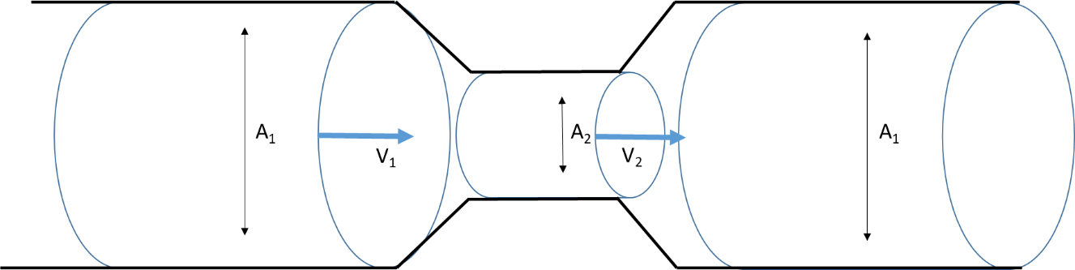
We also know that:
$$L= {(Dt)}^{\frac{1}{2}}$$
Where L is the length and D is the diffusion coefficient. Therefore, as the fluid front moves along the length of the lateral flow capillary network the speed of the flow will be reduced. This is also affected by the viscosity of the liquid and surface tension.
Figure 4 – Graph showing the test line colour intensity against the concentration of CRP for three different membrane types.
Statistical analysis performed on the data from Figure 4 shows that there is no significant difference in test line colour intensity between the different membranes. Therefore, CN95 was chosen as this is a very commonly used membrane.
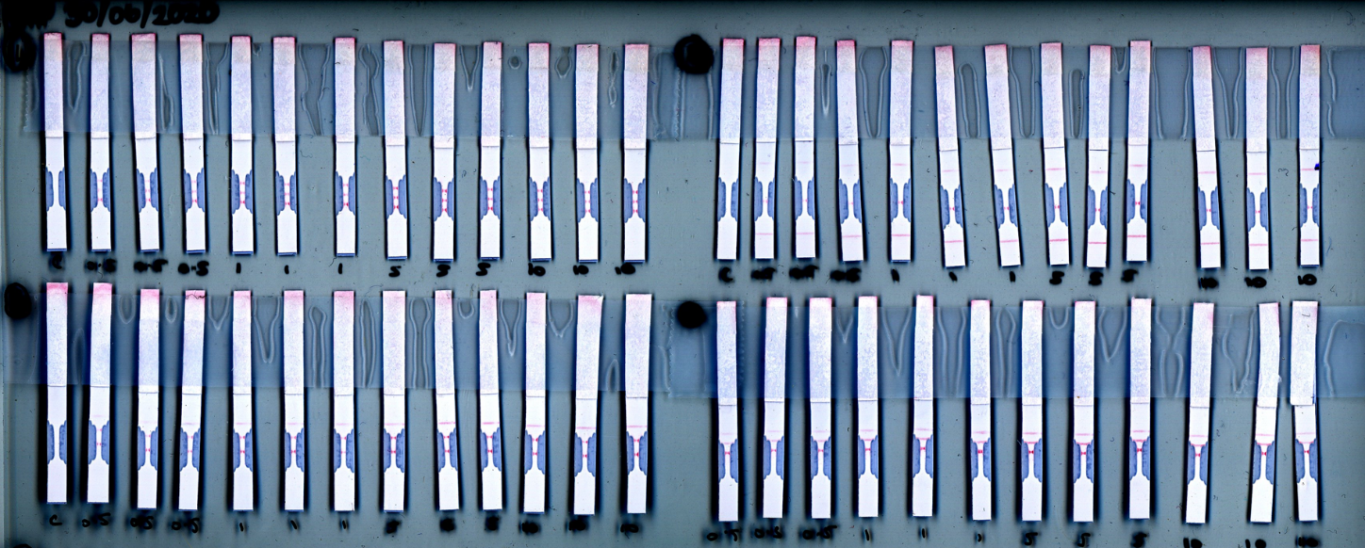
Figure 5 -Scanned image of multiple constricted lateral flow tests with multiple test lines at different positions along the flow path showing no visible test line for the control devices.

