Supplementary Figure 1. Life stages figure to help stimulate discussions with public contributors

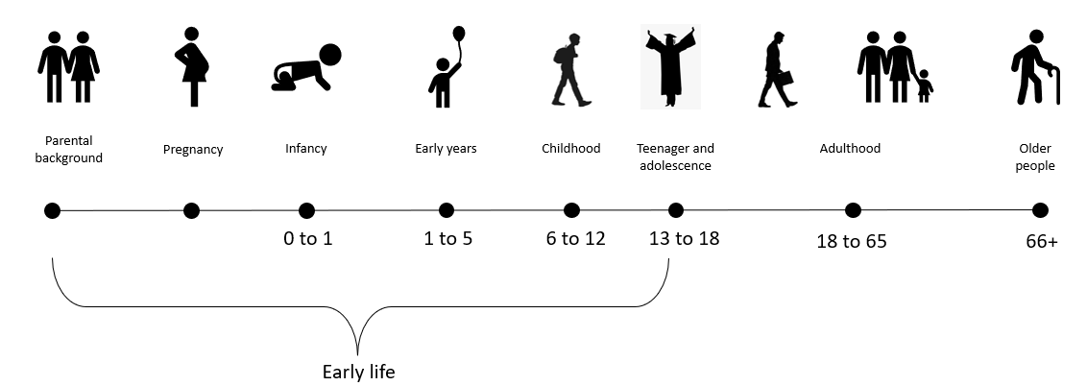

Supplementary Figure 2. Influences on multimorbidity across the lifecourse

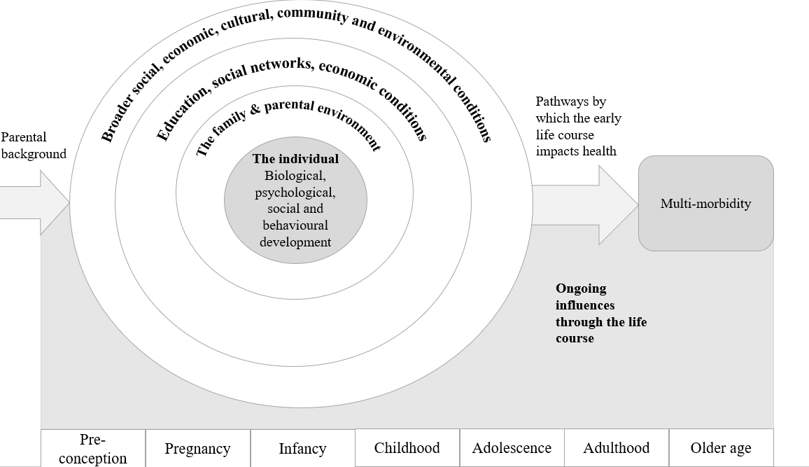

Supplementary Figure 3. Influences on multimorbidity in childhood
