Surfactin Conjugated Silver Nanoparticles as an Antibacterial and Antibiofilm Agent against Pseudomonas aeruginosa
Lutfur Rahman ^{1,2}, Yasra Sarwar ¹, Shazia Khaliq ¹, Inayatullah ³, Wasim Abbas ¹, Ameena Mobeen ¹, Ata Ullah ¹, Syed Zajif Hussain ⁴, Waheed S. Khan ¹, Maria-Eleni Kyriazi ⁵, Irshad Hussain ⁴, Antonios G. Kanaras ^{6,7,}* and Asma Rehman ^{1,}*
¹ National Institute for Biotechnology and Genetic Engineering College Pakistan Institute of Engineering and Applied Sciences (NIBGE-C, PIEAS), Faisalabad (38000), Pakistan
² Division of Engineering in Medicine, Department of Medicine, Brigham and Women’s Hospital, Harvard Medical School, 65 Landsdowne Street, Cambridge, MA 02139, USA
³ Department of Anatomy, Saidu Medical and Dental College, Saidu Sharif, Mingora, Swat, Pakistan
⁴Department of Chemistry and Chemical Engineering, SBA School of Science & Engineering (SBASSE), Lahore University of Management Sciences (LUMS), DHA, Lahore Cantt-54792, Pakistan
⁵College of Engineering and Technology, American University of the Middle East, Kuwait
⁶School of Physics and Astronomy, Faculty of Engineering and Physical Sciences, University of Southampton, Southampton SO171BJ, U.K
⁷ Institute for Life Sciences, University of Southampton, Southampton SO171BJ, U.K
*Correspondence author; asmanano@gmail.com, a.kanaras@soton.ac.uk

Abstract
The emergence of antimicrobial resistance is an alarming global health concern and has stimulated the development of novel functional nanomaterials to combat Multidrug resistant (MDR) bacteria. In this work, we demonstrate for the first time the synthesis and application of surfactin coated silver nanoparticles as an efficient antibacterial and antibiofilm agent against the drug resistant bacteria Pseudomonas aeruginosa for safe dermal applications. Our in vivo studies showed no significant superficial dermal irritation, edema and erythema whilst microscopic analysis revealed that surfactin coated silver nanoparticles caused no pathological alterations at the applied concentrations. These results support the potential use of surfactin coated silver nanoparticles against drug resistant bacterial, biofilm infections and in skin wound dressing applications.
Keywords: Antimicrobial resistance, surfactin, cytotoxicity, dermal irritation, silver nanoparticles, bacteria.

INTRODUCTION
The emergence of antimicrobial resistance (AMR) is a major healthcare challenge of the 21st century and one of the leading threats to public health worldwide. According to a recent report, it has been estimated that 4.95 million deaths in 2019 were associated to bacterial AMR. Antibiotic resistant Pseudomonas aeruginosa is classified as one of the resistant bacterial strains associated to these mortalities.¹ Clinically, P. aeruginosa is one of the most important and drug resistant Gram-negative bacteria, found in different chronic wounds that causes lower respiratory and urinary tract infections (UTI). Its resistance to available drugs has been suggested to be due to different mechanisms including biofilm development or the presence of active efflux machinery to expel antibiotics from cells.^{2,3}
To overcome the rapid emergence of AMR, there is a need to develop novel antimicrobial compounds/materials. The use of nanoparticles (NPs) has been suggested due to their facile synthesis, which allows the tuning of their antimicrobial properties, thus creating a growing interest for their application towards the killing of bacteria.^{4,5,6} The properties of NPs are dependent upon their size, morphology, chemical composition, as well as their surface chemistry, which when tuned with the appropriate biomolecules can lead to their increased stability within complex biological media as well as enhanced antimicrobial activity.. Naturally available antibacterial biomolecules that could be used for nanomaterials functionalization may be of plants, animal, or microbial origin. Most of the compounds reported as antibacterial agents are microbial secondary metabolites,⁷ phenolics, flavonoids and biopolymers.⁸
Apart from the ligand coating, the chemical composition of nanoparticles is also important. Silver nanoparticles (AgNPs) have been proposed as the most promising candidates to fight bacteria due to the high reactivity of silver.⁹ Citrate-capped-AgNPs and fungal mediated synthesis of AgNPs shows significant potential as bactericidal agent against both planktonic and sessile bacteria with low cytotoxic effect in cell line.^{10,11} Bano et al. reported actinomycetes’ secondary metabolites coated AgNPs against pathogenic bacteria (S. pneumoniae, H. influenzae, and N. meningitidis). Moreover, the synthesized nanoparticles also showed potential antibiofilm activity against all the tested bacterial strains. The antibacterial and antibiofilm activities of these nanoparticles might be due to the interaction of conjugated biomolecules with the bacterial cells and biofilm components.¹² Moreover, silver ions may cause alteration in the permeability of the cell wall/membrane, and also interact with intracellular molecules such as DNA, enzymes, and proteins.¹³
The interaction of nanoparticles with extracellular and intracellular components mainly depends upon the surface moiety/molecules present on their surfaces. The cellular and organ level toxicity of such nanomaterials is an important impediment to limit their use for real applications. However, it has been reported previously that functionalization or coating of AgNPs with biomolecules decrease their toxicity.^{14,15} Bhargava et al. reported the antibacterial activity of fructose functionalized AgNPs against P. aeruginosa and its anticolonization effect on a catheter.¹⁴ Moreover, biosurfactant,¹⁶ polydopamine,¹⁷ fucoidan and phytochemicals ^{18,19} coated NPs were demonstrated to be used as antibacterial, anti-adherent and antibiofilm agents against various pathogenic bacteria.
Surfactin (a microbial metabolite) is a natural cyclic lipopeptide biosurfactant, produced by bacillus species and has a rich biological activity (e.g., antiviral, antitumor and antifungal etc.) due to its unique structure. Its amphiphilic properties allows surfactin to be used in both hydrophobic and hydrophilic environments and on phospholipid membranes.²⁰ Based on its interactive properties with plasma membrane and other biomolecules,²¹ it was hypothesized that conjugation of surfactin to NPs could synergistically enhance their antimicrobial activity and facilitate the NPs delivery through the complex environment (e.g., cysts and biofilms etc.) developed by bacteria to escape antimicrobial agents.
Herein, we report for the first time the synthesis and evaluation of surfactin conjugated silver nanoparticles (SUR-AgNPs) as antibacterial, anti-adherent and antibiofilm agents against the biofilm developing multidrug resistant bacterial strain, P. aeruginosa. The in vitro and in vivo cytotoxicity of SUR-AgNPs and the safety threshold for dermal application were evaluated with the aim of developing an alternative treatment towards this bacterial strain without the use of antibiotics.

EXPERIMENTAL SECTION

Materials
All the chemicals and reagents used in the current study were of analytical grade and used without further purification. Chemicals used were silver nitrate (99%, ACROS), sodium hydroxide (97%, ACROS), sodium borohydride (TCI, Japan), ethanol analytical grade (Sigma-Aldric), PBS (pH, 7.4) Mueller Hinton agar (MHA) media (OXOID), tryptic soy broth (TSB) (OXOID), acridine orange dye (1%) and crystal violet dye (1%). Dulbecco’s modified Eagle’s medium (Thermo Scientific HyClone, Logan, UT, USA), Hi-fetal bovine serum (Invitrogen life technologies, Carlsbad, CA, USA), Pen-strep (100 IU/mL penicillin and 100 µg/mL streptomycin), L-glutamine, non-essential amino acids (NEAAs) (Invitrogen life technologies, Carlsbad, CA, USA), trypsin-EDTA solution (Gibco, Carlsbad, CA, USA), MTT (3-(4,5-Dimethylthiazol-2-yl)-2,5-diphenyltetrazolium bromide) from Sigma-Aldric and dimethyl sulfoxide (DMSO) were used for cytotoxicity studies.

Synthesis of surfactin conjugated silver nanoparticles
Surfactin conjugated silver nanoparticles were synthesized using a wet chemical method. Briefly, a surfactin stock solution (1.42 mL, 20 mg/mL methanol) was added to a sodium hydroxide solution (16.3 mL, 6.13 mM) and stirred for 60 min at room temperature. Subsequently, a silver nitrate solution (0.84 mL, 99.5 mM) was added dropwise to reach a 4.5 mM final salt concentration in the reaction mixture. After 45 min, the color of the solution changed from transparent to a turbid solution, indicating the formation of a complex between surfactin and silver ions. Finally, freshly prepared chilled solution of sodium borohydride (400 µL, 1 mg/mL) was added at once, resulting in a dark brown solution, which indicated the formation of SUR-AgNPs. The synthesized NPs were purified through centrifugation at 14,000 rpm for 15 min and washed 2-3 times with deionized water and absolute ethanol, respectively.

Characterization of nanoparticles
The morphology and size of the SUR-AgNPs was determined using high resolution FE-SEM (Field Emission Scanning Electron Microscope). A Zeta Sizer Nano Series instrument (Malvern) was used to determine their hydrodynamic diameter, polydispersity index and zeta potential. For an elemental composition analysis, the samples were analyzed utilizing Energy Dispersive X-Ray (EDX), while functional groups were analyzed using Fourier-transform infrared spectroscopy (FTIR). The optical properties of nanoparticles were investigated using a Nanodrop, Thermoscientific 2000C, operated in cuvette mode to obtain spectral scans in the rage of 200-900 nm.

Antibacterial activity of surfactin-conjugated silver nanoparticles
The antibacterial activity of SUR-AgNPs was evaluated using a standard agar well-diffusion method according to a previously reported protocol.²² The bacterial strain Pseudomonas aeruginosa was obtained from the culture collection of Enteric pathogens sub-group at Health Biotechnology Division (HBD), NIBGE. Bacteria were cultured in Tryptone Soya Broth (TSB) and incubated at 37 °C for 14-16 h till logarithmic phase. A standardized inoculum (1 × 10⁸ CFU/mL) was uniformly spread on Mueller Hinton Agar (MHA) media plates, followed by the formation of wells (6 mm) using sterilized borer. A calculated volume of SUR-AgNPs from a stock solution (15 mg/mL) was added to the respective wells, to maintain specific concentrations (100, 75, 50 and 25 µg/well). To compare the synergistic effect, surfactin was used as a control. The treated MHA-plates were incubated at 37 °C for 24 hours, to investigate the bacterial growth inhibition. After 24 hours, the zone of inhibition by each concentration was recorded in millimeter (mm) for triplicate analysis.
Minimum inhibitory concentration (MIC) and minimum bactericidal concentration (MBC) were determined using a broth dilution method, while viable colonies were quantified by counting colony forming units per milliliter (CFU/mL). For this purpose, the actively dividing bacterial culture was transferred to TSB tubes, supplemented with different concentrations of SUR-AgNPs (0-100 µg/mL) and incubated at 37 °C for 24 h in a shaking incubator. Next day, a calculated amount (50 µL) of samples from each concentration was taken and mixed gently with autoclaved deionized water at a ratio of 1:9, respectively. From the diluted culture, 50 µL bacterial suspension was transpired and spread uniformly on MHA-plates in triplicate to calculate the viable bacterial cells. The prepared plates were incubated at 37 °C for 18-24 h and then viable colonies were counted using colony counter.

Anti-adherent assay and antibiofilm activities
To evaluate the anti-adherent activity of synthesized nanoparticles, different concentrations (2.5, 5, 10, 20, 30, 40, 50, 100, 150, and 200 µg/mL) of SUR-AgNPs were prepared in 3 mL TSB in glass tubes and 100 µL P. aeruginosa inoculum was added to each tube. Tubes containing bacterial culture with and without free surfactin were used as control. All the tubes were incubated at 37 °C for 48-72 hours, to check cell growth and adhesion to the glass surface. Afterwards, the culture was discarded gently, and tubes were washed thrice with PBS (pH 7.4), to remove planktonic cells. Tubes were incubated with 1% crystal violet dye for 45 min in dark to stain the adherent bacterial cells. Then, they were washed with deionized water several times, to remove the excess amount of dye. The remaining dye was dissolved using 30% citric acid solution and the absorbance was measured at 590 nm using a spectrophotometer, to determine the percentage of anti-adherent activity of SUR-AgNPs.
To evaluate the antibiofilm potential of SUR-AgNPs, P. aeruginosa was allowed to form a biofilm on sterile glass slides by transferring 50 µL of actively dividing seed culture to 3 mL TSB in tubes and incubating for 72 h at 37 °C. After the development of the biofilm, the culture was removed, and the surface was washed with freshly prepared autoclaved PBS buffer (pH 7.4) three times. Then, 3 mL freshly prepared TSB media (autoclaved, temperature 37 °C) were added, containing different concentrations (2.5, 5, 10, 20, 30, 40, 50, 100, 150, and 250 µg/mL) of SUR-AgNPs. Culture tubes without nanoparticles and surfactin (667 µg/mL) were considered as controls to evaluate the antibiofilm activity of SUR-AgNPs. All tubes containing either SUR-AgNPs, or free surfactin or no nanoparticles were further incubated for 24 h at 37 °C. Next day, the tubes were washed with PBS three times, and biofilms were stained with crystal violet (1%) in dark for 45 min. The excessive dye was washed, and the biofilm was dissolved in 30% glacial acetic acid solution. To determine the antibiofilm activity, the absorbance was measured at 590 nm. The following equation was used to calculate the percentage of antibiofilm inhibition in the presence of nanoparticles.²³
$$\% Antibiofilm Inhibition=\left[\frac{1-Absorbance of sample}{Absorbance of Control}\right]×100$$

Antibiofilm activity observed by light and confocal microscope imaging
To assess the antibiofilm activity of SUR-AgNPs, a biofilm was developed on the surface of sterilized glass slides. Briefly, microscopic glass slides were placed vertically in autoclaved TSB media containing glass tubes, so that the biofilms form in the center of each slide. A standardized inoculum (1 × 10⁸ CFU/mL) of actively dividing P. aeruginosa was added to each tube and incubated for 72 hours at 37 °C in a shaking incubator for the biofilm development. The slides containing the biofilm were moved to freshly prepared TSB media glass tubes and supplemented with a different concentration (0, 10, 20, 30, 40 µg/mL) of SUR-AgNPs and inoculated further for 24 hours. For the microscopic examination, the slides were washed with PBS buffer (pH 7.4) three times, followed by crystal violate staining in dark for 45 min. The stained biofilm was washed with deionized water 3-4 times and covered with a coverslip. The slides were observed using an optical microscope and the images were captured using a 48 mega pixel digital camera.
For a confocal microscopy study, P. aeruginosa was grown on a sterile glass slide to form a biofilm as mentioned above. After incubation with different concentrations (0, 10, 20, 30, 40 µg/mL) of SUR-AgNPs for 24 hours, the growth medium was discarded, and the slides were washed thoroughly with PBS buffer to remove any planktonic bacteria. The biofilms were stained with acridine orange (1%) for dead cells identification¹⁶. The samples were examined through confocal laser scanning microscope by exciting the acridine orange dye at 488 nm while the emission was recorded at 526 nm. The biofilm without the addition of nanoparticles was used as a control.

Cytotoxicity study of surfactin conjugated silver nanoparticles
The standard MTT (3-(4,5-dimethylthiazol-2-yl)-2,5-diphenyltetrazolium bromide) assay was performed to evaluate the cytotoxic activity of SUR-AgNPs. Huh7.0 cells at a density of 0.2 x10⁶ cells/mL were seeded in 96 well plate and incubated for 24 hours. To add fresh media along with SUR-AgNPs, a calculated quantity of SUR-AgNPs was added in DMEM media and shifted to the respective wells. The cells incubated with SUR-AgNPs at a concentration of 1, 10, 25, 50, 100, 250, 500 and 1000 µg/mL for 72 hours were marked as treated groups, while untreated cells were considered as control. The morphological changes of cells were observed using an inverted phase contrast microscope (IMT-2; Olympus, Tokyo, Japan). Afterwards, the MTT (10 µL, 12 mM) reagent was added to the respective wells and incubated further for 4 hours. The culture media was removed and 100 µL DMSO was added, to dissolve the end product i.e., formazan. A synergy H1 hybrid multi-mode microplate reader (BioTek Instruments Inc., Winooski, VT, USA) was operated to record the absorbance at 570 nm. The experiments were conducted in triplicates and the results were expressed as the mean cell survival percentage.

In vivo dermal irritation test
For a dermal irritation assay, an Organisation for Economic Co-operation and Development (OECD) test guideline 404 (OECD TG 404 2002) was followed. Prior to the experiment, rabbits were divided into three groups and acclimatized in a controlled environmental condition (Temp = 25 °C, Humidity 50% ± 5%). The dorsal portions of skin were shaved and next day each area was divided into four quadrants. Three concentrations (1000, 2000, and 3000 µg/mL) of nanoparticles along with positive sodium lauryl sulfate (SLS) and negative controls were applied on the respective area. The treated area was covered properly with non-irritant surgical patches for 4 hours. After removing the patches, the skin area was washed using deionized water and the data regarding any visual changes (erythema, edema) was collected after one hour. Further images were taken after 0, 24, 48 and 72 hours utilizing a digital camera and the data was recorded for each treatment. For histopathological analysis skin tissues (with SUR-AgNPs and SLS) were removed using a sterilized scalpel blade and preserved in 10% formalin buffer solution. The collected biopsy was then microscopically examined according to a previously reported protocol.²⁴
Statistical analysis
For the statistical analysis and graphs designing, GraphPad prism 8 (i.e., Tukey's HSD test) and OriginPro 8.5 was used, while images were analyzed through ImageJ software (i.e., Particle size distribution). Illustration was done using Adobe Illustrator CC 2017.

Results and Discussion

Characterization of SUR-AgNPs
Surfactin is an important biomolecule consisting of different amino acids in its structural composition. It possesses both anionic (-COO⁻) and cationic (-NH⁺) groups, which enhances its interactions and binding capabilities with other biomolecules or with metal ions to form complexes. The synthesized SUR-AgNPs were initially optically characterized (Figure 1A). A Surface Plasmon Resonance (SPR) peak appears at 433 nm, which is a characteristic peak of AgNPs. To confirm the morphological aspects of the synthesized NPs, a sample was analyzed via FE-SEM. During microscopic analysis, it was observed that the synthesized SUR-AgNPs were homogeneous in shape (Figure 1B, and supporting information Figure S1).
The hydrodynamic diameter and surface zeta potential of the synthesized NPs was then assessed. The prepared SUR-AgNPs were found to have an average hydrodynamic radius of ~21.9 nm (Figure 1C). The zeta potential of SUR-AgNPs was measured to be -31.2 ± 5.75 mV (Figure 1D). The high negative surface potential was due to the overall negative charge of the surfactin ligands arising from the presence of the carboxylic groups. ²⁵
Figure 1E shows the FT-IR spectra both for free surfactin (black line) and SUR-AgNPs (red line). For the free surfactin, the band appearing at 3300 cm⁻¹ is a characteristic band of peptide compounds, representing the N-H stretching mode, typical in surfactin. The stretching peaks at 2930 cm⁻¹ and 2854 cm⁻¹ indicate the presence of C-H (2840-3000 cm⁻¹) functional groups present in the aliphatic chains of surfactin (C₁₃-C₁₆).²⁶ The strong peak observed at 1620–1660 cm⁻¹ corresponds to the C=O stretching vibration of amide-1 region, and the stretching at 1520–1550 cm⁻¹ from the deformation mode of the N–H bond combined with the C–N stretching mode. The peak at 1206 cm⁻¹ is a characteristic for the vibration of C-O bonds in surfactin.²⁷
In the case of SUR-AgNPs, the broad intense band between 3000-3500 cm⁻¹ indicates the presence of a large number of NH functional groups. The peaks at 2130, 1640 and 1540 cm⁻¹ are characteristic of the presence of C-N, C=O and N-H functional groups, respectively. Moreover, the appearance of an extra band at 2130 cm⁻¹ corresponds to C-N stretching in the SUR-AgNPs.^{28,29} The appearance of these functional groups indicates the successful coating of surfactin on the surface of silver nanoparticles.
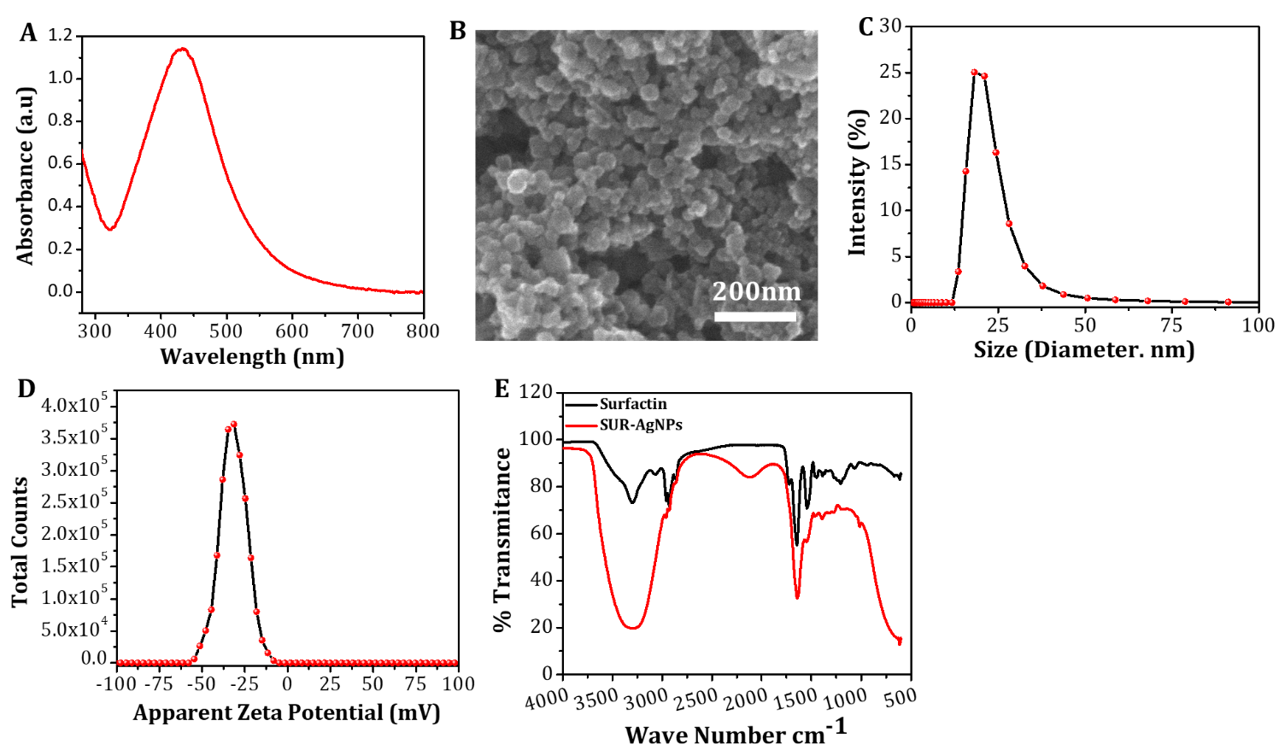
Figure 1. UV-Vis absorption spectrum of SUR-AgNPs (A), FE-SEM image (B), hydrodynamic particle size distribution obtained by DLS (PDI 0.281) (C), apparent zeta potential (D) and comparative FTIR analysis of SUR-AgNPs and surfactin (E).
Bactericidal activity of surfactin conjugated silver nanoparticles
The antibacterial activity of SUR-AgNPs was evaluated through the well-diffusion method by exposing bacteria to different concentrations of NPs as shown in Figure 2A. The zone of inhibition (ZOI) for each concentration (0-100 µg/well) was carefully measured. The results showed that by increasing the concentration of NPs, the zone of inhibition was increased and a significant difference (p < 0.05) between the control (free surfactin) and treated samples was observed (Figure 2B). The maximum zone of inhibition i.e., ~22.3 ± 0.3mm (mean ± SD) was recorded at a concentration of 100 µg/well against the MDR-bacterial strain (Pseudomonas aeruginosa). The surfactin (ligand) used in the current study, to synthesize AgNPs, is an amphipathic molecule and is known to interact with bacterial cell membrane components.³⁰ Therefore, surfactin facilitates the penetration of NPs³¹ through the bacterial cell wall. To determine the minimum inhibitory and bactericidal concentrations, bacteria were exposed to a range (0, 25, 50, 75 & 100 µg) of SUR-AgNP. The MIC and MBC of SUR-AgNPs determined were 20 µg/mL and 45 µg/mL, respectively (Figure 2C). SUR-AgNPs showed enhanced bactericidal activity when compared to free surfactin. Then, the bactericidal activity of viable cell counts i.e., CFU/mL (colony forming unit/mL) in a dose dependent manner was performed. The results (Figure 2D-E) showed that by increasing nanoparticle concentration, the viable cells’ count decreased. A small number of CFU/mL (4x10⁴) was counted at a concentration of 35 µg/mL, however none were observed at a higher SUR-AgNP concentration of 40 µg/mL. In comparison to plates treated with SUR-AgNPs, the control (free Surfactin, 667 µg/mL) developed a large number of CFU/mL. From the results it can be inferred that ~97% of cell death occurs at 35 µg/mL SUR-AgNPs concentration. It was further observed that the bacterial colonies decreased by ~3 folds upon every 10 µg/mL increment in SUR-AgNP concentration. Figure S2 shows the quantitative analysis of colonies on plates (Figure 2E1-E4) with varying nanoparticle concentrations. As the concentration of SUR-AgNPs decreases the bacterial growth increases, reaching a typical growth curve pattern at very low nanoparticle concentrations. The plate-counting (CFU/mL) results correlated with the well diffusion assay, as a similar pattern of bacterial growth inhibition was observed by increasing the nanoparticle concentration. In solid media, nanoparticle diffusion is slow, which limits NP interaction with bacterial cells, resulting in slightly low inhibitory effects. In liquid media, NPs are in a suspended form, which maximizes their interaction with bacterial cells. Metals like copper, silver and iron etc. have the capability to generate reactive oxygen species.³² These reactive species are responsible for the induction of oxidative stress and hence show bactericidal activity.³³ Therefore, it may be proposed that the enhanced antibacterial activity of SUR-AgNPs is a combined effect resulting from the surfactin ligand, which facilitates the penetration of nanoparticles in bacteria, the leaching of silver ions from the AgNPs, and the release of ROS due to the silver.
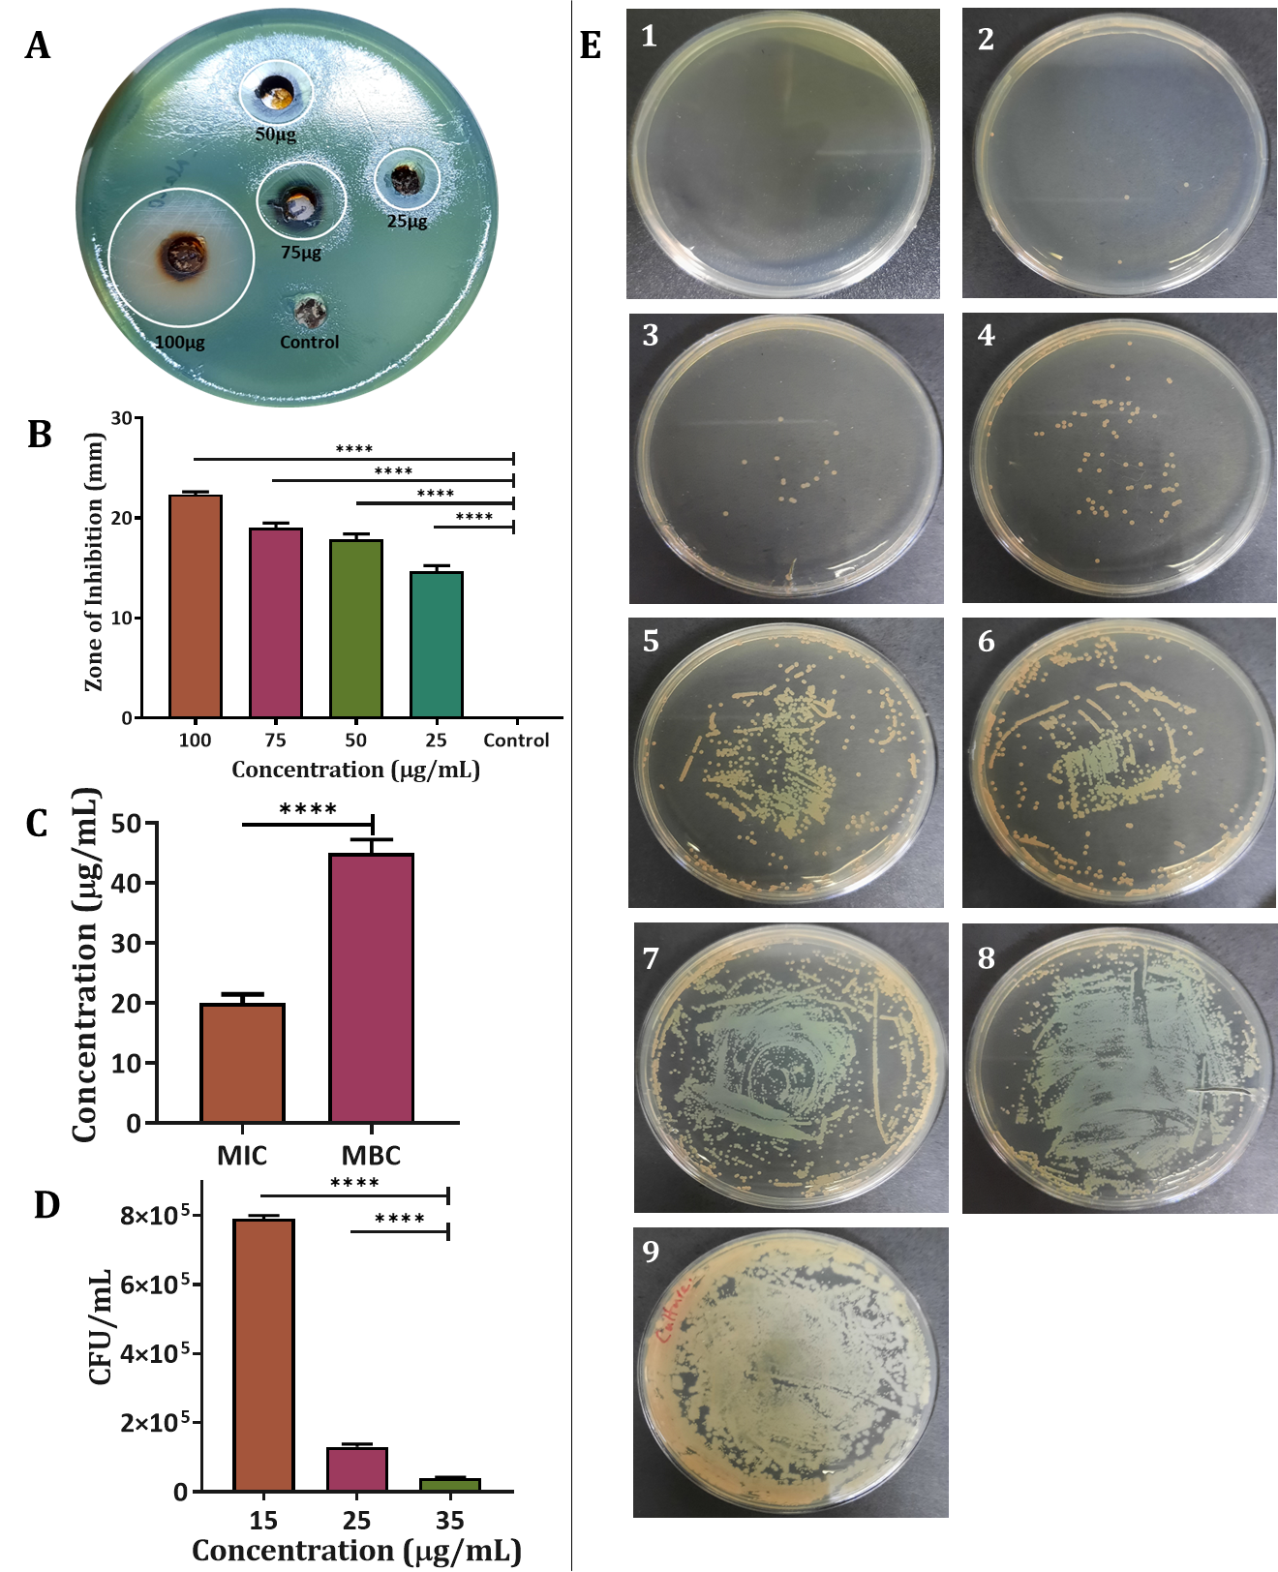
Figure 2. (A) Plate well diffusion assay illustrating zone of inhibition, (B) Zone of inhibition measured at different concentrations of SUR-AgNPs (0, 25, 50, 75 & 100 µg/well), showing significance difference “****” at p < 0.0001 among the treated groups as well as compared to control (incubation with free surfactin, 100 µg/well), (C) MIC and MBC for the antibacterial activity of SUR-AgNPs , (D) Graph showing decrease in Colonies Forming Unit (CFU) count per mL at 35, 25 and 15 µg/mL concentrations of SUR-AgNPs. (E 1-7) photographs showing number of viable colonies on plates after treating with different concentration of SUR-AgNPs (40, 35,25, 15,10, 5, 2.5 µg/mL), (E 8) free surfactin, (E 9) Growth control containing only Pseudomonas aeruginosa.

Anti-adherent and Antibiofilm activities
We then investigated the anti-adherent and antibiofilm activities of SUR-AgNPs. To check the anti-adherent activity, the P. aeruginosa culture was incubated for 72 hours with different concentrations (2.5, 5, 10, 20, 30, 40, 50, 100, 150, and 250 µg/mL) of SUR-AgNPs in 3 mL glass tubes. After treatment, the tubes were washed with PBS (pH 7.4) and the biofilm was stained using crystal violet dye (Figure 3A). The results showed that the formation of biofilm rings within the glass test tubes (at the point of liquid air interface) increased with decreasing concentrations of NPs. These results confirmed that SUR-AgNPs, significantly interfered with the adherence of bacterial cells to form biofilms in a concentration dependent manner. It was observed that at 20 µg/mL, the anti-adherent activity of SUR-AgNPs was approximately 90%, while the free surfactin showed ~80% activity at a much higher concentration (667 µg/mL) (Figure 3B). The results suggested that the free surfactin can also be used as anti-adherent agent, however its effective concentration was significantly higher in comparison to the required concertation of SUR-AgNPs. The free surfactin showed >75% inhibitory effect at a concentration of 667 µg/mL which is 33-folds higher than that of SUR-AgNPs (20 µg/mL), thus limits its direct use as anti-adherent agent.
To further investigate the effect of SUR-AgNPs on pre-formed biofilms we first allowed P. aeruginosa bacteria to develop biofilm for 72 hours. After the biofilm development, the planktonic cells were removed, and the biofilm was washed three times with autoclaved PBS buffer (pH 7.4). Finally, 3mL fresh TSB media containing different concentrations (2.5-250 µg/mL) of SUR-AgNPs were added to the respective tubes with existing biofilms and incubated for 24h at 37 °C. A sample containing only TSB and samples containing only free surfactin (667 µg/mL) were also used as negative and positive controls, respectively. After treatment, the biofilm was washed with PBS and stained with crystal violet dye (1%). The samples were washed with deionized water to remove the extra dye. The samples with increasing concentrations of SUR-AgNPs showed increased activity against the biofilms (Figure 3C). Furthermore, the biofilm rings were dissolved in 30% acetic acid and the percent biofilm eradication activity was calculated from the absorbance data recorded at 590 nm (Figure 3D). The results revealed that at a NP concentration of 100 µg/mL an inhibition of NPs showed > 80% biofilm eradication while free surfactin showed ~55% inhibition at 667 µg/mL (Figure 3D). Interestingly nanoparticles showed enhanced antibiofilm activity (1.53-fold more than free surfactin) and at significantly lower concentrations (~6.67 fold less concentration of NPs than surfactin). The data reveals that 50% inhibition occurs at substantially lower concentration (10-20 µg/mL) of SUR-AgNPs compared to free surfactin. This is in agreement with the results previously reported for planktonic bacteria (Staphylococcus epidermidis) as well as its anti-adherent activity, where only free surfactin was used.³⁴ The variation in the active dose depends upon different factors that are related to biofilm strength as well as the physicochemical nature of nanoparticles. Some bacterial strains develop coherent biofilms and protect themselves from environmental anoxia by adopting intracellular metabolism and gene expression strategies.³⁵ Overall, these results demonstrate significant antibacterial, anti-adherent and antibiofilm potential of SUR-AgNPs.
The activity of NPs was also studied microscopically. Figure 3E shows biofilms that were treated with different concentrations (10, 20, 30 and 40 µg/mL) of nanoparticles. For the microscopic study the biofilms were stained with a dye (crystal violet). Light microscopy images shown in Figure 3E confirm that the biofilms are gradually decreasing in the presence of higher nanoparticle concentrations (Figure 3 E2-5) as compared to the control (with no SUR-AgNPs; Figure 3 E1). Confocal microscopy imaging (Figure 3F) demonstrated a similar pattern of biofilm eradication. Acridine orange was used to stain biofilms, which can penetrate into the cells resulting in a red florescence, reflecting living bacterial colonies.³⁶ The image (Figure 3 F1) showing a red color indicated living biofilm, however SUR-AgNPs treated images (Figure 3 F2-5) showed a decrease pattern in red fluorescence as the concentration increased. A similar pattern was observed by Khalid et al., after treating the biofilm with Rhamnolipids (RL) coated AgNPs to confirm their antibiofilm activity.¹⁶ Overall, biofilms treated with SUR-AgNPs presented a serious structural damage to the biofilm in a concentration dependent manner (Figure 3 F2-5). As previously reported, other types of silver nanoparticles such as, epigallocatechin gallate-coated silver nanoparticles can inhibit biofilms developed by Bacillus subtilis, in a concentration dependent manner.³⁷ It is hypothesized that the antimicrobial activity of AgNPs is mainly due to the disruption in biofilm structure and interaction with bacterial cells components via different mechanisms. Nanoparticles initially penetrate the biofilms and migrate internally where they react with the biofilm components (such as lipids, proteins, nucleic acids, and polysaccharides). In particular, NPs damage the bacterial outer boundaries, which leads to the internal generation of reactive oxygen species (ROS). The generated ROS then interact with the intracellular molecules (proteins, enzymes, DNA and RNAs) resulting in their damage or alteration of their configuration and functions resulting in a change of the metabolic pathways and stress thus leading to bacterial death.⁸
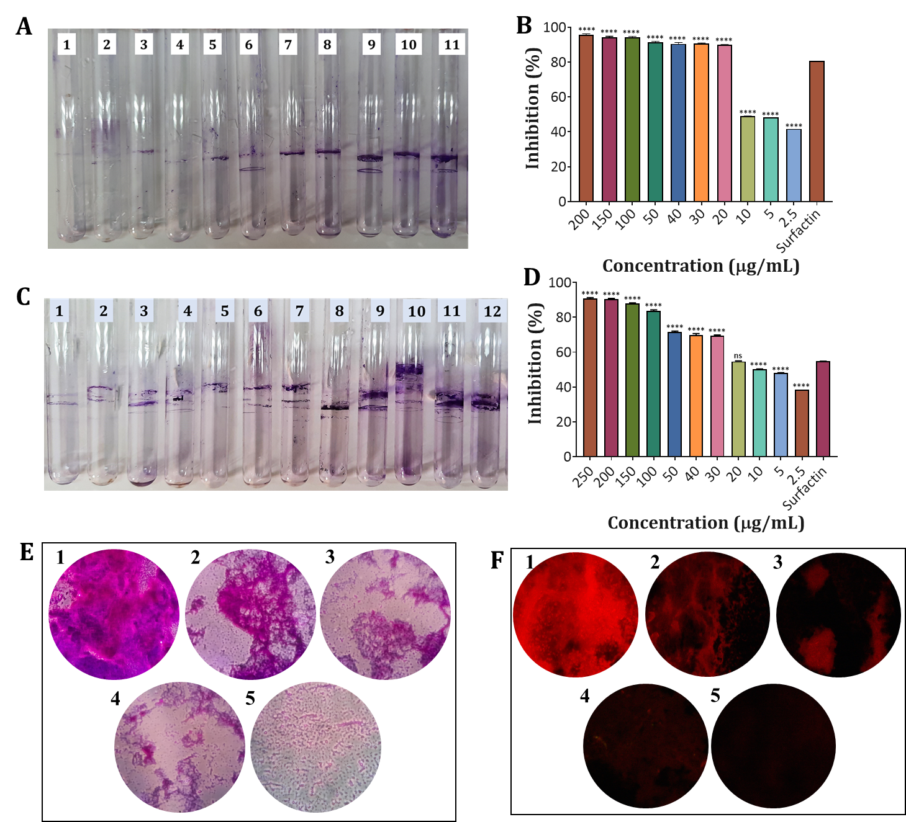
Figure 3. (A) Digital photographs showing anti-adherent activity of SUR-AgNPs at different concentration (200-2.5 µg/mL, labeled as A 1-10) and surfactin (666.7 µg/mL, A 11), (B) Percent anti-adherent activity of SUR-AgNPs at 2.5-200 µg/mL and surfactin. Group labeled as (****) representing significant difference from the surfactin at p < 0.0001, while (ns) showing non-significant difference (C) Digital photographs of antibiofilm assay of SUR-AgNPs at different concentrations (2.5-250 µg/mL, marked as C 1-11) and surfactin (C12), (D) Graph showing percent biofilm eradication at 2.5-250 µg/mL along with control (surfactin). In comparison with control (free surfactin), groups marked as (****) represent significant difference while (ns) showing non-significant difference at p < 0.0001. (E) Light microscopic examination of non-treated biofilm (control, no NPs; E1) and eradicated biofilm at selected concentrations (10, 20, 30, 40 µg/mL) of SUR-AgNPs (E2-E5), respectively, (F) Representative confocal microscopy images of control (with no NPs; F1) and biofilms eradication at different concentrations (10, 20, 30, 40 µg/mL) of SUR-AgNPs (F2-F5), respectively.

Cytotoxicity Study
The cytotoxicity evaluation on human cell lines is an important aspect concerning the biosafety of nanoparticles. Human hepatoma cell lines were exposed to surfactin and SUR-AgNPs at different concentrations (1-1000 µg/mL) for 72 hours, and an MTT assay was performed. Free surfactin showed no significant changes in cell morphology even at higher doses as compared to control (No surfactin) (Figure S 1a). On the other hand, SUR-AgNPs showed a dose dependent cell cytotoxic effect in comparison to the control (no SUR-AgNPs), as shown in Figure 4A. It can be further observed that for a 75 µg/mL concentration, the nanoparticles significantly decreased cell viability. However, for a lower concentration of 50 µg/mL, the cells grew normally, and percent cell viability increases as compared to higher SUR-AgNPs concentration.
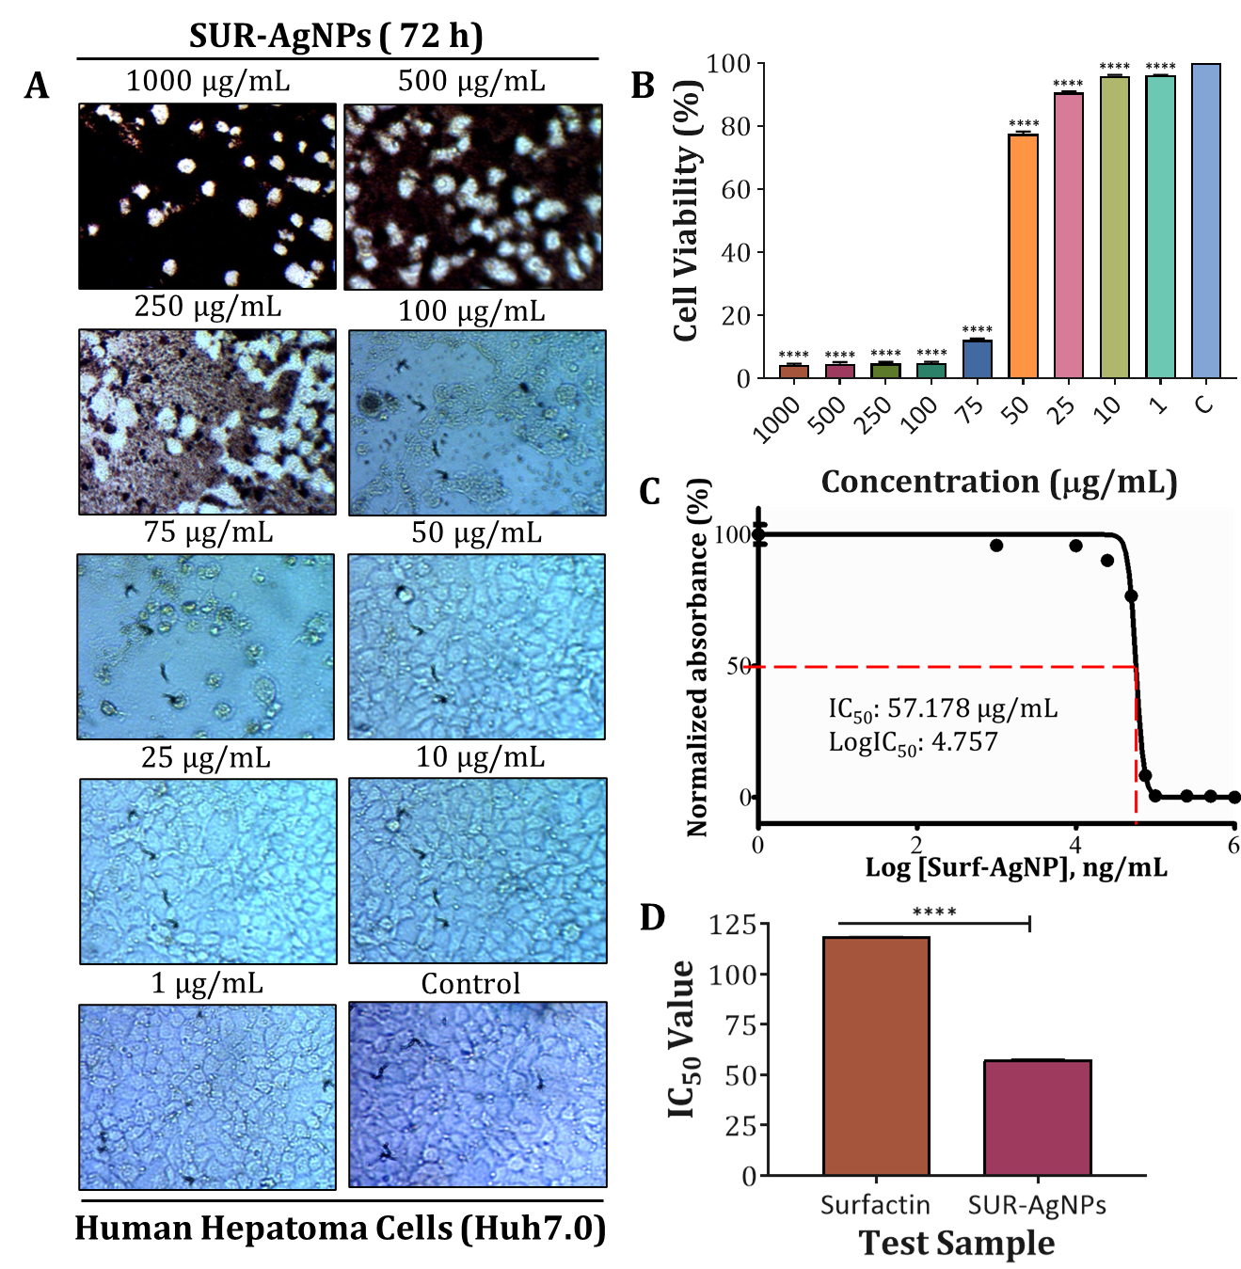
Figure 4. (A) Microscopic images showing cells morphology and the effect of surfactin on Huh 7.0 cell lines treated at a concentration of (1000-1 µg/mL) and control (without SUR-AgNPs). (B) Percent cell viability when exposed to SUR-AgNPs at different concentrations (1000-1 µg/mL) and control (without SUR-AgNPs). (****) representing significant difference from the control at p < 0.0001 (C) IC₅₀ value calculated for SUR-AgNPs and (D) Comparative statistical analysis, showing significant difference at p < 0.0001 (****) among the tested samples (surfactin and SUR-AgNPs).
The percentage of cell viability determined for surfactin is > 88% at higher concentration (1000 µg/mL) and the IC₅₀ is > 100 µg/mL (supplementary data; Figure S 1b-c). However, SUR-AgNPs showed gradual decrease in percentage of viable cells upon increasing the NPs concentration (Figure 4B). The IC₅₀ values determined for SUR-AgNPs is > 50 µg/mL (Figure 4C). Statistically the IC₅₀ value of SUR-AgNPs shows significant difference at p < 0.05 as compared to surfactin (Figure 4D). The IC₅₀ value determined in the cell line study is 57.178 µg/mL, which is higher than the MIC and MBC measured in antibacterial assay. It is reported that nanoparticles showing greater IC₅₀ value are considered as nontoxic. However, the toxicity of a nanoparticle depends upon its nature and type of cell lines.^{38,39} Based on our results, it might be concluded that the desired antibacterial activity can be obtained by applying nanoparticles in a concentration less than the IC₅₀ value as determined in the cell line study.

Acute Dermal Irritation Test
To conduct dermal irritation tests, we applied varying concentrations of SUR-AgNPs to the skin of healthy rabbits. As a positive control 4% SLS was used with no particles. Figure 5 shows digital photographs demonstrating that the application of SUR-AgNPs do not cause any irritation. According to the indexing values each concentration was scored as “0” DII (dermal irritation index), indicating the non-irritant nature of SUR-AgNPs (Figure S2A). On the other hand, the application of SLS (positive control) showed skin irritation symptoms (erythema and edema) after one hour of the removal of the patches. At longer times, the positive control showed a gradual increase in edema as well as in erythema (Figure S2B). After 48 h, no further increase was observed in edema while erythema remained persistent for 72 h (Figure 5A). The overall dermal irritation index was found to be 4.25, which can be considered as a moderate irritant. The severity of skin irritation and persistence depends upon the nature of irritant applied as well as on the time of exposure. For dermal application, biogenic ligands are mostly preferred due to their non-toxic, biocompatible, and non-irritant nature.⁴⁰ Some studies have reported biosurfactant as skincare ingredients in cosmetics.^{41,42} The non-irritant nature even at higher doses (3 mg/mL) of SUR-AgNPs might be due to the presence of the surfactin coating. However, some materials may cause internal tissue injuries, so in that case tissue microscopic examination is highly recommended. No histopathological changes were observed in SUR-AgNPs treated samples (Figure 5B). The photographs of SUR-AgNPs samples showed no physiological changes (epidermis, intact keratin, dermis, and hair follicles etc). On the other hand, the positive control samples showed pathological alteration; detached keratin (DK), subepithelial split (SES) and dermal edema (DE). Based on visual observation and microscopic analysis, it can be suggested that SUR-AgNPs are non-irritant and cause no skin irritation at the recommended doses. The concentrations applied on rabbits’ skin are very high (1000, 2000 and 3000 µg/mL) as compared to the MIC (20 µg/mL) and MBC (40 µg/mL; determined for antibacterial assay) as well as IC₅₀ (57.178 µg/mL) calculated in the in vitro cytotoxicity experiment. Therefore, it could be proposed as an antimicrobial agent in wound dressing materials against drug resistant P. aeruginosa that cause skin infections.
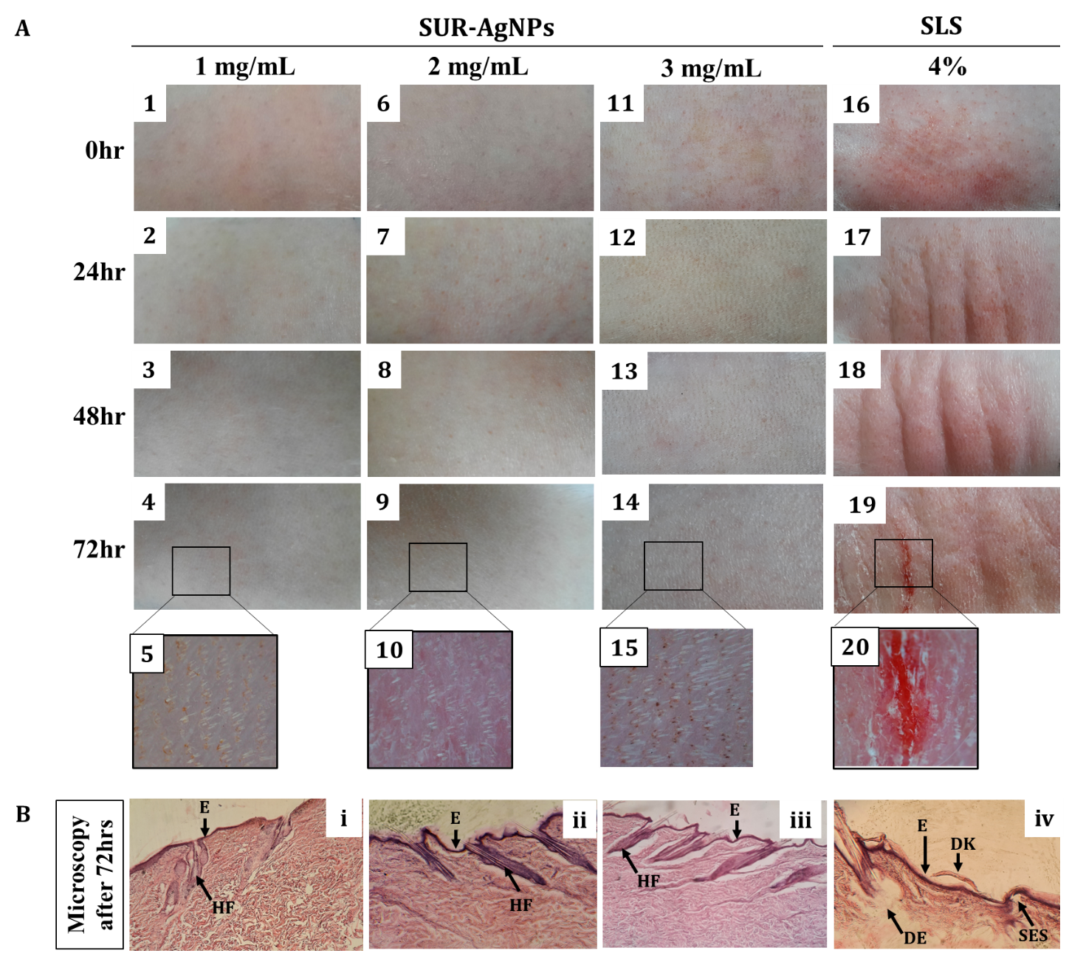
Figure 5. (A) Digital photographs of rabbit’ skin after 0, 24, 48 and 72 hours post exposure to different concentration of SUR-AgNPs and SLS (4%). Images (A1-A5) at 1 mg/mL, (A6-A10) at 2 mg/mL and (A11-A15) at 3 mg/mL concentration of SUR-AgNPs shows no irritation sign and symptoms after 72 hours. Positive control (A16-A20) shows irritation symptoms, and the severity increases with the passage of time. (B) The representative histological slides of the rabbit’s skin after the applications of SUR-NPs and SLS (4%). For microscopy Haematoxylin & Eosin stained, 5 µm thick section of rabbit skin, treated with 1, 2 and 3 mg/mL SUR-AgNPs and SLS (4%). Images (Bi-iii) showing normal skin architecture (E: Epidermis, HF: hair follicles) with no pathological changes.at all the tested concentrations of SUR-AgNPs. Slide (B-iv) is positive control (SLS) showing pathological changes (DK: detached keratin, DE: dermal edema, SES: subepidermal splits). Photomicrograph taken at 40X.

Conclusion
In summary, surfactin-coated silver nanoparticles are synthesized and assessed as antimicrobial and antibiofilm agents against the antibiotic resistant P. aeruginosa bacteria for the first time. The newly synthesized SUR-AgNPs had an average particle size of about 18 nm and a highly negative zeta potential that ensured their excellent colloidal stability. SUR-AgNPs showed enhanced antibacterial and anti-adherent activity and increased antibiofilm activity when compared to the free surfactin. The IC₅₀ value determined for Huh-7.0 cell lines was greater than the MIC and MBC, suggesting that they could be suitable as a treatment against P. aeruginosa bacteria. Due to its non-irritating skin nature and no pathological alteration, the SUR-AgNPs could potentially be exploited for external dermal applications against a broader range of skin infections.

Acknowledgment
LR and AR gratefully acknowledge the financial support from the International Foundation for Science (IFS) Sweden (Grant No. I2-W-6706-1).

Associated Content
The supporting information is available free of charge at XXXX.
It includes additional microscopy image of nanoparticles, cytotoxicity of surfactin, growth analysis of bacteria in several concentrations of nanoparticles, acute dermal irritation tests in various concentrations of nanoparticles.

Authors contribution
AGK, AR, MEK and IH conceived the basic idea, offered useful suggestions during this study, and reviewed the final draft of manuscript. AR supervised the experiments. LR conducted the experiments and wrote the first draft of manuscript. YS supervised the antibacterial experiments, SK isolated and provided the surfactin. AU contributed in drawing graphs and illustration. WB conducted cytotoxicity study. AM guided in the in vivo experiment. IU was involved in tissue processing and microscopic analysis. SZH helped in material characterization and WSK guided in nanomaterial synthesis.

References
(1) Murray, C. J.; Ikuta, K. S.; Sharara, F.; Swetschinski, L.; Aguilar, G. R.; Gray, A.; Han, C.; Bisignano, C.; Rao, P.; Wool, E. Global Burden of Bacterial Antimicrobial Resistance in 2019: A Systematic Analysis. Lancet 2022, 399, 629-655.
(2) Karami, P.; Khaledi, A.; Mashoof, R. Y.; Yaghoobi, M. H.; Karami, M.; Dastan, D.; Alikhani, M. Y. The Correlation between Biofilm Formation Capability and Antibiotic Resistance Pattern in Pseudomonas aeruginosa. Gene Rep. 2020, 18, 100561.
(3) She, P.; Wang, Y.; Liu, Y.; Tan, F.; Chen, L.; Luo, Z.; Wu, Y. Effects of Exogenous Glucose on Pseudomonas aeruginosa Biofilm Formation and Antibiotic Resistance. Microbiologyopen 2019, 8, e933.
(4) Martínez-Castañon, G. A.; Nino-Martinez, N.; Martinez-Gutierrez, F.; Martínez-Mendoza, J.; Ruiz, F. Synthesis and Antibacterial Activity of Silver Nanoparticles with Different Sizes. J. Nanopart. Res. 2008, 10, 1343-1348.
(5) Pal, S.; Tak, Y. K.; Song, J. M. Does the Antibacterial Activity of Silver Nanoparticles Depend on the Shape of the Nanoparticle? A Study of the Gram-Negative Bacterium Escherichia coli. Appl. Environ. Microbiol. 2007, 73, 1712-1720.
(6) Helmlinger, J.; Sengstock, C.; Groß-Heitfeld, C.; Mayer, C.; Schildhauer, T.; Köller, M.; Epple, M. Silver Nanoparticles with Different Size and Shape: Equal Cytotoxicity, but Different Antibacterial Effects. RSC Advances 2016, 6, 18490-18501.
(7) Rahman, L.; Shinwari, Z. K.; Iqrar, I.; Rahman, L.; Tanveer, F. An Assessment on the Role of Endophytic Microbes in the Therapeutic Potential of Fagonia indica. Ann. Clin. Microbiol. Antimicrob. 2017, 16, 1-12.
(8) Rahman, L.; Asif, S.; Ullah, A.; Khan, W. S.; Rehman, A. Biofunctionalized Nano-Antimicrobials-Progress, Prospects and Challenges. Curr. Top. Med. Chem. 2022, 22, 1046-1067.
(9) Lucío, M. I.; Kyriazi, M.-E.; Hamilton, J.; Batista, D.; Sheppard, A.; Sams-Dodd, E.; Humbert, M. V.; Hussain, I.; Christodoulides, M.; Kanaras, A. G. Bactericidal Effect of 5-Mercapto-2-Nitrobenzoic Acid-Coated Silver Nanoclusters Against Multidrug-Resistant Neisseria gonorrhoeae. ACS Appl. Mater. Interfaces. 2020, 12, 27994-28003.
(10) Feroze, N.; Arshad, B.; Younas, M.; Afridi, M. I.; Saqib, S.; Ayaz, A. Fungal Mediated Synthesis of Silver Nanoparticles and Evaluation of Antibacterial Activity. Microsc. Res. Tech. 2020, 83, 72-80.
(11) Flores, C. Y.; Miñán, A. G.; Grillo, C. A.; Salvarezza, R. C.; Vericat, C.; Schilardi, P. L. Citrate-Capped Silver Nanoparticles Showing Good Bactericidal Effect Against Both Planktonic and Sessile Bacteria and a Low Cytotoxicity to Osteoblastic Cells. ACS Appl. Mater. Interfaces. 2013, 5, 3149-3159.
(12) Bano, N.; Iqbal, D.; Al Othaim, A.; Kamal, M.; Albadrani, H. M.; Algehainy, N. A.; Alyenbaawi, H.; Alghofaili, F.; Amir, M.; Roohi. Antibacterial Efficacy of Synthesized Silver Nanoparticles of Microbacterium proteolyticum LA2(R) and Streptomyces rochei LA2(O) Against Biofilm Forming Meningitis Causing Microbes. Sci. Rep. 2023, 13, 4150.
(13) Hemlata; Meena, P. R.; Singh, A. P.; Tejavath, K. K. Biosynthesis of Silver Nanoparticles Using Cucumis prophetarum Aqueous Leaf Extract and their Antibacterial and Antiproliferative Activity Against Cancer Cell Lines. ACS omega 2020, 5, 5520-5528.
(14) Bhargava, A.; Pareek, V.; Roy Choudhury, S.; Panwar, J.; Karmakar, S. Superior Bactericidal Efficacy of Fucose-Functionalized Silver Nanoparticles Against Pseudomonas aeruginosa Pao1 and Prevention of its Colonization on Urinary Catheters. ACS Appl. Mater. Interfaces. 2018, 10, 29325-29337.
(15) Jacob, S. J. P.; Prasad, V. S.; Sivasankar, S.; Muralidharan, P. Biosynthesis of Silver Nanoparticles Using Dried Fruit Extract of Ficus carica-Screening for its Anticancer Activity and Toxicity in Animal Models. Food Chem. Toxicol. 2017, 109, 951-956.
(16) Khalid, H. F.; Tehseen, B.; Sarwar, Y.; Hussain, S. Z.; Khan, W. S.; Raza, Z. A.; Bajwa, S. Z.; Kanaras, A. G.; Hussain, I.; Rehman, A. Biosurfactant Coated Silver and Iron Oxide Nanoparticles with Enhanced Anti-biofilm and Anti-adhesive Properties. J. Hazard. Mater. 2019, 364, 441-448.
(17) Adnan, N. N. M.; Sadrearhami, Z.; Bagheri, A.; Nguyen, T. K.; Wong, E. H.; Ho, K. K.; Lim, M.; Kumar, N.; Boyer, C. Exploiting the Versatility of Polydopamine‐Coated Nanoparticles to Deliver Nitric Oxide and Combat Bacterial Biofilm. Macromol. Rapid Commun. 2018, 39, 1800159.
(18) Abbina, S.; Gill, A.; Mathew, S.; Abbasi, U.; Kizhakkedathu, J. N. Polyglycerol-Based Macromolecular Iron Chelator Adjuvants for Antibiotics to Treat Drug-Resistant Bacteria. ACS Appl. Mater. Interfaces. 2020, 12, 37834-37844.
(19) Nieto-Maldonado, A.; Bustos-Guadarrama, S.; Espinoza-Gomez, H.; Flores-López, L. Z.; Ramirez-Acosta, K.; Alonso-Nuñez, G.; Cadena-Nava, R. D. Green Synthesis of Copper Nanoparticles Using Different Plant Extracts and their Antibacterial Activity. J. Environ. Chem. Eng. 2022, 10, 107130.
(20) Akintayo, S. O.; Treinen, C.; Vahidinasab, M.; Pfannstiel, J.; Bertsche, U.; Fadahunsi, I.; Oellig, C.; Granvogl, M.; Henkel, M.; Lilge, L. Exploration of Surfactin Production by Newly Isolated Bacillus and Lysinibacillus Strains from Food Related Sources. Lett. Appl. Microbiol. 2022, 75, 378-387.
(21) Castelletto, V.; Barnes, R. H.; Karatzas, K.-A.; Edwards-Gayle, C. J.; Greco, F.; Hamley, I. W.; Rambo, R.; Seitsonen, J.; Ruokolainen, J. Arginine-Containing Surfactant-like Peptides: Interaction with Lipid Membranes and Antimicrobial Activity. Biomacromolecules 2018, 19, 2782-2794.
(22) Kaur, A.; Preet, S.; Kumar, V.; Kumar, R.; Kumar, R. Synergetic Effect of Vancomycin Loaded Silver Nanoparticles for Enhanced Antibacterial Activity. Colloids Surf. B 2019, 176, 62-69.
(23) Mohanta, Y. K.; Biswas, K.; Jena, S. K.; Hashem, A.; Abd_Allah, E. F.; Mohanta, T. K. Anti-biofilm and Antibacterial Activities of Silver Nanoparticles Synthesized by the Reducing Activity of Phytoconstituents Present in the Indian Medicinal Plants. Front. Microbiol. 2020, 11, 1143.
(24) Zeb, A.; Rahman, L. Eruca sativa Seed Oil: Characterization for Potential Beneficial Properties. Pak. J. Pharm. Sci. 2018, 31, 1251-1258.
(25) El Badawy, A. M.; Silva, R. G.; Morris, B.; Scheckel, K. G.; Suidan, M. T.; Tolaymat, T. M. Surface Charge-Dependent Toxicity of Silver Nanoparticles. Environ. Sci. Technol. 2011, 45, 283-287.
(26) Barale, S. S.; Ghane, S. G.; Sonawane, K. D. Purification and Characterization of Antibacterial Surfactin Isoforms Produced by Bacillus velezensis SK. AMB Express 2022, 12, 1-20.
(27) Janek, T.; Gudiña, E. J.; Połomska, X.; Biniarz, P.; Jama, D.; Rodrigues, L. R.; Rymowicz, W.; Lazar, Z. Sustainable Surfactin Production by Bacillus subtilis Using Crude Glycerol from Different Wastes. Molecules 2021, 26, 3488.
(28) Al-Ansari, M.; Alkubaisi, N.; Gopinath, K.; Karthika, V.; Arumugam, A.; Govindarajan, M. Facile and Cost-Effective Ag Nanoparticles Fabricated by Lilium lancifolium Leaf Extract: Antibacterial and Antibiofilm Potential. J. Clust. Sci. 2019, 30, 1081-1089.
(29) Fang, C.; Bauman, J. D.; Das, K.; Remorino, A.; Arnold, E.; Hochstrasser, R. M. Two-Dimensional Infrared Spectra Reveal Relaxation of the Nonnucleoside Inhibitor Tmc278 Complexed with HIV-1 Reverse Transcriptase. Proc. Natl. Acad. Sci. 2008, 105, 1472-1477.
(30) Chen, X.; Lu, Y.; Shan, M.; Zhao, H.; Lu, Z.; Lu, Y. A Mini-Review: Mechanism of Antimicrobial Action and Application of Surfactin. World J. Microbiol. Biotechnol. 2022, 38, 143.
(31) Lewińska, A.; Domżał-Kędzia, M.; Wójtowicz, K.; Bazylińska, U. Surfactin-Stabilized Poly (D, L-Lactide) Nanoparticles for Potential Skin Application. Colloids Surf. A Physicochem. Eng. Asp. 2022, 648, 129216.
(32) Makhdoumi, P.; Karimi, H.; Khazaei, M. Review on Metal-Based Nanoparticles: Role of Reactive Oxygen Species in Renal Toxicity. Chem. Res. Toxicol. 2020, 33, 2503-2514.
(33) Lam, P. L.; Wong, R. S. M.; Lam, K. H.; Hung, L. K.; Wong, M. M.; Yung, L. H.; Ho, Y. W.; Wong, W. Y.; Hau, D. K. P.; Gambari, R. The Role of Reactive Oxygen Species in the Biological Activity of Antimicrobial Agents: An Updated Mini Review. Chem. Biol. Interact. 2020, 320, 109023.
(34) Abdelli, F.; Jardak, M.; Elloumi, J.; Stien, D.; Cherif, S.; Mnif, S.; Aifa, S. Antibacterial, Anti-adherent and Cytotoxic Activities of Surfactin (S) from a Lipolytic Strain Bacillus safensis F4. Biodegradation 2019, 30, 287-300.
(35) Vestby, L. K.; Grønseth, T.; Simm, R.; Nesse, L. L. Bacterial Biofilm and its Role in the Pathogenesis of Disease. Antibiotics 2020, 9, 59.
(36) Palestrant, D.; Holzknecht, Z. E.; Collins, B. H.; Parker, W.; Miller, S. E.; Bollinger, R. R. Microbial Biofilms in the Gut: Visualization by Electron Microscopy and by Acridine Orange Staining. Ultrastruct. Pathol.: 2004; 28, 23-27.
(37) Meesaragandla, B.; Hayet, S.; Fine, T.; Janke, U.; Chai, L.; Delcea, M. Inhibitory Effect of Epigallocatechin Gallate-Silver Nanoparticles and their Lysozyme Bioconjugates on Biofilm Formation and Cytotoxicity. ACS Appl. Bio Mater. 2022, 5, 4213-4221.
(38) Faedmaleki, F.; Shirazi, F. H.; Salarian, A. A.; Ashtiani, H. A.; Rastegar, H. Toxicity Effect of Silver Nanoparticles on Mice Liver Primary Cell Culture and HepG2 Cell Line. Iran. J. Pharm. Res. 2014, 13, 235–242.
(39) Li, X.; Liu, W.; Sun, L.; Aifantis, K. E.; Yu, B.; Fan, Y.; Feng, Q.; Cui, F.; Watari, F. Effects of Physicochemical Properties of Nanomaterials on their Toxicity. J. Biomed. Mater. Res. A. 2015, 103, 2499-2507.
(40) Rana, S.; Singh, J.; Wadhawan, A.; Khanna, A.; Singh, G.; Chatterjee, M. Evaluation of In Vivo Toxicity of Novel Biosurfactant from Candida parapsilosis Loaded in PLA-PEG Polymeric Nanoparticles. J. Pharm. Sci. 2021, 110, 1727-1738.
(41) Adu, S. A.; Naughton, P. J.; Marchant, R.; Banat, I. M. Microbial Biosurfactants in Cosmetic and Personal Skincare Pharmaceutical Formulations. Pharmaceutics 2020, 12, 1099.
(42) Adu, S. A.; Twigg, M. S.; Naughton, P. J.; Marchant, R.; Banat, I. M. Characterisation of Cytotoxicity and Immunomodulatory Effects of Glycolipid Biosurfactants on Human Keratinocytes. Appl. Microbiol. Biotechnol. 2023, 107, 137-152.

TOC
