Fig. 1 Schematic illustrations of (a) the procedure for HPT sample preparation and (b) the tensile testing samples cut from the HPT-processed disks.

Fig. 2 Microstructure of pure Mg before HPT: (a) IPF figure, (b) misorientation distribution, (c) pole figure.

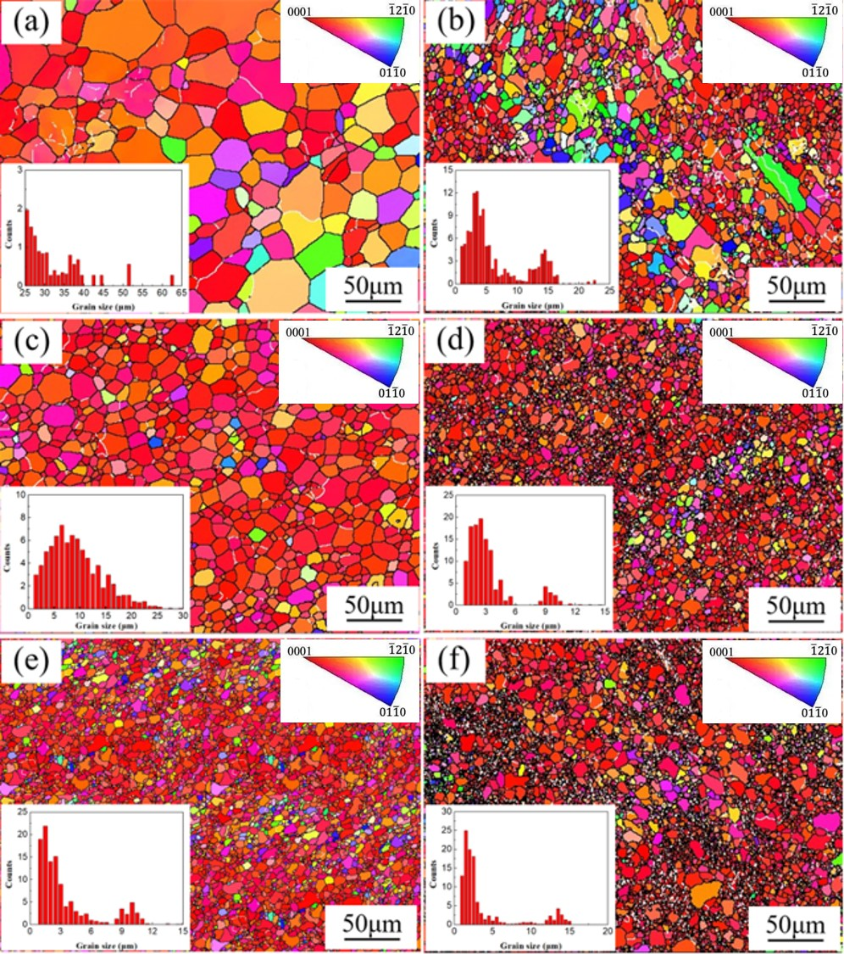
Fig. 3 IPF pictures of the samples after HPT processing under different conditions: (a) 1/8 turn at 293 K, (b) 1/8 turn at 423 K, (c) 1 turn at 293 K, (d) 1 turn at 423 K, (e) 10 turns at 293 K and (f) 10 turns at 423 K

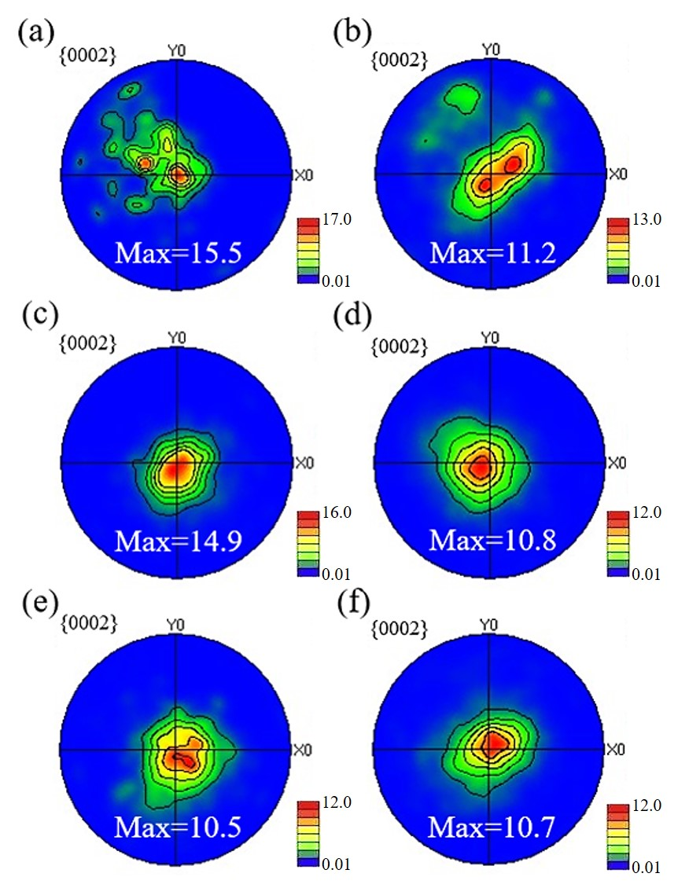
Fig. 4 The {0001} pole figures of the samples after HPT processing for (a) 1/8 turn at 293 K, (b) 1/8 turn at 423 K, (c) 1 turn at 293 K, (d) 1 turn at 423 K, (e) 10 turns at 293 K and (f) 10 turns at 423 K

Fig. 5 The XRD results of samples after HPT and the 2sinθ/λ-δcosθ/λ curves for dislocation density calculations.

Fig. 6 Vickers microhardness along selected diameters of Mg disks processed by HPT at temperatures of (a) 293 and (b) 423 K

Fig. 7 Engineering stress-engineering strain curves of samples processed by HPT for different numbers of turns at temperatures of (a) 293 and (b) 423 K.

Fig. 8 True strain-true stress and work hardening rate curves of samples processed by HPT at temperatures of (a) 293 and (b) 423 K.

Fig. 9 TEM images of samples after HPT processing through different turns and temperatures: (a) 1/8 turn at 293 K, (b) 1/8 turn at 423 K, (c) 1 turn at 293 K, (d) 1 turn at 423 K, (e) 10 turns at 293 K and (f) 10 turns at 423 K

