Structure and cryogenic mechanical properties of severely deformed
non-equiatomic alloys of Fe-Mn-Co-Cr system

E. D. Tabachnikovaª, T.V. Hryhorovaª, S.N. Smirnovª, I.V. Kolodiy^{b}, Yu.O. Shapovalovª, A.V. Levenets^{b}, S.E. Shumilinª, I.V. Kashubaª, M.A. Tikhonovsky^{b}, F. Spieckermann^{c}, M.J. Zehetbauer^{d}, E. Schafler^{d}, Y. Huang^{e}, T.G. Langdon^{f}

ªB.Verkin Institute for Low Temperature Physics and Engineering of the National Academy of Sciences of Ukraine, 47 Nauky Ave., Kharkiv, 61103, Ukraine
^{b}National Science Center Kharkiv Institute of Physics and Technology, Akademichna St., Kharkiv, 61108, Ukraine
^{c}Department of Materials Science, Chair of Materials Physics, Montanuniversität Leoben, 8700 Leoben, Austria
^{d}Faculty of Physics, University of Vienna, Boltzmanngasse 5, 1090 Wien, Austria
^{e}Department of Design and Engineering, Faculty of Science and Technology, Bournemouth University, Poole, Dorset BH12 5BB, UK
^{f}Department of Mechanical Engineering, University of Southampton, Southampton SO17 1BJ, UK
e-mail: tabachnikova@ilt.kharkov.ua

Keywords: high entropy alloys, microstructure, cryogenic temperatures, mechanical properties.
The work is devoted to a study of the structure and mechanical properties of two non-equiatomic medium-entropy nanocrystalline alloys, in which in a coarse state additional mechanisms act during plastic deformation - twinning (TWIP) in the Fe₄₀Mn₄₀Co₁₀Cr₁₀ alloy and phase transformations (TRIP) in the Fe₅₀Mn₃₀Co₁₀Cr₁₀ alloy. The nanocrystalline state in these alloys is achieved by high-pressure torsion (HPT) at 300 K and 77 K after different numbers of revolutions n = 0.25 and n = 5. In the nanostructural state in the TWIP Fe₄₀Mn₄₀Co₁₀Cr₁₀ and the TRIP Fe₅₀Mn₃₀Co₁₀Cr₁₀ alloys a basically complete phase transition from the fcc lattice to hcp is observed, the content of which does not depend very strongly on the HPT temperature and deformation. For both alloys in the nanostructured state, there is a significant decrease in differences in the phase composition and microhardness Hv by comparison with the coarse-grained state. A decrease in the HPT temperature and an increase in HPT deformation for all the cases studied lead to an increase in the value of Hv. The Fe₄₀Mn₄₀Co₁₀Cr₁₀ TWIP alloy remains ductile under active compression deformation at 300 and 77 K, while there is no macroscopic plasticity in the Fe₅₀Mn₃₀Co₁₀Cr₁₀ TRIP alloy under similar conditions. For both alloys the thermally-activated character of plastic deformation is retained during the transition from the coarse-grained to the nanostructured state.
Робота присвячена вивченню структури та механічних властивостей двох нееквіатомних середньоентропійних нанокристалічних сплавів, в яких у крупнозернистому стані під час пластичної деформації діють додаткові механізми – двійникування (TWIP) у Fe₄₀Mn₄₀Co₁₀Cr₁₀ та фазові перетворення (TRIP) в Fe₅₀Mn₃₀Co₁₀Cr₁₀. Нанокристалічний стан у цих сплавах досягається крутінням під високим тиском (HPT) при 300 К і 77 К при кількості обертів n = 0,25 і n = 5. У нанокристалічному стані у досліджених сплавах спостерігається в основному повний фазовий перехід від ГЦК до ГПУ ґратки, вміст якого не залежить від температури та деформації HPT. У вивчених сплавах у нанокристалічному стані спостерігається суттєве зменшення відмінностей у фазовому складі та мікротвердості Hv, які спостерігаються у цих сплавах у крупнозернистому стані. Зниження температури та збільшення деформації HPT для всіх досліджених випадків призводять до збільшення значення Hv. TWIP сплав Fe₄₀Mn₄₀Co₁₀Cr₁₀ залишається пластичним при активній деформації стиску при 300 і 77 K, тоді як у TRIP Fe₅₀Mn₃₀Co₁₀Cr₁₀ сплаві за аналогічних умов макроскопічна пластичність відсутня. При переході від крупнозернистого до нанокристалічного стану у досліджених сплавах зберігається термоактиваційний характер пластичної деформації.

1. Introduction
In recent decades, the physical and mechanical properties of a new class of materials, multicomponent high-entropy alloys (HEA HEAs) [1–10], have been actively studied and these, which have a number of advantages over traditional alloys. The improvement in the physico-mechanical properties of HEAs is usually associated with the features of their structure due, in particular, due to higher values of the entropy of mixing compared to traditional multicomponent alloys [11]. According to classical thermodynamics the entropy of mixing between soluble components is maximum when these components are in equiatomic concentrations [11]. The value of the entropy of mixing in single-phase equiatomic multicomponent alloys increases with an increase in the number of components included in such a system. The HEA crystal lattice, which consists of atoms of heterogeneous different elements with different electronic structures and different atomic sizes, is significantly distorted compared to the an ideal lattice out of homogeneous identical atoms. This approach is confirmed in by the well-studied equiatomic HEA CoCrFeMnNi [5, 12–16], which exhibits enhanced mechanical properties compared to traditional alloys: high strength, high and ductility, and high fracture toughness, especially at cryogenic temperatures. The high cryogenic strength (≈ 1280 MPa) and plasticity (≈ 70%) of this HEA are associated with the simultaneous action of two mechanisms, slip and twinning, whose significant contribution is especially pronounced at low temperatures [12]. As shown by the results of the mechanical properties studies of HEAs in recent years [5–10, 17–31], the maximum entropy of mixing is not a necessary the only factor for achieving high mechanical properties. These studies show that in many nonequiatomic non-equiatomic HEAs, as well as in medium entropy equiatomic alloys (MEAs) with less than 5 components such as CoNiCr, Fe₄₀Mn₄₀Co₁₀Cr₁₀, Fe₅₀Mn₃₀Co₁₀Cr₁₀, and a number of others, high physical and mechanical properties are observed. During deformation, especially at low temperatures, several deformation mechanisms operate in these alloys, such as twinning and phase transformations, known as the TWIP and TRIP mechanisms [32–34]. In this context, not only twinning mechanisms but also those which involve deformation induced phase transformations are important here, both being known as TWIP and TRIP mechanisms, respectively [32–34]. The effect of TWIP and TRIP mechanisms Their effects in coarse-grained HEAs Fe₄₀Mn₄₀Co₁₀Cr₁₀, Fe₅₀Mn₃₀Co₁₀Cr₁₀ in a wide temperature range (300 K – 0.5 K) ) was first studied in our early work [35-37]. first studied by the works [35-37]. It was shown that in these HEAs in the coarse-grained state under uniaxial tension in the It was shown that in these HEAs in the coarse-grained state under uniaxial tension in the temperature range of 0.5 – 4.2 K, due to the action of the TWIP and TRIP mechanisms, a strength of ≈ 1.5 – 1.8 GPa and plasticity of ≈ 65 – 85% were achieved and this far exceeds similar values in traditional alloys.
It was shown that in these HEAs in the coarse-grained state under uniaxial tension in the ultralow temperature range of 0.5 – 4.2 K, due to the action of the TWIP and TRIP mechanisms, a strength of ≈ 1.5 – 1.8 GPa and plasticity of ≈ 65 – 85% were achieved and this far exceeds similar values in traditional alloys.
It was is shown that in these HEAs in the coarse-grained state under uniaxial tension within the ultralow temperature range of 4.2 – 0.5 K, a strength of ≈ 1.5 – 1.8 GPa and plasticity of ≈ 65 – 85% are achieved by means of TWIP and TRIP mechanisms, values which far exceed the mechanical properties in traditional alloys. It is obvious that use of the TRIP and TWIP mechanisms in HEA opens up open many potential possibilities for creating cryogenic high strength materials. However, despite intensive of the numerous studies of these alloys, many aspects of questions about the deformation of these materials remain insufficiently studied open. In particular, it is of great interest to study the processes of grain structure refinement of TWIP and TRIP alloys under severe plastic deformation (SPD) and the possibility potential of increasing their strength by creating a nanostructured state. In this respect, the present regard, this work is devoted to a the study of the structure and mechanical properties of TWIP Fe₄₀Mn₄₀Co₁₀Cr₁₀ alloy and TRIP Fe₅₀Mn₃₀Co₁₀Cr₁₀ alloy after SPD at 300 K and 77 K by high-pressure torsion (HPT). The HPT method has been widely used in many works to obtain a nanostructured state in a number of HEAs [16, 38–43] and can be effectively used to study microstructure the microstructural evolution and phase transformations caused by deformations deformation up to very high strains [44, 45]. In addition, one of the tasks of the work is to study the stability of the microstructure formed after HPT deformation at 300 and 77 K, depending on long-term storage under ambient conditions (atmospheric pressure, in air at room temperature).

2. Materials and methods of research

Non-equiatomic high-entropy alloys Fe₄₀Mn₄₀Co₁₀Cr₁₀ (TWIP) and Fe₅₀Mn₃₀Co₁₀Cr₁₀ (TRIP) were obtained by arc melting of elements at low pressure in a high purity argon atmosphere inside a the cooled water copper plate. The purity of the alloying elements was above beyond 99.9 (at.)%. In order to ensure chemical homogeneity, the ingots were remelted at least 5 times. After casting, homogenization annealing was carried out in an argon atmosphere at 1000 °C for 24 hours. The blanks were then rolled at room temperature into a tape 1 mm thick with a reduction of 10–15% per pass with intermediate annealing at a temperature of 1000 °C for 1 h after 50-60% reduction. Disks with 10 mm in diameter were cut from the tape, and then which was mechanically ground to a thickness of 0.9 mm and annealed at a temperature of 1000 °C for 1 h. The HPT method was used to To obtain the nanostructured state., The applied the method of High Pressure Torsion (HPT) was used. The HPT deformation technique was applied at 300 and 77 K and similar to that described in detail in [41]. The HPT method was used to obtain the nanostructural state. The applied HPT deformation technique at 300 and 77 K was similar to that described in detail in [41].The temperature of 77 K was obtained by immersion of the sample and the HPT -plungers anvils in liquid nitrogen. Straight radial lines were have been attached to the upper and lower surfaces of the ssamples, which could also be identified after the HPT processing, and the rotation angle fully coincided with the monitored rotations of the plunger. This indicated anvil, indicating that no slip occurred during HPT processing; moreover, such a slip event would have led to manifested in a sudden decrease in the torque curves, but such decreases were never observed (Fig.6). The in situ torques during the HPT process were measured by two V-shaped strain gauges connected as full bridges. These strain gauges were diagonally arranged on a hollow cylinder made of steel supporting the nonrotating non-rotating, fixed HPT anvil, being part of the HPT facility used. After appropriate calibration, the nominal electronic torque resolution was 0.01 Nm, whereas the electronic measuring noise was about a factor 10 higher. For the shear stress derived, this means a measuring resolution of distinctly below 1 MPa. Values of shear strain were calculated by using have been calculated by the equation [41]
, (1)
where n is the number of rotations, r is the distance from the rotation axis, and h is the sample thickness achieved after HPT processing (h = 0.8 mm). The plungers were have been rotated at a rate of 0.2 rpm¸ which corresponds to a the maximum shear strain rate during torsion dγ/dt = 0.11s⁻¹. The number of rotations n was 0.25 and 5. For the measurement of microhardness, the HPT discs disks were mechanically polished. Using a PAAR MHD and PMT microhardness tester equipped with a Vickers indenter, a load of 1.5 N was applied for 15 s, and indentations were achieved in distances of 0.5 mm along four different radial directions of the disc disk from the center to the edge. edges. The microhardness values obtained at the same distance from the center were averaged over four values and plotted on the corresponding graphs. Microhardness measurements were carried out two hours after HPT and one year under ambient conditions (atmospheric pressure, in air at room temperature).Microhardness measurements were carried out after two hours as well as after one year of storage at ambient conditions (atmospheric pressure, in air at room temperature). Specimens for mechanical testing with a size of 0.6×0.6×1.2 mm³ were cut out from the edge part of the disks (in the uniform deformation area), which were subjected to five revolutions (n=5).. Samples were deformed by uniaxial compression with a relative loading rate of 10⁻⁴ s⁻¹ at room temperature (300 K) and liquid nitrogen temperature (77 K).
Overall structural characteristics of the alloys were studied using synchrotron radiation. Diffraction patterns were collected at a distance of 4.5 mm from the center of the disk in the region of a homogeneous structure. The size of diffraction area was 0.5×0.5 mm². Diffraction patterns are presented as I = f(Q), where I - intensity, Q = 4πsinθ/λ – scattering vector. Phase composition and structural characteristics of the samples were determined by the Rietveld method (Maud software). The study of microstructural parameters: <ε> –average microstrain, D – size of the coherent scattering domains (CSD) or crystallite size is based on the line profile analysis (LPA). These parameters have different contributions to the broadening of diffraction peaks:
$β_{L}=\frac{λ}{D⋅\text{cos}(θ)}; β_{G}=4ε⋅\text{tg}(θ)$,
where β_{L}, β_{G} – the Lorentzian and Gaussian components of the Voightian Voigtian profile, respectively; λ – the radiation wavelength. Instrumental broadening correction was done by a polycrystalline CeO₂ powder sample. From the FWHM values an instrumental resolution function was obtained, with the help of which the true physical broadening β was determined from the total peaks broadening of the studied samples.which allowed to determine the true physical broadening β was determined from the total peaks broadening of the studied samples.

3. Results and discussion
3.1 Structural characteristics of nanostructured alloys
The diffraction patterns of both alloys subjected to НTР at room and liquid nitrogen temperatures are shown in Fig.1.

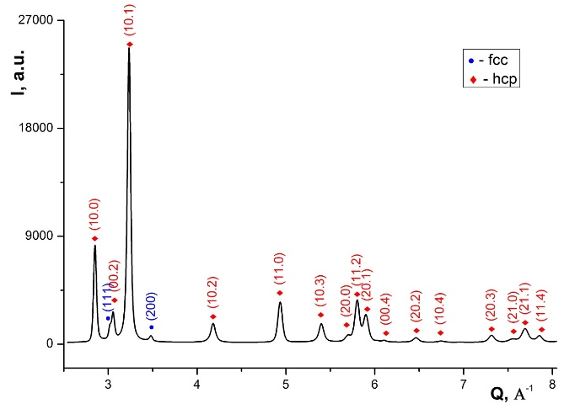 | 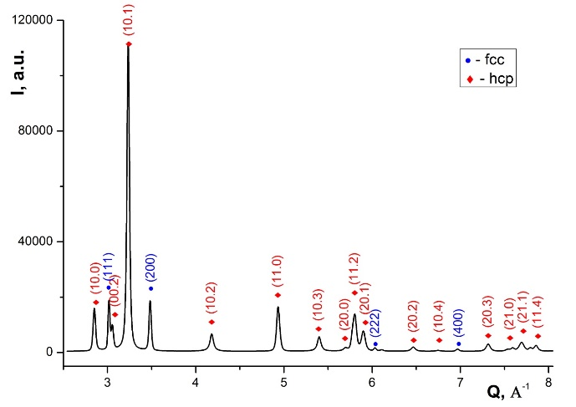
a | b
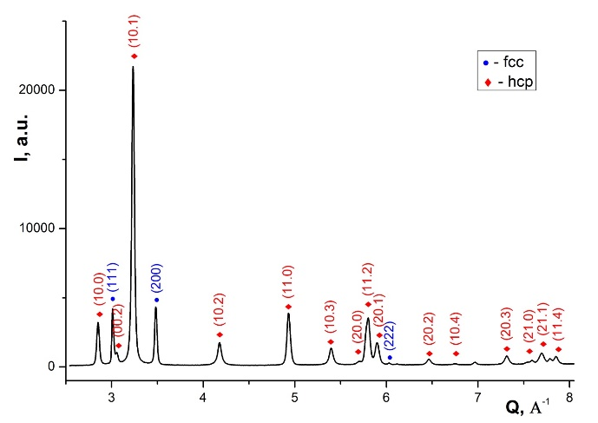 | 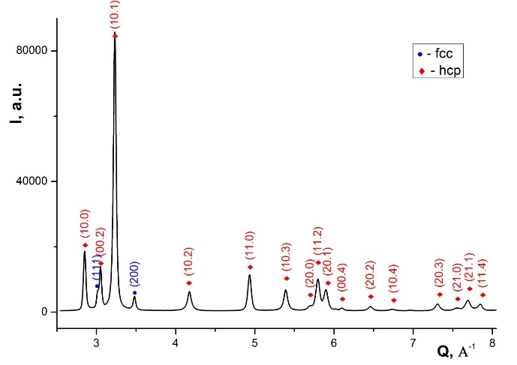
c | d
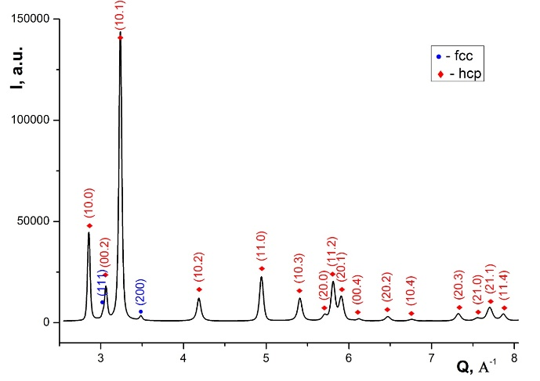 | 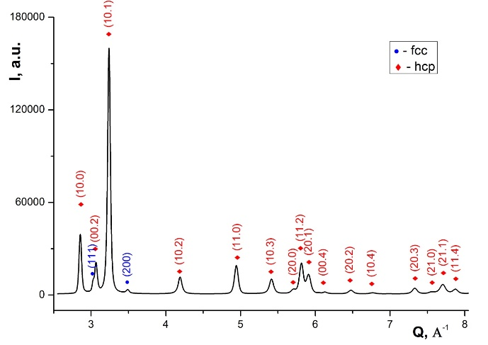
e | f
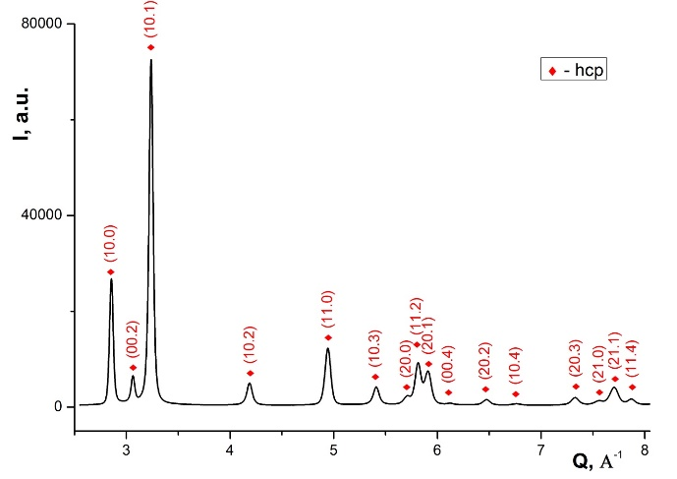
g | k
Fig. 1. Diffraction patterns. For Fe₄₀Mn₄₀Co₁₀Cr₁₀ alloy: a – RT-HPT, n = 0.25; b –cryo-HPT, n = 0.25; c – RT-HPT, n = 5; d – cryo-HPT, n = 5. For Fe₅₀Mn₃₀Co₁₀Cr₁₀ alloy: e – RT-HPT, n = 0.25; f – cryo-HPT, n = 0.25; g – RT-HPT, n = 5; k – cryo-HPT, n = 5.

As seen in Fig. 1, after HPT deformation in of the TWIP Fe₄₀Mn₄₀Co₁₀Cr₁₀ and TRIP Fe₅₀Mn₃₀Co₁₀Cr₁₀ alloys, two phases are observed: fcc and hcp, and in one case after RT-HPT at n = 5 the Fe₅₀Mn₃₀Co₁₀Cr₁₀ alloy contains 100% hcp phases phase (Fig. 1g). An analysis of the intensity distribution of diffraction peaks indicates the presence of texture in all samples. Grains of the hcp phase are preferably oriented with crystallographic planes {10.0} parallel to the sample surface; and for the fcc phase with {100} planes, respectively. An analysis of the broadening and profile shape of the hcp phase peaks showed that (10.2), (10.3), (10.4) peaks are more broadened and have long tails, which may indicate the presence of twins in the structure. Therefore, for the hcp phase, we estimated the twin faults probability (tfp) using the Warren Warren’s model [46]. Note that peak broadening after НРT deformation may be associated with lattice deformation due to the formation of new lattice defects and a decrease in grain size [47]. All results on of the phase composition and microstructural characteristics of the studied TWIP Fe₄₀Mn₄₀Co₁₀Cr₁₀ and TRIP Fe₅₀Mn₃₀Co₁₀Cr₁₀ alloys are given in Table 1. The structural characteristics given in Table 1 for TWIP Fe₄₀Mn₄₀Co₁₀Cr₁₀ and TRIP Fe₅₀Mn₃₀Co₁₀Cr₁₀ alloys in the initial state is taken from [36, 37].

Table 1. Phase composition and structural characteristics of the studied TRIP Fe₅₀Mn₃₀Co₁₀Cr₁₀ and TWIP Fe₄₀Mn₄₀Co₁₀Cr₁₀ alloys, after RT-HPT and cryo-HPT for the number of revolutions n = 0.25 and n = 5. The H_{v} and γ values are are given at valid for a distance r = 4.5 mm from the center of the samples. Dashes correspond to the cases when the microstructural characteristics could not be determined.

Sample | n | γ | Tempe-rature HPT | Phase | Fraction, vol% | Lattice parameters.  Ǻ | Microstructural parameters |  |  | H_{v}., GPa
 |  |  |  |  |  |  | D. nm | <ε>×10³ | tfp×10³ | H_{v}., GPa
twip initial | 0 | 0 |  | hcp | 0
 |  |  |  | fcc | 100 | 3.624 |  |  |  | 1.31
trip initial | 0 | 0 |  | hcp | 41.0 | a = 2.542; c = 4.104 |  |  |  | 2.48
 |  |  |  | fcc | 59.0 | 3.604 | 215.0 | < 0.5 |  | 2.48
twip-hpt | 0.25 | 8.84 | 300 | hcp | 83.4 | a = 2.546; c = 4.114 | 48.7 | 2.24 | 4.1 | 4.15
 |  |  |  | fcc | 16.6 | 3.608 | 87.2 | 1.95 | -
twip-hpt | 0.25 | 8.84 | 77 | hcp | 95.9 | a = 2.546; c = 4.113 | 42.4 | 3.4 | 6.9 | 4.26
 |  |  |  | fcc | 4.1 | 3.611 | - | - | -
twip-hpt | 5 | 177 | 300 | hcp | 81.8 | a = 2.546; c = 4.113 | 54.0 | 2.24 | 4.3 | 4.78
 |  |  |  | fcc | 18.2 | 3.609 | 74.7 | 1.66 | -
twip-hpt | 5 | 177 | 77 | hcp | 93.9 | a = 2.547; c = 4.122 | 42.4 | 2.96 | 6.8 | 5.41
 |  |  |  | fcc | 6.1 | 3.613 | 34.1 | 1.64 | -
trip-hpt | 0.25 | 8.84 | 300 | hcp | 89.7 | a = 2.544; c = 4.103 | 53.5 | 2.99 | 5.2 | 4.37
 |  |  |  | fcc | 10.3 | 3.601 | 42.6 | 1.78 | -
trip-hpt | 0.25 | 8.84 | 77 | hcp | 96.5 | a = 2.543; c = 4.099 | 44.2 | 3.64 | 6.4 | 4.85
 |  |  |  | fcc | 3.5 | 3.598 | - | - | -
trip-hpt | 5 | 177 | 300 | hcp | 100 | a = 2.543; c = 4.106 | 42.7 | 4.03 | 4.1 | 5.15
 |  |  |  | fcc | 0 | - | - | - | -
trip-hpt | 5 | 177 | 77 | hcp | 98.5 | a = 2.543; c = 4.106 | 59.6 | 3.45 | 5.4 | 5.59
 |  |  |  | fcc | 1.5 | 3.605 | - | - | -

From the data presented in Table 1, it follows that in the studied alloys, as a result of HPT deformation, complex structural changes occur, depending on the HPT temperature and the number of revolutions n. Note In the following, the main features of the structure evolution in the Fe₅₀Mn₃₀Co₁₀Cr₁₀ and Fe₄₀Mn₄₀Co₁₀Cr₁₀ alloys: are given:
Feature 1. HPT deformation leads to an increase in the microhardness H_{v} i.e. to with a significant hardening of the investigated alloys. For the TWIP Fe₄₀Mn₄₀Co₁₀Cr₁₀ alloy, the microhardness ratio for the coarse grained and nanostructured states (for RT-HPT, n=5) is approximately 3.7, and for the TRIP Fe₅₀Mn₃₀Co₁₀Cr₁₀ alloy this ratio is 2.1, i.e. the effect of hardening in the TWIP Fe₄₀Mn₄₀Co₁₀Cr₁₀ alloy is even more pronounced. It can be seen from Fig. 2 that for samples in the nanostructured state there is, a decrease in the HPT temperature and an increase in n for all the cases studied leading to an increase in the value of H_{v}.
revolution number lead to an increase in the hardness H_{v}.
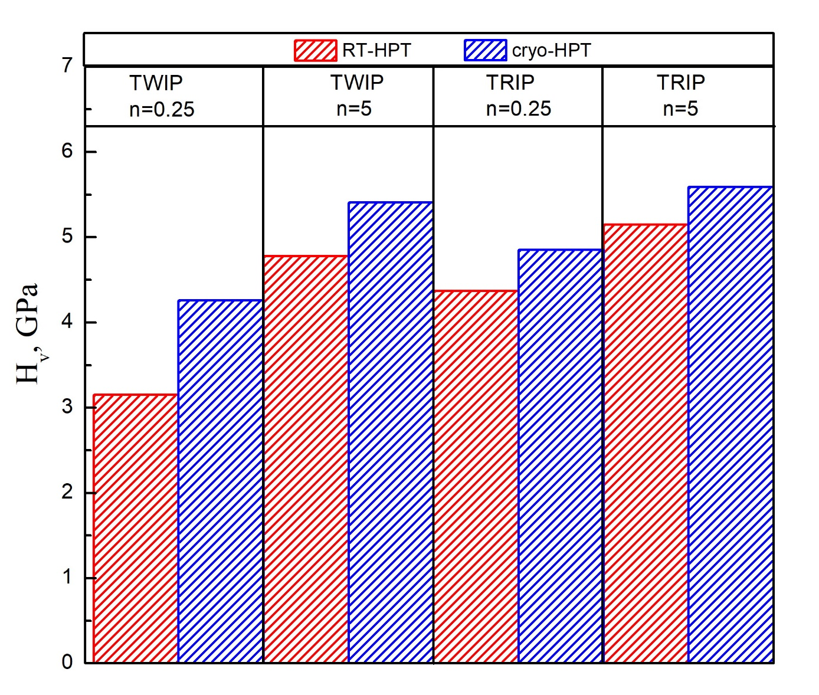

Fig. 2. The value Values of microhardness H_{v} in TRIP Fe₅₀Mn₃₀Co₁₀Cr₁₀ and TWIP Fe₄₀Mn₄₀Co₁₀Cr₁₀ alloys after RT-HPT and cryo-HPT at n = 0.25 and n = 5.

Feature 2. НРТ deformation leads to significant changes in the phase composition. The composition of the hcp and fcc phases in the TRIP Fe₅₀Mn₃₀Co₁₀Cr₁₀ and TWIP Fe₄₀Mn₄₀Co₁₀Cr₁₀ alloys after RT-HPT and cryo-HPT at n = 0.25 and n = 5 is graphically shown in Fig. 3.
fractions which are demonstrated in Fig. 3 in quantitative way.
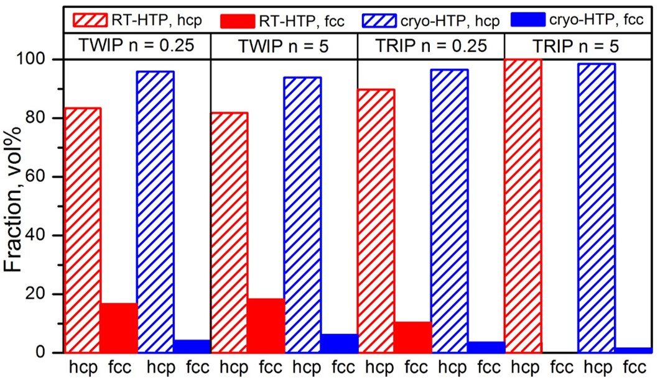
Fig. 3. Composition Fractions of hcp and fcc phases in TRIP Fe₅₀Mn₃₀Co₁₀Cr₁₀ and TWIP Fe₄₀Mn₄₀Co₁₀Cr₁₀ alloys after RT-HPT and cryo-HPT at n = 0.25 and n = 5.

For TWIP Fe₄₀Mn₄₀Co₁₀Cr₁₀ it was found that the single-phase fcc alloy in the initial state becomes a two-phase one after НРT deformation. As can be seen from fig. 2, the content fraction of the hcp phase after RT-HPT at n=0.25, i.e. at low shear strain (γ=8.84) reaches 83.4% and noticeably more (almost 96%) after cryo-HPT. With a further increase in of the number of revolutions to n=5 (γ = 177), however, an insignificant decrease in the hcp phase (by 1.6–2%) is observed at both HPT temperatures. Note that the content fraction of the fcc phase after cryo-HPT is three times less than after RT-HTP for both n=0.25 and n = 5 (Fig. 3). The TRIP Fe₅₀Mn₃₀Co₁₀Cr₁₀ alloy in the initial state contains two phases, the fcc phase (59%) and the hcp phase (41%). For n = 0.25 the content fraction of the hcp phase increases after RT-HPT increases to 89.7% and after cryo-HPT to 96.5%. With an increase in the number of revolutions to n = 5, the samples become practically single-phase − the content fraction of the hcp phase is 100% for RT-HPT and 98.5% for cryo-HPT, respectively.
Feature 3. The microstructure parameters (crystallite sizes D, microdeformation <ε>, and twin faults probability (tfp) for hcp and fcc phases depend on the HPT temperature and the number of revolutions n. Moreover, as can be seen from Fig.4, the crystallite size sizes D in fcc and hcp phase are different.
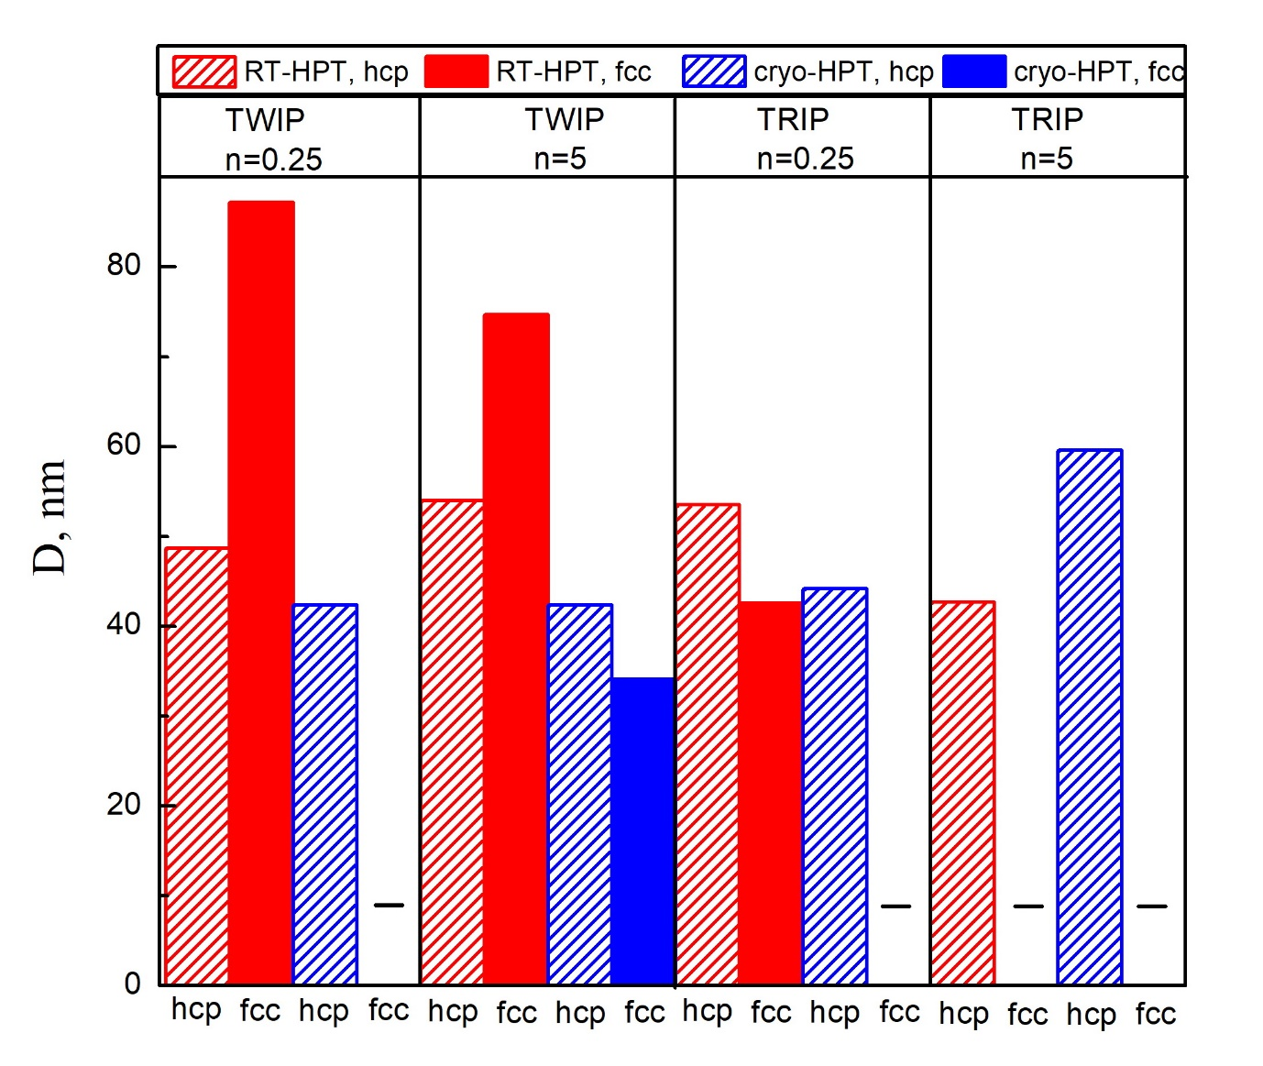
Fig. 4. Composition Comparison of crystallite sizes size D in TRIP Fe₅₀Mn₃₀Co₁₀Cr₁₀ and TWIP Fe₄₀Mn₄₀Co₁₀Cr₁₀ alloys after RT-HPT and cryo-HPT at n = 0.25 and n = 5. Dashes correspond to cases when it was not possible to determine the D values due to the low content of the fcc phase.

The greatest largest difference is observed in the structure of the TWIP Fe₄₀Mn₄₀Co₁₀Cr₁₀ alloy after RT-HTP: the value of D in the fcc phase is 87.2 nm and thus 1.8 times greater than in the hcp phase and is 87.2 nm larger than that of the hcp phase. It is found for both alloys that for the hcp phase with decreasing HPT temperature the values of D tend to decrease with decreasing HPT temperature. This trend, however, does not hold for the TRIP alloy subjected to 5 turns of torsion revolutions of HPT (D is 42.7 nm and 59.6 nm for deformation at 300 K and 77 K temperatures, respectively). In the TWIP alloy, a decrease in the parameter crystallite size D for the fcc phase is also observed with a decrease in the deformation temperature, and this parameter has the smallest value 34.1 nm for the case of n = 5, cryo-HPT. For the hcp phase, an explicit dependence of D on the number of revolutions has not been established found. Apparently, for the hcp phase already at γ beyond n = 0.25 (γ ≥ 8.84) this parameter, D only changes slightly and is comes close to saturation (D = 42−54 nm).
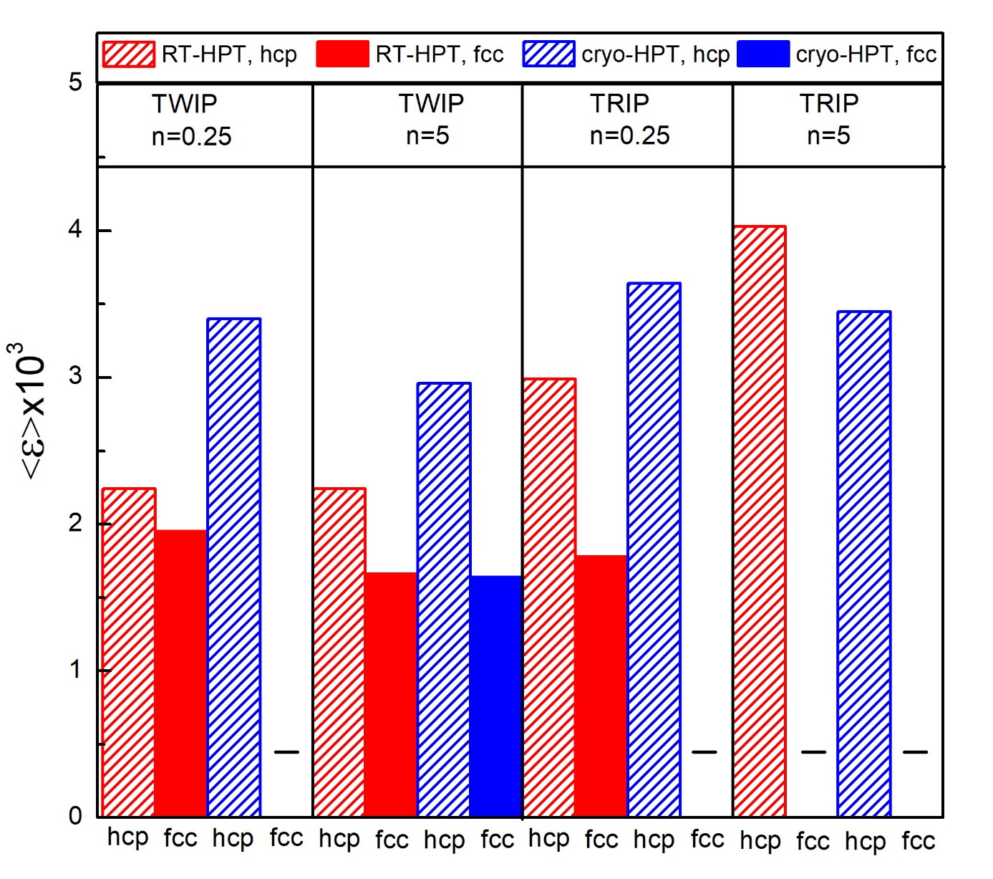
Fig. 5. Microstrain <ε> for hcp and fcc phases in TRIP Fe₅₀Mn₃₀Co₁₀Cr₁₀ and TWIP Fe₄₀Mn₄₀Co₁₀Cr₁₀ alloys after RT-HPT and cryo-HPT at n = 0.25 and n = 5. Dashes correspond to the cases when due to the low content of the fcc phase, <ε> values the could not be determined.
where <ε> could not be determined due to the low content of the fcc phase.
As can be seen in on Fig. 5, the value <ε> in the hcp phase in the TRIP Fe₅₀Mn₃₀Co₁₀Cr₁₀ alloy is higher than that in the TWIP Fe₄₀Mn₄₀Co₁₀Cr₁₀ alloy. For the case n = 0.25 in both alloys, <ε> increases with a decrease in the НРT temperature. At n = 5 such growth is observed only in TWIP Fe₄₀Mn₄₀Co₁₀Cr₁₀. Note also that the twin faults fault probability (tfp) increases with decreasing HPT temperature. In addition, for n = 5 for both НРТ temperatures, the (tfp) values for TWIP Fe₄₀Mn₄₀Co₁₀Cr₁₀ are higher than those for the TRIP Fe₅₀Mn₃₀Co₁₀Cr₁₀ alloy, as shown in Table 1.
Feature 4. Lattice parameters.
It should be noted that the lattice parameters of both phases for TWIP Fe₄₀Mn₄₀Co₁₀Cr₁₀ samples are slightly larger than the corresponding values for TRIP Fe₅₀Mn₃₀Co₁₀Cr₁₀ samples, which may be due to the high content of Mn, where the metallic radius of which r = 1.27Ǻ is being larger than that of Fe (r = 1.26 Ǻ).

3.2. Mechanical characteristics of nanostructured Fe₄₀Mn₄₀Co₁₀Cr₁₀ and Fe₅₀Mn₃₀Co₁₀Cr₁₀ alloys
3.2.1. Torsional shear stress
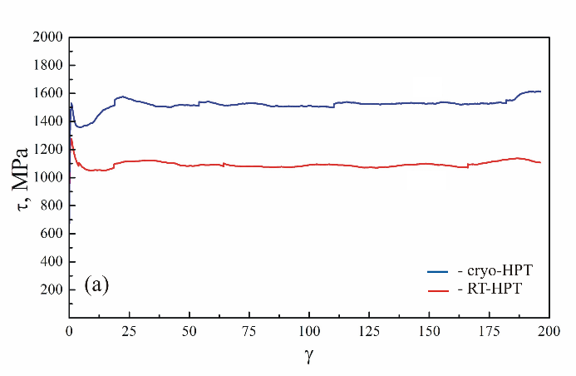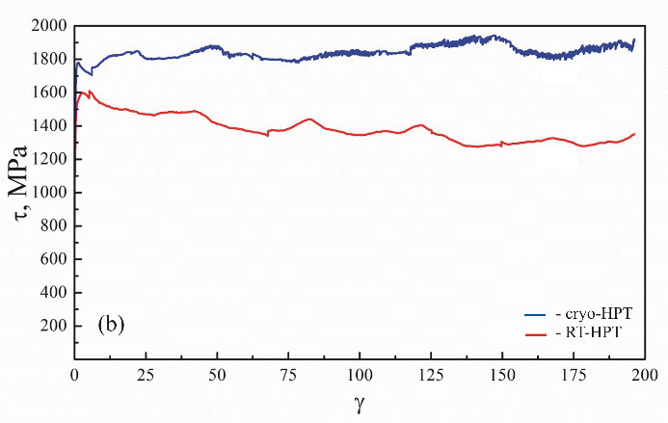
Fig. 6. Torsional shear stress as derived from the torque data measured in situ during 300 K and 77 K HPT-processing for nanostructured of: a - Fe₄₀Mn₄₀Co₁₀Cr₁₀ alloy, b - Fe₅₀Mn₃₀Co₁₀Cr₁₀ alloy.

Fig. 6 shows plots of shear stress τ versus strain γ obtained from torque data measured in situ during the RT-HPT and cryo-HPT processes. Such in situ measurements, as noted in Section 2, As noted in section 2, such in situ measurements indicate the magnitude of the deforming stress during shear deformation, and make it possible to control the absence of check for any slippage occurring between the sample and plungers anvil during the torsion of the sample. It can be seen that during the deformation of TWIP Fe₄₀Mn₄₀Co₁₀Cr₁₀ and TRIP Fe₅₀Mn₃₀Co₁₀Cr₁₀TWIP alloys, the value of τ for all γ in the cryo-HPT process is greater tlarger than the value of τ in the RT-HPT process. At For γ > 20 in the TWIP alloy, the dependences τ(γ) reach a plateau. In the TRIP alloy, with increasing γ, the value of τ at cryo-HPT, on average, slightly increases, and, on average, decreases at RT-HPT. The value of τ is larger for the TRIP deformation than for TWIP Fe₄₀Mn₄₀Co₁₀Cr₁₀ both for cryo-HPT and RT-HPT.

3.2.2. Dependences of microhardness on different parameters for nanostructured Fe₄₀Mn₄₀Co₁₀Cr₁₀ and Fe₅₀Mn₃₀Co₁₀Cr₁₀ alloys

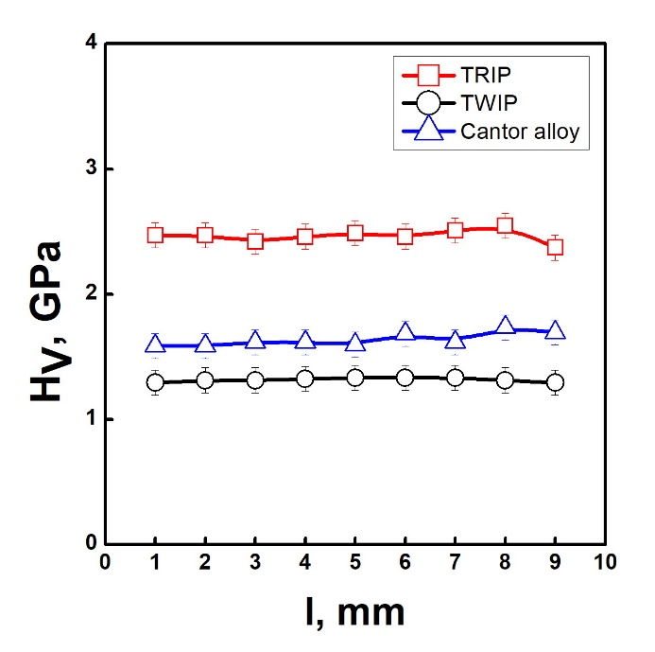
Fig. 7. Microhardness H_{v} depending on the distance l along the disk diameter for the samples in the initial state, for different the following alloys: □ – TRIP Fe₅₀Mn₃₀Co₁₀Cr₁₀, ○ – TWIP Fe₄₀Mn₄₀Co₁₀Cr₁₀, ∆ – Cantor CoCrFeMnNi [48].

Figure 7 shows the H_{v} values for TRIP Fe₅₀Mn₃₀Co₁₀Cr₁₀ and TWIP Fe₄₀Mn₄₀Co₁₀Cr₁₀ alloys in the initial state measured along the sample diameter. The practical absence almost constant values of the dependence H_{v}(l) indicates H_{v}(l) indicate the homogeneity of the structure in the initial coarse-grained samples of these alloys. It can be seen that the TRIP Fe₅₀Mn₃₀Co₁₀Cr₁₀ alloy is stronger than the TWIP Fe₄₀Mn₄₀Co₁₀Cr₁₀ alloy. The ratio of the microhardness values of these alloys (H_{v} -TRIP/ H_{v} -TWIP) is 1.89. For comparison, Fig.7 also shows the dependence H_{v} (l) for the Cantor alloy studied in detail in the literature [5, 12–16].
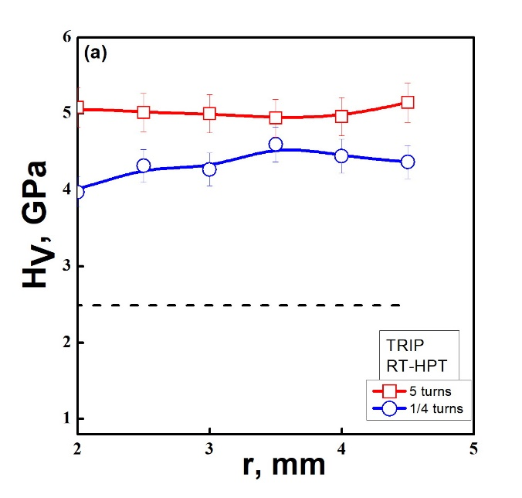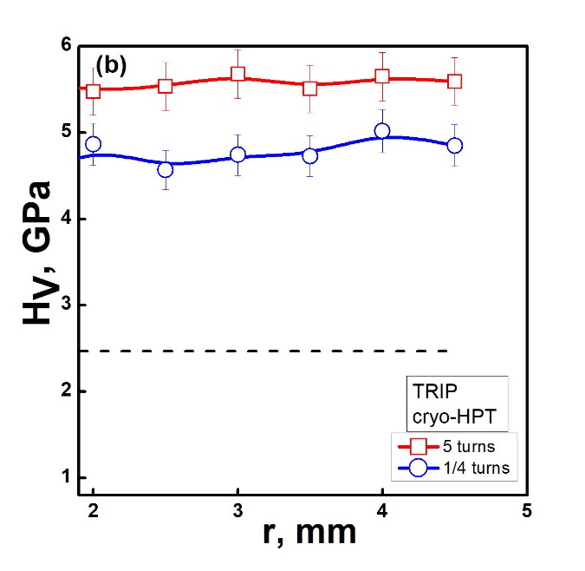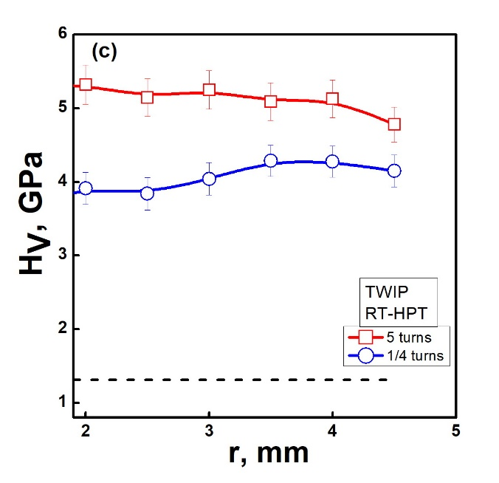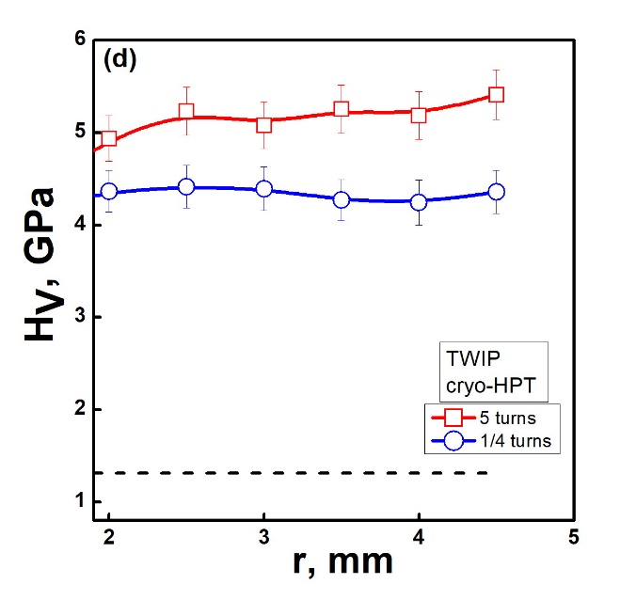
Fig. 8. Microhardness H_{V} depending on the distance from the disk center r. For Fe₅₀Mn₃₀Co₁₀Cr₁₀ alloy: a – RT-HPT, b – cryo-HPT; for Fe₄₀Mn₄₀Co₁₀Cr₁₀ alloy: c – RT-HPT, d – cryo-HPT; □ – n = 5, ○ – n = 0.25. Dotted line- initial state.

For the convenience sake of comparing the microstructural parameters of TRIP Fe₅₀Mn₃₀Co₁₀Cr₁₀ and TWIP Fe₄₀Mn₄₀Co₁₀Cr₁₀alloys, Figs. 8 and 9 show the dependences H_{V}(r) and H_{V}(γ), respectively, for the range r >2. Here the value of H_{V} is practically independent of r (or γ), which corresponds to a region with a homogeneous microstructure in the sample. Note that, according to relation (1), due to the gradient distribution of the shear strain from the center of the samples to its edges, a gradient microstructure is formed in the samples which arises due to the inhomogeneous dynamic crushing of grains [49, 50].Note that, according to relation (1), due to the there is a gradient in strain from the sample’s center to its edge, and thus a gradient in microstructure is formed which is connected with some inhomogeneous dynamic crushing of grains [49, 50]. Therefore, in the region of small radii r < 2, an increase in the value of H_{V} is observed, and for the region r > 2, the value of H_{V} reaches a plateau. This form of the dependence H_{V}(r) and H_{V}(γ) has been experimentally confirmed for many materials [38–43, 48]. Fig. 8 for TRIP Fe₅₀Mn₃₀Co₁₀Cr₁₀ and TWIP Fe₄₀Mn₄₀Co₁₀Cr₁₀ alloys for a region of homogeneous microstructure presents the dependences of the value of H_{V} (r) for n=0.25 and n = 5. It can be seen that, in TRIP Fe₅₀Mn₃₀Co₁₀Cr₁₀ (Fig.8a, b) and TWIP Fe₄₀Mn₄₀Co₁₀Cr₁₀ (Fig.8c, d) alloys, an increase in n leads to an increase in the value of H_{V}.
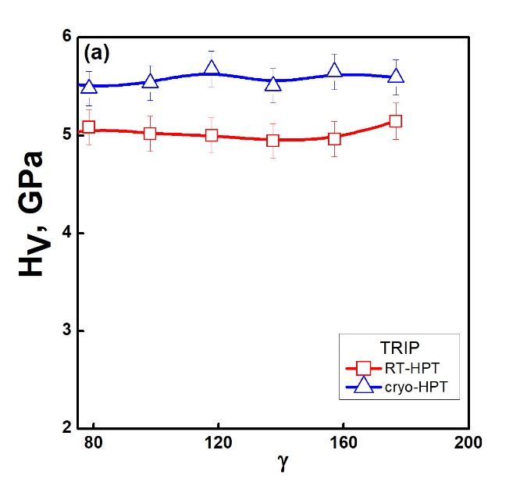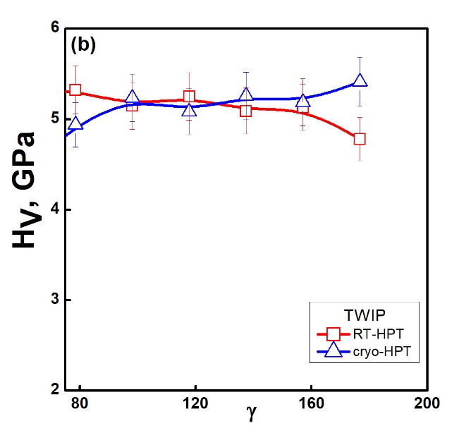
Fig. 9. Microhardness H_{V} depending on the shear strain γ for Fe₅₀Mn₃₀Co₁₀Cr₁₀ and Fe₄₀Mn₄₀Co₁₀Cr₁₀ alloys for different HPT temperatures: a - Fe₅₀Mn₃₀Co₁₀Cr₁₀; b - Fe₄₀Mn₄₀Co₁₀Cr₁₀; ∆ –cryo-HPT, □ – RT-HPT, n=5.

Fig. 9 shows the dependences H_{V}(γ) for n = 5. It can be seen that in the Fe₅₀Mn₃₀Co₁₀Cr₁₀ TRIP alloy, in the region of a homogeneous microstructure, a decrease in the НPT temperature from 300 to 77 K leads to an increase in the microhardness by an average of 10%. In contrast to this, for the TWIP Fe₄₀Mn₄₀Co₁₀Cr₁₀ alloy, a similar decrease in the НРT temperature leads to a slight (within the spread of experimental data) increase in the microhardness value for the region γ >150.
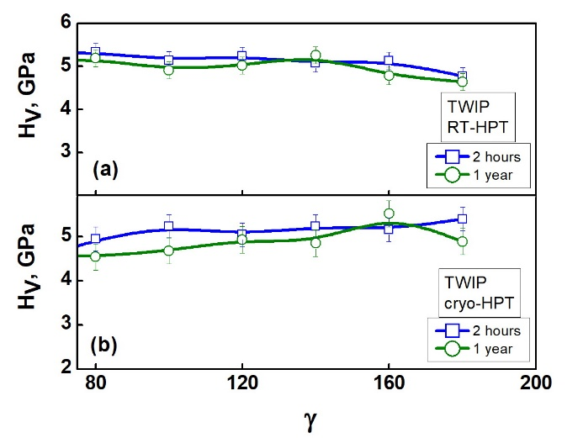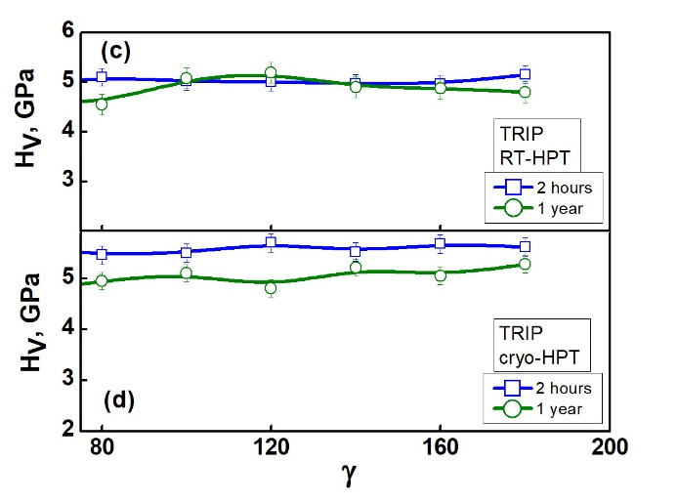
Fig. 10. Microhardness H_{V} depending on the shear strain γ for different adding time times of ambient storage. For Fe₄₀Mn₄₀Co₁₀Cr₁₀ alloy: a – RT-HPT, b – cryo-HPT; for Fe₅₀Mn₃₀Co₁₀Cr₁₀ alloy: c – RT-HPT, d – cryo-HPT; □ – 2 hours, ○ – 1 year.

Fig. 10 for nanograined Fe₄₀Mn₄₀Co₁₀Cr₁₀ and Fe₅₀Mn₃₀Co₁₀Cr₁₀ alloys (for samples after RT-HPT and cryo-HPT, n = 5) shows the dependences of H_{V}(γ) on different sample holding storage times (within 2 hours and for one year) under ambient conditions (atmospheric pressure, in air at room temperature). It can be seen that for the cases shown in Fig. 10 (a, c), the H_{V}(γ) dependences almost coincide. For the alloy Fe₅₀Mn₃₀Co₁₀Cr₁₀ (cryo-HPT), aging for one year led to a slight decrease in the level of microhardness (Fig. 10d). Such a decrease in the microhardness values can be associated with the reverse transitions from the hcp to the fcc phase during the aging of the samples after the НРT deformation. Note that such reverse transformations from the hcp to the fcc phase after НРT deformation were observed in a number of cases in the Cantor alloy [56].
Thus, the above results show that Fe₅₀Mn₃₀Co₁₀Cr₁₀ and Fe40Mn40Co10Cr10 nanocrystalline alloys aged at room temperature for one year remain stable in most cases considered.

3.2.3. Mechanical characteristics under active loading of nanostructured Fe₄₀Mn₄₀Co₁₀Cr₁₀ and Fe₅₀Mn₃₀Co₁₀Cr₁₀ alloys
Samples for deformation by uniaxial compression were cut from the edge part of the disks (in the uniform deformation area) being subjected to HPT deformation at 300 and 77 K. Fig. 11 shows the deformation curves for the Fe₄₀Mn₄₀Co₁₀Cr₁₀ alloy, obtained by uniaxial compression with a relative loading rate of 10⁻⁴ s⁻¹ at room temperature (300 K) and liquid nitrogen temperature (77 K) for nanostructured samples after RT-HPT (Fig. 11a) and after cryo-HPT (Fig. 11b) for the TWIP alloy Fe₄₀Mn₄₀Co₁₀Cr₁₀.
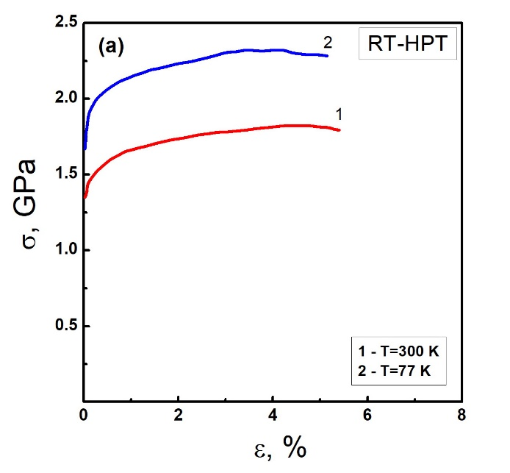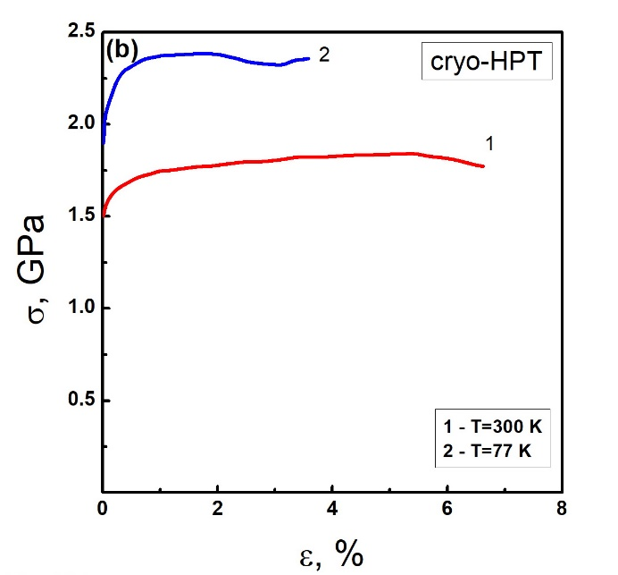
Fig. 11. The deformation curves for nanostructured samples of the Fe₄₀Mn₄₀Co₁₀Cr₁₀ alloy after RT-HPT (a) and after cryo-HPT (b), strain rate 10⁻⁴ s¹; 1 – compression at 300 K, 2 – compression at 77 K.

The parameters of the deformation curves (yield strength σ_{0.2}, ultimate strain ε_{max}, ultimate strength σ_{U}) for the Fe40Mn40Co10Cr10 alloy shown in Fig. 11 are given in Table 2. For comparison, Table 2 also shows the corresponding parameters for samples in the coarse-grained material [36]. As can be seen from the data given in table Table 2, the transition from a coarse-grained to a nanostructured state leads to a significant increase in the yield strength and tensile strength with a decrease in the plasticity resource. Unlike the nanostructured TWIP Fe₄₀Mn₄₀Co₁₀Cr₁₀, the nanostructured TRIP Fe₅₀Mn₃₀Co₁₀Cr₁₀ alloys completely loses plasticity under uniaxial compression at 300 K. The samples were destroyed in the elastic region at at stresses the stress of ≈ 630 MPa. The main Main cracks with numerous smaller lateral cracks appear along the loading axis in the specimens. Obviously, the observed loss of plasticity is associated with an increase in the fraction of grain boundaries in the nanostructured state and the impossibility of relaying plasticity from grain to grain.

Table 2. Mechanical characteristics properties of the Fe₄₀Mn₄₀Co₁₀Cr₁₀ alloy in nanostructured state tested under uniaxial compression, and in initial state [36] tested under uniaxial tension at a rate of 10⁻⁴ s⁻¹, for deformation temperatures of 300 K and 77 K. The HPT temperature is 300 K (RT-HPT) and 77 K (cryo-HPT).
Sample | Deformation  Compression temperature, K | σ_{0.2}, GPa | ε_{max}, % | σ_{U}, GPa
Initial | 300 | 0.19 | 46 | 0.75
Initial | 77 | 0.41 | 46 | 1.71
RT -HPT | 300 | 1.49 | 5.38 | 1.82
RT -HPT | 77 | 1.97 | 5.15 | 2.32
cryo -HPT | 300 | 1.62 | 6.62 | 1.84
cryo -HPT | 77 | 2.17 | 3.5 | 2.38

4. Significance of the results.
4. Discussion
We like to discuss the experimental data obtained for nanostructured alloys TWIP Fe₄₀Mn₄₀Co₁₀Cr₁₀ and TRIP Fe₅₀Mn₃₀Co₁₀Cr₁₀ in the form of the following points:
Point 1. Comparison of data on the structure structures of the samples (synchrotron X-ray studies yielding phase composition, lattice parameters, etc.) obtained after three years after HPT deformation with structures obtained immediately after HPT shows that the microstructure of the studied TWIP Fe₄₀Mn₄₀Co₁₀Cr₁₀ and TRIP Fe₅₀Mn₃₀Co₁₀Cr₁₀ alloys did basically not change during the storage at ambient temperature and atmospheric pressure. This stability of the microstructure is also reflected by the dependences H_{V}(γ) measured two hours and one year after HPT deformation (Fig. 10).
Point 2. A The decrease in the HPT temperature from 300K to 77K leads to an increase in both the torsional shear stress τ (Fig. 6) and the H_{V} values (in the region of a homogeneous microstructure) (Fig. 8). In addition, in the Fe₄₀Mn₄₀Co₁₀Cr₁₀ alloy, with a decrease in the deformation temperature during uniaxial compression, the yield strength also increases (Fig.11). This temperature dependence of these strength values indicates the thermally activated nature of plastic deformation in these the nanostructured alloys studied. Previously, the thermally activated nature of plastic deformation in these alloys was also established for the coarse-grained state [36, 37].
Point 3. Comparison of data on microstructural parameters and mechanical properties of TWIP Fe₄₀Mn₄₀Co₁₀Cr₁₀ and TRIP Fe₅₀Mn₃₀Co₁₀Cr₁₀ alloys in the initial coarse-grained and nanostructured states indicates their significant changes as a result of HPT deformation. significant differences. If for the For the coarse-grained state the values of microhardness Hv and yield stress σ_{0.2} differ significantly between TWIP Fe₄₀Mn₄₀Co₁₀Cr₁₀ and TRIP Fe₅₀Mn₃₀Co₁₀Cr₁₀ alloys, (Н_{v}TRIP/Н_{v}TWIP = 1.89 in Fig. 7, σ_{0.2}TRIP/σ_{0.2}TWIP = 1.3 [36, 37]), then Then after HPT deformation achieving nanostructures, these differences, both in microhardness and in phase composition, practically disappear, become weak as shown in Fig. 3 and Fig. 10. In both alloys, hardening is observed as a result of the increasing appearance of the harder hcp phase, of strong grain crushing according to the Hall-Petch relation, and of the appearance of twins in significant density. In the structure of both alloys, the hcp phase predominates, , the content of which does not depend very strongly with its fraction not depending very strongly on the temperature T and the number of revolutions n during the HPT. Note It should be noted that, for the TRIP Fe50Mn30Co10Cr10 TRIP alloy in the coarse-grained state after active tensile deformation at T = 300 and 77 K, in regions close to the fracture surface, a complete phase transition of the fcc lattice to hcp is observed occurs [37]. A similar result for a TRIP alloy of the same composition was also reported obtained in [28]. It is shown that active tensile deformation at 300 K, due to the fcc-hcp phase transition, leads to an appearance the of a 98% hcp phase [28].of the hcp phase by a fraction of 98% [28]. In contrast to the TRIP alloy, in the coarse-grained TWIP Fe₄₀Mn₄₀Co₁₀Cr₁₀ alloy as a result of active tensile deformation (under similar conditions), the volume f fraction of the formed hcp phase does not exceed 50% [36]. The corresponding data obtained earlier in [36, 37] for coarse-grained TWIP Fe₄₀Mn₄₀Co₁₀Cr₁₀ and TRIP Fe₅₀Mn₃₀Co₁₀Cr₁₀ alloys are given in Table 3.

Table 3. Phase composition of coarse-grained the TRIP Fe₅₀Mn₃₀Co₁₀Cr₁₀ and TWIP Fe₄₀Mn₄₀Co₁₀Cr₁₀ alloys in the initial state and after active deformation by uniaxial tension [36, 37].
Alloy | State | Phase | Volume fraction, % | Lattice parameter, Å
TRIP Fe₄₀Mn₄₀Co₁₀Cr₁₀ | initial | fcc | 59.0 | 3.607
TRIP Fe₄₀Mn₄₀Co₁₀Cr₁₀ | initial | hcp | 41.0 | a=2.552; c=4.107
TRIP Fe₄₀Mn₄₀Co₁₀Cr₁₀ | deformed at 295 K | fcc | 6.0 | 3.614
TRIP Fe₄₀Mn₄₀Co₁₀Cr₁₀ | deformed at 295 K | hcp | 94.0 | a=2.550; c=4.112
TRIP Fe₄₀Mn₄₀Co₁₀Cr₁₀ | deformed at 77 K | fcc | 2.7 | 3.614
TRIP Fe₄₀Mn₄₀Co₁₀Cr₁₀ | deformed at 77 K | hcp | 97.3 | a=2.549; c=4.111
TWIP Fe₅₀Mn₃₀Co₁₀Cr₁₀ | initial | fcc | 100 | 3.618
TWIP Fe₅₀Mn₃₀Co₁₀Cr₁₀ | deformed at 295 K | fcc | 72 | 3.628
TWIP Fe₅₀Mn₃₀Co₁₀Cr₁₀ | deformed at 295 K | hcp | 28 | a=2.558; c=4.123
TWIP Fe₅₀Mn₃₀Co₁₀Cr₁₀ | deformed at 77 K | fcc | 33 | 3.625
TWIP Fe₅₀Mn₃₀Co₁₀Cr₁₀ | deformed at 77 K | hcp | 67 | a=2.552; c=4.119

Point 4. As is known [51–54], the probability of TWIP or TRIP processes occurring during plastic deformation in metallic materials depends significantly on the stacking fault energy (SFE). At SFE from 20 mJ/m2 to 40 mJ/m2, TWIP processes are activated, and at SFE values below 20 mJ/m2, TRIP processes are activated.Increasing the SFE from 20 mJ/m² to 40 mJ/m², TWIP processes are activated, but at SFE values below 20 mJ/m², TRIP processes are activated. Such a dependence is due to the influence of the SFE value on the dissociation of dislocations in the course of deformation. It has been shown [55, 56] that the nucleation of a new phase occurs by rupture of dissociated 1/2<110> dislocations, thus, the easier it is, so the lower the SFE is. In this case, the phase transformation during the HPT occurs almost at the speed of sound, since the partial dislocations involved in the phase transformation have a kinetic energy much higher than under quasi-static conditions [55]. It is assumed [57] that in two-phase (fcc + hcp) HEAs, the hcp phase increases strength, while the fcc phase increases plasticity. New boundaries arising during the phase transition prevent the motion of dislocations [58–60] and lead to strain hardening of these alloys. In the course of HPT large shear deformations lead to the simultaneous action of several deformation mechanisms [61, 62], ], as a result of which the initial differences in the structure of alloys and their strength, observed in coarse-grained TWIP Fe₄₀Mn₄₀Co₁₀Cr₁₀ and TRIP Fe₅₀Mn₃₀Co₁₀Cr₁₀ alloys, are significantly reduced, which was observe in this work.
As a result, the initial differences in the structure of TWIP and TRIP alloys and their strength values observed in their coarse-grained states are significantly reduced by HPT and its nanostructure achieved.
One of the significant differences in the properties of the nanostructured alloys studied in this work is the absence of here is the lack in macroscopic ductility in the TRIP Fe₅₀Mn₃₀Co₁₀Cr₁₀ alloy under active compression deformation, while the TWIP Fe₄₀Mn₄₀Co₁₀Cr₁₀ alloy remains ductile under a similar deformation (Fig. 11). Apparently, the reason for the embrittlement of the TRIP Fe₅₀Mn₃₀Co₁₀Cr₁₀ alloy is the high concentration in comparison with the TWIP Fe₄₀Mn₄₀Co₁₀Cr₁₀ alloy, of highly distorted local regions with a high level of local stresses and lattice microdeformations microstrains, in comparison with the TWIP Fe₄₀Mn₄₀Co₁₀Cr₁₀ alloy, (Fig. 5). It is obvious that microcracks can appear in such regions, which prevent the occurrence of macroscopic plastic deformation in samples deformed by compression and this thus leads to the destruction of samples before reaching the macroscopic yield strength. Thus, a comparison of the structure and mechanical properties of the nanostructured TWIP Fe₄₀Mn₄₀Co₁₀Cr₁₀ and TRIP Fe₅₀Mn₃₀Co₁₀Cr₁₀ alloys showed that both alloys have high strength, but macroscopic plasticity is retained only in the TWIP Fe₄₀Mn₄₀Co₁₀Cr₁₀ alloy. For a more detailed search for the reasons leading to the embrittlement of the TRIP alloy during its macroscopic deformation, it is necessary to conduct additional microstructural studies. For a more detailed explanation of the embrittlement of the TRIP alloy during its macroscopic deformation, it is necessary to conduct additional microstructural studies. The results obtained results confirm the importance of taking into account the TRIP or TWIP effects and the SFE value when designing high-strength materials based on MEA or HEA alloys.

5. Summary and Conclusions
The results of this work can be summarized as follows:
(1) In the nanostructural state, in the TWIP Fe40Mn40Co10Cr10 and TRIP Fe50Mn30Co10Cr10 alloys, a basically complete phase transition from the fcc lattice to hcp is observed, the content of which does not depend very strongly on the HPT temperature and the number of revolutions n in HPT.
2) HPT deformation leads to a significant reduction in differences in phase composition of differences in the phase fractions and in the microhardness values for TWIP and TRIP alloys observed in the coarse-grained state.
(3) HPT deformation leads to a significant increase in the microhardness Hv, and in the values. In TWIP Fe₄₀Mn₄₀Co₁₀Cr₁₀ alloy this effect is more pronounced than in the TRIP Fe₅₀Mn₃₀Co₁₀Cr₁₀ alloy. A decrease in the HPT temperature and an increase in HPT revolution number (i.e. deformation) for all the cases studied lead to an increase in the value of H_{v}.increases in the microhardness value.
(4) It was found that the microstructure microstructures of nanostructured samples of TWIP Fe₄₀Mn₄₀Co₁₀Cr₁₀ and TRIP Fe₅₀Mn₃₀Co₁₀Cr₁₀ alloys remains remain stable for a long time even during long times of storage at ambient temperature.
(5) It has been established that the Fe₄₀Mn₄₀Co₁₀Cr₁₀ TWIP alloy remains ductile under active compression deformation at 300 and 77 K, while there is no macroscopic plasticity in the Fe₅₀Mn₃₀Co₁₀Cr₁₀ TRIP alloy under similar conditions.
(6) It has been established that in TWIP Fe₄₀Mn₄₀Co₁₀Cr₁₀ and TRIP Fe₅₀Mn₃₀Co₁₀Cr₁₀ alloys, the thermally activated character of plastic deformation is retained during the transition from the coarse-grained to the nanostructured state.

References
1. J. W. Yeh, S. K. Chen, S. J. Lin, J. Y. Gan, T. S. Chin, T. T. Shun, C. H. Tsau, and S. Y. Chang, Adv. Eng. Mater. 6, 299 (2004), https://doi.org/10.1002/adem.200300567.
2. B. Cantor, I. T. H. Chang, P. Knight, and A. J. B. Vincent, Mater. Sci. Eng. A 375, 213 (2004), https://doi.org/10.1016/j.msea.2003.10.257.
3. Y. Deng, C. C. Tasan, K. G. Pradeep, H. Springer, A. Kostka, and D. Raabe, Acta Mater. 94, 124 (2015), https://doi.org/10.1016/j.actamat.2015.04.014.
4. O. N. Senkov, G. B. Wilks, J. M. Scott, and D. B. Miracle, Intermetallics 19, 698 (2011), https://doi.org/10.1016/j.intermet.2011.01.004.
5. E. P. George, D. Raabe, and R. O. Ritchie, Nature Rev. Mater. 4, 515 (2019), https://doi.org/10.1038/s41578-019-0121-4.
6. S. L. Wei, S. J. Kim, J. Y. Kang, Y. Zhang, Y. J. Zhang, T. Furuhara, E. S. Park, and C. C. Tasan, Nature Mater. 19, 1175 (2020), https://doi.org/10.1038/s41563-020-0750-4.
7. N. T. Nguyen, P. Asghari-Rad, P. Sathiyamoorthi, A. Zargaran, C. S. Lee, and H. S. Kim, Nature Comm. 11, 2736 (2020), https://doi.org/10.1038/s41467-020-16601-1.
8. K. F. Gan, D. S. Yan, S. Y. Zhu, and Z. M. Li, Acta Mater. 206, 116633 (2021), https://doi.org/, doi:10.1016/j.actamat.2021.116633.
9. W. D. Li, D. Xie, D. Y. Li, Y. Zhang, Y. F. Gao, and P. K. Liaw, Prog. Mater. Sci. 118, 100777 (2021), https://doi.org/10.1016/j.pmatsci.2021.100777.
10. H. Shahmir, M.S. Mehranpour, S.A.A. Shams and T.G. Langdon, J. Mater. Res. Tech. 23, 3362 (2023) https://doi.org/10.1016/j.jmrt.2023.01.181
11. A. D. Pogrebnjak, A. A. Bagdasaryan, I. V. Yakushchenko, and V. M. Beresnev, Russ. Chem. Rev. 83, 1027 (2014), https://doi.org/10.1070/RCR4407.
12. B. Gludovatz, A. Hohenwarter, D. Catoor, E. H. Chang, E. P. George, and R. O. Ritchie, Science 345, 1153 (2014), https://doi.org/10.1126/science.1254581.
13. G. Laplanche, J. Bonneville, C. Varvenne, W. A. Curtin, and E. P. George, Acta Mater. 143, 257 (2018), https://doi.org/10.1016/j.actamat.2017.10.014.
14. Q. Q. Ding, X. Q. Fu, D. K. Chen, H. B Bei, B. Gludovatz, J. X. Li, Z. Zhang, E. P. George, Q. Yu, T. Zhu, and R. O. Ritchie Mater. Today, 25, 21 (2019), https://doi.org/10.1016/j.mattod.2019.03.001.
15. A. V. Podolskiy, E. Schafler, E. D. Tabachnikova, M. A. Tikhonovsky, and M. J. Zehetbauer, Low Temp. Phys. 44, 976 (2018), https://doi.org/10.1063/1.5052688.
16. B. B. Bian, N. Guo, H. J. Yang, R. P. Guo, L. Yang, Y. C. Wu, and J. W. Qia Alloys Compd. 827, 153981 (2020), https://doi.org/10.1016/j.jallcom.2020.153981.
17. A. Hirata, S. X. Song, T. G. Nieh, P. K. Liaw, C. T. Liu, and M. W. Chen, Acta Mater. 144, 107 (2018), https://doi.org/10.1016/j.actamat.2017.10.050.
18. R. Feng, M. C. Gao, C. Zhang, W. Guo, J. D. Poplawsky, F. Zhang, J. A. Hawk, J. C. Neuefeind, Y. Ren, and P. K. Liaw, Acta Mater. 146, 280 (2018), https://doi.org/10.1016/j.actamat.2017.12.061.
19. S. S. Nene, M. Frank, K. Liu, R. S. Mishra, B. A. McWilliams, and K. C. Cho, Sci. Rep. 8, 9920 (2018), https://doi.org/10.1038/s41598-018-28383-0.
20. N. D. Stepanov, D. G. Shaysultanov, R. S. Chernichenko, D. M. Ikornikov, V. N. Sanin, and S. V. Zherebtsov, Mater. Sci. Eng. A, 728, 54 (2018), https://doi.org/10.1016/j.msea.2018.04.118.
21. Q. H. Fang, Y. Chen, J. Li, C. Jiang, B. Liu, Y. Liu, and P. K. Liaw, Int. J. Plast. 114, 161 (2019), https://doi.org/10.1016/j.ijplas.2018.10.014.
22. C. C. Tasan, M. Diehl, D. Yan, M. Bechtold, F. Roters, L. Schemmann, C. Zheng, N. Peranio, D. Ponge, M. Koyama, K. Tsuzaki, and D. Raabe, Ann. Rev. Mater. Res. 45, 391 (2015), https://doi.org/10.1146/annurev-matsci-070214-021103.
23. S. Singh, N. Wanderka, B. S. Murty, U. Glatzel, and J. Banhart, Acta Mater. 59, 182 (2011), https://doi.org/10.1016/j.actamat.2010.09.023.
24. Z. Lei, X. Liu, Y. Wu, H. Wang, S. Jiang, S. Wang, X. Hui, Y. Wu, B. Gault, P. Kontis, D. Raabe, L. Gu, Q. Zhang, H. Chen, H. Wang, J. Liu, K. An, Q. Zeng, T. G. Nieh, and Z. Lu, Nature, 563, 546 (2018), https://doi.org/10.1038/s41586-018-0685-y.
25. Z. Wu, H. Bei, G. M. Pharr, and E. P. George, Acta Mater. 81, 428 (2014), https://doi.org/10.1016/j.actamat.2014.08.026.
26. G. Laplanche, A. Kostka, C. Reinhart, J. Hunfeld, G. Eggeler, and E. P. George, Acta Mater. 128, 292 (2017), https://doi.org/10.1016/j.actamat.2017.02.036.
27. Z. Li, and D. Raabe, JOM 69, 11 (2017), https://doi.org/10.1007/s11837-017-2540-2.
28. Z. Li, C. C. Tasan, K. G. Pradeep, and D. Raabe, Acta Mater. 131, 323 (2017), https://doi.org/10.1016/j.actamat.2017.03.069.
29. T. Gao, X. Jin, J. Qiao, H. Yang, Y. Zhang, and Y. Wu, J. Appl. Phys. 129, 175101 (2021), https://doi.org/10.1063/5.0041352.
30. C. Wei, Y. Lu, X. Du, T. Li, T. Wang, and P. K. Liaw, Mater. Sci. Eng.: A 818, 141446 (2021), https://doi.org/10.1016/j.msea.2021.141446.
31. T. Yang, Y. L. Zhao, J. H. Luan, B. Han, J. Wei, J. J. Kai, and C. T. Liu, Scripta Mater. 164, 30 (2019), https://doi.org/10.1016/j.scriptamat.2019.01.034.
32. S. Yang, Y. Yang, and H. Wang, Adv. Eng. Mater. 22, 1900868 (2019), https://doi.org/10.1002/adem.201900868.
33. E. D. Tabachnikova, A. V. Podolskiy, M. O. Laktionova, N. A. Bereznaia, M. A. Tikhonovsky, and A. S. Tortika, J. Alloys Compd. 698, 501 (2017), https://doi.org/10.1016/j.jallcom.2016.12.154.
34. S. J. Sun, Y. Z. Tian, H. R. Lin, X. G. Dong, Y. H. Wang, Z. J. Zhang, and Z. F. Zhang, Mater. Des. 133, 122 (2017), https://doi.org/10.1016/j.matdes.2017.07.054.
35. J. Moon, E. Tabachnikova, S. Shumilin, T. Hryhorova, Y. Estrin, J. Brechtl, P. K. Liaw, K. A. Dahmen, A. Zargaran, J. W. Bae, H. S. Do, B. -J. Lee, and H. S. Kim, Phys. Rev. Mater. 5, 083601 (2021), https://doi.org/10.1103/PhysRevMaterials.5.083601.
36. T. V. Hryhorova, S. E. Shumilin, Yu. O. Shapovalov, Yu. O. Semerenko, O. D. Tabachnikova, M. A. Tikhonovsky, А. S. Tortika, M. J. Zehetbauer, and E. Schafler, V. N. Karazin National University. Series Physics. 32, 41 (2020), https://doi.org/10.26565/2222-5617-2020-32-05.
37. E. D. Tabachnikova, T. V. Hryhorova, S. E. Shumilin, I. V. Kolodiy, Yu. O. Shapovalov, Yu. O. Semerenko, S. N. Smirnov, I. V. Kashuba, M. A. Tikhonovsky, M. I. Zehetbauer, and E. Schafler, LowTemp. Phys. 48, 845 (2022), https://doi.org/10.1063/10.0014029.
38. H. Shahmir, E. Tabachnikova, A. Podolskiy, M. Tikhonovsky and T. G. Langdon, Journal of Materials Science, 53, 11813 (2018), https://doi.org/10.1007/s10853-018-2456-4.
39. A. V. Levenets, H. V. Rusakova, L. S. Fomenko, Y. Huang, I. V. Kolodiy, R. L. Vasilenko, E. D. Tabachnikova, M. A. Tikhonovsky, T. G. Langdon, Low Temperature Physics, 48, 629-640, (2022), https://doi.org/10.1063/10.0011605.
40. X. Liu, H. Ding, Y. Huang, X. Bai, Q. Zhang, H. Zhang, T. G. Langdond, and J. Cui, J. Alloys Compd, 867, 159063 (2021), https://doi.org/10.1016/j.jallcom.2021.159063.
41. A. V. Podolskiy, Y. O. Shapovalov, E. D. Tabachnikova, A. S. Tortika, M. A. Tikhonovsky, B. Joni, E. Ódor, T. Ungar, S. Maier, C. Rentenberger, M. J. Zehetbauer, and E. Schafler, Adv. Eng. Mater. 22, 1900752 (2020). https://doi.org/10.1002/adem.201900752.
42. Yu. O. Shapovalov, E. D. Tabachnikova, M. A. Tikhonovsky, A. V. Levenets, M. J. Zehetbauer, and E. Schafler, V. N. Karazin National University. Series Physics. 32, 59 (2020), https://doi.org/10.26565/2222-5617-2020-32-07.
43. J. Moon, E. Tabachnikova, S. Shumilin, T. Hryhorova, Yu. Estrin, J. Brechtl, P. K. Liaw, W. Wang, K. A. Dahmen, A. Zargaran, J. W. Bae, H. -S. Do, B. -J. Lee, and H. Seop Kim, Materials Today, 50, 55 (2021), https://doi.org/10.1016/j.mattod.2021.08.001.
44. R. Z. Valiev, Y. Estrin, Z. Horita, T. G. Langdon, M. J. Zehetbauer, and Y. Zhu, JOM 68, 1216 (2016), https://doi.org/10.1007/s11837-016-1820-6.
45. K. Edalati and Z. Horita, Mater. Sci. Eng. A 652, 325 (2016), https://doi.org/10.1016/j.msea.2015.11.074.
46. B. E. Warren, Progress in Metal Physics 8, 147 (1959), https://doi.org/10.1016/0502-8205(59)90015-2.
47. K. Nakagawa, M. Hayashi, K. Takano-Satoh, H. Matsunaga, H. Mori, K. Maki, Y. Onuki, S. Suzuki, and S. Sato, Quantum Beam Sci. 4, 36 (2020), https://doi.org/10.3390/qubs4040036.
48. H. V. Rusakova, L. S. Fomenko, S. N. Smirnov, A. V. Podolskiy, Y. O. Shapovalov, E. D. Tabachnikova, M. A. Tikhonovsky, A. V. Levenets, M. J. Zehetbauer, and E. Schafler, Mater. Sci. Eng. A 828, 142116 (2021), https://doi.org/10.1016/j.msea.2021.142116.
49. A. Heczel, M. Kawasaki, J. L. Lábár, J. il Jang, T. G. Langdon and J. Gubicza, J. Alloy. Compd. 711, 143 (2017), https://doi.org/10.1016/j.jallcom.2017.03.352.
50. B. Schuh, F. Mendez-Martin, B. Völker, E. P. George, H. Clemens, R. Pippan, and A. Hohenwarter, Acta Mater. 96, 258 (2015), https://doi.org/10.1016/j.actamat.2015.06.025.
51. S. L. Wong, M. Madivala, U. Prahl, F. Roters, and D. Raabe, Acta Mater. 118 151 (2016), https://doi.org/10.1016/j.actamat.2016.07.032
52. J. Su, X. Wu, D. Raabe, and Z. Li, Acta Mater. 167, 23 (2019), https://doi.org/10.1016/j.actamat.2019.01.030.
53. S. Allain, J.-P. Chateau, O. Bouaziz, S. Migot, and N. Guelton, Mater. Sci. Eng. A 387, 158 (2004), https://doi.org/10.1016/j.msea.2004.01.059.
54. T.-H. Lee, E. Shin, C.-S. Oh, H.-Y. Ha, and S.-J. Kim, Acta Mater. 58, 3173 (2010), https://doi.org/10.1016/j.actamat.2010.01.056.
55. Haasen, P. Physical Metallurgy, 3rd ed.; Cambridge University Press: Cambridge, UK, 1995; pp. 327–352.
56. R. Chulist, A. Pukenas, P. Chekhonin, A. Hohenwarter, R. Pippan, N. Schell and W. Skrotzki, Materials, 15, 8407 (2022), https://doi.org/10.3390/ma15238407.
57. P. Edalati, A. Mohammadi, M. Ketabchi, and K. Edalati, J. Alloys Compd. 894, 162413 (2022), https://doi.org/10.1016/j.jallcom.2021.162413.
58. Q. Fang, Y. Chen, J. Li, C. Jiang, B. Liu, Y. Liu and P. K. Liaw, Int. J.Plast. 114, 161 (2019), https://doi.org/10.1016/j.ijplas.2018.10.014.
59. X. Li, D. L. Irving and L. Vitos, Sci. Rep. 8, 11196 (2018), https://doi.org/10.1038/s41598-018-29588-z.
60. E. Welsch, D. Ponge, S. M. Hafez Haghighat, S. Sandlöbes, P. Choi, M. Herbig, S. Zaefferer and D. Raabe, Acta Mater. 116, 188 (2016), https://doi.org/10.1016/j.actamat.2016.06.037.
61. I. Gutierrez-Urrutia and D. Raabe, Acta Mater. 60, 5791 (2012), https://doi.org/10.1016/j.actamat.2012.07.018.
62. X. Wu, D. Mayweg, D. Ponge, and Z. Li, Materials Science and Engineering: A, 802, 140661 (2021), https://doi.org/10.1016/j.msea.2020.140661.

M.A.T. and A.V.L. were supported by the National Research Foundation of Ukraine in frame of the project N◦ 2020.02/0327.

