Human dispersals out of Africa via the Levant
Mahmoud Abbas¹, Zhongping Lai^{1*}, John D. Jansen², Hua Tu^{1**}, Mohammad Alqudah³, Xiaolin Xu¹, Bety S. Al-Saqarat⁴, Mu'ayyad Al Hseinat⁴, Xianjiao Ou⁵, Michael D. Petraglia^{6,7,8}, Paul A. Carling^{9,10,11}

¹ Institute of Marine Sciences, Guangdong Provincial Key Laboratory of Marine Disaster Prediction and Prevention, Shantou University, Shantou 515063, China.
² GFU Institute of Geophysics, Czech Academy of Sciences, Prague, Czechia.
³ Department of Earth and Environmental Sciences, Faculty of Science, Yarmouk University, 211163 Irbid, Jordan.
⁴ School of Science, Geology Department, the University of Jordan, Amman, Jordan.
⁵ School of Geography and Tourism, Jiaying University, Meizhou 514015, China.
⁶ Australian Research Centre for Human Evolution, Griffith University, Brisbane, 4111, Australia.
⁷ School of Social Science, University of Queensland, Brisbane, Australia.
⁸ Human Origins Program, National Museum of Natural History, Smithsonian Institution, Washington, D.C., 20560, USA.
⁹The State Key Laboratory of Geohazard Prevention and Geoenvironment Protection (SKLGP), Chengdu University of Technology, Chengdu, Sichuan 610059, China.
¹⁰Geography & Environmental Sciences, University of Southampton, Southampton, SO17 1BJ, UK.
¹¹Lancaster Environment Centre, The University of Lancaster, Bailrigg, Lancaster, LA1 4YQ, UK.

*Corresponding authors at: zhongping_lai@stu.edu.cn (Z Lai*) and htu@stu.edu.cn (H. Tu**)

ABSTRACT
Homo sapiens dispersed from Africa into Eurasia multiple times in the Middle and Late Pleistocene. The route, across northeastern Africa into the Levant, is a viable terrestrial corridor, as the present harsh southern Levant would probably have been savannahs and grasslands during the last interglaciation. Here, we document wetland sediments with luminescence ages falling in the last interglaciation in the southern Levant, showing protracted phases of moisture availability. Wetland sediments in Wadi Gharandal containing Levallois artifacts yielded an age of 84 ka. Our findings support the growing consensus for a well-watered Jordan Rift Valley that funneled migrants into western Asia and northern Arabia.

Teaser
Currently arid Levant was a watered corridor for modern human dispersals during the last interglaciation.

INTRODUCTION
Our species, Homo sapiens, evolved in Africa between ~300 and 200 thousand years (ka) ago (1-3), and dispersed out of the continent during multiple episodes, including Marine Isotope Stage (MIS) 5 (129 – 71 ka) (4-6). The geographical routes of dispersal into Eurasia have been long debated, e.g., the northern route from the Sinai Peninsula to the southern Levant then to Arabia, and the southern route via the Bab El Mandeb strait into the margins of southern Arabia (Fig. 1A) (7-10). The southern route, i.e., the Red Sea crossing, is regarded as possible in glacial periods with low sea level (7, 8, 11). On the other hand, the dispersal via the northern corridor during ~130 – 90 ka has been considered the most viable route in MIS 5 (12, 13), given a growing number of archaeological and paleontological discoveries. These discoveries include hominin fossils and artifacts from the well-known caves of the Mediterranean Levant (Fig. 1B) (5, 6, 14, 15) and the fossil finds, human footprints and Middle Paleolithic artifacts from the Nefud Desert dated to between ~120 – 85 ka (4, 16).
Recent studies suggest that dispersal routes were associated with well-watered corridors that facilitated hominins to move into Eurasia (4, 17, 37-39). Investigations in northern, central, and southern parts of Arabia showed that these areas were habitable in MIS 5, particularly for substages MIS 5e (128 – 121 ka), 5c (104 –97 ka), 5a (82 – 77 ka), and in MIS 3 (~54 ka), owing to climatic amelioration and enhanced humidity (e.g., 4, 10, 16, 19, 20, 25, 26, 40). However, climatic and paleoenvironmental archives from the southern Levant and Jordan, as a vital migration corridor, are not well understood owing to the poor chronological framework of the paleo-water bodies in the region (30, 32, 34, 41).
Widely distributed paleo-aquatic sediments in the Jordan Rift Valley and on the Jordanian Plateau previously were dated to MIS 3 and the Last Glacial Maximum (LGM) by radiocarbon dating of charcoal and organic matters in sediments (32, 42, 43). More extensive field investigation and results of Optically Stimulated Luminescence (OSL) dating recently suggest that these sediments were formed ca., 120 – 65 ka (29, 37). The present study provides a systematic luminescence chronology using quartz OSL and feldspar post-infrared infrared stimulated luminescence (pIR-IRSL) for three paleo-water bodies in the Jordan desert: Wadi Hasa, west-central Jordan, Gregra and Wadi Gharandal along the Jordan River Valley. The current chronology has a bearing on key discussions related to the regional climate and hominin and mammalian biogeography, due to the critical geographic position of the three studied wetlands along the northern route proximate to Africa.

RESULTS
Wadi Gharandal
All the luminescence dating results are listed in Table 1 and shown in Fig. 2. In Wadi Gharandal the paludal sediments were formed during ca. 125–70 ka (GH2 and GH3 in Figs. 2 and S1A). Three in-situ lithic tools were found at a depth of 1.25 m at GH3, and two were identified as Levallois flakes (the inset in Fig. 2). Two luminescence samples were obtained from section GH3 (Fig. 2). Sample GH3-OSL2 at a depth of 1.05 m had a quartz OSL age of 71±5 ka and a single grain feldspar pIR-IRSL₂₉₀ age of 65±10 ka, and GH3-OSL3, at a depth of 1.25 m from the same sediment layer containing the Levallois flakes, yielded ages of 84±5 ka by quartz OSL and 72±6 ka by feldspar single grain pIR-IRSL₂₉₀ method. The measured quartz OSL D_{e} of sample GH3-OSL3 is 161±5 Gy, whilst the 2D₀ yielded a value of 154 Gy indicating a potential saturation. However, the quartz OSL age (84±5 ka) and feldspar single grain pIR-IRSL₂₉₀ age (72±6 ka) of this sample (84±5 ka and 72±6 ka) are close to each other considering the age uncertainty. For sample GH3-OSL2, the single grain feldspar pIR-IRSL₂₉₀ age (65±10 ka) for sample GH3-OSL2 also shows consistency with quartz OSL age (71±5 ka), considering the age uncertainty.

Wadi Hasa
The Wadi Hasa sediment is composed of marl, rich in organic matter, with occasional black mats, voids, and sandy-silts and gravels (section HS1 in Fig. 2). The variation in stratigraphy indicates changes through time in the depositional environment. Marl can be white to tan in color but generally has a light green color; it contains root casts and burrows as well as plant remains and traces of plant roots, indicating deposition in a paludal environment with vegetation. The sharp change in lithology at site HS4 (Fig. S1B), with sediments composed of poorly sorted pebbles, cobbles, and boulders, indicates the influence of flash floods in the wetland environment. The Wadi Hasa wetland was once dammed at an elevation of 779 m a.s.l. (refer to D1 in Fig. S1B). The damming was previously determined (44) and confirmed in the present study as a consequence of rock debris accumulation from a landslide. Rockfalls were noted in the field at the south flank of the wadi along with debris flow deposits as likely mechanisms of prior damming, and the central part of the proposed dammed area consists of fluvial sediments composed mainly of angular, poorly sorted pebbles, cobbles, and boulders.
Luminescence dating results are listed in Table 1 and shown in the stratigraphic log (HS1 in Fig. 2). Quartz OSL ages from Wadi Hasa show that the deposition of the sediments occurred between 81±5 ka and 43±3 ka. At site HS1, the oldest age obtained from the basal part yielded an age of 81±5 ka (HS2-OSL2, D_{e} of 146 Gy), and an age of 72±5 ka (HS2-OSL1, D_{e} of 152 Gy) was obtained from the upper part of the same layer, indicating that the onset of wetland environment in the Wadi Hasa was during MIS 5a. The ages obtained from the middle and upper part of site HS1 are indicative of deposition during the period of ~53 – 42 ka. The summary of the earthquake history in the Dead Sea area showed a series of seismic events during the late Pleistocene (45), suggesting that the failure of the dam might be associated with earthquakes related to the activation of the Dead Sea Transform Fault.

Gregra
The wetland sediments of the Gregra area exhibit similar sedimentological characteristics as those noted in Wadi Hasa (Fig. S1C), being mainly composed of light green marl, muddy sand and marly sand with root casts, rhizocretions and Mn nodules. Angular gravels occur in the lower and middle parts of sections QR1 and QR2, indicating fluvial incision into the wetland facies (Fig. 2, QR1 and QR2). At site QR1, three feldspar multiple-elevated-temperature (MET) pIR-IRSL₂₅₀ ages were measured at the middle and upper part of the 6 m section as the lower part of the section is not exposed. The samples obtained from site QR1 yielded ages of 71±4 ka (QR1-OSL2) and 45±3 ka (QR1-OSL1). An age of 86±7 ka (QR2-OSL1) at the basal part of site QR2 was equivalent to the basal part of site QR1. Thus, the onset of the incision was interpreted to occur before 86±7 ka as marked by the deposition of poorly-sorted fluvial gravel, whilst the formation of Gregra wetland was determined here to be within MIS 5c-a. The wetland sediments at site QR1 interfingered with fluvial sediments during the MIS 5/4 transition. The fluvial sediments at 71±4 ka indicate sporadic flood events, and then a shallow stagnant water environment occurred again until 45±3 ka. The correlation of the feldspar ages of sites QR1 and QR2 indicated a humid period, prior to 45 ka, that allowed sedimentation of paludal sediments in the main valley.

DISCUSSION
Paleohydrological conditions in the Levant and Arabia played an important role during hominin dispersals (4, 16, 17). It is evident that a wide availability of water resources, due to increased precipitation in the Levant and Arabia, provided an opportunity for humans, herbivores, and carnivores to expand and survive over time (4, 16), and that lake formation in Arabia supported human presence (46).
The luminescence ages show that Late Quaternary wetland sediments occurred in Wadi Gharandal (115±8 – 71±5 ka) (with Middle Paleolithic artifacts at 84±5 ka) (Fig. 3B), Wadi Hasa (81±5 – 43±3 ka), and Gregra (86±7 – 45±3 ka). The presence of water could have allowed modern humans to migrate through a green corridor from Africa to Arabia and beyond. In contrast, most of the Paleolithic finds in Arabia were associated with paleolakes and wetland deposits within endorheic basins (17, 40).
Dispersals out of Africa are believed to have taken place during times of substantially increased humidity and available freshwater resources (40, 47). The Out of Africa dispersal scenario in MIS 5e has received major attention owing to the abundance of paleoenvironmental and archaeological archives during this ameliorated period (7, 12, 13, 38, 48-50). Human dispersals outside Africa have been perceived as both failures and successes (51), with MIS 5 dispersals considered as demographic failures and dispersals after 55 ka as successes (49, 52). The dispersal route via the northern corridor from the Sinai Peninsula to the Levant and to Arabia (Fig. 1A) has been considered an optimum route as it was the only terrestrial route out of Africa (17, 53). Dated fossils and archaeological evidence strongly supported the use of this corridor (Fig. 3 and references therein). Modern human fossils in the Levant were dated to be in 130 –100 ka at Skhul and in 100 – 90 ka at Qafzeh caves (5). A human fossil and footprints, preserved in lake sediments at Al Wusta and Alathar paleolakes in northern Arabia, were dated to 95 – 85 ka and 115 ka, respectively, indicating that the southern Levant corridor was likely a route for human dispersals (Fig.3A) (4, 16).
Paleoclimatic proxies from the northern route in MIS 5 showed wetter climate conditions with considerable precipitation in otherwise arid areas (Fig. 1 and Fig. 3C – F) (22, 36). Speleothems from the eastern desert of Egypt showed growth during ~ 129 – 127 ka in Wadi Sannur and during ~130 – 83 ka in Saqia cave (22, 23). The southern Negev desert caves and the Soreq cave showed speleothem growth with enhanced precipitation during MIS 5e, MIS 5c, and MIS 5a, as well as at 55 ka (35, 36, 54, 55), congruent with the timing of sapropel formation in the Mediterranean Sea (56, 57).
Well-dated paleoclimatic records are essential for understanding the role of environmental change in promoting the movement of ancient human populations (Fig. 3B). The climatic and archaeological evidence in the Levant strongly supports the northern terrestrial route for the dispersal of large mammals (60). The chronology of Bir Tirfawi and Bir Sahara in the western desert of Egypt revealed the formation of paleolakes associated with Middle Stone Age tools during most of MIS 5 (18). In the Jordan desert, the chronology of paleolakes and paleowetlands was indicated at Qa’a Azraq (Qa’a means depression) (28), Jurf Ed Darawish (29, 30), Lake Elji (31), Qa’a Jafr (32, 33), and Qa’a Mudawwara (34), indicating water resources availability facilitating human arrivals in Arabia either during MIS 5 and/or MIS 3. Our data show an agreement with the timing of the Dead Sea precursors: the last interglacial Lake Samra and the last glacial lake highstands (Fig. 3G) (58, 59). Further southward, the ages (falling in MIS 5, MIS 3, and the Holocene) of sediments of lakes and wetlands were in agreement with the ages of inter-bedded archaeological layers in Jebel Faya (26, 27), indicating multiple phases of human presence in the region (19). The timing of speleothem deposition in Hoti and Mukalla caves in southern Arabia (24, 25) was consistent with the formation of paleolakes; i.e., the Saiwan paleolake (21), the Khujaymah and Mundafan lakes (20), during the MIS 5 and the Holocene (Figs. 1 and 3B). The links between climate, chronological and archaeological data from the Levant and Arabia indicate that the Levant acted as a well-watered corridor in MIS 5 facilitating human dispersals.

MATERIALS AND METHODS
Sedimentary sections and sampling for the luminescence dating
The fieldwork surveys took place in 2017, 2018, and 2020 at Wadi Hasa, Gregra and Wadi Gharandal. The sedimentology of four exposed sections were investigated in the Wadi Hasa area at sites HS1, HS2, HS3, and HS4 (Fig. S1B). Site HS1 has been sampled for OSL dating. The fieldwork focused on the entrance of the valley where lacustrine sediments are exposed at the margin near Hasa Umayyad castle (site HS1) to re-evaluate the chronology of these sediments that were previously dated by radiocarbon assay (unit C) (43). Site HS2 is located further downstream in the valley where Middle Paleolithic stone tools were found at the surface, and site HS4 is located downstream of the dam area (D1 in Fig. S1B) determined by (44).
In the Wadi Hasa, sediments are deposited at relatively the same altitudes within the flat wide area at the entrance of the wadi, represented by site HS1, and the wadi narrows downstream. All sites are located on the northern side of the wadi, except site HS3, where the elevation is at its maximum: ca., 812 m a.s.l. in contrast to 809 m a.s.l. at site HS1. The elevation decreases gently westward of the valley reaching 800 m a.s.l. at site HS2 and 780 m a.s.l. at the location of the proposed former dam, and 759 m a.s.l. at site HS4 to below sea level near the Dead Sea. At site HS1, eight OSL samples were collected from an 8 m thick exposure. A dramatic change in lithology is recorded downstream of the dam area, where boulders and poorly-sorted cobbles at site HS4 indicate flash flood deposition. The elevations of the various sites were recorded using Real-Time Kinematic (RTK) positioning within a global navigation satellite system (GNSS) with an uncertainty of 40 cm.
At Gregra, three wetland sedimentary sections were investigated, distributed over a wide area in a narrow valley and a flat upstream area (Fig. S1C). The main purpose was to date the wetland sediments deposited along the margins of the valley at sites QR1 and QR2 located downstream. These sediments are deposited near the Proterozoic rocks of Jabal Hamra (Hamra Mountain) at an elevation of 50 m a.s.l. and 63 m a.s.l., respectively.
The wetland sediments varied in thickness from 2 m upstream at the site QR3 to around 7 m at sites QR1 and QR2 downstream. The extension and depth of the paludal sediments were mapped. The elevations and extensions of the different units were recorded using a portable Garmin GPS. Two luminescence samples were collected from the middle and upper part of site QR1 to determine the minimum age of the sediments; whilst one OSL sample was collected from the basal part of site QR2 to determine the maximum age.
The fieldwork at Wadi Gharandal focused on obtaining luminescence samples for the in-situ lithic tools reported in site GH3 (Fig. S1A) (37). Two OSL samples were collected from site GH3; one from 20 cm above and another at the same elevation of the lithic tool.
At all sites, luminescence samples were collected by inserting 40 mm diameter, 20 cm long stainless-steel tubes into freshly exposed sediments. Subsequently, both ends of the tubes were sealed to prevent light exposure.

Luminescence analysis
Sample preparation and equipment
Thirteen sediment samples were opened under subdued red light in the luminescence dating laboratory of the Shantou University, Shantou, China. The sediment within 2 to 3 cm of the ends of the tubes were removed so that only unexposed sediments was used in the analyses. All samples were subject to standard procedures (61) using either quartz or feldspar. Among these samples, three, obtained from the Gregra area sites QR1 and QR2, were subject to feldspar MET pIR-IRSL. Two samples from Wadi Gharandal, GH3-OSL3 and GH3-OSL2, were measured using both quartz and feldspar (single grain) for age comparison due to potential quartz OSL signal saturation.
Samples were treated with HCl (10%) and H₂O₂ (30%) to remove carbonate and organic materials and then sieved to obtain 90–125 and 63–125 μm fractions according to fraction availability. For quartz OSL samples, both fractions were then etched by HF (40%) for 40 minutes to obtain pure quartz and to remove outermost layer exposed to α-particles, and then washed for 20 min with HCl (10%) to remove acid-soluble fluorides (62). The grain fraction of 63 – 125 μm were used for samples from section HS1, and 90 – 125 μm for samples from section GH3. Quartz grains were mounted in stainless steel discs using silicone oil in an area of ~5 mm in diameter. There could be several thousands of grains in an aliquot according to previous calculation (63). The purity of the quartz was checked by IRSL (64), and none of the samples contained a notable IRSL signal. For feldspar samples, the 90–125 μm fractions were used to concentrate feldspar by density separation (2.53–2.58 g/cm³) using sodium polytungstate.
Luminescence measurements were performed on a Risø TL/OSL-DA-20 reader equipped with a ⁹⁰Sr/⁹⁰Y beta source. Quartz signals were stimulated by blue LED (470±20 nm) and recorded by a 9235QA photomultiplier through a 7.5 mm Hoya U-340 filter. Feldspar signals were stimulated by IR LED (870±40 nm) for multiple grains aliquots and by IR laser (830 nm) for single grain measurement and recorded by the same 9235QA photomultiplier through a combination of Schott BG39 and Coring 7-59 filters.

Preheat and dose recovery test
For quartz OSL samples, preheat plateau test have been applied on two representative samples, GH3-OSL2 and HS1-OSL1, from Wadi Gharandal and Wadi Hasa, respectively. Preheats following natural or regenerative doses at 200, 220, 240, 260, 280, and 300 ºC with preheat following test doses 40 ºC lower were used for the modified SAR (65). Each preheat temperature was tested with three aliquots. Fig. S2A and B show results of preheat plateau between 220 – 300 ºC. The sizes of the given doses for the dose recovery experiments are 98 Gy for sample HS1-OSL1, and 138 Gy for sample GH3-OSL2. Acceptable dose recovery ratios for both samples are observed at the preheat of 260 ºC (Fig. S2C). Therefore, a preheat at 260 ºC for 10 s and a subsequent preheat (following test dose) at 220 ºC for 10 s were selected for D_{e} measurements for all quartz OSL samples in this study. This approach is consistent with previous work on similar settings from Jordan wetland sediments (37).
For single grain feldspar measurement, dose recovery tests were conducted applying two-steps pIR-IRSL single aliquot regeneration (SAR) protocol using three popular temperature combinations: pIR₅₀-IRSL₂₂₅, pIR₅₀-IRSL₂₉₀, and pIR₂₀₀-IRSL₂₂₅. Firstly, 15 aliquots (~3 mm size) of feldspar from sample GH3-OSL3 were bleached in Hönle UVACUBE 400 solar simulator for two days. Then these aliquots were separated into three groups (five aliquots each) and measured the residual dose (two aliquots) and dose recovery (three aliquots) applying the above mentioned three pIR-IRSL protocols. Residual dose is low (~5 Gy) and thus can be ignored for the investigated samples. For dose recovery test, a known dose close to the equivalent dose (202.4 Gy) was given, followed by a pIR-IRSL protocol, with a test dose (101.2 Gy) half of the given dose. The results showed that none of the given doses can be recovered for lower temperature (IRSL₅₀ or IRSL₂₀₀). However, for the higher temperatures of pIR₅₀-IRSL₂₉₀ or pIR₂₀₀-IRSL₂₉₀, the dose recovery ratios are within unity (0.90±0.03 and 0.90±0.04, respectively) (Fig. S2D). Thus, we selected pIR₅₀-IRSL₂₉₀ as the protocol for D_{e} measurement and only used the IRSL₂₉₀ D_{e} for age calculation.
For the feldspar MET pIR-IRSL measurement, the IR stimulations at 50, 100, 150, 200, 250, and 290 °C with a preheat of 320 °C were applied (66, 67). For dose recovery test (three aliquots), the modified single aliquot regeneration procedure was applied. A known dose close to the equivalent dose (446.4 Gy) was given. The mean dose recovery ratio for the MET pIR-IRSL₂₅₀ signal was 1.05±0.02, indicating that this protocol could recover a known dose. Fig. S2E shows the dose recovery ratios of MET pIR-IRSL signals at 100, 150, 200, 250, 290 ºC were within 0.9 – 1.1. Given that: 1) the highest anomalous fading is observed at 50 ºC, and it decreases to a negligible level as the stimulation temperature increases to ≥250 ºC (67); 2) dose recovery ratios at 250 ºC showed better concentration than 290 ºC, the MET pIR-IRSL₂₅₀ was used for D_{e} determination. The MET pIR-IRSL₂₅₀ signal also has been used for lacustrine sediments in the northeast Tibetan plateau (e.g., 66).

D_{e} measurements
The quartz OSL signal was stimulated by blue LEDs at 130 °C for 40 s. The initial 0.64 s of stimulation was integrated to construct a growth curve, after subtraction the background (last 1.6 s). D_{e} was measured by a combination of the SAR procedure (65) and the standard growth curve (SGC) procedure (65, 68). For each sample, six aliquots were firstly measured with a full SAR sequence to produce 6 D_{e}s. These growth curves were then averaged to establish a sample-specific SGC (Fig. S3A and B), onto which the test dose (9.92 Gy) corrected natural OSL signals of c. 12 aliquots were projected to obtain D_{e}s. The final D_{e} for a sample is the average of all D_{e}s by both SAR and SGC. The shine down curves of the OSL signals (Fig. S3A and B) showed that the signals decrease rapidly during the first second of stimulation, indicating that the OSL signal is dominated by fast component. The D_{e}s of the OSL aliquots are normally distributed (Fig. S4A-D) with low over-dispersion values (OD<20%; also given in Table 1 for all samples). The 2D₀ values of all quartz OSL growth curves, calculated using exponential fitting, are less than the measured D_{e} (Table 1), except for GH3-OSL3, suggesting the validity of these quartz OSL ages.
All samples firstly were measured using quartz OSL. The initial test using quartz OSL for three samples from Gregra area (QR) showed that quartz OSL signals were saturated. Thus, we applied feldspar MET pIR-IRSL protocol for these samples. It has been reported that the MET pIR-IRSL (250 ºC) had negligible fading (67, 69, 70), and had low residual dose (21 Gy at most) for old samples (e.g., quartz signal saturated samples) (67, 69, 70).
In feldspar MET pIR-IRSL measurement, the test dose in dose recovery test was 81 Gy, ~ 18 % of the given dose (446 Gy), and that in D_{e} measurement is 75 Gy, ~ 17 % of estimated D_{e} (~450 Gy), both falling in the valid test dose range (71, 72). An example of shine down curves of test dose of different SAR cycles showed that there is little dependence of the Tx signal to the preceding regeneration dose (Fig. S3F). Typical shine down curves of the MET pIR-IRSL₂₅₀ signals from sample QR2-OSL1 are shown in Fig. S3E. The initial intensity of IRSL 50 °C is the strongest, and the initial intensity of the MET pIR-IRSL signals have a general increasing trend toward higher temperatures. The dose response curve of the MET pIR-IRSL₂₅₀ signal was fitted with an exponential plus linear function (Fig. S3E). The MET pIR-IRSL₂₅₀ D_{e}s are normally distributed (Fig. S4G and H) with low OD values (<20%, Table 1), suggesting that these samples in Jordan wetland settings are well-bleached. The final D_{e} has been determined using the Central Age Model (CAM).
Feldspar single grain technique was applied to the two most important samples (GH3-OSL2 and GH3-OSL3) for comparison of their quartz OSL ages, as sample GH3-OSL3 was collected from the same sediment layer containing the artifacts and GH3-OSL2 from just above the artifacts. For single grain measurement, pIR₅₀-IRSL₂₉₀, modified from (71), was used, but with IR laser instead of IR LED stimulation for the lower temperature stimulation, and without high temperature wash at the end of each cycle. Preheat temperature of 320 °C for 60 s was used prior to stimulation of IR laser at 50 °C of 2 s, and then 290 °C of 2 s. We used the pIR-IRSL₂₉₀ signal for D_{e} calculation, because that the IRSL signal at the higher temperature was considered to be suffering much less fading than that of the lower temperature, and that the IRSL at lower temperature did not pass the dose recovery test (see preheat and dose recovery test section). A representative shine down curve and dose response curve for sample GH3-OSL3 are shown in Fig. S3C. Test dose was 98.3 Gy, ~ 60-70% of the D_{e}s, falling in the valid test dose range (71, 72). An example of shine down curves of test dose of different SAR cycles (Fig. S3D) showed that there is little dependence of the T_{x} signal to the preceding regeneration dose.
Results for each grain were accepted if they pass the rejection criteria: 1) recycling ratio within 10% of unity, 2) maximum uncertainty in T_{x} less than 20%, 3) maximum uncertainty in D_{e} less than 30%, 4) maximum recuperation less than 5%, and 5) T_{n} signal more than three sigma above BG. For 500 feldspar grains measured, 240 (GH3-OSL2) and 316 (GH3-OSL3) grains passed all criteria and gave D_{e} results. Symmetrical D_{e} distributions (Fig. S4E and F) indicated that these samples were not suffered from incomplete bleaching. Thus, CAM was applied for determining the final D_{e}. Fading test was performed on four multiple-grain aliquots lasting for up to ~15 days, and the final pIR-IRSL₂₉₀ age was corrected using attained g-values (2.0±0.8 and 1.7±0.5 for the samples GH3-OSL2 and GH3-OSL3, respectively).

Dose rate measurement
The uranium and thorium content were measured using ICP-MS, whereas ICP-OES was used to determine the potassium content. The internal K and Rb concentrations in feldspar grains were assumed to be 12.5±0.5% and 400±100 ppm, respectively (73). All these concentrations were converted to dose rate according to (74). The cosmic ray contribution was calculated based on the altitude, geographical location, and depth of the samples (75). The water content was estimated as 20±5 % to accommodate the uncertainty after deposition, in consideration of the extreme dryness (<1 % water content) of the samples, as collected in the field, was not representative of their long-term water content. This consideration was especially relevant for samples associated with wetlands, which were likely to be intermittently saturated or, at times, submerged. For such samples, we assumed an average water content ranging between 15 and 25 %. This decision was based on an assumption that the wetlands were saturated for a substantial fraction of the burial age. The estimated water content was consistent with similar settings in Jordan wetlands (e.g., 29, 37). The final dose rate and assigned ages in the present study were calculated using the LDAC program (76) for feldspar single grain pIR-IRSL, and the website program of DARC (77) for quartz OSL and feldspar MET pIR-IRSL.

REFERENCES
1. J.-J. Hublin, A. Ben-Ncer, S. E. Bailey, S. E. Freidline, S. Neubauer, M. M. Skinner, I. Bergmann, A. Le Cabec, S. Benazzi, K. Harvati, New fossils from Jebel Irhoud, Morocco and the pan-African origin of Homo sapiens. Nature 546, 289-292 (2017).
2. I. McDougall, F. H. Brown, J. G. Fleagle, Stratigraphic placement and age of modern humans from Kibish, Ethiopia. Nature 433, 733-736 (2005).
3. C. M. Vidal, C. S. Lane, A. Asrat, D. N. Barfod, D. F. Mark, E. L. Tomlinson, A. Z. Tadesse, G. Yirgu, A. Deino, W. Hutchison, Age of the oldest known Homo sapiens from eastern Africa. Nature 601, 579-583 (2022).
4. H. S. Groucutt, R. Grün, I. A. S. Zalmout, N. A. Drake, S. J. Armitage, I. Candy, R. Clark-Wilson, J. Louys, P. S. Breeze, M. Duval, et al. Homo sapiens in Arabia by 85,000 years ago. Nature Ecology & Evolution 2, 800-809 (2018).
5. R. Grün, C. Stringer, F. McDermott, R. Nathan, N. Porat, S. Robertson, L. Taylor, G. Mortimer, S. Eggins, M. McCulloch, U-series and ESR analyses of bones and teeth relating to the human burials from Skhul. Journal of Human Evolution 49, 316-334 (2005).
6. I. Hershkovitz, G. W. Weber, R. Quam, M. Duval, R. Grün, L. Kinsley, A. Ayalon, M. Bar-Matthews, H. Valladas, N. Mercier, The earliest modern humans outside Africa. Science 359, 456-459 (2018).
7. C. J. Bae, K. Douka, M. D. Petraglia, On the origin of modern humans: Asian perspectives. Science 358, eaai9067 (2017).
8. J. Hill, A. Avdis, G. Bailey, K. Lambeck, Sea-level change, palaeotidal modelling and hominin dispersals: The case of the southern Red Sea. Quaternary Science Reviews 293, 107719 (2022).
9. M. D. Petraglia, P. S. Breeze, H. S. Groucutt, Blue Arabia, Green Arabia: examining human colonisation and dispersal models. Geological setting, palaeoenvironment and archaeology of the Red Sea, 675-683 (2019).
10. T. M. Rosenberg, F. Preusser, D. Fleitmann, A. Schwalb, K. Penkman, T. W. Schmid, M. A. Al-Shanti, K. Kadi, A. Matter, Humid periods in southern Arabia: windows of opportunity for modern human dispersal. Geology 39, 1115-1118 (2011).
11. E. Hölzchen, C. Hertler, C. Willmes, I. P. Anwar, A. Mateos, J. Rodríguez, J. O. Berndt, I. J. Timm, Estimating crossing success of human agents across sea straits out of Africa in the Late Pleistocene. Palaeogeography, Palaeoclimatology, Palaeoecology 590, 110845 (2022).
12. M. D. Petraglia, M. Haslam, D. Q. Fuller, N. Boivin, C. Clarkson, Out of Africa: new hypotheses and evidence for the dispersal of Homo sapiens along the Indian Ocean rim. Annals of Human Biology 37, 288-311 (2010).
13. M. D. Petraglia, A. Parton, H. S. Groucutt, A. Alsharekh, Green Arabia: Human prehistory at the crossroads of continents. Quaternary International 382, 1-7 (2015).
14. I. Hershkovitz, H. May, R. Sarig, A. Pokhojaev, D. Grimaud-Hervé, E. Bruner, C. Fornai, R. Quam, J. L. Arsuaga, V. A. Krenn, A middle pleistocene homo from Nesher Ramla, Israel. Science 372, 1424-1428 (2021).
15. O. Marder, O. Barzilai, T. Abulafia, I. Hershkovitz, M. Goder-Goldberger, Chrono-cultural considerations of middle paleolithic occurrences at Manot cave (western galilee), Israel. The Middle and Upper Paleolithic Archeology of the Levant and Beyond, 49-63 (2018).
16. M. Stewart, R. Clark-Wilson, P. S. Breeze, K. Janulis, I. Candy, S. J. Armitage, D. B. Ryves, J. Louys, M. Duval, G. J. Price, et al. Human footprints provide snapshot of last interglacial ecology in the Arabian interior. Science Advances 6, eaba8940 (2020).
17. P. S. Breeze, H. S. Groucutt, N. A. Drake, T. S. White, R. P. Jennings, M. D. Petraglia, Palaeohydrological corridors for hominin dispersals in the Middle East∼ 250–70,000 years ago. Quaternary Science Reviews 144, 155-185 (2016).
18. K. Nicoll, A revised chronology for Pleistocene paleolakes and Middle Stone Age–Middle Paleolithic cultural activity at Bîr Tirfawi–Bîr Sahara in the Egyptian Sahara. Quaternary International 463, 18-28 (2018).
19. H. S. Groucutt, T. S. White, E. M. L. Scerri, E. Andrieux, R. Clark-Wilson, P. S. Breeze, S. J. Armitage, M. Stewart, N. Drake, J. Louys, et al. Multiple hominin dispersals into Southwest Asia over the past 400,000 years. Nature 597, 376-380 (2021).
20. A. Matter, E. Neubert, F. Preusser, T. Rosenberg, K. Al-Wagdani, Palaeo-environmental implications derived from lake and sabkha deposits of the southern Rub'al-Khali, Saudi Arabia and Oman. Quaternary International 382, 120-131 (2015).
21. T. M. Rosenberg, F. Preusser, I. Blechschmidt, D. Fleitmann, R. Jagher, A. Matter, Late Pleistocene palaeolake in the interior of Oman: a potential key area for the dispersal of anatomically modern humans out‐of‐Africa? Journal of Quaternary Science 27, 13-16 (2012).
22. F. Henselowsky, R. Eichstädter, A. Schröder-Ritzrau, D. Herwartz, A. Almoazamy, N. Frank, K. Kindermann, O. Bubenzer, Speleothem growth phases in the central Eastern Desert of Egypt reveal enhanced humidity throughout MIS 5. Quaternary International, (2021).
23. M. I. El-Shenawy, S.-T. Kim, H. P. Schwarcz, Y. Asmerom, V. J. Polyak, Speleothem evidence for the greening of the Sahara and its implications for the early human dispersal out of sub-Saharan Africa. Quaternary Science Reviews 188, 67-76 (2018).
24. D. Fleitmann, S. J. Burns, M. Mudelsee, U. Neff, J. Kramers, A. Mangini, A. Matter, Holocene forcing of the Indian monsoon recorded in a stalagmite from southern Oman. Science 300, 1737-1739 (2003).
25. D. Fleitmann, S. J. Burns, M. Pekala, A. Mangini, A. Al-Subbary, M. Al-Aowah, J. Kramers, A. J. Q. S. R. Matter, Holocene and Pleistocene pluvial periods in Yemen, southern Arabia. 30, 783-787 (2011).
26. S. J. Armitage, S. A. Jasim, A. E. Marks, A. G. Parker, V. I. Usik, H.-P. Upermann, The southern route “out of Africa”: evidence for an early expansion of modern humans into Arabia. Science 331, 453-456 (2011).
27. K. Bretzke, F. Preusser, S. Jasim, C. Miller, G. Preston, K. Raith, S. J. Underdown, A. Parton, A. G. Parker, Multiple phases of human occupation in Southeast Arabia between 210,000 and 120,000 years ago. Scientific Reports 12, 1600 (2022).
28. C. J. H. Ames, C. E. Cordova, K. Boyd, C. Schmidt, D. Degering, J. Kalbe, B. G. Jones, A. Dosseto, J. T. Pokines, A. S. Alsouliman, Middle to Late Quaternary palaeolandscapes of the central Azraq Basin, Jordan: Deciphering discontinuous records of human-environment dynamics at the arid margin of the Levant. Quaternary International 635, 31-52 (2022).
29. S. Mischke, Z. Lai, G. Faershtein, N. Porat, M. Röhl, P. Braun, J. Kalbe, H. Ginat, A Late Pleistocene Wetland Setting in the Arid Jurf ed Darawish Region in Central Jordan. Frontiers in Earth Science 9, 722435 (2021).
30. K. Moumani, J. Alexander, M. D. Bateman, Sedimentology of the late Quaternary Wadi Hasa Marl Formation of central Jordan: A record of climate variability. Palaeogeography, Palaeoclimatology, Palaeoecology 191, 221-242 (2003).
31. N. Abu-Jaber, S. Al Khasawneh, M. Alqudah, C. Hamarneh, A. Al-Rawabdeh, A. Murray, Lake Elji and a geological perspective on the evolution of Petra, Jordan. Palaeogeography, Palaeoclimatology, Palaeoecology 557, 109904 (2020).
32. C. P. Davies, Quaternary paleoenvironments and potential for human exploitation of the Jordan Plateau desert interior. Geoarchaeology 20, 379-400 (2005).
33. P. G. Macumber, Evolving landscape and environment in Jordan. The archaeology of Jordan, 1-30 (2001).
34. N. Petit-Maire, P. Carbonel, J.-L. Reyss, P. Sanlaville, A. Abed, R. Bourrouilh, M. Fontugne, S. Yasin, A vast Eemian palaeolake in Southern Jordan (29 N). Global and Planetary Change 72, 368-373 (2010).
35. M. Bar-Matthews, A. Ayalon, M. Gilmour, A. Matthews, C. J. Hawkesworth, Sea–land oxygen isotopic relationships from planktonic foraminifera and speleothems in the Eastern Mediterranean region and their implication for paleorainfall during interglacial intervals. Geochimica et Cosmochimica Acta 67, 3181-3199 (2003).
36. M. Bar-Matthews, J. Keinan, A. Ayalon, Hydro-climate research of the late Quaternary of the Eastern Mediterranean-Levant region based on speleothems research–A review. Quaternary Science Reviews 221, 105872 (2019).
37. B. S. Al-Saqarat, M. Abbas, Z. Lai, S. Gong, M. M. Alkuisi, A. M. B. A. Hamad, P. A. Carling, J. D. Jansen, A wetland oasis at Wadi Gharandal spanning 125–70 ka on the human migration trail in southern Jordan. Quaternary Research 100, 154-169 (2021).
38. R. M. Beyer, M. Krapp, A. Eriksson, A. Manica, Climatic windows for human migration out of Africa in the past 300,000 years. Nature Communications 12, 4889 (2021).
39. J. E. Tierney, P. B. deMenocal, P. D. Zander, A climatic context for the out-of-Africa migration. Geology 45, 1023-1026 (2017).
40. S. L. Nicholson, R. Hosfield, H. S. Groucutt, A. W. G. Pike, D. Fleitmann, Beyond arrows on a map: The dynamics of Homo sapiens dispersal and occupation of Arabia during Marine Isotope Stage 5. Journal of Anthropological Archaeology 62, 101269 (2021).
41. M. Abbas, B. Al-Saqarat, A. Al-Shdaifat, Paleoclimate reconstruction of the quaternary sediments near the Gulf of Aqaba (Southern Jordan). Arabian Journal of Geosciences 9, 1-13 (2016).
42. G. A. Catlett, J. A. Rech, J. S. Pigati, M. Al Kuisi, S. Li, J. S. Honke, Activation of a small ephemeral lake in southern Jordan during the last full glacial period and its paleoclimatic implications. Quaternary Research 88, 98-109 (2017).
43. J. A. Rech, H. Ginat, G. Catlett, S. Mischke, E. Winer-Tully, J. S. Pigati, Pliocene-Pleistocene water bodies and associated geologic deposits in Southern Israel and Southern Jordan. In: Enzel, Y., Bar-Yosef, O., (Eds.), Quaternary of the Levant: Environments, Climate Change, and Humans. Cambridge University Press, Cambridge, UK, pp. 127–134. (2017).
44. J. Schuldenrein, G. A. Clark, Landscape and prehistoric chronology of West‐Central Jordan. Geoarchaeology 9, 31-55 (1994).
45. Y. Lu, J. Moernaut, N. Waldmann, R. Bookman, G. Ian Alsop, A. Hubert‐Ferrari, M. Strasser, A. Agnon, S. Marco, Orbital‐and Millennial‐Scale Changes in Lake‐Levels Facilitate Earthquake‐Triggered Mass Failures in the Dead Sea Basin. Geophysical Research Letters 48, e2021GL093391 (2021).
46. M. Engel, A. Matter, A. G. Parker, A. Parton, M. D. Petraglia, G. W. Preston, F. Preusser, Lakes or wetlands? A comment on ‘The middle Holocene climatic records from Arabia: Reassessing lacustrine environments, shift of ITCZ in Arabian Sea, and impacts of the southwest Indian and African monsoons’ by Enzel et al. Global and Planetary Change 148, 258-267 (2017).
47. H. F. Lamb, C. R. Bates, C. L. Bryant, S. J. Davies, D. G. Huws, M. H. Marshall, H. M. Roberts, H. Toland, 150,000-year palaeoclimate record from northern Ethiopia supports early, multiple dispersals of modern humans from Africa. Scientific Reports 8, 1077 (2018).
48. A. Frumkin, O. Bar-Yosef, H. P. Schwarcz, Possible paleohydrologic and paleoclimatic effects on hominin migration and occupation of the Levantine Middle Paleolithic. Journal of Human Evolution 60, 437-451 (2011).
49. E. A. A. Garcea, Successes and failures of human dispersals from North Africa. Quaternary International 270, 119-128 (2012).
50. H. S. Groucutt, M. D. Petraglia, G. Bailey, E. M. L. Scerri, A. Parton, L. Clark‐Balzan, R. P. Jennings, L. Lewis, J. Blinkhorn, N. A. Drake, et al. Rethinking the dispersal of Homo sapiens out of Africa. Evolutionary Anthropology: Issues, News, and Reviews 24, 149-164 (2015).
51. R. J. Rabett, The success of failed Homo sapiens dispersals out of Africa and into Asia. Nature Ecology & Evolution 2, 212-219 (2018).
52. J. J. Shea, Transitions or turnovers? Climatically-forced extinctions of Homo sapiens and Neanderthals in the east Mediterranean Levant. Quaternary Science Reviews 27, 2253-2270 (2008).
53. O. Bar-Yosef, A. Belfer-Cohen, Following Pleistocene road signs of human dispersals across Eurasia. Quaternary International 285, 30-43 (2013).
54. A. Vaks, M. Bar-Matthews, A. Ayalon, A. Matthews, L. Halicz, A. Frumkin, Desert speleothems reveal climatic window for African exodus of early modern humans. Geology 35, 831-834 (2007).
55. A. Vaks, M. Bar-Matthews, A. Matthews, A. Ayalon, A. Frumkin, Middle-Late Quaternary paleoclimate of northern margins of the Saharan-Arabian Desert: reconstruction from speleothems of Negev Desert, Israel. Quaternary Science Reviews 29, 2647-2662 (2010).
56. K. M. Grant, R. Grimm, U. Mikolajewicz, G. Marino, M. Ziegler, E. J. Rohling, The timing of Mediterranean sapropel deposition relative to insolation, sea-level and African monsoon changes. Quaternary Science Reviews 140, 125-141 (2016).
57. M. Rossignol-Strick, Mediterranean Quaternary sapropels, an immediate response of the African monsoon to variation of insolation. Palaeogeography, Palaeoclimatology, Palaeoecology 49, 237-263 (1985).
58. Y. Bartov, S. L. Goldstein, M. Stein, Y. Enzel, Catastrophic arid episodes in the Eastern Mediterranean linked with the North Atlantic Heinrich events. Geology 31, 439-442 (2003).
59. N. Waldmann, M. Stein, D. Ariztegui, A. Starinsky, Stratigraphy, depositional environments and level reconstruction of the last interglacial Lake Samra in the Dead Sea basin. Quaternary Research 72, 1-15 (2009).
60. M. Stewart, J. Louys, G. J. Price, N. A. Drake, H. S. Groucutt, M. D. Petraglia, Middle and Late Pleistocene mammal fossils of Arabia and surrounding regions: implications for biogeography and hominin dispersals. Quaternary International 515, 12-29 (2019).
61. M. J. Aitken, Introduction to optical dating: the dating of Quaternary sediments by the use of photon-stimulated luminescence (Clarendon Press, 1998).
62. Z.-P. Lai, A. G. Wintle, Locating the boundary between the Pleistocene and the Holocene in Chinese loess using luminescence. The Holocene 16, 893-899 (2006).
63. G. A. T. Duller, Single‐grain optical dating of Quaternary sediments: why aliquot size matters in luminescence dating. Boreas 37, 589-612 (2008).
64. Z. Lai, H. Brückner, Effects of feldspar contamination on equivalent dose and the shape of growth curve for OSL of silt-sized quartz extracted from Chinese loess. Geochronometria 30, 49-53 (2008).
65. H. M. Roberts, G. A. T. Duller, Standardised growth curves for optical dating of sediment using multiple-grain aliquots. Radiation Measurements 38, 241-252 (2004).
66. Z. Ding, L. Yu, Z. Lai, P. An, X. Miao, R. Xu, Z. Liu, Post-IR IRSL chronology of paleo-lacustrine sediments from yardangs in the Qaidam Basin, NE Tibetan Plateau. Geochronometria 48, 313-324 (2021).
67. B. Li, S.-H. Li, Luminescence dating of K-feldspar from sediments: a protocol without anomalous fading correction. Quaternary Geochronology 6, 468-479 (2011).
68. Z. Lai, Testing the use of an OSL standardised growth curve (SGC) for De determination on quartz from the Chinese Loess Plateau. Radiation Measurements 41, 9-16 (2006).
69. B. Li, S. Li, A reply to the comments by Thomsen et al. on" Luminescence dating of K-feldspar from sediments: a protocol without anomalous fading correction". Quaternary Geochronology 8, 49-51 (2012).
70. X. Fu, T. J. Cohen, L. J. Arnold, Extending the record of lacustrine phases beyond the last interglacial for Lake Eyre in central Australia using luminescence dating. Quaternary Science Reviews 162, 88-110 (2017).
71. C. Thiel, J.-P. Buylaert, A. Murray, B. Terhorst, I. Hofer, S. Tsukamoto, M. Frechen, Luminescence dating of the Stratzing loess profile (Austria)–Testing the potential of an elevated temperature post-IR IRSL protocol. Quaternary International 234, 23-31 (2011).
72. D. Colarossi, G. A. T. Duller, H. M. Roberts, Exploring the behaviour of luminescence signals from feldspars: Implications for the single aliquot regenerative dose protocol. Radiation Measurements 109, 35-44 (2018).
73. D. J. Huntley, M. R. Baril, The K content of the K-feldspars being measured in optical dating or in thermoluminescence dating. Ancient Tl 15, 11-13 (1997).
74. G. Guérin, N. Mercier, R. Nathan, G. Adamiec, Y. Lefrais, On the use of the infinite matrix assumption and associated concepts: a critical review. Radiation Measurements 47, 778-785 (2012).
75. J. R. Prescott, J. T. Hutton, Cosmic ray contributions to dose rates for luminescence and ESR dating: large depths and long-term time variations. Radiation Measurements 23, 497-500 (1994).
76. P. Liang, S. L. Forman, LDAC: An Excel-based program for luminescence equivalent dose and burial age calculations. Ancient TL 37, 21-40 (2019).
77. J. A. Durcan, G. E. King, G. A. T. Duller, DRAC: Dose Rate and Age Calculator for trapped charge dating. Quaternary Geochronology 28, 54-61 (2015).
78. L. E. Lisiecki, M. E. Raymo, A Pliocene‐Pleistocene stack of 57 globally distributed benthic δ18O records. Paleoceanography 20, 1 – 17 (2005).

Acknowledgments
We thank Dr. Abdullah Al-Rawabdeh from Yarmouk University for providing the RTK GNSS, Ehab Aletoum from Tsinghua University and Yuansen Lai from Xi’An Tieyi International Cooperative School for their help during the fieldwork, and Dr. Lupeng Yu from Linyi University for help in measuring the three MET pIR-IRSL samples. Penghui Lin from Shantou University and Jiarong Xie from Jiaying University are thanked for their assistance in the luminescence laboratories.
Funding:
This work was supported by Natural Science Foundation of China (BSCTPES NO. 41988101 and NO. 41702379), STU Scientific Research Foundation for Talents (NTF19003 and NTF19027), and the Council for British Research in the Levant (CBRL).
Data and Material Availability:
All data are available in the main text, supplementary materials, and cited references.
Competing interests:
All authors declare no competing interests.

Figure captions:
Fig. 1 Map showing archaeological, paleoclimatological, and paleoenvironmental records from the Levant and Arabia mentioned in the text. (A) The arrows indicate the suggested routes of human dispersals out of Africa (see, 9, 17). The blue squares show sites with human fossils and footprints in northern Arabia, including those at Al Wusta paleolake (4) and Alathar paleolake (16), respectively. The green circles refer to paleolake/wetland sediments in the western desert of Egypt and Arabia, namely: Bir Tirfawi and Bir Sahara (18), Khall Amayshan (19), Mundafan (20), Khujaymah (20), and Saiwan (21). The green triangles show speleothem deposition in caves in the eastern desert of Egypt including Saqia cave (22), Wadi Sannur (23), and in southern Arabia including Hoti cave in Oman and Mukkala cave in Yemen (24, 25). The main dated archaeological site in southeastern Arabia is Jebel Faya in the UAE (blue rhombus) (26, 27). (B) Digital Elevation Model map of the Levant showing the location of the study areas (red stars) along the Jordan Rift Valley (Wadi Gharandal and Gregra) and in the Jordanian Plateau (Wadi Hasa), and the paleolakes and speleothem records in the region. Paleolakes are represented by green circles, namely: Qa’a Azraq (28), Jurf Ed Darawish (29, 30), Lake Elji (31), Qa’a Jafr (32, 33), and Qa’a Mudawwara (34). Speleothem records in the Levant include Soreq cave (green triangle) (35, 36), and the blue squares show sites with human fossils including Skhul and Qafzeh caves (5). The source of Digital Elevation Model data is derived from www.gscloud.cn.

Fig. 2 Stratigraphic sections with luminescence ages of paludal sediments from Wadi Hasa (HS), Gregra area (QR), and Wadi Gharandal (GH). The inset shows lithic artifacts collected from site GH3. In (A) and (B) are the photographs of the two Levallois flakes. Both flakes include a faceted striking platform and a clear bulb of percussion. The light-colored zones are calcium carbonate accretions acquired after burial of the flakes (photograph from (37) with permission).

Fig. 3 Compilation of ages from this study with archaeological, paleoclimatic, and paleoenvironmental records from the Levant and Arabia since 140 ka. References for A, B, and D and site locations refer to Fig.1A and B. References for the other sites are: C (57), F (55), G (58, 59), and MIS records (78). The red line (Jurf Ed Darawish, site 9) and the quartz OSL and feldspar pIR-IRSL₂₉₀ ages of sample GH3-OSL3 at Wadi Gharandal (site 5) indicate the times of human presence. Archaeological and climatic records are: 1. Skhul cave, 2. Qafzeh cave, 3. Al Wusta, 4. Alathar, 5. Wadi Gharandal (study area), 6. Wadi Hasa (study area), 7. Gregra (study area), 8. Jurf Ed Darawish, 9. Qa’a Jafr, 10. Qa’a Azraq, 11. Qa’a Mudawwara, 12. Lake Elji, 13. Bir Tarfawi, 14. Bir Sahara, 15. Khall Amayshan, 16. Mundafan, 17. Khujaymah, 18. Saiwan, 19. Hoti cave, 20. Mukalla cave, 21. Wadi Sannur, 22. Saqia cave.

Table 1. Summary of luminescence dating results.
Sample ID * | Mineral † | Depth  (m) | K (%) | Th (ppm) | U (ppm) | Water content  (%) | Total dose  rate (Gy/ka) | Equivalent dose,  D_{e} (Gy) | OD (%) | 2D₀ | Age (ka)
HS1-OSL1 | Q | 4.6 | 0.932±0.093 | 5.48±0.27 | 3.10±0.15 | 20±5 | 1.79±0.09 | 96.7±3.4 | 12±3 | 154 | 54±3
HS1-OSL2 | Q | 4.2 | 0.770±0.077 | 4.53±0.23 | 2.60±0.13 | 20±5 | 1.52±0.07 | 86.6±2.7 | 12±2 | 155 | 57±3
HS1-OSL3 | Q | 3.8 | 1.067±0.106 | 6.27±0.31 | 3.15±0.16 | 20±5 | 1.97 ±0.10 | 92.3±2.5 | 5±2 | 151 | 47±3
HS1-OSL4 | Q | 2.6 | 0.816±0.081 | 5.14±0.26 | 3.67±0.18 | 20±5 | 1.82±0.09 | 79.3±1.8 | 8±2 | 136 | 43±3
HS1-OSL5 | Q | 1.3 | 1.044±0.104 | 5.93±0.30 | 3.08±0.15 | 20±5 | 1.97±0.10 | 91.5±3.1 | 11±2 | 147 | 46±3
HS1-OSL6 | Q | 0.8 | 0.824±0.082 | 4.62±0.23 | 2.56±0.13 | 20±5 | 1.63±0.08 | 69.6±1.7 | 9±2 | 137 | 43±3
HS2-OSL1 | Q | 7.1 | 0.890±0.089 | 5.80±0.29 | 4.91±0.24 | 20±5 | 2.09±0.10 | 152±7 | 15±3 | 155 | 72±5
HS2-OSL2 | Q | 7.9 | 0.908±0.090 | 5.29±0.25 | 3.46±0.17 | 20±5 | 1.80±0.08 | 146±4 | 10±2 | 168 | 81±5
GH3-OSL2 | Q | 1.05 | 0.936±0.093 | 3.69±0.18 | 4.55±0.23 | 20±5 | 2.01±0.09 | 144±6 | 7±3 | 155 | 71±5
 | F | 1.05 | 0.936±0.093 | 3.69±0.18 | 4.55±0.23 | 20±5 | 2.68±0.19 | 146±15 | 30±1 | - | 65±10 ‡
GH3-OSL3 | Q | 1.25 | 0.962±0.096 | 3.92±0.20 | 3.69±0.18 | 20±5 | 1.90±0.093 | 161±5 | 5±3 | 154 | 84±5
 | F | 1.25 | 0.962±0.096 | 3.92±0.20 | 3.69±0.18 | 20±5 | 2.57±0.14 | 159±3 | 28±1 | - | 72±6 ‡
QR1-OSL1 | F | 0.3 | 0.930±0.090 | 6.80±0.34 | 2.78±0.14 | 20±5 | 2.61±0.14 | 119±1 | 2±1 | - | 45±3 #
QR1-OSL2 | F | 2.5 | 1.275±0.127 | 9.17±0.46 | 3.31±0.16 | 20±5 | 3.16±0.17 | 223±4 | 7±2 | - | 71±4 #
QR2-OSL1 | F | 5.3 | 1.516±0.151 | 12.6±0.63 | 9.66±0.48 | 20±5 | 5.25±0.33 | 449±23 | 16±4 | - | 86±7 #
* HS is for samples from Wadi Hasa; GH for Wadi Gharandal, and QR for Gregra. † Q is for Quartz, F for Feldspar. ‡ is for Feldspar pIR-IRSL₂₉₀ ages calculated using CAM model followed by fading rate correction, the g-values of which are 1.72±0.48%/decade (GH3-OSL3) and 1.97±0.81%/decade (GH3-OSL2), respectively. # is for feldspar ages using MET pIR-IRSL₂₅₀.

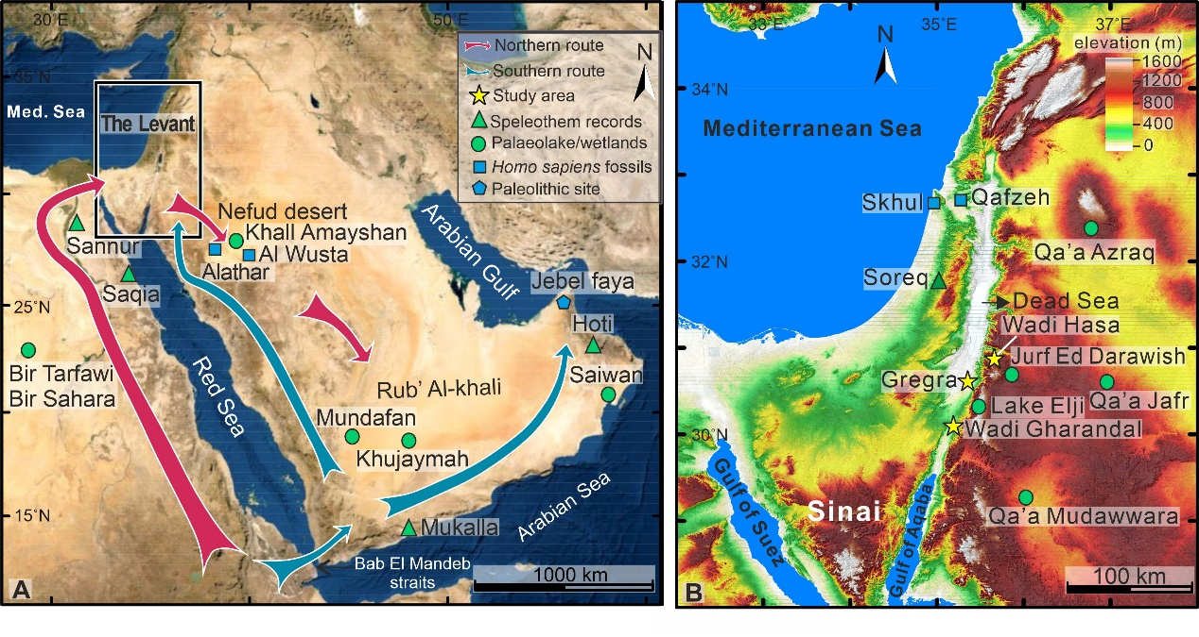
Fig 1
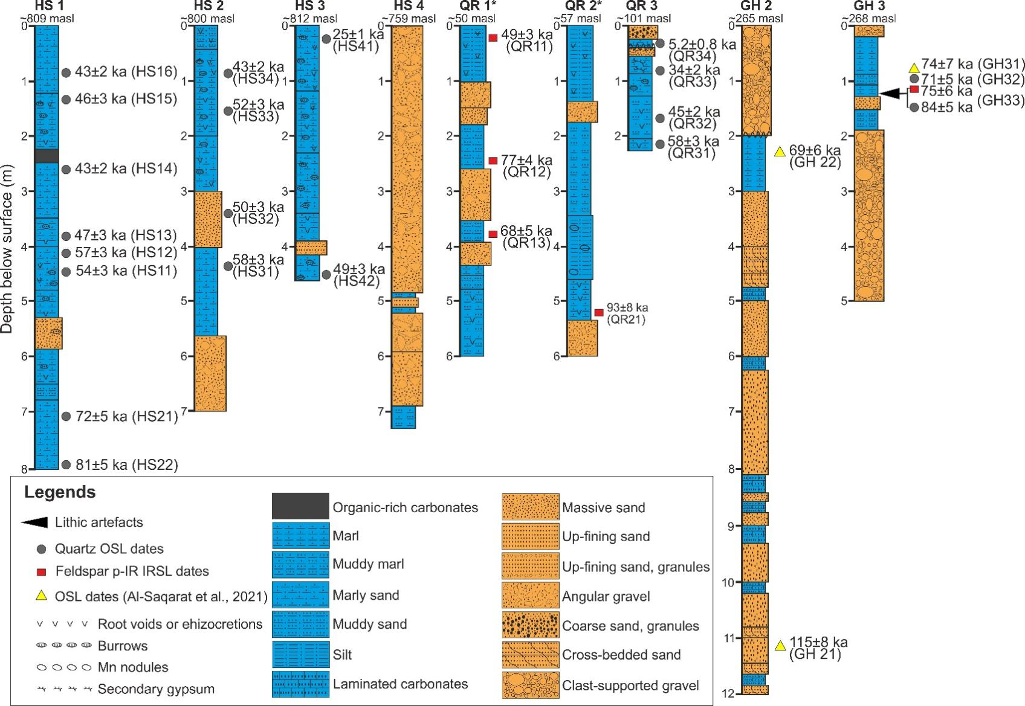
Fig. 2
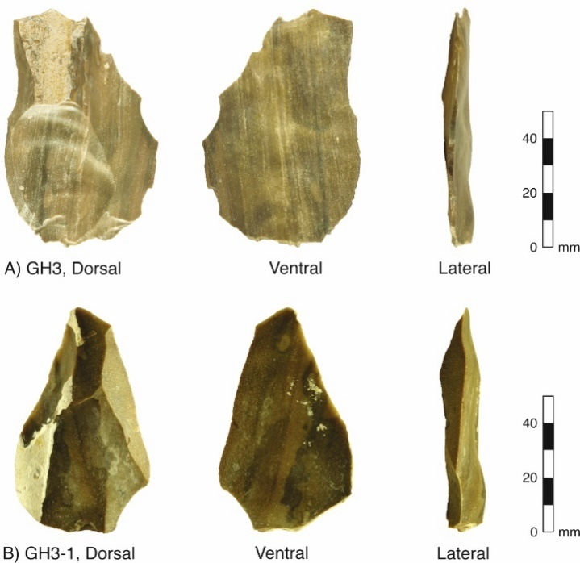
Fig. 2 inset
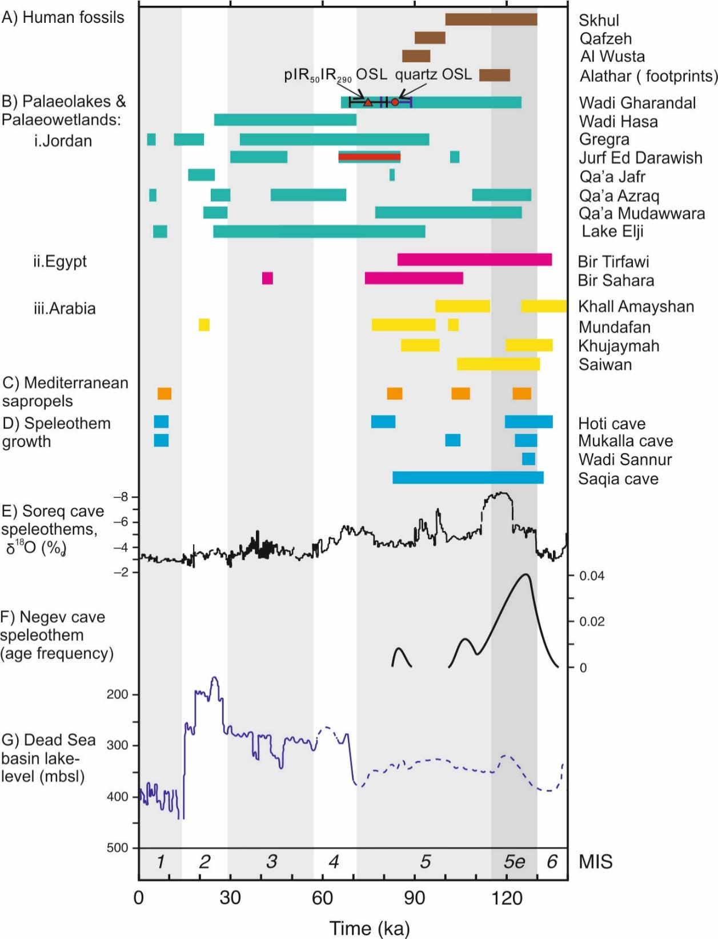
Fig. 3

