INTER-RATER AGREEMENT OF SERIAL RADIOGRAPHS TO IDENTIFY NON-PROGRESSION OF INGESTED MULTIPLE MAGNETS IN CHILDREN.
Paediatric Surgical Trainee Research Network
Multiple magnet ingestion (MMI) by children is increasing in incidence [1]. Magnets can attract one another from different locations within the gastrointestinal tract, causing fistulae, perforation and an increased risk of segmental volvulus, meaning MMI is associated with a high rate of intervention [2]. Most children are asymptomatic, so the decision to intervene is commonly determined by serial plain film radiographs (XR) demonstrating the absence of progression [3]. Current guidelines suggest repeating XRs every 6 – 12 hours [4].
This study aimed to investigate the inter-rater agreement of specialist paediatric surgeons assessing multiple magnet progression on serial XRs and to investigate whether there was variation in subsequent management. Surgeons were surveyed as they typically make the decision to intervene endoscopically or surgically.
An online survey was disseminated to paediatric surgeons. Four serial anonymised abdominal XR (AXR) from four children after MMI were shown sequentially to survey participants (Figure 1). The timing of each AXR after the first was shown in hours. After each AXR, participants were asked whether they thought the magnets had progressed (yes, no, or unknown) and their subsequent management (discharge with safety-netting, repeat AXR 6 – 12 hours, repeat AXR 12 – 24 hours, repeat AXR 24 – 48 hours, repeat AXR >48 hours, endoscopic retrieval, laparoscopic retrieval, or laparotomy and retrieval) assuming the child was asymptomatic. The outcomes (undisclosed to participants) were that two children passed the magnets without intervention and two children developed intestinal fistulae requiring surgical treatment and retrieval.
Agreement of the assessment of progression and subsequent management were evaluated using Krippendorff’s alpha (KA) coefficient with bootstrapped 95% confidence intervals (CI). KA >0.8 indicates strong agreement and <0.6 indicates low agreement.
Thirty paediatric surgeons completed the survey: 10 (33%) consultants, 17 (57%) ST5 – ST7 trainees, and three (10%) junior trainees (≤ST4). Experiences of MMI varied, with 9/30 (30%) involved in <10 cases, 19/30 (63%) involved in 10 – 50 cases, and 2/30 (7%) involved in >50 cases.
For each individual AXR reviewed there was low agreement between respondents for both assessment of multiple magnet progression, KA=0.544 (CI 0.345 – 0.724) and subsequent management, KA=0.431 (CI 0.215 – 0.666). Classifying subsequent management as discharge, repeat AXR or intervention also showed low agreement, KA=0.578 (CI 0.341 – 0.781). In the two children who developed a fistula and underwent surgery, non-progression was identified by the fourth AXR by 27/30 (90%) and 24/30 (80%) surgeons respectively, and surgical retrieval was suggested by 25/30 (83%) and 22/30 (73%) (Table 1).
In this study, low agreement was observed for the assessment of multiple magnet progression on serial XRs. However, ≥80% of surgeons identified non-progression in the children who developed complications by the end of the series. This suggests that assessment of multiple magnet progression is a useful diagnostic tool, but there is no consensus on its definition. Objectively defining progression would allow for earlier diagnosis and treatment of complications, and reduce radiation exposure. We also observed low agreement for subsequent management. Further work should include defining multiple magnet progression, and creating an evidence-based investigation and treatment pathway for MMI.

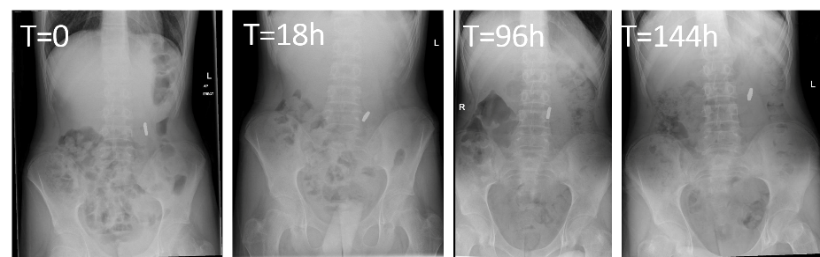
Figure 1 – The abdominal plain film radiograph series for patient one.

Table 1 – Proportion of surgeons classifying magnets as non-progressing and opting for surgical removal after each radiograph. Patients one and two developed fistulae (magnets did not progress). Patients three and four passed the magnets without intervention. AXR – abdominal plain film radiograph.
 | First to Second AXR |  | Second to Third AXR |  | Third to Fourth AXR
 | Not progressing | Surgical Removal | Not progressing | Surgical Removal | Not progressing | Surgical Removal
Patient One | 17/30 (57%) | 3/30 (10%) | 26/30 (87%) | 25/30 (83%) | 27/30 (90%) | 25/30 (83%)
Patient Two | 0/30 (0%) | 2/30 (7%) | 22/30 (73%) | 10/30 (33%) | 24/30 (80%) | 22/30 (73%)
Patient Three | 0/30 (0%) | 0/30 (0%) | 6/30 (20%) | 3/30 (10%) | 0/30 (0%) | 0/30 (0%)
Patient Four | 12/30 (40%) | 3/30 (10%) | 0/30 (0%) | 0/30 (0%) | 0/30 (0%) | 0/30 (0%)

REFERENCES
- Thakkar H, Burnand KM, Healy C, Makin E, Davidson J, Bethell G, Elagami H, Scarlett A, Parkar S, Upadhyaya M, Yardley I. Foreign body ingestion in children: a magnet epidemic within a pandemic. Archives of Disease in Childhood (2021). Doi:10.1136/archdischild-2021-322106.
- Middelberg LK, Leonard JC, Shi J, Aranda A, Brown JC, Cochran CL, Eastep K, Gonzalez R, Haasz M, Herskovitz S, Hoffman JA, Koral A, Lamoshi A, Levitte S, Lo YHJ, Montminy T, Novak I, Ng K, Novotny NM, Parrado RH, Ruan W, Shaprio J, Sinclair EM, Stewart AM, Talathi S, Tavarez MM, Townsend P, Zaytsev J, Rudolph B. High-Powered Magnet Exposures in Children: A Multi-Center Cohort Study. Pediatrics (2022). Doi: 10.1542/peds.2021-054543.
- Neville JJ, Harwood R, Bethell GS, Rhodes H, Arthur F, Eastwood MP, Hotonu S, Tullie L, Hall NJ. Magnet and button battery ingestion in children: multicentre observational study of management and outcomes. BJS Open (2022). Doi:10.1093/bjsopen/zrac056.
- Stibbards S, Kenney S, Emsden S, Landes C, Price J, Almond S, See TC, Agrawal S, Desai A, Bliss H, Harwood R, Decker E. Royal College of Emergency Medicine Best Practice Guideline: Ingestion of Super Strong Magnets in Children (2021). https://rcem.ac.uk/clinical-guidelines/ accessed December 2022.

(501/500 words)

