Abstract=250 words
Main text=3,369 words
Figures=3
Tables=2
Supplementary methods=1
Supplementary figures=13
Supplmentary tables=14
References=41

Incidence, prevalence, and global burden of schizophrenia - data, with critical appraisal, from the Global Burden of Disease (GBD) 2019

Marco Solmi^{1-6*}, Georgios Seitidis⁷, Dimitris Mavridis^{7,8}, Christoph U. Correll^{6,9-11}, Elena Dragioti¹², Synthia Guimond^{13,14}, Lauri Tuominen^{1,14}, Aroldo Dargél^{1-3,15}, Andre F Carvalho¹⁶, Michele Fornaro¹⁷, Michael Maes¹⁸, Francesco Monaco¹⁹, Minjin Song²⁰, Jae Il Shin^{21*}, Samuele Cortese^{5,22,23}
1 Department of Psychiatry, University of Ottawa, Ontario, Canada.
2 On Track: The Champlain First Episode Psychosis Program, Department of Mental Health, The Ottawa Hospital, Ontario, Canada.
3 Ottawa Hospital Research Institute (OHRI) Clinical Epidemiology Program, University of Ottawa, Ontario, Canada
4 School of Epidemiology and Public Health, Faculty of Medicine, University of Ottawa, Ontario, Canada
5 Centre for Innovation in Mental Health (CIMH), School of Psychology, Faculty of Environmental and Life Sciences, University of Southampton, UK
6 Department of Child and Adolescent Psychiatry, Charité-Universitätsmedizin Berlin, Berlin, Germany
7 Department of Primary Education, Evidence Synthesis Methods Team, University of Ioannina, Ioannina, Greece
8 Faculté de Médecine, Paris Descartes University, Sorbonne Paris Cité, Paris, France
9 Department of Psychiatry, Zucker Hillside Hospital, Glen Oaks, NY, USA
10 Department of Psychiatry and Molecular Medicine, Donald and Barbara Zucker School of Medicine at Hofstra/Northwell, Hempstead, NY, USA
11 Center for Psychiatric Neuroscience, Feinstein Institute for Medical Research, Manhasset, NY, USA
12 Pain and Rehabilitation Centre, and Department of Health, Medicine and Caring Sciences, Linkoping University, SE-581 85 Linkoping, Sweden
- Department of psychoeducation and psychology, University of Quebec in Outaouais
14 Department of psychiatry, University of Ottawa, The Royal's Institute of Mental Health Research
15 Ottawa Hospital Research Institute (OHRI) Neuroscience Program, University of Ottawa, Ontario, Canada
16 IMPACT (Innovation in Mental and Physical Health and Clinical Treatment) Strategic Research Centre, School of Medicine, Barwon Health, Deakin University, Geelong, VIC, Australia
17 Section of Psychiatry, Department of Neuroscience, Reproductive Science, and Dentistry, Federico II University of Naples, Naples, Italy
18 Department of Psychiatry, Faculty of Medicine, Chulalongkorn University, Bangkok, Thailand; Cognitive Impairment and Dementia Research Unit, Department of Psychiatry, Faculty of Medicine, Chulalongkorn University, Bangkok, Thailand
19 Department of Mental Health, ASL Salerno, Salerno, Italy
20 Yonsei University College of Medicine, Seoul, Republic of Korea
21 Department of Pediatrics, Yonsei University College of Medicine, Seoul, Republic of Korea
22 Clinical and Experimental Sciences (CNS and Psychiatry), Faculty of Medicine, University of Southampton, Southampton, UK
23 Division of Psychiatry and Applied Psychology, School of Medicine, University of Nottingham, Nottingham, UK.

*Corresponding author
Marco Solmi, MD, PhD
Associate Professor
University of Ottawa, Ontario, Canada
msolmi@toh.ca

*Co-corresponding author
Prof. Jae Il Shin, M.D., Ph. D.
Department of Pediatrics, Yonsei University College of Medicine, Yonsei-ro 50, Seodaemun-gu, C.P.O. Box 8044, Seoul 03722, Korea
Tel.: +82-2-2228-2050; Fax: +82-2-393-9118; E-mail: shinji@yuhs.ac

Abstract
Schizophrenia substantially contributes to the burden of mental disorders. Schizophrenia’s burden and epidemiological estimates in some countries have been published, but updated estimates of prevalence, incidence, and schizophrenia-related disability at the global level are lacking. Here, we present the data from and critically discuss the Global Burden of Diseases, Injuries, and Risk Factors Study data, focusing on temporal changes in schizophrenia’s prevalence, incidence, and disability-adjusted life years (DALYs) globally. From 1990 to 2019, schizophrenia raw prevalence (14.2 to 23.6 million), incidence (941,000 to 1.3 million), and DALYs (9.1 to 15.1 million) increased by over 65%, 37%, and 65% respectively, while age-standardized estimates remained stable globally. In countries with high socio-demographic index (SDI), both prevalence and DALYs increased, while in those with low SDI, the age-standardized incidence decreased and DALYs remained stable. The male/female ratio of burden of schizophrenia has remained stable in the overall population over the past 30 years (i.e., M/F=1.1), yet decreasing from younger to older age groups (raw prevalence in females higher than males after age 65, with males having earlier age of onset, and females longer life expectancy). Our results suggest that schizophrenia’s raw prevalence, incidence, and burden have been increasing since 1990. Age-adjusted estimates did not reduce. Schizophrenia detection in low SDI countries is suboptimal, and its prevention/treatment in high SDI countries should be improved, considering its increasing prevalence. Schizophrenia sex ratio inverts throughout the lifespan, suggesting different age of onset and survival by sex. However, prevalence and burden estimates for schizophrenia are probably underestimated. GBD does not account for mortality from schizophrenia (and other mental disorders).
Introduction
Schizophrenia is a severe mental disorder characterized by positive (delusions, hallucinations, thought disorganization) and negative (alogia, social withdrawal, blunted affect) symptoms, which is associated with severe functional impairment [1]. The proportion of individuals with onset of schizophrenia-spectrum disorders before the ages of 14, 18, and 25 are 3%, 12.3%, and 47.8%, respectively, with a peak at age 20.5 years and a median age at onset of age 25 years. Additionally, people with schizophrenia have frequent physical comorbidities [2], unhealthy lifestyle [3], and numerous cardiovascular (among others) risk factors [4, 5] that, together with disparities in physical healthcare[6, 7], and disease-related symptoms, lead to significant burden and premature mortality [8].
The global burden of disease 2019 (GBD 2019) study provides estimates of the prevalence, incidence, and burden of medical disorders, including mental disorders and schizophrenia[9]. GBD 2019 estimates disease burden (i.e., disability-adjusted life years, DALYs – one DALY equals to loss of one healthy year of life) by summing up the estimated years of life lived with a disability (YLDs, nonfatal burden), and the years of life lost (YLLs, burden related with death) [10].
Previous publications have reported on the GBD estimates of schizophrenia, documenting its local or global prevalence, incidence, or burden [11, 12]. According to the 2010 GBD data, although schizophrenia has a lower prevalence than other mental disorders, it globally accounted for >7% of burden associated with mental and substance use disorders overall and across any age group. This result likely represents an underestimate of the real burden of schizophrenia, which would be higher if increased mortality was taken into account [13]. Indeed, schizophrenia has increased all-cause, suicide, natural-cause, and specific-cause mortality vs. the general population [8], but GBD only recognizes anorexia nervosa among psychiatric disorders as a cause of mortality [10]. Subsequently, the GBD 2016, including 129 data sources, reported that, globally, the raw prevalence of schizophrenia increased from over 13 million people in 1990 to almost 21 million cases in 2016 [12]. Furthermore, the 2017 GBD report concluded that, from 1990-2017 (GBD 2017), the global, age-standardized incidence rate of schizophrenia decreased slightly, but age-standardized disability remained stable, and raw estimates of both incidence and disability increased further [11]. More recently, a systematic report of the GBD 2019 capstone paper encompassing 396 medical diseases, including major mental disorders, documented a slight increase in the burden of schizophrenia among people aged 25-49 years [9]. A subsequent report from the GBD 2019 Mental Disorders Collaborators group, narrowing the focus to twelve mental disorders, showed that schizophrenia ranked fifth as a cause of burden in individuals aged 15-24 years, and third (after depressive and anxiety disorders which have higher prevalence) among people (both sexes) aged 25-69 years, and fourth in >70 year-olds, respectively [10].
Notwithstanding its importance, the GBD 2019 paper [10] on mental disorders did not report detailed data on the epidemiology and burden estimates of schizophrenia (and their changes from 1990) by country, sex, age, and individual year, given its overarching angle [9].
Regional estimates are essential since differences exist among countries. For example, local increases in the burden of mental disorders, measured with loss of healthy life years from 2006-2012, have recently been reported in Medellin, documenting schizophrenia as the most contributing disorder [14]. Comparably, the GBD 2013 study reported that schizophrenia was more prevalent in China than India [15]. Also, estimates by sex are needed, given that the epidemiology of mental disorders can differ by sex. For instance, in GBD 2010, females accounted for more DALYs in all mental disorders, except for mental disorders occurring in childhood, schizophrenia, and substance use disorders [16]. Differences are also relevant across age groups as, for instance, the relative suicide-related mortality risk is particularly increased in younger females with incident schizophrenia [8].
To fill these gaps, we aimed to provide yearly (from 1990-2019) raw and age-standardized estimates of prevalence, incidence, and disability of schizophrenia, and their changes over time, considering sex, age, and regional differences based on the GBD 2019 data. We also aimed to critically appraise and discuss limitations of the GBD data related to schizophrenia.

Methods
Data source
The Global Burden of Disease Collaborative Network website (http://ghdx.healthdata.org) provides open access to the GBD 2019 Results Database.
GBD 2019 estimates incidence, prevalence, mortality, and disability indices, including YLLs, YLDs, and DALYs associated with 369 diseases and injuries [9] from 204 countries and territories grouped into 21 regions and seven super-regions. Data are collected from censuses, household surveys, civil registrations, and vital statistics, disease registries, health service use databases, air pollution monitors, satellite imaging, and disease notifications, among other sources (in total, 86,249 sources, including 19,354 deaths, 31,499 on incidence, 19,773 on prevalence, and 26,631 on other metrics). Diseases and injuries considered by the GBD 2019 are provided with four levels of granularity, increasing from Level 1 (broadest) to Level 4 (most detailed). Specifically, Level 1 reports on three broad causes of death and disability (i.e., communicable, maternal, and nutritional diseases; non-communicable diseases; and injuries), Level 2 on 22, Level 3 on 174, and Level 4 on 301 specific causes[9].
The GBD 2019 defines schizophrenia based on the DSM or the International Classification of Diseases (ICD) criteria, current edition at the time of data collection [9]. Additional information on the methodology is available in the supplementary methods in the appendix (Tables S1-S3, Figures S1-S13) [9].

Measures
We extracted prevalence, incidence, YLD, and DALYs with their uncertainty intervals (95%UIs, 2.5, and 97.5 percentiles) [9] for schizophrenia. Due to absent data on schizophrenia-related deaths, GBD sets YLLs equal to zero for schizophrenia. Estimates were extracted globally, as well as by region, income group, sex, and year from 1990-2019, and are presented as raw and age-standardized measures (Table S4-10).
The socio-demographic index (SDI) accounts for income per capita, educational attainment, and total fertility rate in women <25 years old [9]. Estimates are provided by SDI group (low <0.46, low-middle 0.46-0.60, middle 0.61-0.68, high-middle 0.69-0.80, high >0.80) (see Table S14 for countries’ SDI, and Figure S9 for SDI centrality and dispersion).

Statistical analyses
GBD assembles clinical informatics data, including hospital data, ambulatory (including general practitioner) visits, and health insurance claims. For each GBD cause (diseases), non-primary to primary diagnosis ratios and outpatient to inpatient care ratios are extracted from several regions [9]. The log of the ratios is modeled by age and sex using Meta-Regression-Bayesian Regularised Trimmed (MR-BRT), the Bayesian meta-regression tool[9].
GBD uses three main modeling strategies, including the Cause of Death Ensemble model (CODEm), Spatiotemporal Gaussian process regression, and DisMod-MR 2.1, to generate estimates of each measure of interest by age, sex, location, and year [9]. More details of each model are provided in Supplementary Methods.
To test whether changes in age-adjusted and raw prevalence, incidence, and DALYs from 1990 to 2019 occurred in certain age groups in particular, or in certain SDI groups, we conducted two meta-regression analyses. The first used age groups as moderators and 1990 to 2019 changes as outcome. The second assigned the corresponding SDI value to each country, and used it as moderators with, again, 1990 to 2019 changes in prevalence, incidence and DALY as outcomes.

Results
Global estimates
Schizophrenia prevalence, incidence, and DALYs age-standardized estimates from 1990-2019 (in five-year intervals) are reported in Table 1. Since the GBD 2019 estimate of YLL is zero in schizophrenia, YLDs and DALYs values are identical. Raw and age-standardized estimates for each year from 1990-2019 are also reported (Table S4). GBD 2019 estimated that in 2019, almost 24 million people were affected by schizophrenia globally, corresponding to an age-standardized prevalence of 287.41 per 100,000 (95%UI=246.16-330.88). Incident cases were almost 1.29 million globally in 2019, corresponding to an age-standardized incidence of 16.31 (95%UI=13.8-19.42) per 100,000. During the 1990-2019 period, the raw prevalence of schizophrenia increased from 14.2 million (95%UI=12.1-16.4) to 23.6 million (95%UI=20.2-27.1), corresponding to a relative increase of 65.87% (Table S5). Conversely, age-standardized prevalence decreased by 0.87%. Similarly, the raw incidence estimate increased by 37.11%,while age-standardized estimates decrease by 3.30% (Table 1, S4).
In 2019, schizophrenia was associated with 15,107,248.26 DALYs globally, corresponding to an age-standardized estimate of 184.15 DALYs per 100,000 (95%UI=134.32-234.54). As for prevalence and incidence, raw DALYs increased by 65.44%, while age-standardized DALYs did not change significantly (-0.56, 95%UI=-1.57-0.38) (Table 1, S4).

Esimates across countries
Schizophrenia was associated with different prevalence, incidence, and disability indices across countries (Figure 1, Table S6), SDI strata (Table 2, Figures S1-5), and GBD (super) regions (Tables S5, S7, Figures S6-10).
Across countries, the largest increase in age-standardized prevalence, incidence, and burden from 1990-2019 was in Denmark (prevalence and DALY in Equatorial Guinea), while DALYs decreased the most in Democratic People's Republic of Korea and Nauru, with the largest decline in incidence in the Netherlands (Figure 1, Table S6).

Estimates across sociodemographic categories
Across SDI categories (Table 2, Figures S1-5), age-standardized prevalence, incidence, and DALY indices of schizophrenia were particularly high in countries with high SDI. In 2019, in high SDI countries, the age-standardized prevalence of schizophrenia was 335.95 per 100,000 (95%UI=287.57-388.23), without significant increase from 1990, while the prevalence increased by 3.12% in high-middle SDI countries. No significant age-standardized prevalence changes emerged for middle, low-middle, or low SDI countries. Age-standardized incidence was the highest in high SDI countries, namely 19.14 per 100,000 (95%UI=16.08-22.75), yet no significant increase emerged across any SDI group. In middle, low-middle, and low SDI countries, the age-standardized incidence decreased, with the largest decrease in the middle SDI group, namely -6.57% (95%UI=-8.22 to -4.92). The highest age-standardized DALYs were observed in high SDI countries (213.36 DALYs per 100,000, 95%UI=155.49-271.87), increased in high-middle SDI countries by 3.79% only from 1990 to 2019, and did not significantly change in lower SDI countries (Figures S1-5).

Estimates across GBD regions
Across GBD regions (Table S5, S7, Figures S8-S10), the largest prevalence, incidence and DALY were found in the high-income North-America region (418.94 per 100,000, 95%UI=363.84-479.24, 23.01 per 100,000, 95%UI=19.63-27.04, 261.99 per 100,000, 95%UI=194.92-328.49 respectively), but the largest increase occurred in Southeast Asia (5.36, 95%UI=3.72-6.94, 2.37, 95%UI=0.98-3.66 ,5.87 95%UI=3.56-8.16 respectively).

Estimates by sex
Raw prevalence, incidence, and DALYs have been growing steadily over the last 30 years in both males and females (Table S8). The male-to-female estimate ratio held stable over time from 1990 to 2019 (both number ratio and age-standardized rate ratio) (Figure 2, Figure S11-12). Prevalence, incidence, and DALY figures across GBD regions in 2019 for males and females are separately reported in Table S7. Estimates are also reported by sex and age group in Figure 3 and Table S10, showing that the incidence peaked at age 20-24, and DALYs peaked between age 35-39, in both sexes. The male-to-female ratio was >1 in younger age strata but then decreased throughout the lifespan. The male-to-female ratio of prevalence, incidence and DALYs across GBD regions over time is also reported in Table S11-13.
Meta-regression exploring the impact of sociodemographic index and age on change in prevalence, incidence, and DALYs estimates from 1990 to 2019

Meta-regression analyses showed that countries with lower SDI had larger increase of raw prevalence (beta=-1.93, p<0.001), incidence (beta=-2.57, p<0.001), and DALYs (beta=-2.15, p<0.001) from 1990 to 2019. Regarding age-adjusted estimates, we found a significant association between lower SDI and larger incidence (beta=-0.41, p<0.001), but not age-adjusted prevalence, or DALYs.
Older age groups were associated with larger increases in raw prevalence (beta=0.03, p<0.001), incidence (beta=0.01, p<0.001) and DALYs (beta=0.03, p<0.001), but with negligible and inconsistent changes in age-adjusted prevalence (beta<0.01, p<0.001), incidence (beta>-0.01, p<0.001), and DALYs (beta<0.01, p<0.001).
Discussion
To our knowledge, this is the most comprehensive and detailed report on the incidence, prevalence, and burden of schizophrenia in the period 1990-2019 globally and across specific countries, based on data from the GBD 2019. Globally, we show that, from 1990-2019, raw prevalence increased by over 65%, incidence by 37.11%, DALYs by over 65%, but age-adjusted prevalence and incidence estimates showed a slight decrease, and burden did not change. Across GBD regions, the highest prevalence, incidence, and burden emerged for high-income countries. The male-to-female ratio of epidemiology and burden of schizophrenia did not change over the past 30 years. The male-to-female ratio progressively decreased from younger to older age groups, indicating earlier age at onset for males and longer life expectancy for females. Increases in raw estimates of prevalence, incidence and DALYs from 1990 to 2019 were larger in older age groups.
The GBD 2019 estimates for schizophrenia represent a substantial advance compared to the previous estimates from the GBD, with the inclusion of new data from 18 locations which were not included in previous GBD versions (in Argentina, Australia, Austria, Brazil, China, Colombia, Cyprus, Finland, United Kingdom, India, Iran, Lebanon, Nigeria, Saudi Arabia, South Korea, Spain, Taiwan, and United States).
The global age-adjusted prevalence of schizophrenia estimated based on studies published up to 2018 was 287.4 (246.2-330.9) per 100,000 (both sexes). The absolute global prevalence value estimated by GBD 2019, i.e. 0.29%, is lower than what reported in the literature. For instance a systematic review reported a median lifetime morbid risk of schizophrenia of 0.72% (interquartile range: 0.47-1.72%), pooling data from 188 studies and >150,000 cases with schizophrenia [17]. Several reasons might explain the significant difference with GBD prevalence estimates of schizophrenia, largely related with data inputing for missing data, as well as, likely, underestimation from countries where schizophrenia is probably underdiagnosed and undertreated due to poor access to mental healthcare. Pooling data from 177 countries, the World Health Organization Mental Health Atlas 2017 reported that only 50 provided reliable coverage estimate for psychosis (i.e., the proportion of people with a disorder contacting a mental health service) [18]. In those 50 countries, the average service coverage estimate was 10.9% in low income countries, 21.5% in lower middle income countries, and 59.5% in high income countries [18]. Also, among those who access to care, in low income countries schizophrenia is only detected in 75% of the cases, due to misdiagnoses [19].
Relative changes in estimates within the same GBD methodology are informative. Raw epidemiology and burden estimates have increased by up to two thirds over the past 30 years, and age-adjusted estimates have not decreased [10]. It might be argued that the prevalence of schizophrenia has changed due to changes in the diagnostic criteria. While the five key symptoms of schizophrenia were held stable from the Diagnostic and Statistical Manual of Mental Disorders Fourth (DSM)-IV to Fifth edition - DSM-5 (i.e., delusions, hallucinations, disorganized speech, disorganized or catatonic behavior, negative symptoms) [20, 21], the combination of symptoms needed for diagnosis has changed [22–24]. For the criterion A of schizophrenia, in DSM-IV-TR two positive symptoms were regularly required, but one symptom was enough if it was a Schneiderian first-rank symptom (i.e., bizarre delusion or auditory hallucination of a running commentary or ‘conversing voices’). In DSM-5 at least two psychotic symptoms are required in all cases (at least one being a delusion, hallucination, or disorganized speech), regardless they are a Schneiderian first-rank symptom or not [25]. However, it is unlikely this drove the change in raw prevalence estimates, as the change in DSM-5 criteria appear to have a negligible effect on the prevalence of schizophrenia according to previous research [25]. The findings of increase in raw prevalence and no decrease in age-adjusted prevalence call for more research and clinical implementation of preventive strategies to avoid or delay the onset of schizophrenia [26].
Several umbrella reviews have assessed possible risk factors across meta-analyses, [27–29], with one additional meta-analysis reporting on pregnancy and perinatal factors [30], and one on risk factors for transition to psychosis within subjects meeting ultra-high risk for psychosis (UHR) criteria [31]. In the meta-analyses included in these umbrella reviews, in the main as well as sensitivity analyses, despite several factors having nominally significant associations with schizophrenia, when accounting for several sources of bias [32–34], the credibility results were generally weak, being only in few cases convincing or highly suggestive. Currently only eigth risk factors for schizophrenia are supported by convincing credibility, namely UHR, black-Caribbean ethnicity in England, famine during pregnancy, birth weight <2kg, <2.5kg, <3kg, small for gestational age at birth, and cannabis use. Childhood adversities are also a transdiagnostic risk factor supported by highly suggestive evidence. Only two risk factors for schizophrenia-spectrum disorders were transdiagnostic across other mental disorders according to specific criteria[35], namely childhood adversities (shared with borderline personality disorder, and bipolar disorder), and tobacco smoking (shared with opioid use disorder) [29], suggesting psychosis has specific environmental risk factors compared with other disorders. When exploring the population attributable fraction for schizophrenia, the largest impact on schizophrenia emerged for childhood adversities (37.84%), UHR (12.37%), and cannabis use (9.73%)[36].
Public health prevention strategies should therefore target particularly these factors. Also, stable age-adjusted estimates of schizophrenia over 30 years suggest that the diagnostic validity of the schizophrenia construct can be solidly operationalized (as opposed to other disorders for which operationalization of criteria from large electronic records registers is more challenging - including anxiety, attention-deficit/hyperactivity disorders, depression, or bipolar disorder (type II in particular)[8, 37, 38]. Moreover, the absence of major changes in age-adjusted estimates over time indicates that the diagnostic criteria for schizophrenia held substantially stable across different editions of the major diagnostic manuals, just marginally affecting the prevalence and incidence estimates released over the past decades[39].

Regional differences in epidemiological and burden estimates of schizophrenia can be explained by two main hypotheses. First, the largest estimates come from high-income countries where health systems routinely collect and store epidemiologic data on mental health. Hence, the large figures can reflect granular reporting. Conversely, low income countries might still be developing sustainable systematic data collection infrastructure, and estimates might be largely biased by underreporting. A different interpretation, might be that certain characteristics of high-income countries increase the risk of schizophrenia, which however is not grounded on solid evidence. Of note, the larger increases in raw estimates of prevalence, incidence and DALYs in countries with lower SDI might suggest that detection of schizophrenia in those SDI groups has improved since 1990.
Regarding the male-to-female ratio, again no material change has occurred over the past years, yet we show that there is an inversion from more males in younger age groups, to more females in older age groups. This finding might reflect the fact that males have an earlier illness onset [40], that females have an increased relative risk of suicide than males in incident schizophrenia [8], and that the absolute number of deaths in schizophrenia is largely due to natural causes [2, 8], which might occur earlier in males, as it does in the general population. Higher substance use disorder comorbidity including higher rates of smoking in males than females, which are associated with earlier mortality in schizophrenia, might also drive the male/female ratio inversion at older age[8, 41].

Another critical aspect of the GBD is that GBD neglects the increased mortality that affects people with schizophrenia. Indeed, in GBD 2019, since the death could only be assigned to one cause, and only anorexia nervosa and bulimia nervosa were enlisted among the causes of death, mortality due to schizophrenia was set to zero. Hence, years of life lost could not be computed for schizophrenia. Death was assigned to other causes among people with schizophrenia, such as suicide or physical comorbidities. In particular, despite this well-established increased mortality for schizophrenia, in GBD 2010, the number of cause-specific deaths globally was as low as around 20,000 individuals, despite approximately 700,000 all-cause deaths being associated with schizophrenia[39], and in GBD 2019, no death event was attributed to schizophrenia. This limitation extends to the estimates of DALYs, which are the sum of YLD and YLL and which are certainly underestimated by the GBD 2019 for mental disorders, particularly schizophrenia, that remains one of the mental disorders with the highest mortality[8]. If the underestimated DALYs are considered together with the potentially underestimated prevalence, the real burden of schizophrenia might be dramatically different from what is reported in GBD 2019.
People with schizophrenia have up to 12-15 years of reduced life expectancy compared with the general population [42–44]. Increased mortality in schizophrenia is due to a higher risk of all-cause and specific-cause mortality. Recently, a meta-analysis that included 135 studies reporting on mortality risk in people with schizophrenia versus the general population, showed increased risk of 2.5 times for all-cause mortality, almost ten times for suicide-related mortality, and up to 7 times for natural-cause mortality among specific natural causes [8]. GBD typically assigns death to the ultimate cause of death (e.g. cardiovascular disease). Conversely, there is large evidence on the association between schizophrenia and unhealthy lifestyle, including sedentary behavior, unhealthy diet, smoking, and substance abuse, which contribute to increased risk of cardiovascular disease, and related death[3, 45–47]. Given the pervasive impact of schizophrenia on functioning and behavior, whereby age at onset of schizophrenia generally preceeds the onset of physical disorders, and of which poor lifestyle and more established risk factors are a manifestation, schizophrenia (and other mental disorders) should be acknowledged among causes of death in GBD. One methodological adjustment to avoid underestimating DALYs and YLL of schizophrenia (and other mental disorders) can be to account for cause-specific relative risk estimates for each cause of death in people with mental disorders.

In addition to the shortcomigns dicussed, this work has several limitations. First, GBD applies large data imputation for estimates in countries where sources are limited or absent. This might be one the reasons for a potential underestimation of schizophrenia prevalence globally. An updated systematic review of prevalence estimates of schizophrenia from representative samples is needed. Second, data do not represent any change eventually occurred during the COVID-19 pandemic.

In conclusion, schizophrenia raw prevalence, incidence and burden has been largely increasing between 1990 and 2019. Age-adjusted estimates did not decrease, calling for more research and then translation of findings in the field of primary and secondary prevention of schizophrenia. Reporting from low-income countries should be improved. Schizophrenia sex ratio inverts throughout the lifespan, suggesting differential age at onset, and survival among males and females.

Acknowledgments
Not applicable
Authors' contributions
All authors contributed and approved the study’s protocol. MS created the first draft of the manuscript. MS, DY, and SL analysed data. MS, JS, MF, and SC provided overall guidance. Finally, all authors read, edited, and approved the final version of the manuscript.

Conflict of interest statements
MS received honoraria/has been consultant for Angelini, Lundbeck, Otsuka. CUC has been a consultant and/or advisor to or has received honoraria from: AbbVie, Acadia, Alkermes, Allergan, Angelini, Aristo, Boehringer-Ingelheim, Cardio Diagnostics, Cerevel, CNX Therapeutics, Compass Pathways, Darnitsa, Gedeon Richter, Hikma, Holmusk, IntraCellular Therapies, Janssen/J&J, Karuna, LB Pharma, Lundbeck, MedAvante-ProPhase, MedInCell, Merck, Mindpax, Mitsubishi Tanabe Pharma, Mylan, Neurocrine, Newron, Noven, Novo Nordisk,Otsuka, Pharmabrain, PPD Biotech, Recordati, Relmada, Reviva, Rovi, Seqirus, SK Life Science, Sunovion, Sun Pharma, Supernus, Takeda, Teva, and Viatris. He provided expert testimony for Janssen and Otsuka. He served on a Data Safety Monitoring Board for Compass, Lundbeck, Relmada, Reviva, Rovi, Supernus, and Teva. He has received grant support from Janssen and Takeda. He received royalties from UpToDate and is also a stock option holder of Cardio Diagnostics, Mindpax, LB Pharma and Quantic.
MF received consulting fees & fees for non-CME/CE services from: Angelini, AstraZeneca, Boehringer Ingelheim, Bristol Meyers Squibb, Eli Lilly, GlaxoSmithKline, Innova Pharma, Lundbeck, Pfizer, Sanofi, Servier. All outside of the present work. S Co has received honoraria from the following non-profit associations: British Association for Psychopharmacology (BAP), Association for Child and Adolescent mental health (ACAMH), and Canadian ADHD Alliance Resource (CADDRA). Other authors have no conflict of interest o declare.

Data sharing
Data are publicly available at the Institute for Health Metrics and Evaluation (IHME) website (http://www.ghdx.healthdata.org/gbd-results-tool).

Ethics committee approval
We followed the standard procedure recommended registering additional publications from the GBD 2019 project after the publication of the capstone paper[9]. The Institutional Review Board approved our study at Yonsei University Health System for data use.

References
1. Correll CU. Pharmacotherapy of schizophrenia | Pharmakotherapie der Schizophrenie. Nervenarzt. 2020;91:34–42.
2. Correll CU, Solmi M, Veronese N, Bortolato B, Rosson S, Santonastaso P, et al. Prevalence, incidence and mortality from cardiovascular disease in patients with pooled and specific severe mental illness: a large-scale meta-analysis of 3,211,768 patients and 113,383,368 controls. World Psychiatry. 2017;16:163–180.
3. Firth J, Solmi M, Wootton RE, Vancampfort D, Schuch FB, Hoare E, et al. A meta-review of “lifestyle psychiatry”: the role of exercise, smoking, diet and sleep in the prevention and treatment of mental disorders. World Psychiatry. 2020;19:360–380.
4. Vancampfort D, Stubbs B, Mitchell AJ, De Hert M, Wampers M, Ward PB, et al. Risk of metabolic syndrome and its components in people with schizophrenia and related psychotic disorders, bipolar disorder and major depressive disorder: A systematic review and meta-analysis. World Psychiatry. 2015;14:339–347.
5. Vancampfort D, Correll CU, Galling B, Probst M, De Hert M, Ward PB, et al. Diabetes mellitus in people with schizophrenia, bipolar disorder and major depressive disorder: A systematic review and large scale meta-analysis. World Psychiatry. 2016;15:166–174.
6. Solmi M, Firth J, Miola A, Fornaro M, Frison E, Fusar-Poli P, et al. Disparities in cancer screening in people with mental illness across the world versus the general population: prevalence and comparative meta-analysis including 4 717 839 people. The Lancet Psychiatry. 2020;7:52–63.
7. Solmi M, Fiedorowicz J, Poddighe L, Delogu M, Miola A, Høye A, et al. Disparities in Screening and Treatment of Cardiovascular Diseases in Patients With Mental Disorders Across the World: Systematic Review and Meta-Analysis of 47 Observational Studies. Am J Psychiatry. 2021;178:793–803.
8. Correll CU, Solmi M, Croatto G, Schneider LK, Rohani-Montez SC, Fairley L, et al. Mortality in people with schizophrenia: a systematic review and meta-analysis of relative risk and aggravating or attenuating factors. World Psychiatry. 2022;21:248–271.
9. Vos T, Lim SS, Abbafati C, Abbas KM, Abbasi M, Abbasifard M, et al. Global burden of 369 diseases and injuries in 204 countries and territories, 1990&#x2013;2019: a systematic analysis for the Global Burden of Disease Study 2019. Lancet. 2020;396:1204–1222.
10. GBD Collaborators Mental Disorders. Global, regional, and national burden of 12 mental disorders in 204 countries and territories, 1990–2019: a systematic analysis for the Global Burden of Disease Study 2019. The Lancet Psychiatry. 2022;9:137–150.
11. He H, Liu Q, Li N, Guo L, Gao F, Bai L, et al. Trends in the incidence and DALYs of schizophrenia at the global, regional and national levels: results from the Global Burden of Disease Study 2017. Epidemiol Psychiatr Sci. 2020;29:e91–e91.
12. Charlson FJ, Ferrari AJ, Santomauro DF, Diminic S, Stockings E, Scott JG, et al. Global Epidemiology and Burden of Schizophrenia: Findings From the Global Burden of Disease Study 2016. Schizophr Bull. 2018;44:1195–1203.
13. Whiteford HA, Degenhardt L, Rehm J, Baxter AJ, Ferrari AJ, Erskine HE, et al. Global burden of disease attributable to mental and substance use disorders: findings from the Global Burden of Disease Study 2010. Lancet. 2013;382:1575–1586.
14. Grisales-Romero H, González D, Porras S. Años de vida saludable perdidos a causa de trastornos mentales y enfermedades del sistema nervioso de la población de Medellín, 2006-2012. Rev Colomb Psiquiatr. 2020;49:29–38.
15. Baxter AJ, Charlson FJ, Cheng HG, Shidhaye R, Ferrari AJ, Whiteford HA. Prevalence of mental, neurological, and substance use disorders in China and India: a systematic analysis. The Lancet Psychiatry. 2016;3:832–841.
16. Whiteford HA, Ferrari AJ, Degenhardt L, Feigin V, Vos T. The global burden of mental, neurological and substance use disorders: an analysis from the Global Burden of Disease Study 2010. PLoS One. 2015;10:e0116820–e0116820.
17. McGrath J, Saha S, Chant D, Welham J. Schizophrenia: A Concise Overview of Incidence, Prevalence, and Mortality. Epidemiol Rev. 2008;30:67–76.
18. Jaeschke K, Hanna F, Ali S, Chowdhary N, Dua T, Charlson F. Global estimates of service coverage for severe mental disorders: findings from the WHO Mental Health Atlas 2017. Glob Ment Heal. 2021;8:e27.
19. Ayano G, Demelash S, yohannes Z, Haile K, Tulu M, Assefa D, et al. Misdiagnosis, detection rate, and associated factors of severe psychiatric disorders in specialized psychiatry centers in Ethiopia. Ann Gen Psychiatry. 2021;20:10.
20. American Psychiatric Association. Diagnostic and statistical manual of mental disorders : DSM-5. 2013.
21. Association AP. Diagnostic and Statistical Manual of Mental Disorders: DSM-IV. 2000.
22. Tandon R, Gaebel W, Barch DM, Bustillo J, Gur RE, Heckers S, et al. Definition and description of schizophrenia in the DSM-5. Schizophr Res. 2013;150:3–10.
23. Tandon R. The Nosology of Schizophrenia: Toward DSM-5 and ICD-11. Psychiatr Clin. 2012;35:557–569.
24. Substance Abuse and Mental Health Services Administration. Impact of the DSM-IV to DSM-5 Changes on the National Survey on Drug Use and Health [Internet]. Rockville (MD): Substance Abuse and Mental Health Services Administration (US); 2016 Jun. Table 3.22.
25. Tandon R, Bruijnzeel D, Rankupalli B. Does change in definition of psychotic symptoms in diagnosis of schizophrenia in DSM-5 affect caseness? Asian J Psychiatr. 2013;6:330–332.
26. Fusar-Poli P, Correll C, Arango C, Berk M, Patel V, Ioannidis J. Preventive psychiatry: a blueprint for improving the mental health of young people. World Psychiatry. 2021;20:200–221.
27. Radua J, Ramella-Cravaro V, Ioannidis JPA, Reichenberg A, Phiphopthatsanee N, Amir T, et al. What causes psychosis? An umbrella review of risk and protective factors. World Psychiatry. 2018;17:49–66.
28. Belbasis L, Köhler CA, Stefanis N, Stubbs B, van Os J, Vieta E, et al. Risk factors and peripheral biomarkers for schizophrenia spectrum disorders: an umbrella review of meta-analyses. Acta Psychiatr Scand. 2018;137:88–97.
29. Arango C, Dragioti E, Solmi M, Cortese S, Domschke K, Murray RM, et al. Risk and protective factors for mental disorders beyond genetics: an evidence-based atlas. World Psychiatry. 2021;20:417–436.
30. Davies C, Segre G, Estradé A, Radua J, De Micheli A, Provenzani U, et al. Prenatal and perinatal risk and protective factors for psychosis: a systematic review and meta-analysis. The Lancet Psychiatry. 2020;7:399–410.
31. Oliver D, Reilly TJ, Baccaredda Boy O, Petros N, Davies C, Borgwardt S, et al. What Causes the Onset of Psychosis in Individuals at Clinical High Risk? A Meta-analysis of Risk and Protective Factors. Schizophr Bull. 2020;46:110–120.
32. Fusar-Poli P, Radua J. Ten simple rules for conducting umbrella reviews. Evid Based Ment Health. 2018;21:95–100.
33. Ioannidis JPA. Integration of evidence from multiple meta-analyses: A primer on umbrella reviews, treatment networks and multiple treatments meta-analyses. CMAJ. 2009;181:488–493.
34. Solmi M, Dragioti E, Croatto G, Radua J, Borgwardt S, Carvalho AF, et al. Risk and protective factors for cannabis, cocaine, and opioid use disorders: An umbrella review of meta-analyses of observational studies. Neurosci Biobehav Rev. 2021;126:243–251.
35. Fusar-Poli P, Solmi M, Brondino N, Davies C, Chae C, Politi P, et al. Transdiagnostic psychiatry: a systematic review. World Psychiatry. 2019;18:192–207.
36. Dragioti E, Radua J, Solmi M, Arango C, Oliver D, Cortese S, et al. Global population attributable fraction of potentially modifiable risk factors for mental disorders: a meta-umbrella systematic review. Mol Psychiatry. 2022;27:3510–3519.
37. Taipale H, Solmi M, Lähteenvuo M, Tanskanen A, Correll CU, Tiihonen J. Antipsychotic use and risk of breast cancer in women with schizophrenia: a nationwide nested case-control study in Finland. The Lancet Psychiatry. 2021;8:883–891.
38. Solmi M, Tiihonen J, Lähteenvuo M, Tanskanen A, Correll C, Taipale H. Antipsychotics Use Is Associated With Greater Adherence to Cardiometabolic Medications in Patients With Schizophrenia: Results From a Nationwide, Within-subject Design Study. Schizophr Bull. 2021. 21 July 2021. https://doi.org/10.1093/SCHBUL/SBAB087.
39. Charlson FJ, Baxter AJ, Dua T, Degenhardt L, Whiteford HA, Vos T. Excess Mortality from Mental, Neurological, and Substance Use Disorders in the Global Burden of Disease Study 2010Washington (DC): The International Bank for Reconstruction and Development / The World Bank © 2016 International Bank for Reconstruction and Development / The World Bank.; 2016.
40. Solmi M, Radua J, Olivola M, Croce E, Soardo L, Salazar de Pablo G, et al. Age at onset of mental disorders worldwide: large-scale meta-analysis of 192 epidemiological studies. Mol Psychiatry. 2021;27:281–295.
41. Hunt GE, Large MM, Cleary M, Lai HMX, Saunders JB. Prevalence of comorbid substance use in schizophrenia spectrum disorders in community and clinical settings, 1990–2017: Systematic review and meta-analysis. Drug Alcohol Depend. 2018;191:234–258.
42. Hjorthøj C, Stürup AE, McGrath JJ, Nordentoft M. “Years of potential life lost and life expectancy in schizophrenia: a systematic review and meta-analysis”: Correction. The Lancet Psychiatry. 2017;4:e19–e19.
43. Crump C, Winkleby MA, Sundquist K, Sundquist J. Comorbidities and mortality in persons with schizophrenia: A Swedish national cohort study. Am J Psychiatry. 2013. 2013. https://doi.org/10.1176/appi.ajp.2012.12050599.
44. Lawrence D, Hancock KJ, Kisely S. The gap in life expectancy from preventable physical illness in psychiatric patients in Western Australia: Retrospective analysis of population based registers. BMJ. 2013;346.
45. Kahn RS, Sommer IE, Murray RM, Meyer-Lindenberg A, Weinberger DR, Cannon TD, et al. Schizophrenia. Nat Rev Dis Prim. 2015;1:1–23.
46. De Hert M, Schreurs V, Vancampfort D, Van Winkel R. Metabolic syndrome in people with schizophrenia: A review. World Psychiatry. 2009.
47. Vancampfort D, Firth J, Schuch FB, Rosenbaum S, Mugisha J, Hallgren M, et al. Sedentary behavior and physical activity levels in people with schizophrenia, bipolar disorder and major depressive disorder: a global systematic review and meta-analysis. World Psychiatry. 2017;16:308–315.

Table 1. Prevalence, Incidence, and DALYs and YLDs of schizophrenia, by 5 years (age-standardized rate per 100,000).
 | Prevalence | Incidence | DALYs and YLDs
1990 | 289.92  (249.79, 333.22) | 16.87  (14.38, 19.99) | 185.19  (134.92, 235.26)
1995 | 289.91  (250.11, 333.35) | 16.80  (14.31, 19.96) | 185.42  (135.10, 235.18)
2000 | 288.64  (248.49, 332.09) | 16.69  (14.21, 19.86) | 184.72  (134.49, 234.57)
2005 | 288.67  (248.41, 331.96) | 16.66  (14.21, 19.80) | 184.89  (134.77, 234.92)
2010 | 288.52  (248.63, 331.85) | 16.57  (14.09, 19.70) | 185.10  (134.59, 235.78)
2015 | 288.03  (247.02, 331.43) | 16.42  (13.91, 19.58) | 184.68  (134.34, 235.07)
2019 | 287.41  (246.16, 330.88) | 16.31  (13.80, 19.42) | 184.15  (134.32, 234.54)
Percent change between 1990 and 2019 | -0.87  (-1.67, -0.13) | -3.30  (-4.34, -2.23) | -0.56  (-1.57, 0.38)
Data in parentheses are 95% uncertainty intervals. DALYs = disability-adjusted life-years, YLDs = years lived with disability.

Table 2. Prevalence, incidence, DALYs, and YLDs of schizophrenia in counts and age-standardized rates for both sexes combined in 1990 and 2019, with percentage change between 1990 and 2019 by socio-demographic index.
 | 1990 |  | 2019 |  | Change in age-standardized rates  1990 vs. 2019 (%) | Change in raw figures  1990 vs. 2019 (%)
 | Counts | Age-standardized  Rate (per 100,000) | Counts | Age-standardized  Rate (per 100,000)
Prevalence
High SDI | 3073719.11  (2635694.76, 3528506.00) | 334.32  (286.86, 385.18) | 4040727.47  (3489802.85, 4634833.49) | 335.95  (287.57, 388.23) | 0.49  (-0.54, 1.53) | 31.46  (28.47, 34.85)
High-middle SDI | 3460459.09  (3009049.53, 3939174.13) | 291.85  (254.10, 331.49) | 5240142.90  (4607654.40, 5913554.35) | 300.96  (263.22, 341.25) | 3.12  (2.06, 4.27) | 51.43  (48.14, 55)
Middle SDI | 4330298.89  (3703510.22, 5008575.17) | 282  (243.15, 324.39) | 7572107.51  (6477155.03, 8752794.33) | 282.96  (242.19, 327.23) | 0.34  (-1.03, 1.69) | 74.86  (69.65, 80.16)
Low-middle SDI | 2462398.54  (2077533.57, 2899958.57) | 272.96  (233.05, 317.91) | 4697193.53  (3982834.27, 5527000.87) | 273.69  (232.38, 319.24) | 0.27  (-1, 1.58) | 90.76  (86.95, 94.63)
Low SDI | 892518.42  (741776.63, 1068008.49) | 237.21  (199.03, 278.88) | 2034495.54  (1691028.08, 2438611.08) | 237.28  (197.9, 279.19) | 0.03  (-1.12, 1.15) | 127.95  (125.13, 130.63)
Incidence
High SDI | 163826.69  (137301.48, 194620.07) | 19.03  (16.06, 22.71) | 178152.98  (150468.15, 209862.20) | 19.14  (16.08, 22.75) | 0.53  (-0.45, 1.54) | 8.74  (5.83, 12.24)
High-middle SDI | 215704.56  (186227.64, 252466.76) | 17.40  (15.09, 20.21) | 252822.10  (217855.01, 291671.28) | 17.64  (15.22, 20.57) | 0.84  (-0.36, 2.10) | 16.64  (11.46, 21.79)
Middle SDI | 317174.82  (268848.60, 375264.31) | 16.96  (14.51, 20.00) | 411500.26  (346741.02, 489083.12) | 16.39  (13.90, 19.53) | -6.57  (-8.22, -4.92) | 25.31  (19.20, 31.83)
Low-middle SDI | 174157.17  (145830.48, 208811.15) | 15.46  (12.99, 18.52) | 288288.67  (241334.04, 347095.56) | 15.18  (12.70, 18.24) | -3.01  (-4.25, -1.67) | 63.54  (58.96, 68.24)
Low SDI | 69370.95  (57672.85, 84042.72) | 14.48  (12.10, 17.49) | 158320.96  (131223.94, 192075.95) | 14.36  (11.96, 17.33) | -6.06  (-7.25, -4.99) | 116.16  (113.49, 118.76)
DALYs & YLDs
High SDI | 1951262.66  (1413196.17, 2478027.43) | 212.71  (154.37, 270.57) | 2541568.15  (1865247.53, 3207291.30) | 213.36  (155.49, 271.87) | 0.31  (-1.09, 1.58) | 30.25  (26.91, 33.75)
High-middle SDI | 2226321.04  (1638435.63, 2813078.02) | 187.35  (137.18, 235.77) | 3367871.62  (2476407.48, 4227909.76) | 194.45  (142.55, 244.50) | 3.79  (2.08, 5.55) | 51.28  (47.47, 55.51)
Middle SDI | 2808099.64  (2069011.83, 3585149.66) | 181.43  (132.55, 229.44) | 4878967.45  (3547734.68, 6228126.98) | 182.38  (133.36, 232.51) | 0.53  (-1.10, 2.30) | 73.75  (68.45, 79.4)
Low-middle SDI | 1573294.53  (1134738.91, 2021633.65) | 172.89  (124.78, 220.82) | 3006048.43  (2167795.59, 3849888) | 174.3  (125.23, 222.16) | 0.82  (-1.10, 2.61) | 91.07  (86.48, 95.61)
Low SDI | 567932.83  (408008.35, 735532.88) | 149.58  (107.5, 192.57) | 1304857.92  (936059.49, 1691711.88) | 150.61  (108.07, 193.89) | 0.69  (-1.33, 2.61) | 129.76  (124.97, 134.62)
Data in parentheses are 95% uncertainty intervals. SDI: socio-demographic index, DALYs: disability-adjusted life years, YLDs = years lived with disability.
Figure 1. Age-standardized (a) prevalence (b) incidence, (c) DALY rates (per 100 000) by location, both sexes combined, 2019.
(a)
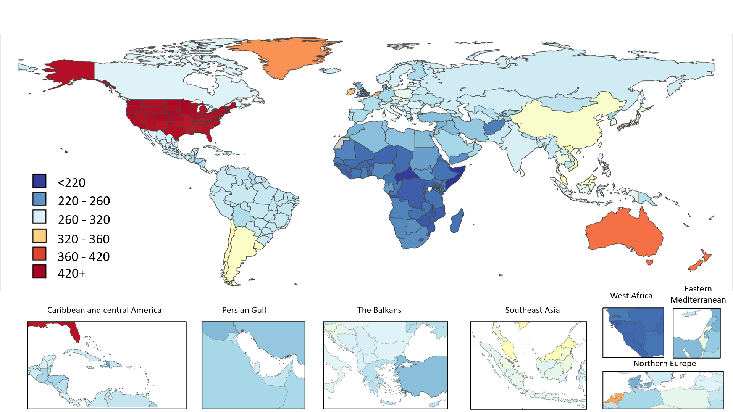
(b)
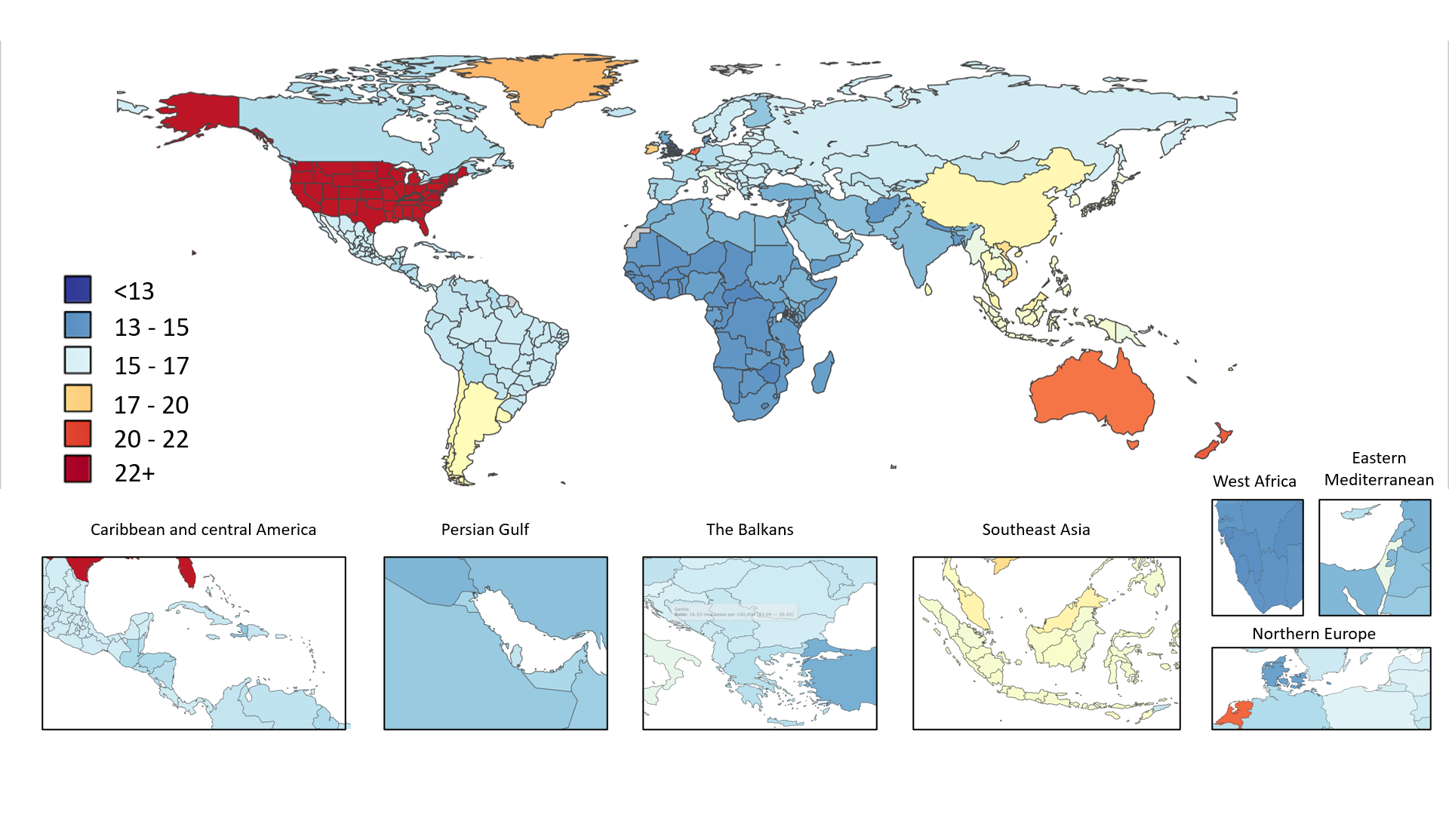

(c)
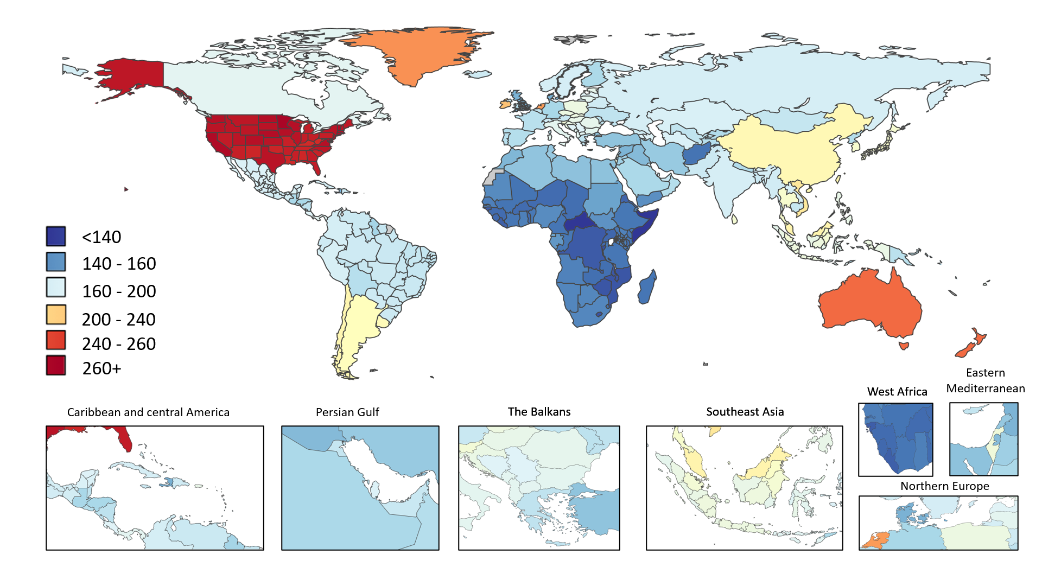

Figure 2. Trends from 1990 to 2019 (a) in number and age-standardized prevalence rates (b) in male to female (M/F) prevalence ratio of schizophrenia at the global level.

(2a)
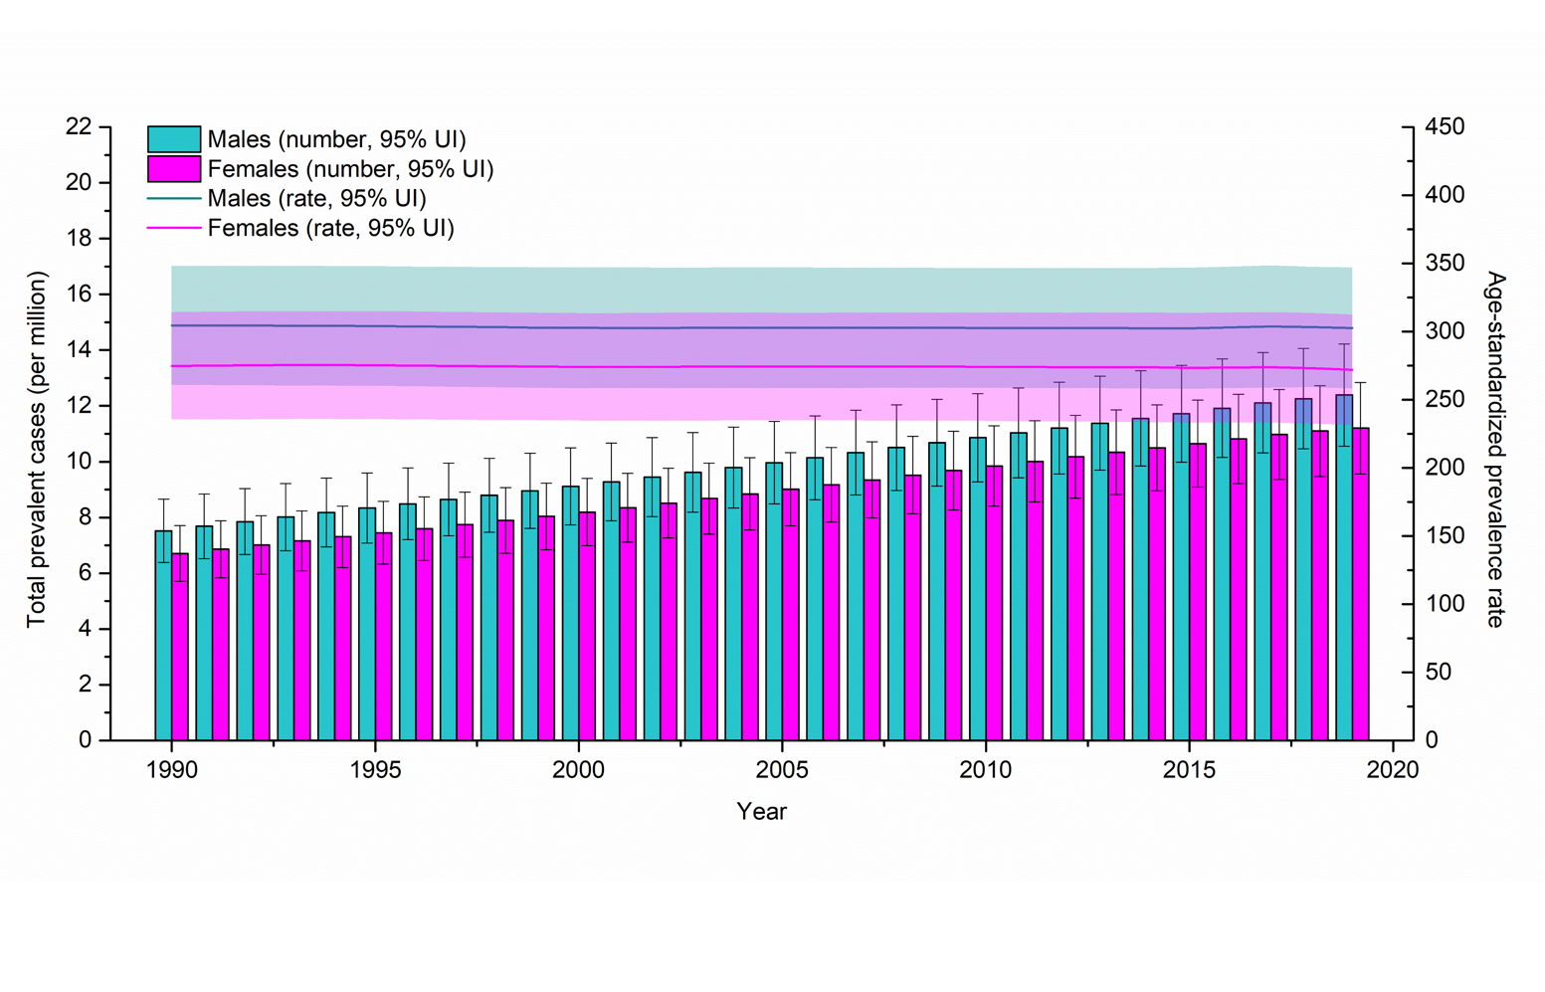

(2b)
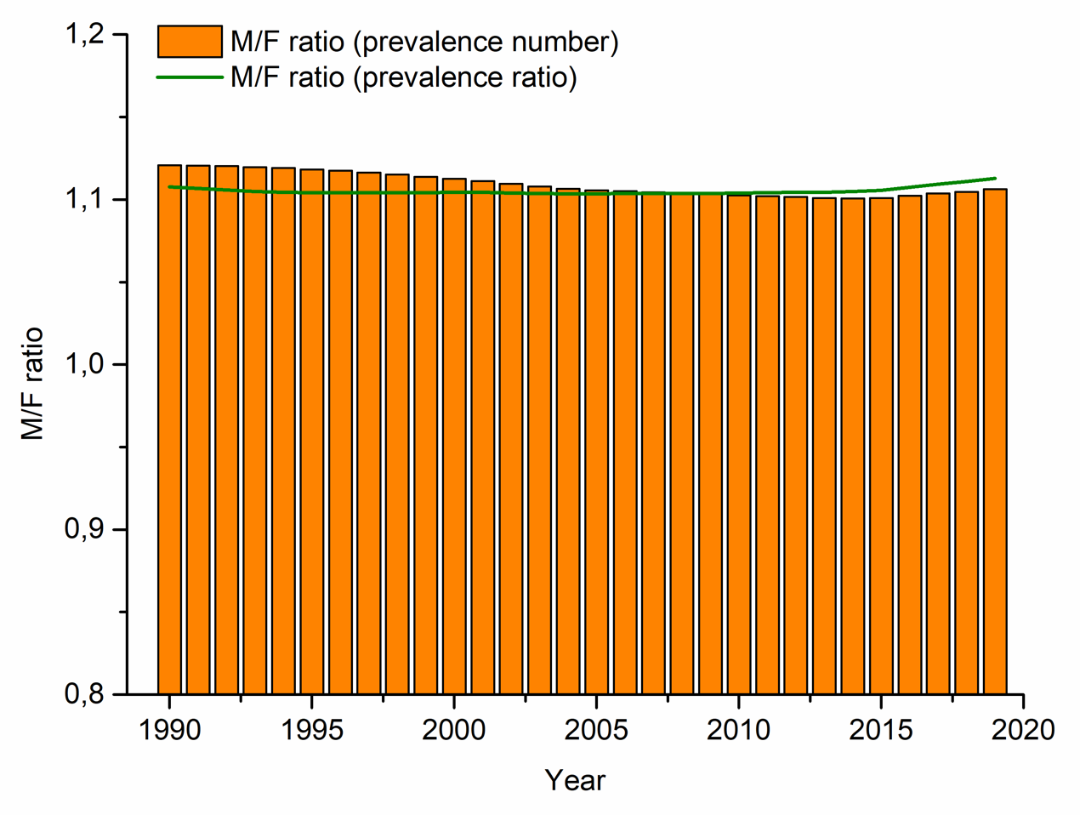
Error bars indicate the 95% uncertainty level (UI) for prevalent cases; shading indicates the 95% UI for the age-standardized prevalence rate.

Figure 3. Age patterns by sex in 2019 of (a) the total prevalent cases and age-specific prevalence rate (b) male to female (M/F) prevalence ratio of schizophrenia at the global level.
(3a)
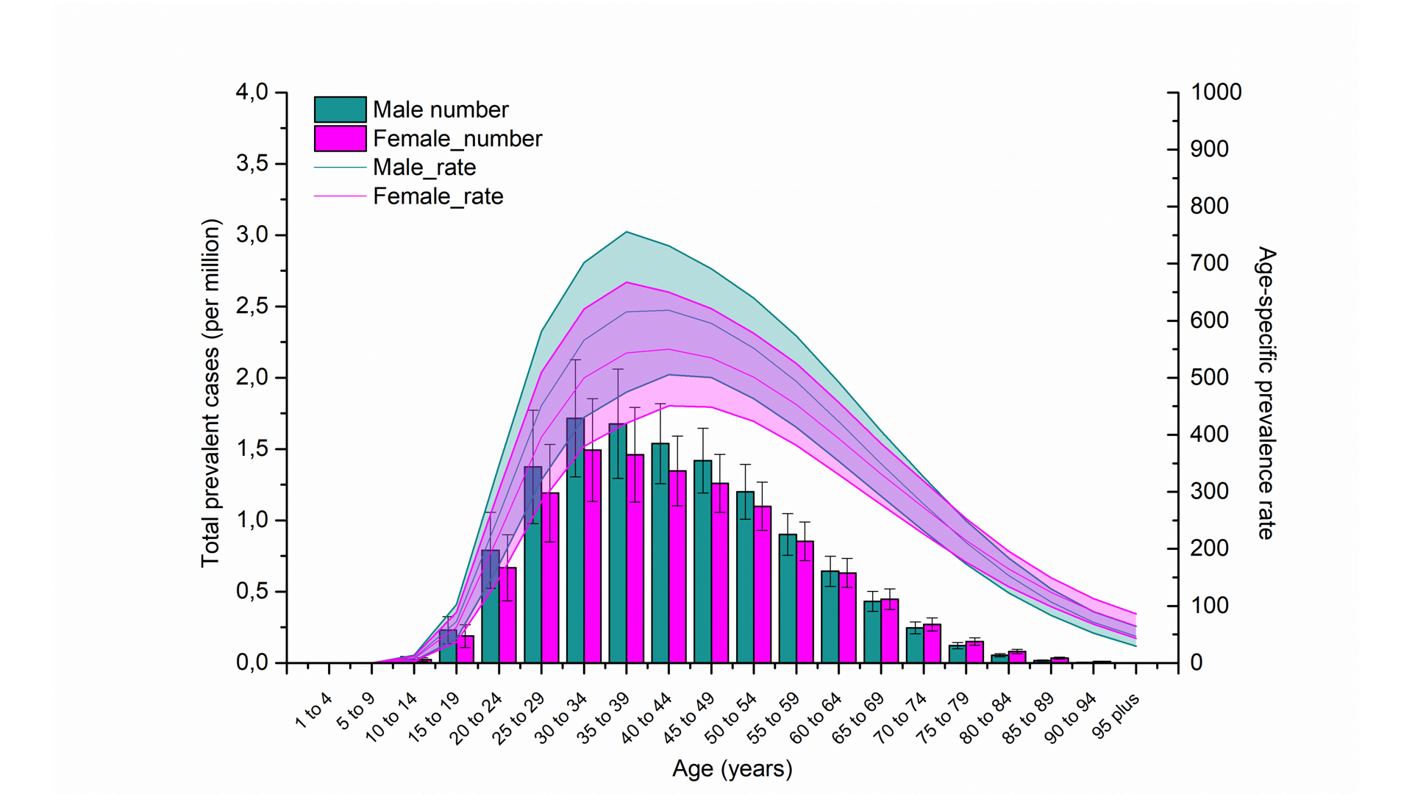

(3b)

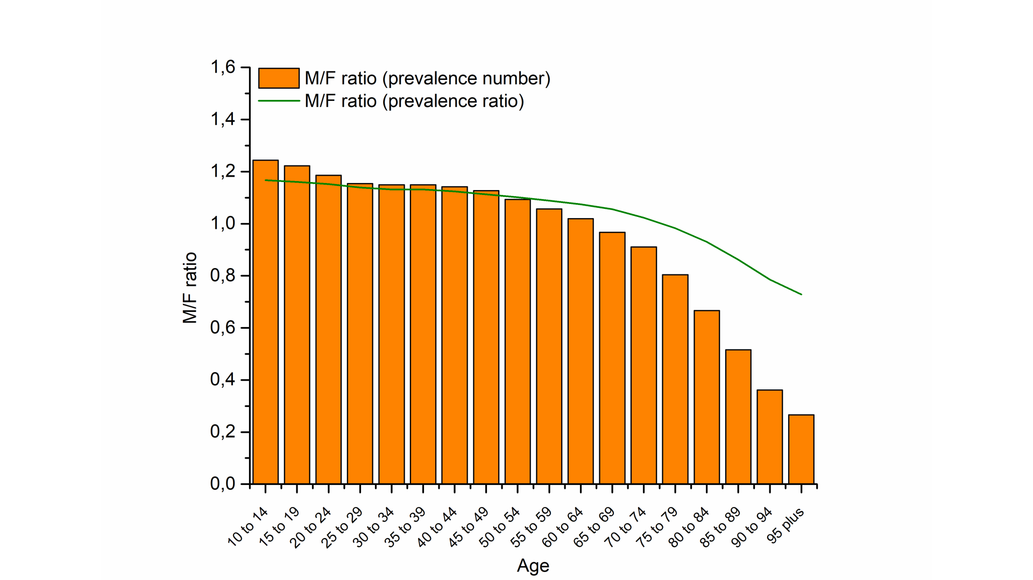
Error bars indicate the 95% uncertainty level (UI) for prevalent cases; shading indicates the 95% UI for the age-standardized prevalence rate.

