Adhesives for medical application - peel strength testing and evaluation of biophysical skin response

Florence Mbithiª and Peter R Worsley^{a, *}
ªSkin Sensing Research Group, School of Health Sciences, University of Southampton, Southampton, UK (United Kingdom).
Author’s email addresses: f.mbithi@soton.ac.uk and P.R.Worsley@soton.ac.uk
*Corresponding author address: AA60, Southampton General Hospital, School of Health Sciences, University of Southampton, Southampton SO16 6YD, UK. E-mail address: P.R.Worsley@soton.ac.uk

Key Words
Medical adhesives, Peel strength, Skin response, Repeat application, Skin preparation.

Abstract
Background: Medical adhesives are commonly used for securing wound dressings and medical devices used for diagnostic or therapeutic purposes. Mechanical irritation of skin due to adhesive stripping and repeated application can lead to discomfort and device removal. This study aims to examine the peel strength and skin response to different medical adhesives in a cohort of healthy volunteers.
Method: Twelve healthy participants were recruited for peel strength testing of three candidate adhesive tapes, and evaluation of the skin response after adhesive removal. A modified ASTM D903 peel strength testing was performed at 180° peeling angle and a rate of 300 mm/minute on the forehead, upper back and forearm skin. A longitudinal study was conducted on the forearm and back, with the adhesive samples left in-situ for up to 60 hours for analysis of repeat application. The effects of two skin preparation approaches (water and alcohol cleaning) prior to adhesive application were also assessed. Skin biophysical properties were assessed at baseline and at various timepoints following adhesive removal using transepidermal water loss (TEWL), erythema and hydration.
Results: Peel strength reduced uniformly with repeat application over prolonged periods for all the adhesive samples tested. Skin preparation with water and alcohol cleansing prior to adhesive application increased peel strength at both the back (1.1% and 2.9%), and forearm (21.3% and 20%) sites. There was statistically significant increase from baseline to post-tape application for TEWL, skin redness and hydration (p<0.001). However, there were no statistically significant differences between adhesive types (TEWL: p=0.38, SR: p=0.53, HY: p=0.46). TEWL increased the most post-adhesion across all test sites and adhesive samples with repeat application (p<0.05). Two-way ANOVA tests revealed no statistically significant interactions between the effects of application duration and adhesive on skin redness or TEWL for both the back and forearm sites (p>0.05), though a significant interaction was indicted for hydration at the back site (p=0.01).
Conclusion: This study revealed that site and duration of adhesive application effected peel strength. The corresponding changes in skin properties identified that skin barrier function was disrupted with long-term application of adhesives. The back site was identified to be most reliable for adhesion testing and skin response assessment for future work.

Introduction
Adhesives are widely used in a variety of medical and pharmaceutical applications, including the attaching and securing of dressings and medical devices. Adhesives designed for use on human skin are required to be non-irritant, non-sensitizing, residue-free, comfortable to wear, and should not induce trauma to the skin on removal or upon repeated application (Rippon et al., 2007). Silicone adhesives are currently widely used for various medical applications as they meet the requirements for use on human skin, including reusability and high moisture vapour transmission rate and fluid handling capacity than rubber and acrylic-based adhesives (Lin et al., 2008; Liu et al., 2018).
Adhesives for medical applications are required to have a high tack level and appropriate peel bond strength to stay in place and hold devices in the proper position throughout the wearing time and repeated application (Chen & Flavin, 1972; Venkatraman & Gale, 1998). Adhesives need to accommodate wide levels of adhesion resulting from the many different skin types within the population and load in which they support. Adhesives have a viscoelastic form and employ cohesion and adherence to the skin to resist debonding (Papon, 2011). The most common methods used to monitor adhesive performance are tack (the instantaneous tendency to stick to the skin), shear strength (the internal or cohesive strength to resist shearing forces), and peel adhesion (ability to resist separation from the skin surface) (Jones, 1989; Minghetti et al., 2004; Venkatraman & Gale, 1998). Peeling is the most observed mode of adhesive bond failure (Chen & Flavin, 1972; Zhang & Wang, 2009). Peel tests on human skin are complex primarily owing to the great variability of skin on the body and its properties. In addition, there is a challenge to create reproducible and accurate testing at the bedside (Lir et al., 2007). One of the major characteristics of human skin is its rough contour, which constantly renews through a process of exfoliation (shedding) of the epidermis. In addition, there are many skin surface biofluids including sweat and sebum which could interfere with peel strength. Hair can also reduce the effective area of contact between the adhesive and the skin, causing reduced adhesion (Renvoise et al., 2007).
For simplicity therefore, the majority of standard peel tests use flat and rigid substrates such as steel, glass, low density polyethylene and epoxy surfaces (Godbey, 2016). Other studies have proposed the use of synthetic substrates that simulate the mechanical and surface properties of human skin (Lir et al., 2007; Renvoise et al., 2009), or artificial lab-grown skin (Cantor, 1999). The results from these surfaces are precise and reproducible and may be a guide for initial to very short-term adhesion. However, the data are not predictive of adhesion to human skin over time (Renvoise et al., 2009). On the other hand, human and pig skin are reported to be especially similar in anatomy, topical features such as texture and roughness (R_{a} values = 20 ±3 μm), and biochemical properties (Nussinovitch et al., 2008). Hence, hair-removed pig skin has become increasingly adopted as a substitute substrate material for in vitro human skin adhesion testing studies (Dana et al., 2013; Feula et al., 2016; Liu et al., 2018). However, there are distinct differences between porcine and human skin, for example, porcine stratum corneum (SC) showed significantly lower Young's moduli (both in-plane and out-of-plane) compared to human SC at physiological humidity condition (Ranamukhaarachchi et al., 2016).
Mechanical irritation of skin due to adhesive stripping and repeated application evokes damage to the skin and can lead to the loss of skin integrity (Bashir et al., 2001; Breternitz et al., 2007; Dykes et al., 2001; Zillmer et al., 2006). Several studies have investigated the skin response to a range of insults applying established non-invasive biophysical skin measurement techniques including transepidermal water loss (TEWL), erythema (skin redness), hydration, inflammatory biomarkers, pH, and sub-epidermal moisture (SEM) (Shi et al., 2020; Soetens et al., 2019; P. Worsley & Voegeli, 2013). Studies have reported increase in TEWL, erythema and SEM post- tape stripping (Bashir et al., 2001; Breternitz et al., 2007; Grove et al., 2013; Lund et al., 1997; Richters et al., 2021; Waring et al., 2013), though further research is required to investigate temporal skin response to prolonged exposure to medical adhesives. Damage to the skin facilitates ingress of foreign matter and potential pathogens that cause infections. Incidence of various hospital-acquired infections (HAIs) is clinically significant, augmenting the burden on the resources of patients and healthcare providers (Bader et al., 2019; Waring et al., 2009). Thus, research is required to investigate temporal skin response to prolonged exposure to medical adhesives.

In this study, three candidate silicone adhesive materials (3MTM1774, 3MTM1776, 3MTM2480) were evaluated using a peel adhesion test and biophysical skin health measures. The peel strength, a measure of the minimum force required for the delamination of adhesive from skin surface to occur, was quantitatively determined on forehead, forearm, and back skin of healthy volunteers. An adapted ASTM D903 peel strength test was used, with controls on the peel angle and rate. However, modifications were required given the in-vivo nature of the tests. The biophysical skin response (TEWL, erythema, hydration, and sebum inflammatory biomarkers) to application of the adhesives was also assessed. Further, the effect of skin cleansing protocols prior to adhesive application on peel strength and skin response were investigated. An aging test was also performed to predict the long-term performance of the adhesives and the skin reactions. The study hypothesis was that peel strength would vary depending on adhesive tape properties, and that repeated application over time would impair skin barrier function.

Method

2.1 Participants
Healthy volunteer participants were recruited for the study from the local community. The inclusion criteria for the study included adults with no systemic skin disease, open wounds, or allergy to the adhesive patches (tested prior to the study). The exclusion criteria included any systemic skin disease, open wounds, or allergies to the adhesives. Institutional ethics was granted for the study (University of Southampton, Faculty of Health Sciences Ethics number 23826), and informed consent was obtained from each participant prior to testing.

2.2 Adhesion Test Protocol
Specific anatomical areas of the face and the back were chosen for evaluation to represent areas where the adhesive pads would be used for medical applications, and that have known high production of sebum (Leyden, 1995). The inner forearm was also tested as a lower sebum producing site and an area often used for pre-clinical evaluation of skin properties. The back and forearm also provided the space required to assess different pre-adhesive skin preparations. Following application of the adhesive sample strips, a roller was applied three times along the length of each strip to ensure a constant application pressure. On day 1, the adhesive strips were removed after 60 minutes of application for all three sites. A longitudinal study was conducted on the forearm and back, with the adhesive samples left in-situ for 48 hours, then repeated 12 hours later. This was performed to provide analysis of repeat application of the adhesives, as typically observed during prolonged medical device application in different care settings.

On day 1 of testing, an additional adhesive sample was applied to the forearm and back sites to assess the effects of different skin preparation approaches, prior to application of the adhesive sample strips. This resulted in 4 test sites including 3 adhesive material sites and 1 site with differing skin preparation (Figure 1). The three distinct skin preparation approaches prior to adhesive application were:
- No skin preparation – normative sebum and other biomarkers on the skin surface.
- pH neutral water wipe and drying.
- Alcohol wipe and drying.
The water and alcohol wiping were applied with a cotton swab and allowed to air-dry immediately prior to application of the adhesive sample strips.

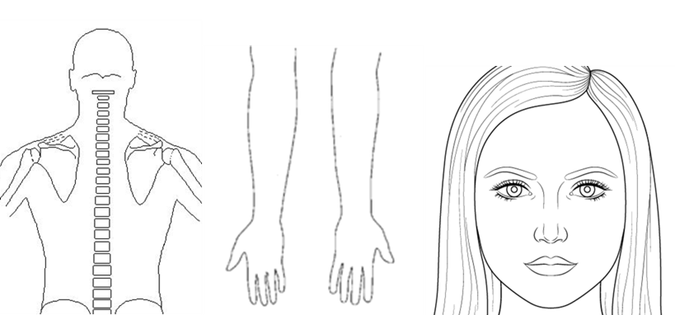
KEY
Sample 1
Sample 2
Sample 3
Sample 1 – Skin Preparation Altered Control

Figure 1. An illustration of the test sites for the adhesion peel strength and biophysical skin health measurements.
All measurements were carried out in the Biomechanics Testing Laboratory within the Clinical Academic Facility. After a 30-minute period of acclimatization, at an ambient temperature of 23°C ± 2°C. Baseline biophysical measurements of TEWL, skin hydration, skin redness, temperature, and sebum were taken on the untreated control areas (30х20mm) on the volar the forearm, thoracic region of the back, and the forehead (Figure 1). Correct positioning of the different adhesive patches applied on each site was ensured by measurement, with at least 20mm separation, marked with a non-permanent pencil. A modified ASTM D903 Peel or Stripping Strength of Adhesive Bonds test was performed using a Loadstar® RAS1 S-Beam Load Cell and iLVDT Displacement Sensor system (Loadstar Sensors, CA, USA). The adhesive samples were peeled at an angle of 180° and a rate of 300mm/minute (Video and Still images of the protocol can be found in the eSupplimentary files). Figure 2A depicts the experimental setup for the back site, with the participant lying in prone, the displacement rig placement adjacent to the back at an equivalent height, and the adhesive sample peeled at 180°. An example trace of the force-displacement curve derived from the modified rig are presented in Figure 2B. Following the removal of the adhesive patches, biophysical skin measurements were performed at all five sites (4 experimental, 1 untreated control).

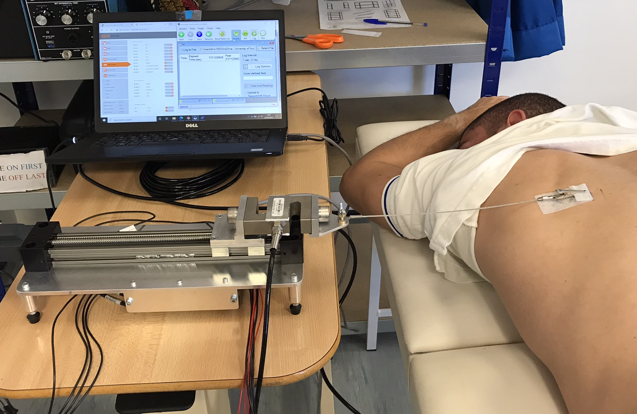A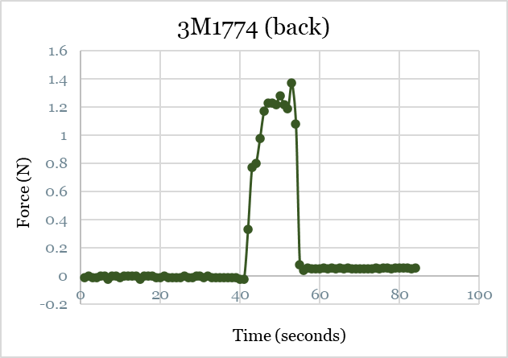 B
Figure 2 (A) The peel test experimental setup for the back site, with the participant lying in prone, the displacement rig placed at an equivalent height, and the adhesive sample 3MTM1774 peeled at 180°. (B) An example of the force curve derived from the experimental setup for the back site.

2.3 Measures of Skin Properties
Skin barrier function was assessed using transepidermal water loss (TEWL), measured using a handheld open-chamber probe method (Tewameter® TM 300, Courage & Khazaka, Germany). The probe was placed in gentle contact on the skin and during a period of equilibrium, sampling at 1Hz, a mean value was estimated over a 5-second window and recorded as g·h^{–1}.m^{–2}. Skin hydration was measured using a handheld probe, Corneometer® CM 825 (Courage & Khazaka, Germany). The measurement principle is based on the electrical capacitance of the skin stratum corneum layer, and skin hydration was recorded as arbitrary units (au) between 0-120. Skin redness was measured using a handheld probe, Mexameter® MX 18 (Courage & Khazaka, Germany), widely used in dermatological research and cosmetic application fields (Kmieć et al., 2013). The measurement principle is based on absorption/reflection of three specific light wavelengths, and skin redness was recorded as arbitrary units (au) between 0-999.

2.4 Data Analysis
Data was analysed using IBM SPSS statistics V28 (IBM, Armonk, New York). Normality was assessed using a Shapiro-Wilk normality test. Two-way ANOVA tests were done to assess interactions between independent variables such as time, adhesive type, and test site, on the dependent variables (i.e., measures of peel strength and skin reaction). Paired-samples t-tests were performed to evaluate between two related groups of measures. Intraclass correlation (ICC) was used to assess reliability and repeatability of peel strength testing between adhesive types across the n=11 samples at the different test sites. ICC estimates and their 95% confidence intervals were calculated based on a mean-rating (k = 3), 2-way random-effects model. The Intraclass Correlation Coefficient (ICC) is a value between 0 and 1. It is suggested that ICC values below 0.5, between 0.5 and 0.75, between 0.75 and 0.9, and above 0.9 indicate poor, moderate, good, and excellent reliability, respectively (Koo & Li, 2016). Statistical significance was defined as p< 0.05.

Results
The participants were aged between 24 and 49 years (average age 39 years). The demographics, Fitzpatrick skin type (Richters et al., 2017), and sebum levels of the participants are summarized in Table 1.

Table 1. Summary of participant demographics and skin sensitivity perception score.
Participant ID | Age | Fitzpatrick Skin Type | Sebum (A.U.)
1 | 30 | 2 | 29
2 | 32 | 2 | 74
3 | 33 | 3 | 26
4 | 35 | 3 | 9
5 | 37 | 3 | 28
6 | 42 | 2 | 56
7 | 42 | 2 | 17
8 | 47 | 4 | 24
9 | 48 | 3 | 51
10 | 48 | 2 | 24
11 | 49 | 3 | 13
*12 | 24 | 2 | 18
*Participant did not complete the last data collection session.

3.1 Adhesion/Peel Strength
After one hour of adhesive application, the 3MTM2480 and 3MTM1776 adhesives had the highest (0.0409 ± 0.010 N/mm) and lowest (0.0188 ± 0.006 N/mm) mean peel strength, respectively across all test sites (Figure 3a). The mean differences between adhesives and between sites were statistically significant, p<0.001. A two-way ANOVA test was conducted that examined the effect of site and adhesive on peel strength. There was a statistically significant interaction between the effects of site and adhesive on peel strength, F (4, 90) = 11.309, p<0.001. Simple main effects analysis showed that there were significant differences in peel strength means between all adhesives for the forearm and back sites (p<0.05), but there were no significant differences between 3MTM1774 and 3MTM1776 for the forehead site (p=0.087). A Tukey post hoc test revealed that peel strength was statistically significantly lower for the forehead (0.0238 ± 0.008 N/mm) site compared to the forearm (0.0287 ± 0.009 N/mm, p=0.002) and back (0.0319 ± 0.008 N/mm, p<0.001) sites.

Peel strength reduced with repeat application over prolonged periods for all the adhesive samples tested (Figures 3b, 3c). A two-way ANOVA test revealed that for the back site, the mean differences between adhesives and between application timepoints were statistically significant, p<0.001. There was a statistically significant interaction between the effects of application duration and adhesive on peel strength, F (4, 90) = 3.43, p=0.01. Peel strength was statistically significantly lower on day 5 (0.017 ± 0.011 N/mm) site compared to day 3 (0.025 ± 0.012 N/mm, p=0.002) and day 1 (0.032 ± 0.016 N/mm, p<0.001) (Figure 3b).

For the forearm site, the mean differences between adhesives and between application timepoints were statistically significant, p≤0.001. There was no statistically significant interaction between the effects of application duration and adhesive on peel strength (p=0.35). Peel strength was statistically significantly lower on day 5 (0.023 ± 0.008N/mm) site compared to day 1 (0.029 ± 0.009 N/mm, p<0.001). There was no statistically significant difference in peel strength between day 1 and 3 (p=0.33) or day 3 and 5 (p=0.053) (Figure 3c).

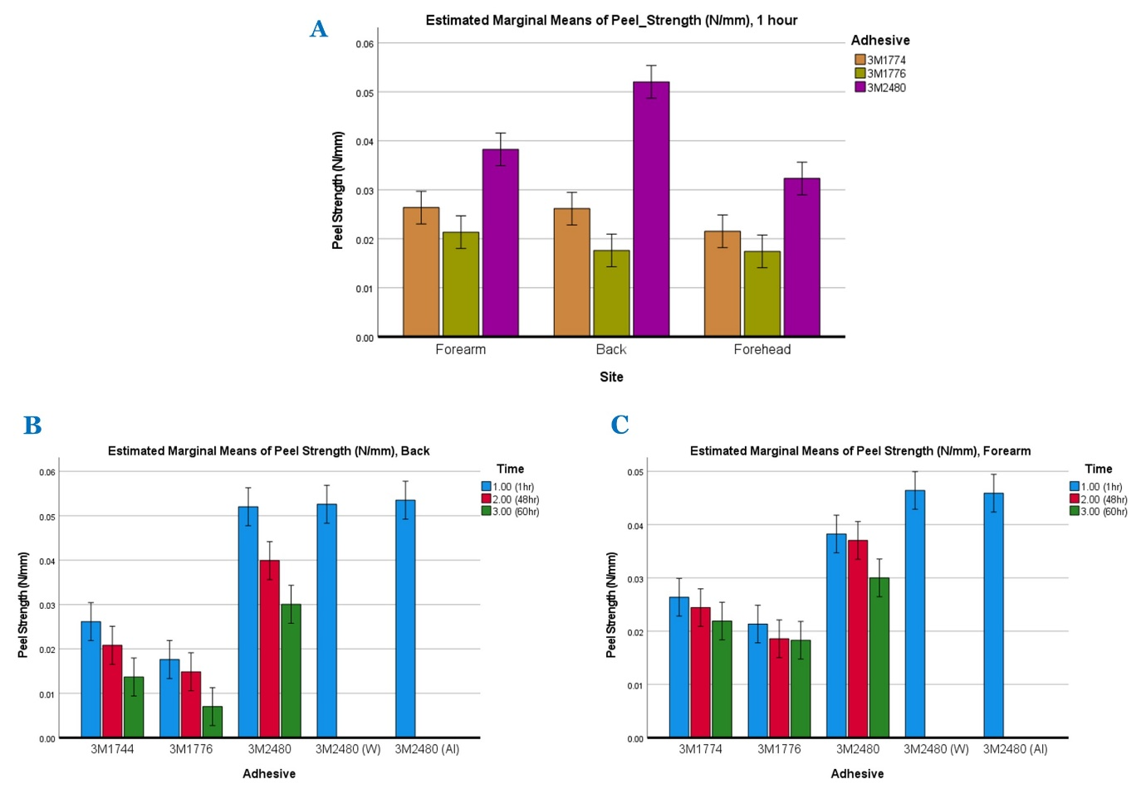
Figure 3A. Peel strength across test sites for the three adhesives tested. Figure 3B, 3C. Peel strength for repeat application for the three adhesives tested. (error bars: 95% Cl)
Skin preparation with water (W) and alcohol (Al) cleansing prior to application of adhesives increased peel strength at both the back and forearm sites, by 1.1% (W), 2.9% (Al), and 21.3% (W), 20% (Al), respectively (Figures 3b, 3c). Paired t-tests showed that in relation to the no skin preparation scenario for the back site, there were weak correlations, and the mean differences in peel strength were not statistically significant (W: p=0.888, Al: p=0.728). For the forearm site, peel strengths following the skin cleansing scenarios were significantly strongly and positively correlated (r=0.94, p<0.001 and r=0.96, p<0.001), and had statistically significant mean differences with the no skin preparation scenario (p<0.001).

3.2 Biophysical Skin Response
After one hour of adhesive application, mean biophysical measures of skin health including skin redness (SR), TEWL, and hydration (HY) increased from the baseline values across all test sites for all the adhesive sample tested (Figure 4a). There was no statistically significant interaction between the effects site and adhesive on the mean changes from baseline values for all the three skin parameters (TEWL: p=0.699, SR: p=0.363, HY: p=0.557). However, there were statistically significant differences in mean changes from baseline values between test sites for all the three skin parameters (p<0.001), with a similar change for each adhesive type. A Tukey post hoc test showed that mean change in TEWL from baseline values was statistically significantly higher for the forehead (10.91 ± 4.32 g·h^{–1}.m^{–2}) site compared to the forearm (5.02 ± 1.79 g·h^{–1}.m^{–2}, p<0.001) and back (7.74 ± 5.43 g·h^{–1}.m^{–2}, p=0.008) sites. The forehead site had the most marked changes in TEWL, representing over 100% increase, while the forearm site had the most marked changes in both redness and hydration measures. Mean skin redness, TEWL and hydration increased with repeat application over prolonged periods across all the adhesive samples tested (Figures 4b, 4c). The TEWL measure had the most marked change post-adhesion across all test sites, across time.

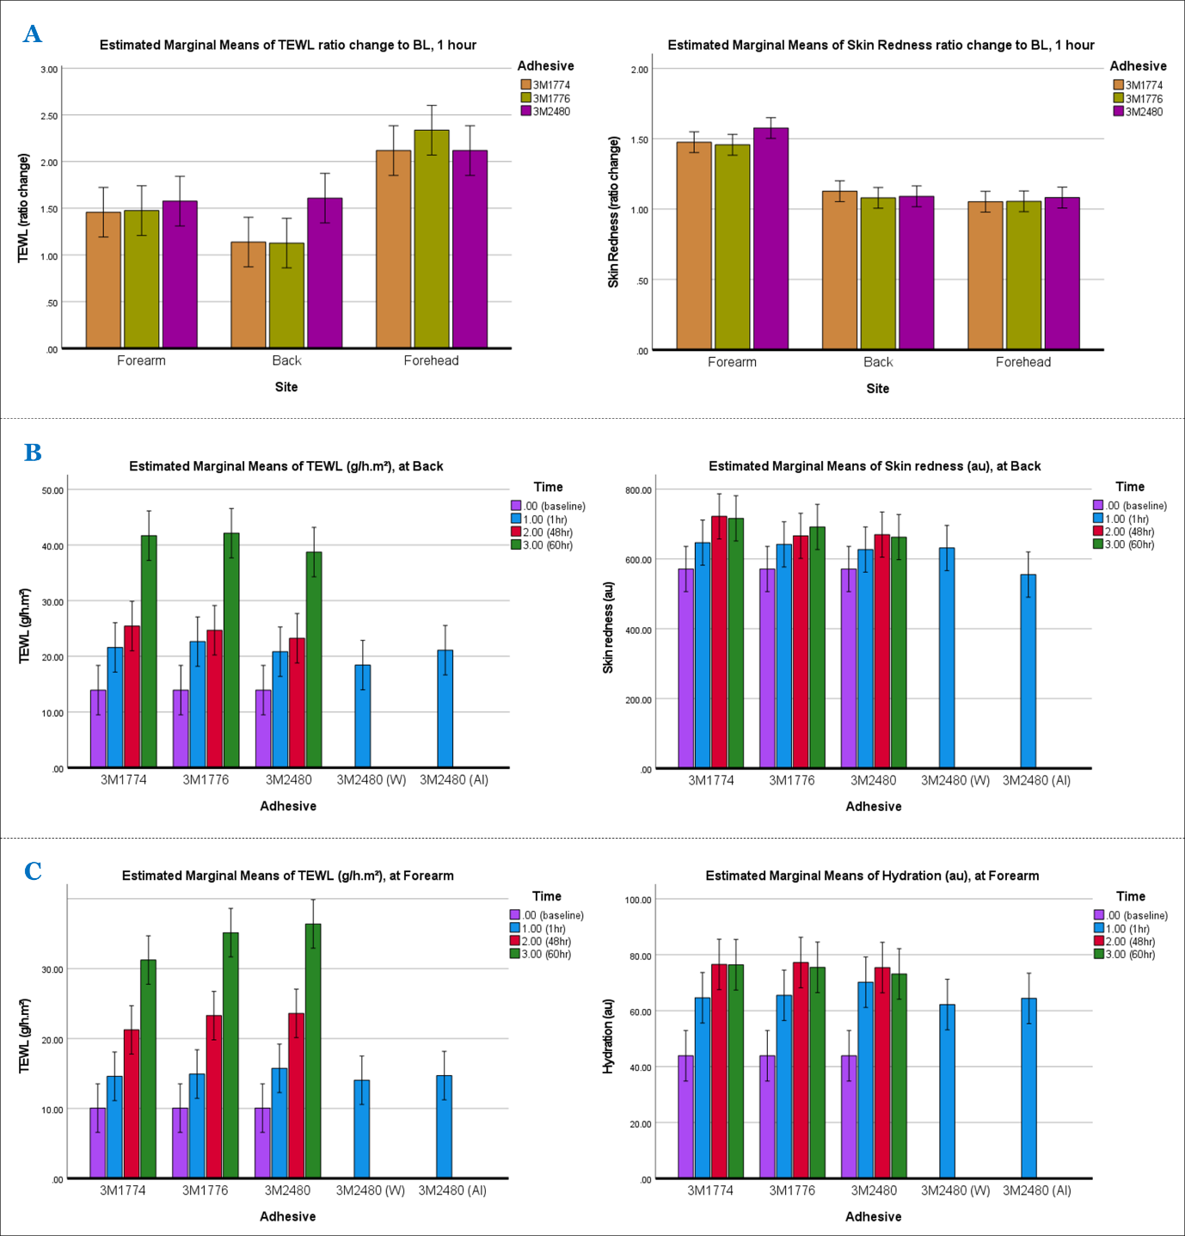

Figure 4A. Skin health biophysical measures across test sites for the three adhesives tested. Figure 4B, 4C. Skin health biophysical measures for repeat application for the three adhesives tested at the back and forearm sites. (error bars 95% Cl)
For the back site, a two-way ANOVA test revealed no statistically significant interaction between the effects of application duration and adhesive on skin redness or TEWL (p=0.96), though a significant interaction was indicted for hydration (p=0.004) (Figure 4b). There were statistically significant mean differences between application timepoints for all the three skin parameters (p<0.001), though no statistically significant difference between the adhesive types (TEWL: p =0.55, SR: p=0.38, HY: p=0.07). Post hoc tests showed statistically significant increase in mean skin redness on day 5 (690 ± 113 au) in comparison to baseline values (571 ± 97 au, p<0.001). Skin redness was higher but not statistically significant on day 5 compared to day 1 (638 ± 101 au, p=0.21) and day 3 (686 ± 110 au, p=0.99).

Similarly, for the forearm site there were statistically significant mean differences between application timepoints for all the three skin parameters (p<0.001), though no statistically significant difference between the adhesive types (TEWL: p =0.23, SR: p=0.31, HY: p=0.99) (Figure 4c). Post hoc tests showed statistically significant increase in mean hydration on day 5 (75 ± 13 au) in comparison to baseline values (44 ± 10 au, p<0.001). Hydration was higher but not statistically significant on day 5 compared to day 1 (66. ± 19 au, p=0.11) and lower than day 3 (76 ± 13 au, p=0.98).

For the skin preparation tests with water and alcohol at the forearm, mean differences in TEWL were statistically significant in relation to the no skin preparation test (W: p=0.002, Al: p=0.007), though not in relation to each other (Figure 4c). For skin redness and hydration, the means were not statistically different between skin preparations. At the back site, mean differences in TEWL, skin redness and hydration were not statistically significant between the skin preparation tests (p>0.05) (Figure 4b).

3.3 Reliability and repeatability with regards to adhesion and skin response
The Intraclass Correlation Coefficient, ICC (2, k) statistic was applied to evaluate the interrater reliability of peel strength and skin biophysical response measures with the set of adhesives as ‘raters’ across the samples at the different test sites. Results revealed highest reliability in measures for the back site, and least reliability for the forehead site (Table 2).

Table 2: Intraclass correlation between peel strength and skin biophysical response measures across the set of adhesives samples at the different test sites.
 | Measure | Intraclass Correlation, ICC (2, k)* | Sig.  (p < 0.05)
BACK | Peel Strength | 0.747 | <.001
 | TEWL | 0.898 | <.001
 | Redness | 0.863 | <.001
 | Hydration | 0.804 | <.001
Forearm | Peel Strength | 0.133 | 0.308
 | TEWL | 0.935 | <.001
 | Redness | 0.840 | <.001
 | Hydration | 0.917 | <.001
Forehead | Peel Strength | 0.292 | 0.244
 | TEWL | 0.210 | 0.312
 | Redness | 0.984 | <.001
 | Hydration | 0.967 | <.001

Discussion
The aims of this study were to evaluate the peel strength of three candidate silicone adhesive materials (3MTM1774, 3MTM1776, 3MTM2480) for medical applications, and the biophysical skin response measures including TEWL, erythema (skin redness), and hydration. An aging test was also performed to predict the long-term performance of the adhesives and the skin reactions. The results revealed distinct differences in the peel strength of the adhesives, with similar trends across three anatomical test sites. The corresponding skin response was characterised by impaired skin barrier function, redness, and increased hydration, which increased during prolonged application.
The peel strength values from this in-vivo study correspond to previous investigations both on human skin and in animal and in-vitro skin models (Liu et al., 2018; Renvoise et al., 2009). There was inter-subject variability in the peel strength, which could be attributed to skin surface properties, sebum content, and potentially sweat (Eiler et al., 2020). Thus, comparison between the anatomical sites must be viewed with respect to the local characteristics of the skin. It has been well established that skin has lower peel strengths than other substrates (Lir et al., 2007), the results from the present study corroborate this finding where values between 0.02-0.05 N/mm were observed.
For one hour of application, the mean differences in peel strength between adhesives and test sites were statistically significant, and the mean biophysical skin response measures including redness, TEWL, and hydration revealed significant differences from the baseline values across all test sites for the set of adhesives samples tested, p<0.05 (Figures 3 and 4). With repeat application over prolonged periods, peel strength reduced uniformly for all the adhesive samples, while TEWL, which is used to assess the status of the skin barrier and objectively analyse skin irritancy potential, had the most marked change (increase) post-adhesion across all test sites and adhesives. TEWL increase indicates impaired skin barrier function, predicting increased compromise to skin health with long-term application of the adhesives (Angelova-Fischer et al., 2012; Breternitz et al., 2007; Fluhr et al., 2005; Lund et al., 1997; Richters et al., 2021; Soltanipoor et al., 2018; Zillmer et al., 2006).
Skin preparation with water and alcohol cleansing prior to application of the adhesives increased peel strength, as well as self-reported levels of discomfort and pain upon adhesive removal for both the back and forearm sites (Figures 3b&3c and 4b&4c), reported similarly in other studies (Bothwell, 1970; Renvoise et al., 2009). However, 1.3% TEWL increase was observed post-adhesion between the no skin preparation and alcohol cleansing tests at the back site, while TEWL decrease was observed for the water cleansing tests at the back, and for both skin preparation tests at the forearm site. Additionally, whereas erythema has conventionally been the most used parameter to visually assess skin irritation (Papanikolaou et al., 2007; Shi et al., 2020). In this investigation we did not observe statistically significant mean differences post-adhesion in relation to the no skin preparation test. This suggests that additional parameters should be considered to assess skin irritation for these skin preparation tests and explore different mechanisms for detecting skin barrier injury, such as the dermal texture index (DTI) to gauge the corneocyte topography (Soltanipoor et al., 2018). In addition, adhesives will remove skin surface cells (corneocytes) and biofluids e.g. sweat and sebum. There is an opportunity to explore the effects on stratum corneum cell structure and maturity (Évora et al., 2021) and biomarkers in biofluids like sebum (Jayabal, Bader, et al., 2023) to expand our understanding on local tissue physiology. These have already been employed to assess the effects of prolonged mechanical loading on the skin from devices (Abiakam et al., 2023; S Évora et al., 2023; P. R. Worsley et al., 2016) and over the site of localised damage i.e. a grade 1 pressure ulcer (Évora et al., 2023; Jayabal, Abiakam, et al., 2023).
The surface properties, mechanical behaviour, and biological properties of human skin vary depending on the location on the human body (Leyva-Mendivil et al., 2017; Sopher & Gefen, 2011). These properties determine to a great extent the adherence performances of adhesives applied on human skin and the biophysical skin response (Bader & Worsley, 2018; Leyden, 1995; Renvoise et al., 2007). In this study, the data showed highest statistical reliability in measured values and parameters across adhesives for the back site, and least reliability for the forehead site (Table 2). This could possibly be associated with known differences in subcutaneous fat distribution in the forehead in relation to age (Coleman & Grover, 2006). The back site was identified in the current preliminary study as the most reliable site for adhesion and skin response comparisons for future work. However, interpreting and making direct comparisons of skin reactions is challenging due to their high complexity, particularly because the physiological properties of human skin are influenced by many factors including gender, age, location on the body, and hormonal changes (Renvoise et al., 2009; Vowels et al., 1995). Additionally, despite reported decrease of skin elasticity and water content with age (Coleman & Grover, 2006; Sopher & Gefen, 2011).
The study is clearly limited by sample size (n=11) and limited age variation, with majority of participants between 40-49 years, and unspecific gender distribution. A larger sample of participants could facilitate advanced analysis on outcomes such as Principal Component Analysis and categorical analysis of responders to adhesive application. Furthermore, evaluation of even longer-term application of adhesives could determine whether and how the skin can compensate for repeated use through structural and functional adaptation. The findings of this study could be extended to identify whether there could be an optimum regime for skin management before and after adhesive application, including the use of moisturisers and barrier products, to protect skin health. The poor reliability of the peel test, particularly at the forehead and arm sites is likely a product of the challenge associated with test consistency, where curvature of the anatomy and alignment with the test rig limit the repeated test reliability. As a result, the authors recommend that this is not a replacement for the current ASTM D903 test standard, rather a complimentary approach for real world application.
Wearable medical devices must be stable, safe for skin contact, and unobtrusive, increasing the need for high-performing adhesives for device fixation. The ability to properly adhere to the skin is a key factor for an effectively functioning device. The adhesives used must perform consistently and attach to the body for continuous and long-term durations. Therefore, the selection and development of adhesives and substrates for wearable medical devices is challenging and requires careful consideration due to the complex and varying nature of human skin and the characteristics of the specific wearable device, such as its size, weight, flexibility, and application purpose. This study has revealed that both the type and duration of application can affect adhesion and skin properties. Further studies are required to assess the performance characteristics of medical grade adhesives to provide functionality whilst protecting skin health.

Conclusions
This study represents a lab-based assessment of peel strength of silicone medical adhesive materials, and the biophysical skin response to adhesive application. The study demonstrated that experimental peel strength data alongside biophysical skin response measurements could inform the development of functional and safe medical adhesives. This study highlights the detriment to the skin barrier function with single instance and repeat application of medical adhesives over prolonged periods, despite a reduction in adhesive strength over time to stay in place throughout the wearing time. It suggests that the skin response to different skin cleansing preparations prior to application of adhesives may differ depending on the location on the human body. It further proposes that locations associated with fairly uniform skin properties such as the back might provide some reliability for adhesion and skin response comparisons.

Acknowledgements
This work was supported by Philips Sleep and Respiratory Care Ltd.

References

Abiakam, N., Jayabal, H., Mitchell, K., Bader, D., & Worsley, P. (2023). Biophysical and biochemical changes in skin health of healthcare professionals using respirators during COVID-19 pandemic. Skin Research and Technology : Official Journal of International Society for Bioengineering and the Skin (ISBS) [and] International Society for Digital Imaging of Skin (ISDIS) [and] International Society for Skin Imaging (ISSI), 29(1). https://doi.org/10.1111/SRT.13239
Angelova-Fischer, I., Becker, V., Fischer, T. W., Zillikens, D., Wigger-Alberti, W., & Kezic, S. (2012). Tandem repeated irritation in aged skin induces distinct barrier perturbation and cytokine profile in vivo. British Journal of Dermatology, 167(4), 787–793. https://doi.org/10.1111/J.1365-2133.2012.11049.X
Bader, D. L., & Worsley, P. R. (2018). Technologies to monitor the health of loaded skin tissues. BioMedical Engineering OnLine, 17(1), 40. https://doi.org/10.1186/s12938-018-0470-z
Bader, D. L., Worsley, P. R., & Gefen, A. (2019). Bioengineering considerations in the prevention of medical device-related pressure ulcers. Clinical Biomechanics, 67, 70–77. https://doi.org/10.1016/J.CLINBIOMECH.2019.04.018
Bashir, S. J., Chew, A. L., Anigbogu, A., Dreher, F., & Maibach, H. I. (2001). Physical and physiological effects of stratum corneum tape stripping. Skin Research and Technology, 7(1), 40–48. https://doi.org/10.1034/J.1600-0846.2001.007001040.X
Bothwell, J. W. (1970). ADHESION TO SKIN Effects of Surgical Tapes on Skin. Adhesion in Biological Systems, 215–221. https://doi.org/10.1016/B978-0-12-469050-9.50019-3
Breternitz, M., Flach, M., Präßler, J., Elsner, P., & Fluhr, J. W. (2007). Acute barrier disruption by adhesive tapes is influenced by pressure, time and anatomical location: integrity and cohesion assessed by sequential tape stripping; a randomized, controlled study. British Journal of Dermatology, 156(2), 231–240. https://doi.org/10.1111/J.1365-2133.2006.07632.X
Cantor, A. S. (1999). Peel Adhesion Using An Artificial Skin As A Predictor Of Adhesion To Human Skin. American Association of Pharmaceutical Scientists Annual Meeting, 14–18.
Chen, W. T., & Flavin, T. F. (1972). Mechanics of Film Adhesion: Elastic and Elastic-Plastic Behavior. IBM Journal of Research and Development, 16(3), 203–213. https://doi.org/10.1147/RD.163.0203
Coleman, S. R., & Grover, R. (2006). The anatomy of the aging face: Volume loss and changes in 3-dimensional topography. Aesthetic Surgery Journal, 26(1 SUPPL.), S4–S9. https://doi.org/10.1016/J.ASJ.2005.09.012/2/10.1016_J.ASJ.2005.09.012-FIG2.JPEG
Dana, S. F., Nguyen, D. V., Kochhar, J. S., Liu, X. Y., & Kang, L. (2013). UV-curable pressure sensitive adhesive films: effects of biocompatible plasticizers on mechanical and adhesion properties. Soft Matter, 9(27), 6270–6281. https://doi.org/10.1039/C3SM50879J
Dykes, P. J., Heggie, R., & Hill, S. A. (2001). Effects of adhesive dressings on the stratum corneum of the skin. Journal of Wound Care, 10(2), 7–10. https://doi.org/10.12968/JOWC.2001.10.2.26054
Eiler, J., Hansen, D., Bingöl, B., Hansen, K., Heikenfeld, J., & Thormann, E. (2020). In vitro evaluation of skin adhesives during perspiration. International Journal of Adhesion and Adhesives, 99, 102574. https://doi.org/10.1016/J.IJADHADH.2020.102574
Évora, A. S., Abiakam, N., Zhang, Z., Johnson, S. A., Adams, M. J., Bader, D. L., & Worsley, P. R. (2023). Characterisation of Superficial Corneocyte Properties over Category I Pressure Ulcers: Insights into Topographical and Maturation Changes. Journal of Dermatological Science, 0(0). https://doi.org/10.1016/j.jdermsci.2023.08.008
Évora, A. S., Adams, M. J., Johnson, S. A., & Zhang, Z. (2021). Corneocytes: Relationship between Structural and Biomechanical Properties. Skin Pharmacology and Physiology, 34(3), 146–161. https://doi.org/10.1159/000513054
Feula, A., Tang, X., Giannakopoulos, I., Chippindale, A. M., Hamley, I. W., Greco, F., Paul Buckley, C., Siviour, C. R., & Hayes, W. (2016). An adhesive elastomeric supramolecular polyurethane healable at body temperature. Chemical Science, 7(7), 4291–4300. https://doi.org/10.1039/C5SC04864H
Fluhr, J. W., Akengin, A., Bornkessel, A., Fuchs, S., Praessler, J., Norgauer, J., Grieshaber, R., Kleesz, P., & Elsner, P. (2005). Additive impairment of the barrier function by mechanical irritation, occlusion and sodium lauryl sulphate in vivo. British Journal of Dermatology, 153(1), 125–131. https://doi.org/10.1111/J.1365-2133.2005.06430.X
Godbey, K. (2016). Skin vs. Stainless Steel: Adhesion Testing for Medical Design. 3M Medical Materials and Technologies.
Grove, G. L., Zerweck, C. R., Houser, T. P., Smith, G. E., & Koski, N. I. (2013). A randomized and controlled comparison of gentleness of 2 medical adhesive tapes in healthy human subjects. Journal of Wound, Ostomy and Continence Nursing, 40(1), 51–59. https://doi.org/10.1097/WON.0B013E318276F2A4
Jayabal, H., Abiakam, N. S., Filingeri, D., Bader, D. L., & Worsley, P. R. (2023). Inflammatory biomarkers in sebum for identifying skin damage in patients with a Stage I pressure ulcer in the pelvic region: A single centre observational, longitudinal cohort study with elderly patients. International Wound Journal, 20(7), 2594–2607. https://doi.org/10.1111/IWJ.14131
Jayabal, H., Bader, D. L., & Worsley, P. (2023). Development of an Efficient Extraction Methodology to Analyse Potential Inflammatory Biomarkers from Sebum. Skin Pharmacology and Physiology, 36(1), 38–50. https://doi.org/10.1159/000528653
Jones, L. A. (1989). Handbook of Pressure Sensitive Adhesive Technology (D. Satas, Ed.; Vol. 1). Springer.
Kmieć, M. L., Pajor, A., & Broniarczyk-Dyła, G. (2013). Evaluation of biophysical skin parameters and assessment of hair growth in patients with acne treated with isotretinoin. Advances in Dermatology and Allergology/Postępy Dermatologii i Alergologii, 30(6), 343–349. https://doi.org/10.5114/PDIA.2013.39432
Koo, T. K., & Li, M. Y. (2016). A Guideline of Selecting and Reporting Intraclass Correlation Coefficients for Reliability Research. Journal of Chiropractic Medicine, 15(2), 155–163. https://doi.org/10.1016/J.JCM.2016.02.012
Leyden, J. J. (1995). New understandings of the pathogenesis of acne. Journal of the American Academy of Dermatology, 32(5), S15–S25. https://doi.org/10.1016/0190-9622(95)90416-6
Leyva-Mendivil, M. F., Lengiewicz, J., Page, A., Bressloff, N. W., & Limbert, G. (2017). Skin Microstructure is a Key Contributor to Its Friction Behaviour. Tribology Letters, 65(1), 1–17. https://doi.org/10.1007/S11249-016-0794-4/FIGURES/6
Lin, S. B., Durfee, L. D., Knott, A. A., & Schalau, G. K. (2008). Technology of Pressure-Sensitive Adhesives and Products (I. Benedek & M. M. Feldstein, Eds.; 1st ed.). CRC Press.
Lir, I., Haber, M., & Dodiuk-Kenig, H. (2007). Skin surface model material as a substrate for adhesion-to-skin testing. Journal of Adhesion Science and Technology, 21(15), 1497–1512. https://doi.org/10.1163/156856107782844783
Liu, L., Kuffel, K., Scott, D. K., Constantinescu, G., Chung, H.-J., & Rieger, J. (2018). Silicone-based adhesives for long-term skin application: cleaning protocols and their effect on peel strength. Biomedical Physics & Engineering Express, 4(1), 015004. https://doi.org/10.1088/2057-1976/AA91FB
Lund, C. H., Nonato, L. B., Kuller, J. M., Franck, L. S., Cullander, C., & Durand, D. J. (1997). Disruption of barrier function in neonatal skin associated with adhesive removal. The Journal of Pediatrics, 131(3), 367–372. https://doi.org/10.1016/S0022-3476(97)80060-1
Minghetti, P., Cilurzo, F., & Casiraghi, A. (2004). Measuring adhesive performance in transdermal delivery systems. American Journal of Drug Delivery, 2(3), 193–206. https://doi.org/10.2165/00137696-200402030-00004/METRICS
Nussinovitch, A., Gal, A., Padula, C., & Santi, P. (2008). Physical characterization of a new skin bioadhesive film. AAPS PharmSciTech, 9(2), 458–463. https://doi.org/10.1208/S12249-008-9061-9/FIGURES/7
Papanikolaou, P., Lyne, P., & Anthony, D. (2007). Risk assessment scales for pressure ulcers: A methodological review. International Journal of Nursing Studies, 44(2), 285–296. https://doi.org/10.1016/J.IJNURSTU.2006.01.015
Papon, E. (2011). Handbook of Adhesion Technology (Adams et al, Ed.; RD). Springer.
Ranamukhaarachchi, S. A., Lehnert, S., Ranamukhaarachchi, S. L., Sprenger, L., Schneider, T., Mansoor, I., Rai, K., Häfeli, U. O., & Stoeber, B. (2016). A micromechanical comparison of human and porcine skin before and after preservation by freezing for medical device development. Nature, Scientific Reports, 6(32074), 1–9. https://doi.org/10.1038/srep32074
Renvoise, J., Burlot, D., Marin, G., & Derail, C. (2007). Adhesion of PSAs on human skin: a better understanding of the mechanisms. 30th Annual Meeting of the Adhesion Society, 30th(Copyright (C) 2017 American Chemical Society (ACS). All Rights Reserved.), 273–275. https://hal.science/hal-01616203
Renvoise, J., Burlot, D., Marin, G., & Derail, C. (2009). Adherence performances of pressure sensitive adhesives on a model viscoelastic synthetic film: A tool for the understanding of adhesion on the human skin. International Journal of Pharmaceutics, 368(1–2), 83–88. https://doi.org/10.1016/J.IJPHARM.2008.09.056
Richters, R. J. H., Uzunbajakava, N. E., Hendriks, J. C. M., Bikker, J. W., van Erp, P. E. J., & van de Kerkhof, P. C. M. (2017). A model for perception-based identification of sensitive skin. Journal of the European Academy of Dermatology and Venereology, 31(2), 267–273. https://doi.org/10.1111/JDV.13829
Richters, R. J. H., Uzunbajakava, N. E., Hendriks, J. C. M., Bikker, J. W., van Erp, P. E. J., & van de Kerkhof, P. C. M. (2021). The identification of biophysical parameters which reflect skin status following mechanical and chemical insults. Clinical Physiology and Functional Imaging, 41(4), 366–375. https://doi.org/10.1111/CPF.12707
Rippon, M., White, R., & Davies, P. (2007). Skin adhesives and their role in wound dressings. Wounds UK, 4(4), 76–86.
S Évora, A., Abiakam, N., Jayabal, H., Worsley, P. R., Zhang, Z., A Johnson, S., J Adams, M., & Bader, D. L. (2023). Characterisation of superficial corneocytes in skin areas of the face exposed to prolonged usage of respirators by healthcare professionals during COVID-19 pandemic. Journal of Tissue Viability, 32(2), 305–313. https://doi.org/10.1016/J.JTV.2023.02.007
Shi, C., Bonnett, L. J., Dumville, J. C., & Cullum, N. (2020). Nonblanchable erythema for predicting pressure ulcer development: a systematic review with an individual participant data meta‐analysis. British Journal of Dermatology, 182(2), 278–286. https://doi.org/10.1111/BJD.18154
Soetens, J. F. J., Worsley, P. R., Herniman, J. M., Langley, G. J., Bader, D. L., & Oomens, C. W. J. (2019). The expression of anaerobic metabolites in sweat and sebum from human skin subjected to intermittent and continuous mechanical loading. Journal of Tissue Viability, 28(4), 186–193. https://doi.org/10.1016/J.JTV.2019.10.001
Soltanipoor, M., Stilla, T., Riethmüller, C., Thyssen, J. P., Sluiter, J. K., Rustemeyer, T., Fischer, T. W., Kezic, S., & Angelova-Fischer, I. (2018). Specific barrier response profiles after experimentally induced skin irritation in vivo. Contact Dermatitis, 79(2), 59–66. https://doi.org/10.1111/COD.12981
Sopher, R., & Gefen, A. (2011). Effects of skin wrinkles, age and wetness on mechanical loads in the stratum corneum as related to skin lesions. Medical and Biological Engineering and Computing, 49(1), 97–105. https://doi.org/10.1007/S11517-010-0673-3/TABLES/5
Venkatraman, S., & Gale, R. (1998). Skin adhesives and skin adhesion: 1. Transdermal drug delivery systems. Biomaterials, 19(13), 1119–1136. https://doi.org/10.1016/S0142-9612(98)00020-9
Vowels, B. R., Yang, S., & Leyden, J. J. (1995). Induction of proinflammatory cytokines by a soluble factor of Propionibacterium acnes: implications for chronic inflammatory acne. Infection and Immunity, 63(8), 3158–3165. https://doi.org/10.1128/IAI.63.8.3158-3165.1995
Waring, M., Bielfeldt, S., & Brandt, M. (2009). Skin adhesion properties of three dressings used for acute wounds. Wounds UK, 5(3), 22–31. https://www.researchgate.net/publication/265578095
Waring, M., Bielfeldt, S., Mätzold, K., Wilhelm, K. P., & Butcher, M. (2013). An evaluation of the skin stripping of wound dressing adhesives. Journal of Wound Care, 20(9), 412–422. https://doi.org/10.12968/JOWC.2011.20.9.412
Worsley, P. R., Prudden, G., Gower, G., & Bader, D. L. (2016). Investigating the effects of strap tension during non-invasive ventilation mask application: a combined biomechanical and biomarker approach. Medical Devices (Auckland, N.Z.), 9, 409. https://doi.org/10.2147/MDER.S121712
Worsley, P., & Voegeli, D. (2013). Back to basics: biophysical methods in tissue viability research. Journal of Wound Care, 22(8), 434–439. https://doi.org/10.12968/JOWC.2013.22.8.434
Zhang, L., & Wang, J. (2009). A generalized cohesive zone model of the peel test for pressure-sensitive adhesives. International Journal of Adhesion and Adhesives, 29(3), 217–224. https://doi.org/10.1016/J.IJADHADH.2008.05.002
Zillmer, R., Agren, M. S., Gottrup, F., & Karlsmark, T. (2006). Biophysical effects of repetitive removal of adhesive dressings on peri-ulcer skin. Journal of Wound Care, 15(5), 187–191. https://doi.org/10.12968/JOWC.2006.15.5.26907

