Additional data for Figure 4:

A
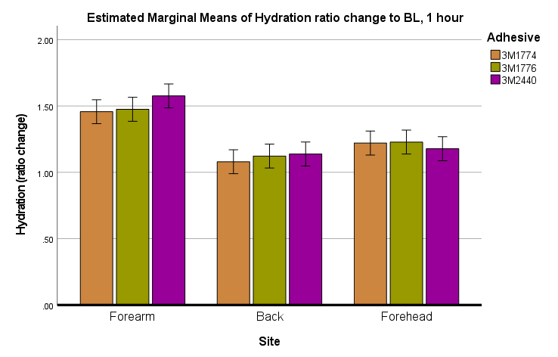
B
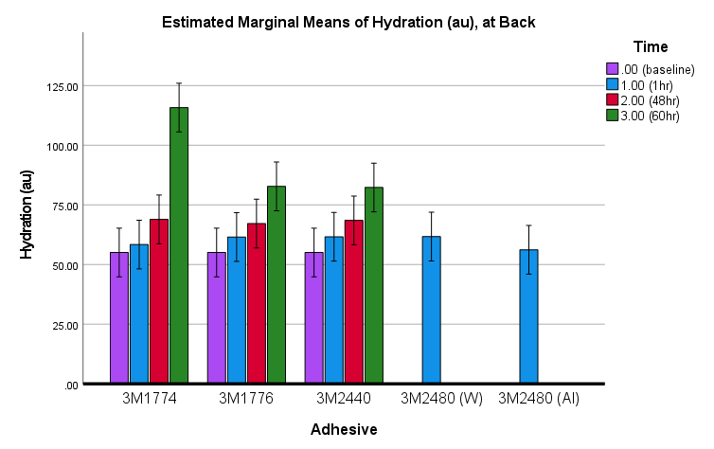
C
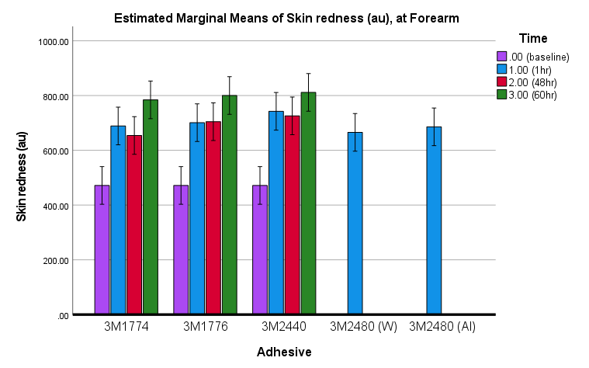
Figure A. Skin health biophysical measures across test sites for the three adhesives tested. Figure B, C. Skin health biophysical measures for repeat application for the three adhesives tested at the back and forearm sites. (error bars 95% Cl)

Example Force/Displacement curves from the peel tests

