A Hybrid Review on Sharia Governance Studies from 2001 to 2022

Yunice Karina Tumewang^{a,b}*, Indri Supriani^{c}, Herlina Rahmawati Dewi^{a,d}, Md. Kautsar Alam^{e}

ª Department of Accounting, Faculty of Business and Economics, Universitas Islam Indonesia
^{b} Department of Accounting, Southampton Business School, University of Southampton
^{c} Department of Islamic Economics, Faculty of Economics and Business, Universitas Airlangga
^{d} Doctoral School of Business Administration, Faculty of Business and Economics, University of Pécs
^{e} Department of Accounting, BRAC University

Abstract
Purpose – This study aims to identify the significant scientific actors, to reveal the intellectual structure, and to explore essential features for future research direction in Sharia governance studies.
Design/methodology/approach – The study applies a hybrid review combining bibliometric analysis and content analysis. It employs Rstudio (biblioshiny), VOSviewer, and Microsoft Excel to analyse 392 articles published in 127 Scopus-indexed journals between January 2001 and September 2022.
Findings – The paper discovered five distinct streams of Sharia governance studies: (1) Structure of Sharia governance; (2) Sharia governance and risk management; (3) Sharia governance and sustainability; and (4) The effect of Sharia governance toward firm’s financial performance. Further, it derives and summarizes 26 main research questions for future studies.
Originality/value – This study is among the first study using a hybrid review on the topic of Sharia governance, allowing future researchers in this field to capture the trends and progress of current literature as well as the research gaps to be filled in by future researchers.
Keywords Bibliometrics, Content Analysis, Sharia Governance, Corporate Governance
Paper type Research paper

- Introduction

Corporate governance has been discussed by academics and practitioners since nearly a century ago, but it has been dramatically intensified just couple decades ago after several worldwide corporate failures and scandals (Durisin & Puzone, 2009). According to OECD (2004), corporate governance is generally defined as the systems of rules, practices, and processes by which companies are governed. The importance of corporate governance to shape the corporate success, both in the developed and developing countries, has been proven by majority of literature (Alnabsha et al., 2018; Ntim, 2013; Thomsen & Pedersen, 2000).
In the context of Islamic financial institutions, Chapra & Ahmed (2002) are among the earliest researchers who discussed the importance and distinction of corporate governance for Islamic banks in terms of the moral commitment embodied in the function of those charged with governance. Going further, several studies have attempted to introduce a specific term of ‘Sharia governance’, highlighting a clear distinction in the governance practice of any corporate adhering to Sharia principles, particularly those Islamic financial institutions. Sharia governance is specifically defined as the regulatory framework which regulates and supervises Islamic financial institutions to ensure the compliance of Sharia law in all its operations (Elasrag, 2014). Considering Shariah as the backbone and fundamental reason for the existence of Islamic finance industry, Sharia governance is dominantly attributed to the long-term sustainability of this industry. Many scholars in this field have further proven that Sharia governance is statistically significant for firm’s financial performance such as profitability (Aslam & Haron, 2020), earnings management (Kolsi & Grassa, 2017), and credit rating (Grassa, 2016); as well as non-financial one including Shariah risk (Ginena, 2014), CSR disclosure (Farook et al., 2011), and Islamic banks’ products and services disclosure (Grassa et al., 2018).
Considering this importance, the interest on this field modestly arose from the practitioners’ side, however the academic literature is still limited compared to other issues in Islamic finance, but recently growing. This fact has triggered the authors to conduct a comprehensive review of the major literature in the field of Sharia governance. This study is distinct due to several reasons. Firstly, this study applies a hybrid review approach by combining the result of bibliometric analysis with the in-depth discussion from content analysis. Secondly, this study reviewed an exhaustive list of 392 articles published in 127 journals indexed by Scopus which is widely considered as one of the largest multidisciplinary bibliographic databases. Thirdly, it also tracks the intellectual structure development during an extensive period of time (2001 until September 2022) and conducts the analysis using the latest software of Rstudio and VOSviewer.
This study yields multiple findings. Firstly, it reveals various significant aspects of Sharia governance literature which include the leading articles and journals, as well as the most influential authors, affiliations, and countries. Following that, this study also identifies and discusses 4 (four) major research streams: (1) Structure of Sharia governance; (2) Sharia governance and risk management; (3) Sharia governance and sustainability; and (4) The effect of Sharia governance toward firm’s financial performance. Lastly, the content analysis is carried out to identify research gaps and elaborate some critical questions to be considered by future researchers in this field.
The remaining part of this study is structured as follows; Section 2 reviews the methodological approach applied in this study. Section 3 demonstrates the result of bibliometric analysis including general performance analysis, citation analysis, and network analysis. Section 4 presents the result of content analysis including major research streams and future research directions. Finally, it ends with Section 5 for conclusion of this study.

- Methodology

This section discusses the research strategy for selecting, validating, and organizing data. It also further explains the tools and tests that were employed to achieve the research objectives.
This study employs a hybrid review approach that combines bibliometric and content analysis. To eliminate subjectivity bias, bibliometric analysis is required in this study due to the ongoing review of the literature (Alshater et al., 2022). Furthermore, the literature or data collected comes from reputable databases and is analysed using statistical tools. As a result, this approach assists the authors in tracking the intellectual structures, identifying the research gaps, and providing the future research questions (Alshater et al., 2022), particularly in the field of Sharia governance investigated in this study.
This study uses RStudio in conjunction with a bibliometric tool called biblioshiny. This tool has been widely used by many researchers to conduct bibliometric research and produce reliable results (Alshater et al., 2022). This study also employs VOSviewer, a network analysis software, to generate a literature map. Furthermore, Microsoft Excel will be used in this study to re-examine the work process and describe graphs. The bibliometric analysis of this study adopted a three-stage approach employed by previous research of (Paltrinieri et al., 2019) and (Muneer M Alshater et al., 2021).
In the first step, the researcher searches relevant databases and selects a database of literature sources to review. Scopus, the world's largest multidisciplinary social sciences database, was used to collect data from all Sharia governance research. Another reason for selecting Scopus as the database is that most studies that use bibliometric analysis use it to maintain certain level of quality (Durán-Sánchez et al., 2019). Scopus is widely preferred due to its easy-to-use interface combined with various options for improving and exporting data ((Alshater et al., 2022; Muneer M Alshater et al., 2021).
The keywords used in this study are determined in the second stage, which is the combination of the words “Sharia” OR “Shariah” OR “Islamic” AND “Governance”. In order to gather as much as possible, the authors did not limit the time coverage, so that the authors can trace the development of relevant publication in this field since the first time it is published, which appears to be from 2001 until October 2022. In addition to that, this study also covers all subject areas to allow more comprehensive review of the related studies. The study then utilises several selected software such as RStudio, VOSviewer, and Microsoft Excel to describe, manage, and analyse the contents of the collected literature by categorizing it into several representative clusters accordingly.
In the third phase of this research, the authors perform a thorough bibliometric analysis, including a general performance analysis, citation analysis, and network analysis (Muneer M Alshater et al., 2021). In this part of the study, the publication trends, the most important countries, and the most important journals, authors, and institutions will be presented. This study also demonstrates how citations change over time, which articles are most frequently cited, bibliographic coupling, co-citation, co-authorship, and a map of the keywords examined. Lastly, the study also conducts a content analysis to show the main streams of current research and provide directions for future research. Therefore, this study provides comprehensive and detailed results that can be used as a reference for future research.

- Result and Discussion

  - General Performance Analysis
    - Growth of sharia governance literature. Table 1 and Figure 1 describe the primary characteristics and publication trend of the analysed data. The data indicates that there are 392 articles on Sharia governance produced by 726 authors, with international collaboration reaching 28.32% and 3,315 citations received through September 2022. In 2001, the first article on sharia governance was published. In addition, during the 2008 financial crisis, a considerable increase in the rate of publications on this topic was observed. In 2021, the total number of published articles reached its highest point, surpassing sixty. Consequently, the findings reveal that sharia governance has garnered the interest of sharia scholars worldwide and that collaborative authorship is on the rise. Given the rising performance moving average trend of sharia governance, the total number of sharia governance publications and citations will grow exponentially over the next few years.
Table 1. Summary of the Review
Description | Results
Main Information about Data
Documents | 392
Citations | 3315
Timespan | 2001- Sept 2022
Average Citations/Author | 4.56
Average Citations/Document | 8.46
Average Citations/Year | 157.86
Average Citations/Author/Year | 81.55
h_index | 28
g_index | 44
References | 19,916
Authors
Total Authors | 726
Authors of single-authored documents | 64
Authors of multi-authored documents | 662
Authors Collaboration
Single-authored documents | 83
Documents per author | 0.54
Authors per document | 1.85
Co-authors per documents | 2.62
International co-authorships (%) | 28.32

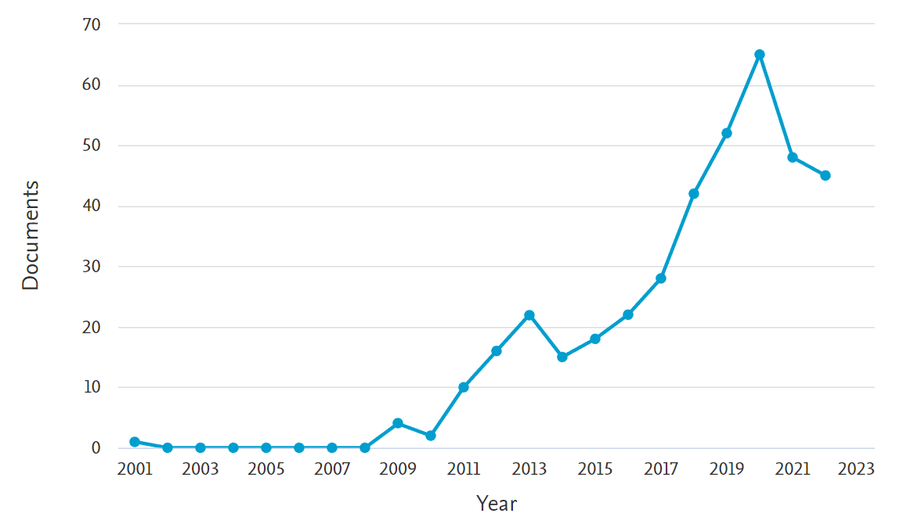
Figure 1. Publication Trend by Year

    - Publication Trend by Geographical Distribution. The scientific contribution of the geographic area depicted in Figure 2 is provided in this study. The figure shows that 17 countries were involved in the publication of sharia governance. The results indicate that Malaysia is cited as the most productive country, with a total publication of 194 documents. The result was also corroborated by the previous bibliometrics studies on Islamic finance, economics, and banking (Muneer M. Alshater, M. Kabir Hassan, Mamunur Rashid, et al., 2021; Alshater et al., 2022; Hassan et al., 2021; Khan et al., 2020; Narayan & Phan, 2019) which discovered that Malaysia becomes the leading country in terms of publication and research on Islamic economics studies. Sharia governance studies were heavily conducted in Asian countries with Muslim majorities, including Indonesia, Bangladesh, Pakistan, Uni Arab Emirates, Tunisia, Bahrain, Qatar, Turkey, and Nigeria.
However, interestingly, the data shows that the United Kingdom has become the second largest contributor to sharia governance research, followed by several other non-Muslim populous countries, namely, the United States, Australia, and France. Hence, the result demonstrated that demographics, ethnicity, and religion do not limit research on Islamic studies. The establishment of research institutions and educational programs in non-Muslim countries also hastens publication from those countries.

Figure 2. Publication Trend by Geographical Distribution

    - The Most Significant Affiliations and Authors on sharia governance. Figure 3, which presents the most relevant institutions in publishing sharia governance research, also reveals that nine of the top ten list affiliations were based in Malaysia, the country with the highest number of contributors. According to the data, Malaysia has become the center for Islamic economics and finance education. International Islamic University Malaysia (IIUM), a specialised institution for Islamic finance education, publishes the greatest number of papers on sharia governance with over 70 (the data reveals that IIUM appears twice in rank first and third due to the inability of the program to integrate the data). In addition, Universiti Teknologi Mara and the International Centre for Education in Islamic Finance are among the top three universities conducting research in this field.
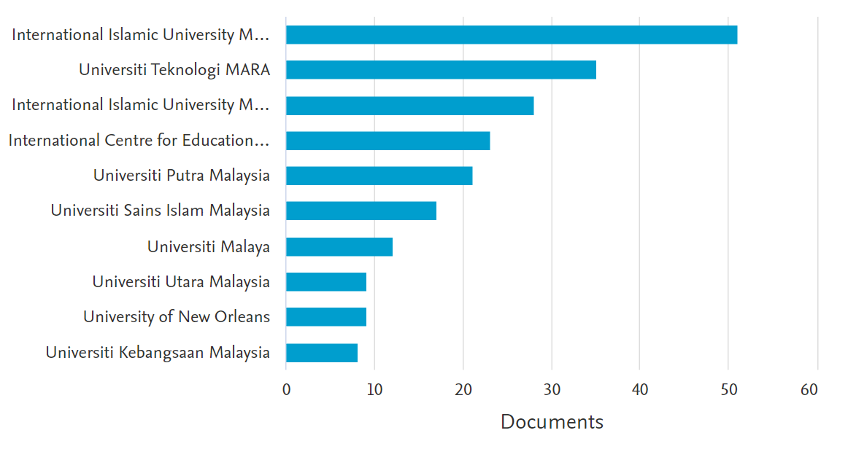

Figure 3. Top 10 Institutions in Sharia Governance Publications

Figure 4 depicts the frequency of scientific production's most prolific authors within the studied period. The data indicates that the top ten writers authored at least six papers; additionally, Md. Kausar Alam, with a total of sixteen works, who is affiliated with the University of South Asia in Bangladesh, is recognized as the most prolific scholar. Razali Haron and Rusni Hassan, both of IIUM in Malaysia, are ranked third and fourth, with 11 and 8 articles, respectively. Several authors, including Rihab Grassa (Higher Colleges of Technology, United Arab Emirates), Ahmad F.S. Hassan (Universiti Putra, Malaysia), M. Kabir Hassan (New Orleans University, United States), Aishath Muneeza (IIUM, Malaysia), and Zurina Shafii (University Sains Islam Malaysia, Malaysia), have made substantial contributions to the publication of works on sharia governance. This information will aid scholars in establishing academic partnership, particularly by allowing prospective scholars to locate the most relevant authors in Sharia governance literature.
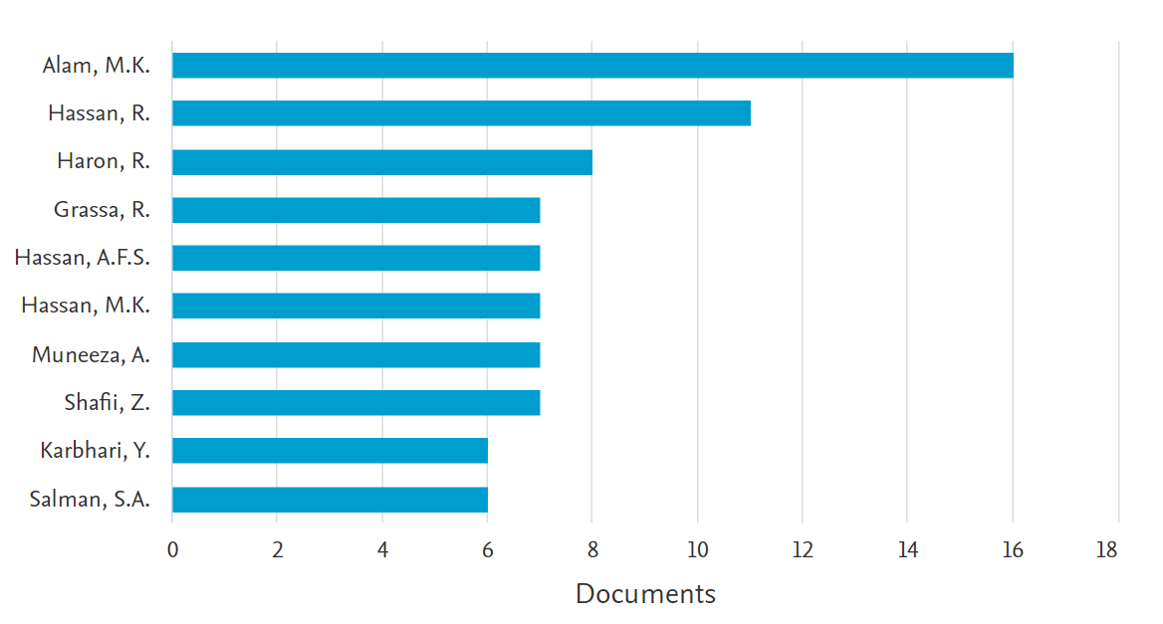

Figure 4. Top 10 Authors by Number of Publications

  - In-Depth Citation Analysis
The influential publications as measured by the total number of citations in the Scopus database are presented in Table 2. An examination of the most-cited papers revealed the most-discussed topic about sharia governance and uncovered a pattern of publication topics. According to Table 2, research written by (Mollah & Zaman, 2015) is the most cited, with a total local citation count of 245 and an annual average citation count of 35. The article compares the efficacy of Islamic and conventional banks’ governance mechanisms. The most cited studies investigated the presence of the shariah supervisory system and its effect on the performance of Islamic finance, as evaluated by efficiency, financial performance, risk management, and earnings management.
In addition, as indicated in Table 2, nine of the eleven most-cited papers focus on sharia governance in Islamic banking. Comparatively, the remaining two articles explore the sharia governance of Islamic stocks and Islamic financial organizations in general. This finding is consistent with the fact that Islamic banks have surpassed Sukuk, Islamic funds, takaful, and others to become the dominant Islamic financial institutions in asset distribution, reaching 70% in 2020 (Thomson Reuters, 2021). Hence, this led to Islamic banking becoming the most popular topic in Islamic finance and economics studies amongst scholars.

Table 2. Top 11 Most-Cited Articles in Sharia Governance Publications
No. | Author | Title | Year | Source Title | Total Citations | Citation per Year
1 | S. Mollah, M. Zaman | Shari'ah supervision, corporate governance and performance: Conventional vs. Islamic banks | 2015 | Journal of Banking and Finance | 245 | 35
2 | S. Farook, M. Kabir Hassan, R. Lanis | Determinants of corporate social responsibility disclosure: The case of Islamic banks | 2011 | Journal of Islamic Accounting and Business Research | 167 | 15.18
3 | M.A. Quttainah, L. Song, Q. Wu | Do Islamic banks employ less earnings management? | 2013 | Journal of International Financial Management and Accounting | 75 | 8.33
4 | H. Farag, C. Mallin, K. Ow-Yong | Corporate governance in Islamic banks: new insights for dual board structure and agency relationships | 2018 | Journal of International Financial Markets, Institutions and Money | 70 | 17.5
5 | M. Safiullah, A. Shamsuddin | Risk in Islamic banking and corporate governance | 2018 | Pacific Basin Finance Journal | 69 | 17.25
6 | N.M. Nomran, R. Haron, R. Hassan | Shari’ah supervisory board characteristics effects on Islamic bank’s performance: Evidence from Malaysia | 2018 | International Journal of Bank Marketing | 54 | 13.5
7 | S. Ali, S.J.H. Shahzad, N. Raza, K.H. Al-Yahyaee | Stock market efficiency: A comparative analysis of Islamic and conventional stock markets | 2018 | Physica A: Statistical Mechanics and its Applications | 53 | 13.25
8 | R. Grassa | Shariah supervisory system in Islamic financial institutions: new issues and challenges: A comparative analysis between Southeast Asia models and GCC models | 2013 | Humanomics | 51 | 5.67
9 | S. Darmadi | Corporate governance disclosure in the annual report: An exploratory study on Indonesian Islamic banks | 2013 | Humanomics | 51 | 5.67
10 | M. Safiullah, A. Shamsuddin | Risk-adjusted efficiency and corporate governance: Evidence from Islamic and conventional banks | 2019 | Journal of Corporate Finance | 49 | 16.33
11 | A.R. Almutairi, M.A. Quttainah | Corporate governance: Evidence from Islamic banks | 2017 | Social Responsibility Journal | 49 | 9.8

Table 3 identified the most productive and influential authors in the field of sharia governance study based on the number of publications and the total number of citations. Table 3 demonstrated that Sabur Mollah became the most relevant author on both measurements, with a total publication of 9 articles and 254 citations. In addition, Mahbub Zaman is in second place with four publications that have been cited 245 times, followed by Rihab Grassa with 224 total citations. Interestingly, Mollah S. and Zaman M. were the authors of the most cited documents, as explained in Table 2. Hence, this result strengthens the consideration of whether sharia supervision boards in Islamic banking play a crucial role in distinguishing Islamic banking from its conventional counterparts is the most discussed topic in sharia governance research.

Table 3. Impact of Top 10 Authors on Maqashid Sharia Studies
No. | Author | H-Index | M-Index | Total Citation | No of Publication | Publication Year Start
1 | Mollah S. | 2 | 0.444 | 254 | 9 | 2014
2 | Zaman M. | 1 | 0.375 | 245 | 4 | 2014
3 | Grassa R. | 7 | 1.000 | 224 | 4 | 2019
4 | Hassan, M. K. | 4 | 0.444 | 172 | 4 | 2014
5 | Farook, S. | 1 | 0.500 | 167 | 3 | 2015
6 | Lanis, R. | 1 | 0.400 | 167 | 3 | 2013
7 | Quttainah, M. A. | 4 | 1.333 | 139 | 3 | 2020
8 | Safiullah, M. | 3 | 0.500 | 129 | 3 | 2015
9 | Alam, M. K. | 7 | 0.800 | 123 | 3 | 2018
10 | Haron, R. | 6 | 0.800 | 121 | 3 | 2018
H-index is when they have h papers that have been cited h times at least;
M-index is the H-index divided by the number of years since the first publication until present

  - Network Analysis
3.3.1. Co-authorship analysis. Alshater et al. (2022) explained that co-authorship analysis allows the researchers to identify the collaboration pattern between the most prolific parties and build the research collaboration network to produce a comprehensive, high-quality paper that provides a cross-country perspective. Figure 5 describes the research collaboration patterns among countries on sharia governance research. The figure depicts that the co-authorship was divided into eight clusters, in which Malaysia became the centre of collaboration, indicated by the largest node of Malaysia (cluster purple). This result demonstrates that Malaysian researchers are highly productive in global research collaborations. Moreover, countries in the same colour cluster tend to have a similar research topic; hence, this finding reflects that Malaysia, Canada, and Yemen; Qatar, Saudi Arabia, and Nigeria (yellow cluster); Australia and Pakistan (brown cluster); and Tunisia and India (red cluster), and the United Kingdom (UK) and Egypt (green cluster) are likely to discuss the related topic.
Furthermore, the close distance between the clusters implies that the countries have a strong research collaboration network. Thus, Malaysia, Tunisia, and the UK are found to have joined research on sharia governance topics. Interestingly, this study reveals that the UK, Australia, Canada, India, Taiwan and the United States (USA) are Muslim minority countries. However, these countries significantly contribute to the patterns of research collaboration. Previous studies using the bibliometrics approach on Islamic banking and finance conducted by (Ahmid, 2019) explain that the UK become the non-Muslim country that provides numerous research and education centres on Islamic economics and finance, particularly after the Global Financial Crisis in 2008. Moreover, (Muneer M. Alshater, M. Kabir Hassan, Ashraf Khan, et al., 2021) described that M. Kabir Hassan, affiliated with the University of New Orleans, has caused the USA to be cited as one of the more vital collaborators in publishing articles on sharia governance. In conclusion, sharia governance research on Islamic financial institutions has attracted Muslim-majority and minority countries, as it has been demonstrated to be an effective alternative to conventional ones.
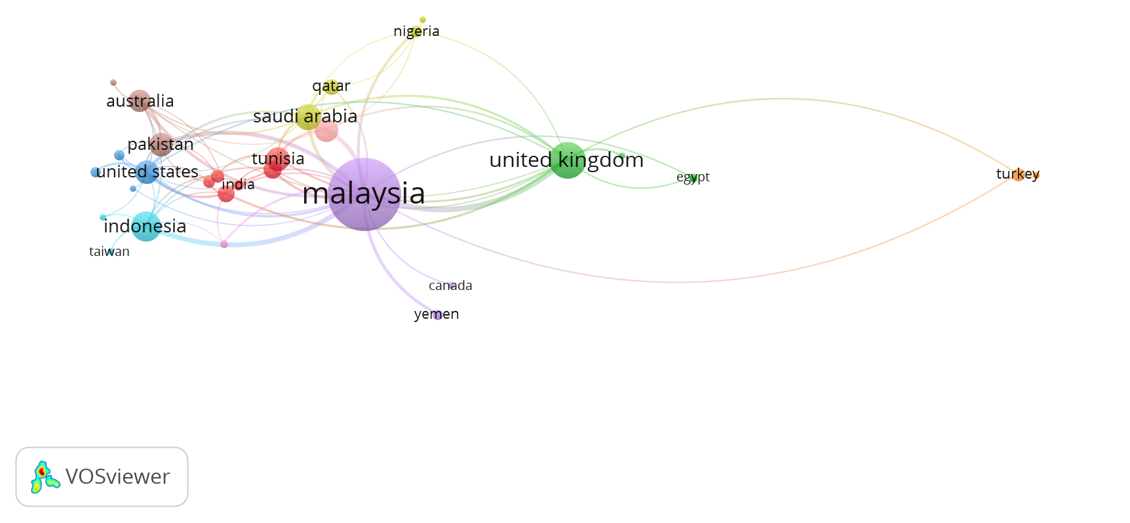
Figure 5. Co-Authorship by Countries

3.3.2 Keyword analysis. The most discussed topics in sharia governance are identified by utilizing keyword co-occurrence analysis. Figure 6 classify the most frequently used keywords into four groups. This data shows that most research has been done on four common topics. Figure 6 shows that ‘Islamic bank’ (81 times), ‘Shariah governance’ (44 times), and ‘Sharia supervisory board’ (19 times) are among the most common keyword in the green cluster. Thus, this study confirms that the red cluster is related to the core principles of Sharia governance and its implementation framework in various countries. Moreover, Bangladesh is also shown as the most common keyword in this cluster. This finding demonstrate that previous studies mainly used Bangladesh as the research object.
Furthermore, Islamic banking (32 times), Sharīʿah governance (12 times), performance (9 times), and risk management (9 times) appear to be the most common keywords in the blue cluster. This result represents that the blue cluster covers the studies related to shariah governance's impact on Islamic financial institutions' risk management and financial performance. The most frequently used keywords in the red cluster are Malaysia (34 times), Islamic finance (30 times), and governance (26 times). In this cluster, corporate social responsibility, sustainable development, and sustainability occurred ten, nine, and eight times, respectively. Hence, this cluster primarily examines the role of sharia governance in establishing sustainable development, particularly in the Malaysian context. Lastly, in cluster yellow, corporate governance (90 times), financial performance (14 times), and Islamic bank (10 times) are the most frequently appearing keywords. Thus, the studies related to the effect of sharia governance on the financial performance of Islamic financial institutions are grouped in cluster yellow. Importantly, Figure 6 and Table 4 reveal that Islamic banks or Islamic banking constantly appear in four clusters. Hence, this result implies that most of the research assesses the sharia governance of Islamic banking. In contrast, other Islamic financial institutions such as zakat, waqf, takaful, the stock market, and microfinance are rarely investigated.

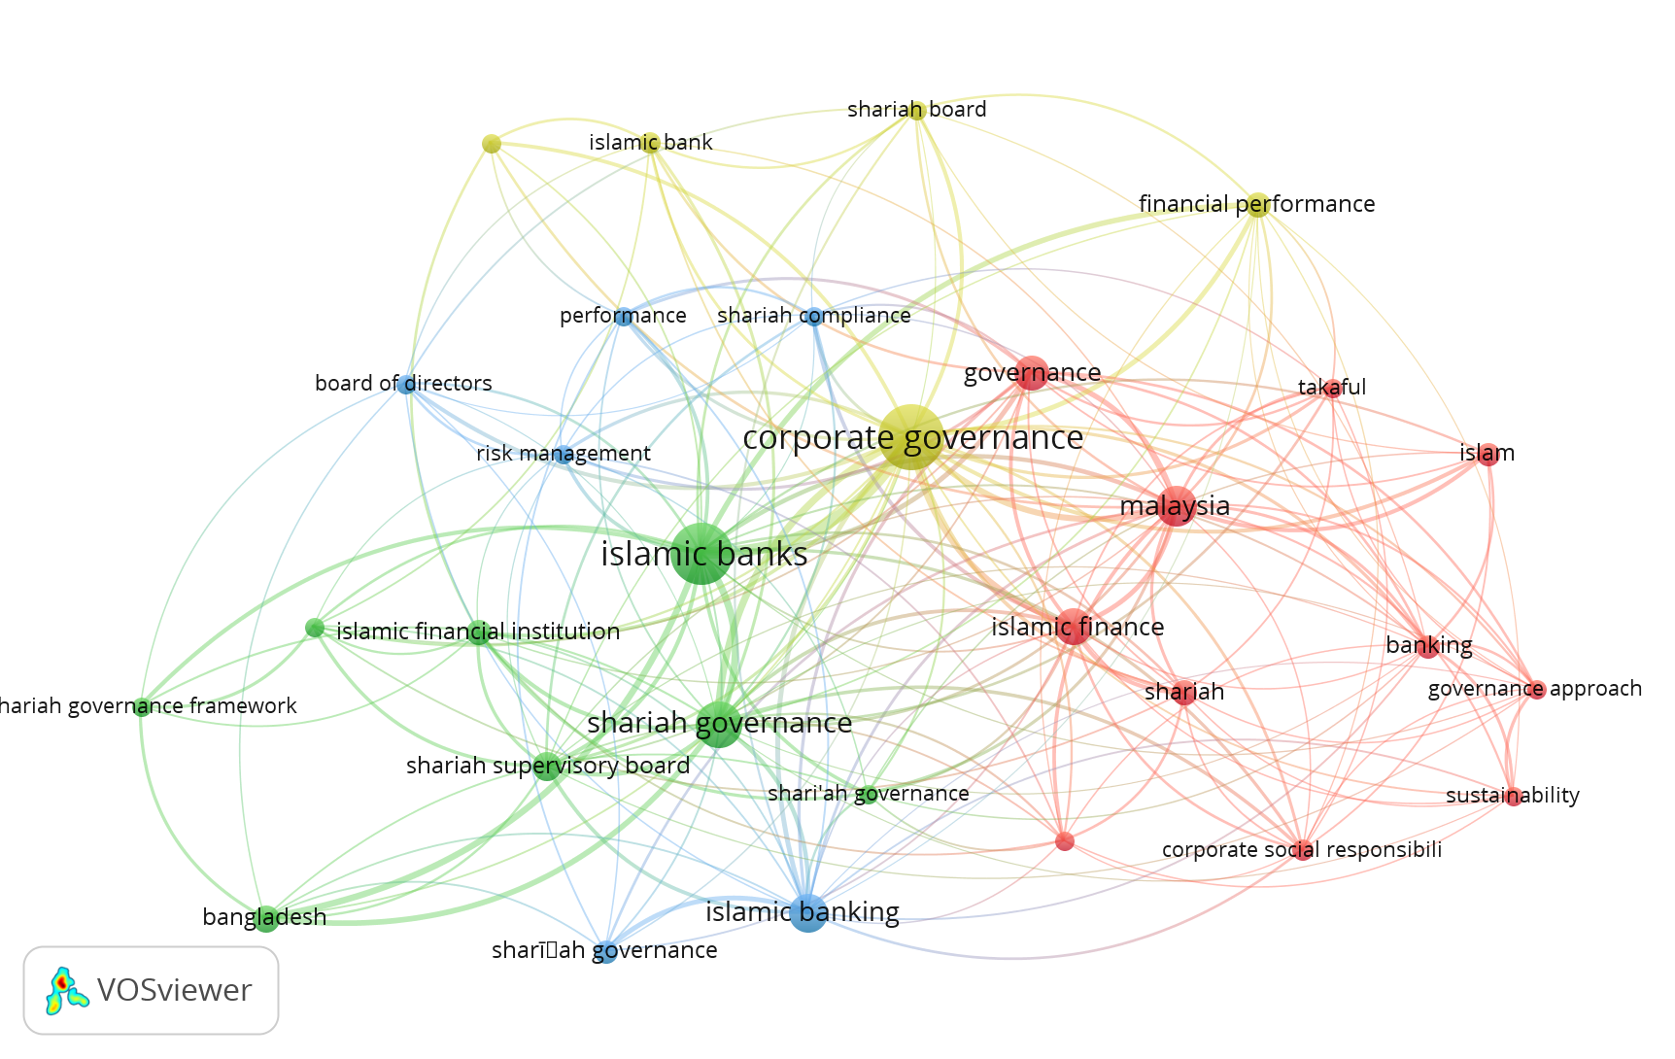
Figure 6. Keyword Co-Occurrence

Table 4. Occurrences and Total Link Strength of Top Keywords

No. | Keyword | Occurrences | Total link strength
Cluster 1: Structure of Sharia governance
1 | Bangladesh | 15 | 15
2 | Islamic banks | 81 | 63
3 | Islamic financial institutions | 14 | 11
4 | Shariah audit | 8 | 8
5 | Shari`ah governance | 12 | 7
6 | Shariah governance | 44 | 38
7 | Shariah governance framework | 8 | 7
8 | Shariah supervisory board | 19 | 16
Cluster 2: Sharia governance and Risk Management
1 | Board of directors | 8 | 7
2 | Islamic banking | 32 | 21
3 | Performance | 9 | 8
4 | Risk management | 9 | 8
5 | Shariah compliance | 8 | 8
6 | Sharīʿah governance | 12 | 7
Cluster 3: Sharia governance and sustainability
1 | Banking | 12 | 10
2 | Corporate social responsibility | 10 | 9
3 | Governance | 26 | 20
4 | Governance approach | 8 | 7
5 | Islam | 11 | 8
6 | Islamic finance | 30 | 21
7 | Malaysia | 34 | 34
8 | Shariah | 14 | 11
9 | Sustainability | 8 | 6
10 | Sustainable development | 9 | 8
11 | Takaful | 8 | 7
Cluster 4: The effect of Sharia governance toward firm’s financial performance
1 | Corporate governance | 90 | 72
2 | Financial performance | 14 | 12
3 | Islamic bank | 10 | 7
4 | Shariah board | 9 | 8
5 | Shari’ah governance | 8 | 6

- Research Streams and Future Research Direction

  - Research Streams
The first stream is structure of Sharia governance. Attached with a special function and regulation derived from Sharia principles, Islamic financial institutions need a set of governance structure which eventually distinct them from their conventional counterpart. However, in the absence of a well-conceptualized framework at the International regulatory level, Sharia governance structures are independently developed in line with respective countries’ needs and experiences. Several studies have attempted to introduce the special features of corporate governance practice in Islamic perspective (Alnasser & Muhammed, 2012; bin Abdulaziz Alaqil, 2019; Hasan, 2012; Mansour & Bhatti, 2018), while several others put their efforts to narratively present a thorough comparison among countries/regions (Grassa, 2013, 2015; Grassa & Matoussi, 2014; Hasan, 2011; Kasi & Muhammad, 2018; Saba, 2019). In this stream, GCC, Southeast Asian, and United Kingdom are among the most-widely investigated regions.
Pertaining to the distinct features of corporate governance from the standpoint of Islamic financial institutions, (Chapra & Ahmed, 2002) is found to be one of the earliest researchers highlighting the importance and distinction of corporate governance for Islamic banks in terms of the moral commitment embodied in the function of those charged with governance. As the discussion is being further developed by several studies (Alnasser & Muhammed, 2012; bin Abdulaziz Alaqil, 2019; Hasan, 2012; Mansour & Bhatti, 2018), a significant distinction to its conventional counterpart is gradually established over the time, which include the need of Shariah regulatory framework and some additional organs to execute Sharia compliance review such as Sharia Supervisory Board (SSB), Sharia audit, and Sharia risk management (Alnasser & Muhammed, 2012).
With this significance of Sharia governance, a number of studies are interested to investigate and compare the ongoing practices across geographical locations and documented varying approaches applied by these different countries/regions. As suggested by (Grassa, 2013; Saba, 2019), some countries opt for a greater involvement of regulatory authorities at both the national and the institutional level, while some others favour less involvement of regulatory authorities and have adopted a regulatory framework for Shariah governance merely at the institutional level. Meanwhile, the remaining countries (typically non-Muslim-dominant countries) prefer to not give any specific regulation for Shariah governance practices and leave it to the voluntary initiative of the IFIs and the influence from the market (Hasan, 2011). These findings led to the call upon the harmonization of Sharia governance regulatory framework at the multinational level.

Second stream discussed about Sharia governance and risk management. Sharia governance has been well-known as an efficient and useful tool for managing risks exposed by Islamic banking and finance sector which include asset quality management, operational risk, liquidity risk, credit risk, and Sharia risk. Among them, Sharia non-compliance risk (SNCR) becomes one of the most widely discussed, considering the unique nature and high importance of complying to Sharia principles for Islamic banks. However, there are mixed findings as to what extent the significant effect brought by Sharia governance structures including Sharia committee (SC) and Sharia Supervisory Boards (SSBs). Using a limited sample of Indonesia, (Mukhibad et al., 2022) found no association exists between SSB and SNCR. Conversely, with a broader sample of Southeast Asian Islamic banks, (Basiruddin & Ahmed, 2019) have proven that financial expertise and meeting frequency of Shariah committee could lower the risk.
On another side, other studies (Ginena, 2014; Hanefah et al., 2020; Sani & Abubakar, 2021) have attempted to conceptually develop a guideline/framework to help relevant stakeholders in understanding the definition, classification, and measurement of Sharia risk (Hanefah et al., 2020; Hassan, 2016); and further drew a conceptual link to the role of governance structure in Islamic bank and financial institutions (Ginena, 2014). Relatedly, (Sani & Abubakar, 2021) critically conceptualises a framework proposing the conduct of risk-based Sharia audit (RBSA) in Islamic financial institutions (IFIs).
Having a look at other risk-management issues, the inconclusive findings also appear on other empirical studies investigating credit risk, where the presence of SSB causes a higher credit risk is captured by (Aslam & Haron, 2021; Rosli et al., 2019) on OIC countries, but a lower credit risk is documented by (Safiullah & Shamsuddin, 2018) on 28 countries globally. Meanwhile, for the risk-taking behaviour in Islamic banks, some scholars demonstrated that SSB size positively affects risk-taking behaviour of Islamic banks leading to a higher return (Hassan et al., 2018) and/or greater efficiency (Ben Zeineb & Mensi, 2018; Safiullah & Shamsuddin, 2019), while (Prasojo et al.) advocated a positive moderating effect on the relationship between risk-taking and the performance of Islamic banks. These studies promote the compliance of Islamic banks toward AAOIFI’s requirement to have at least three members of SSB. In the same vein, other scholars also suggest the role of SSB in achieving better credit ratings disclosure (Elamer et al., 2021), enhanced operational risk disclosure (Neifar & Jarboui, 2018), higher liquidity risk (Aslam & Haron, 2021; Safiullah & Shamsuddin, 2018), and diminished insolvency risk (Safiullah & Shamsuddin, 2018).

Third stream draws a link between Sharia governance and sustainability. Interest in research of corporate governance and sustainability-related issues has been arose in all sectors including Islamic banking and finance. The review of existing literature in this field shows the dominance of Sharia governance in improving sustainability performance, highlighting a predominant focus on merely financial performance indicators (Jan et al., 2022; Mehreen et al., 2020; Yesuf & Aassouli, 2020) and/or Corporate Social Responsibility (CSR) disclosure index (Arsad et al., 2021; Farook et al., 2011; Gunardi et al., 2022; Khan, 2013; Ridwan & Mayapada, 2022; Sulub et al., 2018; Yadiat & Amrania, 2017; Yusoff et al., 2018; Zafar & Sulaiman, 2020). Some of these studies have empirically found that a specifically tailored corporate governance mechanism in Islamic banks (i.e. presence and monitoring role of Sharia supervisory boards) are evident to significantly enhance Islamic banks’ financial performance (Jan et al., 2022; Yesuf & Aassouli, 2020) as well as their CSR reporting (Farook et al., 2011; Gunardi et al., 2022).
However, a lack of consistent definition and measurement is found within the existing literature, which trigger other scholars to conceptually develop a link between Sharia governance and multi-faceted sustainability performance (A. Jan et al., 2021; A. A. Jan et al., 2021; Khan, 2019; Nasir et al., 2021). Several scholars (A. A. Jan et al., 2021; Nasir et al., 2021) have sought to draw a link between Sharia governance and various fundamental dimensions of Islamic banks (i.e. economic, social, and environmental aspects), while several others (A. Jan et al., 2021; Khan, 2019) have proposed the reform of Sharia governance of Islamic bank and its novel sustainability indicators for a better alignment with Sustainable Development Goals (SDGs).

Fourth stream investigated the effect of Sharia governance toward firm’s performance. Many scholars have uncovered an enormous effect of Sharia governance on the firm’s financial performance but a negligible effect on firm’s social and/or environmental performance. The existing literature have resulted in mixed findings on the relationship between various attributes of Sharia supervisory boards (SSBs) towards profitability and market performance of Islamic banks. While (Ajili & Bouri, 2018) found no significant effect of corporate governance index in GCC’s Islamic banks toward financial performance, (Nawaz, 2019) found a negative effect of SSB size on market performance in 47 banks globally. On contrary, other scholars (Alam et al., 2022; Aslam & Haron, 2020; Farag et al., 2018; Mollah & Zaman, 2015; Nomran & Haron, 2020) demonstrated a positive and significant effect of SSB attributes on both financial and market performance (i.e. Tobin’s Q, ROA, ROE). These varying results can be attributed by the different samples selected, different time period taken, and/or different measurement of each variable. For example, (Nawaz, 2019) developed an index by combining several attributes of SSB (existence, size, doctoral qualification, and financial expertise) with various attributes of Board of Directors and Audit Committee, while (Nomran & Haron, 2020) used a specific SSB characteristic (e.g. SSB size) as a single independent variable.
Relatedly, other studies further investigated various financial performance indicators such as quality of the reported earnings (Farooq & Abdelbari, 2015; Kolsi & Grassa, 2017; Quttainah et al., 2013; Wan Ismail et al., 2015) and credit ratings (Grassa, 2016). Investigating Sharia-compliant companies in MENA and Malaysia respectively, (Farooq & Abdelbari, 2015) and (Wan Ismail et al., 2015) captured a lower earnings management leading to a higher quality of reported earnings due to their Shariah status and screening pressure by regulators and institutional investors. Likewise, in Islamic banks, (Quttainah et al., 2013) also found that Islamic banks with will less likely do earnings management. Furthermore, (Kolsi & Grassa, 2017) documented that SSB size negatively affects earnings management. This inverse relationship is also found by (Grassa, 2016) while examining the effect of supervisory role of Sharia board towards credit ratings.

  - Research Gap and Direction for Future Research

After performing a content analysis of the selected literature, in Table 7, the authors present 26 future research questions classified into several sub-streams under 4 (four) major streams as have been identified earlier.

Table 7. Research Gap and Future Research Direction
Major Streams | Sub-streams | Future Research Questions | Source
Structure of Sharia governance | Introduction to corporate governance in Islamic financial institutions | - The majority of studies are merely descriptive. Future studies could provide an empirical evidence on this. | Authors’ review
 | A diverse range of Sharia governance practices across countries | - Many studies documented the differences, but could not conclude which system is better to be set as the best practice | Authors’ review
 |  | - What are the effects of unique characteristics in regulations, laws, and regulatory frameworks in other countries toward the structure of governance in Islamic banks? | (Grassa & Matoussi, 2014)
 |  | - Do we need a harmonized regulation at the international level? Is it better to be different or should all be the same? | (Grassa, 2013)
 |  | - How to develop a comprehensive regulatory framework governing SSB attributes and Shariah practices? | (Grassa, 2013)
 |  | - What is the effect of different Sharia governance practices at country level toward their Islamic banks’ performance? | (Hasan, 2011)
Sharia governance and risk management | The role of other governance mechanisms in managing the risk | - How is the role of other governance mechanisms in Islamic banks such as religious audit and religious risk management in influencing the decisions of SBs? | (Haridan et al., 2018)
 |  | - How is the importance of cultural and institutional variables in achieving the effectiveness of Sharia boards? | (Haridan et al., 2018)
 |  | - There is a need to carry out further research to extend our study and explore more on the roles that Shariah bodies play in governance and other effective characteristics of board and SCs (Sharia committees). | (Basiruddin & Ahmed, 2019)
 | Measurement of Sharia Non-Compliance Risk (SNCR) | - Many studies used non-halal income as an indicator for SNCR, although it can be used for social activities as suggested by relevant authorities. Future researchers could develop other related indicators to measure it. | (Mukhibad et al., 2022)
 |  | - As some companies have their own Shariah audit procedures and programmes for purifying Sharia Non-Compliance Income, a deeper study on this issue would be fruitful. | (Hanefah et al., 2020)
Sharia governance and sustainability | The reform of Sharia governance to achieve sustainability | - Several studies conceptually proposed regulatory reform of Islamic finance including their Sharia governance structure and practice, future studies could critically examine and further support with necessary action/initiative, otherwise provide the alternatives. | (Khan, 2013)
 | Constructing a representative sustainability index | - Could develop a sustainability index linked with the concept of maqashid sharia | (Aliyu et al., 2017)
 |  | - Integrate the sustainability index based on SDGs and maqashid sharia, and how Sharia governance could play role on achieving the common goal between them | Authors’ review
 |  | - Future studies have the opportunities to assess the banking sustainability in relation to the business performance of the clients of the banks/other stakeholder’s interest | (Aliyu et al., 2017)
 | Sustainability after covid-19 pandemic | - Survival and the effects of Islamic banks’ governance decisions can be assessed during and after the lifespan of the banks, particularly after the crisis resulted from the Covid-19 pandemic | Authors’ review & (Aliyu et al., 2017)
The effect of Sharia governance toward firm’s performance | The effect of Sharia Supervisory Board (SSB) | - In investigating the role of Sharia supervisory board, future studies could extend some other attributes of SSB such as SSB remuneration, gender diversity, and others | (Ajili & Bouri, 2018; Mollah & Zaman, 2015)
 |  | - Several studies have empirically demonstrated a positive effect of SSB size toward Islamic banks’ performance, however it is possible that there is an upper limit to this benefit. Hence, future studies could provide an empirical analysis regarding the optimal SSB size of the Islamic banks | (Almutairi & Quttainah, 2017)
 |  | - Future research should give more attention regarding the impact of the SSB educational qualification on the Ibs’ performance by taking into account the different PhD degree fields (majority having PhD in Shariah and Law, instead of Accounting & Finance | (Almutairi & Quttainah, 2017)
 |  | - Further research could explore more about the nature, operation, and effects of Sharia boards and their contribution to the governance and accountability of Islamic financial institutions. | (Mollah & Zaman, 2015)
 | Measurement of firm performance | - Most of studies employed several accounting-based measures of financial performance which may not accurately portray Islamic bank’s performance. Hence, other measures (i.e. earnings quality) could be considered | Authors’ review; (Almutairi & Quttainah, 2017)
 |  | - As Islamic banks should not be merely financial-oriented, other dimensions of performance (i.e environmental performance) could provide insightful discussion | Authors’ review
 | Sharia governance indicators | - Instead of using certain attribute of Sharia board as a single variable, future studies could employ a set of indicators using a weighted method to construct Sharia governance index | Authors’ review; (Ajili & Bouri, 2018)
 |  | - Future research can be carried out by incorporating the external Corporate Governance mechanism for a more comprehensive insight | (Aslam & Haron, 2020)
 | Sharia governance on firm’s financial performance | - As the majority of studies focusing on Islamic banks, future studies could extend to other Islamic financial institutions (e.g. Islamic microfinance, takaful, mutual fund) | (Aslam & Haron, 2020)
 |  | - Considering the mixed findings, further studies could employ a larger data set and compare across multiple jurisdictions to generate a stronger result | (Farook et al., 2011)

- Conclusion

Considering the crucial role of a system to ensure and preserve the quality of Sharia compliance, the issues related to Sharia governance have drawn attention from many scholars around the world, including those Western Muslim-minority countries (United Kingdom, United States of America, and France). This hybrid review of these relevant literatures has advocated that Sharia governance is a an increasingly important subject to protect the interest of all stakeholders for any corporations adhering to Islamic principles. This study yielded three main contributions to the growing body of knowledge of Sharia governance.
Firstly, this study reveals that Malaysia and its research and education centre have the most influence on the growth of sharia governance literature. Furthermore, it also displays the research collaboration patterns between the countries, which benefits junior scholars in sharia governance by fostering research collaboration and increasing the quantity and quality of future research. The outcome demonstrates that Malaysia has become the global hub for constructing a high-quality research network. However, intriguingly, non-Muslim-dominant countries such as the United Kingdom, Australia, and the United States also provide opportunities for research collaboration.
Secondly, this study identified three streams of research and discussed their progress as well as contributions. The four streams are (i) the structure of Sharia governance, (ii) Sharia governance and risk management, (iii) Sharia governance and sustainability, and (iv) the effect of Sharia governance and firm’s performance. Thirdly, this study also identifies several gaps in each cluster of current literature and present several suggestions/recommendations for future research. This study highlights the need for developing a well-harmonised framework for Sharia governance at the international level, in order to further construct a robust measurement for the implementation of Sharia governance across jurisdictions. Lastly, considering a massive growth of other non-banking sectors in Islamic finance industry, the discussion of Sharia governance need to be extended to other types of Islamic financial institutions such as Islamic microfinance, Islamic capital market, takaful, mutual fund, and others.

References

Ahmid, A. F. (2019). Bibliometric analysis of PhD dissertations written in Islamic banking and finance in the United Kingdom. İslam Ekonomisi ve Finansı Dergisi (İEFD), 5(1), 63-91.
Ajili, H., & Bouri, A. (2018). Corporate governance quality of Islamic banks: measurement and effect on financial performance. International Journal of Islamic and Middle Eastern Finance and Management, 11(3), 470-487. https://doi.org/10.1108/IMEFM-05-2017-0131
Alam, M. K., Rahman, M. M., Runy, M. K., Adedeji, B. S., & Hassan, M. F. (2022). The influences of Shariah governance mechanisms on Islamic banks performance and Shariah compliance quality. Asian Journal of Accounting Research, 7(1), 2-16. https://doi.org/10.1108/ajar-11-2020-0112
Aliyu, S., Hassan, M. K., Mohd Yusof, R., & Naiimi, N. (2017). Islamic Banking Sustainability: A Review of Literature and Directions for Future Research [Article]. Emerging Markets Finance & Trade, 53(2), 440-470. https://doi.org/10.1080/1540496X.2016.1262761
Almutairi, A. R., & Quttainah, M. A. (2017). Corporate governance: evidence from Islamic banks. Social Responsibility Journal, 13(3), 601-624. https://doi.org/10.1108/srj-05-2016-0061
Alnabsha, A., Abdou, H. A., Ntim, C. G., & Elamer, A. A. (2018). Corporate boards, ownership structures and corporate disclosures. Journal of Applied Accounting Research, 19(1), 20-41. https://doi.org/10.1108/jaar-01-2016-0001
Alnasser, S. A. S., & Muhammed, J. (2012). Introduction to corporate governance from Islamic perspective. Humanomics.
Alshater, M. M., Hassan, M. K., Khan, A., & Saba, I. (2021). Influential and intellectual structure of Islamic finance: a bibliometric review. International Journal of Islamic and Middle Eastern Finance and Management, 14(2), 339-365. https://doi.org/10.1108/IMEFM-08-2020-0419
Alshater, M. M., Hassan, M. K., Rashid, M., & Hasan, R. (2021). A bibliometric review of the Waqf literature. Eurasian Economic Review, 12(2), 213-239. https://doi.org/10.1007/s40822-021-00183-4
Alshater, M. M., Hassan, M. K., Sarea, A., & Samhan, H. M. (2022). Islamic accounting research between 1982 and 2020: a hybrid review. Journal of Islamic Accounting and Business Research(ahead-of-print).
Alshater, M. M., Saad, R. A. J., Wahab, N. A., & Saba, I. (2021). What do we know about zakat literature? A bibliometric review. Journal of Islamic Accounting and Business Research, 12(4), 544-563.
Arsad, S., Said, R., Yusoff, H., & Ahmad, R. (2021). Corporate Governance and Islamic Corporate Social Responsibility Disclosures: Shari’ah Compliant Companies in Malaysia. Estudios De Economia Aplicada, 39(10), 35.
Aslam, E., & Haron, R. (2020). Does corporate governance affect the performance of Islamic banks? New insight into Islamic countries. Corporate Governance: The international journal of business in society, 20(6), 1073-1090. https://doi.org/10.1108/cg-11-2019-0350
Aslam, E., & Haron, R. (2021). Corporate governance and risk-taking of Islamic banks: evidence from OIC countries. Corporate Governance: The international journal of business in society, 21(7), 1460-1474. https://doi.org/10.1108/cg-08-2020-0311
Basiruddin, R., & Ahmed, H. (2019). Corporate governance and Shariah non-compliant risk in Islamic banks: evidence from Southeast Asia. Corporate Governance: The international journal of business in society, 20(2), 240-262. https://doi.org/10.1108/cg-05-2019-0138
Ben Zeineb, G., & Mensi, S. (2018). Corporate governance, risk and efficiency: evidence from GCC Islamic banks. Managerial Finance, 44(5), 551-569. https://doi.org/10.1108/mf-05-2017-0186
bin Abdulaziz Alaqil, A. (2019). Islamic Shari’ah and the Principles of Corporate Governance: An Introduction. In Research in Corporate and Shari’ah Governance in the Muslim World: Theory and Practice. Emerald Publishing Limited.
Chapra, M. U., & Ahmed, H. (2002). Corporate governance in Islamic financial institutions.
Durán-Sánchez, A., Del Río-Rama, M. d. l. C., Álvarez-García, J., & García-Vélez, D. F. (2019). Mapping of scientific coverage on education for Entrepreneurship in Higher Education. Journal of Enterprising Communities: People and Places in the Global Economy, 13(1/2), 84-104. https://doi.org/10.1108/JEC-10-2018-0072
Durisin, B., & Puzone, F. (2009). Maturation of Corporate Governance Research, 1993-2007: An Assessment. Corporate Governance: An International Review, 17(3), 266-291. https://doi.org/10.1111/j.1467-8683.2009.00739.x
Elamer, A. A., Ntim, C. G., Abdou, H. A., Owusu, A., Elmagrhi, M., & Ibrahim, A. E. A. (2021). Are bank risk disclosures informative? Evidence from debt markets. International Journal of Finance & Economics, 26(1), 1270-1298. https://doi.org/10.1002/ijfe.1849
Elasrag, H. (2014). Corporate governance in Islamic Finance: Basic concepts and issues. Available at SSRN 2442014.
Farag, H., Mallin, C., & Ow-Yong, K. (2018). Corporate governance in Islamic banks: New insights for dual board structure and agency relationships. Journal of International Financial Markets, Institutions and Money, 54, 59-77. https://doi.org/10.1016/j.intfin.2017.08.002
Farook, S., Kabir Hassan, M., & Lanis, R. (2011). Determinants of corporate social responsibility disclosure: the case of Islamic banks. Journal of Islamic Accounting and Business Research, 2(2), 114-141. https://doi.org/10.1108/17590811111170539
Farooq, O., & Abdelbari, A. (2015). Earnings management behaviour of Shariah-compliant firms and non-Shariah-compliant firms. Journal of Islamic Accounting and Business Research, 6(2), 173-188. https://doi.org/10.1108/jiabr-07-2013-0021
Ginena, K. (2014). Sharī‘ah risk and corporate governance of Islamic banks. Corporate Governance, 14(1), 86-103. https://doi.org/10.1108/cg-03-2013-0038
Grassa, R. (2013). Shariah supervisory system in Islamic financial institutions. Humanomics, 29(4), 333-348. https://doi.org/10.1108/h-01-2013-0001
Grassa, R. (2015). Shariah supervisory systems in Islamic finance institutions across the OIC member countries. Journal of Financial Regulation and Compliance, 23(2), 135-160. https://doi.org/10.1108/jfrc-02-2014-0011
Grassa, R. (2016). Corporate governance and credit rating in Islamic banks: Does Shariah governance matters? Journal of Management & Governance, 20(4), 875-906. https://doi.org/10.1007/s10997-015-9322-4
Grassa, R., Chakroun, R., & Hussainey, K. (2018). Corporate governance and Islamic banks’ products and services disclosure. Accounting Research Journal, 31(1), 75-89. https://doi.org/10.1108/arj-09-2016-0109
Grassa, R., & Matoussi, H. (2014). Corporate governance of Islamic banks. International Journal of Islamic and Middle Eastern Finance and Management, 7(3), 346-362. https://doi.org/10.1108/imefm-01-2013-0001
Gunardi, A., Herwany, A., Febrian, E., & Anwar, M. (2022). Research on Islamic corporate social responsibility and Islamic bank disclosures. Journal of Sustainable Finance & Investment, 12(4), 1308-1329.
Hanefah, M. M., Kamaruddin, M. I. H., Salleh, S., Shafii, Z., & Zakaria, N. (2020). Internal control, risk and Sharīʿah non-compliant income in Islamic financial institutions. ISRA International Journal of Islamic Finance, 12(3), 401-417. https://doi.org/10.1108/ijif-02-2019-0025
Haridan, N. M., Hassan, A. F. S., & Karbhari, Y. (2018). Governance, religious assurance and Islamic banks: Do Shariah boards effectively serve? Journal of Management and Governance, 22(4), 1015-1043. https://doi.org/10.1007/s10997-018-9418-8
Hasan, Z. (2011). A survey on Shari'ah governance practices in Malaysia, GCC countries and the UK. International Journal of Islamic and Middle Eastern Finance and Management, 4(1), 30-51. https://doi.org/10.1108/17538391111122195
Hasan, Z. (2012). Shari'ah Governance in Islamic banks. Edinburgh University Press.
Hassan, M. K., Alshater, M. M., Hasan, R., & Bhuiyan, A. B. (2021). Islamic microfinance: A bibliometric review. Global Finance Journal, 49, 100651.
Hassan, M. K., Miglietta, F., Paltrinieri, A., & Floreani, J. (2018). The effects of Shariah board composition on Islamic equity indices' performance. Business Ethics: A European Review, 27(3), 248-259. https://doi.org/10.1111/beer.12185
Hassan, R. (2016). Shariah non-compliance risk and its effects on islamic financial institutions. Al-Shajarah: Journal of the International Institute of Islamic Thought and Civilization (ISTAC), 21(3).
Jan, A., Mata, M. N., Albinsson, P. A., Martins, J. M., Hassan, R. B., & Mata, P. N. (2021). Alignment of islamic banking sustainability indicators with sustainable development goals: Policy recommendations for addressing the covid-19 pandemic. Sustainability, 13(5), 2607.
Jan, A. A., Lai, F.-W., Draz, M. U., Tahir, M., Ali, S. E. A., Zahid, M., & Shad, M. K. (2022). Integrating sustainability practices into islamic corporate governance for sustainable firm performance: from the lens of agency and stakeholder theories. Quality & Quantity, 56(5), 2989-3012. https://doi.org/10.1007/s11135-021-01261-0
Jan, A. A., Lai, F.-W., & Tahir, M. (2021). Developing an Islamic Corporate Governance framework to examine sustainability performance in Islamic Banks and Financial Institutions. Journal of Cleaner Production, 315, 128099.
Kasi, U., & Muhammad, J. (2018). Design, qualification and Shariah governance of stock screening methodologies in selected Gulf Cooperation Council (GCC) countries in comparison with the United States. Qualitative Research in Financial Markets, 10(2), 189-209. https://doi.org/10.1108/qrfm-04-2017-0039
Khan, A., Hassan, M. K., Paltrinieri, A., Dreassi, A., & Bahoo, S. (2020). A bibliometric review of takaful literature. International Review of Economics & Finance, 69, 389-405.
Khan, M. M. (2013). Developing a conceptual framework to appraise the corporate social responsibility performance of Islamic banking and finance institutions. Accounting and the Public Interest, 13(1), 191-207.
Khan, T. (2019). Reforming Islamic Finance for Achieving Sustainable Development Goals. journal of king Abdulaziz University Islamic Economics, 32(1), 3-21. https://doi.org/10.4197/Islec.32-1.1
Kolsi, M. C., & Grassa, R. (2017). Did corporate governance mechanisms affect earnings management? Further evidence from GCC Islamic banks. International Journal of Islamic and Middle Eastern Finance and Management, 10(1), 2-23. https://doi.org/10.1108/IMEFM-07-2015-0076
Mansour, W., & Bhatti, M. I. (2018). The new paradigm of Islamic corporate governance. Managerial Finance, 44(5), 513-523. https://doi.org/10.1108/mf-01-2018-0043
Mehreen, M., Marimuthu, M., Karim, S., & Jan, A. (2020). Proposing a Multidimensional Bankruptcy Prediction Model: An Approach for Sustainable Islamic Banking. Sustainability, 12(8), 3226. https://doi.org/10.3390/su12083226
Mollah, S., & Zaman, M. (2015). Shari’ah supervision, corporate governance and performance: Conventional vs. Islamic banks. Journal of Banking & Finance, 58, 418-435. https://doi.org/10.1016/j.jbankfin.2015.04.030
Mukhibad, H., Nurkhin, A., Waluyo Jati, K., & Yudo Jayanto, P. (2022). Corporate governance and Islamic law compliance risk. Cogent Economics & Finance, 10(1), 2111057. https://doi.org/10.1080/23322039.2022.2111057
Narayan, P. K., & Phan, D. (2019). A survey of Islamic banking and finance literature: Issues, challenges and future directions. Pacific-Basin Finance Journal, 53(C), 484-496. https://EconPapers.repec.org/RePEc:eee:pacfin:v:53:y:2019:i:c:p:484-496
Nasir, N. M., Nair, M. S., & Ahmed, P. K. (2021). Institutional isomorphism and environmental sustainability: a new framework from the Shariah perspective. Environment, Development and Sustainability, 23(9), 13555-13568. https://doi.org/10.1007/s10668-021-01227-0
Nawaz, T. (2019). Exploring the Nexus Between Human Capital, Corporate Governance and Performance: Evidence from Islamic Banks. Journal of Business Ethics, 157(2), 567-587. https://doi.org/10.1007/s10551-017-3694-0
Neifar, S., & Jarboui, A. (2018). Corporate governance and operational risk voluntary disclosure: Evidence from Islamic banks. Research in International Business and Finance, 46, 43-54. https://doi.org/https://doi.org/10.1016/j.ribaf.2017.09.006
Nomran, N. M., & Haron, R. (2020). Shari’ah supervisory board’s size impact on performance in the Islamic banking industry. Journal of Islamic Accounting and Business Research, 11(1), 110-129. https://doi.org/10.1108/jiabr-05-2017-0070
Ntim, C. G. (2013). An Integrated Corporate Governance Framework and Financial Performance in South African-Listed Corporations. South African Journal of Economics, 81(3), 373-392. https://doi.org/10.1111/j.1813-6982.2011.01316.x
OECD. (2004). OECD Principles of Corporate Governance.
Paltrinieri, A., Hassan, M. K., Bahoo, S., & Khan, A. (2019). A bibliometric review of sukuk literature. International Review of Economics & Finance. https://doi.org/https://doi.org/10.1016/j.iref.2019.04.004
Prasojo, P., Yadiati, W., Fitrijanti, T., & Sueb, M. (2022). Do Risk-Taking and Shariah Governance Have a Relationship with Maqasid Shariah-Based Performance? Global Review of Islamic Economics and Business, 10(1).
Quttainah, M. A., Song, L., & Wu, Q. (2013). Do Islamic Banks Employ Less Earnings Management? Journal of International Financial Management & Accounting, 24(3), 203-233. https://doi.org/10.1111/jifm.12011
Ridwan, R., & Mayapada, A. G. (2022). Does sharia governance influence corporate social responsibility disclosure in Indonesia Islamic banks? Journal of Sustainable Finance & Investment, 12(2), 299-318. https://doi.org/10.1080/20430795.2020.1749819
Rosli, N. F., Abdul-Rahman, A., & Amin, S. I. M. (2019). Credit Risk Determinants: A Systematic Review for Islamic and Conventional Banks. International Journal of Business & Management Science, 9(3).
Saba, I. (2019). Shari’ah Governance Framework in Different Jurisdictions. In Research in Corporate and Shari’ah Governance in the Muslim World: Theory and Practice. Emerald Publishing Limited.
Safiullah, M., & Shamsuddin, A. (2018). Risk in Islamic banking and corporate governance. Pacific-Basin Finance Journal, 47, 129-149.
Safiullah, M., & Shamsuddin, A. (2019). Risk-adjusted efficiency and corporate governance: Evidence from Islamic and conventional banks. Journal of Corporate Finance, 55, 105-140. https://doi.org/https://doi.org/10.1016/j.jcorpfin.2018.08.009
Sani, S. D., & Abubakar, M. (2021). A proposed framework for implementing risk-based Shari’ah audit. Journal of Financial Reporting and Accounting, 19(3), 349-368. https://doi.org/10.1108/jfra-02-2020-0041
Sulub, S. A., Salleh, Z., & Hashim, H. A. (2018). A review of corporate governance and corporate social responsibility disclosure of Islamic banks: A call for additional transparency. Journal of Sustainability Science and Management, 4, 147-158.
Thomsen, S., & Pedersen, T. (2000). Ownership Structure and Economic Performance in the Largest European Companies. Strategic Management Journal, 21(6), 689-705. http://www.jstor.org/stable/3094306
Thomson Reuters. (2021). Islamic Finance Development Report 2021.
Wan Ismail, W. A., Kamarudin, K. A., & Sarman, S. R. (2015). The quality of earnings in Shariah-compliant companies: evidence from Malaysia. Journal of Islamic Accounting and Business Research, 6(1), 19-41. https://doi.org/10.1108/jiabr-03-2013-0005
Yadiat, G., & Amrania, G. (2017). The effect of Islamic corporate governance (icg) and Islamic corporate social responsibility (icsr) disclosures on market discipline with financial performance used as intervening variables (empirical study on shariah based banks operating in qismut count. Int. J. Appl. Bus. Econ. Res, 15(24), 119-141.
Yesuf, A. J., & Aassouli, D. (2020). Exploring synergies and performance evaluation between Islamic funds and socially responsible investment (SRIs) in light of the Sustainable Development Goals (SDGs). Heliyon, 6(8), e04562. https://doi.org/10.1016/j.heliyon.2020.e04562
Yusoff, H., Azhari, N. K. M., & Darus, F. (2018). Effects of financial performance and governance on corporate social responsibility disclosure: Evidence from Islamic financial institutions in Malaysia. Global Journal Al-Thaqafah, 8(1), 57-72.
Zafar, M. B., & Sulaiman, A. A. (2020). Measuring corporate social responsibility in Islamic banking: what matters? International Journal of Islamic and Middle Eastern Finance and Management, 13(3), 357-388. https://doi.org/10.1108/IMEFM-05-2019-0227

