EXAMINING USABILITY, ACCEPTABILITY AND ADOPTION OF A SELF-DIRECTED, TECHNOLOGY-BASED INTERVENTION FOR UPPER LIMB REHABILITATION AMONGST STROKE SURVIVORS: A FEASIBILITY STUDY
Authors: Michelle Broderick^{1*}, Robert O’Shea², Jane Burridge PhD³, Sara Demain PhD³, Louise Johnson PhD³, Paul Bentley PhD¹
*Corresponding author

Affiliations:
1 Department of Brain Sciences, Imperial College London, Charing Cross Hospital Campus, Fulham Palace Rd, London, W6 8RF, UK
2 School of Biomedical Engineering & Imaging Sciences, Kings College London, Becket House, SE1 7EU, UK
3 School of Health Sciences, University of Southampton, Southampton SO17 1BJ, UK

Corresponding Author:
E-mail: m.broderick19@ic.ac.uk
Address: 10th Floor Lab Room 10L22, Imperial College London, Charing Cross Hospital
Campus, Fulham Palace Rd, London, W6 8RF, UK
Tel: 07716027824
ORCID ID: 0000-0002-8644-3739

Total number of tables and figures: Tables 1, 2, 3, 4 Figures 1, 2, 3, 4
Appendices: 1
Abstract Word Count: 402 words
Text Body Word Count: 3,913 words
References: 75 references
Attachments: Response to editor and reviewers, letter to the editor

Background: Upper limb (UL) recovery after stroke is strongly dependent upon rehabilitation dose. Rehabilitation technologies present pragmatic solutions to dose enhancement, complementing therapeutic activity within conventional rehabilitation, connecting clinicians with patients remotely and empowering patients to drive their own recovery. To date, rehabilitation technologies have been poorly adopted. Understanding the barriers to adoption may shape strategies to enhance technology use, and therefore increase rehabilitation dose, thus optimising recovery potential. We examined usability, acceptability and adoption of a self-directed, exercise-gaming technology within a heterogeneous stroke survivor cohort, and investigated how stroke survivor characteristics, technology usability, and attitudes towards technology influenced adoption. Methods: A feasibility study of a novel exercise-gaming technology for self-directed UL rehabilitation in early subacute stroke survivors (n=30) was conducted in an inpatient, acute hospital setting. Demographic and clinical characteristics were recorded, participants’ performance in using the system (usability) was assessed using a 4-point performance rating scale (adapted from the Barthel Index) and adherence with the system was electronically logged throughout the trial. The Technology Acceptance Model (TAM) was used to formulate a survey examining the acceptability of the system. Spearman’s rank correlations were used to examine associations between participant characteristics, user performance (usability), end-point technology acceptance and intervention adherence (adoption). Results: The technology was usable for 87% of participants and the overall technology acceptance rating was 68% (95% CI: 56-79%). Participants trained with the device for a median of 26 minutes daily (IQR: 16-31), over an enrolment period of 8 days (IQR: 5-14). Technology adoption positively correlated with user performance (usability)($ρ$=0.55, 95% CI: [0.23, 0.75], P=.007) and acceptability: domains of perceived usefulness ($ρ$=0.42, 95%CI: [ 0.09, 0.68] P=.03) and perceived ease of use ($ρ$=0.46, 95% CI: [ 0.10, 0.74] P=.02). Technology acceptance decreased with increased global stroke severity ($ρ$= -0.56, 95% CI: [-0.79, -0.22] P= .007). Conclusion: This technology was usable and acceptable for the majority of the cohort, intervention dose of technology-facilitated, self-directed UL training exceeded conventional care norms. Technology usability and acceptability were determinants of adoption and appear to be mediated by stroke severity. The results demonstrate the importance of selecting technologies for stroke survivors on the basis of individual needs and abilities, as well as optimising the accessibility of technologies for the target user group. Facilitating changes in stroke survivors’ beliefs and attitudes towards rehabilitation technologies may enhance adoption. Further work is needed to understand how technology can be optimised to benefit those with more severe stroke.

Background
Stroke rehabilitation outcomes are strongly influenced by dose, or amount, of rehabilitation [1–5]. Rehabilitation dose in conventional clinical practice is insufficient for meaningful improvements in upper limb (UL) outcomes[6]. Increasing dose presents organisational and individual challenges[7,8]; digital technologies may offer a solution to this[9–13]. Technologies have the potential to complement therapeutic activity within conventional rehabilitation, connect clinicians with patients remotely and empower patients to drive their own recovery, reducing the burden on rehabilitation services, overcoming regional resource disparities and increasing access to rehabilitation [14].
Rehabilitation technologies often encompass behaviour change concepts which serve to optimise user engagement (goals and planning, feedback and monitoring, repetition and substitution, comparison of outcomes, reward and threat)[15], as well as features and components which enhance conditions for motor re-learning[16]. These features include enriched, multisensorial stimulation, opportunities for massed practice that is variable, task-specific and goal-oriented, real-time and longitudinal performance, results feedback, increasing difficulty and adjusting to each user’s unique and changing needs/abilities. In this work, we focus on self-directed rehabilitation technologies, which enable users to complete >50% of training independently [17], allowing for formal or informal support for intervention components such as obtaining and setting up equipment, charging electrical devices etc. Self- directed technology-based interventions are of particular interest due to the potential resource efficiency; bolstering the ability of stroke survivors to engage in rehabilitation activities with minimal professional support, thus presenting a pragmatic solution to dose enhancement and facilitating increased access to rehabilitation across the stroke recovery pathway.

While rehabilitation technology research has become increasingly prevalent in line with technological innovations in this field [18], clinical adoption remains poor [19,20]. Perceived barriers and facilitators to adoption of stroke rehabilitation technologies have been proposed [20,21,30,31,22–29], influencing technology design in terms of accessibility, reliability, adaptability and clinical utility [27,32–40]. Previous research focuses on design features of the devices, whereas the influence of stroke survivor characteristics, the usability of technologies, and users’ attitudes and beliefs about rehabilitation technologies are poorly understood [41], limiting clinical interpretation and generalisability[42]. Moreover, most previous studies of technology adoption are based in research environments with high levels of support and supervision, rather than in unsupervised, natural environments, where stroke survivors spend the majority of their time [43–46].

Technology usability (or user performance) refers to a measure of how well a specific user, in a specific context, can use a technology to achieve a defined goal, effectively and efficiently[47]. Usability is a key theme presented in qualitative literature examining stroke survivors’ and clinicians’ perceptions and experiences of rehabilitation technologies [26,48]. Usability is also central in the design of rehabilitation technologies, however usability outcomes are rarely reported within clinical trials[47]. Technology acceptance refers to the user's willingness to employ a technology for its intended use. It is widely considered as a pre-adoption stage and also has value in predicting adoption [49]. Like usability, technology acceptability is thought to be associated with specific stroke survivor characteristics including age, sex, previous experience with technology, available support and time since stroke [50]. The Technology Acceptance Model (TAM) [51] proposes that acceptability is determined by two main factors: perceived ease of use and perceived usefulness [51]. Perceived ease of use refers to the degree to which a person believes that the use of a system will be effortless, whilst perceived usefulness refers to the degree to which a person believes that the use of a system will be advantageous to them[51]. The easier the use of a system is perceived to be, the higher the probability that a person experiences the system as useful, and subsequently is willing to use it [51] (See Figure 1.)

Figure 1. Technology Acceptance Model [51].
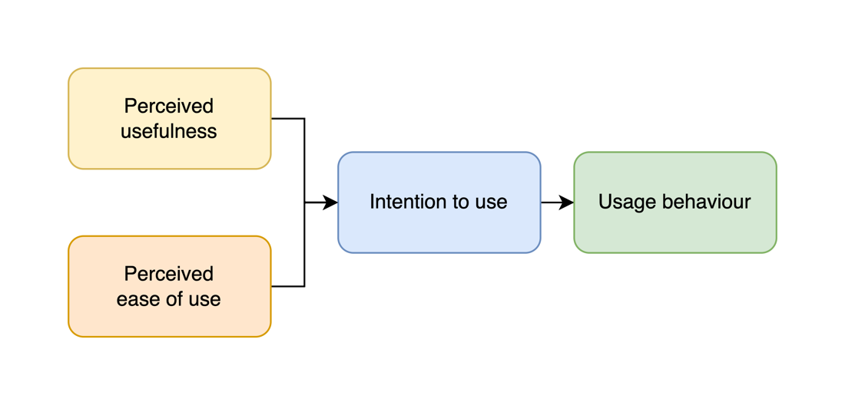
The TAM has been frequently adapted to understand acceptance of healthcare technologies amongst clinicians [52–57]. Perceived ease of use and perceived usefulness have been strongly associated with adoption of telemedicine platforms in a stroke context [58]. Different factors are reported as important in predicting technology acceptance amongst different professional stakeholders [58], for example, within telemedicine trials, perceived ease of use was found to be more important to non-nurses (radiologists, physicians, allied healthcare professionals) and perceived usefulness was more important to nurses. Perceived usefulness of telemedicine services is a major factor explaining adoption by clinicians [59]. Only a small number of studies [60,61] have applied the TAM to examine stroke survivors’ acceptance of UL rehabilitation technology (interactive gaming and mobile rehabilitation applications), however, these studies do not evaluate real world adoption, or consider stroke survivor characteristics. This study evaluates how real-world adoption, in absence of close professional support, relates to acceptance, usability and participant characteristics.

Methods

Ethics
The study was approved by the UK National Research Ethics Service (Ref: 78462). All participants gave informed written consent prior to recruitment.

Study design
Questionnaire survey of stroke survivors enrolled in a prospective, non-randomised feasibility study of an adapted UL rehabilitation system for self-directed rehabilitation.

Aims
To explore usability, acceptability and adoption of a low cost, self-directed, exercise-gaming technology, while examining the impact of relevant user demographics and clinical variables, within a heterogeneous stroke survivor cohort (See Appendix 1. for diagrammatic representation this working theory/hypothesis in the form of a logic model). Research feasibility results are discussed in a separate publication [62].

Patient population
Participants were a convenience sample of inpatient, early sub-acute stroke survivors (n=30) on hyper-acute or acute stroke units at a single centre, presenting with new UL weakness (of any severity) and able to provide informed consent. Those with uncompensated visual deficits, unremitting UL pain, or significant language or communication difficulties were excluded. Patients were screened and referred by the treating clinical team at a central London stroke centre (turnover ~1500 stroke cases p.a.) between September and December 2019 (See Figure 2.).

Figure 2. Recruitment Flow Diagram
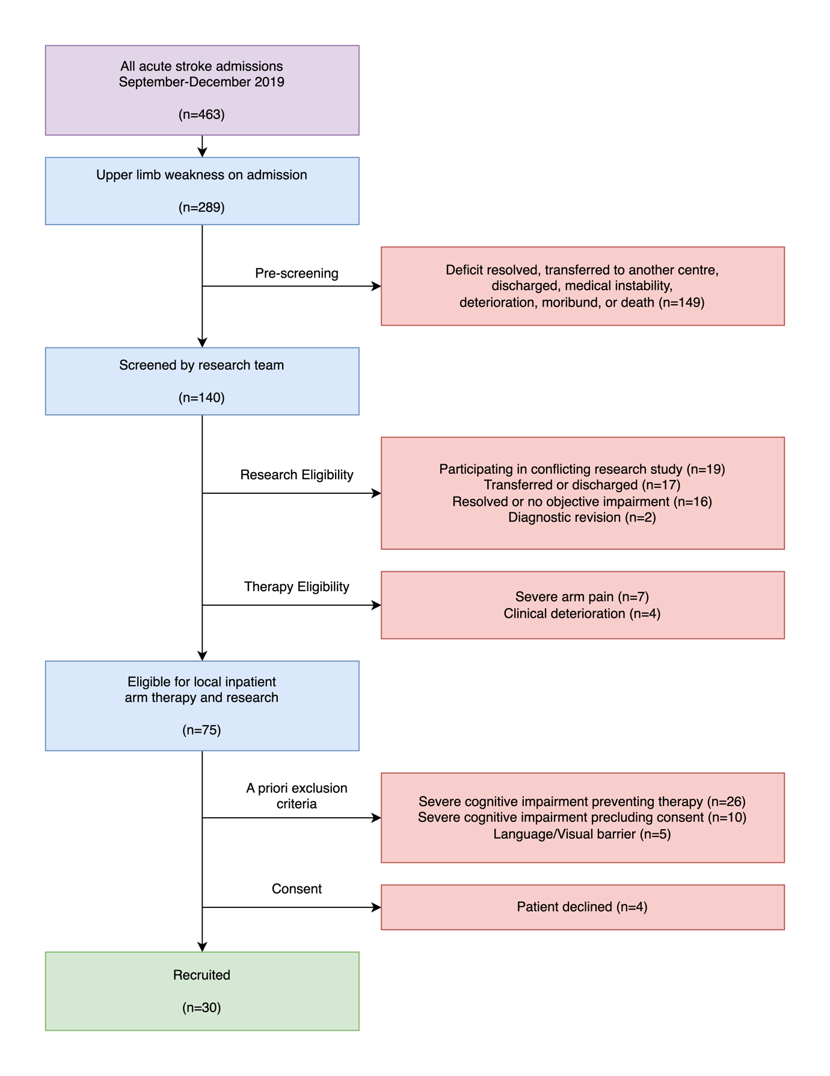

Intervention
An interactive exercise-gaming system (non-immersive virtual reality)[17,63], aimed at improving UL motor recovery after stroke, by promoting self-directed, repetitive UL activity was used. The technology comprised of a flexible, hand-held device that sensed grip force, as well as tracking finger, wrist and arm movements[64](See Figure 3.). The device housed an inbuilt motor enabling haptic feedback; and wireless communication with a computer tablet on which there were a suite of UL exercise games (GripAble app). Once participants selected an activity, the app provided instructions to guide the user. Participants were trained to use the system by an occupational therapist (OT) in a single session; were issued with a standardised user manual and used the system for the remainder of their in-hospital admission. The OT rated each user’s performance in engaging with the intervention (usability) using a 4-point rating scale based on the Barthel Index, to recommend “conditions of use” (independent, modified independence, assistance or unable), including facilitating conditions (such as pillow support of the UL, time-tabling practice, or hands-on-assistance from a relative, friend or informal carer) where appropriate. Participants were encouraged to use the system “as much as possible” as an adjunct to conventional therapy, with all intervention advice provided using a standardised script. Participants were not prompted or supervised in use of the device during the intervention period, although they could receive assistance from relatives, friends or informal carers. Participants were reviewed weekly by the research team to screen for technical issues with the intervention or identify additional user support needs. Adverse events were monitored by the treating clinical teams and/or self-reported by participants.

Figure 3. GripAble device and patient using device. Image demonstrates patient performing single player grasp and release activity. Images copyright of GripAble.co used with full permission of license holder and subject.
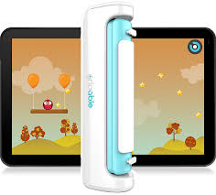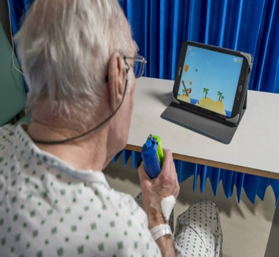

Measures

1. Participant characteristics:
The following demographic and clinical features were recorded on study entry: age; sex; prior technology exposure (prior use of and familiarity with a smart phone, tablet, laptop or computer, as self-reported by participants), Edinburgh Handedness Scale (EHS); time since stroke (days) at enrolment; stroke type (ischemic/haemorrhagic); stroke severity (National Institute of Health Stroke Scale (NIHSS)); UL impairment severity (Fugl Meyer-Upper Extremity Assessment (FM-UE)); cognition (Montreal Cognitive Assessment (MoCA)); premorbid functional status (modified Rankin Scale (mRS)); post-stroke functional independence status (Barthel Index (BI)); mood (Hospital Anxiety and Depression Scale (HADS)); fatigue (Fatigue Severity Scale (FSS)), pain (Faces Pain Rating Scale (FPRS)).

2. User performance (usability)
User performance (usability) was rated by the OT at participant enrolment/intervention set up. A 4-point scale was defined using the BI performance classification; users were classified as 4) independent 3) support for set up only (modified independence); 2) supervision and support required (assistance); 1) or unable to use meaningfully (unable). User performance ratings were made based on the following device functionalities: physical set up; turning on; accessing the activity platform; selecting and executing exercise software; executing the physical exercise requirements; device charging. Final ratings were based on the lowest rating allocated for any domain of device functionality. In the context of this work, other more commonly used scales, such as the system usability scale (SUS), did not align with the features and mechanisms of this technology, the context in which it was used and the data required to inform the intervention. Devising a custom scale enabled us to identify key functionalities associated with effective use of the device. Adopting the taxonomy of the BI enabled clear categorisation of the user performance and indicated associated user support needs, whilst also facilitating communication of user performance and needs in a language accessible to both clinicians and service users, family members or informal carers.

3. Technology acceptability:

An 11‐item survey based on the TAM was adapted from available measures [53] (see Figure 4. for survey items) and administered at the study end-point. Items measured included: perceived usefulness (n = 5 items); intentions to use (n = 2 items); and perceived ease of use (n = 4 items). Participants indicated their level of agreement with each item on a 3-point Likert scale (“Disagree”, “Neutral”, “Agree”). Participants’ comments or supporting statements in the context of their technology acceptance ratings were recorded and used as a contextual aid; no formal qualitative analysis was undertaken.

4. Technology adoption:

Adherence, defined as active time (minutes) on task each day (repetitive UL training or interactive gaming) was used as a surrogate measure for technology adoption [65]. Adherence was measured by a) self-reported session times, and b) digital time-on-task recorded by the device. These measures were strongly correlated (ICC for absolute agreement r=0.87; P<.001). Self-reported times were 14.5% greater (median; IQR: -0.06 – 20.9%) than electronic logs; since the former includes preparatory and rest periods and corresponds more closely to “time scheduled for therapy”, as conventionally reported in rehabilitation studies ⁸.

Data Analysis
Data analysis was performed with R (version 4.0.2) and RStudio (version 1.3.1093). Baseline clinical and demographic variables and questionnaire responses were organised into a single data matrix. Questionnaire responses were coded numerically (“Disagree”: -1; “Neutral”: 0; “Agree”: 1). Missing data were imputed using k-nearest neighbour imputation (k=3) [66]; imputation was performed with the caret library. Scores summarising overall technology acceptance, perceived usefulness, intent to use and ease of use were defined as per the formulae defined in Table 1, whereby questionnaire responses are coded numerically (“Disagree”: -1; “Neutral”: 0; “Agree”: 1) and combined as per the corresponding formula to generate scores.

To assess clinical determinants of technology acceptance, bivariate correlations were measured between baseline participant characteristics (age, prior technology exposure, stroke severity, cognition, UL impairment severity) and clinical outcomes (overall technology acceptance rating, intervention adherence). These variables were selected based on clinical reasoning and existing literature in the field indicating precedent [50]. Associations between integer variables were evaluated using two-sided spearman correlation tests. Bivariate associations between binary and integer variables were measured using the two-sided Wilcoxon rank sum test. P-values were adjusted for multiple hypothesis testing using the Holm method [67].

Table 1. Scores summarising overall technology acceptance, perceived usefulness, intent to use and ease of use.
Score | Formula | Range
Overall Technology Acceptance | “Promoted arm recovery”  + "Increased activity engagement or reduced boredom"  + "Increased control over own rehabilitation activities"  + "Additional benefit to usual rehabilitation"  + "Worthwhile time investment"  + "Would recommend to others"  + "Would participate again or continue to use"  - "Experienced problems"  + "Found easy to use"  + "Found easy to understand"  + "Enjoyed device and activities" | -11 to 11
Perceived Usefulness | “Promoted arm recovery”  + "Increased activity engagement or reduced boredom"  + "Increased control over own rehabilitation activities"  + "Additional benefit to usual rehabilitation"  + "Worthwhile time investment" | -5 to 5
Intent to use | "Would recommend to others"  + "Would participate again or continue to use" | -2 to 2
Ease of use | “Found easy to use”  + “Found easy to understand”  + "Enjoyed device and activities"  - “Experienced problems” | -4 to 4

Results

Sample characteristics
30 participants were recruited over three months, with 29 completing the intervention. One participant was withdrawn by the research team due to medical complications unrelated to research participation. The median enrolment duration was 8 days (IQR: 5-14). Sample characteristics and data collected are summarised in Table 2.

Table 2. Participant characteristics.
Variable | Summary | Complete
Age | mean 70.3, SD 11.9 | 30/30
Sex | Female: n=16, Male: n=14 | 30/30
Stroke Subtype | haemorrhagic: n=8, Ischaemic: n=22 | 30/30
NIHSS | mean 8, SD 4.4 | 30/30
Days Since Stroke | mean 11.1, SD 8.1 | 30/30
MOCA | mean 19.9, SD 5.5 | 24/30
BI | mean 47.1, SD 19.4 | 29/30
FM-UE | mean 33.1, SD 16 | 28/30
FSS | mean 5, SD 1.3 | 29/30
FPRS | mean 1.5, SD 2.6 | 29/30
HADS Depression | mean 6.7, SD 4.1 | 26/30
HADS Anxiety | mean 5.6, SD 3.8 | 26/30
Prior Tech. Exposure | No: n=13, Yes: n=17 | 30/30
Reported Activity | mean 26, SD 12.1 | 20/30
Usability | mean 1.6, SD 1 | 29/30

User Performance (Usability)
The technology was usable for 26/30 participants (87%). The remaining 4/30 participants (13%) were unable to use the device with their affected UL due to the severity of motor impairment (absence of voluntary finger extension or 0/5 on the Oxford Rating Scale (Medical Research Council Manual Muscle Testing Scale)). Motor weakness was monitored throughout enrolment for these 4 participants and remained unchanged. User performance varied; 7 participants were fully independent with all aspects of the technology use (device retrieval, set up and self-directed training), 9 participants achieved modified independence (required only physical set up to use the system, often due to restricted mobility), 8 required assistance(supervision/support) to complete training sessions due to combined physical and cognitive impairments.

Acceptability
The overall technology acceptance rating was 68% (95% CI: 56-79%). TAM subcategories
were also explored independently. 58% of respondents perceived that the device was easy to
use (4 items); 86% reported an intent to use (2 items); and 77% perceived that the device was
useful (5 items). Individual item responses are summarised below in Figure 4.

Figure 4. Technology acceptance survey responses.

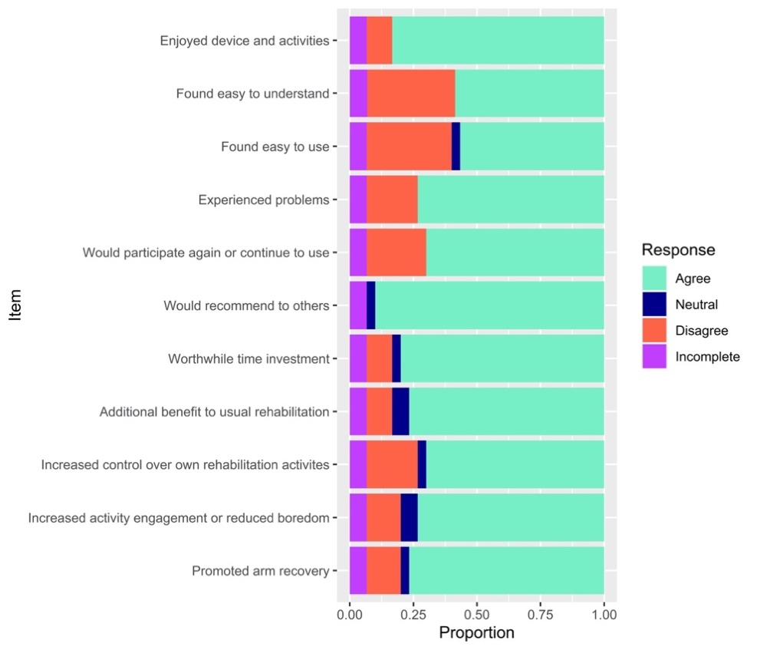

Adoption/Adherence
Participants (n=20) engaged with the device for a median of 26 minutes of training daily (SD 12.1) (Table 2), increasing the conventional UL training dose (25minutes) by two-fold[62].

Interactions/Associations between variables:
NIHSS (global stroke severity) correlated positively with overall technology acceptance rating ($ρ$= -0.56, 95% CI: [-0.79, -0.22], P=.007). No statistically significant correlations were observed between technology acceptance and participants’ age, prior technology exposure, MOCA score or FM-UE score. See Table 3. for full summary of participant variables and technology acceptance.

Table 3. Correlations between participant variables and technology acceptance.
Method | Predictor | Outcome | Result  (95% CI) | Adjusted P
Spearman | Age | Acceptance | $ρ$=0.04  [-0.40, 0.44] | P=.85
Wilcoxon rank sum | Prior tech exposure | Acceptance | Location Difference= 0.00  [-1.00, 3.00] | P=.73
Spearman | NIHSS | Acceptance | $ρ$=-0.56  [-0.79, -0.22] | P=.007
Spearman | MOCA | Acceptance | $ρ$=0.20  [-0.14, 0.52] | P=.50
Spearman | FM-UE | Acceptance | $ρ$=0.39  [ 0.00, 0.66] | P=.08

Lastly, associations of technology adoption with technology usability and technology acceptance variables were examined. Technology adoption (intervention adherence) correlated positively with user performance (usability) ($ρ$=0.55 [ 0.23, 0.75], P=.007) and perceived ease of use ($ρ$=0.46 [ 0.10, 0.74], P=.02), as well as perceived usefulness ($ρ$= 0.42 [ 0.09, 0.68], P=.03). No significant correlation was observed between participants’ self-reported intent to use the technology and intervention adherence during the trial period. See Table 4. for a full summary of correlations between intervention adherence and technology usability and acceptability variables.

Table 4. Correlations between intervention adherence and technology usability and acceptability variables.

Method | Predictor | Outcome | Result  (95% CI) | Adjusted P-value
Spearman | Usability | Intervention_adherence | $ρ$=0.55  [ 0.23, 0.75] | P=.007
Spearman | Percieved_usefulness | Intervention_adherence | $ρ$=0.42  [ 0.09, 0.68] | P=.03
Spearman | Intent_to_use | Intervention_adherence | $ρ$=0.25  [-0.09, 0.54] | P=.18
Spearman | Ease_of_use | Intervention_adherence | $ρ$=0.46  [ 0.10, 0.74] | P=.02

Discussion
This self-directed, technology-facilitated intervention was broadly usable and acceptable within this study cohort. Stroke severity correlated negatively with technology acceptance; those participants with most severe stroke reported lower acceptability ratings across all domains. Participants achieved an average UL training dose of 26 minutes daily, as an adjunct to conventional face-to-face UL rehabilitation, exceeding the conventional care dose typically observed in subacute stroke rehabilitation settings [68]. Technology adoption positively correlated with technology usability, perceived ease of use and perceived usefulness; indicating that the usability of technology, as well as the effort associated with using the technology, influenced actual use. Furthermore, our findings suggest that perceived usefulness of technology, in this case, the extent to which participants associated the technology with UL rehabilitation and recovery, influenced adoption. A strength of this study is the broad sampling of participants, recruited in the acute/ sub-acute stroke recovery phase, including older adults, those with cognitive impairment and those with moderate to severe stroke, representing cohorts frequently excluded from stroke rehabilitation research [69]. Less than half of participants (43%) had previously owned or used a smartphone.

Although the technology was usable for the majority of participants, many required facilitating conditions to optimise their participation, highlighting the importance of assessing and addressing individual user needs. Clinical adoption of rehabilitation technologies may be improved by enhancing usability and acceptability. This can be achieved through design optimisation, education and user support, targeting the domains of usability, “perceived ease of use” and “perceived usefulness”. In this study, a positive association was observed between perceived usefulness of technology and its adoption, presenting a promising avenue to improve engagement. A robust clinical evidence base may enhance perceived usefulness of rehabilitation technologies amongst stakeholders. Thus far, systematic reviews and meta-analyses have found evidence in the domain of technology-facilitated UL interventions after stroke to be insufficient and/or of low quality, leaving limited scope for interpreting the efficacy of such interventions [17,50,70,71] and thus restricting the extent to which clinical guidelines, or individual clinicians may advocate for adoption.

This study examined a stroke rehabilitation intervention, focusing on interactive gaming and non-immersive virtual reality, with a target function to achieve repetitive, task-specific UL training to promote UL motor recovery. We observed that participants with most severe UL impairment, showed a trend towards lower technology acceptance ratings. In this sense, patient characteristics can be linked with specific technology characteristics (the mechanism and target function i.e. repetitive UL training for UL recovery). Rehabilitation technology is often discussed with ambiguity; there is lack of consensus on the taxonomy, classification and categorisation of technology. This may lead to barriers in interpreting the efficacy and applications of technology amongst target users. Individual technologies comprising of unique mechanisms and target functions, are likely to benefit from individual evaluation, incorporating the relevant user cohort to identify important interactions between user characteristics and outcomes in usability, acceptability and adoption, as well as clinical efficacy. Thorough reporting of technology subtypes and participant subgroups may advance clinical translation. Use of a framework for describing and categorising rehabilitation technologies, and indeed digital health technologies more broadly, would likely enhance reporting standards.

Limitations
Although this study population was heterogeneous in terms of age, sex, and clinical characteristics, it represented a single institution; future work will incorporate a multicentre design. Imputation may have biased associations where data missingness patterns were non-random, multivariate imputation was employed to minimise this bias. The power of our analysis was limited by the sample size – consequently, some real effects may have failed to generate statistically significant associations. The sample size was kept intentionally small to allow for feasibility testing in this instance, while this addressed the current aims, a larger sample size will be recruited in a planned subsequent trial (ClinicalTrials.gov Identifier: NCT04475692). As an observational study, findings are subject to the limitation that observed correlations do not necessarily imply causal relationships.

In the TAM survey, neutral responses were limited to questions which required a hypothetical comparison to an experience without rehabilitation technology (i.e. conventional rehabilitation). The cognitive demands of such theoretical comparisons likely exceed those of questions interrogating the participants’ own experience. All respondents to the non-hypothetical questions “Enjoyed device and activities”, “Found easy to understand”, “Experienced problems” and “Would participate again or continue to use”, chose to agree or disagree, rather than remain neutral. This observation may guide future survey development to improve participant engagement and response reliability. A further limitation of the TAM survey used here is that questions were largely unidirectional; inverting questions may have reduced the risk of positive response bias.

Future work
Findings suggest that technology acceptance and subsequently adoption, negatively correlate with stroke severity in this instance. Identifying interventions for severe stroke is a key clinical, academic and patient priority[72], a focus for future work may be in adapting this
technology/intervention design to enhance acceptability and accessibility for those with most severe post-stroke impairments.

Technology adoption is a complex and dynamic process. We implemented a post intervention TAM survey only; administering both pre and post intervention surveys may support our understanding of the mechanisms of technology adoption, as well as mediating conditions. Several authors report significant changes in technology acceptance amongst users over time and/or in line with specific facilitating conditions (social support, peer support, increased availability and frequency of training, system upgrades etc.)[38]. Furthermore, perseverance with technology-facilitated interventions is anticipated to change over the intervention timespan[50]; understanding factors that influence long-term adoption of rehabilitation technologies for stroke survivors will form an important aspect of future research (ClinicalTrials.gov Identifier: NCT04475692).

Closed questionnaires and quantitative data collection allowed us to examine specific and tangible aspects of technology usability, acceptability and adoption, along with clinical and demographic variables; richer themes and context may be derived from a mixed methods exploration, encompassing the broader spectrum participants’ experiences and feelings.

Finally, adoption of health technology hinges upon multiple stakeholders and may in a large part be determined by technology usability and acceptability amongst clinicians [19], this is echoed in Health Education England’s recent development of a digital competency framework for NHS staff [73]. In the context of this self-directed intervention, we focused on user experience from the perspective of the patient, further work may explore acceptance amongst broader stakeholders including clinicians and care-givers, who play a pivotal role in supported self-management in this setting.

Conclusion
In an age of digitalised healthcare, technology usability and acceptability represent increasingly important determinants of health outcomes[9,74,75]. We explored the adoption of a low-cost (<£1,000) rehabilitation technology, used in a self-directed context, within a heterogeneous cohort of stroke survivors. To our knowledge, this is the first study to concurrently examine technology usability, acceptability and adoption in this context, and to evaluate the influence of stroke survivor characteristics. The technology was usable and acceptable to the majority of participants and greatly supplemented conventional rehabilitation provision. We have presented a robust analysis, identifying associations between stroke survivor characteristics, technology usability, acceptability and adoption. Our findings provide insights that will inform intervention planning and implementation, emphasising the need for specificity when reporting digital health interventions and reiterating the importance of a holistic and person-centred approach to optimise translation of technologies into clinical practice.

Acknowledgements:
This work was funded by the National Institute for Health Research and Innovate UK (i4i grant). The authors wish to acknowledge the stroke survivors, clinicians and research support staff who have contributed to this work.

Data availability:
The data sets generated during and/or analysed during this study are available from the corresponding author on reasonable request.

Conflicts of interest:
Dr Paul Bentley was part of the scientific group involved in the early development and testing of the technology used in this trial (GripAble). No other authors have conflicts of interest to declare.

References

1. Daly JJ, McCabe JP, Holcomb J, Monkiewicz M, Gansen J, Pundik S. Long-Dose Intensive Therapy Is Necessary for Strong, Clinically Significant, Upper Limb Functional Gains and Retained Gains in Severe/Moderate Chronic Stroke. Neurorehabil Neural Repair SAGE Publications Inc.; 2019 Jul 1;33(7):523–537. doi: 10.1177/1545968319846120
2. Schneider EJ, Lannin NA, Ada L, Schmidt J. Increasing the amount of usual rehabilitation improves activity after stroke: a systematic review. J Physiother Australian Physiotherapy Association; 2016 Oct 1;62(4):182–187. PMID:27637769
3. Kwakkel G, Wagenaar RC, Koelman TW, Lankhorst GJ, Koetsier JC. Effects of intensity of rehabilitation after stroke: A research synthesis. Stroke Lippincott Williams and Wilkins; 1997;28(8):1550–1556. doi: 10.1161/01.STR.28.8.1550
4. Clark B, Whitall J, Kwakkel G, Mehrholz J, Ewings S, Burridge J. The effect of time spent in rehabilitation on activity limitation and impairment after stroke. Cochrane Database Syst Rev John Wiley & Sons, Ltd; 2021 Oct 25;2021(10). doi: 10.1002/14651858.CD012612.PUB2
5. Jeffers MS, Karthikeyan S, Gomez-Smith M, Gasinzigwa S, Achenbach J, Feiten A, Corbett D. Does Stroke Rehabilitation Really Matter? Part B: An Algorithm for Prescribing an Effective Intensity of Rehabilitation. Neurorehabil Neural Repair SAGE Publications Inc.; 2018 Jan 1;32(1):73–83. doi: 10.1177/1545968317753074
6. Bernhardt J, Chan J, Nicola I, Collier JM. Little therapy, little physical activity: Rehabilitation within the first 14 days of organized stroke unit care. J Rehabil Med 2007 Jan;39(1):43–48. doi: 10.2340/16501977-0013
7. Clarke DJ, Burton LJ, Tyson SF, Rodgers H, Drummond A, Palmer R, Hoffman A, Prescott M, Tyrrell P, Brkic L, Grenfell K, Forster A. Why do stroke survivors not receive recommended amounts of active therapy? Findings from the ReAcT study, a mixed-methods case-study evaluation in eight stroke units. Clin Rehabil SAGE Publications Ltd; 2018 Aug 1;32(8):1119–1132. doi: 10.1177/0269215518765329
8. Eng XW, Brauer SG, Kuys SS, Lord M, Hayward KS. Factors affecting the ability of the stroke survivor to drive their own recovery outside of therapy during inpatient stroke rehabilitation. Stroke Res Treat Hindawi Publishing Corporation; 2014; doi: 10.1155/2014/626538
9. World Health Organization (WHO). Recommendations on digital interventions for health system strengthening. Food Nutr Bull. 2019. PMID:21194458ISBN:978-92-4-155050-5
10. NHS at 70: What will new technology mean for the NHS and its patients? | The Health Foundation. Available from: https://www.health.org.uk/publications/nhs-at-70-what-will-new-technology-mean-for-the-nhs-and-its-patients [accessed Sep 23, 2020]
11. Ballantyne R, Rea PM. A game changer: ‘The use of digital technologies in the management of upper limb rehabilitation.’ Adv Exp Med Biol Springer; 2019. p. 117–147. doi: 10.1007/978-3-030-31904-5_9
12. Sarfo FS, Ulasavets U, Opare-Sem OK, Ovbiagele B. Tele-Rehabilitation after Stroke: An Updated Systematic Review of the Literature. J Stroke Cerebrovasc Dis. W.B. Saunders; 2018. p. 2306–2318. PMID:29880211
13. Mekbib DB, Han J, Zhang L, Fang S, Jiang H, Zhu J, Roe AW, Xu D. Virtual reality therapy for upper limb rehabilitation in patients with stroke: a meta-analysis of randomized clinical trials. Brain Inj. Taylor and Francis Ltd; 2020. p. 456–465. doi: 10.1080/02699052.2020.1725126
14. Global strategy on digital health 2020-2025. 2021; Available from: http://apps.who.int/bookorders. [accessed Jun 8, 2022]
15. Taub E, Crago JE, Burgio LD, Groomes TE, Cook EW, DeLuca SC MN. An operant approach to rehabilitation medicine: Overcoming learned nonuse by shaping. JExp Anal Behav 1994;61(2):281–293.
16. Maier M, Ballester BR, Verschure PFMJ. Principles of Neurorehabilitation After Stroke Based on Motor Learning and Brain Plasticity Mechanisms. Front Syst Neurosci. Frontiers Media S.A.; 2019. doi: 10.3389/fnsys.2019.00074
17. Da-Silva RH, Moore SA, Price CI. Self-directed therapy programmes for arm rehabilitation after stroke: a systematic review. Clin Rehabil. SAGE Publications Ltd; 2018. p. 1022–1036. doi: 10.1177/0269215518775170
18. Dominguez-Tellez P, Moral-Munoz JA, Salazar A, Casado-Fernandez E, Lucena-Anton D. Game-Based Virtual Reality Interventions to Improve Upper Limb Motor Function and Quality of Life After Stroke: Systematic Review and Meta-analysis. Games Health J United States; 2020;9(1):1–10. doi: https://dx.doi.org/10.1089/g4h.2019.0043
19. Langan J, Subryan H, Nwogu I, Cavuoto L. Reported use of technology in stroke rehabilitation by physical and occupational therapists. Disabil Rehabil Assist Technol Taylor and Francis Ltd; 2018 Oct 3;13(7):641–647. doi: 10.1080/17483107.2017.1362043
20. Glegg SMN, Levac DE. Barriers, Facilitators and Interventions to Support Virtual Reality Implementation in Rehabilitation: A Scoping Review. PM R. Elsevier Inc.; 2018. p. 1237-1251.e1. doi: 10.1016/j.pmrj.2018.07.004
21. Collins RC, Kerr AK, Thomson AT. User requirements for an upper limb weight support device for stroke rehabilitation. Clin Rehabil Sage Publications Inc.; 2018;32(10):1411–1412. doi: 10.1177/02692155187843
22. Caughlin S, Mehta S, Corriveau H, Eng JJ, Eskes G, Kairy D, Meltzer J, Sakakibara BM, Teasell R. Implementing Telerehabilitation After Stroke: Lessons Learned from Canadian Trials. Telemed e-Health Mary Ann Liebert Inc; 2019 Sep 9; doi: 10.1089/tmj.2019.0097
23. Bagot KL, Moloczij N, Barclay-Moss K, Vu M, Bladin CF, Cadilhac DA. Sustainable implementation of innovative, technology-based health care practices: A qualitative case study from stroke telemedicine. J Telemed Telecare SAGE Publications Ltd; 2020 Jan 1;26(1–2):79–91. doi: 10.1177/1357633X18792380
24. Mehrotra A, Ray K, Brockmeyer DM, Barnett ML, Bender JA. Rapidly Converting to “Virtual Practices”: Outpatient Care in the Era of Covid-19. NEJM Catal 2020;1(2). doi: 10.1056/CAT.20.0091
25. Hollander JE, Sites FD. The Transition from Reimagining to Recreating Health Care Is Now. 2020; doi: 10.1056/CAT.20.0093
26. Kerr A, Smith M, Reid L, Baillie L. Adoption of stroke rehabilitation technologies by the user community: Qualitative study. J Med Internet Res Journal of Medical Internet Research; 2018 Aug 1;20(8). doi: 10.2196/rehab.9219
27. Hochstenbach-Waelen A, Seelen HA. Embracing change: practical and theoretical considerations for successful implementation of technology assisting upper limb training in stroke. J Neuroeng Rehabil 2012;9(1):52. doi: 10.1186/1743-0003-9-52
28. Fager SK, Burnfield JM. Patients’ experiences with technology during inpatient rehabilitation: Opportunities to support independence and therapeutic engagement. Disabil Rehabil Assist Technol 2014 Mar;9(2):121–127. doi: 10.3109/17483107.2013.787124
29. White JH, Janssen H, Jordan L, Pollack M. Tablet technology during stroke recovery: A survivor’s perspective. Disabil Rehabil Informa Healthcare; 2015 Jun 1;37(13):1186–1192. PMID:25212736
30. Paquin K, Crawley J, Harris JE, Horton S. Survivors of chronic stroke – participant evaluations of commercial gaming for rehabilitation. Disabil Rehabil Taylor and Francis Ltd; 2016 Oct 8;38(21):2144–2152. PMID:26728133
31. Lemke M, Rodríguez Ramírez E, Robinson B, Signal N. Motivators and barriers to using information and communication technology in everyday life following stroke: a qualitative and video observation study. Disabil Rehabil Disabil Rehabil; 2020 Jul 2;42(14):1954–1962. PMID:30686063
32. Tyagi S, Lim DSY, Ho WHH, Koh YQ, Cai V, Koh GCH, Legido-Quigley H. Acceptance of Tele-Rehabilitation by Stroke Patients: Perceived Barriers and Facilitators. Arch Phys Med Rehabil W.B. Saunders; 2018 Dec 1;99(12):2472-2477.e2. PMID:29902469
33. Chen Y, Abel KT, Janecek JT, Chen Y, Zheng K, Cramer SC. Home-based technologies for stroke rehabilitation: A systematic review. Int J Med Inform. Elsevier Ireland Ltd; 2019. p. 11–22. doi: 10.1016/j.ijmedinf.2018.12.001
34. White J, Janssen H, Jordan L, Pollack M. Tablet technology during stroke recovery: a survivor’s perspective. Disabil Rehabil Informa Healthcare; 2015 Jun 19;37(13):1186–1192. doi: 10.3109/09638288.2014.958620
35. van Ommeren AL, Smulders LC, Prange-Lasonder GB, Buurke JH, Veltink PH, Rietman JS. Assistive Technology for the Upper Extremities After Stroke: Systematic Review of Users’ Needs. JMIR Rehabil Assist Technol JMIR Publications Inc.; 2018 Nov 29;5(2):e10510. doi: 10.2196/10510
36. Pallesen H, Andersen MB, Hansen GM, Lundquist CB, Brunner I. Patients’ and Health Professionals’ Experiences of Using Virtual Reality Technology for Upper Limb Training after Stroke: A Qualitative Substudy. Rehabil Res Pract Hindawi Limited; 2018;2018:1–11. doi: 10.1155/2018/4318678
37. Timmermans AA, Seelen HA, Willmann RD, Kingma H. Technology-assisted training of arm-hand skills in stroke: Concepts on reacquisition of motor control and therapist guidelines for rehabilitation technology design. J Neuroeng Rehabil. 2009. PMID:19154570
38. Bagot KL, Moloczij N, Barclay-Moss K, Vu M, Bladin CF, Cadilhac DA. Sustainable implementation of innovative, technology-based health care practices: A qualitative case study from stroke telemedicine. J Telemed Telecare SAGE Publications Ltd; 2020 Jan 1;26(1–2):79–91. doi: 10.1177/1357633X18792380
39. Thomson K, Pollock A, Bugge C, Brady MC. Disability and Rehabilitation: Assistive Technology Commercial gaming devices for stroke upper limb rehabilitation: a survey of current practice) Commercial gaming devices for stroke upper limb rehabilitation: a survey of current practice Commercial gaming devices for stroke upper limb rehabilitation: a survey of current practice. Disabil Rehabil Assist Technol Informa UK Ltd; 2016 Aug 17;11(6):454–461. doi: 10.3109/17483107.2015.1005031
40. Mubin O, Alnajjar F, Al Mahmud A, Jishtu N, Alsinglawi B. Exploring serious games for stroke rehabilitation: a scoping review. Disabil Rehabil Assist Technol. Taylor and Francis Ltd; 2020. doi: 10.1080/17483107.2020.1768309
41. Brouns B, Van Bodegom-Vos L, De Kloet AJ, Vliet Vlieland TPM, Gil ILC, Souza LMN, Braga LW, Meesters JJL. Differences in factors influencing the use of eRehabilitation after stroke; A cross-sectional comparison between Brazilian and Dutch healthcare professionals. BMC Health Serv Res BioMed Central Ltd.; 2020 Jun 1;20(1). PMID:32487255
42. Morone G, Palomba A, Martino Cinnera A, Agostini M, Aprile I, Arienti C, Paci M, Casanova E, Marino D, LA Rosa G, Bressi F, Sterzi S, Gandolfi M, Giansanti D, Perrero L, Battistini A, Miccinilli S, Filoni S, Sicari M, Petrozzino S, Solaro CM, Gargano S, Benanti P, Boldrini P, Bonaiuti D, Castelli E, Draicchio F, Falabella V, Galeri S, Gimigliano F, Grigioni M, Mazzoleni S, Mazzon S, Molteni F, Petrarca M, Picelli A, Posteraro F, Senatore M, Turchetti G, Straudi S. Systematic review of guidelines to identify recommendations for upper limb robotic rehabilitation after stroke. Eur J Phys Rehabil Med 2021; doi: 10.23736/S1973-9087.21.06625-9
43. Morone G, Cocchi I, Paolucci S, Iosa M. Robot-assisted therapy for arm recovery for stroke patients: state of the art and clinical implication. Expert Rev Med Devices England; 2020;17(3):223–233. doi: https://dx.doi.org/10.1080/17434440.2020.1733408
44. Laver KE, Adey-Wakeling Z, Crotty M, Lannin NA, George S, Sherrington C. Telerehabilitation services for stroke. Cochrane Database Syst Rev. John Wiley and Sons Ltd; 2020. doi: 10.1002/14651858.CD010255.pub3
45. Schröder J, van Criekinge T, Embrechts E, Celis X, Van Schuppen J, Truijen S, Saeys W. Combining the benefits of tele-rehabilitation and virtual reality-based balance training: a systematic review on feasibility and effectiveness. Disabil Rehabil Assist Technol. Taylor and Francis Ltd; 2019. p. 2–11. doi: 10.1080/17483107.2018.1503738
46. Flynn N, Kuys S, Froude E, Cooke D. Introducing robotic upper limb training into routine clinical practice for stroke survivors: Perceptions of occupational therapists and physiotherapists. Aust Occup Ther J Blackwell Publishing; 2019 Aug 10;66(4):530–538. doi: 10.1111/1440-1630.12594
47. Yen P-Y, Bakken S. Review of health information technology usability study methodologies. J Am Med Informatics Assoc Oxford Academic; 2012 May 1;19(3):413–422. doi: 10.1136/amiajnl-2010-000020
48. Sivan M, Gallagher J, Holt R, Weightman A, O’Connor R, Levesley M. Employing the International Classification of Functioning, Disability and Health framework to capture user feedback in the design and testing stage of development of home-based arm rehabilitation technology. Assist Technol Taylor and Francis Inc.; 2016 Jul 2;28(3):175–182. doi: 10.1080/10400435.2016.1140689
49. Holden RJ, Karsh BT. The Technology Acceptance Model: Its past and its future in health care. J Biomed Inform. 2010. p. 159–172. PMID:19615467
50. Neibling BA, Jackson SM, Hayward KS, Barker RN. Perseverance with technology-facilitated home-based upper limb practice after stroke: a systematic mixed studies review. J Neuroeng Rehabil BioMed Central; 2021 Dec 24;18(1):43. doi: 10.1186/s12984-021-00819-1
51. Davis FD. Perceived usefulness, perceived ease of use, and user acceptance of information technology. MIS Q Manag Inf Syst 1989 Sep;13(3):319–339. doi: 10.2307/249008
52. Karahanna E, Straub DW. The psychological origins of perceived usefulness and ease-of-use. Inf Manag Elsevier; 1999 Apr 5;35(4):237–250. doi: 10.1016/S0378-7206(98)00096-2
53. Nikolaus S, Bode C, Taal E, Vonkeman HE, Glas CA, van de Laar MA. Acceptance of New Technology: A Usability Test of a Computerized Adaptive Test for Fatigue in Rheumatoid Arthritis. JMIR Hum Factors JMIR Publications Inc.; 2014 Dec 4;1(1):e4. doi: 10.2196/humanfactors.3424
54. Brewster L, Mountain G, Wessels B, Kelly C, Hawley M. Factors affecting front line staff acceptance of telehealth technologies: A mixed-method systematic review. J Adv Nurs. 2014. p. 21–33. doi: 10.1111/jan.12196
55. Lemon C, Liu N, Lane S, Sud A, Branley J, Khadra M, Kim J. Changes in User Perceptions of a Telemedicine System over Time: From Initial Implementation to Everyday Use. Telemed e-Health Mary Ann Liebert Inc.; 2018 Jul 1;24(7):552–559. doi: 10.1089/tmj.2017.0194
56. Braun MT. Obstacles to social networking website use among older adults. Comput Human Behav 2013;29(3):673–680. doi: 10.1016/j.chb.2012.12.004
57. Rahimi B, Nadri H, Afshar HL, Timpka T. A systematic review of the technology acceptance model in health informatics. Appl Clin Inform. Georg Thieme Verlag; 2018. p. 604–634. doi: 10.1055/s-0038-1668091
58. Bagot K, Moloczij N, Arthurson L, Hair C, Hancock S, Bladin CF, Cadilhac DA. Nurses’ Role in Implementing and Sustaining Acute Telemedicine: A Mixed‐Methods, Pre‐Post Design Using an Extended Technology Acceptance Model. J Nurs Scholarsh Blackwell Publishing Ltd; 2020 Jan 11;52(1):34–46. doi: 10.1111/jnu.12509
59. Kowitlawakul Y. The technology acceptance model: Predicting nurses’ intention to use telemedicine technology (eICU). CIN - Comput Informatics Nurs Comput Inform Nurs; 2011 Jul;29(7):411–418. doi: 10.1097/NCN.0b013e3181f9dd4a
60. Bhattacharjya S, Cavuoto LA, Reilly B, Xu W, Subryan H, Langan J. Usability, usefulness, and acceptance of a novel, portable rehabilitation system (mRehab) using smartphone and 3D printing technology: Mixed methods study. JMIR Hum Factors JMIR Publications Inc.; 2021 Jan 1;8(1):e21312. doi: 10.2196/21312
61. Chen MH, Huang LL, Wang CH. Developing a Digital Game for Stroke Patients’ Upper Extremity Rehabilitation – Design, Usability and Effectiveness Assessment. Procedia Manuf Elsevier B.V.; 2015;3:6–12. doi: 10.1016/j.promfg.2015.07.101
62. Broderick M, Almedom L, Burdet E, Burridge J, Bentley P. Self-Directed Exergaming for Stroke Upper Limb Impairment Increases Exercise Dose Compared to Standard Care: https://doi.org/101177/15459683211041313 SAGE PublicationsSage CA: Los Angeles, CA; 2021 Aug 27;0(0):154596832110413. doi: 10.1177/15459683211041313
63. Pollock A, Farmer SE, Brady MC, Langhorne P, Mead GE, Mehrholz J, van Wijck F. Interventions for improving upper limb function after stroke. Cochrane Database Syst Rev 2014 Nov 12; doi: 10.1002/14651858.CD010820.pub2
64. Lotay R, Mace M, Rinne P, Burdet E, Bentley P. Optimizing self-exercise scheduling in motor stroke using Challenge Point Framework theory. IEEE Int Conf Rehabil Robot IEEE Computer Society; 2019. p. 435–440. doi: 10.1109/ICORR.2019.8779497
65. Lohse KR, Lang CE, Boyd LA. Is more better? Using metadata to explore dose-response relationships in stroke rehabilitation. Stroke Lippincott Williams and Wilkins; 2014;45(7):2053–2058. doi: 10.1161/STROKEAHA.114.004695
66. Kuhn M, Contributions from Jed Wing, Steve Weston, Andre Williams, Chris Keefer, Allan Engelhardt, Tony Cooper, Zachary Mayer, Brenton Kenkel, the R Core Team, Michael Benesty, Reynald Lescarbeau, Andrew Ziem, Luca Scrucca, Yuan Tang, Can Candan and TH. caret: Classification and Regression Training. R Packag version 60-79. 2018. p. 216.
67. Holm S. A simple sequentially rejective multiple test procedure. Scand J Stat 1979;6:65–70.
68. Hayward KS, Brauer SG. Dose of arm activity training during acute and subacute rehabilitation post stroke: a systematic review of the literature. Clin Rehabil 2015 Dec;29(12):1234–43. PMID:25568073
69. Nelson MLA, McKellar KA, Yi J, Kelloway L, Munce S, Cott C, Hall R, Fortin M, Teasell R, Lyons R. Stroke rehabilitation evidence and comorbidity: a systematic scoping review of randomized controlled trials. Top Stroke Rehabil Top Stroke Rehabil; 2017;24(5):374–380. PMID:28218020
70. Laver KE, Lange B, George S, Deutsch JE, Saposnik G, Crotty M. Virtual reality for stroke rehabilitation. Cochrane Database Syst Rev. John Wiley and Sons Ltd; 2017. PMID:29156493
71. Thomson K, Pollock A, Bugge C, Brady M. Commercial gaming devices for stroke upper limb rehabilitation: A systematic review. Int J Stroke Blackwell Publishing Ltd; 2014;9(4):479–488. doi: 10.1111/ijs.12263
72. Pollock A, St George B, Fenton M, Firkins L. Top 10 research priorities relating to life after stroke - consensus from stroke survivors, caregivers, and health professionals. Int J Stroke Blackwell Publishing Ltd; 2014;9(3):313–320. doi: 10.1111/j.1747-4949.2012.00942.x
73. Development of a digital competency framework for UK Allied Health Professionals | 2020 Topol Digital Health Fellowship.
74. Glied S, Lleras-Muney A. Technological innovation and inequality in health. Demography Duke University Press; 2008;45(3):741–761. PMID:18939670
75. Lynch EA, Cadilhac DA, Luker JA, Hillier SL. Inequities in access to inpatient rehabilitation after stroke: An international scoping review. Top Stroke Rehabil. Taylor and Francis Ltd.; 2017. p. 619–626. doi: 10.1080/10749357.2017.1366010

