Comparative risk of acute myocardial infarction for anti-osteoporosis drugs in primary care: a meta-analysis of propensity-matched cohort findings from the UK Clinical Practice Research Database and the Catalan SIDIAP Database.
Authors: Sara Calderon-Larranaga³*, Marta Pineda-Moncusí¹*, Sara Khalid¹, Arvind Sami², Samuel Hawley ^{1,2}, Andrew Judge ^{1,2,5}, Nigel Arden ⁶, Tjeerd P Van Staa ^{7,8}, Cyrus Cooper ^{2,9,10}, Bo Abrahamsen¹¹, M Kassim Javaid ², and Daniel Prieto-Alhambra^{2,12}

*Joint first authors, Corresponding author
AFFILIATIONS

- Centre for Statistics in Medicine, Nuffield Department of Orthopaedics, Rheumatology, and Musculoskeletal Sciences, University of Oxford, Windmill Road, Oxford OX3 7LD, United Kingdom
- Oxford NIHR Biomedical Research Centre, University of Oxford, Windmill Road, Oxford OX3 7LD, United Kingdom
- Family and Community Medicine Teaching Unit of Granada. Cartuja University Health Centre. Andalusian Health Service (SAS), Avda. Juan Pablo II, 18001 Granada, Spain
- London School of Hygiene and Tropical Medicine, Keppel St, London WC1E 7HT, United Kingdom
- Bristol NIHR Biomedical Research Centre, Musculoskeletal Research Unit, University of Bristol, Southmead Hospital, Bristol BS10 5NB, United Kingdom
- Arthritis Research UK Centre for Sport, Exercise, and Osteoarthritis, University of Oxford, Windmill Road, Oxford OX3 7LD, UK
- Farr Institute, University of Manchester, Vaughan House, Portsmouth Road, Manchester M13 9PL, United Kingdom.
- Utrecht Institute for Pharmaceutical Sciences, Utrecht University, David de Wied building, Universiteitsweg 99, 3584 CG Utrecht, the Netherlands
- Medical Research Council Lifecourse Epidemiology Unit, University of Southampton, Southampton SO16 6YD, United Kingdom
- NIHR Southampton Biomedical Research Centre, University of Southampton and University Hospital Southampton NHS Foundation Trust, Southampton SO16 6YD, United Kingdom
- Odense Patient Data Explorative Network OPEN, Institute of Clinical Research, University of Southern Denmark, Odense, Denmark
- GREMPAL (Grup de Recerca en Malalties Prevalents de l’Aparell Locomotor) research group, CIBERFes and Idiap Jordi Gol Primary Care Research Institute, Universitat Autònoma de Barcelona and Instituto de Salud Carlos III, Gran Via de Les Corts Catalanes, 591 atico, 08007 Barcelona, Spain

Correspondance to
Dr Sara Khalid
Centre for statistic in Medicine, Nuffield Department of Orthopaedics, Rheumatology, and Musculoskeletal Sciences, University of Oxford, Windmill Road, Oxford OX3 7LD, United Kingdom

sara.khalid@ndorms.ox.ac.uk

ABSTRACT
Purpose
To evaluate the comparative safety of anti-osteoporosis drugs based on the observed risk of acute myocardial infarction while on treatment in a primary care setting.
Methods
Propensity-matched cohort study and meta-analysis.
Setting Two primary care records databases covering UK NHS (CPRD) and Catalan healthcare (SIDIAP) patients during 1995-2014 and 2006-2014 respectively. The outcome was accute myocardial infarction while on treatment. Users of alendronate (reference group) were compared to those of 1) other oral bisphosphonates (OBP), 2) strontium ranelate (SR), and 3) selective estrogen receptor modulator (SERM), after matching on baseline characteristics (socio-demographics, fracture risk factors, co-morbidities, and concomitant drug/s use) using propensity scores. Multiple imputation was used to handle missing data on confounders, and competing risk modelling for the calculation of relative risk (sub-distribution hazard ratios, SHR) according to therapy. Country-specific data were analysed individually and meta-analysed.
Results
An 10% increased risk of acute myocardial infarction was found in users of other bisphosphonates as compared to alendronate users within CPRD. Meta-analysis of CPRD and SIDIAP results showed a 9% increased risk in users of other bisphosphonate as compared to alendronate users. Sensitivity analysis showed SERMS users with diabetes and chronic kidney disease were at an elevated risk.
Conclusions
This study provides additional data on the risk of acute myocardial infarction in patients receiving osteoporosis treatment. The results favour the cardiovascular safety of alendronate as a first line choice for osteoporosis treatment.
Keywords
Acute Myocardial Infarction, Osteoporosis Treatment, CPRD, SIDIAP
Mini Abstract
The aim of this study was to evaluate the risk of acute myocardial infarction in patients taking osteoporosis medication. Patients were taken from the SIDIAP or CPRD database and were matched using propensity scores. Patients with diabetes and chronic kidney disease taking SERMs, were at an increased risk.
INTRODUCTION
Osteoporosis is characterised by low bone mass and deterioration of bone microarchitecture with an increased susceptibility to fragility fractures and consequent disability, pain, and decrease of quality of life. [1]
Among higher risk women, anti-osteoporosis-drugs (AODs) have proved to be an effective additional treatment to improve bone strength and diminish fracture risk [2]. It has long been speculated that specific AODs also provide additional extra-skeletal benefits.
A 2-year follow-up cohort study analysing the risk of acute myocardial infarction in patients with osteoporotic fractures receiving bisphosphonate treatment found a 65% risk reduction amongst bisphosphonate users (HR 0.36 [0.14-0.84]) [3], but this was not replicated in subsequent meta-analysis and a sequential trial analysis (TSA)[4, 5] . On the other hand, according to the safety update report published by the European Medicines Agency (EMA) in 2013, pooled analyses of SOTI and TROPOS trials showed an increased risk of AMI with strontium ranelate [6, 7]. Latest observational studies have, however, failed to support such findings, which might be attributed to inherent methodological issues, such as confounding by indication, few events and short duration of exposure [8–11]. Amidst safety concerns, since August 2017, strontium ranelate has been discontinued worldwide by manufacturers alluding to commercial reasons based on the limited uses of the drug [12]. As regards the Selective Estrogen Receptor Modulators (SERMs), RUTH and MORE trials have failed to demonstrate any association with increased risk of AMI[13, 14], though the RUTH trial found an increased occurrence of fatal stroke. The available RCTs did not address AMI as the primary endpoint[15, 16].
Population-based studies provide the advantage of assessing the safety of new treatments in much larger populations than those participating in phase 3 trials, and under conditions that reflect current medical practice. Moreover, they allow for including less selected populations than those in clinical trials, providing a better representation of the use of the drug in real life.
The aim was to compare the association between available AODs and the risk of acute myocardial infarction (AMI) utilising “real world” data from the healthcare records from two countries
METHODS
Study Design
A retrospective cohort study was conducted including all registered users of anti-osteoporosis medications. Data from two anonymised primary care outpatient records were used.
Data Sources
SIDIAP comprises of primary care anonymised electronic medical records for a representative >80% of the population of Catalonia [17]. The Catalan healthcare system is universal in coverage with primary care physicians as the gatekeepers to the system and responsible for long-term prescriptions. SIDIAP is linked to community pharmacy dispensations data.
The CPRD database (www.cprd.com) contains anonymised, computerised primary care outpatient records for a representative sample of the UK population. In addition to comprehensive demographic information, data include medication prescriptions by general practitioners (GPs), clinical events, referrals, and hospital admissions with their major outcomes in a sample of >7 million patients [18]. The CPRD is administered by the Medicines and Healthcare products Regulatory Agency (MHRA) and has broad National Research Ethics Service Committee (NRES) ethics approval for purely observational research using the primary care data and established data linkages.
Participants and Variables
Individuals with AOD exposure from 1995-2014 in CPRD and 2006-2014 in SIDIAP, and at least 1 year of data before this index date were recruited. Index date was defined as date of first AOD prescription in CPRD and first AOD dispensation in SIDIAP.
AOD exposure was identified by GP prescriptions in CPRD and dispensations in SIDIAP, considering that in both countries AODs are available only under prescription. A single prescription counted as a user. Alendronate users were considered as the reference group, to be compared with the treatment group, which could be one of the following: [1] selective estrogen receptor modulators (SERMs) [2] strontium ranelate (SR), and [3] other oral bisphosphonates (OBP). The OBP included in this study were risedronate and ibandronate, as these were most commonly used in both countries after alendronate. Amongst SERMs, Raloxifine was the most widely prescribed drug in both datasets and the only one included in this study. Male SERM users were excluded from both datasets, as SERMs are only licensed for use in women. Parenteral therapies such as zoledronate, denosumab and teriparatide are not well captured in primary care records and were not included.
Outcome was the first occurrence of an AMI event, and follow-up time was the duration between the start of treatment (first AOD prescription/dispensation) and end of treatment, where end of treatment was defined as the first-occurring evnet out of the following: (a) a gap in prescription/dispensation of 90 days or more, (b) switching to another AOD treatment, (c) transfer out of the study or loss to follow up, (d) end of study period (2014), (e) death, or (f) AMI.

Confounders included in the analysis for CPRD and SIDIAP were age, gender, body mass index (BMI), smoking, drinking, Charlson morbidity index, previous hip fracture, previous non hip fracture, and type 2 diabetes. CPRD exclusive were corticosteroids, serum cholesterol, marital status, ischeamic heart disease, cerebrovascular disease, chronic renal failure, and EGFR. In the analysis for SIDIAP, additional confounders were also included (which were not available in CPRD ( number of systemic glucocorticoids dispensed, LDL cholesterol, ischaemic heart disease, myocardial infarction, temporary ischeamic attack, history of stroke, haemorrhagic stroke, chronic kidney disease diagnosed from lab results, history of chronic kidney failure listed in ICD 10, history of nephrotic syndrome coded in ICD 10 number of packages of HRT dispensed, number of anticoagulants dispensed, deprivation index score, and country of origin in Spanish) as listed in Table 2.
Statistical methods
PS matching
Due to the non-randomised nature of an observational study, the analysis may be subject to confounding such as that posed by baseline characteristics. Propensity score (PS) matching is used to match “comparable” patients from the control and treatment groups, such that matched patients are similar with respect to baseline characteristics. For each drug comparison (i.e. alendronate vs OBP; alendronate vs SERMs; and alendronate vs SR users) PS matching was performed in order to reduce the difference between baseline characteristics (as listed in Table 1 for CPRD and Table 2 for SIDIAP). PS matching was performed with MatchIt within the software package R (version 3.3.2) using the nearest neighbours matching algorithm, and a caliper width of 0.2[19] of the standard deviation of the logit of the PS[20] was used to restrict the search for matches within the caliper distance. A subject in the treatment group could be matched to up to 4 subjects in the control group, without replacement. For a given variable, the standardised mean difference (SMD) in the distribution of the variable for the control and treatment groups was used to assess if a good match had been obtained [20]. Control and treatment groups were considered to be well-matched with respect to a variable if the absolute SMD was < 0.1 after matching. Multivariable adjustment was performed for any confounders with a remaining SMD≥0.1 after PS matching.
Missing data
Prior to PS matching, missing information in variables included in the PS model was addressed using multiple imputation with chained equations methods. Assuming that data were missing at random, a series of 50 multiple imputations were performed to impute the missing values for those confounders that were found to have missingness (BMI, smoking, and drinking status). Confounders, study exposure, time-to-event, and outcome status were included in the multiple imputation models, which also included pre-specified interactions. Multiple imputation by chained equations was performed with ICE library implemented in the Stata software (version 13).
Survival Analysis
The effect of AOD exposure on the risk of AMI was estimated by directly comparing the outcomes and follow-up times in the treatment and control groups in the matched sample in a survival model. The relative risk of AMI (denoted by sub-hazard ratio (SHR)) in the presence of a competing risk of death was estimated using the proportional hazards regression model described by Fine and Gray[21]using the cpmrsk package in R)[22]. The proportional assumption of the cox regression was checked. Cumulative incidence function curves (CIF) of the observed AMI risk over time were produced for the control and treatment groups in the matched sample.
Sub-Group Analyses
Treatment-variable interaction was investigated for the following variables as pre-specified per protocol: octogenarian (age 80 years), obesity (BMI>30), gender, previous glucocorticoid use, and previous fracture history. For this, a treatment–variable interaction term was included in the Fine and Gray model, in addition to the terms included in the primary survival analysis above. Stratified analyses for each sub-group are reported in Supplementary Table 1 (a) and (b) are described in the Discussion where the p-value for interaction is borderline or significant (p<0.1) in both CPRD and SIDIAP analyses, and/or the interaction is considered to be of clinical relevance.
Meta-analysis
Meta-analyses were performed to compare and combine results of the survival analysis for the CPRD and SIDIAP datasets. Results for the two datasets analysed individually and then pooled using fixed effects model in case of homogeneity and random effects model if a significant between-study heterogeneity was found. Heterogeneity was assessed using the $I^{2}$ test statistic and the $χ^{2}$ test (P < 0.01 indicated possible significance). This was performed using Review Manager (RevMan version 5.3; Cochrane, London, UK).

RESULTS
Study population
The cohort consisted of 163,949, and 156,917 patients included from the UK (CPRD) and Catalan (SIDIAP) populations, respectively (Figure 1). Propensity score (PS) matching was done as detailed in the corresponding flowcharts (Figure 1). Patients were followed-up for a median (interquartile range) of years 1.22 (1.83) and 4.82 (4.16) years in CPRD and SIDIAP, respectively. Baseline characteristics of alendronate and other AOD users were similar after propensity matching, with an absolute standardised mean difference (SMD) below 10% for almost all baseline characteristics, as shown in Tables 1 and 2 for CPRD and SIDIAP participants, respectively. However, when comparing each matched sample to one another, SERM users were younger than alendronate, OBP and SR users. We also found a lower prior type 2 diabetes, ischemic cardiopathy, cerebrovascular disease, and chronic kidney failure rate amongst SERM compared to the other AOD users within the CPRD, that was reflected in the SIDIAP. Within CPRD, SR users appeared to have an increased chronic kidney failure rate compared to OB and SERM users.
Outcomes

Alendronate vs SERM users. When analysing the rate of AMI for SERM users as compared to alendronate users in the CPRD database, we identified 0.85 and 1.05 cases of AMI per 100 person-years, respectively (Table 3). Within the SIDIAP, AMI rate per 100 person-years was 0.07 and 0.08 for alendronate and SERM users, respectively. The cumulative incidence of AMI comparing alendronate to SERM of an AMI is shown in S1 (a) for CPRD and (b) for SIDIAP.
After adjusting for the competing risk of mortality, no significant differences in the relative risk of AMI were found either in the CPRD nor in the SIDIAP datasets (SHR 1.21 [95%CI 0.89-1.65] and (SHR 1.05 [95%CI 0.70, 1.55] respectively).
Meta-analysis of the findings from both datasets did not demonstrate any AMI risk difference between alendronate and SERM users (SHR 1.15 [95%CI 0.90, 1.46]) as shown in Figure S3.
Alendronate vs strontium ranelate users. The incidence rate of AMI was 1.41 per 100 person-year in patients who received alendronate and 1.53 per 100 person-years in strontium ranelate users, within the CPRD dataset (Table 3). Patients registered in SIDIAP had an incidence rate of 0.15 per 100 patient-years for both alendronate users and strontium ranelate users. The cumulative incidence of AMI comparing alendronate to SR of an AMI is shown in Figure S1 (c) and (d). Within the CPRD, AMI risk appeared to be lower but not significant (SHR 0.95 [95%CI 0.71, 1.26]) amongst SR compared to alendronate users, while no significant differences were found amongst patients in SIDIAP identified as SR and alendronate users (SHR 0.97 [95%CI 0.78, 1.20]) Table 3.
Meta-analyses of the results for CPRD and SIDIAP demonstrated no statistically significant difference in risk (SHR 0.82 [95%CI 0.58, 1.16]) as shown in Figure S4.
Alendronate vs other bisphosphonate users. The absolute incidence rate for AMI was 1.96 per 100 patient-years (alendronate users) and 2.86 per 100 patient-years (other bisphosphonate users) within the CPRD dataset (Table 3). In SIDIAP, the incidence rate was 0.17 per 100 patient-years for both alendronate and other bisphosphonate users. The cumulative incidence of AMI comparing alendronate to SR of an AMI is shown in Figure S1 (e) and (f).
When AMI rates in alendronate and other bisphosphonate users within the CPRD dataset were compared, an increased risk (SHR 1.10 [95%CI 1.03, 1.18]) amongst users of OBP was found. An increased risk was also found in
SIDIAP (SHR 1.03 [95%CI 0.90, 1.18]) however it was not statistically significant.
Meta-analysing the datasets identified a 9% higher MI risk amongst OBP compared to alendronate users (SHR 1.09 [95%CI 1.02, 1.15]) as shown in Figure S5.
Analysis of Interactions
The only clinically relevant interaction which was consistent across the two datasets was with users of SERMs and previous history of cardiovascular risk factors (diabetes (p-value of significance of interaction = 0.001) and CKD (p-value for significance of interaction p<0.001)). Patients taking SERMs with a history of diabetes were at a greater risk of AMI compared to diabetic users of alendronate , with SHR of 3.69 [95%CI 1.26 -10.80] in CPRD, and 1.54 [0.75-3.15] in SIDIAP (Supplementary Table 1). Similarly, users of SERMs with a previous history of CKD had a significant increase in risk of AMI compared to alendronic acid users with a similar history, with SHR of 6.1 [1.37-27.20] in CPRD, and 2.4 [0.77-7.27] in SIDIAP. The meta-analysed results for these sub-groups is shown in Figure s2.
Sub-group Analysis
Stratified analysis by age showed no statistically significant differences in the risk of AMI between the age groups, in CPRD and SIDIAP (Table 4). In CPRD a reduced risk was seen with SERMS use in patients over 80 (0.59 (0.21 - 1.65)) as compared to those under 80 (1.33 (0.96 - 1.84)), but these risks were not statistically significant.
Similarly, in SIDIAP a reduced risk was seen with SR use in patients over 80 (0.75 (0.45 - 1.24)) as compared to those under 80 (1.03 (0.81 - 1.31)), but these risks were also not statistically significant.
Some differences in the risk of AMI for men and women were seen in both CPRD and SIDIAP, but these risks were not statistically significant (Table 5). SERMS were not included, as they are not indicated for men.

DISCUSSION

In this study, we report on the AMI risk of different AODs utilising “real world” data from the UK and Catalan primary care records. While alendronate appeared to be safer compared to OBP, with a 9% higher AMI risk amongst users of the latter, no significant MI risk difference was found amongst SR and SERM compared to alendronate users.
Differences in baseline risk are known and have been described previously [23] Differences in the incidence rates between CPRD and SIDIAP might be a manifestation of the Mediterranean paradox. Galbete et al., reviewed the evidence and found an inverse relationship between a higher adherence to the Mediterranean diets and reduction in AMI and stroke, amongst other chronic diseases [24]. A stratified analysis by age and gender shows this difference persists.

Studies have demonstrated a lower risk of myocardial infarction or stroke among bisphosphonate users compared to non-users[3, 25]. A retrospective review of medical records by Sing at al. found that alendronate reduced the number of incident MI (HR 0.55 95% CI 0.33-0.89 p=0.014)[26]. They suggested extra-mineral and skeletal effects documented such as reducing cholesterol synthesis via mevalonate pathway, similar to statins, in addition, inhibit vessel pathogenesis and a reduction inflammation[26]. Other beneficial anti-atherosclerotic effects of bisphosphonates have been documented in animal models [27] evidence in human subjects is still inconclusive. Some healthy user bias cannot be dismissed.
On the other hand, a nationwide cohort study in Denmark found an excess risk of AMI amongst users of alendronate, which was not replicated amongst etidronate users when compared to unexposed [28]. Lastly, recent meta-analysis and sequential trial analysis have failed to demonstrate any relation between bisphosphonates and incident MI [4, 5]. Our findings provide further evidence regarding the AMI risk of oral bisphosphonates and corroborate that alendronate is a safe first-line treatment, as recommended in current NICE guidelines[2].
We found a similar AMI risk amongst alendronate compared to strontium ranelate users after meta-analyzing data from both primary care records, which appears to be consistent with the findings in other observational studies[8–11] . A nested case-control study exploring the cardiac safety of strontium ranelate in the UK CPRD found no association between current or past use of strontium ranelate compared to non-users (OR [95%CI] 1.0 [0.8-1.6]) [8]. In the same sense, a large prospective European 3-year follow-up cohort study aiming to assess the safety and acceptability of strontium ranelate in the management of osteoporosis did not report any association with cardiac events [11]. A population-based 6-year follow-up cohort study of a postmenopausal woman in Denmark also found no evidence of any significant association between use of strontium ranelate and acute coronary syndrome (HR [95%CI] 1.0 [0.5-2.0])[10].
However, recent concerns have been raised about a possible increase in cardiovascular risk associated with strontium ranelate use. A pooled analysis of SOTI and TROPOS trials showed a 62% (RR [95%CI] 1.6 [1.1-2.41) higher risk of AMI amongst strontium ranelate compared to placebo users, which led the European Medicines Agency to modify recommendations for its use, including a contradiction in patients with cardiovascular disease [29]. In this respect, Bolland MJ et al. recently concluded that the number of fractures prevented by strontium use was similar to the number of extra cases of venous thromboembolism, pulmonary embolism and myocardial infarction and suggested full disclosure of the strontium trial data to better characterise its risk/benefit profile [30] . Found cardiovascular risk factors and haemostatic parameters were not affected after 12 months of strontium ranelate treatment. The authors concluded, that this result indicates that myocardial infarction with strontium is mediated through a different mechanism[31]. Our study aims to provide further valuable and population-based evidence on this issue and has failed to demonstrate any significant association between strontium ranelate and AMI.
According to the literature, SERMs have not been shown to affect the risk of myocardial infarction [28, 32] which is consistent with our findings. Neither RUTH nor MORE trials have demonstrated any significant higher AMI risk amongst SERM compared to placebo users (RR [95%CI] 0.95 [0.8-1.1] and 0.9 [0.6-1.2] respectively)[13, 14]. Lastly, a nationwide retrospective cohort study in Denmark has also failed to demonstrate any excess risk of AMI amongst users of Raloxifene compared to the unexposed (HR [95%CI] 0.9 [0.5-1.7]) [14]. They found there was no difference in the incidence of AMI in patients with breast cancer (Raloxifene 183 (0.69%) placebo= 208 (0.8))[33].

In secondary analyses after stratification by pre-specified risk factors, SERMs use appeared associated with an excess risk of MI amongst subjects with a previous history of diabetes and/or CKD. Meta –analysis (Figure s2) demonstrates in both type 2 diabetes, and CKD alendronate is more favourable compared to SERMs. There is little evidence specifically addressing how SERMs may affect the risk of AMI in patients taking antiosteoporosis medication in patients with diabetes.
There are some limitations in this study. This study was observational in nature, and there was no randomization, which can result in confounding. Although some possible confounders (such as bone mineral density, physical activity and family history of ischemic cardiac events) are not recorded in CPRD, we have sought to minimise known confounding by using propensity score matching methods as much as possible with the available variables recorded in the two datasets. All attempts were known to eliminate known confounding where data on confounders were available, however the risk of residual confounding/ confounding by indication may remain despite the adjustments. In order to minimize any residual confounding all of the information available from the databases was used. Also, head-to-head comparisons of different available AODs offer the advantage of a high likelihood of patients in the study cohorts having osteoporosis. The decision of treating patients with strontium ranelate might have been based on a previous lack of effectiveness with alendronate, which would shift strontium ranelate towards a more fragile subgroup of patients. However, the alleged reduced risk of AMI amongst alendronate users (reference group) would have made any potential AMI increased risk within strontium ranelate or SERMs users become more visible. Some differences may be explained by the presence of variables which were available in one database and not the other, for example country of origin was present in SIDIAP and not in CPRD. Conversely marital status was present in CPRD and not in SIDIAP. Differences among higher risk of 10 mg dose of Alendronate versus 70 weekly mg dose reported by Pei-Yu Lu et al. were not evaluated since administration doses were not available [34].
The advantages of the present meta-analysis are both the large sample size and the extended duration of follow-up, which allow us to assess the AMI risk of the AODs as used by potentially all NHS patients in actual practice conditions. Moreover, the accuracy of both CPRD and SIDIAP datasets have been previously confirmed[35, 36], as well as their validity for cardiac events, including MI [37, 38]. Lastly, we used propensity score adjustment to accurately estimate relative risks, which is currently recognised as the best analytical approach to reducing the effects of confounding by indication [39].
Conclusion
In this multi-country study, compared to alendronate we found a 9% increase in AMI with other bisphosphonates, a similar risk with strontium ranelate, and no difference in SERMS. We analysed the interactions between cardiovascular risk factors. Patients with history of Diabetes and CKD taking SERMs showed impact on the risk in both CPRD and SIDIAP compared to those without. Further head to Head RCTs would help to confirm these findings.

Declarations
Funding
This work was partially funded by a Project Grant from the National Osteoporosis Society. This work was supported by the NIHR Biomedical Research Centre, Oxford. DPA is funded by a National Institute for Health Research Clinician Scientist award (CS-2013-13-012). Andrew Judge was supported by the NIHR Biomedical Research Centre at the University Hospitals Bristol NHS Foundation Trust and the University of Bristol. The views expressed in this publication are those of the authors and not necessarily those of the NHS, the National Institute for Health Research or the Department of Health. This study has been approved by the Independent Scientific Advisory Committee (ISAC, protocol number 14_110). This study is based in part on data from the Clinical Practice Research Datalink obtained under licence from the UK Medicines and Healthcare products Regulatory Agency. The data is provided by patients and collected by the NHS as part of their care and support. The interpretation and conclusions contained in this study are those of the author/s alone.
Role of funding source: The study funder had no role in the study design; in the collection, analysis, and interpretation of data; in the writing of the report; and in the decision to submit the article for publication. All authors had full access to all of the data in the study and take responsibility for the integrity of such data and the accuracy of the data analysis.
Authors' contributions
DPA, AJ, CC, TVS, NA, MKJ, BA conceived and planned the study. SK, DPA, SCL, SH extracted and/or prepared the data for the statistical analyses. SK, SH, SCL, MPM conducted the statistical analysis. SK, DPA, SH, SCL, AS, completed the interpretation of the results with contributions from all authors. SK, SCL, AS, DPA, MPM drafted of the manuscript, which was reviewed, commented and approved by all authors. The corresponding author attests that all listed authors meet authorship criteria and
Ethics approval (include appropriate approvals or waivers)
This study has been approved by the Independent Scientific Advisory Committee (ISAC, protocol number 14_110). Ethics approval was not required.
Consent to participate (include appropriate statements)
Not applicable
Consent for publication (include appropriate statements)
The Corresponding Author has the right to grant on behalf of all authors and does grant on behalf of all authors, a worldwide licence to the Publishers and its licensees in perpetuity, in all forms, formats and media (whether known now or created in the future), to i) publish, reproduce, distribute, display and store the Contribution, ii) translate the Contribution into other languages, create adaptations, reprints, include within collections and create summaries, extracts and/or, abstracts of the Contribution, iii) create any other derivative work(s) based on the Contribution, iv) to exploit all subsidiary rights in the Contribution, v) the inclusion of electronic links from the Contribution to third party material where-ever it may be located; and, vi) licence any third party to do any or all of the above.

COMPETING INTERESTS
Competing interests: All authors have completed the ICMJE uniform disclosure form at www.icmje.org/coi_disclosure.pdf and declare Cyrus Cooper reports Personal fees from Alliance for Better Bone Health, Amgen, Eli Lilly, GSK, Medtronic, Merck, Novartis, Pfizer, Roche, Servier, Takeda and UCB. Kassim Javaid reports Honoraria, unrestricted research grants, travel and/or subsistence expenses from: Amgen, Lilly UK, Shire, Internis, Consilient Health, Stirling Anglia Pharmaceuticals, Mereo Biopharma, Optasia Medical, Zebra Medical Vision, Kyowa Kirin Hakin, UCB. Andrew Judge reports Consultancy fees, lecture fees and honoraria from Servier, UK Renal Registry, Oxford Craniofacial Unit, IDIAP Jordi Gol and Freshfields Bruckhaus Deringer, is a member of the Data Safety and Monitoring Board (which involved receipt of fees) from Anthera Pharmaceuticals, Inc., and received consortium research grants from Roche.Bo Abrahamsen reports Institutional research grants UCB and Novartis. Advisory board and consulting fees UCB.Daniel Prieto Alhambra reports DPA’s institution received speaker fees from AMGEN and UCB Biopharma, consultancy fees from UCB Biopharma, research grants from UCB, Amgen and Les Laboratoires Servier, and financial support to organise educational activities from Janssen (on behalf of IMI-funded EHDEN and EMIF consortiums) and Synapse Management Partners.Sara Khalid, Sara Calderon-Larranaga, Marta Pineda-Moncusí, Arvind Sami, Samuel Hawley, Tjeerd P Van Staa declare that they have no conflict of interest.
DATA SHARING STATEMENT
The different data sources have provided the research team with data subject to different licenses, which do not allow sharing.
TRANSPARENCY STATEMENT
The lead author affirms that the manuscript is an honest, accurate, and transparent account of the study being reported; that no important aspects of the study have been omitted; and that any discrepancies from the study as originally planned have been explained.

REFERENCES

1. Sambrook P, Cooper C (2006) Osteoporosis. Lancet 367:2010–2018
2. NICE (2008) Alendronate, etidronate, risedronate, raloxifene, strontium ranelate and teriparatide for the secondary prevention of osteoporotic fragility fractures in postmenopausal women [TA161]
3. Kang J-HJ-H, Keller JJ, Lin H-CH-C (2012) A population-based 2-year follow-up study on the relationship between bisphosphonates and the risk of stroke. Osteoporos Int 23:2551–2557. https://doi.org/10.1007/s00198-012-1894-0
4. Huang B, Huang F, Gui Y, et al (2015) Association Between Bisphosphonates Therapy and Incident Myocardial Infarction: Meta-analysis and Trial Sequential Analysis. J Cardiovasc Pharmacol 66:168–477
5. Kim DH, Rogers JR, Fulchino LA, et al (2015) Bisphosphonates and risk of cardiovascular events: a meta-analysis. PLoS One 10:e0122646. https://doi.org/10.1371/journal.pone.0122646
6. (2013) Protelos-H-C-560-PSU-31: EPAR. Assessment report. Periodic safety update report
7. Bolland MJ, Grey A (2016) Ten years too long: strontium ranelate, cardiac events, and the European Medicines Agency. BMJ 354:
8. Cooper C, Fox KM, Borer JS (2014) Ischaemic cardiac events and use of strontium ranelate in postmenopausal osteoporosis: a nested case-control study in the CPRD. Osteoporos Int 25:737–745
9. Abrahamsen B, Grove EL, Vestergaard P (2014) Nationwide registry-based analysis of cardiovascular risk factors and adverse outcomes in patients treated with strontium ranelate. Osteoporos Int 25:757–762
10. Svanström H, Pasternak B, Hviid A (2014) Use of strontium ranelate and risk of acute coronary syndrome: cohort study. Ann Rheum Dis 73:1037–1043
11. Audran M, Jakob FJ, Palacios S, et al (2013) A large prospective European cohort study of patients treated with strontium ranelate and followed up over 3 years. Rheumatol Int 33:2231–2239
12. (2017) Strontium ranelate discontinued. Drug Ther Bull Aug 2
13. Barrett-Connor E, Mosca L, Collins P, et al (2002) Raloxifene Use for The Heart (RUTH) Trial Investigators. Effects of raloxifene on cardiovascular events and breast cancer in postmenopausal women. JAMA 355:125–137
14. Barrett-Connor E, Grady D, Sashegyi A, et al (2002) Raloxifene and cardiovascular events in osteoporotic postmenopausal women - Four-year results from the MORE (Multiple Outcomes of Raloxifene Evaluation) randomized trial
15. Lyles KW, Colón-Emeric CS, Magaziner JS, et al (2007) Zoledronic acid and clinical fractures and mortality after hip fracture. N Engl J Med 357:1799–1809
16. Reginster J-Y, Wilson KM, Dumont E, et al (2005) Strontium ranelate reduces the risk of nonvertebral fractures in postmenopausal women with osteo-porosis: treatment of peripheral osteoporosis (TROPOS) study. J Clin Endocrinol Metab 90:2816–2822
17. Ramos R, Ballo E, Marrugat J, et al (2012) Validity for use in research on vascular diseases of the SIDIAP (Information System for the Development of Research in Primary Care): the EMMA study. Rev Esp Cardiol (Engl Ed) 65:29–37. https://doi.org/10.1016/j.recesp.2011.07.017
18. Herrett E, Gallagher AM, Bhaskaran K, et al (2015) Data Resource Profile: Clinical Practice Research Datalink (CPRD). Int J Epidemiol 44:827–836. https://doi.org/10.1093/ije/dyv098
19. (1993) Consensus development conference: diagnosis, prophylaxis, and treatment of osteoporosis. Am J Med 94:646–650
20. Austin PC (2008) The performance of different propensity-score methods for estimating relative risks. J Clin Epidemiol 61:537–545. https://doi.org/10.1016/j.jclinepi.2007.07.011
21. Fine JP, Gray RJ (1999) A Proportional Hazards Model for the Subdistribution of a Competing Risk. J Am Stat Assoc 94:496–509. https://doi.org/10.1080/01621459.1999.10474144
22. Scrucca L, Santucci A, Aversa F (2007) Competing risk analysis using R: an easy guide for clinicians. Bone Marrow Transpl 40:381–387
23. Nichols M, Townsend N, Scarborough P, Rayner M (2012) European Cardiovascular Disease Statistics 2012. European Heart Network, Brussels
24. Galbete C, Schwingshackl L, Schwedhelm C, et al (2018) Evaluating Mediterranean diet and risk of chronic disease in cohort studies: an umbrella review of meta-analyses. Eur J Epidemiol 33:909–931. https://doi.org/10.1007/s10654-018-0427-3
25. Pittman CB, Davis LA, Zeringue AL, et al (2014) Myocardial infarction risk among patients with fractures receiving bisphosphonates. Mayo Clin Proc 89:43–51
26. Sing C-W, Wong AYS, Kiel DP, et al (2018) Association of Alendronate and Risk of Cardiovascular Events in Patients With Hip Fracture. J Bone Miner Res 33:1422–1434. https://doi.org/10.1002/jbmr.3448
27. Synetos A, Toutouzas K, Benetos G, et al (2014) No Catheter based inhibition of arterial calcification by bisphosphonates in an experimental atheroscle-rotic rabbit animal model. Int J Cardiol 176:177–181
28. Vestergaard P (2012) Acute Myocardial Infarction and Atherosclerosis of the Coronary Arteries in Patients Treated with Drugs Against Osteoporosis: Calcium in the Vessels and no... Calcif Tissue Int 90:22–29
29. (2013) Recommendation to restrict the use of Protelos / Osseor ( strontium ranelate ) CHMP confirms recommendation from the PRAC
30. Bolland MJ, Grey A (2014) A comparison of adverse event and fracture efficacy data for strontium ranelate in regulatory documents and the publication record. BMJ Open 4:
31. Atteritano M, Catalano A, Santoro D, et al (2016) Effects of strontium ranelate on markers of cardiovascular risk in postmenopausal osteoporotic women. Endocrine 53:305–312. https://doi.org/10.1007/s12020-015-0721-8
32. Ensrud K, Genazzani AR, Geiger MJ, et al (2006) Effect of raloxifene on cardiovascular adverse events in postmenopausal women with osteoporosis. Am J Cardiol 97:520–527
33. Barrett-Connor E, Mosca L, Collins P, et al (2006) Effects of Raloxifene on Cardiovascular Events and Breast Cancer in Postmenopausal Women. N Engl J Med 355:125–137. https://doi.org/10.1056/NEJMoa062462
34. Lu PY, Hsieh CF, Tsai YW, Huang WF. Alendronate and raloxifene use related to cardiovascular diseases: differentiation by different dosing regimens of alendronate. Clin Ther. Sep 2011;33(9):1173-9. doi:10.1016/j.clinthera.2011.07.012
35. Khan NF, Harrison SE, Rose PW (2010) Validity of diagnostic coding within the General Practice Research Database: a systematic review. Br J Gen Pract 60:128–36
36. Herrett E, Thomas SL, Schoonen WM, et al (2010) Validation and validity of diagnoses in the General Practice Research Database: a systematic review. Br J Cinical Pharmacol 69:4–14
37. Varas-Lorenzo C, García-Rodríguez LA, Perez-Gutthann S, Duque-Oliart A (2000) Hormone replacement therapy and incidence of acute myocardial infarction. A population-based nested case-control study. Circulation 101:2572–2578
38. Hammad TA, McAdams MA, Feight A, et al (2008) Determining the predictive value of Read/OXMIS codes to identify incident acute myocardial infarction in the General Practice Research Database. Pharmacoepidemiol Drug Saf 17:1197–1201
39. Normand S-LT, Sykora K, Li P, et al (2005) Readers guide to critical appraisal of cohort studies: 3. Analytical strategies to reduce confounding. BMJ 330:1021–1023

Tables And Figures

Figure 1 Recruitment of patients through the study within the (a) CPRD and (b) SIDIAP
(a)

(b)

Table 1 Baseline Characteristics for the CPRD dataset after propensity score matching
 | Alendronate | SERMs | SMD | Alendronate | SR | SMD | Alendronate | OBP | SMD ****
n | 7939 | 1990 |  | 12180 | 3046 |  | 109802 | 28946
Age (mean (sd)) | 65.3 (9.5) | 64.7 (9.33) | 0.07 | 78.9 (10.1) | 79.3 (10.3) | 0.04 | 73.2 (10.5) | 73.3 (10.5) | 0.01
Female n (%) | 7939 (100%) | 1990 (100%) | NA | 10353  (85%) | 2589 (85%) | 0.01 | 89252 (81.3) | 23711 (81.9) | 0.02
*BMI (mean (sd)) | 25.7 (5.3) | 25.7 (5.2) | 0.01 | 24.2 (5.2) | 24.1 (5.4) | 0.01 | 25.4 (5.4) | 25.4 (5.4) | 0.01
**Smoking (%) |  |  | 0.01 |  |  | 0.07 |  |  | 0.02
Never n (%) | 4675 ( 58.9) | 1167 ( 58.6) |  | 7067 (58.0) | 1761 (57.8) |  | 58146 (53.0) | 15543 (53.7)
Current n (%) | 2084 (26.3) | 520 (26.1) |  | 3709 (30.5) | 937 (30.8) |  | 35544 (32.4) | 9219 (31.8)
Ex n (%) | 1177 (14.8) | 303 (15.2) |  | 1404 (11.5) | 348 (11.4) |  | 16112 (14.7) | 4184 (14.5)
***Drinker |  |  | 0.02 |  |  | 0.01 |  |  | 0.029
No n (%) | 1598 (20.1) | 389 (19.5) |  | 4700 (38.6) | 1183 (38.8) |  | 30062 (27.4) | 8305 (28.7)
Mild n (%) | 232 (2.9) | 59 (3.0) |  | 606 (5.0) | 157 (5.2) |  | 4712 (4.3) | 1218 (4.2)
Heavy n (%) | 6109 (76.9) | 1542 (77.5) |  | 6874 (56.4) | 1706 (56.0) |  | 75028 (68.3) | 19423 (67.1)
Charlson Co morbitiy Index (%) |  |  | 0.04 |  |  | 0.01 |  |  | 0.03
Charlson Co morbitiy Index ==0 n (%) | 6087 (76.7) | 1546 (77.7) |  | 5868 (48.2) | 1477 (48.5) |  | 60632 (55.2) | 15651 (54.1)
Charlson Co morbitiy Index ==1 n (%) | 1022 (12.9) | 259 (13.0) |  | 2099 (17.2) | 520 (17.1) |  | 21133 (19.2) | 5840 (20.2)
Charlson Co morbitiy Index >=2 n (%) | 830 (10.5) | 185 (9.3) |  | 4213 (34.6) | 1049 (34.4) |  | 28037 (25.5) | 7455 (25.8)
Hip Fracture n (%) | 40 (0.5) | 5 (0.3) | 0.04 | 1488 (12.2) | 393 (12.9) | 0.02 | 3505 (3.2) | 934 (3.2) | 0.00
Non hip Fracture n (%) | 66 (0.8) | 13 (0.7) | 0.02 | 451 (3.7) | 109 (3.6) | 0.01 | 2734 (2.5) | 693 (2.4) | 0.01
Type 2 Diabetes n (%) | 246 ( 3.1) | 45 ( 2.7) | 0.02 | 1334 (11.0) | 333 (10.9) | 0.00 | 8066 (7.3) | 2106 (7.3) | 0.00
Corticosteroids n (%) | 925 (11.7) | 219 (11.0) | 0.02 | 1894 (15.6) | 467 (15.3) | 0.01 | 34668 (31.6) | 9293 (32.1) | 0.01
Serum cholestrol (mean (sd)) | 5.56 (1.1) | 5.57 (1.1) | 0.00 | 5.1 (1.1) | 5.2 (1.2) | 0.01 | 5.3 (1.2) | 2.3 (1.2) | 0.00
Marital status = married n (%) | 1547 (19.5) | 380 (19.1) | 0.01 | 1632 (13.4) | 404 (13.3) | 0.00 | 18456 (16.8) | 4762 (16.5) | 0.01
Ischeamic Heart Disease n (%) | 638 (8.0) | 162 (8.1) | 0.00 | 2258 (18.5) | 561 (18.4) | 0.00 | 17849 (16.3) | 5068 (17.5) | 0.03
Cerebro Vascular disease n (%) | 239 (3.0) | 59 (3.0) | 0.00 | 1604 (13.2) | 412 (13.5) | 0.01 | 9194 (8.4) | 2516 (8.7) | 0.01
Chronic Renal Failure (%)n (%) | 145 (1.8) | 24 (1.2) | 0.05 | 2646 (21.7) | 662 (21.7) | <0.00 | 8211 (7.5) | 2023 (7.0) | 0.02
EGFR (mean (sd)) | 0.31 (0.1) | 0.31 (0.1) | 0.02 | 0.28 (0.09) | 0.28 (0.0) | 0.00 | 0.30 (0.1) | 0.29 (0.1) | 0.09
*after imputing 45% missing data for BMI in CPRD
** after imputing for 22% missing data for smoking in CPRD
*** after imputing for 54% missing data for drinking in CPRD

Table 2 Baseline characters for SIDIAP after propensity score matching
 | Alendronate | SERMs | SMD | Alendronate | SR | SMD | Alendronate | OBP | SMD
n | 27484 | 8096 |  | 51858 | 13116 |  | 63828 | 39317 | 0.06
Age | 63.3 (11.3) | 61.9 (11.3) | 0.19 | 69.2 (11.3) | 69.04 (11.3) | 0.01 | 69.6 (11.3) | 69.00 (11.3) | 0.06
Female n (%) | 27484 (100%) | 8096(100%) | NA | 41815 (80.6) | 10629 (81) | 0.01 | 50567 (79.2) | 29878 (76.0) | 0.08
*BMI (mean (sd)) | 27.65 (5.0) | 27.51 (4.8) | 0.03 | 28.27 (4.9) | 28.48 (5.0) | 0.04 | 27.97 (4.9) | 28.21 (4.9) | 0.05
**Smoke n (%) |  |  | 0.02 |  |  | 0.02 |  |  | 0.02
0 | 21760 (79.2) | 6357 (78.5) |  | 41096 (79.2) | 10477 (79.9) |  | 49009 (76.8) | 30495 (77.6)
1 | 2906 (10.6) | 874 (10.8) |  | 5969 (11.5) | 1468 (11.2) |  | 8641 (13.5) | 5076 (12.9)
2 | 2818 (10.8) | 865 (10.7) |  | 4793 (9.2) | 1171 (8.9) |  | 6178 (9.7) | 3746 (9.5)
***Alcohol n (%) | 5978 (21.8) | 1805 (22.3) | 0.01 | 12659 (24.4) | 3185 (24.3) | 0 | 15626 (24.5) | 10102 (25.7) | 0.03
Carlson Morbidity Category n (%) |  |  |  |  |  | 0.01 |  |  | 0.07
1 | 19944 (72.6) | 6187 (76.4) |  | 32319 (62.3) | 8251 (62.9) |  | 35885 (56.2) | 23399 (59.5)
2 | 4752 (17.3) | 1258 (15.5) |  | 11373 (21.9) | 2858 (21.8) |  | 14678 (23.0) | 8746 (22.2)
3 | 2788 (10.1) | 651 (8.0) |  | 816 (15.7) | 2007 (15.3) |  | 13265 (20.8) | 7172 (18.2)
Previous history of hip fracture n (%) | 220 (0.8) | 52 (0.6) | 0.02 | 1654 (3.2) | 418 (3.2) | <0.00 | 2093 (3.3) | 833 (2.1) | 0.07
Previous history of non-hip fracture n (%) | 2249 (8.2) | 533 (6.6) | 0.06 | 6635 (12.8) | 1642 (12.5) | 0.01 | 8953 (14.0) | 3952 (10.1) | 0.12
Type 2 diabetes (%) | 2003 (7.3) | 511 (6.3) | 0.04 | 6964 (13.4) | 1768 (13.5) | 0 | 8665 (13.6) | 5349 (133.6) | 0
Number of systemic glucocorticoids dispensed n (%) | 1619 (5.9) | 390 (4.8) | 0.05 | 4327 (8.3) | 1085 (8.3) | 0 | 7876 (12.3) | 167(11.9) | 0.01
LDL Cholesterol (mean (sd) | 136.49 (32.5) | 136.94 (32.41) | 0.01 | 130.70 (33.3) | 130.86 (33.2) | 0.01 | 129.52 (33.5) | 130. 15 (334) | 0.02
Ischaemic heart disease n (%) | 353 (1.3) | 85 (1.0) | 0.02 | 1896 (3.7) | 469 (3.6) | 0 | 2800 (4.4) | 1728 (4.4) | <0.00
Myocardial Infarction n (%) | 90 (0.3) | 22 (0.3) | 0.01 | 697 (1.3) | 168 (1.3) | 0.01 | 1045 (1.6) | 669 (1.7) | 0.01
Temporary Ischaemic Stroke/Attack aka TIA n (%) | 117 (0.4) | 25 (0.3) | 0.02 | 293 (0.6) | 75 (0.6) | 0 | 577 (0.9) | 246 (0.6) | 0.03
History of stroke n (%) | 331 (1.2) | 86 (1.1) | 0.01 | 1405 (2.7) | 352 (2.7) | 0 | 2068 (3.2) | 1123 (2.9) | 0.02
Haemorrhagic stroke n (%) | 48 (0.2) | 13 (0.2) | 0 | 96 (0.2) | 22 (0.2) | 0 | 141 (0.2) | 89 (0.2) | 0
Chronic kidney failure diagnosed from lab results n (%) | 911 (3.3) | 213 (2.6) | 0.04 | 3343 (6.4) | 848 (6.5) | 0.01 | 4538 (7.1) | 2486 (6.3) | 0.03
History of chronic kidney failure (coded in ICD10 code/s) n (%) | 441 (1.6) | 107 (1.3) | 0.02 | 1534 (3.0) | 385 (2.9) | 0 | 2454 (3.8) | 1278 (3.3) | 0.03
History of nephrotic syndrome (coded in ICD10 code/s) n (%) | 8 (0.0) | 1 (0.0) | 0.01 | 19 (0.0) | 5 (0.0) | 0 | 27 (0.0) | 24 (0.1) | 0.01
Number of packages of HRT n (%) | 2348 (8.5) | 798 (9.9) | 0.05 | 3240 (6.2) | 918 (7.0) | 0.03 | 3473 (5.4) | 2366 (6.0) | 0.03
Number of anticoagulants dispensed n (%) | 429 (1.6) | 106 (1.3) | 0.02 | 2322 (4.5) | 586 (4.5) | <0.00 | 3202 (5.0) | 1873 (4.8) | 0.01
Deprivation index score in quintiles n (%) |  |  |  |  |  | 0.022 |  |  | 0.1
1 | 3723 (13.5) | 1217 (15.0) |  | 6106 (11.8) | 1507 (11.5) |  | 7825 (12.3) | 5663 (14.4)
2 | 5165 (18.8) | 1626 (20.1) |  | 9093 (17.5) | 2275 (17.3) |  | 11020 (17.3) | 7083 (18.0)
3 | 5332 (19.4) | 1514 (18.7) |  | 9943 (19.2) | 2488 (19.0) |  | 12491 (19.6) | 7430 (18.9)
4 | 4591 (16.7) | 1298 (16.0) |  | 9188 (17.7) | 2329 (17.8) |  | 11051 (17.3) | 6188 (15.7)
5 | 3549 (12.9) | 1479 (18.3) |  | 6690 (12.9) | 1665 (12.7) |  | 8959 (14.0) | 4769 (12.1)
6 | 5124 (18.6) | 1479 (18.3) |  | 10838 (20.9) | 2852 (21.7) |  | 12482 (19.6) | 8184 (20.8)
Country of origin==Spanish n (%) | 27048 (98.4) | 7989 (98.7) | 0.02 | 51299 (98.9) | 12983 (99.0) | 0.01 | 62722 (98.3) | 38911 (99.0) | 0.06

*after imputing 26% missing data for BMI in SIDIAP
** after imputing 16% missing data for smoking in SIDIAP
*** after imputing 56% missing data for drinking in SIDIAP
Table 3: Incidence rate (IR) per 100 person-years (PY) and sub-hazard ratio (SHR) with 95% confidence interval (CI) for AMI risk in the propensity-matched population.
 | CPRD |  | SIDIAP
Drug | IR (100 PYs) | SHR [95% CI] | IR (100 PYs) | SHR [95% CI]
Alendronate | 0.85 | ref | 0.07 | ref
SERMs | 1.05 | 1.21 (0.89-1.65) | 0.08 | 1.05 (0.70-1.55)
Alendronate | 1.41 | ref | 0.15 | ref
Strontium ranelate | 1.52 | 0.95 (0.72-1.26) | 0.15 | 0.97 (0.78-1.20)
Alendronate | 1.96 | ref | 0.17 | ref
Other bisphosphonates | 2.86 | 1.10 (1.03-1.18) | 0.17 | 1.03 (0.90-1.18)

Table 4. Incidence Rates of AMI Stratified by Age

 | CPRD |  |  |  | SIDIAP
 | Age>=80 |  | Age<80 |  | Age>=80 |  | Age<80
Treatment | IR (100 PYs) | SHR [95% CI] | IR (100 PYs) | SHR [95% CI] | IR (100 PYs) | SHR [95% CI] | IR (100 PYs) | SHR [95% CI]
Alendronate | 2.39 | ref | 1.40 | ref | 0.33 | ref | 0.14 | Ref
Other bisphosphonates | 2.72 | 1.08 ( 0.97, 1.2) | 1.69 | 1.11 (1.03 - 1.21) | 0.29 | 0.94 (0.70 - 1.26) | 0.15 | 1.07 (0.92 - 1.25)
Alendronate | 2.23 | Ref | 1.42 | Ref | 0.30 | ref | 0.14 | Ref
Strontium ranelate | 1.73 | 0.66  (0.46 - 0.94) | 1.30 | 0.76 (0.49 - 1.17) | 0.22 | 0.75 (0.45 - 1.24) | 0.14 | 1.03 (0.81 - 1.31)
Alendronate | 1.85 | Ref | 0.74 | Ref | 0.23 | Ref | 0.06 | Ref
SERMs | 1.12 | 0.59 (0.21- 1.65) | 1.05 | 1.33 (0.96 - 1.84) | 0.32 | 1.28 (0.45 - 3.61) | 0.07 | 1.07 ( 0.70 1.65)

Table 5. Incidence Rates of AMI Stratified by Gender
 | CPRD |  |  |  | SIDIAP
 | Men |  | Women |  | Men |  | Women
Treatment | IR (100 PYs) | SHR [95% CI] | IR (100 PYs) | SHR [95% CI] | IR (100 PYs) | SHR [95% CI] | IR (100 PYs) | SHR [95% CI]
Alendronate | 2.75 | Ref | 1.43 | Ref | 0.39 | ref | 0.11 | Ref
Other bisphosphonates | 3.17 | 1.08 (0.95 - 1.23) | 1.73 | 1.11 ( 1.03- 1.20) | 0.38 | 1.00 (0.83 - 1.22) | 0.11 | 1.02 (0.84- 1.23)
Alendronate | 2.34 | Ref | 1.39 | Ref | 0.35 | Ref | 0.11 | Ref
Strontium ranelate | 2.70 | 1.05 (0.60- 1.84) | 1.32 | 0.84 (0.61 - 1.16) | 0.41 | 1.2 (0.88 - 1.63) | 0.09 | 0.85 (0.63- 1.15)
Alendronate | na | na | na | na | na | na | na | na
SERMs | na | na | na | na | na | na | na | na

Supplementary Figures and Tables

Figure S1 Cumulative Fracture Incidence comparing Alendronate v SERMs (a: CPRD, b: SIDIAP) Alendronate v Strontium Ranelate (c: CPRD, b: SIDIAP) and Alendronate v OBP (e: CPRD, f: SIDIAP).
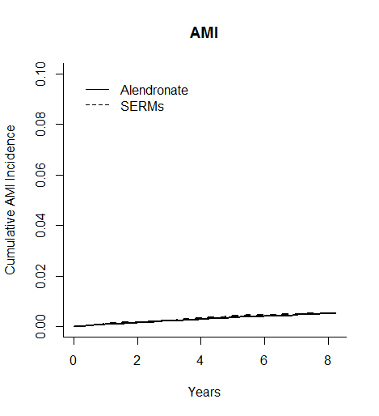
(B)
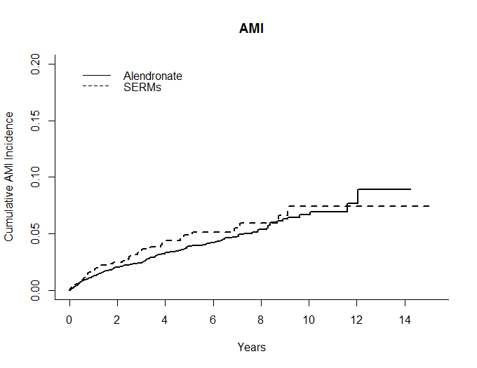
b
a
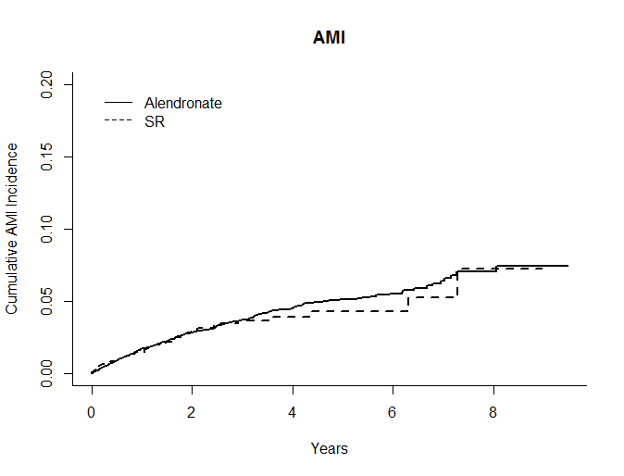
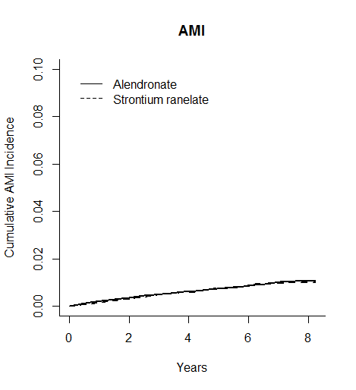
c
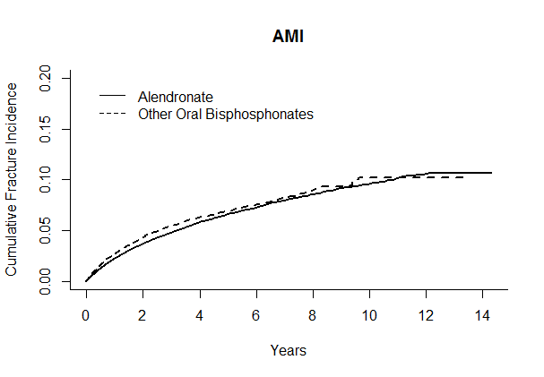
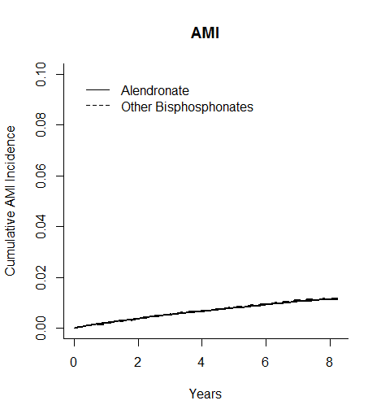
e
d
f
Figure s2 Stratified Forrest Plots for Meta analysis for a subgroup of patients with (a) CKD and with (b) DM
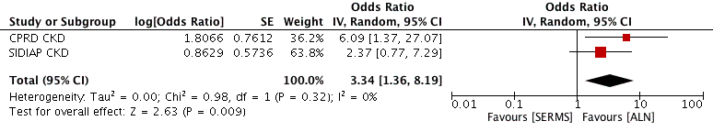
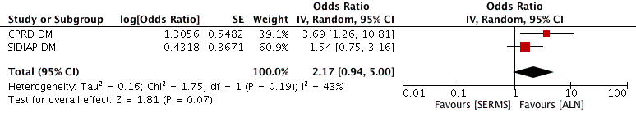

CPRD (a)
 | Alen | OBP |  | Alen | SR |  | Alen | SERMs
Interaction | IR | IR | SHR (95% CI) | IR | IR | SHR (95% CI) | IR | IR | SHR (95% CI)
Obese | 1.50 | 1.86 | 1.13, 1.04-1.24 | 1.13 | 1.07 | 0.818, 0.521-1.28 | 0.86 | 0.94 | 1.1, 0.738-1.64
Not Obese | 1.84 | 2.10 | 1.07, 0.971-1.18 | 1.92 | 2.08 | 0.903, 0.633-1.29 | 0.73 | 1.28 | 1.71 , 1.05 -2.79
Steroid User | 2.25 | 2.59 | 1.07, 0.963-1.19 | 2.26 | 0.80 | 0.295, 0.108-0.802 | 1.17 | 1.86 | 1.57,0.773-3.17
Non Steroid User | 1.41 | 1.71 | 1.12,1.03-1.22 | 1.73 | 1.64 | 0.779, 0.585-1.04 | 0.82 | 0.95 | 1.14,0.813-1.6
Previous Fracture | 1.74 | 2.01 | 1.1,0.834-1.46 | 1.93 | 0.99 | 0.426, 0.186-0.977 | 0.41 | 3.42 | 6.58, 0.452 -95.9
No Previous Fracture | 1.64 | 1.96 | 1.1, 1.03-1.18 | 1.78 | 1.63 | 0.759, 0.567-1.01 | 0.86 | 1.04 | 1.19, 0.873-1.62
Chronic Kid Fail | 2.61 | 2.52 | 0.951,0.748-1.21 | 1.95 | 1.44 | 0.645, 0.337-1.23 | 1.34 | 7.36 | 6.09, 1.37-27.2
No Chronic Kid Fail | 1.59 | 1.93 | 1.12, 1.04-1.2 | 1.28 | 1.55 | 1.06, 0.776-1.45 | 0.85 | 0.98 | 1.14, 0.829-1.57
Has diabetes | 2.57 | 2.91 | 1.09,0.886-1.34 | 2.83 | 3.06 | 0.903, 0.477-1.71 | 1.05 | 3.91 | 3.69, 1.26-10.8
No Diabetes | 1.58 | 1.89 | 1.1 , 1.03 -1.18 | 1.70 | 1.36 | 0.662, 0.488-0.897 | 0.85 | 0.96 | 1.11, 0.803-1.54
Has Dementia | 1.42 | 1.20 | 0.873,0.458-1.66 | 1.22 | 0.87 | 0.686, 0.194-2.42 | 0.00 | 0.00 | na
No Dementia | 1.59 | 1.98 | 1.18, 1.1-1.26 | 1.53 | 1.59 | 0.928, 0.697-1.24 | 0.81 | 1.06 | 1.33, 0.968-1.81
Table S1Comparison of interactions between CPRD (a)and SIDIAP (b)

SIDIAP (b)
 | Alen | OBP |  | Alen | SR |  | Alen | SERMs
Interaction | IR | IR | SHR (95% CI) | IR | IR | SHR (95% CI) | IR | IR | SHR (95% CI)
Obese | 0.19 | 0.15 | 0.792, 0.622-1.01 | 0.18 | 0.15 | 0.841, 0.588-1.2 | 0.12 | 0.09 | 0.808, 0.428-1.53
Not Obese | 0.16 | 0.18 | 1.18, 0.998-1.39 | 0.14 | 0.15 | 1.05, 0.8-1.38 | 0.05 | 0.07 | 1.27, 0.758-2.11
Steroid User | 0.22 | 0.24 | 1.14, 0.797-1.64 | 0.21 | 0.30 | 1.52, 0.841-2.75 | 0.04 | 0.10 | 2.39, 0.418-13.6
Non Steroid User | 0.16 | 0.16 | 1.02, 0.878-1.18 | 0.15 | 0.13 | 0.908, 0.719-1.15 | 0.07 | 0.07 | 1.01, 0.668-1.51
Previous Fracture | 0.19 | 0.21 | 1.2, 0.838-1.73 | 0.17 | 0.14 | 0.897, 0.489-1.65 | 0.06 | 0.16 | 2.45, 0.691-8.69
No Previous Fracture | 0.16 | 0.16 | 1.01, 0.876-1.18 | 0.15 | 0.15 | 0.98, 0.777-1.24 | 0.07 | 0.07 | 0.966, 0.635-1.47
Chronic Kid Fail | 0.34 | 0.30 | 0.922, 0.634-1.34 | 0.29 | 0.25 | 0.881, 0.469-1.65 | 0.16 | 0.39 | 2.37, 0.422-0.772
No Chronic Kid Fail | 0.15 | 0.16 | 1.06, 0.913-1.2 | 0.15 | 0.14 | 0.978, 0.777-1.23 | 0.07 | 0.07 | 0.956, 0.624-1.47
Has diabetes | 0.38 | 0.40 | 1.1, 0.857-1.42 | 0.37 | 0.34 | 0.936, 0.626 -1.4 | 0.27 | 0.41 | 1.54, 0.752-3.15
No Diabetes | 0.14 | 0.13 | 1.01, 0.856-1.18 | 0.12 | 0.12 | 0.981, 0.759-1.27 | 0.06 | 0.05 | 0.927, 0.574-1.5
Has Dementia | 0.32 | 0.27 | 0.887, 0.398-1.97 | 0.11 | 0.42 | 3.24, 0.242-43.3 | 0.32 | 0.28 | 0.951, 0.271-3.34
No Dementia | 0.16 | 0.17 | 1.04, 0.905-1.19 | 0.07 | 0.07 | 1.04, 0.694-1.55 | 0.15 | 0.14 | 0.977, 0.784-1.22

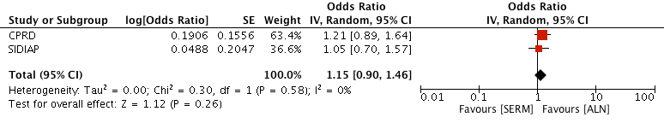
Figure S3: AMI relative risk (SHR) amongst SERM users compared to alendronate users, after meta-analyzing data from CPRD and SIDIAP datasets

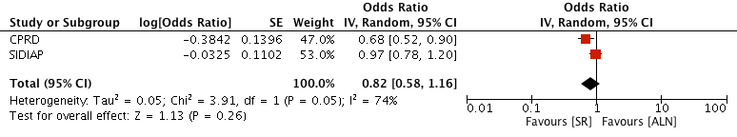
Figure S4: AMI relative risk (SHR) amongst strontium ranelate users compared to alendronate users, after meta-analyzing data from CPRD and SIDIAP datasets.
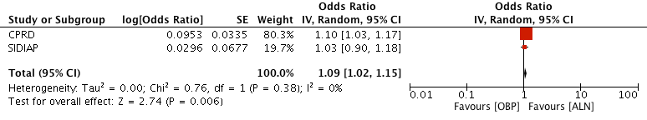
Figure S5: AMI relative risk (SHR) amongst other bisphosphonate users compared to alendronate users, after meta-analyzing data from CPRD and SIDIAP datasets

