Article
Study on the surface modification of nanostructured Ti alloys and coarse-grained Ti alloys
Hsuan-Kai Lin ¹, Yi-Hong Cheng ¹, Guan Yuan Li ¹, Ying-Chi Chen ¹, Piotr Bazarnik ², Jessica Muzy ³, Yi Huang ^{4,5,}* and Terence G. Langdon ⁵
Citation: Lastname, F.; Lastname, F.; Lastname, F. Title. Metals 2021, 11, x. https://doi.org/10.3390/xxxxx
Academic Editor: Firstname Lastname
Received: date
Accepted: date
Published: date
Publisher’s Note: MDPI stays neutral with regard to jurisdictional claims in published maps and institutional affiliations.
Copyright: © 2021 by the authors. Submitted for possible open access publication under the terms and conditions of the Creative Commons Attribution (CC BY) license (http://creativecommons.org/licenses/by/4.0/).
¹ Graduate Institute of Materials Engineering, National Pingtung University of Science and Technology, Pingtung 912, Taiwan; hklin@mail.npust.edu.tw (H.-K.L.); xswzaq86248@gmail.com (Y.-H.C.); csb20491@gmail.com (G.Y.L.); peicih840228@gmail.com (Y.-C.C.)
² Warsaw University of Technology, Faculty of Materials Science and Engineering, Woloska 141, 02-507, Poland; Piotr.Bazarnik@pw.edu.pl
³ Phelma - School of Engineering in Physics, Electronics and Materials, 38016 Grenoble Cedex 1, France; Jessica.Muzy1@grenoble-inp.org
⁴ Department of Design and Engineering, Faculty of Science and Technology, Bournemouth University, Poole, Dorset BH12 5BB, UK; yhuang2@bournemouth.ac.uk
⁵ Materials Research Group, Department of Mechanical Engineering, University of Southampton, Southampton SO17 1BJ, UK; langdon@soton.ac.uk
* Correspondence: yhuang2@bournemouth.ac.uk; Tel.: +44 1202 961295
Abstract: Commercial purity titanium (CP-Ti) and a Ti-6Al-4V alloy (Ti64) were processed by high-pressure torsion (HPT) to 10 and 20 turns. The HPT processing produced a nanostructured microstructure and a significant strength enhancement in the CP-Ti and Ti64 samples. After 20 turns the samples of HPT-processed CP-Ti and Ti64 were subjected to laser surface treatments in an air atmosphere using different scanning speeds and laser powers. The surface roughness of the laser-modified samples increased with increasing laser power and this produced a hydrophilicity due to a lower contact angle. After a holding time of 27 days, these samples underwent a hydrophilic-to-hydrophobic transformation as the contact angle increased from 13° to as much as 120° for the CP-Ti sample and for the Ti64 sample the contact angle increased from 10° to 126°. In addition, the laser surface modification process was carried out with different atmospheres (air, vacuum and O₂) on heat-treated but unstrained CP-Ti and Ti64 samples and the contact angle changed due to the surface element content. Thus, as the carbon content increased from 28% to 47% in CP-Ti in vacuum environment, the surface contact angle increased from 22° to 140°. When a laser surface modification process is conducted under oxygen-less conditions, it is concluded that the contact angle increases rapidly in order to control the hydrophobic properties of Ti and the Ti alloy.
Keywords: CP-Ti; high-pressure torsion; hydrophobic; laser surface modification; Ti-6Al-4V

1. Introduction
With the rapid development of modern science and technology, the introduction of new and modified materials has become attractive within materials science. Titanium alloys are a popular material for biomedical applications due to their high mechanical strength, excellent biocompatibility and good corrosion resistance [1-3]. There are reports where other elements are added to Ti alloys and this may enhance their properties by producing lower densities and improved biocompatibility and corrosion resistance [4]. In general, the mechanical properties of high purity Ti are lower than for titanium alloys, such as the Ti-6Al-4V alloy, and therefore the mechanical strength is generally improved through the application of thermo-mechanical processing.
In practice, the application of severe plastic deformation (SPD) is a beneficial procedure for refining the grain structure and enhancing the mechanical strength of many metals and alloys. For example, the procedures of accumulative roll-bonding (ARB) [5], equal-channel angular pressing (ECAP) [6] and high-pressure torsion (HPT) [7] are effective SPD procedures that have been used very extensively for achieving ultrafine-grain structures in a wide range of materials [8-13]. However, ECAP processing is normally conducted at a high temperature [14] whereas HPT processing can be carried out at room temperature due to the very high hydrostatic pressure which prevents segmentation and cracking during the processing operation [15]. As a result, HPT is preferred in Ti alloys for achieving grain refinement and strength enhancement.
Wettability is an important role in a variety of surface-related phenomena and the surface characteristics of ultrafine-grained materials have a significant impact on their performance in industry and biomedicine [16, 17]. Superhydrophobic surfaces have many attractive features including self-cleaning, heat transfer and corrosion [18] and they are used widely in different fields such as in anti-ice applications in aeronautics [19]. There are some reports of a difference between lotus leaves, which have recognized superhydrophobic surfaces, and the superhydrophobic effect associated with metallic surfaces because the effect in lotus leaves is due to their dual-scale roughness at both the coarse micrometer and nanometer scales [20-22]. In addition, hydrophilic phenomena provide a good tissue adhesion on implants and are designed for rapid cell-cell communications [22, 23]. For example, a titanium alloy may be treated by acid etching or sandblasting to become bioactive and thereby improve the connectivity between the bone implants and the surrounding tissue [24-26]. Obviously, therefore, surface modifications of engineering metals and alloys are essential in order to control and optimize their fundamental properties.
Various surface modification techniques are now available including thermal spraying, mechanical treatment, chemical treatments, laser texturing and sol–gel processing. In practice, it has been demonstrated that a laser modification is a useful tool for modifying the surface topography at the micro/nano scale [27-29] and to date there are reports demonstrating the feasibility of generating hydrophobic or hydrophilic characteristics on coarse-grained metals by laser surface machining [30, 31]. Nevertheless, only a few studies are at present available investigating the potential for combining both a modification of the surface properties and an improvement in the mechanical strength of ultrafine-grained Ti alloys [32]. The wetting behavior of a surface is significantly affected by the chemical composition and roughness as described in the classic and early models of Wenzel [33] and Cassie-Baxter [34] and the wetting properties of Ti alloy are controlled by roughness so that the contact angle can be changed through two different states on rough solids [35]. It was reported that after laser surface treatment the melted and re-solidified metal oxide on the surface can absorb organic compounds in ambient air leading to surface hydrophobicity [36-38]. Thus, as the observation period increases so the contact angle also increases and this means that the surface behavior changes from a hydrophilic to a hydrophobic state due to the local composition.
In general, it is apparent that high energy metal oxides are generated during laser processing and this leads to a hydrophilic behavior so that the wettability of the surfaces changes over time from hydrophilicity to superhydrophobicity [39]. Most investigations to date have only explored tuning the wettability by laser texturing in an air atmosphere [40]. For example, it was shown that the processing atmosphere can accelerate or slow down the wettability transition thereby extending the durability of the superhydrophilic surfaces [41] and it was also reported that wettability differences existed between samples processed under various atmospheres so that the overall wettability tendencies were contributed by a combination of surface chemistry and the topographic effects for all surfaces [42-45].
Due to limited information available to date on the laser surface modifications on nanostructured Ti alloys, the present study was initiated to examine the surface morphology of HPT-processed samples of pure Ti and a Ti-6Al-4V alloy after laser surface treatment using different laser powers, speeds and holding times. This study will investigate different methods to fabricate a hydrophobic surface which can be used in medical devices. An examination was also conducted to evaluate the effects of the chemical compositions processed in different environments in creating either superhydrophilic or superhydrophobic surfaces.

2. Materials and Methods
A sample of grade 2 commercial purity (CP) titanium (99.4% Ti) was purchased from Titanium Industries UK, Ltd. (Birmingham, UK) in the form of a round bar with a diameter of 12.7 mm. A sample of the Ti-6Al-4V (Ti64) alloy was obtained from GoodFellow Cambridge Ltd., UK, in the form of a round bar with a diameter of 10.0 mm. Typical composition analysis of Ti64 (in ppm) shows that it contains Fe 300, C 220, H 100, N 100 and O 650 in addition to Al 6% and V 4%. The as-received CP-Ti was annealed at 973 K for 2 h in a vacuum furnace and the as-received Ti64 was heat treated in two steps with an initial solution anneal at 1323 K for 45 min followed by a stress relief annealing at 873 K for 3 h and then furnace cooling to room temperature. After the heat treatments, both the CP-Ti and the Ti64 rods were machined and cut into disc samples with diameters of 10 mm and thicknesses of ~0.8 mm [46].
Both the CP-Ti and the Ti64 disc samples were processed to totals of 10 or 20 turns by HPT at room temperature under an imposed pressure of 6.0 GPa using a rotational speed of 1 rpm. The principle of processing by HPT is illustrated schematically in Fig. 1(a) [47]. The sample is generally in the form of a thin disc and it is placed between two massive anvils, subjected to a pressure P and then torsionally strained through rotation of either the lower or upper anvil. The HPT facility operated under quasi-constrained conditions where there is a small outflow of material around the periphery of the disc during the torsional straining [48, 49]. Fig. 1(b) shows the disc samples before and after HPT processing, with the flash at the edge of the disc after HPT processing. For CP-Ti and the Ti64 alloy, the heat treated but unstrained samples are designated as N0 whereas the HPT-processed 10 and 20 turns samples are designated as N10 and N20, respectively. For optical microstructure observations of CP-Ti and Ti64, the samples were finally polished using a colloidal silica solution, then etched with Kroll reagent (2% HF + 10% HNO₃ + 88% H₂O) for a few seconds. The optical microstructures of both CP-Ti and Ti64 samples were examined using an Olympus BX51 optical microscope (OM). The deformation microstructures of CP-Ti and Ti64 after 10 or 20 turns of HPT processing were characterized using a JEOL1200 transmission electron microscope (TEM) operating under an acerating voltage of 120 kV. The standard 3 mm TEM disc samples were always taken from about 4 mm from the centres of the HPT-processed discs. The grain sizes of HPT-processed samples were measured using the linear intercept method with image J with at least 30 grains measured from TEM images and the mean grain size value was used for comparison purposes. The microhardness was measured using a hardness tester equipped with a Vickers indenter (FM300, Future-tech Corp.) under a load of 200 gf and with a dwell time of 15 s.

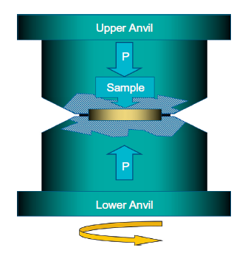 | 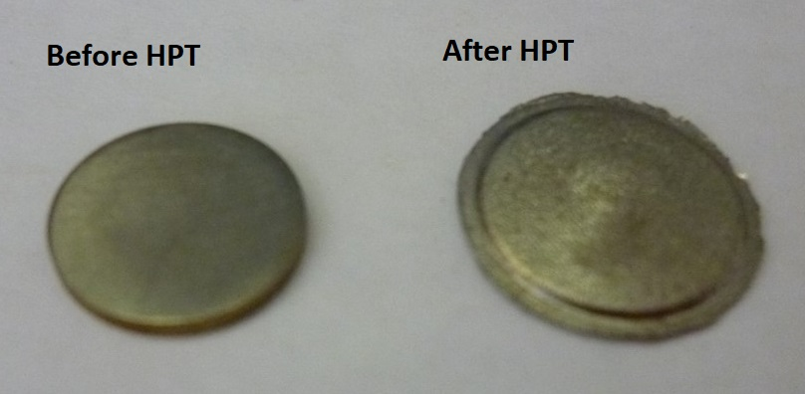
(a) | (b)
Figure 1. (a) Principle of HPT processing [47], (b) Disc samples before and after HPT processing
The surfaces of the HPT-processed samples were modified by laser surface texturing in an air atmosphere using various scanning speeds, laser powers and holding times in order to evaluate the influence of the various laser processing parameters on the surface roughness and hydrophilic/hydrophobic properties. The laser irradiations were performed on the heat treated but unstrained samples in air, vacuum and O₂ atmospheres. The samples for laser treatment were hand-rubbed against the abrasive papers first. Four grades of abrasive papers were used: 800 grit, 1200 grit, 2000 grit and 4000 grit. Then the samples were polished by using alumina powder with a particle size of 0.3 μm. Prior to the laser surface texturing, the samples were further polished by alumina to a roughness of ~56 ± 6 nm. The samples were then surface treated using a fiber laser (SPI G3, UK) with a wavelength of 1064 nm, a repetition rate of 25 kHz, a laser spot size of 40 µm and a pulse duration of > 10 ns. The laser texturing process was carried out in power ranges of 0.9 - 5.0 W and with a scanning speed of 150 mm s⁻¹. Figure 2 shows the configuration of the laser surface treatment system.
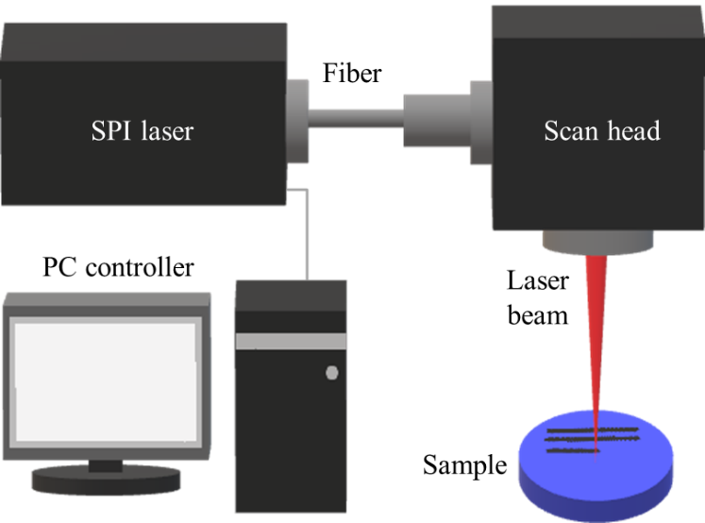
Figure 2. A schematic diagram of the laser system
The surface morphologies of the various laser-treated samples were examined using an optical microscope (HRM-300, Huvitz). The hydrophilic/hydrophobic properties of the surface-modified samples were investigated by measuring the contact angles of droplets of de-ionized water with volumes of 1 µL. In these experiments the contact angle and roughness were measured three times and the average value was used for comparison purposes. The roughness of the laser-modified samples was measured using an Alpha step profiler (D-300, KLA) with a scanning speed of 0.4 mm s⁻¹, a scan line length of 5 mm and a load of 10 mg. The content of element C was measured using analysis with an Auger electron nanoscope (ULVAC-PHI, PHI 700). The laser-treated surfaces were observed over a period from 1 to 27 days in order to fully evaluate the evolution of the surface hydrophilic or hydrophobic characteristics. The surface morphology of laser modified samples was observed by a field-emission scanning electron microscope (SEM) with model JSM-7600F. The microstructures of the Ti-6Al-4V alloy and the surface modified specimens were examined by X-ray Diffractometer (XRD, Bruker D8 Advance). The 2 theta ranges are 20-80 deg and the step mode is 0.03 deg and 0.4 second per step. It should be noted that Cu-Kα radiation (λ = 0.154 nm) at 40 kV and 40 mA was used.

3. Results
Figure 3 shows the microstructures of CP-Ti samples in the as-annealed state and after HPT processing to 10 and 20 turns by OM and TEM observations. In Fig. 3(a) the as-annealed CP-Ti has a coarse grain structure with an average grain size of ~65 µm and an initial hardness value of ~157 Hv.
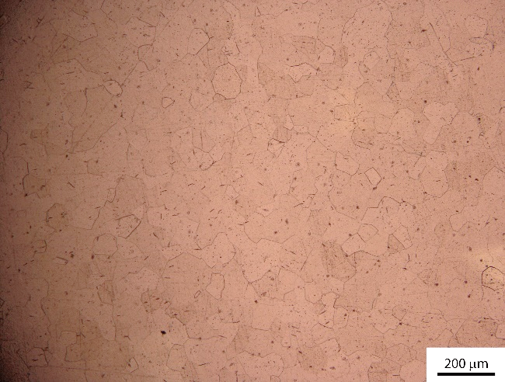
(a)
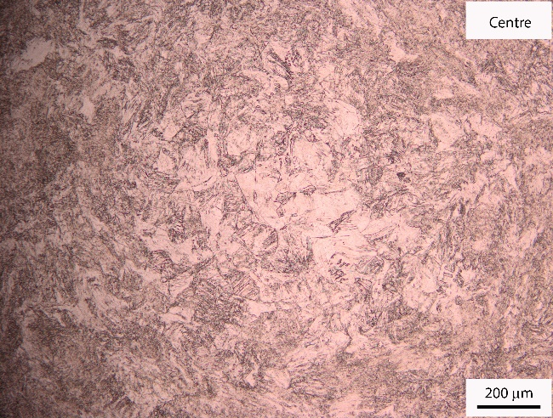 | 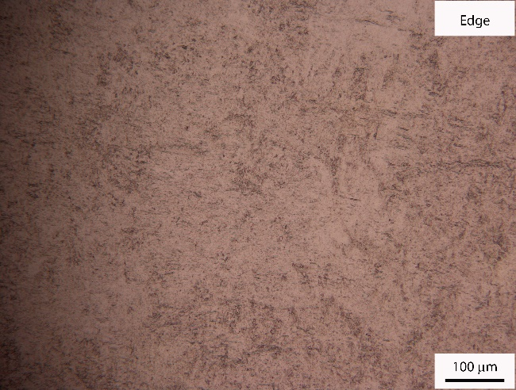
(b) | (c)
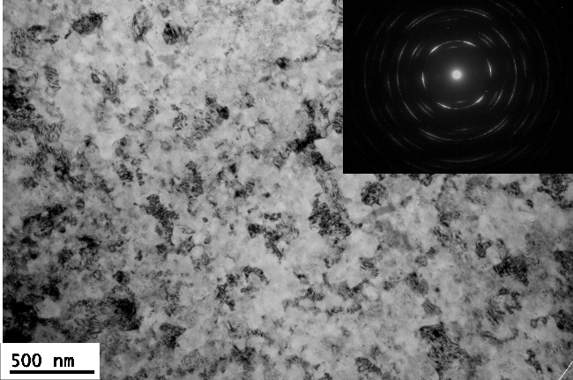 | 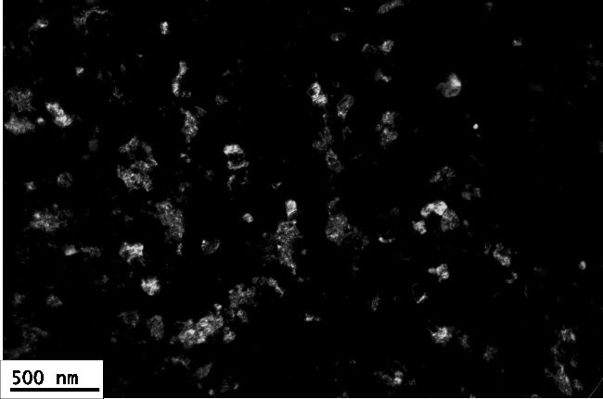
(d) | (e)
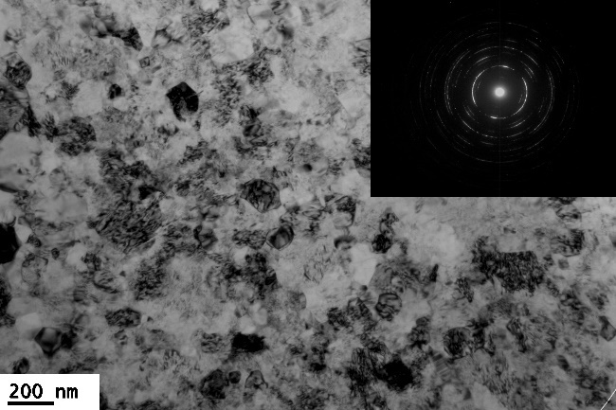 | 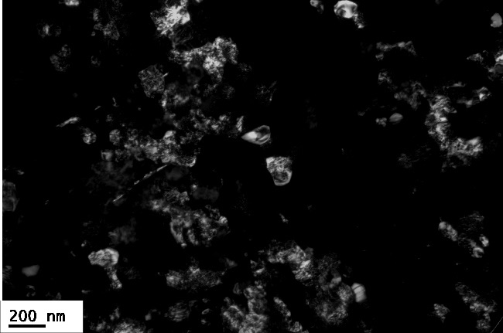
(f) | (g)
Figure 3. Microstructures of CP-Ti in (a) as-annealed state (OM image, magnification 100×), and after HPT processing to (b) 1 turn in disc centre area (OM image, magnification 100×), (c) 1 turn in disc edge area (OM image, magnification 200×), (d) and (e) 10 turns ~4 mm from disc edge area (TEM bright field and dark field images), (f) and (g) 20 turns ~4 mm from disc edge area (TEM bright field and dark field images)
After HPT processing to 1 turn, as shown in Fig. 3(b) and (c), in the disc centre area there remain some coarse grains but the torsional movement is visible because grains began to deform which is different from the as-annealed CP-Ti sample in Fig. 3(a), whereas on the disc edge area it is more difficult to see grains under the optical microscope even at higher magnification because of the heavy shear strain and subsequent grain refinement. The TEM microstructures of CP-Ti after 10 turns and 20 turns HPT processing are shown in Fig. 3(d-g) which include bright and dark field images. The SAD (selected area diffraction) patterns of 10 turns and 20 turns samples were inserted into the top-right corners in Fig. 3(d) and Fig. 3(f), respectively. 10 and 20 turns HPT processing led to the formation of numerous high-angle grain boundaries and ultrafine grains, which are visible in the ring in the relevant SAD patterns. The shapes and sizes of the grains were found to be much easier to recognize in the corresponding dark field images and from Fig. 3(e) and (g) it is clear that most of the ultra-fine grains have equiaxed shapes. Further HPT processing, as shown in the TEM images in Fig. 3(d-g), demonstrate that significant grain refinement was achieved in CP-Ti with a mean grain size of about 70 ± 18 and 60 ± 12 nm after 10 and 20 turns, respectively.

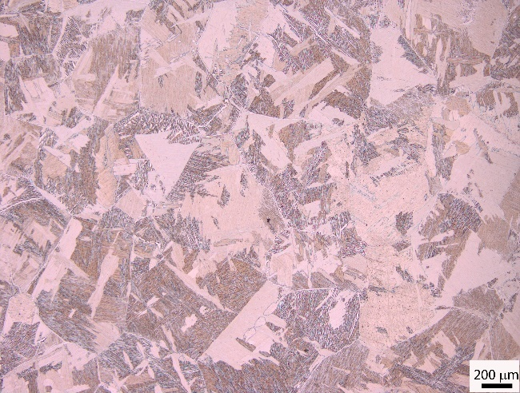 | 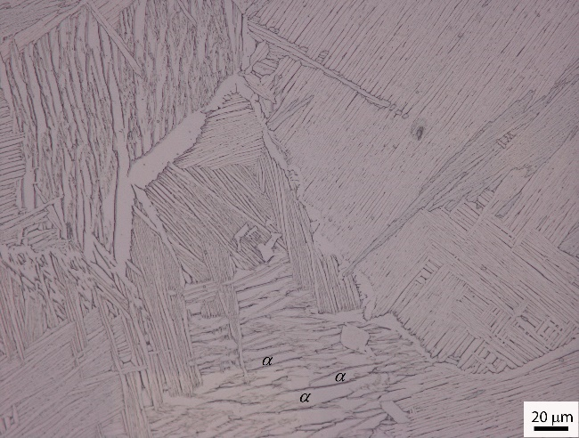
(a) | (b)
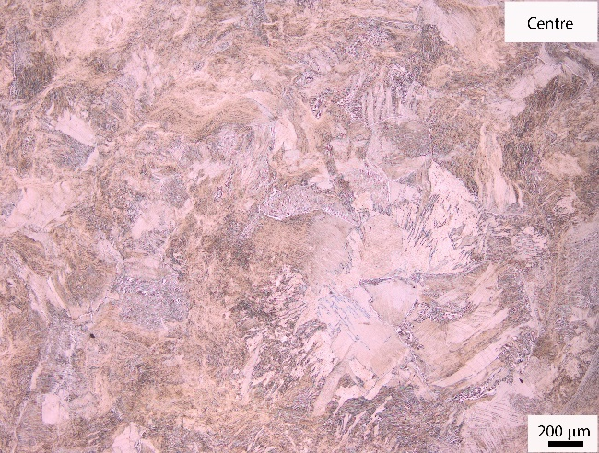 | 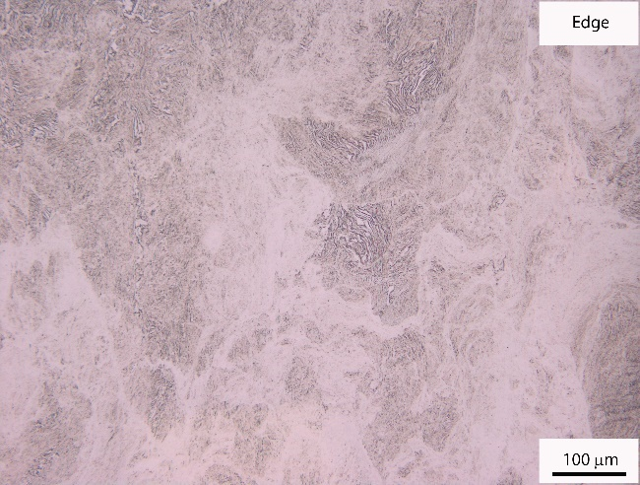
(c) | (d)
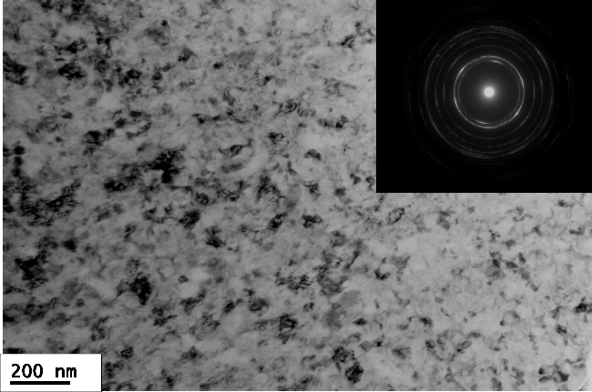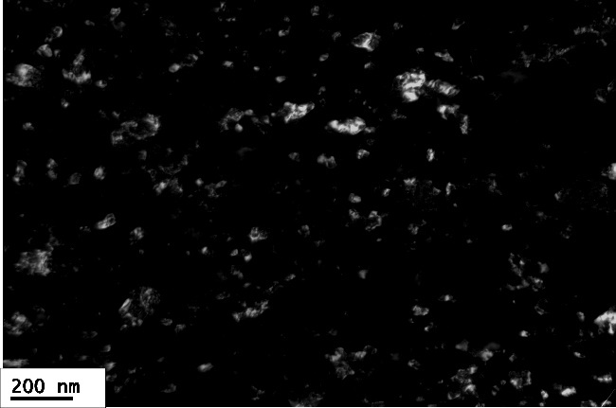
(e) | (f)
Figure 4. Microstructures of Ti64 in (a) as-heat treated condition with low magnification (OM image, magnification 50×), (b) as-heat treated condition with high magnification (OM image, magnification 500×) and after HPT processing (c) 1 turn in disc centre area (OM image, magnification 50×), (d) 1 turn in disc edge area (OM image, magnification 200×), (e) and (f) 10 turns at ~4 mm from disc edge area (TEM bright field and dark field image)
The initial microstructure of the Ti64 alloy after the two-steps heat treatment is shown in Fig. 4(a) and (b) at two different magnifications where lamellar (α+ β) phases are present within the grains. The microstructure obtained by slow cooling from the β phase field contains individual α plates separated by the remaining β matrix. At the low magnification OM image in Fig. 4(a) there is a coarse grain structure with an average grain size of ~540 µm. Whereas in the high magnification OM image in Fig. 4(b) lamellar (α+ β) phases are clearly visible with α plates in light colour and β plates in dark colour, and the thicknesses of the coarse α plates are in the range of ~2-6 μm. Ti64 has an initial hardness value of ~309 Hv for the heat-treated condition. After HPT processing to 1 turn, in the disc centre area the coarse grains and lamellar structures within grains were deformed but they remain visible in Fig. 4(c), whereas in the disc edge area most lamellar (α+ β) phases were fragmented and only a small amount of lamellar (α+ β) phases remained in sparse areas, but the grain structures are too small to be seen in the optical microscope in Fig. 4(d). After HPT processing to 10 turns, there was evidence for significant grain refinement with a mean grain size of about 50 ± 10 nm as shown in Fig. 2(e) and (f). The SAD pattern in Fig. 4(e) became ring-like thereby showing an evolution of grain structures into large numbers of high-angle boundaries.
For the CP-Ti and Ti64, a laser surface modification in an air atmosphere with a repetition rate of 25 kHz and a scanning speed of 150 mm s⁻¹ was applied to the 20 turns HPT-processed samples (the N20 samples) and the heat treated but unstrained samples (the N0 samples). The surface textures of laser treated N0 and N20 samples of CP-Ti and Ti64 are displayed in Fig. 5 from which valleys and hills can be observed on the sample surfaces. These are marks after the laser beam moves on the surface. Fig. 6 shows the effect of different laser powers on the contact angle and surface roughness in both CP-Ti and Ti64. For the N0 samples, as shown in Fig. 6(a), the roughness of the Ti64 alloy was smaller than CP-Ti when the applied laser power was smaller than 2 W but the roughness of the Ti64 samples became larger than for CP-Ti when the laser power increased above ~3 W. For the N20 samples, the roughness of Ti64 was significantly larger than for CP-Ti when the applied laser power was 5 W, as shown in Fig. 6(b). Fig. 7 shows the observations of the surface morphology in the laser treated zone of the laser modified CP-Ti and Ti64 samples with different holding times (1 day and 14 days) after applying a laser power of 5 W in air atmosphere. Only 1 day after laser treatment, the surface morphology of Ti64 N20 samples shows more bumps than in CP-Ti N20 samples, as shown in Fig. 7(c) and (g), which confirms the larger roughness value of Ti64 N20 sample than CP-Ti N20 sample in Fig. 6(b). The roughness measurements in Fig. 6(a) matched with the surface morphology observations in CP-Ti N0 and Ti64 N0 samples in Fig. 7(a) and (e) as well. Whereas comparing Fig. 6(a) and (b), it is concluded that the roughness of the laser-treated N20 samples was rougher than for the N0 samples in Ti64 but there was no significant difference in the roughness values between the N20 and the N0 samples in CP-Ti. For the N20 samples as shown in Fig. 6(b), the contact angles of Ti64 and CP-Ti were measured as ~11° and ~17°, respectively, when the applied laser power was 5 W. It is readily apparent that Ti64 is more hydrophilic than CP-Ti for samples processed to 20 turns by HPT and, in addition, the N20 CP-Ti sample has both a lower roughness and a higher contact angle compared with the Ti64 alloy.
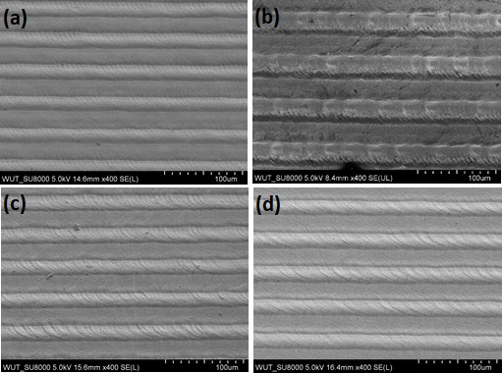
Figure 5. SEM images of the laser textured surfaces in (a) CP-Ti N0, (b) CP-Ti N20, (c) Ti64 N0 and (d) Ti64 N20 samples
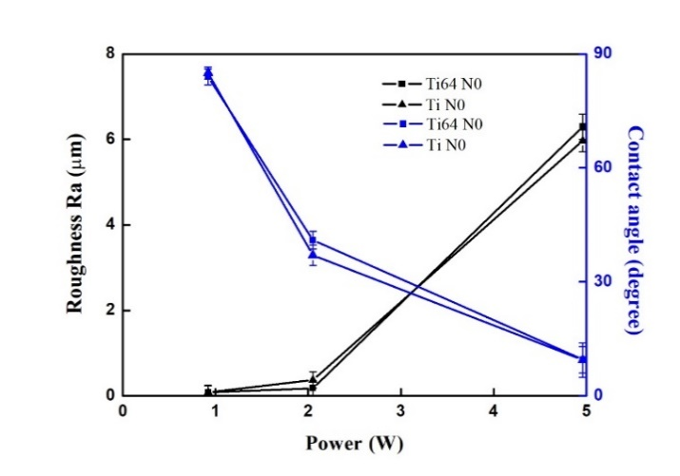 | 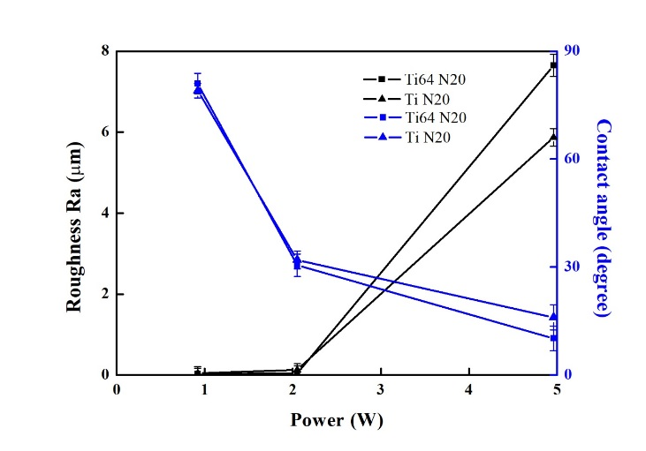
(a) | (b)
Figure 6. The roughness and contact angle of the CP-Ti and Ti64 samples for (a) N0 and (b) N20 after laser surface modification in an air atmosphere
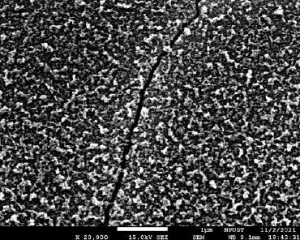 | 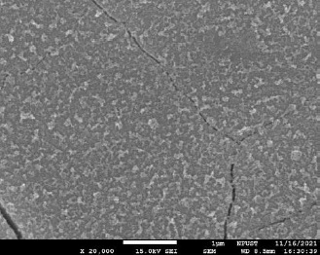
(a) | (b)
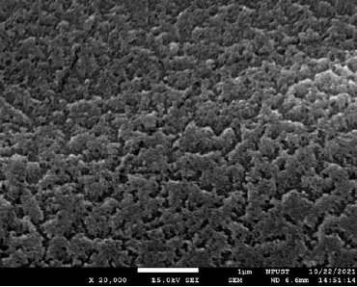 | 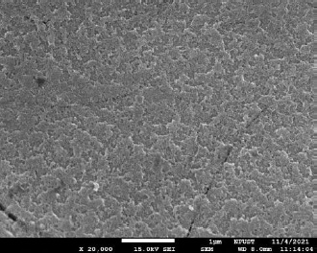
(c) | (d)
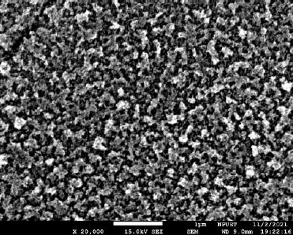 | 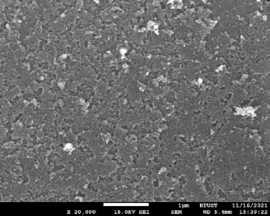
(e) | (f)
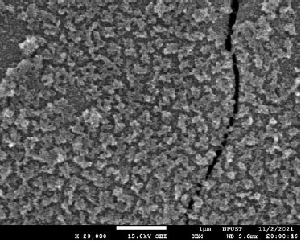 | 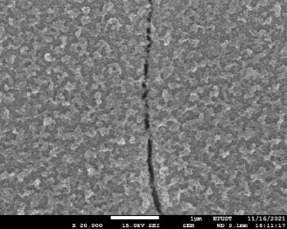
(g) | (h)
Figure 7. SEM images of the surface observations on laser modified samples with different holding times (1 day and 14 days) after applying 5W laser power in air atmosphere (a) CP-Ti N0 sample, 1 day, (b) CP-Ti N0 sample, 14 days, (c) CP-Ti N20 sample, 1 day, (d) CP-Ti N20 sample, 14 days, (e) Ti64 N0 sample, 1 day, (f) Ti64 N0 sample, 14 days (g) Ti64 N20 sample, 1 day, (h) Ti64 N20 sample, 14 days
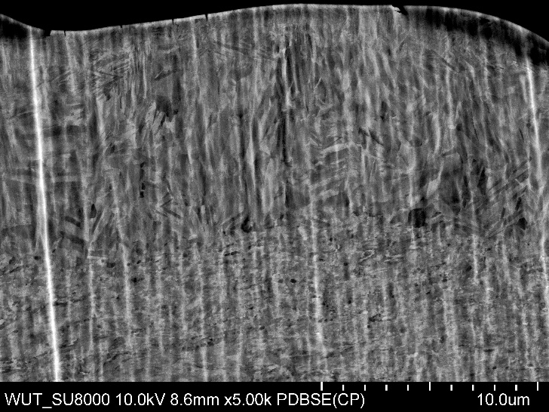
(a)
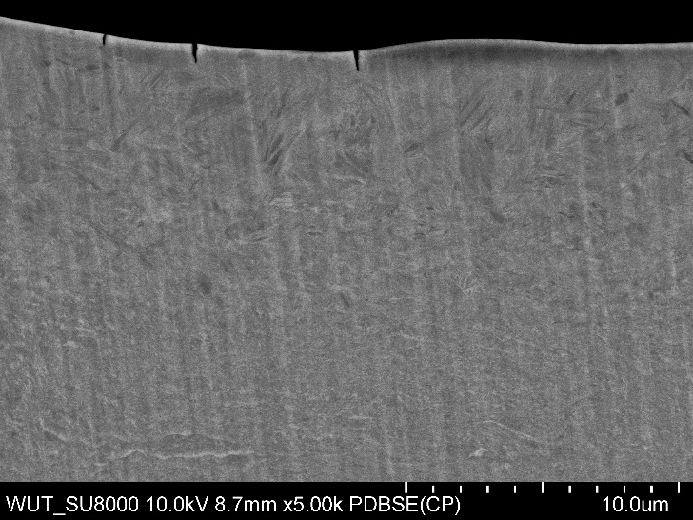 | 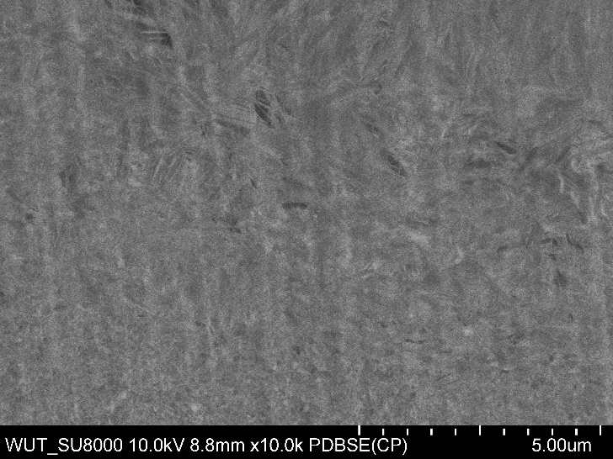
(b) | (c)
Figure 8. SEM cross-sectional images of laser modified samples after 14 days for (a) CP-Ti N20 sample, (b) Ti64 N20 sample (low magnification) and (c) Ti64 N20 sample (high magnification)
The SEM cross-section observations of laser treated ultrafine-grained CP-Ti and Ti64 (HPT-processed N20 samples) are displayed in Fig. 8. For CP-Ti N20 sample, Fig. 8(a) clearly shows the microstructure difference between upper and bottom part of the cross-section, where the upper part has coarse-grained microstructure due to laser surface modification whereas bottom part is far from surface and therefore remains the matrix ultrafine-grained microstructure. Measurements from Fig. 8(a) demonstrate that microstructure coarsening occurred from surface to about 12 µm in depth in CP-Ti N20 sample. Similar microstructure coarsening phenomena was observed in Ti64 N20 sample as well. The boundary between coarse-grained and ultrafine-grained area is not very clear in Fig. 8(b), but it is still identifiable in high magnification image in Fig. 8(c). The microstructure coarsening due to laser modification on Ti64 N20 sample occurred from surface to a depth of about 10 µm.
The XRD patterns of the HPT-processed and the surface modified Ti64 specimens at a laser power of 5 W are shown in Fig. 9. Before HPT processing, the β(110) peak could be detected in the heat treated but unstrained N0 sample. After HPT processing to 20 turns, the microstructure of Ti64 has α phase with detected peaks of (10-10)α, (0002)α, (10-11)α and (10-12)α, but no β(110) peak was detected. Laser treated Ti64 N20 sample show a similar X-ray pattern as that of HPT-processed N20 sample, but no obvious TiO₂ structures were detected. Considering the low laser power applied (5 W) in the current research, it is assumed that the TiO₂ layer could be too thin for detection by X-ray.
N0 samples of CP-Ti and Ti64 were selected for laser treatment under different atmospheres of vacuum, air and oxygen with a laser power of 5 W and a scanning speed of 150 mm s⁻¹ in order to evaluate the effect of laser treatment atmosphere on surface modifications. The relationship between the contact angle and the holding time (in days) is shown in Fig. 10. It is apparent that the surface contact angle increases with an increase in the holding time and the contact angle of samples laser-treated in vacuum shows that the samples are more hydrophobic than those laser-treated in the O₂ atmosphere. The contact angles of CP-Ti and Ti64 laser-treated in a vacuum were 140° and 145°, respectively, after 27 days. By contrast, the contact angles of CP-Ti and Ti64 in the O₂ atmosphere after 27 days were only 22° and 68°, respectively. Fig. 11 shows the contact angle images for CP-Ti with different atmospheres after 27 days holding time, where it is apparent that laser treated CP-Ti in an O₂ atmosphere has a smaller contact angle than when laser treated in vacuum and air atmospheres. It is necessary to mention that any given atmosphere (air, vacuum and O₂) laser treatment and with an increase in the subsequent holding time can lead to a transformation from hydrophilic-to-hydrophobic properties.
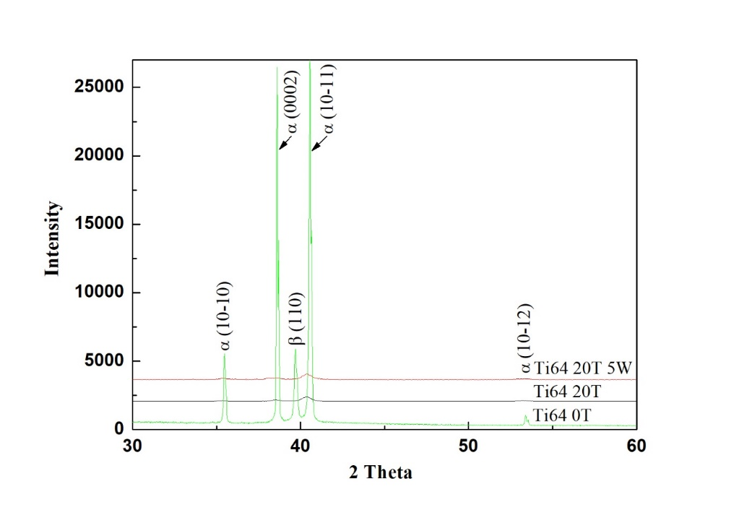
Figure 9. XRD spectra of the heat treated but unstrained N0 sample, HPT-processed N20 sample and the surface modified N20 sample of Ti64 at a laser power of 5 W
Figure 10. The contact angle versus the holding time (in days) for the N0 samples of CP-Ti and Ti64 measured separately in vacuum and oxygen atmospheres
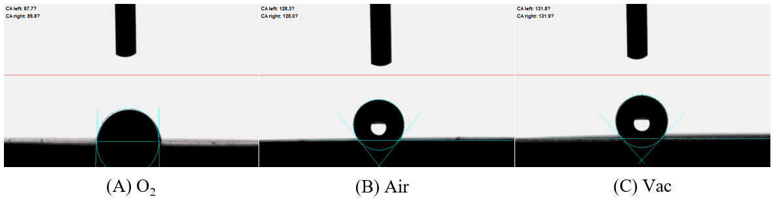
Figure 11. The contact angle images for CP-Ti with different atmospheres after 27 days holding time
According to these results in Fig. 10, it is anticipated that the different atmospheres will produce different carbon and oxygen contents as a study reported that different wettability was found to be a consequence of changes in surface chemistry [50]. Therefore, the various samples were examined using Auger electron nanoscope analysis. The relationship between the carbon and oxygen content and the holding time is shown for all samples in Fig. 12. In Fig. 12(a) the variations of the carbon content with holding time is presented for the laser-treated CP-Ti and Ti64 in vacuum and in an air atmosphere. Thus, when the surface carbon content of the CP-Ti sample is 47% after 27 holding days in Fig. 12(a) the contact angle reaches 140º (as shown in Fig. 10) for laser treatment in the vacuum atmosphere. Comparing the carbon content in Fig. 12(a) with the corresponding contact angles in Fig. 10, the result demonstrates that the contact angle increases when the carbon content is higher. By contrast, laser treatment in the oxygen environment leads to a mass production of oxygen as shown in Fig. 12(b) and then a reduction in the formation of carbon. In addition, the contact angle in the oxygen environment increases with increasing holding time at a lower rate than recorded in the vacuum or air atmospheres as shown in Fig. 10.
(a) | (b)
Figure 12. The variations of the concentration of chemical elements in the laser modified surface with different holding times during different atmospheres in the N0 samples of CP-Ti and Ti64 for (a) the carbon content and (b) the oxygen content.
Figure 13. The relationship between the holding time and the measured values of the contact angles for CP-Ti and Ti64 samples treated in an air atmosphere with a laser power 5 W
The N0 and N20 samples were treated in the air atmosphere with a laser power of 5 W and a scanning speed of 150 mm s⁻¹ in order to obtain different surface modifications. After the laser modification, the contact angles of the N0 and N20 CP-Ti samples were 13° and 10°, and for Ti64 the angles for the N0 and N20 samples were both equal to 10°. The relationships between the holding time and the measured contact angles for the CP-Ti and Ti64 samples placed in an air atmosphere are shown in Fig. 13. It is readily apparent that, although there is some scatter in the individual datum points, the average contact angle of the N0 CP-Ti sample increased from 13° to 120° after 27 days and that of the N0 Ti64 sample increased from 10° to 117°. Obviously, laser treatment in air and subsequent holding for 27 days can lead the surface of treated samples to transform from hydrophilic-to-hydrophobic. Fig. 7(b), (d), (f) and (h) shows the surface morphology after 14 days of laser treatment in the CP-Ti N0 sample, CP-Ti N20 sample, Ti64 N0 sample and Ti64 N20 sample. Comparing the surface morphology after 1 day of laser treatment with that after 14 days of laser treat-ment in Fig. 7, it is found that the surface texture of each sample changed to less bumps and therefore contributed to high contact angles after 14 days. It is important to mention that the cracks in the surface morphology images shown in Fig. 7 may be related to the laser power. There are several reports [51, 52] that thermal input, shock waves and thermal accumulations would result in the form of cracking. In practice, these defects could be decreased by using femtosecond (short pulse width) or ultraviolet (short wavelength) lasers.

4. Discussion
The use of HPT processing was conducted in this research in order to produce an ultrafine-grained microstructure in CP-Ti and a Ti64 alloy. Lower numbers of HPT processing, for example 1 turn of processing, led to a microstructure difference in the disc centre and edge area in both CP-Ti and Ti64 as shown in Fig. 3(b-c) and Fig. 4(c-d), which is consistent with a rigid body assumption that strain imposed on the disc has a linear dependence on the distance from the disc centre and the strain is a maximum value at the outer edge of the disc [53]. It is seen that at the beginning of torsion the accumulated plastic strain increases mostly at the edge of the sample, while it is nearly zero in the central portion of the sample. This region of zero strain shrinks gradually with the progress of straining. Strain gradient plasticity modelling of high-pressure torsion [54] confirms that 5 turns are sufficient to obtain a nearly uniform distribution of strain across the entire HPT sample. So, as the HPT numbers of turns increase to 10 or 20 turns, samples should have more homogeneous microstructures along the disc diameter. The mean grain sizes of about 70 ± 18 nm and ~60 ± 12 nm after 10 turns and 20 turns for the CP-Ti samples, as shown in Fig. 3(d-g), demonstrates that the nanostructured CP-Ti was produced through the heavy shear deformation. There is a report that when the HPT numbers of turns is sufficiently high it is possible to achieve a saturation in the ultrafine-grained microstructure [55]. Fig. 4(e-f) shows that significant grain refinement occurred after 10 turns of the Ti64 sample with a mean grain size of about 50 ± 10 nm. However, the average hardness values after 10 and 20 turns for the Ti64 samples were measured as ~385 Hv and ~390 Hv, respectively, and this is consistent with the development of a saturation in the microstructural conditions during HPT processing, so that it is reasonable to suggest the grain size in the 20 turns sample is similar to or even smaller than the grain size developed in the 10 turns sample.
It is obvious that, through HPT processing to 20 turns, nanograined structures were developed in both the CP-Ti and the Ti64 alloy with both materials exhibiting significant grain refinements. Based on the analysis of the results in Figs. 3 – 4, it is concluded that 20 turns of HPT processing will produce a mean grain size of about 50 ± 10 nm or even smaller in Ti64, but in CP-Ti the mean grain size is about 60 ± 12 nm.
The surface of HPT-processed N20 samples (with nanograined microstructures) and heat-treated but unstrained N0 samples (with coarse-grained microstructures) were modified by the laser surface texturing in air to evaluate the influence of the laser processing parameters on the surface roughness and the hydrophilic/hydrophobic properties. After the laser surface texturing, the surface contact angle of all samples was hydrophilic as shown in Fig. 6. Comparing Fig. 6(a) with Fig. 6(b), there was no significant difference in the roughness values between the nanostructured N20 sample and the coarse-grained N0 sample of CP-Ti, but the nanostructured N20 sample showed a higher contact angle than the coarse-grained N0 sample. Whereas in Ti64, the roughness of the nanostructured N20 samples was rougher than for the coarse-grained N0 samples, but the nanostructured N20 sample showed similar contact angle to the coarse-grained N0 sample. Obviously, nanostructured CP-Ti and Ti64 have slightly different response to the laser treatment of corresponding coarse-grained materials. It is also apparent that the surface contact angle increases with an increase in the holding time for all samples treated in air atmosphere as displayed in Fig. 13. Accordingly, it can be seen that when the surface roughness is increased in HPT-processed ultrafine-grained materials so the surface contact angle changes from hydrophilic to super-hydrophilic. These phenomena are directly related to the traditional Wenzel model [33] in which the surface roughness directly affects the surface contact angle [56].
The coarse-grained CP-Ti and Ti64 (the N0 samples) were laser treated under different environments of vacuum, air and oxygen. Figure 10 shows that the contact angles of the samples laser treated in vacuum and air atmospheres are more hydrophobic than samples laser treated in an O₂ atmosphere. The rough surface geometry and the low surface-energy chemical are widely known to be critical for achieving hydrophobicity, particularly on metal surfaces. In the O₂ atmosphere, the surface still absorbs organic compounds but the increasing rate of contact angle became slower than samples laser treated in vacuum and air atmospheres, with the result that the contact angles of CP-Ti and Ti64 are smaller than those of samples treated in vacuum and air atmospheres as shown in Fig. 10. Some early research reported that the change of hydrophobicity is not obvious in the atmosphere of O₂ [43-45] and this is similar to the current results in Fig. 10 that laser-treated CP-Ti and Ti64 in an O₂ atmosphere have lower contact angles after 27 days holding. It can be concluded that the contact angles for both the CP-Ti and Ti64 samples increased with a change of the laser treatment atmosphere in the order of O₂, air and vacuum. Several reports showed that a decomposition of carbon dioxide into carbon occurred during the pulsed laser treatment [57, 58]. There is also a similar result showing that the surface with the highest carbon content has the highest contact angle [59]. Therefore, current research only focused on the analysis of oxygen and carbon content. The elemental analysis in Fig. 12 shows that the oxygen content on the surface of the CP-Ti and Ti64 decreases and the carbon content increases with holding time. Accordingly, this corresponds to the contact angle increase with increasing holding time in the vacuum or air atmospheres in Fig. 10. The laser processing showed a capability to tune the final wetting behaviour by controlling the topography and modulating the chemical composition given by the processing environment [50]. Samples were oxidized after laser texturing and metal oxide shows hydrophilicity. The mechanism of wettability change was explained as a combined effect of micro-burr structure and surface chemistry [57]. It is obvious, therefore, that Ti is more easily combined with oxygen so that the carbon content of the surface decreases [60]. Therefore, laser modifications at different atmospheres produces different levels of contact angles and different rates of change for the transformations of the contact angles. This means that choosing the proper laser modification atmosphere will be a useful procedure in controlling both the contact angle transformation and the rate of occurrence of the transformation.
It is important to note that there exists a contact angle difference between laser-treated CP-Ti and Ti64 in the O₂ atmosphere after 27 days holding in Fig. 10. In general, the higher the surface roughness, so the larger the contact angle with increasing holding time. The roughness of the Ti64 N0 sample is higher than for the Ti N0 sample (shown in Fig. 6) and therefore it is reasonable that the contact angle of the Ti64 N0 sample is larger than for Ti N0 in an O₂ atmosphere as shown in Fig. 10. In summary, the contact angles of CP-Ti and Ti64 are smaller than that of CP-Ti and Ti64 samples treated in vacuum and air atmospheres.
According to our previous result [61], the specimen was annealed at lower temperature (< 500 °C) or lower laser power. No obvious structures were observed and the annealed thickness was thin. The XRD patterns of the annealed Ti-6Al-4V sample have a little TiO₂ structure. However, with an increase in the laser power, the titanium oxide layer grows quicker; while the rutile phase becomes the main structure when the laser power is raised to 8.5 W. In this study, the laser power is 5 W and no obvious TiO₂ structures were observed. The annealed layer is thin so that the content of elemental C and O was measured using analysis with an Auger electron nanoscope.
It is apparent that the surface becomes rough via the laser surface modification and this produces a hydrophilic state. For the samples placed in the air atmosphere with different holding times, the surface gradually evolved from a hydrophilic to a hydrophobic state. It is important to note also that the oxygen content plays an important role in the wettability mechanism. Thus, in other studies on Ti-6Al-4V alloys it was revealed that oxides formed over a period of days and this gave an increase in the Cassie-Baxter state contact angles due to multi-scale modifications [62]. In practice, the hydrophobic state occurs mainly by the formation of superimposed nanoscale and micrometer-sized corrugations and the carbon composition also increases with an increase of holding time. Thus, the hydrophobic surface is affected by the microtexture and chemical composition.

5. Summary and conclusions
1) Samples of CP-Ti and Ti64 were successfully processed by up to 10 and 20 turns using high-pressure torsion in order to produce nanostructured microstructures. Mean grain sizes of about 70 ± 18 and 60 ± 12 nm were developed in CP-Ti after 10 and 20 turns, respectively. The Ti64 had a mean grain size of about 50 ± 10 nm after HPT processing to 10 turns.
2) Laser surface modifications were applied on HPT-processed 20 turns CP-Ti and Ti64 samples. With an applied laser power of 5 W, the measured contact angles of Ti64 and CP-Ti were ~11° and ~17°, respectively, so it is readily apparent that Ti64 is more hydrophilic than CP-Ti for samples processed to 20 turns by HPT. The laser modified surface became hydrophilic, the contact angle increased with an increase in the holding time and the surface transformed gradually from a hydrophilic state to hydrophobic state.
3) Laser surface modifications were applied in three different atmospheres of vacuum, air and oxygen on coarse-grained CP-Ti and Ti64 samples. The contact angles increased with the carbon content concentrations in both CP-Ti and Ti64 due to the change in the laser treatment atmospheres. The slow formation of carbon produced a rapid increase of contact angle in a vacuum environment. The rate of increase of the contact angle in the oxygen environment was also greatly reduced. The maximum contact angle could reach to 140° in a vacuum atmosphere. This study describes a simple method that can be employed to fabricate a hydrophobic surface for use in medical devices.
Author Contributions: Conceptualization, H.-K.L., Y.H. and T.G.L.; methodology and HPT processing, J.M. and Y.H.; microstructure investigation, P.B. and J.M.; laser treatment and surface observation, H.-K.L., Y.-H.C., G.Y.L. and Y.-C.C.; writing and editing, H.-K.L., Y.H. and T.G.L.
Funding: This research was funded by the Ministry of Science and Technology of Taiwan under Grant No. MOST 109-2927-I-020-501 and by the Royal Society in the UK under Grant No. IEC\R3\193025.
Conflicts of Interest: The authors declare no conflict of interest.

References
- Balazic, M.; Kopac, J.; Jackson, M.J.; Ahmed, W., Review: titanium and titanium alloy applications in medicine. International Journal of Nano and Biomaterials 2008, 1, 3-34.
- Li, Y.; Yang, C.; Zhao, H.; Qu, S.; Li, X.; Li, Y., New developments of Ti-based alloys for biomedical applications. Materials 2014, 7 (3), 1709-1800.
- Figueiredo, R.B.; Barbosa, E.R.deC.; Zhao, X.; Yang, X.; Liu, X.; Cetlin, P.R.; Langdon, T.G., Improving the fatigue behavior of dental implants through processing commercial purity titanium by equal-channel angular pressing. Materials Science and Engineering 2014, A619, 312-318.
- Sergueeva, A.V.; Stolyarov, V.V.; Valiev, R.Z.; Mukherjee, A.K., Advanced mechanical properties of pure titanium with ultrafine grained structure. Scripta Materialia 2001, 45, 747-752.
- Saito, Y.; Utsunomiya, H.; Tsuji, N.; Sakai, T., Novel ultra-high straining process for bulk materials—development of the accumulative roll-bonding (ARB) process. Acta Materialia 1999, 47 (2), 579-583.
- Valiev, R.Z.; Langdon, T.G., Principles of equal-channel angular pressing as a processing tool for grain refinement. Progress in Materials Science 2006, 51 (7), 881-981.
- Zhilyaev, A.P.; Langdon, T.G., Using high-pressure torsion for metal processing: Fundamentals and applications. Progress in Materials Science 2008, 53 (6), 893-979.
- Stolyarov, V.V.; Zhu, Y.T.; Alexandrov, I.V.; Lowe, T.C.; Valiev, R.Z., Influence of ECAP routes on the microstructure and properties of pure Ti. Materials Science and Engineering A 2001, 299 (1-2), 59-67.
- Stolyarov, V.V.; Zhu, Y.T.; Lowe, T.C.; Valiev, R.Z., Microstructures and properties of ultrafine-grained pure titanium processed by equal-channel angular pressing and cold deformation. Journal of Nanoscience and Nanotechnology 2001, 1 (2), 237-242.
- Wingsa-Ngam, J.; Kawasaki, M.; Langdon, T.G., A comparison of microstructures and mechanical properties in a Cu-Zr alloy processed using different SPD techniques. Journal of Materials Science 2013, 48, 4653-4660.
- Sabbaghianrad, S.; Langdon, T.G., Developing superplasticity in an aluminum matrix composite processed by high-pressure torsion. Materials Science and Engineering A 2016, 655, 36-43.
- Shahmir, H.; He, J.; Lu, Z.; Kawasaki, M.; Langdon, T.G., Effect of annealing on mechanical properties of a nanocrystalline CoCrFeNiMn high-entropy alloy processed by high-pressure torsion. Materials Science and Engineering A 2016, 676, 294-303.
- Silva, C.L.P.; Soares, R.B.; Pereira, P.H.R.; Figueiredo, R.B.; Lins, V.F.C.; Langdon, T.G., The effect of high-pressure torion on microstructure, hardness and corrosion behavior for pure magnesium and different magnesium alloys, Advanced Engineering Materials 2019, 21, 1801081.
- Lin, H.; Huang, J.; Langdon, T.G., Relationship between texture and low temperature superplasticity in an extruded AZ31 Mg alloy processed by ECAP. Materials Science and Engineering A 2005, 402 (1-2), 250-257.
- Huang, Y.; Figueiredo, R.B.; Baudin, T.; Brisset, F.; Langdon, T.G., Evolution of strength and homogeneity in a magnesium AZ31 alloy processed by high-pressure torsion at different temperatures. Advanced Engineering Materials 2012, 14, 1018-1026.
- Niekiel, F.; Schweizer, P.; Kraschewski, S.M.; Butz, B.; Spiecker, E., The process of solid-state dewetting of Au thin films studied by in situ scanning transmission electron microscopy. Acta Materialia 2015, 90, 118-132.
- Wang, M.; Yang, Z.; Yang, C.; Zhang, D.; Tian, Y.; Liu, X., The investigation of mechanical and thermal properties of super-hydrophobic nitinol surfaces fabricated by hybrid methods of laser irradiation and carbon ion implantation. Applied Surface Science 2020, 527, 146889.
- Dongre, G.; Rajurkar, A.; Raut, R.; Jangam, S., Preparation of super-hydrophobic textures by using nanosecond pulsed laser. Materials Today: Proceedings 2021, 42, 1145-1151.
- Luo, B.; Shum, P. W.; Zhou, Z.; Li, K., Preparation of hydrophobic surface on steel by patterning using laser ablation process. Surface and Coatings Technology 2010, 204 (8), 1180-1185.
- Kwon, M. H.; Shin, H. S.; Chu, C. N., Fabrication of a super-hydrophobic surface on metal using laser ablation and electrodeposition. Applied Surface Science 2014, 288, 222-228.
- Oh, Y.; Lee, M., Single-pulse transformation of Ag thin film into nanoparticles via laser-induced dewetting. Applied Surface Science 2017, 399, 555-564.
- Raimbault, O.; Benayoun, S.; Anselme, K.; Mauclair, C.; Bourgade, T.; Kietzig, A.-M.; Girard-Lauriault, P.-L.; Valette, S.; Donnet, C., The effects of femtosecond laser-textured Ti-6Al-4V on wettability and cell response. Materials Science and Engineering C 2016, 69, 311-320.
- Hong, T.F.; Chi, K.P.; Lin, H.K.; Wu, Y.D., Laser surface modification for rapid oxide layer formation on Ti-6Al-4V. Journal of Laser Micro Nanoengineering 2014, 9 (1), 64-67.
- Moritz, N.; Areva, S.; Wolke, J.; Peltola, T., TF-XRD examination of surface-reactive TiO₂ coatings produced by heat treatment and CO₂ laser treatment. Biomaterials 2005, 26 (21), 4460-4467.
- Elias, C.N.; Oshida, Y.; Lima, J.H.; Muller, C.A., Relationship between surface properties (roughness, wettability and morphology) of titanium and dental implant removal torque. Journal of the Mechanical Behavior of Biomedical Materials 2008, 1 (3), 234-42.
- Ponsonnet, L.; Reybier, K.; Jaffrezic, N.; Comte, V.; Lagneau, C.; Lissac, M.; Martelet, C., Relationship between surface properties (roughness, wettability) of titanium and titanium alloys and cell behaviour. Materials Science and Engineering C 2003, 23 (4), 551-560.
- Apreutesei, M.; Billard, A.; Steyer, P., Crystallization and hardening of Zr-40 at.% Cu thin film metallic glass: Effects of isothermal annealing. Materials & Design 2015, 86, 555-563.
- Liu, X.; Chu, P.K.; Ding, C., Surface modification of titanium, titanium alloys, and related materials for biomedical applications. Materials Science and Engineering R: Reports 2004, 47 (3-4), 49-121.
- Zulfiqar, U.; Hussain, S.Z.; Awais, M.; Khan, M.M.J.; Hussain, I.; Husain, S.W.; Subhani, T., In-situ synthesis of bi-modal hydrophobic silica nanoparticles for oil-water separation. Colloids and Surfaces A: Physicochemical and Engineering Aspects 2016, 508, 301-308.
- Fu, J.; Zhu, Y.; Zheng, C.; Liu, R.; Ji, Z., Evaluate the effect of laser shock peening on plasticity of Zr-based bulk metallic glass. Optics & Laser Technology 2015, 73, 94-100.
- Yilbas, B.S.; Ali, H., Laser texturing of Hastelloy C276 alloy surface for improved hydrophobicity and friction coefficient. Optics and Lasers in Engineering 2016, 78, 140-147.
- Lin, H.K.; Li, G.Y.; Mortier, S.; Bazarnik, P.; Huang, Y.; Lewandowska, M.; Langdon, T.G., Processing of CP-Ti by high-pressure torsion and the effect of surface modification using a post-HPT laser treatment. Journal of Alloys and Compounds 2019, 784, 653-659.
- Wenzel, R.N., Resistance of solid surfaces to wetting by water. Industrial & Engineering Chemistry 1936, 28 (8), 988-994.
- Cassie, A.; Baxter, S., Wettability of porous surfaces. Transactions of the Faraday Society 1944, 40, 546-551.
- David, R.; Neumann, A.W., Energy barriers between the Cassie and Wenzel states on random, superhydrophobic surfaces. Colloids and Surfaces. A: Physicochemical and Engineering Aspects 2013, 425, 51-58.
- Takeda, S., M. Fukawa, Y. Hayashi, K. Matsumoto, Surface OH group governing adsorption properties of metal oxide films, Thin Solid Films 1999, 339(1), 220-224.
- Yang, C.J., X.S. Mei, Y.I. Tian, D.W. Zhang, Y. Li, X.P. Liu, Modification of wettability property of titanium by laser texturing, The International Journal of Advanced Manufacturing Technology 2016, 87(5), 1663-1670.
- Vidhya, Y.E.B., A. Pattamatta, A. Manivannan, N.J. Vasa, Influence of fluence, beam overlap and aging on the wettability of pulsed Nd3+: YAG nanosecond laser-textured Cu and Al sheets, Applied Surface Science 2021, 548, 149259.
- Ta, D.V.; Dunn, A.; Wasley, T.J.; Kay, R.W.; Stringer, J.; Smith, P.J.; Connaughton, C.; Shephard, J.D., Nanosecond laser textured superhydrophobic metallic surfaces and their chemical sensing applications. Applied Surface Science 2015, 357, 248-254.
- Ta, V.D.; Dunn, A.; Wasley, T.J.; Li, J.; Kay, R.W.; Stringer, J.; Smith, P. J.; Esenturk, E.; Connaughton, C.; Shephard, J.D., Laser textured superhydrophobic surfaces and their applications for homogeneous spot deposition. Applied Surface Science 2016, 365, 153-159.
- Guan, Y.C.; Luo, F.F.; Lim, G.C.; Hong, M.H.; Zheng, H.Y.; Qi, B., Fabrication of metallic surfaces with long-term superhydrophilic property using one-stop laser method. Materials & Design 2015, 78, 19-24.
- Pou, P.; del Val, J.; Riveiro, A.; Comesaña, R.; Arias-González, F.; Lusquiños, F.; Bountinguiza, M.; Quintero, F.; Pou, J., Laser texturing of stainless steel under different processing atmospheres: From superhydrophilic to superhydrophobic surfaces. Applied Surface Science 2019, 475, 896-905.
- Samanta, A., Q. Wang, S.K. Shaw, H. Ding, Roles of chemistry modification for laser textured metal alloys to achieve extreme surface wetting behaviors, Materials & Design 2020, 192, 108744.
- Liu, M., Z. Yang, L. Dong, Z. Wang, S. Wang, L. Wang, Y. Xie, Q. Zhang, Z. Weng, Y. Tian, Vacuum conditions for tunable wettability transition on laser ablated Ti-6Al-4V alloy surfaces, Colloids and Surfaces A: Physicochemical and Engineering Aspects 2022, 647, 129023.
- Shi, Y., Z. Jiang, J. Cao, K.F. Ehmann, Texturing of metallic surfaces for superhydrophobicity by water jet guided laser micro-machining, Applied Surface Science 2020, 500, 144286.
- Huang, Y.; Mortier, S.; Pereira, P.H.R.; Bazarnik, P.; Lewandowska, M.; Langdon, T.G., Thermal stability and mechanical properties of HPT-processed CP-Ti. IOP Conference Series: Materials Science and Engineering 2017, 194, 012012.
- Xu, C., Z. Horita, T.G. Langdon, The evolution of homogeneity in an aluminum alloy processed using high-pressure torsion. Acta Materialia 2008, 56, 5168-5176.
- Figueiredo, R B.; Cetlin, P.R.; Langdon, T.G., Using finite element modeling to examine the flow processes in quasi-constrained high-pressure torsion. Materials Science and Engineering A 2011, 528 (28), 8198-8204.
- Figueiredo, R.B.; Pereira, P.H.R.; Aguilar, M.T.P.; Cetlin, P.R.; Langdon, T.G., Using finite element modeling to examine the temperature distribution in quasi-constrained high-pressure torsion. Acta Materialia 2012, 60 (6-7), 3190-3198.
- Pou, P.; del Val, J.; Riveiro, A.; Comesaña, R.; Arias-González, F.; Lusquiños, F.; Bountinguiza, M.; Quintero, F.; Pou, J., Laser texturing of stainless steel under different processing atmospheres: From superhydrophilic to superhydrophobic surfaces. Applied Surface Science 2019, 475, 896-905.
- Eberle, G.; Schmidt, M; Pude, F.; Wegener,K., Laser surface and subsurface modification of sapphire using femtosecond pulse. Applied Surface Science 2016, 378, 504-512.
- Fu, J.; Zhu, Y.; Zheng, C.; Liu, R.; Ji, R., Effect of laser shock peening on mechanical properties of Zr-based bulk metallic glass. Applied Surface Science 2014, 313, 692-697.
- Valiev, R.Z.; Ivanisenko, Yu.V.; Rauch, E.F.; Baudelet, B., Structure and deformaton behaviour of Armco iron subjected to severe plastic deformation. Acta Materialia 1996, 44, 4705-4712.
- Estrin, Y.; Molotnikov, A.; Davies, C.H.J.; Lapovok, R., Strain gradient plasticity modelling of high-pressure torsion. Journal of the Mechanics and Physics of Solids 2008, 56, 1186-1202.
- Sabbaghianrad, S.; Langdon, T.G., An evaluation of the saturation hardness in an ultrafine-grained aluminum 7075 alloy processed using different techniques. Journal of Materials Science 2015, 50 (12), 4357-4365.
- Yeh, K.Y.; Chen, L.J.; Chang, J.Y., Contact angle hysteresis on regular pillar-like hydrophobic surfaces. Langmuir 2008, 24 (1), 245-251.
- Ngo, C.-V.; Chun, D.-M., Fast wettability transition from hydrophilic to superhydrophobic laser-textured stainless steel surfaces under low-temperature annealing. Applied Surface Science 2017, 409, 232-240.
- Kietzig, A.-M.; Hatzikriakos, S.G.; Englezos, P., Patterned superhydrophobic metallic surfaces. Langmuir 2009, 25 (8), 4821-4827.
- Huerta-Murillo, D.; García-Girón, A.; Romano, J.M.; Cardoso, J.T.; Cordovilla, F.; Walker, M.; Dimov, S.S.; Ocaña, J.L., Wettability modification of laser-fabricated hierarchical surface structures in Ti-6Al-4V titanium alloy. Applied Surface Science 2019, 463, 838—846.
- Liu, Z.; Welsch, G., Literature survey on diffusivities of oxygen, aluminum, and vanadium in alpha titanium, beta titanium, and in rutile. Metallurgical Transactions A 1988, 19A (4), 1121-1125.
- Hong, T.F.; Chi, K.P.; Lin, H.K.; Wu, Y.D., Laser Surface Modification for Rapid Oxide Layer Formation on Ti-6Al-4V. JLMN-Journal of Laser Micro/Nanoengineering 2014, 9, 64-67.
- Zeng, Q., Size matching effect on Wenzel wetting on fractal surfaces. Results in Physics 2018, 10, 588-593.

