RESEARCH ARTICLE

Global Sensitivity Analysis Evaluation

Evaluation of Global Sensitivity Analysis Methods for Computational Structural Mechanics Problems
Cody R. Crusenberry,¹* Adam J. Sobey,^{2,3†} and Stephanie C. TerMaath^{1†}
¹Department of Mechanical, Aerospace, and Biomedical Engineering, University of Tennessee, Nathan W. Dougherty Engineering Building, 1512 Middle Dr, Knoxville, TN 37920, USA
²Maritime Engineering, University of Southampton, Boldrewood Innovation Campus, Southampton, SO16 7QF, UK
³Data-Centric Engineering, The Alan Turing Institute, The British Library, London, NW1 2DB, UK
*Corresponding author: ccrusenb@vols.utk.edu
†The author equally contributed
Received:----; Revised:----; Accepted:-----;

Keywords: Sensitivity analysis; computational modelling; peridynamics; finite element analysis; surrogate modelling.

Abstract
The curse of dimensionality confounds comprehensive evaluation of computational structural mechanics problems. Adequately capturing complex material behaviour and interacting physics phenomenon in models can lead to long run times and memory requirements resulting in the need for substantial computational resources to analyse one scenario for a single set of input parameters. The computational requirements are then compounded when considering the number and range of input parameters, spanning material properties, loading, boundary conditions, and model geometry, that must be evaluated to characterize behaviour, identify dominant parameters, perform uncertainty quantification, and optimize performance. To reduce model dimensionality, Global Sensitivity Analysis enables the identification of dominant input parameters for a specific structural performance output. However, many distinct types of Global Sensitivity Analysis methods are available, presenting a challenge when selecting the optimal approach for a specific problem. While substantial documentation is available in the literature providing details on the methodology and derivation of Global Sensitivity Analysis methods, application-based case studies focus on fields such as finance, chemistry, and environmental science. To inform selection and implementation of a Global Sensitivity Analysis method for structural mechanics problems, this paper investigates five of the most widespread Global Sensitivity Analysis methods with commonly used structural mechanics methods and models of varying dimensionality and complexity. It is concluded that all methods can identify the most dominant parameters, although at significantly different computational costs. And, different methods provide different quantitative capabilities. Therefore, method selection is dependent on computational resources, information required from the GSA, and available data.

Impact Statement
The lack of practical guidance for nonexperts and general users when selecting candidate Global Sensitivity Analysis methods promotes the use of inadequate approaches for a given workflow, such as the implementation of local methods on non-linear problems. Using an inadequate Global Sensitivity Analysis method can result in the introduction of error, inconclusive results, and the potential for unnecessarily high or inaccurately low model dimensionality. Critically, using a Global Sensitivity Analysis method lacking the required functionality also deprives the user of potentially notable discoveries pertaining to parameter behaviours and interactions. Moreover, existing case studies often overlook the importance of Global Sensitivity Analysis sample size on prediction accuracy, as the results are often assumed, not proven, to converge. Therefore, the current literature often concludes that either all methods are adequate for the given model, or a particular method is best suited based on ease of implementation. Our aim is to supplement the methodology focused literature with structural mechanics case studies aimed at illuminating the selection of an appropriate Global Sensitivity Analysis method based on modelling and analysis attributes. This paper is written from a practical viewpoint to inform nonexperts in selecting a Global Sensitivity Analysis method as evaluated by desired accuracy, required information, and available computational resources.

1. Introduction
The rapid growth of accessible computing power has enabled the formulation and analysis of complex, physics-based computational models in the field of structural mechanics. Researchers can now realistically capture the physics, chemistry, and mechanics necessary to simulate phenomena ranging from the atomic scale (such as exploring the effects of chemical composition on mechanical properties,) to the macro scale, (such as investigating progressive failure of layered or hybrid structures). Techniques and methods used to formulate these computational models vary substantially with respect to fidelity, computational demands, and complexity where the selection is based on the physical process to be simulated, data quality, and required accuracy. Simulating a specific scenario in a reasonable amount of time, even one with a high dimensionality and complex behaviour, is achievable with today’s computational capabilities. However, comprehensive exploration of the design and analysis space to understand the change in structural performance caused by geometry, loading, boundary conditions, and material properties can quickly become intractable, even when utilizing high performance computing (HPC) resources.

The curse of dimensionality must therefore be overcome by reducing the parameter space to include only the most influential parameters on the outputs under evaluation and identifying the significant interactions between parameters. Such information then informs uncertainty quantification and improved model formulation to ensure that the most dominant parameters and behaviours are fully characterized and captured. Additionally, experimental testing and parameter characterization can then focus on limited data collection to fully quantify the influential input parameters and to better understand significant parameter behaviour and interactions that impact model performance. Identification of the most significant input parameters also informs the development of fast running, yet accurate, lower fidelity models, such as a reduced order surrogate model. Therefore, an approach to efficiently sample the input space so that the model is evaluated as few times as possible while capturing the important statistical properties of the response is essential to inform model development, data collection, and interpretation of the results.

Simply put, sensitivity analysis is a method which links the uncertainty in the output of a computational model to the input parameters. While a local sensitivity analysis captures sensitivity relative to an individual parameter, global sensitivity analysis (GSA) evaluates sensitivity with regards to the entire parameter space. Thus, results from a GSA can be used to rank the influence of each parameter on a particular response. While GSA provides the necessary information to identify dominant input parameters, many distinct types of GSA methods exist, presenting a challenge when selecting the optimal approach for a specific problem. This ambiguity is exacerbated as the GSA literature is comprised mostly of papers describing the complex mathematics of the methodology with infrequent cases of application-based studies and conclusions, especially in the field of structural mechanics. Current GSA literature focused on applied problems is concentrated on dissimilar fields to structural mechanics, such as finance, chemistry, and environmental science (Campolongo & Saltelli, 1997; Saltelli, Ratto, Tarantola, & Campolongo, 2005).

This lack of practical guidance for nonexperts and general users when selecting candidate GSA methods promotes the use of inadequate approaches for a given workflow or the implementation of local methods on non-linear problems, which continues to permeate the literature, while a relatively low percentage of engineering specific publications utilize appropriate methods, Saltelli et al. (2019). Using an inadequate GSA method for a computational structural mechanics problem leads to the introduction of error, inconclusive results, and the potential for unnecessarily high model dimensionality. Critically, using a GSA method lacking the required functionality also deprives the user of potentially notable discoveries pertaining to parameter behaviour and interactions. Our aim is to supplement the methodology focused literature with case studies aimed at illuminating the selection of an appropriate GSA method based on modelling and analysis attributes. The GSA methods selected for evaluation are available from open-source code and readily implemented using generally accessible computational hardware/resources. Optimal performance is evaluated based on a variety of criteria including convergence, required resources, and relative accuracy.

2. Overview of GSA methods
GSA method selection was based on popularity, documentation, open-source availability, and computational resource requirements. A total of five GSA methods were evaluated representing a range of mathematical approaches, namely Sobol’ Indices, Morris Method, Extended Fourier Amplitude Sensitivity Test (EFAST),Random Sampling-High Dimensional Model Representation (RS-HDMR), and Derivative-Based Global Sensitivity Measure (DGSM). Each of these methods were analysed using sampling methods considered to be optimal by the literature, and a brief mathematical/conceptual overview of each method is included. Table 1 compares various functionalities of each method along with a reference for additional information, where the ability to estimate the first (Si), total (ST), and higher order (n-order) sensitivity measures is noted. The first order sensitivity measure is a parameter’s estimated contribution to the variance of the model output independent of possible interaction with other parameters. The total order sensitivity measure is a parameter’s estimated contribution to a model’s variance inclusive of interactions between all other model parameters. A methods ability to estimate a parameter’s n-order sensitivity measures allows for the inspection of the parameter’s contribution to the model variance while including interactive effects from n number of parameters, where a 2nd order interaction would yield a parameter’s estimated contribution inclusive of interaction from a second parameter. Although the Morris method and the DGSM do not calculate first order measures, these methods were included in this study due to their application in grouping/screening procedures where they are commonly used as an initial step to reduce model dimensionality prior to employing more computationally expensive variance-based methods (Saltelli et al., 2008; Saltelli et al., 2006). All investigated methods are readily implemented using consumer grade workstations (do not require HPC access) and are available in the open-source python library, SALib (Herman, 2017).
Table 1. Comparison of the GSA methods
 | Capabilities
 | First Order | Total Order | n-Order | Quantitative | Sampling Method | Sample Size Limitations | Algorithmic Basis | Primary Citation
Sobol | Yes | Yes | Yes | Yes | Saltelli Extension – Sobol’ Sequence | No | Variance | Saltelli et al. (2010)
Morris | No | Yes | No | No | Campolongo –Trajectories | No | Derivative | Campolongo et al. (2007)
EFAST | Yes | Yes | Yes | Yes | Search-Curve – Saltelli Proposed Transformation | Yes | Variance | Saltelli et al. (1999)
HDMR | Yes | Yes | Yes | Yes | Stratified Latin Hypercube | Yes | Variance | Li et al. (2010)
DGSM | No | Yes | No | No | Morris – Trajectories | No | Derivative | Sobol & Kucherenko (2009)

2.1 Sobol’ Indices: Variance-Based
This GSA method, originally formulated by Sobol’ (1990), applies analysis of variance to estimate the significance of an input parameter based on first and total order indices. A significant advantage of the Sobol’ method is that higher order indices can be calculated to further investigate parameter interactions. This method measures the contribution of an input parameter by first determining the total variance of the model throughout the sample space. Then by fixing a single parameter and evaluating the model throughout the sample space again, a comparison can be made between the total variance of the model and the variance with the single input being fixed. The significance of the fixed parameter is then based on the difference between these two variances. The original Sobol’ method used a Monte Carlo algorithm to determine the first order sensitivity measure estimates of an arbitrary group of parameters with respect to a function $f\left(x\right)$ decomposed into $2^{k}$ summands, where k is the number of parameters in the function and $x=[x_{1},x_{2},…,x_{k}]$. First order indexes $S_{i}$ quantify the significance of a single, independent parameter on the uncertainty of the model output.
Multiple modifications and contributions were made to the original algorithm by exploring various sampling methods, estimators, capabilities, and limitations (Jansen, 1999; Jansen, Rossing, & Daamen, 1994; Saltelli et al., 2010; Sobol', 2001; Sobol', 2005). An improved sampling method expanded on Sobol’s quasi-random LPt-sequence (Sobol’ & Shukhman, 1995). Of these contributions, the Saltelli et al (2010) and Jansen (1999) publications are considered particularly noteworthy, where the Saltelli et al (2010) approach introduces an algorithm where first and total order indices can be calculated simultaneously while utilising the Jansen (1999) estimator. The total order index, $S_{T}$, highlights the significance of a parameter while also considering all k-number interactions with the other parameters with respect to the model output. The distinction between a parameter’s first and total indices is significant in evaluating and identifying interactions with other parameters. If the first and total order indices are similar in value, then minimal interaction is present. If the first and total order indices are significantly different, then the parameter is interacting with other parameters. While not explicitly available in the SALib library, it is also possible for the Sobol’ method to estimate a parameter’s significance based on its $n^{th}$-order index, where the index is based on the parameter’s own contribution and its interaction with all the other parameters at the nth level, where $n< k$, with respect to the model output, while if $n=k$ the resulting estimation is simply the total order index.
The Sobol’ method was chosen for investigation based on its widespread use, the ability to explore $n^{th}$-order interactions, and its robustness. The specific implementation by Saltelli (2010) with the total-order effects determined using Janson’s (1999) reversed estimator scheme was evaluated (Puy, Becker, Piano, & Saltelli, 2022). A brief mathematical overview begins with the decomposition form of the function in question $f\left(x\right)$ as shown in Eq.1, where each term is square integrable over$Ω$,
$f= f_{0}+ \sum_{i}{f_{i}}+ \sum_{i}{\sum_{i<j}{}}f_{ij}+…+ f_{12…k} ,$ $[1]$
Each term in Eq.1 is obtained from the series of conditionals shown in Eqs.2a-c,
$f_{0}=E\left(Y\right)$, [2a]
$f_{i}= E_{X\sim i}\left(X_{i}\right)-E\left(Y\right),$ [2b]
$f_{ij}= E_{X\sim ij}\left(X_{i},X_{j}\right)- f_{i}- f_{j}-E(Y)$… [2c]
and so on for higher order terms.
The partial variance is shown in Eq.3a-b,
$V_{i}=V_{X_{i}}\left[E_{X\sim i}\left(X_{i}\right)\right],$ [3a]
$V_{ij}= V_{X_{i}X_{j}}\left(E_{X\sim ij}\left(X_{i},X_{j}\right)\right)- V_{X_{i}}\left(E_{X\sim i}\left(X_{i}\right)\right)- V_{X_{j}}(E_{X\sim j}(Y|X_{j}))$… [3b]
and so on for higher order terms.
The output variance of the function is given in Eq.4,
$V\left(Y\right)= \sum_{i}{V_{i}}+ \sum_{i}{\sum_{i<j}{}}V_{ij}+…+V_{12…k}.$ [4]
The first order sensitivity index is given by Eq.5, a ratio between the first order partial variance and the output variance,
$S_{i}=\frac{V_{i}}{V(Y)} .$ [5]
The total variance is shown in Eq.6, where N is the number of samples, A and B are sample matrixes of size $Nxk$. $A_{B}^{(i)}$ is a matrix where the $i^{th}$ column is taken from matrix B, and all other columns are that of matrix A,
$V_{T}=E_{X\sim i}\left(V_{X_{i}}\left(X_{\sim i}\right)\right)=\frac{1}{2N}\sum_{j=1}^{N}{{(f{\left(A\right)}_{j}-f{\left(A_{B}^{\left(i\right)}\right)}_{j})}^{2}}.$ [6]
The total sensitivity index for variable $i$ is shown in Eq.7, as a ratio between the total variance and the output variance,
$S_{T_{i}}= \frac{V_{T}}{V(Y)}.$ [7]

Further reading and detailed derivations are provided in (Saltelli et al., 2010; Saltelli et al., 2008).
2.2 The Morris Method: Derivative-Based
The Morris method is a one factor at a time (OFAAT) derivative-based approach to determine parameter influence measures called elementary effects (Morris, 1991). Advancing beyond a simple OFAAT method, the Morris method uses an average of these elementary effects evaluated at multiple points to remove the localizing effects of a single sample method, where derivatives are taken at a single point in the parameter space. The method is found to be efficient when examining datasets with many parameters, with a minimised computational cost when compared to variance-based methods (Saltelli et al., 2008), but lacks the quantitative ability of the aforementioned Sobol’ method and is therefore considered a qualitative method. The Morris method was chosen based on the reduced computational cost of generating qualitative total order SA measures. Sampling methods for the Morris method create a trajectory on which the parameters are varied given pseudo-random starting points. Improvements made on Morris’ original sampling method were formulated by (Campolongo, Cariboni, & Saltelli, 2007), where the samples/trajectories are chosen to uniformly stratify the dataset in p-levels, improving the sample space coverage and minimizing overlapping sequences. As an addition to the originally proposed method, Campolongo et al (2007) suggested taking the absolute value of the calculated elementary effect. This method of using the absolute value is shown to improve the accuracy of the predicted elementary effect when the model exhibits non-monotonic behaviour. Eq.8 shows the method in which the mean of the elementary effects of each variable is calculated as proposed by Campolongo et al (2007). The mean elementary effect is often compared to the total order GSA measures estimated by variance-based methods (Campolongo et al., 2007; Saltelli et al., 2008; Sobol' & Kucherenkob, 2009). Where $r$ in Eq.8 is the number of trajectories or sample sets, and $EE_{i}^{j}$ is the elementary effect determined from each trajectory for each input variable $x_{i}=[x_{1}, x_{2},…,x_{k}]$ where $k$ is the number of input parameters in $f(x)$,
$μ_{i}^{*}=\frac{1}{r}\sum_{j=1}^{r}{\left|{EE}_{i}^{j}\right|}.$ [8]
Eq.9 shows the method of calculating the standard deviation of the mean elementary effect. This represents the magnitude of interactive effects between variable $x_{i}$ and all other parameters $x_{\sim i}$,
$σ_{i}^{2}= \frac{1}{(r-1)}\sum_{j=1}^{r}{{({EE}_{i}^{j}- μ)}^{2}}.$ [9]
The analytical derivative in Eq.10 is the method used to calculate the elementary effects. Where $Δ$ is a value contained in [1/$(p-1)$,…,$1-1$/$(p-1)$], where p is the level of discretization of the sample set. Conceptually this is the partial derivative of the model where an input variable $x_{i}$ is changed by $Δ$,
$EE_{i}= \frac{[Y\left(X_{1}, X_{2},…,X_{i-1},X_{i}+∆,…, X_{k}\right)-Y(X_{1},X_{2},…,X_{k})]}{∆} .$ [10]
2.3 Extended Fourier Amplitude Sensitivity Test: Fourier Transformation Based
The Fourier Amplitude Sensitivity Test (FAST), originally proposed by Cukier, Levine, & Shuler (1978), uses Fourier transformation coefficients to determine first order sensitivity indices. Later the FAST method was expanded by Saltelli & Bolado (1998) by implementing an improved sampling method and estimator of total order indices, referred to as the Extended FAST (EFAST) method. For the first order indices, it is suggested that the EFAST sensitivity measure is comparable to that of Sobol’s first order, with a reduction in computational cost, while the total order may differ based on the interdependencies of parameters (Saltelli, Tarantola, & Chan, 1999). The EFAST method represents a unique GSA method when compared to variance and derivative based methods and the potential of decreased computational time compared to Sobol’s method given the more deterministic sampling scheme, while allowing for higher order terms to be included. The k-dimensional sample space is explored using design points taken over a search curve to explore the input space with various frequencies $(ω_{1}, ω_{2},…,ω_{k})$. These frequencies are selected to prohibit interference with one another, allowing for the frequencies to respond uniquely to each input. A Fourier transformation is used on the search curve and the resulting Fourier coefficients are used to calculate the variances required for the sensitivity indices. Eq.11 shows the general form of the search curve proposed by Saltelli et al (1999), where $ω_{i}$ are the frequencies corresponding to each k-input, s is a scaler evaluated throughout the range $\left(-π<s<π\right)$, and $φ$ is a phase-shift coefficient randomly chosen between $(0<φ<2π)$,
$x_{i}=\frac{1}{2}+\frac{1}{π}\left(sin\left(ω_{i}s+φ_{i}\right)\right).$ [11]
Eq. 12 shows that the function $f(s)$ is a function of k-numbers of search curves, each evaluated through the range of s, where k is the number of inputs,
$f\left(s\right)=f\left(x_{1}\left(s\right),x_{2}\left(s\right),…,x_{k}\left(s\right)\right)$. [12]
Eq. 13 shows the method used to calculate the output variance of the model,
$\hat{D}=\frac{1}{2π}\int_{-π}^{π}{f^{2}\left(s\right)ds}- {\left[\frac{1}{2π}\int_{-π}^{π}{f\left(s\right)ds}\right]}^{2}.$ [13]
Eq. 14 and Eq. 15 show how the Fourier coefficients are calculated to represent $f\left(s\right)$ as a Fourier series expansion,
$A_{j}=\frac{1}{2π}\int_{-π}^{π}{f\left(s\right)coscos \left(js\right) ds,}$ [14]
$B_{j}=\frac{1}{2π}\int_{-π}^{π}{f\left(s\right)sinsin \left(js\right)ds,}$ [15]
and
$Λ_{j}= A_{j}^{2}+B_{j}^{2}$ . [16]
Eq. 17 shows how the partial variance of each k-input is calculated using $Λ$, which is calculated using Eq.16 and where p is the number of higher harmonics,
$D_{i}=2\sum_{p=1}^{+∞}{Λ_{pω_{i}}}.$ [17]
Eq. 18 shows the method of determining the total variance (Homma & Saltelli, 1996; Saltelli et al., 1999), which is the difference between the model’s output variance and the partial variance of all parameters except the $i^{th}$ term,
$D_{T_{i}}=D-D_{\sim i}.$ [18]
The total and first order indices are then calculated using Eq.19 and Eq.20 respectively,
$S_{T_{i}}=\frac{D_{T_{i}}}{D}$ [19]
and
$S_{i}=\frac{D_{i}}{D} .$ [20]
2.4 Random Sampling-High Dimensional Model Representation: Meta-model approach
This method utilizes a meta-model approach where the randomly sampled data is represented by a component function allowing the RS-HDMR method to be used on unstructured datasets. This is particularly useful when the data has already been obtained and the particular sampling method/sequence for the other methods weren’t utilized, whereas the other methods require specific sampling methods of the inputs. This method first approximates a function representing the dataset using an expansion of a bias function in the form of cubic B-splines followed by improved estimations of the component function using backfitting. Upon convergence of the component function, sensitivity measures are calculated using the equations shown below. A complete derivation and explanation of the RS-HDMR method is provided by Li et al. (2010). The RS-HDMR method was selected given the level of versatility the method offers when applied to existing datasets or datasets that would be too computationally expensive to obtain using specific sampling methods. The sensitivity indexes are represented here as total $(S_{p_{j}})$, Eq.22, structural first order $(S_{p_{j}}^{a})$, Eq.23, and correlated $(S_{p_{j}}^{b}$), Eq.24 contributions.
$S_{p_{j}}=\frac{\sum_{s=1}^{N}{f_{p_{j}}(x_{P_{j}}^{\left(s\right)})(y^{\left(s\right)}- \underline{y})}}{\sum_{s=1 }^{N}{{\left(y^{(s)}- \underline{y}\right)}^{2}}} ,$ [22]
$S_{p_{j}}^{a}=\frac{\sum_{s=1}^{N}{{\left(f_{p_{j}}\left(x_{p_{j}}^{\left(s\right)}\right)\right)}^{2}}}{\sum_{s=1 }^{N}{{\left(y^{(s)}- \underline{y}\right)}^{2}}} ,$ [23]
$S_{p_{j}}^{b}=S_{p_{j}}-S_{p_{j}}^{a}$ , [24]
2.5 Derivative-Based Global Sensitivity Measure
The DGSM method was proposed by Sobol' & Kucherenkob (2009) as an advancement to the original Morris method. Their work provides a link between the importance measure and the total sensitivity index. The DGSM method is selected here based on the prospect of improving the quantitative ability of the Morris method for total order sensitivity measures while retaining the relatively low computational cost compared to the more complex methods. Differentiating the DGSM from the improved Morris method proposed by Campolongo et al (2007), the partial derivatives of a function’s local variance is squared, as opposed to taking the absolute value. Similar to Eq.8 in the Morris method, Eq.25 shows the method of calculating the importance measure, $ν_{i}$ for each variable. The normalization of this importance measure is shown in Eq.26, where the link between the importance measure and Sobol’s total sensitivity index is provided in (Sobol & Kucherenkob, 2009),
$v_{i}= \int_{H^{n}}^{ }{{\left(\frac{∂f}{∂x_{i}}\right)}^{2}dx. }$ [25]
Eq.26 shows the link between the importance measure and the total sensitivity index for variable i, where D is the total output variance shown in Eq.6,
$S_{i}^{tot} ≤ \frac{ν_{i}}{π^{2}D}.$ [26]

3. Technical Approach
The convergence, performance, and computational resource requirements for the GSA methods were evaluated by applying each method to three case studies (Fig. 1). These case studies consisted of two widespread structural mechanics analysis methods, finite elements (FE) and peridynamics (PD), with varying model fidelity and complexity. Surrogate models were then formulated for each case study, allowing for large sample sizes to be generated for the GSA methods with a comparably minimal computational cost relative to collecting sampling data directly from the higher fidelity models.
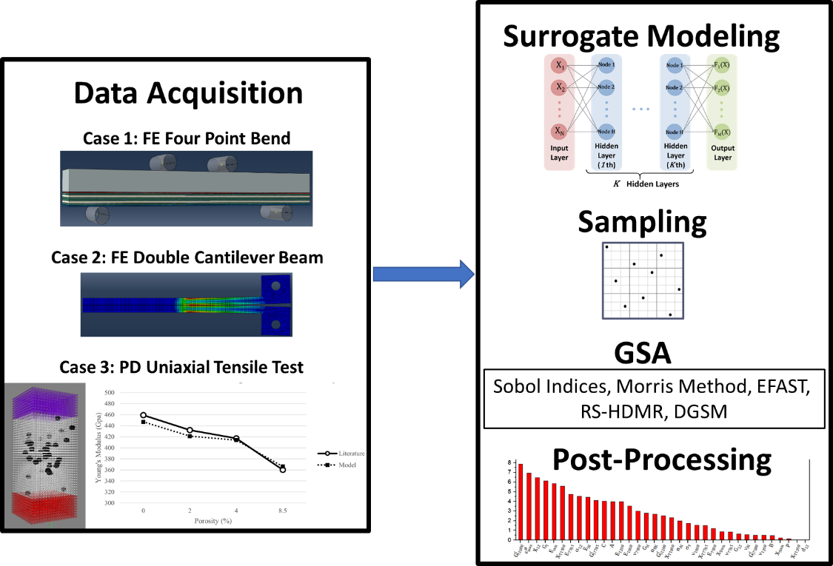
Figure 1. The technical approach used for evaluating the GSA methods.
3.1 Data Acquisition from Case Study Models
The study data was obtained from both macro and micro structural mechanics models created using two different software packages, Abaqus 2019 by Dassault Systèmes® and Peridigm (M.L. Parks, 2012), a peridynamics code developed at Sandia National Laboratories (Silling & Lehoucq, 2010). Models created from these two distinct modelling techniques were validated for accuracy and used to create the respective surrogate models for GSA data collection.
3.1.1 Case 1: Layered Structure under Four Point Bend Loading (FE FPB 41)
The most complex case study is the 41-parameter FE macroscale model created using Abaqus. This model represents a layered Four-Point Bend (FPB) specimen, fabricated from varying Eglass fabric/epoxy composite lamina and 5456 aluminium, that exhibits complex, progressive failure with non-linear behaviour. Full details of the model development and validation are available (Arndt et al, 2022). The parameter ranges are provided in Table 2 as well as the parameter symbol from the model development paper. Given the sparseness of the data, the mean values were used to validate the model and a range of $±20\%$ of the mean values, representing a z-score of 2 for an assumed 10% standard deviation (Mead, Gilmour, & Mead, 2012), was assigned, to each parameter to create the sampling range for both surrogate model development and GSA sampling, This z-score was assumed to capture adequate parameter variation which is critical for GSA.
Table 2. Parameter descriptions and ranges used in the FE FPB model study.
Parameter Number | Description | Units | Min. Value | Mean Value | Max Value
X0 | Youngs modulus Aluminium 5456-H116 (Al-5456) | Gpa | 55.70 | 69.63 | 83.56
X1 | Poissons Ratio Al-5456 | - | 0.23 | 0.29 | 0.35
X2 | Yeild Stress Al-5456 | MPa | 164.35 | 205.44 | 246.53
X3 | Johnson Cook Strength Coefficient Al-5456 | MPa | 571.37 | 714.22 | 857.06
X4 | Johnson Cook Strain Hardening Exponent Al-5456 | - | 0.49 | 0.61 | 0.73
X5 | Youngs Modulus E-BX 1200 | Gpa | 15.44 | 19.30 | 23.16
X6 | Tensile Strength E-BX 1200 | MPa | 292.31 | 365.38 | 438.46
X7 | Poissons Ratio E-BX 1200 | - | 0.12 | 0.15 | 0.18
X8 | Intralaminar Fracture Toughness E-BX 1200 | N/m | 21015.22 | 26269.03 | 31522.83
X9 | Youngs Modulus E-BX 1800 | GPa | 15.44 | 19.30 | 23.16
X10 | Tensile Strength E-BX 1800 | MPa | 292.31 | 365.38 | 438.46
X11 | Poissons Ratio E-BX 1800 | - | 0.12 | 0.15 | 0.18
X12 | Intralaminar Fracture Toughness E-BX 1800 | N/m | 21015.22 | 26269.03 | 31522.83
X13 | Youngs Modulus Hexcell 7500 | GPa | 15.61 | 19.51 | 23.41
X14 | Tensile Strength Hexcell 7500 | MPa | 257.56 | 321.95 | 386.34
X15 | Poissons Ratio Hexcell 7500 | - | 0.12 | 0.15 | 0.18
X16 | Intralaminar Fracture Toughness Hexcell 7500 | N/m | 14010.15 | 17512.68 | 21015.22
X17 | Youngs Modulus Hexcell 7781 | GPa | 24.27 | 30.33 | 36.40
X18 | Tensile Strength Hexcell 7781 | MPa | 386.06 | 482.58 | 579.10
X19 | Poissons Ratio Hexcell 7781 | - | 0.12 | 0.15 | 0.18
X20 | Intralaminar Fracture Toughness Hexcell 7781 | N/m | 14010.15 | 17512.68 | 21015.22
X21 | Shear Modulus of Laminate | GPa | 4.41 | 5.52 | 6.62
X22 | Shear Strength of Laminate | MPa | 28.46 | 35.57 | 42.69
X23 | Shear Damage Parameter | - | 0.22 | 0.28 | 0.33
X24 | Maximum Shear Damage | - | 0.57 | 0.71 | 0.86
X25 | Maximum Shear Plastic Strain | - | 0.02 | 0.02 | 0.02
X26 | Effective Shear Yeild Stress | MPa | 28.46 | 35.57 | 42.69
X27 | Coefficient in Shear Hardening Equation | GPa | 3.58 | 4.48 | 5.38
X28 | Power Term in Shear Hardening Equation | - | 0.58 | 0.73 | 0.87
X29 | Youngs Modulus for Intralaminar Adhesive Resin (IAR) | GPa | 55.15 | 68.94 | 82.73
X30 | Nominal Stress Normal-only Mode IAR | MPa | 41.99 | 52.49 | 62.99
X31 | Nominal Stress First/Second Direction IAR | MPa | 26.91 | 33.63 | 40.36
X32 | Normal Mode Fracture Energy IAR | N-m/m^2 | 1064.77 | 1330.96 | 1597.16
X33 | Shear Mode Fracture Energy First/Second Direction IAR | N-m/m^2 | 2324.00 | 2905.00 | 3486.01
X34 | Mixed Mode Behaviour for Benzeggagh-Kenane IAR | - | 2.08 | 2.60 | 3.12
X35 | Youngs Modulus for Composite/Metal Interface Adhesive Resin (CMAR) | GPa | 55.15 | 68.94 | 82.73
X36 | Nominal Stress Normal-only Mode CMAR | MPa | 84.32 | 105.40 | 126.47
X37 | Nominal Stress First/Second Direction CMAR | MPa | 53.81 | 67.27 | 80.72
X38 | Normal Mode Fracture Energy CMAR | N-m/m^2 | 1064.77 | 1330.96 | 1597.16
X39 | Shear Mode Fracture Energy First/Second Direction CMAR | N-m/m^2 | 2324.00 | 2905.00 | 3486.01
X40 | Mixed Mode Behaviour for Benzeggagh-Kenane CMAR | - | 2.08 | 2.60 | 3.12

3.1.2 Case 2: Double Cantilever Beam with Epoxy Adhesive (FE DCB 9)
This 9 parameter macroscale FE model created in Abaqus represents a double cantilever beam (DCB) specimen fabricated from 5456 aluminum adherends bonded by a thermoset epoxy, a standard method for obtaining mode I fracture properties. This model has the lowest dimensionality of the case studies and the fracture behaviour is straight forward. Full details are provided in Smith (2021). It was hypothesized that the lower dimensionality of the FE DCB 9 model may demonstrate that selection of a less robust GSA method allows a reduction in computational resource requirements while maintaining accuracy as the problem is simpler. The parameter ranges are provided in Table 3 as well as the parameter symbols from the original paper. To test the capability of the GSA methods to encompass a larger parameter space relative to values, a range of $±30\%$ of the means (z-score of 3) was applied.
Table 3. Parameter descriptions and ranges used in the FE DCB 9 model study.
Parameter Number | Description | Units | Min. Value | Mean Value | Max Value
X0 | Youngs Modulus Al | MPa | 49700 | 71000 | 92300
X1 | Poisson’s Ratio Al | - | 0.231 | 0.33 | 0.429
X2 | Youngs Modulus Cohesive Resin (CR) | MPa | 1148 | 1640 | 2132
X3 | Shear Modulus Dir-1 CR | MPa | 4417 | 6310 | 8203
X4 | Shear Modulus Dir-2 CR | MPa | 4417 | 6310 | 8203
X5 | Nominal Stress Normal-only Mode CR | MPa | 48.3 | 69 | 89.7
X6 | Nominal Stress First Direction CR | MPa | 28 | 40 | 52
X7 | Nominal Stress Second Direction CR | MPa | 28 | 40 | 52
X8 | Normal Mode Fracture Energy CR | N-m/m^2 | 0.42 | 0.6 | 0.78

3.1.3 PD Uniaxial Tensile Test (PD Uniaxial 18)
This 18 parameter microscale model predicts the Young’s modulus of a zirconium diboride (ZrB2) tensile specimen as a function of porosity using PD to test the GSA methods on a distinctly different methodology and size scale than the FE case studies. The model was recreated based on a problem from the literature (Guo, Kagawa, Nishimura, & Tanaka, 2008) and was validated using all four of the reported specimens with varied void density (Fig. 1). The mean parameter values provided in Table 4 are the arithmetic means of the input to the 4 validation models and the data range was $±20\%$ of this mean value. The parameters reported as integers deviated from the $±20\%$ ranges and were instead chosen to comply with the required format of the PD code. The minimum horizon value was based on Peridigm analysis requirements (Parks, 2012), and the maximum value was limited to 0.2 due to the rapidly increasing computational cost above this value. Note that a majority of the reported values in Table 4 lack units as the values were normalized to the scale of the model.
Table 4. Parameter descriptions and ranges used in the PD Uniaxial 18 model study.
Parameter Number | Description | Units | Min. Value | Mean Value | Max Value
X0 | Point Volume (Normalized to Scale) | - | 1.90E-04 | 2.38E-04 | 2.86E-04
X1 | Void Density | % | 0.04 | 0.05 | 0.06
X2 | Center of Void Distrobution X-axis (Normalized to Scale) | - | 0.40 | 0.50 | 0.60
X3 | Center of Void Distrobution Y-axis (Normalized to Scale) | - | -1.09 | -1.36 | -1.63
X4 | Center of Void Distrobution Z-axis (Normalized to Scale) | - | 0.40 | 0.50 | 0.60
X5 | Mean Void Radius (Normalized to Scale) | - | 0.04 | 0.05 | 0.06
X6 | Maximum Variation of Void Radius from Mean | % | 0.16 | 0.20 | 0.24
X7 | Void Convex Hull Discretization | - | 16.00 | 20.00 | 24.00
X8 | Standard Deviations for Void Distrobution X-axis | - | 1 | 2 | 3
X9 | Standard Deviations for Void Distrobution Y-axis | - | 1 | 2 | 3
X10 | Standard Deviations for Void Distrobution Z-axis | - | 1 | 2 | 3
X11 | Standard Deviations for Void Radius | - | 1 | 2 | 3
X12 | Density of ZrB2 (Voidless) | kg/m^3 | 4.54E+03 | 5.68E+03 | 6.82E+03
X13 | Bulk Modulus of ZrB2 (Voidless) | Pa | 1.86E+11 | 2.32E+11 | 2.78E+11
X14 | Shear Modulus (Voidless) | Pa | 1.57E+11 | 1.96E+11 | 2.35E+11
X15 | Hourglass Coefficient | - | 0.020 | 0.025 | 0.030
X16 | Horizon Radius (Normalized to Scale) | - | 0.11 | 0.15 | 0.2
X17 | Number of Loading Steps in Analysis | - | 1 | 3 | 5

3.6 Surrogate Modelling
The computational time required for the parameter sampling needed for GSA using high fidelity models is typically prohibitive, therefore surrogate models are developed to obtain the data set. A surrogate model is an approximation of a complex system, based on a limited number of data points, that predicts the relationship between the system inputs and outputs. With proper construction, surrogate models accurately mimic the behaviour of the high-fidelity simulation at a much lower computational cost (milliseconds versus minutes/hours per simulation for the three cases).
To formulate the surrogate models, output data was generated at points identified using stratified Latin hypercube sampling (Shields et al, 2015; Shields & Zhang, 2016). This process was automated through Distribution-based Input for Computational Evaluations (DICE) developed by the Naval Surface Warfare Center Carderock Division (NSWCCD) (Nahshon & Reynolds, 2016). DICE is a standalone executable that generates an array of input vectors using a specified sampling method for the provided parameter ranges and distributions. The surrogate models were trained on these datasets using forward-feed neural networks by means of TensorFlow V2.11 (Abadi et al., 2016). The datasets were broken into three subsets, the training dataset, the validation dataset, and the testing dataset. The training dataset was used to train the neural network (NN) and the validation dataset acted as a benchmark from which accuracy metrics were determined to evaluate the current training iteration of the surrogate model. The validation dataset is determined from random sampling during each training iteration where the data is shuffled and resampled before each iteration. The training/validation dataset were allocated such that the training and validation datasets were 80% and 20% of the training/validation (parent) dataset, respectively. This process was repeated until the root-mean square error (RMSE) of the NN’s estimation of the entire validation dataset was less than 5%. RMSE was chosen as it is more sensitive to higher magnitude errors than mean absolute error. Upon the convergence of the NN validation metric the testing dataset that was withheld from training of the NN was used to predict values for each model, where the accuracy of the predictions made by the NN versus the actual was shown to agree well with the validation accuracy found during training. This agreement between the validation metric and the accuracy of the predictions made by the NN from the testing data versus the actual values refute overtraining of the NN model. Parameters of each of the NN surrogates is shown in Table 5, where the number of hidden layers is specified, with a input layer equal to the number of model parameters and an output layer of a single neuron were needed to complete the NN’s architecture.
Table 5. Architecture of the Forward Feed Neural Network used for surrogate modelling, all of which have the same number of neurons for each layer where the number of hidden layers is specified.
Model | Neurons | Layers | Learning Rate | Drop Out | Max Epochs | Optimizer | Activation Function
FE 4PB 41 | 576 | 2 | 0.00225 | 0.1 | 100 | Adam | ReLU
FE DCB 9 | 256 | 1 | 0.00075 | 0.1 | 200 | Adam | ReLU
PD Uni 18 | 384 | 1 | 0.0005 | 0.4 | 200 | Adam | ReLU

Table 6 shows the number of runs used to train the NN surrogate models, the training dataset sizes, the testing dataset sizes and the RMSEs of the NN’s estimations resulting from the testing datasets. The size of the dataset generated from each parent model was dictated by the model complexity, where the parent dataset used to train and validate the NN increased with the model dimensionality of each of the three cases. It should be noted that the models with a higher number of parameters require considerably more parent runs to achieve an accurate surrogate model. The computational time to generate an adequate dataset is further impacted when considering that the models with a larger number of parameters are more complex for the cases shown, which led to a much higher computational time per single analysis of the original models.
Table 6. The number of parent model runs required to train the surrogate models, the test/train split, and the RMSE error of the final surrogate model.
Model | Training Dataset Size | Testing Dataset Size | RMSE Testing (%)
FE 4PB 41 | 4000 | 1000 | 1.71
FE DCB 9 | 1200 | 300 | 2.59
PD Uni 18 | 2400 | 600 | 3.00

3.7 Sampling for GSA
Once the surrogate model for each case study parent model was formulated, these surrogate models were used to collect datasets for GSA according to the sampling scheme specific to each GSA method in SALib, where the sampling strategies used for the Sobol’, Morris, EFAST, and DGSM methods are identified in their primary citations (Table 1). The HDMR method allows for any appropriate sampling method, and the stratified Latin hypercube method was applied. Parameters were normalised within the range of 0-1 to be evaluated by the neural network model, where normalised parameters increase the rate of convergence of the training. To determine the rate of convergence for each GSA method, the sample size was increased between 300 to 500,000 for each GSA method when possible. Due to numerical or hardware limitations some sample sizes were not possible when implementing certain methods; specifically, the EFAST method has limitations at smaller sample sizes, while some sample sizes were too large for the HDMR method when the available RAM was insufficient (<128Gb).

4. Case Studies Results
4.1 Convergence Study
The number of samples at convergence was determined for each method and summarized in Table 7. Convergence is determined as the number of samples required for each method to produce constant estimations (within 5% for two consecutive increases in sample size) for all parameters with a sensitivity measure contributing more than 10% to the model output. The rate of convergence for each method is visualized by heatmaps that report the absolute difference as a percentage between consecutive sample sizes (Figs. 2,3). The heatmaps present convergence rates for the individual parameters estimated to contribute more than 10%, an average rate for the parameters contributing greater than 10% (GT 10%), an average rate for parameters that were identified to be non-negligible by inspection of the indices (Top 10 or Top 3), and an average rate for all parameters (All). In general, more parameters resulted in larger datasets to achieve convergence. This finding is important as GSA can provide relevant information without convergence for some objectives. For example, if the objective is to identify the most dominant parameters, this information will be evident at a much smaller computational cost than if the specific ordering or converged influence values for all parameters are needed.

Table 7. Number of samples for convergence required by each method to estimate first and total order GSA measures for parameters contributing more than 10% to the model output.
Cost of Convergence
Model | Sobol ‘ | Morris | EFAST | HDMR | DGSM
FE FBP 41: First Order | 500K+ | N/A | 500K+ | 2500 | N/A
FE FBP 41: Total Order | 50K | 5000 | 500K+ | 50K+ | 25K
FE DCB 9: First Order | 1000 | N/A | 2000 | 300 | N/A
FE DCB 9: Total Order | 1000 | 300 | 2000 | 300 | 300
PD Uniaxial 18: First Order | 200K+ | N/A | 25K | 750 | N/A
PD Uniaxial 18: Total Order | 50K | 10K | 25K | 5000 | 10K

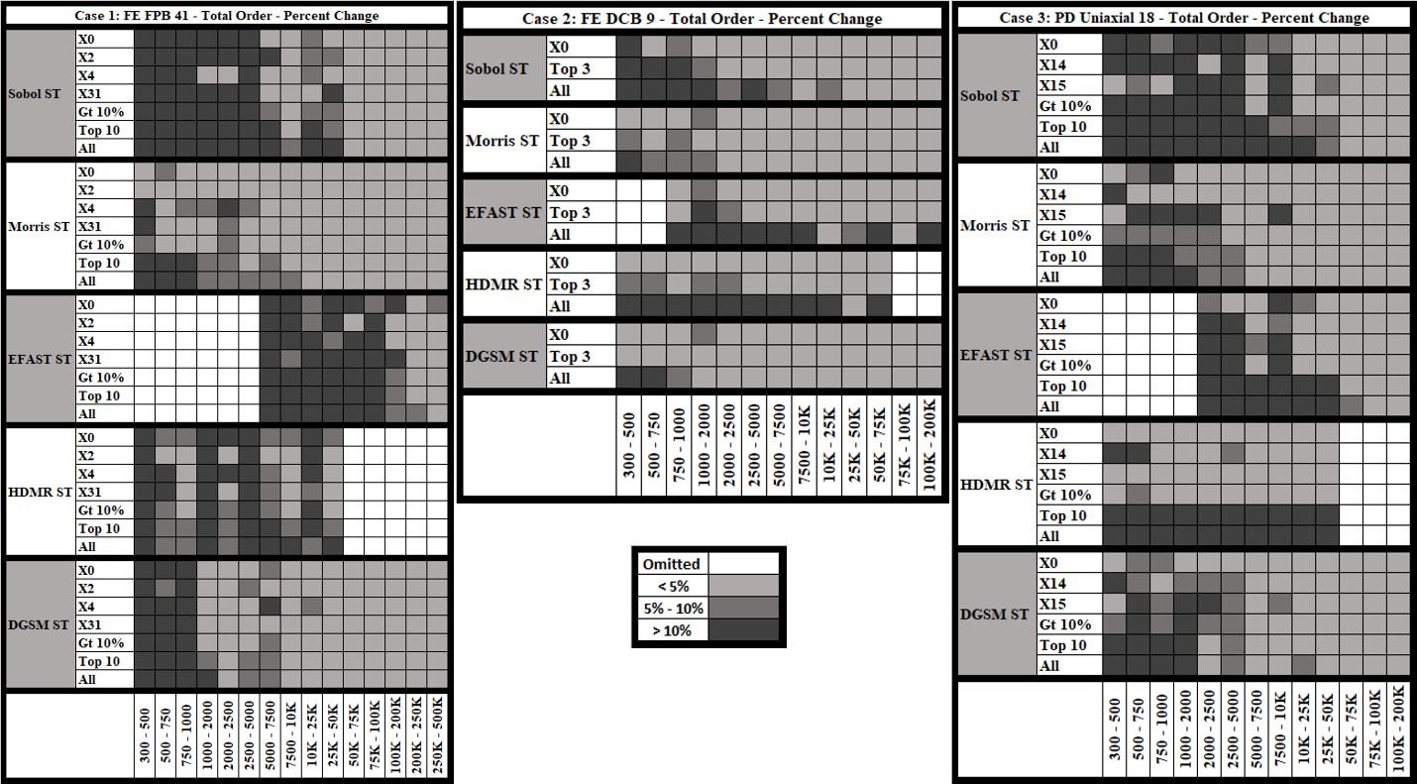
Figure 2. Heat maps for total order convergence
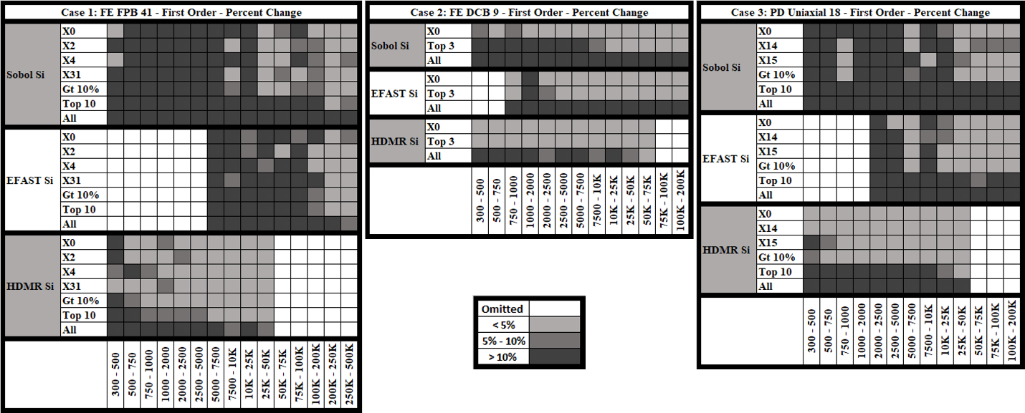
Figure 3. Heat maps for first order convergence

4.2 Case 1: FE FPB 41
The converged first and total order sensitivity measures calculated by each GSA method for Case 1 are shown in Figs. 4a and 4b, and quantitative sensitivity measures are provided in Table 8. Each of the GSA methods produced similar estimations for first order indices when available. Total indices differed with HDMR and DGSM predicting higher measures than Sobol and EFAST for the most influential parameter (X2). Meanwhile, the Morris method differentiated the dominant parameters but generally underpredicted parameters of greater significance and overpredicted parameters with less significance as compared to the other methods.
Parameters X2, X0, X4, X31 have the largest overall influence on the model’s output as indicated by both total and first order indices. All methods ranked these as the top four influential parameters, although the order of importance determined by the Morris method deviated from the other methods for I-3 and I-4 (the third and fourth most influential parameter, respectively). The Morris method switched the importance of X4 and X31; however, there is a small difference in sensitivity measure between the two, indicating that they are similar in importance. Similarly, the I-5 (the fifth most influential parameter) ranking deviated with DGSM and EFAST predicting X31 and the other methods selecting X28. As seen in Table. 8, there is a small difference between the two indices, again indicating that these two parameters are similar in importance.
The HDMR method predicted some interaction between parameters as indicated by the difference between the total and first order measures. Meanwhile, the Sobol’ and EFAST methods calculated nearly identical first and total values, indicating minimal, if any, parameter interaction.
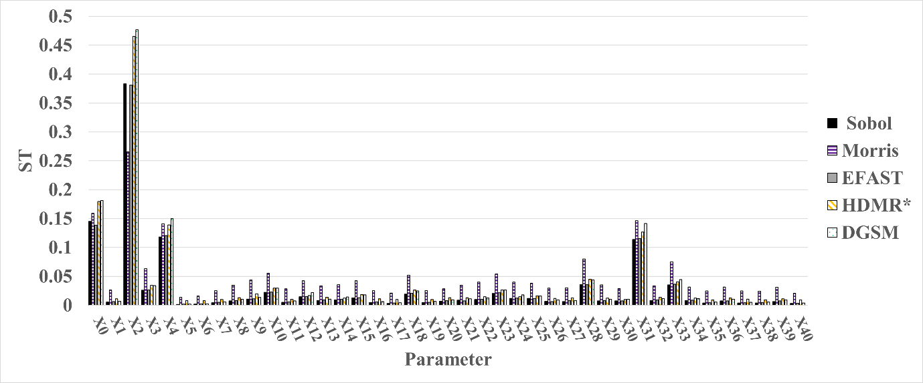
Figure 4a. Values of total order SA measures estimated by each method for the FPB A-41 model using a sample size of 50,000 for the HDMR method and converged values at 500,000 for all other methods.
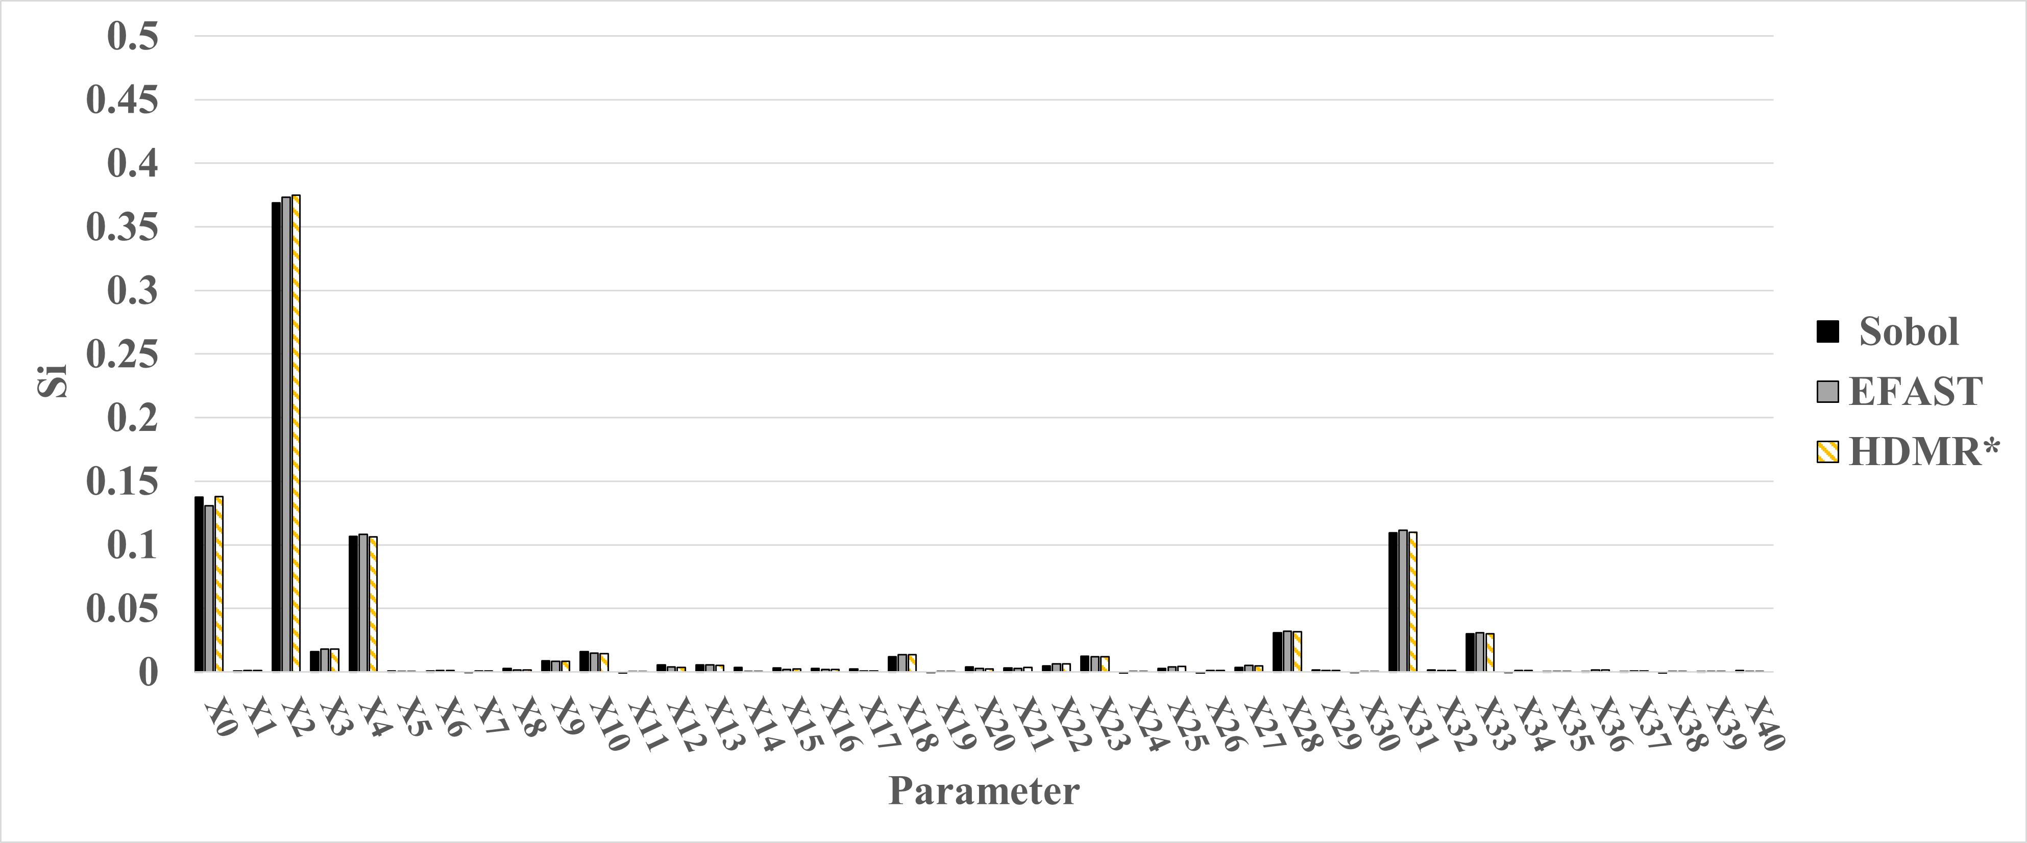
Figure 4b. Values of first order SA measures estimated by each method for the FPB A-41 model using a sample size of 50,000 for the HDMR method and converged values at 500,000 for all other methods.

Table 8. Top 5 influential parameters for Case 1 ranked in order from most (I-1) to less (I-5) significant by each method at converged values.
Method | I-1 |  | I-2 |  | I-3 |  | I-4 |  | I-5
Order | ST | Si | ST | Si | ST | Si | ST | Si | ST | Si
Sobol’ | X2 (0.38) | X2 (0.37) | X0 (0.14) | X0 (0.14) | X4 (0.12) | X31 (0.11) | X31 (0.11) | X4 (0.10) | X28 (0.04) | X28 (0.03)
EFAST | X2 (0.38) | X2 (0.37) | X0 (0.14) | X0 (0.13) | X4 (0.12) | X31 (0.11) | X31 (0.11) | X4 (0.10) | X33 (0.04) | X28 (0.03)
HDMR | X2 (0.47) | X2 (0.37) | X0 (0.18) | X0 (0.14) | X4 (0.14) | X31 (0.11) | X31 (0.13) | X4 (0.10) | X28 (0.05) | X28 (0.03)
Morris | X2 (0.26) | -- | X0 (0.16) | -- | X31 (0.15) | -- | X4 (0.14) | -- | X28 (0.08) | --
DGSM | X2 (0.48) | -- | X0 (0.18) | -- | X4 (0.15) | -- | X31 (0.14) | -- | X33 (0.04) | --

4.3 Case 2: FE DCB 9
The converged first and total order sensitivity indices for the FE DCB 9 model are shown in Fig. 5a,5b, with the quantitative values provided in Table 9. As with Case 1, all methods predicted similar results for first order measures, when available, with differences noted in the total measures. The Morris method continued a trend of overestimating the less significant parameters indices while underestimating the significant parameters indices relative to the other methods, while in general predicting the same set of most influential parameters. Meanwhile, the DGSM method again predicted sensitivity measures 20-40% higher than the other methods. However, for Case 2, the HDMR predictions aligned with Sobol’ and EFAST sensitivity measures rather than the DGSM predictions as in Case 1.
For Case 2, parameter X0 was determined to be the most significant parameter with little interaction with other parameters, shown by the large and similar magnitudes for both total and first order measures. All of the methods identified the same three dominant parameters, X0, X1, and X8, with the DGSM switching the order of X1 and X8. Given the extremely small difference in sensitivity measures, indicating nearly equal importance between these two parameters, this difference is considered insignificant.
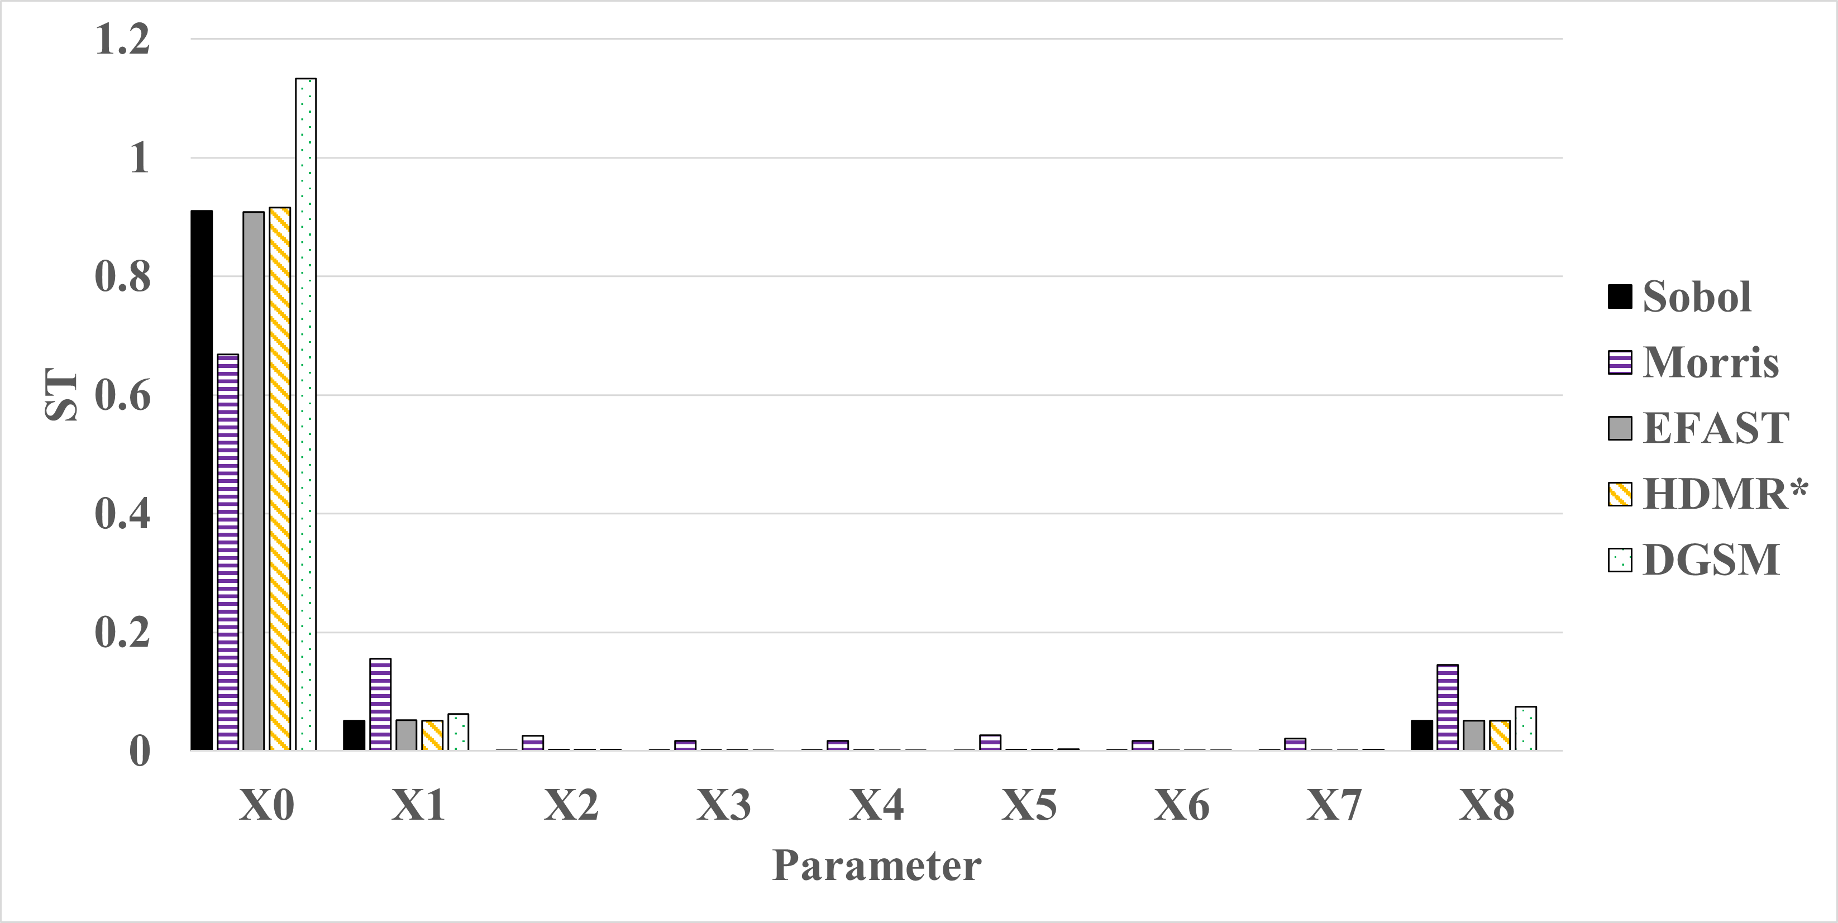
Figure 5a. Converged values of total order SA measures estimated by each method for the FE DCB 9 model using a sample size of 75,000 for the HDMR method and 200,000 for all other methods.

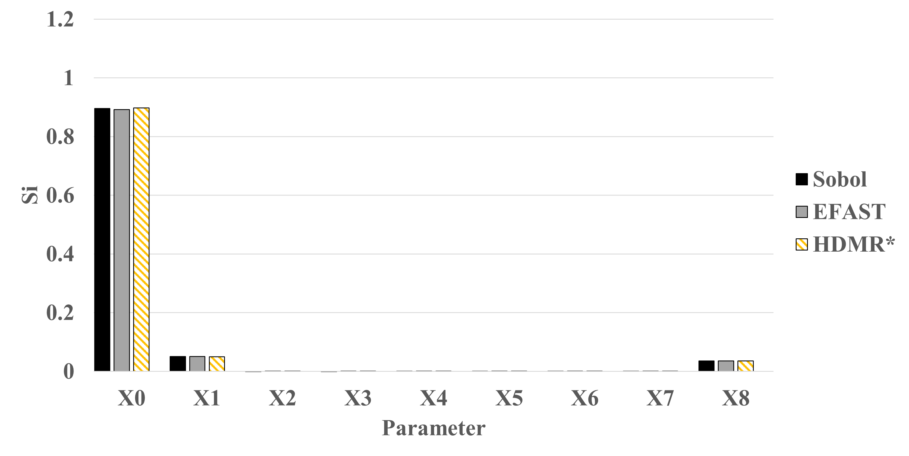
Figure 5b. Converged values of first order SA measures estimated by each method for the FE DCB 9 model using a sample size of 75,000 for the HDMR method and 200,000 for all other methods.
Table 9. The most influential parameters for Case 2 ranked in order from most (I-1) to less significant (I-3) by each method at converged values.
Method | I-1 |  | I-2 |  | I-3
Order | ST | Si | ST | Si | ST | Si
Sobol’ | X0 (0.91) | X0 (0.9) | X1 (0.05) | X1 (0.05) | X8 (0.05) | X8 (0.04)
EFAST | X0 (0.91) | X0 (0.89) | X1 (0.05) | X1 (0.05) | X8 (0.05) | X8 (0.04)
HDMR | X0 (0.92) | X0 (0.89) | X1 (0.05) | X1 (0.05) | X8 (0.05) | X8 (0.04)
Morris | X0 (0.67) | -- | X1 (0.16) | -- | X8 (0.14) | --
DGSM | X0 (1.13) | -- | X8 (0.07) | -- | X1 (0.06) | --

4.4 Case 3: PD Uniaxial 18
Total and first order sensitivity indices for Case 3 are shown in Fig. 6a,6b, with quantitative values provided in Table 10. As with Case 2, it was observed that both the Morris and the DGSM varied from the other methods for the total order estimations while all other predictions were nearly identical. Parameters X0, X15, and X14 were shown by the GSA methods to be the most dominant with minimal parameter interaction shown by the relatively large and similar estimations for both total and first order measures. However, the DGSM method alone ranked X15 over X0 as the most influential parameter. All methods except for the DGSM predicted X13 as the fifth most influential parameter. DGSM instead predicted X16 which is a notable difference when comparing X13 and X16 in Table. 10.
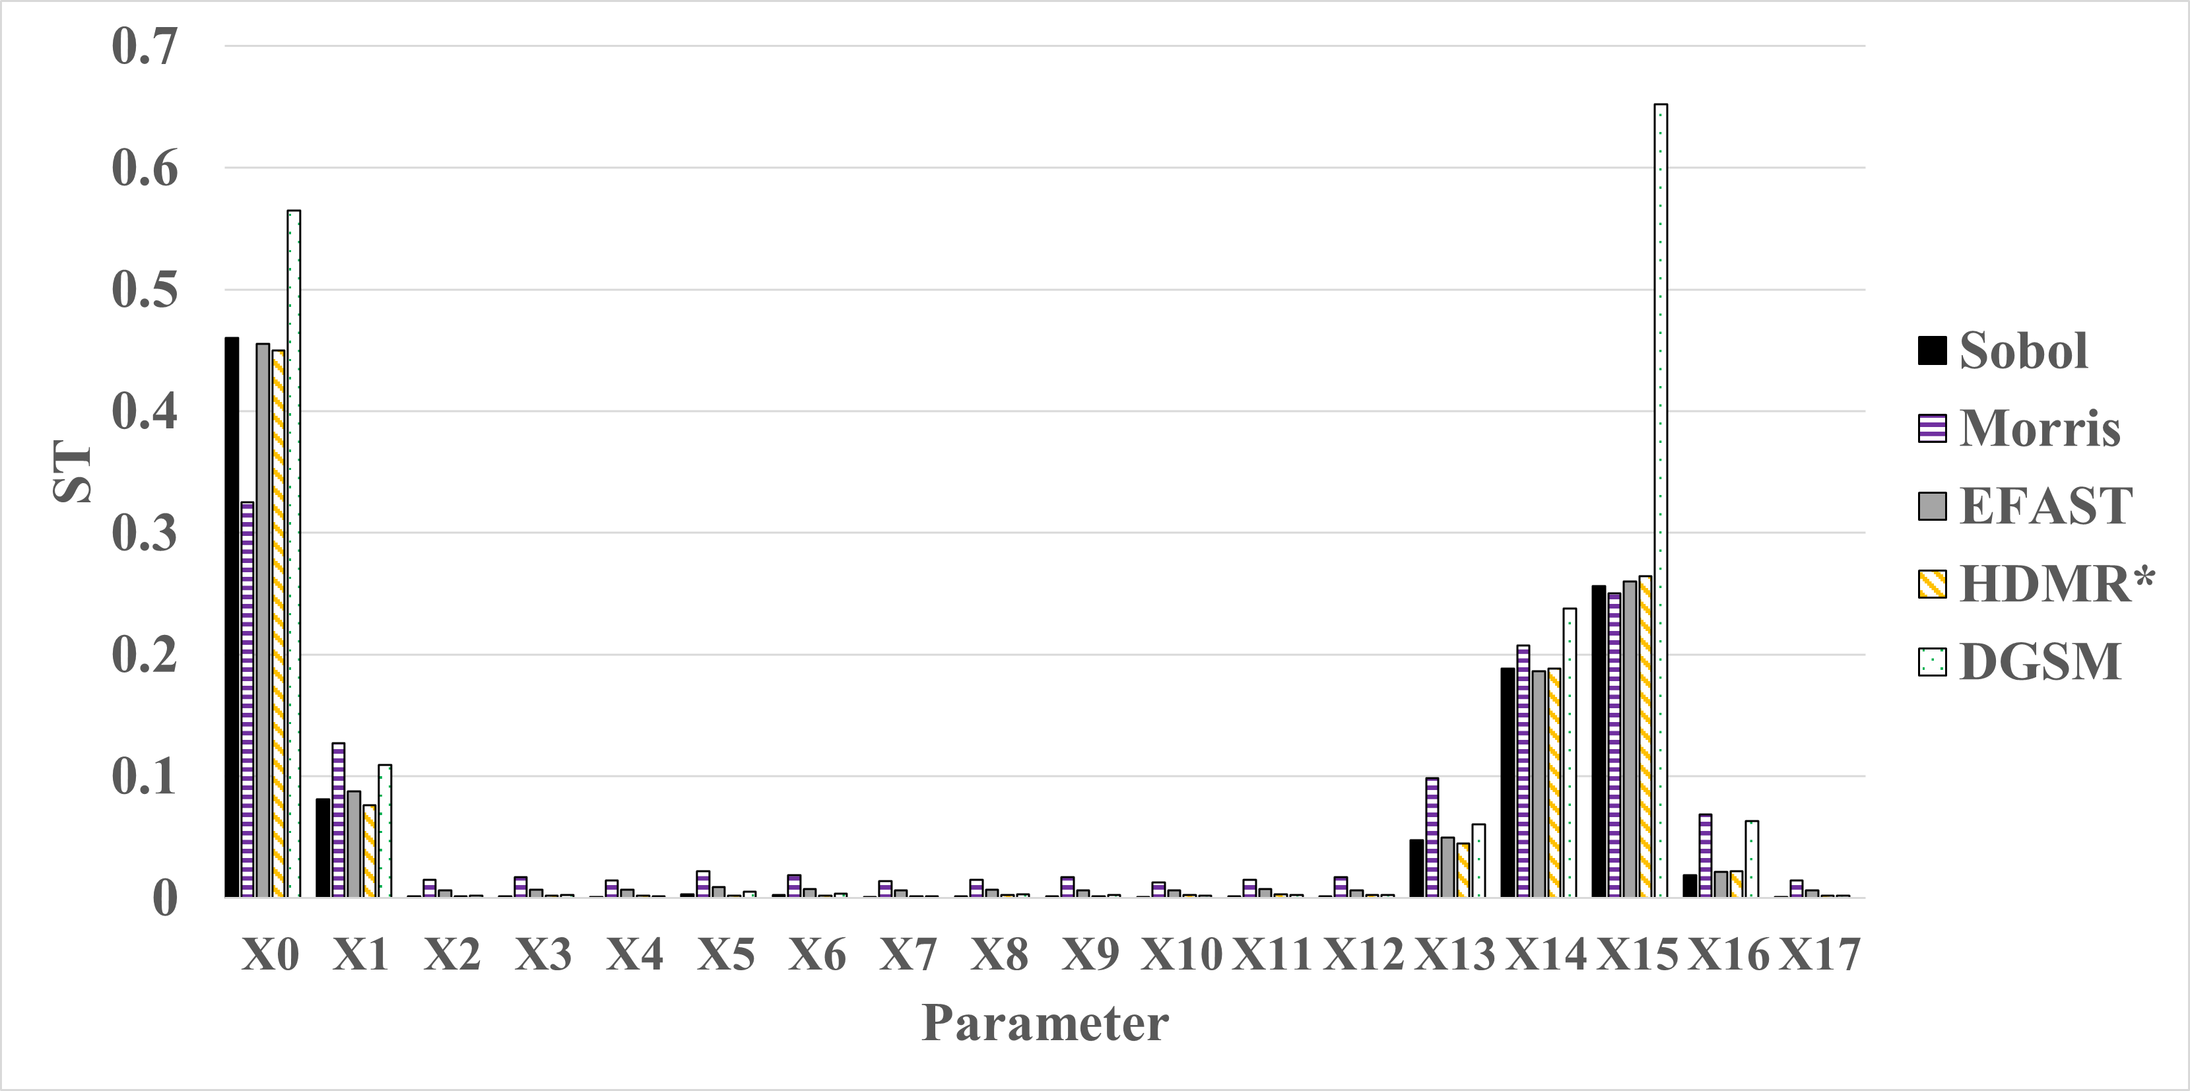
Figure 6a. Converged values of total order SA measures estimated by each method for the PD Uniaxial18 model using a sample size of 50,000 for the HDMR method and 200,000 for all other methods.

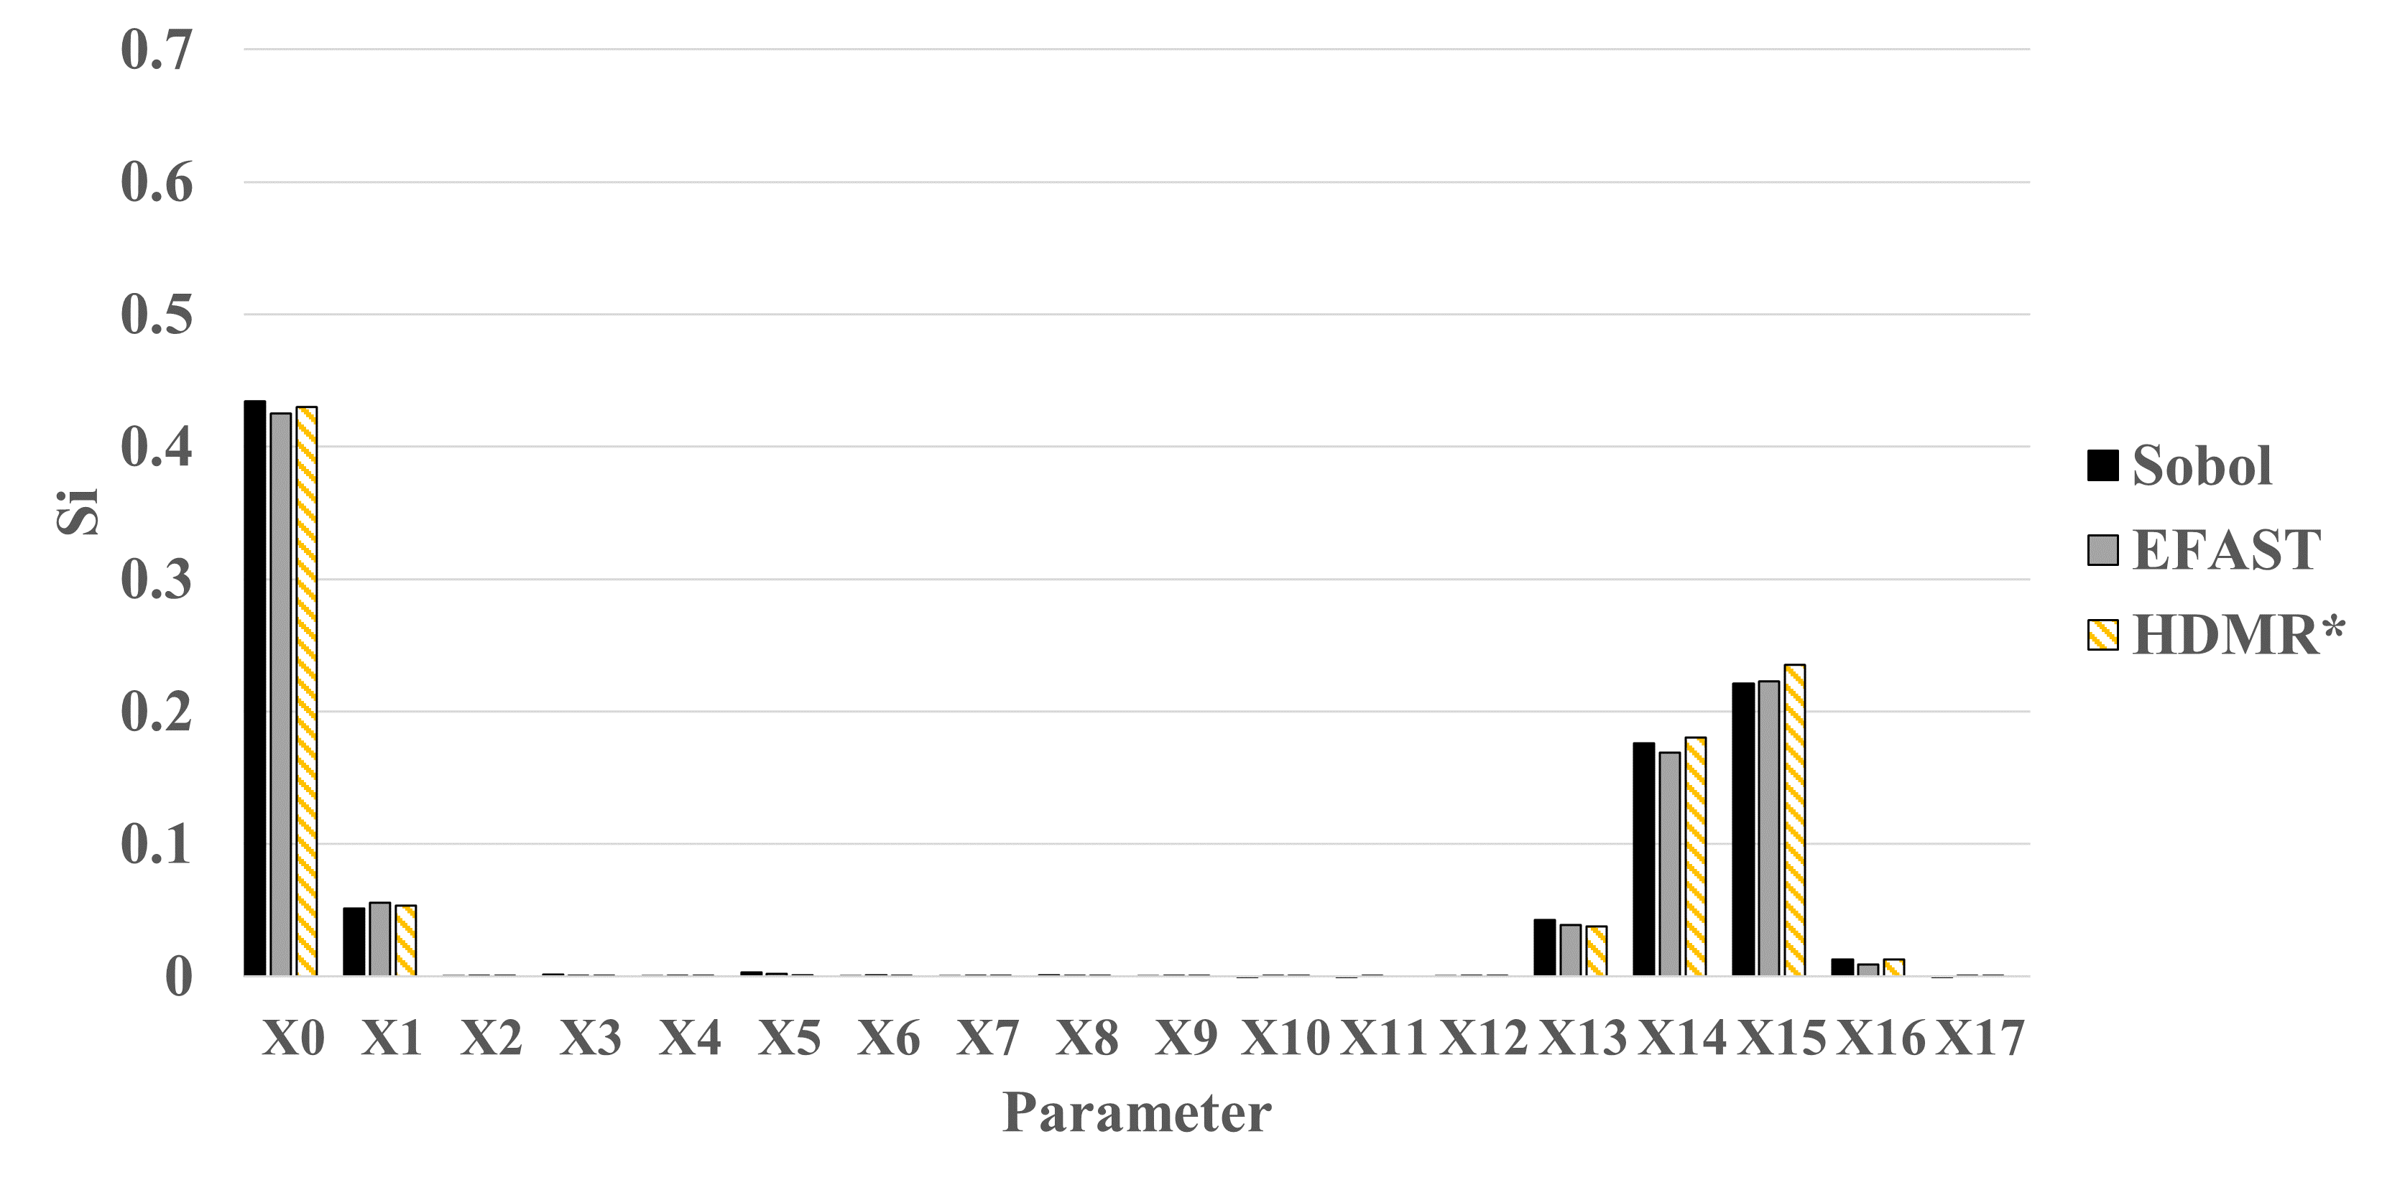
Figure 6b. Converged values of first order SA measures estimated by each method for the PD Uniaxial18 model using a sample size of 50,000 for the HDMR method and 200,000 for all other methods.
Table 10. Dominant parameters for PD Uniaxial 18 ranked in order from most (I-1) to least (I-5) significant by each method.
Method | I-1 |  | I-2 |  | I-3 |  | I-4 |  | I-5
Order | ST | Si | ST | Si | ST | Si | ST | Si | ST | Si
Sobol’ | X0 (0.46) | X0 (0.43) | X15 (0.26) | X15 (0.22) | X14 (0.19) | X14 (0.18) | X1 (0.08) | X1 (0.05) | X13 (0.05) | X13 (0.04)
EFAST | X0 (0.46) | X0 (0.43) | X15 (0.26) | X15 (0.22) | X14 (0.19) | X14 (0.17) | X1 (0.09) | X1 (0.06) | X13 (0.05) | X13 (0.04)
HDMR | X0 (0.45) | X0 (0.43) | X15 (0.26) | X15 (0.24) | X14 (0.19) | X14 (0.18) | X1 (0.08) | X1 (0.05) | X13 (0.04) | X13 (0.04)
Morris | X0 (0.33) | -- | X15 (0.25) | -- | X14 (0.21) | -- | X1 (0.13) | -- | X13 (0.09) | --
DGSM | X15 (0.65) | -- | X0 (0.56) | -- | X14 (0.24) | -- | X1 (0.11) | -- | X16 (0.06) | --

5. Discussion
5.1 Convergence
For case 1 and case 2 the EFAST method required the same number of samples to converge as the Sobol method but was more efficient for case 3. The improved convergence of the EFAST method for case 3 did not appear to be caused by parameter interdependence or the lack of and given the models for each case are represented by NN surrogate models, it was concluded that the outstanding convergence performance for case 3 for the EFAST method isn’t directly related to the model construction. The convergence rate of the EFAST method for case 3 was considered to be unrelated to the model itself excluding the possibility of a “goldilocks dimensionality” that could suit the EFAST method particularly well.

Comparing the first and total order convergence results, its shown that the first order parameter measures converged faster than the total order measures, except for the Sobol’ method. Because the total order measure is a sum of the first order measure and all interdependent measures, it is speculated that the variance of the interdependence component opposes the variation of the first order measure, indicating convergence by acceptable variation. The SALib library version of the Sobol’ method calculates the first and total order measures simultaneously using identical sample matrices, eliminating implementation as the source of this behaviour. It was observed that the EFAST method required the same number of samples to converge for both first and total order for each of the three cases, where the HDMR method converged more rapidly for the first order than the total order GSA measures for case 1 and 3. The lower CoC for the first order measure compared to the total order is intuitive and is believed to be due to the method in which the particular HDMR method contained in the SALib uses to estimate the first and total order GSA measures, using both a ANOVA method and an analysis of covariance (ANCOVA) as opposed to the Sobol method using only ANOVA.

The trend for CoC increased as a function of the number of parameters, with two exceptions caused by numerical instability. For Case 3, the Morris method exhibited a single deviation for one of the dominant parameters with an error >10% from the converged sensitivity value in the 7500-10,000 sample range (Fig. 2), resulting in the Case 3 CoC to be greater than the Case 1 CoC. Instability in convergence was also noted in the Sobol method for cases 1 and 3 where the dominant parameters oscillated about the converged value after 5000 samples until consistently predicting the converged value at 50,000 samples for both cases. The reduced CoC for both the Morris method and the DGSM method is likely due to both methods using a derivative based approach to estimating the total order GSA measure, while the reduced CoC for the HDRM method when compared to the other quantitative methods studied is thought to be caused by implementation of the ANCOVA alongside the ANOVA approach as opposed to only ANOVA as with the Sobol method.

The number of parameters that should be included in a convergence study depends on the intended use of the GSA results. If the purpose is an initial screening to reduce model dimensionality for more detailed investigation, the dominant parameters can be readily identified early in the convergence evaluation using any of the methods. If accurate sensitivity predictions are required for all of the parameters, then all of the parameters should be considered for the GSA convergence evaluation, at a significantly higher CoC.

5.2 Parameter Ordering
All methods were able to similarly identify the least significant parameters for all cases, but discrepancies can be seen in the exact ordering of the converged GSA measures by inspecting Tables 8,9,10 showing the ordering of the most influential parameters and the exact value estimated by each method. For case 1 the top five most influential parameters are shown along with their estimated GSA measure in Table 8, where all methods agreed on the ordering of the top two parameters, the yield stress and Young’s modulus of the aluminium adherends (X2 and X0) respectively). Out of the three quantitative methods the HDMR method suggested stronger interactions between the parameters indicated by the increased estimated total order GSA sensitivity measure for X2 compared to the estimated first order sensitive measure. The cause of the increased interactions estimated by the HDMR method is unclear, given that the method performed similarly to the other quantitative methods for case 2 and 3. It is also noted that the parameter estimated by the HDMR method to have a high degree of interaction (X2) represents the yield strength of the aluminium adherends in the FPB model, which is not directly dependant on any other of the models parameters. While the reasoning for the presumed over-estimated GSA sensitive measure for X2 shown by the HDMR method was unclear, the importance of understanding a given model and its parameters was demonstrated, where a potential over or underestimation might be identified by the user. Minor discrepancies for case 1 can be seen in the ordering of the third and fourth most influential parameters (X4 and X31), where the order is determined by a magnitude of only 0.01 for each method. The fifth most influential parameter for case 1 estimated by each method varied between parameters X28 and X33 with these parameters having relatively small GSA measures compared to the top four. Given these minor discrepancies for case 1 it is considered to show adequate agreement between all five of the methods pertaining to parameter ordering.

For case 3 all methods similarly estimated the same top parameters for the respective model except for the DGSM method. Parameter ordering estimated by the DGSM method for case 3 shown in Table 10 indicates the largest discrepancy of any test case where the DGSM method opposes all other methods for the most significant parameter being estimated as X15, the hourglass coefficient for the Peridynamics correspondence material definition, as opposed to X0, the Peridynamics point volume effecting computed material stiffness. The DGSM method greatly overestimates the significance of X15 compared to the other methods, skewing the respective parameter ordering for case 3. Case 3 is the only case to show major disagreement with the ordering of the parameters with a non-negligible magnitude of relative significance (0.09) between the top two parameters estimated by the DGSM method.

For all cases all quantitative methods demonstrated a fair agreement on the ordering and the estimated GSA sensitivity measure for each of the top parameters. The non-quantitative methods (Morris and DGSM) were able to identify the top parameters at a low CoC with little discrepancies on the ordering but generally different GSA sensitivity measures when compared to the truly quantitative methods. This disagreement between the quantitative and non-quantitative GSA values is inherent to the methods themselves and was considered to be an accurate demonstration of the non-quantitative methods.

5.3 Method Selection
All the methods predicted similar results when identifying the most dominant parameters for each of the cases. Therefore, method selection is based on the information required from the GSA and available computational resources. This method was found to be robust for all three of the test cases but required the most computational resources and highest convergence cost. One option to effectively utilizing the Sobol’ method while significantly reducing computational resources is to use another method to first eliminate parameters with little influence on the output. Once the parameter space is reduced, the Sobol’ method can be applied to obtain more detailed, higher order information on the influential parameters.

To minimize computational resources or to provide information for a reduction in model dimensionality, the Morris method is ideal, given the rapid rate of convergence at a significantly smaller number of samples for each test case. As the Morris method was shown to identify the dominant parameters with only a small number of samples, this method is particularly efficient when long-running, high fidelity models are used to generate the output, as a minimal number of data is needed. Once the most dominant parameters are identified, additional output data can be generated by varying only the significant parameters for focused surrogate modelling and Sobol’ analysis. Alternatively, identification of the significant parameters also informs focused design, analysis, optimization, and uncertainty quantification.

Both the Morris method and the Sobol’ method require a specific sampling method to be optimally efficient. Therefore, method selection must be determined prior to data generation directly from the high-fidelity models or the sample data determined from a surrogate model following the sample scheme. For existing data sets, the HDMR method uses any random or quasi-random sampling method and converges relatively quickly compared to the other quantitative methods. This approach allows for the HDMR method to be applied to experimental test data or other cases where the data sampling is not as easy to control. Despite the unique ability to use any sampling method, the HDMR method is limited by RAM capacity, requiring a great deal of RAM to evaluate large sample sizes. Both the DGSM and the EFAST method performed adequately but with no clear advantage or being limited by sample sizes, respectively.

5.4 Limitations
The present study is limited to three test cases that do not encompass all potential model characteristics or dimensionalities that could be encountered when performing GSA. An open-source code was utilized due to its availability to any person or organization but acts as a limitation by not comparing several packages available to perform GSA, instead using only a single Python library for the comparisons. Hardware limitations are noted when examining the HDMR method, where limited RAM capacity prevented a more exhaustive convergence study from being performed.

6. Conclusions
It is concluded that method selection is dependent on computational resources, information required from the GSA, and available data. The method of Morris is found to be the optimal method for estimating the total order GSA measure given a small dataset (an approximate average of 5000 for this study). The method of Sobol’ is found to be the most robust for first and total order SA measures, but also the most computationally expensive given the size of the dataset required for the method to converge (an approximate average of 130,000 for this study). The HDMR method performed well at predicting first order SA measures given medium dataset sizes (an approximate average of 10,000 for this study) and offering omission of specific sampling techniques. The EFAST method and the DGSM method performed relatively average compared to the other methods for the particular models investigated making them less noteworthy for this individual study.

Funding statement. This research was supported by United States Office of Naval Research (ONR) grant N00014-21-1-2041 under the direction of Dr. Paul Hess. It was also supported by the Lloyd’s Register Foundation.
Competing interests. None
Data availability statement. Data generated from the finite element and peridynamic models can be found in Harvard Dataverse: https://doi.org/link
Ethical standards. The research meets all ethical guidelines, including adherence to the legal requirements of the study country.
Author contributions. Conceptualization: C.C. Methodology: C.C; S.T. Data curation: C.C; S.T. Data visualisation: C.C; S.T. Writing original draft: C.C; S.T; A.S. All authors approved the final submitted draft.
Supplementary material. None.

References
Abadi, M., Agarwal, A., Barham, P., Brevdo, E., Chen, Z., Citro, C., . . . Devin, M. (2016). Tensorflow: Large-scale machine learning on heterogeneous distributed systems. arXiv preprint arXiv:1603.04467.
Arndt, C., Heng, B., Butler, R., and TerMaath, S. (2022). Nondeterministic Parameter Space Characterization of the Damage Tolerance of a Composite/Metal Structure. Preprint arXiv: 2210.14054.
Campolongo, F., Cariboni, J., & Saltelli, A. (2007). An effective screening design for sensitivity analysis of large models. Environmental modelling & software, 22(10), 1509-1518.
Campolongo, F., & Saltelli, A. (1997). Sensitivity analysis of an environmental model: an application of different analysis methods. Reliability Engineering & System Safety, 57(1), 49-69.
Cukier, R., Levine, H., & Shuler, K. (1978). Nonlinear sensitivity analysis of multiparameter model systems. Journal of computational physics, 26(1), 1-42.
Guo, S., Kagawa, Y., Nishimura, T., & Tanaka, H. (2008). Elastic properties of spark plasma sintered (SPSed) ZrB2–ZrC–SiC composites. Ceramics international, 34(8), 1811-1817.
Homma, T., & Saltelli, A. (1996). Importance measures in global sensitivity analysis of nonlinear models. Reliability Engineering & System Safety, 52(1), 1-17.
Jansen, M. J. (1999). Analysis of variance designs for model output. Computer Physics Communications, 117(1-2), 35-43.
Jansen, M. J., Rossing, W. A., & Daamen, R. A. (1994). Monte Carlo estimation of uncertainty contributions from several independent multivariate sources. In Predictability and nonlinear modelling in natural sciences and economics (pp. 334-343): Springer.
Jon Herman, W. U. (2017). SALib: An open-source Python library for sensitivity analysis: Journal of Open Source Software, 2(9).
Li, G., Rabitz, H., Yelvington, P. E., Oluwole, O. O., Bacon, F., Kolb, C. E., & Schoendorf, J. (2010). Global sensitivity analysis for systems with independent and/or correlated inputs. The journal of physical chemistry A, 114(19), 6022-6032.
M.L. Parks, D. J. L., J.A. Mitchell, and S.A. Silling. (2012). Peridigm Users' Guide. Sandia National Laboratories: Tech. Report SAND2012-7800.
Mead, R., Gilmour, S. G., & Mead, A. (2012). Statistical principles for the design of experiments : [applications to real experiments]. Cambridge, UK ;: Cambridge University Press.
Morris, M. D. (1991). Factorial sampling plans for preliminary computational experiments. Technometrics, 33(2), 161-174.
Nahshon, K., & Reynolds, N. (2016). DICE: Distribution-based Input for Computational Evaluations, Version 0.3. Retrieved from West Bethesda, MD:
Puy, A., Becker, W., Piano, S. L., & Saltelli, A. (2022). A comprehensive comparison of total-order estimators for global sensitivity analysis. International Journal for Uncertainty Quantification, 12(2).
Saltelli, A., Aleksankina, K., Becker, W., Fennell, P., Ferretti, F., Holst, N., . . . Wu, Q. (2019). Why so many published sensitivity analyses are false: A systematic review of sensitivity analysis practices. Environmental modelling & software, 114, 29-39.
Saltelli, A., & Annoni, P. (2010). How to avoid a perfunctory sensitivity analysis. Environmental Modelling & Software, 25(12), 1508-1517.
Saltelli, A., Annoni, P., Azzini, I., Campolongo, F., Ratto, M., & Tarantola, S. (2010). Variance based sensitivity analysis of model output. Design and estimator for the total sensitivity index. Computer physics communications, 181(2), 259-270.
Saltelli, A., & Bolado, R. (1998). An alternative way to compute Fourier amplitude sensitivity test (FAST). Computational Statistics & Data Analysis, 26(4), 445-460.
Saltelli, A., Ratto, M., Andres, T., Campolongo, F., Cariboni, J., Gatelli, D., . . . Tarantola, S. (2008). Global sensitivity analysis: the primer: John Wiley & Sons.
Saltelli, A., Ratto, M., Tarantola, S., & Campolongo, F. (2005). Sensitivity analysis for chemical models. Chemical reviews, 105(7), 2811-2828.
Saltelli, A., Ratto, M., Tarantola, S., Campolongo, F., & Commission, E. (2006). Sensitivity analysis practices: Strategies for model-based inference. Reliability Engineering & System Safety, 91(10-11), 1109-1125.
Saltelli, A., Tarantola, S., & Chan, K.-S. (1999). A quantitative model-independent method for global sensitivity analysis of model output. Technometrics, 41(1), 39-56.
Shields, M. D., Teferra, K., Hapij, A., & Daddazio, R. P. (2015). Refined stratified sampling for efficient Monte Carlo based uncertainty quantification. Reliability Engineering & System Safety, 142, 310-325.
Shields, M. D., & Zhang, J. (2016). The generalization of Latin hypercube sampling. Reliability Engineering & System Safety, 148, 96-108.
Silling, S. and R. Lehoucq. (2010) Peridynamic theory of solid mechanics. Advances in applied mechanics, 44, 73-168.
Smith, K. (2021) Correlating fracture toughness and surface roughness for a ductile epoxy adhered to aluminium substrates. University of Tennessee, Knoxville, MS thesis.
Sobol', I. M. (2001). Global sensitivity indices for nonlinear mathematical models and their Monte Carlo estimates. Mathematics and computers in simulation, 55(1-3), 271-280.
Sobol', I. M., & Kucherenkob, S. (2009). Derivative based global sensitivity measures and their link with global sensitivity indices.
Sobol', I. y. M. (1990). On sensitivity estimation for nonlinear mathematical models. Matematicheskoe modelirovanie, 2(1), 112-118.
Sobol', I. y. M. (2005). Global sensitivity indices for the investigation of nonlinear mathematical models. Matematicheskoe modelirovanie, 17(9), 43-52.
Sobol’, I. M., & Shukhman, B. V. (1995). Integration with quasirandom sequences: numerical experience. International Journal of Modern Physics C, 6(02), 263-275.

