Ultrastructural cilia defects in multi-ciliated uterine glandular epithelial cells from women with reproductive failure

**In brief**: The causes of subfertility and recurrent pregnancy loss are often unclear. This study shows that endometrial gland cilia from women with subfertility have ultrastructural defects.

**Short title:** Endometrial cilia in reproductive failure

Jennifer E Pearson-Farr1, Regan Doherty2,5, David S Chatelet2, Patricia Goggin2,5, Ka Ying Bonnie Ng3, Jane S Lucas 3,5, Jane K Cleal1,6, Ying C Cheong*1,4, Rohan M Lewis*1,6

**\*These authors contributed equally**

**Author Affiliations**

[1] Human Development and Health, University of Southampton, Faculty of Medicine, Tremona Road, Southampton, SO16 6YD, UK.

[2] Biomedical Imaging Unit, Faculty of Medicine, University of Southampton, SO16 6YD, UK.

[3] School of Clinical and Experimental Sciences, University of Southampton Faculty of Medicine, Southampton, SO16 6YD, UK

[4] Complete Fertility Centre Southampton, Princess Anne Hospital, Coxford Road, Southampton, SO16 5YA, UK.

[5] Primary Ciliary Dyskinesia Centre, University Hospital Southampton NHS Foundation Trust, Southampton, UK SO16 6YD.

[6] Institute for Life Sciences, University of Southampton, Highfield, Southampton SO17 1BJ, UK

**Corresponding Author:** Professor Rohan Lewis PhD. University of Southampton. Institute of Developmental Sciences Building MP887, Southampton University Hospital Tremona Road, Southampton. SO16 6YD, UK. Rohan.Lewis@soton.ac.uk

**Key words:** fertility, pregnancy loss, motile cilia, microtubules, dynein arms

**Word count:** 2930

**ABSTRACT**

Endometrial glands secrete products into the endometrium and are necessary for embryo implantation and successful pregnancy. However, structural and functional abnormalities in endometrial gland cilia from women with reproductive failure remain poorly understood. This was a cross sectional study where endometrial biopsies were collected at days 19-23 of the menstrual cycle from women with unexplained recurrent pregnancy loss (n = 15), unexplained subfertility (n = 11) or from egg donor control participants (n = 10). Endometrial gland cilia ultrastructure was imaged by transmission electron microscopy and cilia defects assessed by an electron-microscopist from a national primary ciliary dyskinesia diagnostic centre. Endometrial glands were isolated, and the cilia beat frequency recorded by high speed video. Subfertile women have proportionately lower ultrastructurally normal cilia (P < 0.05); higher frequency of absent dynamin arms (P < 0.01) or inner arm defects (P < 0.01) and lower cilia beat frequency (P < 0.05). The mechanisms underlying these obversions have yet to be determined. Recent studies have identified cilia related gene expression changes associated with reproductive failure and this study adds to the growing body of literature revealing structural and functional changes. The observation that cilia defects occurred at a higher frequency in endometrial glands of subfertile women raises the question of its mechanistic role in implantation.

**INTRODUCTION**

The uterine endometrium is a heterogeneous tissue forming the first point of contact for an implanting blastocyst and the site of maternal fetal attachment during pregnancy. Endometrial glands are invaginations of the luminal epithelium which support the uterine environment during early pregnancy, through nutrient delivery and signalling to the embryo and surrounding cells. During the implantation window of the menstrual cycle, defined as 7-10 days after the luteinizing hormone (LH) surge, the endometrium adopts a distinct molecular signature known as the receptive endometrium (Wang 2020). Inappropriate endometrial receptivity is thought to underlie reproductive failure (Macklon 2014), defined as subfertility (> 12 months of inability to conceive) and recurrent pregnancy loss (≥ 3 miscarriages). There is a clinical need to relate the structure of the endometrium to endometrial function to facilitate the understanding of endometrial receptivity status and early clinical intervention. Structural and functional abnormalities in endometrial gland cilia from women with reproductive failure remain poorly understood.

Multi-ciliated epithelial cells in the endometrium are a distinct cell type (Bartosch 2011) with a particular cell transcriptomic signature (Wang 2018). As well as being present on the surface of the womb, multi-ciliated cell are found both within endometrial glands (Pearson-Farr 2021). Specific changes in gene splicing within endometrial glands are reported to be associated with recurrent miscarriage including *GALNT11* which regulates Notch 1 and the balance between motile and immotile cilia (Boskovski, et al. 2013, Pearson-Farr 2022). Patients with Primary Ciliary Dyskinesia (PCD) caused by mutations in the proteins CCDC39 and CCDC40, have microtubule disarrangement and inner arm defects in airway motile cilia (Antony 2013, Lucas 2020). It is possible that genetic or environmental factors may also affect endometrial cilia but no quantitative study of endometrial gland cilia defects has previously been performed. Identifying endometrial gland cilia defects may provide ways to diagnose women at risk of reproductive disorders and may help explain the pathogenesis of these disorders.

To address the gaps in our knowledge regarding the structure and function of endometrial gland cilia in subfertility and recurrent pregnancy loss, we used high resolution serial block face scanning electron microscopy (SBFSEM) to quantify the dimensions of glandular cilia from multi-ciliated cells in the control group. 3D imaging with SBFSEM overcomes limitations of 2D imaging techniques, allowing whole cellular structures to be characterized (Lewis 2020). A comparative transmission electron microscopy (TEM) analysis was performed to quantify ultrastructural cilia defects in endometrium glands from women with subfertility, recurrent pregnancy loss and a control group. Additionally, high-speed video analysis was performed to compare the beat frequency of cilia inside isolated endometrial glands from women with subfertility, recurrent pregnancy loss and a control group.

**MATERIALS AND METHODS**

**Ethics approval**

The study was approved by Isle of Wight, Portsmouth & South East Hampshire Research Ethics Committee (08/H0502/162) for the endometrial tissue and Southampton and South West Hampshire Research Ethics Committee (06/Q1702/109) for the human epithelial cilia image shown in figure 4. Written informed consent was given by all participants.

**Endometrial biopsy collection**

Participants that met the study criteria were recruited for collection of an endometrial tissue biopsy at a tertiary fertility and gynaecology referral centre in Southampton, UK. These included subfertility, recurrent pregnancy loss and control participants. Control participants (n = 10) were recruited from healthy fertile women who elected to donate eggs at the local fertility centre in Southampton having met the criteria for egg donation. Control participants had no history of subfertility or recurrent pregnancy loss. Recurrent pregnancy loss participants (n = 15) had a history of three or more first trimester losses (RCOG 2011), while subfertility participants (n = 11) had a history of more than one year of infertility. One subfertility patient had a medical history of Primary Ciliary Dyskinesia (PCD). All endometrial biopsies were collected from women experiencing normal menstrual cycles without hormonal stimulation. Informed written consent was given by all participants, and ethical approval for this study was given by the Isle of Wight, Portsmouth & South East Hampshire Research Ethics Committee (08/H0502/162). Endometrial biopsies were collected by pipelle catheter (Stocker 2017) on days 12-23 of the cycle and immediately immersed into either 3% glutaraldehyde in 0.1 M cacodylate buffer at pH 7.4 for electron microscopy or 50:50 DMEM/ Ham’s F12 nutrient mixture, containing 5% streptomycin at room temperature for endometrial gland isolation. One TEM image of ciliated respiratory epithelium from a healthy volunteer was donated by the Southampton PCD service for comparison. Ethics approval for this study was given by Southampton and South West Hampshire Research Ethics Committee (06/Q1702/109).

**Serial block face scanning electron microscopy**

Endometrial tissue pieces of 3-4 mm3 were fixed in 3% glutaraldehyde 0.1 M sodium cacodylate buffer at pH 7.4, stained with heavy metals and dehydrated (Goggin 2020). The endometrial pieces were polymerised in Spurr replacement resin (AgarScientific) at 60°C for 16+ h. The resin block was trimmed to a frustum with top face approximately 500 µm2 including an endometrial gland. This sub-block was mounted onto an aluminium pin with conductive glue and sputter coated with gold/palladium. Endometrial glands were imaged by Gatan 3View® inside a FEI Quanta 250 FEGSEM microscope at 3.0 kV accelerating voltage and a vacuum of 40 Pa (Palaiologou 2020). Stacks of consecutive images were generated with a voxel size of 0.01 x 0.01 x 0.05 µm in x, y and z. Total image dimensions ranged from 24 to 55 µm in x and y depending on the size of the gland. The depth of the gland in the z ranged from 25 to 75 µm.

**Transmission electron microscopy and cilia defect analysis**

Endometrial tissue pieces of 3-4 mm3 were fixed in 3% glutaraldehyde 0.1 M sodium cacodylate buffer at pH 7.4, stained with heavy metals and dehydrated using a graded ethanol series (Palaiologou 2020). The investigators were blinded to study groups before sample processing and throughout imaging and analysis. The samples were polymerised and encapsulated in Spurr replacement resin (AgarScientific) at 60°C for 16+ h. Thin sections (90 nm) were cut, stained with lead citrate and imaged using Hitachi HT7700 TEM at 100 kV. The number of cilia were counted following PCD TEM guidelines (Shoemark 2020), recording the proportion of cilia that had cilia defects. Cilia were typically longer than microvilli and pinopode cellular projections and had an internal striated protein structure. Cilia defects quantified included microtubule disarrangement, one of the central pair tubules missing and transposition (where the central pair of microtubules is transposed to a peripheral position) (Figure 1f).

**3D cilia reconstruction and dimension quantification**

Cilia segmentation was carried out using a semi-automated software application ITK-SNAP (RRID:SCR_002010, version 3.6.0, www.nitrc.org/projects/itk-snap/), via seeded segmentation, followed by manual clean up. 3D image analysis was performed in Avizo 3D Software (RRID:SCR_014431, version 9.5.0, www.thermofisher.com/uk/en/home/electron-microscopy/products/software-em-3d-vis/avizo-software), all work was carried out using the IRIDIS 5 High Performance Computing Facility. 3D cilia parameters were quantified in Avizo, including the number of cilia per multi-ciliated cell and the curved length of cilia from basal body to tip.

**Endometrial gland isolation and high-speed video live imaging**

Endometrial biopsies were collected into 50:50 DMEM/ Ham’s F12 nutrient mixture, containing 5% streptomycin at room temperature, and endometrial gland isolation was started within 1 h of tissue collection. Endometrial biopsies were minced into smaller pieces of 1-2 mm3 before being digested with 0.7 mg/ml type 1A collagenase in 50:50 DMEM/ Ham’s F12 nutrient mixture, containing 5% streptomycin at 37°C for 2 x 15 min intervals with gentle agitation. The digested endometrial cell suspension was then passed through a serum gradient to collect the endometrial gland fraction. The endometrial gland fraction was then back washed over a 50 µm sieve and plated in 50:50 DMEM and Ham’s F12 nutrient media, 5% streptomycin with 10% FBS on a 22 mm diameter well plate and kept at 37°C until live imaging. 100 µl of the endometrial gland fraction were mounted into a cover well chamber gasket (diameter 20 mm, depth 0.5 mm), that was then attached to a glass slide. Live imaging was performed on an Olympus 1 X 71 microscope on an anti-vibration table, using a 100x oil objective, encased in a custom-built environmental chamber at 37°C no longer than 3.5 h after tissue collection. The cilia beat frequency (CBF) was recorded via Photron fastcam MC2 high speed video at 500 frames per second. CBF was calculated by counting how many frames it took for the cilia to make 10 complete forward and backward strokes at 120 frames per second, to calculate a parameter of beats per second (Hz). In addition, whether the cilia beat pattern was coordinated or asynchronous was assessed by a trained investigator.

**Statistical analysis**

The proportion of cilia ultrastructural defects and the cilia beat frequency in multi-ciliated uterine glandular epithelial cells from women with subfertility and recurrent pregnancy loss were compared to samples from control participants. Data were tested for a normal distribution by the Shapiro-Wilk normality test before further statistical analysis was carried out using t-tests to compare control and clinical groups. Data that were normally distributed were presented as the mean ± standard deviation, while non-normally distributed were presented as median ± 25th and 75th percentile. All data were statistically analysed using GraphPad Prism Version 9.2.0 (RRID:SCR_002798). Significance between study groups was accepted as P ≤ 0.05.

**RESULTS**

***Ultrastructural analysis of endometrial gland cilia***

To quantify the proportion of cilia ultrastructural defects in multi-ciliated uterine glandular epithelial cells from women with subfertility and recurrent pregnancy loss compared to a control group, TEM was performed on all patient samples and the proportion of cilia with ultrastructural defects was quantified. Women with subfertility had a significantly lower percentage of normal cilia 9+2 ultrastructural arrangements compared to the control group (P < 0.05; Fig 1a). Women with subfertility had a significantly higher percentage of microtubule disarrangement compared to the control group (P < 0.05; Fig 1b). Women with subfertility had a significantly higher percentage of cilia transposition defects compared to the control group (P < 0.05; Fig 1c). Women with subfertility (P < 0.01) and recurrent pregnancy loss (P = 0.07) had a lower percentage of no dynein arms missing compared to the control group; (Fig 1d). Women with subfertility (P < 0.01) and recurrent pregnancy loss (P = 0.07) had a higher percentage of total inner dynein arm defects compared to the control group (Fig 1e). Women with subfertility had a significantly higher percentage of total microtubule defects compared to the control group (P < 0.05; Fig 1f). There was an association between microtubule defects and inner arm defects in endometrial gland cilia of women with subfertility (Fig 2a).

***High speed video analysis of cilia beating***

The average cilia beat frequency of endometrial gland multi-ciliated cells in the control group was 13.74 ± 1.92 Hz (Fig 3a; n = 4; Supplementary videos 1 and 2). The average cilia beat frequency in endometrial glands in women with subfertility was significantly lower (8.58 ± 2.43 Hz compared to control patients (P < 0.05; Fig 3a). An example image of an isolated endometrial gland is shown in Fig 3b. Endometrial gland cilia have an internal striated protein structure (Fig 4a) and protrude into the glandular lumen (Fig 4b). The cilia beating pattern in endometrial glands was unsynchronized with non-uniform positional direction of glandular cilia central pairs (Fig 4c), compared to the uniform direction of cilia central pairs in human airways (Fig 4d). This asynchronous beating pattern of cilia was observed in all participants (n = 12) in all study groups (Fig 4c). Multi-ciliated glandular epithelial cells from the control group were segmented and reconstructed in 3D. The mean number of cilia per multi-ciliated glandular cell was 36.8 ± 13.6 (n = 5, multi-ciliated cells from three control participants) and the average length of cilia was 3.3 µm ± 1.0 (n = 5 multi-ciliated cells from three control participants) (Fig 5a). There were no significant differences in cilia length between cells (P = 0.04). An example 3D reconstruction of endometrial gland cilia is shown in Fig 5b.

**DISCUSSION**

***Principal findings***

An increase in the proportion of ciliary axonemal defects and a reduction in cilia beat frequency was reported in endometrial glands from women with subfertility. Whilst further exploration is required, the assessment of cilia ultrastructure and function specific to endometrial glands may add value in the assessment of the endometrium in women suffering from subfertility.

***Results in the context of what is known***

The observation that cilia defects occurred at a higher frequency in endometrial glands from women with subfertility raises the possibility that cilia dysfunction is involved in the pathogenesis of this condition. Alternatively, cilia defects may reflect an underlying cause of both cilia defects and subfertility. Cilia defects are well described in PCD where genetic variants cause abnormalities of airway ciliary function and ultrastructure. Secondary ciliary dyskinesia occurs due to environmental factors e.g. inflammation, tobacco smoke and infections. These predisposing disease modifying factors are known to be mirrored within the endometrium (Bouyer. J. 2003, Cao 2020, Shah 2009), and indeed one of the participants with a history of subfertility in whom we observed reduced cilia beat frequency was later shown to have PCD. Understanding whether or not cilia defects are a cause of subfertility or a result of subfertility, may help understand the condition. The cilia defects were significantly elevated in subfertility but not recurrent pregnancy loss, although there was certainly more variation in the recurrent pregnancy loss group and a larger study may need to be performed. Subfertility and recurrent pregnancy loss are likely to result from multiple pathologies of which those associated with cilia defects may only be a subset, and this may explain some of the variation in the data.

This study demonstrates impaired cilia beat frequency in endometrial gland cilia in women with subfertility. Airway cilia beat function is a product of dynein arm activation (Lucas 2020, Satir 2014), therefore the abnormal ciliary axonemal structures may play a role in abnormal cilia beat function. These provisional findings of endometrial cilia defects require a more extensive investigation between ultrastructural and cilia beat frequency analysis.

Our data also provide functional data of the biology of endometrial gland cilia, demonstrating that they have an unsynchronised beating pattern. A synchronous beating pattern, as seen in lung epithelia, would have suggested they guide gland secretions out into the lumen of the womb. This study established 3D architecture of complete endometrial gland multi-ciliated cells of control participants during the implantation window. This imaging approach allowed baseline quantification of cilia number and cilia length in these cells. These 3D methods provide a platform to study whole multi-ciliated cells in unsuccessful pregnancy endometrial phenotypes. Such studies may be facilitated by more automated and machine learning based segmentation approaches which could speed up this process (Lewis 2020, Tun 2021).

The biological roles of endometrial gland epithelial cell cilia is not well understood and so the mechanistic link between cilia function and reproductive failure is unclear. The association between cilia defects and reproductive failure observed here does however illustrate the need for further fundamental and clinical research in this area. We think that it is unlikely that multi-ciliated epithelial cells in the endothelial gland in the gland help move glandular secretions into the lumen. This is because of the relatively low number of multi-ciliated cells compared to airway epithelia and the unsynchronised beating pattern. It is possible that the beating of the cilia acts to mix the different glandular secretions before they are secreted into the lumen of the womb. Computational modelling of endometrial glands could help address the effect of cilia beating of contents within the glandular lumen. The multi-ciliated cells may also have a sensing function which, perhaps in combination with mixed glandular secretions, may help regulate the composition of these secretions. Communication analysis based on single cell sequencing of endometrial glands could help address questions about a signalling role for the multi-ciliated cells.

Identifying cilia defects in the endometrium of women with subfertility has diagnostic potential as a marker for this condition. Alongside other indicators, identifying endometrial gland cilia defects could allow earlier diagnosis of subfertility. Furthermore, as subfertility may have multiple causes, cilia defects could potentially identify subtypes of subfertility, leading to more personalised therapies.

This research poses the question of whether the observed endometrial gland cilia defects could directly cause subfertility or indicate an underlying endometrial condition that is the primary cause of subfertility. In either case, identifying the mechanism underlying endometrial cilia defects may help identify the pathogenesis of subfertility. Transcriptomic or proteomic approaches could be used to identify the molecular defects resulting in the defects in cilia structure and function. In a recent study, we have shown splicing defects in cilia related genes in isolated endometrial glands from women with recurrent pregnancy loss, supporting a role for endometrial gland cilia in reproductive disorders (Pearson-Farr 2022). A single cell approach to identify cell type specific transcriptomic signatures may be of particular help in explaining the defects observed in this study (Garcia-Alonso 2021).

A strength of this study was that ultrastructural analyses were made by an electron-microscopist from a national PCD diagnostic centre, and who was blind to the study group. These findings require further investigation to confirm the results, especially in the recurrent pregnancy loss group. In this group, rates of endometrial gland cilia defects appeared higher and more variable than in controls indicating that there may be an effect that we were not powered to detect in this group.

***Conclusions***

In conclusion, the cilia ultrastructure impairments quantified in this study highlight new endometrial targets that could be used in therapeutic treatments. Determining the biological role of endometrial gland cilia is essential if we are to understand their possible role in fertility disorders and help identify a perturbed endometrium.

**ACKNOWLEDGEMENTS**

We would like to thank women who consented to be part of this study and clinical staff who assisted with sample collection. The study was funded by Wellbeing of Women project grant RG2147. The authors acknowledge the use of the IRIDIS High Performance Computing Facility, and associated support services at the University of Southampton, in the completion of this work. The Primary Ciliary Dyskinesia Centre is funded by NHS England.

**Author contributions**

JP and KN performed sample collection. JP and RD performed all laboratory analysis. DS and PG supported imaging and image analysis. JSL advised on motile ciliary function and structure. JC, YC and RL initiated, designed and obtained funding for the study. All authors contributed data interpretation and the writing of the study.

**Acknowledgements:** The authors would like to thank women who consented to provide tissue for this study.

**Declaration of interest**: The authors declare that there is no conflict of interest that could be perceived as prejudicing the impartiality of the research reported.

**Funding:** This project was funded by Wellbeing of Women (RG2147). Equipment in the Biomedical Imaging Unit was supported by MR/L012626/1 Southampton Imaging under MRC UKRMP. High speed video equipment was supported by NHS England and NIHRRfPB (200470).

**REFERENCES**

**Antony, D, Becker-Heck, A., Zariwala, M.A., Schmidts, M., Onoufriadis, A., Forouhan, M., Wilson, R., Taylor-Cox, T., Dewar, A., Jackson, C., et al.** 2013 Mutations in CCDC39 and CCDC40 are the Major Cause of Primary Ciliary Dyskinesia with Axonemal Disorganization and Absent Inner Dynein Arms. *Human Mutation* **34** 462-472.

**Bartosch, C, José M.L., Jorge B., Mário S.** 2011 Human Endometrium Ultrastructure During the Implantation Window.” *Reproductive Sciences* **18** 525–539.

**Boskovski, MT, S Yuan, NB Pedersen, CK Goth, S Makova, H Clausen, M Brueckner, and MK Khokha** 2013 The heterotaxy gene GALNT11 glycosylates Notch to orchestrate cilia type and laterality. *Nature* **504** 456-459.

**Bouyer. J., CJ, Shojaei. T., Pouly. J.L., Fernandez. H., Gerbaud. L., Job-Spira. N.** 2003 Risk Factors for Ectopic Pregnancy: A Comprehensive Analysis Based on a Large Case-Control, Population-Based Study in France | American Journal of Epidemiology. *American Journal of Epidemiology* **157** 185–194.

**Cao, Y, Chen, M., Dong, D., Xie, S., Liu, M.** 2020 Environmental Pollutants Damage Airway Epithelial Cell Cilia: Implications for the Prevention of Obstructive Lung Diseases. *Thoracic Cancer* **11** 505–510.

**Garcia-Alonso, L, Handfield, L.F., Roberts, K., Nikolakopoulou, K., Fernando, R.C., Gardner, L., Woodhams, B., Arutyunyan, A., Polanski, K., Hoo, R., et al.** 2021 Mapping the temporal and spatial dynamics of the human endometrium in vivo and in vitro. *Nature Genetics* **53** 1698–1711.

**Goggin, P, Ho, E.M.L., Gnaegi, H., Searle, S., Oreffo, R.O.C., Schneider, P** 2020 Development of protocols for the first serial block-face scanning electron microscopy (SBF SEM) studies of bone tissue. *Bone* **131** 115107.

**Lewis, RM, and Pearson-Farr, J.E.** 2020 Multiscale Three-Dimensional Imaging of the Placenta. *Placenta* **102** 55-60.

**Lucas, JS, Davis, S.D., Omran, H., Shoemark, A.** 2020 Primary ciliary dyskinesia in the genomics age. *Lancet Respir Med* **8** 202-216.

**Macklon, NS, and Brosens, J.J.** 2014 The Human Endometrium as a Sensor of Embryo Quality1. *Biology of Reproduction* **91** 98.

**Palaiologou, E, Goggin, P., Chatelet, D.S., de Souza, R.R., Chiu, W., Ashley, B., Lofthouse, E.M., Sengers, B.G., Torrens, C., Page, A.M., Cleal, J.K., Lewis, R.M.** 2020 Serial block-face scanning electron microscopy reveals novel intercellular connections in human term placental microvasculature. *Journal of Anatomy* **237** 241-249.

**Pearson-Farr, JE** 2021 Novel insights into endometrial architecture and function in reproductive health and disease., pp. 263. Univeraity of Southampton.

**Pearson-Farr, JE, Wheway, G., Jongen, M.S.A., Goggin, P., Lewis, R.M., Cheong, Y., Cleal, J.K.** 2022 Endometrial gland-specific progestagen-associated endometrial protein and cilia gene splicing changes in recurrent pregnancy loss. *Reproduction and Fertility* **3** 162–172.

**RCOG** 2011 The Investigation and Treatment of Couples with Reccurent First-trimester and Second-trimester Miscarriage. *Royal College Obstetricians and Gynaecologists* **22** 0-2.

**Satir, P, Heuser, T., Sale, W.** 2014 A Structural Basis for How Motile Cilia Beat. *BioScience* **64** 1073–1083.

**Shah, AS, Ben-Shahar, Y., O. Moninger, T., Kline, J.N., Welsh, M.J.** 2009 Motile Cilia of Human Airway Epithelia Are Chemosensory. *Science* **325** 1131–1134.

**Shoemark, A, Boon, M., Brochhausen, C., Bukowy-Bieryllo, Z., De Santi, M.M., Goggin, P., Griffin, P., Hegele, R.G., Hirst, R.A., Leigh, M.W., et al.** 2020 International consensus guideline for reporting transmission electron microscopy results in the diagnosis of primary ciliary dyskinesia (BEAT PCD TEM Criteria). *Eur Respir J* **55** 1900725.

**Stocker, L, Cagampang, F., Cheong, Y.** 2017 Identifying Stably Expressed Housekeeping Genes in the Endometrium of Fertile Women, Women with Recurrent Implantation Failure and Recurrent Miscarriages. *Scientific Reports* **7** 14857.

**Tun, WM, Poologasundarampillai, G., Bischof, H., Nye, G., King, O.N.F., Basham, M., Tokudome, Y., Lewis, R.M., Johnstone, E.D., Brownbill, P., Darrow, M., Chernyavsky, I.L.** 2021 A massively multi-scale approach to characterizing tissue architecture by synchrotron micro-CT applied to the human placenta. *J R Soc Interface* **18** 20210140.

**Wang, W, Vilella, F., Alama, P., Moreno, I., Mignardi, M., Isakova, A., Pan, W., Simon, C., Quake, S.R** 2020 Single-Cell Transcriptomic Atlas of the Human Endometrium during the Menstrual Cycle. *Nature Medicine* **26** 1644–1653.

**Wang, W, Vilella, F., Moreno, I., Pan, W., Quake, S., Simon, C.** 2018 Single Cell RNAseq Provides a Molecular and Cellular Cartography of Changes to the Human Endometrium through the Menstrual Cycle. *Fertility and Sterility* **110** e2.

**Figure legends**

**Figure 1. Endometrial gland cilia from women with reproductive failure have a higher number of cilia defects versus controls.** Percentage of cilia **a)** without a 9+2 ultrastructure **b)** microtubule disarrangement, **c)** transposition, **d)** inner arm defect and **e)** total microtubule defects in women with subfertility and recurrent pregnancy loss (RPL) compared to controls. * = a difference between study groups P < 0.05, ** = a difference between study groups P < 0.01. f) Representative images of a 9 + 2 microtubule arrangement in controls, and the cilia defects represented above, white bars = 500 nm.

**Figure 2. Microtubule disarrangement and inner arm defects linked in ciliated uterine glandular epithelial cells from women with subfertility.** There was a positive correlation (R2 = 0.28, P = 0.003) between the percentage of microtubule disarrangement and inner arm defects in women with subfertility. There was no significant relationship in the other groups.

**Figure 3. Cilia beat frequency may be reduced in endometrial glands from women with subfertility**. **a**) Decreased cilia beat frequency in women with subfertility compared to controls (red is a subfertility patient with a known history of PCD), RPL = recurrent pregnancy loss * = a difference between study groups P < 0.05. **b**) representative image of endometrial glands freshly isolated from endometrial biopsies in which imaging of cilia beat frequency was determined (black bar = 50 µm). **c**) representative confocal image of cilia stained with radial spoke head protein 4 (red) inside endometrial glands (Tissue stained with DAPI, blue). **d**) representative video of an exposed endometrial ciliated cell showing the beating slowed down 17 times. **e**) representative video snapshot of cilia beating on the inside of an endometrial gland, cilia are apparent in the moving image.

**Figure 4. Arrangement of endometrial gland cilia supports an unsynchronised beat pattern.** **a)** TEM image of non-uniform positional direction of glandular cilia central pairs, suggesting an unsynchronised cilia beating pattern, white bar = 500 nm. More details on microtubule arrangement can be found in supplementary figure 1. **b**) Comparative TEM image of cilia in the respiratory tract from a healthy volunteer with a coordinated cilia beat function, white bar = 500 nm, yellow arrow = cilia beat direction. **c**) SBFSEM image of endometrial gland cilia, white bar = 1 µm, white arrow = cilia **d)** 3D reconstruction of ciliated cells inside the glandular lumen, black bar = 5 µm.

**Figure 5. 3D reconstruction allows quantification of endometrial gland cilia length. a**) Distribution curve of cilia length indicating that there is variation in cilia length within and between ciliated cells however there were no significant differences between these 5 ciliated cells by ANOVA (P = 0.4, n = 5 ciliated cells). **b**) 3D reconstruction of single ciliated cell showing individual cilium on which quantitative analysis was based in a different colour and the cell body in blue. Scale bar = 2 µm.

**TABLES**

**Table 1** Demographics, menstrual cycle characteristics and fertility history of participants.

|  |  |  |  |
| --- | --- | --- | --- |
| **Characteristic** | **Control**  **(n = 10) mean (SD)** | **Subfertility**  **(n = 11) mean (SD)** | **RPL**  **(n = 15) mean (SD)** |
| **Demographic characteristics** |  |  |  |
| Maternal age (years) | 28.6 (2.4) | 33.0 (2.0) | 33.3 (3.3) |
| Maternal BMI | 26.6 (5.0) | 22.3 (1.3) | 23.8 (3.5) |
| **Menstrual cycle** |  |  |  |
| Sample collected on **(day)** | 20.8 (1.6) | 21.3 (2.4) | 21.6 (1.7) |
| Length of menstrual cycle **(days)** | 28.4 (0.6) | n/a | 27.5 (0.5) |
| **Fertility history** |  |  |  |
| Contraceptive use in last year | none | none | none |
| Number of pregnancies | 1 (0) | 1 (0) | 7 (3) * |
| Number of miscarriages | 0 (0) | 0 (0) | 6 (3) * |

* P < 0.01 indicates a difference from controls, RPL = Recurrent pregnancy loss, n/a = not available.

**Figure legends**

**Figure 1. Endometrial gland cilia from women with reproductive failure have a higher number of cilia defects versus controls.** Percentage of cilia **a)** without a 9+2 ultrastructure **b)** microtubule disarrangement, **c)** transposition, **d)** inner arm defect and **e)** total microtubule defects in women with subfertility and recurrent pregnancy loss (RPL) compared to controls. * = a difference between study groups P < 0.05, ** = a difference between study groups P < 0.01. f) Representative images of a 9 + 2 microtubule arrangement in controls, and the cilia defects represented above, white bars = 500 nm.

**Figure 2. Microtubule disarrangement and inner arm defects linked in ciliated uterine glandular epithelial cells from women with subfertility.** There was a positive correlation (R2 = 0.28, P = 0.003) between the percentage of microtubule disarrangement and inner arm defects in women with subfertility. There was no significant relationship in the other groups, despite a similar trend.

**Figure 3. Cilia beat frequency may be reduced in endometrial glands from women with subfertility**. **a**) Decreased cilia beat frequency in women with subfertility compared to controls (red is a subfertility patient with a known history of PCD), RPL = recurrent pregnancy loss * = a difference between study groups P < 0.05. **b**) representative image of endometrial glands freshly isolated from endometrial biopsies in which imaging of cilia beat frequency was determined (black bar = 50 µm). **c**) representative confocal image of cilia stained with radial spoke head protein 4 (red) inside endometrial glands (Tissue stained with DAPI, blue). **d**) representative video of an exposed endometrial ciliated cell showing the beating slowed down 17 times. **e**) representative video snapshot of cilia beating on the inside of an endometrial gland, cilia are apparent in the moving image.

**Figure 4. Arrangement of endometrial gland cilia supports an unsynchronised beat pattern.** **a)** TEM image of non-uniform positional direction of glandular cilia central pairs, suggesting an unsynchronised cilia beating pattern, white bar = 500 nm. More details on microtubule arrangement can be found in supplementary figure 1. **b**) Comparative TEM image of cilia in the respiratory tract from a healthy volunteer with a coordinated cilia beat function, white bar = 500 nm, yellow arrow = cilia beat direction. **c**) SBFSEM image of endometrial gland cilia, white bar = 1 µm, white arrow = cilia **d)** 3D reconstruction of ciliated cells inside the glandular lumen, black bar = 5 µm.

**Figure 5. 3D reconstruction allows quantification of endometrial gland cilia length. a**) Distribution curve of cilia length indicating that there is variation in cilia length within and between ciliated cells however there were no significant differences between these 5 ciliated cells by ANOVA (P = 0.4, n = 5 ciliated cells). **b**) 3D reconstruction of single cilia on which quantitative analysis was based, each individual cilium is presented in a different colour. Scale bar = 2 µm.

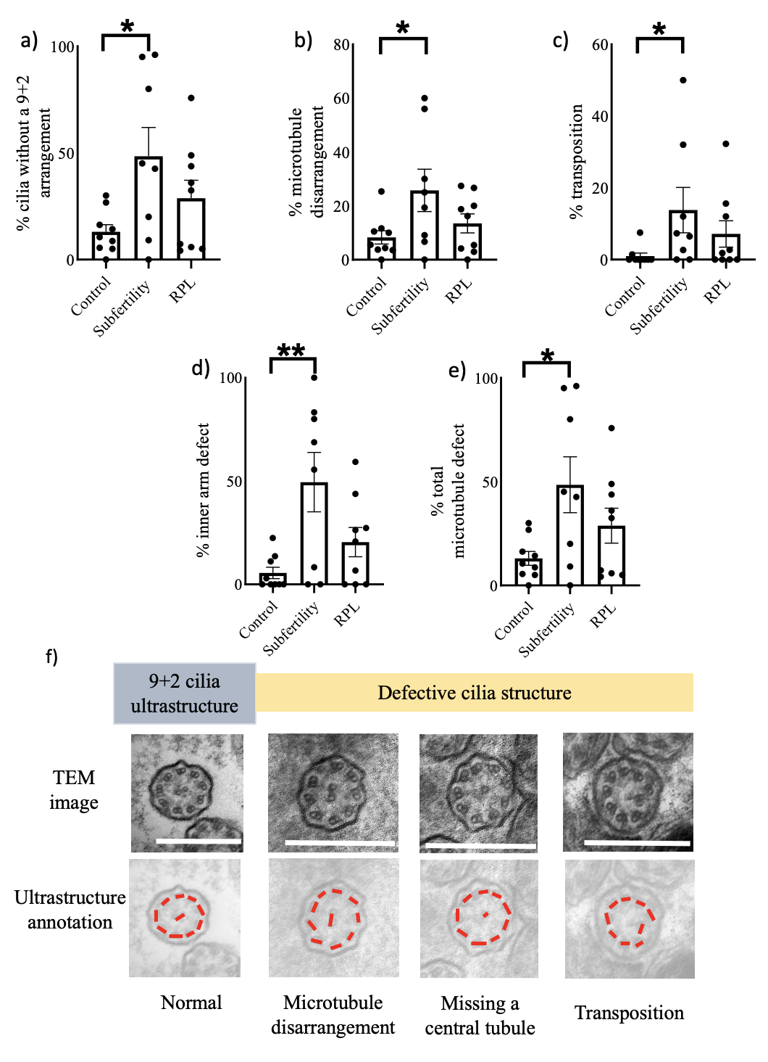

**Figure 1. Endometrial gland cilia from women with reproductive failure have a higher number of cilia defects versus controls.** Percentage of cilia **a)** without a 9+2 ultrastructure **b)** microtubule disarrangement, **c)** transposition, **d)** inner arm defect and **e)** total microtubule defects in women with subfertility and recurrent pregnancy loss (RPL) compared to controls. * = a difference between study groups P < 0.05, ** = a difference between study groups P < 0.01. f) Representative images of a 9 + 2 microtubule arrangement in controls, and the cilia defects represented above, white bars = 500 nm.



**Figure 2. Microtubule disarrangement and inner arm defects linked in ciliated uterine glandular epithelial cells from women with subfertility.** There was a positive correlation (R2 = 0.28, P = 0.003) between the percentage of microtubule disarrangement and inner arm defects in women with subfertility. There was no significant relationship in the other groups, despite a similar trend.

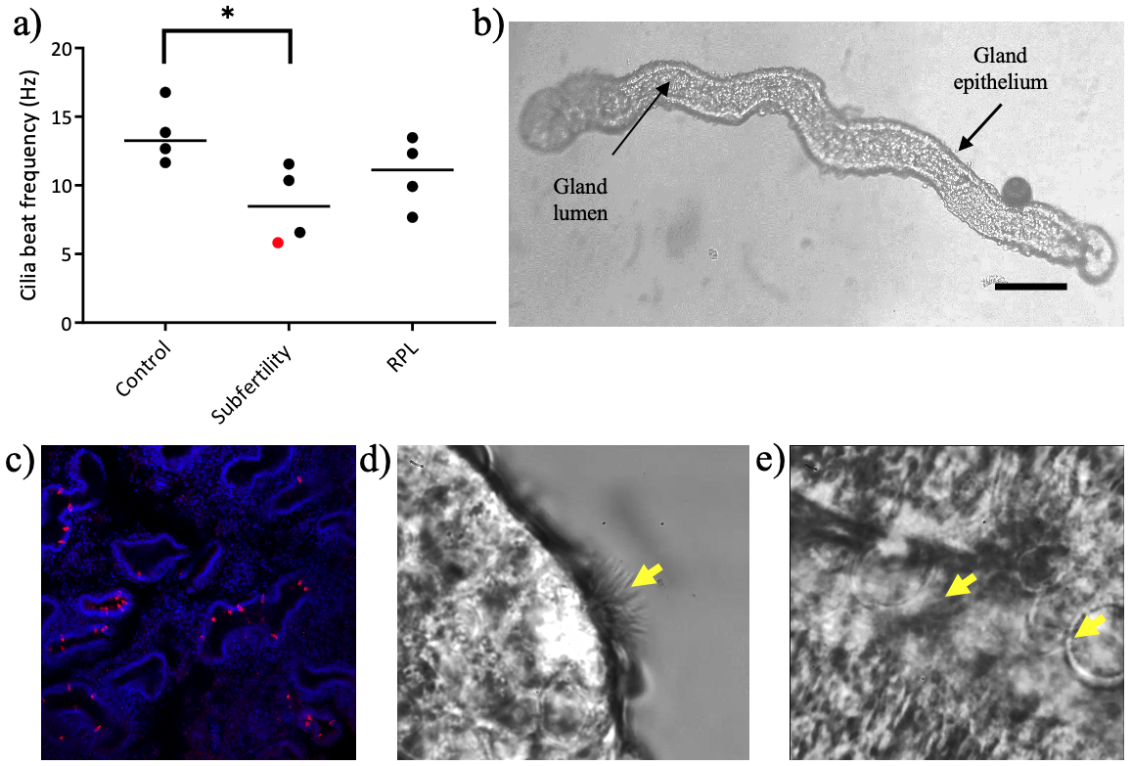

**Figure 3. Cilia beat frequency may be reduced in endometrial glands from women with subfertility**. **a**) Decreased cilia beat frequency in women with subfertility compared to controls (red is a subfertility patient with a known history of PCD), RPL = recurrent pregnancy loss * = a difference between study groups P < 0.05. **b**) representative image of endometrial glands freshly isolated from endometrial biopsies in which imaging of cilia beat frequency was determined (black bar = 50 µm). **c**) representative confocal image of cilia stained with radial spoke head protein 4 (red) inside endometrial glands (Tissue stained with DAPI, blue). **d**) representative video of an exposed endometrial ciliated cell showing the beating slowed down 17 times. **e**) representative video snapshot of cilia beating on the inside of an endometrial gland, cilia are apparent in the moving image.

**Note: Panels d) and e) to be replaced by in text video, for text video links please link panel d) to supp video 1 and panel e) to supp video 2.**

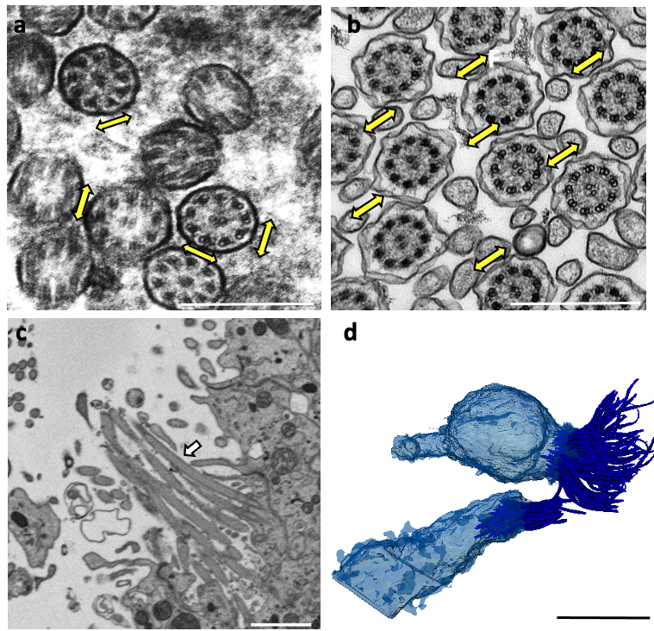**Figure 4. Arrangement of endometrial gland cilia supports an unsynchronised beat pattern.** **a)** TEM image of non-uniform positional direction of glandular cilia central pairs, suggesting an unsynchronised cilia beating pattern, white bar = 500 nm. More details on microtubule arrangement can be found in supplementary figure 1. **b**) Comparative TEM image of cilia in the respiratory tract from a healthy volunteer with a coordinated cilia beat function, white bar = 500 nm, yellow arrow = cilia beat direction. **c**) SBFSEM image of endometrial gland cilia, white bar = 1 µm, white arrow = cilia **d)** 3D reconstruction of ciliated cells inside the glandular lumen, black bar = 5 µm.

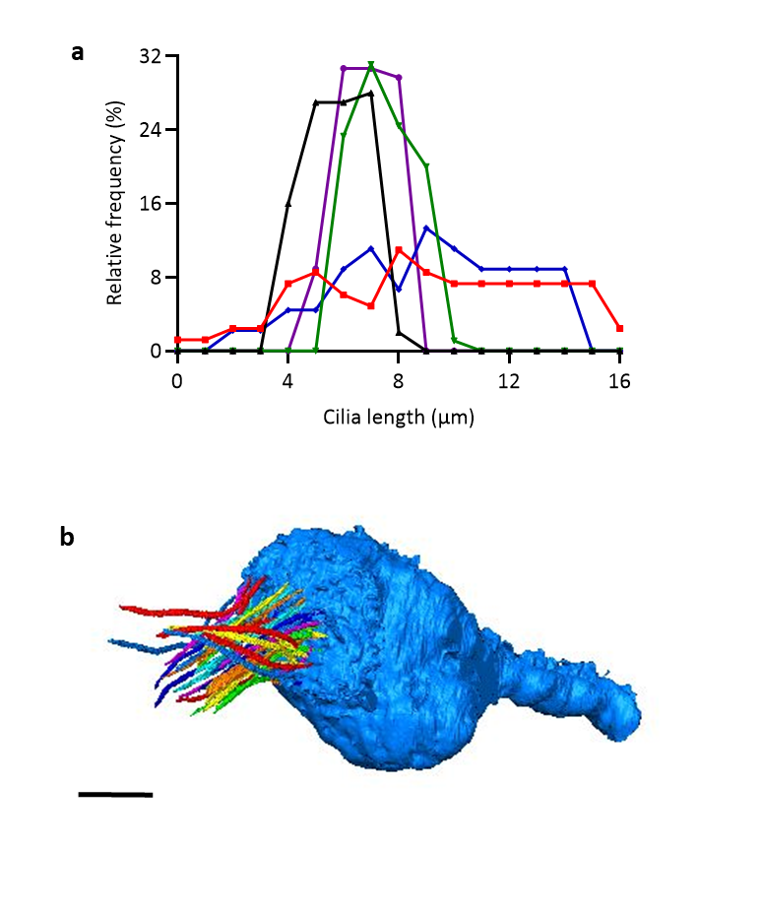

**Figure 5. 3D reconstruction allows quantification of endometrial gland cilia length. a**) Distribution curve of cilia length indicating that there is variation in cilia length within and between ciliated cells however there were no significant differences between these 5 ciliated cells by ANOVA (P = 0.4, n = 5 ciliated cells). **b**) 3D reconstruction of single cilia on which quantitative analysis was based, each individual cilium is presented in a different colour. Scale bar = 2 µm.