Human Milk Extracellular Vesicles Preserve Bronchial Epithelial Barrier Integrity
and Reduce TLR3-Induced Inflammation in vitro

Karra. N. ª | Van Herwijnen.M.J.C ^{b} | Wauben. M.H.M ^{b} | Swindle. E.J. ^{c,d} | Morgan. H. ^{a,d}

ª Electronics and Computer Science, Faculty of Physical Sciences and Engineering, ^{c} Clinical and Experimental Sciences, Faculty of Medicine, ^{d} Institute for Life Sciences,
University of Southampton. ^{b} Department of Biomolecular Health Sciences, Faculty of Veterinary Medicine, Utrecht University.
Corresponding Author: Hywel Morgan (hm@ecs.soton.ac.uk)

Abstract
Breast milk is essential for facilitating the growth and development of infants and for providing immune protection against viral infections in the infant’s airways. Yet, regulation of inflammation by milk components may be needed to reduce immune pathology. While milk-derived extracellular vesicles (EVs) are bestowed with immunomodulatory capacities, their role in bronchial epithelial barrier function and inflammation has not yet been examined. We hypothesised that during feeding, milk is not only ingested, but aerosols containing milk EVs are inhaled and locally delivered to the infant’s airways to suppress aberrant inflammation. A bronchial epithelial model of viral infection was used to explore the direct effect of milk EVs on cellular barrier function and cytokine release during stimulation with a viral dsRNA analogue (Poly I:C). We demonstrate that milk EVs improved the dsRNA-mediated decrease in ionic barrier integrity, limited tight junction reorganisation and reduced inflammatory cytokine production (IL-6, IL-8 and TNF-α). This protective response was EV-mediated, could be successfully titrated and exhibited a time-dependent response. The results indicate that if EV-containing milk aerosols are inhaled during feeding, this may lead to protection of the airway integrity from adverse inflammatory effects.

Keywords
Extracellular Vesicles, Exosomes, Anti-Inflammatory, Bronchial Epithelium, Barrier Integrity, Milk

Introduction
The importance of breastfeeding is well established; it provides nutrition, facilitates growth and development, protects the infant from infection whilst the adaptive immune system develops [1], [2]. It also regulates inflammatory responses [3] with a lower incidence of infectious morbidity and mortality in infants [4]. Breast milk contains a multitude of components, like milk fat globules, casein micelles, immune cells, oligosaccharides, microbes and EVs, each with their own function [2], [5], [6]. Milk EVs are nanosized lipid bilayer enclosed particles released by a multitude of cells, such as epithelial cells and immune cells [5]. Milk EVs can provide communication between mother and child, delivered via their cargo that includes proteins, lipids, small RNAs and metabolites [1][3]. Because of the oral route of breast milk, there has been a focus on milk EV function in the gastro-intestinal tract. Milk EVs have been shown to dampen endosomal toll-like receptor-induced immune responses (TLR-3, TLR-9) and protect against oxidative stress injury in the gut [3], [7]–[9]. However, milk EVs may also play a role in reducing viral-induced inflammation in the airways [5] as milk aerosols are thought to be inhaled during breastfeeding, as infants use cyclical sucking and breathing patterns with intermittent windows to swallow milk [10]. The existence of milk aerosols and their inhalation has been further demonstrated during occupational tasks e.g., milking cows and walking through milk storage rooms [11]. Since the airways have a large surface area that interacts with the external environment, colloidal material present in aerosols can be taken up, making the airways highly susceptible to damage or inflammation induced by these particulates, toxins, microorganisms or allergens [12]. Such that impairment of epithelial barrier function and repeated infections in the first 3 years of life can significantly increase the risk of developing asthma [13]. Although there is a comprehensive insight into the anti-inflammatory capabilities of EVs, a possible physiological role of milk EVs in controlling bronchial inflammation has not yet been investigated.

This study investigated the impact of milk EVs on a bronchial epithelial cell line when challenged in the presence or absence of a viral dsRNA analogue (Poly I:C), focusing on barrier integrity (determined from ionic permeability and immunofluorescent staining analysis) and cytokine release.

Methods and Materials

EV Isolation
Fresh and mature human milk was collected by 3 healthy mothers as previously described [6] using an electric breast pump. Donors had a mean age of 33 ± 1 years, were at a mean lactational stage of 5.3 ± 1.5 months and had a mean parity of 1.7 ± 0.6. Informed consent was given by the donors and this study was approved by the local ethics committee. EVs and EV-depleted (EV-dpl) procedural controls were isolated as previously described [3] using differential centrifugation, density gradient separation and size exclusion chromatography. Isolated EV and EV-dpl samples were eluted in minimal essential medium MEM and Glutamax (Gibco) and stored (at -80 ºC) and shipped on dry ice until use. We previously validated this EV isolation protocol and characterized 2 out of 3 donor samples (milk EVs and EV-dpl) used in this study by nanoparticle tracking analysis (NTA) and Western blot analysis [3]. Data are available in the EV-TRACK knowledgebase (EV-TRACK ID: EV200007) [14]. Samples were freeze-thawed once to aliquot into smaller volumes and supplemented with 1% Penicillin-Streptomycin and 10% foetal bovine serum (FBS) (Life Technologies) and stored at -80 ºC until required.

Cell Culture and Challenge
The bronchial epithelial cell (BEC) line 16HBE14o- was used, owing to its ability to form tight junctions between cells leading to the generation of a polarised epithelial barrier with a high transepithelial electrical resistance (a measure of ionic permeability) [15]. Cells were maintained in MEM and Glutamax (Gibco), supplemented with 1% Penicillin-Streptomycin and 10% foetal bovine serum (FBS) (Life Technologies) termed complete MEM. Upon reaching ~70% confluency, cells were incubated in Hanks' Balanced Salt Solution (HBSS) without Ca²⁺ and Mg²⁺ for 10 minutes at 37 ºC before detachment via a 5-minute incubation in 1 X trypsin (Life Technologies). The trypsin was then neutralised with complete MEM and the cell suspension pelleted at 300 x g for 5 minutes at 21 ºC. The cell pellet was resuspended in complete MEM and cells were counted using the trypan blue exclusion method. The cells were apically seeded onto collagen coated (30 μg/mL, Advanced Biomatrix) transwell inserts (Merck) at a density of 4.5 x 10⁵ cells/cm² for 1 hour to facilitate cell adhesion before measurements were conducted. Apical and basolateral media was replaced on days 2 and 4. Cells were apically challenged on day 5 following the formation of a barrier with 20 μL dsRNA analogue polyinosinic:polycytidylic acid (Poly I:C, 5 μg/mL) (Invivogen), with or without 5-100 μL of EV or EV-dpl sample, using fresh complete MEM as a control. As cells were grown in transwells the total apical volume was 200 μL, EV samples were 1:1 diluted with apical media providing an EV concentration of half the physiological concentration found in breast milk for the highest volume used (100 μL), which was diluted further in the titration studies to generate 25%, 12.5%, 5% and 2.5% of the physiological concentration.

Trans Epithelial Resistance (TER)
Daily TER measurements were made using conventional “chop stick” electrodes and a Millicell ERS-2 Voltohmmeter (Merck). Following the day 5 measurement, cells were challenged, and TER measurements made hourly for 5 hours and then at 24 hours.

ELISA
At the end of the experiment (24 hours after challenge), samples from the apical and basolateral compartments were centrifuged at 300 x g for 5 minutes. The resultant cell-free supernatants were stored at -20 ºC until required. ELISAs were performed using the R&D Systems Duoset ELISA kits (IL-8: DY208, IL-6: DY206, TNF-α: DY210) and accompanying Ancillary Kit (DY008). 96-well plates were incubated with capture antibody (IL-8: 4 μg/mL, IL-6: 2 μg/mL, TNF-α: 4 μg/mL) overnight at room temperature. Plates were washed thrice in wash buffer (0.05% Tween-20 in PBS), and incubated with block buffer (1% BSA in PBS, pH 7.2-7.4, 0.2 μm filtered) for IL-8 or in reagent diluent (0.1% BSA 0.05% Tween-20 in Tris Buffered Saline, pH 7.2-7.4, 0.2 μm sterile filtered) for IL-6 and TNF-α for a minimum of 1 hour before being rinsed thrice in wash buffer. Experimental apical and basolateral supernatant samples were thawed on ice and diluted in reagent diluent using optimised dilutions outlined in the ESI and incubated with the standards for 2 hours in the dark at room temperature. The plate was washed again and incubated for 2 hours in the dark with a detection antibody (IL-8: 10 ng/mL, IL-6: 50 ng/mL and TNF-α: 400 ng/mL) prior to rinsing (3X) and a 20-minute incubation in the dark with HRP-solution (1:40 dilution) at room temperature. The plate was then washed again (3X) and incubated with 1 X TMB (Thermo Fisher Scientific) at room temperature with periodic gentle agitation until a colour change was detected then the reaction is stopped with 2N Sulphuric Acid and the plate read at 450 nm and 570 nm following a 30 second shake at 400 rpm.

Immunofluorescence Staining
Samples were fixed in 4% Paraformaldehyde (PFA) for 20 minutes and stored in PBS at 4°C. Samples were permeabilised with 0.1% Triton X-100 in PBS and blocked with PBS plus 2% BSA and 0.1% Tween 20 and incubated overnight with Acti-stain555-phalloidin (Cytoskeleton) and AlexaFlour®488- conjugated anti-human mouse occludin antibody (Life Technologies) at 4°C in a humidified chamber. Samples were washed thrice (PBS with 0.1% Tween-20) and counterstained with DAPI nuclear stain before rinsing with PBS and 0.1% Tween-20 solution (thrice) and dH₂O. Samples were mounted onto glass coverslips using Mowiol (Merck) and were aligned using a Leica DMI 6000 inverted fluorescence microscope prior to images being captured at 63X using confocal microscopy in xyz mode (Leica TCS-SP8 laser scanning microscope) using laser wavelengths of 405nm (DAPI), 561nm (Actin) and 488nm (Occludin).

Data Analysis
All results are presented as mean and standard deviation. Statistical analysis was performed using Graphpad Prism. A Shapiro-Wilk test assessed the data for normality. A one-way ANOVA with a Bonferroni post-test or Friedman’s Test with a Dunn’s post-test correction was used to calculate statistical significance. Results were considered statistically significant when p < 0.05 where *p≤0.05 , **p≤0.01 , ***p≤0.001 , ****p≤0.0001 .

Results

Milk EVs Preserve Bronchial Epithelial Barrier Integrity during Inflammation.
To determine the anti-inflammatory capacity of milk EVs on BECs during viral induced inflammation in the airways, bronchial epithelial cells (16HBE14o-) were apically challenged after 5 days of growth (ESI) with Poly I:C (a dsRNA analogue recognized by TLR3) in the presence and absence of EVs or EV-depleted controls (EV-dpl). The barrier response was monitored over 24 hours. For control cells without Poly I:C challenge (media control), the TER remained largely unchanged during the first 5 hours of measurement, declining gradually over 24 hours (Figure 1A). A similar trend in TER was observed when cells were exposed to milk EVs (Figure 1A) or the procedural EV-dpl control (Figure 1B), indicating no detrimental or stimulatory effects of milk EVs. In contrast, exposure of cells to Poly I:C reduced the TER as expected by over 50% in the first 3 hours after challenge(Figure 1A/B). Remarkedly, the Poly I:C-induced loss in TER could be overcome by the presence of milk EVs (Figure 1A), where the TER remained at approximately 100% over the first 5 hours, reducing at 24 hours similar to the media control. This contrasts with the Poly I:C-induced loss in TER in the presence of EV-dpl control (Figure 1B), where the TER already decreased in the first hours.

Figure 1C summarises these data in terms of mean (normalised) TER 24 hours post challenge. There was no significant difference between the media controls in the absence or presence of EV-dpl control or milk EVs. This was in sharp contrast with the TER of cells challenged with Poly I:C alone which was significantly reduced at 24 hours. Addition of EVs to Poly I:C challenged cells reversed the decline in TER substantially, whilst EV-dpl samples demonstrated subdued protection.

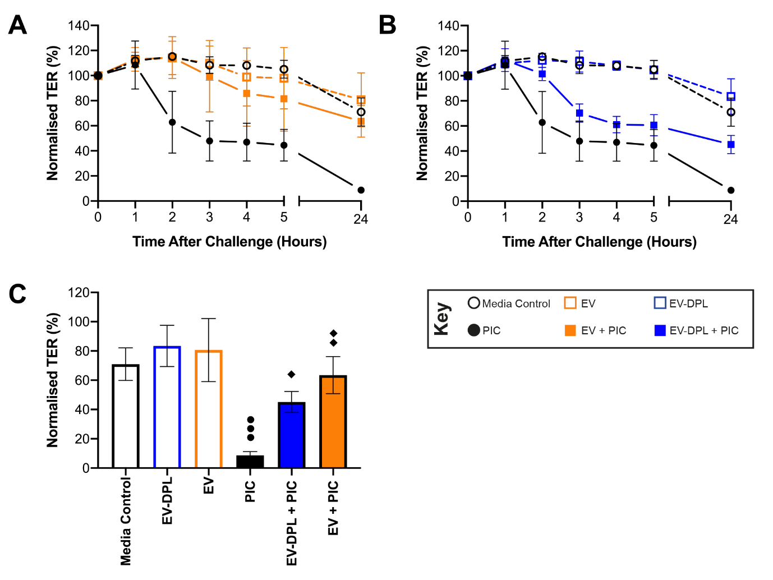
Figure 1: Bronchial epithelial barrier integrity as a function of time following challenge with Poly I:C and milk EVs. Polarised 16HBE14o- cells were apically challenged with Poly I:C (5 μg/mL) in the presence or absence (100 μL) of EV or EV-DPL samples and the TER measured periodically over a 24-hour period. (A) is EV data with control media and Poly I:C (PIC); (B) is the corresponding EV-dpl data and (C) Normalised TER values of the 24-hour time points. The TER is normalised to the value at day 5 (100%). Results are the average ± standard deviation of n=3 repeats in triplicate (3 milk donors in singlet). The different symbols detail the significance of multiple comparisons: ●●● p≤0.001 vs media control, ♦ p≤0.05 and ♦♦p≤0.01 vs Poly I:C as determined by one-way ANOVA with Bonferroni correction for multiple testing.

Milk EVs Modulate Inflammatory Cytokine production during Stimulation of BECs with Poly I:C.

Following stimulation with Poly I:C, BECs produce pro-inflammatory cytokines including IL-6, IL-8 and TNF-α that initiate and perpetuate inflammatory response [16] [17]. The concentration of inflammatory cytokines (IL-8, IL-6 and TNF-α) was measured 24 hours post challenge by ELISA and the results are summarised in Figure 2. To facilitate comparison of the data, the concentrations are normalised by subtracting the cytokine concentrations for the media control and normalising to the Poly I:C values.

Figure 2 shows that cells treated with EV or EV-dpl only produced levels of IL-8, IL-6 and TNF-α similar to the unstimulated media control. When cells were challenged with Poly I:C in the presence of EV-dpl, cytokine release was reduced in both the apical and basolateral compartments by 64% and 65% for IL-8, 45% and 53% for IL-6 and 57% and 53% for TNF-α respectively. However, significantly stronger effects were observed for cells treated with EVs, with a substantial reduction of ~90% in the cytokine ratios for IL-8 and IL-6, whilst TNF-α release was inhibited completely in the apical compartment and significantly reduced by 95% in the basolateral compartment. These data suggest that in the presence of EVs there is a significant modulation of Poly I:C-induced cytokine production, whilst a smaller effect is observed with EV-dpl samples.

Figure 2: Milk EV modulation of cytokine responses following challenge with Poly I:C. Polarised 16HBE14o- cells were apically challenged with Poly I:C (5 μg/mL) in the presence or absence (100 μL) of EV or EV-DPL samples. 24 hours after challenge the apical and basolateral samples were centrifuged at 300 x g for 5 minutes with the supernatants analysed for IL-8, IL-6 and TNF-α by ELISA. The cytokine concentrations were plotted by first subtracting the unstimulated media concentrations then normalising to concentration after Poly I:C challenge. The different symbols detail the significance of multiple comparisons: ♦♦♦ p≤0.001 and ♦♦♦♦ p≤0.0001 vs Poly I:C and ■■ p≤0.01, ■■■ p≤0.001 and ■■■■ p≤0.0001 vs EV-dpl + Poly I:C as determined by one-way ANOVA with Bonferroni correction for multiple testing. The data shows the average ± standard deviation of n=3 repeats in triplicate (3 donors in singlet).

Extracellular Vesicles Display Concentration Dependent Modulation of Barrier Integrity Following Challenge with dsRNA analogue.

To determine whether the protective function of EVs was concentration dependent, different concentrations of EVs and corresponding EV-dpl controls were tested in the presence of Poly I:C (5 μg/mL), by analysing the TER and IL-8 release. The milk EV concentration was varied by diluting the EV samples in media, such that 100 μL of EVs in a 200 μL final volume equated to 50% of the physiological milk EV concentration down to 5 μL EVs in a final volume of 200 μL which equated to 2.5% of the physiological concentration.

Figure 3 shows the change in (normalised) TER over 24 hours for different concentrations of EVs following Poly I:C challenge. The barrier integrity was highly modulated in the presence of EV samples in a time and concentration-dependent manner. One hour after challenge the higher volumes of EVs 25, 50 and 100μL generated TERs similar to the media control, whilst EV-dpl samples also showed some modulation but to a lesser extent. The difference within concentration and sample type was more pronounced as time increased. After 2 hours, a protective effect of EVs was observed on the Poly I:C-induced reduction in TER from 20% to 83% in the presence of 100 μL of EVs. After 3 hours a similar pattern was observed with EVs at 100 μL and 50 μL demonstrating a significant protection in the Poly I:C-induced increase in ionic permeability of the epithelial barrier (from 16% for Poly I:C alone compared to 62% for 100 μL EVs + Poly I:C (Control = 100%) (Figure 3C). While the effect was not as pronounced at 4-5hr stimulation, at 24 hours post challenge the highest concentration of EVs (100 μL) showed protection from the Poly I:C-induced reduction in TER (from 2% for Poly I:C alone to 45% for EV + Poly I:C) while for the corresponding EV-dpl control the TER dropped to 10% of the initial value. These data show that the effect of EVs on the TER is influenced by both time and concentration, where just 50% of physiological milk concentrations of EVs provide protection 24 hours after administration. Supporting this conclusion are the ELISA results where Poly I:C alone generated the greatest amount of IL-8, which was markedly reduced in the presence of the 50% and 25% of the physiological concentration of EVs (100-50 μL) and EV-dpl (100 μL) samples (see ESI).

Figure 3: Concentration dependent modulation of TER with milk EVs in the presence of Poly I:C. Polarised 16HBE14o- cells were apically challenged with Poly I:C (5 μg/mL) in the presence or absence (5 to 100 μL) of EV or EV-DPL samples to achieve a total apical volume of 200 μL. The TER was measured periodically over a 24-hour period. Following apical challenge ionic barrier integrity was monitored by hourly transepithelial electrical resistance (TER) measurements for 5 hours (A) and then at 24 hours (B) using “chopstick” electrodes. The results in (A and B) are normalised to the day 5 value (100%). The different symbols detail the significance of multiple comparisons: ● p≤0.05, ●● p≤0.001 and ●●●● p≤0.0001 vs the Media Control, ♦ p≤0.05, ♦♦♦ p≤0.001 and ♦♦♦♦ p≤0.0001 vs Poly I:C and ■■ p≤0.01 and ■■■■ p≤0.0001 vs EV-dpl + Poly I:C as determined by one-way ANOVA or Friedman test with a Bonferroni or Dunn’s correction for multiple testing. The data shows the average ± standard deviation of n=3 repeats in triplicate (3 donors in singlet).

Extracellular Vesicles Preserve Tight Junction Organisation Following Challenge with Poly I:C.

To determine whether the EVs were able to maintain the integrity of tight junction organisation and formation, samples were immunofluorescently stained with an occludin antibody and counterstained with DAPI to visualise nuclei and phalloidin to visualise the cytoskeleton. Images of only tight junctions are shown in Figure 4 (overlaid images with nuclear and actin staining available in the ESI). Media control, as well as EV-dpl and EVs in the absence of Poly I:C had a similar apicolateral localisation of the tight junction protein occludin with pericellular location (Figure 4A, C and D). The distribution of occludin was disrupted in the presence of Poly I:C, where the occludin was re-organised and concentrated at the cell-cell junctions, also displaying gaps within the perimeter (Figure 4B). When EVs are applied in conjunction with Poly I:C, the tight junction distribution appeared similar to control conditions without Poly I:C with prominent staining encircling the cells, whereas the EV-dpl sample are less able to modulate the Poly I:C response with weaker tight junction staining in comparison to EVs.

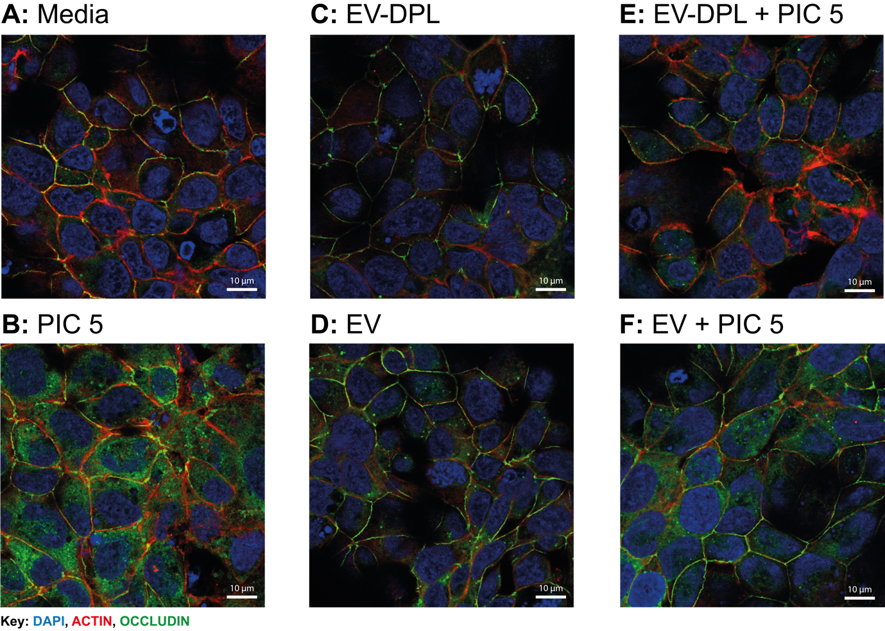
Figure 4: Bronchial epithelium tight junction organisation following challenge with Poly I:C in the absence of presence of milk EVs or EV-dpl controls, imaged by immunofluorescent staining. Polarised 16HBE14o- cells were apically challenged with Poly I:C (5 μg/mL) in the presence or absence (100 μL) of EV or EV-DPL samples. Samples were fixed using 4% PFA, 24-hours after challenge then immunofluorescently stained using DAPI nuclear, Actin cytoskeleton and occludin tight junction staining. Images show the occludin tight junction apicolateral region of Z projection stack only, captured using confocal imaging at 63X at wavelengths 405 (DAPI), 561 (Actin) and 488 (Occludin) (Leica TCS laser scanning microscope). The images are representative of n=3 donors.

Discussion

The airways host a large surface area with a continuous epithelium that interacts with the external environment [18], where the barrier function is essential to maintain homeostasis. During the early stages of development before adaptive immunity has been gained, the infant is protected by the pattern recognition receptors (such as TLRs) expressed on airway epithelial cells, which are able to recognise pathogens and hazards and aid the development of adaptive immunity [19]. Breast milk plays an important role in this immunological programming. Where it has been shown that in breast fed infants compared to formula fed infants a more anti-inflammatory milieu is created [20]. Breast milk is enriched in a variety of molecules that have demonstrated an ability to modulate immune responses [21], an example of which are milk EVs that can dampen TLR activation in the oral cavity and gut [3], [7]–[9]. Since milk aerosols could be inhaled by infants during breast feeding due to the intermittent periods required to swallow milk during a continuous sucking and breathing cycle [10], this provides a route for milk particles to travel into the airways. To study possible immune modulatory effects of milk EVs on infant’s airways we used the immortalised bronchial epithelial cell line 16HBE14o- (originally obtained from a 1 year old male [15]).

As indicated by the MISEV guidelines [22], in order to claim an EV-mediated effect, appropriate controls should be used in experiments and effects should be titratable. For this, we deployed procedural controls made from EV-depleted milk supernatant which was subjected to the same isolation protocol as the EV sample, resulting in a donor-matched procedural milk control [3]. To evaluate potential immune modulatory effects of human milk EVs, we used a previously described method to test effects of milk EVs in a physiological concentration [3]. In this volume-based method, isolated EVs were tested in in vitro cell cultures at concentrations similar to their concentration in milk (9.3 × 10¹⁰ ± 1.2 × 10¹⁰ particles/mL)[3]. In our study cells were grown on Transwells at a liquid-liquid interface and EV samples were 1:1 diluted with apical media giving an EV concentration of half the physiological concentration found in breast milk. This indicates that the observed effects in our study could be an underestimation of the physiological capacity to modulate epithelial cell responses. However, knowledge is lacking about the concentration of EVs in milk aerosols. By investigating the potency of different EV concentrations, we here demonstrated that EV concentrations of 50% of the physiological concentration was able to inhibit viral dsRNA analogue Poly I:C activation of the immortalised bronchial epithelial cell line 16HBE14o-up to 24 hours post-challenge.

Poly I:C activates signalling via the toll like receptor 3 (TLR-3) pathway [22] and has been shown to disassemble tight junction complexes and reorganise the cell actin cytoskeleton without inducing cell death [23], [24]. EVs were found to greatly circumvent Poly I:C induced barrier disruption compared to the control EV-dpl samples. The addition of EVs allowed barrier maintenance comparable to the unstimulated condition (TER). This difference could be attributed in the variabilities observed in the organisation of tight junction occludin, as Poly I:C is able to reorganise and concentrate occludin to the cell-cell junctions, generating gaps around the perimeter leading to a reduction in ionic barrier integrity [23], [24]. The addition of EVs rescued tight junctions, maintaining strong apicolateral staining around cells, whereas this ability was less pronounced in the EV-dpl samples. These observations suggest that addition of EVs leads to modulation of the inflammatory response when cells are challenged with Poly I:C. The less pronounced modulatory effects of the EV-dpl samples might be caused by residual EVs but also other bioactive agents present in human breast milk, such as human milk oligosaccharides that have shown in the intestines to modulate the TLR-3 pathway and lactoferrin that inhibits IL-6, TNF-α and IL-8 production can be involved [21]. Our results demonstrate the need for a proper procedural matrix control when evaluating EV-mediated effects.

The inflammatory cytokines IL-6, IL-8 and TNF-α also play an important role in bronchial epithelial barrier function in terms of initiation and perpetuation of inflammatory responses [16], and addition of Poly I:C leads to an increase in their secretion [17]. For the cytokine analysis performed in this study the cytokine concentrations were plotted in terms of relative change with respect to the values 24 hours after Poly I:C challenge. This approach reduced passage-to-passage variability and differences in the absolute secretion levels for each cytokine to facilitate comparison. Poly I:C induced high values of IL-6 and IL-8 secretion, but lower amounts of TNF-α, as reported previously [16]. The addition of EVs to the Poly I:C significantly inhibited the cytokine over-expression by 80-90% for IL-6 and IL-8 and completely inhibited the Poly I:C mediated increase in TNF-α expression, which was significantly less prominent in the EV-dpl samples. These results were supported by previous findings for other cell types/organs where milk or stem cell EVs respectively reduced IL-6 production in a murine macrophage cell line [25] or in primary monocyte derived dendritic cells in response to LPS [26][27]. IL-6 and TNF-α were also reduced in a colitic murine model [28] and in a hepatic murine cell line [29]. Likewise, in an oral epithelial model, milk EVs were found to downregulate TLR-3 activation via reduction of IL-8 and IL-6 expression [3]. Thus, milk EVs are able to significantly modulate the inflammatory response by actively reducing the expression of inflammatory cytokines.

Conclusion
This work demonstrates that milk EVs can modulate the TLR-3 response (induced by Poly I:C) of bronchial epithelial cells in vitro by maintaining ionic barrier integrity and cellular organisation (occludin tight junctions and actin cytoskeleton). In addition, EVs reduce or inhibit apical and basolateral inflammatory cytokine production (IL-6, IL-8 and TNF-α), in a concentration and time dependent manner. A better understanding of the physiological relevance between milk EVs and the airways is needed, as in vivo small milk particles could be inhaled during breastfeeding and provide a natural mechanism by which inflammation is regulated by breast milk. As such milk EVs might also provide the basis for new intranasal therapeutics. Though future studies are required to further substantiate the physiological relevance.

Acknowledgements
This work was funded by the European union’s Horizon 2020 Framework Programme under the grant FETOPEN-801367 evFoundry. We would like to thank Jonathan James of the Brooke Lab, University of Southampton for provision of 16HBE14o- cell stocks and João Fernandes of the Centre of Hybrid Biodevices, University of Southampton for his technical support.

Declaration of Interest Statement
The authors declare no conflicts of interest.

References
[1] J. D. Galley and G. E. Besner, “The therapeutic potential of breast milk-derived extracellular vesicles,” Nutrients, vol. 12, no. 3, 2020, doi: 10.3390/nu12030745.
[2] C. Castellote et al., “Premature delivery influences the immunological composition of colostrum and transitional and mature human milk,” J. Nutr., vol. 141, no. 6, pp. 1181–1187, 2011, doi: 10.3945/jn.110.133652.
[3] M. I. Zonneveld et al., “Human milk extracellular vesicles target nodes in interconnected signalling pathways that enhance oral epithelial barrier function and dampen immune responses,” J. Extracell. Vesicles, vol. 10, no. 5, pp. 1–33, Mar. 2021, doi: 10.1002/jev2.12071.
[4] C. G. Victora et al., “Breastfeeding in the 21st century: Epidemiology, mechanisms, and lifelong effect,” The Lancet, vol. 387, no. 10017. pp. 475–490, 2016, doi: 10.1016/S0140-6736(15)01024-7.
[5] M. J. C. Van Herwijnen et al., “Comprehensive proteomic analysis of human milk-derived extracellular vesicles unveils a novel functional proteome distinct from other milk components,” Mol. Cell. Proteomics, vol. 15, no. 11, pp. 3412–3423, 2016, doi: 10.1074/mcp.M116.060426.
[6] M. I. Zonneveld et al., “Recovery of extracellular vesicles from human breast milk is influenced by sample collection and vesicle isolation procedures,” J. Extracell. Vesicles, vol. 3, no. 1, p. 24215, Jan. 2014, doi: 10.3402/jev.v3.24215.
[7] R. Gao et al., “A comparison of exosomes derived from different periods breast milk on protecting against intestinal organoid injury,” Pediatr. Surg. Int., vol. 35, no. 12, pp. 1363–1368, 2019, doi: 10.1007/s00383-019-04562-6.
[8] H. Miyake et al., “Endothelin receptor B affects the perfusion of newborn intestine: possible mechanism of necrotizing enterocolitis development,” Pediatr. Surg. Int., vol. 35, no. 12, pp. 1339–1343, 2019, doi: 10.1007/s00383-019-04559-1.
[9] P. Dong et al., “Protective Effects of Human Milk-Derived Exosomes on Intestinal Stem Cells Damaged by Oxidative Stress,” Cell Transplant., vol. 29, pp. 1–8, 2020, doi: 10.1177/0963689720912690.
[10] E. C. Goldfield, M. J. Richardson, K. G. Lee, and S. Margetts, “Coordination of sucking, swallowing, and breathing and oxygen saturation during early infant breast-feeding and bottle-feeding,” Pediatr. Res., vol. 60, no. 4, pp. 450–455, 2006, doi: 10.1203/01.pdr.0000238378.24238.9d.
[11] D. A. Ramirez and S. L. Bahna, “Food hypersensitivity by inhalation,” Clin. Mol. Allergy, vol. 7, pp. 1–6, 2009, doi: 10.1186/1476-7961-7-4.
[12] N. Karra, E. J. Swindle, and H. Morgan, “Drug delivery for traditional and emerging airway models,” Organs-on-a-Chip, vol. 1, no. December 2019, p. 100002, 2020, doi: 10.1016/j.ooc.2020.100002.
[13] S. T. Holgate, G. Roberts, H. S. Arshad, P. H. Howarth, and D. E. Davies, “The role of the airway epithelium and its interaction with environmental factors in asthma pathogenesis,” Proc. Am. Thorac. Soc., vol. 6, no. 8, pp. 655–659, 2009, doi: 10.1513/pats.200907-072DP.
[14] J. Van Deun et al., “EV-TRACK: Transparent reporting and centralizing knowledge in extracellular vesicle research,” Nat. Methods, vol. 14, no. 3, pp. 228–232, 2017, doi: 10.1038/nmeth.4185.
[15] P. J. Callaghan, B. Ferrick, E. Rybakovsky, S. Thomas, and J. M. Mullin, “Epithelial barrier function properties of the 16HBE14o- human bronchial epithelial cell culture model,” Biosci. Rep., vol. 40, no. 10, pp. 1–16, 2020, doi: 10.1042/BSR20201532.
[16] A. W. ming Chow, W. hung Ko, J. F. ting Liang, J. S. chong Wong, Y. Fu, and N. L. sang Tang, “Polarized secretion of interleukin (IL)-6 and IL-8 by human airway epithelia 16HBE14o- cells in response to cationic polypeptide challenge,” PLoS One, vol. 5, no. 8, 2010, doi: 10.1371/journal.pone.0012091.
[17] A. R. Lever et al., “Comprehensive evaluation of poly(I:C) induced inflammatory response in an airway epithelial model,” Physiol. Rep., vol. 3, no. 4, pp. 1–11, 2015, doi: 10.14814/phy2.12334.
[18] M. M. Leiva-Juárez, J. K. Kolls, and S. E. Evans, “Lung epithelial cells: Therapeutically inducible effectors of antimicrobial defense,” Mucosal Immunol., vol. 11, no. 1, pp. 21–34, 2018, doi: 10.1038/mi.2017.71.
[19] X. Xu-Chen, J. Weinstock, D. Rastogi, A. Koumbourlis, and G. Nino, “The airway epithelium during infancy and childhood: A complex multicellular immune barrier. Basic review for clinicians,” Paediatr. Respir. Rev., vol. 38, pp. 9–15, 2021, doi: 10.1016/j.prrv.2021.04.002.
[20] E. Kainonen, S. Rautava, and E. Isolauri, “Immunological programming by breast milk creates an anti-inflammatory cytokine milieu in breast-fed infants compared to formula-fed infants,” Br. J. Nutr., vol. 109, no. 11, pp. 1962–1970, 2013, doi: 10.1017/S0007114512004229.
[21] J. D. Thai and K. E. Gregory, “Bioactive Factors in Human Breast Milk Attenuate Intestinal Inflammation during Early Life,” Nutrients, vol. 12, no. 2, p. 581, Feb. 2020, doi: 10.3390/nu12020581.
[22] C. Théry et al., “Minimal information for studies of extracellular vesicles 2018 (MISEV2018): a position statement of the International Society for Extracellular Vesicles and update of the MISEV2014 guidelines,” J. Extracell. Vesicles, vol. 7, no. 1, 2018, doi: 10.1080/20013078.2018.1535750.
[23] F. Rezaee et al., “Polyinosinic:polycytidylic acid induces protein kinase D–dependent disassembly of apical junctions and barrier dysfunction in airway epithelial cells,” J. Allergy Clin. Immunol., vol. 128, no. 6, pp. 1216-1224.e11, Dec. 2011, doi: 10.1016/j.jaci.2011.08.035.
[24] C. Blume et al., “Temporal monitoring of differentiated human airway epithelial cells using microfluidics,” PLoS ONE, vol. 10, no. 10. 2015, doi: 10.1371/journal.pone.0139872.
[25] S. R. Ascanius, M. S. Hansen, M. S. Ostenfeld, and J. T. Rasmussen, “Milk-Derived Extracellular Vesicles Suppress Inflammatory Cytokine Expression and Nuclear Factor-κB Activation in Lipopolysaccharide-Stimulated Macrophages,” Dairy, vol. 2, no. 2, pp. 165–178, 2021, doi: 10.3390/dairy2020015.
[26] M. Reis, E. Mavin, L. Nicholson, K. Green, A. M. Dickinson, and X. N. Wang, “Mesenchymal stromal cell-derived extracellular vesicles attenuate dendritic cell maturation and function,” Front. Immunol., vol. 9, no. NOV, pp. 1–14, 2018, doi: 10.3389/fimmu.2018.02538.
[27] M. O. Gomzikova, V. James, and A. A. Rizvanov, “Therapeutic Application of Mesenchymal Stem Cells Derived Extracellular Vesicles for Immunomodulation,” Front. Immunol., vol. 10, no. November, pp. 1–9, 2019, doi: 10.3389/fimmu.2019.02663.
[28] A. Benmoussa et al., “Concentrates of two subsets of extracellular vesicles from cow’s milk modulate symptoms and inflammation in experimental colitis,” Sci. Rep., vol. 9, no. 1, pp. 1–16, 2019, doi: 10.1038/s41598-019-51092-1.
[29] H. Haga et al., “Extracellular vesicles from bone marrow–derived mesenchymal stem cells protect against murine hepatic ischemia/reperfusion injury,” Liver Transplantation, vol. 23, no. 6. pp. 791–803, 2017, doi: 10.1002/lt.24770.

Electronic Supplementary Information

ESI 1: Barrier integrity of bronchial epithelial cells after 5 days of growth. 16HBE14o- cells were grown for 5 days with cell growth media changed in the apical and basolateral chambers on days 2 and 4. The TER was measured daily. Day 0 and Day 5 measurements for Figure 1 (A) and Figure 3 (B). Results are the average and standard deviation of n=3 independent experiments.

ESI 2: Concentration dependent modulation of IL-8 release with and without extracellular vesicle immune protection when challenged with a viral dsRNA analogue. Polarised 16HBE14o- cells were apically challenged with Poly I:C (5 μg/mL) in the presence or absence (5 to 100 μL) of EV or EV-DPL samples to achieve a total apical volume of 200 μL. 24 hours after challenge the apical (A) and basolateral (B) samples were centrifuged at 300 x g for 5 minutes with the supernatants analysed for IL-8 concentrations using ELISAs. The raw data was analysed as follows: the duplicates were averaged, the 520 nm reading subtracted from the 450 nm reading, and then the average blank was subtracted. The data was then extrapolated using GraphPad prism (Sigmoidal 4PL, X is concentration). The results show the average and standard deviation of n=3 repeats (3 donors in singlet). Statistical significance was determined using one-way ANOVA analysis with a Bonferroni post-test. Significance of results indicated as when p<0.05 = *. Symbols detail multiple comparisons: circle = Vs. Media Control, diamond for vs. Poly I:C and square for vs. EV-dpl + Poly I: C.

ESI 3: Dilution ratios for ELISA cytokine analysis.
 | Conditions without Poly I:C |  | Conditions with Poly I:C
 | Apical | Basolateral | Apical | Basolateral
IL-8 | 1 in 25 | 1 in 10 | 1 in 25 | 1 in 25
IL-6 | 1in 20 | 1 in 10 | 1 in 100 | 1 in 50
TNF-α | 1 in 2 | 1 in 2 | 1 in 5 | 1 in 5

