Title page
Title
Decrease of peripheral natural killer cell level during early pregnancy predicts live birth in women with unexplained recurrent pregnancy loss：A prospective cohort study

Authors
Miaoxian Ou^{1,2}, MD
Lu Luo^{1,2}, MD, PhD, Associate Professor
Yuxin Yang^{1,2}, MD
Niwei Yan^{1,2}, MD, PhD
Xi Yan⁴, MD
Xue Zhong^{1,2}, MD
Ying Cheong^{4,5}, MD, PhD, Professor
Tinchiu Li⁶, MD, PhD, Professor
Juan Ouyang^{3 #}, MD, PhD, Professor
Qiong Wang^{1,2 #}, MD, PhD, Professor

Affiliations
1 Reproductive Medicine Center, The First Affiliated Hospital, Sun Yat-sen University, Guangzhou, China
2 Guangdong Provincial Key Laboratory of Reproductive Medicine, Guangzhou, China
3 Department of Laboratory Medicine, The First Affiliated Hospital of Sun Yat-sen University, Guangzhou, China
4 Human Development and Health, Faculty of Medicine, Southampton United Kingdom.
5 Complete Fertility, Southampton, United Kingdom
6 Department of Obstetrics & Gynecology, Chinese University of Hong Kong, Hong Kong, China

Disclosure statement
The authors report no conflicts of interest.
Financial support
This work was supported by the Guangzhou Municipal Science and Technology Project 202206010003, National Natural Science Foundation of China 81170568 and Science Foundation of Guangdong Province 2021A1515010290.

Corresponding author:
Qiong Wang, MD, PhD, Professor
Reproductive Medicine Center, The First Affiliated Hospital, Sun Yat-sen University, Guangzhou, China
Guangdong Provincial Key Laboratory of Reproductive Medicine, Guangzhou, China
No.58 Zhongshan Er Road, Guangzhou, Guangdong Province, P.R. China
E-mail: wqiong@mail.sysu.edu.cn
Telephone: +86 136090233322

Juan Ouyang, MD, PhD, Professor
Department of Laboratory Medicine, The First Affiliated Hospital of Sun Yat-sen University, Guangzhou, China
No.58 Zhongshan Er Road, Guangzhou, Guangdong Province, P.R. China
E-mail: ouyangj2@mail.sysu.edu.cn
Telephone: +86 13312865906

Word count
Abstract: 394 words
Main text: 2957 words

Condensation page
Tweetable statement
A five-year prospective cohort study included 1758 women with recurrent pregnancy loss evidences the decrease of peripheral natural killer cells during early pregnancy compared to pre-pregnancy may benefit to subsequent live birth.

Short title
Decrease of peripheral NK cell level predicts live birth in women with URPL

AJOG at a Glance (116 words)
A. Why was this study conducted?
Peripheral natural killer (pNK) cells decrease in middle and late pregnancy stage among healthy women, but the change of pNK cells level during early pregnancy and the relationship between the change of pNK cells level and pregnancy outcomes in women with unexplained recurrent pregnancy loss (URPL) has not been explored.
(50/56 words)

B. What are the key findings?
A lower early gestational pNK cells level has been observed in 61.5% women with URPL. Women with a lower gestational pNK cells level compared to pre-pregnancy pNK cells level have a significantly higher live birth compared to those without (89% vs 49%, p<0.001).
(39 43words)

C. What does this add to what is known?
The decrease of pNK cells level in early pregnancy may be fundamental important in the physiology of the establishment of a normal pregnancy.
(23words)

Abstract
BACKGROUND: Previous studies have suggested that the trophoblast cells inhibit the proliferation of peripheral natural killer (pNK) cells and the level of pNK cells decrease in middle and late pregnancy stage among healthy women. The change of pNK cells level during early pregnancy and the relationship between the change of pNK level and pregnancy outcomes in women with unexplained recurrent pregnancy loss (URPL) has not been sufficiently explored.
OBJECTIVE: This study aims to characterize the level of pre-pregnancy pNK to early pregnancy among women with URPL and whether the change in the level of pNK cells in early pregnancy from pre-pregnancy can predict pregnancy outcomes.
STUDY DESIGN: In this prospective cohort study, 1758 women with recurrent pregnancy loss were recruited between January 2017 and December 2021, of which 252 URPL women had pre-pregnancy and early pregnancy (4-6 weeks gestation) pNK measurements. These 252 women were divided into two groups: those with a lower gestational pNK levels (Group 1) compared to pre pregnancy, and those without (Group 2). Their respective outcomes on live birth and pregnancy loss were comparatively analyzed using Chi-square and Student’s t. Candidate influence factors for live birth were selected using the Akaike information criterion (AIC). Then the participates were randomly divided into training and testing groups. Multivariable logistic regression model was performed, and nomogram was calculated to assess the possibility of live birth. Overall predictive accuracy was assessed by Hosmer−Lemeshow test, discriminated by area under the receiver operating characteristic curve (ROC) and validated by plotting the predicted probabilities and the observed probabilities.
RESULTS: When early gestational pNK cells levels were compared with pre pregnancy pNK cells levels, 89% (154) women had a comparatively lower early gestational pNK cells levels versus 38.9% (98) women with increase or no change of their pNK cells levels. The live birth rate in Group 1 was 89.0% (137/154), which was significant high than 49.0% (48/98) of Group 2 (p<0.001). Decrease of pNK cells level (odds ratio [OR]=1.36, 95% CI 1.22-1.55, p<0.001) and anti-Muellerian hormone (AMH) (OR=1.41, 95% CI 1.14-1.81, p=0.003) were important predicting factors for higher live birth. Female BMI (OR=0.97, 95% CI 0.82-1.15, p=0.763) and parity (OR=1.61, 95% CI 0.71-4.12, p=0.287) were also predicting factors. Furthermore, the area under the ROC curve of the model to diagnose of live birth was 0.853 with a cutoff value of decreasing more than 0.85%, sensitivity of 81.6% and specificity of 78.0 using the test dataset. And the Hosmer−Lemeshow test showed that the model was a good fit (p = 6.068).
CONCLUSION: We report a comparative decrease in pNK cells levels in over 60% URPL women at 4-6 weeks of gestation, when compared to their pre-pregnancy pNK cells level. Compared to pre pregnancy pNK cells levels, a decrease pNK cells level during early pregnancy might be a useful predictor for LBR in women with URPL.
Key words: 1. Early pregnancy 2. Live birth 3. Peripheral NK 4. Unexplained recurrent pregnancy loss

Introduction
Recurrent pregnancy loss (RPL) is generally defined as the loss of two or more before 24 completed gestational weeks, affecting 1-5% of couples during their reproductive life ^{1,2}. Without medical management or intervention, the live birth rate decreases with an increasing of number of pregnancy loss ^{3,4}. RPL is a risk factor for obstetric complications and long-term sequelae including cardiovascular disease and venous thromboembolism ⁵⁻⁷. Approximately 50% RPL can be attributed to genetic, anatomic, endocrine, autoimmune, thrombophilia, infectious diseases, and environmental factors⁸. The remaining 50% are classified as unexplained recurrent pregnancy loss (URPL), which is thought to be correlated with undiagnosed immunological abnormality, including the disequilibrium of natural killer (NK) cells level.^{9,10}
Activated NK cells are essential innate immune cells which eliminate target cells by antibody-dependent cell-mediated cytotoxicity, perforin-granzyme pathways and death receptor-mediated pathways, then resulting in the apoptosis of target cells. Aberrant distributions of decidual NK (dNK) cells with low cytotoxicity and strong cytokine-producing capacity is known to suppress the extravillous trophoblast invasion and embryo growth in women with URPL¹¹⁻¹⁵; hence endometrial sampling is proposed as an investigative and diagnostic tool^{16,17} , but endometrial sampling can only be performed preconception. Thus, many studies look to peripheral blood natural killer (pNK) cells as an option for monitoring the immunological process during pregnancy. pNK cells, which make up approximately 10-15% circulating lymphocytes, play a significant role in regulating the immune tolerance and establishing successful maternal fetal interface^{18,19}. pNK cells could traverse the intervillous space and then display their function by contact with villus directly. In addition, pNK cells are recruited to the endometrium and participate in the process of decidualization. CD56+CD16+ NK cells, which account for 90-95% pNK cells, produce cytokines with strong cytotoxicity, such as perforin and granzyme B to mediate cell killing while CD56+CD16−NK cells have weak cytotoxicity ²⁰.
Early studies have observed elevated pre-pregnancy pNK cells level with higher cytotoxicity in women with URPL ²¹⁻²³. Previous studies also indicated that trophoblast cells and serum β-human chorionic gonadotropin (β-hCG) might inhibit pNK proliferation and then the number of pNK cells decreases in the middle and late pregnancy stages compared to non-pregnancy state amongst healthy women²⁴⁻²⁶ . Hence, it is plausible that the comparative levels of pre-pregnancy versus gestational pNK cells may be predictive of pregnancy outcomes^{27,28}.
In this study, we aim to investigate the relative change in pre-pregnancy pNK cells level compared to early pregnancy among women with a history of URPL and explored if the change is predictive of pregnancy outcomes.

Materials and Methods
Study design
The prospective cohort study enrolled women with RPL between January 2017 and December 2021 in the Reproductive Medicine Center of the First Affiliated Hospital of Sun Yat-sen University. RPL was defined as two or more consecutive pregnancy losses before 24 weeks ². URPL were diagnosed by RPL women excluded knowing causes according to ESHRE guideline ². Known causes of RPL were (1) parental chromosomal translocations; (2) clinical endocrine disease, including polycystic ovarian syndrome, thyroid diseases such as hyperthyroidism, hypothyroidism, thyroiditis and diabetes mellitus; (3) structural uterine abnormalities by transvaginal ultrasonography; (4) primary and acquired thrombophilia, including antiphospholipid syndrome (including anticardiolipin antibody, lupus anticoagulant antibody, anti-b2 glycoprotein I antibody); (5) infectious diseases, including endometritis by endometrial biopsy; (6) clinical autoimmune disease, including systemic lupus erythematosus and Sjogren syndrome.
All the RPL women were consented, and blood samples were taken at their routine basal sex hormones on day 2-5 of menstruation and also for pNK measurement.
Exclusion criteria were: (1) previous pregnancy loss over 12 gestational weeks (as the causative factors for 2nd versus 1st trimester are different); (2) lack of consent; (3) positive for antinuclear antibodies or antithyroid antibody; (4) no conception within a year after initial blood tests or until study end, whichever was sooner; (5) unwilling to have blood sample for pNK cell measurement during pregnancy; (6) the use of immunological medication before or after three months of pregnancy. pNK was also measured at 4 to 6 weeks of gestation.
Ultrasound was carried out at around 6-8 gestational weeks to confirm fetal heartbeat. At around 12 weeks of pregnancy, nuchal translucency was carried out. If the women miscarried, chromosome analysis of the chorionic tissue would be recommended. And the pregnancy outcomes were followed up by telephone call after eleven months of pregnancy.
The trial was approved by the ethics committees of the institutional review board of the First Affiliated Hospital of Sun Yat-sen University [2016-116].

Relevant laboratory analysis
All the serological indexes were measured before 10 am on day 2-5 of the menstrual cycle together with their routine basal sex hormone (FSH, LH and E₂). A total of 3 ml peripheral blood for pNK cells was obtained aseptically by venipuncture in EDTA-coated vacutainer tubes (BD). The whole blood was stored at room temperature, transported to laboratory and processed within two hours. Peripheral blood mononuclear cells (PBMCs) were isolated with density gradient centrifugation by Ficoll-Paque Plus gradient (GE Healthcare) and assessed by flow cytometric analysis within one hour.
Freshly thawed PBMC were used for surface staining and analysis for NK and NKT-like cell markers. PBMCs were suspended in staining buffer and plated at 1×10⁵-10⁶ cells according to the manufacturer’s instructions. After staining for 30 minutes with anti-human AF700-CD3, phycoerythrin (PE)-CD56, BUV396-CD16 (all from BD Biosciences) in the dark, multicolor flow cytometry was performed using a BD FACS Canto instrument. The percentages of CD3⁻CD56⁺, CD3⁻CD56⁺CD16⁺, CD3⁻CD56⁺CD16⁻, CD3⁺, CD3⁺CD56⁺cells in the PBMCs were calculated respectively. NK cells were identified as CD3⁻CD56⁺ cells population and NKT-like cells were identified as CD3⁺CD56⁺ cell population within the lymphocyte. CD3⁻CD56⁺CD16⁺ cells and CD3-CD56⁺CD16⁻ cells were subsets of NK cells. Peripheral natural killer cells level was identified as the percentage of CD3-CD56+ cells population within the lymphocyte.

Assessment of outcomes
Based on the relative change in pre-pregnancy pNK cells compared to early pregnancy, the outcomes were analyzed in two groups; those who had a lower pNK cell levels (Group 1, pre-pregnancy pNK - gestational pNK > 0) and those without (Group 2, pre-pregnancy pNK - gestational pNK ≤ 0). The primary pregnancy outcomes were live birth and early pregnancy loss. A live birth was defined as the delivery at least one live baby after 24 weeks. Early pregnancy loss was defined as the spontaneous loss of pregnancy before 12 weeks of gestation which included biochemical pregnancy and early miscarriage. Biochemical pregnancy was defined as the detection of human chorionic gonadotropin in maternal urine or blood, but no clinical pregnancy was achieved. Early miscarriage was defined as spontaneous intrauterine pregnancy demise confirmed by transvaginal ultrasound before 12 weeks. Pregnancy loss in the second trimester was defined as the spontaneous loss of pregnancy between 12 to 24 weeks of gestation. Termination of pregnancy referred to iatrogenic abortion due to fatal fetal dysplasia or chromosome abnormality between 12 to 24 weeks. Ectopic pregnancy was defined as embryo implantation outside the uterine cavity.
The secondary outcomes included preterm birth, preeclampsia or gestational hypertension, gestational diabetes and small for gestational age (SGA). Preeclampsia or gestational hypertension was defined as as a rise in systolic blood pressure to ≥140mmHg or in diastolic pressure to ≥90mmHg on two separate occasions in a patient before 20 weeks of gestation and new-onset proteinuria or, in the absence of proteinuria, new-onset hypertension with new onset of any of the following: thrombocytopenia, impaired liver function, renal insufficiency, pulmonary edema, or cerebral or visual disturbances²⁹. Gestational diabetes was defined as any degree of glucose intolerance with onset or first recognition during pregnancy and was diagnosed when ≥1 value exceeds the IADPSG criteria in women undergoing a 75 g oral glucose tolerance test (OGTT) after fasting for ≥8 hours³⁰. SGA was defined as estimated fetal weight or abdominal circumference below the 10th percentile of given reference ranges³¹. Spontaneous premature labor was defined as birth between 20 and 37 weeks of gestation following the spontaneous onset of labor, preterm prelabor rupture of membranes, or premature dilation of the cervix (cervical insufficiency)³².

Statistical analysis
Statistical analyses were performed with SPSS version 27.0, GraphPad Prism version 8.0 and R version 4.2.3. The normality of continuous variables was assessed using Shapiro-Wilk normality test. Normally distributed continuous variables, expressed as mean ± SD, were analyzed using Student t-test while nonnormally distributed variables were compared using the Kruskale Wallis test as medians and inter quartile ranges (IQR). Categorical variables, presented as number of cases (n) with occurrence percentage (%), were compared among the groups utilizing chi square analysis.
Total 16 candidate influence factors for live birth included, they were maternal age, male age, female BMI, male BMI, number of parities, number of previous pregnancy loss, months from the last miscarriage to pregnancy, mode of conception, anti-Muellerian hormone (AMH), pre-pregnancy pNK cells level, pre-pregnancy CD56+CD16+ cells level, pre-pregnancy CD56+CD16- cells level, pre-pregnancy CD3+ cells level, pre-pregnancy CD3+CD56+ cells level, gestational pNK cells level and change of pNK cells level. The candidate influence factors were calculated using pairwise correlations and those with correlations larger than 0.7 were removed to reduce the effects of collinearity. Akaike information criterion (AIC) was further used to select the remained candidate influence factors and then the final candidate predictor variables subsequently included in multivariable logistic regression models.
70% of the study participants were randomly selected to form the training dataset for model construction, while the remaining 30% of participants were used for model testing to assess the final model performance. For nomogram, logistic regression modeling was performed to examine the association between the decrease of pNK cells level and live birth. Overall predictive model performance was assessed using the confusion matrix, discrimination by area under the receiver operating characteristic curve (AUC), and calibration by plotting the predicted probabilities and the observed probabilities. The Youden index was used to find out the balanced sensitivity and specificity. And the Nagelkerke pseudo-R2 and to Hosmer-Lemeshow test has been used to explain the model and the goodness of the fit.

Results
Characteristics of the subjects
A total of 1758 women with history of RPL were enrolled from January 2017 and December 2021 (Fig. 1). Among these, 713 women were excluded as consent was not provided. A further 444 women were excluded for the known causes for RPL including 39 women who had a chromosome abnormity in either partner, 44 had autoimmune diseases, 44 had thyroid disease, 25 had polycystic ovary syndrome, 18 had diabetes mellitus, 15 had a significant uterine abnormality, 32 had endometritis, 5 had thrombophilia, 220 had multiple factors. Six hundred and one URPL women with pre-pregnancy pNK level were enrolled. Fifty-five women had a positive for ANA or antithyroid antibody, 148 women did not have another pregnancy in one year or till study end, 75 women were unwilling to detect pNK after pregnancy, 67 women received immunosuppressive medications treatment three months before or after pregnancy were excluded according to excluding criterion. Six women were loss to follow-up after pregnancy. 252 with UPRL were included for analysis.
Over a 5-year period, 185 women had live birth, 62 women experienced pregnancy losses, 3 women had ectopic pregnancies, 2 women had terminal of pregnancy for fetal malformation. Among 62 women who suffered pregnancy loss, 51 had early miscarriage, and 11 had biochemical pregnancy. Among those women with early miscarriage, 15 had abnormal embryonic chromosome karyotype, 16 had normal embryonic chromosome karyotype and 20 did not have any karyotype results as no tissue was collected or presence of maternal blood contamination. We did not find any difference in the decreasing of pNK levels in the pre pregnancy and gestational samples between those with normal and abnormal embryonic chromosome karyotypes (Table 2).
When comparing pre pregnancy pNK cell levels to gestational levels, 154 women had a lower pNK cell levels (Group 1) whilst 98 women did not (Group 2). Table 1 provides the comparative demographic characteristics of the two groups, which showed no statistical differences in age, BMI, gravidity, parity, number of previous pregnancy losses, mode of conception including natural, IUI, IVF-FET ( Fresh cycles), IVF-ET ( Frozen cycles) and blood tests (including anti-Mullerian hormone (AMH), anti-thyroid peroxidase antibody (TGAB), anti-thyroid peroxidase antibody (TPOAB), level of pre-pregnancy CD56+CD16- cells, pre-pregnancy CD3+CD56+cells and pre-pregnancy CD3+cells amongst the two groups (p>0.05). The total pre-pregnancy pNK and CD56+CD16+ subset pNK cells were higher in group 1 compared to group 2 (p＜0.001). The gestational pNK cells were lower in group 1 compared to group 2 (p=0.001).

Pre pregnancy and early gestational pNK cell levels
Overall, compared to pre pregnancy levels, gestational pNK cell level was decreased in 61.1% (154) URPL women (Group 1). In 48 % (98) of women, their pNK levels increased or remain unchanged at 4-6 gestational weeks (Group 2). Women in Group 1 had significant decreased in pNK cell levels (pre pregnancy: 19.57 ± 7.73%; early gestation 14.78 ± 5.99 %, p＜0.001); Group 2 had a significantly increased pNK cell levels (pre pregnancy 14.50 ± 6.71%, early gestation 17.59 ± 7.36 %, p＜0.001) (Figure 2).

A decrease in gestational pNK levels compared to pre pregnancy levels is associated with higher live birth rate amongst women with URPL
The mean live birth rate in 252 women was 73.4%, the mean rate of pregnancy loss in all women was 24.6%. Pregnancy outcomes in Group 1 and Group 2 had been shown in Table 2. The percentage of women with a live birth and pregnancy loss in Group 1 was 89% (137) and 9.7% (15) respectively; compared to Group 2, where 49% (n=48) women had a live birth and 48% (47) had a pregnancy loss (p＜0.001) (Table 2). 9.09% (1) women experienced biochemical pregnancy in Group 1 while 90.91% (10) women in Group 2 (p＜0.001). 30% (14) women in Group 1 while 70% (35) in Group 2 had early miscarriage (p＜0.001). Women in Group 1 had a significant higher live birth rate (74.05%, n=137) than women in Group 2 (25.95%, n=48) (p＜0.001). However, the other pregnancy outcomes were no differences between two groups (Table 2).

Decrease of pNK during early pregnancy is a significant factor impacting on live birth in women with URPL
Of the 16 candidate variables for live birth, pre-pregnancy pNK cells level, pre-pregnancy CD56+CD16+ cells level, pre-pregnancy CD3+ cells level and gestational pNK cells level was found strong correlation by using pairwise correlations and then the last three factors were excluded. Of the remaining candidate variables, four variables were retained after selection using AIC, all of which exhibited significant associations with live birth in the multivariable logistic regression model (Figure 3). Specifically, the decrease of pNK cells level (OR=1.36, 95% CI: 1.22–1.55, p<0.001) were positively associated with high live birth rate, while AMH (OR=1.41, 95% CI: 1.14–1.81, p=0.003) were also associated with live birth. However, female BMI (OR=0.97, 95% CI: 0.82–1.15, p<0.090) , and number of parity (OR=1.61, 95% CI: 0.71–4.12, p<0.090) were risk factors for live birth but with no significance.

The decrease of pNK level from pre pregnancy to early gestation predict live birth
The nomogram demonstrated the possibility of each influence factor for women with live birth (Figure 3). For each woman, higher total points indicated a higher possibility of live birth. The multivariable logistic regression model based on these 4 factors yielded an AUC of 0.853 for the training dataset (95% CI: 0.796–0.911; Figure 4). The model had good calibration, with an average discrepancy (difference between predicted and observed frequency) of 1.90% and maximum discrepancy of 7.1%. The calibration intercept is 0.00 and calibration slope is 1.00 (Figure 5A). And the Hosmer-Lemeshow test and Nagelkerke pseudo-R2 also demonstrated the goodness of the fit in the training test (p = 6.068, R2=0.442). For the test dataset, the model yielded an AUC of 0.875 (95% CI: 0.763–0.986; Figure 4), with average and maximal discrepancies of 3.3% and 7.5% (Figure 5B). The calibration intercept is 0.00 and calibration slope is 1.00 (Figure 1.00 (Figure 3)). The Youden index was 0.704, which yielded a specificity of 0. 816 and sensitivity of 0.780 for the training dataset. There is no statistical difference between the ROC curve for the training dataset and the ROC curve for the test dataset (p=0.741). Furthermore, the positive predictive value (PPV) of the training dataset was calculated at 91.7% and the negative predictive value (NPV) at 58.8%, whereas the PPV of the test dataset was 94.1% .and NPV at 60%.

Comments
Principal Findings
Women with a lower gestational pNK compared to pre-pregnancy pNK have a significantly higher live birth (89.0%) compared to those without (49.0%). Both decrease of pNK cells level and high AMH were important predicting factors for live birth, and decrease of pNK cells level shown the strongest influence. Lower female BMI and a greater number of parities were also predicting factors for live birth. A logistic regression model incorporating these factors demonstrated good prediction performance for both training and test datasets.

Results in the Context of What is Known
Our study found that the pNK cells level in the pre-pregnancy menstrual phase tends to become lower in early pregnancy in URPL women with a subsequent live birth. A large cohort study have shown higher pre pregnancy pNK cells levels was not a risk factor for subsequent pregnancy outcomes³³, which was in line with our previous study³⁴. However, pNK cells levels have not been investigated during the transitional period from pre-pregnancy to early pregnancy, a critical time during trophoblast invasion and spiral artery remodeling for the establishment of a balanced maternal-fetal interface³⁵. Lower pNK cells level during the second and third trimester when compared to non-pregnancy status was observed previously^{25,36}, which may indicate a modulation of inflammatory and immunity milieu in women with good prognosis ²⁶. Indeed, immunomodulatory treatments was proposed to lower the immune status including pNK cells levels and benefits on live birth have been reported³⁷⁻⁴¹.
The novelty of our study is that we observed a natural decrease in pNK cells level in women with a subsequent live birth from 19.57 ± 7.72 % pre pregnancy to 14.78± 5.99 % in early pregnancy without any treatments; a finding not been described before. None of previous studies on decreased pNK cells level after immunological intervention with higher live birth rate have measured the level of pNK cells for untreated group^{42,43}, so that the change of pNK cells level after pregnancy without treatment was unclear until this observation.
Several studies showed that higher pre-pregnancy pNK cells level and pNK activity were found in women with RPL than controls, but neither pre-pregnancy pNK cells level nor pNK activity could predict subsequent live birth or miscarriage ^{10,33}. In this study, lower pre-pregnancy pNK cells level was found in no decreased or increasing pNK group (Group 2) and women in Group 2 were more likely to experience a subsequent pregnancy loss. Nevertheless, we don’t think lower pre-pregnancy could be a predictor for live birth because the factor of pre-pregnancy pNK cells level was not present after enrolled in the logistic predictive model with other factors.

Clinical Implications
Our study showed that it is the negative change of pNK cell levels from pre-pregnancy to early pregnancy that may predict live birth rate in women with URPL and adds an additional layer of complexities when evaluating the impact of immunosuppressive treatment on this group of women. Specifically, according to our predict model, a decrease value of pNK cells level after pregnancy compared to menstruation phase could be a forecast of live birth. Consisted with previous studies, we found not only pregnancy pNK but also pre-pregnancy total pNK and CD3⁺, CD3⁺CD56⁺, CD56⁺CD16⁺ pNK subsets alone were not reliable predictors for live birth³³. The fluctuation of pNK during menstrual cycle had been explored and the level of pNK has been reported to be lower in the menstrual state compared with luteal phase⁴³. In this study, the pre-pregnancy pNK measurement was made on the menstruation day 2-5.

Research Implications
In the endometrium and decidua of healthy women, studies reported a relatively lower uNK cells after menstruation, with levels gradually increased during the secretory phase, reaching a peak and transitioned to dNK in the early pregnancy ^{44,45}. It is plausible that pNK cells could migrate to decidua and be converted to dNK⁴⁶; with the decreased gestational pNK population reflecting on a higher recruitment and transformation of pNK in the decidua ^{47,48}. Hence, the decrease of pNK cells in early pregnancy may be fundamental important in the physiology of the establishment of a normal pregnancy. The biological role of the dynamic transition of pNK in pre pregnancy to early pregnancy and its relations with placentation and embryo development requires further exploration.

Strengths and limitations
We report a large comparative observational study of assessing pNK cells pre and during early gestation as a guide to likelihood of live birth. We are limited by the nature of observational study, but we have adjusted for known confounders. It would need to be further confirmed by comparative studies with normal controls. Twenty women did not have results of the embryonic chromosome testing due to detection failure or maternal blood contamination which could have confounded our results. Another limitation relates to the variable time frame where the menstrual pNK cells were obtained pre pregnancy (within 1 year), which may confound the results, although the immune cell profile in the menstrual phase between different menstrual cycles has been shown to be similar ²⁶. The peripheral NK cells not necessarily reflect the NK population within the endometrial tissue; although it is known that pNK cells could traverse the intervillous space and then display their function by contact with villus directly⁴⁰. Nevertheless, further research is required on the inter-relationship of peripheral and uterine NK subpopulations.

Conclusions
To conclude, our results showed that pNK level could decrease in early pregnancy in women with URPL and this observed decrease of NK in early gestational may be a useful predictor of a higher live birth rate.

Declaration of Competing Interest
The authors have no relevant financial or non-financial interests to disclose.

Acknowledgements
The study team would like to acknowledge the contributions of for technical support in the lab and for administrative support.

Funding
This work was supported by the [Guangzhou Municipal Science and Technology Project, 202206010003, National Natural Science Foundation of China, 81170568 and Science Foundation of Guangdong Province, 2021A1515010290.

Author Contributions
Qiong Wang and Lu Luo contributed to the study conception and design. Material preparation and data collection were performed by Miaoxian Ou, Lu Luo, Niwei Yan, Yuxin Yang, Xi Yan, Xue Zhong, Juan Ouyang. The primary analysis was performed by Miaoxian Ou and Qiong Wang. Qiong Wang, Ying Cheong and TC Li provided advice on further date analysis and manuscript revisions. The first draft of the manuscript was written by Miaoxian Ou and all authors commented on the manuscript. All authors read and approved the final manuscript.

Data Availability
The datasets generated and analyzed during the current study are available from the corresponding author on reasonable request.
Ethics approval
This study was performed in line with the principles of the Declaration of Helsinki. Approval was granted by the Ethics Committee of First Affiliated Hospital of Sun Yat-sen University [2016-116].

References
- Evdokia D, Ellen M, Shigeru S, et at. Recurrent pregnancy loss. Nat Rev Dis Primers. 2020; 6(1):98-117.
- Bender AR., Christiansen OB., Elson J., et al..ESHRE Guideline Group on RPL., 2023; ESHRE guideline: recurrent pregnancy loss: an update in 2022. Hum Reprod Open, 2023(1):hoad002.
- Gundlapalli AV, Scalchunes C, Boyle M, et al. Fertility, pregnancies and outcomes reported by females with common variable immune deficiency and hypogammaglobulinemia: results from an internet-based survey. J Clin Immunol. 2015;35(2):125-34.
- Bender AR, Christiansen OB, Elson J, et al. ESHRE guideline: recurrent pregnancy loss. Hum Reprod Open. 2018;2018(2):hoy004.
- Quenby S, Gallos ID, Dhillon SRK, et al. Miscarriage matters: the epidemiological, physical, psychological, and economic costs of early pregnancy loss. The Lancet. 2021;397(10285): 1658-67.
- Koert E, Malling GMH, Sylvest R, et al. Recurrent pregnancy loss: couples’ perspectives on their need for treatment, support and follow up. Hum Reprod. 2019;34(2):291-96.
- Magnus MC, Wilcox AJ, Morken N et al.. Role of maternal age and pregnancy history in risk of miscarriage: prospective register based study. BMJ 2019:l869.
- Colley E, Hamilton S, Smith P, et al. Potential genetic causes of miscarriage in euploid pregnancies: a systematic review. Hum Reprod Update. 2019;25(4):452-72.
- Guerrero B, Hassouneh F, Delgado E, et al. Natural killer cells in recurrent miscarriage: an overview. J Reprod Immunol. 2020;142:103209-18.
- Wang F, Jia W, Fan M et al.. Single-cell Immune Landscape of Human Recurrent Miscarriage. Genomics, Proteomics & Bioinformatics 2021; 19:208-222.
- Feyaerts D, Benner M, Van CB, et al. Human uterine lymphocytes acquire a more experienced and tolerogenic phenotype during pregnancy. Sci Rep. 2017;7(1):2884-2894.
- Yang F, Zheng Q, Jin L. Dynamic function and composition changes of immune cells during normal and pathological pregnancy at the maternal-fetal interface. Front Immunol. 2019;10:2317-32.
- Tong X, Gao M, Du X, et al. Analysis of uterine cd49a+ nk cell subsets in menstrual blood reflects endometrial status and association with recurrent spontaneous abortion. Cell Mol Immunol. 2021;18(7):1838-40.
- Guo C, Cai P, Jin L, et al. Single-cell profiling of the human decidual immune microenvironment in patients with recurrent pregnancy loss. Cell Discov. 2021;7(1):1-15.
- Yagel Simcha,The developmental role of natural killer cells at the fetal-maternal interface.[J] .Am J Obstet Gynecol, 2009, 201: 344-50.
- Craciunas L, Gallos I, Chu J et al.. Conventional and modern markers of endometrial receptivity: a systematic review and meta-analysis. Human Reproduction Update 2019; 25:202-223.
- Lucas ES, Vrljicak P, Muter J et al.. Recurrent pregnancy loss is associated with a pro-senescent decidual response during the peri-implantation window. Communications Biology 2020; 3
- El-Badawy O, Helmy AS, Abbas AM et al.. Concordance between peripheral and decidual NK cell subsets and killer immunoglobulin-like receptors in women with recurrent spontaneous miscarriages. Journal of Reproductive Immunology 2020; 140:103130.
- Salazar MD, Wang WJ, Skariah A, et al. Post-hoc evaluation of peripheral blood natural killer cell cytotoxicity in predicting the risk of recurrent pregnancy losses and repeated implantation failures. J Reprod Immunol. 2022;150:103487.
- Smith SL, Kennedy PR, Stacey KB et al.. Diversity of peripheral blood human NK cells identified by single-cell RNA sequencing. Blood Advances 2020; 4:1388-1406.
- Aoki KKSM. Preconceptional natural-killer-cell activity as a predictor of miscarriage. Lancet. 1995;345(8961):1340-42.
- Kwak JYH, Beaman KD, Gilman SA, et al. Up-regulated expression of cd56+, cd56+/ cd16+, and cd19+ cells in peripheral blood lymphocytes in pregnant women with recurrent pregnancy losses. Am J Reprod Immunol. 1995;34(2):93-99.
- King K, Smith S, Chapman M, et al. Detailed analysis of peripheral blood natural killer (nk) cells in women with recurrent miscarriage. Hum Reprod. 2009;25(1):52-58.
- Mikhailova VA, Kudryavtsev IV, Serebryakova MK, et al. Trophoblast cell influence on peripheral blood natural killer cell proliferation and phenotype in non-pregnant women and women in early pregnancy. Immunobiology. 2020;225(3):151910.
- Forsberg A, Abrahamsson TR, Nilsson L, et al. Changes in peripheral immune populations during pregnancy and modulation by probiotics and ω-3 fatty acids. Sci Rep. 2020;10(1):18723-34.
- Huber WJ, Sauerbrun CMT, Krueger PM, et al. Human chorionic gonadotropin‐mediated modulation of pregnancy‐compatible peripheral blood natural killer cells in frozen embryo transfer cycles. Am J Reprod Immunol. 2021;85(1):e13324-38.
- Goldman-Wohl Debra,Gamliel Moriya,Mandelboim Ofer et al. Learning from experience: cellular and molecular bases for improved outcome in subsequent pregnancies.[J] .Am J Obstet Gynecol, 2019, 221: 183-193.
- Von Woon E, Greer O, Shah N, et al. Number and function of uterine natural killer cells in recurrent miscarriage and implantation failure: a systematic review and meta-analysis. Hum Reprod Update. 2022; 28(4):548-82.
- Society for Maternal-Fetal Medicine (SMFM).Executive summary: Workshop on Preeclampsia, January 25-26, 2021, cosponsored by the Society for Maternal-Fetal Medicine and the Preeclampsia Foundation.[J] .Am J Obstet Gynecol, 2021, 225: B2-B7.
- ACOG Practice Bulletin No. 190: gestational diabetes mellitus. Obstet Gynecol 2018;131: e49–64
- Leon-Martinez Daisy,Lundsberg Lisbet S,Culhane Jennifer et al. Fetal growth restriction and small for gestational age as predictors of neonatal morbidity: which growth nomogram to use?[J] .Am J Obstet Gynecol, 2023,
- Aris IM, Kleinman KP, Belfort MB, Kaimal A,Oken EA. 2017 US reference for singleton birth weight percentiles using obstetric estimates of gestation. Pediatrics 2019;144: e20190076
- Katano K, Suzuki S, Ozaki Y, et al. Peripheral natural killer cell activity as a predictor of recurrent pregnancy loss: a large cohort study. Fertil Steril. 2013;100(6):1629-34.
- Wang Q*, Li TC, Wu YP, Cocksedge KA, Kong QY, Fu YS, Yao SZ. Reappraisal of Peripheral NK Cells in the Women with Recurrent Miscarriage. Reprod Biomed Online. 2008，17（6）：814-818.
- Wang F, Qualls AE, Marques-Fernandez L, et al. Biology and pathology of the uterine microenvironment and its natural killer cells. Cell Mol Immunol. 2021;18(9):2101-13.
- Kraus TA, Engel SM, Sperling RS, et al. Characterizing the pregnancy immune phenotype: results of the viral immunity and pregnancy (vip) study. J Clin Immunol. 2012;32(2):300-11.
- Sung N, Khan SA, Yiu ME, et al. Reproductive outcomes of women with recurrent pregnancy losses and repeated implantation failures are significantly improved with immunomodulatory treatment. J Reprod Immunol. 2021;148:103369-76.
- Woon EV, Day A, Bracewell MT, et al. Immunotherapy to improve pregnancy outcome in women with abnormal natural killer cell levels/activity and recurrent miscarriage or implantation failure: a systematic review and meta-analysis. J Reprod Immunol. 2020;142:103189-01.
- Kuon RJ, Müller F, Vomstein K, et al. Pre-pregnancy levels of peripheral natural killer cells as markers for immunomodulatory treatment in patients with recurrent miscarriage. Arch Immunol Ther Exp (Warsz). 2017;65(4):339-46.
- Ho Y, Chen H, Huang C et al. Peripheral CD56+CD16+ NK Cell Populations in the Early Follicular Phase Are Associated With Successful Clinical Outcomes of Intravenous Immunoglobulin Treatment in Women With Repeated Implantation Failure. Frontiers in Endocrinology 2020; 10.
- Meng L, Lin J, Chen L, et al. Effectiveness and potential mechanisms of intralipid in treating unexplained recurrent spontaneous abortion. Arch Gynecol Obstet. 2016;294(1):29-39.
- Yamada H, Deguchi M, Saito S, et al. Intravenous immunoglobulin treatment in women with four or more recurrent pregnancy losses: A double-blind, randomised, placebo-controlled trial. EClinicalMedicine. 2022;50:101527.
- Lee C, Vijayan M, Wang X, et al. Glycodelin-a stimulates the conversion of human peripheral blood cd16−cd56bright nk cell to a decidual nk cell-like phenotype. Hum Reprod. 2019;34(4):689-701.
- Zhang Y, Huang C, Lian R, Xu J, Fu Y, Zeng Y, Tu W. The low cytotoxic activity of peripheral blood NK cells may relate to unexplained recurrent miscarriage. Am J Reprod Immunol. 2021 Jun;85(6):e13388. doi: 10.1111/aji.13388. Epub 2021 Jan 27. PMID: 33410220.
- Garcia-Alonso L, Handfield L, Roberts K, et al. Mapping the temporal and spatial dynamics of the human endometrium in vivo and in vitro. Nat Genet. 2021;53(12):1698-711.
- Fraser R, Zenclussen AC. Killer timing: the temporal uterine natural killer cell differentiation pathway and implications for female reproductive health. Front Endocrinol (Lausanne). 2022;13:904744-54.
- Liu Y, Gao S, Zhao Y, et al. Decidual natural killer cells: a good nanny at the maternal-fetal interface during early pregnancy. Front Immunol. 2021;12:663660-71.
- Whettlock EM, Woon EV, Cuff AO, et al. Dynamic changes in uterine nk cell subset frequency and function over the menstrual cycle and pregnancy. Front Immunol. 2022;13. 880438

Table 1. Baseline characteristics of women who had a decrease in pNK cell levels measured in early gestation compared to pre pregnancy (Group 1) and those
with no decrease in pNK cell levels (Group 2)
 | Both  (n=252) | Group 1  (n=154) | Group 2  (n=98)
Characteristic | Mean (SD) or n (%) | Mean (SD) or n (%) | Mean (SD) or n (%) | P value
Female age (year) | 32.55 (4.57) | 32.47 (4.36) | 32.67 (4.89) | 0.736
Male age (year) | 34.36 (5.06) | 34.16 (4.73) | 34.67 (5.58) | 0.453
Female BMI(kg/m²) | 21.36 (2.34) | 21.16 (2.27) | 21.68 (2.43) | 0.087
Number of gravidity | 2.66 (1.29) | 2.66 (1.29) | 2.74 (1.34) | 0.599
Number of parity | 0.25 (0.51) | 0.25 (0.52) | 0.26 (0.50) | 0.899
Number of previous pregnancy loss
twice | 153 (60.7) | 94 (61.43) | 59 (38.56) | 0.895
3 times | 66 (26.2) | 38 (57.58) | 28 (42.42) | 0.493
≥4 times | 33 (13.1) | 22 (66.67) | 11 (33.33) | 0.483
Mean gestational weeks of previous pregnancy loss | 7.09 (1.80) | 7.08 (1.81) | 7.10 (1.80) | 0.944
Mode of conception (%)
Nature | 165 (65.5) | 99 (60.0). | 66 (40.0) | 0.899
IUI | 4 (1.6 ) | 3 (75.0) | 1 (25.0) | 0.566
IVF-ET (Fresh cycles) | 12 (4.8) | 8 (66.67) | 4 (33.33) | 0.686
IVF-ET (Frozen cycles) | 71 (28.2) | 44 (28.6) | 27 (27.6) | 0.864
AMH (ng/ml) | 3.71 (2.71) | 3.85 (2.04) | 3.50 (2.38) | 0.211
TPOAB (mU/L) | 1.08 (1.54) | 1.11 (1.64) | 1.02 (1.38) | 0.652
TGAB (mU/L) | 0.24 (0.61) | 0.27 (0.69) | 0.20 (0.46) | 0.413
ANA (U/ml) | 4.42 (3.48) | 4.71 (3.39) | 3.94 (3.27) | 0.086
Pre-pregnancy pNK cells level (%) | 17.60 (7.71) | 19.57 (7.72) | 14.50 (6.61) | ＜0.001
Pre-pregnancy CD56+CD16+ cells level (%) | 14.85 (7.39) | 16.13 (7.53) | 12.78 (6.70) | ＜0.001
Pre-pregnancy CD56+CD16- cells level (%) | 6.52 (6.15) | 6.58 (7.11) | 6.44 (4.27) | 0.862
Pre-pregnancy CD3+ cells level (%) | 69.65 (9.72) | 68.87 (8.62) | 70.94 (11.19) | 0.100
Pre-pregnancy CD3+ CD56+cells level (%) | 5.58 (4.32) | 5.48 (3.86) | 6.66 (5.14) | 0.303
Gestational pNK cells level (%) | 15.88 (6.68) | 14.78 (5.99) | 17.59 (7.36) | 0.001
Months from the last miscarriage to the test of pre-pregnancy pNK cells level (months) | 14.65 (16.45) | 15.35 (16.25) | 13.57 (16.79) | 0.403
BMI body mass index, IUI intra-uterine insemination, IVF-ET in vitro fertilization-embryo transfer, AMH anti-Muellerian hormone, TPOAB anti-thyroid peroxidase antibody, TGAB antithyroglobulin antibody, ANA antinuclear antibody

Table 2. pregnancy outcomes and chromosome karyotype of miscarriage
 | Group 1 | Group 2 | P value
Pregnancy outcomes
Biochemical | 1 (9.09) | 10 (90.91) | ＜0.001
Early miscarriage | 14 (28.57) | 35 (71.43) | ＜0.001
＜ 6 weeks | 1 (50.0) | 1 (50.0) | 0.746
＜ 8 weeks | 3 (18.75) | 13 (81.25) | ＜0.001
＜ 10 weeks | 6 (28.57) | 15 (71.43) | 0.001
＜ 12 weeks | 4 (40.0) | 6 (60.0) | 0.162
Ectopic pregnancy | 1 (33.33) | 2 (66.67) | 0.321
Second trimester miscarriage | 2 (100.00) | 0 (0) | 0.257
Terminal pregnancy | 1 (50.0) | 1 (50.0) | 0.746
Live births | 137 (74.05) | 48 (25.95) | ＜0.001
Preterm birth | 24 (92.31) | 2 (7.69) | ＜0.001
Term delivery | 113 (71.07) | 46 (28.93) | ＜0.001
Preeclampsia or gestational hypertension | 4 (80.0) | 1 (20.0) | 0.758
Gestational diabetes | 22 (84.62) | 4 (15.38) | 0.232
SGA | 6 (85.71) | 1 (7.36) | 0.679
Spontaneous premature labor | 16 (88.89) | 2 (11.11) | 0.164
Chromosome karyotype of abortus
Normal embryonic chromosome karyotypes | 3 (20) | 12 (80) | 0.378
Abnormal embryonic chromosome karyotypes | 6 (42.9) | 8 (57.1) | 0.162
Unknown | 5 (25.0) | 15 (75.0) | 0.646
SGA Small for gestational age

Table 3. Multivariate logistic regression for predictive variables consisting of the final model for association with live birth
Variable | Coefficient (95% CI) | OR (95% CI) | Importance | P value
Female BMI | -0.11 (0.22, 33) | 0.97 (0.82-1.15) | 2.875 | 0.763
AMH | 0.15 (0.001-0.31) | 1.41（1.14-1.81） | 3.478 | 0.003
Number of parity | 0.02 (0.004-0.05) | 1.61（0.71-4.12） | 5.119 | 0.287
Decrease of pNK cells level | 0.28 (0.19-0.38) | 1.32 (1.21-1.47) | 34.375 | <0.001
BMI body mass index, AMH anti-Muellerian hormone

Supplementary Table S1. Baseline characteristics of live birth and pregnancy loss group
 | Live birth women  (n=185) | Pregnancy loss women  ( n= 62)
Characteristic | Mean (SD) or n (%) | Mean (SD) or n (%) | P value
Female age (year) | 32.22 (4.30) | 33.48 (5.19) | 0.086
Male age (year) | 33.98 ( 4.84) | 35.53 (5.62) | 0.055
Female BMI (kg/m²) | 21.08 ( 2.29) | 22.04 (2.34) | 0.006
Male BMI (kg/m²) | 24.48 ( 3.64) | 24.47 (3.84) | 0.982
Number of gravidity | 2.68 (1.26) | 2.77 (1.44) | 0.628
Number of parity | 0.27 (0.53) | 0.19 (0.44) | 0.262
Number of previous pregnancy loss
twice | 118 (78.67) | 32 (21.33) | 0.089
3 times | 43 (67.18) | 21 (32.81) | 0.098
≥4 times | 24 (72.7) | 9 (27.3) | 0.757
Mean gestational weeks of previous pregnancy loss | 7.19 (1.91) | 6.84 (1.47) | 0.188
Pregnancy type (%)
Nature | 128 (79.01) | 34 (21.99) | 0.040
IUI | 4 (100.0) | 0 (0.0) | 0.575
IVF-ET ( Fresh cycles) | 7 (58.33) | 5 (41.67) | 0.183
IVF-ET ( Frozen cycles) | 46 (66.67) | 23 (33.33) | 0.063
AMH (ng/ml) | 3.94 (2.27) | 3.13 (1.77) | 0.005
Basal FSH (IU/L) | 6.16 (3.42) | 5.63 (1.71) | 0.246
TPOAB (mU/L) | 1.04 (1.55) | 1.24 (1.55) | 0.371
TGAB (mU/L) | 0.25 (0.64) | 0.23 (0.52) | 0.816
ANA (U/ml) | 4.60 (3.51) | 4.04 (3.49) | 0.275
Pre-pregnancy pNK cells level (%) | 18.38 (7.81) | 15.01 ( 6.38) | ＜0.001
Pre-pregnancy CD56+CD16+ cells level (%) | 15.22 (7.53) | 13.50 (6.44) | 0.083
Pre-pregnancy CD56+CD16-cells level (%) | 6.65 (6.72) | 6.15 (432) | 0.584
Pre-pregnancy CD3+ cells level (%) | 70.11 (7.81) | 69.43 (12.81) | 0.694
Pre-pregnancy CD3+CD56+ cells level (%) | 5.75 (4.38) | 6.30 (4.25) | 0.390
Gestational pNK cells level (%) | 15.24 (5.92) | 17.44 (7.87) | 0.046
Months from the last miscarriage to the test of pre-pregnancy pNK cells level (months) | 14.56 (15.61) | 14.30 (18.38) | 0.912
BMI body mass index, IUI intra-uterine insemination,IVF-ET in vitro fertilization-embryo transfer, AMH anti-Muellerian hormone, TPOAB anti-thyroid peroxidase antibody, TGAB antithyroglobulin antibody, ANA antinuclear antibody

FIGURE 1 Flowchart of the study

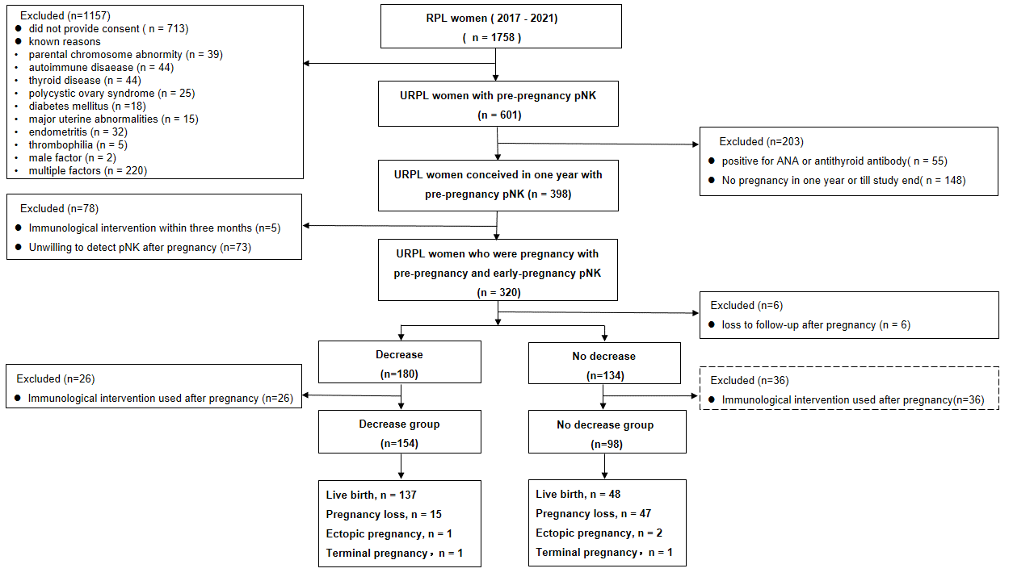

FIGURE 2 pNK level of before and after pregnancy in Group 1 and Group 2

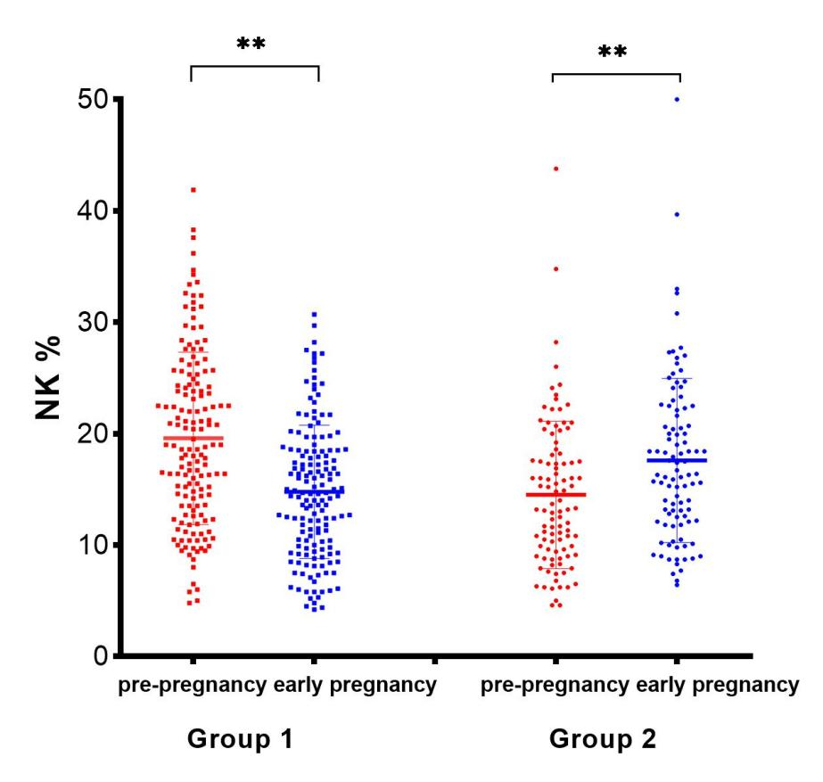

Note: **, p＜0.001

FIGURE 3 nomogram for association with live birth

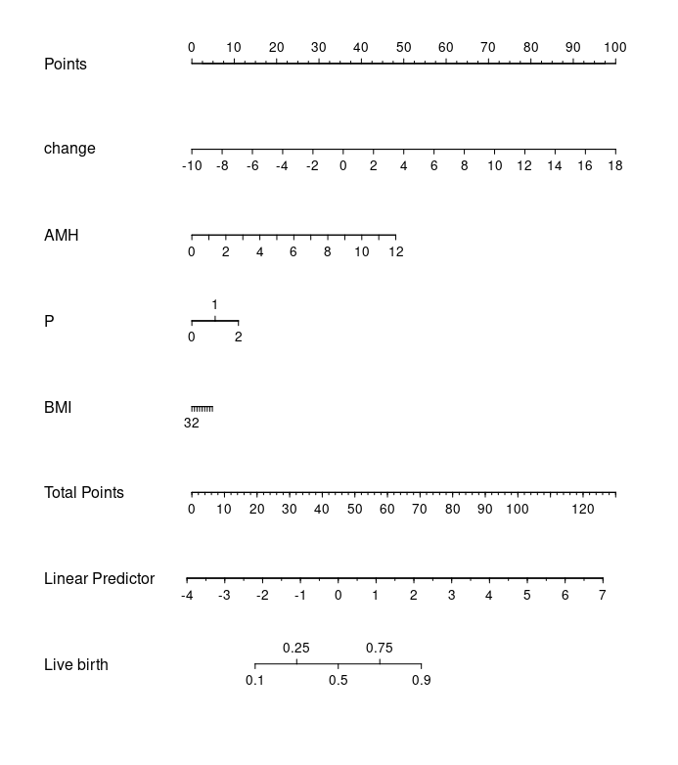
#P=number of parities, change=decrease of pNK, AMH= anti-Muellerian hormone, BMI= body mass index

FIGURE 4 ROC curve of decreased pNK for live birth predicting in all women
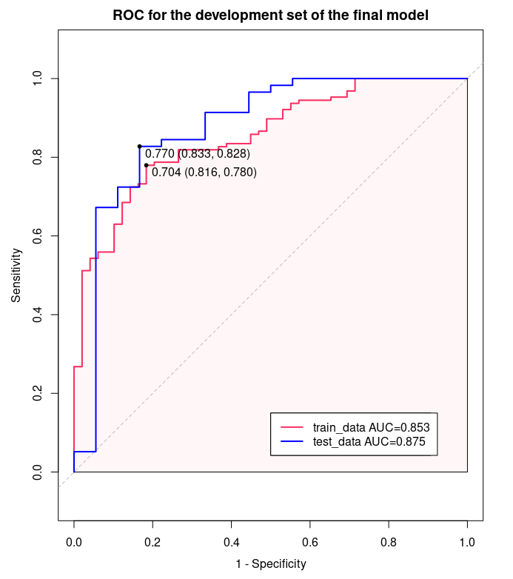

FIGURE 5 Calibration plots for the training (A) and test (B) datasets.
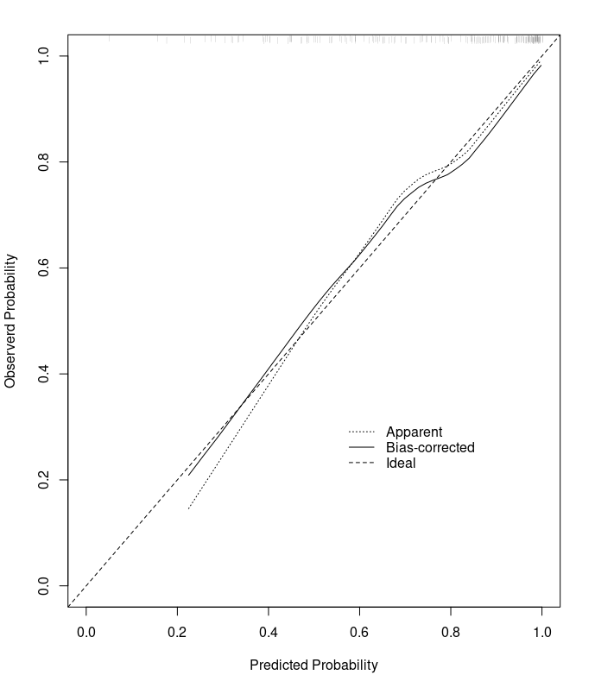
A. Calibration plots for the training dataset
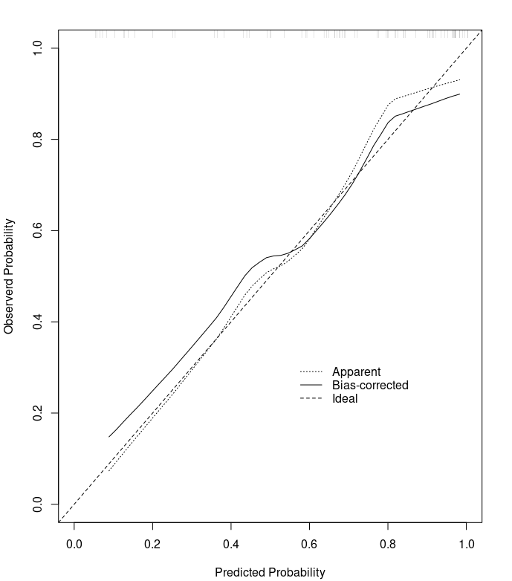
B. Calibration plots for the test datasets

Supplementary FIGURE S1 ROC for the pre-pregnancy pNK, CD3+, CD56+CD16+,CD3+CD56+, gestational pNK cells level and live birth

