Metasurface-integrated microring resonators for off-chip vortex beam generation

Jianzhi Huang,Wangke Yu, Zihang Zheng, Jize Yan,and Xu Fang*

School of Electronics and Computer Science, University of Southampton, Southampton SO17 1BJ, United Kingdom

Abstract

Vortex beams that carry orbital angular momentum (OAM) have garnered significant attention, as they bring the degree of freedom of OAM to modern optical communication, beyond the traditional degrees of freedom such as amplitude, phase and polarization. Meanwhile, metasurfaces composed of ultra-thin layers of subwavelength structures have also been utilized for light manipulation. Nevertheless, the combination of these two concepts has not been explored in the form of microring resonator-based light emitter. In this work, we demonstrate a Si-based, passive, conjugate symmetry-breaking emitter in numerical simulation. This broken conjugate symmetry enables the emitter to generate OAMs with different topological charges, when it is driven at two opposite input directions.

Keywords: Optical vortex; metasurface; conjugate symmetry; microring light emitter

# INTRODUCTION

Vortex beam carries OAM and possesses a doughnut-shaped intensity profile. It has been widely studied for applications such as optical communication [1], optical tweezers [2], and optical computing [3]. Numerous approaches have been developed for vortex beam generation, and they utilize devices such as spiral phase plates [4], diffraction gratings [5], metasurface plates [6] and ring resonators [7, 8]. Among these methods, ring resonators show advantages in scalability, reliability, miniaturization and wavelength-based OAM tuning.

In a conventional microring resonator-based vortex beam emitter, an angular grating is embedded in the microring. The output light originates from the whispering gallery mode (WGM) circulating inside the microring. Changing the input light direction only changes the chirality of the vortex beam, i.e., the absolute value of the topological charge remains unchanged. This is referred to as conjugate symmetry. However, metasurfaces with extreme light manipulation capability can break the conjugate symmetry in a microring emitter, creating a new phenomenon that can be referred to as asymmetric vortex beam emission. It represents a new approach for integrated vortex beam generation.

# Methodology

The asymmetry vortex beam emitter presented here is a combination of a microring resonator and a metasurface. Figure 1 is a schematic diagram of the emitter. It contains a Si bus waveguide and a Si microring resonator. A Si metasurface is positioned on top of the microring, with a thin SiO2 buffer layer placed between them. This Si metasurface consists of many nanopillars that that repeat as super cells. These nanopillars have the same height but vary in cross section. They function like truncated waveguides and possess a continuous  phase change in a super cell. When the microring is at a resonance wavelength, a WGM is formed inside the ring. It circulates in either the clockwise or the counter-clockwise direction, following that of the input light.

*[x.fang@soton.ac.uk](mailto:x.fang@soton.ac.uk)

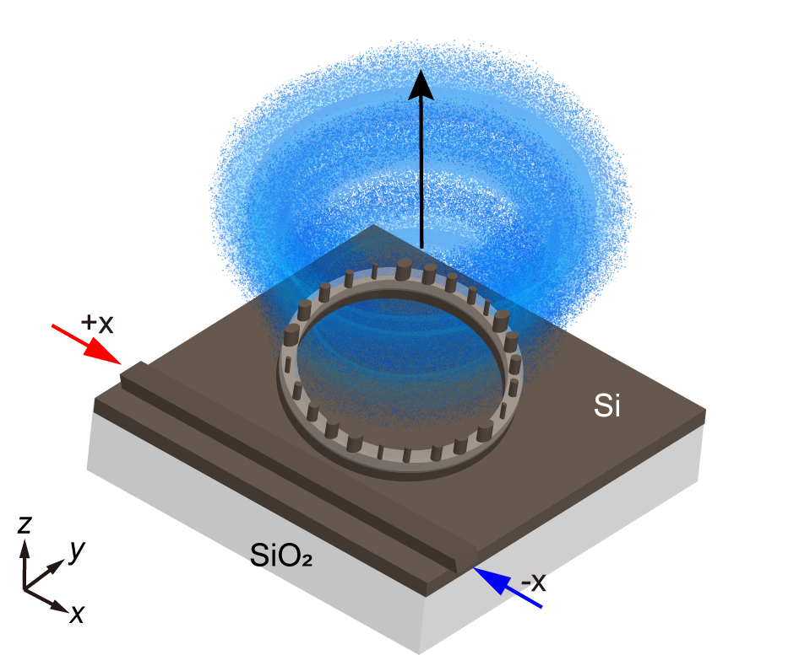

Figure 1. Schematic diagram of the metasurface-integrated microring vortex beam emitter. A metasurface of Si nanopillars is placed on top of a Si microring. A SiO2 thin film separates the Si nanopillars and the Si microring. The direction of the WGM depends on the direction of the input light.

For the conventional microring vortex beam emitters that have a standard angular grating on top, the topological charge of the emitted vortex beam obeys the angular phase-matching condition [7] of

|  |  |  |
| --- | --- | --- |
|  |  | (1) |

Here, *m* is the azimuthal order of the WGM, and  is the element number of the angular grating. The sign of the topological charge depends on the WGM direction. As the equation indicates, the absolute value of the topological charge stays invariant when the input light changes its direction.

For the metasurface-integrated microring vortex beam emitter discussed here, a phase gradient is imprinted by the metasurface onto the output vortex beam. As a result, by replacing the conventional angular grating with a metasurface, the OAM of the emitted beam has an extra component. The topological charge is now

|  |  |  |
| --- | --- | --- |
|  |  | (2) |

Here,  is an integer that is equivalent to the number of super cells in the metasurface. The sign of  is independent of the rotation direction of the WGM, because it represents the intrinsic phase gradient of the metasurface.

# SIMULATION and ANALYSIS

The simulated results of an example device are presented and analyzed in this section. The Si rib waveguide of the microring is 500 nm in width and 220 nm in height, and it has a 100 nm-thick Si slab. The metasurface on top has eight repeating super cells, and each super cell contains five different elliptical nanopillars. A linear phase ramp is formed along the microring, leading to .

In the transmission spectrum of the device, sharp resonances can be observed at wavelengths of 1574 nm, 1600 nm and 1627 nm. Each of these resonances represents a WGM in the microring. From the azimuthal orders of these WGMs, we can get the analytical values of the topological charge based on Equation (2). Figure 2 shows the far-field maps at these three resonance wavelengths. The OAM values derived from these numerically simulated results match well with the analytical results derived from Equation (2).

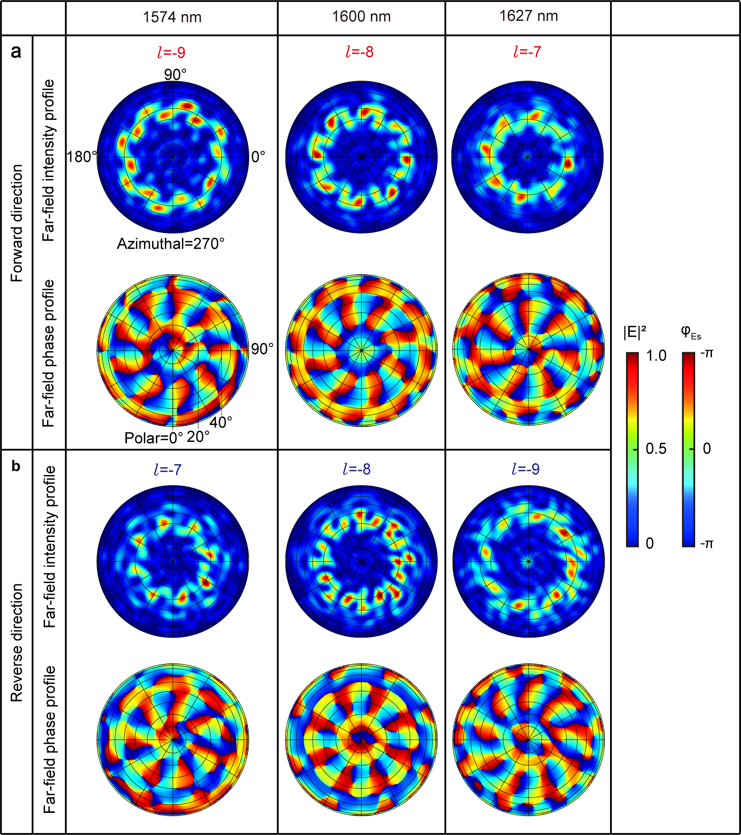

Figure 2. Far-field maps of the emitted vortex beam, at resonance wavelengths of 1574 nm, 1600 nm and 1627 nm. The intensity profiles and azimuthal phase profiles are shown, for input in (a) the  direction and (b) the  direction. All the intensity maps are normalized against their respective maximum value.

To further compared the numerical results against the theoretical prediction, we have analyzed the OAM components of the electric field at the resonance wavelength of 1627 nm. Here, we use the Stokes parameters to describe the polarization state of the radiation [9]. Vortex beams emitted by microring resonators are vector vortex beams [10, 11]. We assume that the out-coupling of the nanopillars does not alter the polarization state. The Stokes parameters are these four: , ,  and . They are utilized to describe the polarization distribution of an optical field.

|  |  |  |
| --- | --- | --- |
|  |  | (3) |
|  |  | (4) |
|  |  | (5) |
|  |  | (6) |

Here, is the intensity distribution of the total electromagnetic field. Meanwhile, ,  and  are associated with intensity distributions of three pairs of orthogonal polarization states. They are the horizontal and vertical polarizations, the diagonal and anti-diagonal polarizations, and the right-handed and left-handed circular polarizations, respectively. As an example, here we analyze the right-handed and left-handed circular polarizations.

Based on the hybrid-order Poincaré sphere analysis [12], every state can be decomposed into a linear superposition of right-handed and left-handed circular polarizations that carry OAM. It is worth noting that, as the total angular momentum is conserved in free space, decomposition in the basis of circular polarization can shift the value of OAM in the two polarizations.

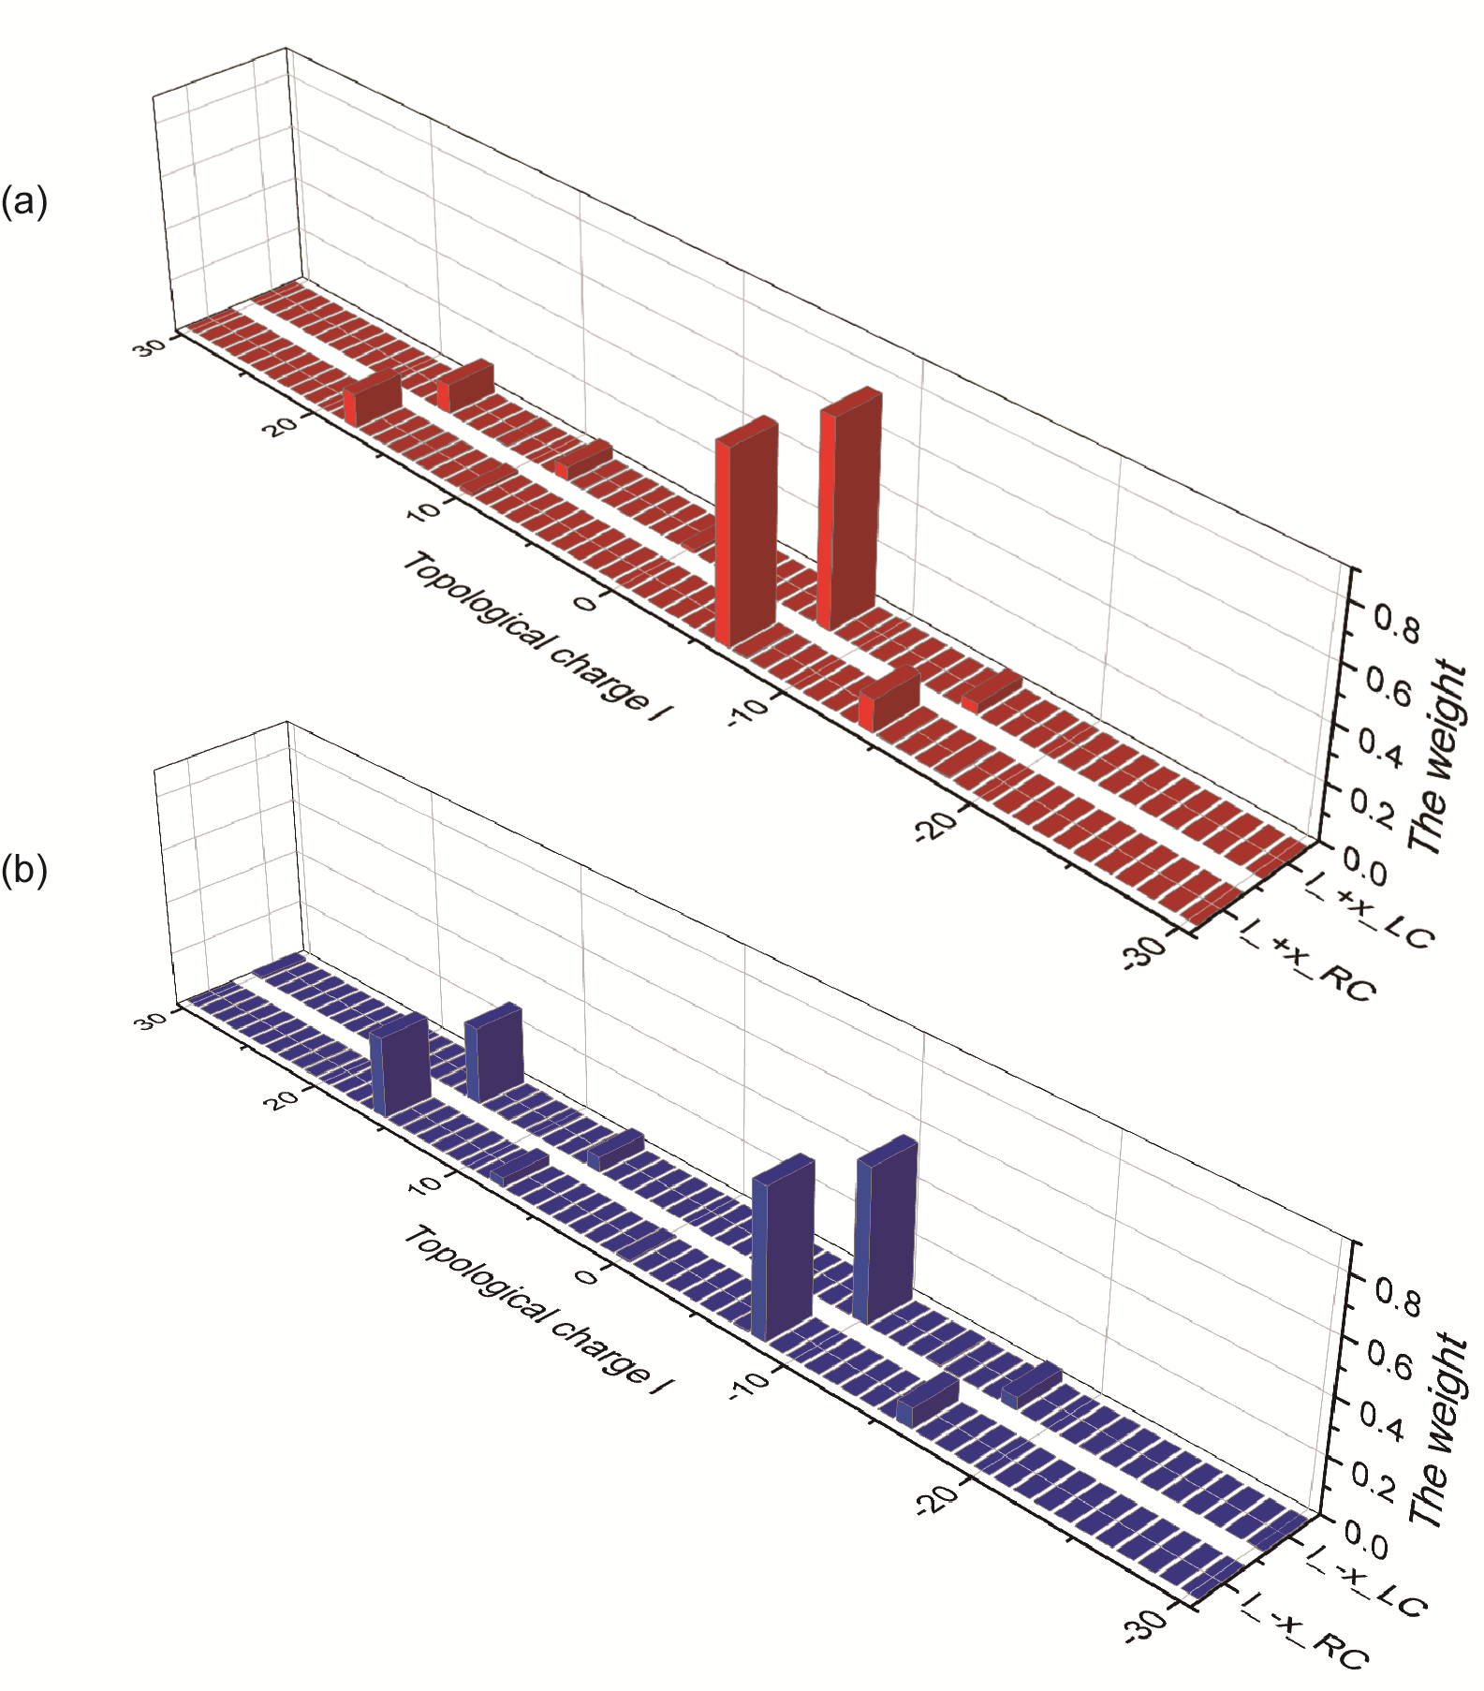

Figure 3. OAM spectrum analysis for the output vortex beam at 1627 nm. The red and blue bar charts are the spectra for the  and the  input, respectively. The decomposition is based on right-handed (RC) and left-handed (LC) circular polarization.

Figure 3 shows the OAM spectra, obtained by applying the decomposition to numerically simulated field maps. In Figure 3a, the dominant topological charge  is and . Here, indicates that the incident light is along the direction. Meanwhile, RC and LC represent the right-handed and left-handed circular polarizations, respectively. Their weights are 0.70 and 0.75, respectively. In addition, we have also analyzed the OAM of the output beam produced by the input light propagating along the  direction (Figure 3b). The dominant  now changes to  and , which have weights of 0.55 and 0.56, respectively. The dominant OAM values meet well with the analytical results. This decomposition further verifies that the metasurface breaks the conjugate symmetry in the vortex beam emission.

# CONCLUSION

In summary, we have introduced and numerically verified a new approach for integrated vortex beam emission. This approach combines a metasurface-structured waveguide and an angular grating-decorated microring resonator. The intrinsic phase gradient of the metasurface breaks the conjugate symmetry of system, resulting in a new phenomenon that we refer to as asymmetry vortex beam emission. It enables the device to emit two different sets of vortex beams by changing the input direction. This feature represents a new functionality for integrated vortex beam generation.

Reference

1. L. Zhu, A. Wang, M. Deng, B. Lu, and X. Guo, "Free-space optical communication with quasi-ring Airy vortex beam under limited-size receiving aperture and atmospheric turbulence," Opt Express **29**, 32580-32590 (2021).

2. M. Padgett and R. Bowman, "Tweezers with a twist," Nature Photonics **5**, 343-348 (2011).

3. G. Bharti, U. Biswas, and J. Rakshit, "Design of micro-ring resonator based all optical universal reconfigurable logic circuit," Optoelectronics and Advanced Materials-Rapid Communications **13**, 407-414 (2019).

4. G. A. Turnbull, D. A. Robertson, G. M. Smith, L. Allen, and M. J. Padgett, "The generation of free-space Laguerre-Gaussian modes at millimetre-wave frequencies by use of a spiral phase plate," Optics Communications **127**, 183-188 (1996).

5. F. E. Mahmouli and S. D. Walker, "4-Gbps Uncompressed Video Transmission over a 60-GHz Orbital Angular Momentum Wireless Channel," IEEE Wireless Communications Letters **2**, 223-226 (2013).

6. J. Li, Y. Zhang, J. Li, X. Yan, L. Liang, Z. Zhang, J. Huang, J. Li, Y. Yang, and J. Yao, "Amplitude modulation of anomalously reflected terahertz beams using all-optical active Pancharatnam-Berry coding metasurfaces," Nanoscale **11**, 5746-5753 (2019).

7. X. Cai, J. Wang, M. J. Strain, B. Johnson-Morris, J. Zhu, M. Sorel, J. L. O’Brien, M. G. Thompson, and S. Yu, "Integrated Compact Optical Vortex Beam Emitters," Science **338**, 363-366 (2012).

8. H. Pi, T. Rahman, S. A. Boden, T. Ma, J. Yan, and X. Fang, "Integrated vortex beam emitter in the THz frequency range: Design and simulation," APL Photonics **5**, 076102 (2020).

9. L. D. Landau, *The classical theory of fields* (Elsevier, 2013), Vol. 2.

10. J. Zhu, X. Cai, Y. Chen, and S. Yu, "Theoretical model for angular grating-based integrated optical vortex beam emitters," Opt Lett **38**, 1343-1345 (2013).

11. R. Li, X. Feng, D. Zhang, K. Cui, F. Liu, and Y. Huang, "Radially Polarized Orbital Angular Momentum Beam Emitter Based on Shallow-Ridge Silicon Microring Cavity," IEEE Photonics Journal **6**, 1-10 (2014).

12. X. Yi, Y. Liu, X. Ling, X. Zhou, Y. Ke, H. Luo, S. Wen, and D. Fan, "Hybrid-order Poincaré sphere," Physical Review A **91**, 023801 (2015).